BEFORE THE FLORIDA PUBLIC SERVICE COMMISSION

In re: Petition for Determination DOCKET NO. ______
of Need for Expansion of an Electrical Submitted for filing:
Power Plant, for Exemption from September 22, 2006
Rule 25-22.082, F.A.C., and for Cost
Recovery through the Fuel Clause

DIRECT TESTIMONY
OF DANIEL L. RODERICK

ON BEHALF OF
PROGRESS ENERGY FLORIDA

R. ALEXANDER GLENN JAMES MICHAEL WALLS
JOHN BURNETT Florida Bar No. 706272
PROGRESS ENERGY SERVICE DIANNE M. TRIPLETT
COMPANY, LLC Florida Bar No. 0872431
P.O. Box 14042 CARLTON FIELDS, P.A.
St. Petersburg, Florida 33733 Post Office Box 3239
Telephone: (727) 820-5180 Tampa, FL 33601
Facsimile: (727) 820-5519 Telephone: (813) 223-7000
Telecopier: (813) 229-4133
IN RE: PETITION FOR DETERMINATION OF NEED FOR EXPANSION OF AN ELECTRICAL POWER PLANT, FOR EXEMPTION FROM RULE 25-22.082, F.A.C., AND FOR COST RECOVERY THROUGH THE FUEL CLAUSE

BY PROGRESS ENERGY FLORIDA
FPSC DOCKET NO. _________________

DIRECT TESTIMONY OF DANIEL L. RODERICK

I. INTRODUCTION AND QUALIFICATIONS

- Please state your name and business address.
- My name is Daniel L. Roderick. My business address is Crystal River Energy Complex, Nuclear Administration 2C, 15760 West Power Line Street, Crystal River, Florida 34428.

Q. By whom are you employed and in what capacity?
A. I am employed by Progress Energy Florida (“PEF” or the “Company”) in the Nuclear Generation Group and serve as the Director of Site Operations at Crystal River Unit 3 (“CR3”), PEF’s nuclear plant.

Q. What are your responsibilities as the Director of Site Operations?
A. I am responsible for the safe, efficient, and reliable generation of electricity from the Company’s nuclear plant. All plant functions, including the Plant General Manager, Engineering Manager, Training Manager, and Licensing, report to me and are under my supervision.
Q. Please summarize your educational background and work experience.
A. I have a Bachelor of Science and Master of Science degree in Industrial Engineering from the University of Arkansas and a Senior Reactor Operator License. I have been at CR3 since 1996, serving in my current position of Director Site Operations and, prior to that position, Plant General Manager, Engineering Manager, and Outage Manager, respectively. Prior to my employment with the Company, I was employed for twelve years with Entergy Corporation at its Arkansas Nuclear One plant in Russellville, Arkansas with responsibilities in Plant Operations and Engineering.

II. PURPOSE AND SUMMARY OF TESTIMONY

- What is the purpose of your testimony?
- The purpose of my testimony is to support the Company’s request for a determination of need for the expansion of power capacity at CR3, for exemption from the bid rule, Rule 25-22.082, F.A.C., and for cost recovery through the fuel clause for the replacement and modification of equipment at CR3 to support an increase in reactor power from the nuclear plant.
Specifically, I will generally describe the current Crystal River site and CR 3. I will further explain the planned changes to the nuclear plant that are necessary to support the power uprate project. I will also generally describe the expected impact of the power uprate on the transmission system and thermal limits on the discharged cooling water that must be addressed to obtain the full benefits of the power uprate project at CR3. I will further present the Company’s current cost estimates for the project, explain the procedures in place to ensure the costs incurred for the project are reasonable and prudent, and explain the economic need for the project because the project will provide additional, reliable base load capacity to customers while generating substantial fuel savings. Finally, I will explain the adverse consequences to the Company and its customers if the CR3 uprate project is delayed.

Q. Why is the Company considering the CR3 power uprate project?
A. The primary reason for this project is to reduce total fuel costs to customers over the extended life of CR3 by increasing low cost nuclear fuel generation and reducing or replacing generation from higher cost fuel power plants or purchased power obligations. The Company has performed studies to find innovative ways to reduce the total fuel cost to the customer by expanding existing nuclear generation and implementing new technological innovations. To illustrate, in preparing for the steam generator replacement and related work during the Company’s upcoming 2009 nuclear refueling outages necessary to extend the remaining life of the nuclear unit, the Company determined that additional power can be generated through increased efficiencies from technological advancements and additional modifications to accommodate nuclear fuel enrichment at the unit. The result of a power uprate at the nuclear unit from these additional technological efficiencies and fuel enrichment modifications will be increased generation capacity from the Company’s lowest cost fuel source. This will allow PEF to replace or reduce higher cost generation from alternative fuel sources. The Company’s need for the CR3 power uprate project is, therefore, economic because of the significant fuel savings for customers that will be realized from the project.

Q. Do you have any exhibits to your testimony?
A. Yes, I have supervised the preparation of or prepared the following exhibits to my direct testimony.
- Exhibit No. ___ (DLR-1), an aerial view of the Crystal River complex, including CR3.
- Exhibit No. ___ (DLR-2), a picture of the primary plant configuration for the pressurized water reactor nuclear plant at CR3 that shows the major components of the nuclear reactor and primary coolant system.
- Exhibit No. ___ (DLR-3), a schematic of the major components in the primary system and the balance of the nuclear plant that shows the major components in the secondary systems, including the main turbine and main generator.
All of these exhibits are true and accurate.

Q. Please give an overview of the Company’s presentation in this proceeding.
A. In addition to my own testimony, the Company will present the testimony of the following witnesses:
- Mr. Samuel Waters, who will explain the economic need for the CR3 power uprate by providing testimony regarding the significant fuel savings that will be realized from the project. Mr. Waters will explain how the project will increase the supply of adequate, reliable electricity at a reasonable cost and why the project is the most cost-effective alternative to the Company because it will result in a lower cost supply of electricity to the Company’s customers. Mr. Waters will further generally describe the Company’s existing facilities and other supply resources and the Company’s Demand-Side Management resources (DSM), and explain why DSM resources cannot mitigate the economic need for the project.
- Mr. Javier Portuondo, who will generally discuss the costs of the CR3 power uprate project and the anticipated fuel savings including the net present value of the benefit to customers. Mr. Portuondo will further explain that the CR3 power uprate project costs were not anticipated in the Company’s last base rate proceeding and are not recognized in the Company’s base rates. Finally, Mr. Portuondo will explain that the significant fuel savings the Company’s customers will realize from the project justify recovery of the power uprate project costs by the Company through the Fuel and Purchase Power Cost Recovery Clause (“Fuel Clause”).

Q. Please summarize your testimony.
A. The CR3 power uprate project is an innovative application of technological advancements and efficiencies during existing planned outages at CR3 to obtain increased nuclear fuel generation capacity. The result of this increased production with low cost nuclear fuel will be the reduction in or replacement of higher cost fossil fuel and purchased power generation resources, yielding substantial fuel savings at a net savings to the cost of the project for customers. No alternative generation option exists that can supply the benefits of additional, reliable, base load, nuclear generation at a net savings to PEF’s customers. Also, the power uprate will increase the level of nuclear production in the fuel supply mix on PEF’s system, increasing fuel diversity for PEF and the State of Florida. The CR3 power uprate project represents a unique opportunity to increase fuel diversity and reduce the reliance on fossil fuel generation at no net cost to customers, but rather at a net savings to customers.
To obtain the full benefit of the fuel savings generated by the power uprate project, however, PEF must timely commence material and equipment orders to meet the window of opportunity to perform the power uprate during the planned refueling outages at CR3. Any delay in the approval of PEF’s Petition will delay and reduce the substantial fuel savings benefits PEF’s customers will receive as a result of the power uprate project.

III. THE CRYSTAL RIVER SITE AND CR3 UNIT

Q. Please describe the Crystal River site.
A. The Crystal River site is a 4,700 acre site located in Citrus County, Florida that contains four coal-fired generating units, one nuclear generating unit, and related support facilities, such as fuel transportation and storage facilities. The site generators are connected to a transmission substation. The Crystal River substation contains both 230 kv and 500 kv transmission lines that supply power generated at the site to the Company’s transmission system. The four coal-fired and one nuclear power units at the site generate approximately 3,200 MWe. Exhibit No. ___ (DLR-1) is an aerial photograph that accurately depicts the Crystal River site, including CR3.

Q. Please describe the nuclear generating unit at the Crystal River site.
A. CR3, the nuclear generating unit, is a B&W pressurized water reactor that
includes a Primary and Secondary System. The Primary System is located within the containment building and includes the reactor vessel, pressurizer, steam generators, primary coolant system, and related equipment. Exhibit No. ___ (DLR-2) is a picture of the major components of the Primary System, including the nuclear reactor and the primary reactor coolant system.
The Primary System is a closed loop system. The nuclear reactor produces heat that eventually is turned into steam then into electricity. The heat is removed from the reactor by water in the primary coolant system that is continuously pumped around the Primary System. Heat transfers from the fuel cells to the surrounding metal fuel cladding which in turn heats the water flowing between and around the fuel rods. The heated water then travels from the core through pipes to the steam generators. In the steam generators, heat is transferred from the reactor primary coolant system to the physically separated secondary coolant system producing steam in the secondary system. The Primary System operates at about 600 degrees F and 2150 PSI. The high pressure prevents the water in the primary system from turning to steam.
The secondary water coolant system is under less pressure, operating at over 450 degrees F and 850 PSI, and when the water in the secondary coolant system is heated it turns to steam, which turns the turbine that powers the generator. The steam exiting the turbine is then condensed to water. The water is pumped back to the steam generators by a series of pumps and heat exchangers where it is once again converted to steam, thereby completing the cycle. Exhibit No. ___ (DLR-3) is a schematic of the major components of the Primary and Secondary Systems, including the main turbine and main generator. It also shows the electricity produced in the generator passes through some transformers before being passed on to the switchyard at Crystal River, and then onto the transmission grid. The Company’s transmission system is part of the peninsular Florida interconnected electrical grid of all transmission-owning electric utilities in the State and also part of the interface with the transmission facilities of utilities in the Southeastern United States at the Florida border.
CR3 was the third generating unit constructed at the site and it currently produces about 900 MWe. CR3 provides power into the 500 kv transmission system connected to the Crystal River site and uses the 230 kv system at the site for on-site backup power. CR3 supplies its own power needs during normal operation.

IV. THE CR3 POWER UPRATE PROJECT

Q. What is the CR3 power uprate project?
A. The power uprate project for CR3 increases the electrical power output
from the plant from about 900 MWe by approximately 180 MWe to 1,080 MWe. The total cost for the uprate project is estimated at $381.8 million. Of this amount, approximately $250 million is for the power uprate itself. The additional costs address anticipated modifications to the transmission system to handle the additional power, estimated at $89 million, and anticipated modifications to address Point of Discharge (“POD”) issues caused by the additional heat generated by the power increase, which are preliminarily estimated at $43 million.
The power uprate project involves increasing the power or thermal
MWs produced in the reactor core by making modifications to the design to allow for use of more highly enriched fuel. The costs associated with this are for making the physical changes needed to allow for use of this more highly enriched uranium in a safe and economical fashion, not the fuel itself. In addition, some modifications to supporting equipment are necessary to support the additional heat from the power increase to accommodate all designed accident conditions in the plant. The additional heat will raise the temperature exchange between the Primary and Secondary Systems and create more steam to turn the turbines.
In the design of these plants in the 1960’s, the analytical modeling that exists today was not available, and the result was that the best designs of the time over-compensated for the available computer modeling with built-in assumptions having very large safety margins to ensure adequate protection was in place to accomplish all intended functions. Many of these initial safety margins, given today’s analytical engineering tools and advanced testing capabilities, allow for an increase in reactor power with limited physical primary plant changes. Most of these primary system changes involve increasing Emergency Cooling Pump flow rates and the setpoints for actuation of safety systems.
The major modifications resulting from the power uprate involve the secondary system specifically, the turbine generator set, which has three parts, two low pressure and one high pressure rotors, and the generator, plus their supporting systems and equipment. The secondary system must be modified to accept the additional heat produced by the reactor core. This is accomplished by increasing the secondary system water flow to the steam generators. Increasing the flow requires larger pumping capacity than currently exists, which requires modification or replacement of some existing pumps and heat exchangers. A detailed pinch point study for these flows will define which pumps and motors will need to be upgraded or replaced based on the lowest cost required to achieve the necessary secondary system water flow.
In addition to the reactor power increase, design improvements to some major system components will allow for increased efficiencies, providing additional steam power beyond that obtained from the more enriched fuel. These design improvements to obtain the steam efficiencies are factored into the CR3 power uprate costs. For example, when the steam turbine high pressure rotor was designed in 1962, a multi-piece assembly was made. These multi-piece assemblies cause drag on the system, but better technology did not exist at the time. Since then, in the late 1990’s, technological advancements have resulted in a single piece rotor blade that has less drag and, therefore, provides increased megawatt output for the same steam input.
The CR3 power uprate project, including all modifications and technological advancements, will generate an additional 180 MWe by the end of 2011. The power uprate project will make CR3 the largest single generating unit in Florida at 1,080 MWe. CR3 is currently licensed by the Nuclear Regulatory Commission (“NRC”). The Company plans to submit a licensed power change to the NRC for the CR3 uprate project in 2009 and NRC approval is expected in 2011.

- Has a power uprate of this kind ever been performed on a B&W pressurized water reactor?
A. While the innovative power uprate planned for CR3 has not been undertaken at any other B&W designed plant, similar power uprates have been accomplished and approved by the NRC at other nuclear plants designed by Westinghouse and General Electric. Initial discussions with the NRC indicate that a similar process to the one used for licensing power uprates at Westinghouse and General Electric designed plants would be used to license CR3 to the additional power level.
Q. What is the likelihood that the NRC will approve the license extension for CR3?
A. The power uprate project assumes that the ongoing activities to renew the license of CR3 will be successful and that the license now due to expire in 2016 will be extended to 2036. License renewal of nuclear power plants is an ongoing nuclear industry process that requires technical information submitted by the applicant and approval by the NRC for the operating license to be extended for 20 years. License renewals have been granted for Progress Energy's Robinson and Brunswick Units 1 and 2 plants. In addition, four of the seven plants of a similar design to CR3 have already received approval for license renewal. No license extensions for plants have been rejected after a detailed NRC review and no utility has been told that it would not be able to renew its license. As a result, there is a high likelihood that the license renewal for CR3 will be granted by the NRC and therefore the 2036 date used in the economic model for the power uprate can be achieved.

Q. Are there any environmental benefits from the CR3 power uprate project?
A. Yes, there are. The CR3 power uprate will use nuclear fuel, which is the cleanest fuel source on PEF’s system. During normal operations, there are no greenhouse gas emissions and no emissions of other pollutants common to other fuel sources for power production such as carbon monoxide, sulphur dioxide, aerosols, mercury, nitrogen oxides, and particulates or photochemical smog. Further, because the CR3 power uprate will displace higher cost fossil fuels with nuclear fuel there likely will also be a reduction in the greenhouse gas and other emissions from fossil fuel resources. From an environmental viewpoint, the CR3 power uprate project is an attractive means of obtaining cost-effective generating capacity.

Q. What is the schedule for the CR3 uprate project?
- The CR3 power uprate project is planned for the scheduled refueling outages for CR3 in 2009 and 2011. The plant currently has a steam generator replacement scheduled for the 2009 refueling outage. The duration for the steam generator replacement outage is currently estimated at approximately 75 days. To meet this schedule and ensure that the power uprate project is performed during the scheduled outages, PEF must begin ordering equipment and material.
Most of the physical modifications will be complete by 2009 during the scheduled steam generator replacement outage. The Company currently anticipates, for example, that all or at least part of the turbine and generator replacement can be completed during the 2009 outage. Other modifications and replacements will be evaluated for inclusion in the 2009 outage if the outage is not extended, appropriate resources are available to support the changes, and the impact of further modifications or replacements for the power uprate project on the duration of the scheduled 2011 refueling outage can be minimized.
The full power uprate is scheduled for 2011, when the remaining work necessary to provide the full 180 MWe power uprate will be completed. The CR3 power uprate project is expected to generate 40
additional MWe by the end of 2009 and then an additional 140 MWe by the end of 2011. The modifications and equipment changes necessary to support the uprate will be scheduled to minimize any plant outage time while assuring that appropriate resources are available to support the changes.

- Will the CR3 uprate project require changes to other units or the Crystal River site?
- No. All changes necessary to generate the full power uprate are internal to the CR3 power block and switchyard. No changes to the Company’s current plant siting are required. However, modifications to the transmission system and to address POD issues to accommodate the full 180 MWe power uprate may be necessary.

- Why may changes to the current transmission system be necessary as part of the CR3 power uprate project?
- After the power uprate project is complete, CR3 will become the largest power generator on the Company’s system. Changes may be necessary to the transmission system to accommodate the 1,080 MWe CR3 will generate following the uprate project. The Company is studying and will continue to study the impacts of this additional power to the transmission system and what modifications, if any, are necessary. The final study will not be completed until closer to the time that the power uprate project commences because the transmission system changes periodically with transmission additions or modifications that are occasioned by other generators and users on the interconnected transmission grid, particularly within peninsular Florida, but also extending to the interface with the southeastern United States utility transmission systems. Current cost estimates of $89 million are preliminary, based on the existing transmission system and known transmission projects that are underway. The Company believes these cost estimates are reasonable and sufficient for the Company to proceed with the project. Refinements to the cost estimates, however, will be made over time to account for any changes to the transmission system or changes in labor, commodity, and land market conditions.

- What changes are anticipated to address the POD issues?
A. The power uprate from the project will generate additional heat and steam thereby increasing the water temperature of the cooling water for the CR3 unit. This additional heat will likely cause the Company to exceed the thermal permit requirements for the cooling water discharge. An optimal solution has not yet been identified but we have preliminarily assumed an estimated cost of $43 million to address the POD issues at the discharge canal associated with the uprate project. The Company will evaluate all reasonable options before making a final determination of how to address the POD issue. Whatever modifications are necessary to address the thermal cooling water discharge limit, however, will accommodate the full power generated by CR3.

Q. Is the POD impact the only environmental issue associated with the CR3 power uprate?
A. Yes, we believe it is. CR3 is located at the Crystal River Energy Complex and is currently being operated under license from the NRC and necessary federal and state permits. The environmental issues associated with the Crystal River site have therefore been addressed and resolved under the prior license and permits. Because the CR3 power uprate project is limited to the CR3 power block and switchyard the project’s impact on the site is minimal and most if not all of the current permit requirements for the operation of CR3 will not be affected by the power uprate project. The potential impact to the environment that we see from the project is the effect of the additional heat from the power uprate on the temperature of the discharge water.

V. NEED FOR THE CR3 POWER UPRATE PROJECT

Q. Is there a need for the CR3 power uprate project?
- Yes, but it is an economic need. Although the power uprate project will provide the Company and its customers with additional, reliable base load power there is no reliability need for the project. The power uprate project is not required to meet the Company’s twenty percent Reserve Margin requirement or Loss of Load probability analysis. As discussed more fully in Messrs. Waters' and Portuondo's testimony, there are, however, clear economic benefits from the project. The power uprate for CR3 will provide additional base load generation from the lowest cost fuel currently on the Company’s system, thereby displacing generation with higher priced fuel or higher cost purchased power. The result will be significant fuel savings to the Company’s customers that far exceed the cost of the project. The fuel savings and net present value of the fuel savings are described in the testimony of Mr. Waters.

- Are the costs of the power uprate project reasonable and prudent?
- Yes. The Company will conduct competitive bids for the purchase of major components for the power uprate project. This process involves a detailed review of designs and pricing to make sure the best quality for the price is obtained. In addition, benchmark comparison to power uprates performed at other plants in Progress Energy’s system will be made to factor in the latest experience gained from those uprates. By incorporating a competitive bidding process and relying on efficiencies achieved from experience, the Company will ensure that the power uprate costs are reasonable and prudent.
VI. BENEFIT TO THE STATE

- Will the State benefit from the power uprate project?
- Yes, it will. As discussed above, the power uprate provides the customers of Florida more electric power with the lowest cost fuel available for their electric consumption, at significant fuel savings. The power uprate project will also increase the Company’s fuel diversity and fuel supply reliability with additional generation capacity from nuclear as opposed to fossil fuels. The reduction in the reliance on more expensive fossil fuels that are subject to supply interruptions and significant price volatility is a benefit not only to PEF’s customers but also to the State economy as a whole. Finally, nuclear generation is environmentally friendly and it is a proven and safe technology, so the additional power comes at no additional environmental cost. All of these benefits demonstrate that the CR3 power uprate project serves the public welfare.

VII. CONSEQUENCES OF DELAY

Q. Are there any adverse consequences if the power uprate project is delayed?
- Yes. The steam generator replacement scheduled for 2009 provides a unique window of opportunity for the large power uprate modifications to be made. If that window is missed, performing the power uprate later will require another unplanned outage or an outage extension. That will require production of power during that additional outage time with higher priced fuels, reducing the benefits of the project.
In addition, the costs of construction and commodities are increasing, which will increase the cost of the uprate project if it is delayed beyond the 2009 outage. As the costs of the project rise over time the fuel savings will be delayed and reduced by the higher costs of the project.
Finally, delaying the power uprate project means delaying the fuel savings benefits to customers. While the project is delayed the power that would have been produced with low-cost nuclear fuel will be produced by higher priced fuel generation resources.

VIII. BID RULE EXEMPTION

- Can the Company also use a competitive bid process to determine if the power uprate project is the most cost effective alternative available to the Company?
- No, it cannot. The power uprate project at CR3 will result in the lowest cost supply of electricity on PEF's system to the people of Florida. Specifically, the power uprate results in net savings to the Company’s customers. The bid rule was established as a tool to determine the most cost-effective alternative to the Company’s generation proposal. No power generation alternative is available that will provide base load generating capacity at a net savings to customers comparable to the benefits of the CR3 power uprate project. All other potential suppliers of generation capacity would likely provide the additional capacity of the CR3 power uprate project – 180MWe – at a net cost to the Company’s customers and without the environmental and fuel diversity benefits of nuclear power. Because the power uprate project provides customers with additional nuclear generation at a net savings, not a net cost, it is by definition the lowest cost supply of reliable electricity to customers and, therefore, the most cost effective alternative for the Company.

Q. Will the issuance of a Request For Proposals (RFP) for generation alternatives to the CR3 power uprate project have an adverse effect on the project?
A. Yes. An RFP process will take months from preparation of the RFP to the solicitation of bids, review and analysis of any responses, and making a final decision. To meet the current schedule to begin work on the CR3 project uprate during the 2009 CR3 outage PEF must commence ordering equipment and material now. Engaging in an RFP process, therefore, will delay equipment and material orders for the project and the Company will miss the window of opportunity to perform power uprate work during the 2009 outage. Such a delay, as I have already explained, will require a separate outage time for the power uprate project and result in increased equipment and material costs for the project reducing the fuel savings benefits. Further, any remaining fuel savings benefits for customers would be delayed to the disadvantage of the customer.
There also is no benefit to PEF’s customers from an RFP process. The CR3 power uprate project will take advantage of the cheapest fuel the Company has and a fuel that is not available in other supply side alternatives. Any potential bidder in an RFP necessarily must propose a different, higher price fuel source for the alternative generation. It necessarily follows that any alternative generation source will not generate the same fuel savings and other benefits of the CR3 power uprate on PEF’s system. PEF, therefore, does not need to conduct an RFP process to know that the CR3 power uprate project will increase the reliable supply of electricity to PEF’s customers at the lowest cost to and most benefit for PEF’s customers.

Q. Does an RFP process for the CR3 power uprate project present a substantial hardship to PEF or its customers?
A. Yes, an RFP process to test an alternative generation option would be a substantial hardship to both PEF and its customers. Remember, the need for the CR3 project is an economic, not a reliability need. PEF has enough capacity to meet its customers’ needs for reliable generation without the CR3 power uprate project, just at a higher total cost to the customer. The hardship to PEF’s customers, then, if PEF is required to engage in an RFP process for potential alternative generation to the CR3 power uprate project, is that they will lose the fuel savings benefits of the project. With fuel savings estimated at over $2.6 billion, as explained by Mr. Waters in his testimony, the hardship of the loss would be substantial.
PEF would also suffer a substantial hardship. PEF likewise has an interest in lowering the total costs of energy to its customers and PEF certainly has an interest in increasing fuel diversity on its system. Further, an RFP process imposes substantial technical requirements and cost on PEF to conduct the RFP process, all for a futile effort in the case of the CR3 power uprate project.

IX. CONCLUSION

Q. Please summarize the benefits of the CR3 power uprate project.
A. There is an economic need for the CR3 power uprate project. By undertaking and completing the project PEF will generate substantial fuel savings for its customers that will be a significant benefit to them and the Company. The Company will also increase fuel diversity to its benefit and the benefit of the state, all by providing additional, reliable base load generation from an environmentally friendly source. No additional base load generation source can provide additional, reliable electrical power at a net fuel savings to customers comparable to that provided by the CR3 power uprate project. We urge the Commission to approve the need for the CR3 power uprate project, to waive all of the bid rule requirements, and to provide for cost recovery of the project through the Fuel Clause.

Q. Does this conclude your testimony?
A. Yes, it does.

Exhibit 1
General Site Layout

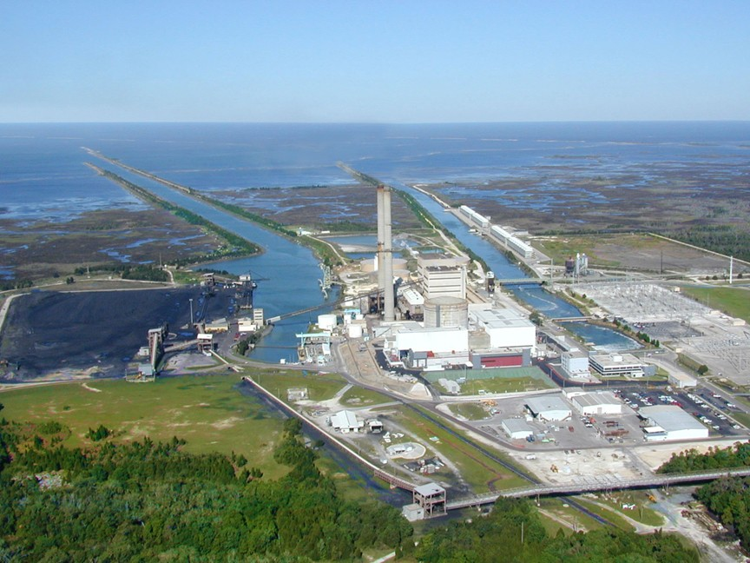
Exhibit 2

Primary Plant Configuration

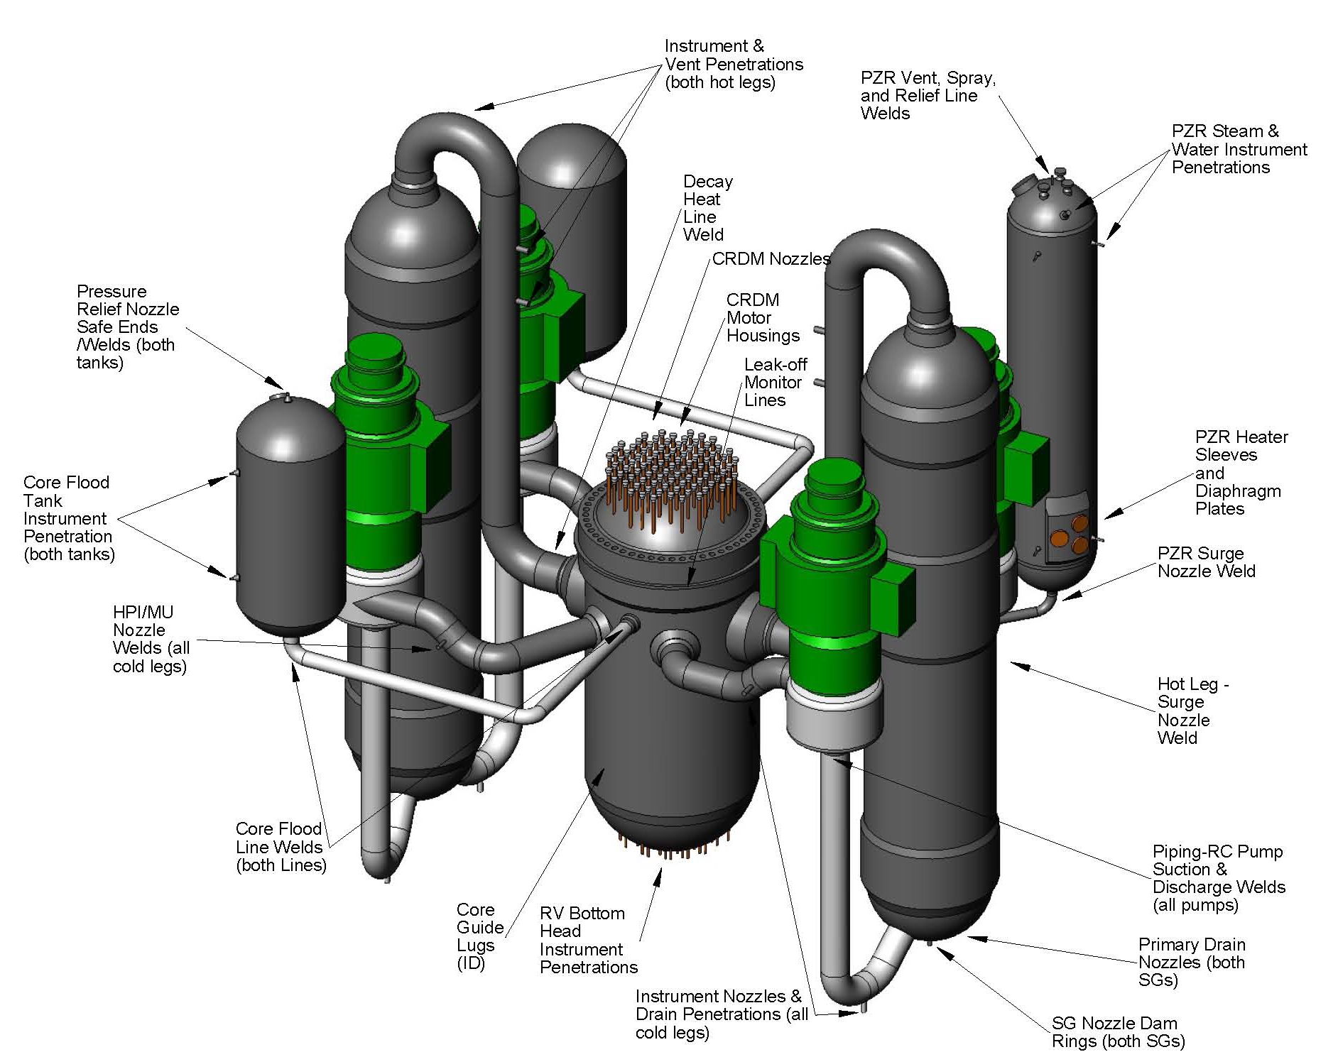

Exhibit 3
Secondary Plant Interface



