State of Florida |  | Public Service Commission  Capital Circle Office Center ● 2540 Shumard Oak Boulevard  Tallahassee, Florida 32399-0850  -M-E-M-O-R-A-N-D-U-M-
DATE: | June 4, 2015
TO: | Office of Commission Clerk (Stauffer)
FROM: | Division of Economics (Garl)  Office of the General Counsel (Villafrate)
RE: | Docket No. 150093-GU – Joint petition for approval of territorial agreement in Hardee County, by Peoples Gas System and Sebring Gas System, Inc.
AGENDA: | 06/18/15 – Regular Agenda Conference – Proposed Agency Action – Interested Persons May Participate
COMMISSIONERS ASSIGNED: |  |  | All Commissioners
PREHEARING OFFICER: |  |  | Patronis
CRITICAL DATES: |  |  | None
SPECIAL INSTRUCTIONS: |  |  | None

Case Background
On March 23, 2015, Peoples Gas System (PGS) and Sebring Gas System, Inc. (Sebring) filed a joint petition requesting Commission approval of a territorial Agreement for a portion of Hardee County located within and adjacent to the City of Wauchula, Florida. PGS provides natural gas sales and transportation service to customers in Hardee County, Florida. In addition, PGS provides gas transportation service to the gas marketer supplying natural gas to customers that are served by Sebring. PGS plans to continue expanding its distribution system in Hardee County and the surrounding area as provided in the extension of facilities policy contained in its tariff on file with the Commission.
Sebring provides natural gas transportation service to customers within and adjacent to the City of Sebring in Highlands County, immediately east of Hardee County. On May 12, 2014, the City of Wauchula Commission adopted Ordinance 2014-10 awarding a franchise to Sebring to provide natural gas service to residents of the city.
During its evaluation of the petition, staff issued one data request to PGS and Sebring. The questions posed by staff were intended to clarify background information about natural gas service to the City of Wauchula, some provisions of the proposed Agreement, and its impact on ratepayers of both companies. The Commission has jurisdiction over this matter pursuant to Section 366.04, Florida Statutes (F.S.).

Discussion of Issues

Issue 1:
Should the Commission approve the proposed Agreement between PGS and Sebring?

Recommendation:
Yes. The Commission should approve the proposed Agreement. (Garl)

Staff Analysis:
Pursuant to Section 366.04(3)(a), F.S., the Commission has the jurisdiction to approve territorial agreements between and among natural gas utilities. Rule 25-7.0471, Florida Administrative Code (F.A.C.), provides that in approving territorial agreements, the Commission shall consider:
(a) The reasonableness of the purchase price of any facilities being transferred;
(b) The reasonable likelihood that the agreement, in and of itself, will not cause a decrease in the reliability of natural gas service to the existing or future ratepayers of any utility party to the agreement, and
(c) The reasonable likelihood that the agreement will eliminate existing or potential uneconomic duplication of facilities.
(d) Other relevant factors that may arise from the circumstances of a particular case.
Unless the Commission determines that the agreement will cause a detriment to the public interest, the agreement should be approved.
The proposed territorial Agreement establishes the area Sebring will serve within the corporate limits of the City of Wauchula and certain adjoining areas as depicted on the map included as Attachment A to this recommendation. The Agreement specifically excludes the Hardee County Fleet Maintenance facility occupying approximately one block in the southern portion of the city, which will be served by PGS. The term of the Agreement is until termination or modification is mutually agreed to by the parties or as mandated by an entity or court of appropriate jurisdiction.
In response to staff’s data request, the companies stated that natural gas service was not previously available to the City of Wauchula. As a result, there are no customers or facilities to be transferred between PGS and Sebring. Reliability of service will increase from no service to full access to natural gas service for residents of Wauchula. Furthermore, there will be no uneconomic duplication of facilities within the area to be served by Sebring, because Sebring’s installation of its distribution system will be the only natural gas pipelines in the area, with the exception of the one excluded facility.
The PGS and Sebring response to the staff data request further explained that the excluded facility belongs to Hardee County. Prior to the negotiation of the PGS-Sebring territorial agreement, PGS and Hardee County had committed to the construction of a Compressed Natural Gas (CNG) station to service Hardee County vehicles. PGS will provide gas service to the station. The carve out of this customer from the Agreement is necessary to keep the agreements made between PGS and the customer (Hardee County) intact since construction of the CNG station has been completed. Sebring currently has no facilities near the CNG station. If necessary for Sebring to serve customers in this area, and to avoid duplication of service facilities, PGS and Sebring may establish a second interconnect on the PGS main line in this area. From that interconnect, Sebring could proceed to design and build-out their distribution facilities.
After review of the petition, the proposed Agreement, and the parties’ response to a data request, staff believes that the proposed Agreement is in the public interest and will enable PGS and Sebring to better serve their current and future customers. It appears that the proposed Agreement eliminates any potential uneconomic duplication of facilities and will not cause a decrease in the reliability of natural gas service. As such, staff believes that the proposed Agreement between PGS and Sebring will not cause a detriment to the public interest and recommends that the Commission approve it.

Issue 2:
Should this docket be closed?

Recommendation:
Yes. If no protest is filed by a person whose substantial interests are affected within 21 days of the issuance of the Order, this docket should be closed upon the issuance of a Consummating Order. (Villafrate)

Staff Analysis:
If no protest is filed by a person whose substantial interests are affected within 21 days of the issuance of the Order, this docket should be closed upon the issuance of a Consummating Order.

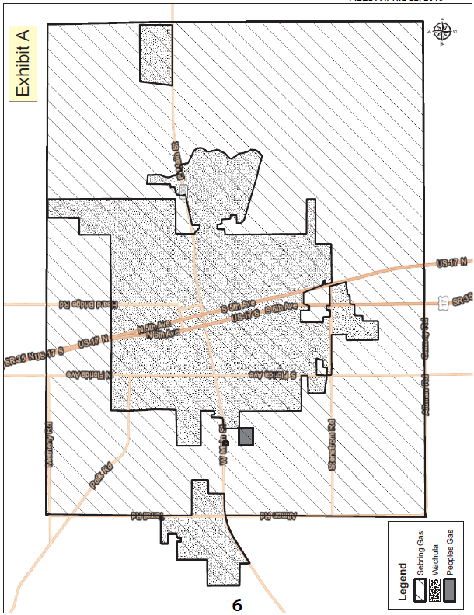

Peoples Gas System Tariff, Original Volume No. 3, Fourth Revised Sheet No 5.601, effective March 13, 2012; Second Revised Sheet No. 5.601-1, effective January 6, 2004; and Second Revised Sheet No. 5.601-2, effective January 29, 2008.
Utilities Commission of the City of New Smyrna Beach v. Florida Public Service Commission, 469 So. 2d 731 (Fla. 1985).

