State of Florida  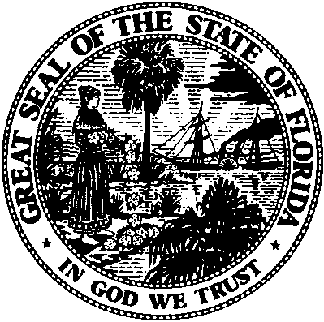 |  | Public Service Commission  Capital Circle Office Center ● 2540 Shumard Oak Boulevard  Tallahassee, Florida 32399-0850  -M-E-M-O-R-A-N-D-U-M-
DATE: | June 4, 2015
TO: | Office of Commission Clerk (Stauffer)
FROM: | Office of Industry Development and Market Analysis (Crawford)  Office of the General Counsel (Ames)
RE: | Docket No. 150099-EI – Petition for approval of revised net metering tariff and agreement adopting terms of standard interconnection agreement for Tier 1, Tier 2, or Tier 3 renewable generator systems, by Tampa Electric Company.
AGENDA: | 06/18/15 – Regular Agenda – Interested Persons May Participate
COMMISSIONERS ASSIGNED: |  |  | All Commissioners
PREHEARING OFFICER: |  |  | Administrative
CRITICAL DATES: |  |  | 60 day requirement waived until 6/19/2015
SPECIAL INSTRUCTIONS: |  |  | None

Case Background
On March 27, 2015, Tampa Electric Company (TECO) filed a petition for approval of revisions to the net metering tariff and agreement adopting terms of the standard interconnection agreement (SIA) for Tier 1, Tier 2, and Tier 3 renewable generator systems. In its petition, TECO seeks approval of a modification to its Net Metering Tariff (NM-1) and an associated new agreement that facilitates the adoption of the terms, conditions, and obligations of an existing SIA by tenants who lease premises with pre-existing customer owned renewable generator facilities installed by the property owner. Following the filing of the petition, staff held two informal meetings between staff, the utility, and interested persons to the docket. During the informal meeting held May 21, 2015 modifications to the proposed agreement were discussed including identifying specific provisions of the pre-existing SIA which the tenant would be responsible for and additional clarifying language related to consequences of property owners’ failure to abide by all of its commitments under the pre-existing SIA between the property owner and TECO. On May 27, 2015, TECO filed a supplement to its petition incorporating changes discussed during the May 21, 2015 meeting. On May 22, 2015 TECO by letter waived the sixty day file and suspend period with respect to this docket.

The Commission has jurisdiction over this matter pursuant to Sections 366.06 Florida Statutes (F.S.).

Discussion of Issues

Issue 1:
Should TECO’s petition for the approval of its revised net metering tariff and agreement adopting terms of the SIA for Tier 1, Tier 2, or Tier 3 renewable generator systems be suspended pending a final decision in this docket?

Recommendation:
Yes. The revised net metering tariff and agreement adopting terms of the SIA for Tier 1, Tier 2, or Tier 3 renewable generator systems should be suspended pending final decision in this docket. (Ames, B. Crawford)

Staff Analysis:

TECO filed its petition on March 27, 2015 seeking approval of its revised net metering tariff and agreement adopting terms of the SIA for Tier 1, Tier 2, or Tier 3 renewable generator systems

The suspension of the rate increase is authorized by Section 366.06(3), F.S., which provides:
Pending a final order by the commission in any rate proceeding under this section, the commission may withhold consent to the operation of all or any portion of the new rate schedules, delivering to the utility requesting such increase, within 60 days, a reason or written statement of good cause for withholding its consent.

Staff recommends that the Commission suspend TECO’s request for approval of its revised net metering tariff and agreement adopting terms of the SIA for Tier 1, Tier 2, or Tier 3 renewable generator systems. Suspending the tariff will allow staff adequate time to thoroughly review the petition and issue a fully informed recommendation for the Commission’s review. Staff believes that this reason constitutes good cause consistent with the requirement of Section 366.06(3), F.S.

Issue 2:
Should this docket be closed?

Recommendation:
No. The docket should remain open to allow staff adequate time to review the filing and bring a recommendation back to the Commission on the merits of the filing. (Ames)

Staff Analysis:
The docket should remain open pending the Commission’s final decision on the revised net metering tariff and agreement adopting terms of the SIA for Tier 1, Tier 2, or Tier 3 renewable generator systems.

Document No. 02087-15, April 14, 2015, Notice of Informal Meeting between Commission staff and interested persons to Docket No. 150099-EI, and Document No. 02849-15, May 14, 2015, Notice of Informal Meeting between Commission Staff and interested persons to docket No. 150099-EI.
Document No. 03328-15, June 3, letter waiving the sixty day file and suspend period until June 19, 2015, with respect to the revised net metering tariff and agreement proposed in Docket No. 150099-EI.

