State of Florida |  | Public Service Commission  Capital Circle Office Center ● 2540 Shumard Oak Boulevard  Tallahassee, Florida 32399-0850  -M-E-M-O-R-A-N-D-U-M-
DATE: | July 9, 2015
TO: | Office of Commission Clerk (Stauffer)
FROM: | Office of the General Counsel (Gervasi)  Office of Commission Clerk (Stauffer)  Division of Economics (Rome)
RE: | Docket No. 150143-OT – Proposed repeal of Rule 25-22.028, F.A.C., Filing, Number of Copies, and proposed amendment of Rule 25-40.001, F.A.C., Exceptions to the Uniform Rules of Procedure.
AGENDA: | 07/21/15 – Regular Agenda – Rule Proposal - Interested Persons May Participate
COMMISSIONERS ASSIGNED: |  |  | All Commissioners
PREHEARING OFFICER: |  |  | Brisé
RULE STATUS: |  |  | Proposal May Be Deferred
SPECIAL INSTRUCTIONS: |  |  | None

Case Background
Rule 25-22.028, Florida Administrative Code (F.A.C.), Filing, Number of Copies, sets forth how to file documents in the Commission Clerk’s Office and the required number of copies of pleadings that must be submitted. Rule 25-22.028(1) states that filings may be made by U.S. Mail, hand delivery, or courier service; requires that filings by companies with gross annual operating revenues of more than $750,000, Class A water and wastewater utilities, and parties to proceedings affecting those entities, must include a copy of the document on diskette, with certain exceptions for materials for which a request for confidential classification is pending and for attachments, such as exhibits attached to a petition; and requires that “[w]here a document is served upon a party . . . , its original and the appropriate copies, or, in the case of interrogatories or production of documents, a notice of service, shall be filed . . . no later than 5 days after service.” Rule 25-22.028(2) requires the original and seven copies of all pleadings to be submitted, but that initial pleadings for rate increases, except for rate increases by water and wastewater companies, are required to be filed with 20 copies.
In 1998, when the Uniform Rules of Procedure (Uniform Rules) were implemented by the Administration Commission, many of the Commission’s procedural rules contained in Chapter 25-22, F.A.C., were rendered unnecessary and repealed. However, the Administration Commission granted the Commission exceptions from the Uniform Rules in order to keep certain of its rules, including Rule 25-22.028, F.A.C. A list of all Commission rules that are exceptions to the Uniform Rules is contained in Rule 25-40.001, F.A.C., Exceptions to the Uniform Rules of Procedure.
This recommendation addresses whether the Commission should propose to repeal Rule 25-22.028, F.A.C., thus causing Uniform Rule 28-106.104, F.A.C., Filing, to take its place, and to amend Rule 25-40.001, F.A.C., to remove Rule 25-22.028 from the list of the Commission’s exceptions to the Uniform Rules. The Commission’s Notices of Development of Rulemaking were published in the Florida Administrative Register on April 15, 2015, in Volume 41, Number 73, and on June 9, 2015, in Volume 41, Number 111. No rule development workshop was requested, and thus a workshop was not held. The Commission has jurisdiction pursuant to sections 120.54, 120.569, 120.57, 350.01(7), and 350.127(2), Florida Statutes (F.S.).

Discussion of Issues

Issue 1:
Should the Commission propose to repeal Rule 25-22.028, F.A.C., Filing, Number of Copies, thus causing Uniform Rule 28-106.104, F.A.C., to take its place, and to amend Rule 25-40.001, F.A.C., Exceptions to the Uniform Rules of Procedure, to remove Rule 25-22.028 from the list of the Commission’s exceptions to the Uniform Rules?

Recommendation:
Yes, the Commission should propose to repeal Rule 25-22.028, F.A.C., thus causing Uniform Rule 28-106.104, F.A.C., to take its place, and to amend Rule 25-40.001, F.A.C., to remove Rule 25-22.028 from the list of the Commission’s exceptions to the Uniform Rules, as shown on Attachment A of this recommendation. (Gervasi, Stauffer, Rome)

Staff Analysis:
Pursuant to subsection 120.54(5)(a)1., F.S., the Uniform Rules are the rules of procedure for each agency subject to Chapter 120, F.S., including the Commission, unless the Administration Commission grants an exception to the agency under that subsection. In its Petition for Exceptions to the Uniform Rules filed in 1998, the Commission argued that Rule 25-22.028 contained additional filing requirements for the larger regulated entities and parties to provide computer diskette files, multiple copies of filings, and the filing of notices of service of interrogatories and the production of documents. The Administration Commission granted the exception to Uniform Rule 28-106.104, F.A.C., pursuant to subsection 120.54(5)(a)2., F.S., thus allowing the Commission to keep Rule 25-22.028 in place, upon determining that the exception was required for the most efficient operation of the agency.
At the time of implementation of the Uniform Rules, the Commission had not yet begun accepting electronic filings. With the advent of electronic filing, the reasons for keeping Rule 25-22.028, F.A.C., have become obsolete. It is no longer necessary for the Commission to require companies with gross annual operating revenues of more than $750,000, Class A water and wastewater utilities, and parties to proceedings affecting those entities, to include a copy of their filings on diskette, or on any other form of electronic media, such as a CD, DVD, or flash drive.
Moreover, electronically filed documents are published on the Commission’s local area network and on its website. Therefore, it is unnecessary for the Commission to continue to require parties and interested persons to furnish additional copies of electronically filed documents, except for rate case minimum filing requirements (MFRs). MFRs are typically voluminous and contain numerous schedules of calculations, the quality of which tends to degrade and become difficult to read when scanned into an electronic format. Nevertheless, there is no need to require by rule that electronically filed MFRs must be accompanied by paper copies because Rule 28-101.001(2)(3), F.A.C., requires the acceptable nature and scope of electronic filings to be set forth in an agency’s Statement of Agency Organization and Operation. Therefore, in addition to giving instructions on how to electronically file documents with the Commission, the “Filing Documents Electronically” section of the Commission’s Statement of Agency Organization and Operation states that:
[t]here is no requirement to file additional copies when documents are e-filed, except for rate case minimum filing requirements filed pursuant to Rules 25-6.043, 25-6.0435, 25-7.039, 25-7.040, 25-30.436, or 25-30.437, F.A.C., which electronic filings must be accompanied by the appropriate number of copies as provided by the rule or order under which the filing is made.
It is also unnecessary for the Commission to keep Rule 25-22.028 to require the filing of a notice of service when interrogatories or production of documents are served upon a party. The Uniform Rules require the filing of a notice of service of interrogatories. Rule 28-106.206, F.A.C., states that “parties may obtain discovery through the means and in the manner provided in Rules 1.280 through 1.400, Florida Rules of Civil Procedure,” and Rule 1.340(e), Florida Rules of Civil Procedure, requires the filing of a notice of service of interrogatories, giving the date of service and the name of the party to whom they were directed. And the requirement to file a notice of service of production of documents will be appropriately included in the standard language contained in Commission Orders Establishing Procedure.
Rule 25-40.001, F.A.C., clearly delineates the provisions of the Commission’s rules that provide exceptions to the Uniform Rules, as required by Section 120.54(5)(a)3., F.S. If the Commission proposes to repeal Rule 25-22.028, F.A.C., thus causing Uniform Rule 28-106.104, F.A.C., to take its place, the Commission should also propose to amend Rule 25-40.001, to remove Rule 25-22.028 from the list of the Commission’s exceptions to the Uniform Rules.
Statement of Estimated Regulatory Costs
The Florida Administrative Procedure Act encourages an agency to prepare a Statement of Estimated Regulatory Costs (SERC). Section 120.54(3)(b), F.S. An agency must prepare a SERC if the proposed rule is likely to directly or indirectly increase regulatory costs in excess of $200,000 in the aggregate within one year after implementation of the rule, and shall consider the impact of the rule on small businesses, small counties, and small cities. Id.
Section 120.541(2)(a), F.S., requires a SERC to include an economic analysis showing whether the rule, directly or indirectly, is likely to: 1) have an adverse impact on economic growth, private sector job creation, employment, or investment; 2) have an adverse impact on business competitiveness; or 3) increase regulatory costs in excess of $1 million in the aggregate within five years after the implementation of the rule. Section 120.541(3), F.S., requires that if the adverse impact or regulatory costs of the rule exceed any of those criteria, the rule shall be submitted to the President of the Senate and Speaker of the House, and may not take effect until it is ratified by the Legislature.
The SERC prepared by staff is included as Attachment B to this recommendation. It indicates that economic growth, private-sector job creation or employment, investment, and business competitiveness are not expected to be adversely impacted during the five-year period following implementation of the rules, and that the utilities affected may benefit from the recommended rule changes. Based on the SERC, the recommended repeal of Rule 25-22.028 and amendment of Rule 25-40.001 will not require legislative ratification.
Attachment B also contains the estimated number of individuals and entities likely to be required to comply with the rules, the estimated cost of implementing and enforcing the rules, the estimated transactional costs likely to be incurred by individuals and entities required to comply with the rules, and an analysis of the impact on small businesses, small counties, and small cities. Section 120.541(2)(b)-(e), F.S., requires that a SERC include these considerations.
For the foregoing reasons, staff recommends that the Commission propose the repeal of Rule 25-22.028, F.A.C., thus causing Uniform Rule 28-106.104, F.A.C., to take its place, and to amend Rule 25-40.001, F.A.C., to remove Rule 25-22.028 from the list of the Commission’s exceptions to the Uniform Rules, as shown on Attachment A of this recommendation.

Issue 2:
Should this docket be closed?

Recommendation:
Yes, if no requests for hearing or comments are filed, the rules as proposed should be filed for adoption with the Secretary of State and the docket should be closed. (Gervasi)

Staff Analysis:
Unless comments or requests for hearing are filed, the rules as proposed may be filed with the Secretary of State without further Commission action. The docket may then be closed.

25-22.028 Filing, Number of Copies.
(1) Filing. Filing shall be accomplished by submitting the original document and the appropriate number of copies, as provided by rule, to the Office of Commission Clerk. Filing may be made by U.S. Mail, hand delivery, or courier service. Filings on behalf of companies with gross annual operating revenues derived from intrastate business in excess of $750,000, Class A water and sewer utilities, and parties to proceedings affecting these entities, shall also include a copy of the document on diskette in word processing or spreadsheet format, whichever is appropriate, when filing documents capable of being generated by word processing or spreadsheet software. Material for which a request for confidential classification is pending under Rule 25-22.006, F.A.C., should not be included in a diskette copy. The diskette filing need not recreate document attachments not originally generated for the purpose of filing with the Commission, such as exhibits attached to a petition. The copy of the document on diskette shall be filed within 1 working day of the date the original printed document is filed. Information about the word processing and spreadsheet software preferred by the Commission may be obtained from the Director of the Division. Each diskette shall be accompanied by a statement specifying the density of the diskette, the operating system and the software used to prepare the document on diskette. For purposes of the requirement that copies of documents be filed on diskette, “document” means all prehearing statements regardless of length, and pleadings, post hearing statements of positions on issues or briefs, proposed findings of fact and conclusions of law in excess of 5 pages exclusive of the service list. In case of a discrepancy between an original printed document that is filed and the document on diskette, the filed original document shall prevail. If the filing is made with the presiding officer during the course of a hearing, as provided by subsection 28-106.104(1), F.A.C., the responsible party shall ensure that a copy of the document is submitted on diskette to the Division within 5 working days. Where a document is served upon a party pursuant to these rules, its original and the appropriate copies, or, in the case of interrogatories or production of documents, a notice of service, shall be filed with the Office of Commission Clerk no later than 5 days after service.
(2) Number of Copies. The original and seven copies of all pleadings shall be submitted to the Office of Commission Clerk. However, initial pleadings for increases in rates, except rate increases by water and wastewater utilities, shall be filed with 20 copies. The requirement for filing 20 copies shall apply to all exhibits appended to the original petition, prepared testimony and exhibits, briefs and other supplemental data requested by the Commission.
Rulemaking Authority 350.01(7), 350.127(2) FS. Law Implemented 120.569, 120.57 FS. History–Formerly 25-2.58, Amended 12-21-81, Formerly 25-22.28, Amended 2-11-92, 5-3-99, Repealed ___________.

25-40.001 Exceptions to the Uniform Rules of Procedure.
The following provisions of the Commission’s rules are exceptions to the uniform rules of procedure:
UNIFORM RULE | COMMISSION RULE THAT IS AN EXCEPTION
CHAPTER 28-102, F.A.C.  AGENDA AND SCHEDULING OF MEETINGS  AND WORKSHOPS | Rule 25-22.0021, F.A.C.  Agenda Conference Participation.
CHAPTER 28-102, F.A.C. – AGENDA AND  SCHEDULING OF MEETINGS AND WORKSHOPS  AND CHAPTER 28-106 –DECISIONS DETERMINING SUBSTANTIAL INTERESTS | Rule 25-22.0022, F.A.C.  Oral Argument Rule.
Rule 28-102.001, F.A.C.  Notice of Public Meeting, Hearing, or Workshop. | Rule 25-22.001, F.A.C.  Notice of Meeting or Workshop.
Subsection 28-102.002(2), F.A.C.  Agenda of Meetings, Hearings, and Workshops. | Rule 25-22.002, F.A.C.  Agenda of Meetings.
CHAPTER 28-103, F.A.C.  RULEMAKING | Rule 25-22.017, F.A.C.  Rulemaking Proceeding – Adoption.
CHAPTER 28-106, F.A.C.  DECISIONS DETERMINING SUBSTANTIAL  INTERESTS | Rule 25-22.006, F.A.C.  Confidential Information.  Rule 25-22.029, F.A.C.  Point of Entry Into Proposed Agency Action Proceedings.  Rule 25-22.0376, F.A.C.  Reconsideration of Non-Final Orders.  Subsections 25-22.0406(7)-(8) , F.A.C.  Notice and Public Information on General Rate Increase  Requests by Electric, Gas and Telephone Companies.  Subsections 25-22.0407(8) and (10) , F.A.C.  Notice of and Public Information for General Rate  Increase Requests by Water and Wastewater Utilities.  Rule 25-22.060, F.A.C.  Motion for Reconsideration.
Rule 28-106.104, F.A.C.  Filing. | Rule 25-22.028, F.A.C.  Filing, Number of Copies.
Rule 28-106.205, F.A.C.  Intervention. | Rule 25-22.039, F.A.C.  Intervention.
Rule 28-106.208, F.A.C.  Notice of Hearing. | Rule 25-22.029, F.A.C.  Point of Entry into PAA Proceeding.  Rule 25-22.0405, F.A.C.  Notices of Hearings.
Rule 28-106.212, F.A.C.  Subpoenas. | Rule 25-22.045, F.A.C.  Subpoenas.
CHAPTER 28-107 LICENSING | Rule 25-22.075, F.A.C.  Transmission Line Permitting Proceedings.  Rule 25-22.080, F.A.C.  Electrical Power Plant Permitting Proceedings.
Rulemaking Authority 120.54(5)(a)3. FS. Law Implemented 120.54(5)(a)3. FS. History–New 4-28-99, Amended 3-28-07, ____________.

28-106.104 Filing.
(1) In construing these rules or any order of a presiding officer, filing shall mean received by the office of the agency clerk during normal business hours or by the presiding officer during the course of a hearing.
(2) All pleadings filed with the agency shall contain the following:
(a) The style of the proceeding involved;
(b) The docket, case or file number, if any;
(c) The name of the party on whose behalf the pleading is filed;
(d) The name, address, any e-mail address, and telephone number of the person filing the pleading;
(e) The signature of the person filing the pleading; and
(f) A certificate of service that copies have been furnished to all other parties as required by subsection (4) of this rule.
(3) Any document received by the office of the agency clerk before 5:00 p.m. shall be filed as of that day but any document received after 5:00 p.m. shall be filed as of 8:00 a.m. on the next regular business day.
(4) Whenever a party files a pleading or other document with the agency, that party shall serve copies of the pleading or other document upon all other parties to the proceeding. A certificate of service shall accompany each pleading or other document filed with the agency.
(5) All parties, if they are not represented, or their attorneys or qualified representatives shall promptly notify all other parties and the presiding officer of any changes to their contact information by filing a notice of the change.
(6) All papers filed shall be titled to indicate clearly the subject matter of the paper and the party requesting relief.
(7) All original pleadings shall be on white paper measuring 8 1/2 by 11 inches, with margins of no less than one inch. Originals shall be printed or typewritten.
(8) A document shall be filed by only one method (e-filing, facsimile, courier, hand-delivery, or U.S. mail) and shall not be filed multiple times. A duplicate filing will not be docketed and will be destroyed.
Rulemaking Authority 14.202, 120.54(5) FS. Law Implemented 120.54(5) FS. History–New 4-1-97, Amended 1-15-07, 2-5-13.

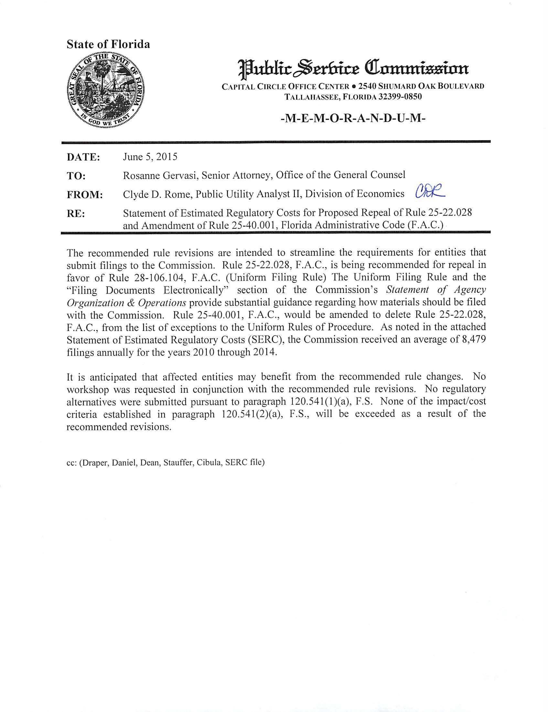

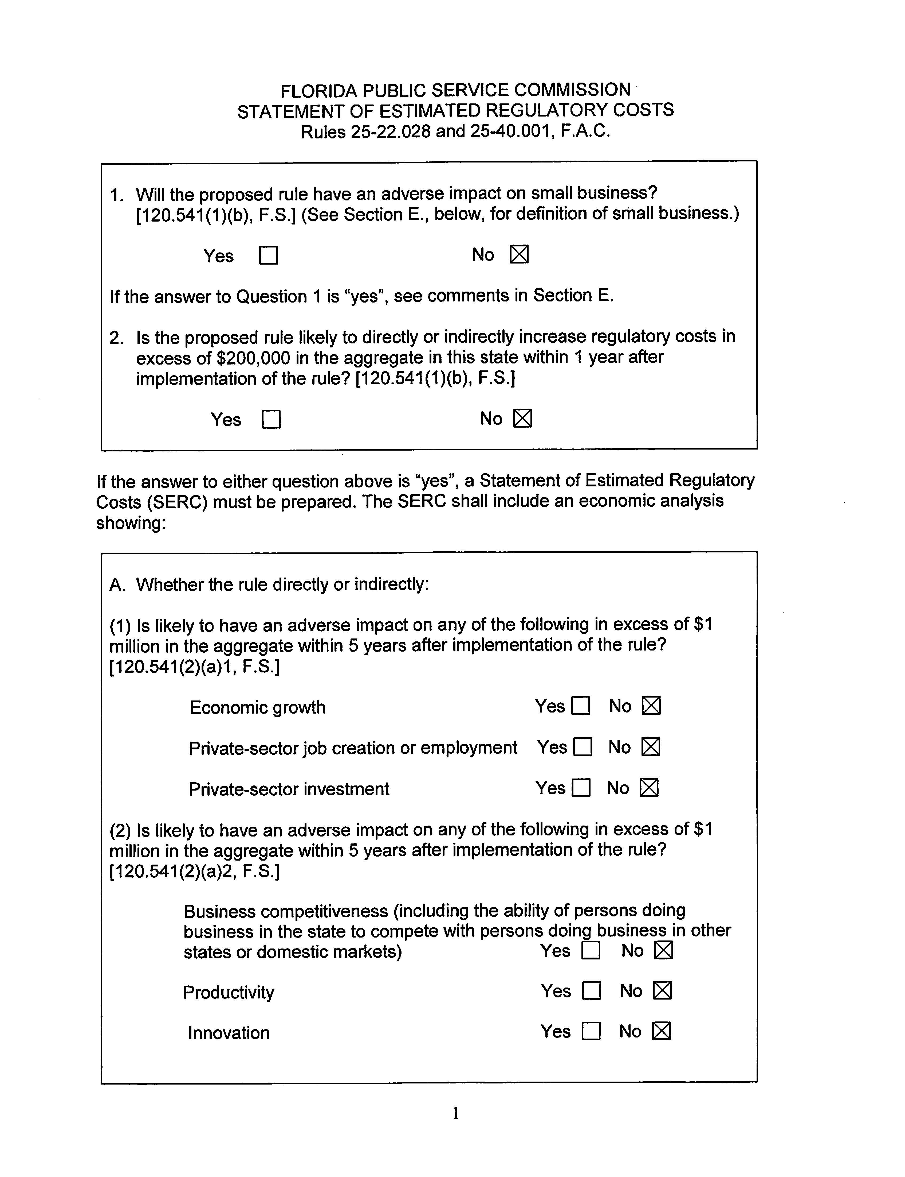

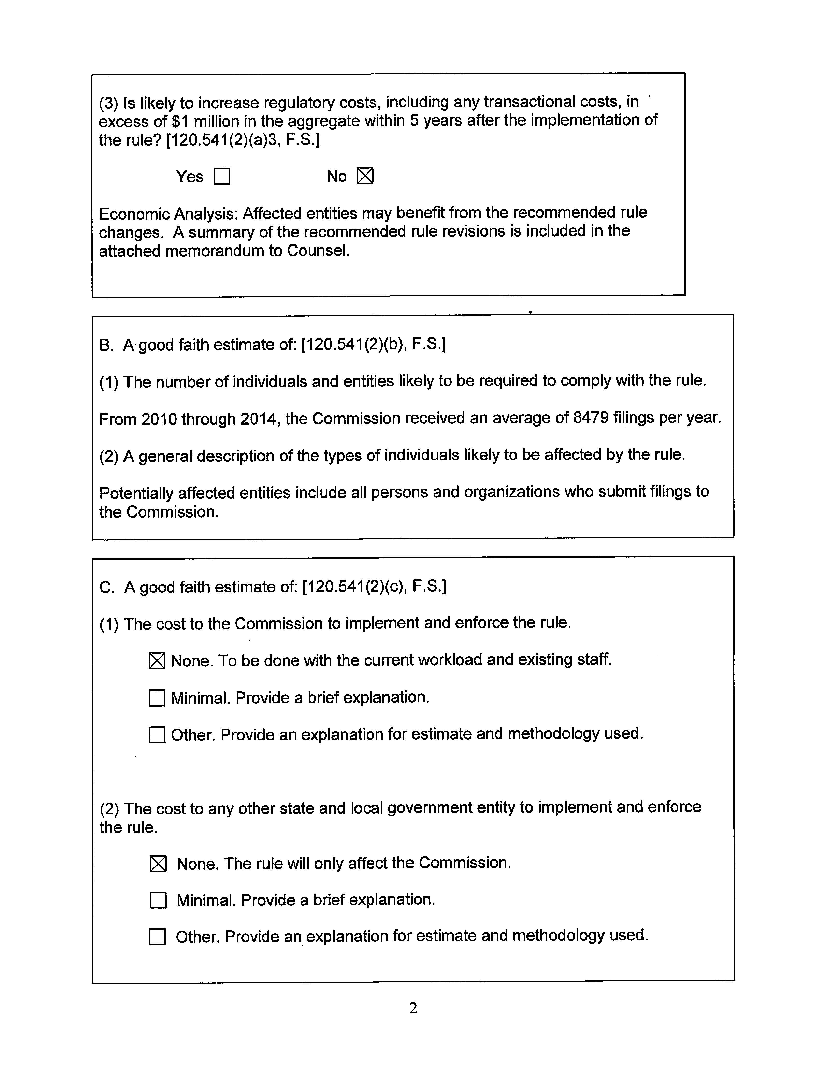

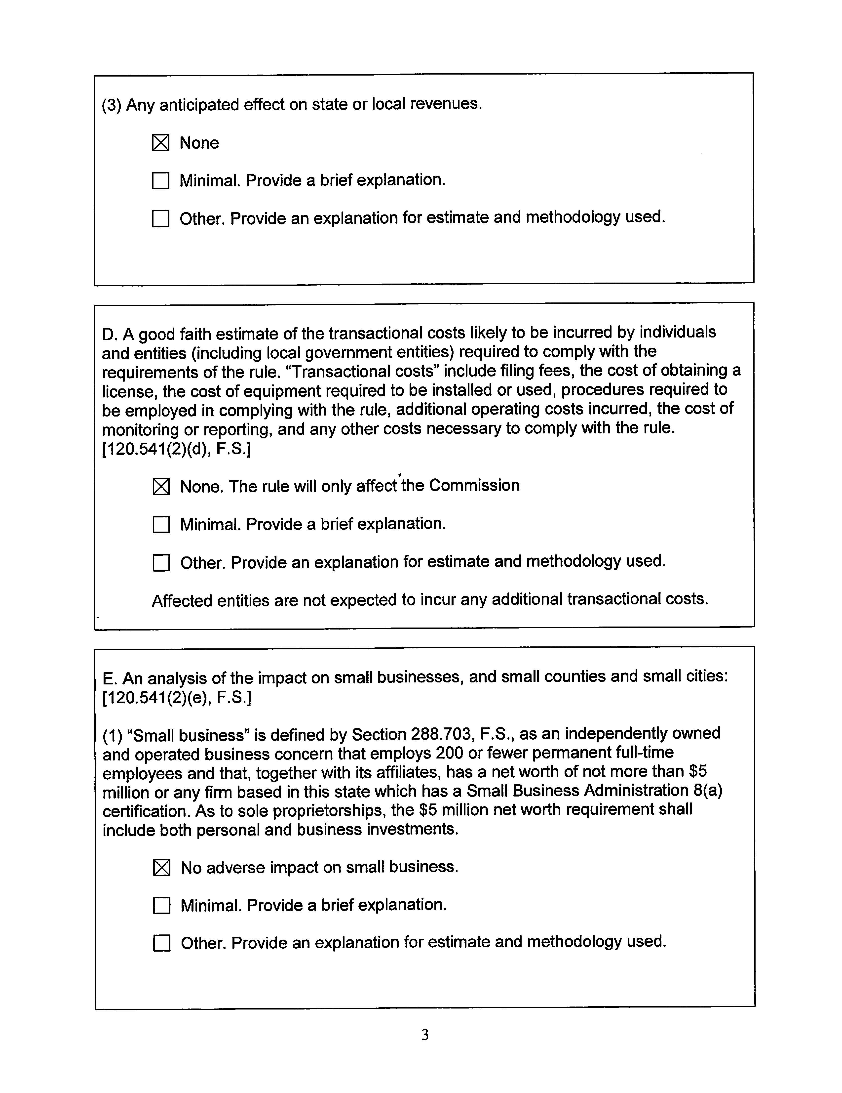

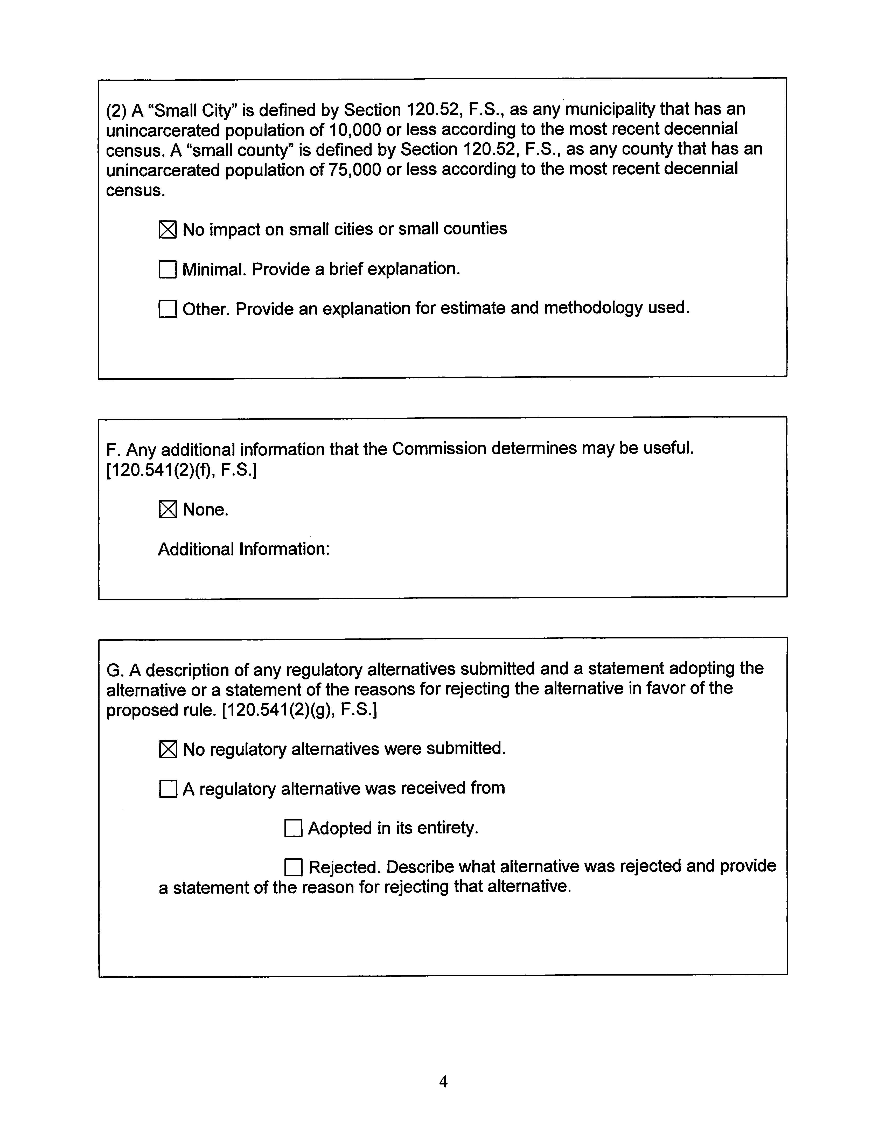

Pursuant to section 14.202, F.S., the Administration Commission was created as part of the Executive Office of the Governor, and is composed of the Governor and Cabinet.
Final Order of the Administration Commission disposing of the Commission’s Petition for Exceptions to the Uniform Rules, issued June 24, 1998, in AC Case No. APA-98-007, and filed in Docket No. 980500-PU, In Re: Proposed Repeal of [various Commission rules contained in Rules 25-21 and 25-22, F.A.C.].
Commission Petition for Exceptions to the Uniform Rules, filed April 15, 1998, in AC Case No. APA-98-007, and filed in Docket No. 980500-PU, In Re: Proposed Repeal of [various Commission rules contained in Rules 25-21 and 25-22, F.A.C.].
Final Order of the Administration Commission disposing of the Commission’s Petition for Exceptions to the Uniform Rules, issued June 24, 1998, in AC Case No. APA-98-007.

