State of Florida  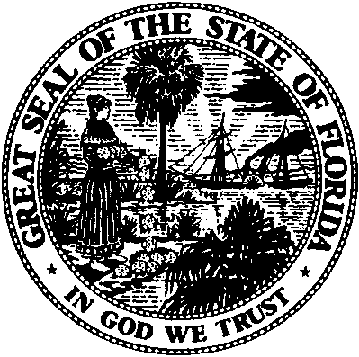 | Public Service Commission  Capital Circle Office Center ● 2540 Shumard Oak Boulevard  Tallahassee, Florida 32399-0850  -M-E-M-O-R-A-N-D-U-M-
DATE: | September 3, 2015
TO: | Office of Commission Clerk (Stauffer)
FROM: | Office of Telecommunications (C. Williams, C. Beard)  Office of the General Counsel (S. Hopkins)
RE: | Application for Certificate of Authority to Provide Telecommunications Service
AGENDA: | 9/15/2015 - Consent Agenda - Proposed Agency Action - Interested Persons May Participate
SPECIAL INSTRUCTIONS: |  | None

Please place the following Applications for Certificate of Authority to Provide Telecommunications Service on the consent agenda for approval.

DOCKET NO. | COMPANY NAME | CERT. NO.
150119-TX | Pro-Net, Inc. | 8878
150161-TX | Kuhl Group Inc. | 8875

The Commission is vested with jurisdiction in this matter pursuant to Section 364.335, Florida Statutes. The Certificates of Authority authorize Pro-Net, Inc. and Kuhl Group Inc. to provide Telecommunications Services in the State of Florida as a Telecommunications Company as defined by Section 364.02(13), Florida Statutes. Pursuant to Section 364.336, Florida Statutes, certificate holders must pay a minimum annual Regulatory Assessment Fee if the certificate is active during any portion of the calendar year. A Regulatory Assessment Fee Return Notice will be mailed each December to the entity listed above for payment by January 30.

