State of Florida |  | Public Service Commission  Capital Circle Office Center ● 2540 Shumard Oak Boulevard  Tallahassee, Florida 32399-0850  -M-E-M-O-R-A-N-D-U-M-
DATE: | November 18, 2015
TO: | Office of Commission Clerk (Stauffer)
FROM: | Division of Economics (Ollila)  Office of the General Counsel (Mapp)
RE: | Docket No. 150203-GU – Petition for approval of 2014 true-up, projected 2015 true-up and 2016 revenue requirements and surcharges associated with cast iron/bare steel pipe replacement rider, by Peoples Gas System.
AGENDA: | 12/03/15 – Regular Agenda – Tariff Filing – Interested Persons May Participate
COMMISSIONERS ASSIGNED: |  |  | All Commissioners
PREHEARING OFFICER: |  |  | Administrative
CRITICAL DATES: |  |  | 8-Month Effective Date: 5/17/16 (60-Day Suspension Date Waived by the Utility)
SPECIAL INSTRUCTIONS: |  |  | None

Case Background
On September 17, 2015, Peoples Gas System (Peoples or the Company) filed a petition for approval of its Cast Iron/Bare Steel Pipe Replacement Rider (Rider) program revenue requirements and surcharges for 2016, commencing with bills rendered for meter readings taken on and after January 1, 2016. The Rider was originally approved in Order No. PSC-12-0476-TRF-GU (2012 order) to recover the cost of accelerating the replacement of cast iron and bare steel distribution pipes through a surcharge on customers’ bills. Peoples’ current surcharges were approved in Order No. PSC-14-0682-TRF-GU.
The 2012 order approving the Rider addressed the reliability and safety rationale for pipeline replacement, the scope of the program, similar actions in other states, and the procedure for annually setting the surcharge to recover the costs of the program. The procedure requires an annual filing with three components:
- A final true-up showing the actual replacement costs and actual surcharge revenues for the most recent 12-month historical period from January 1 through December 31 that ends prior to the annual petition filing, including the final over- or under-recovery for the final true-up period.
- An actual/estimated true-up showing seven months of actual and five months of projected costs and revenues.
- A projection showing 12 months of projected Rider revenue requirement for the period beginning January 1 following the annual filing.
The Commission concluded the order by stating:
We find that replacement of these types of pipelines is in the public interest to improve the safety of Florida’s natural gas infrastructure, and reduce the possibility of loss of life and destruction of property should an incident occur. Given the length of time these pipelines have been installed and the leak history due to corrosion, it is appropriate to approve the proposed accelerated replacement program. Without the Rider, it is reasonable to expect that Peoples will have to file for more frequent base rate proceedings to recover the expenses of the program. The annual filings will provide us with the oversight to ensure that projected expenses are trued-up and only actual costs are recovered. The Rider and its associated surcharges will terminate when all replacements have been made and the revenue requirement has been rolled into rate base.
In its petition, Peoples waived the 60-day file and suspend provisions of Section 366.06(3), Florida Statutes (F.S.). On October 20, 2015, Peoples filed responses to Staff’s First Data Request. This recommendation addresses Peoples’ 2014 final true-up, actual/estimated 2015 true-up, and 2016 revenue requirement and surcharges associated with its cast iron/bare steel pipe replacement rider. The Commission has jurisdiction over this matter pursuant to Sections 366.03, 366.04, 366.05, and 366.06, F.S.

Discussion of Issues

Issue 1:
Should the Commission approve Peoples' proposed Rider surcharges for 2016?

Recommendation:
Yes. The Commission should approve Peoples’ proposed 2016 Rider surcharge for each rate class commencing with bills rendered for meter readings taken on and after January 1, 2016. (Ollila)

Staff Analysis:
The surcharges have been in effect since January 2013. Peoples’ program continues to identify and target for replacement pipelines in the Company’s more urban and high consequence areas. These areas are dictated by the Distribution Integrity Management Program, which uses a risk-based prioritization designed to determine the replacement order for cast iron and bare steel pipelines. Attachment 1 provides an update of mains and services replaced and the replacement forecast through the end of the term of the Rider in 2022. The Company appears to be on track to complete the replacements on time.
The 2012 order states that Peoples agreed to identify and report any operations and maintenance (O&M) and depreciation savings in its annual petition, beginning the second year. In this filing, Peoples reported depreciation expense savings for 2015 ($138,850) and 2016 ($60,000). Peoples stated that it has not been able to identify any O&M expense savings. Peoples indicated in its petition that it had a discussion with the Office of Public Counsel, and that once O&M savings can be identified and quantified, those savings will also be offset against expenses attributable to the cast iron and bare steel replacement program.

True-ups by year
Peoples’ calculations for the 2016 revenue requirement and surcharges include a final true-up for 2014, an actual/estimated true-up for 2015, and projected costs for 2016. Attachment 2 contains tables showing the calculation for each year.

Final True-up for 2014
Peoples stated that the revenues for 2014 were $2,176,695, compared to a revenue requirement of $2,156,056. The resulting over-recovery is $20,640 (rounded). After adding interest of $159 and the final 2013 over-recovery of $33,685, and subtracting the 2013 over-recovery amount ($18,281) that was already collected in the 2014 surcharges, the final 2014 true-up is an over-recovery of $36,203.

Actual/estimated 2015 True-up
Peoples provided actual revenues for January through July and forecast revenues for August through December, which total $3,898,538. The actual/estimated revenue requirement for 2015 is $3,600,290 and includes a return on investment, depreciation expense (less savings), and property tax expense. The forecast over-recovery for 2015 is $298,247 (rounded). After adding interest of $353 and the final 2014 over-recovery of $36,203, and subtracting the 2014 over-recovery amount ($61,277) that was already collected in the 2015 surcharges, the total 2015 true-up is an over-recovery of $273,526.

Projected 2016 Costs
Peoples projects capital expenditures of $11,500,000 for the replacement of cast iron/bare steel infrastructure in 2016. This compares with final 2014 expenditures of $11,736,210 and actual/estimated 2015 expenditures of $12,110,859. The return on investment, depreciation expense (less savings), and property tax expense to be recovered in 2016 total $5,330,536. After subtracting the total 2015 over-recovery of $273,526, the 2016 revenue requirement is $5,057,010.

Proposed surcharges
As established in the 2012 order, the total 2016 revenue requirement is allocated to rate classes using the same methodology that was used for the allocation of mains and services in the cost of service study used in Peoples’ most recent rate case. After calculating the percentage of total plant costs attributed to each rate class, the respective percentages were multiplied by the 2016 revenue requirement resulting in the revenue requirement by rate class. Dividing each rate class’ revenue requirement by projected therm sales provides the Rider surcharge for each rate class.
The proposed 2016 Rider surcharge for residential customers is $0.02137 per therm (compared to the current surcharge of $0.01876 per therm). The monthly bill impact is $0.43 beginning January 1, 2016 for a residential customer who uses 20 therms. The proposed tariff page is provided in Attachment 3.

Conclusion
Staff believes the calculation of the 2016 Rider revenue requirement and the proposed Rider surcharge for each rate class is reasonable and accurate. Therefore, staff recommends approval of Peoples’ proposed 2016 Rider surcharge for each rate class commencing with bills rendered for meter readings taken on and after January 1, 2016.

Issue 2:
Should this docket be closed?

Recommendation:
If Issue 1 is approved and a protest is filed within 21 days of the issuance of the order, the tariff should remain in effect, with any revenues held subject to refund, pending resolution of the protest. If no timely protest is filed, this docket should be closed upon the issuance of a consummating order. (Mapp)

Staff Analysis:
If Issue 1 is approved and a protest is filed within 21 days of the issuance of the order, the tariff should remain in effect, with any revenues held subject to refund, pending resolution of the protest. If no timely protest is filed, this docket should be closed upon the issuance of a consummating order.

Table 1-1
Peoples’ Pipe Replacement Program Progress
 | Main Replacements |  |  |  |  | Service Replacements
 | Replaced  Cast Iron  (miles) | Replaced  Bare Steel  (miles) | Remaining  Cast Iron at Year  End  (miles) | Remaining  Bare Steel  at Year End  (miles) | Total Miles  Remaining | Replaced  Number of  Steel  Services | Total Number of  Remaining  Steel  Services
Year
2012 |  |  | 100 | 354 | 454 |  | 14,978
2013 | 14 | 34 | 86 | 320 | 406 | 907 | 14,071
2014 | 4 | 42 | 82 | 278 | 360 | 950 | 13,121
*2015(projected) | 13 | 48 | 69 | 230 | 299 | 3,521 | 9,600
2016 | 13 | 35 | 56 | 195 | 251 | 1,300 | 8,300
2017 | 13 | 35 | 43 | 160 | 203 | 1,300 | 7,000
2018 | 13 | 35 | 30 | 125 | 155 | 1,300 | 5,700
2019 | 13 | 35 | 17 | 90 | 107 | 1,300 | 4,400
2020 | 13 | 35 | 4 | 55 | 59 | 1,300 | 3,100
2021 | 4 | 35 | 0 | 20 | 20 | 1,300 | 1,800
2022 | 0 | 20 | 0 | 0 | 0 | 1,800 | 0
Source: Peoples’ response to staff’s data request

Table 2-1
Final True-up for 2014
2014 Revenues | $2,176,695
2014 Revenue Requirement | $2,156,056
2014 Over-recovery (rounded) | $20,640
Interest | $159
2013 Final True-up (over-recovery) | $33,685
Less 2013 True-up Refunded | ($18,281)
2014 Final True-up (over-recovery) | $36,203
Source: Exhibit A of the petition

Table 2-2
Actual/Estimated True-up for 2015
2015 Revenues | $3,898,538
2015 Revenue Requirement | $3,600,290
2015 Over-recovery (rounded) | $298,247
Interest | $353
2014 Final True-up (over-recovery) | $36,203
Less 2014 True-up Refunded | ($61,277)
2015 Total True-up (over-recovery) | $273,526
Source: Exhibit B of the petition

Table 2-3
Projected 2016 Costs
2016 Projected Replacements | $11,500,000
Return on Investment | $3,612,427
Depreciation Expense (less savings) | $1,141,189
Property Tax Expense | $576,920
2016 Revenue Requirement | $5,330,536
Less 2015 Total True-up | ($273,526)
Total 2016 Revenue Requirement | $5,057,010
Source: Exhibit C of the petition

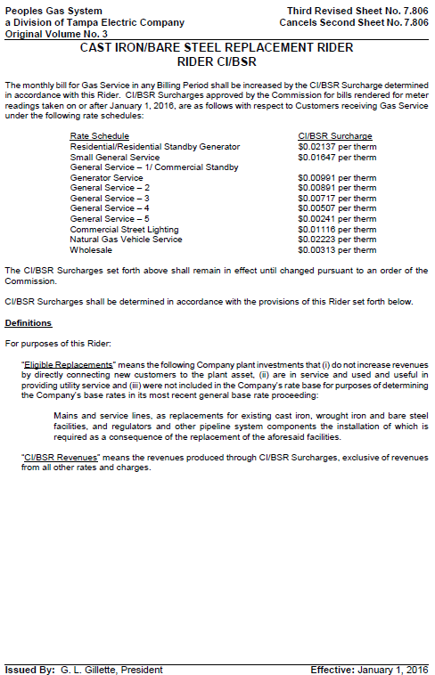

Order No. PSC-12-0476-TRF-GU, issued September 18, 2012, in Docket No. 110320-GU, In re: Petition for approval of Cast Iron/Bare Steel Pipe Replacement Rider (Rider CI/BSR), by Peoples Gas System.
Order No. PSC-14-0682-TRF-GU, issued December 9, 2014, in Docket No. 140183-GU, In re: Petition for approval of Cast Iron/Bare Steel Pipe Replacement Rider (Rider CI/BSR), by Peoples Gas System.
Order No. PSC-12-0476-TRF-GU, issued September 18, 2012, in Docket No. 110320-GU, In re: Petition for approval of Cast Iron/Bare Steel Pipe Replacement Rider (Rider CI/BSR), by Peoples Gas System). .

