State of Florida |  | Public Service Commission  Capital Circle Office Center ● 2540 Shumard Oak Boulevard  Tallahassee, Florida 32399-0850  -M-E-M-O-R-A-N-D-U-M-
DATE: | January 21, 2016
TO: | Office of Commission Clerk (Stauffer)
FROM: | Office of Telecommunications (Bates, Curry, Fogleman, Long)  Office of the General Counsel (Corbari)
RE: | Docket No. 000121B-TP – Investigation into the establishment of operations support systems permanent performance measures for incumbent local exchange telecommunications companies. (CENTURYLINK FLORIDA TRACK)
AGENDA: | 02/02/16 – Regular Agenda – Proposed Agency Action – Interested Persons May Participate
COMMISSIONERS ASSIGNED: |  |  | All Commissioners
PREHEARING OFFICER: |  |  | Brisé
CRITICAL DATES: |  |  | None
SPECIAL INSTRUCTIONS: |  |  | None

Case Background
By Order No. PSC-03-0067-PAA-TP, issued January 9, 2003, the Commission adopted wholesale permanent performance measures for Embarq Florida, Inc. d/b/a CenturyLink (CenturyLink) in Docket Number 000121B-TP. CenturyLink’s Performance Measurement Plan (PMP) is a monitoring device that measures the level of wholesale service performance that CenturyLink provides to competitive local exchange carriers (CLEC or CLECs).
CenturyLink’s Florida PMP included the adoption of the August 2002 CenturyLink Nevada PMP, as well as administrative provisions and an associated compliance methodology. Also, this Order required all changes to CenturyLink’s PMP that were approved in other states to be brought before the Commission for review, approval, and implementation in Florida. CenturyLink complied with the Order and implemented the Florida PMP on February 1, 2003.
By Order No. PSC-03-1438-PAA-TP, issued December 22, 2003, the Commission approved revisions to CenturyLink’s Florida PMP to coincide with revisions to CenturyLink’s Nevada PMP. The revisions were effective beginning with February 2004 data. Additional revisions to CenturyLink’s Florida PMP were approved by the Commission by Order No. PSC-07-0123-PAA-TP, issued February 12, 2007. The revisions were approved by the Public Utilities Commission of Nevada on August 2, 2006. The most recent revisions to CenturyLink’s Florida PMP were approved by the Commission, by Order No. PSC-13-0216-PAA-TP, issued May 22, 2013. Those revisions were approved by the Public Utilities Commission of Nevada on December 5, 2012.
The Commission has jurisdiction pursuant to Section 364.16, F.S.

Discussion of Issues
Issue 1: Should the Commission approve CenturyLink’s proposed revisions to its Florida wholesale Performance Measurement Plan as detailed in CenturyLink’s proposal filed October 15, 2015?

Recommendation: Yes. Staff recommends the Commission approve CenturyLink’s proposed revisions to its Florida wholesale Performance Measurement Plan as detailed in CenturyLink’s proposal filed on October 15, 2015. (Bates)

Staff Analysis: On October 15, 2015, CenturyLink filed a notice with the Florida Public Service Commission that the Nevada Public Utilities Commission (Nevada Commission or Nevada) issued an order approving revisions to its wholesale Performance Measurement Plan (PMP). The proposed revisions to CenturyLink’s PMP include: revising reporting requirements from monthly to quarterly, eliminating several performance measures from the PMP measures, and amending two measures. In addition, the revisions alter the reporting requirements to focus on the products CLECs are currently ordering most, as well as those products requiring repair activity.

The proposed revisions are the same as those provided in CenturyLink’s PMP to the Nevada Commission and are the result of a stipulation entered into by the parties to the Nevada docket. The Nevada docket was opened at CenturyLink’s request to amend its reporting requirements. The Nevada Commission found the stipulation to be in the public interest and approved the revisions on September 30, 2015.

By Order No. PSC-03-0067-PAA-TP, issued January 9, 2003, any changes to CenturyLink’s performance measurements approved by other states must be brought before the Florida Commission to allow staff and CLECs an opportunity to review and comment on such revisions before being implemented in Florida. On October 28, 2015, staff solicited comments from the CLECs and interested parties for review of CenturyLink’s Florida PMP revisions. No comments were filed by the comment due date, December 15, 2015.

CenturyLink’s proposed revisions fall into three areas: (1) general changes to the measures which include modifying the measurable standards and the report period; (2) eliminating low activity products from the service group types; and (3) establishing a new retail comparison for “UNE Loops–xDSL Provisioned.” Attachment A summarizes CenturyLink’s proposed revisions to its PMP.

CenturyLink proposes to revise specific sections of its PMP including the Executive Summary, Performance Measurements, Service Group Types, Auditing, as well as eliminating the PMP Compliance Methodology.

Measurable Standards Modifications
CenturyLink proposes to eliminate fifteen performance measures from the PMP. Measures were eliminated for the following reasons:

- Four measures are being eliminated as redundant (Measures 8, 12, 13 and 22)

- Four are being eliminated because they are addressed in interconnection agreements (Measures 31, 32, 33 and 34)

- Two are being eliminated because they are “unnecessary for continued regulatory focus and attention” (Measures 40 and 41)

- One is being eliminated because it is “not an indication of the level of service provided by CenturyLink” in completing an order (Measure 18)

- One is being eliminated because a subsequent measure is a better indication of installation timeliness (Measure 6)

- One is being eliminated because performance in that measure is “parity by design” (Measure 24)

- One is being eliminated because CLEC networks are “now essentially established” (Measure 26)

- One eliminates the measure related to the availability of the OSS interface (Measure 42)

In addition, CenturyLink is proposing to modify Measure 1 by eliminating the reporting of manual pre-order queries.

Modify Report Period
Commission Order No. PSC-03-0067-PAA-TP, issued January 9, 2003, requires CenturyLink (f/k/a Sprint) to file reports monthly within 15 days after the data collection month. In its order the Commission stated “that any disaggregation failing for three consecutive months, regardless of compliance ranges, should be reported to us on a monthly basis.” CenturyLink’s proposal revises its performance measures reporting requirements. The reporting period will remain monthly, but the reports will be provided to CLECs and the Commission quarterly within 30 days after the calendar quarter. In its revisions, CenturyLink modifies seventeen measures to implement changes to the reporting period.

Elimination of low activity Products from Service Group Types
CenturyLink’s proposal revises the PMP reporting requirements to focus on the products that CLECs are currently ordering most, in addition to those products requiring repair activity. According to CenturyLink, its review of all products indicate six products make up the majority of the Ordering, Provisioning, and Repair activity reported each month. Ten of the twelve products that account for less than 10% of all activity will be eliminated.

Establish New Retail Comparison for ‘UNE Loops–xDSL Provisioned’
According to CenturyLink, the Company attempted to apply a retail comparison for UNE Loops–xDSL Provisioned, but believes because there is no retail equivalent, there is no exact comparison. Since the UNE Loops–xDSL Provisioned element is similar to UNE Loops Non-Designed, CenturyLink proposes a retail comparison between the two will best display the performance of this element. The result of this change is a comparison of Business POTS–Dispatched and for repair the comparison will be Residential and Business POTS.

Conclusion
Staff believes CenturyLink’s proposal is appropriate. Staff finds no inconsistencies between this filing and the competitive provisions of Chapter 364.16, Florida Statutes. No party has objected or filed any comments on this proposal. This proposal was vetted and negotiated in Nevada, which may have contributed to the lack of comments in the Florida filing.

Staff recommends the Commission approve CenturyLink’s proposed revisions to its Florida wholesale PMP as detailed in CenturyLink’s request.

Issue 2:
Should this docket be closed?

Recommendation:
No. If no person whose substantial interests are affected files a protest within 21 days of the issuance date of the Order, the Order will become final upon the issuance of a Consummating Order. Any protest of the Commission’s decision in this matter should identify with specificity the item or measure being protested, and any such protest should not prevent the remainder of the Order from becoming final and effective. Thereafter, this docket should remain open for the Commission to conduct periodic reviews of CenturyLink’s PMP and to complete any third-party audits as outlined in Order No. PSC-03-0067-PAA-TP. (Corbari)

Staff Analysis:
If no person whose substantial interests are affected files a protest within 21 days of the issuance date of the Order, the Order will become final upon the issuance of a Consummating Order. Any protest of the Commission’s decision in this matter should identify with specificity the item or measure being protested, and any such protest should not prevent the remainder of the Order from becoming final and effective. Thereafter, this docket should remain open for the Commission to conduct periodic reviews of CenturyLink’s PMP and to complete any third-party audits as outlined in Order No. PSC-03-0067-PAA-TP.

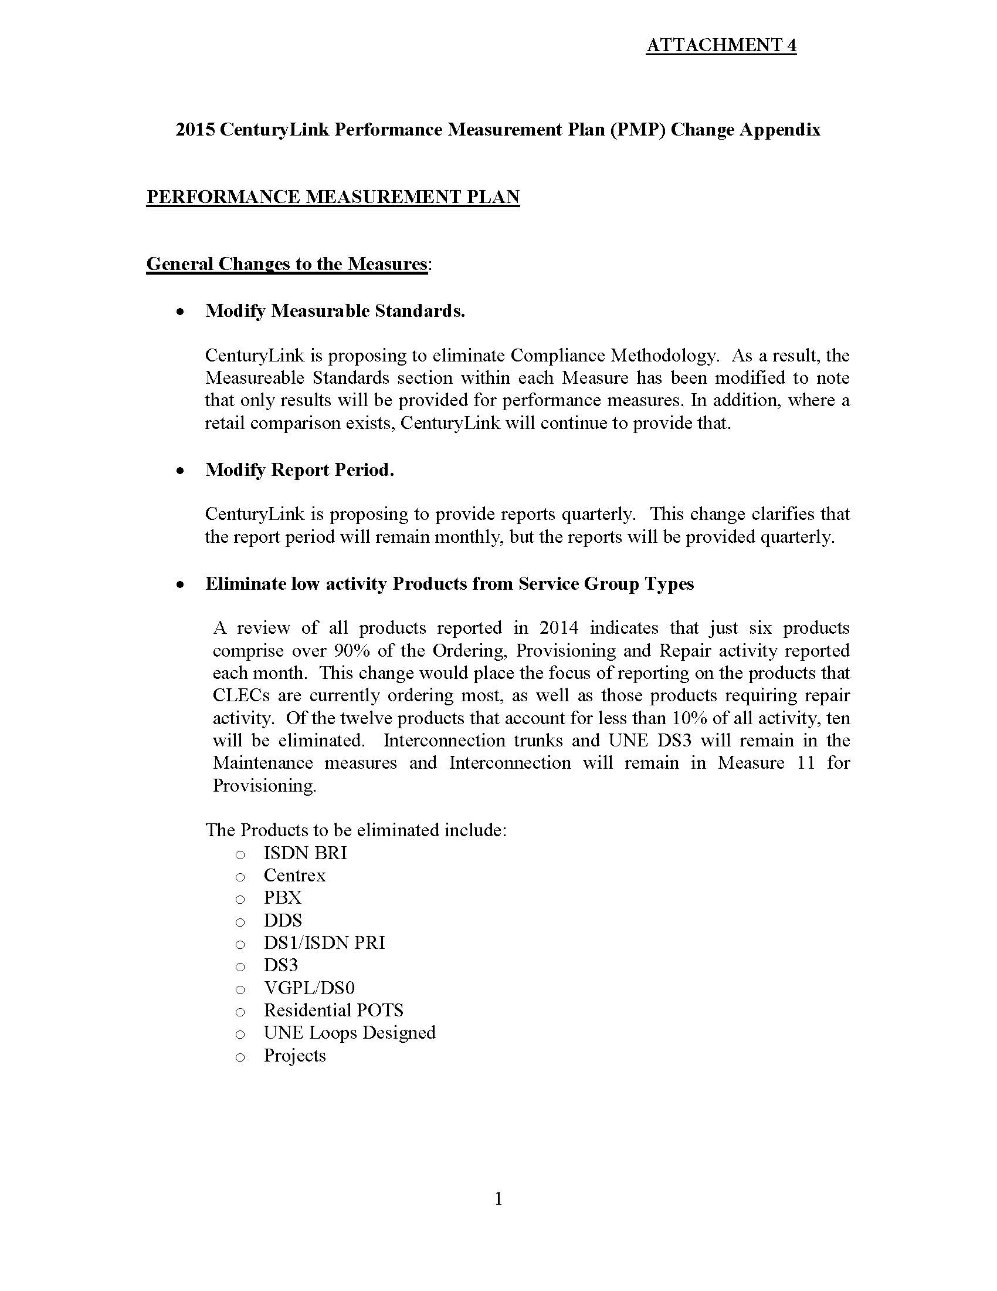
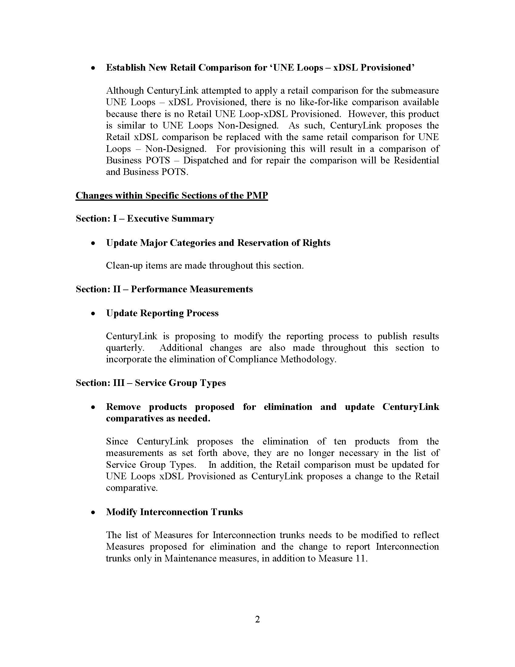

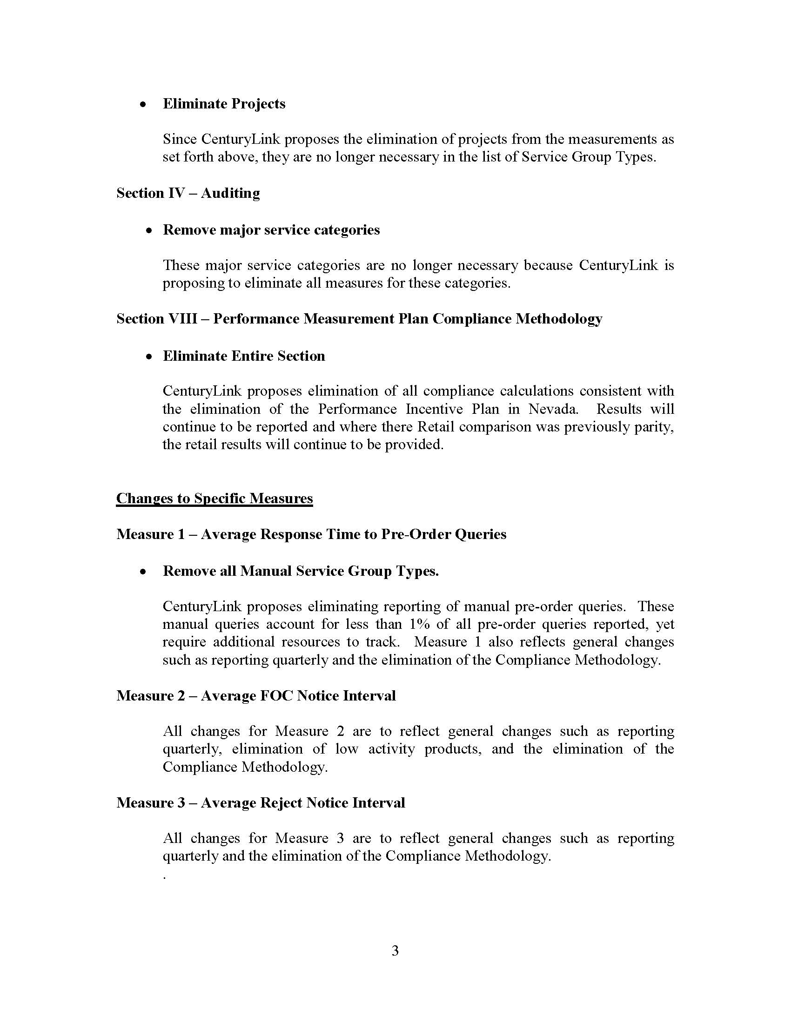

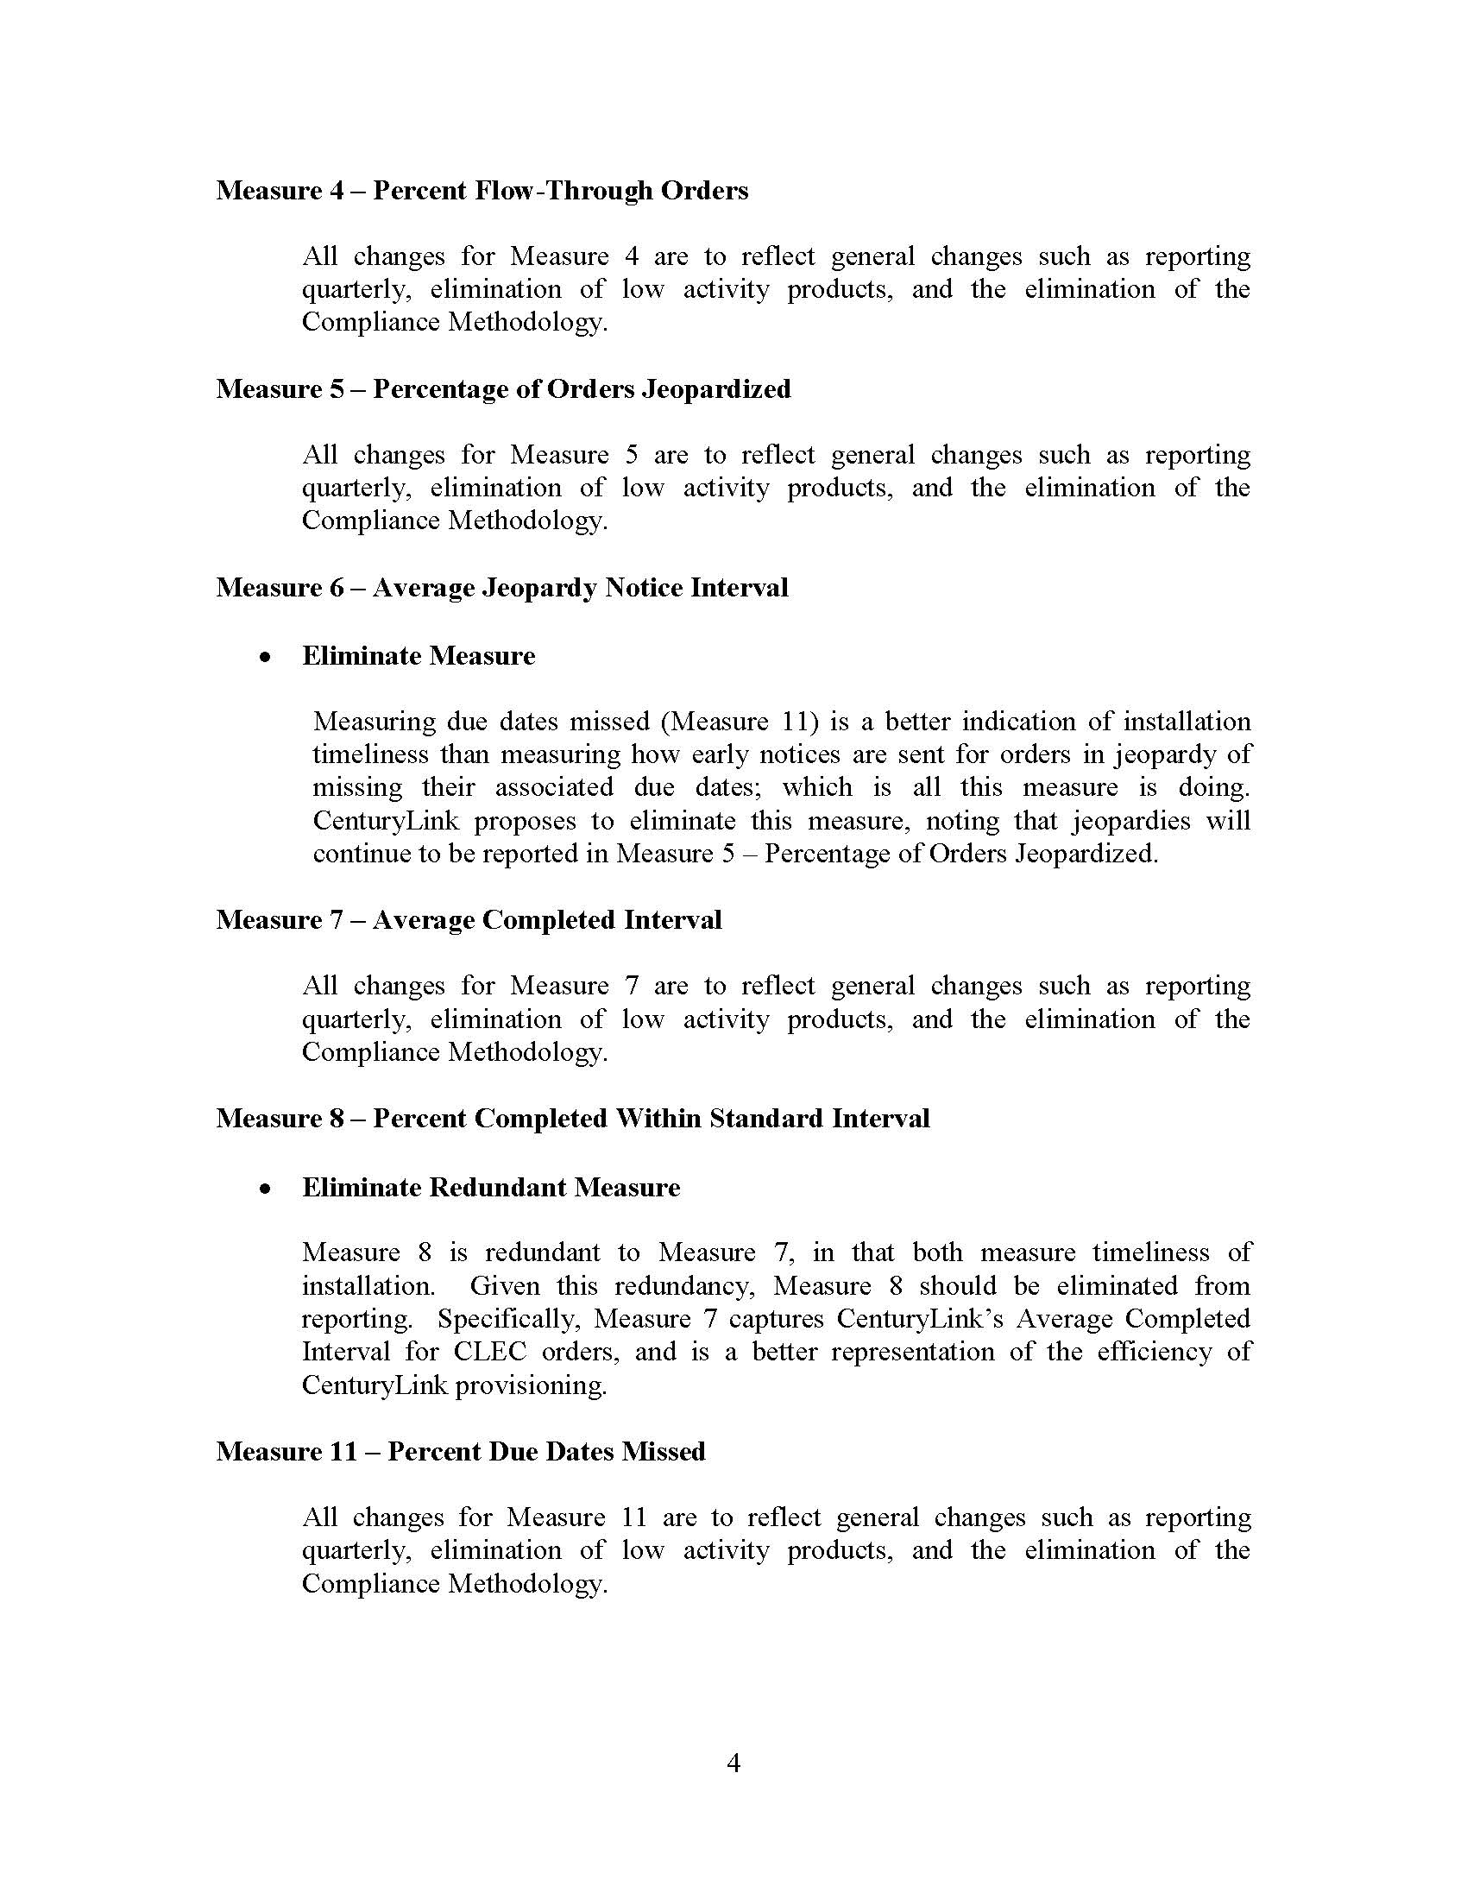

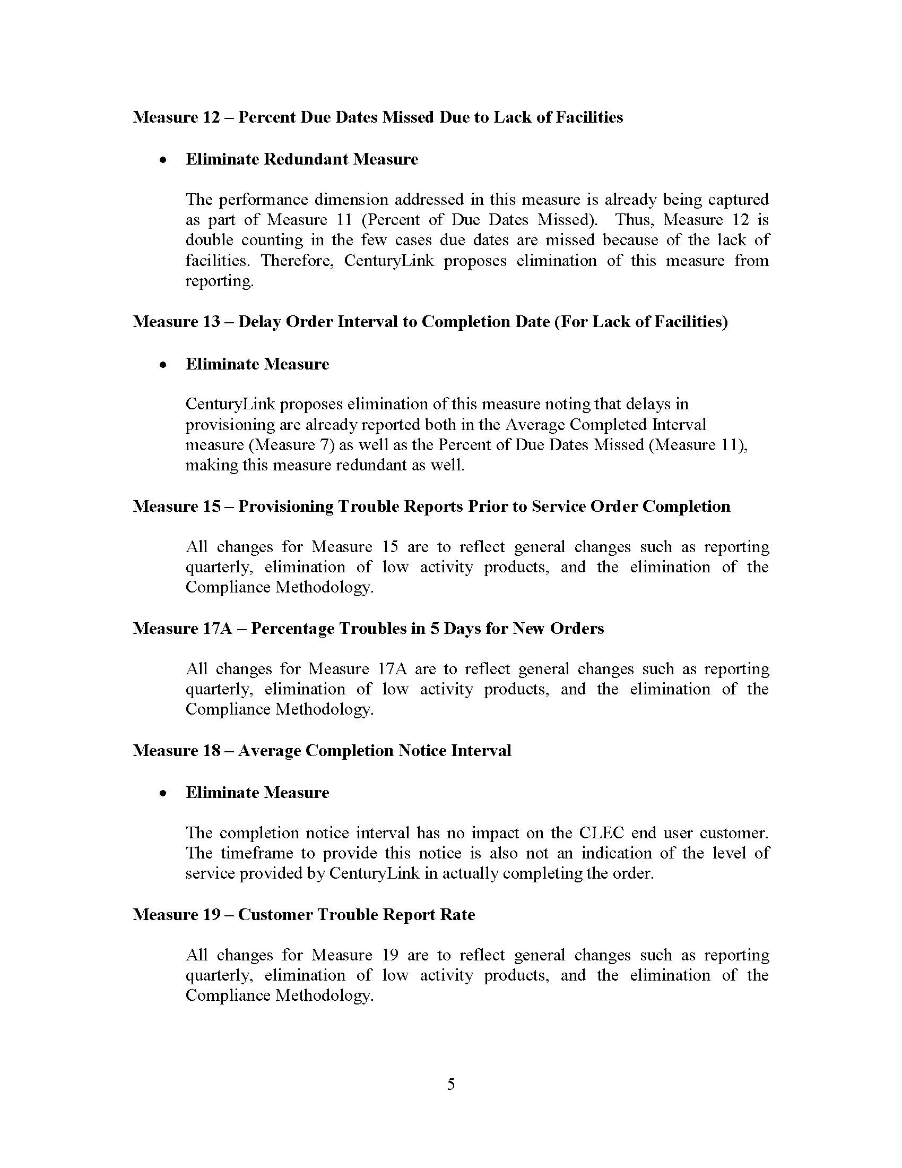

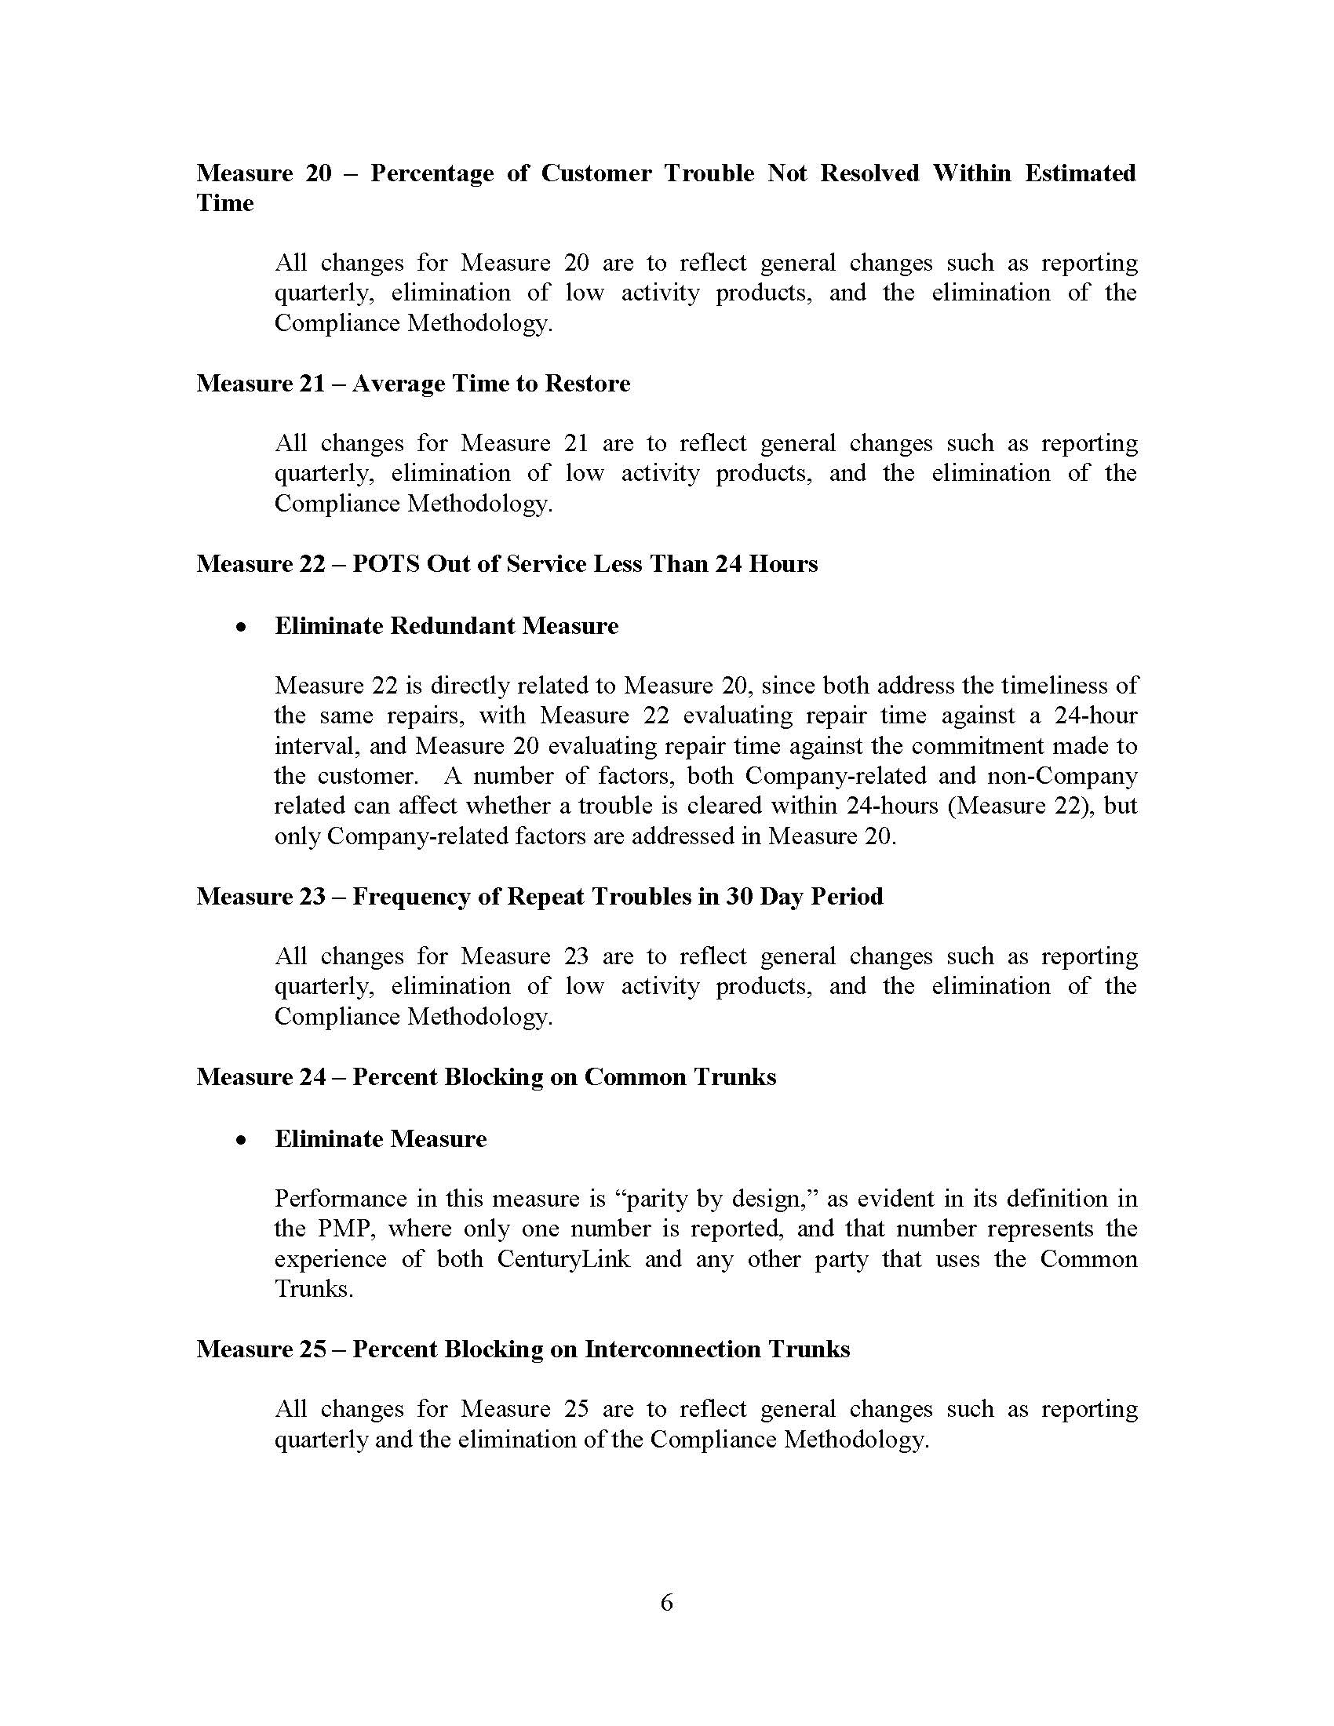

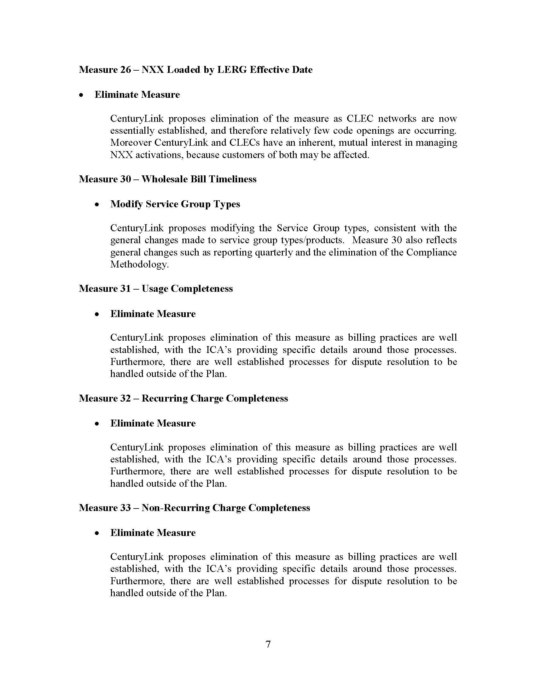

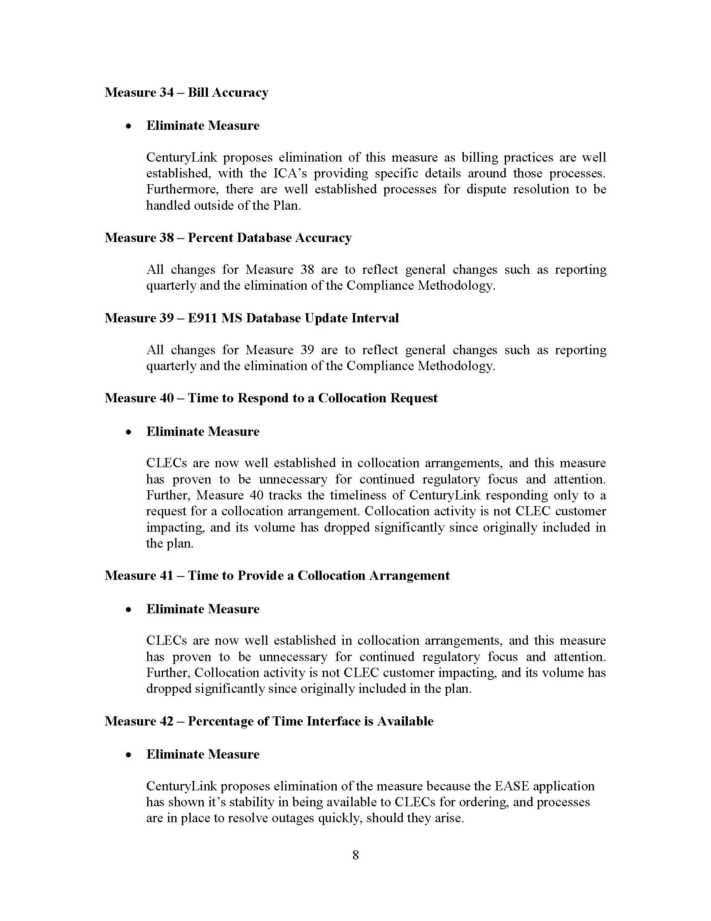

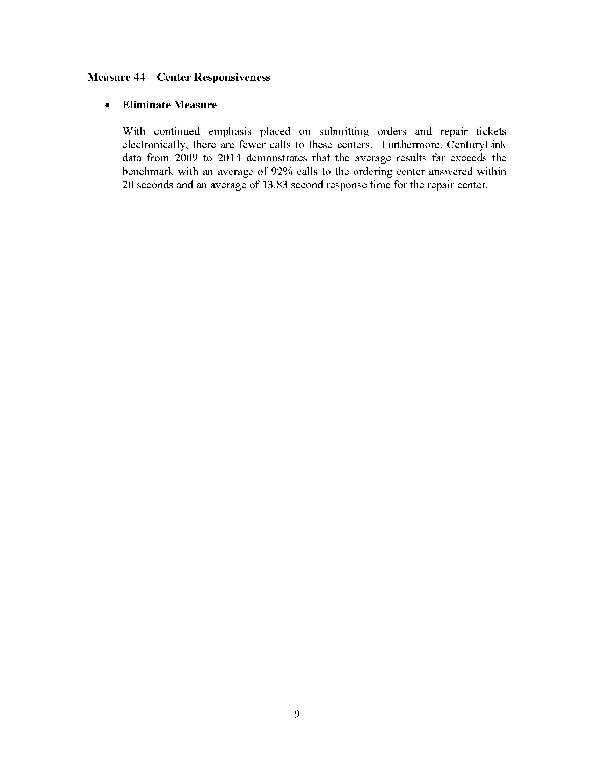

The Nevada Commission also eliminated financial penalties under the Performance Incentive Plan applicable only in Nevada.
The parties entering the stipulation in Nevada were: Central Telephone Company d/b/a CenturyLink (Nevada), Cox Nevada Telecom, LLC, U.S. Telepacific Corp. (Nevada), Mpower Communications Corp., tw telecom of Nevada LLC, Level 3 Communication of Nevada LLC d/b/a XO Communications, and Sprint Communications Company L.P., and the Public Utilities Commission of Nevada’s Regulatory Operations Staff.
Document No. 06617-15. This summary was submitted as Attachment 4 to CenturyLink’s October 15, 2015, filing with the Florida Public Service Commission.
Order No. PSC-03-0067-PAA-TP, issued January 9, 2003, Page 6.
The products to be eliminated include Integrated Services Digital Network Basic Rate Interface (ISDN BRI), Centrex, Private Branch Exchange (PBX), Digital Data Services (DDS), Digital Service 1/Integrated Services Digital Network Primary Rate Interface (DS1/ISDN PRI), Digital Signal 3 (DS3), Voice Grade Private Line/Digital Service 0 (VGPL/DS0), Residential Plain Old Telephone Service (POTS), Unbundled Network Element (UNE) Loops Designed, and Projects.

