BEFORE THE FLORIDA PUBLIC SERVICE COMMISSION

|  |  |
| --- | --- |
| In re: Investigation into the establishment of operations support systems permanent performance measures for incumbent local exchange telecommunications companies. (CENTURYLINK FLORIDA TRACK) | DOCKET NO. 000121B-TP  ORDER NO. PSC-16-0072-PAA-TP  ISSUED: February 15, 2016 |

The following Commissioners participated in the disposition of this matter:

JULIE I. BROWN, Chairman

LISA POLAK EDGAR

ART GRAHAM

RONALD A. BRISÉ

JIMMY PATRONIS

NOTICE OF PROPOSED AGENCY ACTION ORDER

APPROVING REVISIONS TO CENTURYLINK’S

PERFORMANCE MEASUREMENT PLAN

BY THE COMMISSION:

NOTICE is hereby given by the Florida Public Service Commission that the action discussed herein is preliminary in nature and will become final unless a person whose interests are substantially affected files a petition for a formal proceeding, pursuant to Rule 25-22.029, Florida Administrative Code.

BACKGROUND

By Order No. PSC-03-0067-PAA-TP, issued January 9, 2003, thisCommission adopted wholesale permanent performance measures for Embarq Florida, Inc. d/b/a CenturyLink (CenturyLink) in Docket Number 000121B-TP. CenturyLink’s Performance Measurement Plan (PMP) is a monitoring device that measures the level of wholesale service performance that CenturyLink provides to competitive local exchange carriers (CLEC or CLECs).

CenturyLink’s Florida PMP included the adoption of the August 2002 CenturyLink Nevada PMP, as well as administrative provisions and an associated compliance methodology. Order No. PSC-03-0067-PAA-TP also required that all changes to CenturyLink’s PMP approved in other states must be brought before this Commission for review, approval, and implementation in Florida. CenturyLink complied with our Order and implemented the Florida PMP on February 1, 2003.

By Order No. PSC-03-1438-PAA-TP, issued December 22, 2003, we approved revisions to CenturyLink’s Florida PMP to coincide with revisions to CenturyLink’s Nevada PMP. The revisions were effective beginning with February 2004 data. By Order No. PSC-07-0123-PAA-TP, issued February 12, 2007, we approved additional revisions to CenturyLink’s Florida PMP to include revisions approved by the Nevada Public Utilities Commission (Nevada Commission) on August 2, 2006. The most recent revisions to CenturyLink’s Florida PMP were approved by this Commission by Order No. PSC-13-0216-PAA-TP, issued May 22, 2013, to include revisions approved by the Nevada Commission on December 5, 2012.

We have jurisdiction pursuant to Section 364.16, Florida Statutes.

ANALYSIS

By Order No. PSC-03-0067-PAA-TP, issued January 9, 2003, any changes to CenturyLink’s performance measurements approved by other states must be brought before this Commission so that we and CLECs have an opportunity to review and comment on such revisions before the revisions are implemented in Florida. On October 15, 2015, CenturyLink filed a notice with this Commission that the Nevada Commission issued an order approving revisions to its wholesale PMP. On October 28, 2015, our staff solicited comments from the CLECs and interested parties for review of CenturyLink’s Florida PMP proposed revisions. No comments were received.

The revisions proposed by CenturyLink to its Florida PMP include, revising reporting requirements from monthly to quarterly, eliminating several performance measures from the PMP measures, and amending two measures. In addition, the proposed revisions alter the reporting requirements to focus on the products CLECs are currently ordering most, as well as those products requiring repair activity.[1] The proposed revisions to CenturyLink’s Florida PMP are the same as those provided in CenturyLink’s PMP to the Nevada Commission and are the result of a stipulation entered into by the parties to the Nevada docket.[2] The Nevada docket was opened at CenturyLink’s request to amend its reporting requirements. The Nevada Commission found the stipulation to be in the public interest and approved the revisions on September 30, 2015.

CenturyLink’s Proposed PMP Revisions

CenturyLink proposes to revise specific sections of its PMP including the Executive Summary, Performance Measurements, Service Group Types, Auditing, as well as eliminating the PMP Compliance Methodology. CenturyLink’s proposed revisions fall into three general categories: modifying the measurable standards and the report period; eliminating low activity products from the service group types; and establishing a new retail comparison for “UNE Loops–xDSL Provisioned.” A summary of several of the significant revisions are detailed below. A complete summary of CenturyLink’s proposed revisions to its PMP are attached hereto as Attachment A.

*Measurable Standards Modifications*

CenturyLink proposes to eliminate sixteen performance measures from the PMP for the following reasons:

* Four measures are being eliminated as redundant (Measures 8, 12, 13 and 22);
* Four measures are being eliminated because they are addressed in interconnection agreements (Measures 31, 32, 33 and 34);
* Two measures are being eliminated because they are “unnecessary for continued regulatory focus and attention” (Measures 40 and 41);
* One measure is being eliminated because it is “not an indication of the level of service provided by CenturyLink” in completing an order (Measure 18);
* One measure is being eliminated because a subsequent measure is a better indication of installation timeliness (Measure 6);
* One measure is being eliminated because performance in that measure is “parity by design” (Measure 24);
* One measure is being eliminated because CLEC networks are “now essentially established” (Measure 26); and
* Two measures being eliminated relate to the availability of the OSS interface (Measures 42 and 44).

In addition, CenturyLink proposes to modify Measure 1 by eliminating the reporting of manual pre-order queries.

CenturyLink is also required by our Order No. PSC-03-0067-PAA-TP, issued January 9, 2003, to file reports monthly, within 15 days after the data collection month. Our Order states “that any disaggregation failing for three consecutive months, regardless of compliance ranges, should be reported to us on a monthly basis.”[3] CenturyLink’s proposal revises its performance measures reporting requirements. The reporting period will remain monthly, but the reports will be provided to this Commission and CLECs quarterly, within 30 days after the calendar quarter. In its revisions, CenturyLink modifies seventeen measures to implement changes to the reporting period.

*Elimination of low activity Products from Service Group Types*

CenturyLink’s proposal revises the PMP reporting requirements to focus on the products that CLECs are currently ordering most, in addition to those products requiring repair activity. According to CenturyLink, its review of all products indicates six products make up the majority of the Ordering, Provisioning, and Repair activity reported each month. Ten of the twelve products that account for less than 10% of all activity will be eliminated.[4]

*Establish New Retail Comparison for “UNE Loops–xDSL Provisioned”*

According to the Company, CenturyLink attempted to apply a retail comparison for UNE Loops–xDSL Provisioned, but asserts that because there is no retail equivalent, there is no exact comparison. Since the UNE Loops–xDSL Provisioned element is similar to UNE Loops Non-Designed, CenturyLink proposes a retail comparison between the two will best display the performance of this element. The result of this change is a comparison of Business POTS–Dispatched and for repair the comparison will be Residential and Business POTS.

DECISION

We hereby approve the revisions proposed by Embarq Florida, Inc. d/b/a CenturyLink to its wholesale Florida Performance Measurement Plan as summarized in Attachment A and detailed in CenturyLink’s redlined proposal filed on October 15, 2015. We find CenturyLink’s proposed revisions are appropriate and find no inconsistencies between CenturyLink’s filing and the competitive provisions of Chapter 364.16, F.S. No party has objected or filed any comments on CenturyLink’s proposal, which was negotiated, vetted and approved in Nevada.

Based on the foregoing, it is

ORDERED by the Florida Public Service Commission that Embarq Florida, Inc. d/b/a CenturyLink proposed revisions to CenturyLink’s Florida Performance Measurement Plan, as set forth in Attachment A, are hereby approved and incorporated into this Order. It is further

ORDERED that the implementation of the revisions to CenturyLink’s Florida Performance Measurement Plan shall become effective immediately upon this Order becoming final. It is further

ORDERED that the provisions of this Order, issued as proposed agency action, shall become final and effective upon the issuance of a Consummating Order unless an appropriate petition, in the form provided by Rule 28-106.201, Florida Administrative Code, is received by the Office of the Commission Clerk, 2540 Shumard Oak Boulevard, Tallahassee, Florida 32399-0850, by the close of business on the date set forth in the "Notice of Further Proceedings" attached hereto. Such petition shall identify, with specificity, the item or measure being protested, and any such protest shall not prevent the remainder of this Order from becoming final and effective. It is further

ORDERED that in the event this Order becomes final, this docket shall remain open to conduct periodic reviews of CenturyLink’s Performance Measurement Plan and to complete any third-party audits as outlined in Order No. PSC-03-0067-PAA-TP.

By ORDER of the Florida Public Service Commission this 15th day of February, 2016.

|  |  |
| --- | --- |
|  | /s/ Carlotta S. Stauffer |
|  | CARLOTTA S. STAUFFER  Commission Clerk |

Florida Public Service Commission

2540 Shumard Oak Boulevard

Tallahassee, Florida 32399

(850) 413‑6770

www.floridapsc.com

Copies furnished: A copy of this document is provided to the parties of record at the time of issuance and, if applicable, interested persons.

KFC

NOTICE OF FURTHER PROCEEDINGS OR JUDICIAL REVIEW

The Florida Public Service Commission is required by Section 120.569(1), Florida Statutes, to notify parties of any administrative hearing that is available under Section 120.57, Florida Statutes, as well as the procedures and time limits that apply. This notice should not be construed to mean all requests for an administrative hearing will be granted or result in the relief sought.

Mediation may be available on a case-by-case basis. If mediation is conducted, it does not affect a substantially interested person's right to a hearing.

The action proposed herein is preliminary in nature. Any person whose substantial interests are affected by the action proposed by this order may file a petition for a formal proceeding, in the form provided by Rule 28-106.201, Florida Administrative Code. This petition must be received by the Office of Commission Clerk, 2540 Shumard Oak Boulevard, Tallahassee, Florida 32399-0850, by the close of business on March 7, 2016.

In the absence of such a petition, this order shall become final and effective upon the issuance of a Consummating Order.

Any objection or protest filed in this/these docket(s) before the issuance date of this order is considered abandoned unless it satisfies the foregoing conditions and is renewed within the specified protest period.



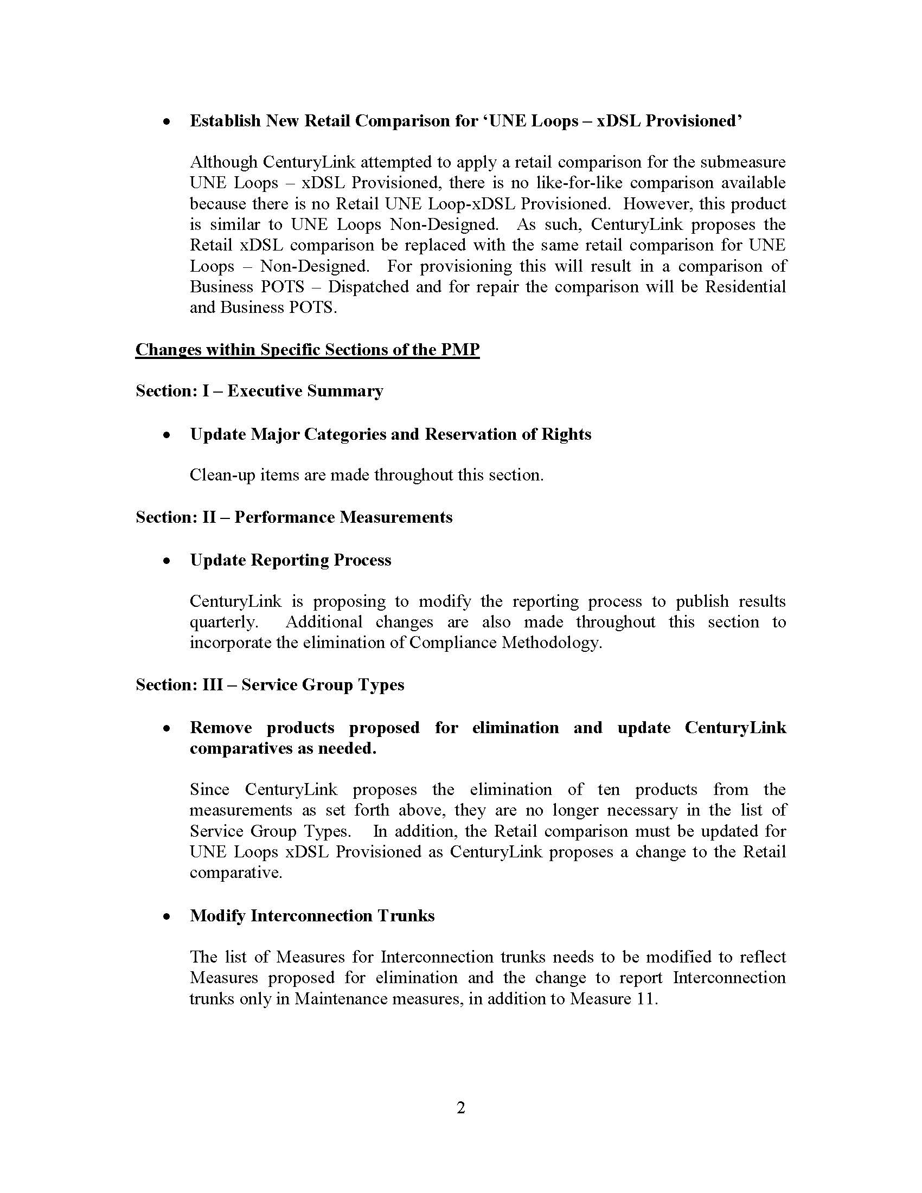

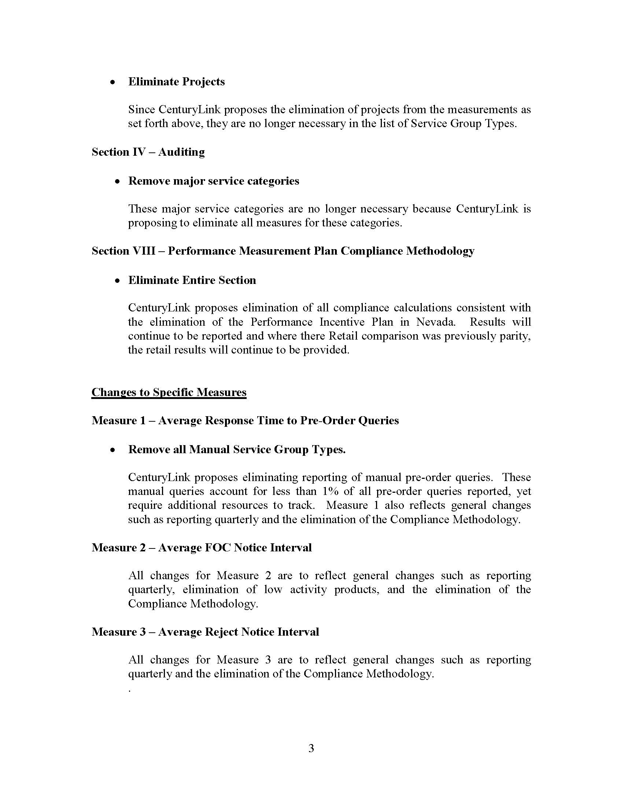

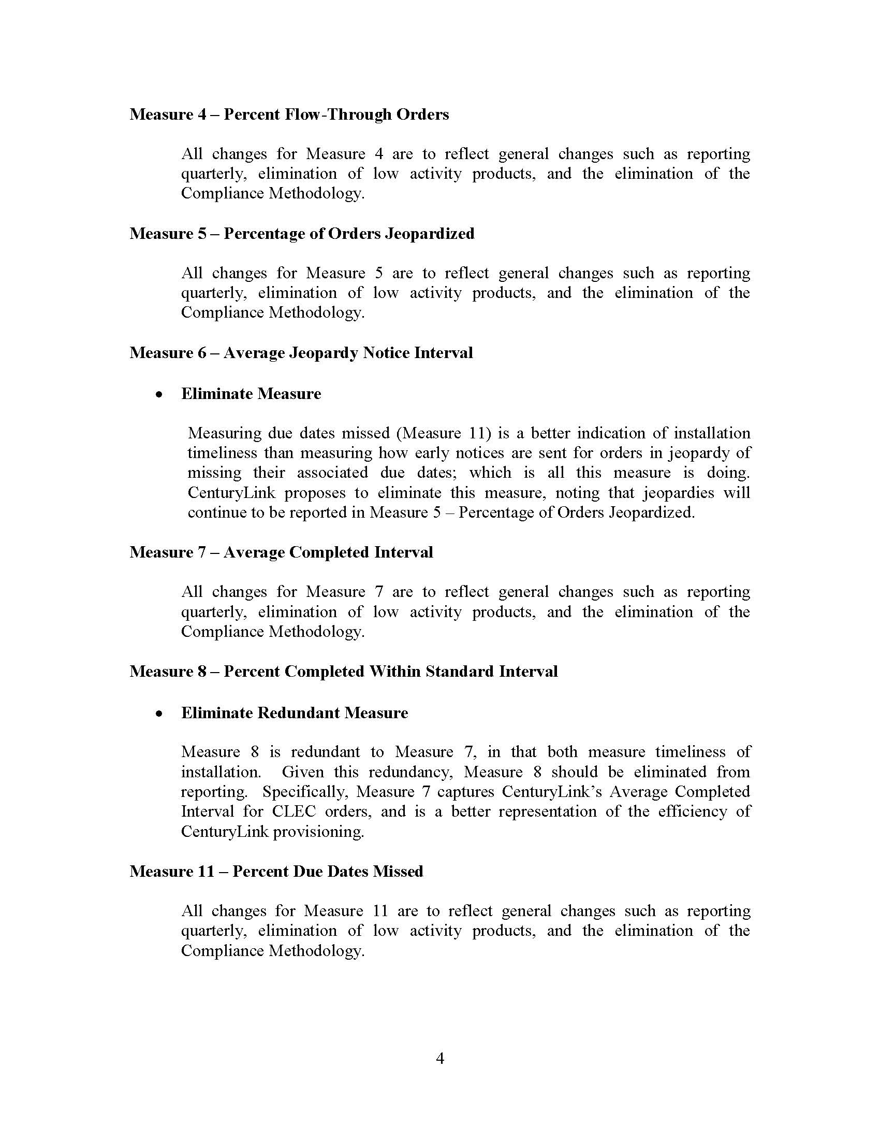

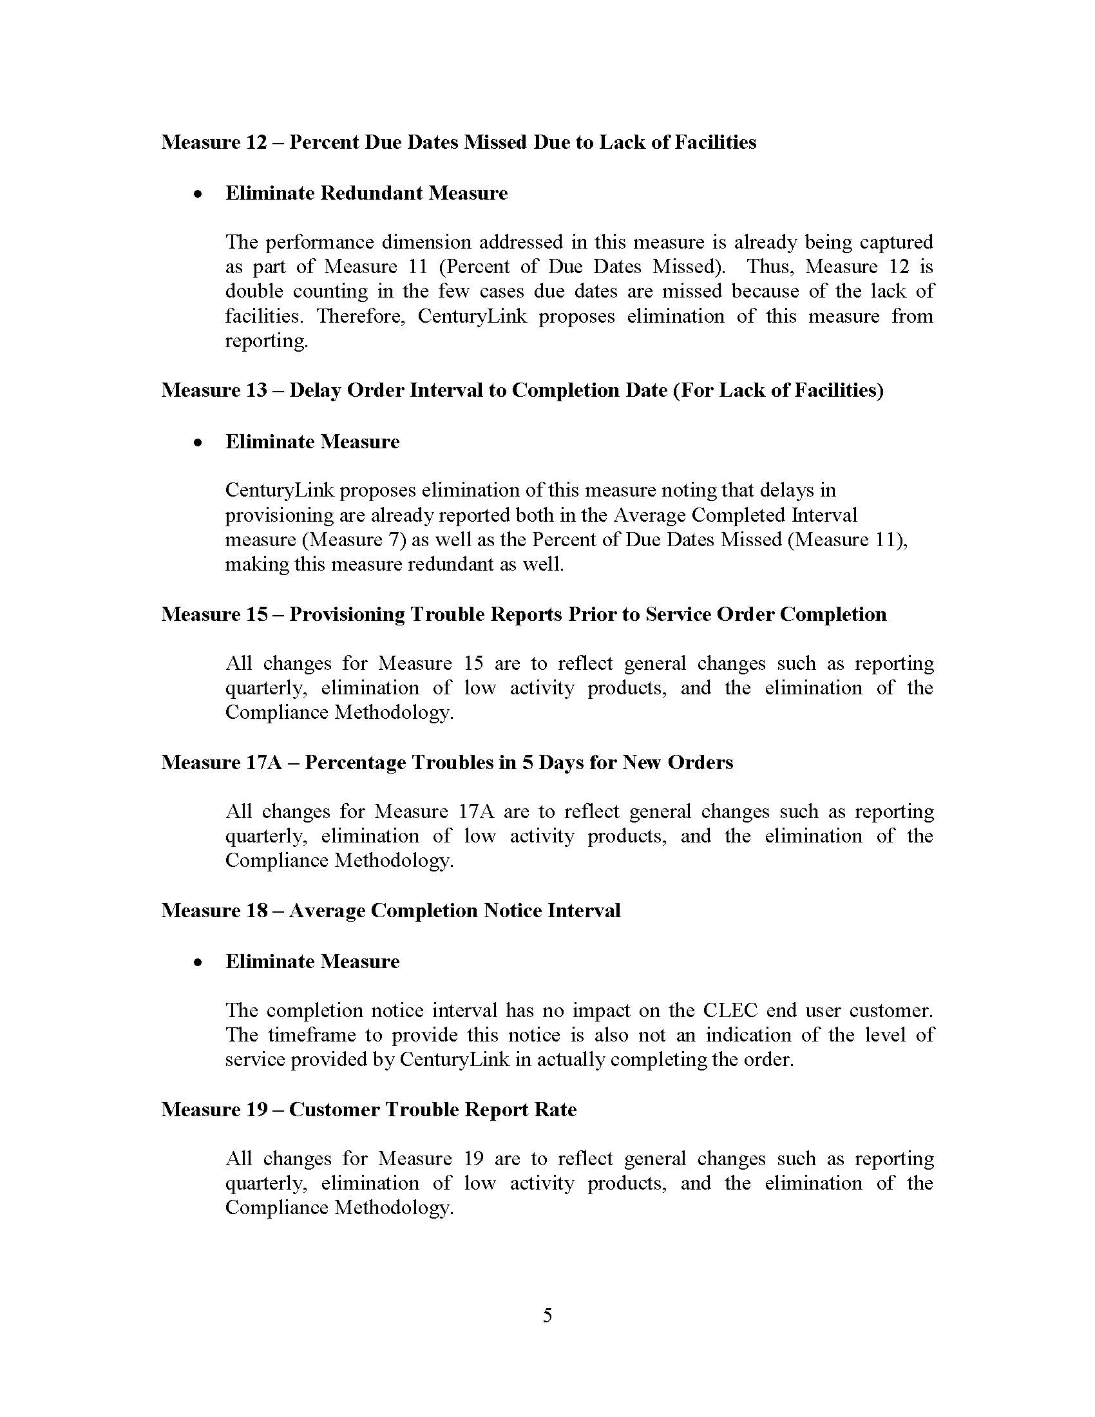

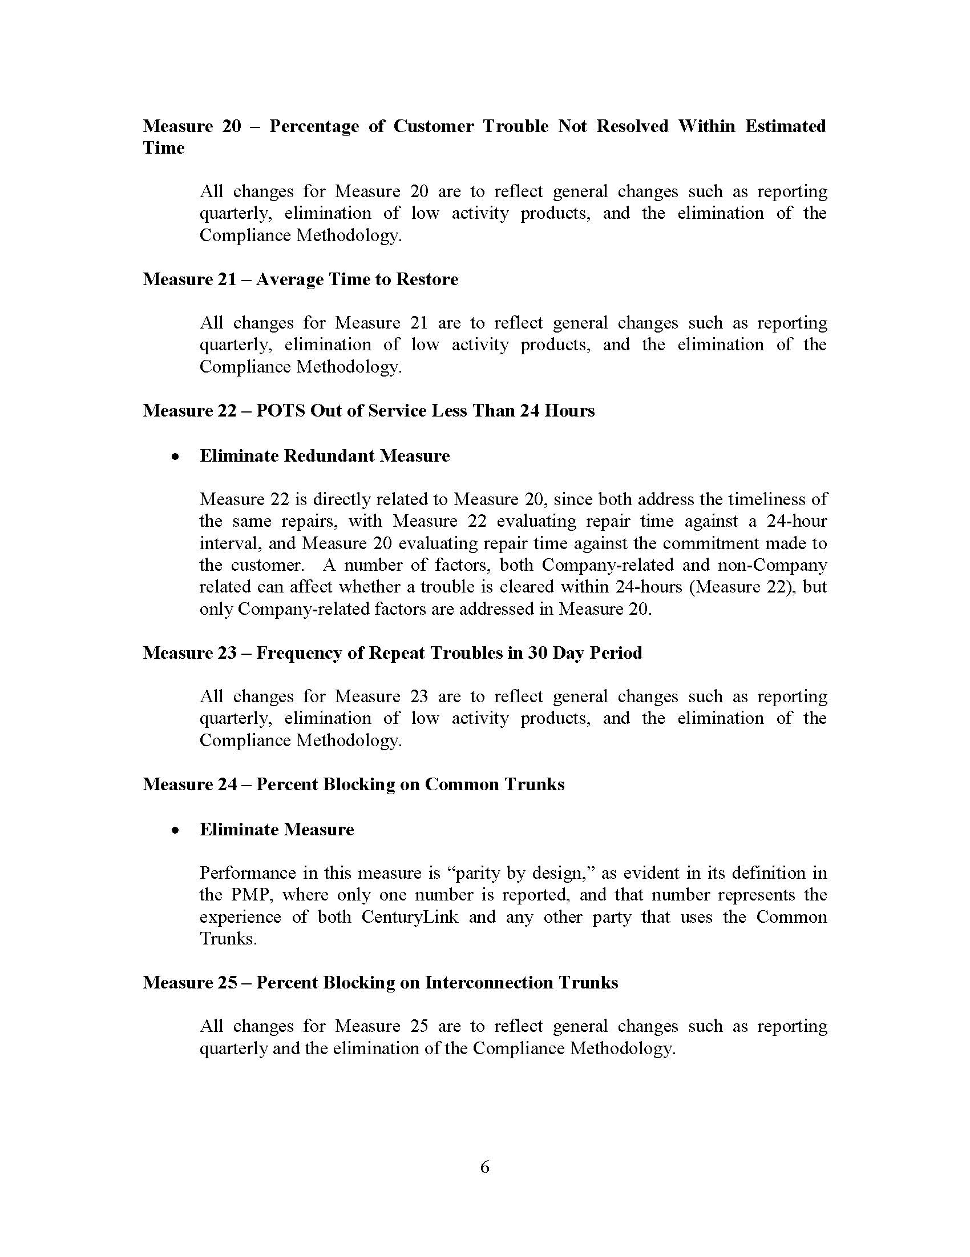

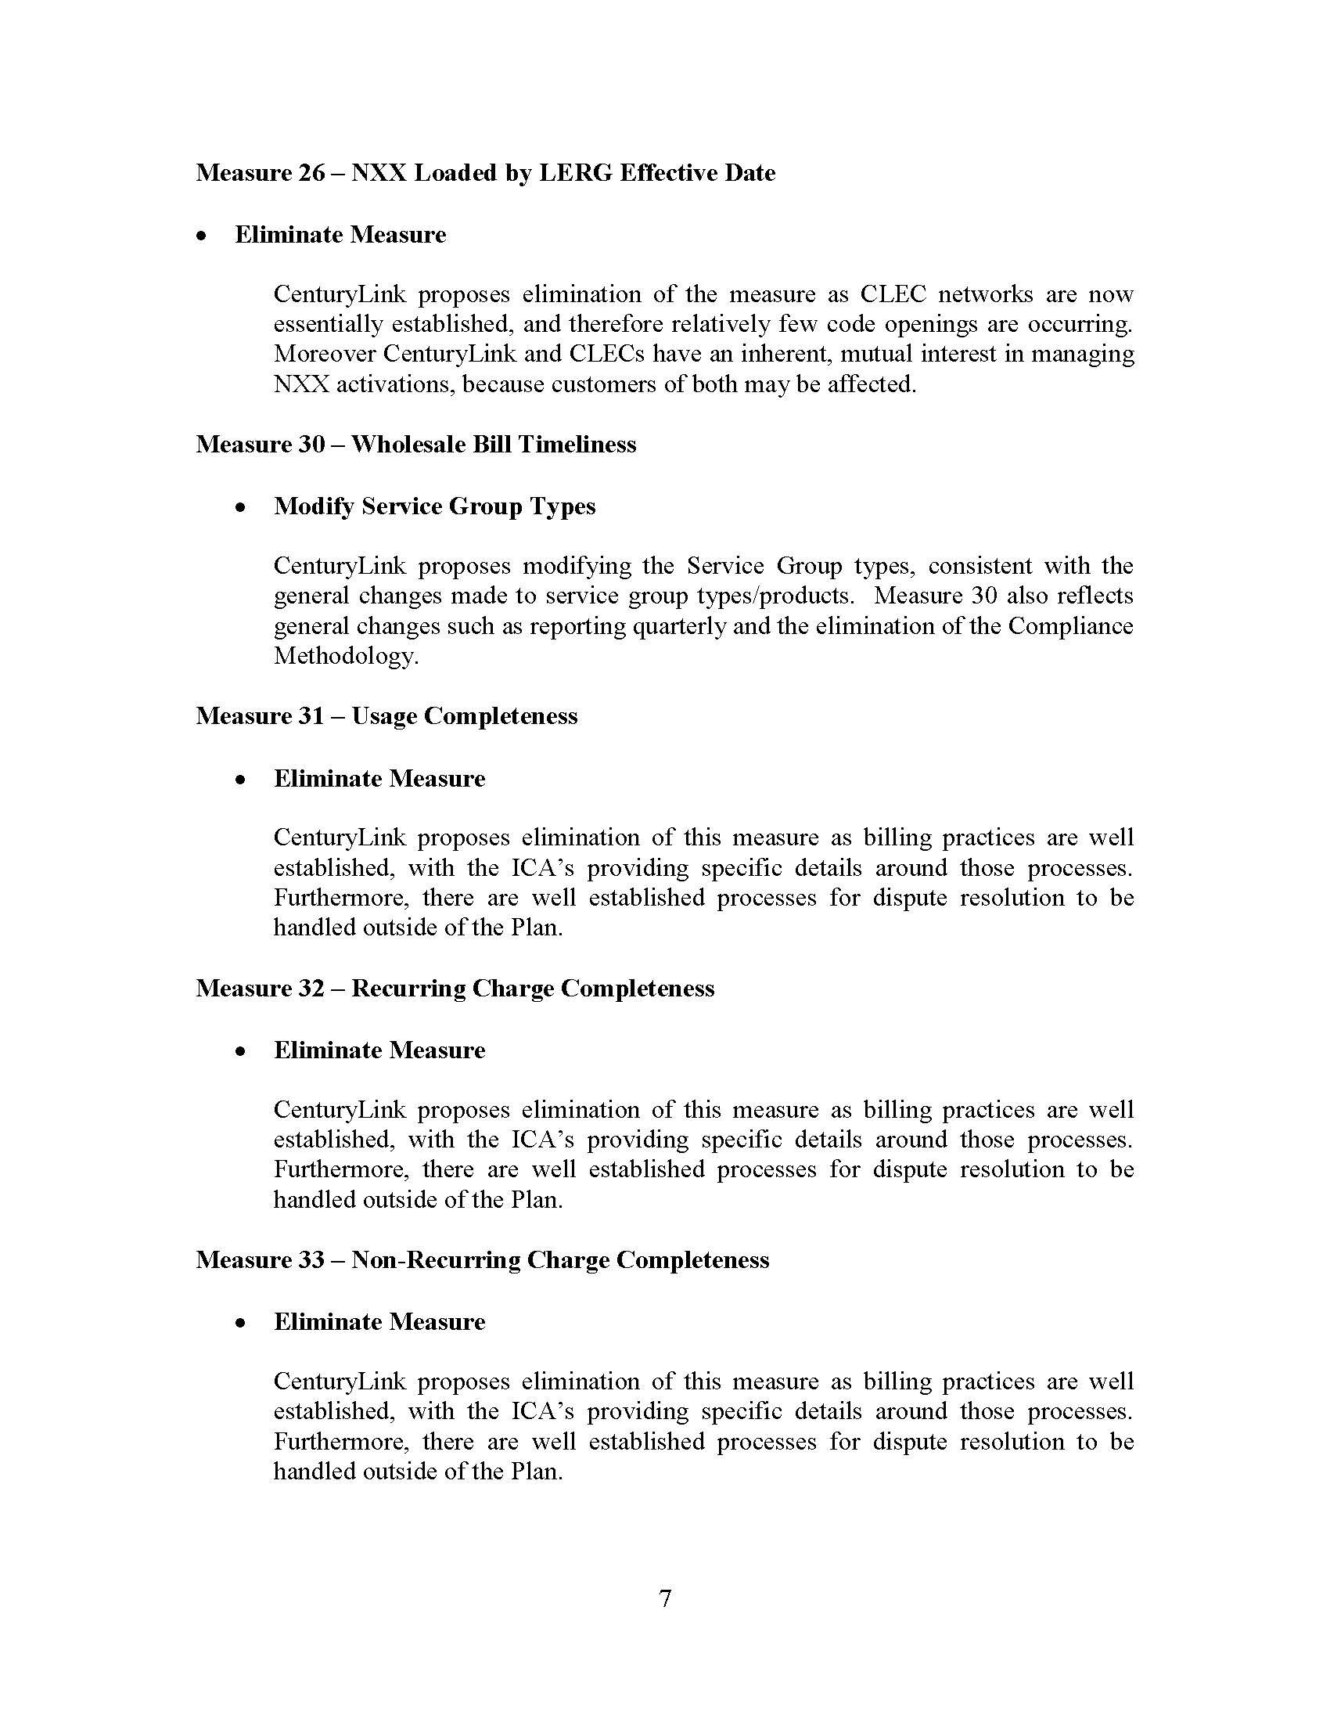

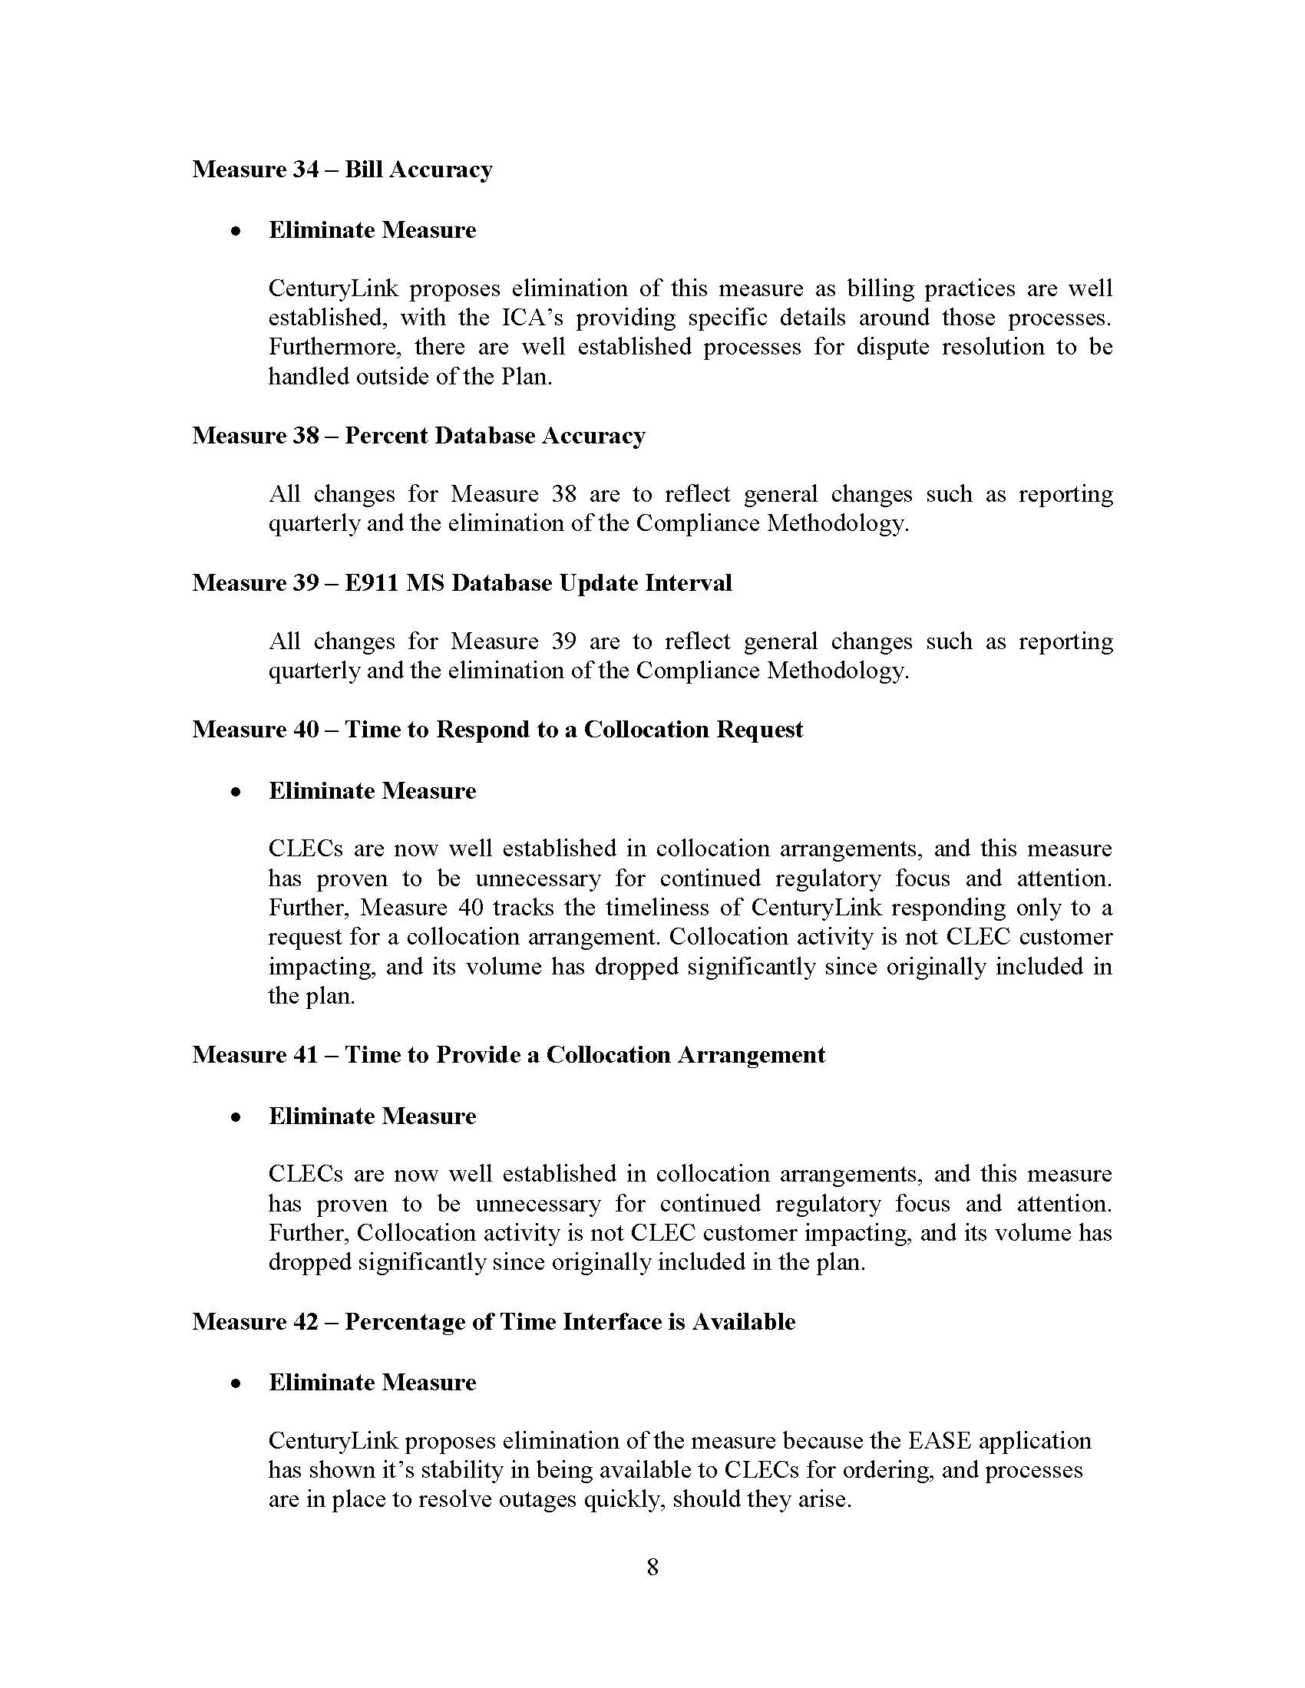

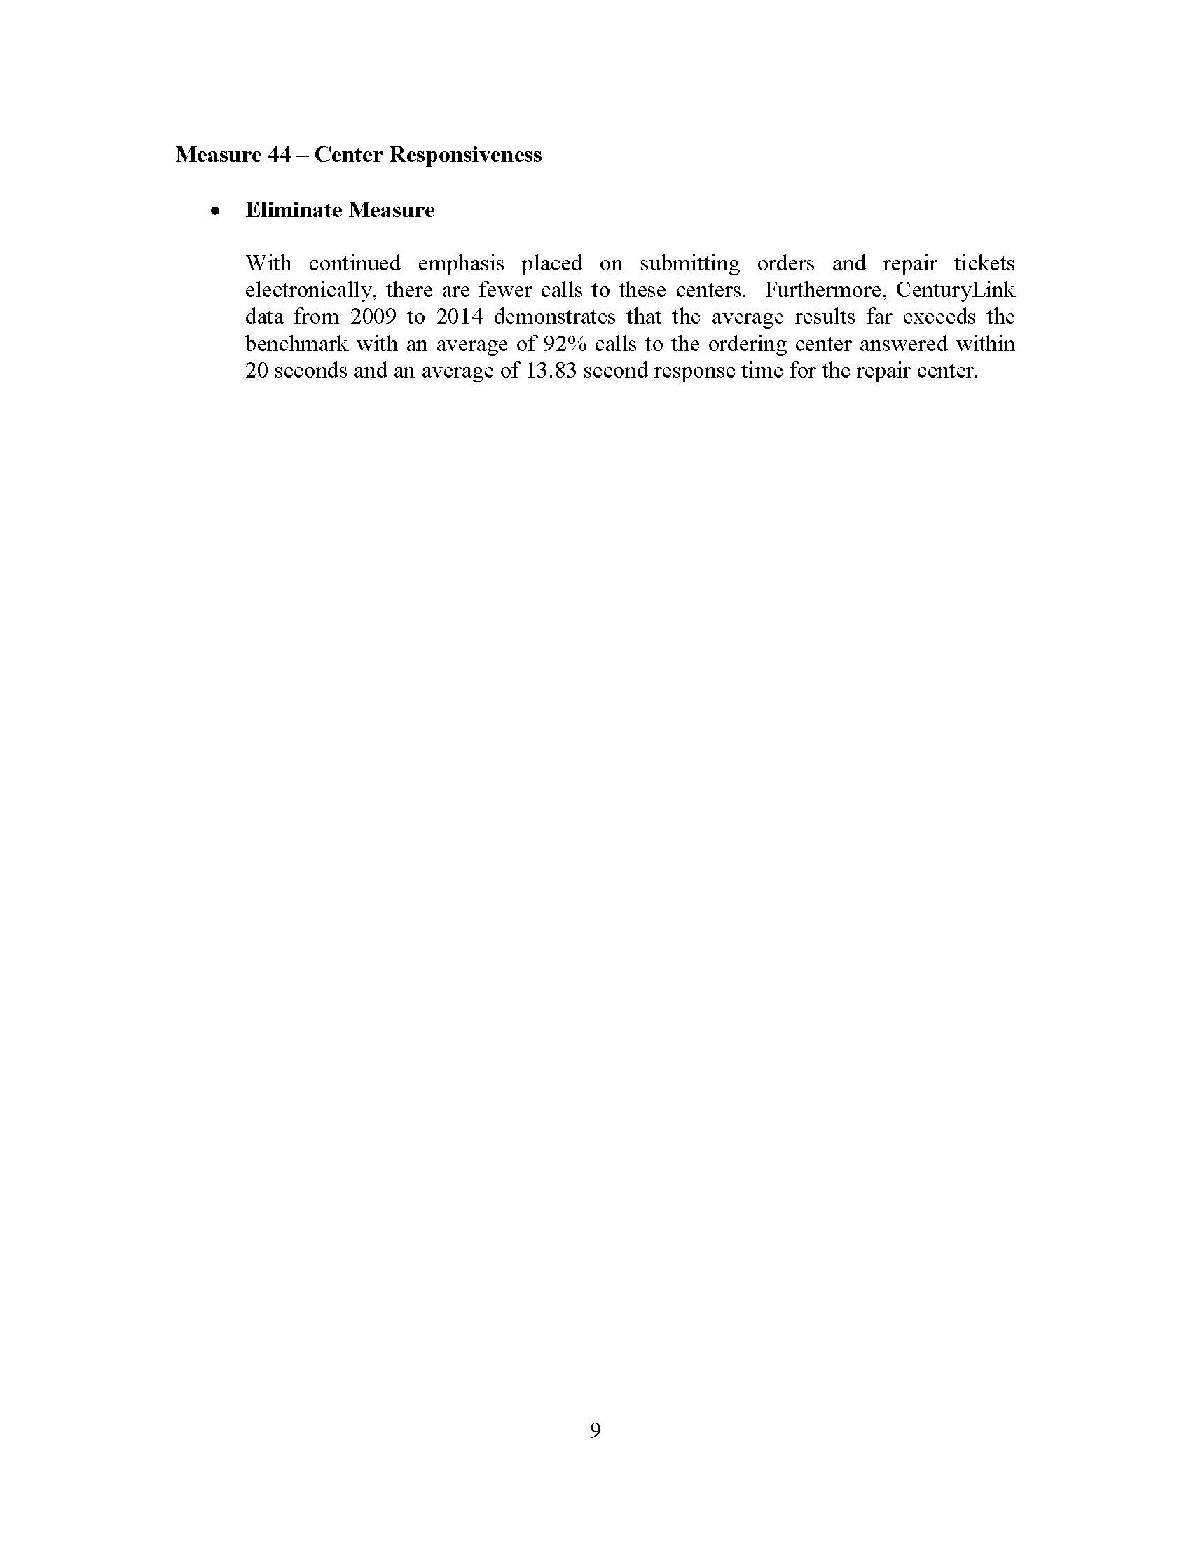

1. The Nevada Commission also eliminated financial penalties under the Performance Incentive Plan applicable only in Nevada.
2. The parties entering the stipulation in Nevada were: Central Telephone Company d/b/a CenturyLink (Nevada), Cox Nevada Telecom, LLC, U.S. Telepacific Corp. (Nevada), Mpower Communications Corp., tw telecom of Nevada LLC, Level 3 Communication of Nevada LLC d/b/a XO Communications, and Sprint Communications Company L.P., and the Public Utilities Commission of Nevada’s Regulatory Operations Staff.
3. Order No. PSC-03-0067-PAA-TP, issued January 9, 2003, Page 6.
4. The products to be eliminated include Integrated Services Digital Network Basic Rate Interface (ISDN BRI), Centrex, Private Branch Exchange (PBX), Digital Data Services (DDS), Digital Service 1/Integrated Services Digital Network Primary Rate Interface (DS1/ISDN PRI), Digital Signal 3 (DS3), Voice Grade Private Line/Digital Service 0 (VGPL/DS0), Residential Plain Old Telephone Service (POTS), Unbundled Network Element (UNE) Loops Designed, and Projects.