State of Florida  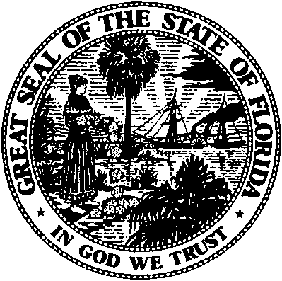 | Public Service Commission  Capital Circle Office Center ● 2540 Shumard Oak Boulevard  Tallahassee, Florida 32399-0850  -M-E-M-O-R-A-N-D-U-M-
DATE: | March 24, 2016
TO: | Office of Commission Clerk (Stauffer)
FROM: | Office of the General Counsel (S. Hopkins)  Office of Telecommunications (D. Flores)
RE: | Application for Certificate of Authority to Provide Telecommunications Service
AGENDA: | 4/5/2016 - Consent Agenda - Proposed Agency Action - Interested Persons May Participate
SPECIAL INSTRUCTIONS: |  | None

Please place the following Application for Certificate of Authority to Provide Telecommunications Service on the consent agenda for approval.

DOCKET NO. | COMPANY NAME | CERT. NO.
160026-TX | Sonic Systems, Inc. d/b/a Sonic Systems, Inc.  of Maryland | 8886

The Commission is vested with jurisdiction in this matter pursuant to Section 364.335, Florida Statutes. The Certificate of Authority authorizes Sonic Systems, Inc. of Maryland to provide Telecommunications Services in the State of Florida as a Telecommunications Company as defined by Section 364.02(13), Florida Statutes. Pursuant to Section 364.336, Florida Statutes, certificate holders must pay a minimum annual Regulatory Assessment Fee if the certificate is active during any portion of the calendar year. A Regulatory Assessment Fee Return Notice will be mailed each December to the entity listed above for payment by January 30.

