BEFORE THE FLORIDA PUBLIC SERVICE COMMISSION

In re: Petition for approval of community solar pilot program, by Gulf Power Company. | DOCKET NO. 150248-EG  ORDER NO. PSC-16-0119-TRF-EG  ISSUED: March 21, 2016

The following Commissioners participated in the disposition of this matter:

JULIE I. BROWN, Chairman
LISA POLAK EDGAR
ART GRAHAM
RONALD A. BRISÉ
JIMMY PATRONIS

ORDER GRANTING APPROVAL OF A FIVE-YEAR COMMUNITY SOLAR PILOT PROGRAM

BY THE COMMISSION:

- Background
On November 19, 2015, Gulf Power Company (Gulf or company) filed a petition for approval of its voluntary five-year Community Solar Pilot Program (solar program or program) and associated tariffs, the termination of its Rate Rider PV (photovoltaics) tariff, and a request for a depreciation rate for the proposed solar PV facilities.
The proposed program would offer all Gulf customers an opportunity to voluntarily contribute to the construction and operation of a 1 megawatt (MW) solar PV facility (solar facility) through annual subscriptions. The energy generated from the solar facility would provide power to all of Gulf’s customers.
Gulf has also requested the termination of its current voluntary Rate Rider PV (PV Rider) tariff. The PV Rider allows any customer to purchase 100-watt blocks of PV energy for $6; however, customers are not charged until sufficient commitments are made to construct a PV facility or purchase PV energy from a third party. As of late 2015 there were 42 customers; to date, no customers have been charged under this tariff as no solar facility has been constructed and no solar energy has been delivered.
On January 7, 2016, we issued an order suspending the tariff pursuant to Section 366.06(3), Florida Statutes (F.S.). The proposed tariff pages are contained in Attachment 1 of this Order. There are three interested persons in this proceeding: the Florida Industrial Power Users Group, the Office of Public Counsel, and the Southern Alliance for Clean Energy (SACE). On February 15, 2016, SACE filed comments on the solar program. We have jurisdiction pursuant to Sections 366.06 and 366.075, F.S.
- Community Solar Five –Year Pilot Program

Description of Proposed Solar Program

According to Gulf, the solar program is designed to allow customers to participate in and receive benefits from a solar facility without having to install, own, or maintain their own system. The program has an annual subscription fee used to cover the full projected annual revenue requirement of the program and a monthly bill credit for participants so that they receive credit for the energy produced by the solar facility. The program will also provide Gulf with the opportunity to collect and analyze data including customer interest, continuity of customer participation, customer satisfaction, actual program costs and sustainability. Gulf proposes that this program be piloted over a five-year period, beginning with the commercial operation of the solar facility.
During this pilot period Gulf plans to report to us annually on the results of the program including participation levels, subscription fee revenue, facility performance, and program costs. At the end of the five-year pilot period (estimated to be 2016-2021); Gulf will file a petition to continue, modify, or close the program and associated tariffs.
Initially, program subscription will be limited to a 1 MW facility, which Gulf asserts balances economies of scale with subscription achievability. Through this petition, Gulf is also seeking our approval to construct additional facilities if Gulf anticipates that new subscriptions will offset the revenue requirements of such facilities. Gulf plans to provide both pre- and post-construction notification to us of any facilities beyond the initial 1 MW facility, and will address the potential for additional facilities in its annual reports.
Gulf’s proposed facility does not fall under the Florida Electrical Power Plant Siting Act, as it will be a solar facility of less than 75 MW in capacity. Similarly, because the proposed facility is less than 75 MW, a Request for Proposal (RFP) to construct the initial facility is not required by Rule 25-22.082, Florida Administrative Code (F.A.C.). However, Gulf did issue an RFP for the construction of the initial facility. Gulf evaluated the bidders and proposals based on technical merit, energy production, and price. Gulf asserts that while each proposal met the technical requirements, the winning proposal had higher energy production and a lower equipment, procurement, and construction (also known as EPC) cost. According to Gulf, the installed cost of the 1 MW facility is expected to be approximately $2.6 million based on the results of the RFP issued by Gulf on September 22, 2015.

Market Research

In order to determine interest, Gulf retained a market research firm to conduct nine customer focus groups and telephonic surveys on solar in general and community solar programs specifically. Gulf asserts that the results indicate that a majority of residential and small business customers are supportive of solar initiatives, and that some are willing to pay a premium for solar. The average annual premium customers surveyed were willing to pay was $346 for residential customers and $414 for business customers. Of those customers interested in community solar, the research shows that two percent of residential customers and one percent of small business customers would “definitely” be willing to pay more for solar.

Subscriptions

In order to strike a balance between a cost low enough to be attractive to customers yet high enough to minimize the number of participants needed to fully subscribe to the program to build the initial facility, Gulf established annual subscription fee levels at $99 and, for a five-year commitment, $89. We note that a five-year commitment may be made at any time during the pilot period. Gulf argues that it is reasonable to distribute the number of customer subscriptions evenly between those who sign up for one year at a time and those who sign a five-year commitment, resulting in approximately 2,880 subscriptions required to cover the levelized (over 35 years) annual revenue requirement for the initial facility. The levelized annual revenue requirement for the initial facility is approximately $270,000. A customer may purchase more than one subscription, depending on the customer’s usage. Gulf’s customers total approximately 450,000; therefore, the 2,880 subscriptions required represent less than one percent of Gulf’s total customers. Gulf asserts that, based on its market research, sufficient customer interest exists to fully subscribe the initial facility.
The number of subscriptions a participant may purchase is limited by the participant’s average annual kilowatt hour (kWh) consumption. The initial facility’s projected output in the first year of operation is 2,150,000 kWh; that number divided by 2,880 (the total number of subscriptions) equals an output of 746 kWh per subscription projected to be delivered to the grid the first year. A customer with an average annual consumption of 12,000 kWh would be limited to 16 subscriptions in the first year of the program (12,000/746=16 subscriptions).

Revenue Requirements

The subscription fees are intended to cover the full projected annual revenue requirements of the solar facilities that would be constructed to support the solar program. Initially, subscriptions will be limited to a 1 MW facility, which will be owned and operated by Gulf and located in Milton, Florida. With our approval, the company anticipates that construction will be complete by the third quarter of 2016, with pre-enrollment beginning after our final action approving the program. Participants will not be billed until the initial facility begins full commercial operation.
The projected levelized annual revenue requirements include all costs associated with the engineering, procurement, construction, and operations and maintenance (O&M) of the solar facility. Impacts of the federal Solar Investment Tax Credits are embedded in the calculation. The projected levelized annual revenue requirement is $270,000. Recurring capital costs are four percent of the $270,000 while O&M costs are 11 percent. The remaining 85 percent is attributable to the costs of the initial facility. The O&M costs include fixed O&M, insurance, and marketing. Marketing represents the only administrative cost included in the revenue requirement. Gulf anticipates the highest level of marketing costs will occur in 2016, $50,000 or approximately 19 percent of the $270,000 levelized annual revenue requirement. Marketing costs are expected to decline through the end of the five-year pilot period to $6,250 or 2.3 percent of the levelized annual revenue requirement. According to Gulf, one objective of the pilot program is to evaluate the actual marketing and other administrative costs required to fully subscribe to this type of program.

Bill Credits and Avoided Energy Costs

Each program subscription in the solar program will receive a monthly bill credit of $2.11 for the first year. The monthly $2.11 credit is calculated by multiplying the solar weighted average annual avoided energy cost (3.4 cents/kWh) by 746 kWh (output per subscription projected to be delivered to the grid the first year), divided by 12 to get a monthly credit.

Gulf will seek to recover the avoided energy costs associated with the output of the solar facilities through the Fuel and Purchased Power Cost Recovery Clause (Fuel Clause). To illustrate, the facility’s projected output in the first year is 2,150,000 kWh. Based on the projected 3.4 cents/kWh avoided energy costs, the avoided energy costs associated with the solar facility is $73,100 (2,150,000 kWh x 3.4 cents/kWh). Gulf asserts that recovery of avoided energy costs is appropriate because all customers will benefit from the output of the solar facility as the output will offset an equal amount of purchased energy (i.e., the amount of purchased energy will decrease by the 2,150,000 kWh). Gulf will recalculate the bill credit on an annual basis as part of the Fuel Clause proceeding to reflect changes in avoided energy cost and capacity output projections. Gulf will provide updated facility output and avoided energy costs for our review in the annual Fuel Clause projection filings.

Marketing

Gulf plans to begin pre-enrollment following the issuance of our final order approving the program. Marketing will focus on Gulf’s three categories of eligible customers: residential, business, and industrial. For the three categories the marketing plan is expected to include targeted emails, bill inserts, webpage, social media promotion, print information, and a video that will be made available on the website and in social media.

Renewable Energy Credits

Gulf asserts that renewable energy credits (REC) resulting from the community solar program will be retired on behalf of the program participants. Once retired, the RECs cannot be sold or transferred to another party. Gulf’s proposed treatment of RECs will have a zero impact on program revenue requirements.

Additional Considerations

Overall, the solar program and its components are reasonable. However, there are topics that we find merit further discussion.

Risk of Insufficient Subscriptions

When asked to explain who would assume the risk for unrecovered costs if subscriptions are insufficient to cover the projected annual revenue requirements during the pilot program or if Gulf decides to close the solar program after the five-year pilot period, Gulf asserts that its market research indicates that sufficient customer interest exists to fully cover the project’s program costs with revenues from participants. Furthermore, Gulf asserts that it is important to remove uncertainty about whether the initial facility will be built; therefore, it plans to begin construction once it receives a final order while it is signing up participants. Gulf explains that the proposed solar program is experimental and limited in size and scope; undersubscription is not anticipated. Should undersubscription occur, Gulf notes that the initial facility will continue to provide service to all of Gulf’s customers. The company asserts that if subscriptions consistently fall significantly short of the number needed to recover the costs during the pilot, Gulf anticipates further discussion with us concerning the program.
When asked if it would be willing to absorb costs if undersubscription occurs, as FPL has committed to in its VSP program, Gulf asserts that it acknowledges that its shareholders, as opposed to its non-participating customers, are assuming the risk that program costs will not be fully supported by the program structure. Gulf further asserts that it is not seeking by its petition to insulate itself or its shareholders from that risk. Furthermore, Gulf asserts that it is not assuming that our approval of the solar program will have the effect of insulating shareholders from that risk. Gulf contends that it does reserve its right to petition us for alternative treatment of the solar program and/or solar assets if circumstances develop in the future to warrant proposing alternative treatment. According to Gulf, for example, should the program’s assets become cost-effective for Gulf’s general body of customers in the future, it must retain the ability to petition us for appropriate regulatory treatment of the assets based on the facts and circumstances as they exist at the time. We note that this Order does not address prudency. Gulf will have to demonstrate prudency in a future proceeding, if it seeks to recover costs.

Avoided Energy Costs

By using annually projected avoided energy costs and recovering these from the general body of ratepayers through the Fuel Clause, Gulf is shifting some risk for avoided energy costs from the program participants to the general body of ratepayers. For example, if actual avoided energy costs are below the projected values Gulf calculated, non-participants would see a net loss. Conversely, if actual avoided energy costs are higher than projected, non-participants would see a net benefit. Regardless, Gulf would recover the projected avoided energy costs through the Fuel Clause, subject to our review. This is similar to fixed energy rates in purchased power agreements, although these tend to include multiple year terms and additional security provisions associated with system performance. For example, in Docket No. 150035-EI, we approved three renewable purchased power agreements for solar facilities with 25-year terms featuring fixed energy rates.

One method to mitigate the risk would be to include a true-up provision in the calculation of the annual avoided energy costs as part of the Fuel Clause. Gulf asserts that a true-up mechanism was possible but based on the utility’s analysis the cost and complexity of implementation far exceeded any costs to be trued up. We note that since this is a pilot program and the avoided energy cost will be recalculated each year, the difference between forecasted and actual as-available energy values should be minimal.

Reporting requirements

Gulf’s planned annual reports to us include participation levels, subscription fee revenue, facility performance, and program costs. We find that additional information shall be included in the annual reports: the level of participation by type of participant (e.g., one-year and five-year); how many subscriptions each participant purchases; the annual dollar amount of bill credits paid to participants; and, the amount of annual avoided energy costs retained by Gulf. Gulf shall file an initial annual report on the commercial operation date of the solar facility and subsequently on each anniversary date for the duration of the five-year pilot period. Gulf shall provide both pre- and post-construction notification to us of any facilities beyond the initial facility, in addition to addressing the potential for additional facilities in its annual reports. These reports shall be filed in this docket.

Decision

We find that the proposed solar program provides an opportunity for customers to participate in a community solar project and also provides energy for Gulf’s general body of ratepayers. We find it appropriate to approve Gulf’s community solar five-year pilot program and associated tariffs, effective March 1, 2016.
We further find that Gulf shall file an initial annual report on the commercial operation date of the initial solar facility and subsequently on each anniversary date, to include participation levels, the level of participation by type of participant (e.g., one-year and five-year), how many subscriptions each participant purchases, subscription fee revenue, facility performance, program costs, the annual dollar amount of bill credits paid to participants, and the amount of annual avoided energy costs retained by Gulf.
- Termination of the optional PV Rider tariff
Gulf requests termination of its PV Rider tariff, a voluntary subscription program dating from 1999. The PV Rider is an optional rate rider that permits any customer to purchase one or more 100-watt blocks of PV energy for a monthly charge of $6.00 per block. Participating customers must commit to an initial term of five years; however, they are not charged until Gulf receives sufficient customer commitments to cover the cost of constructing a solar facility or purchasing solar energy from a third party. The minimum threshold for this program, 10,000 100-watt blocks, has not been attained, thus no solar facility has been built, no solar energy has been delivered, and no participant has been billed. Since 2005 the greatest number of participants, 70, occurred in 2005. The smallest number of participants is 42, as of the end of 2015.
Gulf contends that continuing this rate rider in conjunction with its proposed solar program has the potential to lead to customer confusion and that the solar program is likely to be a preferable alternative to customers interested in promoting solar energy. Gulf notes that the PV River program showed the difficulty of achieving adequate customer participation without a PV facility already in operation.

Decision

We find that the termination of the optional PV Rider is reasonable and approve its termination effective March 1, 2016. We find it appropriate that participants shall be notified of the termination of the PV Rider within 30 days of the March 1, 2016, effective date.
- Solar Facilities Depreciation Rate
Gulf is seeking our establishment of a depreciation rate for planned investments in utility-scale solar facilities. Specifically, Gulf requests approval to depreciate solar-to-electric generating facility investments over an average service life of 35 years, with a zero net salvage provision. Using these life and salvage parameters, the resulting whole life depreciation rate equals 2.9 percent. The major components of Gulf’s planned initial solar PV facility include Solar World Sunmodule SW 320 XL MONO PV modules, SMA Sunny World Tripower 24000TL-US inverters, and RBI Solar Ground Mount racking units. The company intends to record its utility-scale solar investments in Federal Energy Regulatory Commission accounts 340 thru 346, which are classified as “Other Power Production.”

We have addressed depreciation matters in utility-scale solar generation. Most recently, we approved depreciation life parameters for Tampa Electric Company’s (TECO) solar PV generating unit at the Tampa International Airport (TIA). We found TECO’s proposed depreciation parameters of a 30-year average service life and a zero net salvage provision to be appropriate for initial investment recovery of the TIA Plant. However, in the instant proceeding, Gulf is proposing to depreciate its solar plant investments over a 35-year life, while also estimating a zero net salvage provision. This results in a lower rate of depreciation, i.e. 2.9 percent versus the 3.3 percent approved for TECO. We note that we also ordered a 30-year life (and resulting 3.3 percent depreciation rate) for FPL’s DeSoto and Space Coast Solar Energy Centers.

Gulf asserts that a 35-year life is appropriate for use in recovering its solar plant investments based a study conducted by Southern Company Services (SCS) and KPMG LLP (KPMG). The study divided components of a generic PV plant into three categories: PV panels, inverters, and other PV components. The three individual component categories’ average service lives’ were then multiplied by the percentage of overall initial investment they represent of the facility. At this point, the weighted average service lives were summed. Overall, the weighted average service life of the solar PV facility infrastructure totaled approximately 35 years. We have reviewed the SCS and KPMG Study and the findings are consistent with Gulf’s request.

Concerning Gulf’s proposed zero net salvage provision, the company claims it currently has minimal experience operating and maintaining utility-scale solar facilities, and thus does not have sufficient data with respect to cost of removal or gross salvage values. However, the company asserts that it will address and update, as warranted, depreciation components through future depreciation studies. We note that according to Rule 25-6.0436(8)(a), F.A.C., the company is required to file an updated depreciation study at least once every four years from submission of its most recent study. We have previously ordered a zero net salvage provision for utility-scale solar facilities for both FPL and TECO.

For the purposes of determining a depreciation rate for Gulf’s planned solar PV investments, we find that the methodology the company used as a basis for its request is reasonable. We recognize that if by estimating a 35-year life and a zero net salvage results in a rate of investment recovery that is inadequate, this would likely be identified in a future depreciation review proceeding and adjustment sought at that time. Rule 25-6.0436, F.A.C, provides methods and procedures for maintaining appropriate rates of asset recovery. Gulf’s request of a 35-year average service life for its solar PV investments, which is based on the SCS and KPMG Study, and a zero percent net salvage, appears reasonable at this time. If approved, the resulting whole life depreciation rate for Gulf’s planned solar PV investments would be 2.9 percent.

Decision

For the reasons discussed above, we approve a whole life depreciation rate of 2.9 percent, which is based on a 35-year average service life and zero percent net salvage for Gulf’s proposed solar facilities.

Based on the foregoing, it is

ORDERED by the Florida Public Service Commission that Gulf Power Company’s community solar five-year pilot program and associated tariffs is hereby approved as set forth in the body of this Order, effective March 1, 2016. It is further
ORDERED that Gulf Power Company shall file an initial annual report on the commercial operation date of the initial solar facility and subsequently on each anniversary date, to include participation levels, the level of participation by type of participant (e.g., one-year and five-year), how many subscriptions each participant purchases, subscription fee revenue, facility performance, program costs, the annual dollar amount of bill credits paid to participants, and the amount of annual avoided energy costs retained by Gulf. It is further
ORDERED that the termination of the optional PV Rider is reasonable and its termination is approved effective March 1, 2016. It is further
ORDERED that participants shall be notified of the termination of the PV Rider within 30 days of the effective date. It is further
ORDERED that a whole life depreciation rate of 2.9 percent, which is based on a 35-year average service life and zero percent net salvage for Gulf’s proposed solar facilities is approved. It is further

ORDERED that if a protest is filed within 21 days of the issuance of this order, the tariff shall remain in effect pending resolution of the protest. There will not be any dollar amount subject to refund because Gulf will not begin pre-enrollment until a final order is issued. It is further

ORDERED that if no timely protest is filed, this docket shall be closed upon the issuance of a consummating order.
By ORDER of the Florida Public Service Commission this 21st day of March, 2016.

/s/ Carlotta S. Stauffer
CARLOTTA S. STAUFFER
Commission Clerk
Florida Public Service Commission
2540 Shumard Oak Boulevard
Tallahassee, Florida 32399
(850) 413-6770
www.floridapsc.com

Copies furnished: A copy of this document is provided to the parties of record at the time of issuance and, if applicable, interested persons.

TLT

NOTICE OF FURTHER PROCEEDINGS OR JUDICIAL REVIEW

The Florida Public Service Commission is required by Section 120.569(1), Florida Statutes, to notify parties of any administrative hearing that is available under Section 120.57, Florida Statutes, as well as the procedures and time limits that apply. This notice should not be construed to mean all requests for an administrative hearing will be granted or result in the relief sought.

Mediation may be available on a case-by-case basis. If mediation is conducted, it does not affect a substantially interested person's right to a hearing.

The Commission's decision on the tariffs is interim in nature and will become final, unless a person whose substantial interests are affected by the proposed action files a petition for a formal proceeding, in the form provided by Rule 28-106.201, Florida Administrative Code. The action, for all other aspects of the Order, proposed herein is preliminary in nature. Any person whose substantial interests are affected by the action proposed by this order may file a petition for a formal proceeding, in the form provided by Rule 28-106.201, Florida Administrative Code. This petition must be received by the Office of Commission Clerk, 2540 Shumard Oak Boulevard, Tallahassee, Florida 32399-0850, by the close of business on April 11, 2016.

In the absence of such a petition, this order shall become final and effective upon the issuance of a Consummating Order.

Any objection or protest filed in this/these docket(s) before the issuance date of this order is considered abandoned unless it satisfies the foregoing conditions and is renewed within the specified protest period.

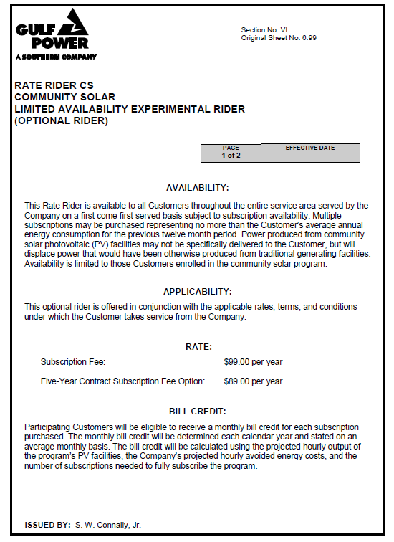

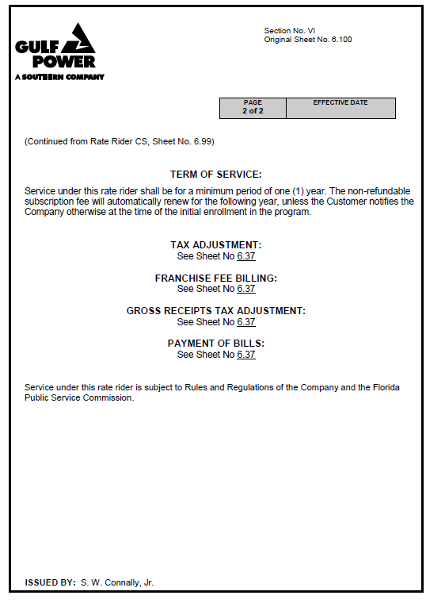

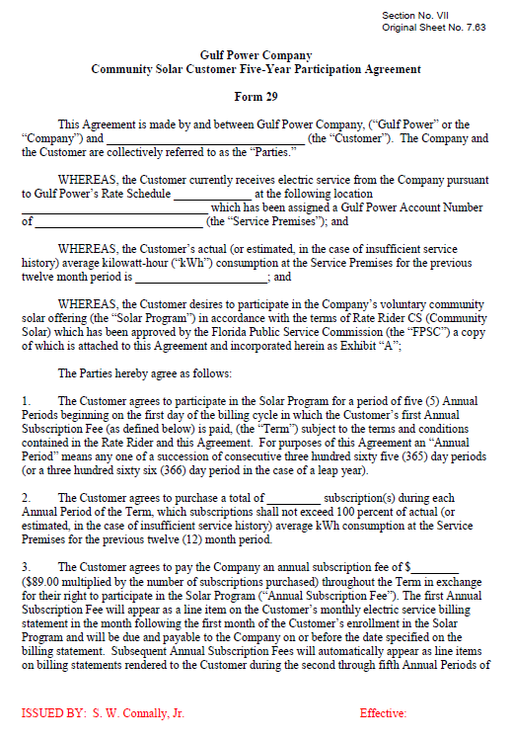

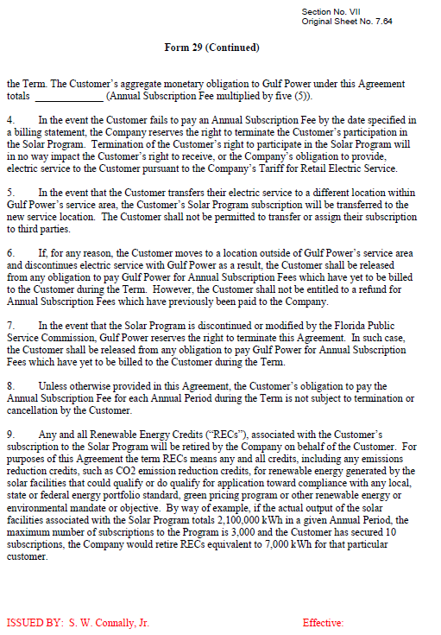

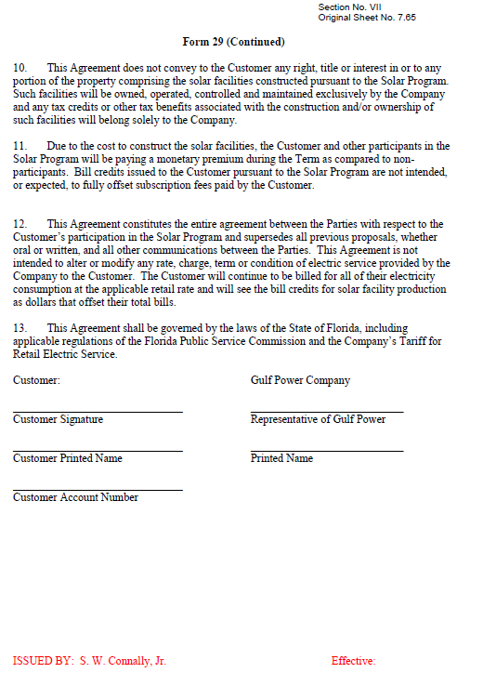

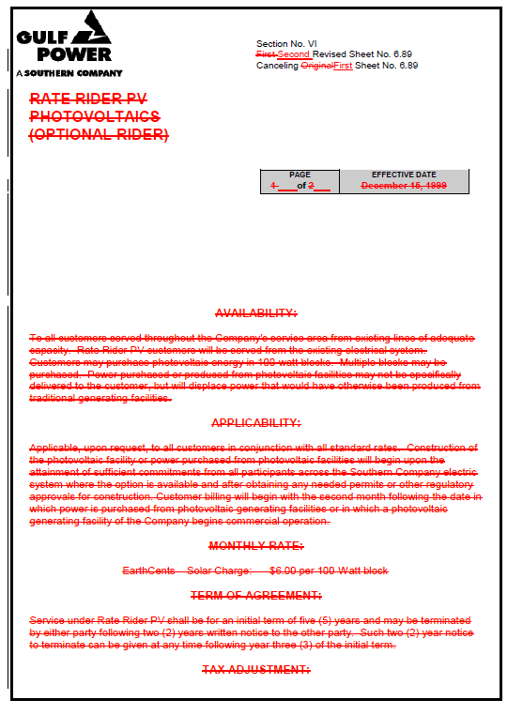

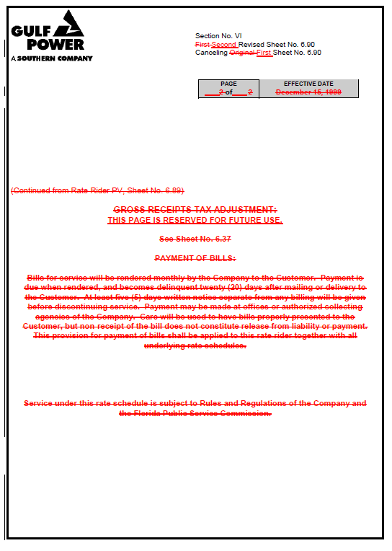

Order No. PSC-99-2485-TRF-EI, issued December 20, 1999, in Docket No. 991317-EI, In re: Petition by Gulf Power Company for approval of optional rate rider PV (photovoltaics).
Order No. PSC-16-0015-PCO-EG, issued January 7, 2016, in Docket No. 150248-EG, In re: Petition for approval of community solar pilot program, by Gulf Power Company.
See, Section 403.503(14), F.S.
Order No. PSC-14-0468-TRF-EI, issued August 29, 2014, in Docket No. 140070-EI, In re: Petition for approval of voluntary solar partnership pilot program and tariff, by Florida Power & Light Company.
Order No. PSC-15-0155-PAA-EI issued April 22, 2015, in Docket No. 150035-EI, In re: Petition for approval of energy purchase agreements between Gulf Power Company and Gulf Coast Solar Center I, LLC, Gulf Coast Solar Center II, LLC, and Gulf Coast Solar Center III, LLC.
Gulf contends that the program is designed such that the avoided energy costs associated with facility output that is to be recovered through the Fuel Clause will be equal to the annual energy credits to be paid to subscribers if the program is fully subscribed (2,880 subscriptions). However, if the program is not fully subscribed, energy credits paid to subscribers would be less than the avoided energy costs recovered through the Fuel Clause.
Order No. PSC-08-0731-PAA-EI, issued November 3, 2008, in Docket 080543-EI. In re: Request for approval to begin depreciating new technology solar photovoltaic plant sites for DeSoto and Space Coast Solar Energy Centers over 30-year period, effective with in-service dates of units, by Florida Power & Light Company; Order No. PSC-15-0573-PAA-EI, issued December 18, 2015, in Docket No. 150211-EI, In re: Petition for approval of depreciation rates for solar photovoltaic generating units, by Tampa Electric Company.
Order No. PSC-08-0731-PAA-EI.
Order No. PSC-08-0731-PAA-EI; Order No. PSC-15-0573-PAA-EI.

