State of Florida |  | Public Service Commission  Capital Circle Office Center ● 2540 Shumard Oak Boulevard  Tallahassee, Florida 32399-0850  -M-E-M-O-R-A-N-D-U-M-
DATE: | March 24, 2016
TO: | Office of Commission Clerk (Stauffer)
FROM: | Division of Accounting and Finance (Cicchetti)  Office of the General Counsel (Gervasi)
RE: | Docket No. 150148-EI – Petition for approval to include in base rates the revenue requirement for the CR3 regulatory asset, by Duke Energy Florida, Inc.  Docket No. 150171-EI – Petition for issuance of nuclear asset-recovery financing order, by Duke Energy Florida, Inc. d/b/a Duke Energy.
AGENDA: | 04/05/16 – Regular Agenda – Motion to Approve Stipulation – Parties May Participate
COMMISSIONERS ASSIGNED: |  |  | All Commissioners
PREHEARING OFFICER: |  |  | Brisé
CRITICAL DATES: |  |  | None
SPECIAL INSTRUCTIONS: |  |  | None

Case Background
In February 2013, Duke Energy Florida, Inc. (DEF) announced its decision to retire its nuclear plant, Crystal River Unit 3 (CR3), in Citrus County, Florida. The retirement of CR3 was the subject of two settlement agreements. The first settlement agreement, reached in 2012, was a global settlement that addressed several issues, including issues related to the CR3 retirement. The second settlement agreement, the Revised and Restated Stipulation and Settlement Agreement (RRSSA), reached in 2013, replaced and supplanted the 2012 settlement agreement. The Commission approved the RRSSA by Order No. PSC-13-0598-FOF-EI. Among other things, the RRSSA contemplated that DEF would create a regulatory asset to account for the recovery of costs associated with the retirement of CR3. The parties to the RRSSA were DEF, the Office of Public Counsel (OPC), the Florida Industrial Power Users Group (FIPUG), the Florida Retail Federation (FRF), and White Springs Agriculture Chemicals, Inc. d/b/a PCS Phosphate (PCS Phosphate).

Docket No. 150148-EI – CR3 Regulatory Asset
On May 22, 2015, pursuant to Sections 366.04 and 366.05, Florida Statutes (F.S.), DEF filed its Petition for Approval to Include in Base Rates the Revenue Requirement for the Crystal River Unit 3 Regulatory Asset (CR3 Regulatory Asset Petition), along with supporting testimony and exhibits. DEF intended its petition to be the first step in the securitization process, authorized by Section 366.95, F.S.

Docket No. 150171-EI – Financing Order
On July 27, 2015, pursuant to Sections 366.04, 366.05, and 366.95, F.S., and consistent with the RRSSA and its CR3 Regulatory Asset Petition, DEF filed its Petition for Issuance of a Nuclear Asset-Recovery Financing Order (Financing Order Petition), along with supporting testimony and exhibits, requesting that the Commission issue a financing order to permit DEF to securitize certain costs, including the CR3 Regulatory Asset value as outlined in its CR3 Regulatory Asset Petition filed in Docket No. 150148-EI.

Consolidation of Dockets
Along with its Financing Order Petition, DEF also filed a Motion to Consolidate, requesting that its CR3 Regulatory Asset Petition and Financing Order Petition be consolidated pursuant to Rule 28-106.108, Florida Administrative Code (F.A.C.). By Order No. PSC-15-0327-PCO-EI, issued on August 13, 2015, Docket Nos. 150148-EI and 150171-EI were consolidated into Docket No. 150171-EI.

First RRSSA Amendment
On August 31, 2015, DEF filed a Motion for Approval of Stipulation. DEF requested that the Commission approve the proposed Stipulation reached by the parties to amend the RRSSA. The proposed Stipulation was intended to resolve the CR3 Regulatory Asset-related issues in Docket No. 150148-EI to ensure that the financing order issued in Docket No. 150171-EI would be consistent with the RRSSA.

By Order No. PSC-15-0465-S-EI, issued October 14, 2015, the Commission granted DEF’s Motion for Approval of Stipulation and found that the RRSSA, as amended, was in the public interest.

Financing Order
By Order No. PSC-15-0537-FOF-EI, issued November 19, 2015, the Commission approved DEF’s Petition for Issuance of a Nuclear Asset-Recovery Financing Order. The financing order permits DEF to securitize certain costs, including the CR3 Regulatory Asset value as outlined in its CR3 Regulatory Asset Petition filed in Docket No. 150148-EI.

Motion for Approval of Second RRSSA Amendment
On March 9, 2016, DEF filed a Motion for Approval of Stipulation to Amend the RRSSA (Second RRSSA Amendment), as reflected in Exhibit 1 to the Stipulation. All parties to the RRSSA, including DEF, OPC, PCS Phosphate, FRF, and FIPUG, are signatories to the Second RRSSA Amendment. This recommendation addresses the Motion for approval of the Second RRSSA Amendment. The Commission has jurisdiction pursuant to Sections 366.04 and 366.05, F.S. The motion and stipulation are attached.

Discussion of Issues

Issue 1:
Should DEF’s Motion for Approval of Stipulation to Amend RRSSA as reflected in Exhibit 1 to the Stipulation (Second RRSSA Amendment) be approved?

Recommendation:
Yes, DEF’s Motion for Approval of Stipulation to Amend RRSSA as reflected in Exhibit 1 to the Stipulation (Second RRSSA Amendment) is in the public interest and should be approved. (Cicchetti, Gervasi)

Staff Analysis:
In the Motion for approval of the Second RRSSA Amendment, DEF states that the parties request that the RRSSA be amended as reflected in Exhibit 1 to the Stipulation. Exhibit 1 to the Stipulation contains targeted and limited changes to clarify how certain Extended Power Uprate (“EPU”) costs should be recovered through the capacity cost recovery clause in a manner that preserves, and is consistent with, the original intent of the parties at the time the RRSSA was found by the Commission to be in the public interest. Exhibit 1 to the Stipulation reads as follows:
The fourth sentence of paragraph 9(a) is amended to read: “Intervenor Parties agree that CR3 EPU assets that were placed in-service and closed to electric plant in-service FERC 101, which amount equals $35,894,547 as of December 31, 2015 and includes carrying charges through December 31, 2015, shall not be included in, or recovered or further trued up as part of, the CR3 Regulatory Asset but instead shall be recovered in an amount estimated to be $38,108,444 as of December 31, 2016 (subject to true up), through the CCR Clause over the years 2017 and 2018 at a carrying cost rate of 3 percent, and CR3 EPU Assets never closed to electric plant in-service FERC 101 shall be recovered as a part of the CR3 EPU Regulatory Asset through the NCRC or other appropriate docket(s).
DEF further states that it is the intent of the parties that all provisions of the RRSSA remain in full force and effect, except for the matters specifically addressed in the proposed Second RRSSA Amendment. According to DEF, the method of recovery outlined in the Second RRSSA Amendment gives certainty to customers and is superior in terms of carrying costs than the recovery contemplated in the original RRSSA. The stipulating parties each agree that the Second RRSSA Amendment is therefore in the best interest of DEF’s customers and in the public interest.
For the reasons stated in the Motion, staff agrees that the proposed Second RRSSA Amendment as reflected in Exhibit 1 to the Stipulation is in the public interest, and therefore recommends that it should be approved.

Issue 2:
Should these dockets be closed?

Recommendation:
No, these dockets should remain open through completion of the Commission’s review of the actual costs of the nuclear asset-recovery bond issuance conducted pursuant to Section 366.95(2)(c)5., F.S., and the financing order. (Gervasi)

Staff Analysis:
These dockets should remain open through completion of the Commission’s review of the actual costs of the nuclear asset-recovery bond issuance conducted pursuant to Section 366.95(2)(c)5., F.S., and the financing order.

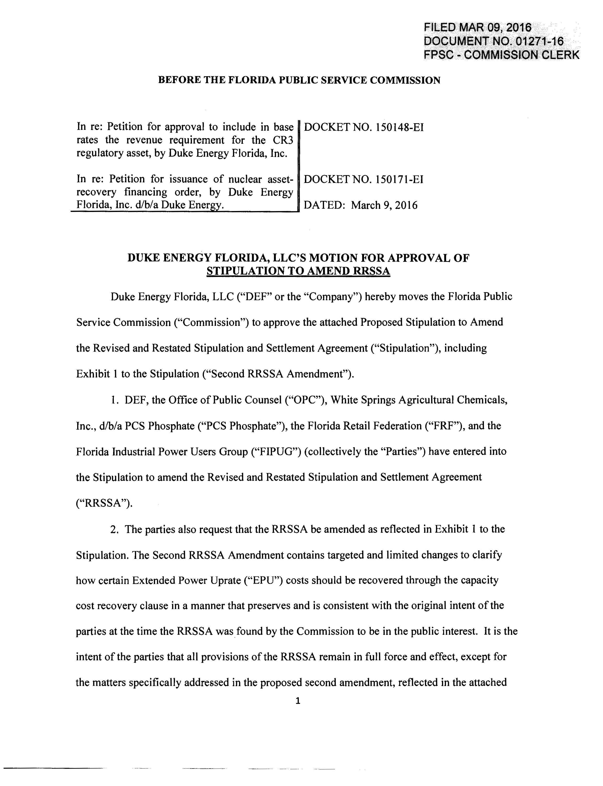

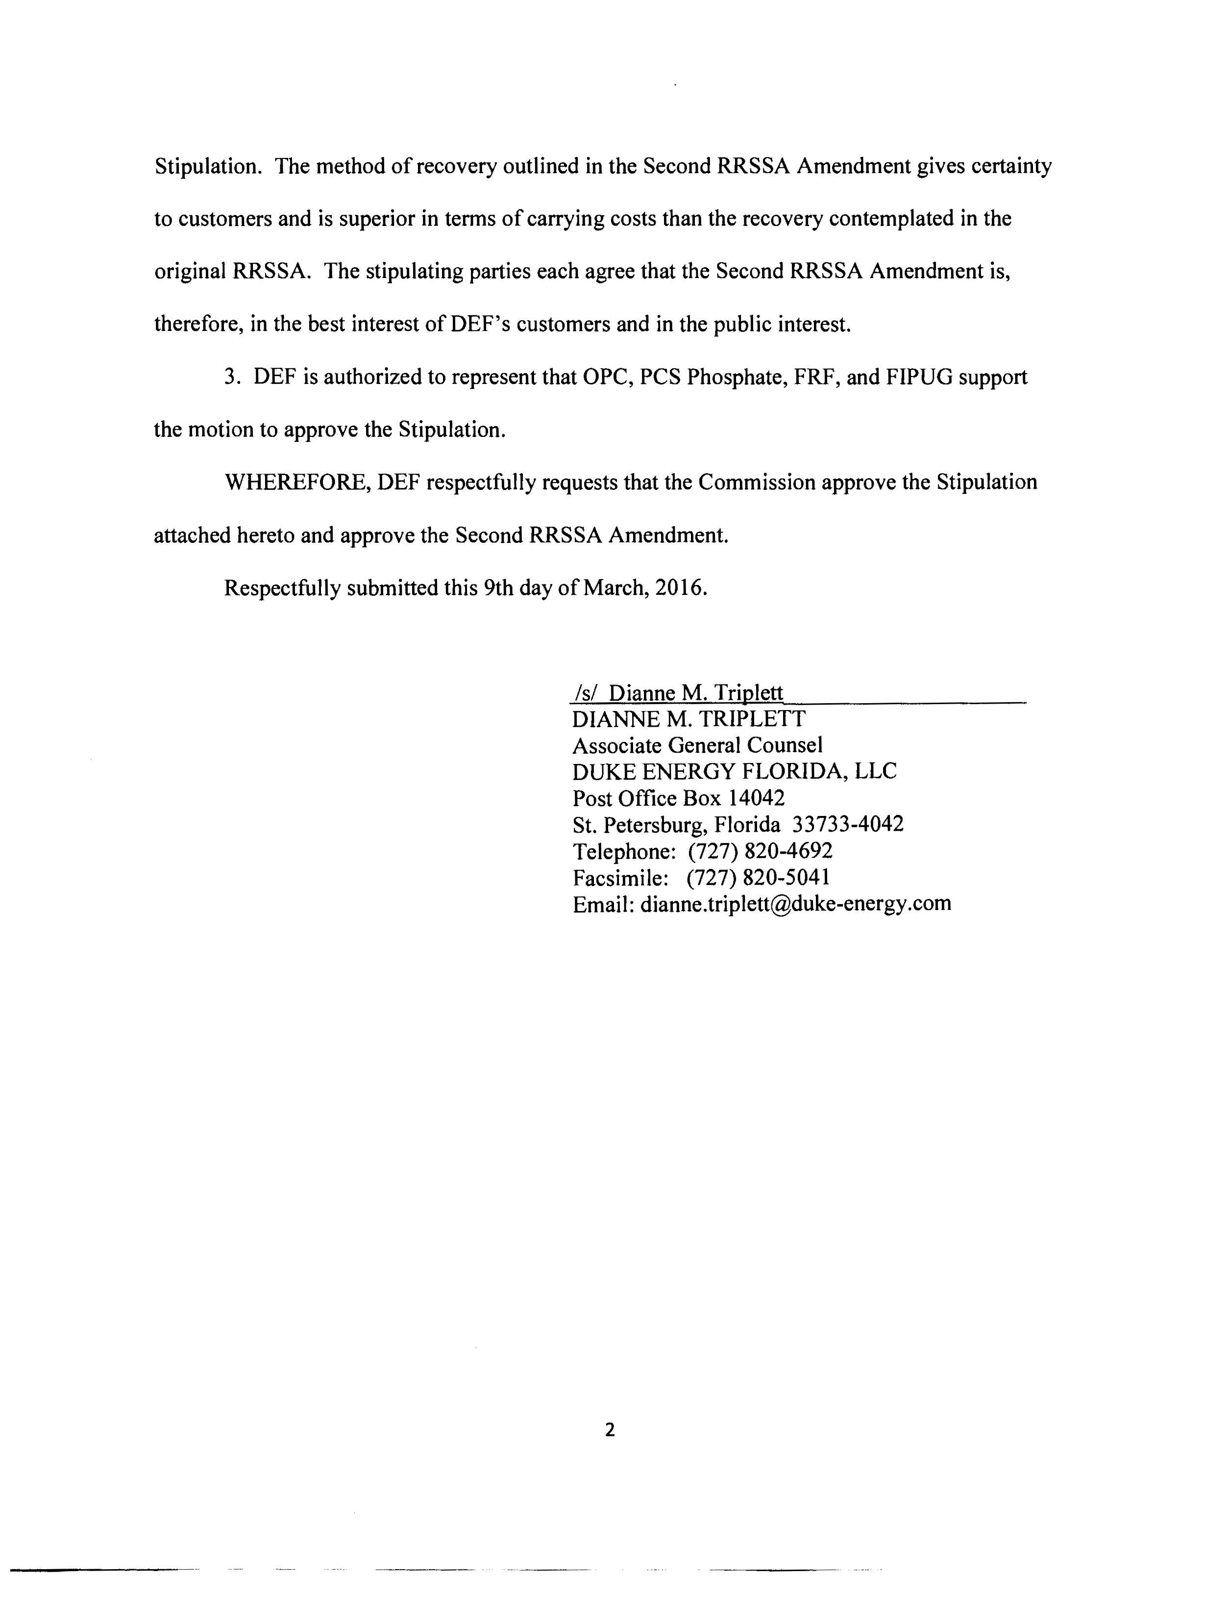

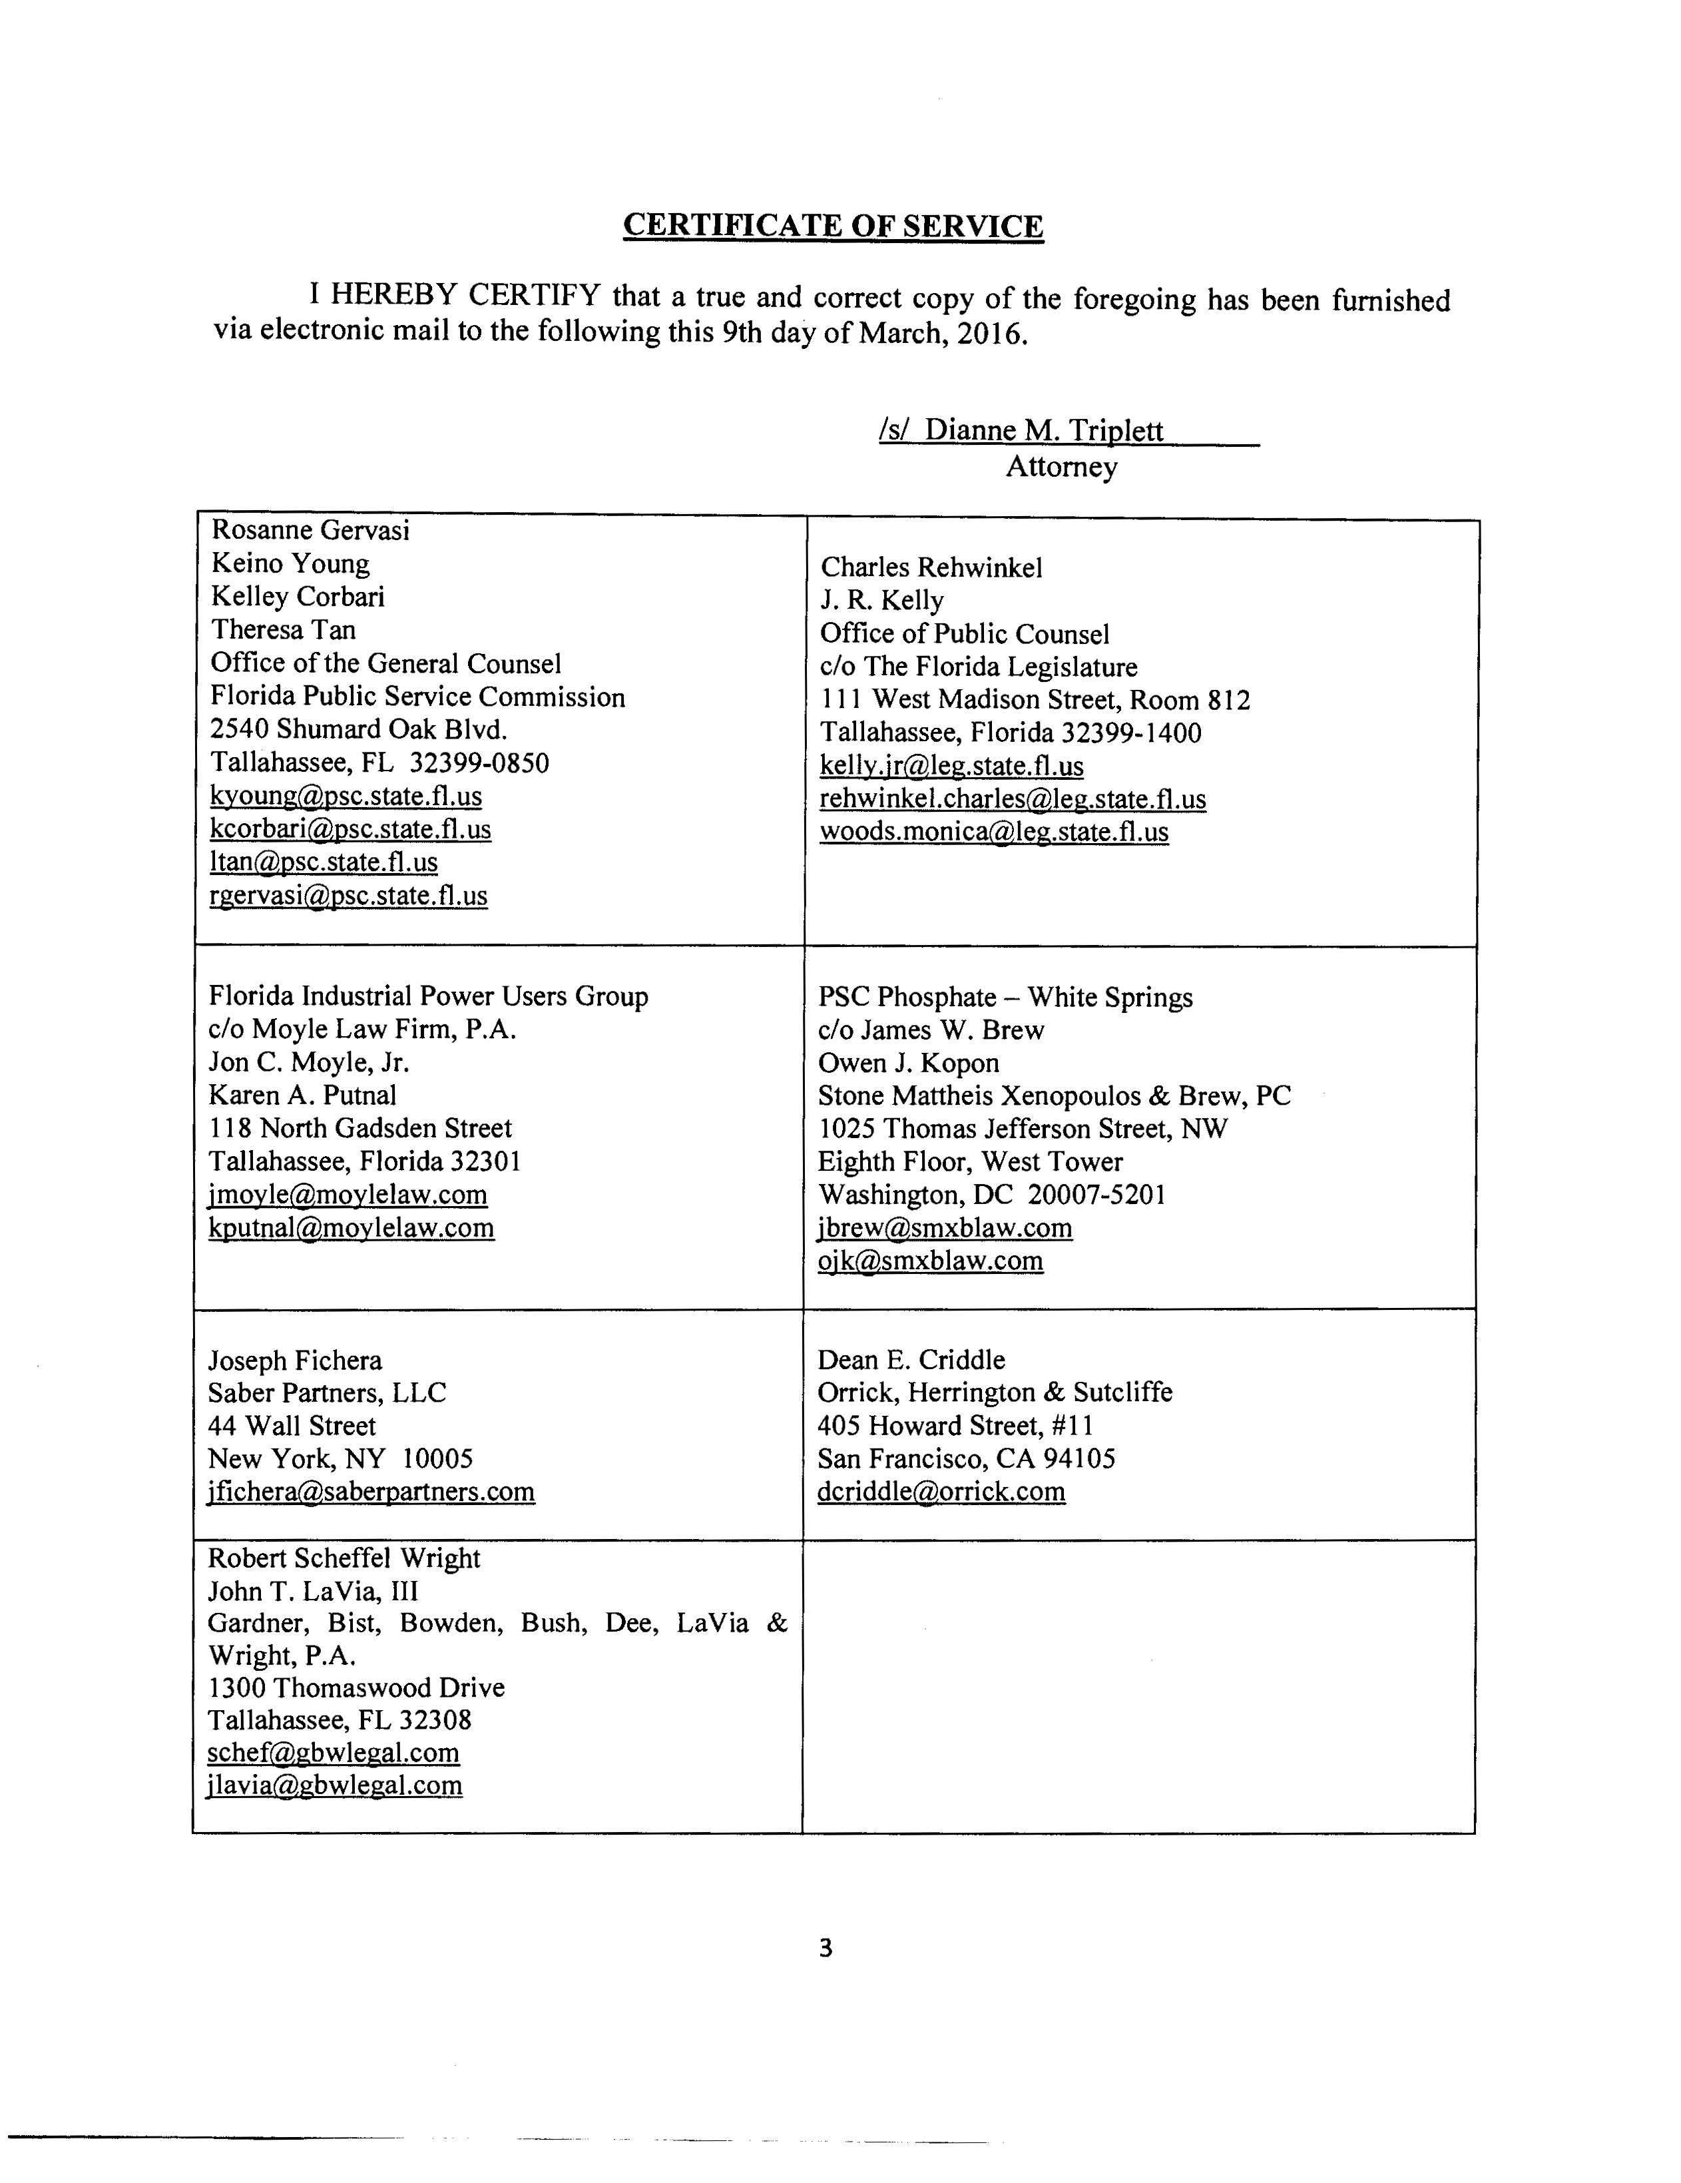

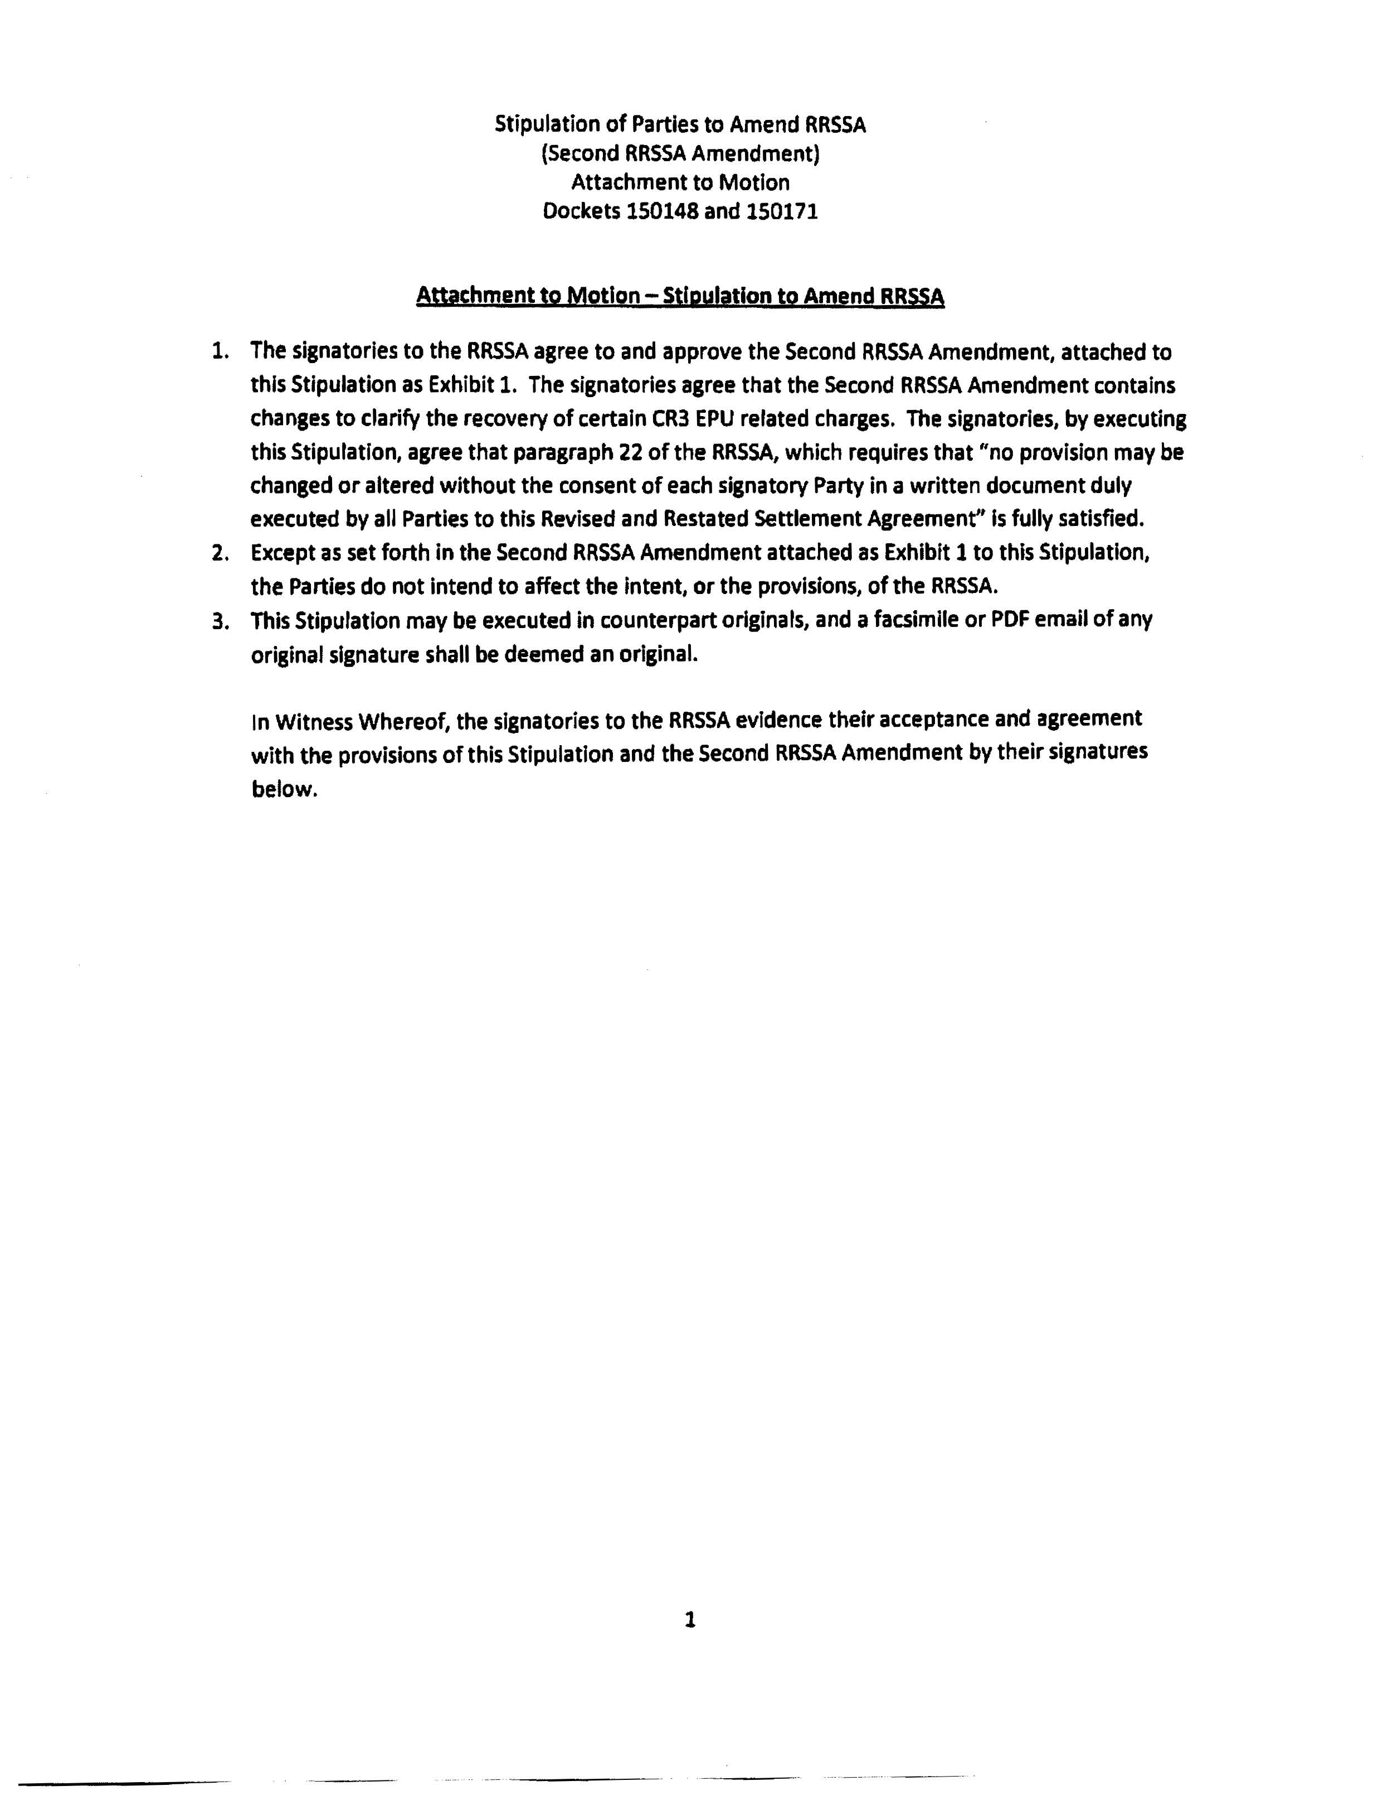

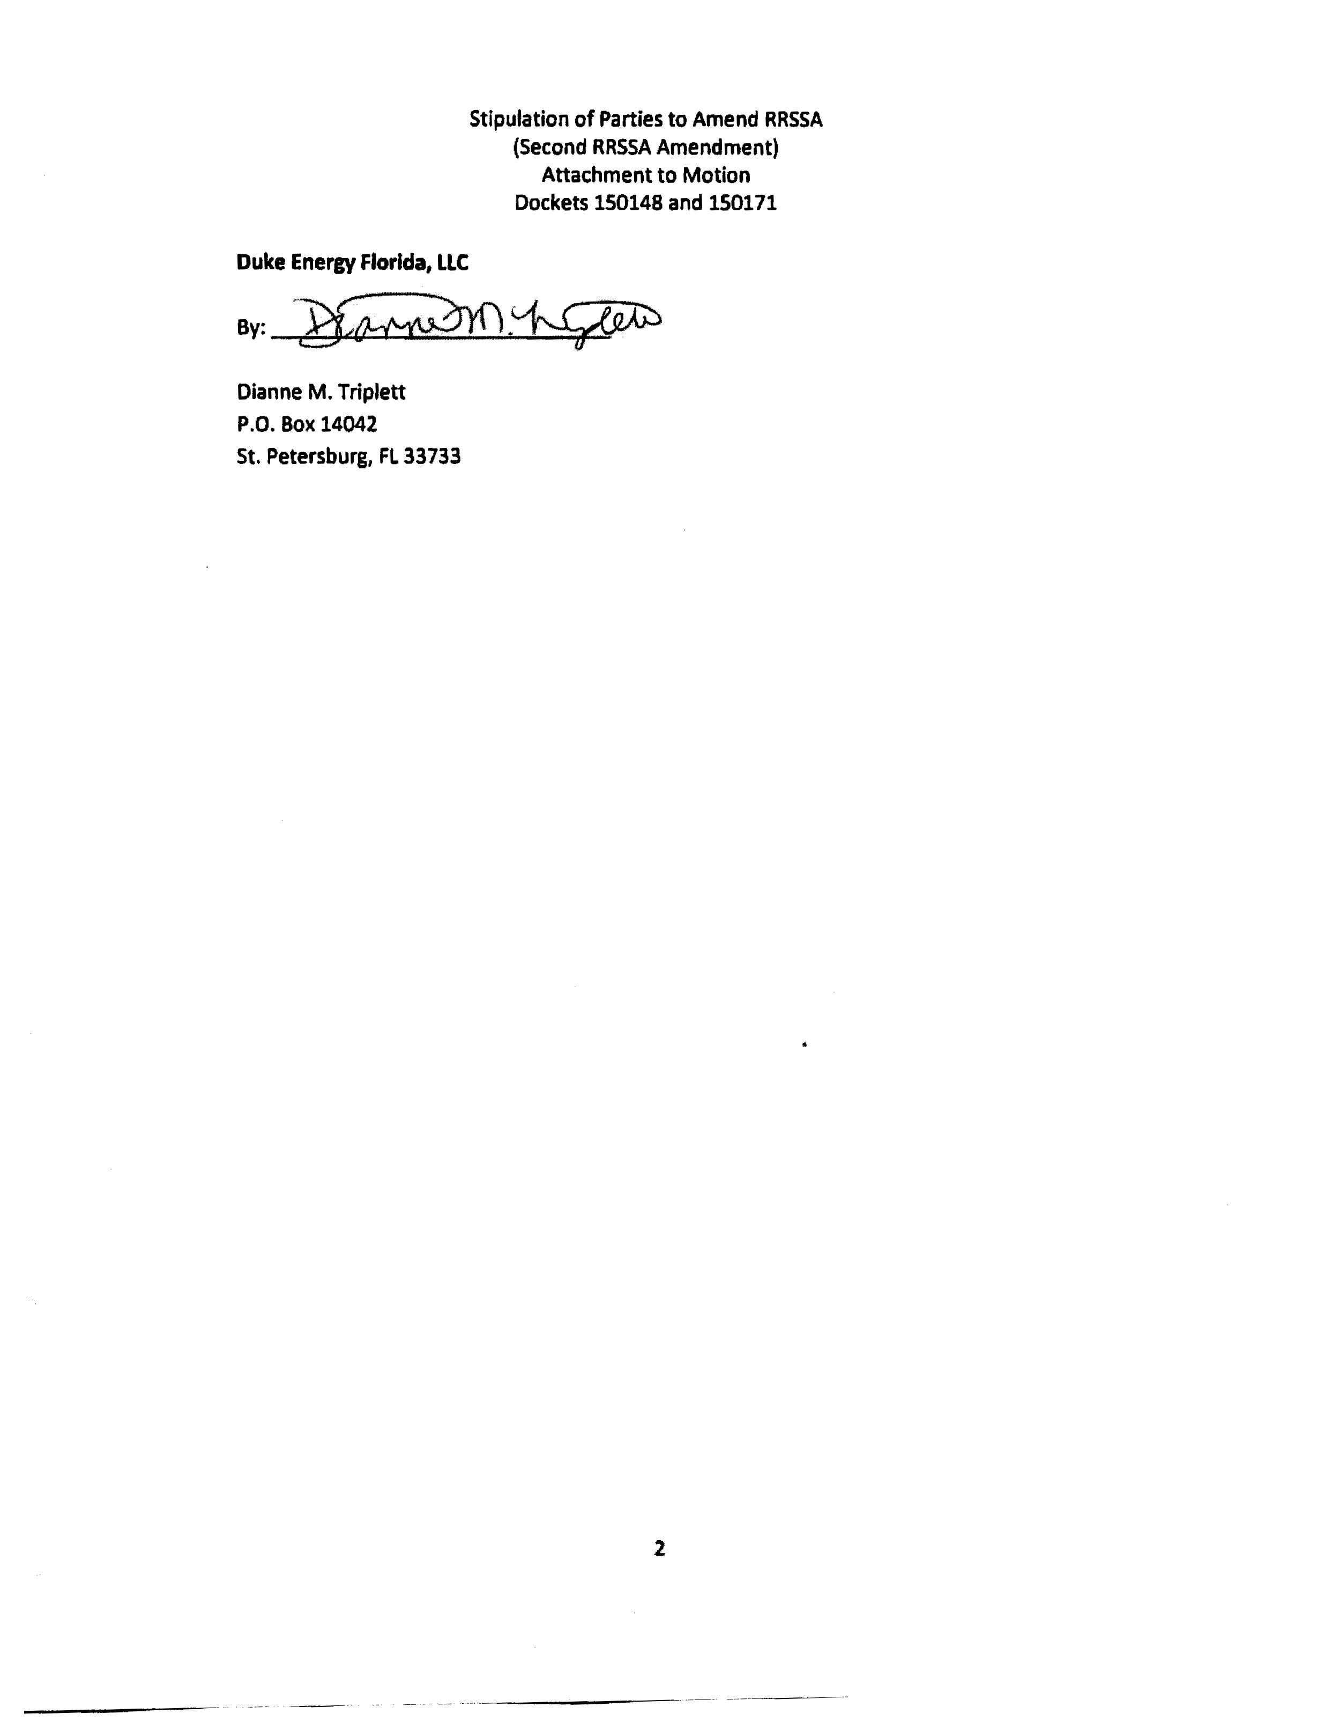

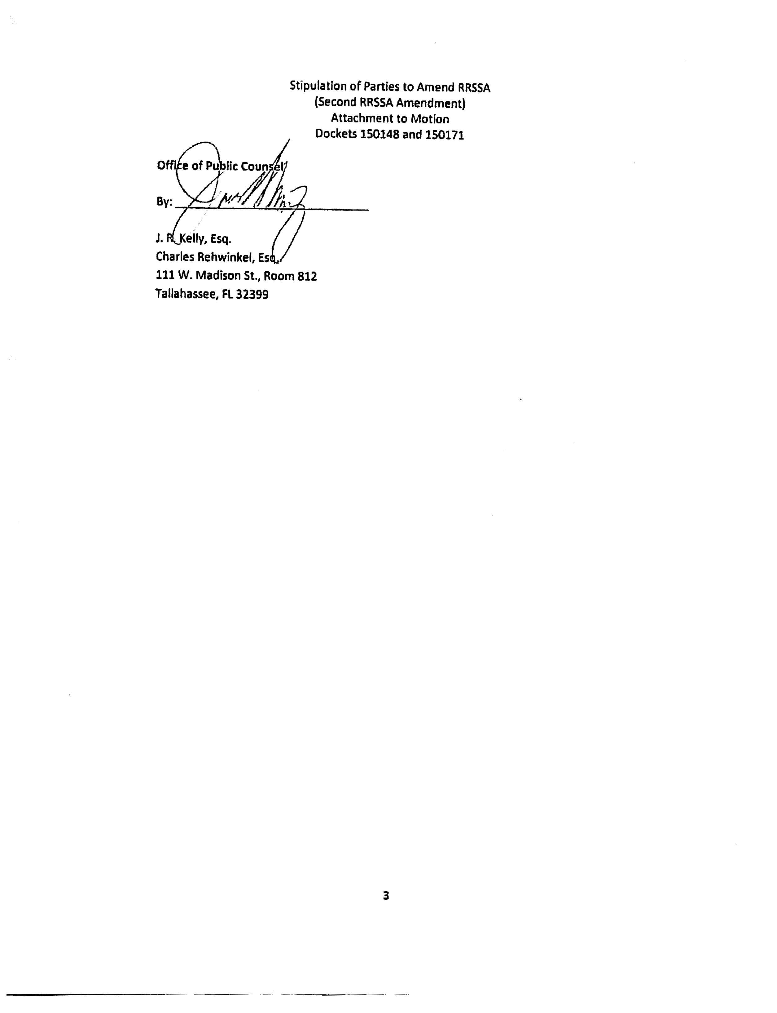

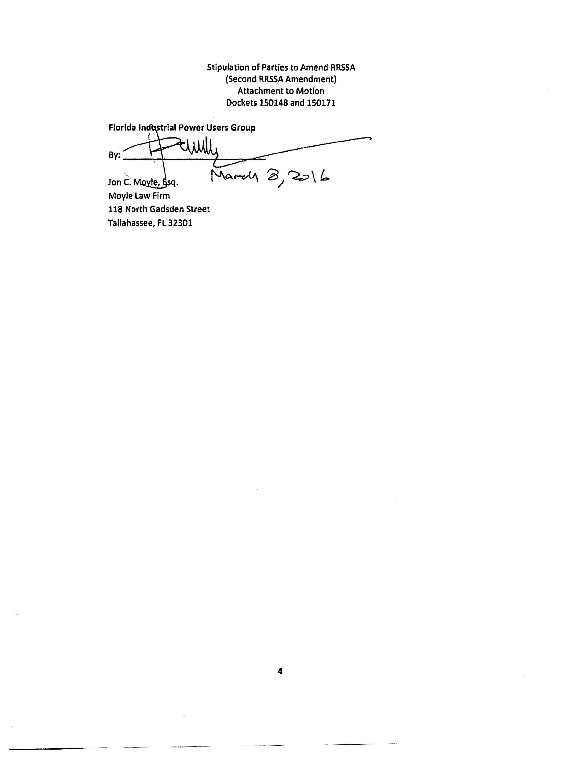

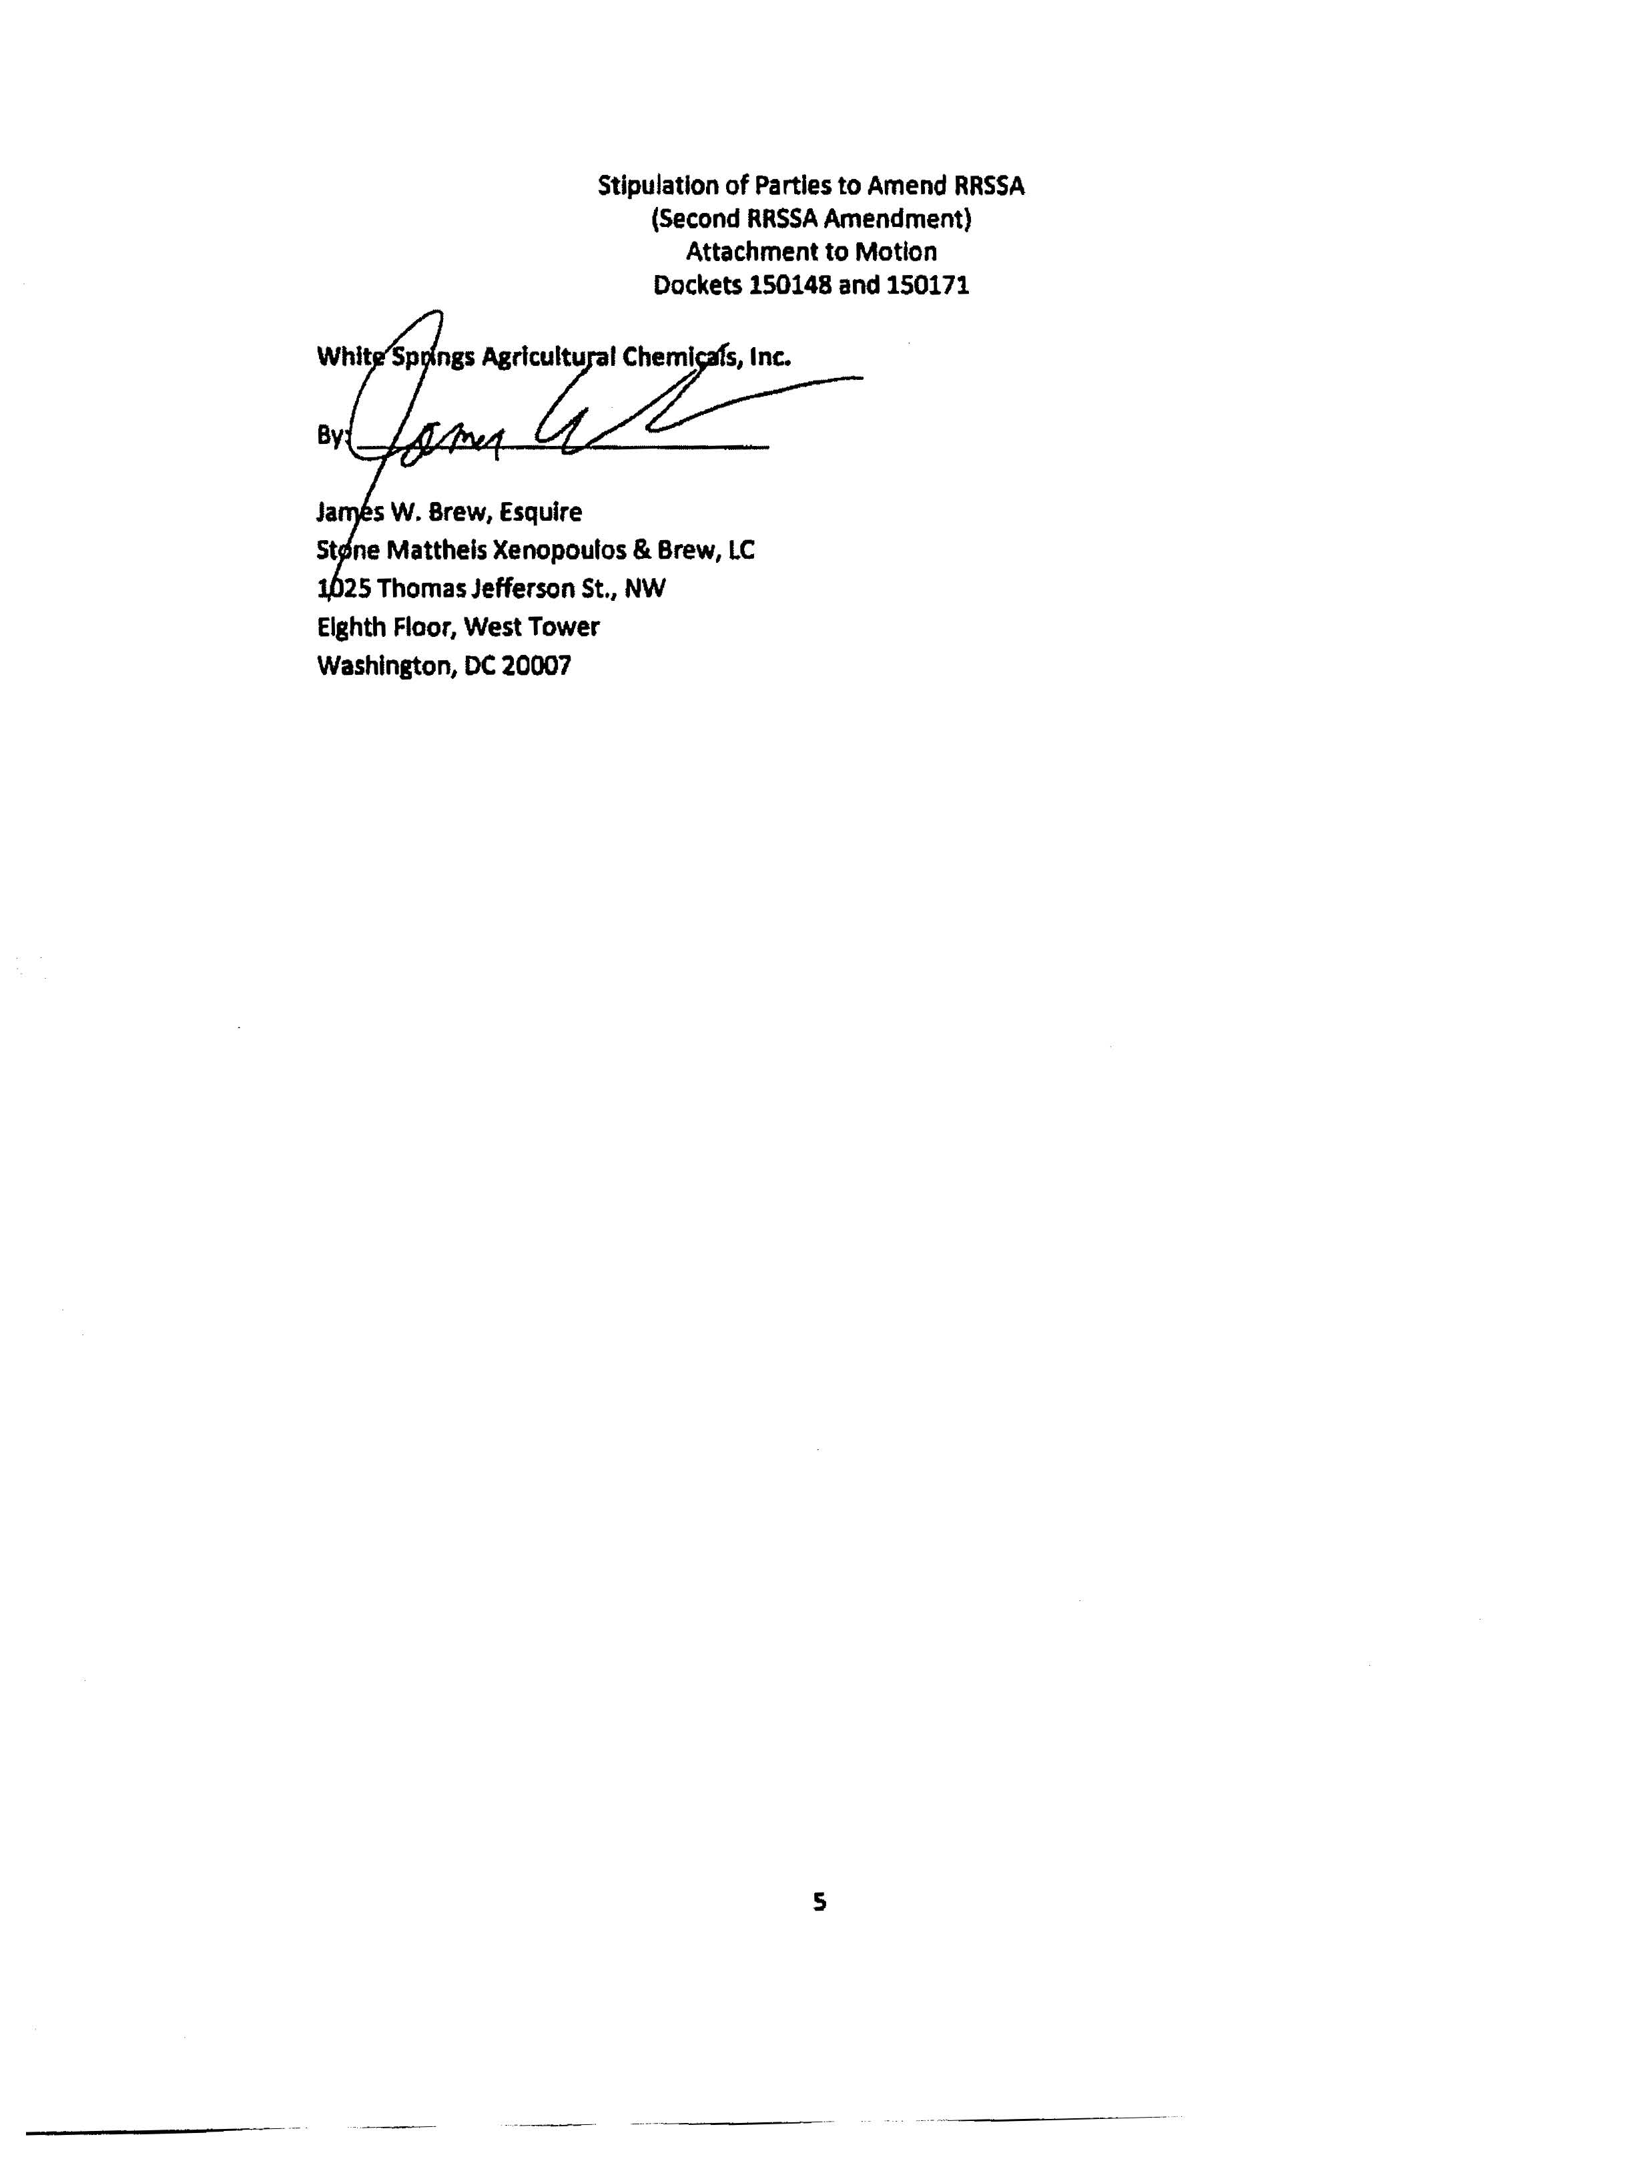

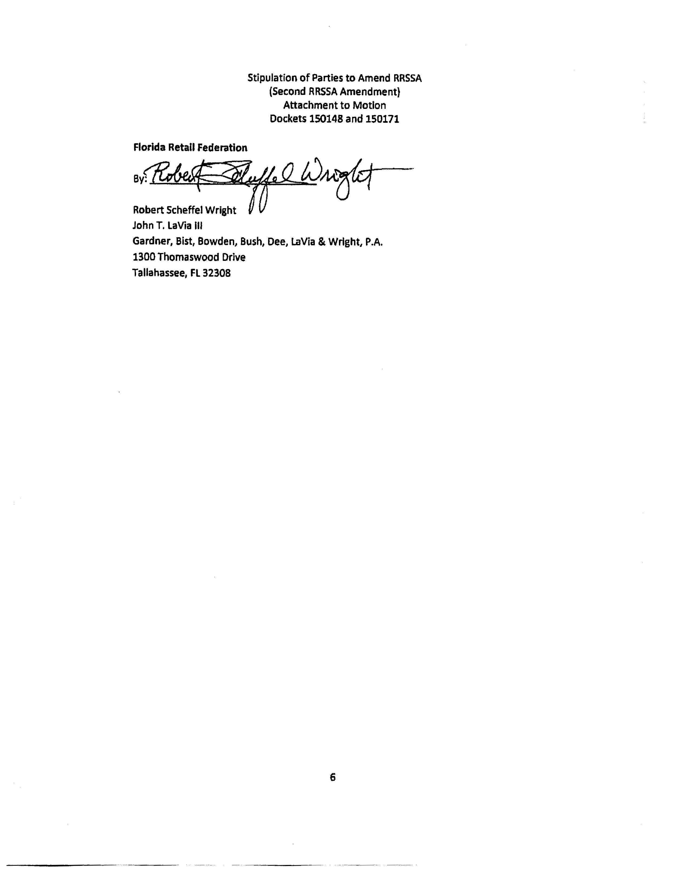

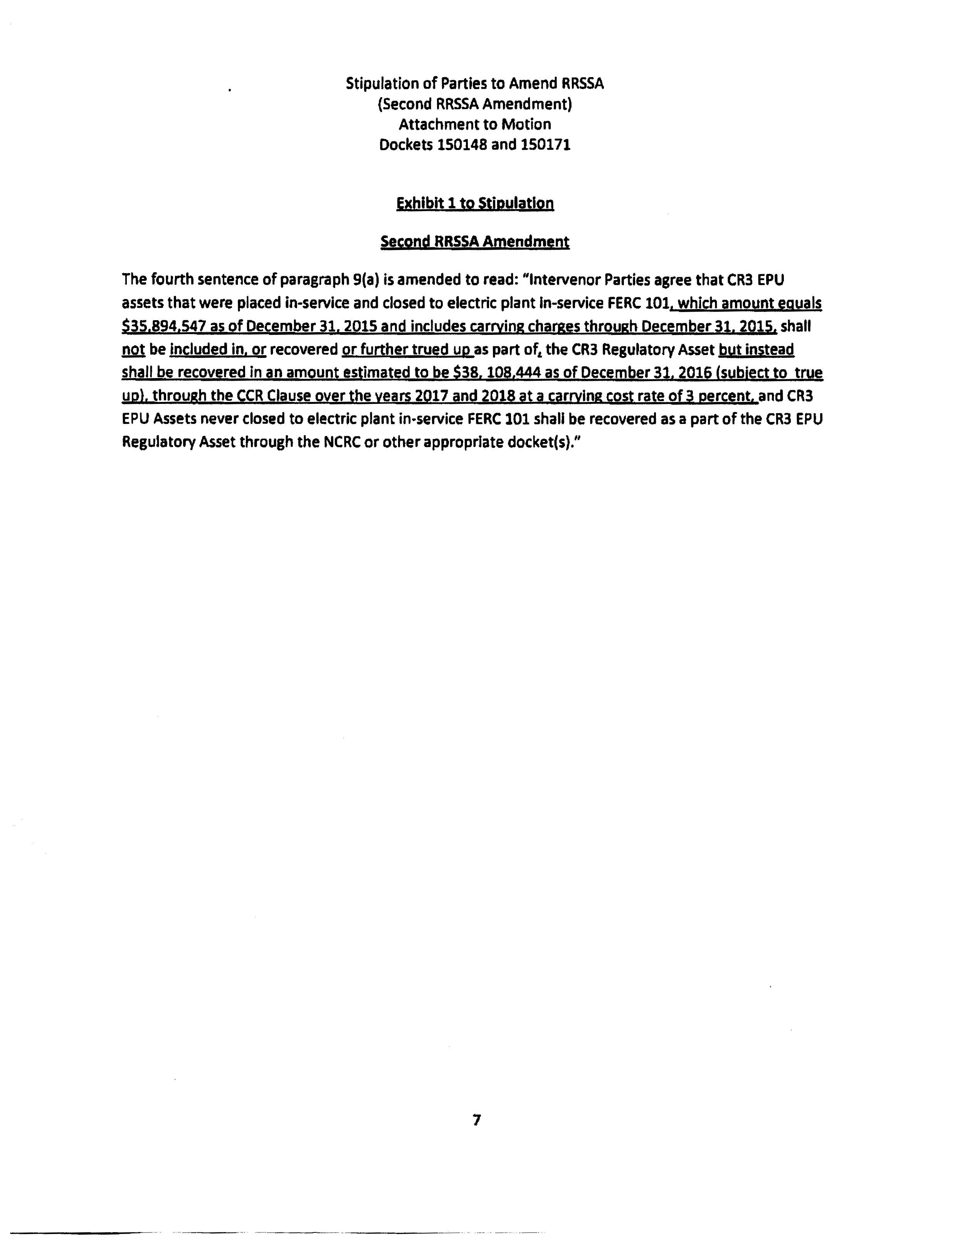

Order No. PSC-12-0104-FOF-EI, issued March 8, 2012, as amended by Order No. PSC-12-0104A-FOF-EI, issued March 15, 2012, in Docket No. 120022-EI, In re: Petition for limited proceeding to approve stipulation and settlement agreement by Progress Energy Florida, Inc. (approving the 2012 settlement agreement).
Order No. PSC-13-0598-FOF-EI, issued November 12, 2013, in Docket No. 130208-EI, as amended by Order No. PSC-13-0598A-FOF-EI, issued November 13, 2013, In re: Petition for limited proceeding to approve revised and restated stipulation and settlement agreement by Duke Energy Florida, Inc. d/b/a Duke Energy.

