BEFORE THE FLORIDA PUBLIC SERVICE COMMISSION

In re: Petition for approval to include in base rates the revenue requirement for the CR3 regulatory asset, by Duke Energy Florida, Inc. | DOCKET NO. 150148-EI
In re: Petition for issuance of nuclear asset-recovery financing order, by Duke Energy Florida, Inc. d/b/a Duke Energy. | DOCKET NO. 150171-EI  ORDER NO. PSC-16-0138-FOF-EI  ISSUED: April 5, 2016

The following Commissioners participated in the disposition of this matter:

JULIE I. BROWN, Chairman
LISA POLAK EDGAR
ART GRAHAM
RONALD A. BRISÉ
JIMMY PATRONIS

FINAL ORDER GRANTING MOTION FOR APPROVAL OF STIPULATION
TO AMEND THE RRSSA

BY THE COMMISSION:

Background
In February 2013, Duke Energy Florida, Inc. (DEF) announced its decision to retire its nuclear plant, Crystal River Unit 3 (CR3), in Citrus County, Florida. The retirement of CR3 was the subject of two settlement agreements. The first settlement agreement, reached in 2012, was a global settlement that addressed several issues, including issues related to the CR3 retirement. The second settlement agreement, the Revised and Restated Stipulation and Settlement Agreement (RRSSA), reached in 2013, replaced and supplanted the 2012 settlement agreement. We approved the RRSSA by Order No. PSC-13-0598-FOF-EI. Among other things, the RRSSA contemplated that DEF would create a regulatory asset to account for the recovery of costs associated with the retirement of CR3. The parties to the RRSSA were DEF, the Office of Public Counsel (OPC), the Florida Industrial Power Users Group (FIPUG), the Florida Retail Federation (FRF), and White Springs Agriculture Chemicals, Inc. d/b/a PCS Phosphate (PCS Phosphate).

Docket No. 150148-EI – CR3 Regulatory Asset

On May 22, 2015, pursuant to Sections 366.04 and 366.05, Florida Statutes (F.S.), DEF filed its Petition for Approval to Include in Base Rates the Revenue Requirement for the Crystal River Unit 3 Regulatory Asset (CR3 Regulatory Asset Petition), along with supporting testimony and exhibits. DEF intended its petition to be the first step in the securitization process, authorized by Section 366.95, F.S.

Docket No. 150171-EI – Financing Order

On July 27, 2015, pursuant to Sections 366.04, 366.05, and 366.95, F.S., and consistent with the RRSSA and its CR3 Regulatory Asset Petition, DEF filed its Petition for Issuance of a Nuclear Asset-Recovery Financing Order (Financing Order Petition), along with supporting testimony and exhibits, requesting that this Commission issue a financing order to permit DEF to securitize certain costs, including the CR3 Regulatory Asset value as outlined in its CR3 Regulatory Asset Petition filed in Docket No. 150148-EI.

Consolidation of Dockets

Along with its Financing Order Petition, DEF also filed a Motion to Consolidate, requesting that its CR3 Regulatory Asset Petition and Financing Order Petition be consolidated pursuant to Rule 28-106.108, Florida Administrative Code (F.A.C.). By Order No. PSC-15-0327-PCO-EI, issued on August 13, 2015, we consolidated Docket Nos. 150148-EI and 150171-EI into Docket No. 150171-EI.

First RRSSA Amendment

On August 31, 2015, DEF filed a Motion for Approval of Stipulation, requesting that we approve the proposed Stipulation reached by the parties to amend the RRSSA. The proposed Stipulation was intended to resolve the CR3 Regulatory Asset-related issues in Docket No. 150148-EI to ensure that the financing order issued in Docket No. 150171-EI would be consistent with the RRSSA.

By Order No. PSC-15-0465-S-EI, issued October 14, 2015, we granted DEF’s Motion for Approval of Stipulation and found that the RRSSA, as amended, was in the public interest.

Financing Order

By Order No. PSC-15-0537-FOF-EI (Financing Order), issued November 19, 2015, in these dockets, we approved DEF’s Financing Order Petition, subject to the terms set forth in the body of the Financing Order. The Financing Order permits DEF to securitize certain costs, including the CR3 Regulatory Asset value as outlined in its CR3 Regulatory Asset Petition filed in Docket No. 150148-EI.

Motion for Approval of Second RRSSA Amendment

On March 9, 2016, DEF filed a Motion for Approval of Stipulation to Amend the RRSSA (Second RRSSA Amendment), as reflected in Exhibit 1 to the Stipulation. All parties to the RRSSA, including DEF, OPC, PCS Phosphate, FRF, and FIPUG, are signatories to the Second RRSSA Amendment. This Order addresses the Motion for approval of the Second RRSSA Amendment. We have has jurisdiction pursuant to Sections 366.04 and 366.05, F.S.
In its Motion for approval of the Second RRSSA Amendment, DEF states that the parties request that the RRSSA be amended as reflected in Exhibit 1 to the Stipulation. Exhibit 1 to the Stipulation contains targeted and limited changes to clarify how certain Extended Power Uprate (“EPU”) costs should be recovered through the capacity cost recovery clause in a manner that preserves, and is consistent with, the original intent of the parties at the time the RRSSA was found by this Commission to be in the public interest. Exhibit 1 to the Stipulation reads as follows:
The fourth sentence of paragraph 9(a) is amended to read: “Intervenor Parties agree that CR3 EPU assets that were placed in-service and closed to electric plant in-service FERC 101, which amount equals $35,894,547 as of December 31, 2015 and includes carrying charges through December 31, 2015, shall not be included in, or recovered or further trued up as part of, the CR3 Regulatory Asset but instead shall be recovered in an amount estimated to be $38,108,444 as of December 31, 2016 (subject to true up), through the CCR Clause over the years 2017 and 2018 at a carrying cost rate of 3 percent, and CR3 EPU Assets never closed to electric plant in-service FERC 101 shall be recovered as a part of the CR3 EPU Regulatory Asset through the NCRC or other appropriate docket(s).
DEF further states that it is the intent of the parties that all provisions of the RRSSA remain in full force and effect, except for the matters specifically addressed in the proposed Second RRSSA Amendment. According to DEF, the method of recovery outlined in the Second RRSSA Amendment gives certainty to customers and is superior in terms of carrying costs than the recovery contemplated in the original RRSSA. The stipulating parties each agree that the Second RRSSA Amendment is therefore in the best interest of DEF’s customers and in the public interest. The Second RRSSA Amendment, including Exhibit 1 to the Stipulation, is attached to this Order as Attachment A.
For the reasons stated in the Motion, we agree that the proposed Second RRSSA Amendment as reflected in Exhibit 1 to the Stipulation is in the public interest, and we hereby grant the Motion to approve it.
Based on the foregoing, it is
ORDERED by the Florida Public Service Commission that Duke Energy Florida, LLC’s Motion for Approval of Stipulation to Amend the RRSSA (Second RRSSA Amendment), as reflected in Exhibit 1 to the Stipulation, is granted. It is further
ORDERED that the Stipulation to Amend the RRSSA (Second RRSSA Amendment), as reflected in Exhibit 1 to the Stipulation and attached hereto as Attachment A, is approved. It is further
ORDERED that Attachment A to this Order is incorporated herein by reference. It is further
ORDERED that these dockets shall remain open through completion of this Commission’s review of the actual costs of the nuclear asset-recovery bond issuance conducted pursuant to Section 366.95(2)(c)5., F.S., and the Financing Order.
By ORDER of the Florida Public Service Commission this 5th day of April, 2016.

/s/ Carlotta S. Stauffer
CARLOTTA S. STAUFFER
Commission Clerk
Florida Public Service Commission
2540 Shumard Oak Boulevard
Tallahassee, Florida 32399
(850) 413-6770
www.floridapsc.com

Copies furnished: A copy of this document is provided to the parties of record at the time of issuance and, if applicable, interested persons.

RG

NOTICE OF FURTHER PROCEEDINGS OR JUDICIAL REVIEW

The Florida Public Service Commission is required by Section 120.569(1), Florida Statutes, to notify parties of any administrative hearing or judicial review of Commission orders that is available under Sections 120.57 or 120.68, Florida Statutes, as well as the procedures and time limits that apply. This notice should not be construed to mean all requests for an administrative hearing or judicial review will be granted or result in the relief sought.

Any party adversely affected by the Commission's final action in this matter may request: 1) reconsideration of the decision by filing a motion for reconsideration with the Office of Commission Clerk, 2540 Shumard Oak Boulevard, Tallahassee, Florida 32399-0850, within fifteen (15) days of the issuance of this order in the form prescribed by Rule 25-22.060, Florida Administrative Code; or 2) judicial review by the Florida Supreme Court in the case of an electric, gas or telephone utility or the First District Court of Appeal in the case of a water and/or wastewater utility by filing a notice of appeal with the Office of Commission Clerk, and filing a copy of the notice of appeal and the filing fee with the appropriate court. This filing must be completed within thirty (30) days after the issuance of this order, pursuant to Rule 9.110, Florida Rules of Appellate Procedure. The notice of appeal must be in the form specified in Rule 9.900(a), Florida Rules of Appellate Procedure.

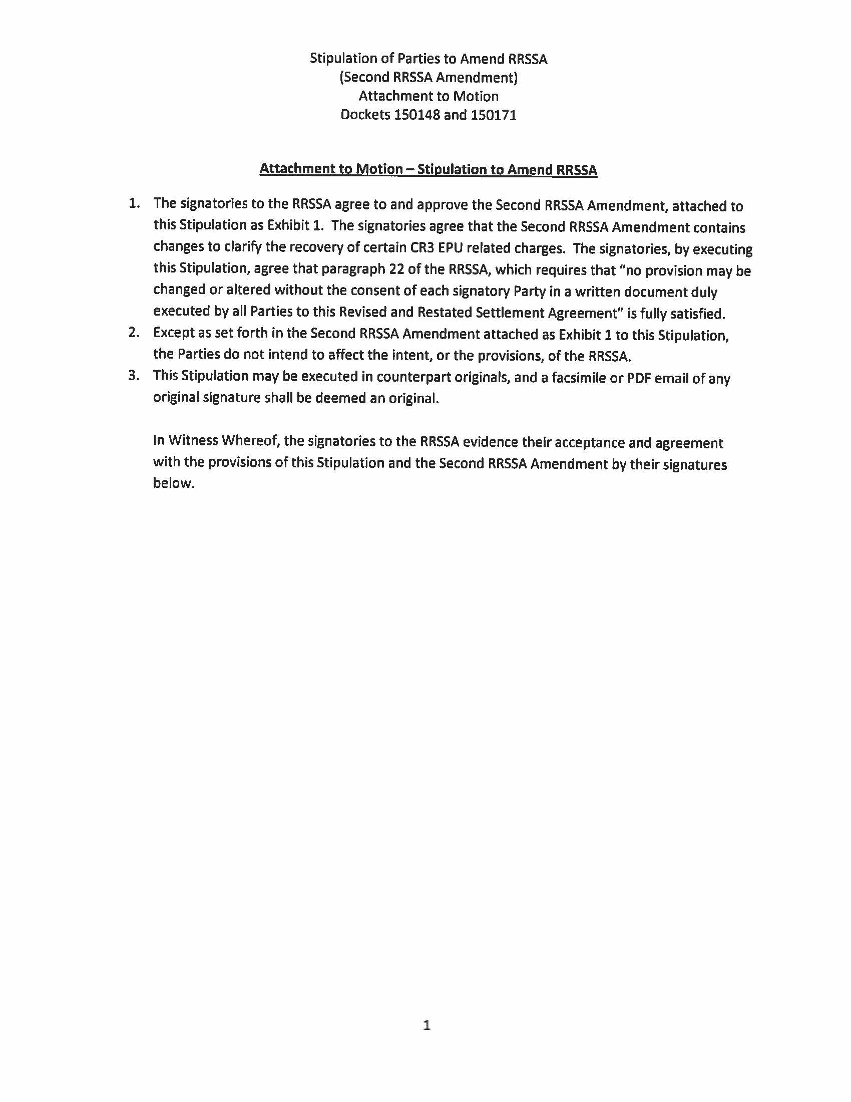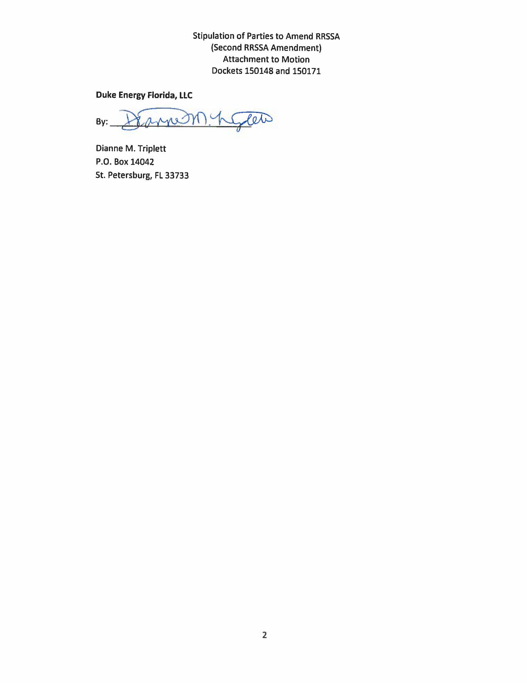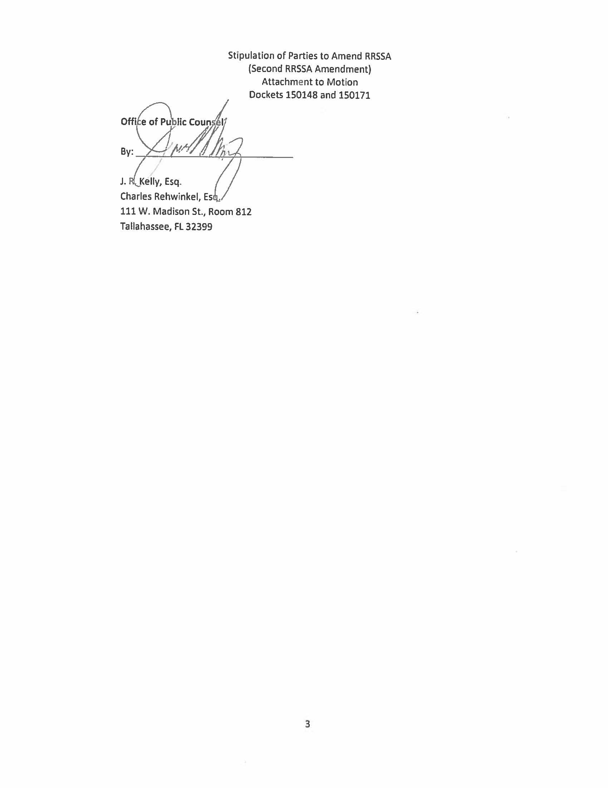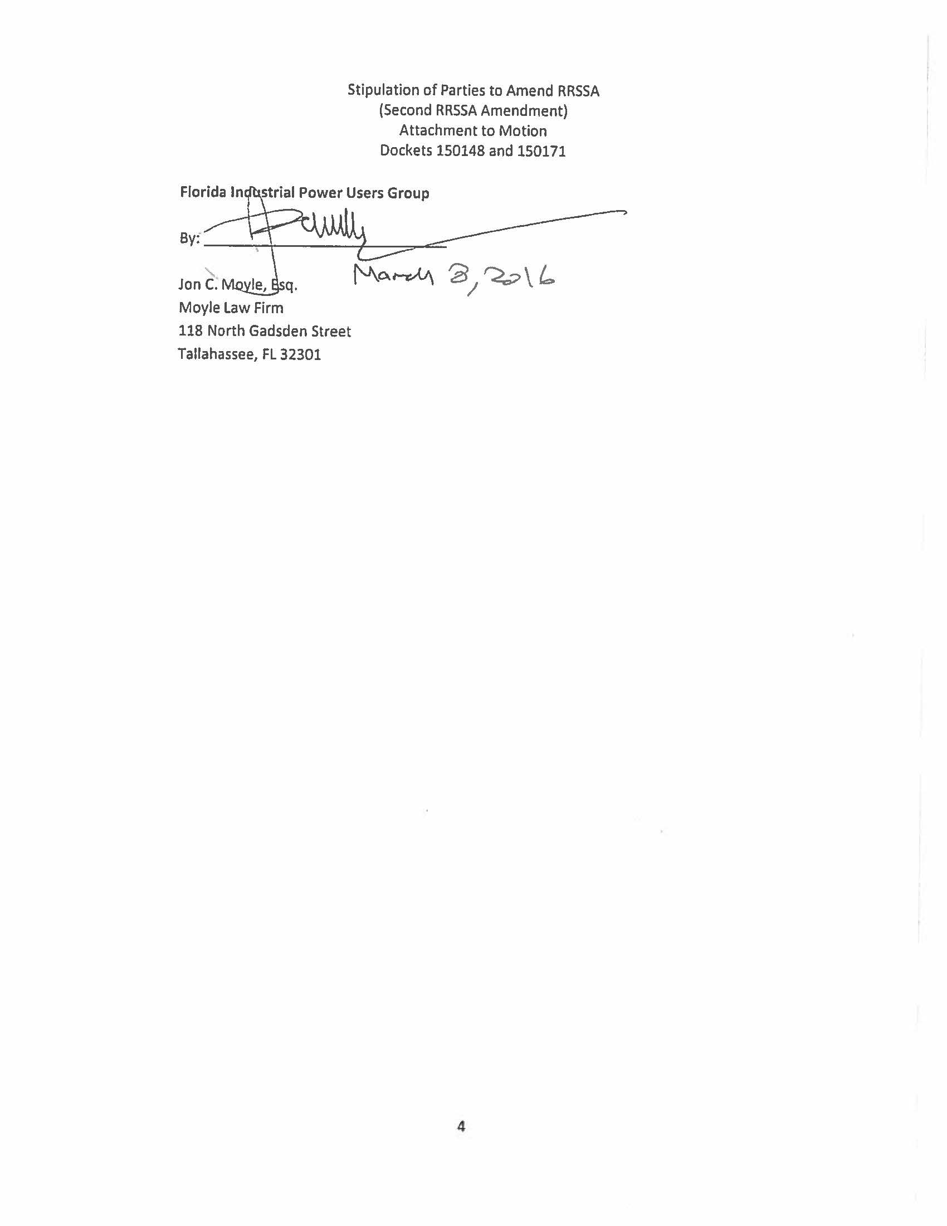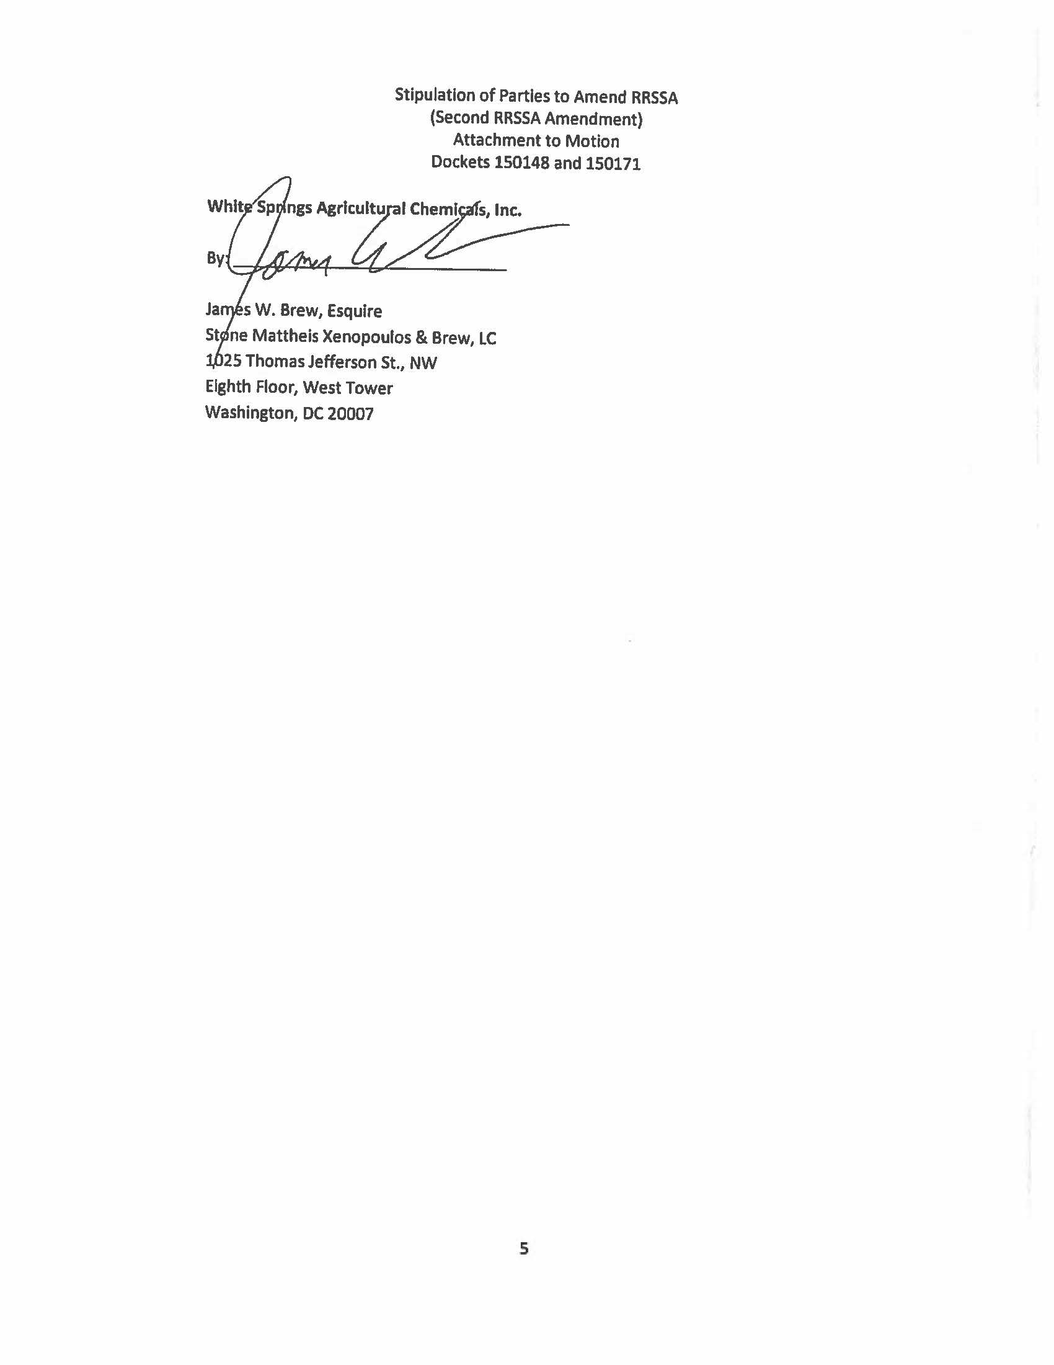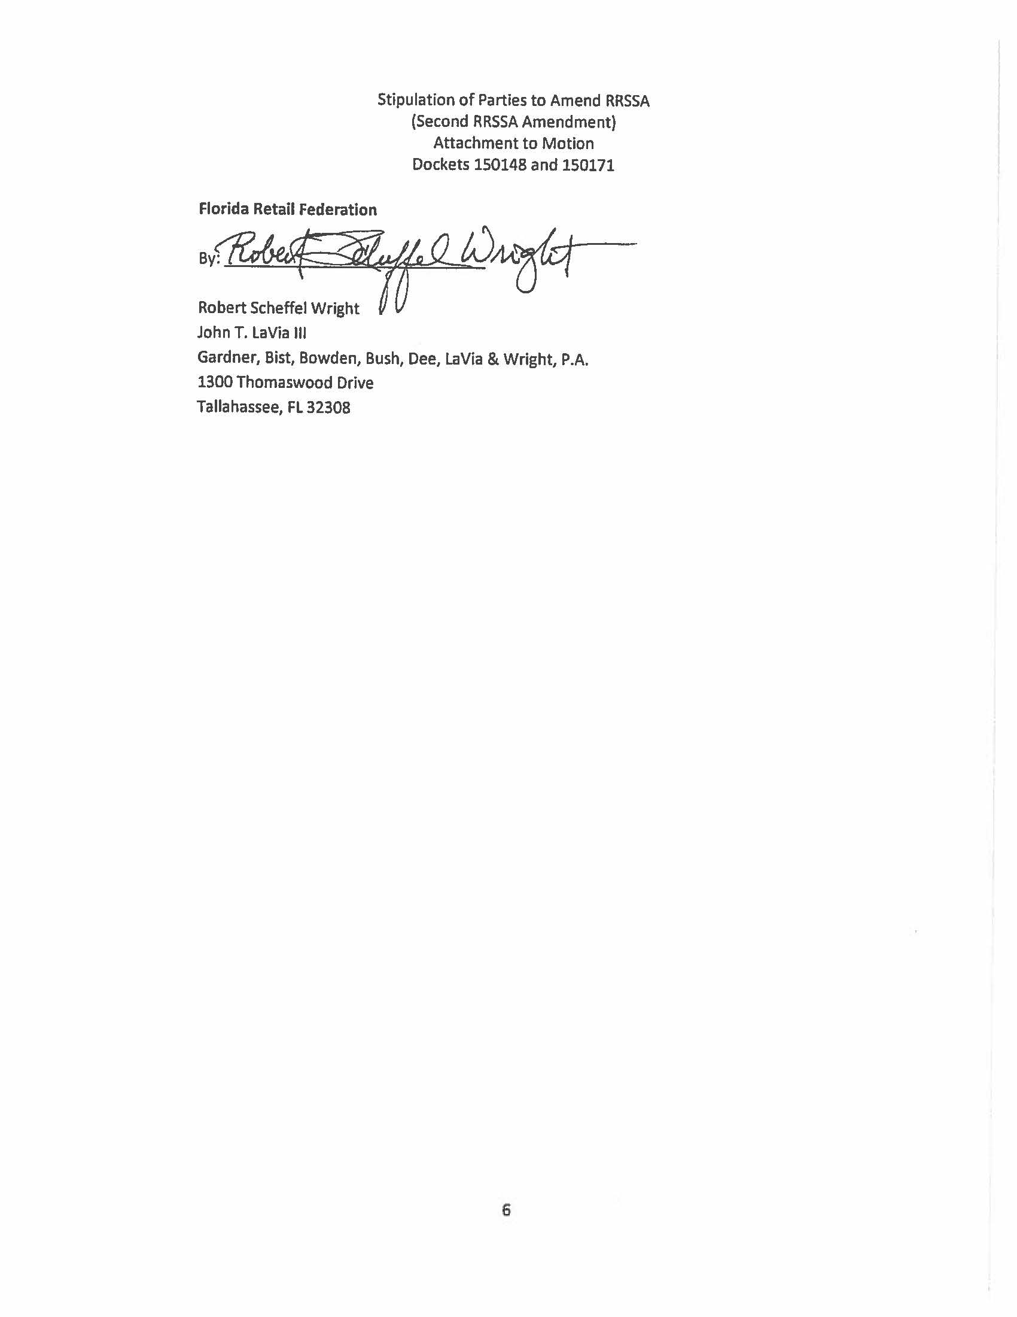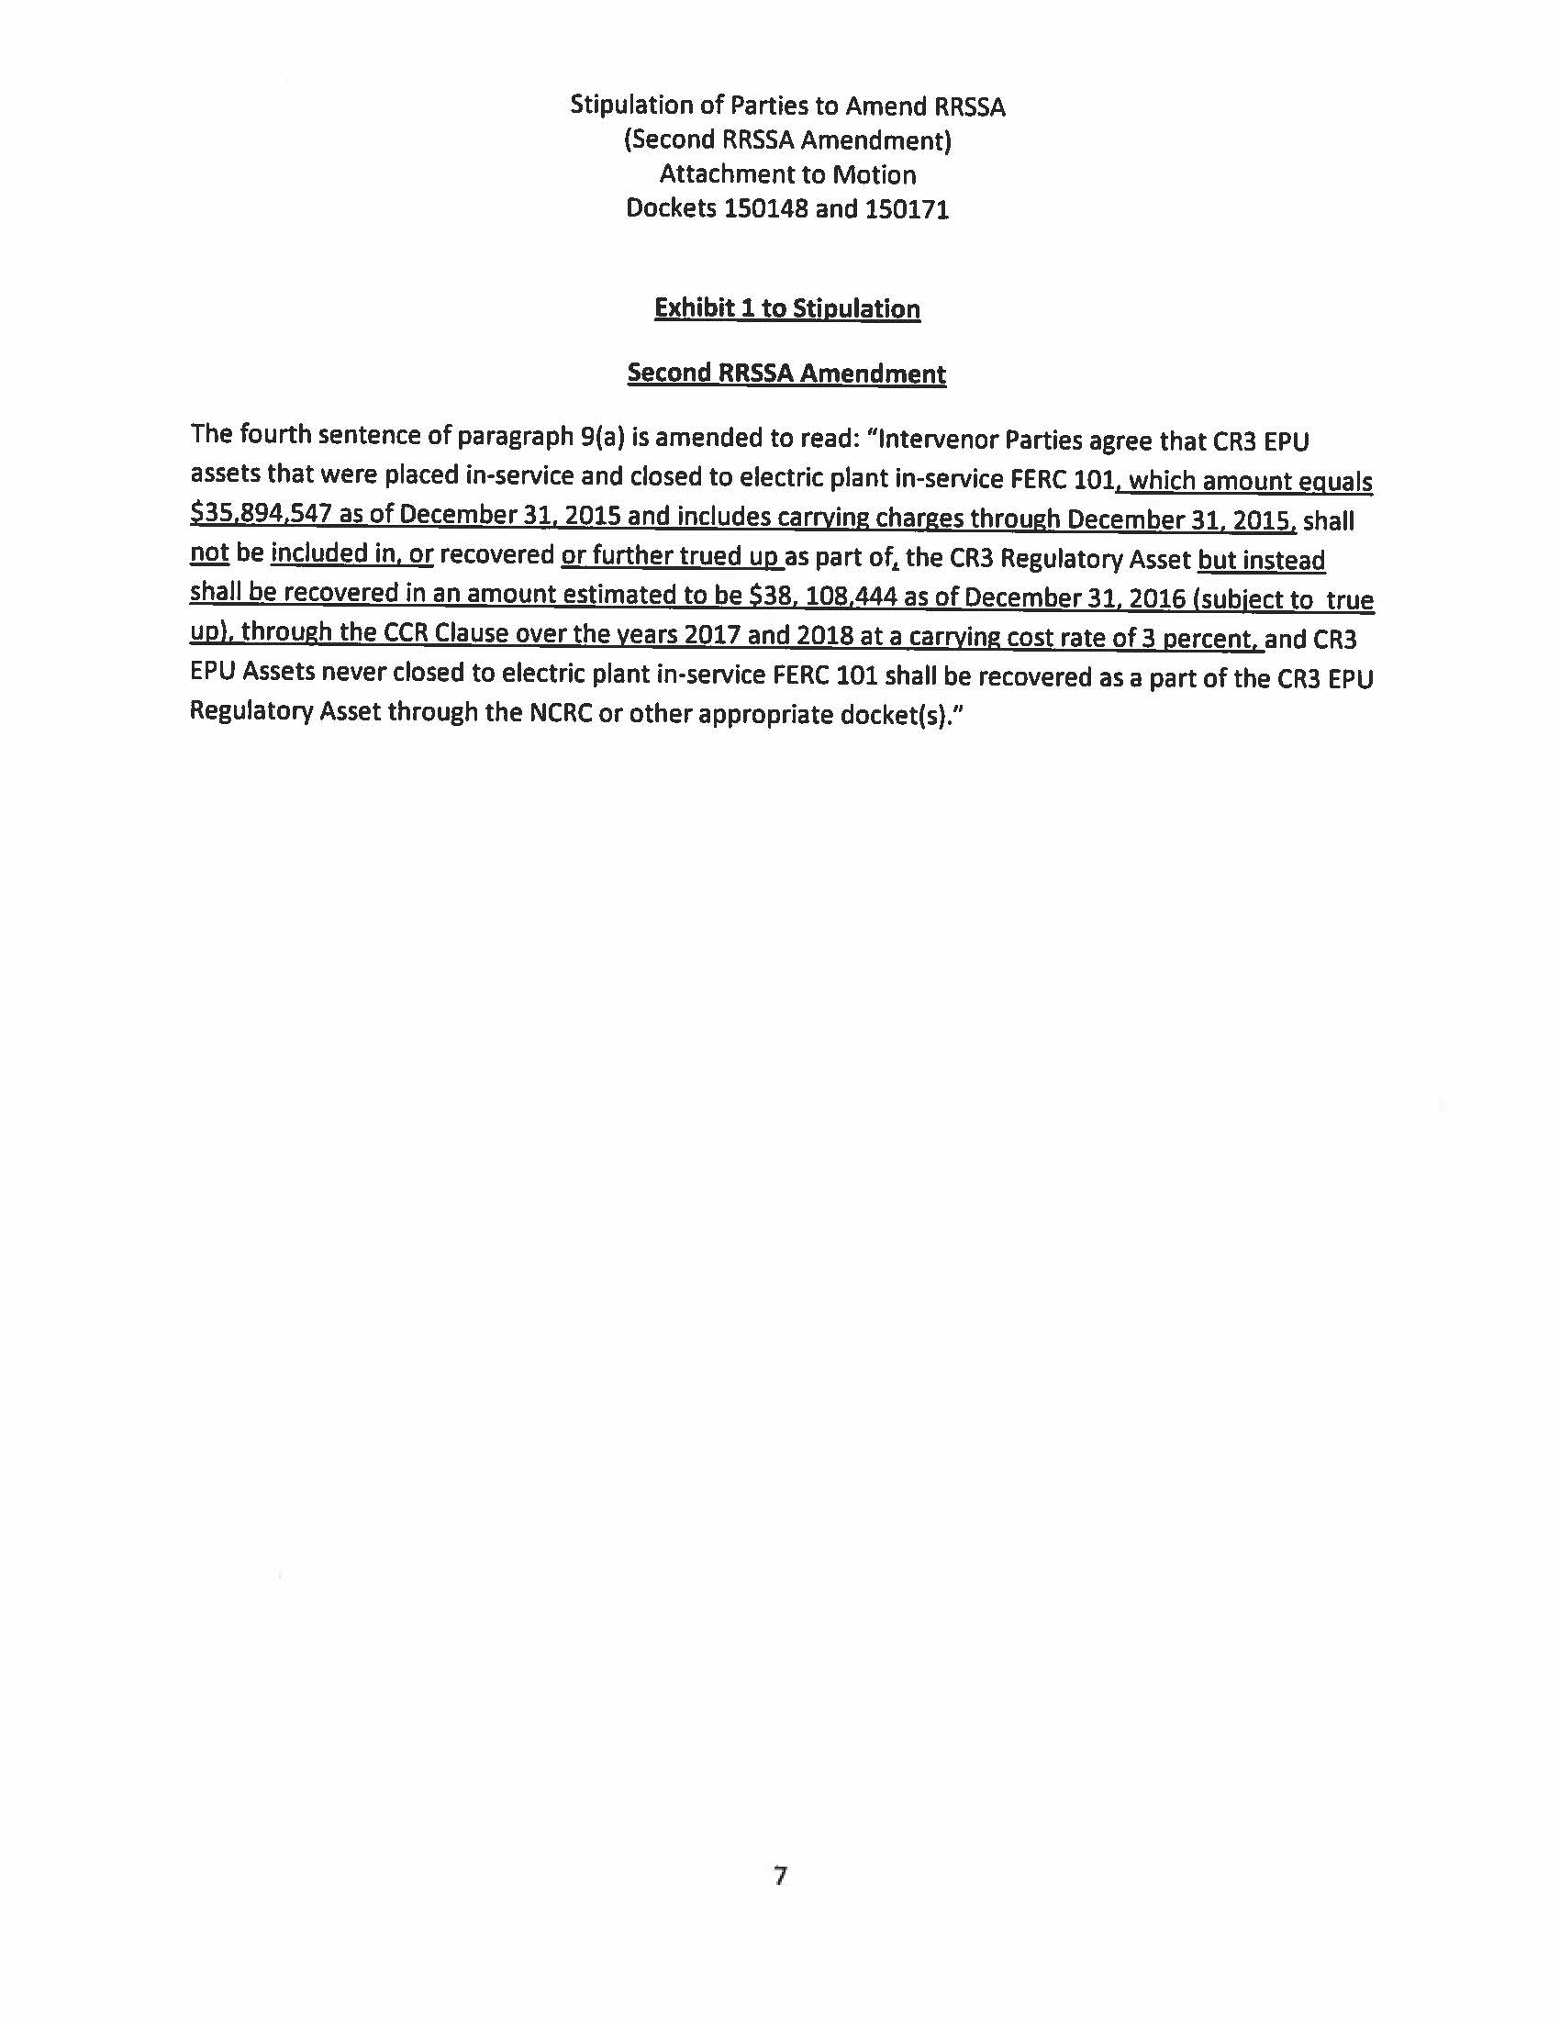

Order No. PSC-12-0104-FOF-EI, issued March 8, 2012, as amended by Order No. PSC-12-0104A-FOF-EI, issued March 15, 2012, in Docket No. 120022-EI, In re: Petition for limited proceeding to approve stipulation and settlement agreement by Progress Energy Florida, Inc. (approving the 2012 settlement agreement).
Order No. PSC-13-0598-FOF-EI, issued November 12, 2013, in Docket No. 130208-EI, as amended by Order No. PSC-13-0598A-FOF-EI, issued November 13, 2013, In re: Petition for limited proceeding to approve revised and restated stipulation and settlement agreement by Duke Energy Florida, Inc. d/b/a Duke Energy.

