State of Florida |  | Public Service Commission  Capital Circle Office Center ● 2540 Shumard Oak Boulevard  Tallahassee, Florida 32399-0850  -M-E-M-O-R-A-N-D-U-M-
DATE: | May 26, 2016
TO: | Office of Commission Clerk (Stauffer)
FROM: | Division of Accounting and Finance (Buys, Archer, Bulecza-Banks, Cicchetti, Yeazel)  Office of the General Counsel (Leathers)
RE: | Docket No. 160006-WS – Water and wastewater industry annual reestablishment of authorized range of return on common equity for water and wastewater utilities pursuant to Section 367.081(4)(f), F.S.
AGENDA: | 06/09/16 – Regular Agenda – Proposed Agency Action – Interested Persons May Participate
COMMISSIONERS ASSIGNED: |  |  | All Commissioners
PREHEARING OFFICER: |  |  | Brisé
CRITICAL DATES: |  |  | None
SPECIAL INSTRUCTIONS: |  |  | None

Case Background
Section 367.081(4)(f), Florida Statutes (F.S.), authorizes the Commission to establish, not less than once each year, a leverage formula to calculate a reasonable range of returns on equity (ROE) for water and wastewater (WAW) utilities. The leverage formula methodology currently in use was established in Order No. PSC-01-2514-FOF-WS. On October 23, 2008, the Commission held a formal hearing in Docket No. 080006-WS to allow interested parties to provide testimony regarding the validity of the leverage formula. Based on the record in that proceeding, the Commission approved the 2008 leverage formula in Order No. PSC-08-0846-FOF-WS. In that order, the Commission reaffirmed the methodology that was previously approved in Order No. PSC-01-2514-FOF-WS.
Staff continues to use the leverage formula methodology established in Order No. PSC-01-2514-FOF-WS and reaffirmed in Order No. PSC-08-0846-FOF-WS. This methodology uses ROEs derived from financial models applied to an index of natural gas utilities. Based on the results of staff’s annual review, there are an insufficient number of WAW utilities that meet the requisite criteria to assemble an appropriate proxy group using only WAW utilities. Therefore, since 2001, the Commission has used natural gas utilities as the proxy companies for the leverage formula. There are many natural gas utilities that have actively traded stocks and forecasted financial data. Staff uses natural gas utilities that derive at least 49 percent of their revenue from regulated rates. These utilities have market power and are influenced significantly by economic regulation. As explained in Issue 1, the model results based on natural gas utilities are adjusted to reflect the risks faced by Florida WAW utilities.
The Commission approved the current leverage formula in 2011 by Order No. PSC-11-0287-PAA-WS. In 2012, 2013, 2014, and 2015 the Commission approved staff’s recommendations to continue to use the 2011 leverage formula for establishing the authorized ROE for WAW utilities. In 2012, 2013, 2014, and 2015, the Commission found that the range of returns on equity derived from the annual leverage formulas were not optimal for determining the appropriate authorized ROE for WAW utilities due to Federal Reserve monetary policies that resulted in historically low interest rates. Consequently, the Commission decided that the range of returns on equity of 8.74 percent to 11.16 percent from the 2011 leverage formula was more reasonable.

Discussion of Issues

Issue 1:
What is the appropriate range of returns on common equity for water and wastewater utilities pursuant to Section 367.081(4)(f), Florida Statutes?

Recommendation:
Staff recommends that the current leverage formula approved by the Commission in Order No. PSC-15-0259-PAA-WS continue to be used until the leverage formula is readdressed in 2017. Accordingly, staff recommends the following leverage formula:
Return on Common Equity = 7.13% + (1.610 ÷ Equity Ratio)
Where the Equity Ratio = Common Equity ÷ (Common Equity + Preferred Equity + Long-Term and Short-Term Debt)
Range: 8.74% @ 100% equity to 11.16% @ 40% equity
Additionally, staff recommends that the Commission cap returns on common equity at 11.16 percent for all WAW utilities with equity ratios less than 40 percent. Staff believes this will discourage imprudent financial risk. This cap is consistent with the methodology in Order No. PSC-08-0846-FOF-WS. (Archer, Yeazel)

Staff Analysis:
Section 367.081(4)(f), F.S., authorizes the Commission to establish a leverage formula to calculate a reasonable range of returns on common equity for WAW utilities. The Commission must establish this leverage formula not less than once a year. For administrative efficiency, the leverage formula is used to determine the appropriate return for an average Florida WAW utility. Traditionally, the Commission has applied the same leverage formula to all WAW utilities. As is the case with other regulated companies under the Commission’s jurisdiction, the Commission has discretion in the determination of the appropriate ROE based on the evidentiary record in any proceeding. If one or more parties file testimony in opposition to the use of the leverage formula, the Commission will determine the appropriate ROE based on the evidentiary record in that proceeding.

Methodology
The leverage formula relies on two ROE models. Staff adjusts the results of these models to reflect differences in risk and debt cost between the index of companies used in the models and the average Florida WAW utility. Both models include a four percent adjustment for flotation costs. The models are as follows:
- A Discounted Cash Flow (DCF) model applied to an index of natural gas utilities that have publicly traded stock and are followed by the Value Line Investment Survey (Value Line). This DCF model is an annual model and uses prospective growth rates.
- The index consists of eight natural gas companies that derive at least 49 percent of their total revenue from gas distribution service. These companies have a median Standard and Poor’s bond rating of A-.
- A Capital Asset Pricing Model (CAPM) using a market return for companies followed by Value Line, the average yield on the Treasury’s long-term bonds projected by the Blue Chip Financial Forecasts, and the average beta for the index of natural gas utilities. The market return for the 2016 leverage formula was calculated using a quarterly DCF model with stock prices as of May 12, 2015.
Staff averages the indicated returns of the above models and adjusted the result as follows:
- A bond yield differential of 45 basis points is added to reflect the difference in yields between an A-/A3 rated bond, which is the median bond rating for the natural gas utility index, and a BBB-/Baa3 rated bond. Florida WAW utilities are assumed to be comparable to companies with the lowest investment grade bond rating, which is Baa3. This adjustment compensates for the difference between the credit quality of “A-” rated debt and the credit quality of the minimum investment grade rating.
- A private placement premium of 50 basis points is added to reflect the difference in yields on publicly traded debt and privately placed debt, which is illiquid. Investors require a premium for the lack of liquidity of privately placed debt.
- A small utility risk premium of 50 basis points is added because the average Florida WAW utility is too small to qualify for privately placed debt.
After the above adjustments, the resulting cost of equity estimate is included in the average capital structure for the natural gas utilities.
Staff notes that the leverage formula depends on four basic assumptions:
- Business risk is similar for all WAW utilities;
- The cost of equity is an exponential function of the equity ratio but a linear function of the debt to equity ratio over the relevant range;
- The marginal weighted average cost of investor capital is constant over the equity ratio range of 40 percent to 100 percent; and
- The debt cost rate at an assumed Moody’s Baa3 bond rating, plus a 50 basis point private placement premium and a 50 basis point small utility risk premium, represents the average marginal cost of debt to a Florida WAW utility over an equity ratio range of 40 percent to 100 percent.
For these reasons, the leverage formula is assumed to be appropriate for the average Florida WAW utility.

Updated Leverage Formula
In the instant docket, staff updated the leverage formula using the most recent 2016 financial data and the Commission approved methodology. The derivation of the leverage formula using the current methodology with updated financial information is presented in Attachment 1 of this recommendation.
Using the updated financial data in the leverage formula decreases both the lower end of the current allowed ROE range by 111 basis points and the upper end of the range by 53 basis points. Overall, the spread between the range of returns on equity based on the updated leverage formula is 300 basis points (7.63 percent to 10.63 percent). In comparison, the spread in the range of returns on equity for the existing leverage formula is 242 basis points (8.74 percent to 11.16 percent). The 300 basis point spread reflected in the updated leverage formula is significantly greater than the 20-year average spread of 187 basis points.
The inflated ROE spread relative to the 2011 leverage formula is caused by the very low bond rates resulting from the Federal Reserve’s various monetary policies and quantitative easing programs, which are largely still in effect. In its press release dated April 27, 2016, the Federal Reserve stated:
Consistent with its statutory mandate, the Committee seeks to foster maximum employment and price stability. The Committee currently expects that, with gradual adjustments in the stance of monetary policy, economic activity will expand at a moderate pace and labor market indicators will continue to strengthen. Inflation is expected to remain low in the near term, in part because of earlier declines in energy prices, but to rise to 2 percent over the medium term as the transitory effects of declines in energy and import prices dissipate and the labor market strengthens further. The Committee continues to closely monitor inflation indicators and global economic and financial developments.
Against this backdrop, the Committee decided to maintain the target range for the federal funds rate at 1/4 to 1/2 percent. The stance of monetary policy remains accommodative, thereby supporting further improvement in labor market conditions and a return to 2 percent inflation.
In determining the timing and size of future adjustments to the target range for the federal funds rate, the Committee will assess realized and expected economic conditions relative to its objectives of maximum employment and 2 percent inflation. This assessment will take into account a wide range of information, including measures of labor market conditions, indicators of inflation pressures and inflation expectations, and readings on financial and international developments. In light of the current shortfall of inflation from 2 percent, the Committee will carefully monitor actual and expected progress toward its inflation goal. The Committee expects that economic conditions will evolve in a manner that will warrant only gradual increases in the federal funds rate; the federal funds rate is likely to remain, for some time, below levels that are expected to prevail in the longer run. However, the actual path of the federal funds rate will depend on the economic outlook as informed by incoming data.
The most recent assumed Baa3 bond rate of 5.63 percent used in the updated leverage formula calculation, which includes a 50 basis point adjustment for small company risk and a 50 basis point adjustment for a private placement premium, remains low relative to historic levels. In comparison, the assumed Baa3 bond rate used in the existing leverage formula is 7.13 percent.
Because interest rates are at historically low levels, thereby increasing the slope of the leverage formula relative to prior years, staff believes the range of returns on equity produced from the updated leverage formula is not optimal for determining the appropriate authorized ROE for Florida WAW utilities at this time. An increase in the slope of the leverage formula means a given change in the equity ratio will result in a greater change to the cost of equity. The results of this year’s leverage formula produced a slope consistent with the slopes produced by financial data for 2012 through 2015. As shown on the following page, Chart 1-1 illustrates the change in the slope of the 2016 leverage formula compared to the current leverage formula.
Chart 1-1
Comparison of Annual Leverage Formulas
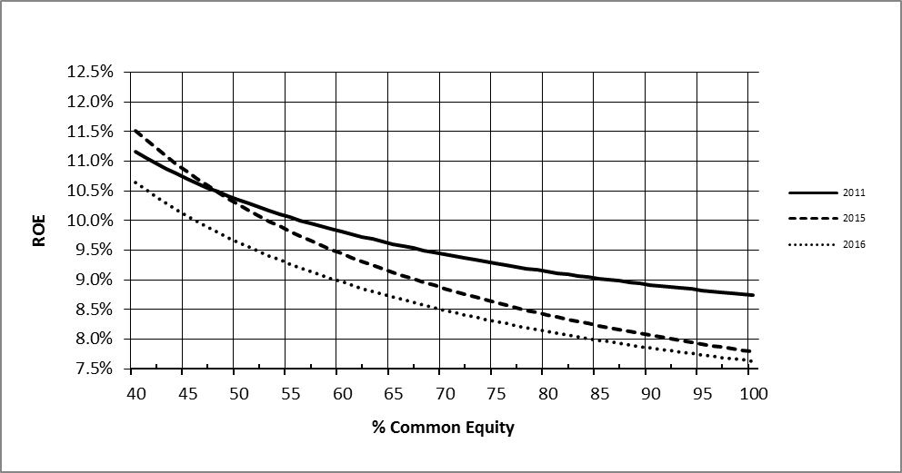
Source: FPSC Staff Analysis
Chart 1-2 illustrates the change in the slope of the leverage formula for the six years 2011 through 2016.
Chart 1-2
Comparison of Annual Leverage Formulas since 2011
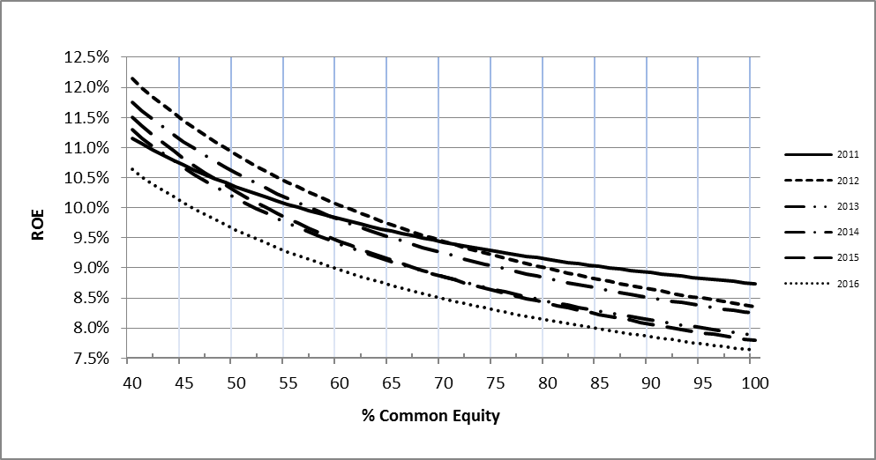Source: FPSC Staff Analysis
In 2015, by Order No. PSC-15-0259-PAA-WS, the Commission approved staff’s recommendation to continue to use the leverage formula initially approved in 2011. The Commission kept the 2011 leverage formula in place because Federal Reserve monetary policies lowered interest rates to historically low levels, thereby increasing the slope of the leverage formula graph relative to previous years. The Federal Reserve’s monetary policies and resulting capital market conditions that existed in 2012 through 2015 are expected to continue in 2016.
Although staff recommends the current leverage formula remain in place, staff has provided the updated leverage formula using the most recent financial information should the Commission decide to not continue to use the current in-place leverage formula and approve the updated leverage formula. In developing the leverage formula, staff used the same methodologies used in the 2011 docket. The updated model produced the following leverage formula:
Return on Common Equity = 5.63% + (2.001 ÷ Equity Ratio)
Where the Equity Ratio = Common Equity ÷ (Common Equity + Preferred Equity + Long-Term and Short-Term Debt)
Range: 7.63% @ 100% equity to 10.63% @ 40% equity
In conjunction with the updated leverage formula, if the Commission decides to approve the updated leverage formula, the returns on common equity should be capped at 10.63 percent for all WAW utilities with equity ratios less than 40 percent to discourage imprudent financial risk. This cap is consistent with the methodology in Order No. PSC-08-0846-FOF-WS.

Conclusion
In staff’s opinion, the existing leverage formula range of 8.74 percent to 11.16 percent initially approved in 2011 is still reasonable for WAW utilities. Staff believes retaining the use of the current in-place leverage formula until the leverage formula is addressed again in 2017 is a reasonable alternative to updating the formula using current 2016 financial information.
Staff continues to believe the leverage formula is a sound, workable methodology that reduces the costs and administrative burdens in WAW rate cases by eliminating the need for cost of equity testimony. Many of the WAW utilities under the Commission’s jurisdiction are small operations that find it beneficial to avoid the costs associated with presenting cost of equity testimony.
Based on the aforementioned, staff recommends that the current leverage formula approved by the Commission in Order No. PSC-15-0259-PAA-WS continue to be used until the leverage formula is readdressed in 2017.

Issue 2:
Should this docket be closed?

Recommendation:
No. Upon expiration of the protest period, if a timely protest is not received from a substantially affected person, the decision should become final and effective upon the issuance of a Consummating Order. However, this docket should remain open to allow staff to monitor changes in capital market conditions and to readdress the reasonableness of the leverage formula as conditions warrant. (Leathers)

Staff Analysis:
Upon expiration of the protest period, if a timely protest is not received from a substantially affected person, the decision should become final and effective upon the issuance of a Consummating Order. However, this docket should remain open to allow staff to monitor changes in capital market conditions and to readdress the reasonableness of the leverage formula as conditions warrant.
Attachment 1
Page 1 of 6

SUMMARY OF LEVERAGE FORMULA RESULTS
 |  |  | Updated Results (2016) | Currently in Effect (2011)
(A) DCF ROE for Natural Gas Utility Index |  | 7.62% |  | 8.25%
(B) CAPM ROE for Natural Gas Utility Index |  | 9.39% |  | 9.40%
AVERAGE |  | 8.51% |  | 8.83%
Bond Yield Differential |  | 0.45% |  | 0.57%
Private Placement Premium |  | 0.50% |  | 0.50%
Small-Utility Risk Premium |  | 0.50% |  | 0.50%
Adjustment to Reflect ROE at 40% Equity Ratio |  | 0.67% |  | 0.76%
Cost of Equity for Average Florida WAW Utility
with a capital structure containing a 40% Equity Ratio |  | 10.63% |  | 11.16%
2011 Leverage Formula (Currently in Effect)
Return on Common Equity = | 7.13% + (1.610 ÷ Equity Ratio)
Range of Returns on Equity (100% to 40%) = | 8.74% to 11.16%
2016 Leverage Formula (Using Current Data)
Return on Common Equity = | 5.63% + (2.011 ÷ Equity Ratio)
Range of Returns on Equity (100% to 40%) = | 7.63% to 10.63%

Attachment 1
Page 2 of 6

MARGINAL COST OF INVESTOR CAPITAL
(2016 Leverage Formula Result)

Average Marginal Cost Rate of the Natural Gas Utility Index
Weighted
Marginal Marginal
Capital Component Ratio Cost Rate Cost Rate

Common Equity 46.22% 9.96% 4.60%
Total Debt 53.78% 5.63% * 3.03%
100.0% 7.63%

Average Marginal Cost Rate at a 40% Equity Ratio

A 40% equity ratio is the floor for calculating the required return on common equity. The return on equity at a 40% equity ratio is 5.63% + (2.001 ÷ 0.40) = 10.63%
Weighted
Marginal Marginal
Capital Component Ratio Cost Rate Cost Rate

Common Equity 40.00% 10.63% 4.25%
Total Debt 60.00% 5.63%* 3.38%
100.00% 7.63%

Common Equity Ratio = Common Equity ÷ (Common Equity + Preferred Equity + Long-Term Debt + Short-Term Debt)

*Assumed 120-month average Baa3 rate as of April 2016 (4.63%) plus a 50 basis point private placement premium and a 50 basis point small utility risk premium.

Sources: Moody's Credit Perspectives and Value Line Selection and Opinion
Attachment 1
Page 3 of 6

ANNUAL DISCOUNTED CASH FLOW MODEL

NATURAL GAS UTILITY INDEX |  |  |  |  |  |  |  |  |  |  | STOCK PRICE
 |  |  |  |  |  |  |  |  |  |  | APRIL 1, 2016 - APRIL 30, 2016
COMPANY |  | DIV0 | DIV1 | DIV2 | DIV3 | DIV4 | EPS4 | ROE4 | GR1-4 | GR4+ | HI-PR | LO-PR | AVG-PR
AGL RESOURCES INC. |  | 2.12 | 2.16 | 2.24 | 2.32 | 2.40 | 4.65 | 11.50 | 1.0357 | 1.0556 | 65.95 | 64.71 | 65.330
ATMOS ENERGY CORPORATION |  | 1.68 | 1.80 | 1.91 | 2.03 | 2.20 | 4.00 | 11.00 | 1.0610 | 1.0509 | 74.86 | 70.41 | 72.635
LACLEDE GROUP, INC. |  | 1.92 | 1.96 | 2.04 | 2.12 | 2.20 | 4.20 | 9.50 | 1.0393 | 1.0452 | 68.40 | 62.65 | 65.525
NORTHWEST NATURAL GAS CO. |  | 1.87 | 1.91 | 1.96 | 2.00 | 2.05 | 3.15 | 9.00 | 1.0239 | 1.0314 | 54.29 | 49.46 | 51.875
PIEDMONT NATURAL GAS CO., INC. |  | 1.35 | 1.39 | 1.43 | 1.47 | 1.51 | 2.20 | 10.50 | 1.0280 | 1.0329 | 60.00 | 59.43 | 59.715
SOUTH JERSEY INDUSTRIES, INC. |  | 1.08 | 1.15 | 1.23 | 1.31 | 1.40 | 2.20 | 11.50 | 1.0678 | 1.0418 | 28.55 | 27.17 | 27.860
SOUTHWEST GAS CORPORATION |  | 1.80 | 1.92 | 2.04 | 2.17 | 2.30 | 4.80 | 13.00 | 1.0620 | 1.0677 | 66.60 | 62.75 | 64.675
WGL HOLDINGS, INC. |  | 1.87 | 1.93 | 1.96 | 2.00 | 2.03 | 3.55 | 11.00 | 1.0170 | 1.0471 | 72.84 | 65.00 | 68.920
AVERAGE |  | 1.7113 | 1.7775 | 1.8498 | 1.9256 | 2.0050 | 3.5938 | 10.8750 | 1.0418 | 1.0466 |  |  | 59.5669
 |  |  |  |  |  | 2.0984 |  | Stock price including a four percent flotation cost: |  |  |  |  | 57.1842
 |  |  | Annual DCF Result: |  | 7.62%
Cash Flows | 1.6055 | 1.5503 | 1.4992 | 1.4503 | 1.4050 | 49.6739
Present Value of Cash Flows | 57.1842

NOTE: The cash flows for this multi-stage DCF Model are derived using the average forecasted dividends and the near term and long term growth rates.
The discount rate equates the cash flows with the average stock price less flotation cost.
$57.184 = Average stock price from April 1, 2015, through April 30, 2016, with a 4 percent flotation cost.
7.62% = Cost of equity required to match the current stock price with the expected cash flows.
Sources:
1. Stock Prices - Yahoo Finance.
2. Dividends (DIV), Dividends Per Share (DPS), Earnings Per Share (EPS), ROE - Value Line Ratings and Reports issued March 4, 2016.

Attachment 1
Page 4 of 6

CAPITAL ASSET PRICING MODEL

CAPM Analysis Formula
K = RF + Beta(MR - RF)
K = Investor's required rate of return
RF = Risk-free rate (Blue Chip forecast for Long-term Treasury bond,
May 1, 2016)
Beta = Measure of industry-specific risk (Average for natural gas utilities followed by Value Line)
MR = Market return (Value Line Investment Analyzer Web Browser, as of May 12, 2016)
9.39% = 3.22% + 0.744(11.25% - 3.22%) + 0.20%
Note: Staff calculated the market return using a quarterly DCF model for a large number of dividend paying stocks followed by Value Line. As of May 12, 2016, the result was 11.25%. Staff also added 20 basis points to the CAPM result to allow for a four-percent flotation cost.
Attachment 1
Page 5 of 6

BOND YIELD DIFFERENTIALS

Public Utility Long Term Bond Yield Averages
Month, Year | A2 | Spread | A3 | Spread | Baa1 | Spread | Baa2 | Spread | Baa3
April, 2016 | 3.970 | 0.170 | 4.140 | 0.170 | 4.310 | 0.170 | 4.480 | 0.170 | 4.650
120-Month Average |  |  |  |  |  |  | 4.480 | 0.1509 | 4.631%
Sources: Moody's Credit Perspectives and Value Line Selection & Opinion

Attachment 1
Page 6 of 6

UTILITY INDEX STATISTICS AND FACTS

Natural Gas Distribution Utility Companies | S&P  Bond Rating | % of Gas Revenue | Value Line Market Capital (millions) | Equity Ratio | Value Line Beta
AGL Resources Inc. | BBB+ | 73% | $ 7,859.41 | 44.86% | 0.60
Atmos Energy Corporation | A- | 71% | $ 7,461.98 | 52.30% | 0.80
Laclede Group, Inc. | A- | 97% | $ 2,897.38 | 42.72% | 0.70
Northwest Natural Gas Co. | A+ | 97% | $ 1,403.93 | 47.25% | 0.65
Piedmont Natural Gas Co., Inc. | A | 93% | $ 4,848.11 | 42.83% | 0.75
South Jersey Industries, Inc. | BBB+ | 57% | $ 1,897.55 | 41.42% | 0.85
Southwest Gas Corporation | BBB+ | 61% | $ 3,036.87 | 50.06% | 0.80
WGL Holdings, Inc. | A+ | 49% | $ 3,421.07 | 48.33% | 0.80
Average: | A- | 75% | $ 4,103.29 | 46.22% | 0.744

Sources:
Value Line Investment Analyzer Web Browser, May 2016
S.E.C. Forms 10Q and 10K for the natural gas utility companies
AUS Utilities Report, issued May, 2016
Standard & Poor’s RatingsDirect

Order No. PSC-01-2514-FOF-WS, issued December 24, 2001, in Docket No. 010006-WS, In re: Water and wastewater industry annual reestablishment of authorized range of return on common equity for water and wastewater utilities pursuant to Section 367.081(4)(f), F.S.
At the May 20, 2008, Commission Conference, upon request of the Office of Public Counsel, the Commission voted to set the establishment of the appropriate leverage formula directly for hearing.
Order No. PSC-08-0846-FOF-WS, issued December 31, 2008, in Docket No. 080006-WS, In re: Water and wastewater industry annual reestablishment of authorized range of return on common equity for water and wastewater utilities pursuant to Section 367.081(4)(f), F.S.
Order No. PSC-11-0287-PAA-WS, issued July 5, 2011, in Docket No. 110006-WS, In re: Water and wastewater industry annual reestablishment of authorized range of return on common equity for water and wastewater utilities pursuant to Section 367.081(4)(f), F.S.
Order No. PSC-12-0339-PAA-WS, issued June 28, 2012, in Docket No. 120006-WS, In re: Water and wastewater industry annual reestablishment of authorized range of return on common equity for water and wastewater utilities pursuant to Section 367.081(4)(f), F.S.
Order No. PSC-13-0241-PAA-WS, issued June 3, 2013, in Docket No. 130006-WS, In re: Water and wastewater industry annual reestablishment of authorized range of return on common equity for water and wastewater utilities pursuant to Section 367.081(4)(f), F.S.
Order No. PSC-14-0272-PAA-WS, issued May 29, 2014, in Docket No. 140006-WS, In re: Water and wastewater industry annual reestablishment of authorized range of return on common equity for water and wastewater utilities pursuant to Section 367.081(4)(f), F.S.
Order No. PSC-15-0259-PAA-WS, issued July 2, 2015, in Docket No. 150006-WS, In re: Water and wastewater industry annual reestablishment of authorized range of return on common equity for water and wastewater utilities pursuant to Section 367.081(4)(f), F.S.
See Federal Reserve System, statement of the Federal Open Market Committee on April 26-27, 2016, available at https://www.federalreserve.gov/monetarypolicy/files/monetary20160427a1.pdf.
Ibid.

