State of Florida |  | Public Service Commission  Capital Circle Office Center ● 2540 Shumard Oak Boulevard  Tallahassee, Florida 32399-0850  -M-E-M-O-R-A-N-D-U-M-
DATE: | June 23, 2016
TO: | Office of Commission Clerk (Stauffer)
FROM: | Division of Accounting and Finance (Barrett, Lester)  Division of Engineering (Matthews)  Office of Industry Development and Market Analysis (Breman)  Office of the General Counsel (Janjic)
RE: | Docket No. 160001-EI – Fuel and purchased power cost recovery clause with generating performance incentive factor.
AGENDA: | 07/07/16 – Regular Agenda – Parties May Participate
COMMISSIONERS ASSIGNED: |  |  | All Commissioners
PREHEARING OFFICER: |  |  | Graham
CRITICAL DATES: |  |  | None
SPECIAL INSTRUCTIONS: |  |  | None

Case Background
On June 2, 2016, Florida Power & Light Company (FPL) and the Office of Public Counsel (OPC) (collectively referred to as “Signatories”) jointly filed a request for approval of a Stipulation and Settlement Agreement (Joint Motion) that addresses the resolution of two issues concerning the recovery of replacement power costs incurred during outage events that occurred at FPL’s St. Lucie Unit 2 in 2014 and 2015. Signatories are bringing this Settlement Agreement before the Commission because they believe it is reasonable and in the public interest, as it will avoid the time and expense of protracted litigation of disputes over the April 2014, February 2015 and April 2015 outages in this or future proceedings. Although these issues were raised at different times in the Fuel Cost Recovery Clause docket (Fuel Clause), the proposed resolution of these issues will be included in this year’s (2016) Fuel Clause proceeding, which is scheduled for November 2-4, 2016. The Signatories state that all current parties in the Fuel Clause either take no position, or do not object to the Joint Motion. The Stipulation and Settlement Agreement (Settlement Agreement) is attached as Exhibit 1.
The Commission has jurisdiction to consider this matter pursuant to Section 366.06, Florida Statutes (F.S.).

Discussion of Issues

Issue 1:
Should the Joint Motion For Approval of Settlement Agreement between FPL and OPC be approved?

Recommendation:
Yes. (Barrett, Lester, Breman, Matthews)

Staff Analysis:
FPL’s St. Lucie Nuclear Station is located on Hutchinson Island, near Fort Pierce, Florida. The station features two baseload generating units, Unit 1 and Unit 2, with Net Summer Capacity ratings of 981 and 987 megawatts, respectively. Generally, when an outage event occurs, other resources in the fleet of generating plants are dispatched to make up for the load not being supplied by the off-line unit. Based upon the duration of an outage and the capacity reduction attributable to the outage, replacement power costs for an out-of-service unit can be calculated. The Commission has historically allowed for cost recovery of replacement power costs, unless it is determined that the outage resulted from an imprudent action by the utility.
As noted previously, the Joint Petition is a comprehensive settlement that resolves open issues in the Fuel Clause related to outage events that occurred at St. Lucie Unit 2 in 2014 and 2015, as described below.
March 2014 Outage (Issue 3J, previously identified as Issue 2N)
In March 2014, St. Lucie Unit 2 entered a planned outage for refueling and for other maintenance activities. During the start-up for bringing the unit back into service, FPL discovered foreign material in one of the unit’s steam generators, necessitating an 18 day extension of the outage. OPC proposed Issue 2N in the 2014 Fuel Clause proceeding to address the cost recovery of the replacement power due to the extension of the planned outage at St. Lucie Unit 2. By Order No. PSC-14-0439-PCO-EI, the Commission deferred consideration of Issue 2N to the 2015 Fuel Clause, when the final true up of 2014 fuel costs would be addressed.
In the 2015 Fuel Clause proceeding, a revised list of issues meant that Issue 2N from the 2014 Fuel Clause proceeding was then identified as Issue 3J. FPL stated that it was in negotiations with its vendor regarding the March 2014 outage at St. Lucie Unit 2, but those negotiations would not be concluded in time to be presented at the 2015 Fuel Clause hearing. Therefore, by Order No. PSC-15-0586-FOF-EI, the Commission again deferred considering the cost recovery of the replacement power due to the extension of the planned outage at St. Lucie Unit 2.
February 2015 Outage (Part 1 of Issue 3O)
An unplanned outage occurred at St. Lucie Unit 2 in February 2015 that lasted about 4 days. This outage was triggered when condenser tube chemistry limits were exceeded due to seawater leakage in a hotwell. In the Joint Motion, FPL states that the leaking condenser tube and an additional 187 other tubes were repaired.
April 2015 Outage (Part 2 of Issue 3O)
The April 2015 outage involved work repairing a leak identified in the safety injection tank discharge header. Engineering analysis determined that vibration fatigue was the source of the leak, and FPL replaced the affected piping, modified the support structure for the piping in order to prevent future problems, and also revised the engineering standard to include more detail for piping supports.

In preparing for the 2015 Fuel Clause hearing, a single issue, Issue 3O, was added to address the cost recovery of replacement power due to the February and April outages. As reflected in Order No. PSC-15-0512-PHO-EI (Prehearing Order), the parties agreed to drop Issue 3O with the understanding that any party could raise it again in this year’s (2016) Fuel Clause proceeding.

Analysis of the Joint Motion
Staff and OPC served discovery requests to FPL in order to learn more about all of the outage events at St. Lucie Unit 2. In the Joint Motion, OPC stated it reviewed FPL’s prepared testimony and exhibits and has conducted both formal and informal discovery regarding the causes of all 3 outages before it entered into the Settlement Agreement with FPL. As the Settlement Agreement states, FPL reached a confidential agreement with one of the vendors that performed work at St. Lucie Unit 2 during the March 2014 planned outage. As a result of the FPL vendor settlement, FPL will credit $8 million to the Fuel Clause for the purpose of calculating the fuel cost recovery factors for 2017, which will be set in the November hearing for Docket No. 160001-EI. The Signatories believe the $8 million credit as part of the Settlement Agreement resolves Issue 3J from Docket No. 150001-EI in its entirety, such that FPL’s recovery of replacement power costs associated with the extended refueling outage in March 2014 will not be disputed in Docket No. 160001-EI or any other Commission proceeding. FPL and OPC agree that each entered into the Settlement Agreement voluntarily, that it fairly and reasonably balances the various positions of the parties on issues in these proceedings, and that it serves the best interests of the customers they represent and the public interest in general. The Signatories believe that the Settlement Agreement is reasonable and in the public interest.
For Issue 3O, the Signatories assert that cost recovery for replacement power associated with the February and April 2015 outage events will not be disputed in this year’s (2016) Fuel Clause proceeding, or in any other Commission proceeding. Based on testimony and discovery responses in this docket, staff concurs.
The Joint Motion is a comprehensive settlement that resolves open issues in the Fuel Clause related to the three outage events described above. Due to the fact that the Signatories were able to reach the proposed stipulation on these issues well in advance of the hearing, and in order to provide greater certainty as to the scope of issues to be addressed in this year’s Fuel Clause hearing, the Signatories have requested that the Commission consider the Joint Motion at the first available Agenda Conference and approve it at that time. The Joint Motion further states that the parties to the Docket No. 160001-EI should be permitted to address the Settlement Agreement at the Agenda Conference. Staff believes the Joint Motion presents an opportunity to fully resolve these matters in advance of the November hearing in Docket No. 160001-EI, and therefore avoid the time and expense of protracted litigation of disputes over the April 2014, February 2015 and April 2015 outages in this or future proceedings. As set forth in the Joint Motion, FPL will credit $8 million to the Fuel Clause for the purpose of calculating the 2017 Fuel Clause factors, which will be approved in the hearing for Docket No. 160001-EI. Staff notes that the Settlement Agreement results in FPL’s customers being refunded for replacement power costs that were incurred in 2014, notwithstanding that there has been no finding of imprudence with respect to any portion of these outages.
Staff believes it is reasonable and appropriate to approve the Joint Motion, because approval will avoid the time and expense of litigating these issues in Docket No. 160001-EI or future proceedings. The Signatories assert that the Settlement Agreement resolves Issues 3J and 3O from Docket No. 150001-EI in their entirety, and staff agrees. Upon approval, cost recovery for replacement power associated with these outage events will not be disputed in this year’s (2016) Fuel Clause proceeding, or in any other Commission proceeding. The Signatories believe that the Settlement Agreement is reasonable and in the public interest. Staff agrees.
Summary
The Joint Motion is a comprehensive settlement that resolves open issues in the Fuel Clause. Staff and OPC thoroughly reviewed the materials FPL provided about these outages. Staff believes FPL took appropriate and reasonable actions to restore St. Lucie Unit 2 from these outage events, and staff acknowledges that no active party in Docket No. 160001-EI has asserted a contrary position on this Joint Motion.
Therefore, staff recommends that the Joint Motion between FPL and OPC be approved.

Issue 2:
Should this docket be closed?

Recommendation:
No. The fuel docket is on-going and should remain open. (Janjic)

Staff Analysis:
The fuel docket is on-going and should remain open.

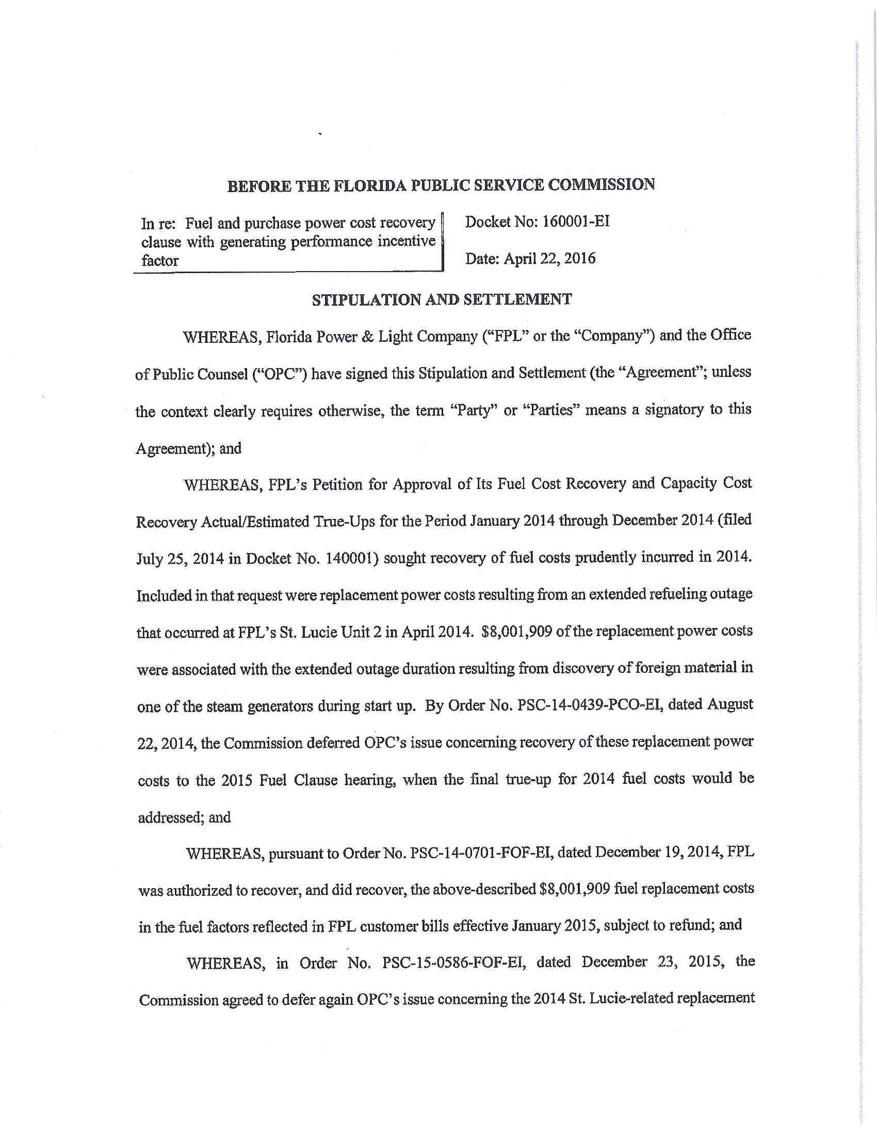

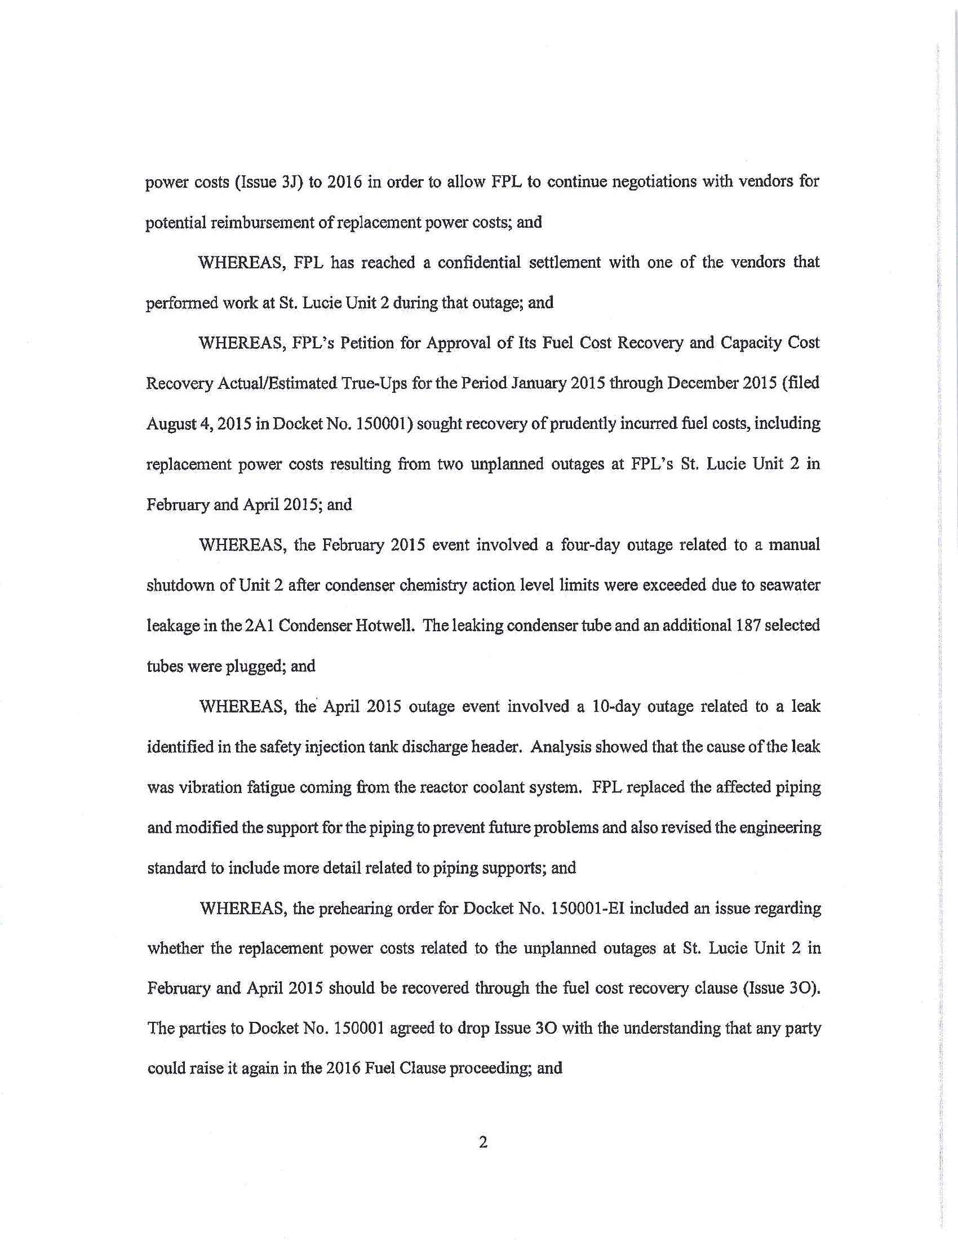

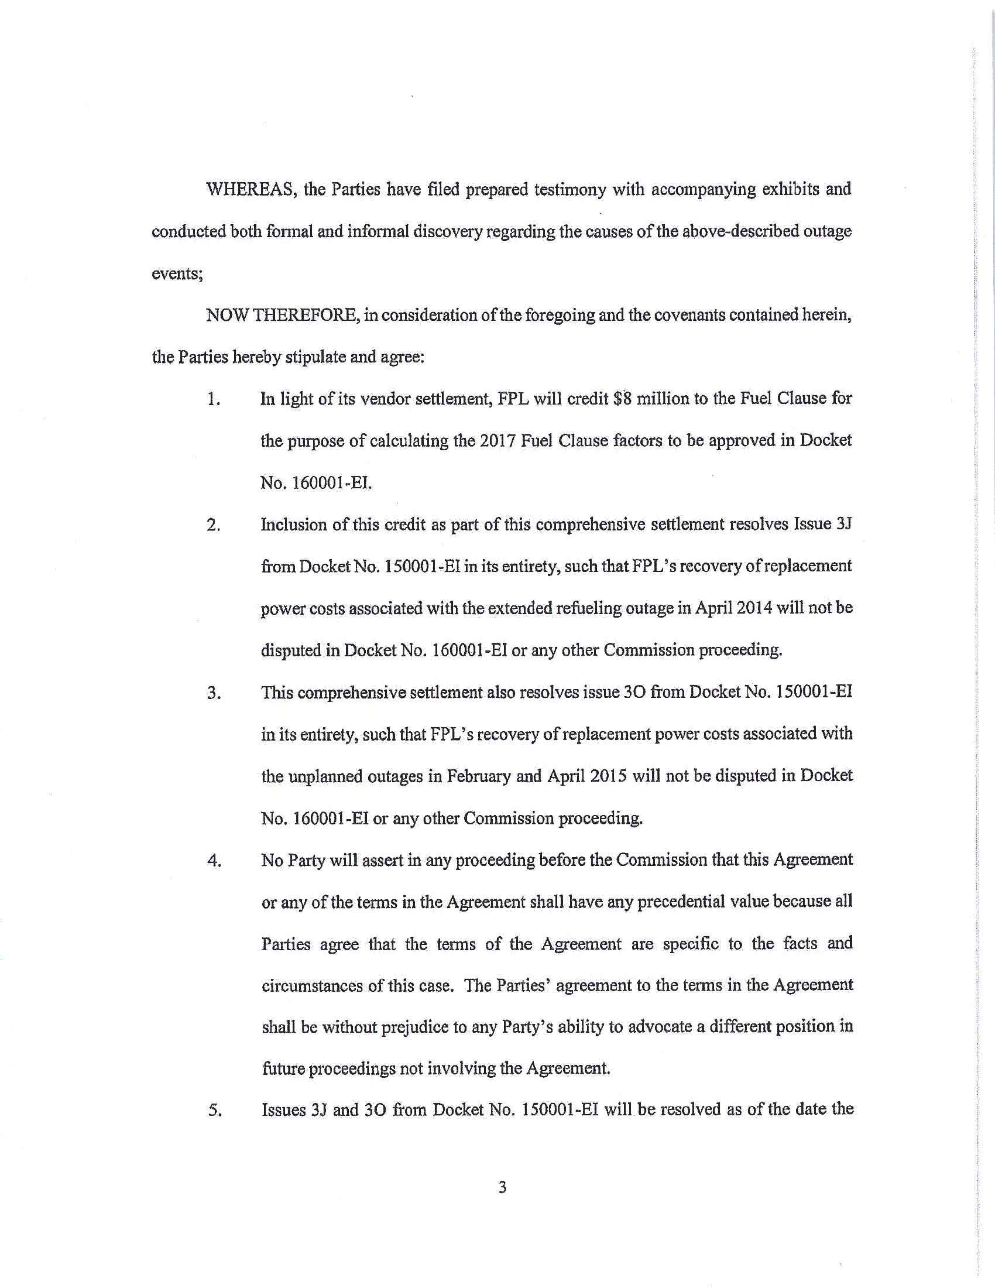

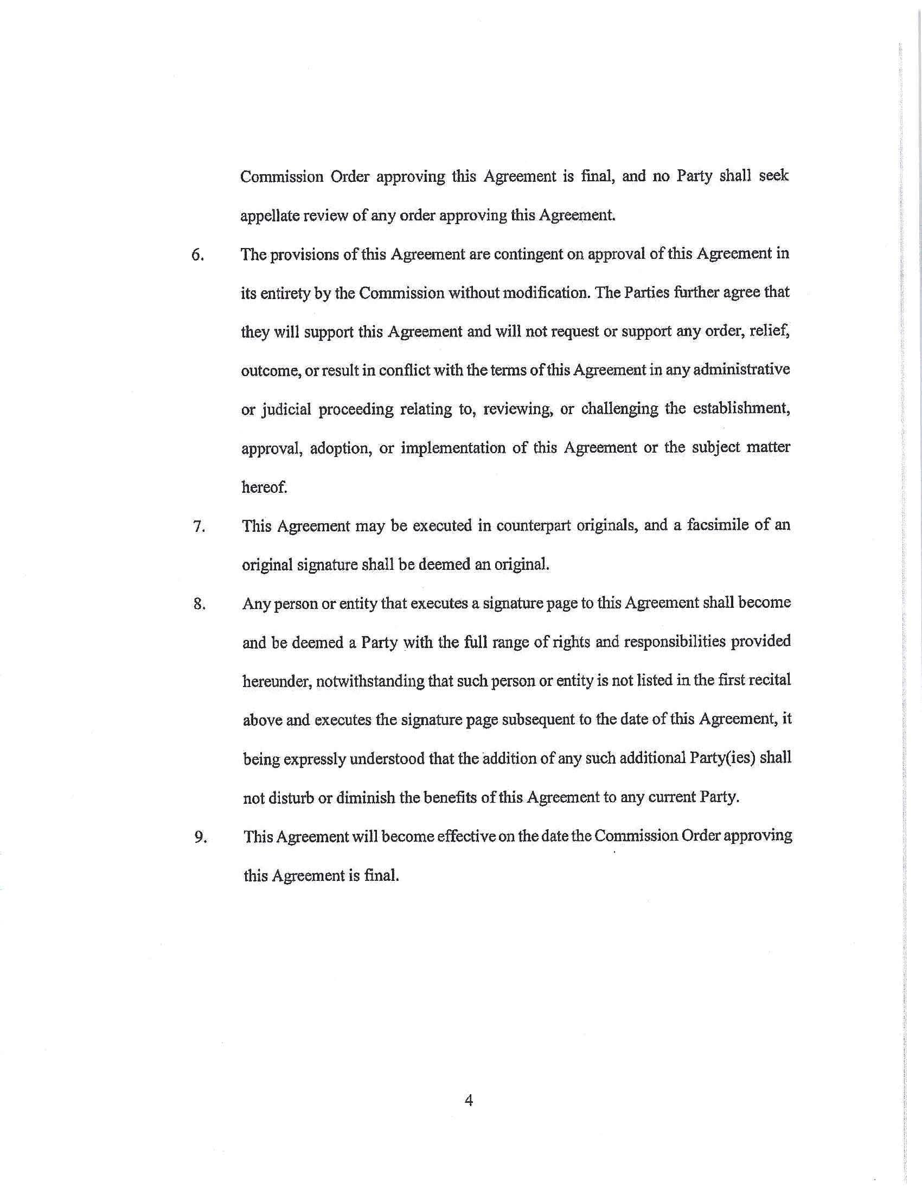

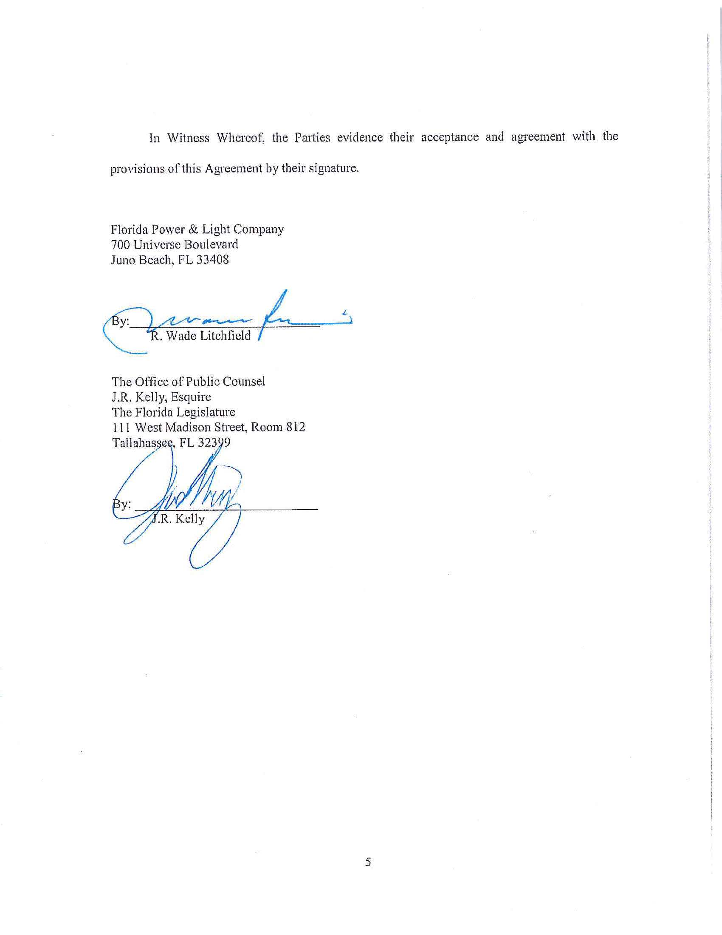

Duke Energy Florida LLC, Gulf Power Company, Tampa Electric Company, Florida Public Utilities Company, and the Florida Industrial Power Users Group take no position on this Joint Motion, while PCS Phosphate – White Springs has no objection to it, and the Florida Retail Federation supports the Joint Motion.
Based on FPL’s response to an interrogatory, the planned refueling outage was extended for 17.94 days. St. Lucie Unit 2 was off-line for a total of 52 days.
Order No. PSC-14-0439-PCO-EI, issued August 22, 2014, in Docket No. 140001-EI, In re: Fuel and Purchased Power Cost Recovery Clause with Generating Performance Incentive Factor.
Order No. PSC-15-0586-FOF-EI, issued December 23, 2015, in Docket No. 150001-EI, In re: Fuel and Purchased Power Cost Recovery Clause with Generating Performance Incentive Factor.
Order No. PSC-15-0512-PHO-EI, issued October 29, 2015, in Docket No. 150001-EI, In re: Fuel and Purchased Power Cost Recovery Clause with Generating Performance Incentive Factor.

