BEFORE THE FLORIDA PUBLIC SERVICE COMMISSION

In re: Petition for approval of modifications to extension of facilities and area extension program tariffs, by Florida City Gas. | DOCKET NO. 170029-GU  ORDER NO. PSC-17-0136-TRF-GU  ISSUED: April 14, 2017

The following Commissioners participated in the disposition of this matter:

JULIE I. BROWN, Chairman
ART GRAHAM
RONALD A. BRISÉ
JIMMY PATRONIS
DONALD J. POLMANN

ORDER APPROVING MODIFICATIONS TO EXTENSION OF FACILITIES
AND AREA EXTENSION PROGRAM TARIFFS

BY THE COMMISSION:

Background

On February 2, 2017, Florida City Gas (FCG or Company) filed a petition for approval of modifications to its existing Extension of Facilities (applicable to general tariff extension customers) and Area Extension Program (AEP) tariffs. In accordance with Rule 25-7.054, Florida Administrative Code, (F.A.C.), the tariffs apply to new customers that require an extension of gas distribution facilities in order to receive service. The proposed tariff modifications will allow FCG to require certain general tariff extension customers and AEP customers to commit to receive natural gas service at a defined minimum annual volume and to pay for the minimum annual volume even if it had not been reached, i.e., a take or pay commitment, in order to receive service.
In a February 7, 2017 email (subsequently filed in the docket), FCG waived the 60-day suspension deadline, pursuant to Section 366.06(3), Florida Statutes (F.S.), until the April 4, 2017 Agenda Conference. FCG responded to Commission staff’s first data request on March 3, 2017. On March 17, 2017, the Company filed revised responses to Commission staff’s data request and revised tariff pages. The proposed tariff pages as revised are contained in Attachment 1 of this order. We have jurisdiction over this matter pursuant to Sections 366.04, 366.05, 366.06, F.S.
Decision

Current Extension of Facilities Tariffs
Rule 25-7.054(3), F.A.C., provides that extensions of gas facilities are made at no cost to the customer when the capital investment necessary to extend service is equal to or less than the Maximum Allowable Construction Cost (MACC). FCG’s tariff defines the MACC as six times the estimated annual gas revenue less the cost of gas (margin revenues). If the required capital investment exceeds the MACC, then the customer must pay the difference between the MACC and the capital costs as an Aid to Construction (ATC) pursuant to FCG’s “Extensions of mains and services above free limit” tariff provision. This tariff provision is shown on Page 1 of 3 of Attachment 1.
FCG stated that during 2012-2016 over 4,400 customers (or on average 880 customers per year) paid ATC costs. The capital investment to serve a new customer may include gas mains, service lines, and regulators.
The AEP tariff is designed to provide FCG with an alternate optional method to recover its capital investment to provide natural gas service to customers in a discrete geographic area who do not have gas service available. The AEP tariff provides for the determination of a charge applicable to all gas customers located in the geographic area over a 10-year amortization period. The AEP charge is applied on a per therm basis in addition to all other tariffed charges. The AEP charge is calculated by a formula based on the amount of investment required and the projected gas sales and resulting revenues collected from customers in the AEP area.
The AEP tariff requires FCG to recalculate and true-up the AEP charge on the third anniversary of the date when the facilities to provide gas service were placed into service, or on the date when 80 percent of the originally forecast annual load is connected, whichever comes first. The Company can true-up the AEP charge only once, and the new charge will be applied prospectively over the remainder of the amortization period.
The AEP tariff includes a provision that the length of the amortization period may be modified upon this Commission’s approval. In 2012, FCG extended its facilities pursuant to the AEP tariff to serve a large commercial customer, a citrus producer (Glades project). In 2016, this Commission approved a delay of the true-up and an extension of the amortization period for two years because the project had not developed as projected. Other than the Glades project, FCG has used the AEP tariff nine times since its 1995 implementation.
FCG’s Proposed Take or Pay Provision
The proposed tariff modifications provide FCG with the option to require a take or pay provision from a general tariff extension customer or an AEP customer. The proposed take or pay provision would require the customer to agree to commit to a minimum volume of natural gas each year.
FCG explained that it views the proposed take or pay provision as another tool to mitigate the risk associated with high-cost extensions. The Company asserted that its ability to fully recover its investment may be compromised when a customer’s actual gas volumes are significantly less than the customer’s estimate of gas volumes used to calculate the MACC and there are minimal or no opportunities to true-up the calculation. FCG asserted that a take or pay provision will add another layer of protection to reduce the risk to the general body of ratepayers from stranded investment. The Company also asserted that a take or pay provision will encourage potential customers to provide business information that will result in a realistic, rather than an inflated, calculation of potential gas volumes.
FCG stated that the process to determine whether a minimum take or pay requirement is necessary is the same for general tariff extension customers or AEP customers. FCG identified three factors it would use to evaluate whether the take or pay provision should be required. The factors are the overall capital investment necessary to extend service, the customer’s use for natural gas, and whether the business is a start-up or established business with verifiable consumption data that can be used to substantiate the annual natural gas use estimates (risk assessment). According to the Company, lower risk businesses are those that have existing natural gas use, are implementing equipment with known gas usage, or can provide verifiable usage data, such as data from an affiliate. A higher risk potential customer might be a new business that has new equipment, projected high volumes, and little or no business or gas usage experience. According to the Company, the “ultimate” factor is the impact to the Company and its ratepayers if the new customer’s volumes are less than projections.
The minimum volume commitment will not be set above the amount used to calculate the MACC. A customer’s specific annual volume commitment would be identified in a schedule that is contained in the gas extension contract. Each year, on the anniversary date of the account, FCG will audit the actual billed volume of natural gas and compare it to the take or pay schedule in the gas extension contract. If the volume is less than the requirement, the Company would bill for the volume shortfall using the applicable charges associated with the customer’s tariff rate for general service extension customers. For an AEP customer, the billing of the volume shortfall would also include the applicable AEP surcharge. The minimum volume commitment is six years for general tariff extension customers and ten years for AEP customers. FCG stated that it does not anticipate frequent use of the take or pay provision for general tariff extension customers or AEP customers.
The Company explained that the Glades project prompted it to review its general tariff extension and AEP tariffs and to consider whether changes to the tariffs might reduce or mitigate future difficulties with lower-than-expected usage. In response to Commission staff’s data request, FCG stated that there had been at least one prior situation where a take or pay provision would have been useful as the expected gas volumes did not materialize due to an unintentional error by the customer concerning the customer’s installed equipment specifications. FCG also stated that there is a potential project currently under consideration in an existing AEP area with the customer being amenable to a take or pay provision. The Company asserts that the proposed revisions are in the public interest and will protect existing ratepayers while facilitating the expansion of service to new customers.
Conclusion
We find that a take or pay provision for general tariff extension customers and AEP customers is reasonable and appropriate because it will limit the risk to the general body of ratepayers. Therefore, this Commission hereby approves FCG’s proposed tariff modifications, as revised on March 17, 2017, to the Extension of Facilities and AEP tariffs effective April 4, 2017.
Based on the foregoing, it is

ORDERED by the Florida Public Service Commission that Florida City Gas’s petition for approval of modifications to its existing Extension of Facilities and Area Extension Program tariffs is hereby approved. It is further

ORDERED that the effective date of the revised tariffs shall be April 4, 2017. It is further

ORDERED that if a protest is filed within 21 days of issuance of this Order, the tariffs shall remain in effect, with any revenues held subject to refund, pending resolution of the protest. It is further

ORDERED that if no timely protest is filed, this docket shall be closed upon the issuance of a Consummating Order.

By ORDER of the Florida Public Service Commission this 14th day of April, 2017.

/s/ Hong Wang
HONG WANG
Chief Deputy Commission Clerk
Florida Public Service Commission
2540 Shumard Oak Boulevard
Tallahassee, Florida 32399
(850) 413-6770
www.floridapsc.com

Copies furnished: A copy of this document is provided to the parties of record at the time of issuance and, if applicable, interested persons.

MAL

NOTICE OF FURTHER PROCEEDINGS

The Florida Public Service Commission is required by Section 120.569(1), Florida Statutes, to notify parties of any administrative hearing or judicial review of Commission orders that is available under Sections 120.57 or 120.68, Florida Statutes, as well as the procedures and time limits that apply. This notice should not be construed to mean all requests for an administrative hearing or judicial review will be granted or result in the relief sought.

Mediation may be available on a case-by-case basis. If mediation is conducted, it does not affect a substantially interested person's right to a hearing.

The Commission's decision on this tariff is interim in nature and will become final, unless a person whose substantial interests are affected by the proposed action files a petition for a formal proceeding, in the form provided by Rule 28-106.201, Florida Administrative Code. This petition must be received by the Office of Commission Clerk, 2540 Shumard Oak Boulevard, Tallahassee, Florida 32399-0850, by the close of business on May 5, 2017.

In the absence of such a petition, this Order shall become final and effective upon the issuance of a Consummating Order.

Any objection or protest filed in this docket before the issuance date of this order is considered abandoned unless it satisfies the foregoing conditions and is renewed within the specified protest period.

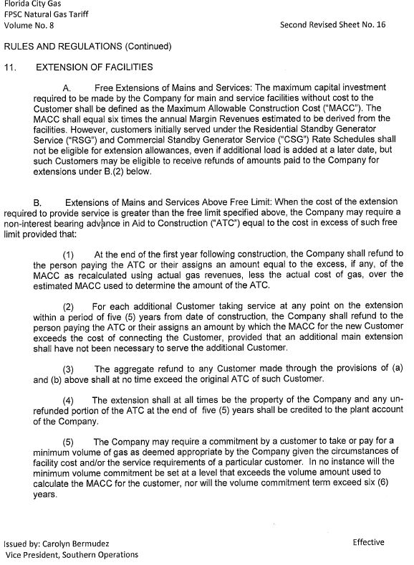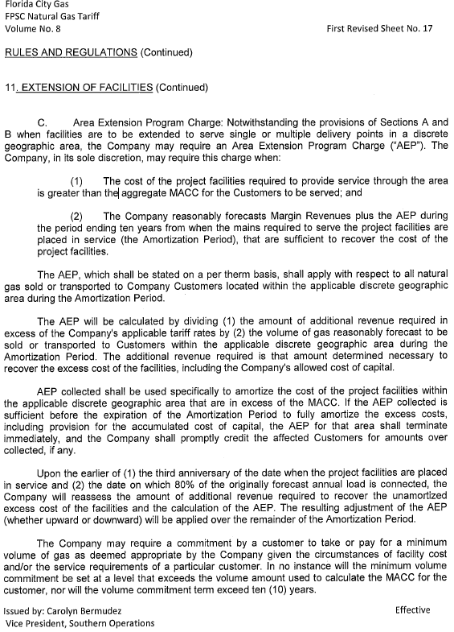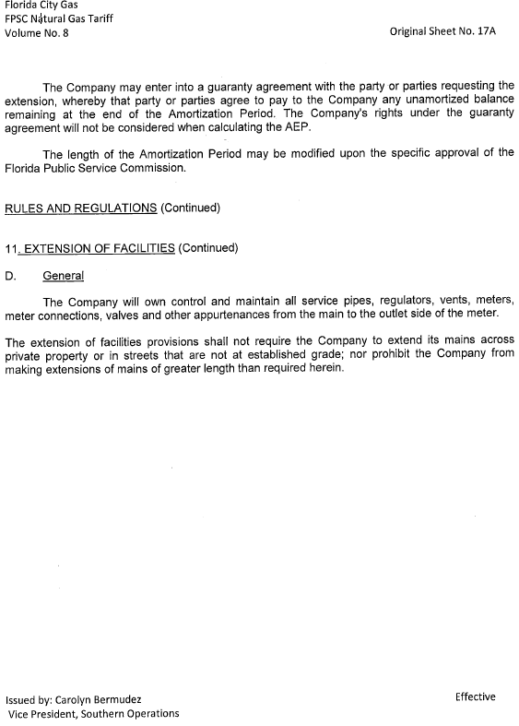

Order No. PSC-95-0506-FOF-GU, issued April 24, 1995, in Docket No. 950206-GU, In re: Petition for approval of tariffs governing extension of facilities by City Gas Company of Florida.
Id.
Order No. PSC-16-0066-PAA-GU, issued February 5, 2016, in Docket No. 150232-GU, In re: Petition for approval of variance from area extension program (AEP) tariff to delay true-up and extend amortization period, by Florida City Gas.

