State of Florida |  | Public Service Commission  Capital Circle Office Center ● 2540 Shumard Oak Boulevard  Tallahassee, Florida 32399-0850  -M-E-M-O-R-A-N-D-U-M-
DATE: | April 21, 2017
TO: | Office of Commission Clerk (Stauffer)
FROM: | Division of Economics (Ollila)  Office of the General Counsel (Janjic)
RE: | Docket No. 170062-GU – Petition for approval to amend gas reliability infrastructure program (GRIP) cost recovery factor, by Florida Division of Chesapeake Utilities Corporation.
AGENDA: | 05/04/17 – Regular Agenda – Tariff Filing – Interested Persons May Participate
COMMISSIONERS ASSIGNED: |  |  | All Commissioners
PREHEARING OFFICER: |  |  | Administrative
CRITICAL DATES: |  |  | 05/08/17 (60 day suspension deadline)
SPECIAL INSTRUCTIONS: |  |  | None

Case Background
On March 8, 2017, the Florida Division of Chesapeake Utilities Corporation (Chesapeake or Company) filed a petition to amend the 2017 gas reliability infrastructure program (GRIP) factor for commercial customers in rate class FTS-9 and to allow the Company to issue refunds to the affected customers. The GRIP program allows Chesapeake to recover the cost of accelerating the replacement of cast iron and bare steel distribution mains through a surcharge on customers’ bills. The 2017 GRIP factors were approved in Order No. PSC-16-0567-TRF-GU. Rate class FTS-9, which currently has six customers, is for customers whose annual therm usage is between 400,000 and 700,000 therms (compared to about 240 therms per year for residential customers).
Chesapeake responded to staff’s first data request on March 28, 2017 and filed revised responses on March 30, 2017. The proposed (legislative) tariff page is contained in Attachment 1 to the recommendation. The Commission has jurisdiction over this matter pursuant to Sections 366.03, 366.04, 366.05, and 366.06, Florida Statutes (F.S.).

Discussion of Issues

Issue 1:
Should the Commission approve Chesapeake's petition to amend the 2017 GRIP factor for rate class FTS-9 customers and issue refunds to FTS-9 customers?

Recommendation:
Yes, the Commission should approve Chesapeake’s petition to amend the 2017 GRIP factor for rate class FTS-9 customers effective on the date of the Commission’s decision and issue refunds in the form of bill credits to the FTS-9 customers. Within 30 days of the issuance of the bill credits, Chesapeake should notify staff that the refunds have been completed. (Ollila)

Staff Analysis:
After a customer questioned Chesapeake about the $0.14596 per therm GRIP factor for the FTS-9 rate class, the Company determined that the GRIP factor was incorrect and should have been $0.08359 per therm. Chesapeake proposes to amend the GRIP factor to $0.08359 per therm and provide refunds using a bill credit to FTS-9 customers. Chesapeake estimated that the refunds will total approximately $71,500.

GRIP Factor
The 2017 GRIP factor was developed by forecasting the 2017 GRIP revenue requirement and allocating the revenue requirement to each rate class using the same methodology used for the allocation of mains and services in the cost of service study used in Chesapeake’s most recent rate case. The revenue requirement allocated to each rate class is then divided by Chesapeake’s forecast of therms for that rate class, resulting in the per therm GRIP factor for each rate class.
Chesapeake explained that the projected therm usage used to calculate the 2017 factor for FTS-9 was understated compared to historical therms and previous projections, resulting in the higher GRIP factor. Chesapeake revised its 2017 FTS-9 therm forecast and used that forecast to develop the amended GRIP factor of $0.08359 per therm. Chesapeake has since reviewed all GRIP factors for Chesapeake, Florida Public Utilities Company (FPUC), and FPUC – Fort Meade and concluded that there were no significant therm over- or understatements used in calculating the 2017 GRIP factors.
In response to staff’s data request, Chesapeake explained that in future proceedings, it plans to thoroughly review the projected annual therms and GRIP factors for reasonableness for each rate class. This review, according to the Company, will enable it to identify and investigate any anomalies in the therm forecast as well as the GRIP factors.

Corrected Billing and Refunds
In its petition, Chesapeake proposed that the corrected GRIP factor for the FTS-9 rate class be effective upon Commission approval. The Company explained to staff that the May billing cycle will begin after May 4, the date of the Commission’s decision; therefore, all FTS-9 customers will be billed the corrected FTS-9 GRIP factor beginning with the May billing cycle.
Chesapeake stated it believes that it is prudent to address the over-recovery of dollars through a correction to the FTS-9 GRIP factor and the issuance of refunds rather than to use the true-up process contained in the annual GRIP filing. The true-up process would have served to reduce Chesapeake’s 2018 GRIP factors for all rate classes; however, FTS-9 customers would not have received the benefit of a refund nor would the lower 2018 GRIP factor have offset the amounts FTS-9 customers overpaid in 2017. Chesapeake proposes to refund the difference between the approved 2017 GRIP factor for FTS-9 customers ($0.14596 per therm) and the amended GRIP factor ($0.08359 per therm), resulting in a refund of $0.06237 per therm for January through April, 2017.
Since all FTS-9 customers are current Chesapeake customers, refunds will be processed using bill credits. The credits will include refunds for any applicable taxes/fees, which will be computed when the refunds are processed through the billing system. Rule 25-7.091, Florida Administrative Code (F.A.C.), requires that interest be paid on all refunds, excluding deposit refunds and refunds associated with adjustment factors. FCG explained in its revised response to staff’s first data request that its interpretation is that Rule 25-7.091, F.A.C., does not apply to the GRIP factor, which it considers an adjustment factor; however, the Company intends to include interest in the calculation of the refund. The refunds will be included with the June billing cycle and the Company informed staff that it plans to notify the affected customers by separate letter once refunds are processed. The Company agreed to notify staff when the refunds are complete.

Conclusion
Staff believes it is reasonable to amend the FTS-9 GRIP factor and to issue refunds to the FTS-9 customers who have been billed the incorrect 2017 GRIP factor.

Staff recommends that the Commission approve Chesapeake’s petition to amend the 2017 GRIP factor for rate class FTS-9 customers effective on the date of the Commission’s decision and issue refunds in the form of bill credits to the FTS-9 customers. Within 30 days of the issuance of the bill credits, Chesapeake should notify staff that the refunds have been completed.

Issue 2:
Should this docket be closed?

Recommendation:
If Issue 1 is approved and a protest is filed within 21 days of the issuance of the order, the tariff should remain in effect, pending resolution of the protest. If no timely protest is filed, this docket should be closed administratively after Chesapeake notifies staff that the refunds are complete. (Janjic)

Staff Analysis:
If Issue 1 is approved and a protest is filed within 21 days of the issuance of the order, the tariff should remain in effect, pending resolution of the protest. If no timely protest is filed, this docket should be closed administratively after Chesapeake notifies staff that the refunds are complete.

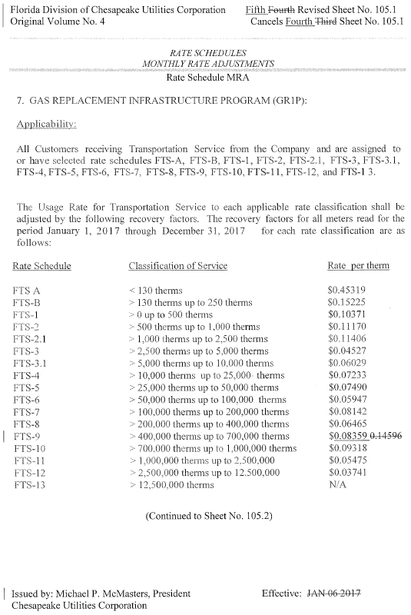

Order No. PSC-16-0567-TRF-GU, issued December 19, 2016, in Docket No. 160199-GU, In re: Joint petition for approval of gas reliability infrastructure program cost recovery factors by Florida Public Utilities Company, Florida Public Utilities Company – Fort Meade, and the Florida Division of Chesapeake Utilities Corporation.
Id.

