BEFORE THE FLORIDA PUBLIC SERVICE COMMISSION

In re: Petition for approval to amend gas reliability infrastructure program (GRIP) cost recovery factor, by Florida Division of Chesapeake Utilities Corporation. | DOCKET NO. 170062-GU  ORDER NO. PSC-17-0194-TRF-GU  ISSUED: May 19, 2017

The following Commissioners participated in the disposition of this matter:

JULIE I. BROWN, Chairman
ART GRAHAM
RONALD A. BRISÉ
JIMMY PATRONIS
DONALD J. POLMANN

ORDER APPROVING FLORIDA DIVISION OF CHESAPEAKE UTILITY CORPORATION’S PETITION TO AMEND THE 2017 GRIP FACTOR

BY THE COMMISSION:

Background

On March 8, 2017, the Florida Division of Chesapeake Utilities Corporation (Chesapeake or Company) filed a petition to amend the 2017 gas reliability infrastructure program (GRIP) factor for commercial customers in rate class FTS-9 and to allow the Company to issue refunds to the affected customers. The GRIP program allows Chesapeake to recover the cost of accelerating the replacement of cast iron and bare steel distribution mains through a surcharge on customers’ bills. The 2017 GRIP factors were approved in Order No. PSC-16-0567-TRF-GU. Rate class FTS-9, which currently has six customers, is for customers whose annual therm usage is between 400,000 and 700,000 therms (compared to about 240 therms per year for residential customers).
Chesapeake responded to Commission staff’s first data request on March 28, 2017 and filed revised responses on March 30, 2017. The proposed (legislative) tariff page is contained in Attachment 1 to this order. We have jurisdiction over this matter pursuant to Sections 366.03, 366.04, 366.05, and 366.06, Florida Statutes (F.S.).

Decision

After a customer questioned Chesapeake about the $0.14596 per therm GRIP factor for the FTS-9 rate class, the Company determined that the GRIP factor was incorrect and should have been $0.08359 per therm. Chesapeake proposes to amend the GRIP factor to $0.08359 per therm and provide refunds using a bill credit to FTS-9 customers. Chesapeake estimated that the refunds will total approximately $71,500.
GRIP Factor
The 2017 GRIP factor was developed by forecasting the 2017 GRIP revenue requirement and allocating the revenue requirement to each rate class using the same methodology used for the allocation of mains and services in the cost of service study used in Chesapeake’s most recent rate case. The revenue requirement allocated to each rate class is then divided by Chesapeake’s forecast of therms for that rate class, resulting in the per therm GRIP factor for each rate class.
Chesapeake explained that the projected therm usage used to calculate the 2017 factor for FTS-9 was understated compared to historical therms and previous projections, resulting in the higher GRIP factor. Chesapeake revised its 2017 FTS-9 therm forecast and used that forecast to develop the amended GRIP factor of $0.08359 per therm. Chesapeake has since reviewed all GRIP factors for Chesapeake, Florida Public Utilities Company (FPUC), and FPUC – Fort Meade and concluded that there were no significant therm over- or understatements used in calculating the 2017 GRIP factors.
In response to Commission staff’s data request, Chesapeake explained that in future proceedings, it plans to thoroughly review the projected annual therms and GRIP factors for reasonableness for each rate class. This review, according to the Company, will enable it to identify and investigate any anomalies in the therm forecast as well as the GRIP factors.
Corrected Billing and Refunds
In its petition, Chesapeake proposed that the corrected GRIP factor for the FTS-9 rate class be effective upon our approval. The Company explained that the May billing cycle will begin after May 4, the date of our decision; therefore, all FTS-9 customers will be billed the corrected FTS-9 GRIP factor beginning with the May billing cycle.
Chesapeake believes that it is prudent to address the over-recovery of dollars through a correction to the FTS-9 GRIP factor and the issuance of refunds rather than to use the true-up process contained in the annual GRIP filing. The true-up process would have served to reduce Chesapeake’s 2018 GRIP factors for all rate classes; however, FTS-9 customers would not have received the benefit of a refund, nor would the lower 2018 GRIP factor have offset the amounts FTS-9 customers overpaid in 2017. Chesapeake proposes to refund the difference between the approved 2017 GRIP factor for FTS-9 customers ($0.14596 per therm) and the amended GRIP factor ($0.08359 per therm), resulting in a refund of $0.06237 per therm for January through April 2017.
Since all FTS-9 customers are current Chesapeake customers, refunds will be processed using bill credits. The credits will include refunds for any applicable taxes/fees, which will be computed when the refunds are processed through the billing system. Rule 25-7.091, Florida Administrative Code (F.A.C.), requires that interest be paid on all refunds, excluding deposit refunds and refunds associated with adjustment factors. Chesapeake explained in its revised response to Commission staff’s first data request that its interpretation is that Rule 25-7.091, F.A.C., does not apply to the GRIP factor, which it considers an adjustment factor; however, the Company intends to include interest in the calculation of the refund. The refunds will be included with the June billing cycle and the Company informed us that it plans to notify the affected customers by separate letter once refunds are processed. The Company agreed to notify Commission staff when the refunds are complete.
Conclusion
We find it reasonable to amend the FTS-9 GRIP factor and to issue refunds to the FTS-9 customers who have been billed the incorrect 2017 GRIP factor.
We therefore approve Chesapeake’s petition to amend the 2017 GRIP factor for rate class FTS-9 customers and issue refunds in the form of bill credits to the FTS-9 customers effective on the date of this Commission’s decision. Within 30 days of the issuance of the bill credits, Chesapeake shall notify Commission staff that the refunds have been completed.
Based on the foregoing, it is

ORDERED by the Florida Public Service Commission that Florida Division of Chesapeake Utilities Corporation’s petition to amend the 2017 GRIP factor for rate class FTS-9 customers and issue refunds in the form of bills credits to the FTS-9 customers is hereby approved with the effective the date of this Commission’s vote. It is further

ORDERED that within 30 days of the issuance of the bill credits, Florida Division of Chesapeake Utilities Corporation shall notify Commission staff that the refunds have been completed. It is further

ORDERED that if a protest is filed within 21 days of issuance of the Order, the tariff shall remain in effect with any charges held subject to refund pending resolution of the protest. It is further

ORDERED that if no timely protest is filed, this docket shall remain open to allow for Commission staff to receive notification that the refunds are complete.

By ORDER of the Florida Public Service Commission this 19th day of May, 2017.

/s/ Hong Wang
HONG WANG
Chief Deputy Commission Clerk
Florida Public Service Commission
2540 Shumard Oak Boulevard
Tallahassee, Florida 32399
(850) 413-6770
www.floridapsc.com

Copies furnished: A copy of this document is provided to the parties of record at the time of issuance and, if applicable, interested persons.

DJ

NOTICE OF FURTHER PROCEEDINGS

The Florida Public Service Commission is required by Section 120.569(1), Florida Statutes, to notify parties of any administrative hearing or judicial review of Commission orders that is available under Sections 120.57 or 120.68, Florida Statutes, as well as the procedures and time limits that apply. This notice should not be construed to mean all requests for an administrative hearing or judicial review will be granted or result in the relief sought.

Mediation may be available on a case-by-case basis. If mediation is conducted, it does not affect a substantially interested person's right to a hearing.

The Commission's decision on this tariff is interim in nature and will become final, unless a person whose substantial interests are affected by the proposed action files a petition for a formal proceeding, in the form provided by Rule 28-106.201, Florida Administrative Code. This petition must be received by the Office of Commission Clerk, 2540 Shumard Oak Boulevard, Tallahassee, Florida 32399-0850, by the close of business on June 9, 2017.

In the absence of such a petition, this Order shall become final and effective upon the issuance of a Consummating Order.

Any objection or protest filed in this docket before the issuance date of this order is considered abandoned unless it satisfies the foregoing conditions and is renewed within the specified protest period.

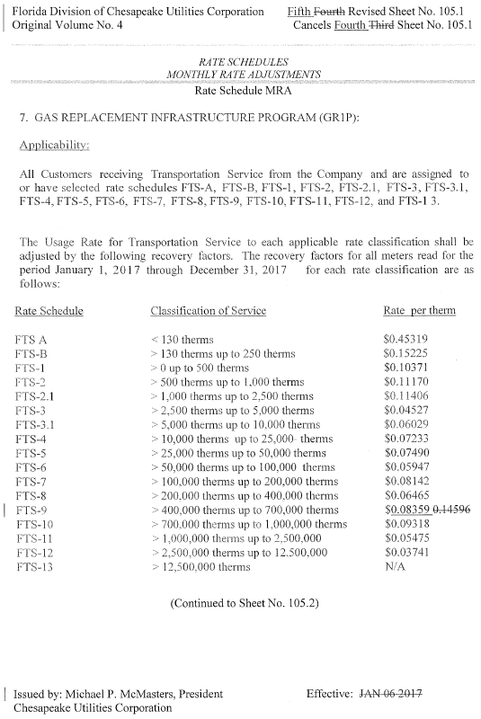

Order No. PSC-16-0567-TRF-GU, issued December 19, 2016, in Docket No. 160199-GU, In re: Joint petition for approval of gas reliability infrastructure program cost recovery factors by Florida Public Utilities Company, Florida Public Utilities Company – Fort Meade, and the Florida Division of Chesapeake Utilities Corporation.
Id.

