BEFORE THE FLORIDA PUBLIC SERVICE COMMISSION

In re: Petition for approval of tariff modifications, by Tampa Electric Company. | DOCKET NO. 170088-EI  ORDER NO. PSC-17-0227-TRF-EI  ISSUED: June 15, 2017

The following Commissioners participated in the disposition of this matter:

JULIE I. BROWN, Chairman
ART GRAHAM
RONALD A. BRISÉ
JIMMY PATRONIS
DONALD J. POLMANN

ORDER MODIFYING TAMPA ELECTRIC COMPANY’S
TARIFF NOS. 5.135 AND 6.030

BY THE COMMISSION:
On April 18, 2017, Tampa Electric Company (TECO or Company) filed a petition requesting Commission approval of amendments to Tariff Sheet Nos. 5.135 (Deposits) and 6.030 (Residential Service). During the 2015 session, the Florida Legislature enacted House Bill 7109 which was incorporated into Chapter 2015-129, Laws of Florida. Among other things, the legislation created Section 366.05(1)(b) and (c), Florida Statutes (F.S.). Paragraph (1)(b) addresses billing periods and Paragraph (1)(c) addresses customer deposits. These laws became effective on July 1, 2015. We adopted amendments to Rules 25-6.100 (Customer Billings) and 25-6.097 (Customer Deposits), Florida Administrative Code (F.A.C.), respectively, to implement the laws enacted in July 2015.
TECO is requesting tariff modifications at this time to ensure that the Company’s tariff language continues to conform to the applicable statutes and Commission rules. This Commission has jurisdiction in this matter pursuant to Sections 366.03, 366.05, and 366.06, F.S.
DECISION
Billing Period
Section 366.05(1)(b), F.S., provides that if this Commission authorizes a public utility to charge tiered rates based upon levels of usage and to vary its regular billing period, the utility may not charge a customer a higher rate because of an increase in usage attributable to an extension of the billing period; however, the regular meter reading date may not be advanced or postponed more than five days for routine operating reasons without prorating the billing for the period. We amended Rule 25-6.100, F.A.C., to implement with the statutory changes. The prior rule specified that the regular meter reading date may be advanced or postponed not more than 5 days without a proration of the billing for the period, but did not address the application of tiered rates to extended billing periods. Tiered rates, such as TECO’s residential energy charges, apply a higher energy charge to usage above 1,000 kilowatt hours.
TECO has proposed to add a paragraph on Tariff Sheet No. 6.030 to reflect the statutory requirements and to include TECO’s current billing practices in its tariff. The proposed tariff language addresses both the proration of charges when billing periods are varied by more than five days, as well as the prohibition against charging higher tiered rates if the extension of a billing period of more than five days causes a customer’s energy consumption to exceed the Company’s tier threshold of 1,000 kilowatt-hours, based on average daily usage. TECO has represented it has historically followed the bill proration practices outlined in Section 366.05(1)(b), F.S.
Customer Deposits
Section 366.05(1)(c), F.S., provides that for an existing account, the total deposit may not exceed two months of average actual charges. For a new service request, the total deposit may not exceed two months of projected charges. Once a new customer has had continuous service for a 12-month period, the amount of the deposit shall be recalculated using actual data. Any difference between the projected and actual amounts must be resolved by the customer paying the additional amount that may be billed by the utility or the utility returning any overcharge.
We amended Rule 25-6.097(1), F.A.C., to state that a utility’s methodology for determining customer deposits for existing and new accounts shall conform to Section 366.05(1)(c), F.S. The prior rule language already required that the total amount of a deposit not exceed twice the average monthly bill; that provision is contained in TECO’s current tariff (Tariff Sheet No. 5.130) and TECO is not proposing to modify that tariff sheet.
TECO’s proposed addition to Tariff Sheet No. 5.135 conforms to the new statutory language regarding the recalculation of the deposit after 12-months. TECO’s proposed addition to Tariff Sheet No. 5.135 comports with this language by providing that: (a) if the recalculated deposit amount based on the previous 12-months billing history is less than the customer’s current deposit amount, the difference between the deposit amounts will be refunded or applied as a credit to the customer account; and (b) if the recalculated deposit amount exceeds the customer’s current deposit amount, the Company may request an additional deposit amount.
Pursuant to Rule 25-6.097(3), F.A.C., utility customers receive refunds of their deposits with interest after a period of 23 months of continuous service, assuming their payment record is satisfactory. Therefore, for the majority of utility customers, the deposit amount recalculation after a 12-month period of continuous service occurs only once.
Upon review of the applicable statutes, Commission rules, and proposed tariffs filed by TECO, we find that the tariff sheet revisions conform to the applicable statutes and Commission rules. Therefore, we approve TECO’s requested modifications to Tariff Sheet Nos. 5.135 and 6.030, as reflected in Attachment A, effective June 5, 2017.
Based on the foregoing, it is

ORDERED by the Florida Public Service Commission that Tampa Electric Company’s modifications to Tariff Sheet Nos. 5.135 and 6.030, as reflected in Attachment A, are hereby approved effective June 5, 2017. It is further
ORDERED that if a protest is filed within 21 days of issuance of the Order, the tariff shall remain in effect with any charges held subject to refund pending resolution of the protest. It is further
ORDERED that if no timely protest is filed, this docket shall be closed upon the issuance of a Consummating Order.
By ORDER of the Florida Public Service Commission this 15th day of June, 2017.

/s/ Carlotta S. Stauffer
CARLOTTA S. STAUFFER
Commission Clerk
Florida Public Service Commission
2540 Shumard Oak Boulevard
Tallahassee, Florida 32399
(850) 413-6770
www.floridapsc.com

Copies furnished: A copy of this document is provided to the parties of record at the time of issuance and, if applicable, interested persons.

SBr

NOTICE OF FURTHER PROCEEDINGS

The Florida Public Service Commission is required by Section 120.569(1), Florida Statutes, to notify parties of any administrative hearing or judicial review of Commission orders that is available under Sections 120.57 or 120.68, Florida Statutes, as well as the procedures and time limits that apply. This notice should not be construed to mean all requests for an administrative hearing or judicial review will be granted or result in the relief sought.

Mediation may be available on a case-by-case basis. If mediation is conducted, it does not affect a substantially interested person's right to a hearing.

The Commission's decision on this tariff is interim in nature and will become final, unless a person whose substantial interests are affected by the proposed action files a petition for a formal proceeding, in the form provided by Rule 28-106.201, Florida Administrative Code. This petition must be received by the Office of Commission Clerk, 2540 Shumard Oak Boulevard, Tallahassee, Florida 32399-0850, by the close of business on July 6, 2017.

In the absence of such a petition, this Order shall become final and effective upon the issuance of a Consummating Order.

Any objection or protest filed in this docket before the issuance date of this order is considered abandoned unless it satisfies the foregoing conditions and is renewed within the specified protest period.

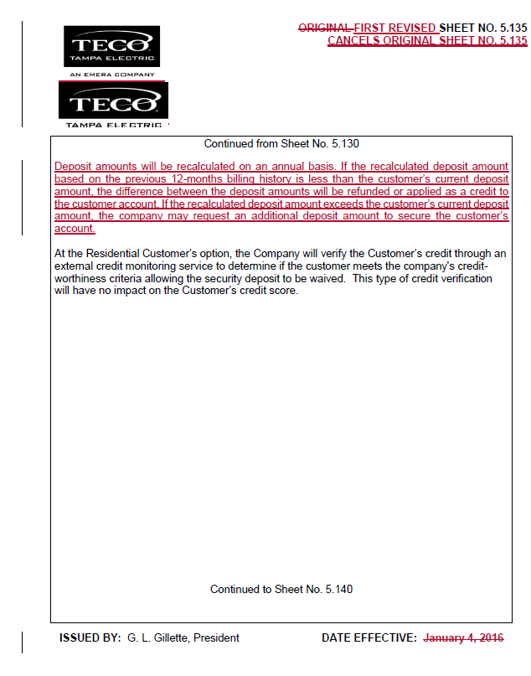
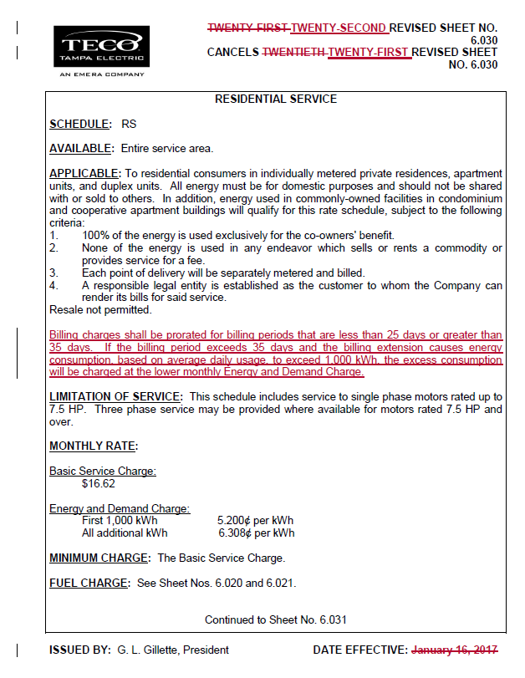

Order No. PSC-16-0024-FOF-PU, issued January 12, 2016, in Docket No. 150241-PU, In re: Proposed amendments to Rules 25-6.093, Information to Customers; 25-6.097, Customer Deposits; 25-6.100, Customer Billings; 25-7.079, Information to Customers; 25-7.083, Customer Deposits; and 25-7.085, Customer Billing, F.A.C.
Id.
Id.

