BEFORE THE FLORIDA PUBLIC SERVICE COMMISSION

In re: Joint petition for approval of amendment to territorial agreement, by Tampa Electric Company and Withlacoochee River Electric Cooperative, Inc. | DOCKET NO. 170068-EU  ORDER NO. PSC-17-0241-PAA-EU  ISSUED: June 21, 2017

The following Commissioners participated in the disposition of this matter:

JULIE I. BROWN, Chairman
ART GRAHAM
RONALD A. BRISÉ
JIMMY PATRONIS
DONALD J. POLMANN

NOTICE OF PROPOSED AGENCY ACTION
ORDER APPROVING AMENDMENT TO TERRITORIAL AGREEMENT

BY THE COMMISSION:

NOTICE is hereby given by the Florida Public Service Commission that the action discussed herein is preliminary in nature and will become final unless a person whose interests are substantially affected files a petition for a formal proceeding, pursuant to Rule 25-22.029, Florida Administrative Code (F.A.C.).

Background

On March 29, 2017, Tampa Electric Company (TECO or the Company) and Withlacoochee River Electric Cooperative, Inc. (WREC) filed a joint petition for approval of an amendment to their current territorial agreement in Pasco County (territorial amendment). TECO serves retail customers in Hillsborough County and in portions of Polk, Pinellas, and Pasco Counties. WREC serves retail customers in portions of Hernando, Citrus, Sumter, Pasco, and Polk Counties.
We approved the original electric service boundary between TECO and WREC in 1974 in Order No. 6281. The boundary was amended in 1990 in Order No. 23905 and further amended in 2006 in Order No. PSC-06-0128-PAA-EU (2006 Order). The 1990 territorial agreement approved in Order No. 23905 has been placed in the docket file and attached as Attachment A to this Order for informational purposes.
The 2006 Order amended the TECO and WREC territorial agreement approved in 1990 in Order No. 23905 in three limited geographic areas: the Meadow Pointe Subdivision, the Belle Chase Subdivision, and the Cannon Ranch Subdivision. The 2006 Order is included as Exhibit A to the petition. Page 7 of the 2006 Order includes a map showing the agreed upon service boundary modifications relative to the Cannon Ranch Subdivision in Pasco County. The 2006 Order did not approve a new territorial agreement and only amended the 1990 territorial agreement with respect to the three subdivisions listed above.
The Cannon Ranch subdivision was never developed and in 2016 a new developer acquired the development rights of the Cannon Ranch subdivision. The new developer renamed the subdivision Mirada Subdivision and has proposed a different development plan from the Canon Ranch Subdivision. The instant petition seeks to only amend the territorial boundaries in the proposed Mirada Subdivision to accommodate the new development plans (as shown in Attachment B to this Order). All other aspects of the territorial agreement approved in 1990 and amended in 2006 remain the same.
Staff issued its first data request on April 21, 2017, to which the responses were received on May 8, 2017. We have jurisdiction over this matter pursuant to Section 366.04, Florida Statues, (F.S.).

Decision

In 2016, the new developer who acquired the former Cannon Ranch Subdivision discussed with TECO and WREC the provision of electric service to the proposed Mirada Subdivision. Those discussions led to a mutual agreement among TECO, WREC, and the developer regarding the most efficient, reliable provision of electricity to the new subdivision.
As required by Rule 25-6.0440(1)(f), F.A.C., the parties provided three large scale maps: a Florida Department of Transportation General County map of Pasco county, the general area of the Mirada Subdivision, and an expanded view of the current and proposed boundary lines specific to the Mirada Subdivision. The specific Mirada Subdivision map is shown in Attachment B to this Order.
The proposed territorial amendment is to accommodate the proposed new subdivision. Essentially, the centerline of Mirada Boulevard will serve as the revised territorial boundary between TECO and WREC as it relates to the Mirada Subdivision. The petitioners assert that this proposal would allow both utilities to have sufficient access to the areas to be served and it will facilitate the orderly provision of electricity by the two utilities. The petitioners further assert that the proposed territorial amendment will not cause a decrease in the reliability of electric service to the existing and future ratepayers of either utility and will prevent the uneconomic duplication of facilities.
The Mirada Subdivision covers 2,350 acres and will have a total of 4,520 customers when developed. TECO will serve 2,420 customers and WREC will serve 2,100 customers. As this subdivision has not been developed yet, there are no customers to be transferred as a result of the proposed territorial amendment. Similarly, there are no affected customers to be notified. The petitioners represented that the developer of the Mirada Subdivision has agreed with TECO and WREC that the new boundary line through the development is appropriate and acceptable to the developer.
After review of the petition, the proposed territorial amendment, and the joint petitioners’ responses to Commission staff’s data request, we find that the proposed territorial amendment is in the public interest and will enable TECO and WREC to better serve the future customers in the Mirada Subdivision in Pasco County. We agree that the proposed territorial amendment eliminates any potential uneconomic duplication of facilities and will not cause a decrease in the reliability of electric service. As such, we hereby approve the proposed territorial agreement between TECO and WREC.
Based on the foregoing, it is

ORDERED by the Florida Public Service Commission that the amendment to the existing territorial agreement between Tampa Electric Company and Withlacoochee River Electric Cooperative, Inc. related to the Mirada Subdivision, f/k/a Cannon Ranch Subdivision, be approved. It is further

ORDERED that the provisions of this Order, issued as proposed agency action, shall become final and effective upon the issuance of a Consummating Order unless an appropriate petition, in the form provided by Rule 28-106.201, Florida Administrative Code, is received by the Commission Clerk, 2540 Shumard Oak Boulevard, Tallahassee, Florida 32399-0850, by the close of business on the date set forth in the “Notice of Further Proceedings” attached hereto. It is further

ORDERED that in the event this Order becomes final, this docket shall be closed.

By ORDER of the Florida Public Service Commission this 21st day of June, 2017.

/s/ Carlotta S. Stauffer
CARLOTTA S. STAUFFER
Commission Clerk
Florida Public Service Commission
2540 Shumard Oak Boulevard
Tallahassee, Florida 32399
(850) 413-6770
www.floridapsc.com

Copies furnished: A copy of this document is provided to the parties of record at the time of issuance and, if applicable, interested persons.

WDT

NOTICE OF FURTHER PROCEEDINGS OR JUDICIAL REVIEW

The Florida Public Service Commission is required by Section 120.569(1), Florida Statutes, to notify parties of any administrative hearing that is available under Section 120.57, Florida Statutes, as well as the procedures and time limits that apply. This notice should not be construed to mean all requests for an administrative hearing will be granted or result in the relief sought.

Mediation may be available on a case-by-case basis. If mediation is conducted, it does not affect a substantially interested person's right to a hearing.

The action proposed herein is preliminary in nature. Any person whose substantial interests are affected by the action proposed by this order may file a petition for a formal proceeding, in the form provided by Rule 28-106.201, Florida Administrative Code. This petition must be received by the Office of Commission Clerk, 2540 Shumard Oak Boulevard, Tallahassee, Florida 32399-0850, by the close of business on July 12, 2017.

In the absence of such a petition, this order shall become final and effective upon the issuance of a Consummating Order.

Any objection or protest filed in this/these docket(s) before the issuance date of this order is considered abandoned unless it satisfies the foregoing conditions and is renewed within the specified protest period.

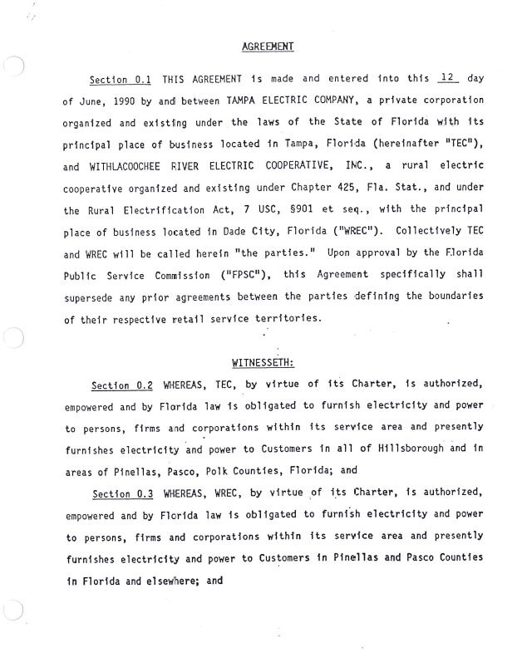

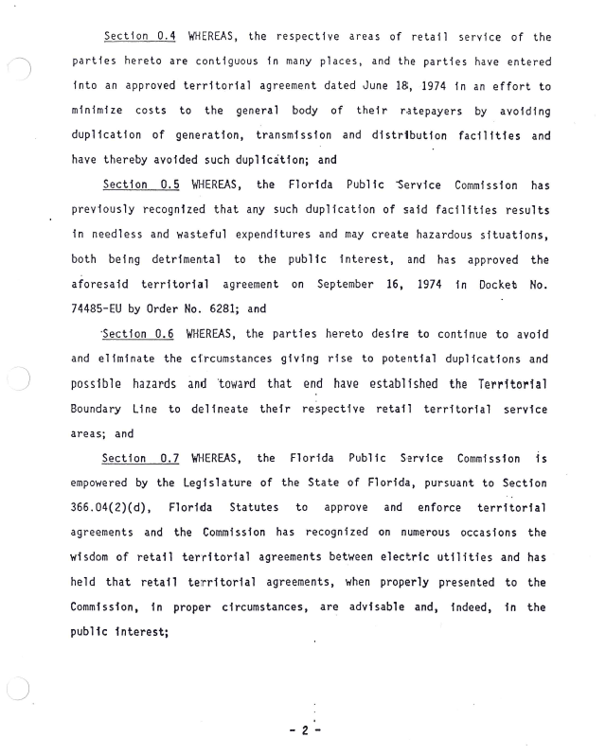
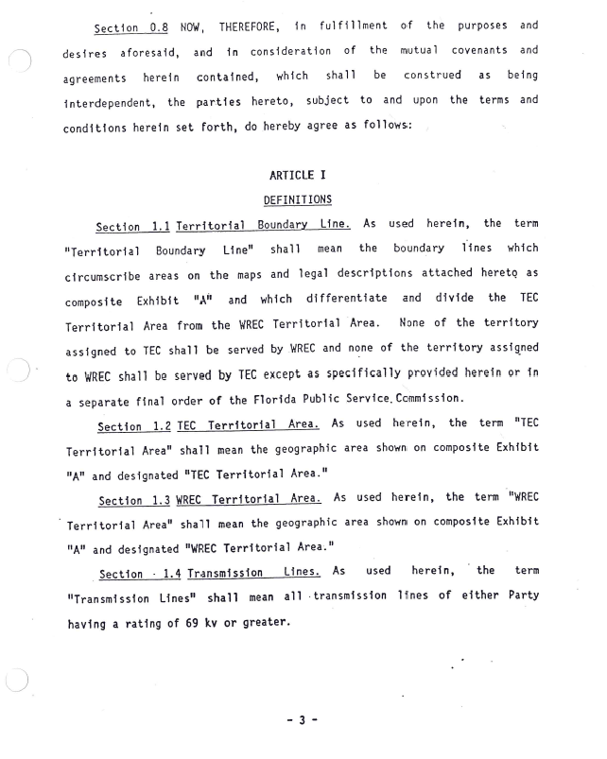
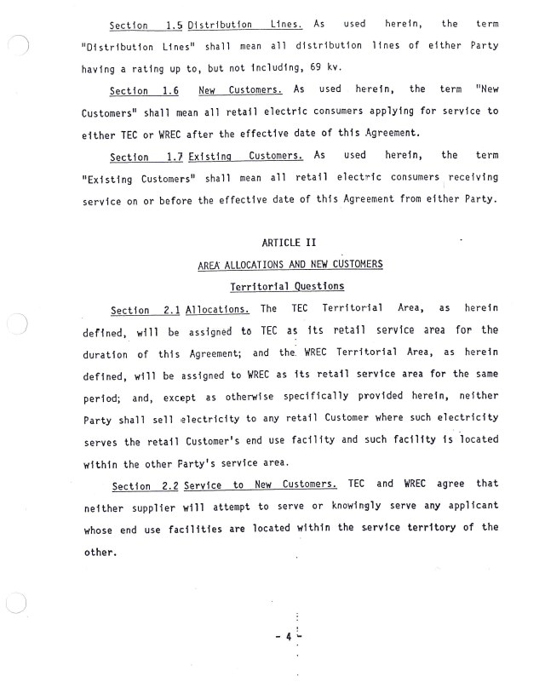
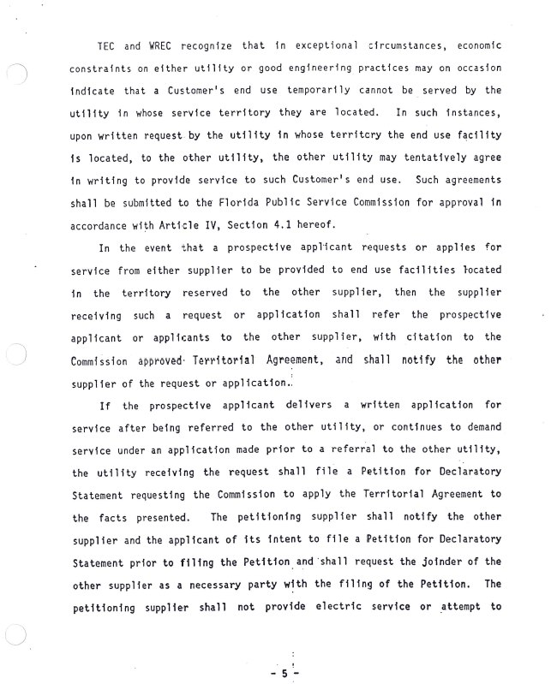
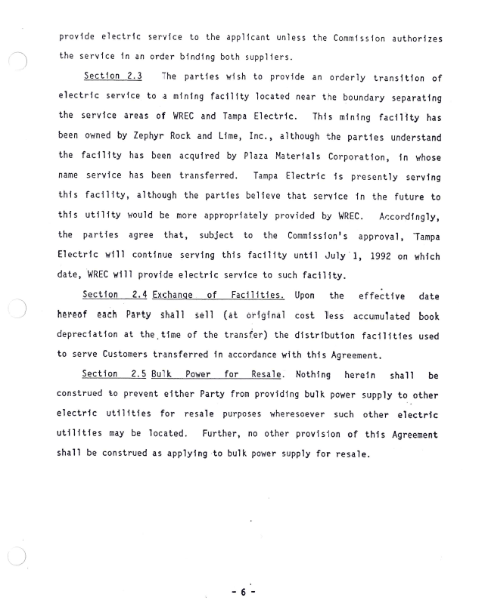
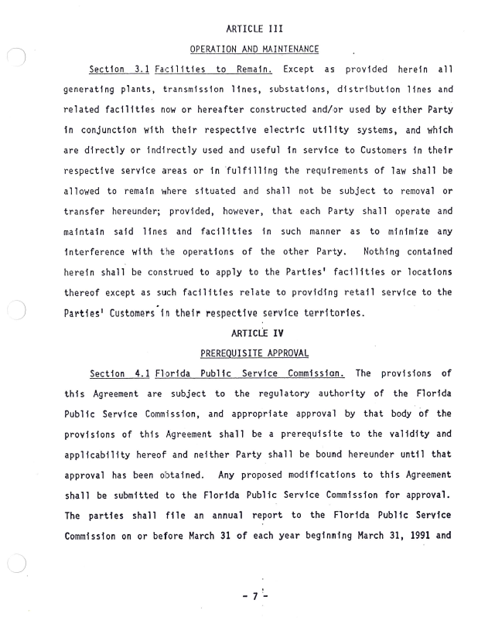
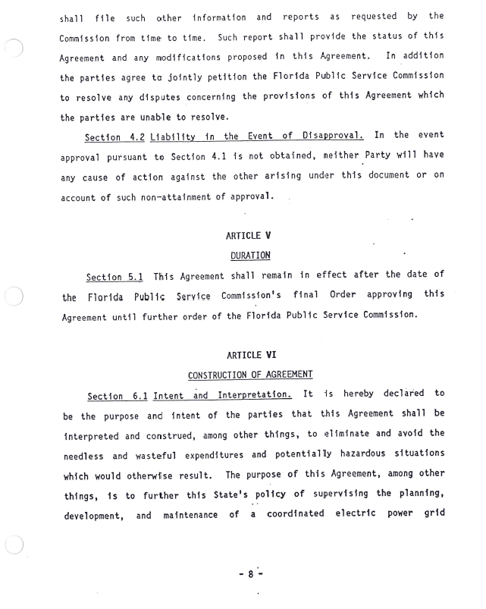
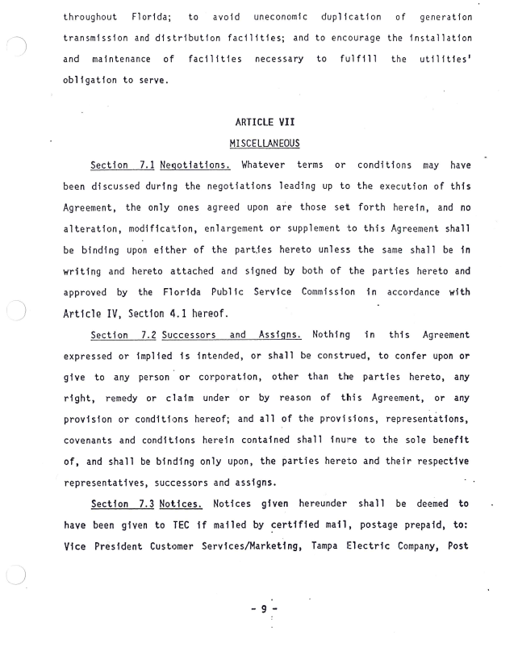
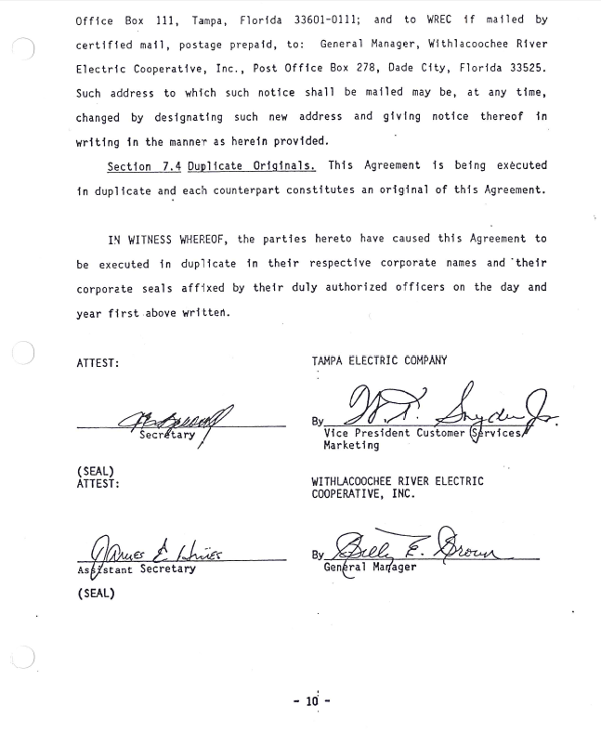
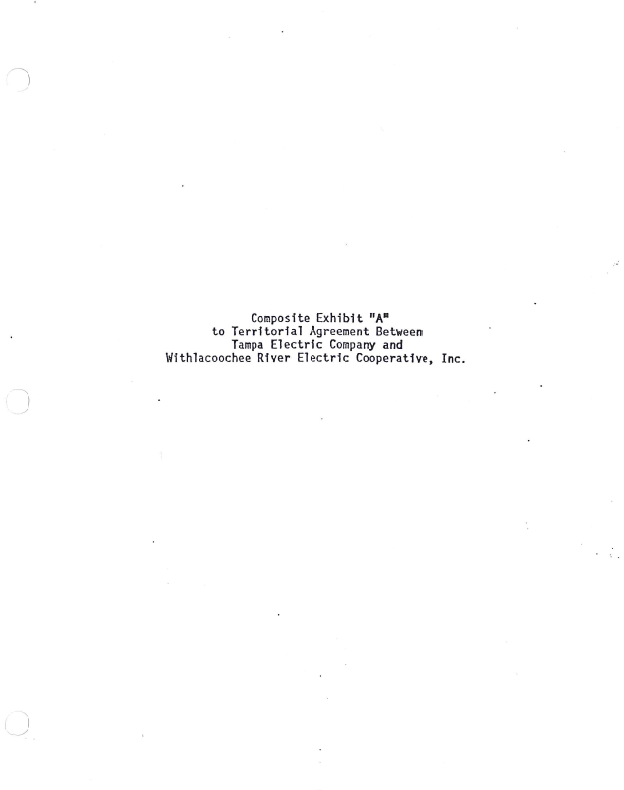
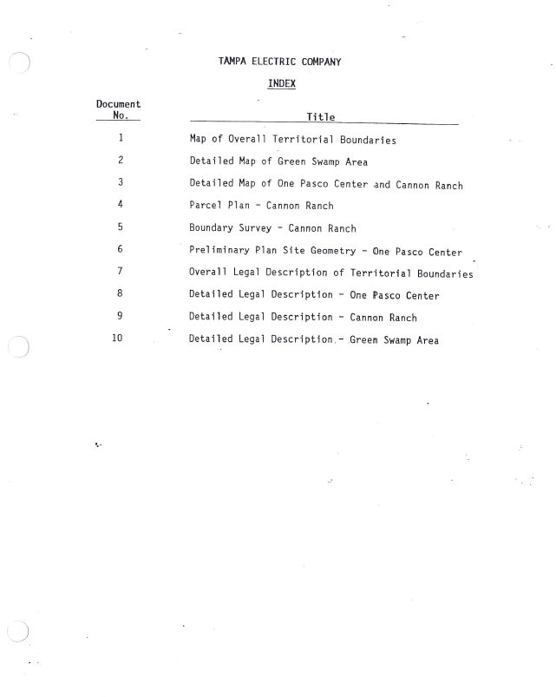
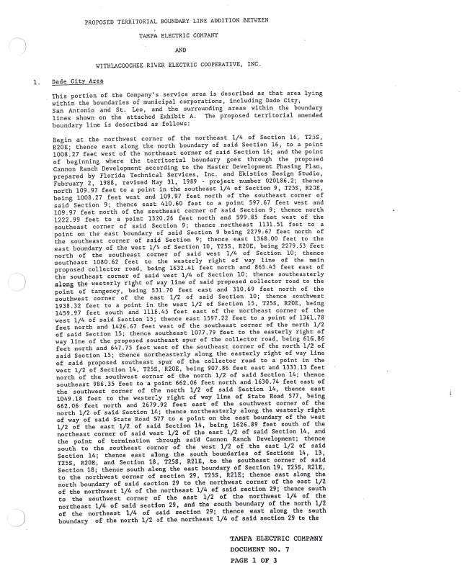
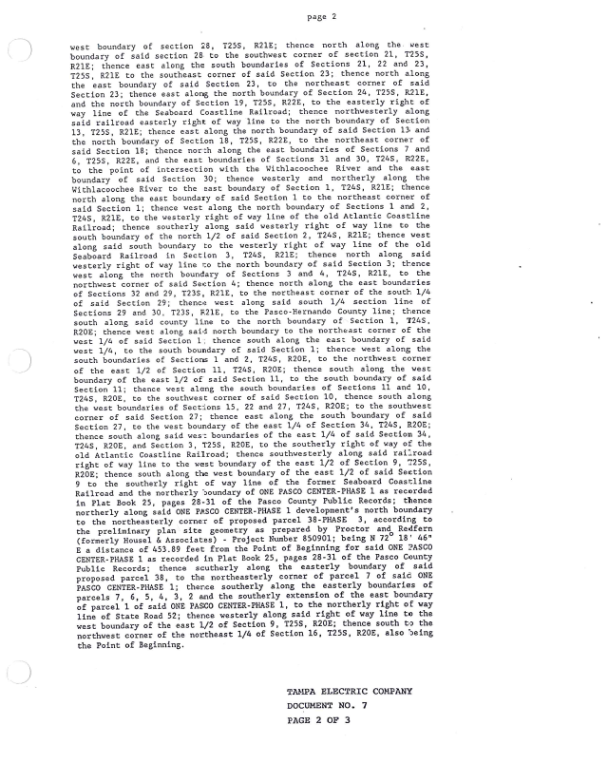
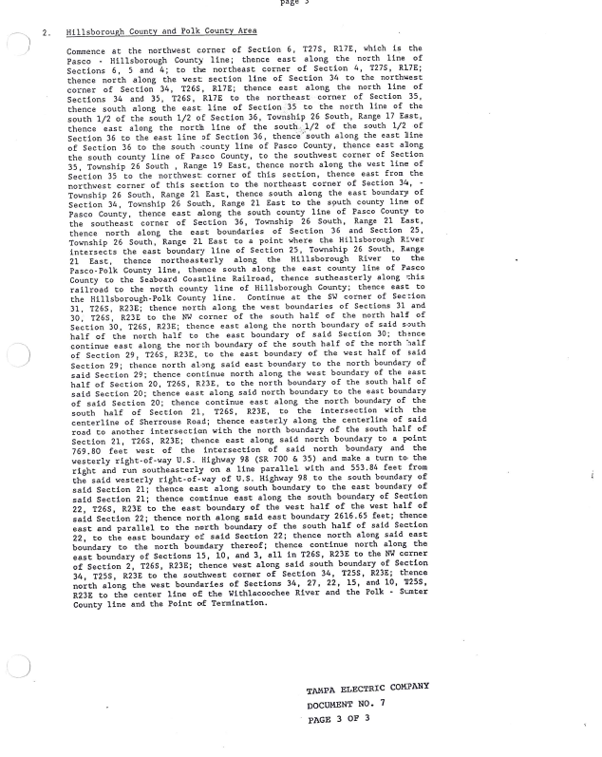
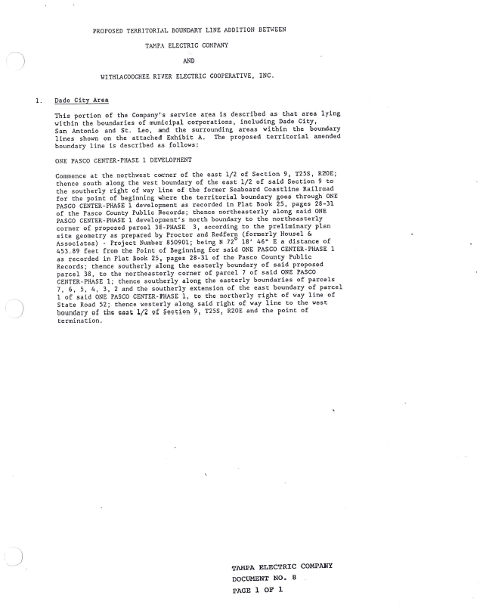
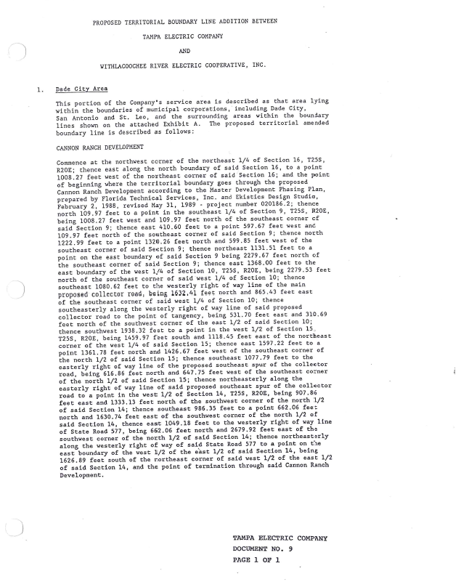
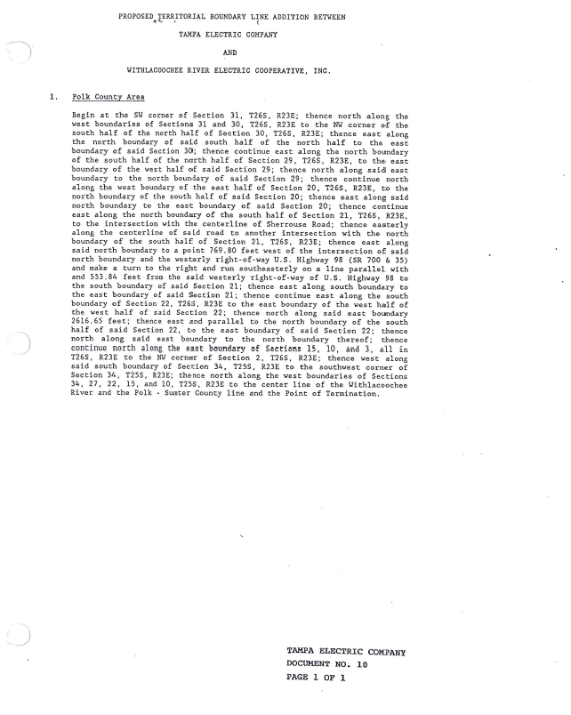

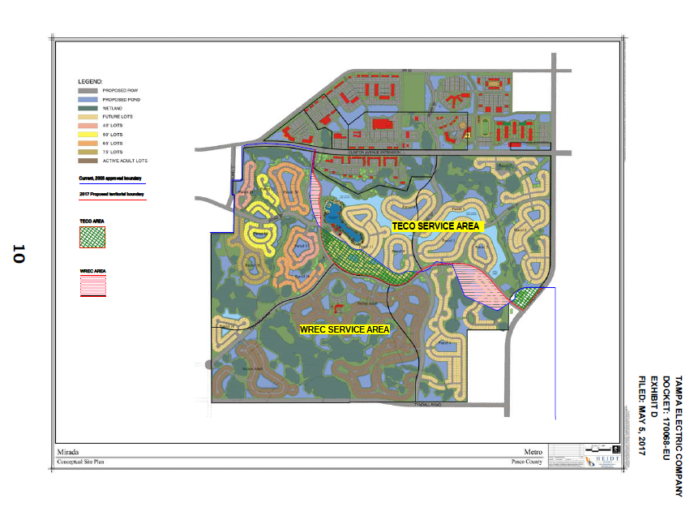

Order No. 6281, issued on September 16, 1974, in docket No. 74485-EU, In re: Application of Tampa Electric Company for approval of territorial agreement with Withlacoochee River Electric Cooperative, Inc., relative to respective retail electric systems and service areas.
Order No. 23905, issued December 20, 1990, in Docket No 900752-EU, In re: Joint Petition for Approval of 1990 Amendment to Territorial Agreement by Tampa Electric Company and Withlacoochee River Electric Cooperative, Inc.
Order No.PSC-06-0128-PAA-EU, issued February 16, 2006, in Docket No. 041408-EU, In re: Joint petition of Tampa Electric Company and Withlacoochee River Electric Cooperative, Inc. for expedited interim approval of customer transfers pending consideration of joint application for permanent relocation of territorial boundaries.
Document No. 05006-17.

