BEFORE THE FLORIDA PUBLIC SERVICE COMMISSION

In re: Joint petition for approval of amended territorial agreement in Orange and Osceola Counties, by Duke Energy Florida, LLC and Reedy Creek Improvement District. | DOCKET NO. 20170175-EU  ORDER NO. PSC-2017-0414-PAA-EU  ISSUED: October 24, 2017

The following Commissioners participated in the disposition of this matter:

JULIE I. BROWN, Chairman
ART GRAHAM
RONALD A. BRISÉ
DONALD J. POLMANN
GARY F. CLARK

NOTICE OF PROPOSED AGENCY ACTION
ORDER APPROVING AMENDED TERRITORIAL AGREEMENT

BY THE COMMISSION:

NOTICE is hereby given by the Florida Public Service Commission that the action discussed herein is preliminary in nature and will become final unless a person whose interests are substantially affected files a petition for a formal proceeding, pursuant to Rule 25-22.029, Florida Administrative Code (F.A.C.).

Background

On August 14, 2017, Duke Energy Florida, LLC (Duke) and the Reedy Creek Improvement District (Reedy Creek) filed a joint petition for approval of an amended territorial agreement (proposed agreement) in Orange and Osceola Counties. The proposed agreement is contained in Attachment A. The maps and written descriptions delineating the area to be served by the proposed agreement are provided in the petition as Exhibits A and B, respectively. Additional maps are contained in the joint petitioners’ response to Commission staff’s data request filed in this docket on August 31, 2017. Due to the voluminous nature of Exhibits A and B and the maps provided in the data request response, they have not been attached to this Order.
The joint petitioners’ territorial agreement was approved by this Commission in 1994 and amended in 2010 (existing agreement). The expiration date of the existing agreement is September 30, 2017. The joint petitioners stated that they will abide by the existing agreement until we approve the proposed agreement. We have jurisdiction over this matter pursuant to Section 366.04, Florida Statutes (F.S.).
Decision

Pursuant to Section 366.04(2)(d), F.S., and Rule 25-6.0440(2), F.A.C., we have jurisdiction to approve territorial agreements between and among rural electric cooperatives, municipal electric utilities, and other electric utilities. Unless we determine that the agreement will cause a detriment to the public interest, the agreement should be approved.
Reedy Creek is a special taxing district created by the Florida legislature. Reedy Creek operates like a municipality in that it is authorized to furnish electric service to areas within its defined legal boundary; however, pursuant to its charter, Reedy Creek cannot furnish retail electric power outside of its boundary. Reedy Creek is authorized to furnish electric power to areas in Orange and Osceola Counties.
There are three differences between the existing and proposed agreements, as explained by the joint petitioners in their response to Commission staff’s data request. First, the proposed agreement includes modified territorial boundaries. Second, the territorial boundary maps in the proposed agreement have been updated to a geographic information system (GIS) format, thus displaying the boundary lines in greater detail. Third, the term of the existing agreement is 23 years and the term of the proposed agreement is 30 years. After the expiration of the 30-year term of the proposed agreement in 2047, the agreement would remain in effect until and unless either party provides written notice of termination no less than 12 months prior to the termination date.
The proposed territorial boundary changes involve three areas. The boundary changes include two areas, which have been de-annexed by Reedy Creek and will be served by Duke under the proposed agreement: the Black Lake parcel and an area in the vicinity of I-4 and Osceola Parkway. The third boundary modification, an area in the vicinity of County Road (CR) 535 and Apopka Vineland Road, is in the Reedy Creek political boundary and is served by Reedy Creek; however, the area was previously shown as served by Duke. The three boundary changes are detailed in the joint petitioners’ response to Commission staff’s data request. There are no customer transfers and no facilities will be purchased or transferred; therefore, no noticing was required pursuant to Rule 25-6.0440(1)(d), F.A.C.
The joint petitioners assert that the proposed agreement will avoid duplication of service and wasteful expenditures, it will protect the health and safety of the public from potentially hazardous conditions, and it will not cause a decrease in the reliability of electric service.

Conclusion
After review of the petition, the proposed agreement, and the joint petitioners’ response to Commission staff’s data request, we find that the proposed agreement is in the public interest and will enable Duke and Reedy Creek to better serve their current and future customers. It appears that the proposed agreement eliminates any potential uneconomic duplication of facilities and will not cause a decrease in the reliability of electric service. As such, we find that the proposed agreement between Duke and Reedy Creek will not cause a detriment to the public interest and is hereby approved.
Based on the foregoing, it is

ORDERED by the Florida Public Service Commission that the joint petition by Duke Energy Florida, LLC and the Reedy Creek Improvement District for approval of an amended territorial agreement is approved. It is further

ORDERED that the provisions of this Order, issued as proposed agency action, shall become final and effective upon the issuance of a Consummating Order unless an appropriate petition, in the form provided by Rule 28-106.201, Florida Administrative Code, is received by the Commission Clerk, 2540 Shumard Oak Boulevard, Tallahassee, Florida 32399-0850, by the close of business on the date set forth in the “Notice of Further Proceedings” attached hereto. It is further

ORDERED that in the event this Order becomes final, this docket shall be closed.

By ORDER of the Florida Public Service Commission this 24th day of October, 2017.

/s/ Carlotta S. Stauffer
CARLOTTA S. STAUFFER
Commission Clerk
Florida Public Service Commission
2540 Shumard Oak Boulevard
Tallahassee, Florida 32399
(850) 413-6770
www.floridapsc.com

Copies furnished: A copy of this document is provided to the parties of record at the time of issuance and, if applicable, interested persons.

DJ

NOTICE OF FURTHER PROCEEDINGS OR JUDICIAL REVIEW

The Florida Public Service Commission is required by Section 120.569(1), Florida Statutes, to notify parties of any administrative hearing that is available under Section 120.57, Florida Statutes, as well as the procedures and time limits that apply. This notice should not be construed to mean all requests for an administrative hearing will be granted or result in the relief sought.

Mediation may be available on a case-by-case basis. If mediation is conducted, it does not affect a substantially interested person's right to a hearing.

The action proposed herein is preliminary in nature. Any person whose substantial interests are affected by the action proposed by this order may file a petition for a formal proceeding, in the form provided by Rule 28-106.201, Florida Administrative Code. This petition must be received by the Office of Commission Clerk, 2540 Shumard Oak Boulevard, Tallahassee, Florida 32399-0850, by the close of business on November 14, 2017.

In the absence of such a petition, this order shall become final and effective upon the issuance of a Consummating Order.

Any objection or protest filed in this/these docket(s) before the issuance date of this order is considered abandoned unless it satisfies the foregoing conditions and is renewed within the specified protest period.

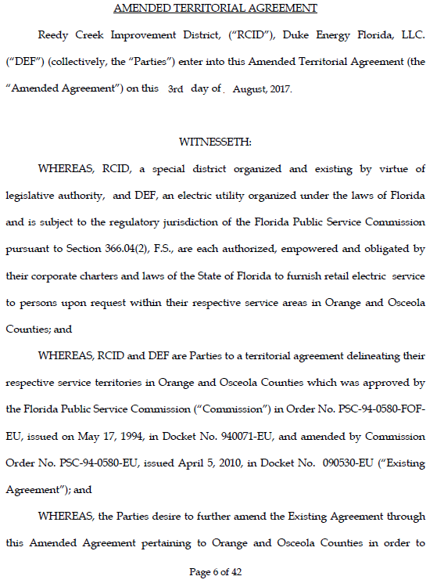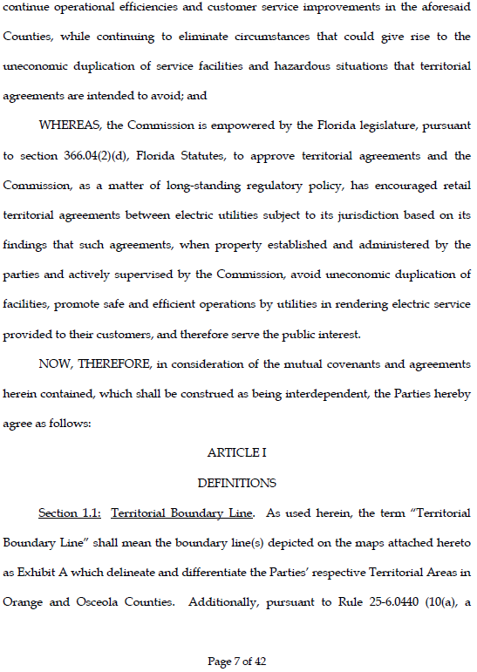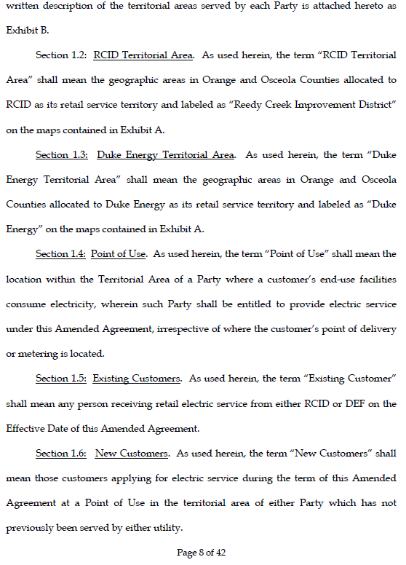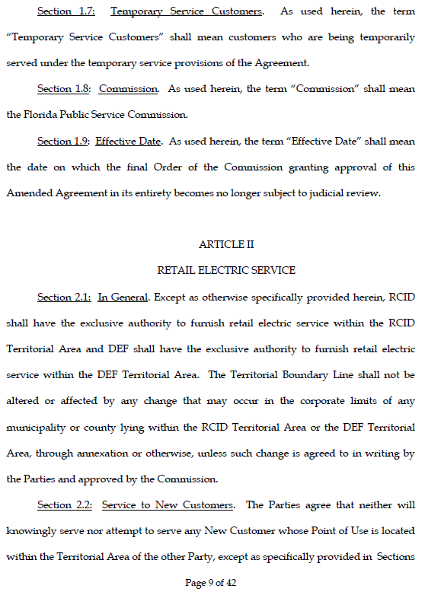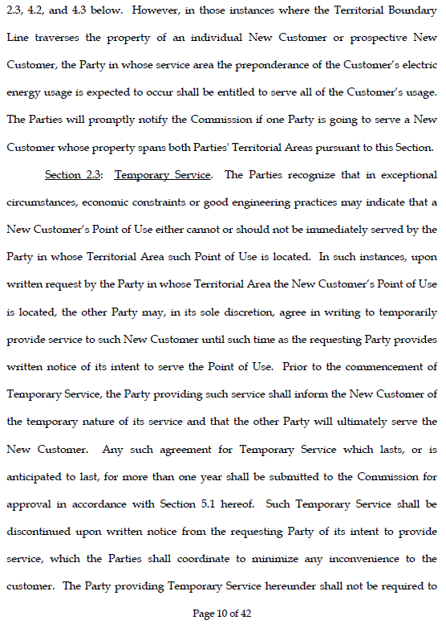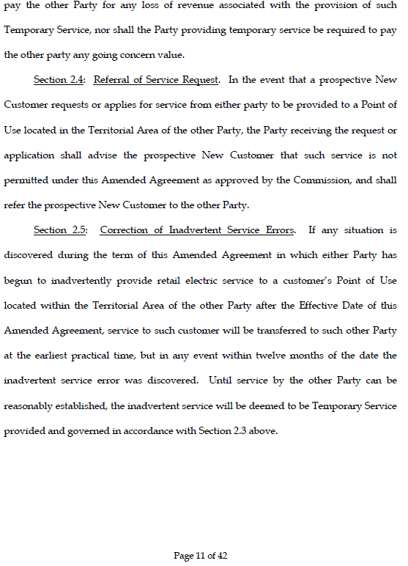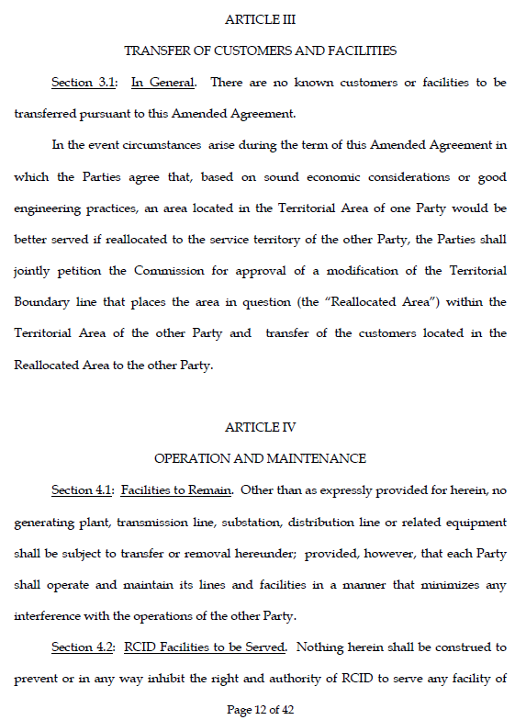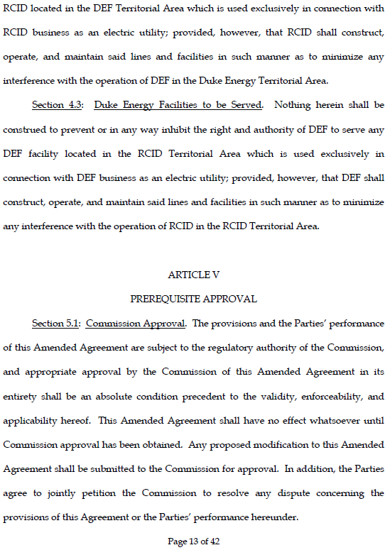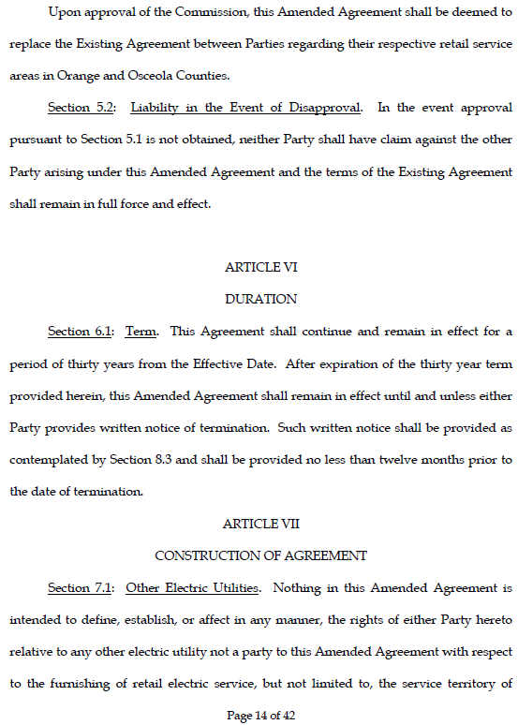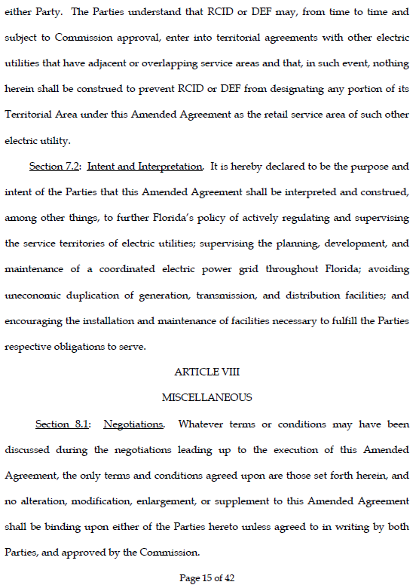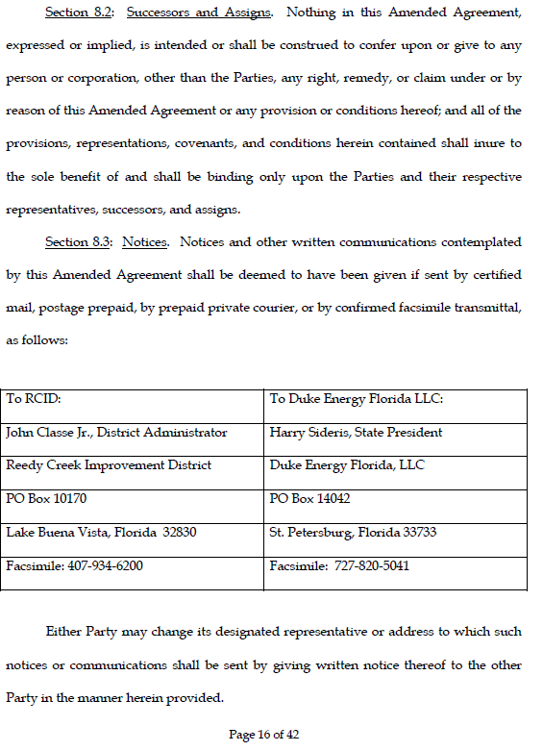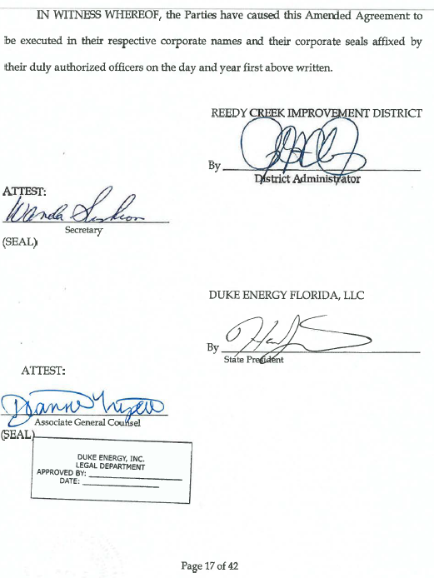

Order No. PSC-94-0580-FOF-EU, issued May 17, 1994, in Docket No. 940071-EU, In re: Joint Petition for approval of territorial agreement between Florida Power Corporation and Reedy Creek Improvement District; Order No. PSC-10-0206-PAA-EU, issued April 5, 2010, in Docket No. 090530-EU, In re: Joint Petition for approval to amend territorial agreement by Progress Energy Florida, Inc. and Reedy Creek Improvement District.
Utilities Commission of the City of New Smyrna Beach v. Florida Public Service Commission, 469 So. 2d 731 (Fla. 1985).

