State of Florida |  | Public Service Commission  Capital Circle Office Center ● 2540 Shumard Oak Boulevard  Tallahassee, Florida 32399-0850  -M-E-M-O-R-A-N-D-U-M-
DATE: | October 26, 2017
TO: | Office of Commission Clerk (Stauffer)
FROM: | Division of Economics (Ollila)  Office of the General Counsel (Brownless)
RE: | Docket No. 20170192-GU – Petition for approval of 2016 true-up, projected 2017 true-up, and 2018 revenue requirements and surcharges associated with cast iron/bare steel pipe replacement rider, by Peoples Gas System.
AGENDA: | 11/07/17 – Regular Agenda – Tariff Filing – Interested Persons May Participate
COMMISSIONERS ASSIGNED: |  |  | All Commissioners
PREHEARING OFFICER: |  |  | Administrative
CRITICAL DATES: |  |  | 8-Month Effective Date: 5/1/18 (60-day suspension date waived by the utility)
SPECIAL INSTRUCTIONS: |  |  | None

Case Background
On September 1, 2017, Peoples Gas System (Peoples or company) filed a petition for approval of its final 2016 true-up, projected 2017 true-up, and 2018 revenue requirements and surcharges associated with the cast iron/bare steel replacement rider (CI/BSR rider or rider). The rider was originally approved in Order No. PSC-12-0476-TRF-GU (2012 order) to recover the cost of accelerating the replacement of cast iron and bare steel distribution pipes through a surcharge on customers’ bills. Peoples’ current surcharges were approved in Order No. PSC-16-0524-TRF-GU. In the 2012 order, the Commission found that “replacement of these types of pipelines is in the public interest to improve the safety of Florida’s natural gas infrastructure, and reduce the possibility of loss of life and destruction of property should an incident occur.”
The Commission approved a comprehensive settlement agreement between Peoples and the Office of Public Counsel (OPC) in Order No. PSC-17-0066-AS-GU. The settlement agreement addressed the company’s 2016 depreciation study, cost recovery associated with Peoples’ manufactured gas plant-related environmental liability, and the reduction of the bottom of Peoples’ authorized earning range. In addition, the settlement agreement added problematic plastic pipe (PPP) installed in the company’s distribution system to eligible replacements under the rider. PPP was manufactured before 1983 and has significant safety concerns. In certain areas, the PPP is interspersed with, or connected to, the cast iron/bare steel pipe that is being replaced under the rider. As provided for in the settlement agreement, PPP replacements are included in the calculation of the 2018 rider surcharges.
In its petition, Peoples waived the 60-day suspension deadline pursuant to Section 366.06(3), Florida Statutes (F.S.). Peoples filed its response to staff’s first data request on September 27, 2017. On October 18, 2017, Peoples filed a revised response to staff’s data request No. 1. OPC intervened in this docket on October 4, 2017, which was acknowledged by Order No. PSC-2017-0393-PCO-GU, issued October 17, 2017. The proposed tariff page is contained in Attachment B. The Commission has jurisdiction over this matter pursuant to Sections 366.03, 366.04, 366.05, and 366.06, F.S.

Discussion of Issues

Issue 1:
Should the Commission approve Peoples' proposed rider surcharges for 2018?

Recommendation:
Yes, the Commission should approve Peoples’ proposed 2018 rider surcharge for each rate class commencing with bills rendered for meter readings taken on and after January 1, 2018. (Ollila)

Staff Analysis:
The rider surcharges have been in effect since January 2013. In 2017, Peoples’ cast iron and bare steel replacement activity has been occurring in Ocala, Sarasota, Jacksonville, Eustis, Orlando, St. Petersburg, Miami, and Tampa, with a larger concentration of replacements in the Tampa and St. Petersburg areas. PPP replacement activity started in May 2017 in Orlando, Lakeland, and Daytona. The original projected completion date for the CI/BSR replacement program was 2022 for mains and services. Peoples now expects to complete the replacement activity for mains in 2021 and services in 2022. Replacement of PPP is expected to continue until 2028.
Peoples continues to use a risk-based prioritization to determine the replacement order, which is primarily identified by the Distribution Integrity Management Program (DIMP). Other factors considered include leak incident rates, the pressure under which a pipeline is operating, areas of significant construction, and the pipeline’s age. In its response to staff’s data request, Peoples characterized its replacement approach as very proactive in removing all pipes identified by the Pipeline Hazardous Materials and Safety Administration (PHMSA) as being of concern. Peoples explained that it plans to secure additional contractors so that the replacement of cast iron and bare steel, as well as PPP, can be accelerated. According to Peoples, an accelerated replacement program is likely to result in better accessibility to contractors and supplies.
Attachment A contains tables which display the replacement progress and forecasts for CI/BSR (Table 1) and for PPP (Table 2). In addition, Peoples provided a third table which consolidates actual and projected CI/BSR and PPP miles replaced, investment, and revenue requirement for each year of the replacement program, both actual and forecast.

True-ups by Year
Peoples’ calculations for the 2018 revenue requirement and surcharges include a final true-up for 2016, an actual/estimated true-up for 2017, and projected costs for 2018. Pursuant to the 2012 order, the capital expenditures for 2016 through 2018 exclude the first $1 million of facility replacements each year, and are thus excluded from recovery. Peoples has included depreciation expense savings as discussed in the 2012 order; however, Peoples stated that it has not identified any operations and maintenance savings.

Final True-up for 2016
Peoples stated that the revenues collected for 2016 were $4,703,679 compared to a revenue requirement of $4,901,227, resulting in an under-recovery of $197,548. Adding the 2015 under-recovery of $98,762, the 2016 under-recovery of $197,548, and interest of $5,188 associated with any over- and under-recoveries, the resulting preliminary under-recovery is $291,122. Order No. PSC-16-0205-AS-GU required Peoples to include a one-time credit of $2,000,000 to customers subject to the rider, resulting in an over-recovery of $1,708,878 for the final 2016 true-up.

Actual/Estimated 2017 True-up
Peoples provided actual revenues for January through July and forecast revenues for August through December of 2017, totaling $4,750,300, compared to an actual/estimated revenue requirement of $6,942,022, resulting in an under-recovery of $2,191,722. Adding the 2016 over-recovery of $1,708,878, the 2017 under-recovery of $2,191,722, and interest of $6,924, the resulting total 2017 true-up is an under-recovery of $475,919.

Projected 2018 Costs
Peoples projects investment or capital expenditures of $35,675,000 for the replacement of cast iron/bare steel infrastructure and PPP in 2018. As shown in Table 3 of Attachment A, this consists of the CI/BSR investment of $22,850,000 and the PPP investment of $12,825,000. This represents an increase of approximately $16.4 million from the 2017 actual/estimated investment ($19,246,093) and an increase of approximately $22.3 million from final 2016 expenditures ($13,331,026). The return on investment, depreciation expense (less savings), and property tax expense associated with that investment are $10,174,749. After adding the total 2017 under-recovery of $475,919, the total 2018 revenue requirement is $10,650,669. Table 1-1 displays the 2018 revenue requirement calculation.
Table 1-1
2018 Revenue Requirement Calculation
2018 Projected Replacements | $35,675,000
Return on Investment | $7,277,347
Depreciation Expense (less savings) | $1,806,515
Property Tax Expense | $1,090,887
2018 Revenue Requirement | $10,174,749
Plus 2017 Under-recovery | $475,919
Total 2018 Revenue Requirement | $10,650,669
Source: Exhibit C, page 1, of the Petition

Proposed Surcharges
As established in the 2012 order, the total 2018 revenue requirement is allocated to rate classes using the same methodology that was used for the allocation of mains and services in the cost of service study used in Peoples’ most recent rate case. After calculating the percentage of total plant costs attributed to each rate class, the respective percentages were multiplied by the 2018 revenue requirement resulting in the revenue requirement by rate class. Dividing each rate class’s revenue requirement by projected therm sales provides the rider surcharge for each rate class.
The proposed 2018 rider surcharge for residential customers is $0.05285 per therm (compared to the current surcharge of $0.02309 per therm). The monthly bill impact is $1.06 for bills rendered for meter readings taken on and after January 1, 2018, for a residential customer who uses 20 therms. The proposed tariff page is provided in Attachment B.

Conclusion
Staff believes the calculation of the 2018 rider revenue requirement and the proposed rider surcharge for each rate class is reasonable and accurate. Therefore, staff recommends approval of Peoples’ proposed 2018 rider surcharge for each rate class commencing with bills rendered for meter readings taken on and after January 1, 2018.

Issue 2:
Should this docket be closed?

Recommendation:
If Issue 1 is approved and a protest is filed within 21 days of the issuance of the order, the tariff should remain in effect, with any revenues held subject to refund, pending resolution of the protest. If no timely protest is filed, this docket should be closed upon the issuance of a consummating order. (Brownless)

Staff Analysis:
If Issue 1 is approved and a protest is filed within 21 days of the issuance of the order, the tariff should remain in effect, with any revenues held subject to refund, pending resolution of the protest. If no timely protest is filed, this docket should be closed upon the issuance of a consummating order.

Table 1
Peoples’ CI/BSR Replacement Program Progress

Year | Main Replacements |  |  |  |  | Service Replacements
 | Replaced Cast Iron (miles) | Replaced  Bare Steel (miles) | Remaining  Cast Iron at Year End (miles) | Remaining Bare Steel at Year  End  (miles) | Total Miles Remaining of CI/BS Mains | Replaced Number of Bare Steel Services | Total Number of Remaining Bare Steel Services
2012 |  |  | 100 | 354 | 454 |  | 14978
2013 | 13 | 38 | 87 | 316 | 403 | 907 | 14071
2014 | 2 | 18 | 85 | 298 | 383 | 7964 | 6107
2015 | 26 | 60 | 59 | 238 | 297 | 1019 | 5088
2016 | 15 | 35 | 44 | 203 | 247 | 1050 | 6963**
2017 (projected) | 15 | 34 | 29 | 183* | 212* | 1078 | 5885
2018 | 10 | 80 | 19 | 103 | 122 | 1200 | 4685
2019 | 10 | 60 | 9 | 43 | 52 | 1200 | 3485
2020 | 9 | 31 | 0 | 12 | 12 | 1200 | 2285
2021 | 0 | 12 | 0 | 0 | 0 | 1200 | 1085
2022 | 0 | 0 | 0 | 0 | 0 | 1085 | 0

*Additional Bare Steel Mains identified in 2017 - Broward - 12 miles, Orlando - 1 mile and Jacksonville - 1 mile.
** In 2016, Peoples upgraded its asset classification system and changed from CIS to GIS. During this change additional bare and unprotected steel services lines were identified in Peoples operating system. This change resulted in a new total number remaining of 6963.

Table 2
Peoples’ PPP Replacement Program Progress
 | PPP (miles) | Total Remaining PPP Mains (miles) | Replaced Number of  PPP Services | Total Number of Remaining PPP Services*
2016 | 0 | 551 | 0 | -
2017 | 23 | 528 | 1800 | -
2018 | 55 | 473 | 3600 | -
2019 | 50 | 423 | Not yet Determined** | -
2020 | 50 | 373 | Not yet Determined** | -
2021 | 50 | 323 | Not yet Determined** | -
2022 | 50 | 273 | Not yet Determined** | -
2023 | 50 | 223 | Not yet Determined** | -
2024 | 50 | 173 | Not yet Determined** | -
2025 | 50 | 123 | Not yet Determined** | -
2026 | 50 | 73 | Not yet Determined** | -
2027 | 50 | 23 | Not yet Determined** | -
2028 | 23 | 0 | Not yet Determined** | -

* Peoples Gas is in the process of determining the total number of PPP service lines.
** This will be determined during the replacement year.

Table 3
Peoples’ CI/BSR & PPP Investment and Revenue Requirement
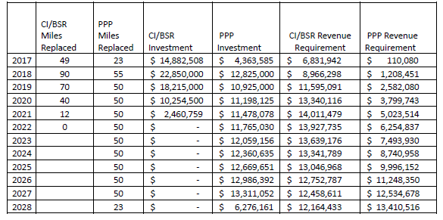
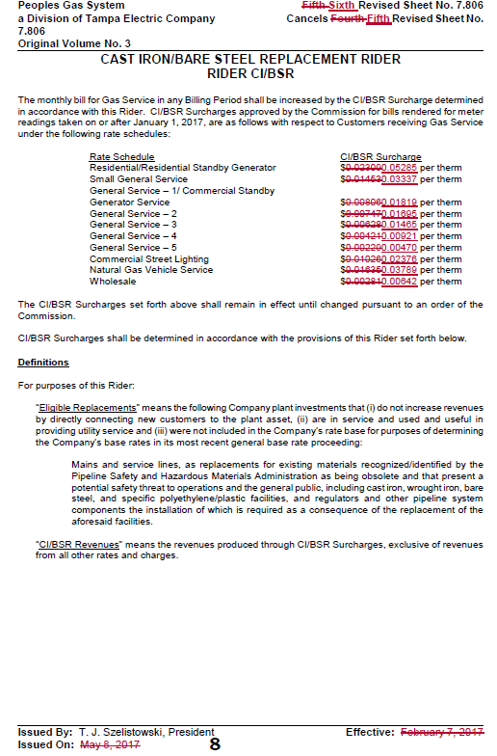

Order No. PSC-12-0476-TRF-GU, issued September 18, 2012, in Docket No. 110320-GU, In re: Petition for approval of Cast Iron/Bare Steel Pipe Replacement Rider (Rider CI/BSR), by Peoples Gas System.
Order No. PSC-16-0524-TRF-GU, issued November 21, 2016, in Docket No. 160201-GU, In re: Petition for approval of 2015 true-up, projected 2016 true-up and 2017 revenue requirements and surcharges associated with cast iron/bare steel pipe replacement rider, by Peoples Gas System.
Order No. PSC-17-0066-AS-GU, issued February 28, 2017, in Docket No. 160159-GU, In re: Petition for approval of settlement agreement pertaining to Peoples Gas System’s 2016 depreciation study, environmental reserve account, problematic plastic pipe replacement, and authorized ROE.
Order No. PSC-16-0205-AS-GU, issued May 10, 2016, in Docket No. 150259-GU, In re: Initiation of show cause proceedings against Peoples Gas System for apparent violations of Sections 368.01 – 05, F.S., and Chapter 25-12, F.A.C.

