BEFORE THE FLORIDA PUBLIC SERVICE COMMISSION

In re: Petition by the Florida Division of Chesapeake Utilities Corporation for approval of special contract with Mosaic Fertilizer LLC. | DOCKET NO. 20170180-GU  ORDER NO. PSC-2017-0453-PAA-GU  ISSUED: November 20, 2017

The following Commissioners participated in the disposition of this matter:

JULIE I. BROWN, Chairman
ART GRAHAM
RONALD A. BRISÉ
DONALD J. POLMANN
GARY F. CLARK

NOTICE OF PROPOSED AGENCY ACTION
ORDER APPROVING A SPECIAL CONTRACT BETWEEN FLORIDA DIVISION OF CHESAPEAKE UTILITIES CORPORATION AND MOSAIC FERTILIZER, LLC

BY THE COMMISSION:

NOTICE is hereby given by the Florida Public Service Commission that the action discussed herein is preliminary in nature and will become final unless a person whose interests are substantially affected files a petition for a formal proceeding, pursuant to Rule 25-22.029, Florida Administrative Code (F.A.C.).

BACKGROUND
On August 23, 2017, the Florida Division of Chesapeake Utilities Corporation (Chesapeake or company) filed a petition for approval of a special contract with Mosaic Fertilizer, LLC (Mosaic). Chesapeake is a local distribution company subject to our regulatory jurisdiction pursuant to Chapter 366, Florida Statues (F.S.). Mosaic is in the business of mining, processing phosphate, and manufacturing fertilizer. Mosaic purchases natural gas for its New Wales facility in Polk County, Florida, which is involved in the production of phosphate fertilizer.
Commission staff issued a data request to Chesapeake on September 15, 2017, for which a response was received on September 19, 2017. We have jurisdiction in this matter pursuant to Sections 366.04, 366.05, and 366.06, F.S.

DECISION
Background
Mosaic is a large volume natural gas transportation customer and currently takes service under Chesapeake’s Firm Transportation Service - 13 (FTS-13) rate schedule. We approved the FTS-13 rates in Chesapeake’s 2009 rate case. The FTS-13 rate schedule contains a flat monthly rate of $16,692.25 and no per therm usage charge. Mosaic continues to be the only customer on the FTS-13 rate schedule. In the 2009 rate case, the FTS-13 rate was designed based on Mosaic’s cost to bypass the Chesapeake’s distribution system while also recovering Chesapeake’s cost to provide service to Mosaic. Mosaic has the ability to bypass Chesapeake’s distribution system because the Florida Gas Transmission (FGT) pipeline traverses Mosaic’s property and Mosaic could directly interconnect with FGT.
Chesapeake only provides transportation service to Mosaic. Chesapeake does not purchase the actual gas commodity for its customers rather, its customers purchase gas from third party marketers or shippers. The FTS-13 rate is available to customers whose annual transportation volume is greater than 12,500,000 therms.
In October 2014, we closed the FTS-13 rate schedule to new customers and grandfathered Mosaic under the FTS-13 rate. Because the FTS-13 rate was designed based on Mosaic’s cost to serve, a new customer seeking service under the same tariff may not have the same cost profile as Mosaic, potentially resulting in the new customer being subsided by the general body of ratepayers.
Due to Mosaic’s current business requirements and processes, its gas transportation volumes have dropped below the 12,500,000 therms annual transportation requirement of the FTS-13 rate schedule. As a result of this reduced level of usage, Mosaic now qualifies for the FTS-12 rate schedule that is available to customers with annual therm usage between 2,500,000 and 12,500,000 therms. Under our currently approved FTS-12 charges, Mosaic would have to pay a firm transportation charge ($9,000) as well as a usage charge ($0.06123 per therm), resulting in a monthly bill of approximately $72,372.
Chesapeake explained in the petition that reclassifying Mosaic as an FTS-12 customer would significantly increase Mosaic’s monthly bill; therefore, Chesapeake identified the most practical step was to negotiate the proposed contract as requested by Mosaic. Pursuant to Rule 25-9.034, F.A.C., and Chesapeake’s tariff special contracts require our approval.

Proposed Contract
The cost of service study provided by Chesapeake shows current total annual operating costs of $102,316 for the Mosaic facilities. The cost of service includes operation and maintenance costs and taxes. Chesapeake explained that the facilities to serve Mosaic are fully depreciated. Therefore, there is no investment and no associated depreciation and return on investment included in the cost of service.
The negotiated annual fixed rate contained in the special contract (confidential) is designed to enable Chesapeake to cover its cost of service. The special contract amount is to be paid by Mosaic to Chesapeake in monthly reservation charges that are fixed and do not vary based on actual usage. The initial maximum daily quantity of gas Chesapeake is obligated to transport to Mosaic is 5,100 dekatherms, with the option for Mosaic to adjust the maximum daily quantity up to 6,100 dekatherms. The term of the special contract is five years and will be extended for additional periods of one year each unless either party gives written notice of termination.
Based on the cost of service study provided, we agree with Chesapeake’s assertion that the monthly reservation charge recovers Mosaic’s cost of service and will therefore provide benefits to Chesapeake’s general body of ratepayers.
Conclusion
Based on our review of the petition and the responses provided to Commission staff’s data request, we find Chesapeake’s representations reasonable and hereby approve the special contract between Chesapeake and Mosaic as shown in Attachment A. The special contract shall be effective as of the date of our vote, November 7, 2017.
Based on the foregoing, it is

ORDERED by the Florida Public Service Commission that the Special Contract between Florida Division of Chesapeake Utilities Corporation and Mosaic Fertilizer, LLC is hereby approved. It is further

ORDERED that all matters contained within Attachment A to this order is incorporated herein. It is further

ORDERED that the Special Contract shall be effective from the date of this Commission’s vote, November 7, 2017. It is further

ORDERED that the provisions of this Order, issued as proposed agency action, shall become final and effective upon the issuance of a Consummating Order unless an appropriate petition, in the form provided by Rule 28-106.201, Florida Administrative Code, is received by the Commission Clerk, 2540 Shumard Oak Boulevard, Tallahassee, Florida 32399-0850, by the close of business on the date set forth in the “Notice of Further Proceedings” attached hereto. It is further

ORDERED that in the event this Order becomes final, this docket shall be closed.

By ORDER of the Florida Public Service Commission this 20th day of November, 2017.

/s/ Carlotta S. Stauffer
CARLOTTA S. STAUFFER
Commission Clerk
Florida Public Service Commission
2540 Shumard Oak Boulevard
Tallahassee, Florida 32399
(850) 413-6770
www.floridapsc.com

Copies furnished: A copy of this document is provided to the parties of record at the time of issuance and, if applicable, interested persons.

KRM

NOTICE OF FURTHER PROCEEDINGS OR JUDICIAL REVIEW

The Florida Public Service Commission is required by Section 120.569(1), Florida Statutes, to notify parties of any administrative hearing that is available under Section 120.57, Florida Statutes, as well as the procedures and time limits that apply. This notice should not be construed to mean all requests for an administrative hearing will be granted or result in the relief sought.

Mediation may be available on a case-by-case basis. If mediation is conducted, it does not affect a substantially interested person's right to a hearing.

The action proposed herein is preliminary in nature. Any person whose substantial interests are affected by the action proposed by this order may file a petition for a formal proceeding, in the form provided by Rule 28-106.201, Florida Administrative Code. This petition must be received by the Office of Commission Clerk, 2540 Shumard Oak Boulevard, Tallahassee, Florida 32399-0850, by the close of business on December 11, 2017.

In the absence of such a petition, this order shall become final and effective upon the issuance of a Consummating Order.

Any objection or protest filed in this/these docket(s) before the issuance date of this order is considered abandoned unless it satisfies the foregoing conditions and is renewed within the specified protest period.

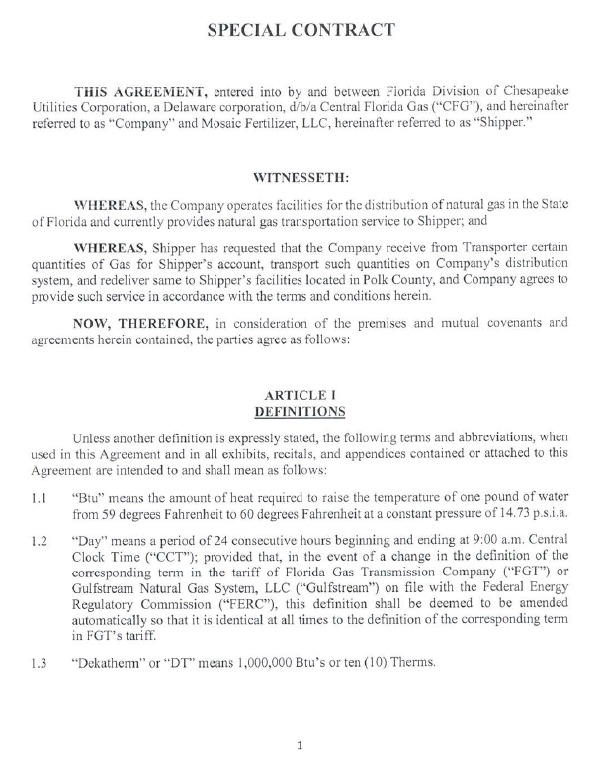
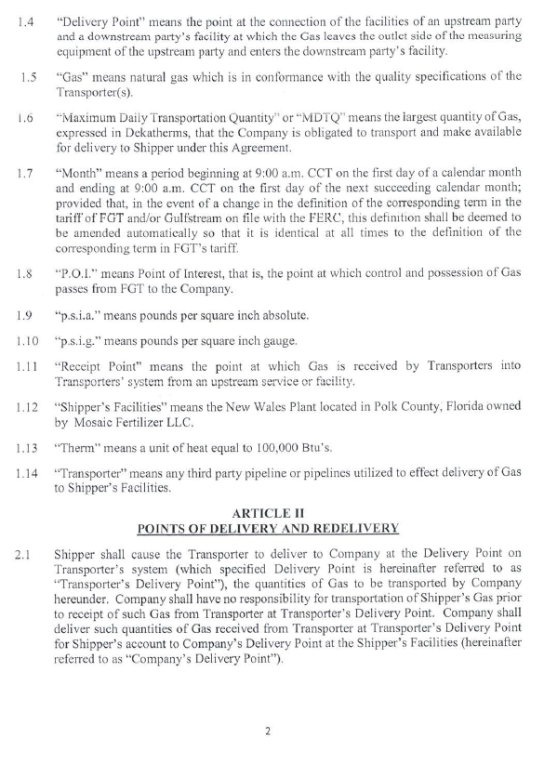

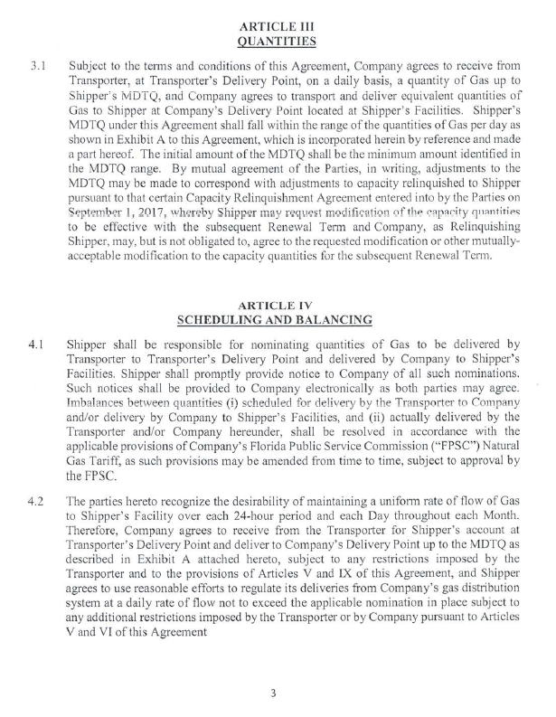
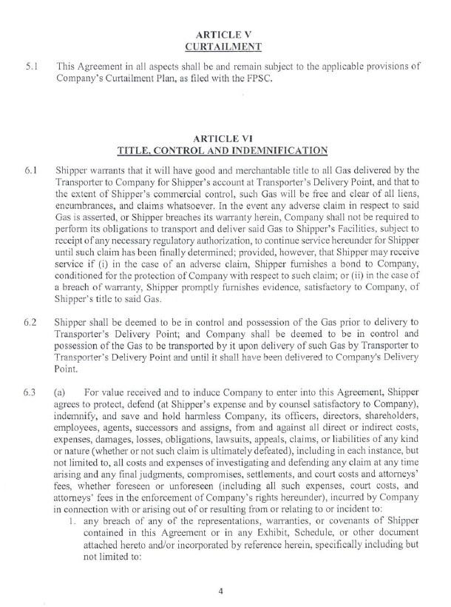

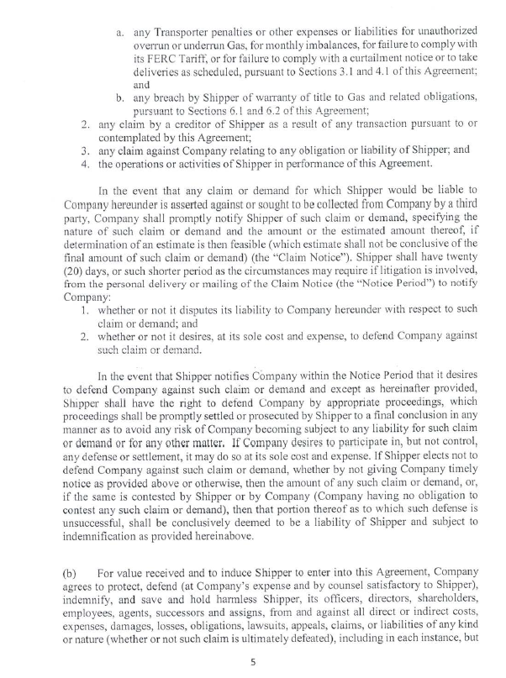
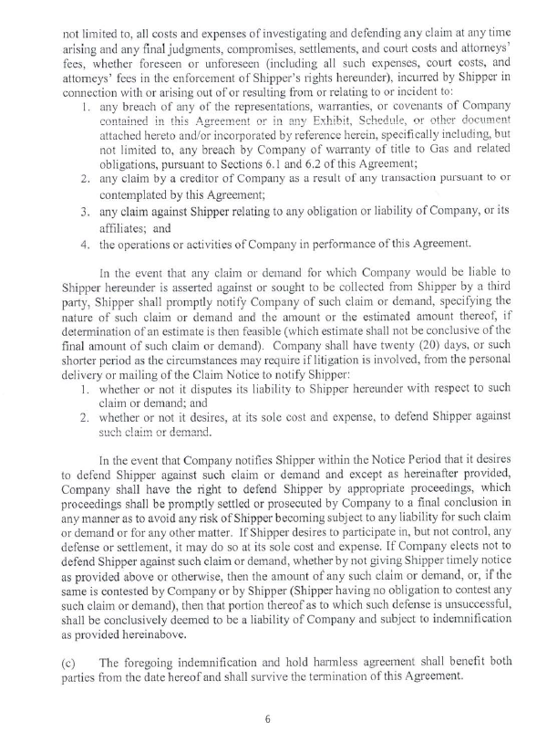
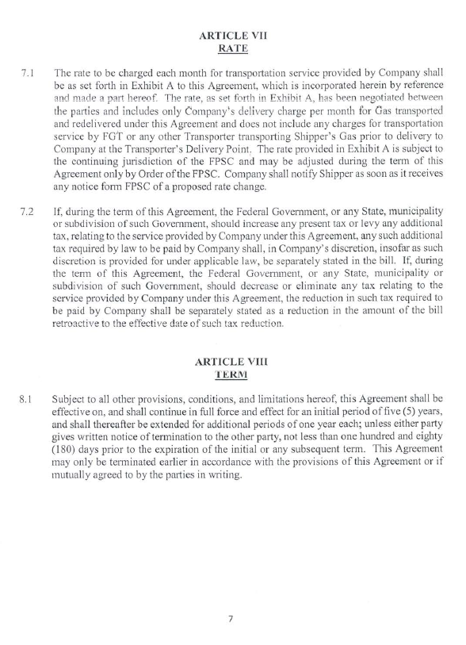
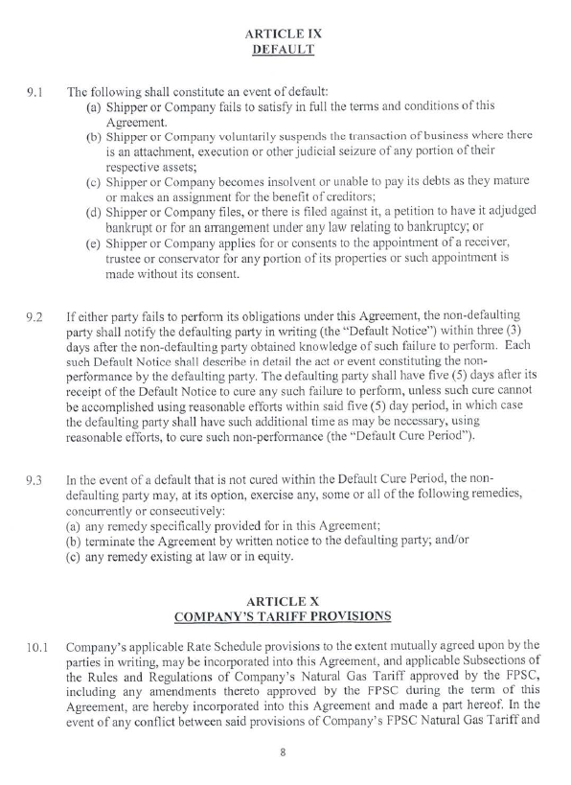
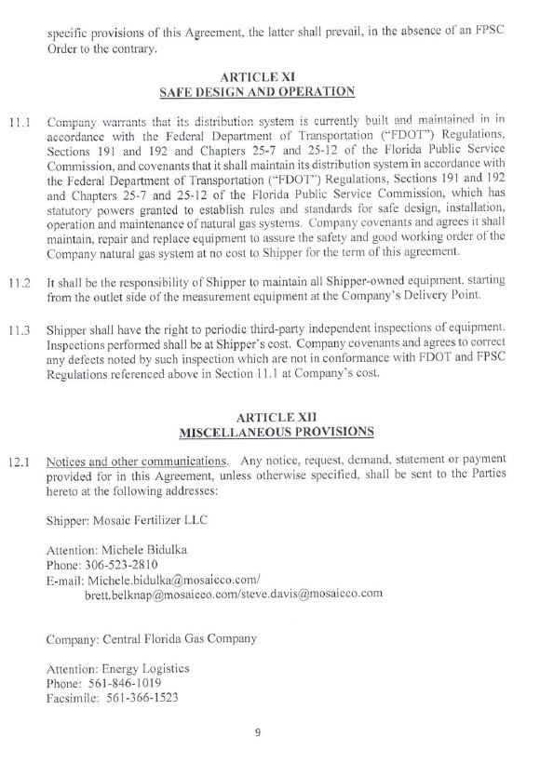

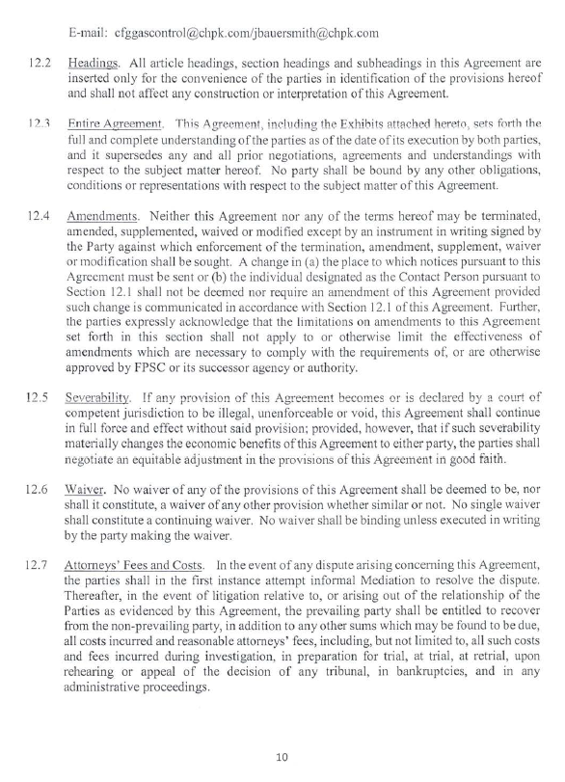
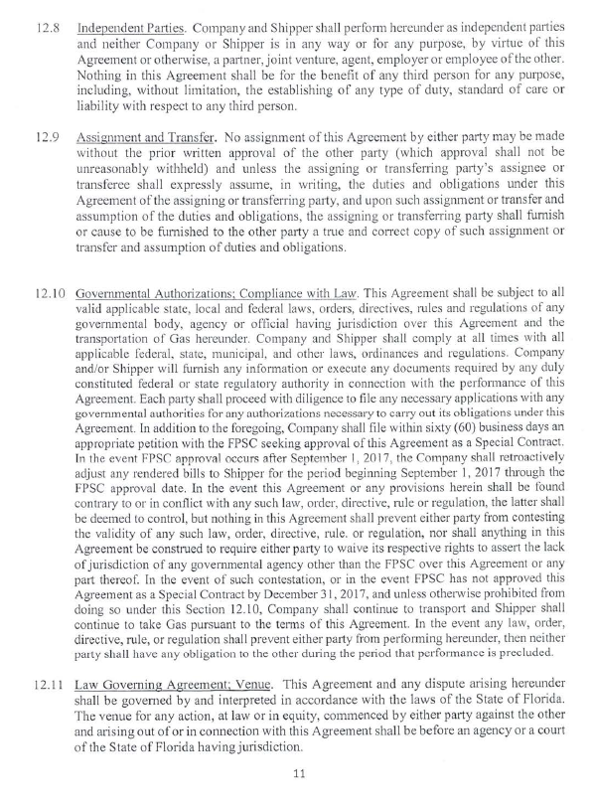
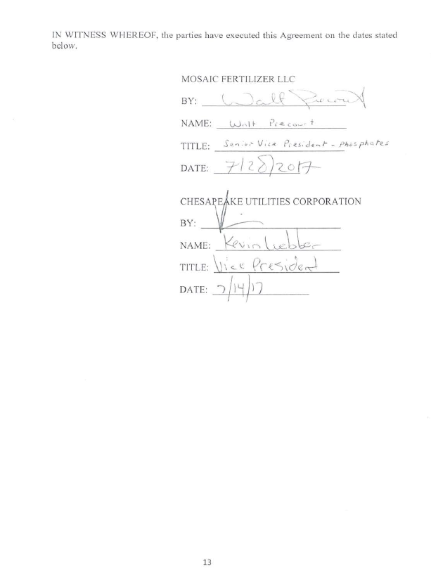

Order No. PSC-10-0029-PAA-GU, issued January 14, 2010, in Docket No. 090125-GU, In re: Petition for increase in rates by Florida Division of Chesapeake Utilities Corporation.
Order No. PSC-14-0592-TRF-GU, issued October 22, 2014, in Docket No. 140151-GU, In re: Petition of the Florida Division of Chesapeake Utilities Corporation to Close Rate Schedule Firm Transportation Service – 13 (FTS-13).

