State of Florida |  | Public Service Commission  Capital Circle Office Center ● 2540 Shumard Oak Boulevard  Tallahassee, Florida 32399-0850  -M-E-M-O-R-A-N-D-U-M-
DATE: | November 30, 2017
TO: | Office of Commission Clerk (Stauffer)
FROM: | Division of Engineering (P. Buys, Ellis, Graves, King, Thompson)  Division of Accounting and Finance (Barrett, Brown, Mouring, Vogel)  Division of Economics (Draper, Higgins, Ollila, Stratis)  Office of the General Counsel (Brownless)
RE: | Docket No. 20170150-EI – Petition for limited proceeding to include reliability and modernization projects in rate base, by Florida Public Utilities Company.
AGENDA: | 12/12/17 – Regular Agenda – Proposed Agency Action – Interested Persons May Participate – Motion to Approve Settlement and Stipulation Prior to Hearing
COMMISSIONERS ASSIGNED: |  |  | All Commissioners
PREHEARING OFFICER: |  |  | Brown
CRITICAL DATES: |  |  | None
SPECIAL INSTRUCTIONS: |  |  | None

Case Background
Florida Public Utility Company (FPUC or Utility) serves more than 32,000 customers located in North Florida. FPUC’s Northwest Division serves Jackson, Calhoun and Liberty counties, and is commonly called the “Marianna Division.” The Utility’s Northeast Division is located in the Fernandina Beach area, and serves Nassau County. FPUC does not generate any of the power it sells, but meets the needs of its customers through contracts for purchased power.
FPUC’s last request for an increase in base rates was filed on April 28, 2014. On August 29, 2014, a Joint Motion for Approval of Stipulation and Settlement (Settlement) was filed. The Commission approved the Settlement, which included a $3.75 million revenue increase, by Order No. PSC-14-0517-S-EI, issued on September 29, 2014.
On July 3, 2017, FPUC filed a petition for a limited proceeding to include in its rate base certain capital projects. The Utility has requested an increase in its total revenue requirement of $1,823,869 representing total capital expenditures of $15,241,515. FPUC explained that the capital investments fall under one of three types of projects: (1) grid modernization and safety; (2) storm hardening; and (3) the interconnection with Florida Power & Light Company. FPUC states that the projects have been designed to enhance the capability of its grid and improve the safety and reliability of its system. Further, the Utility asserts that these projects will benefit both FPUC and its customers, and should be allowed to be recovered through base rates.
On July 21, 2017, a Joint Motion Requesting Commission Approval of Procedure for Conducting Limited Proceedings and for Subsequent Tariff Filing was filed on behalf of FPUC and OPC. On September 21, 2017, the Office of Public Counsel (OPC) filed its Notice of Intervention, which was acknowledged on September 25, 2017.
On November 28, 2017, FPUC and OPC filed another Joint Motion, which requests approval of their Stipulation and Settlement agreement (2017 Agreement) that resolves the issues in this proceeding. Section 7 of the Joint Motion states “[T]he Joint Movants respectfully urge the Commission to consider this Joint Motion for Approval of Stipulation and Settlement at the December 12, 2017, Agenda Conference. Approval by the Commission at the December 12, 2017 Agenda Conference would allow new rates consistent with this 2017 Agreement to be in place with the first billing cycle in January 2018, as contemplated by the 2017 Agreement.” The Joint Motion and Stipulation are attached.
The Commission has jurisdiction over this request for a limited proceeding under Sections 366.076 (1) and 366.041, Florida Statutes (F.S.). This item will be presented orally.
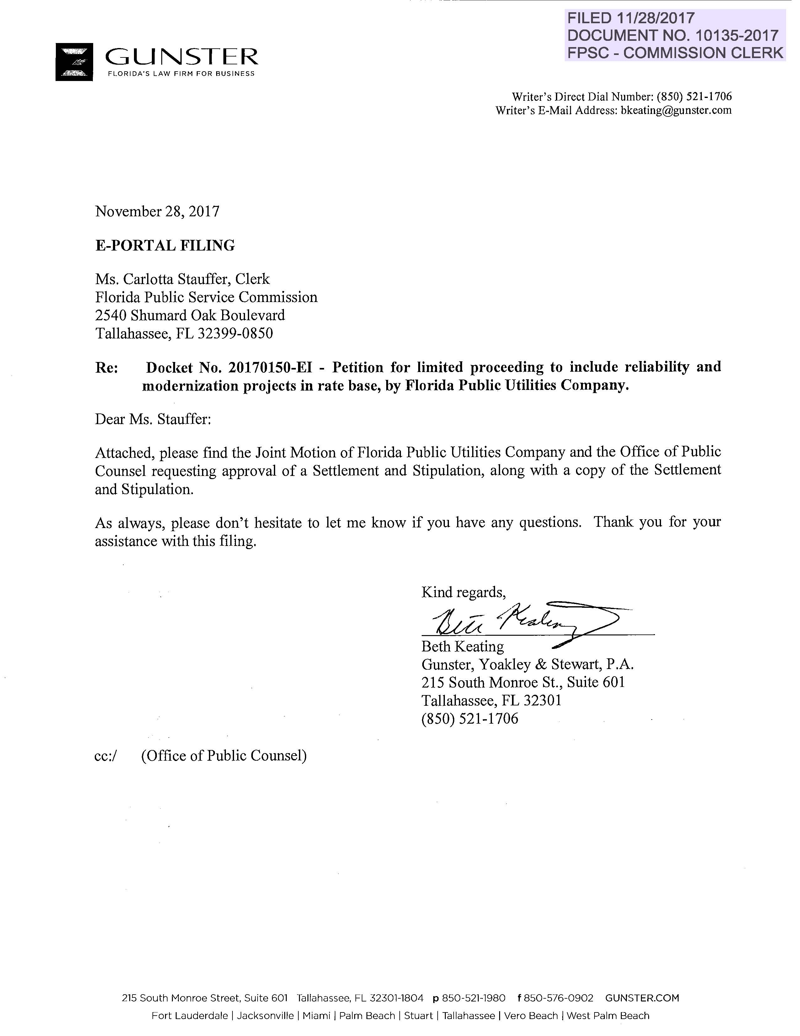

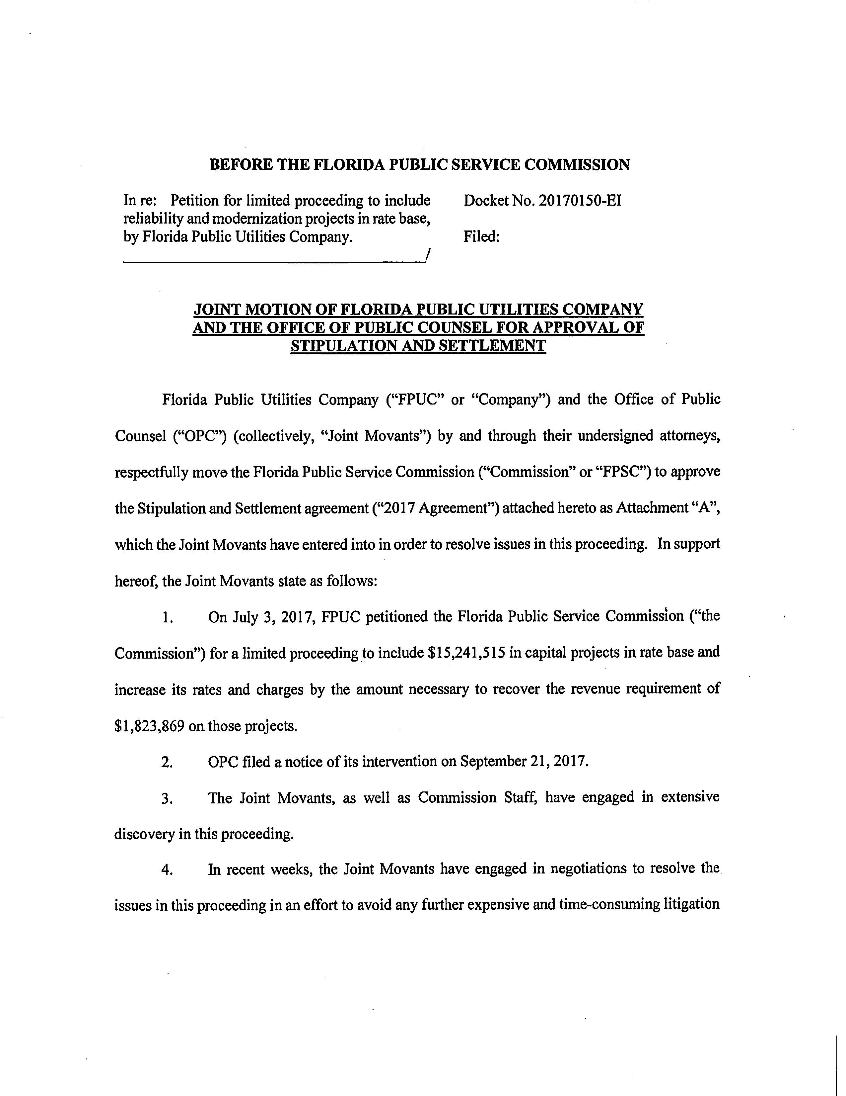

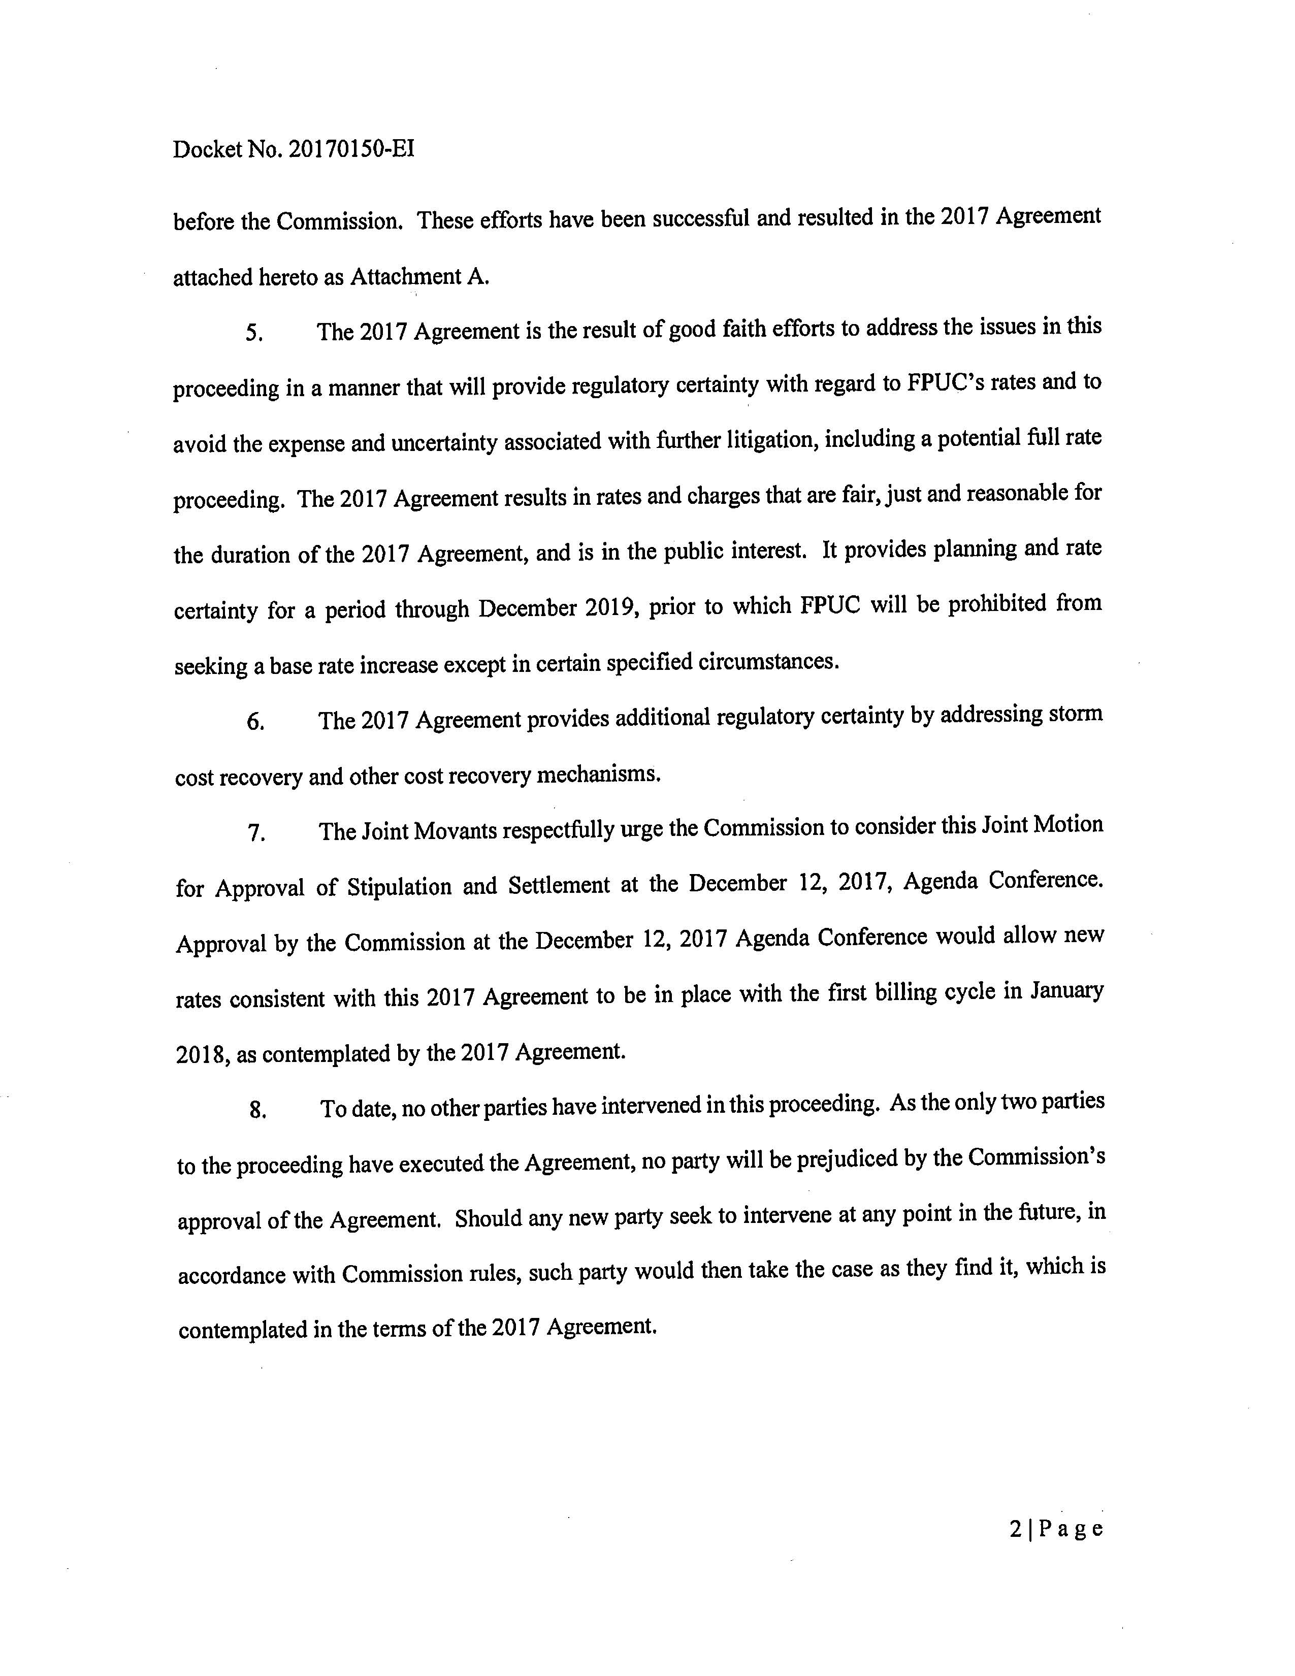

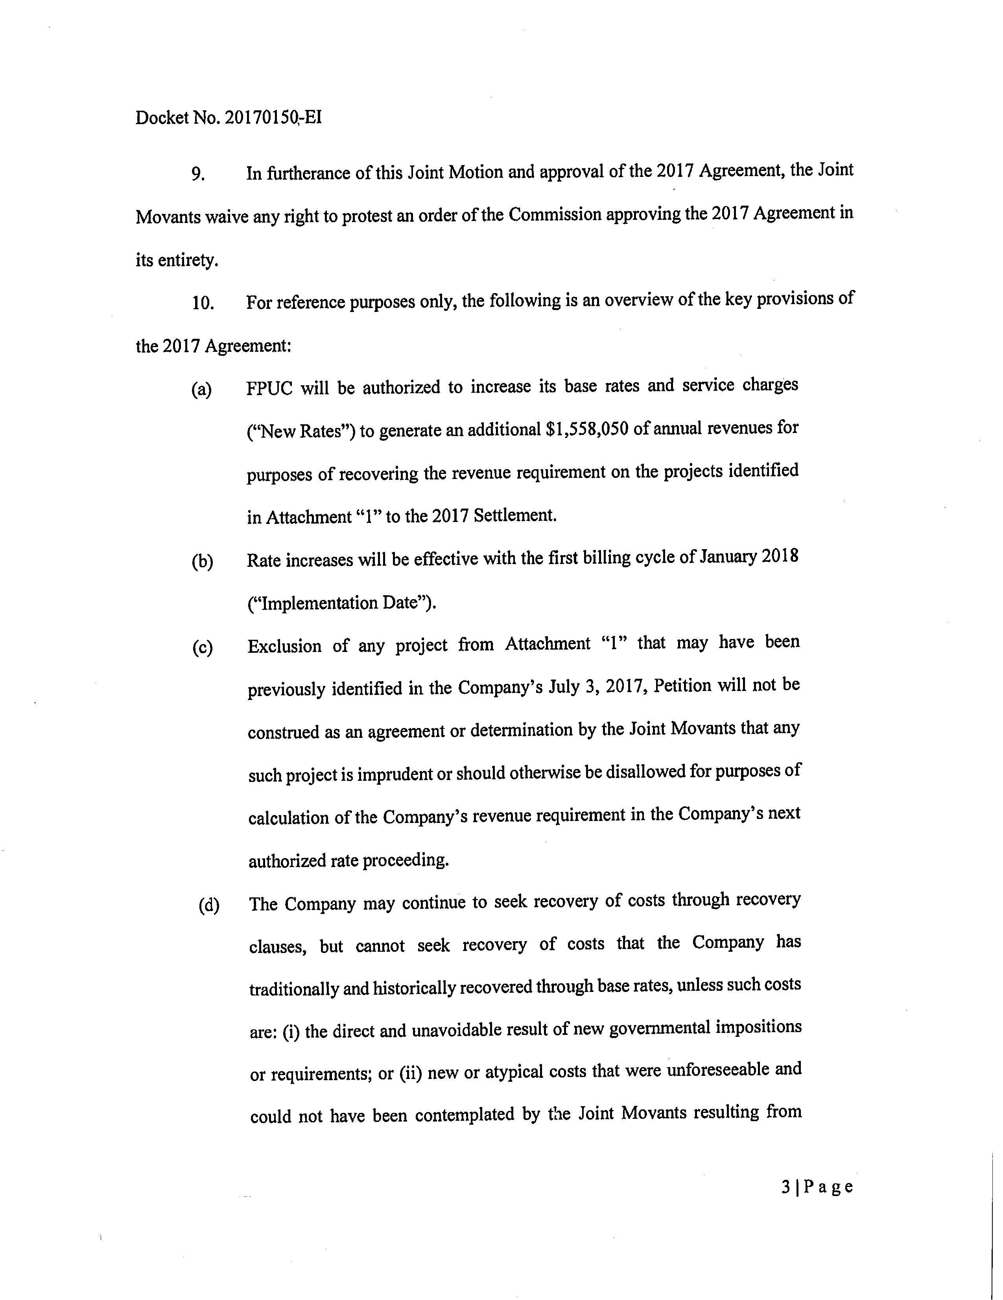

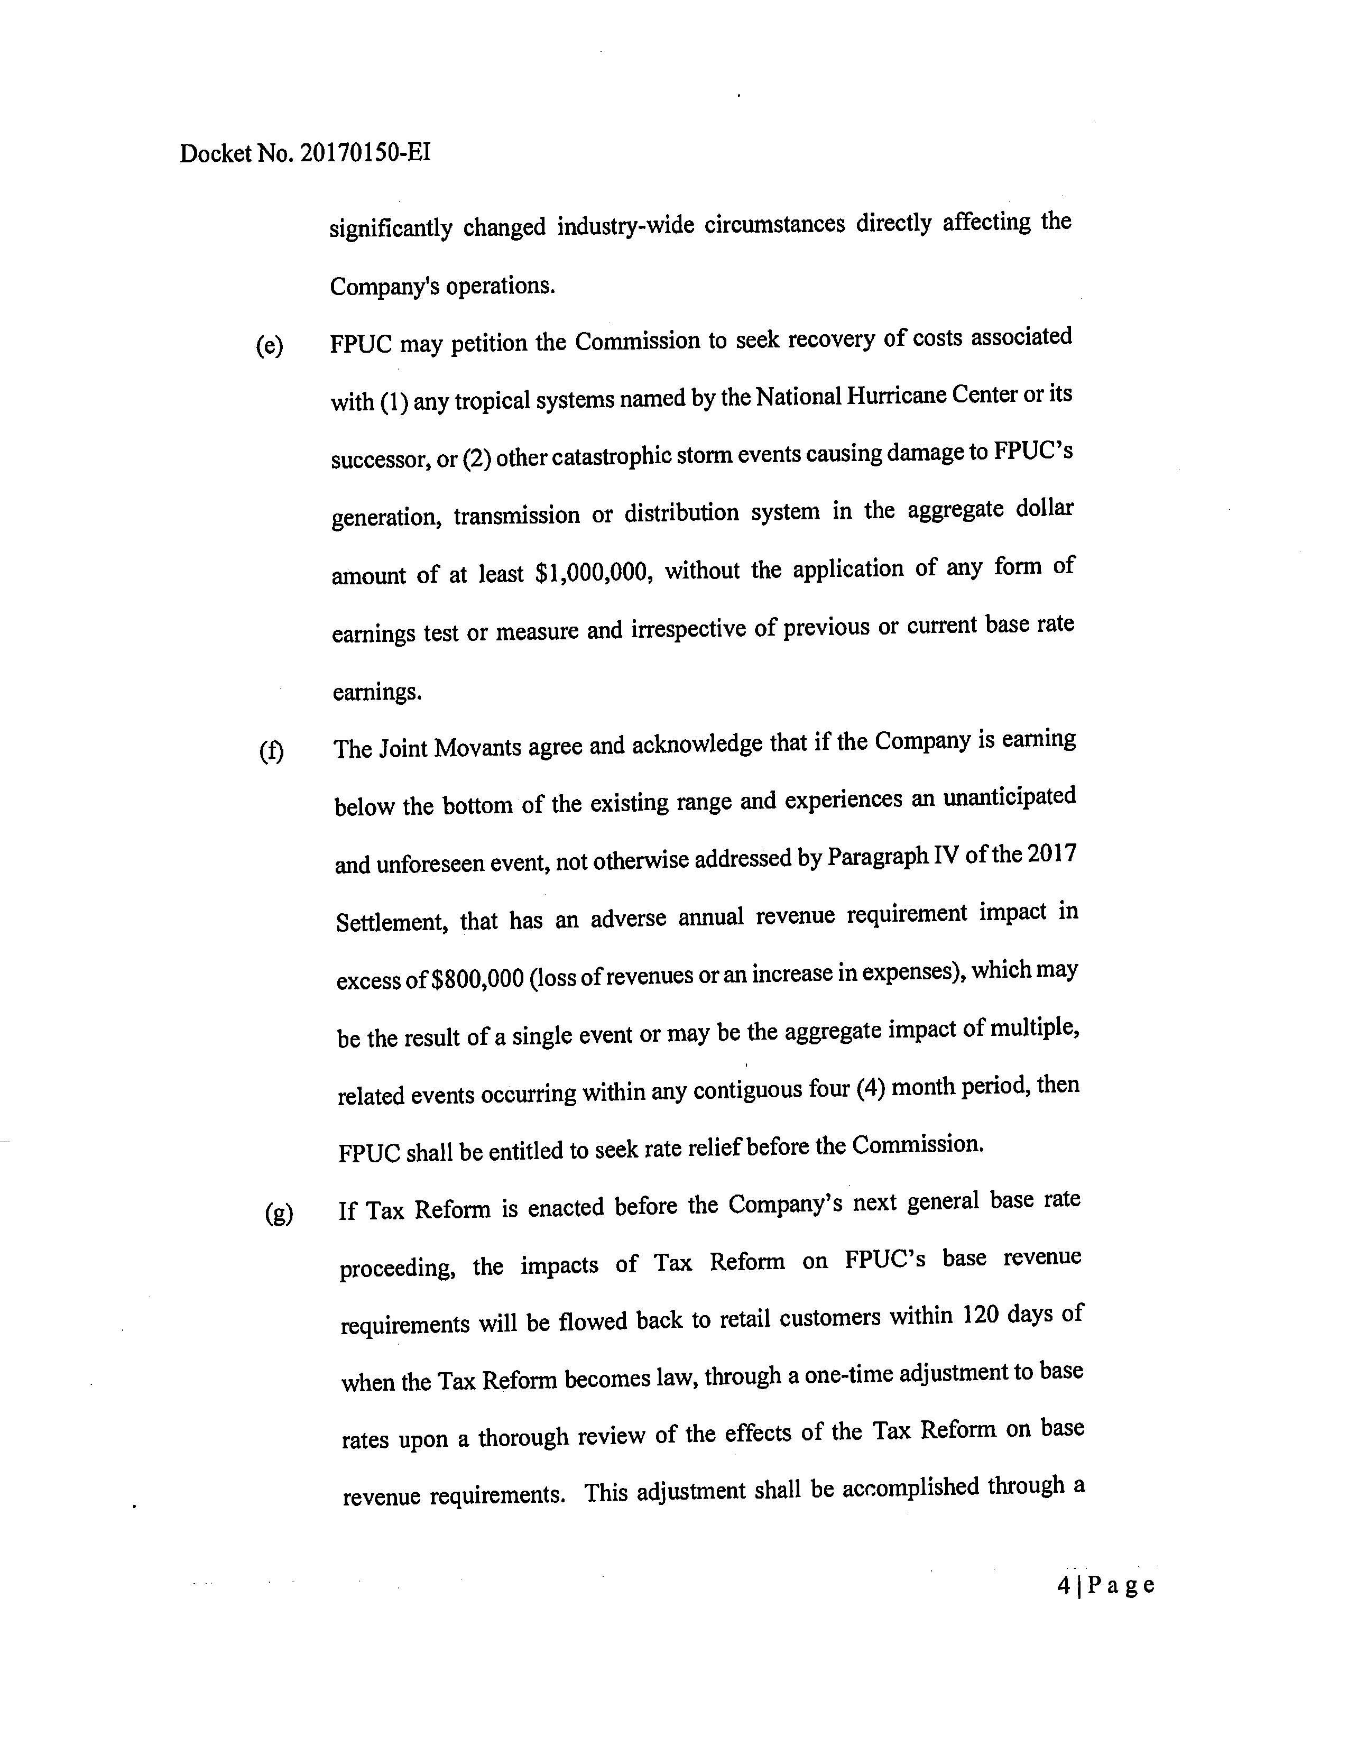

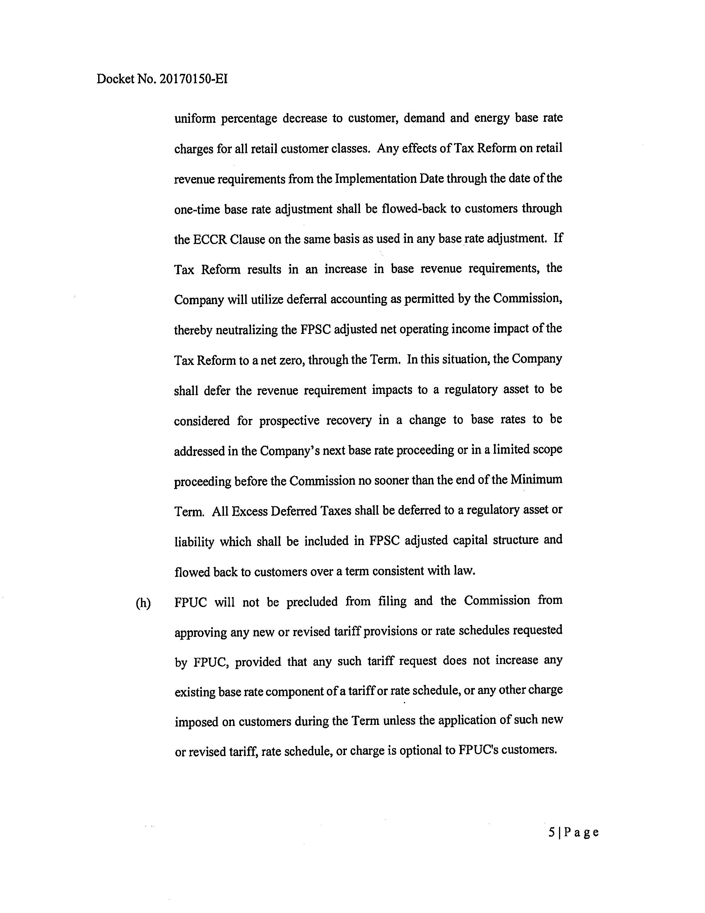

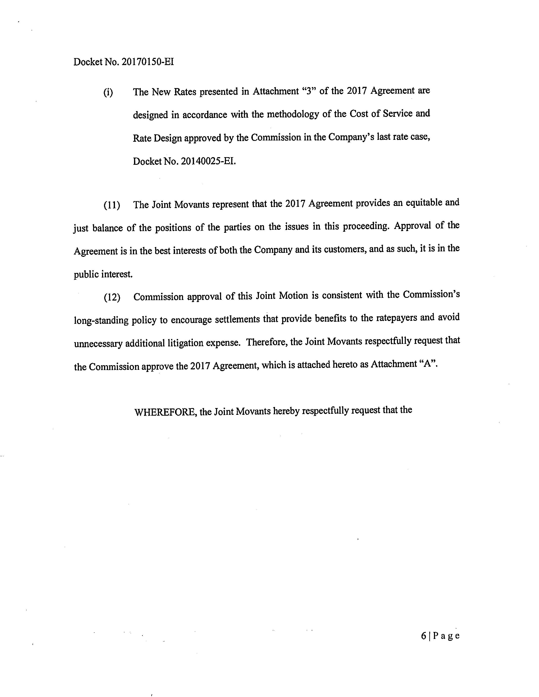

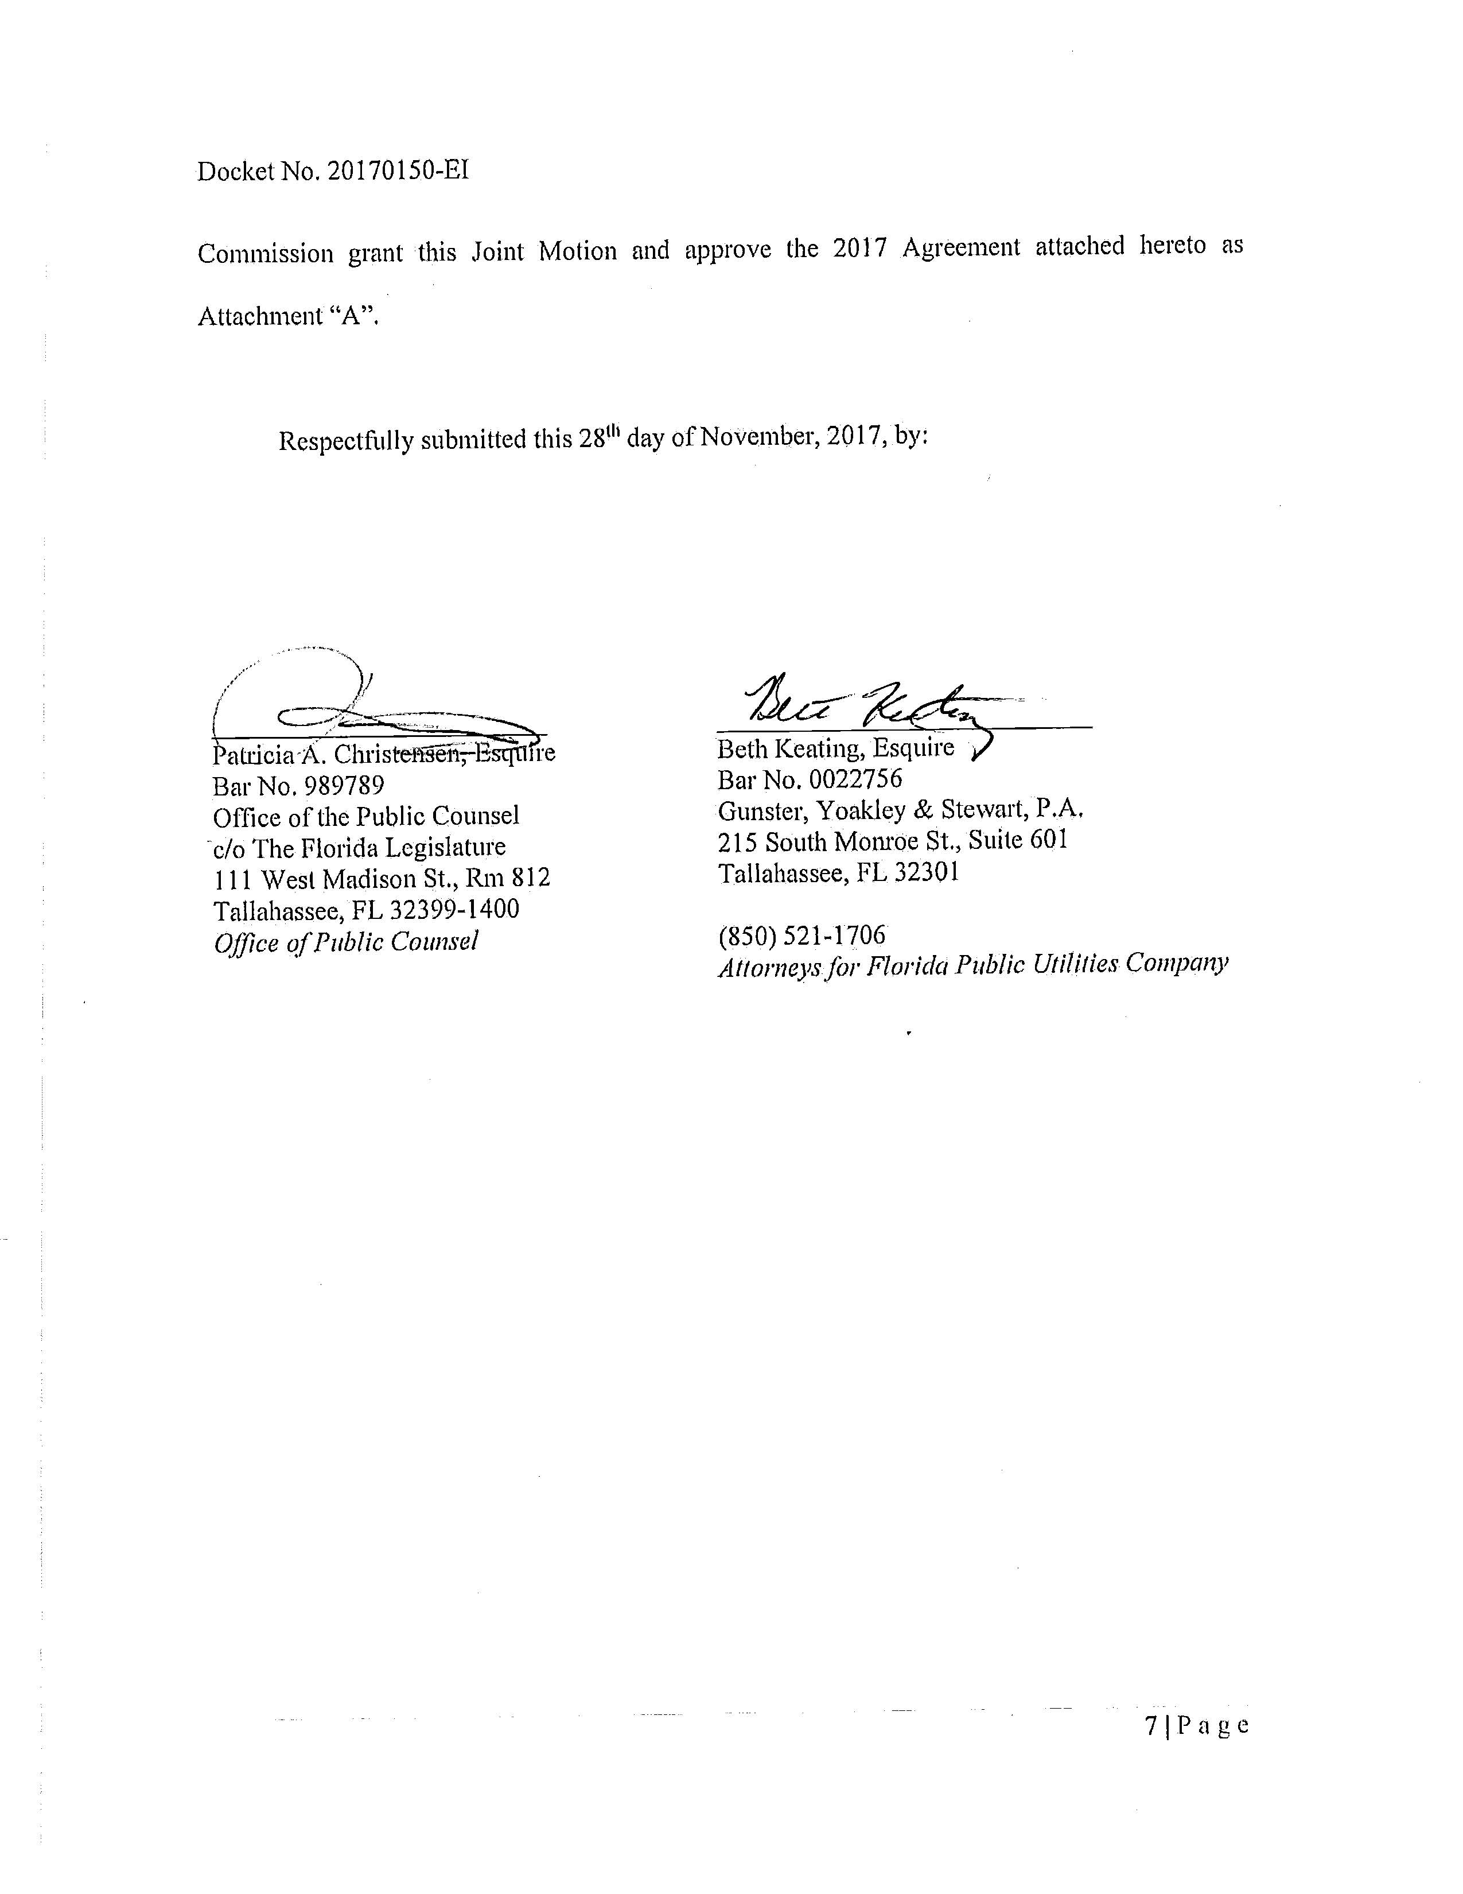

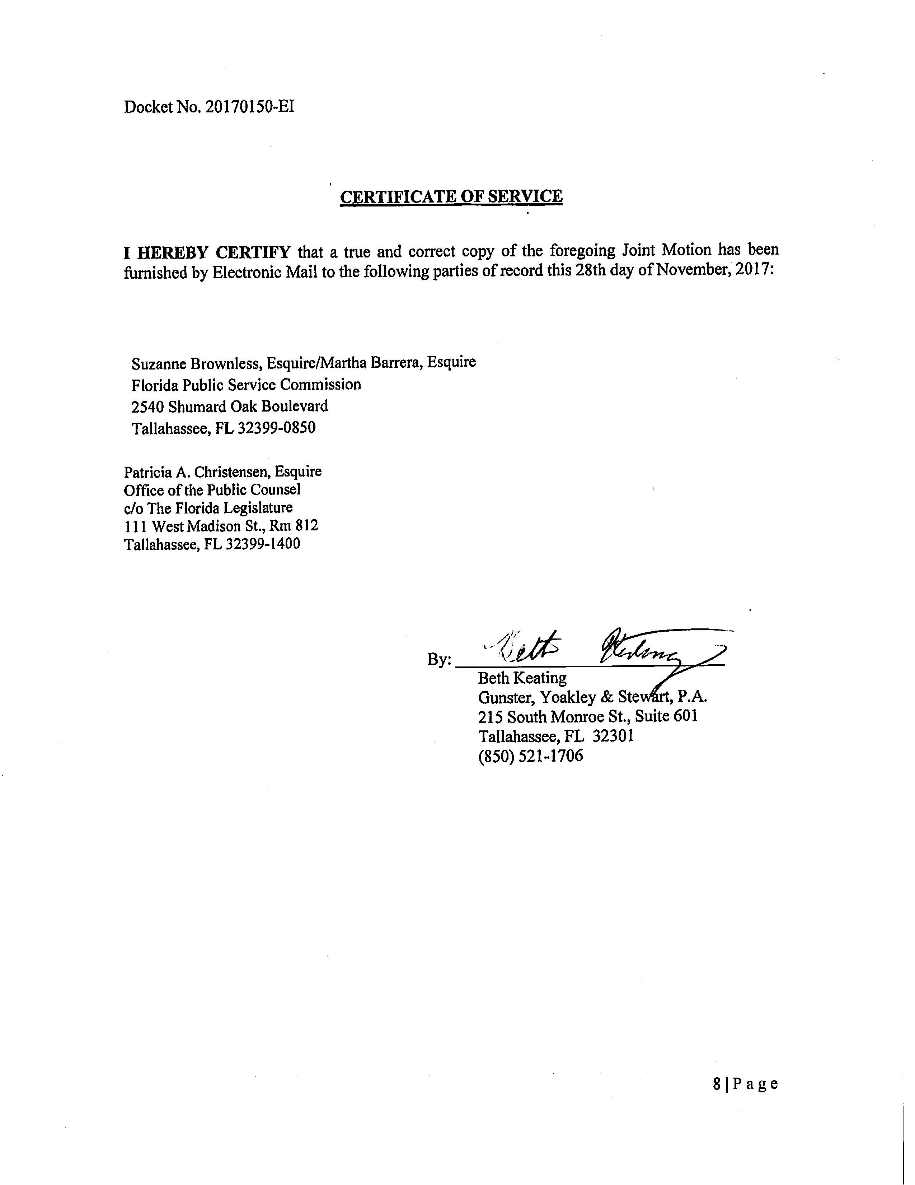

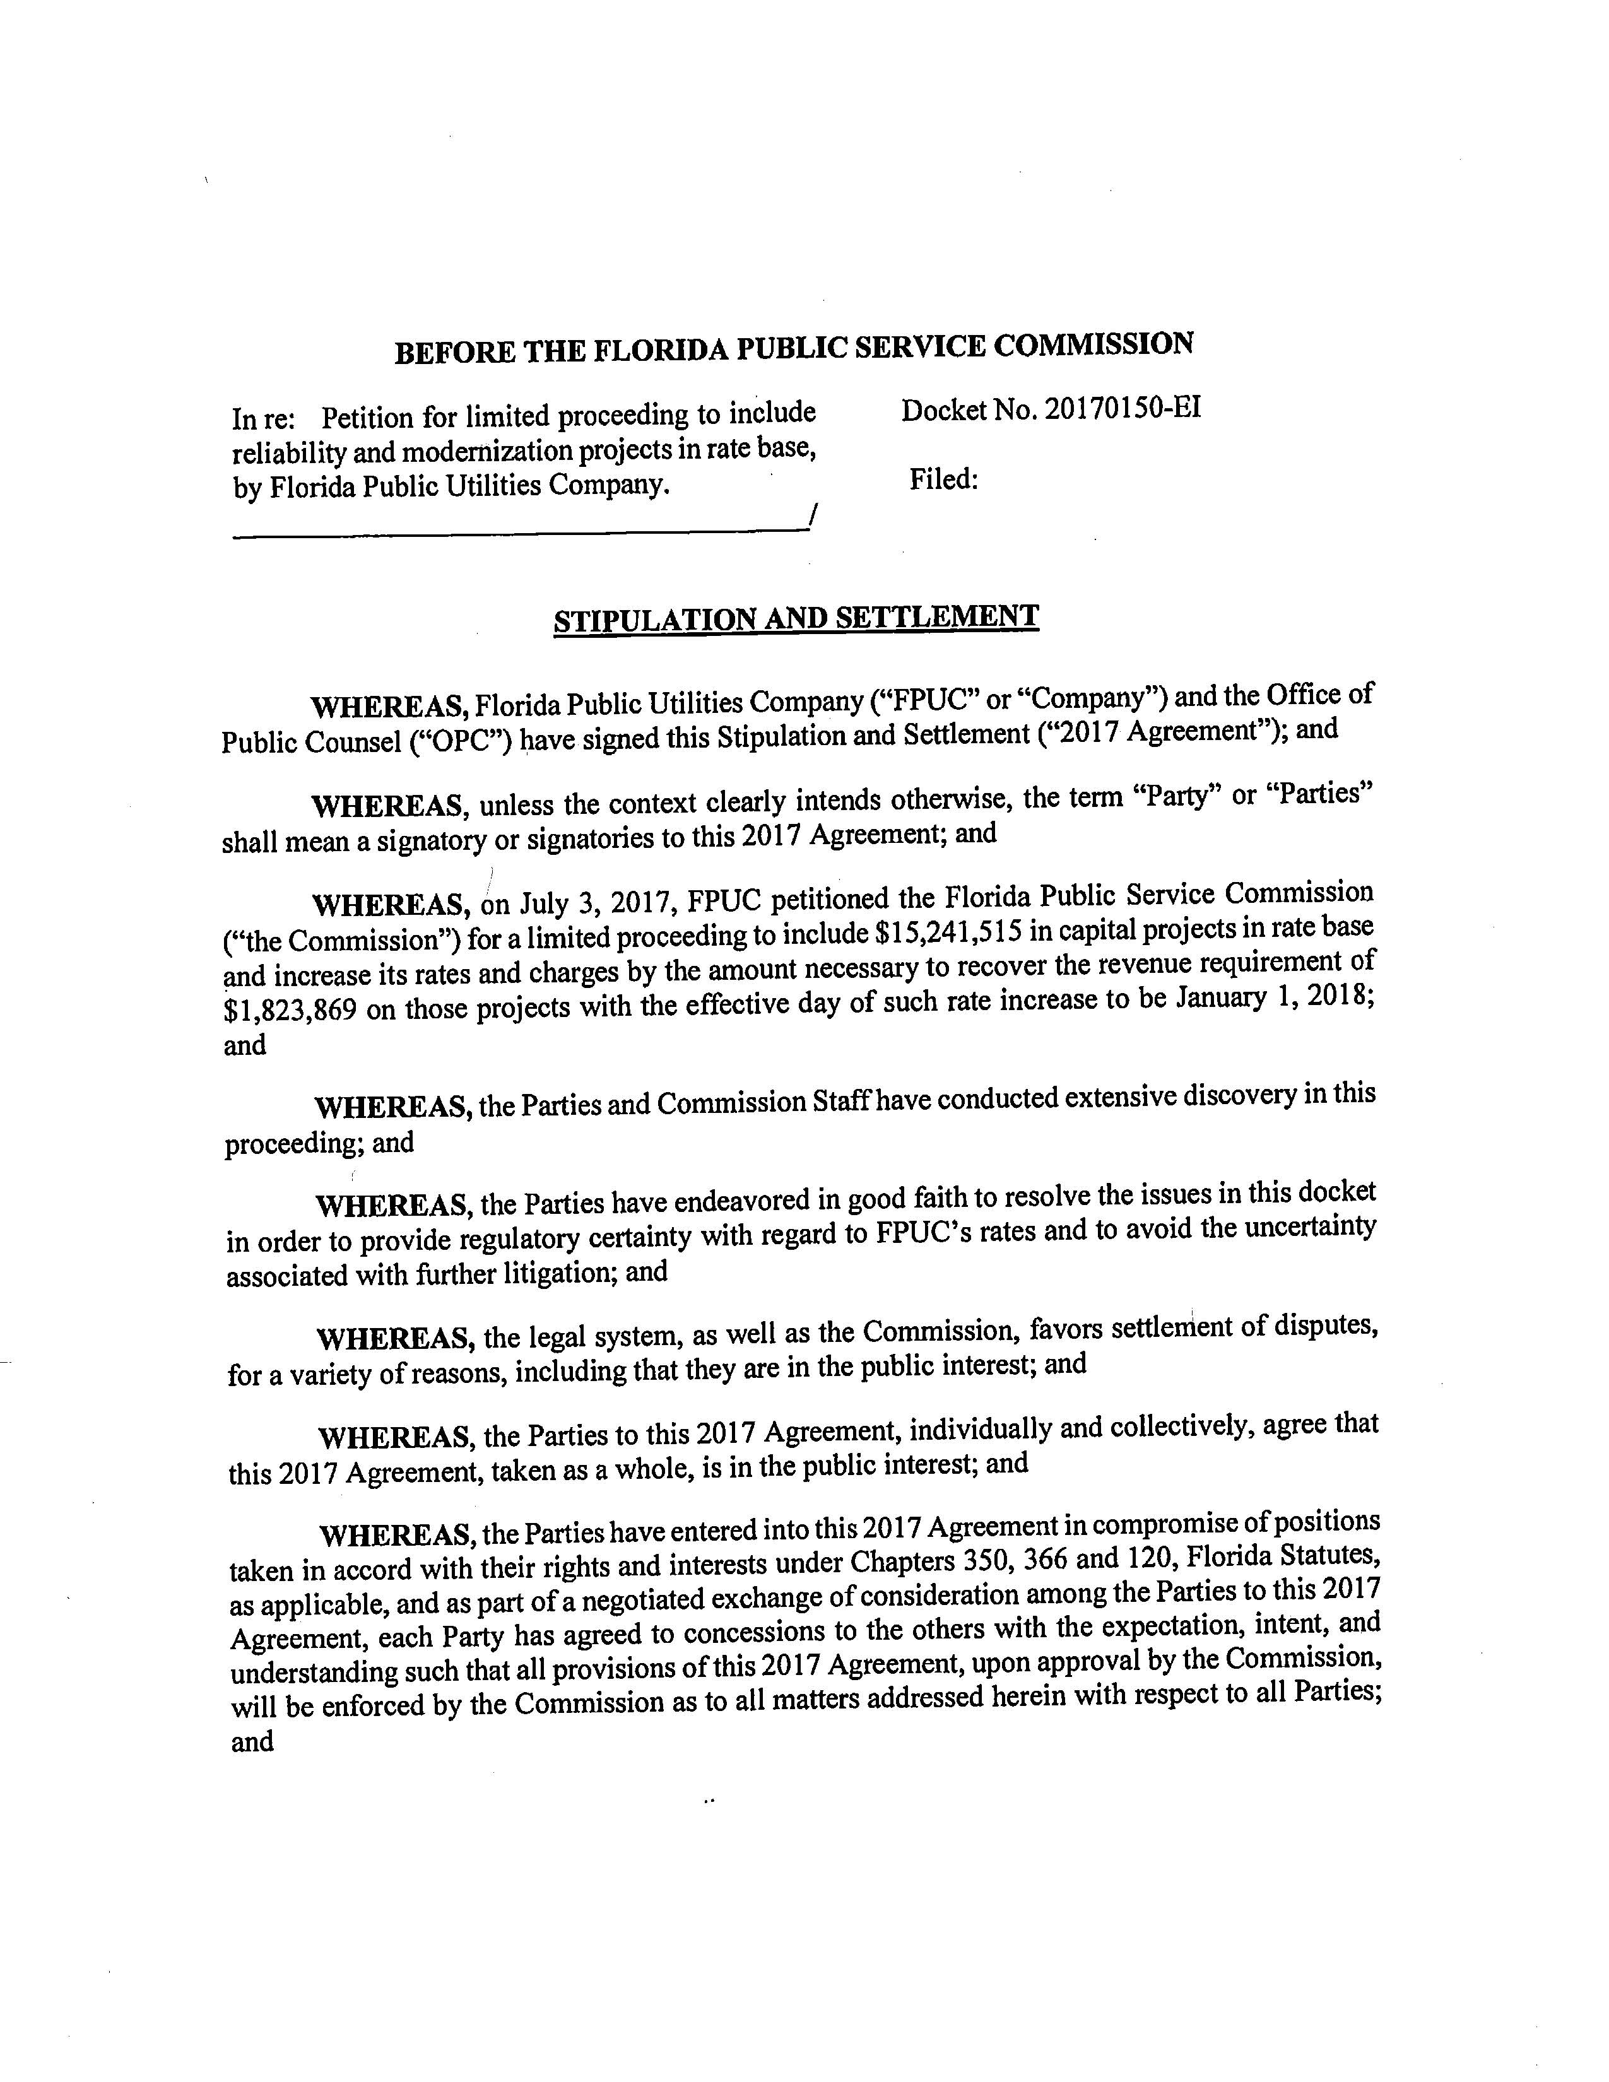

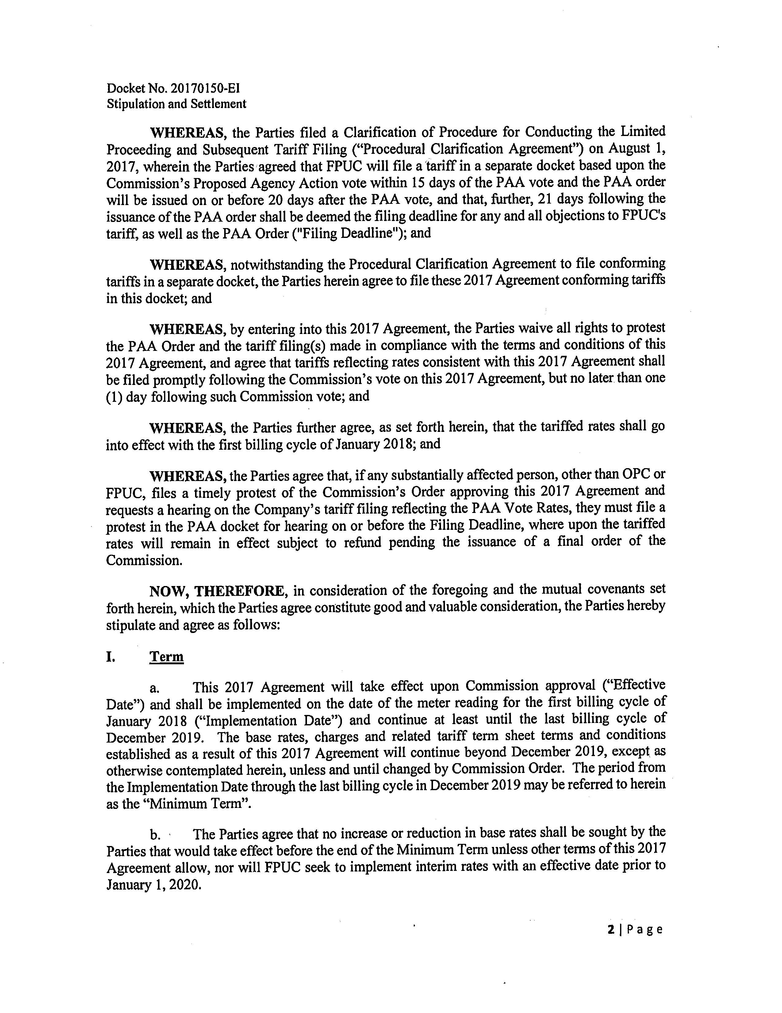

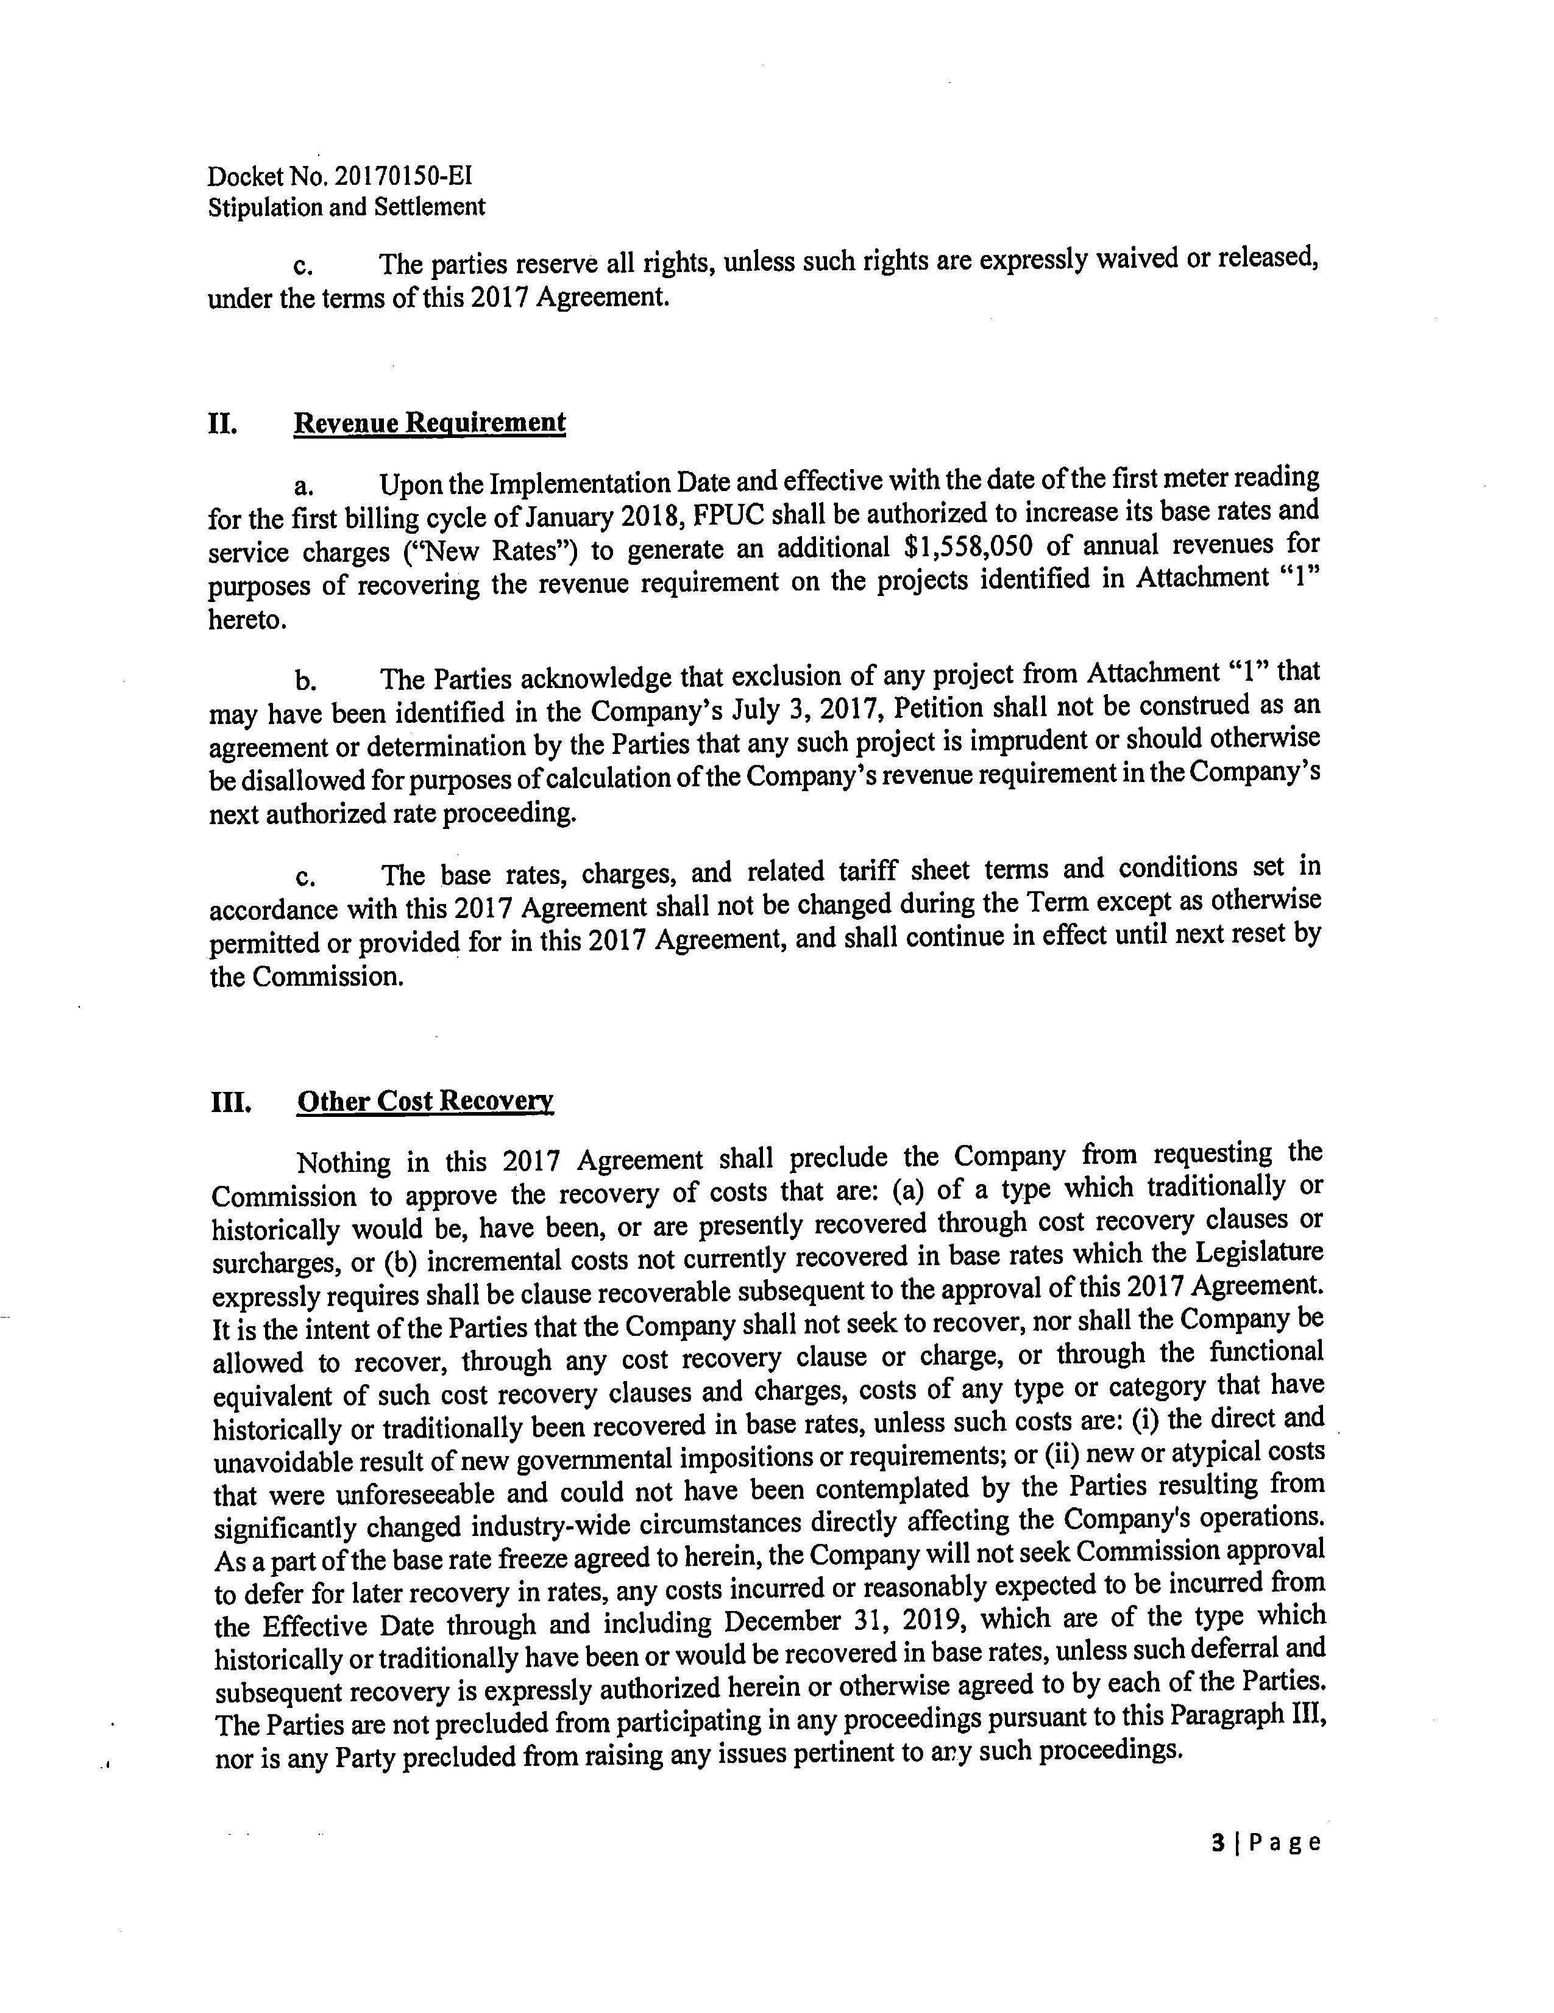

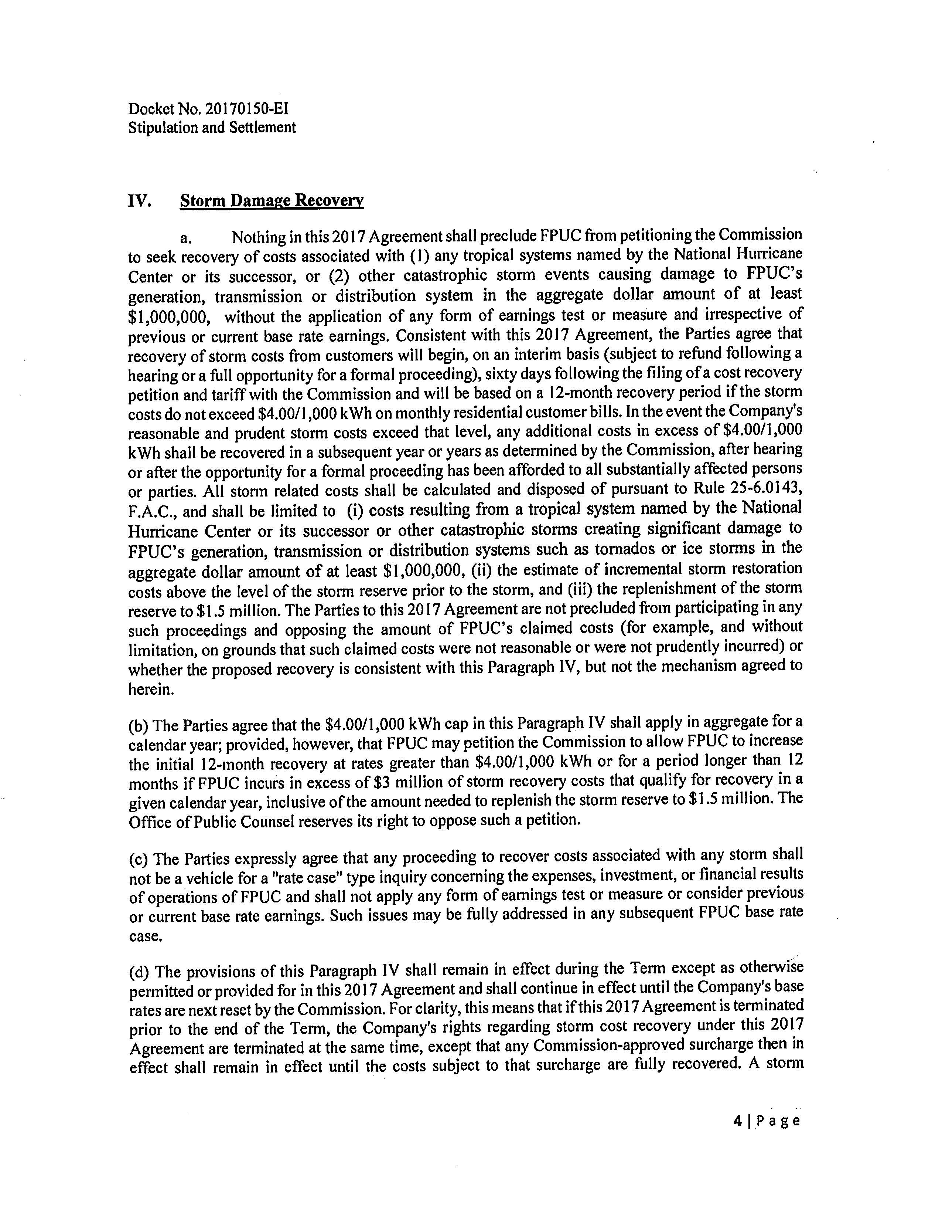

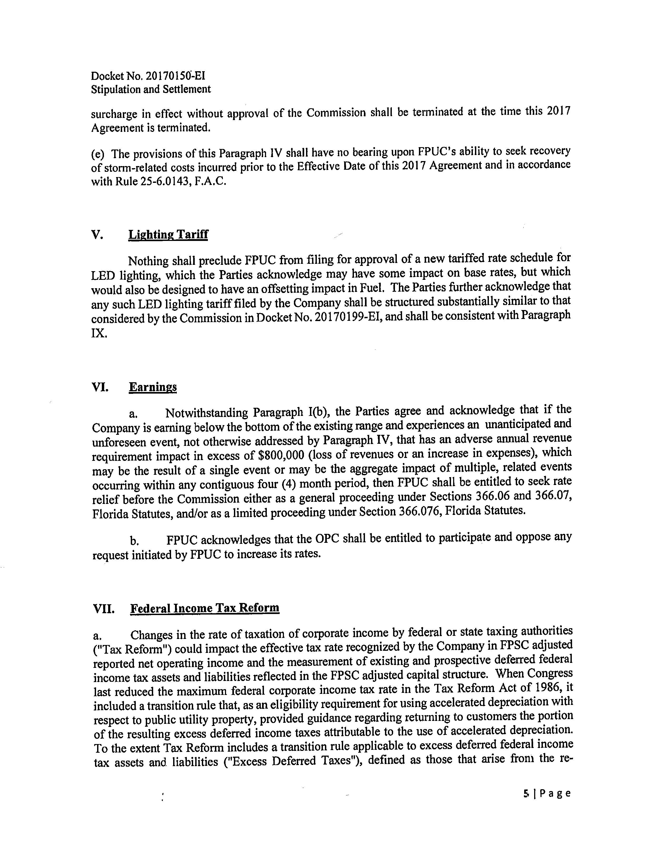

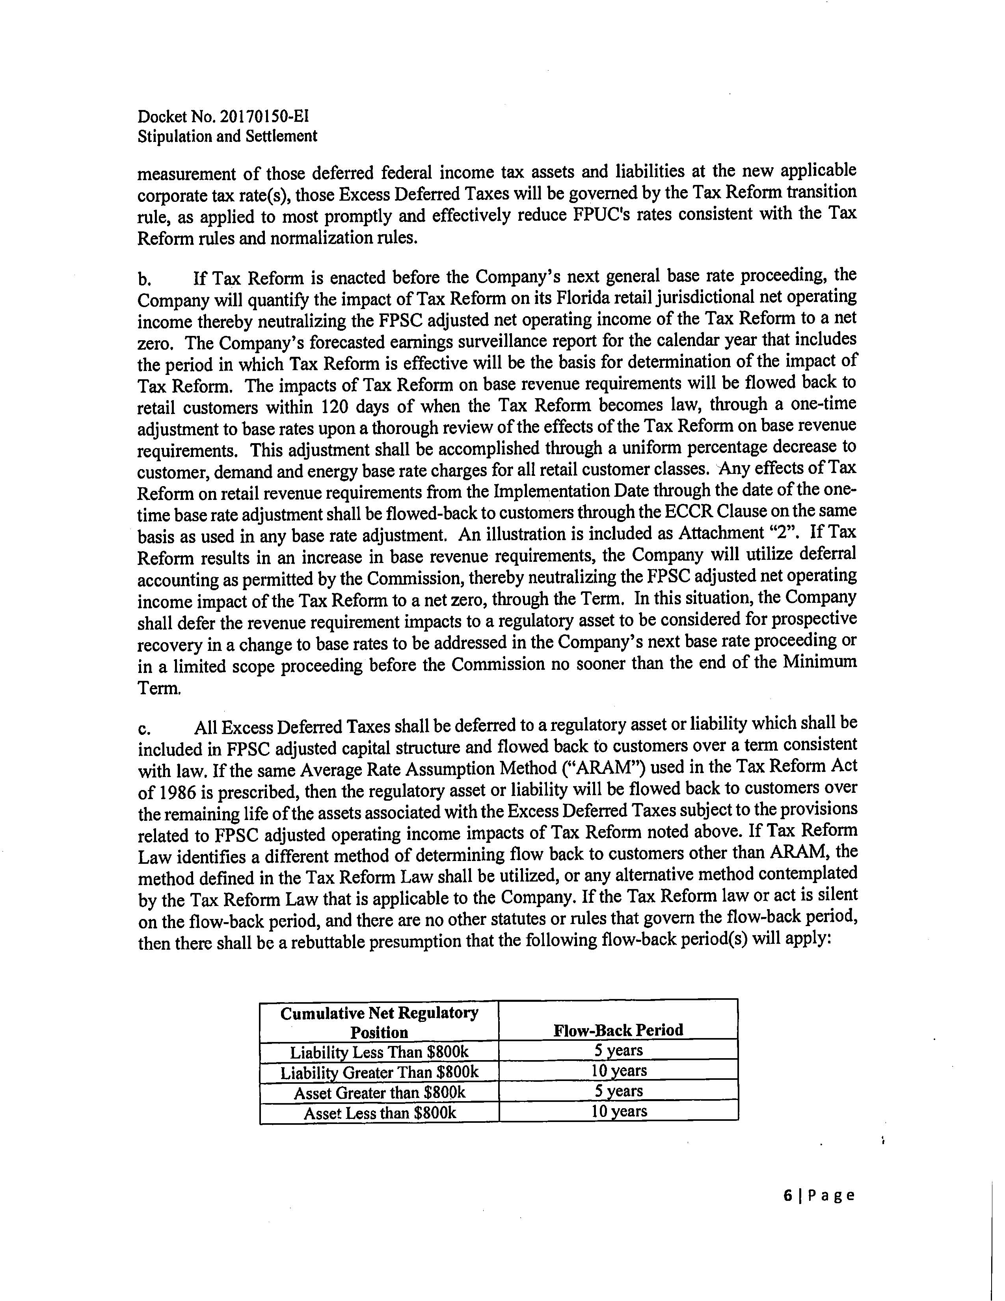

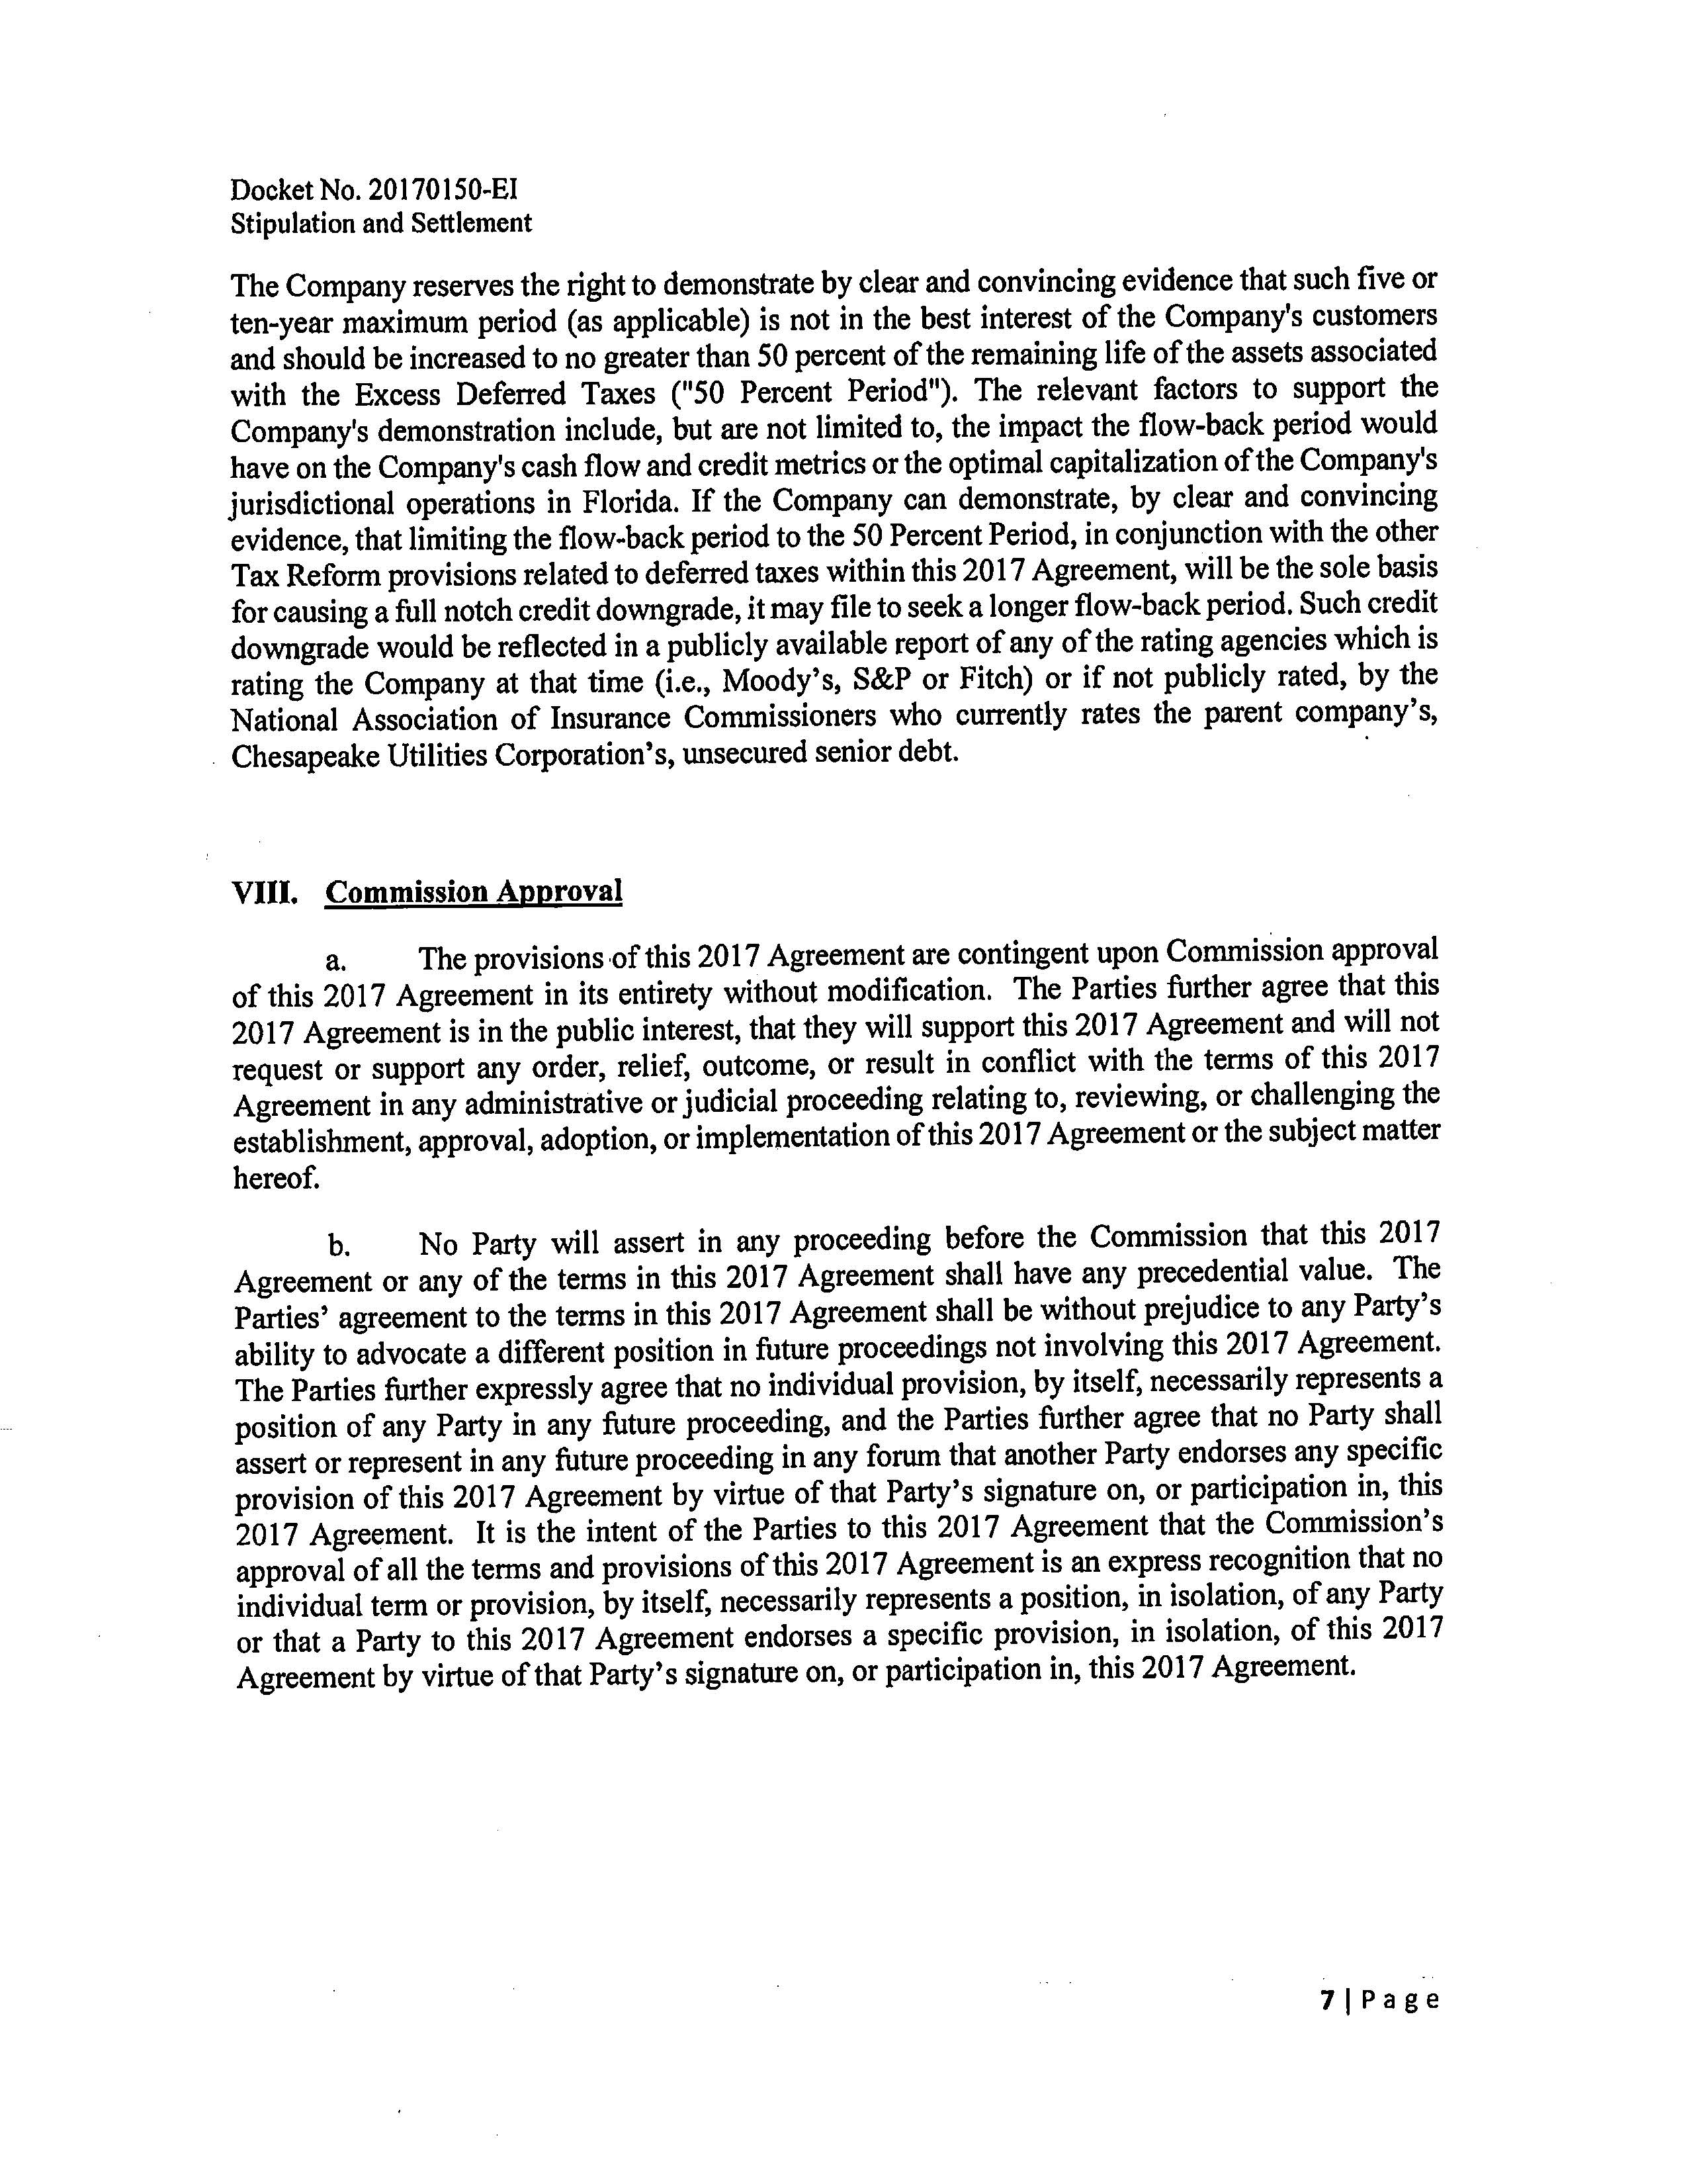

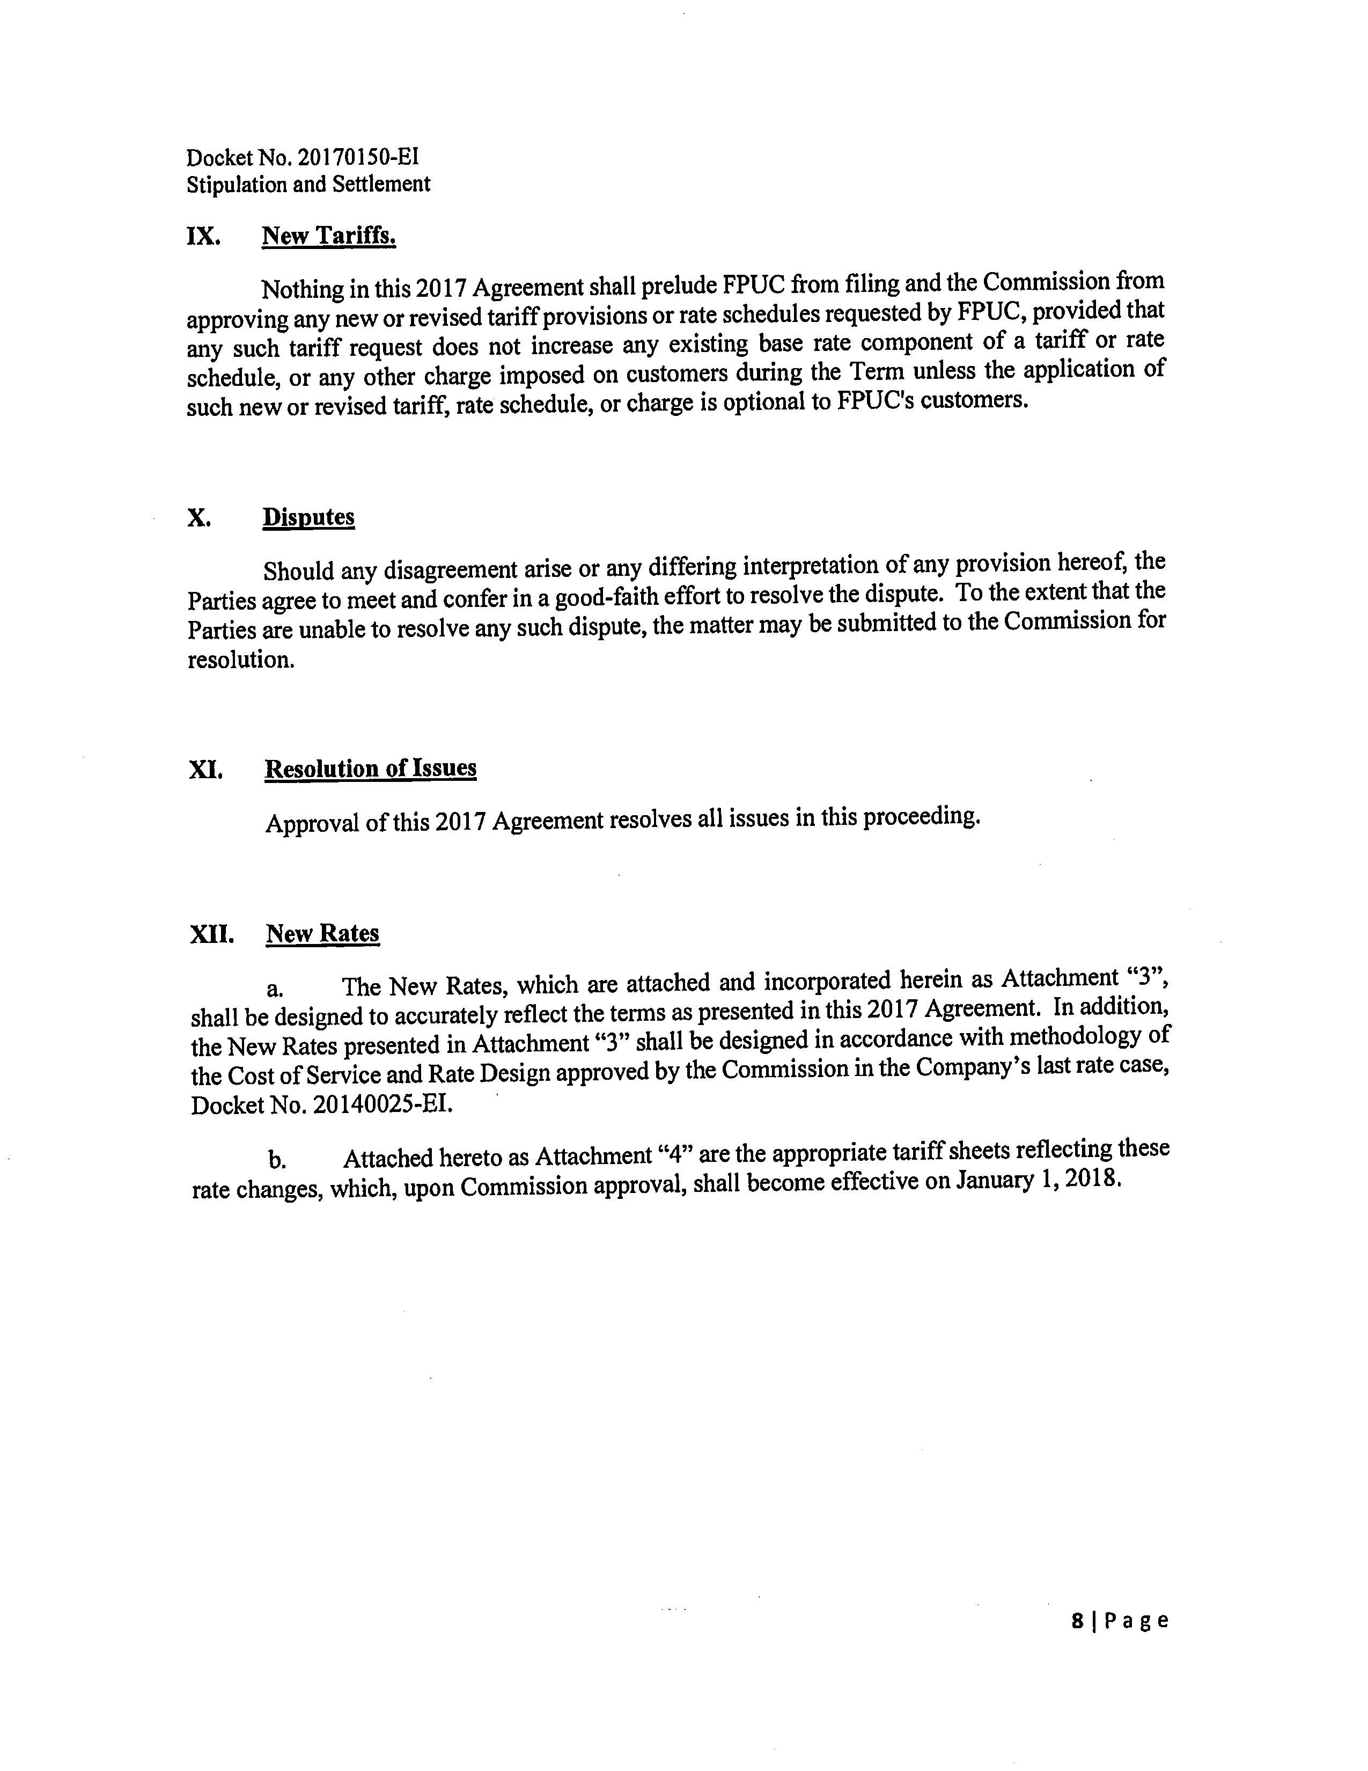

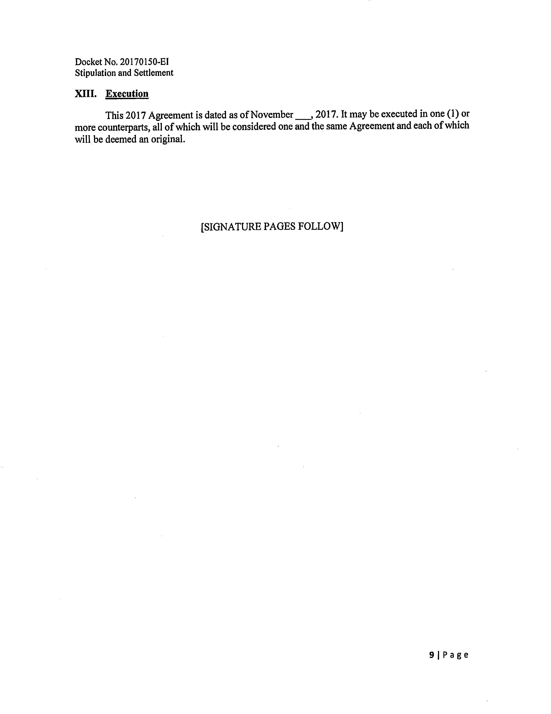

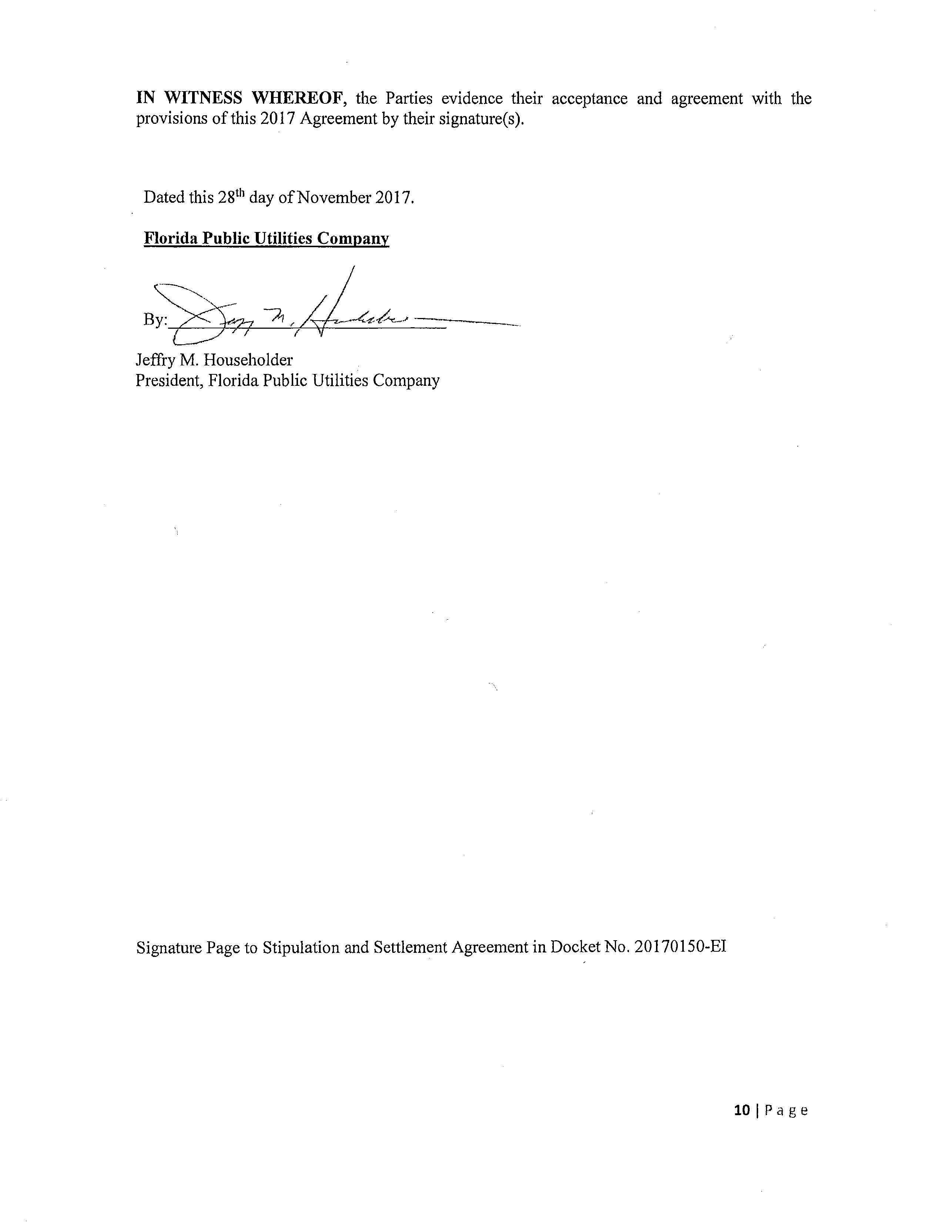

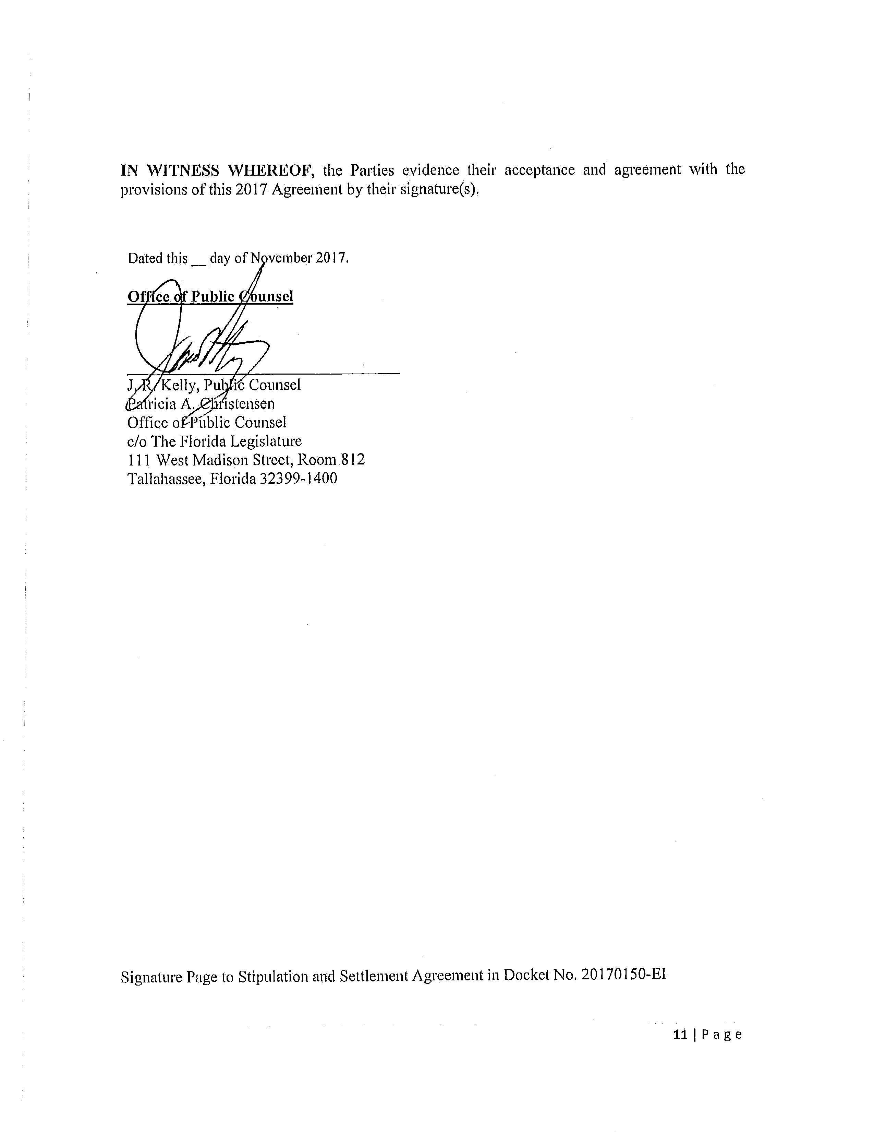

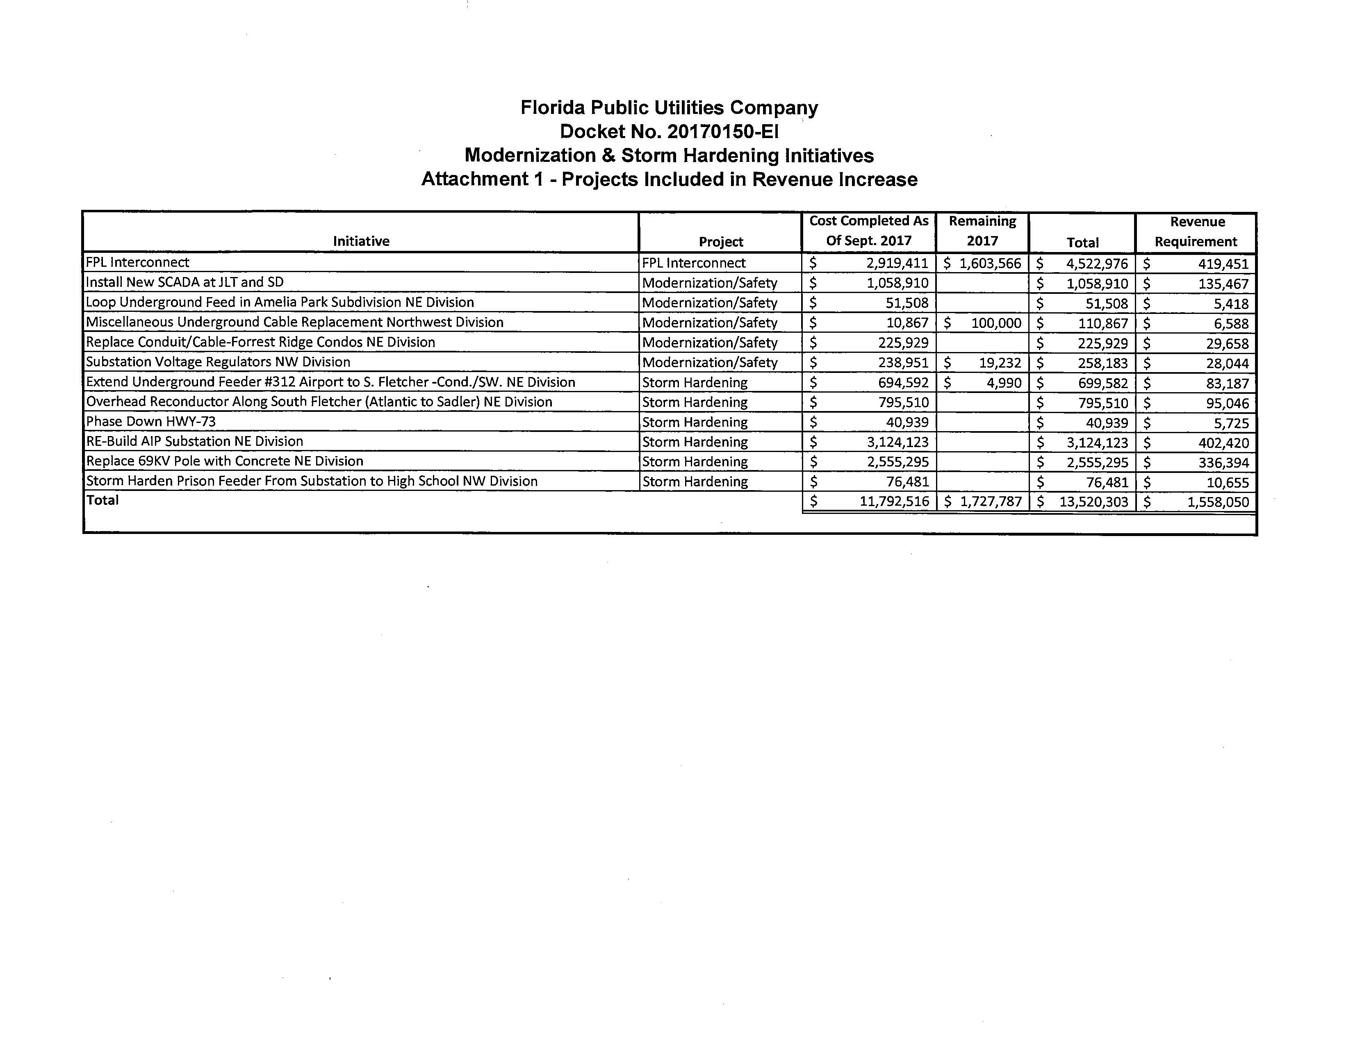

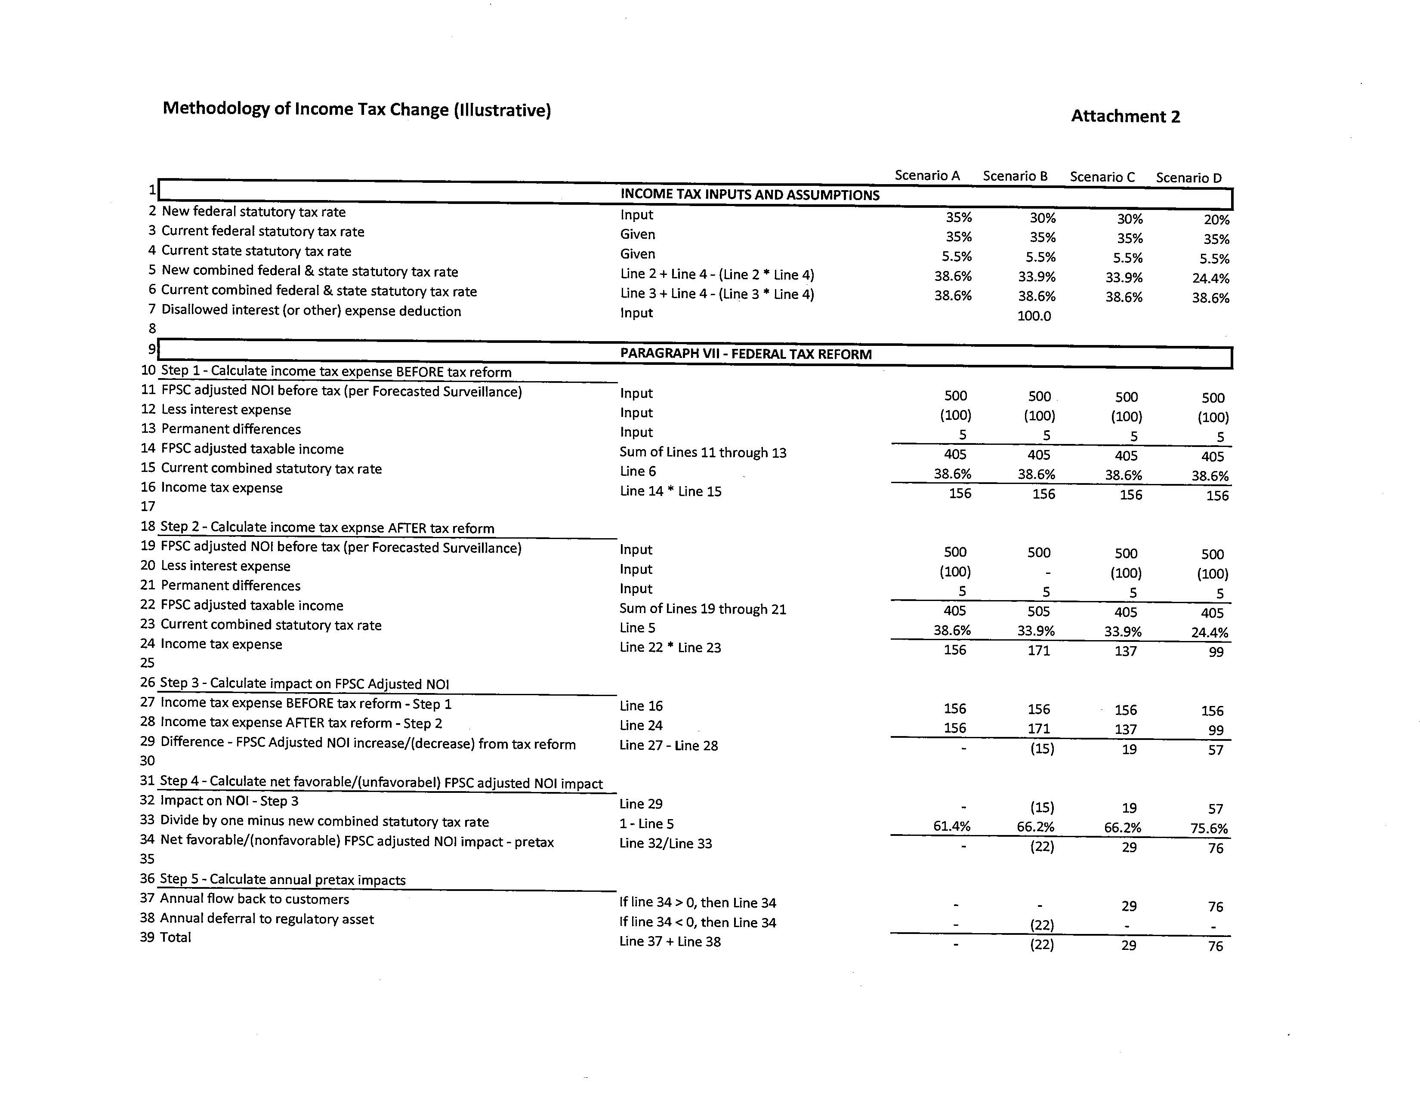

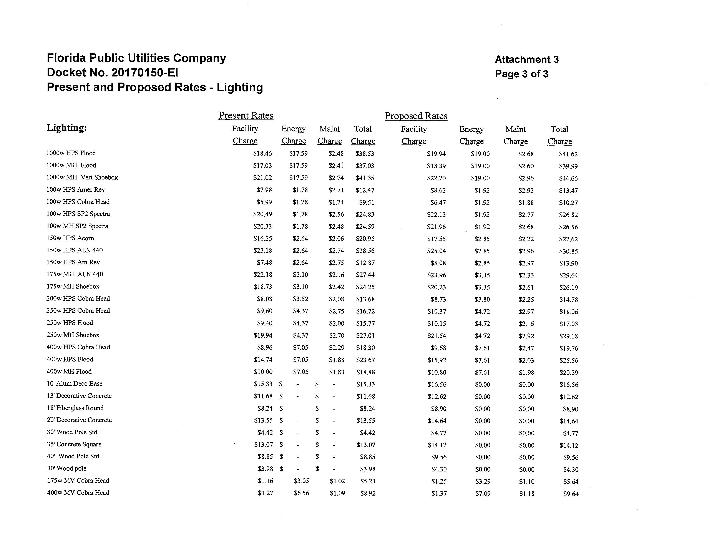

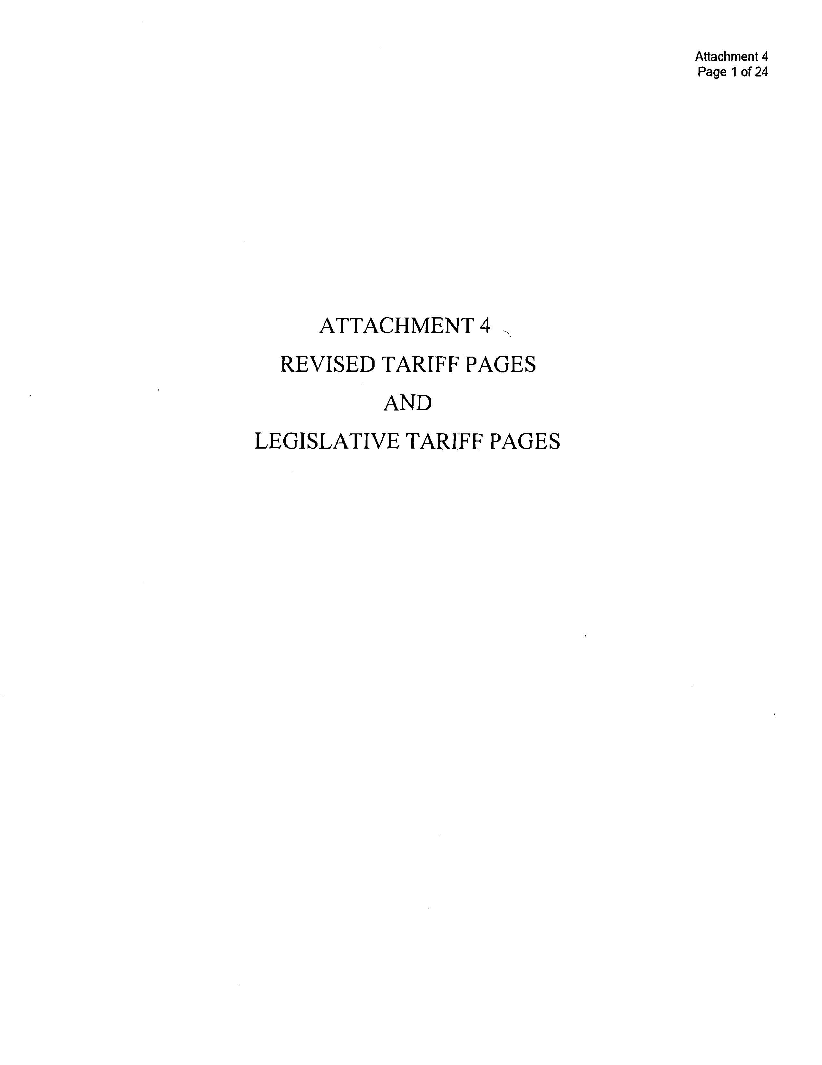

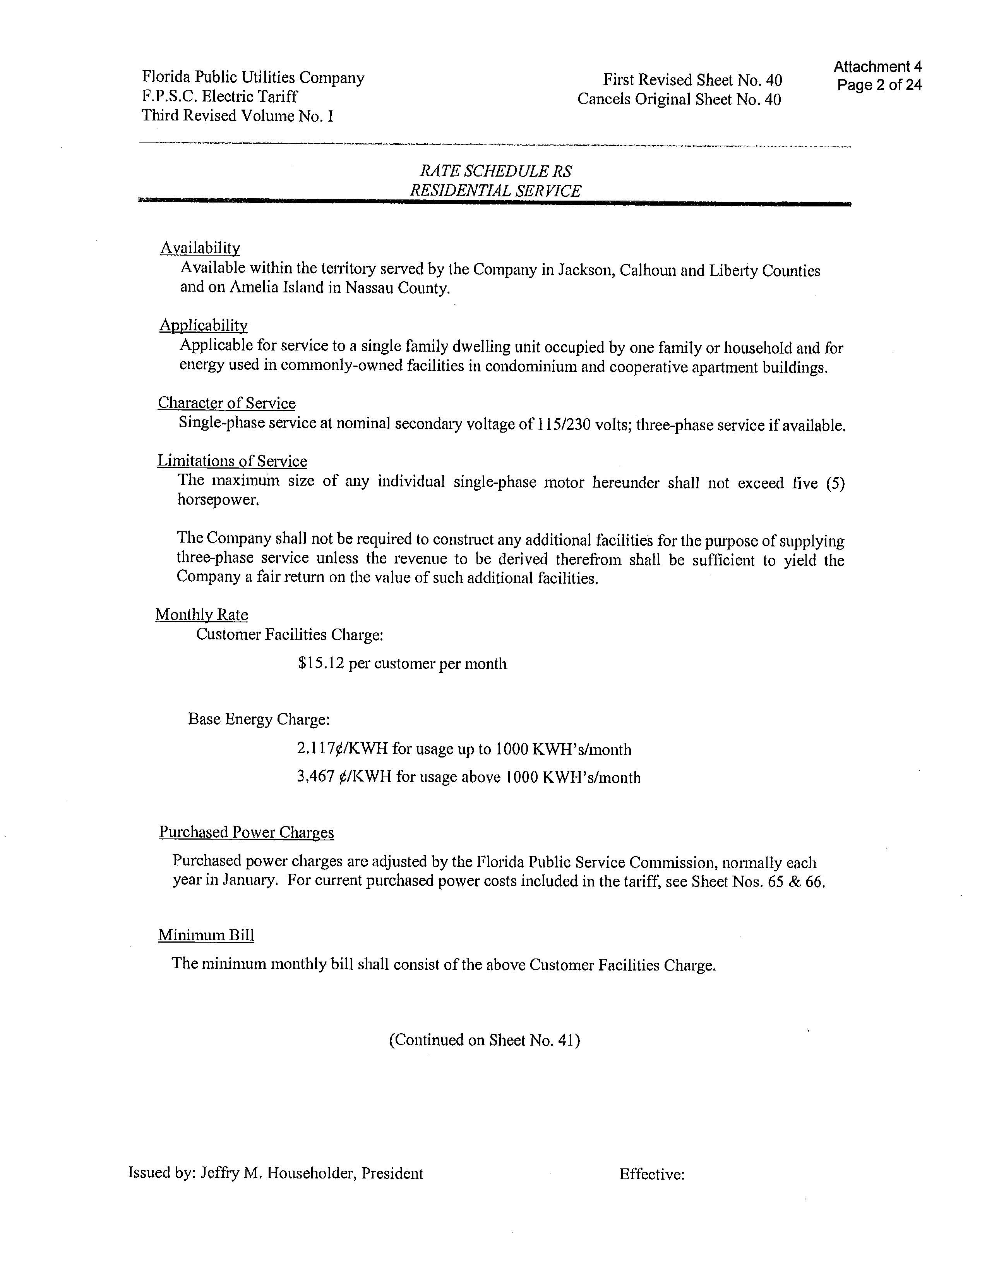

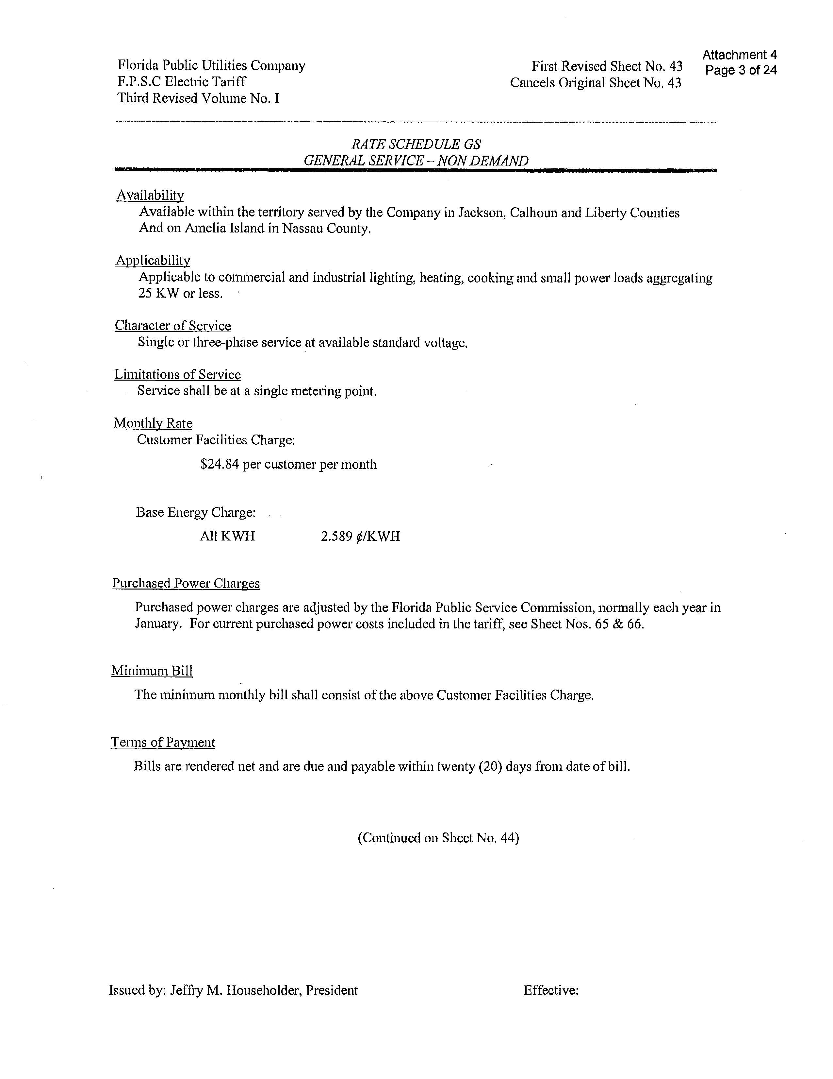

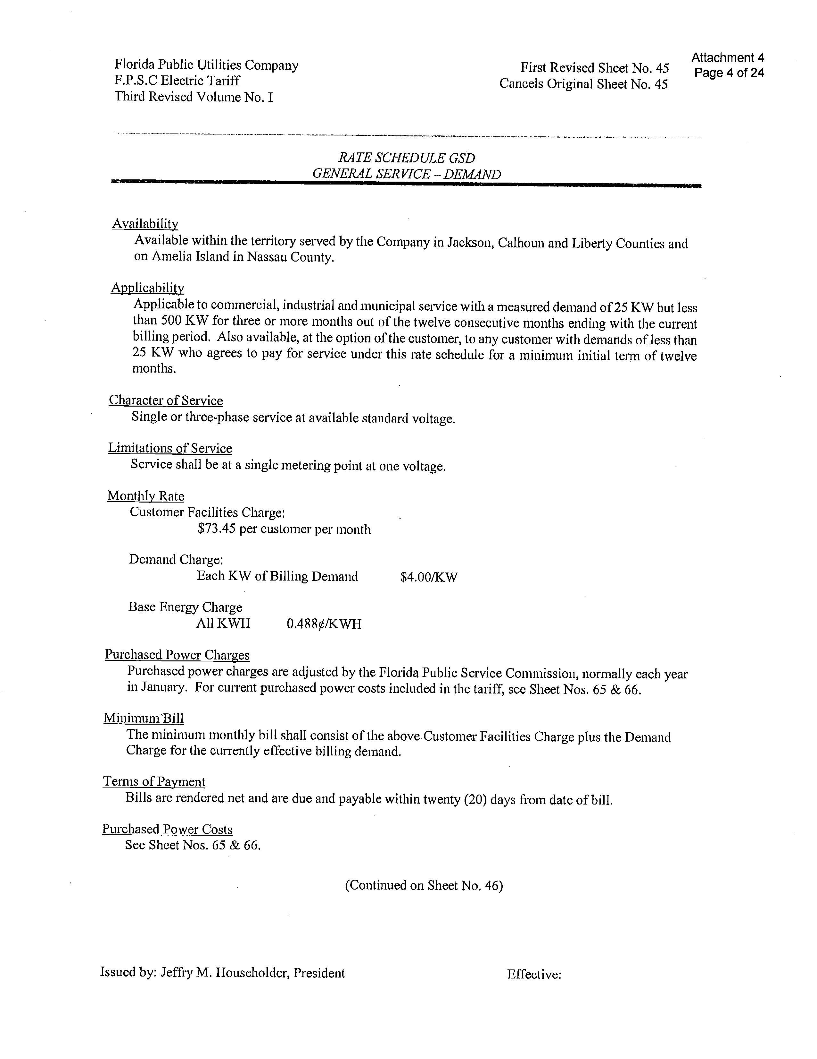

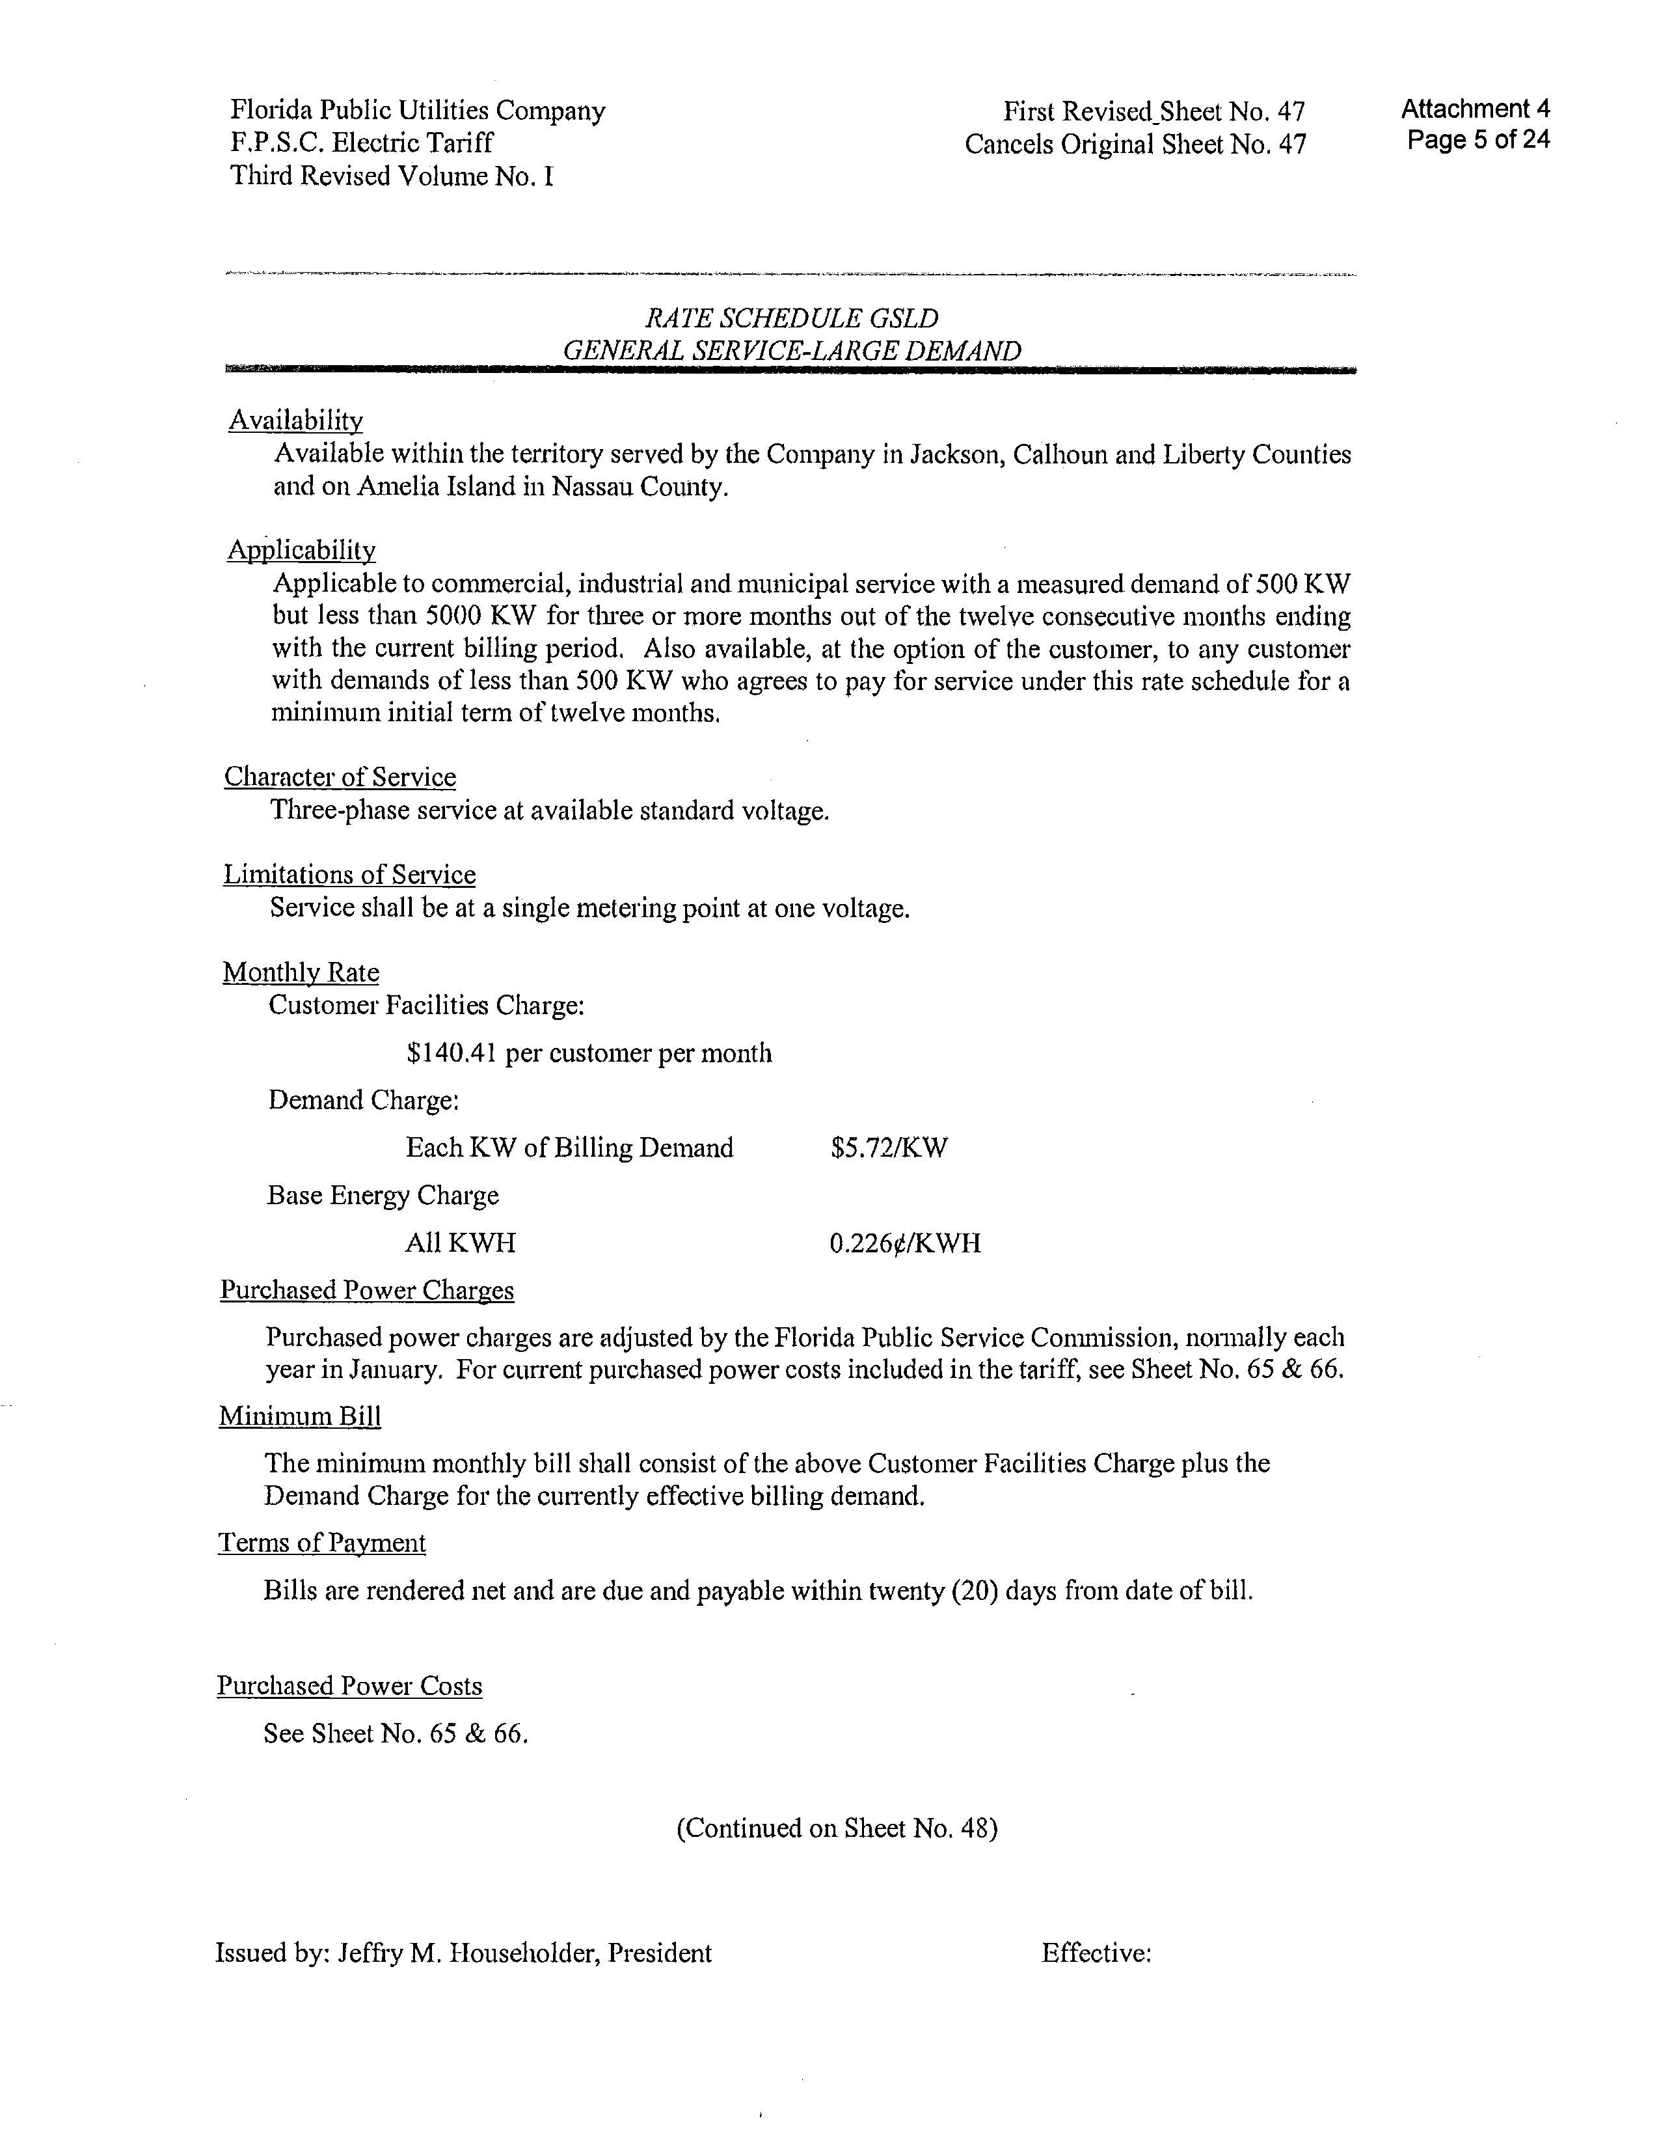

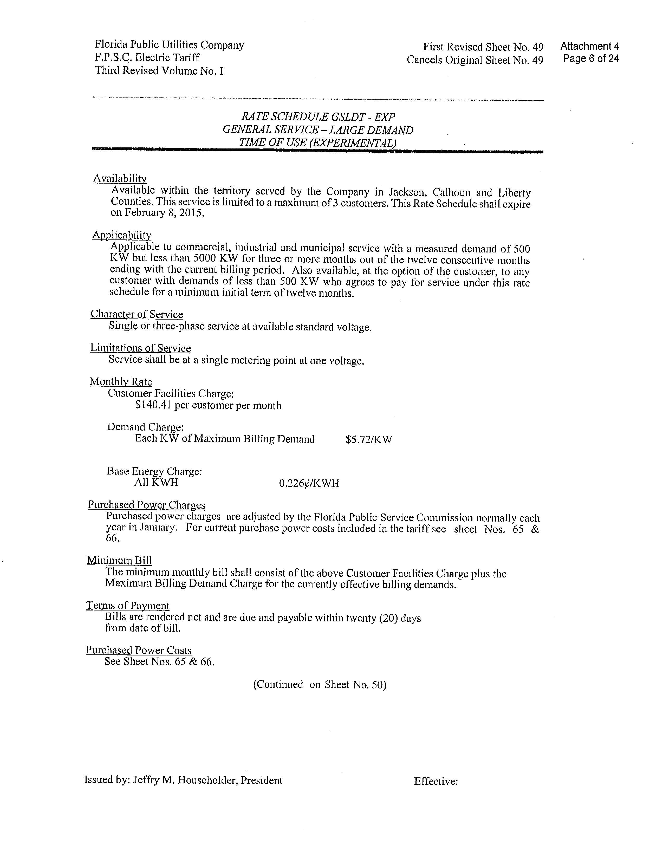

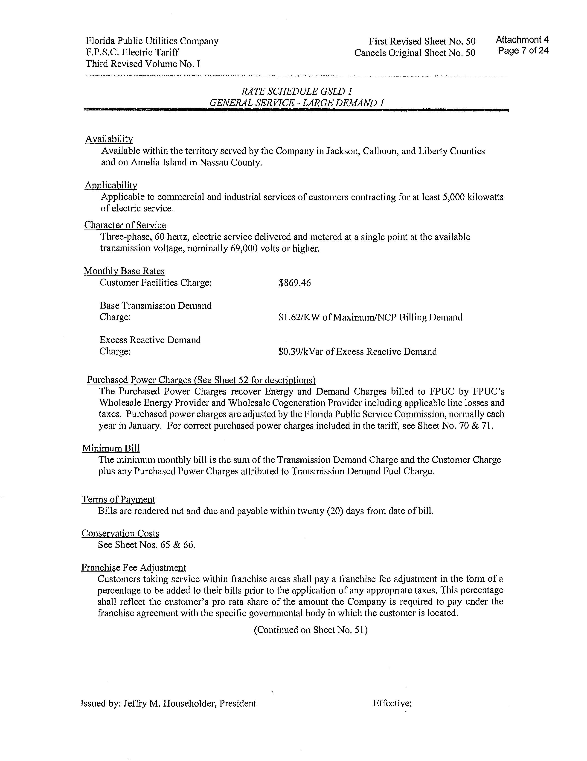

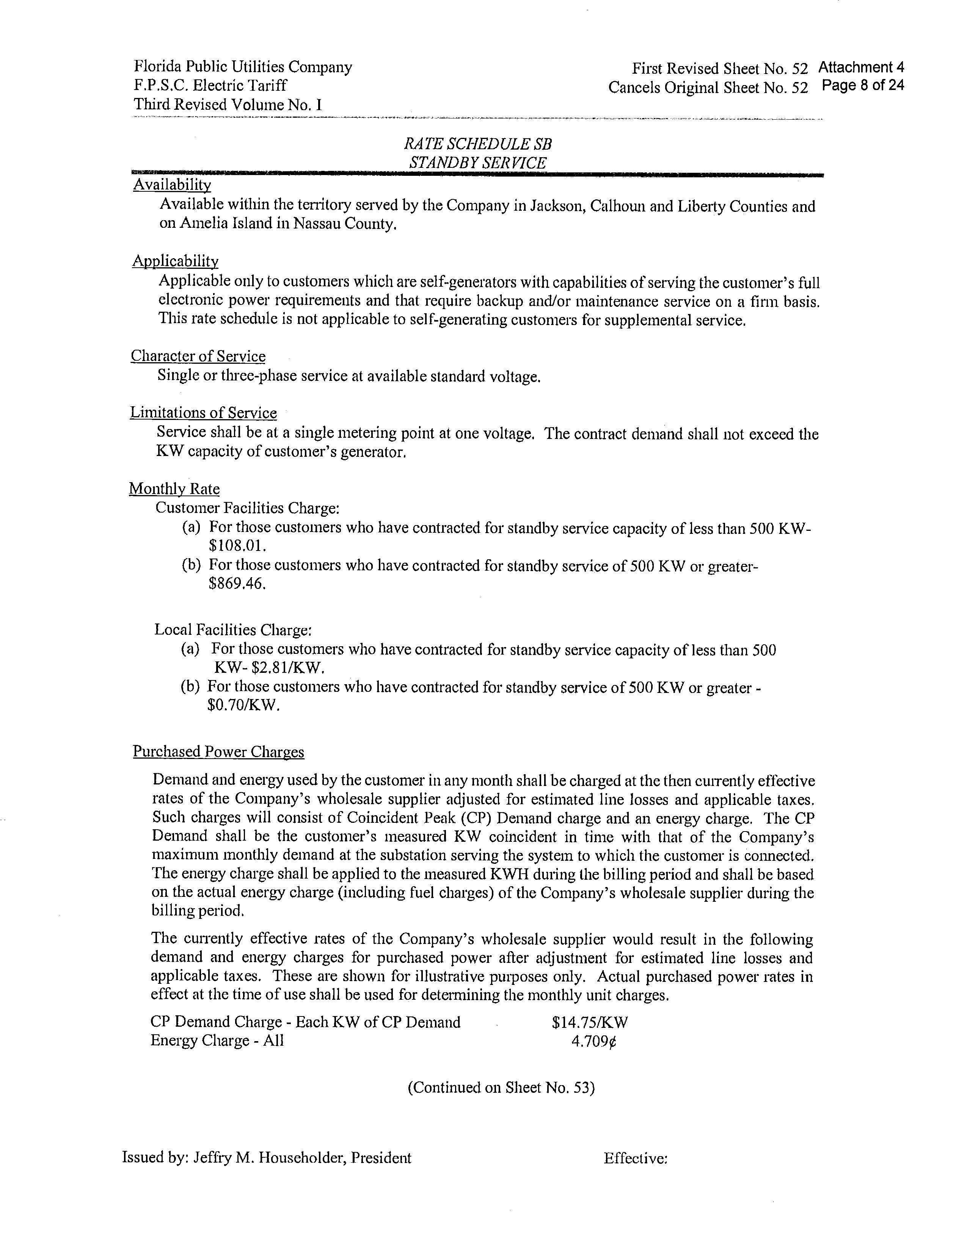

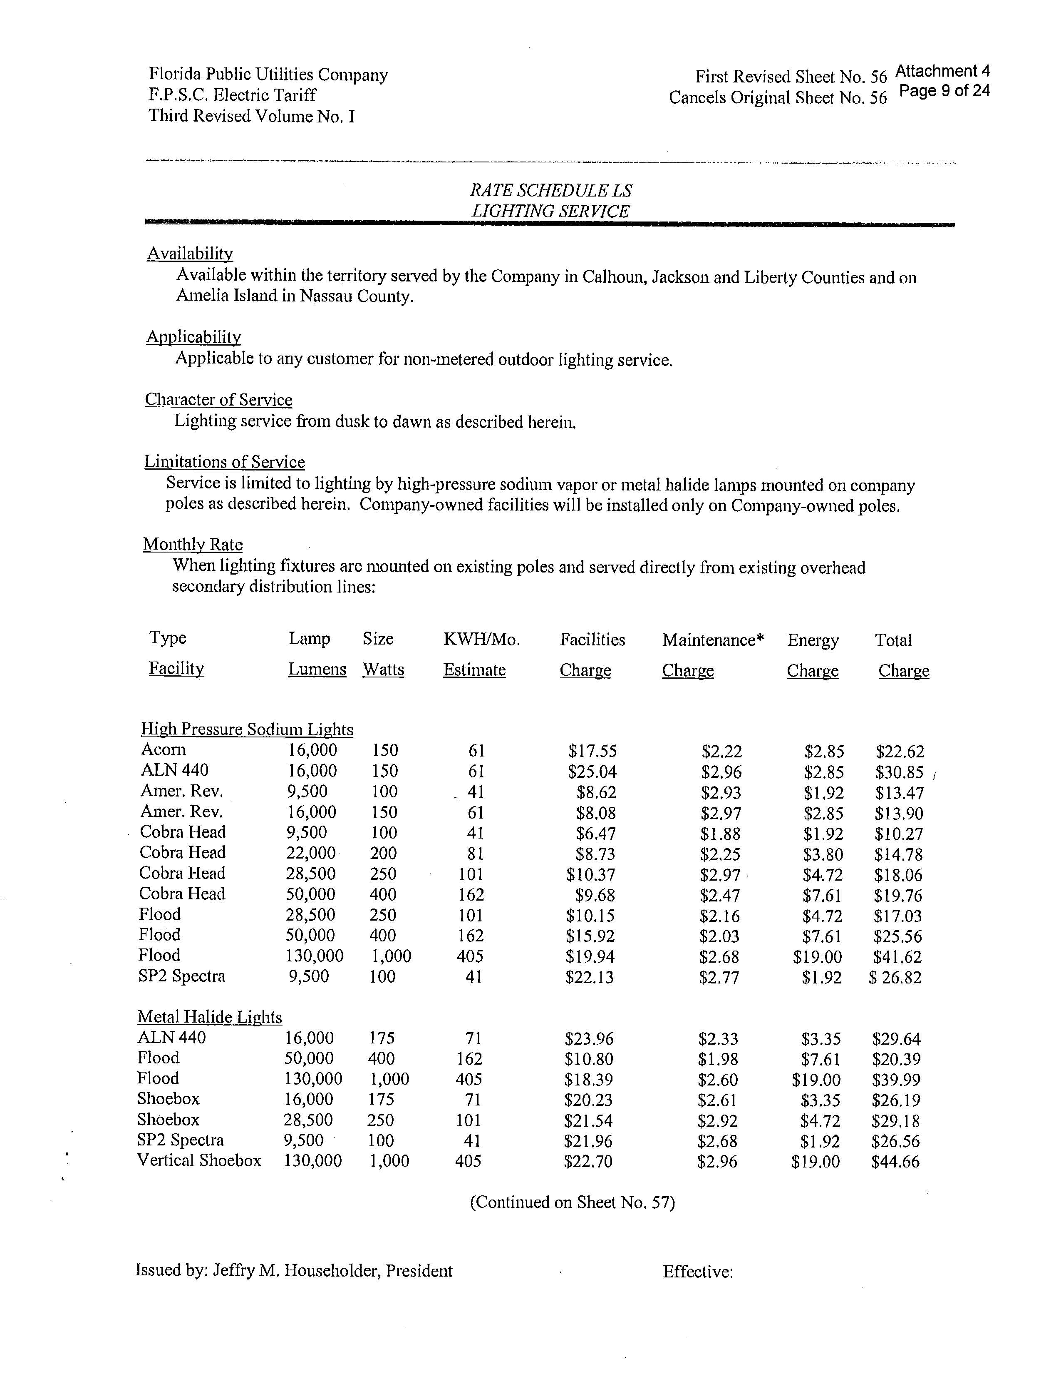

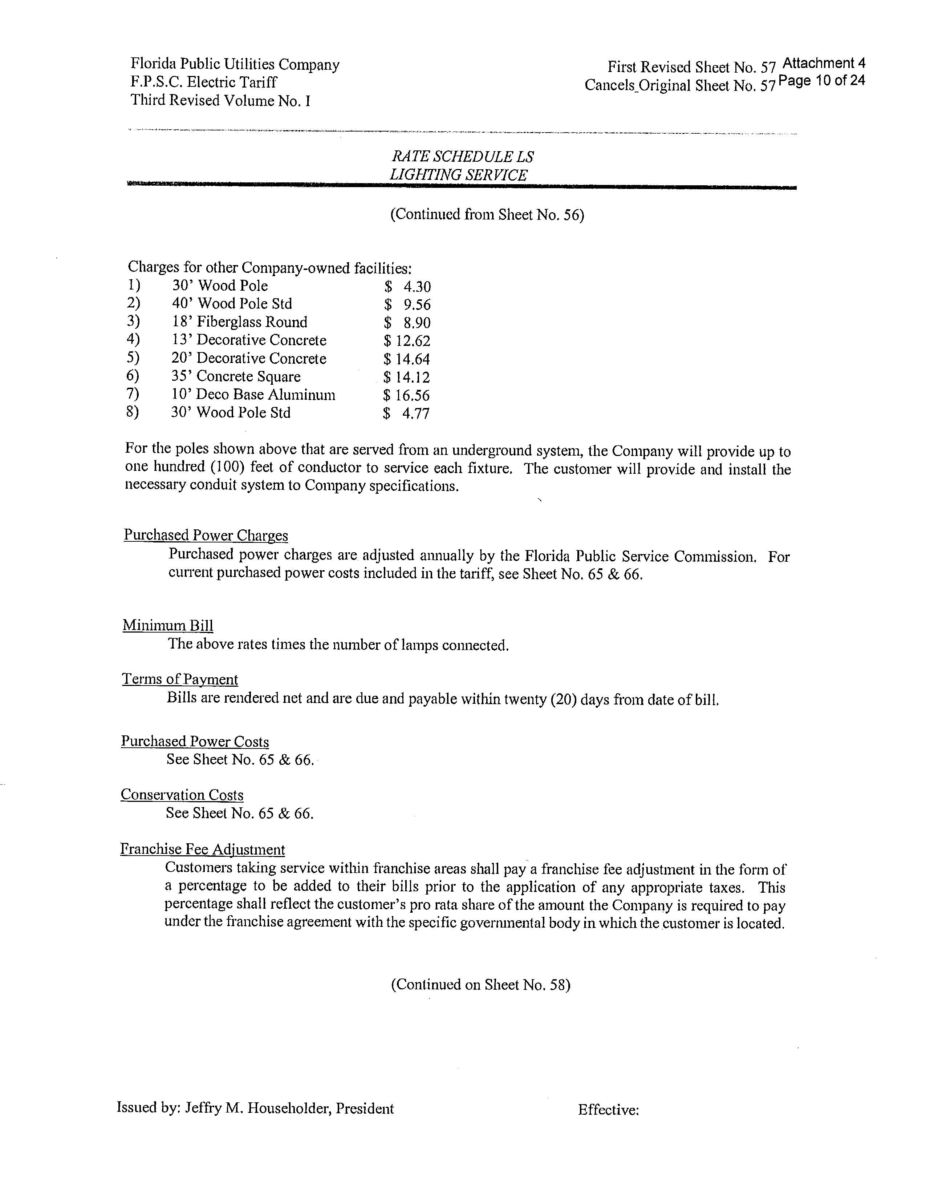

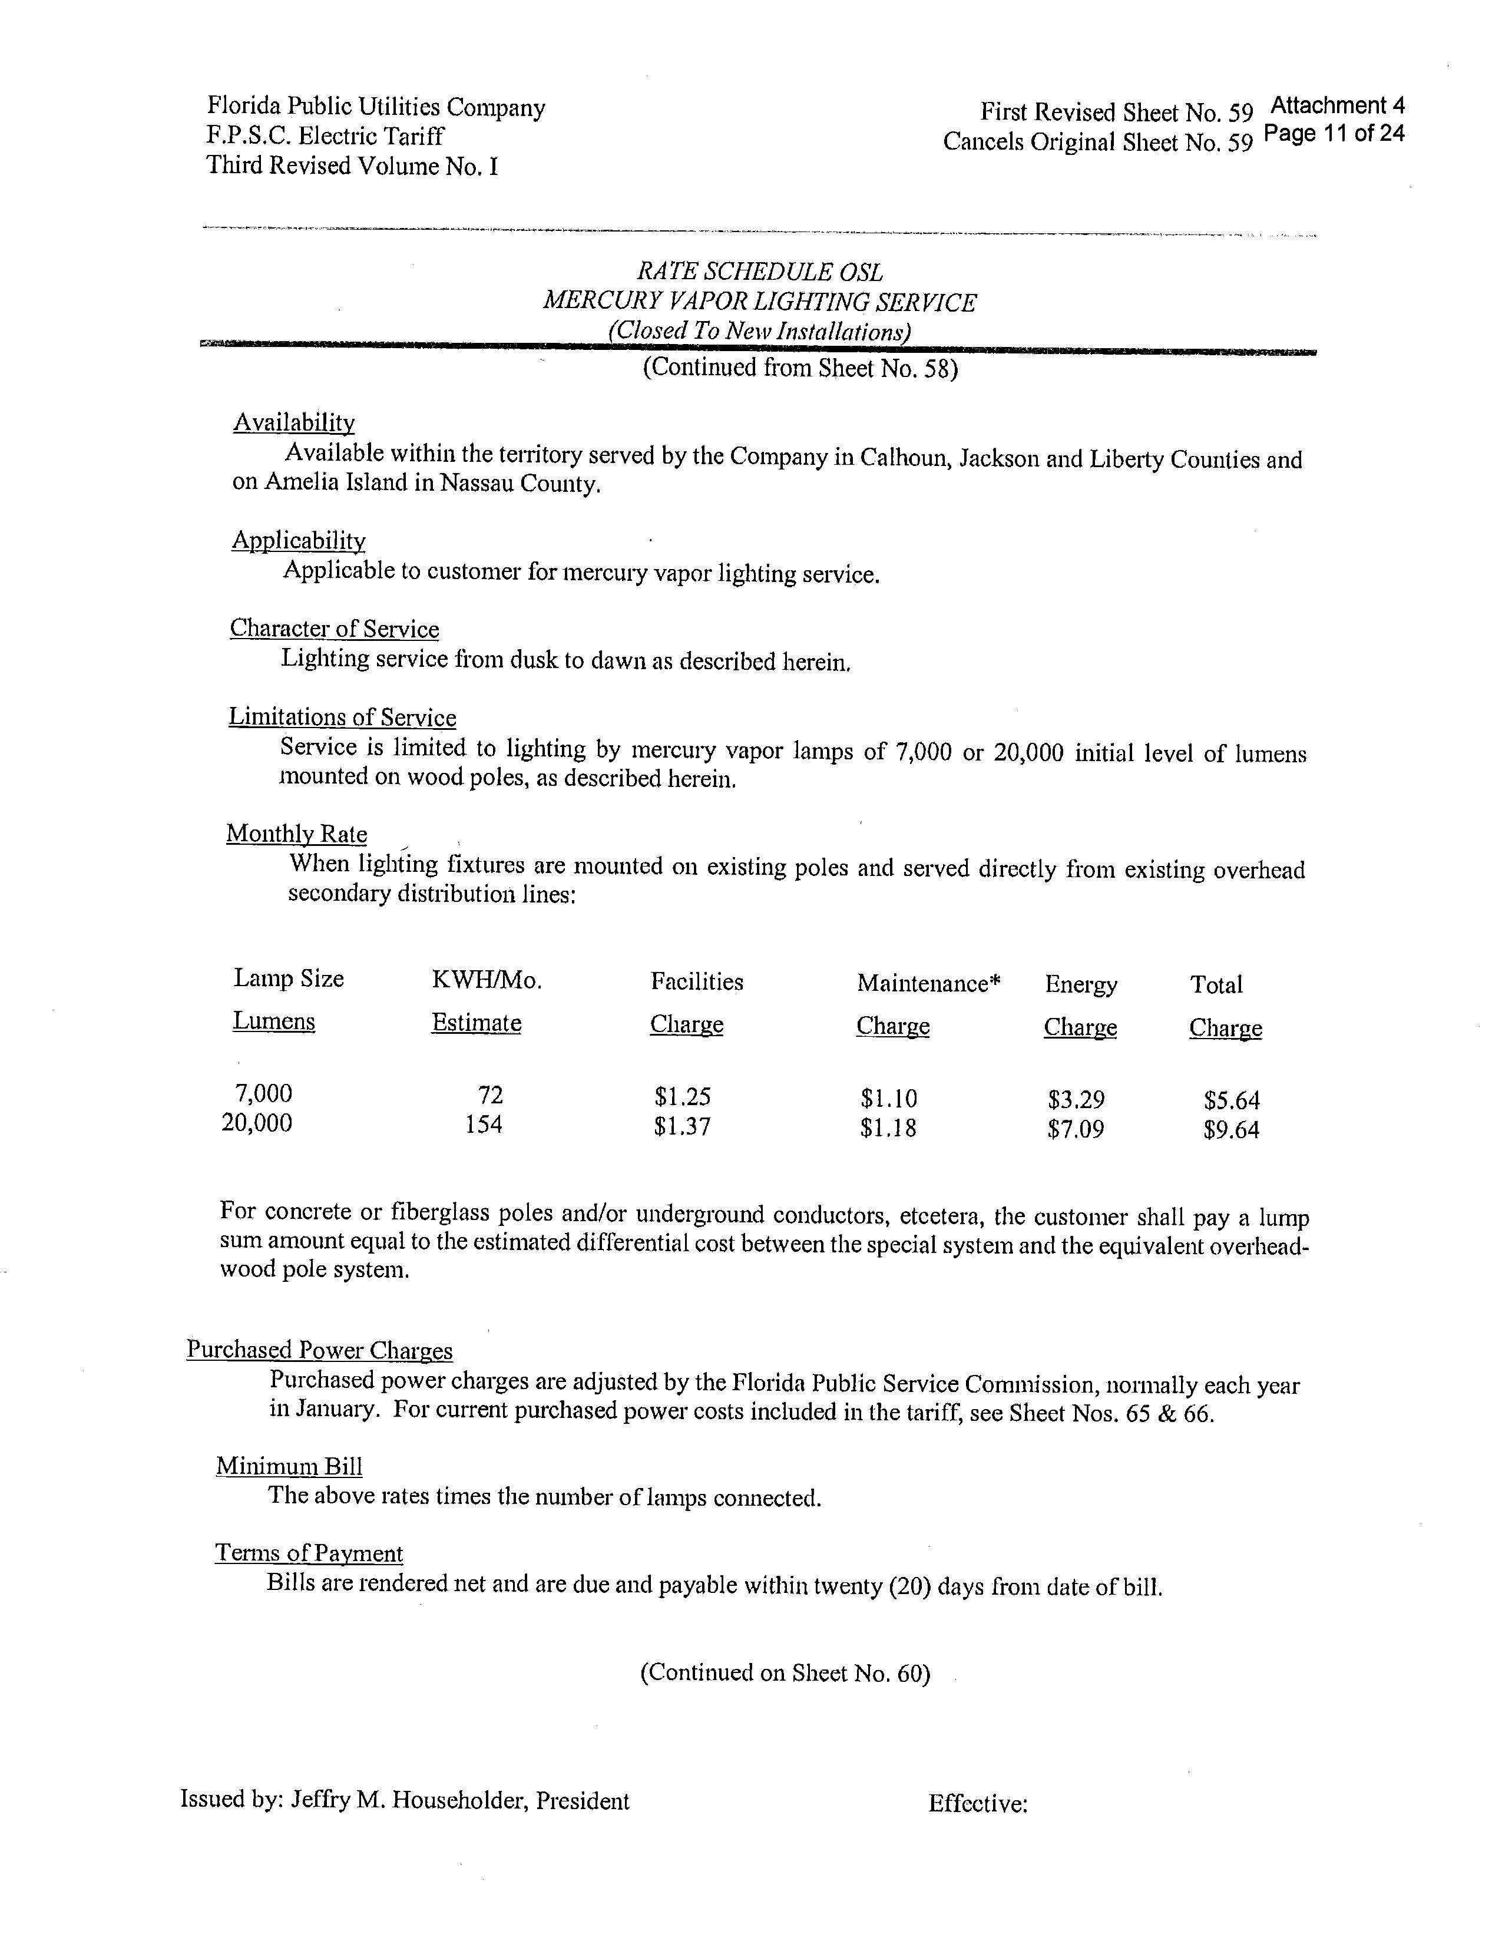

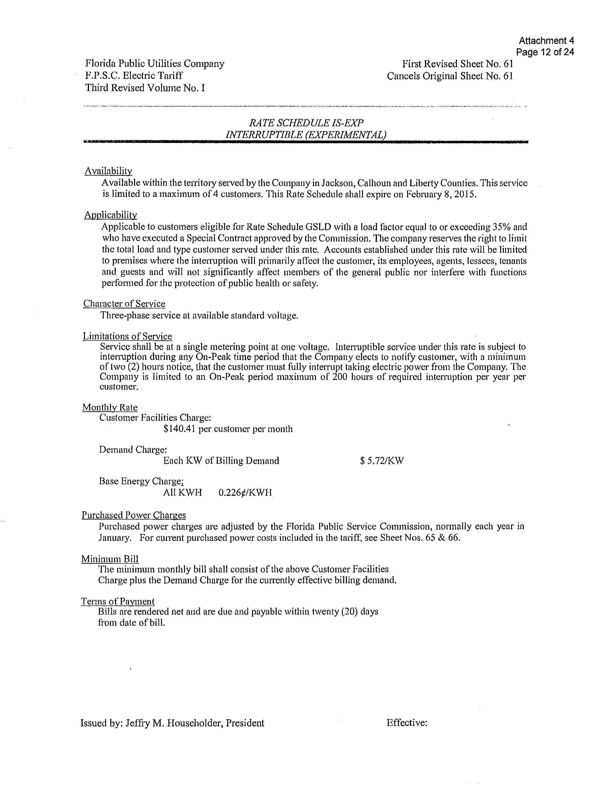

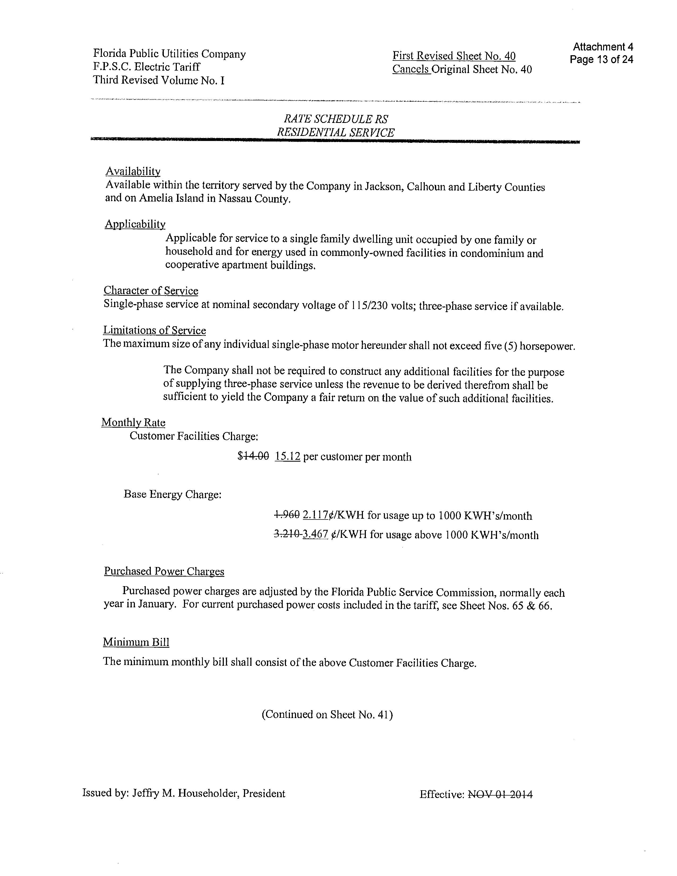

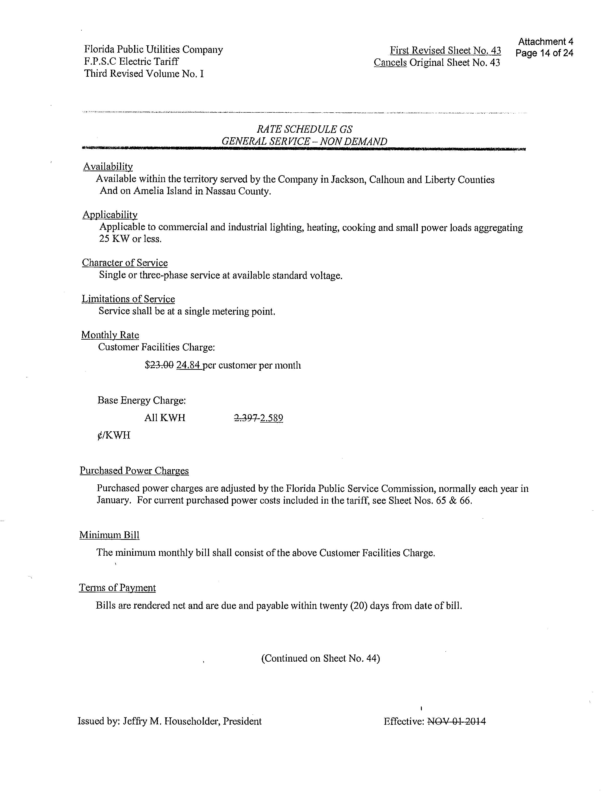

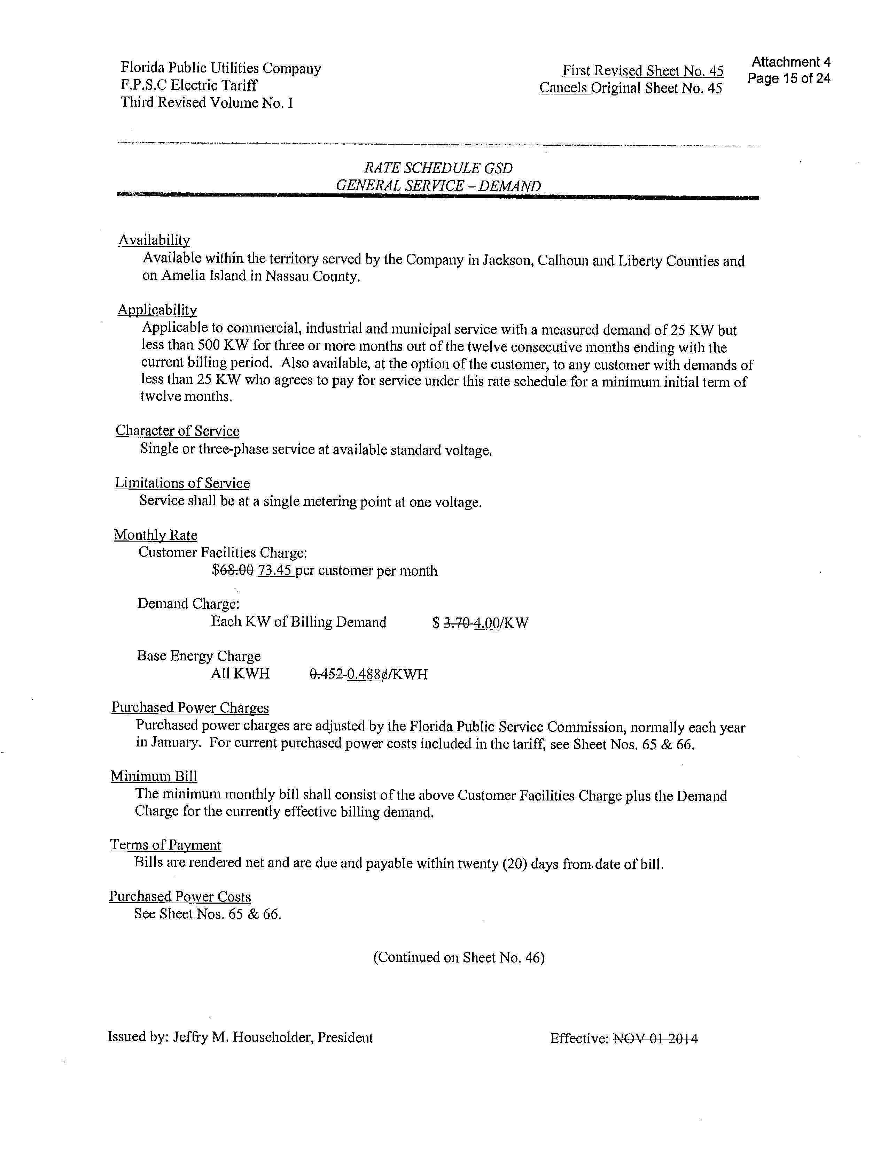

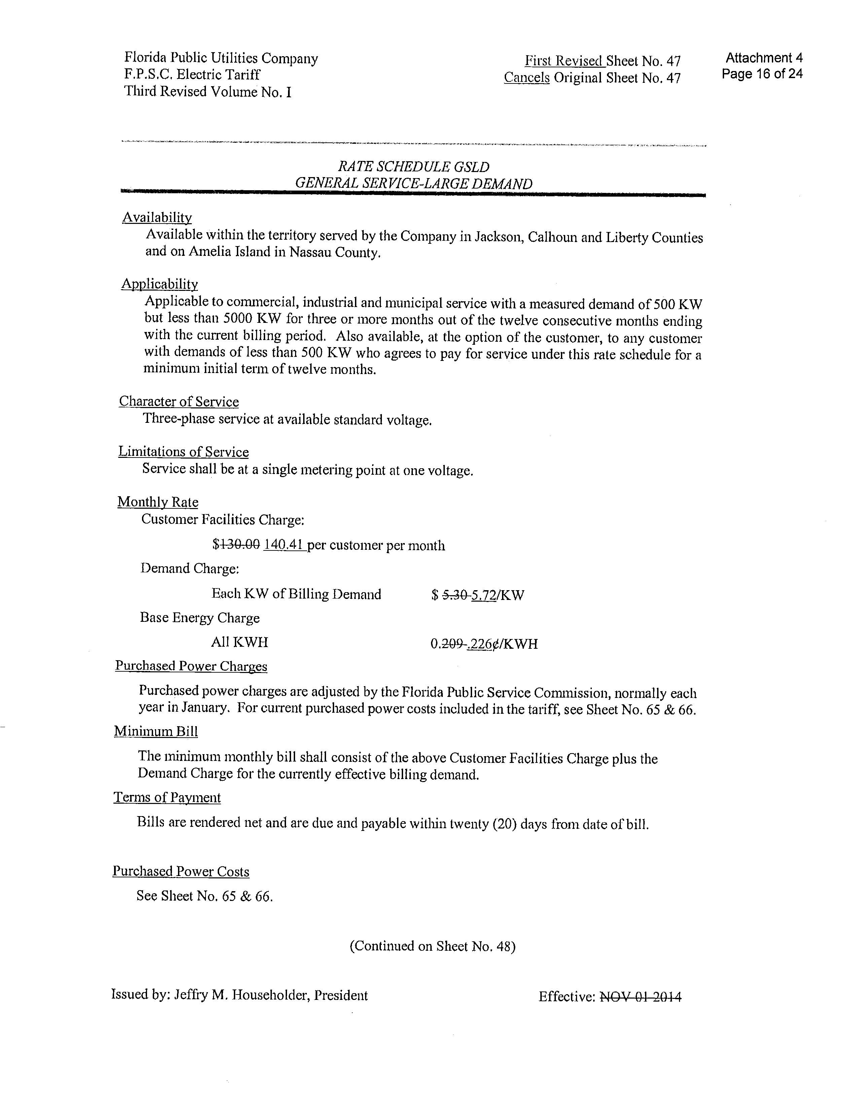

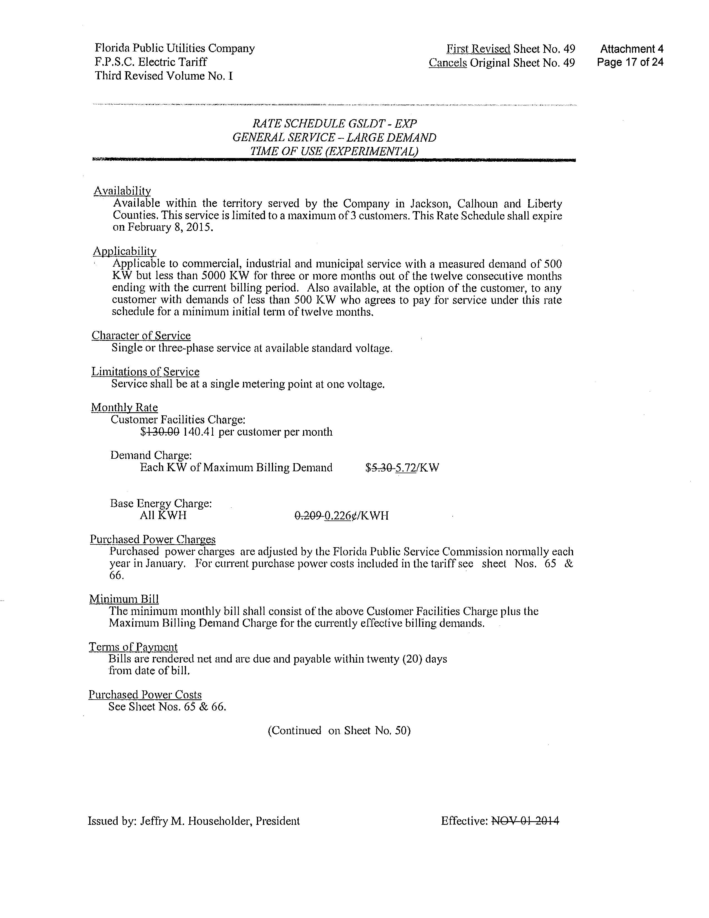

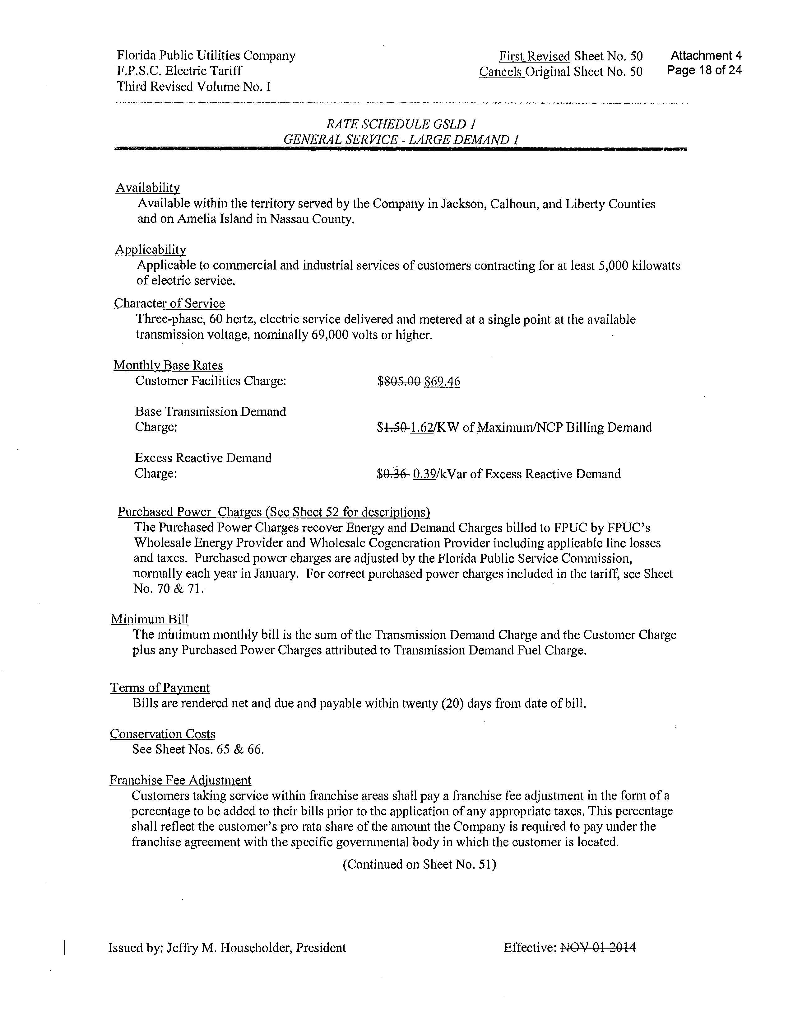

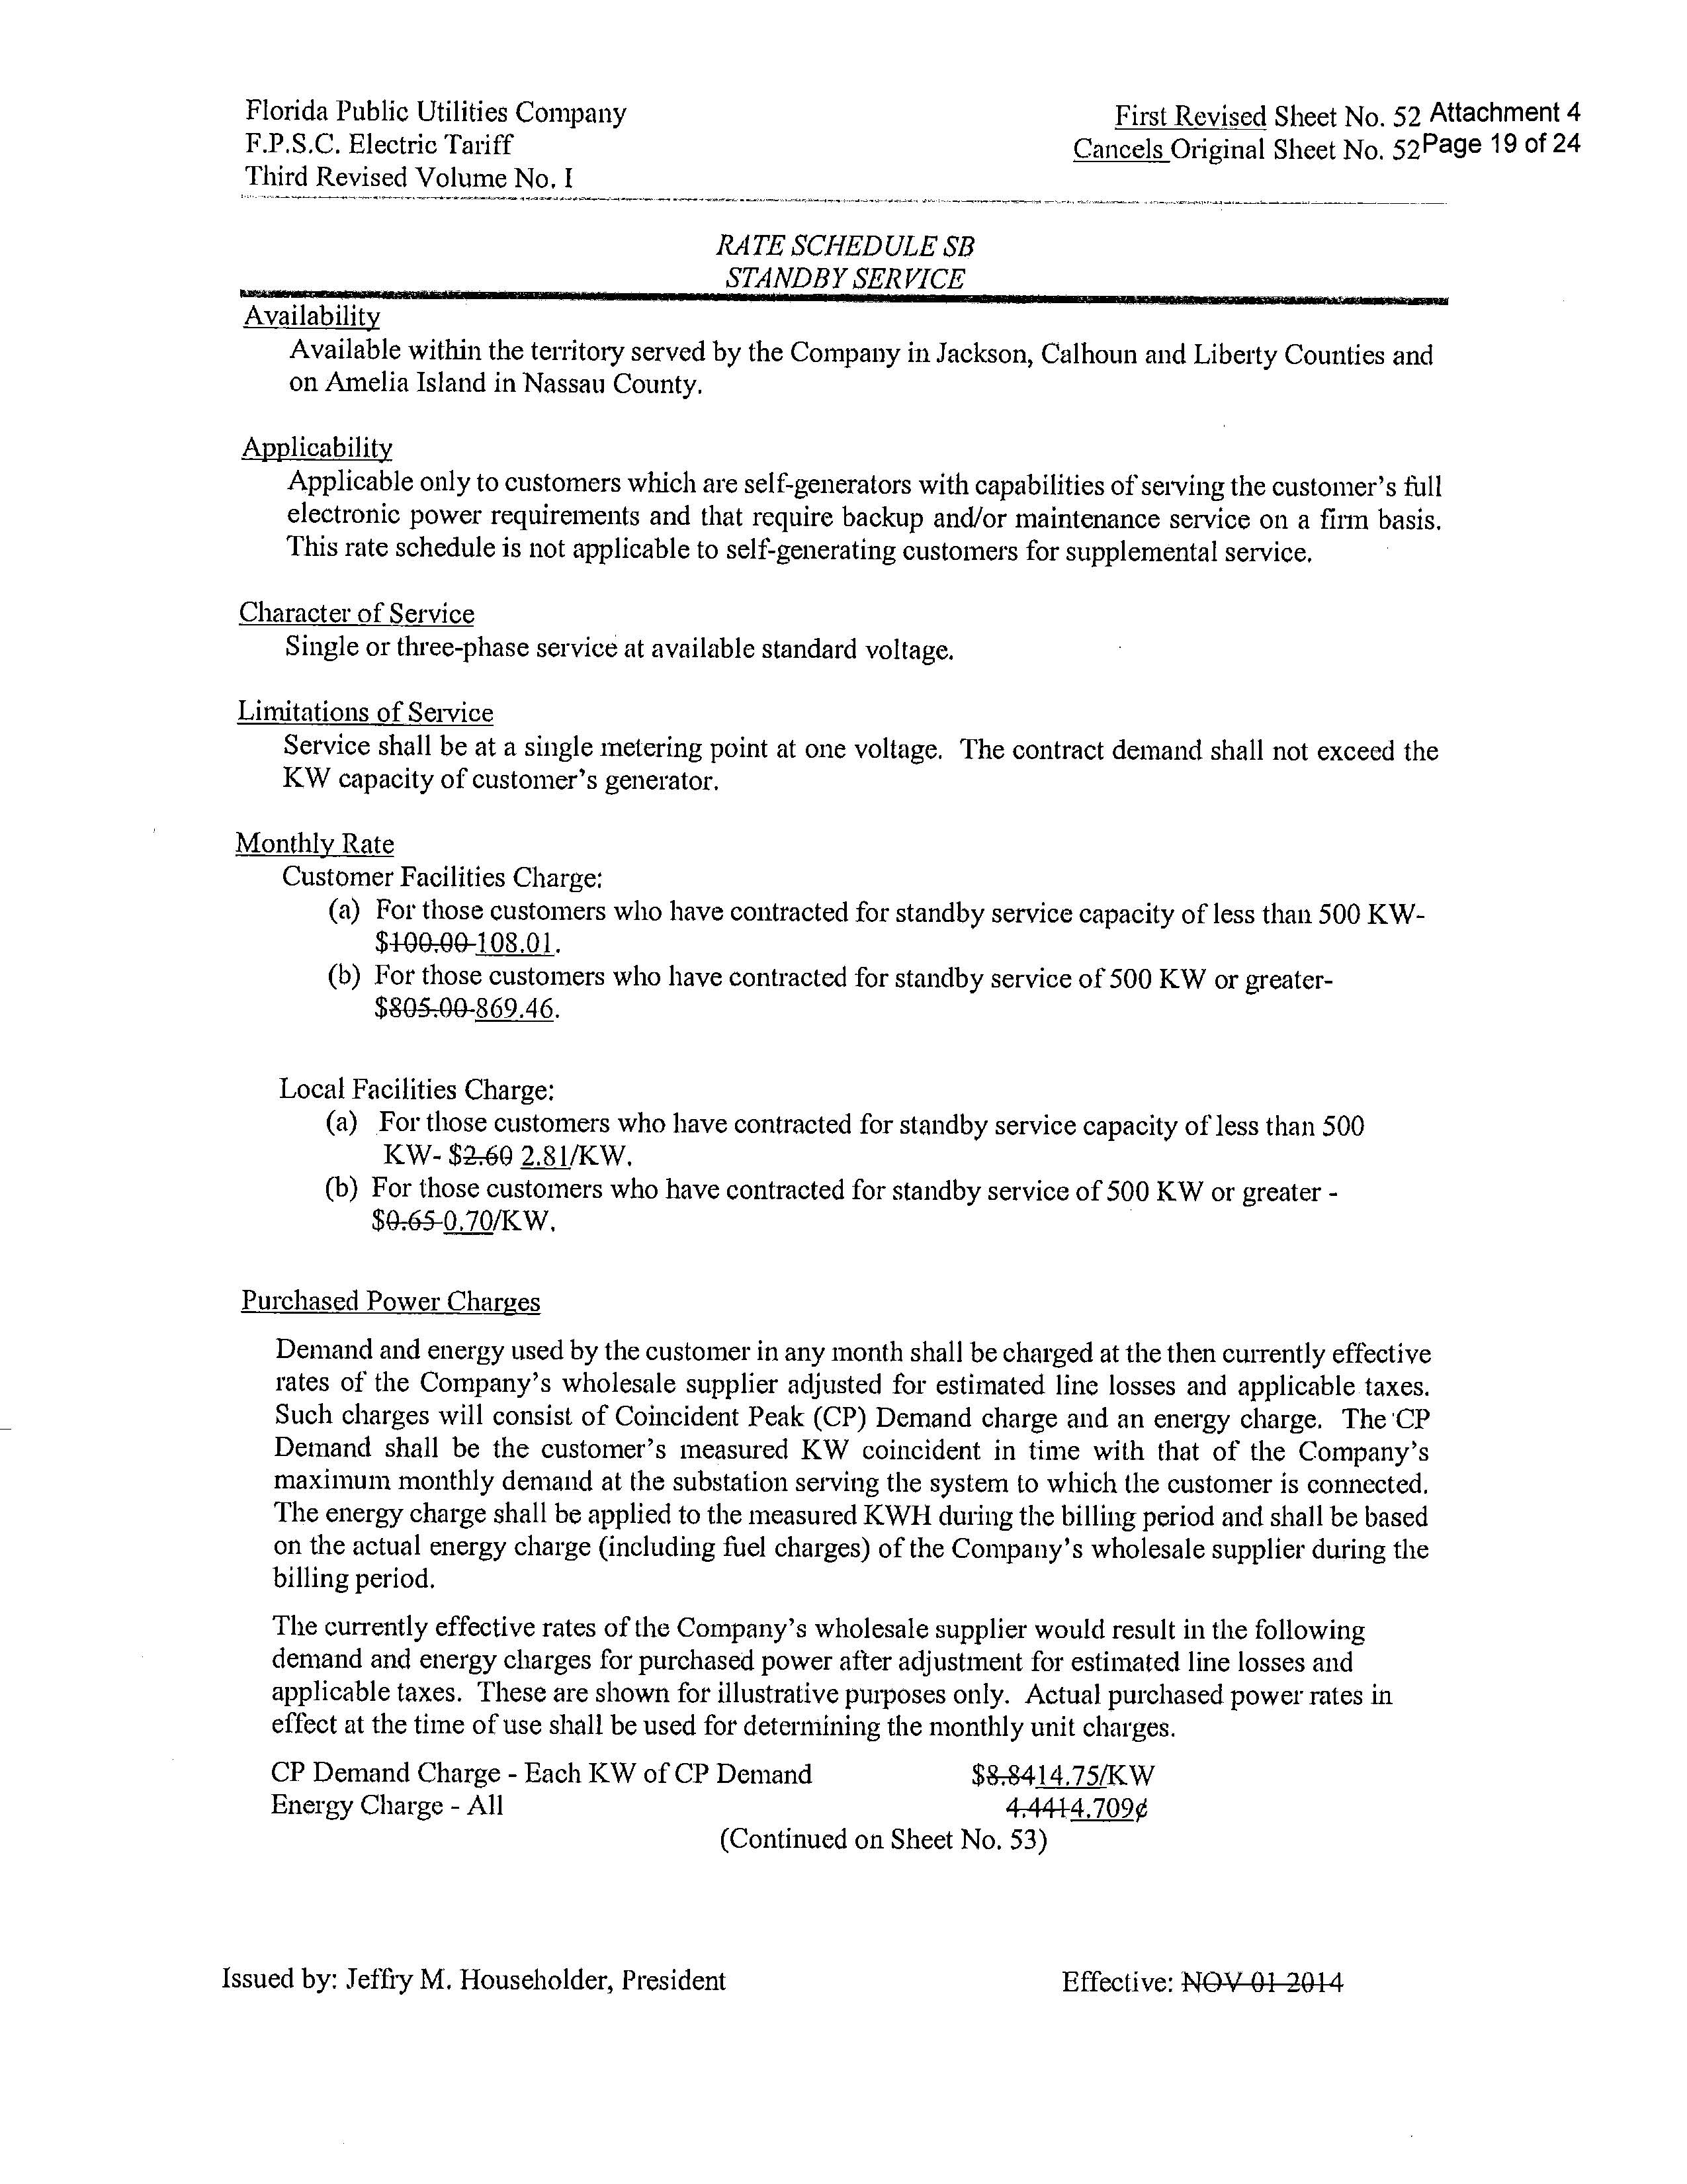

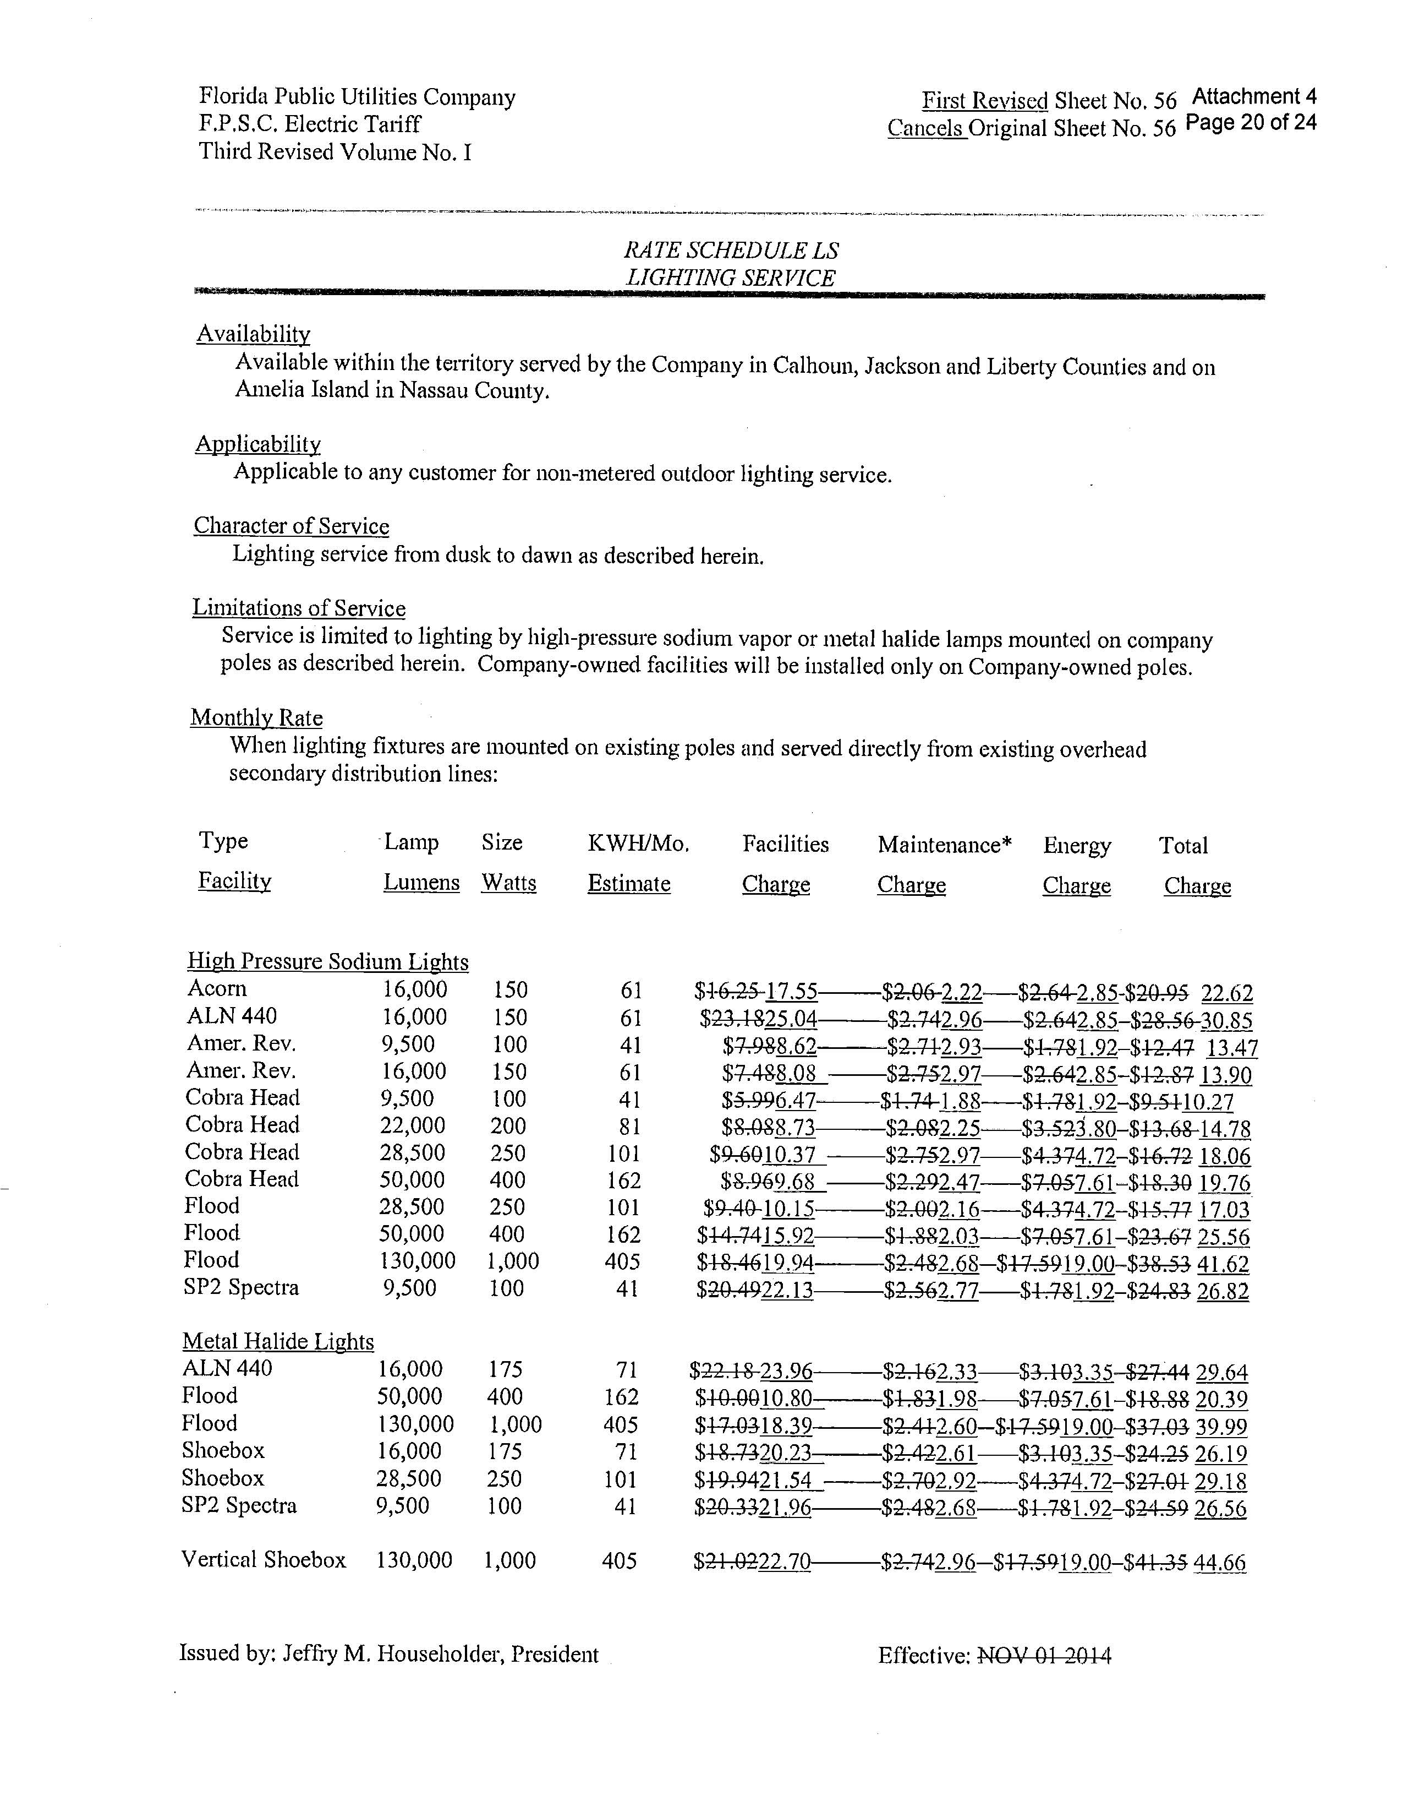

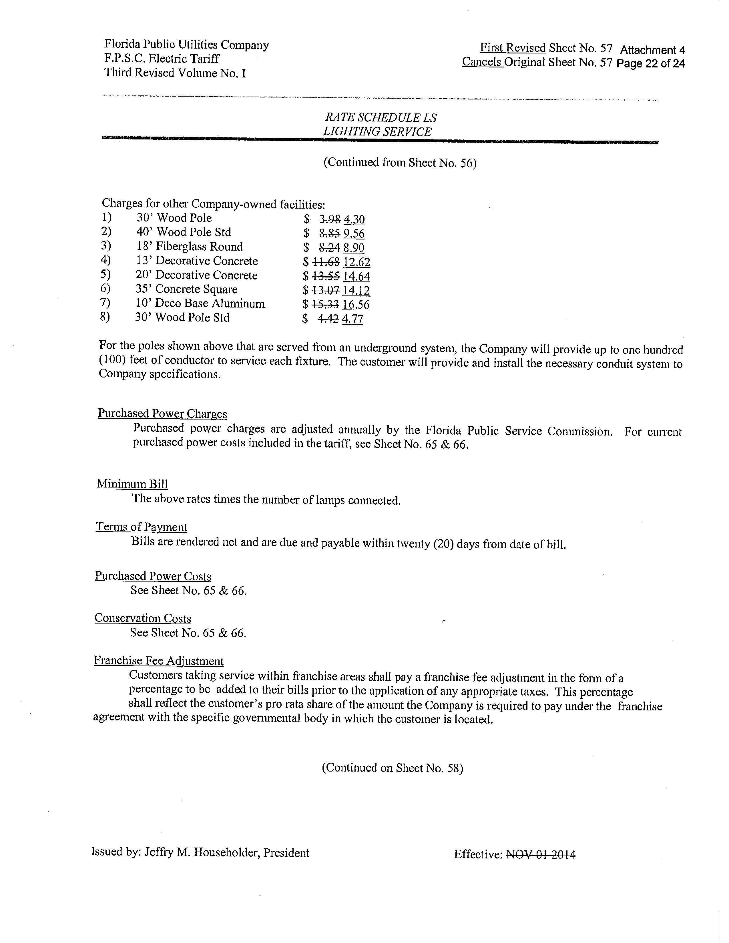

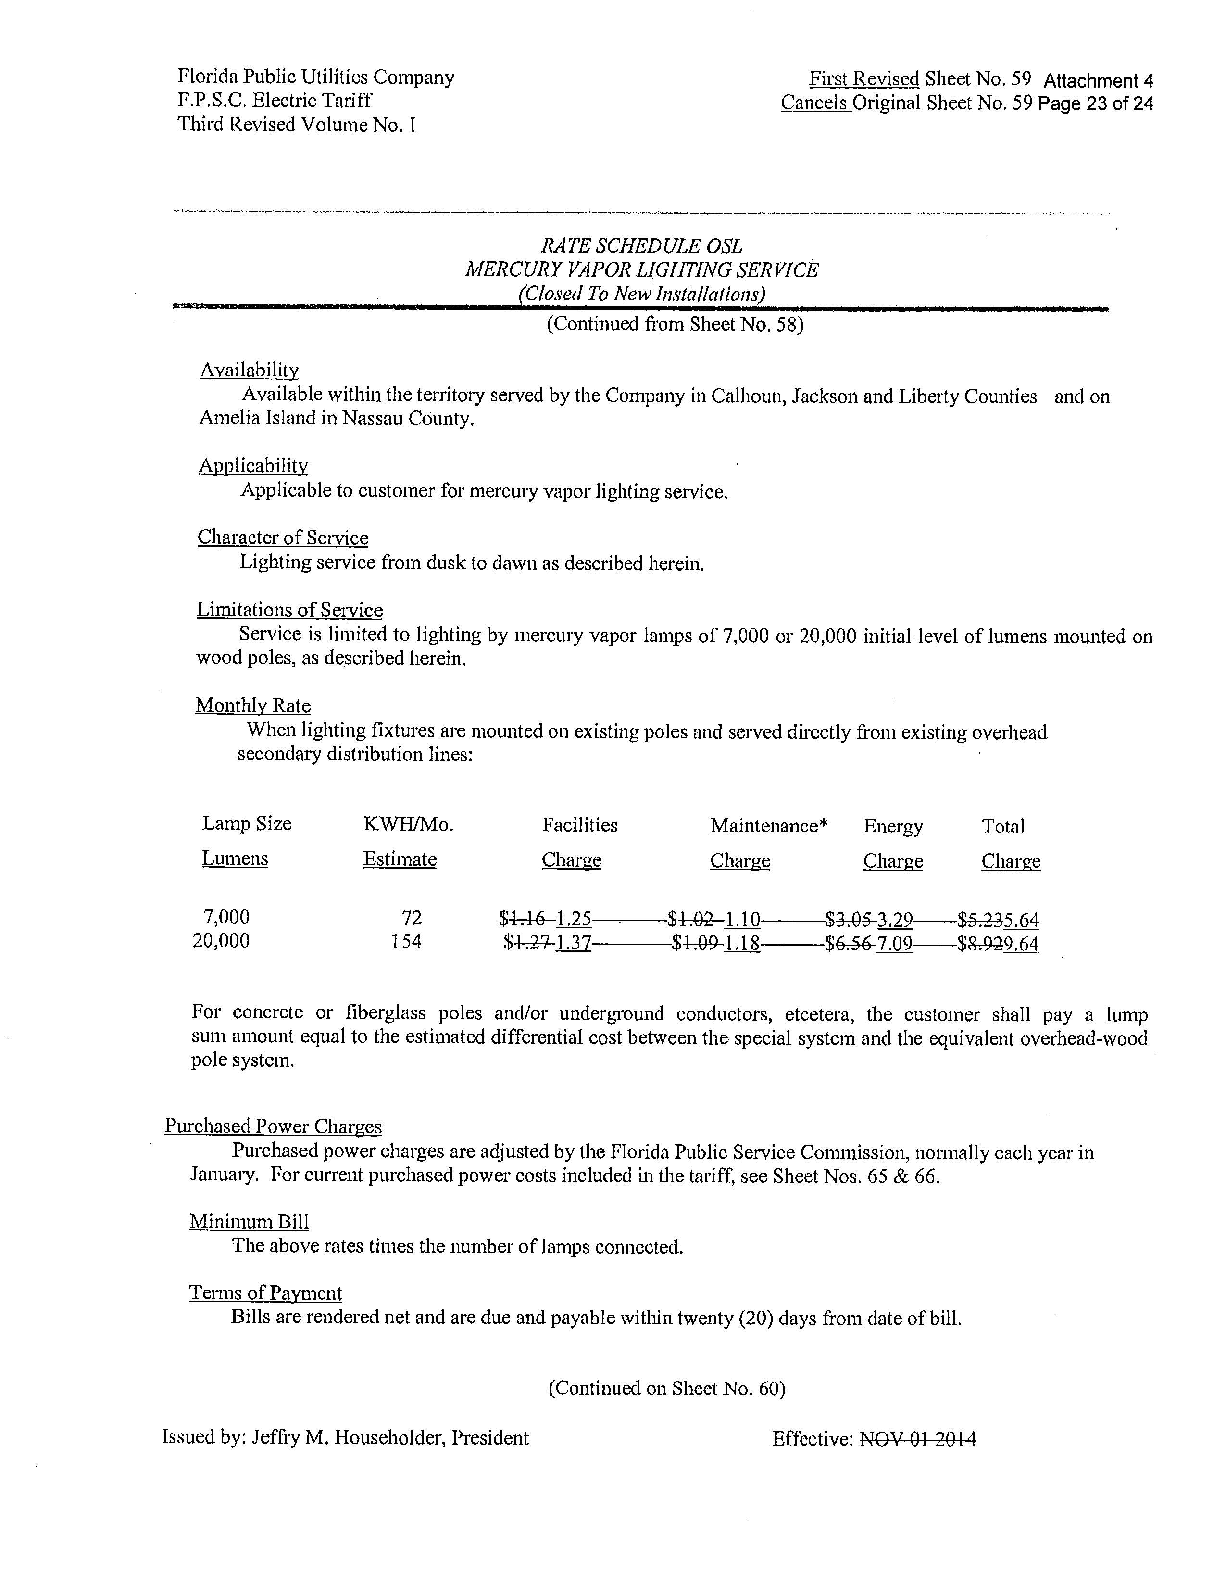

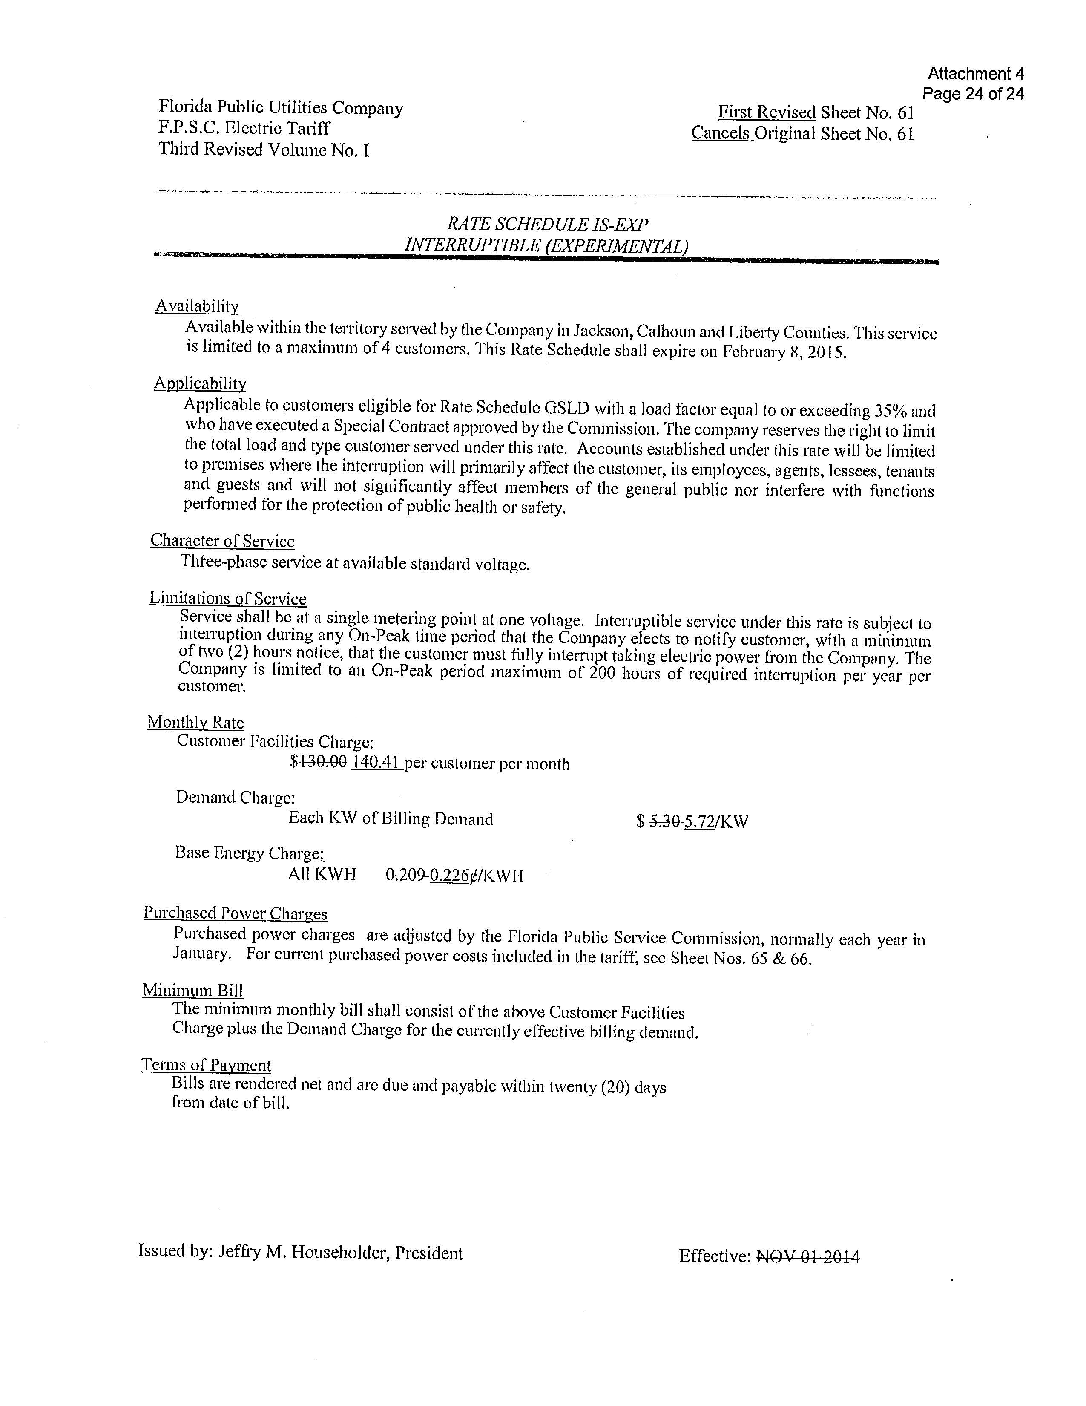

Document No. 06137-2017, in Docket No. 20170150-EI, In re: Petition for limited proceeding to include reliability and modernization projects in rate base, by Florida Public Utilities Company.
Order No. PSC-2017-0360-PCO-EI, issued September 25, 2017, in Docket No. 20170150-EI, In re: Petition for limited proceeding to include reliability and modernization projects in rate base, by Florida Public Utilities Company.

