BEFORE THE FLORIDA PUBLIC SERVICE COMMISSION

In re: Initiation of show cause proceedings against Kincaid Hills Water Company, in Alachua County, for noncompliance with Sections 350.113, 350.117, 367.121, and 367.145, Florida Statutes, and Rules 25-30.110, 25-30.120, 25-30.355, and 25-22.032, Florida Administrative Code. | DOCKET NO. 20170200-WU  ORDER NO. PSC-2017-0470-PCO-WU  ISSUED: December 15, 2017

The following Commissioners participated in the disposition of this matter:

JULIE I. BROWN, Chairman
ART GRAHAM
RONALD A. BRISÉ
DONALD J. POLMANN
GARY F. CLARK

ORDER DIRECTING COMMISSION STAFF TO INITIATE
CERTIFICATE REVOCATION PROCEEDINGS

BY THE COMMISSION:

Background

Our staff opened the instant docket to initiate show cause proceedings against Kincaid Hills Water Company (Kincaid or Utility) for apparent violations of Florida Statutes (F.S.) and Commission rules for: (1) its failure to remit payment of its annual Regulatory Assessment Fees (RAFs) for the years 2008, 2009, 2012, 2013, and 2016; (2) its failure to timely submit its Annual Reports for the years 2009, 2010, 2011, 2012, and 2013; and (3) its failure to respond to customer complaints and to provide a written response to our staff regarding customer complaints.
Kincaid is a Class C water utility providing service in Alachua County. Kincaid became subject to this Commission’s jurisdiction and was granted a grandfather water certificate in 1993. The following information provides a historical overview of this Commission’s activities related to Kincaid.
After failing to submit its Annual Reports for 1994 through 1996, we initiated an enforcement proceeding against Kincaid for violations of Rule 30.110, Florida Administrative Code (F.A.C.) (1997 Proceeding), and we ordered Kincaid to show cause why it should not be penalized $2,628 for failing to submit its Annual Reports. Kincaid failed to respond to our Order, and we assessed Annual Report penalties. After several failed attempts by our staff to contact Kincaid to collect the Annual Report penalty, we submitted the penalty to the Florida Department of Financial Services (DFS) to be written-off as uncollectible.

In 2004, after failing to submit RAFs for the years 1995 through 2003 and failing to submit Annual Reports for the years 1998 through 2003, we initiated an enforcement proceeding against Kincaid for alleged violations of Section 350.113, F.S., and Rules 25-30.110 and 25-30.120, F.A.C. (2004 Proceeding). In an effort to work with Kincaid to resolve its non-compliance issues, and because Kincaid made an effort to cooperate with our staff and submitted all of the delinquent Annual Reports for 1998-2003, we declined to order Kincaid to show cause or assess fines against Kincaid for failing to submit RAFs and Annual Reports. Instead, we approved a payment plan submitted by Kincaid to pay the RAFs, plus statutory penalty and interest, that it owed for the years 1995 to 2003. In addition, Kincaid was put on notice that failure to timely submit RAFs and Annual Reports in the future or comply with any Commission orders would result in further enforcement action.

Kincaid again failed to submit RAFs and Annual Reports the year after the 2004 Proceeding, as well as the following two years. Kincaid made several payments toward the RAF amounts owed pursuant to the payment plan approved by Order No. PSC-04-0615-FOF-WU between June 2004 and January 2006, then ceased submitting payments. After failing to submit RAFs and Annual Reports for 2004, 2005, and 2006, failing to submit payments pursuant to the approved payment plan, and failing to respond to our staff’s attempts to collect the amounts owed, we initiated another enforcement proceeding against Kincaid in 2007 for violations of Section 350.113, F.S., and Rules 25-30.110 and 25-30.120, F.A.C., and Order No. PSC-04-0615-FOF-WU (2007 Proceeding).
At the time we initiated the 2007 Proceeding, Kincaid had serious compliance issues with the Florida Department of Environmental Protection (DEP), as well as the United States Environmental Protection Agency (EPA). Despite finding “a continued pattern of disregard for the directions, orders, and rules of this Commission,” and “a continued pattern of disregard for the timely payment of RAFs,” we again declined to order Kincaid to show cause, finding “exigent and mitigating circumstances” existed. At that time, we reasoned that assessing additional penalties and requiring Kincaid to pay its delinquent RAFs and assessing Annual Report penalties would only further impair Kincaid’s financial viability and its ability to address the DEP and EPA compliance issues. Therefore, we ordered the outstanding RAF amounts, including penalty and interest, owed by Kincaid for the years 1995 through 2006, be submitted to DFS to be written-off as uncollectible. Kincaid was put on notice that “failure to timely file future annual reports will subject it to the penalties authorized by Rule 25-30.110(7), F.A.C., and to show cause proceedings and fines of up to $5,000 per day per violation for each day the violation continues, as set forth in Section 367.161, F.S., or revocation proceedings pursuant to Section 367.161(2), F.S.” In addition, we found Kincaid eligible for a Staff-Assisted Rate Case (SARC). Finally, we ordered the 2007 Proceeding to remain open until Kincaid filed its SARC application, and ordered our staff to bring a recommendation to us should Kincaid fail to timely submit RAFs during the pendency of its SARC.
In April 2008, Kincaid notified our staff that it would not pursue a SARC due to customer dissatisfaction expressed after Kincaid implemented rate increases. Between June 2007 and April 2008, Kincaid received two price-index increases and a 4.5% pass-through increase, which allowed Kincaid to recover RAFs in its rates going forward. With those increases, Kincaid stated it could meet its obligations to pay RAFs and maintain Kincaid without a SARC. By Order No. PSC-08-0386-FOF-WU, we ordered the 2007 Proceeding closed based on Kincaid submitting its 2007 RAFs and receiving the index and pass-through increases.
Kincaid again failed to submit its RAFs for 2008, as well as for the years 2009, 2010, 2011, 2012, and 2013. Additionally, Kincaid again failed to submit its Annual Reports for the years 2009, 2010, 2011, 2012, and 2013. Kincaid also failed to respond to our staff’s repeated attempts to contact Kincaid by telephone, mail, and email. In June 2014, Kincaid’s owner, Mr. Berdell Knowles, Sr., finally responded to our staff regarding Kincaid’s outstanding RAFs, outstanding Annual Reports, and payment options. Mr. Knowles, Sr. agreed to submit Kincaid’s outstanding Annual Reports and RAF returns, along with an initial RAF payment, by June 30, 2014. In addition, Mr. Knowles, Sr. was advised that we could pursue further compliance action if Kincaid did not comply with a RAF payment plan. Mr. Knowles, Sr. failed to submit Kincaid’s 2008-2013 RAF returns or an initial RAF payment, and failed to submit Kincaid’s 2009-2013 Annual Reports by June 30, 2014, as agreed, and again failed to respond to our staff’s attempts to contact Kincaid.
In October 2014, due to Commission staff’s continued inability to contact Mr. Knowles, Sr., our staff communicated with the DEP staff assigned to Kincaid’s compliance issues and obtained the contact information for Mr. Berdell Knowles, Jr., a corporate officer of Kincaid. On October 20, 2014, our staff spoke with Mr. Knowles, Jr. regarding Kincaid’s delinquent RAF and Annual Report status, the lack of cooperation by Mr. Knowles, Sr. to engage in discussions with our staff, and Kincaid’s corporate and financial status. On October 23, 2014, our staff held a conference call with Mr. Knowles, Jr., wherein Mr. Knowles, Jr. agreed to an initial compliance action plan to resolve Kincaid’s compliance issues. Mr. Knowles, Jr. agreed to submit all of Kincaid’s delinquent Annual Reports for years 2009-2013, as well as the RAF amounts owed for the years 2010 and 2011, plus penalty and interest, by November 7, 2014. As part of the initial compliance plan, Kincaid also agreed to continue working with our staff regarding payment of the remaining RAF amounts owed, to consider pursing a SARC, and to submit future RAFs and Annual Reports timely.
On November 14, 2014, we received Kincaid’s payment in the amount of $8,690.15, which satisfied the outstanding RAF amounts owed by Kincaid for 2010 and 2011. On November 14, 2014, we also received Kincaid’s Annual Reports for 2009-2013. On February 16, 2015, our staff held a conference call with Kincaid (Mr. Knowles, Sr. and Mr. Knowles, Jr. both participated), wherein Kincaid agreed to resolve its compliance issues, including negotiation of payment options for its past due RAFs, to submit future RAFs and Annual Reports timely, to pursue a SARC, and to update its corporate status with the Florida Secretary of State, Division of Corporations. Since submitting the $8,690.15 payment, however, Kincaid failed to meet the requirements of the initial compliance plan as agreed. Although Kincaid submitted its 2014, 2015, and 2016 Annual Reports timely, Kincaid failed to meet the other requirements of the initial compliance plan. Specifically, Kincaid failed to: (1) submit additional payments toward its remaining years of delinquent RAFs; (2) continue to work with Commission staff regarding repayment of its remaining years of delinquent RAFs; (3) update its corporate status with the Florida Secretary of State, Division of Corporations; (4) apply for a SARC; and (5) submit its 2016 RAFs.
Our staff received customer complaints regarding Kincaid on October 13, 2016, March 30, 2017, and May 8, 2017. To date, Kincaid has not responded to these customer complaints, nor has Kincaid provided a written response to our staff on each complaint, as required by Rules 25-30.355 and 25-22.032, F.A.C.
By certified letter, dated July 31, 2017, our staff notified Kincaid of apparent violations of Sections 350.113, 350.117, 367.121, and 367.145, F.S., and Rules 25-30.110, 25-30.120, 25-30.355, and 25-22.032, F.A.C., and possible initiation of a show cause proceeding against the Utility for: (1) failing to remit payment of its annual RAFs for the years 2008, 2009, 2012, 2013, and 2016; (2) failing to timely submit its Annual Reports for the years 2009, 2010, 2011, 2012, and 2013; and (3) failing to respond to customer complaints and to provide a written response to our staff regarding customer complaints. Kincaid’s owner, Mr. Knowles, Sr., was informed in that letter that Section 367.161, F.S., provides in pertinent part:
(1) If any utility, by any authorized officer, agent, or employee, knowingly refuses to comply with, or willfully violates, any provision of this chapter or any lawful rule or order of the commission, such utility shall incur a penalty for each such offense of not more than $5,000, to be fixed, imposed, and collected by the commission . . . . Each day that such refusal or violation continues constitutes a separate offense. Each penalty shall be a lien upon the real and personal property of the utility, enforceable by the commission as statutory liens under chapter 85.
(2) The commission has the power to impose upon any entity that is subject to its jurisdiction under this chapter and that is found to have refused to comply with, or to have willfully violated, any lawful rule or order of the commission or any provision of this chapter a penalty for each offense of not more than $5,000, which penalty shall be fixed, imposed, and collected by the commission; or the commission may, for any such violation, amend, suspend, or revoke any certificate of authorization issued by it. Each day that such refusal or violation continues constitutes a separate offense. Each penalty shall be a lien upon the real and personal property of the entity, enforceable by the commission as a statutory lien under chapter 85.
The July 31, 2017, letter put Kincaid on notice that our staff would open a docket to initiate a show cause proceeding if Kincaid did not correct the violations by remitting payment of the delinquent RAFs, remitting payment for penalties for late-filed Annual Reports, and submitting written responses to the customer complaints and our staff by August 31, 2017. Our staff further notified Kincaid that should the Utility ultimately be found in violation of our statutes, rules, or orders, we may impose fines of up to $5,000 per violation, for each day each violation continues, including levying a statutory lien upon the real and personal property of the Utility, or we may amend, suspend, or revoke Kincaid’s certificate, pursuant to Section 367.161, F.S. Additionally, our staff stated that, if necessary, we may also seek injunctive or other appropriate relief in circuit court to compel Kincaid’s compliance, pursuant to Section 367.121, F.S. To date, Kincaid has not remitted payment of the delinquent RAFs, remitted payment for penalties for late-filed Annual Reports, or submitted written responses to the customer complaints and our staff, in response to our staff’s letter.
By certified letter, dated September 28, 2017, our Office of the General Counsel notified Kincaid that Commission staff opened a docket initiating a show cause proceeding for the Utility’s apparent statute and rule violations.
This Order addresses: (1) Kincaid’s apparent violation of Sections 350.113 and 367.145, F.S., and Rule 25-30.120, F.A.C., for failure to submit RAFs for the years 2008, 2009, 2012, 2013, and 2016; (2) Kincaid’s apparent violation of Section 367.121, F.S., and Rule 25-30.110, F.A.C., for failure to timely submit its Annual Reports for the years 2009, 2010, 2011, 2012, and 2013; and (3) Kincaid’s apparent violation of Rules 25-30.355 and 25-22.032, F.A.C., for failing to respond to customer complaints.
We have jurisdiction pursuant to Sections 350.113, 367.121, 367.145, and 367.161, F.S.
Decision
Applicable Law
Pursuant to Sections 350.113 and 367.145, F.S., and Rule 25-30.120, F.A.C., each regulated company under our jurisdiction shall pay to this Commission a RAF based upon the gross operating revenues for the prior year operating period. Rule 25-30.120, F.A.C., requires that utilities pay a regulatory assessment fee of 4.5 percent of its gross revenues derived from intrastate business, or a minimum of $25.00 if there are no revenues or if revenues are insufficient to generate above the $25.00 minimum. Section 350.113(4), F.S., provides for a penalty of 5 percent for the first 30 days, and an additional penalty of “5 percent for each additional 30 days or fraction thereof during the time in which the failure continues, not to exceed a total penalty of 25 percent,” and states that “the commission shall collect the fee and penalty, plus interest and all costs of collection, from the regulated company.” Section 367.145(1)(b), F.S., states that, in addition to the penalties and interest otherwise provided, we may impose a penalty upon a utility for failure to pay regulatory assessment fees in a timely manner in accordance with Section 367.161, F.S. Further, Rule 25-30.120(7)(b), F.A.C., provides that, in addition to statutory penalties and interest, we may impose an additional penalty upon a utility for failing to pay RAFs timely, pursuant to Section 367.161, F.S.
Section 367.121(1)(c) and (i), F.S., authorizes us to require utilities subject to our jurisdiction to file such regular financial reports we deem necessary. Rule 25-30.110(3)(a), F.A.C., provides that each utility under our jurisdiction shall file an Annual Report on or before March 31st, for the preceding year ending December 31. The standard penalty for delinquent Annual Reports is $3 per day, pursuant to Rule 25-30.110(7), F.A.C.
Rule 25-30.355, F.A.C., requires that a utility make a full and prompt acknowledgment and investigation of all customer complaints and respond fully and promptly to all customer requests. Further, Rule 25-22.032(6)(b), F.A.C., requires that a utility respond to a customer complaint received by this Commission by contacting the customer within 15 working days after receiving the complaint from our staff, and provide a written response to the complaint to our staff within 15 working days after receiving the complaint from our staff.

Pursuant to Section 367.161(1), F.S., we are authorized to impose upon any entity subject to our jurisdiction a penalty of not more than $5,000 for each such day a violation continues, if such entity is found to have refused to comply with or to have willfully violated any lawful rule or order of this Commission, or any provision of Chapter 367, F.S. Each day a violation continues is treated as a separate offense. Each penalty is a lien upon the real and personal property of the utility and is enforceable by us as a statutory lien. If a penalty is also assessed by another state agency for the same violation, our penalty will be reduced by the amount of the other agency’s penalty. As an alternative to the above remedies, Section 367.161(2), F.S., permits us to amend, suspend, or revoke a utility’s certificate for any such violation. Part of the determination we must make in evaluating whether to penalize a utility is whether the utility willfully violated the rule, statute, or order. Section 367.161, F.S., does not define what it is to “willfully violate” a rule or order. Willfulness is a question of fact. The plain meaning of “willful” typically applied by the Courts in the absence of a statutory definition is an act or omission that is done “voluntarily and intentionally” with specific intent and “purpose to violate or disregard the requirements of the law.” We note that we must follow very specific noticing requirements set forth in Section 120.60, F.S., prior to revocation or suspension of a certificate.

Factual Allegations

Our records indicate that for purposes of this order, Kincaid failed to submit RAFs for the years 2008, 2009, 2012, 2013, and 2016. Kincaid has a long history of failing to submit RAFs, and has had two enforcement proceedings brought by this Commission in 2004 and 2007 for failing to submit RAFs. In fact, since coming under our jurisdiction in 1993, Kincaid has only submitted RAFs timely two times (2014 and 2015). Despite the numerous attempts by this Commission and our staff over the last 13 years to work with Kincaid to resolve its RAF compliance issues, Kincaid has repeatedly failed to comply with its statutory and regulatory obligations.
Because Kincaid failed to submit its 2008, 2009, 2012, 2013, and 2016 RAFs timely, statutory penalties and interest are also due. The total amount owed by Kincaid for 2008, 2009, 2012, 2013, and 2016 RAFs, plus associated penalties and interest, calculated through November 7, 2017, is $22,403.19. A breakdown of the amount is shown in Table 1 below.

Table 1: Summary of RAF Penalties as of 11/07/17

Year | Revenues | RAFs  (4.5%) | Penalty  (25%)  (As of 11/07/17) | Interest  (1%)  (As of 11/07/17) | Payments | Total  Due  (As of 11/07/17)
2016 | $44,593.00 | $2,006.69 | $501.67 | $160.54 | $0.00 | $2,668.90
2015 | $44,451.00 | $2000.30 | $0.00 | $0.00 | $2000.30 | $0.00
2014 | $48,840.00 | $2,197.80 | $0.00 | $0.00 | $2,197.80 | $0.00
2013 | $49,756.00 | $2,239.02 | $559.76 | $985.17 | $0.00 | $3,783.95
2012 | $58,535.00 | $2,634.08 | $658.52 | $1,501.43 | $0.00 | $4,794.03
2011 | $59,052.00 | $2,657.34 | $664.34 | $876.92 | $4,198.60 | $0.00
2010 | $58,713.00 | $2,642.09 | $660.52 | $1,188.94 | $4,491.55 | $0.00
2009 | $60,274.00 | $2,712.33 | $678.08 | $2,522.47 | $0.00 | $5,912.88
2008 | $50,661.00 | $2,279.75 | $569.94 | $2,393.74 | $0.00 | $5,243.43
Totals | $474,875.00 | $21,369.40 | $4,292.83 | $9,629.21 | $12,888.25 | $22,403.19

Additionally, a review of our records also indicates that Kincaid has repeatedly failed to timely submit its Annual Reports. At issue in this order are the 2009, 2010, 2011, 2012, and 2013 Annual Reports. In 2009, the Annual Report was submitted 1,689 days late. In 2010, the Annual Report was submitted 1,324 days late. In 2011, the Annual Report was submitted 958 days late. In 2012, the Annual Report was submitted 593 days late. In 2013, the Annual Report was submitted 228 days late. Since coming under our jurisdiction in 1993, Kincaid has only submitted five Annual Reports on time (1997, 2007, 2014, 2015, 2016).
The total penalty amount owed by Kincaid for failing to timely submit its Annual Reports for the years 2009 to 2013 is $14,376. A breakdown of the amount is shown in Table 2 below.

Table 2: Summary of Annual Report Penalties

Year | Date Due | Date Submitted | Days Late | Penalty  ($3 per day)
2013 | 03/31/2014 | 11/14/2014 | 228 | $684.00
2012 | 04/01/2013 | 11/14/2014 | 593 | $1,779.00
2011 | 04/02/2012 | 11/14/2014 | 958 | $2,874.00
2010 | 03/31/2011 | 11/14/2014 | 1,324 | $3,972.00
2009 | 03/31/2010 | 11/14/2014 | 1,689 | $5,067.00
Total |  |  | 4,792 | $14,376.00

Finally, our records show that Kincaid is not timely responding to customer complaints. Our Consumer Activity Tracking System (CATS) shows three customer complaints in which Kincaid has failed to respond to both the customer and our staff. Our staff has compiled a list of customer complaints currently open with this Commission, along with a copy of each of the CATS complaint records for review. These complaints were submitted to this Commission on October 13, 2016, March 30, 2017, and May 8, 2017. The complaints show that customers reported regularly experiencing difficulty in reaching a Utility representative and reported Kincaid’s telephone number being out-of-service on occasions. Our staff has experienced great difficulty in reaching Kincaid regarding the customer complaints. Furthermore, Kincaid has failed to adequately respond to our staff’s repeated attempts to contact Kincaid by telephone, mail, and e-mail in order to resolve the complaints. To date, Kincaid has not responded to these customer complaints and has not provided a written response to our staff on these complaints.

By knowingly failing to comply with the provisions of Rules 25-30.355 and 25-22.032, F.A.C., we believe Kincaid’s acts were “willful” in the sense intended by Section 367.161, F.S. Where available, staff looks to prior Commission Orders for guidance on the amount and type of fines for each violation. Accordingly, using prior Order Nos. PSC-06-0349-SC-WS and PSC-11-0541-SC-WS as a guide, the penalty for each failure to respond should be $250. Thus, the total of Kincaid’s penalties for failing to respond to the three customer complaints is $750: $250 for failing to respond to the customer complaint dated October 13, 2016, $250 for failing to respond to the customer complaint dated March 30, 2017, and $250 for failing to respond to the customer complaint dated May 8, 2017.

Analysis and Conclusion

Considering Kincaid’s management’s history, specifically, the fact that the Utility has a long history of noncompliance, we find that Kincaid has a poor record of complying with our rules and statutes. Notably, this is the fourth time our staff has opened a docket to initiate a show cause proceeding since Kincaid became subject to our jurisdiction in 1993. We have previously initiated revocation proceedings against a utility based on its history of noncompliance with orders, rules, and statutory requirements.

We are concerned that Kincaid’s management does not understand how to and is not willing to commit the time to operate a utility within the meaning of Chapter 367, F.S. The operation of a utility under Chapter 367, F.S., if successful, allows a utility the opportunity to earn a return on its investment. If management is not willing to operate as a utility that follows our rules and regulations, the utility’s certificate should be revoked, removing any opportunity the owner has to earn a return on its investment. If the certificate is revoked, a receiver must be appointed pursuant to Section 367.165, F.S., until a sale of the utility system has been approved pursuant to Section 367.071, F.S.

Commission staff is hereby directed to initiate certificate revocation proceedings against Kincaid, consistent with Chapter 120 and Section 367.161, F.S., based on: (1) Kincaid’s apparent violation of Sections 350.113 and 367.145, F.S., and Rule 25-30.120, F.A.C., for failure to submit RAFs for the years 2008, 2009, 2012, 2013, and 2016; (2) Kincaid’s apparent violation of Section 367.121, F.S., and Rule 25-30.110, F.A.C., for failure to timely submit its Annual Reports for the years 2009, 2010, 2011, 2012, and 2013; and (3) Kincaid’s apparent violation of Rules 25-30.355 and 25-22.032, F.A.C., for failing to respond to customer complaints and our staff. Therefore, our staff shall send a letter to the Utility, giving the Utility 30 days’ notice that our staff intends to commence revocation proceedings. Revocation shall be in lieu of the penalties discussed above.

Based on the foregoing, it is

ORDERED by the Florida Public Service Commission that based on Kincaid Hills Water Company’s apparent violation of: (1) Sections 350.113 and 367.145, F.S., and Rule 25-30.120, F.A.C., for failure to submit Regulatory Assessment Fees for the years 2008, 2009, 2012, 2013, and 2016; (2) Sections 367.121, F.S., and Rule 25-30.110, F.A.C., for failure to timely submit its Annual Reports for the years 2009, 2010, 2011, 2012, and 2013; and (3) Rules 25-30.355 and 25-22.032, F.A.C., for failing to respond to customer complaints and Commission staff; Commission staff is hereby directed to initiate certificate revocation proceedings against Kincaid Hills Water Company, consistent with Chapter 120 and Section 367.161, F.S. It is further

ORDERED that Commission staff shall send a letter to the Kincaid Hills Water Company, giving the Utility 30 days’ notice that our staff intends to commence revocation proceedings. It is further

ORDERED that this docket shall remain open until certificate revocation proceedings are initiated, at which point the docket should be closed administratively.

By ORDER of the Florida Public Service Commission this 15th day of December, 2017.

/s/ Carlotta S. Stauffer
CARLOTTA S. STAUFFER
Commission Clerk
Florida Public Service Commission
2540 Shumard Oak Boulevard
Tallahassee, Florida 32399
(850) 413-6770
www.floridapsc.com

Copies furnished: A copy of this document is provided to the parties of record at the time of issuance and, if applicable, interested persons.

MAD/RD

NOTICE OF FURTHER PROCEEDINGS OR JUDICIAL REVIEW

The Florida Public Service Commission is required by Section 120.569(1), Florida Statutes, to notify parties of any administrative hearing or judicial review of Commission orders that is available under Sections 120.57 or 120.68, Florida Statutes, as well as the procedures and time limits that apply. This notice should not be construed to mean all requests for an administrative hearing or judicial review will be granted or result in the relief sought.

Mediation may be available on a case-by-case basis. If mediation is conducted, it does not affect a substantially interested person's right to a hearing.

Any party adversely affected by this order, which is preliminary, procedural or intermediate in nature, may request: (1) reconsideration within 10 days pursuant to Rule 25-22.0376, Florida Administrative Code; or (2) judicial review by the Florida Supreme Court, in the case of an electric, gas or telephone utility, or the First District Court of Appeal, in the case of a water or wastewater utility. A motion for reconsideration shall be filed with the Office of Commission Clerk, in the form prescribed by Rule 25-22.0376, Florida Administrative Code. Judicial review of a preliminary, procedural or intermediate ruling or order is available if review of the final action will not provide an adequate remedy. Such review may be requested from the appropriate court, as described above, pursuant to Rule 9.100, Florida Rules of Appellate Procedure.
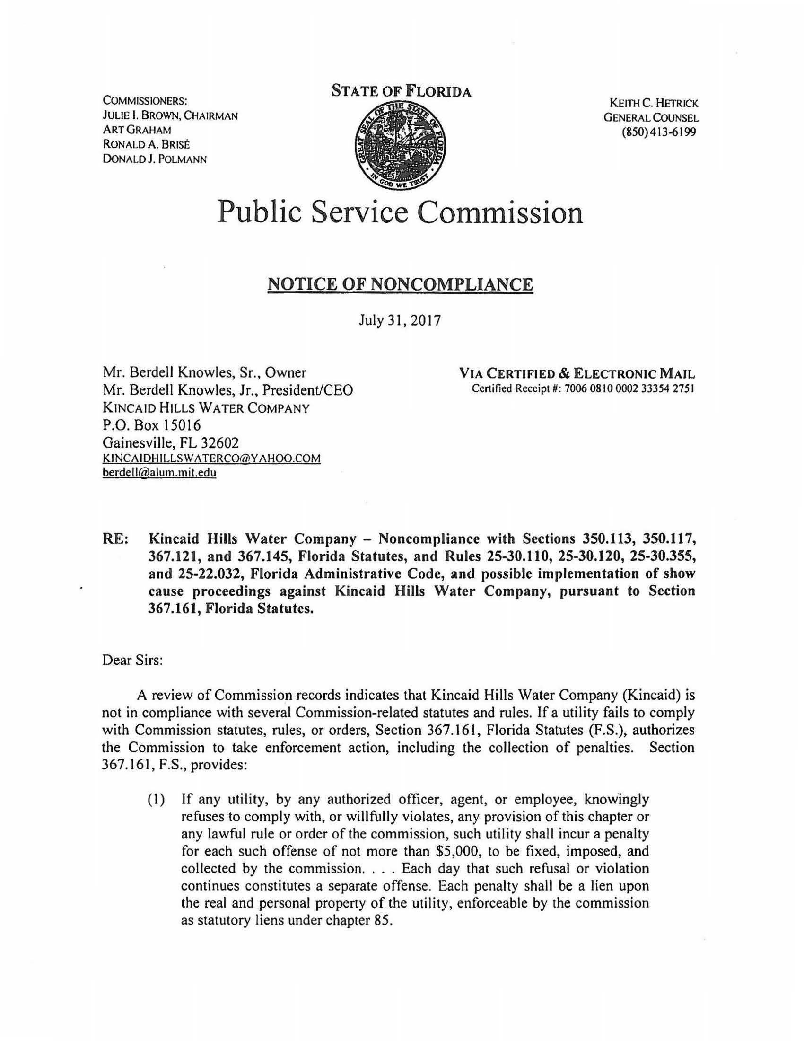
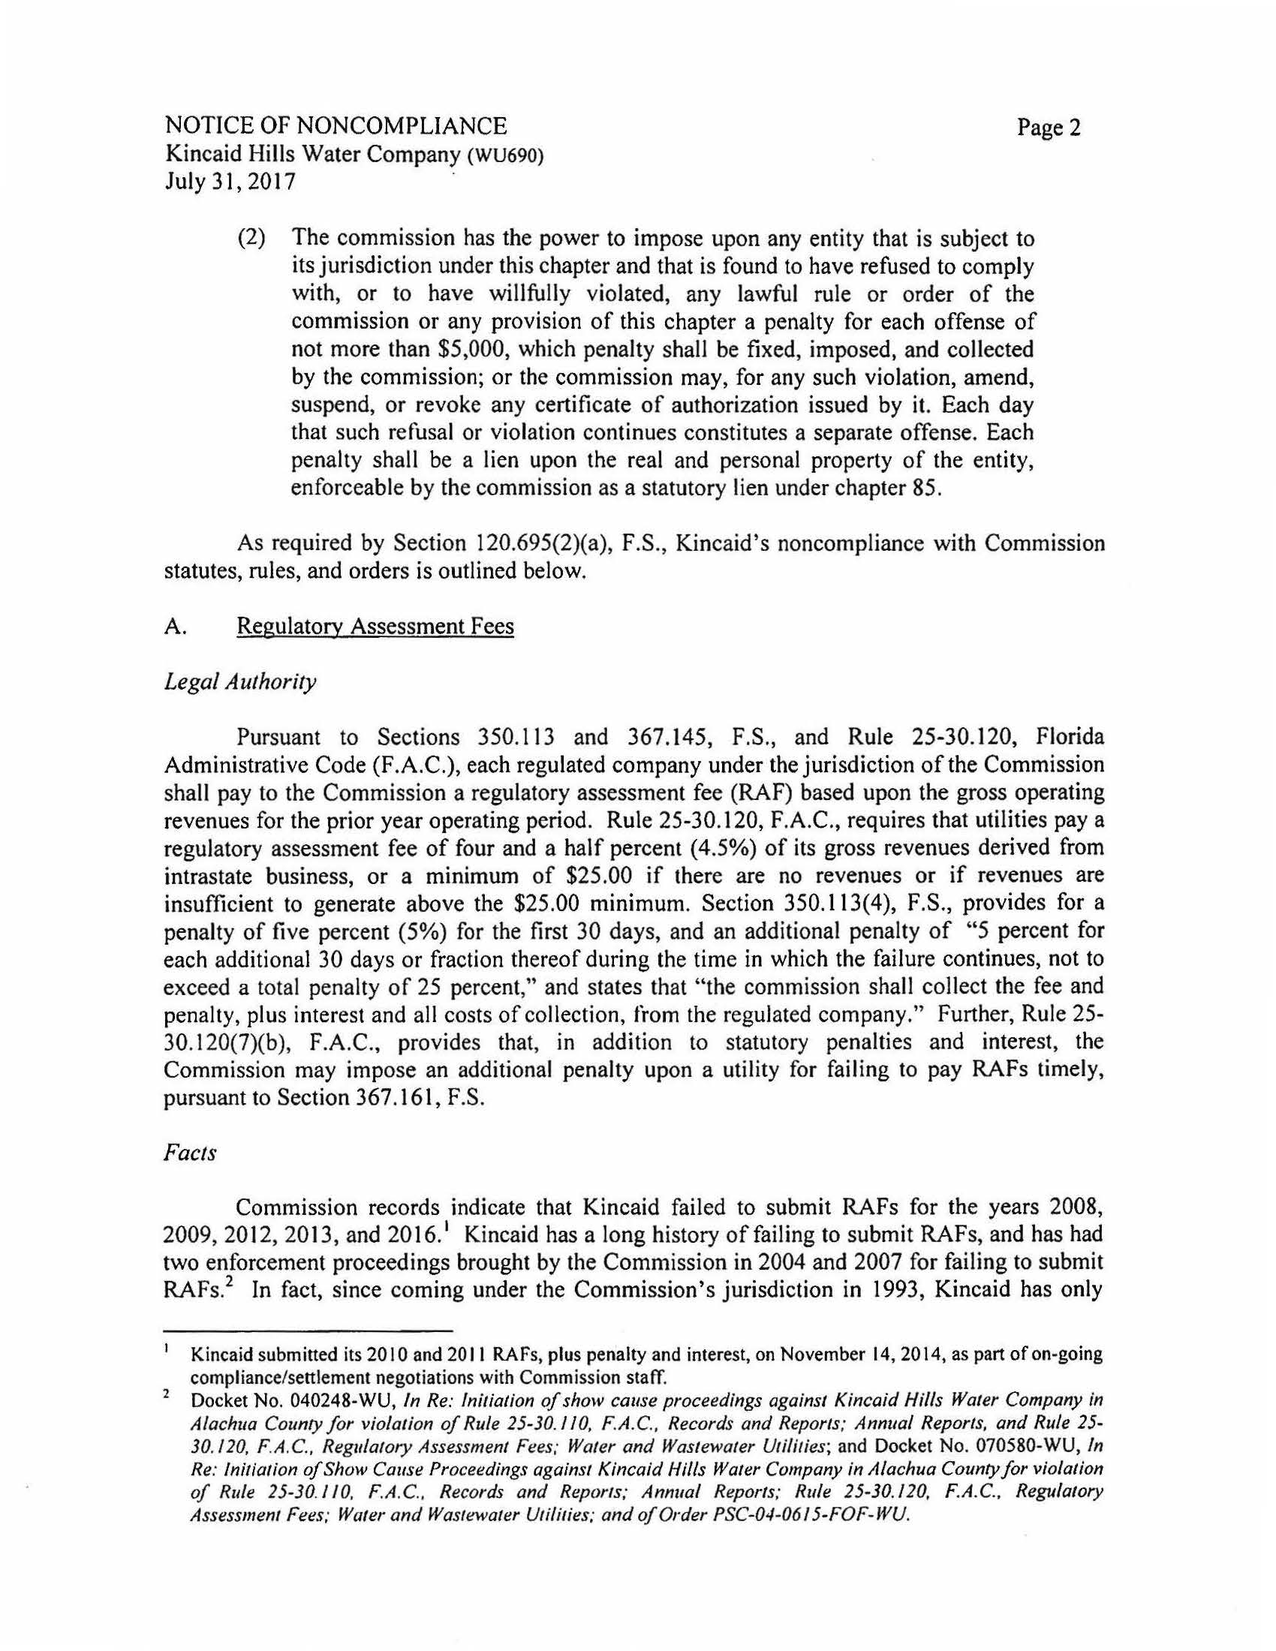

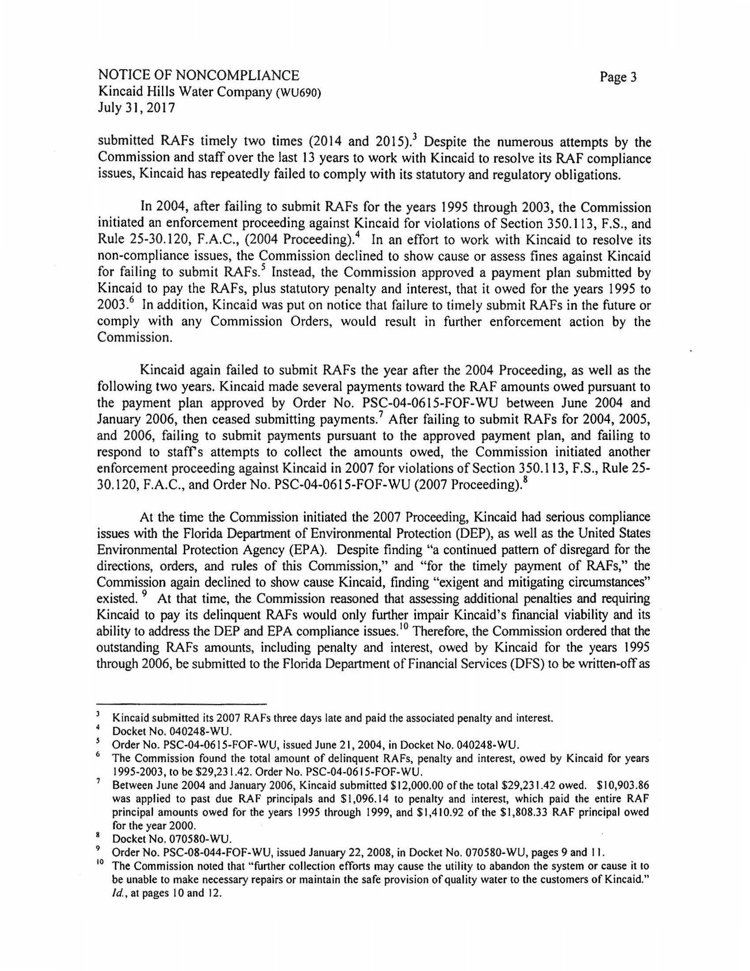

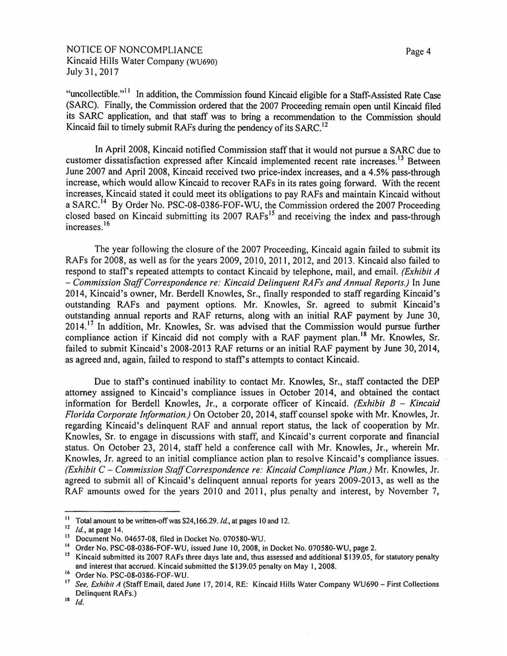

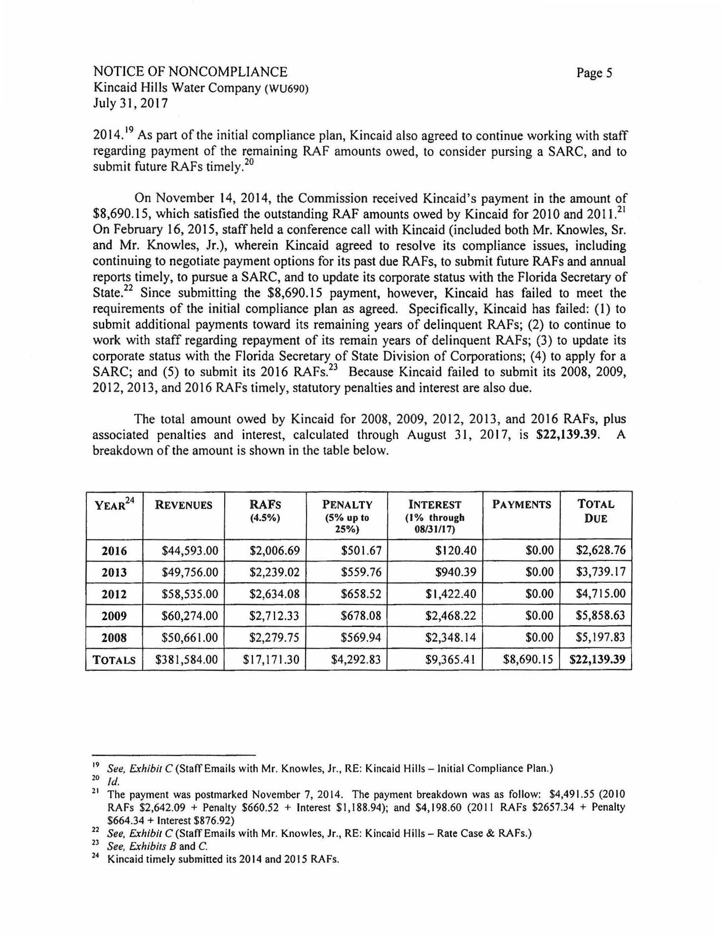

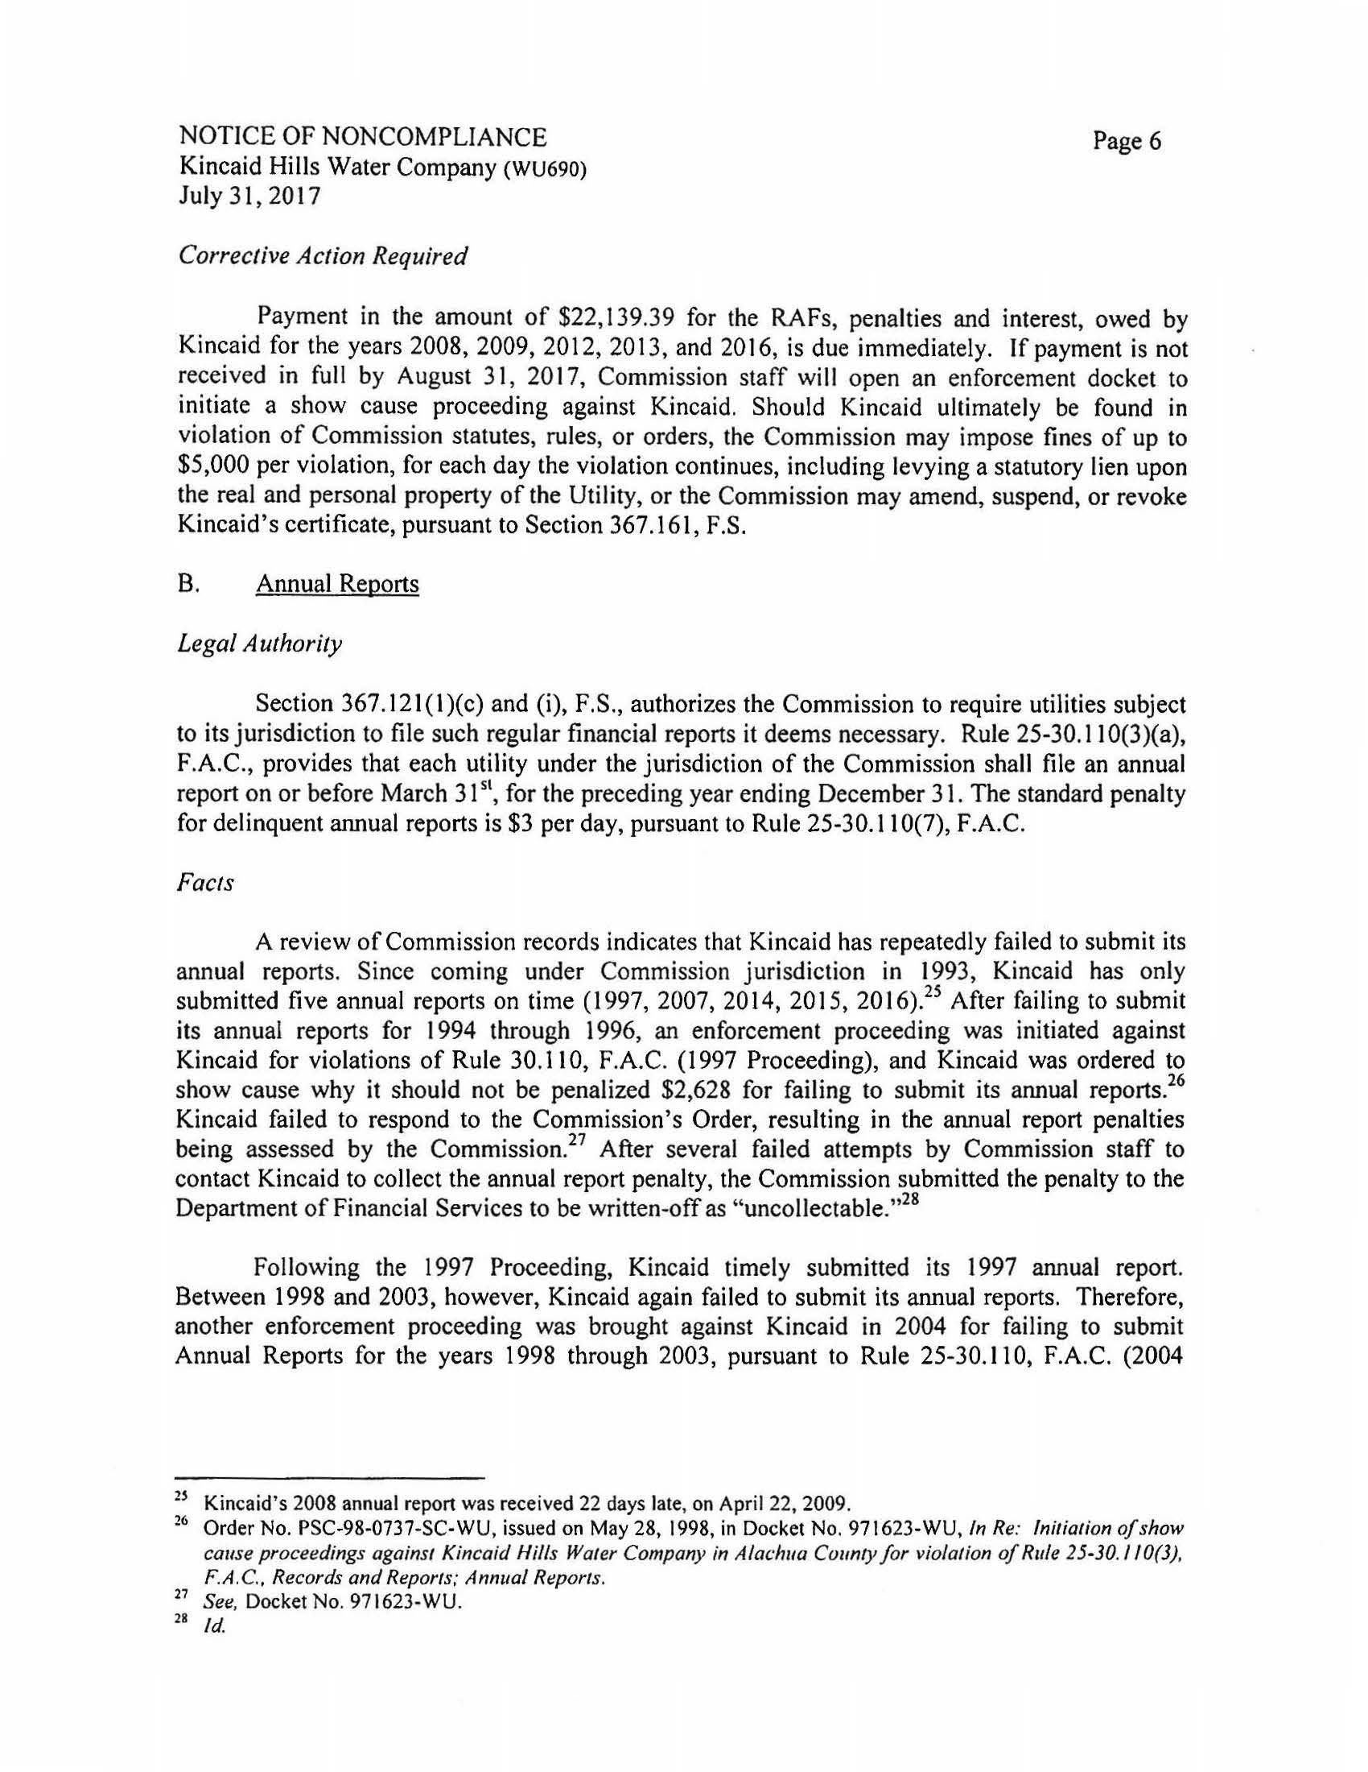

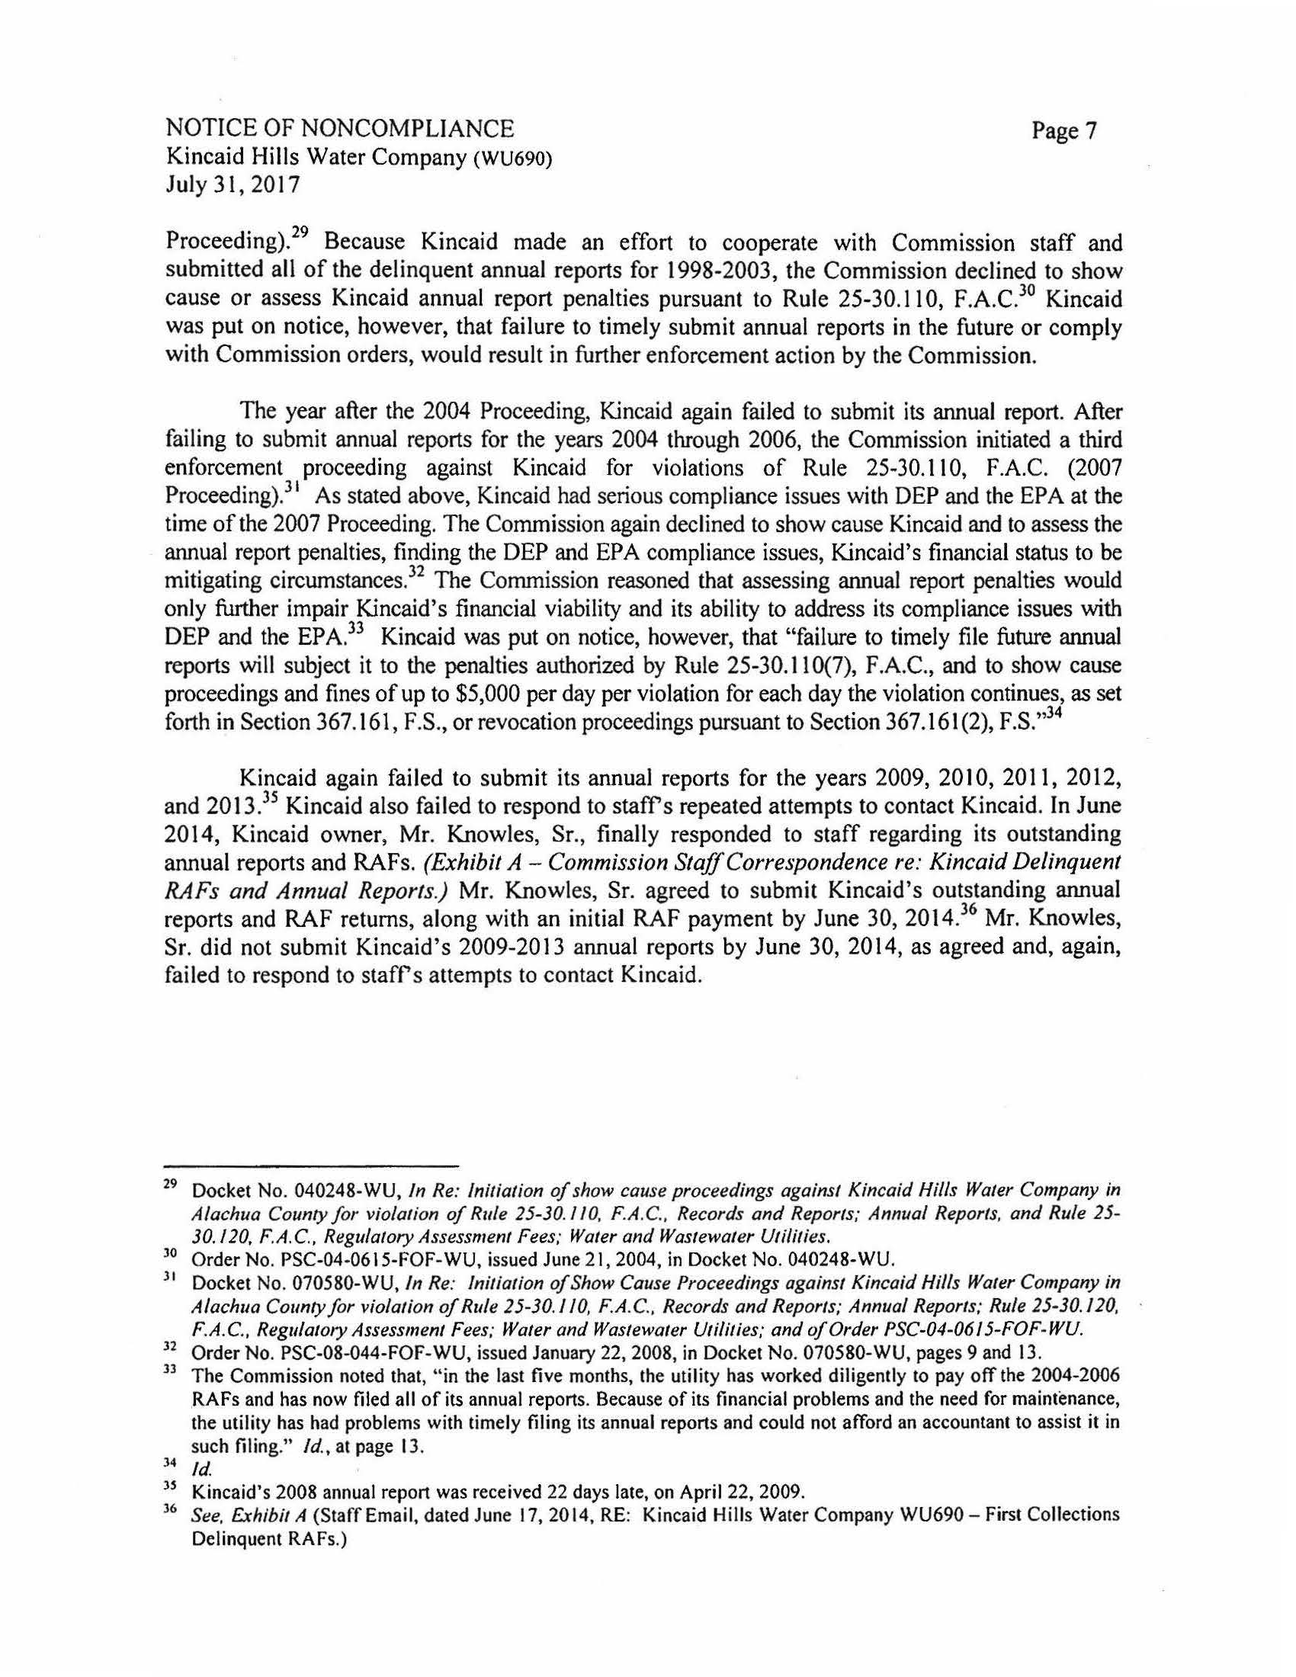

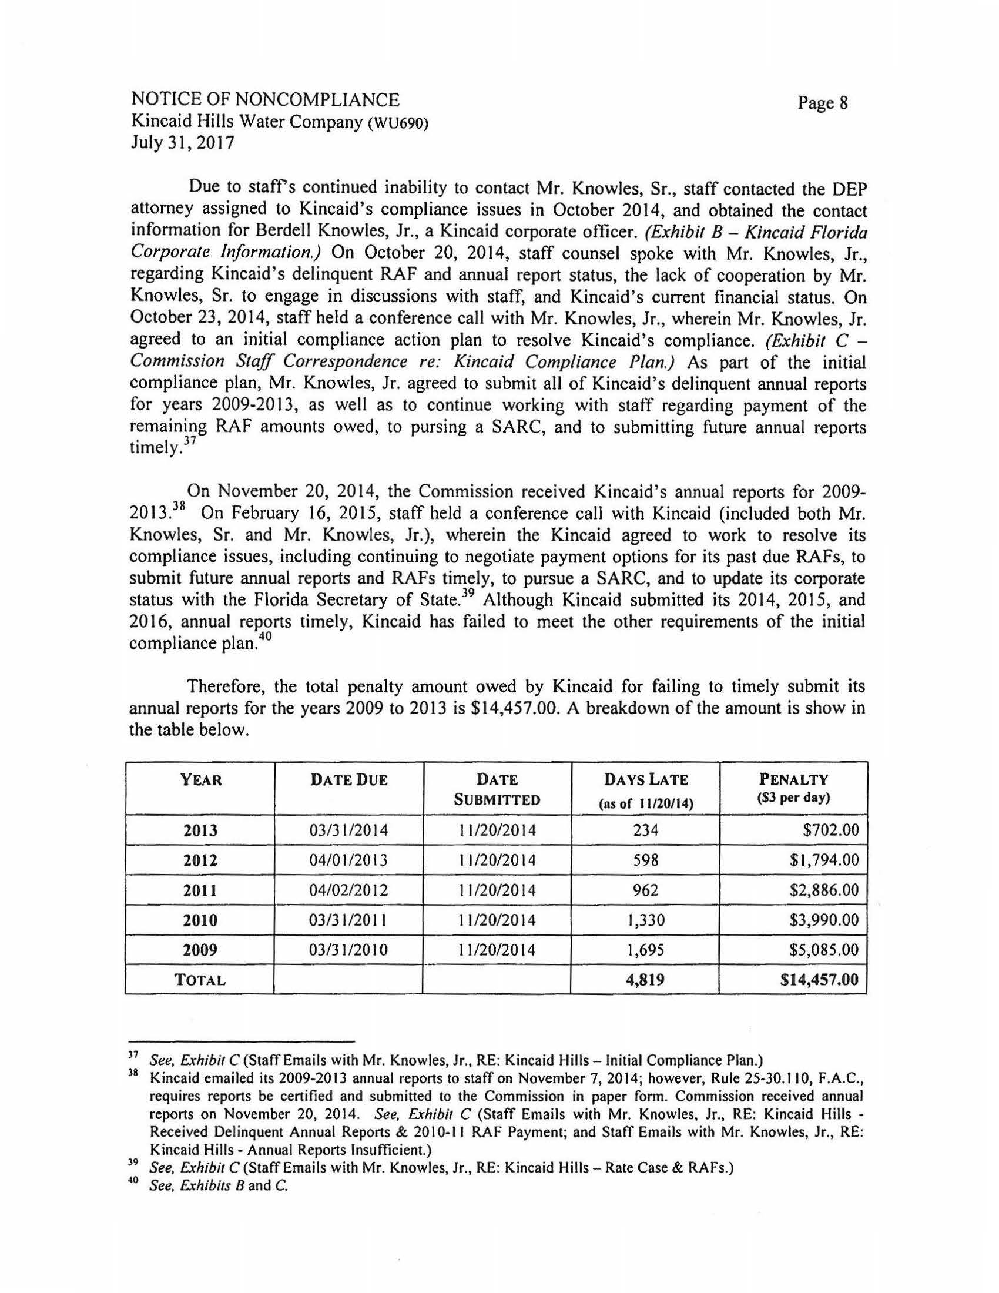

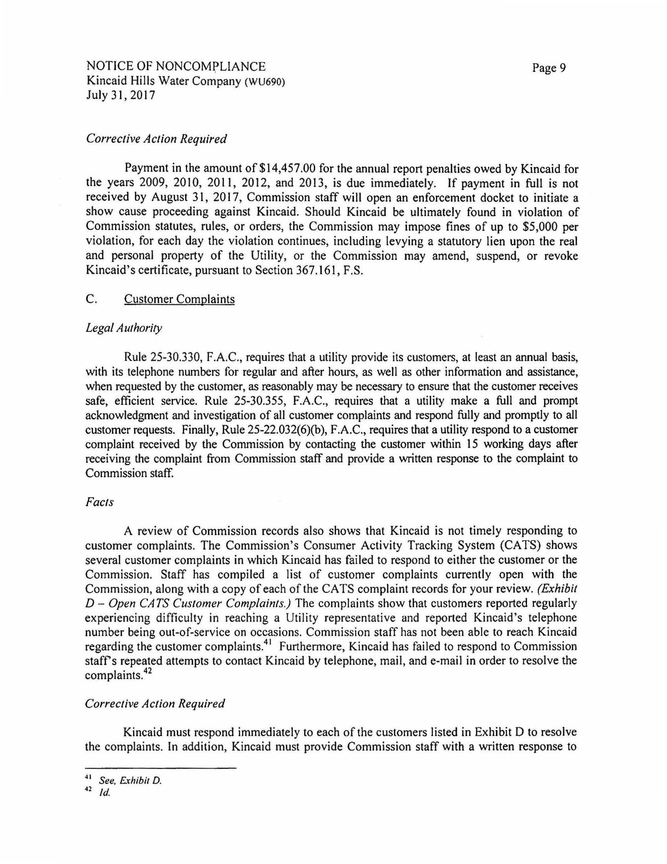

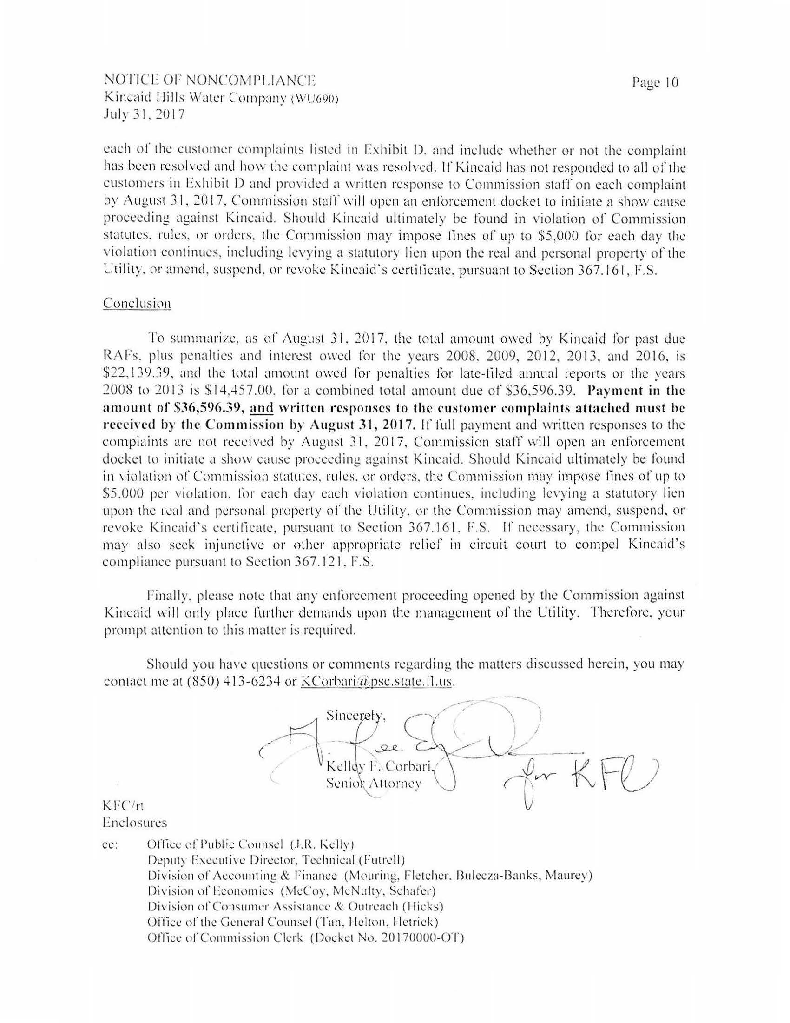

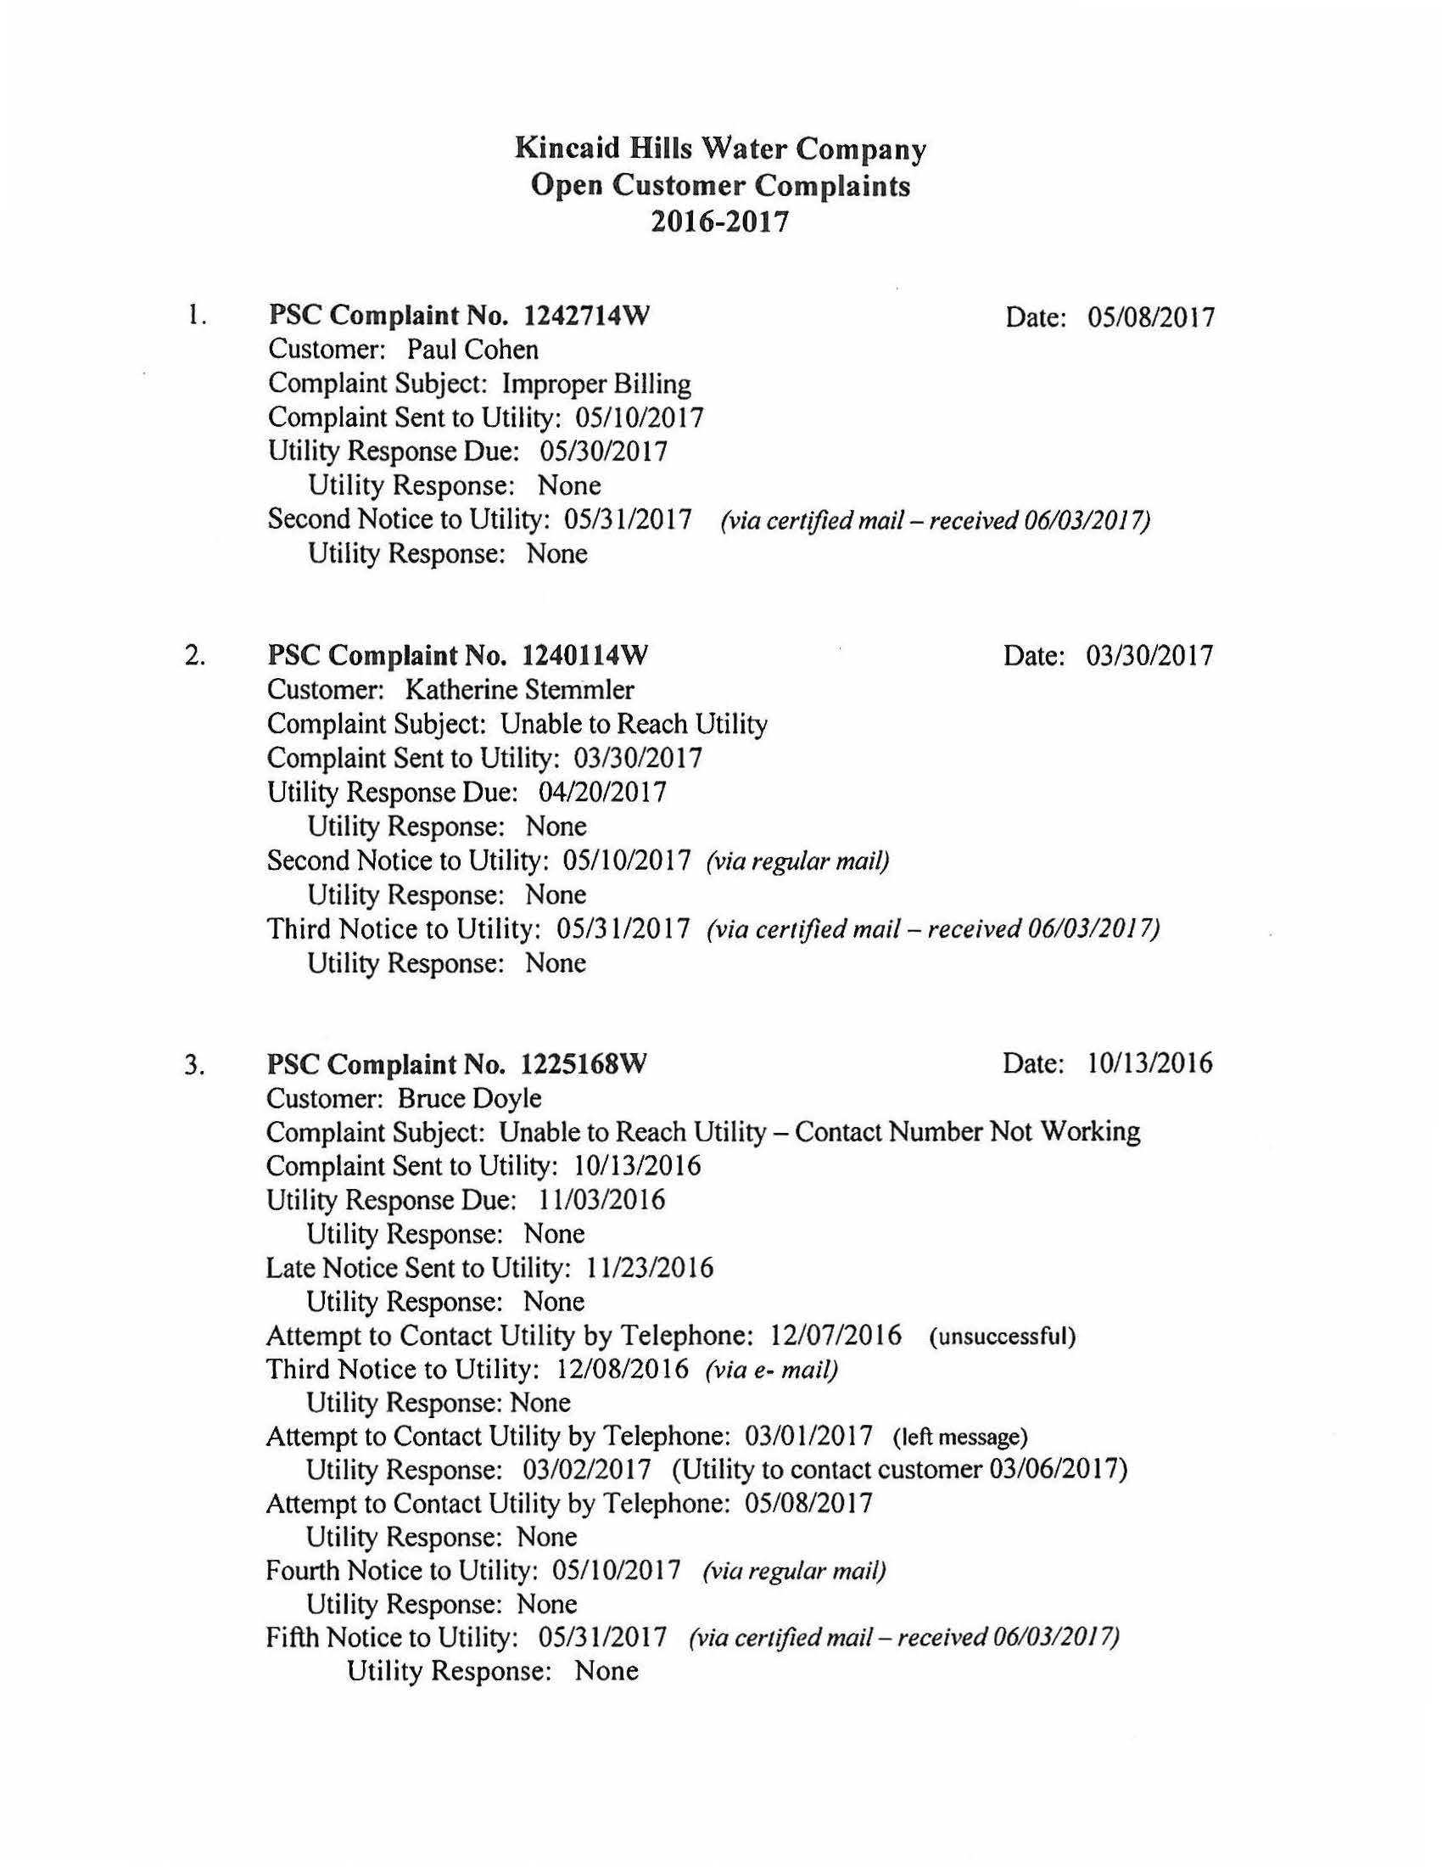

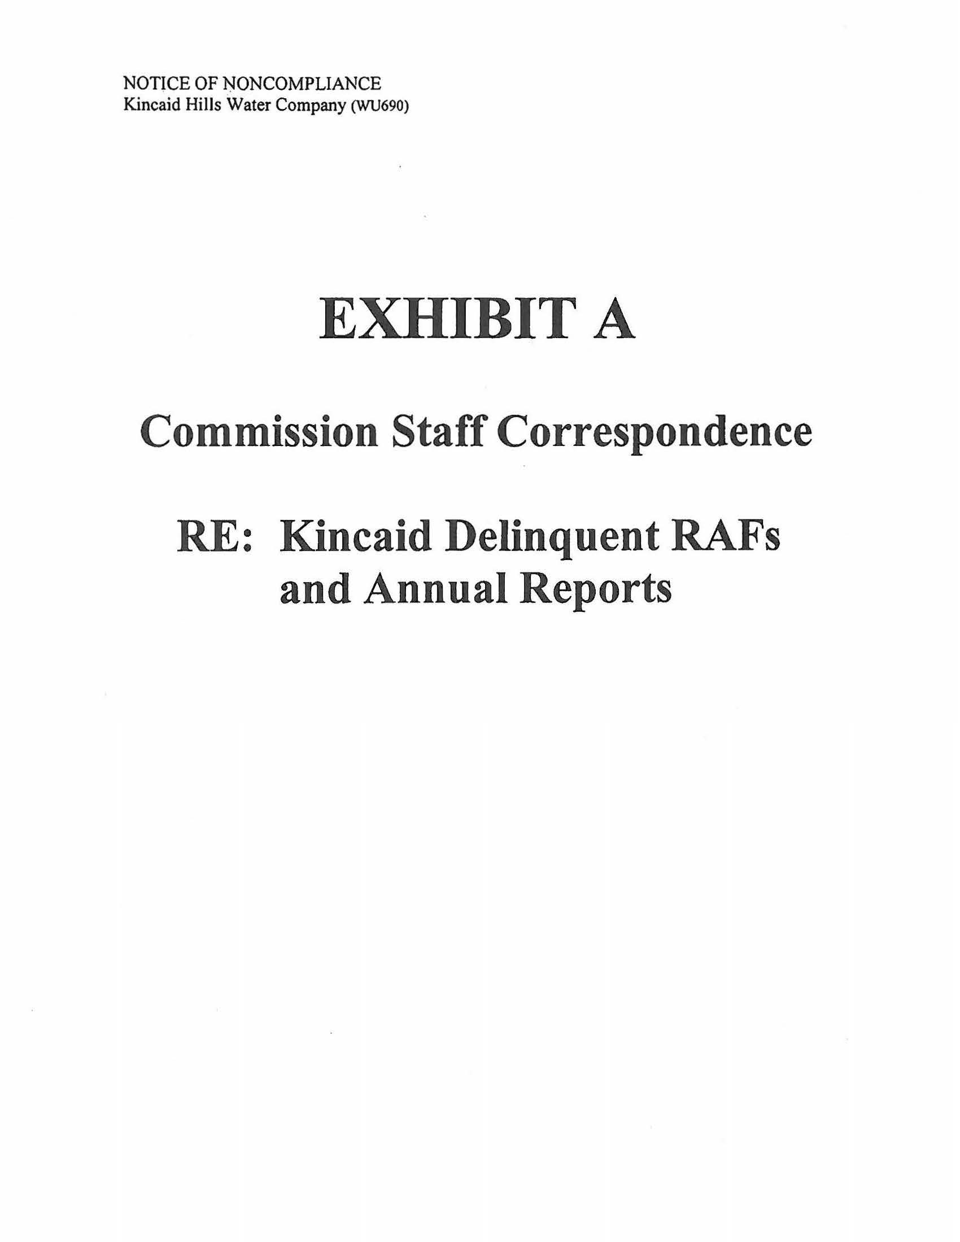

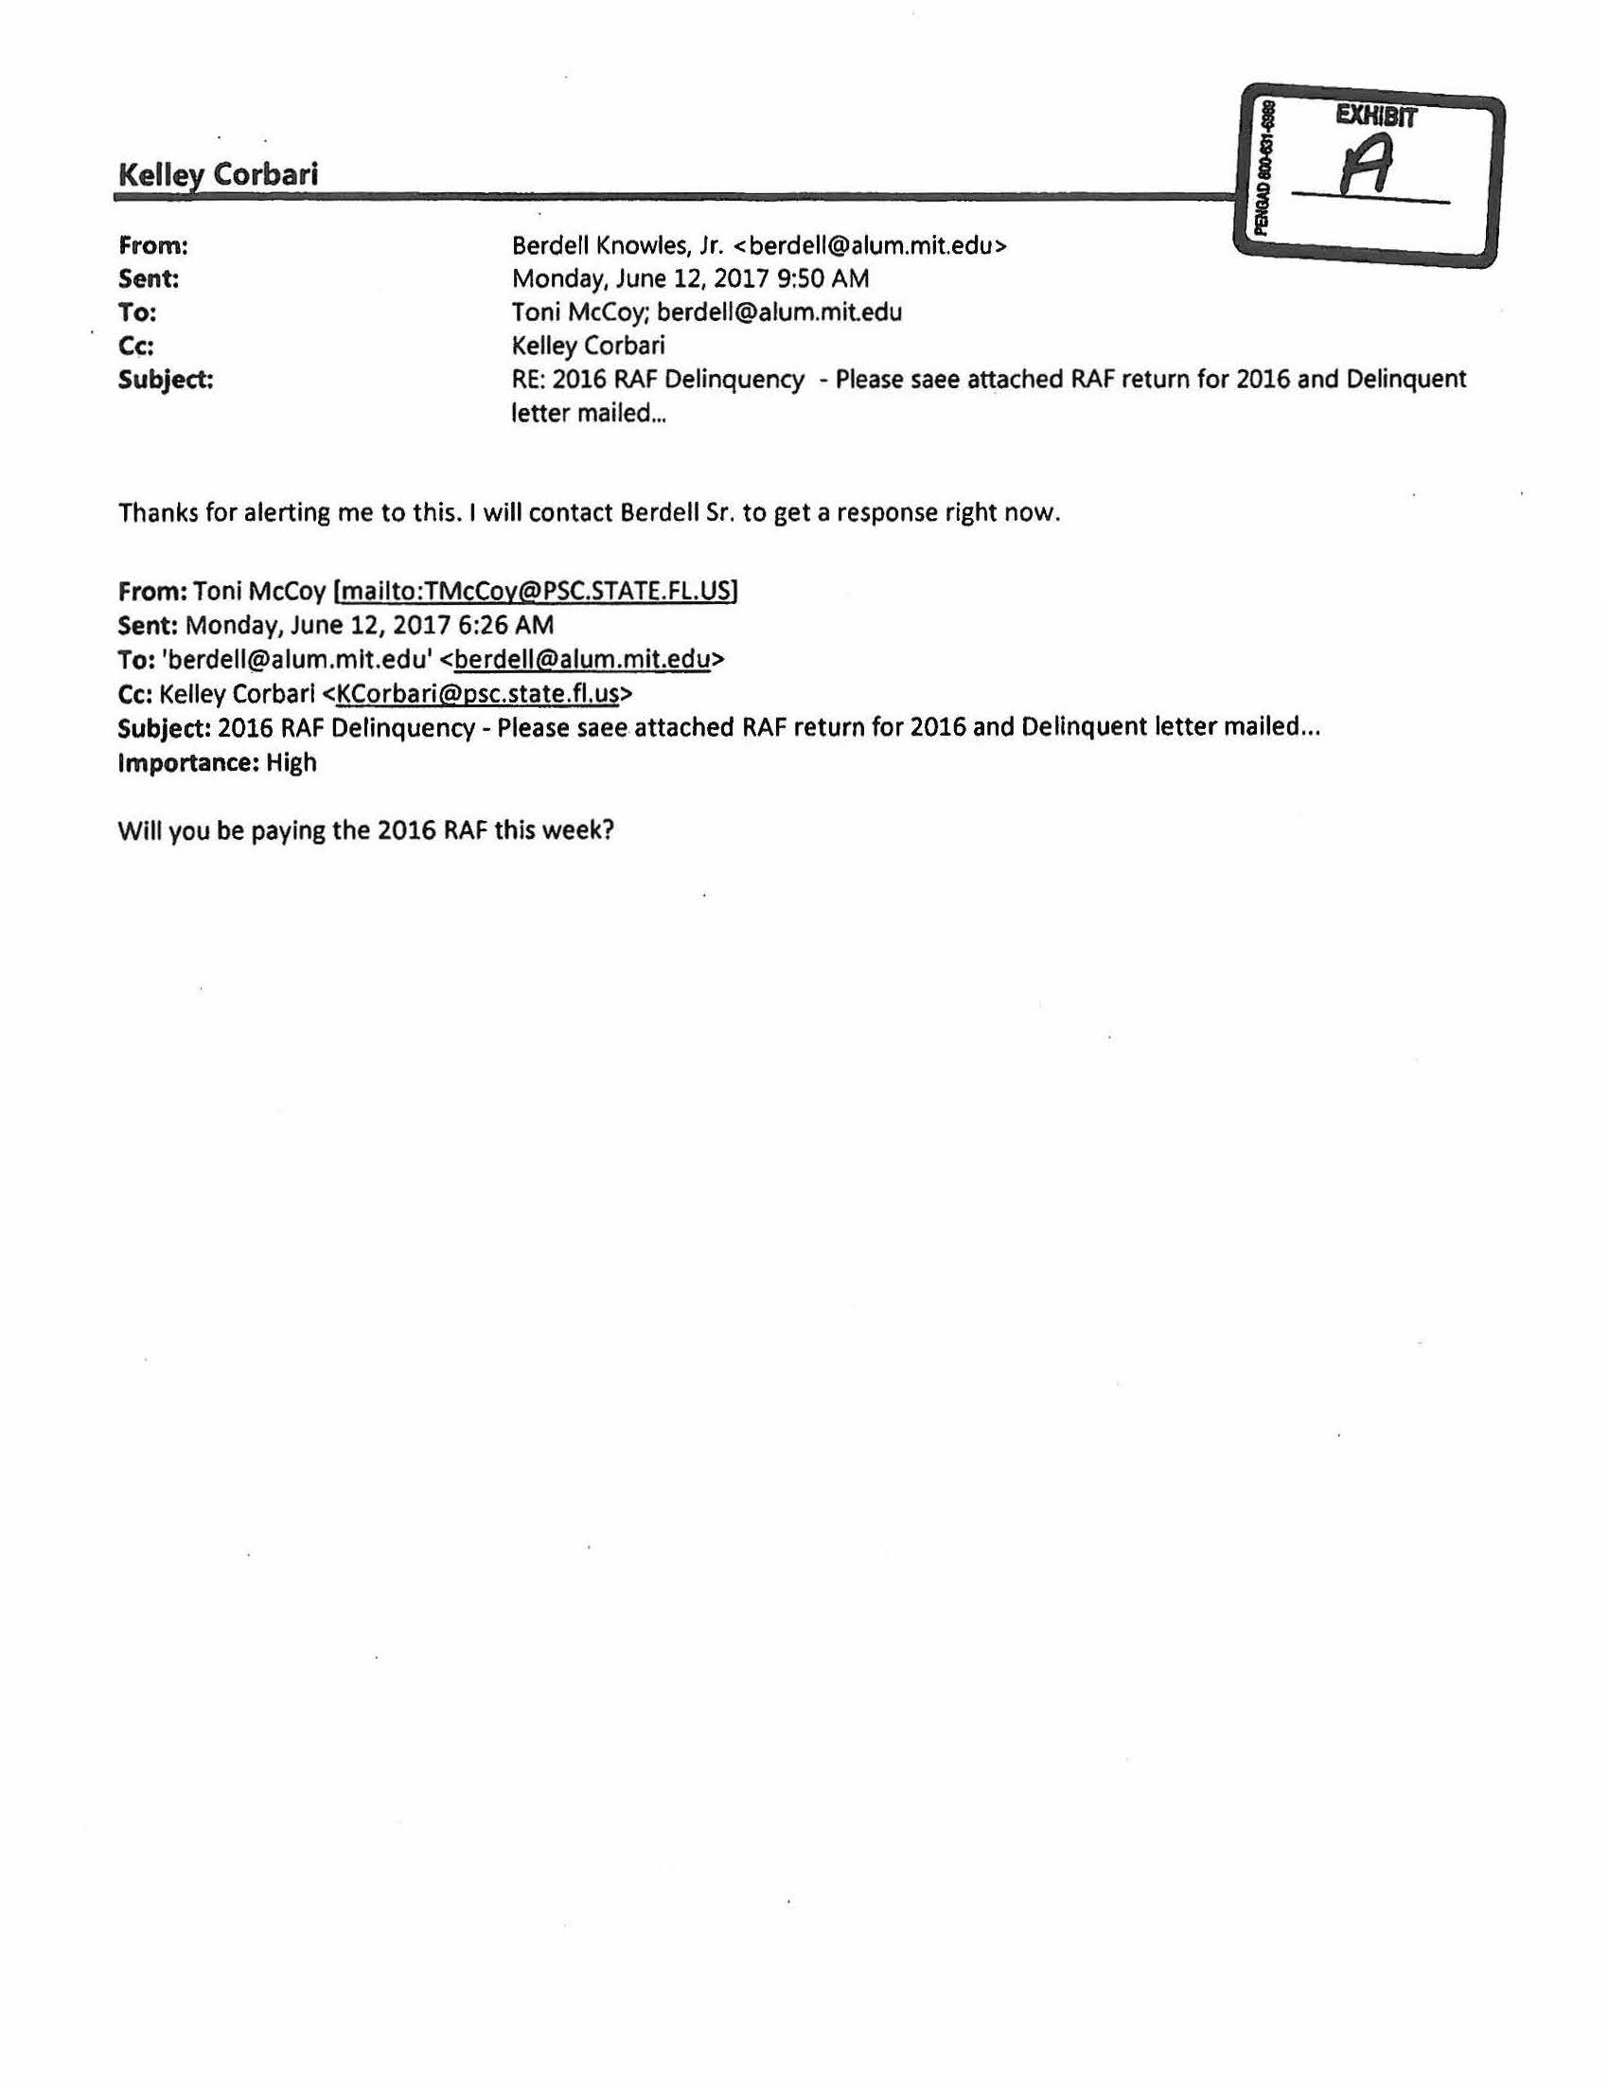

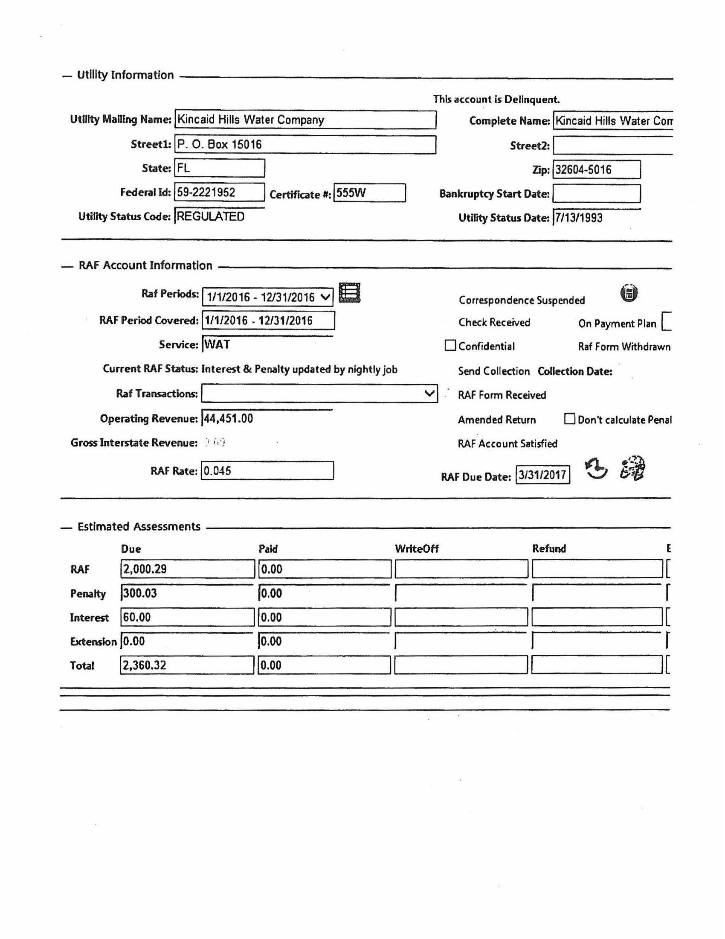

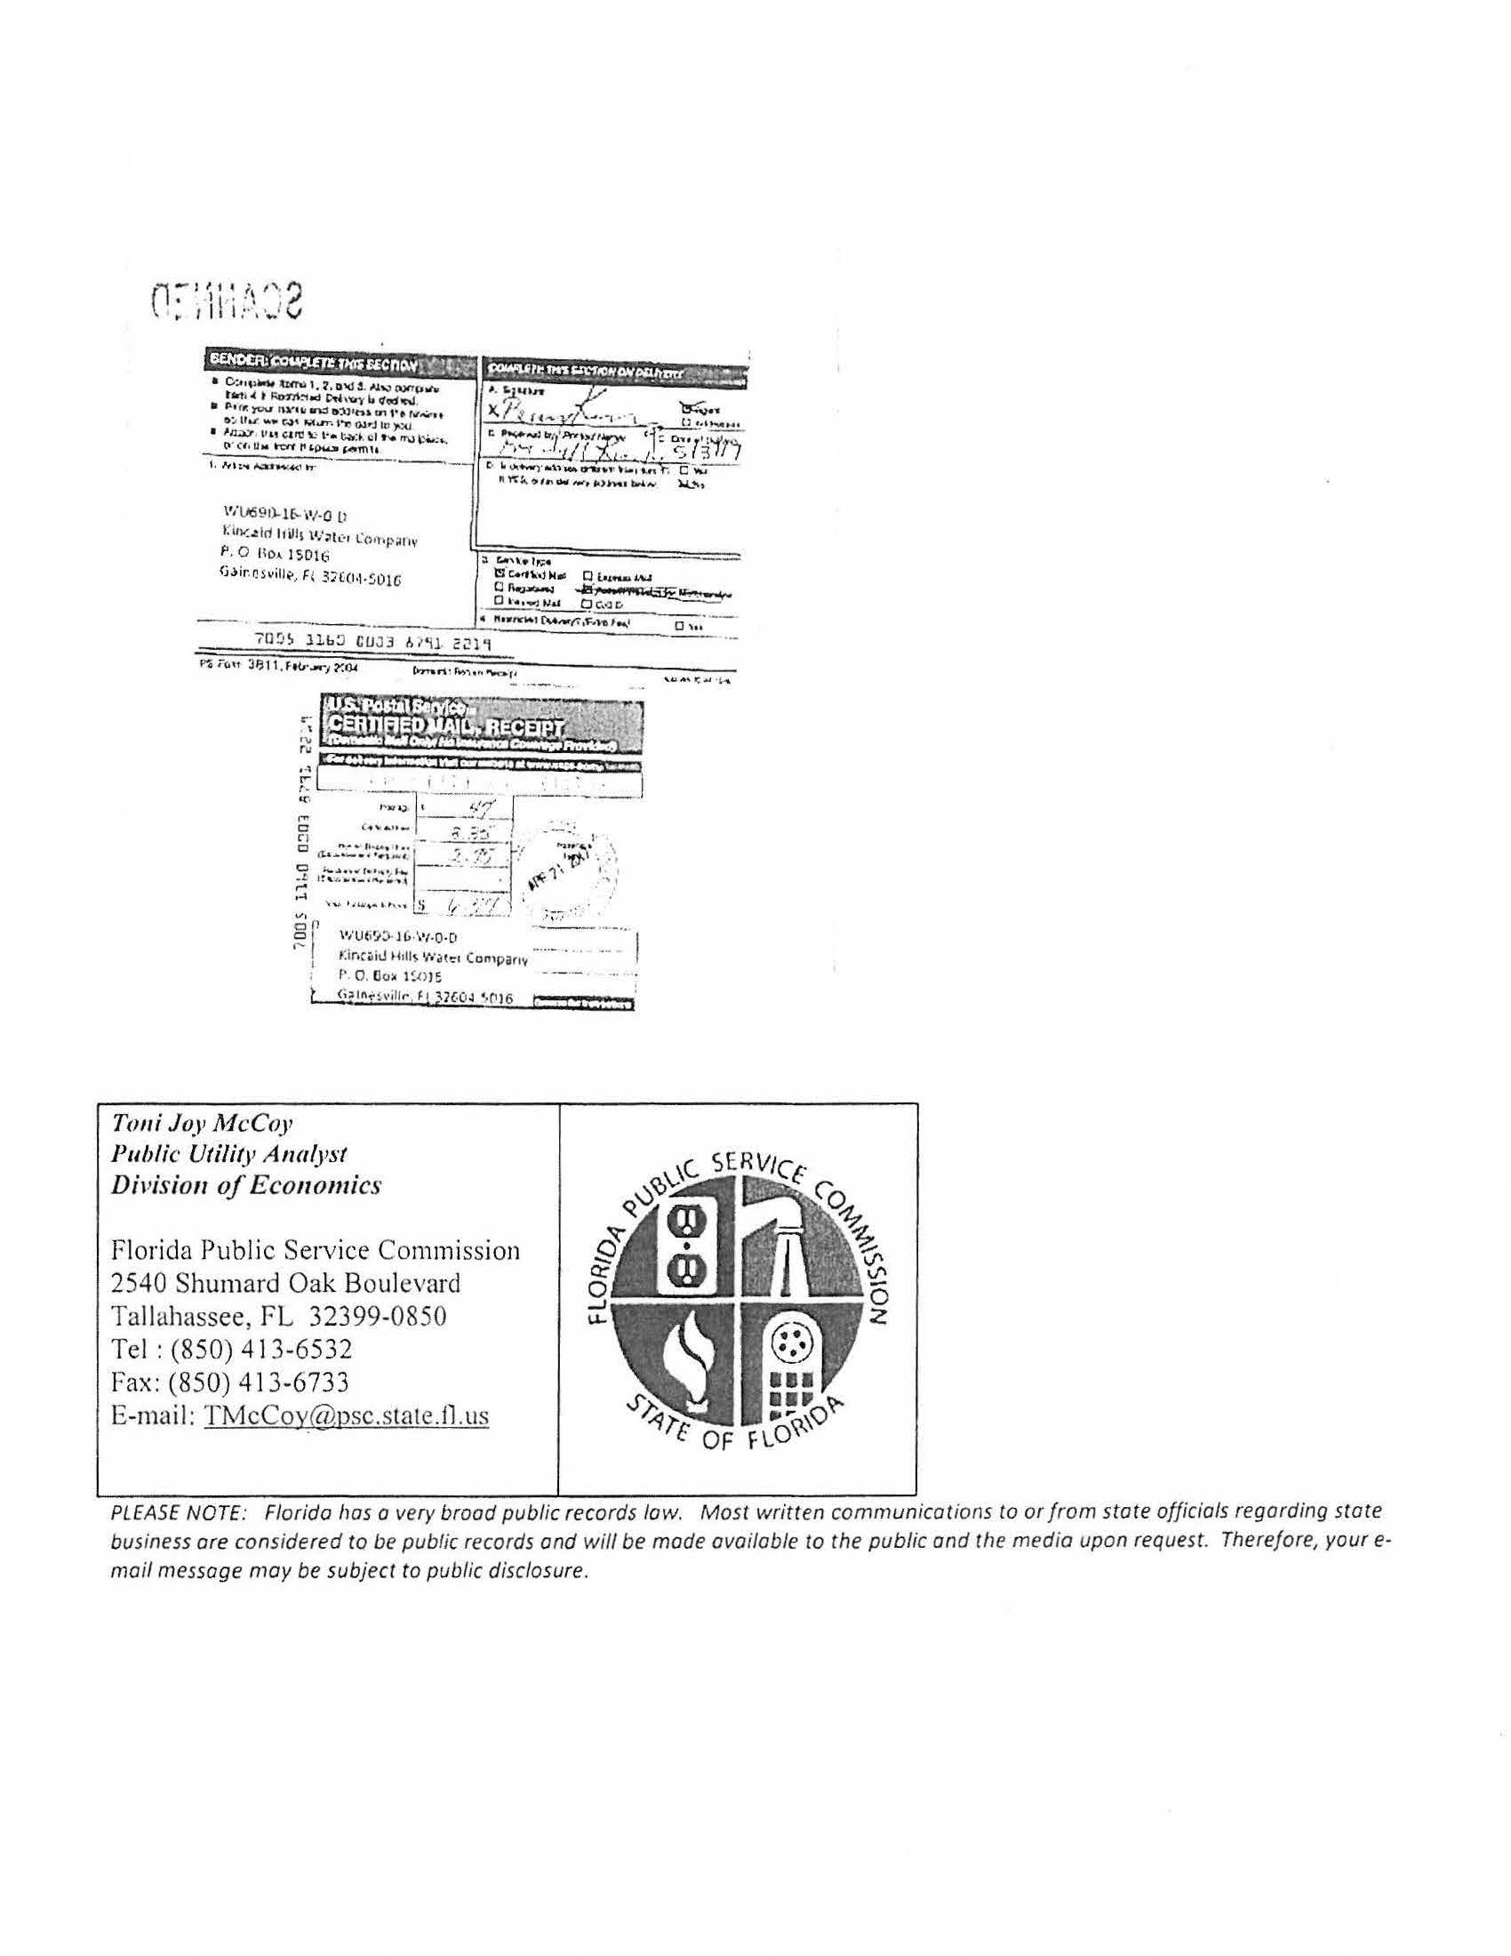

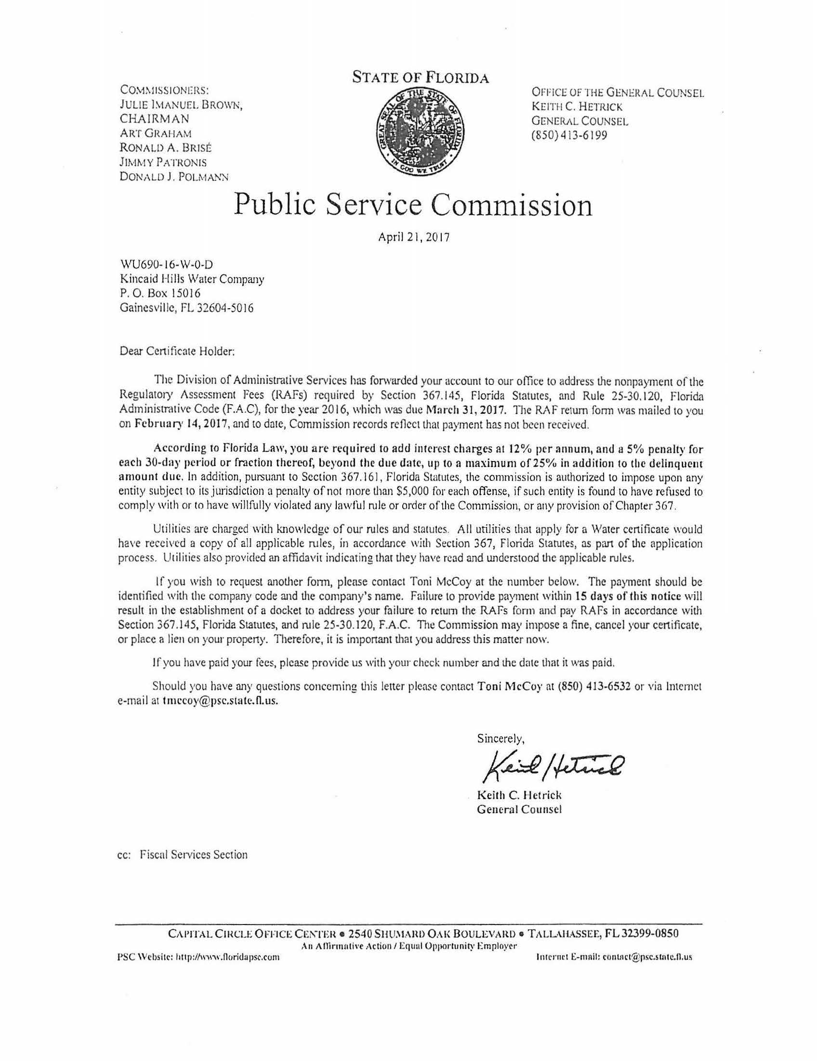

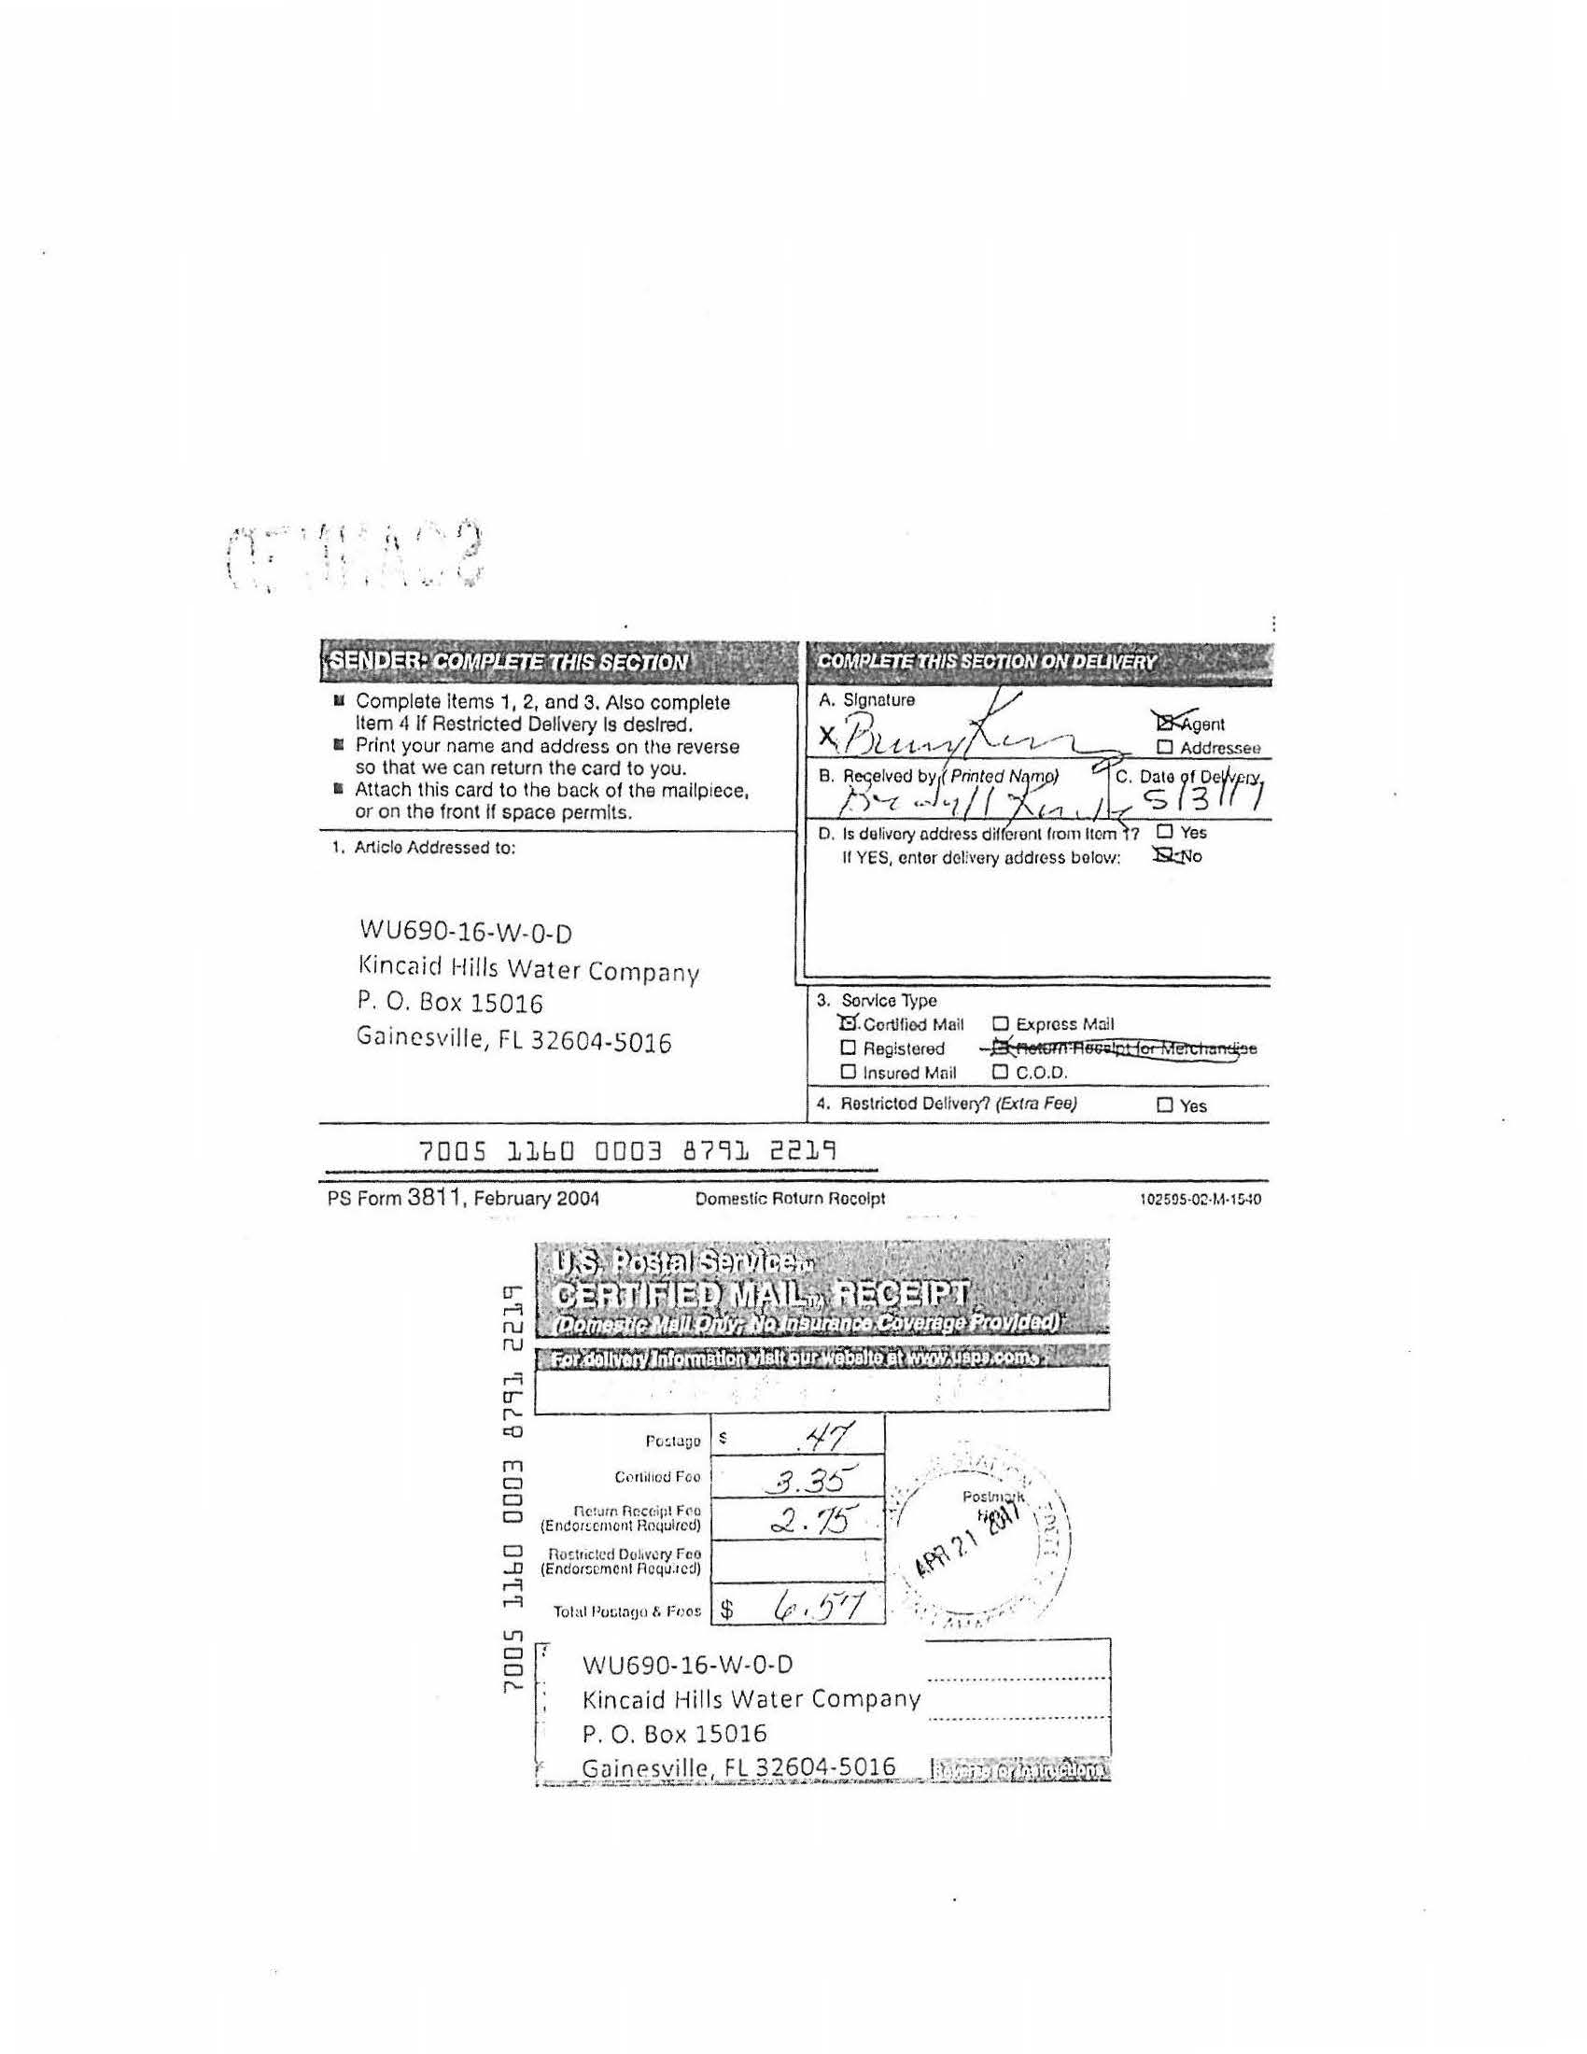

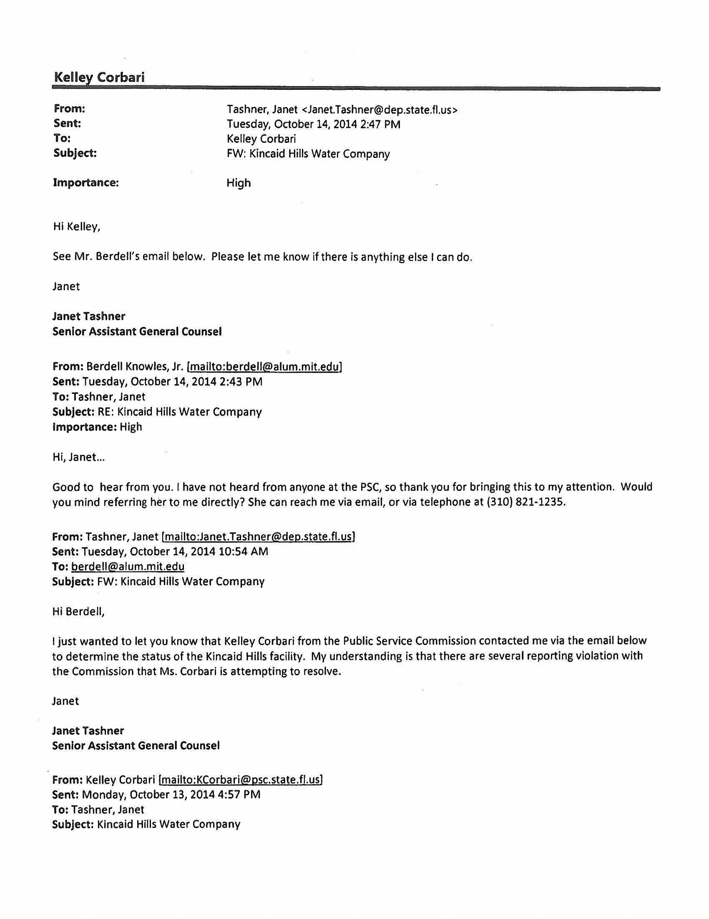

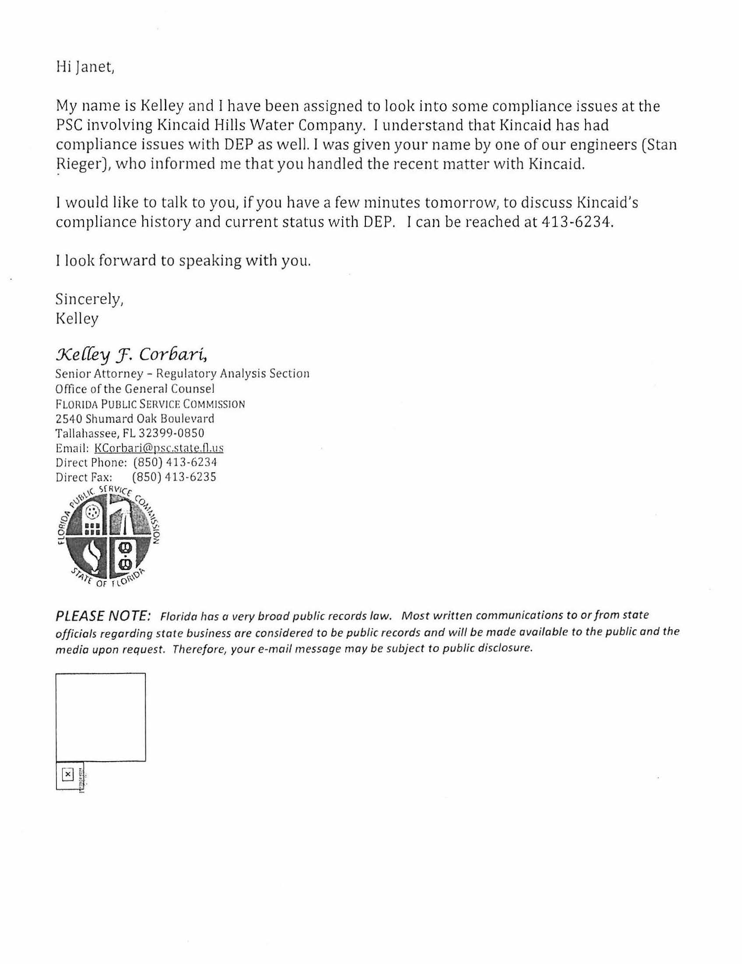

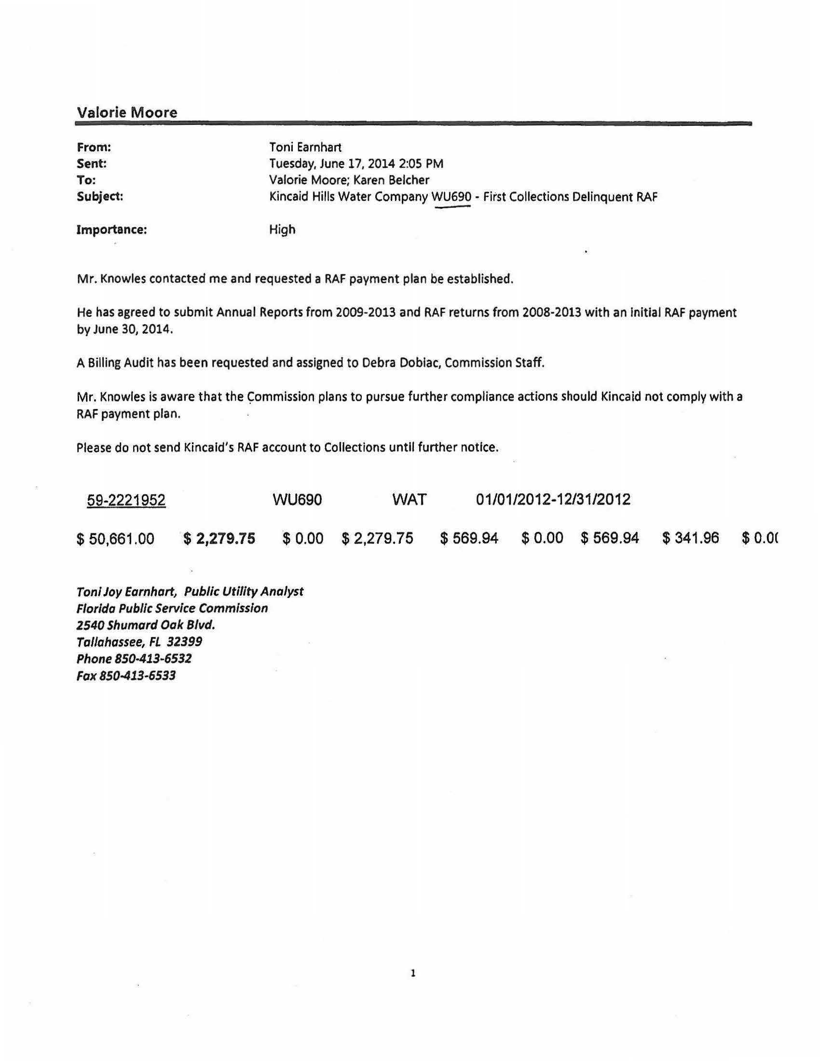

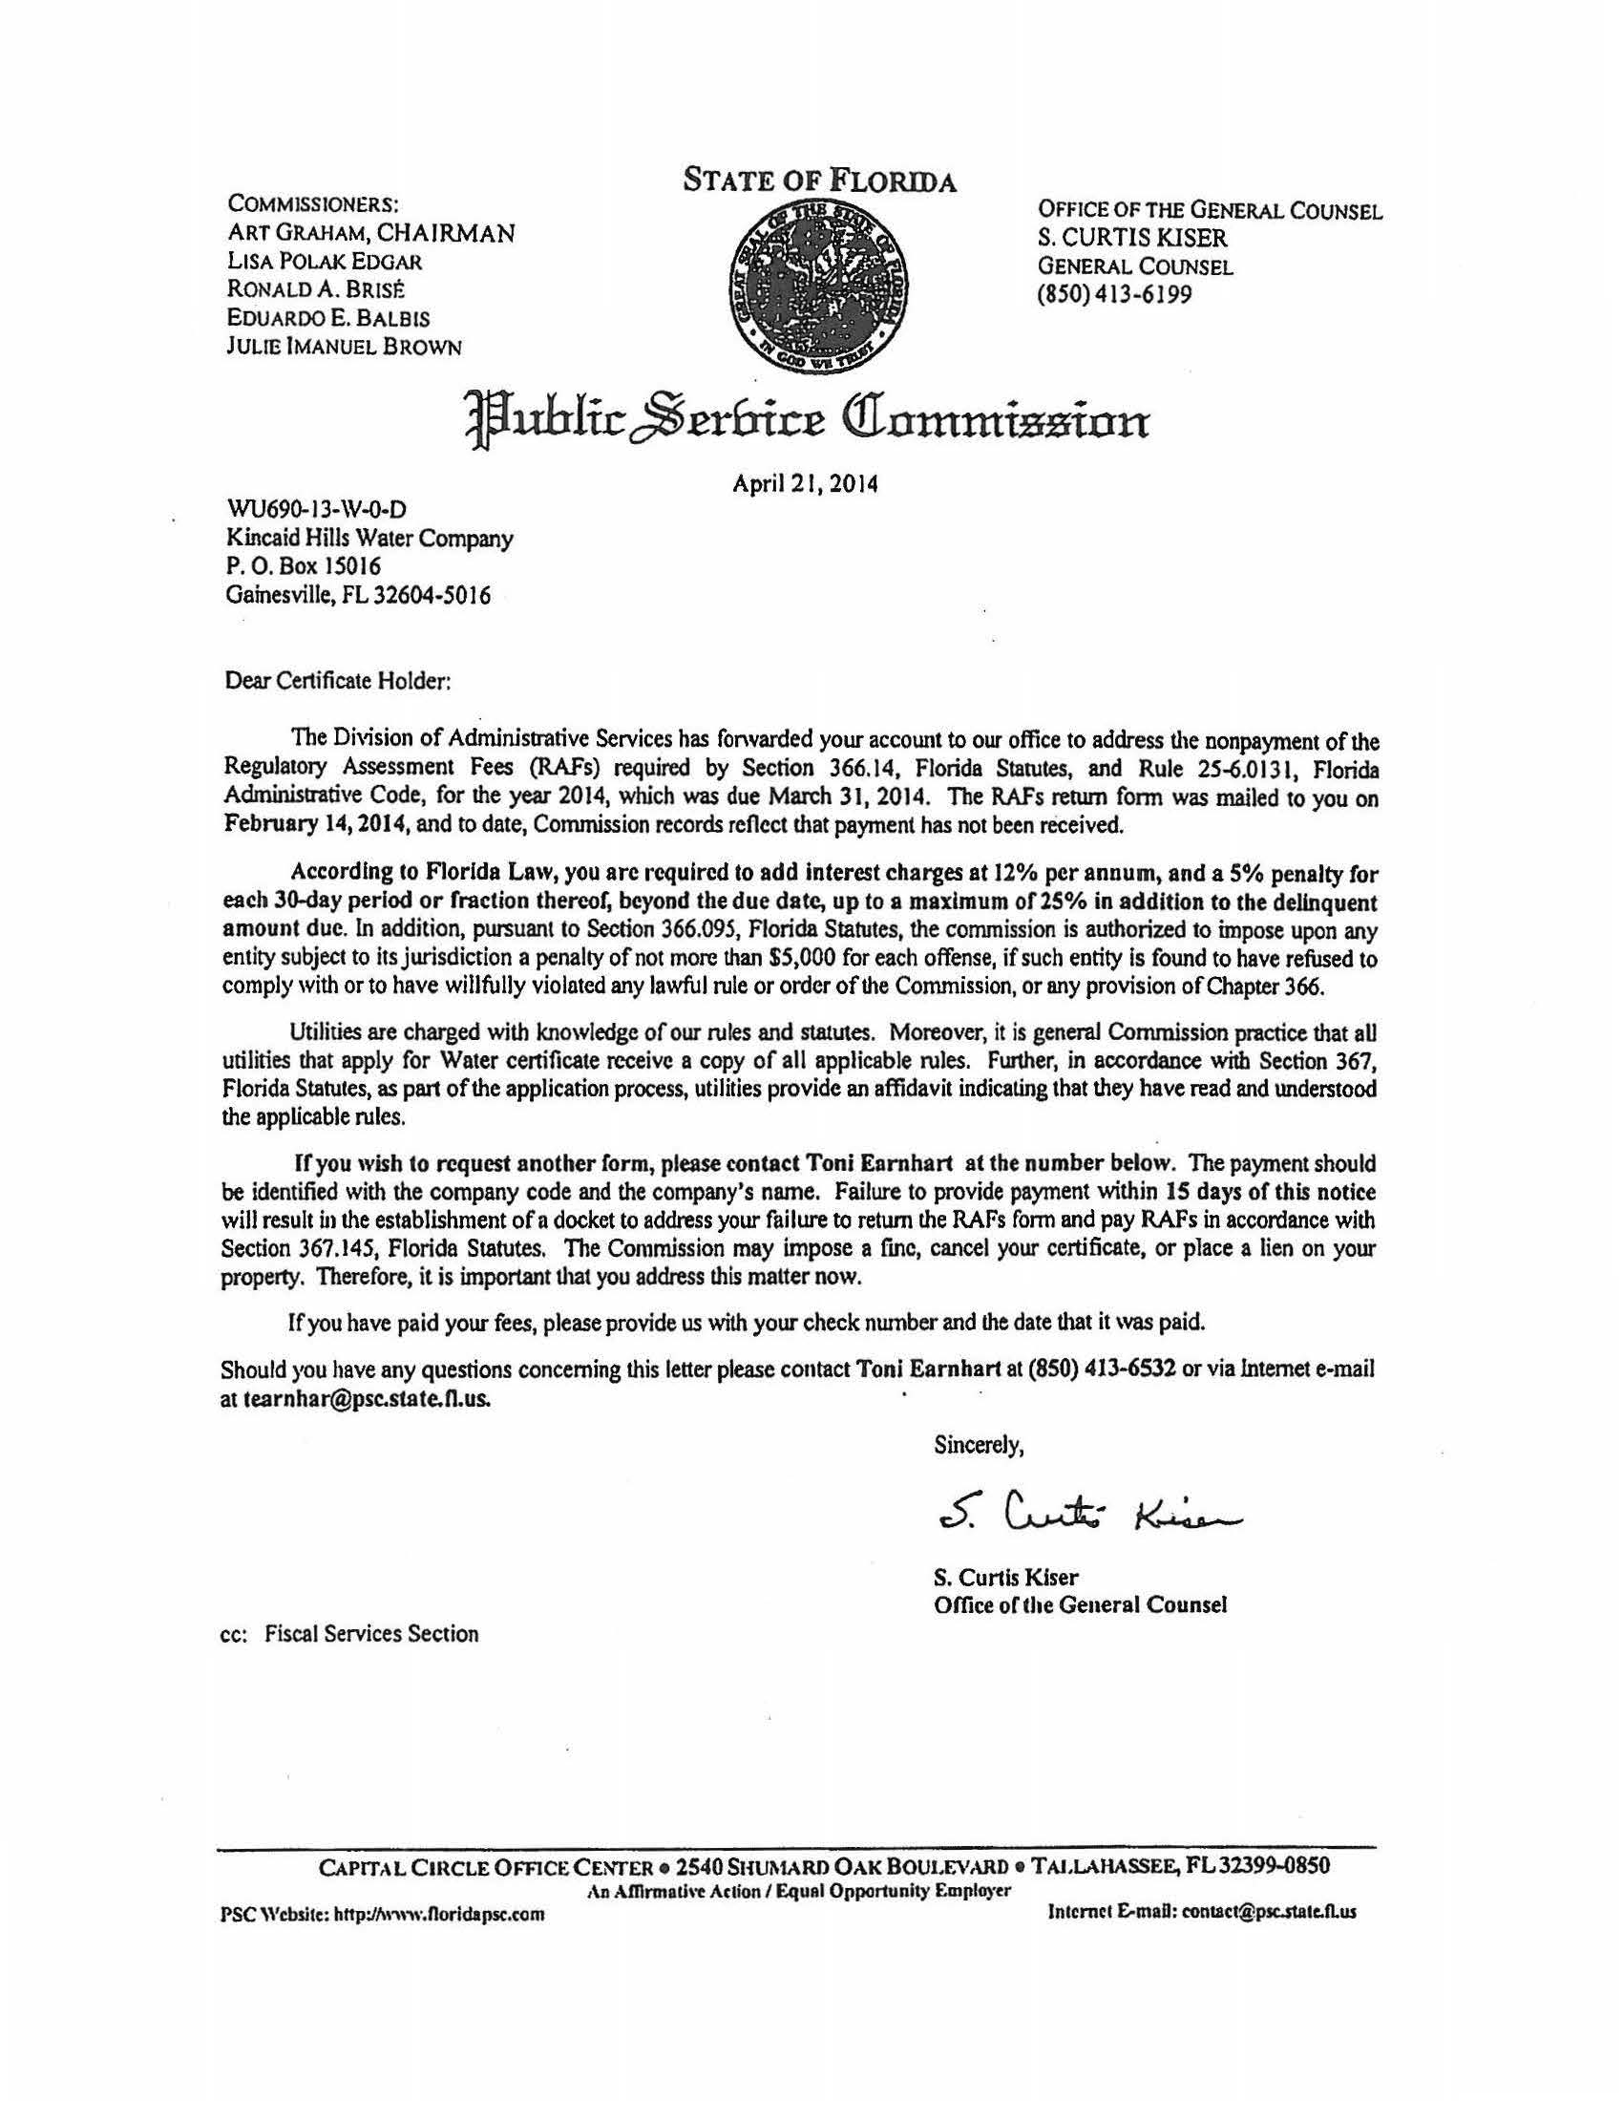

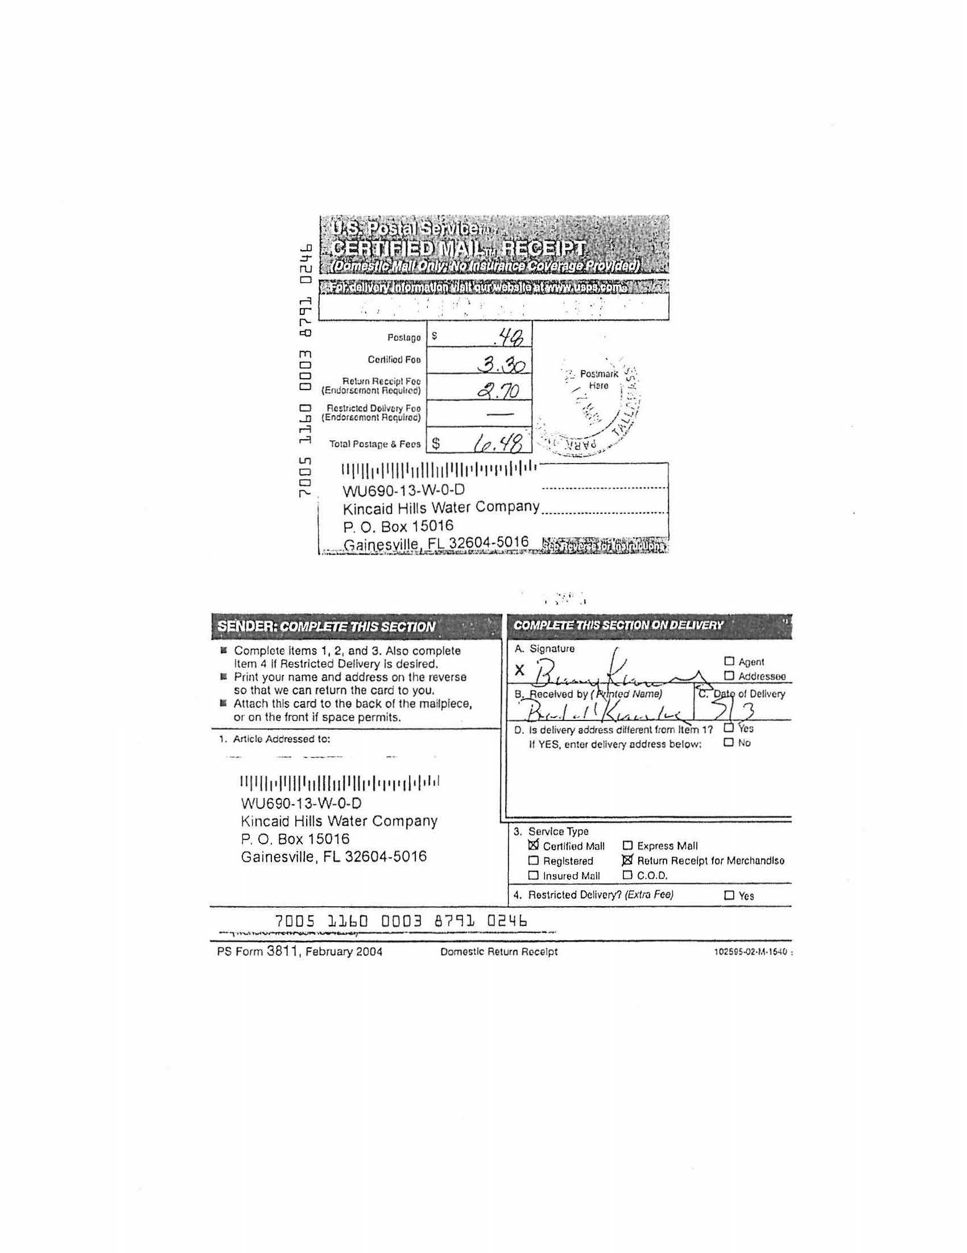

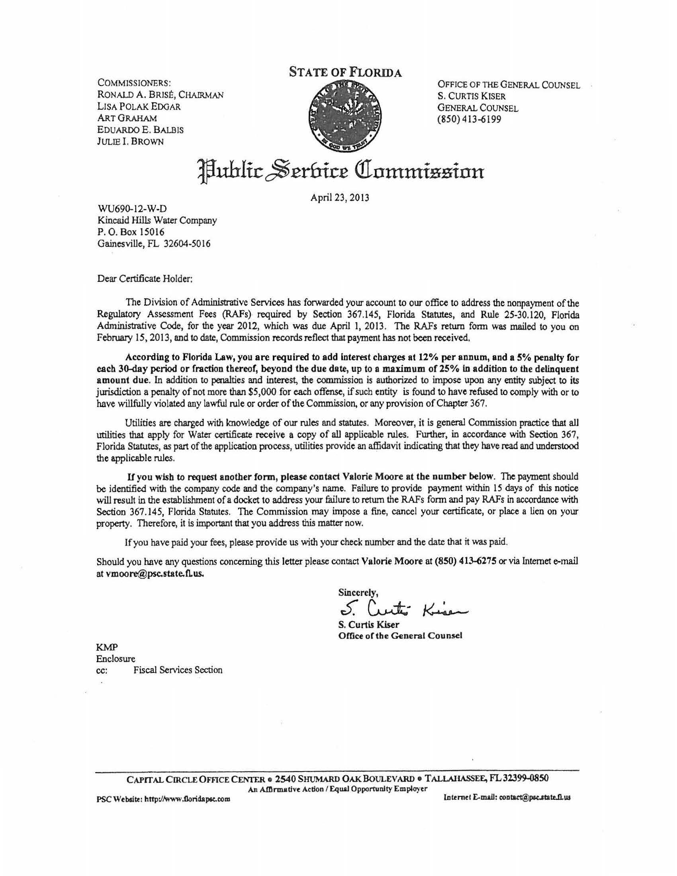

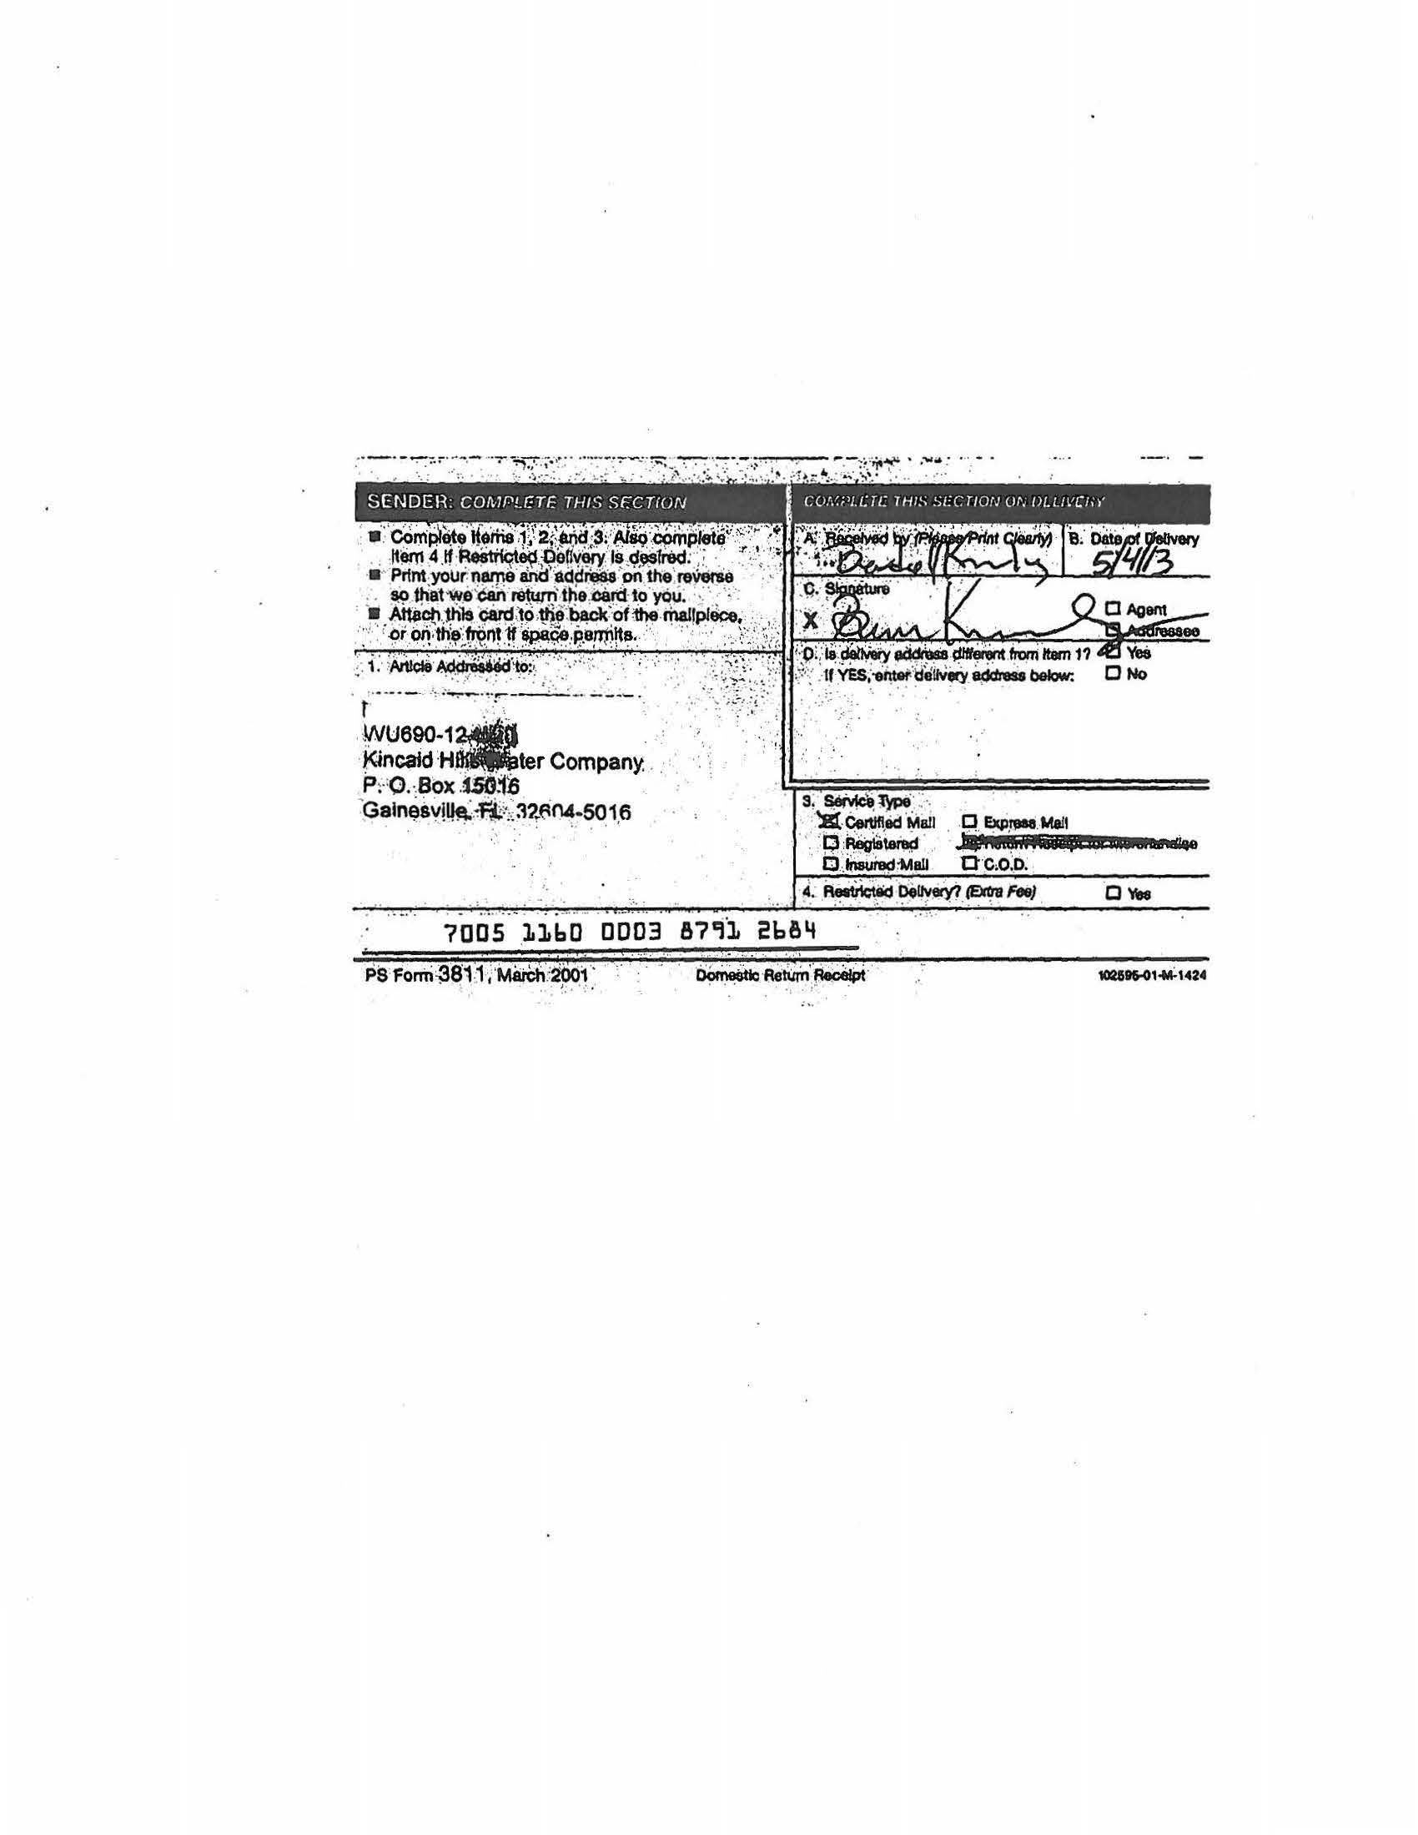

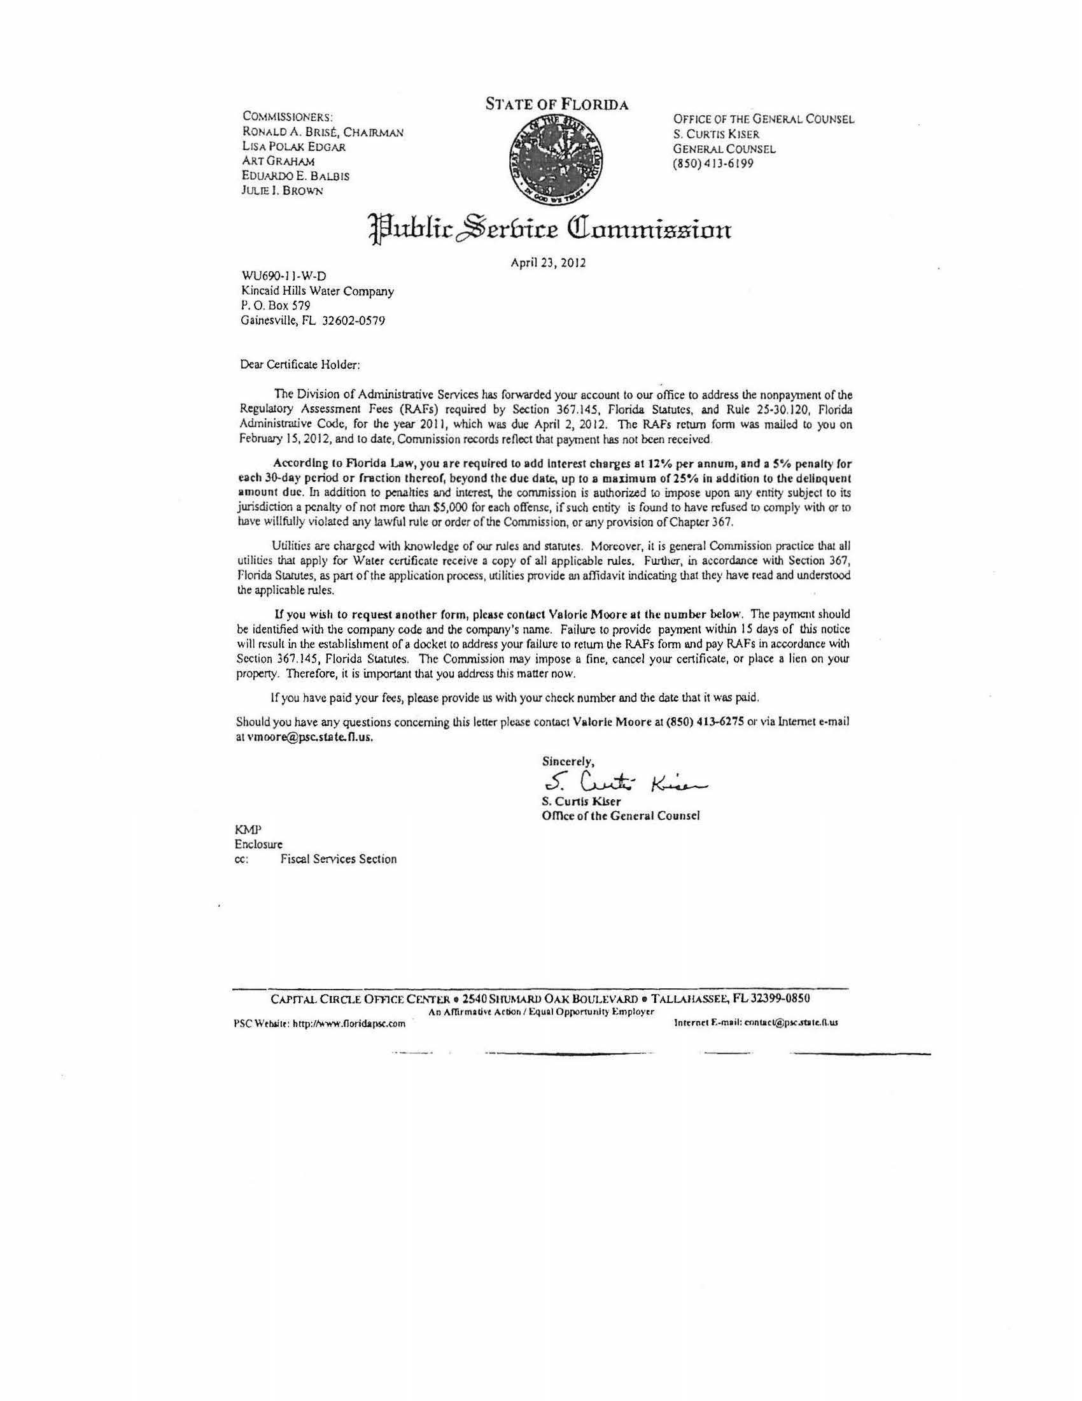

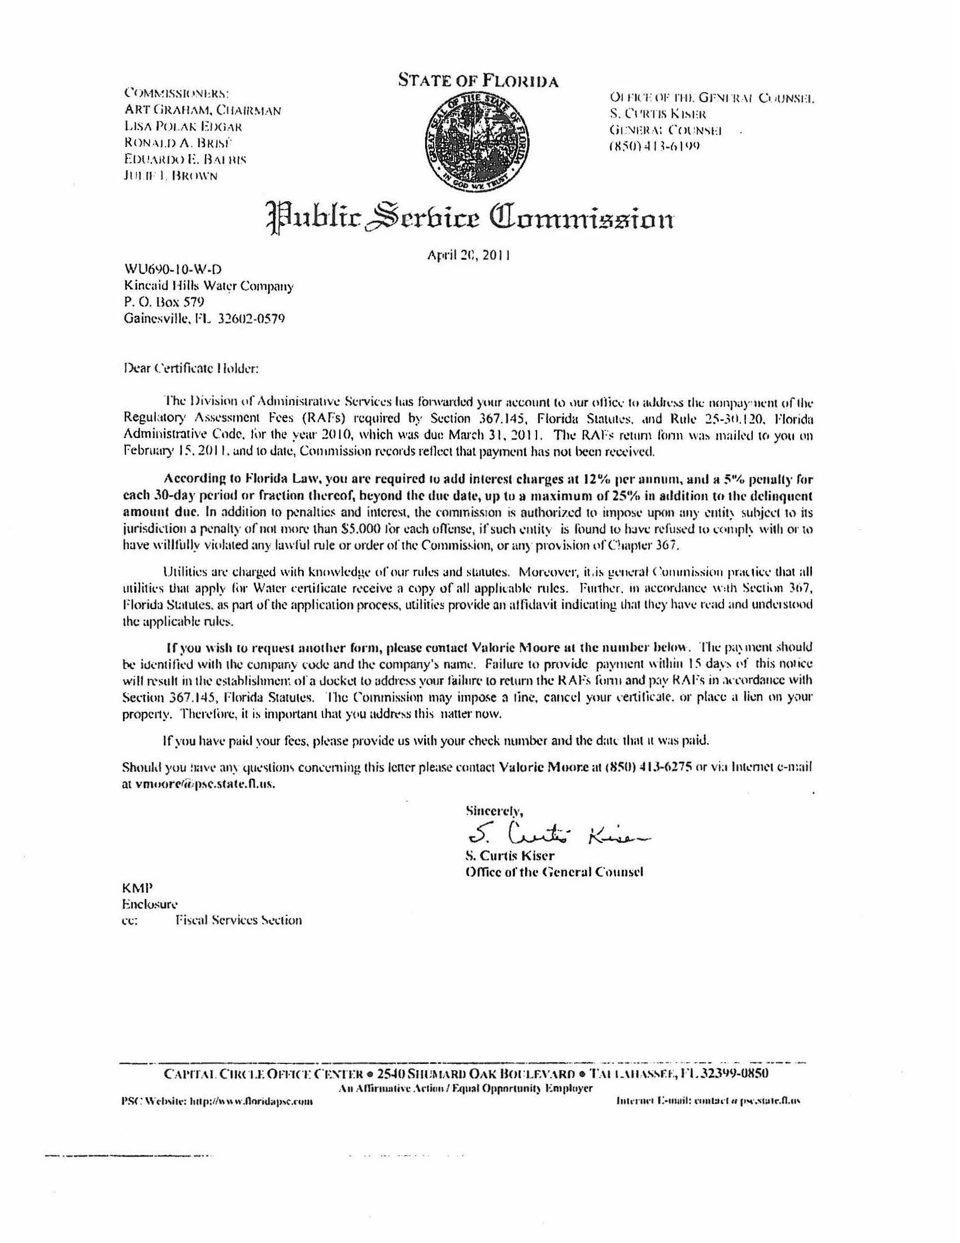

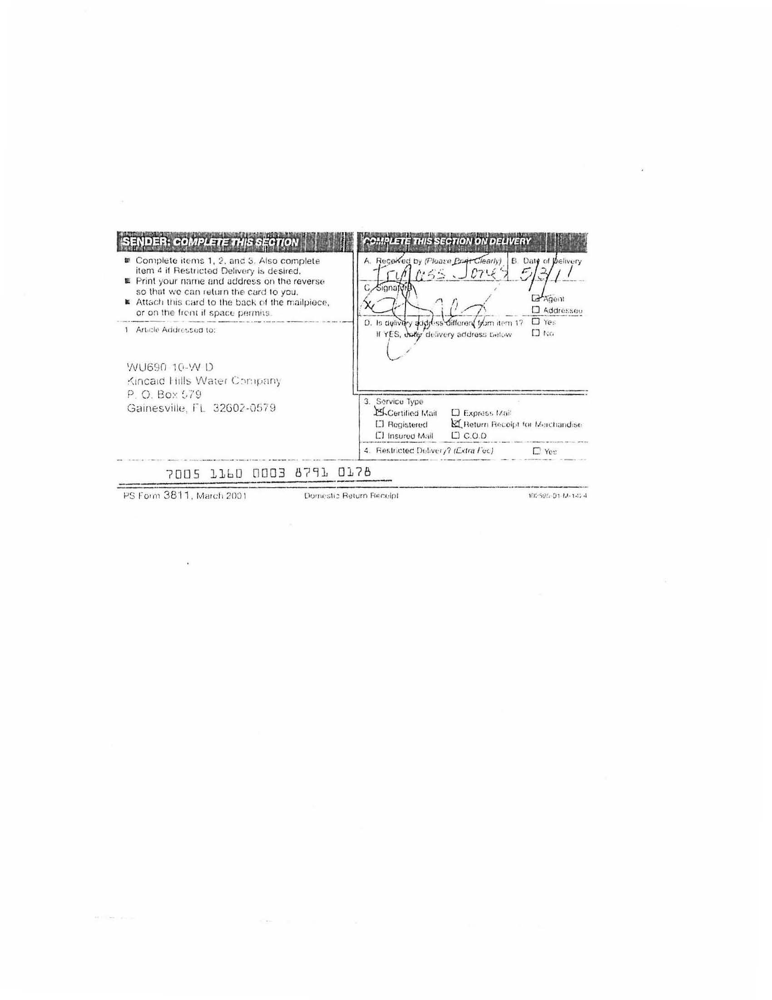

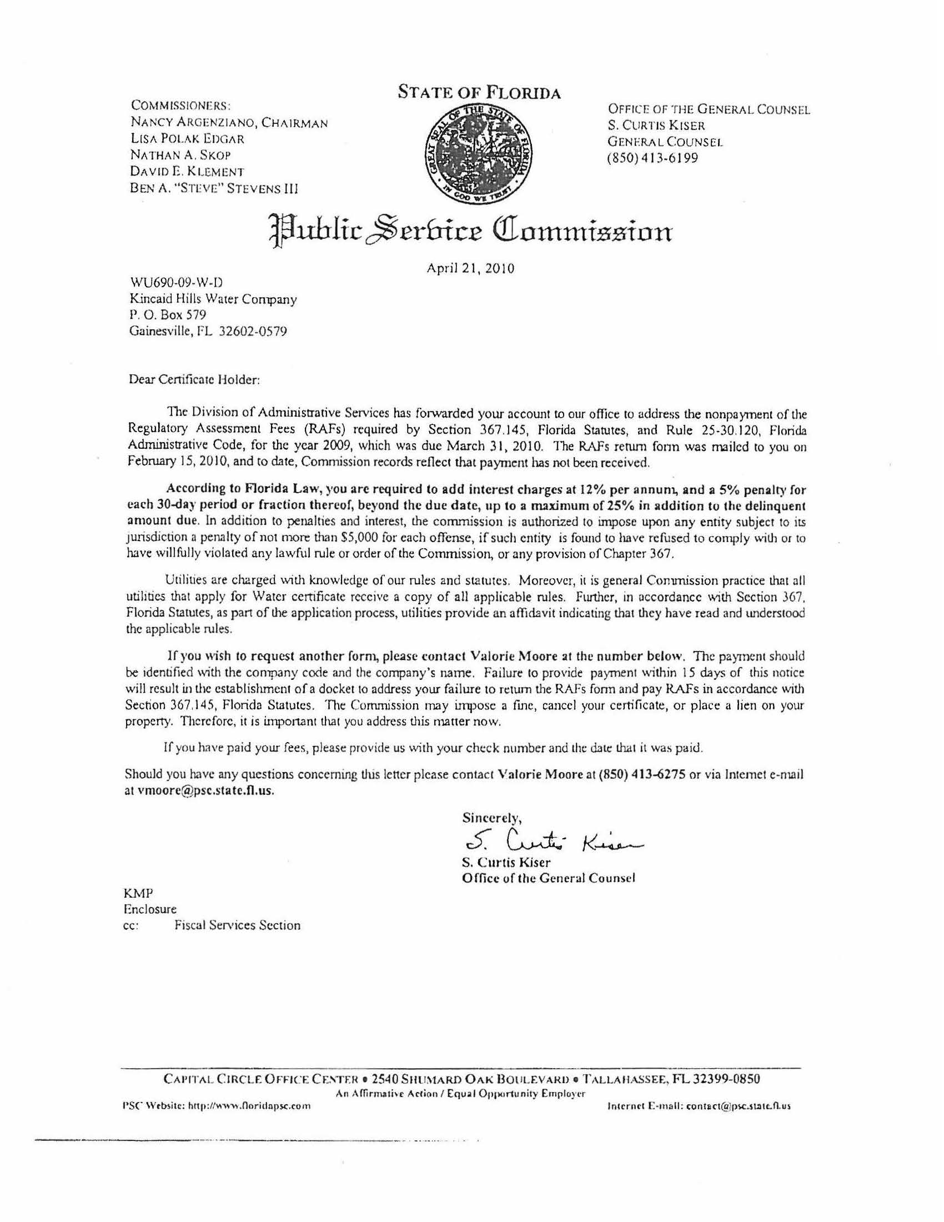

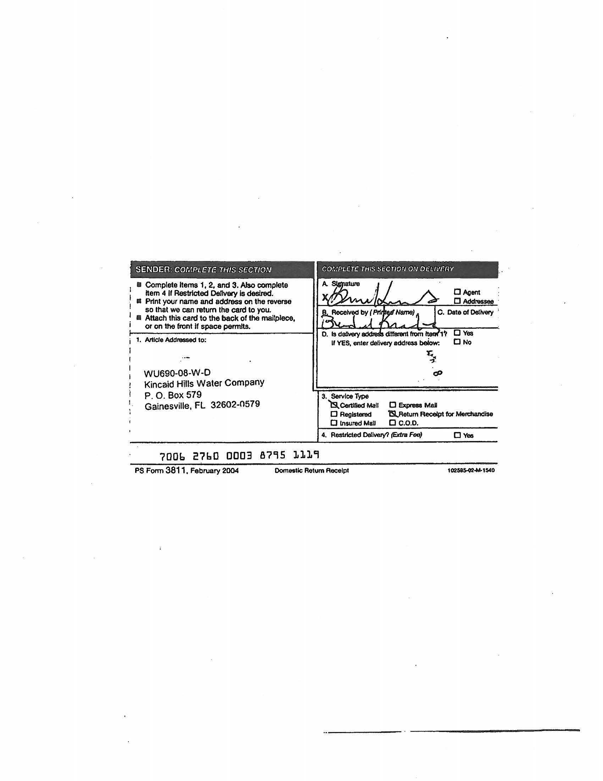

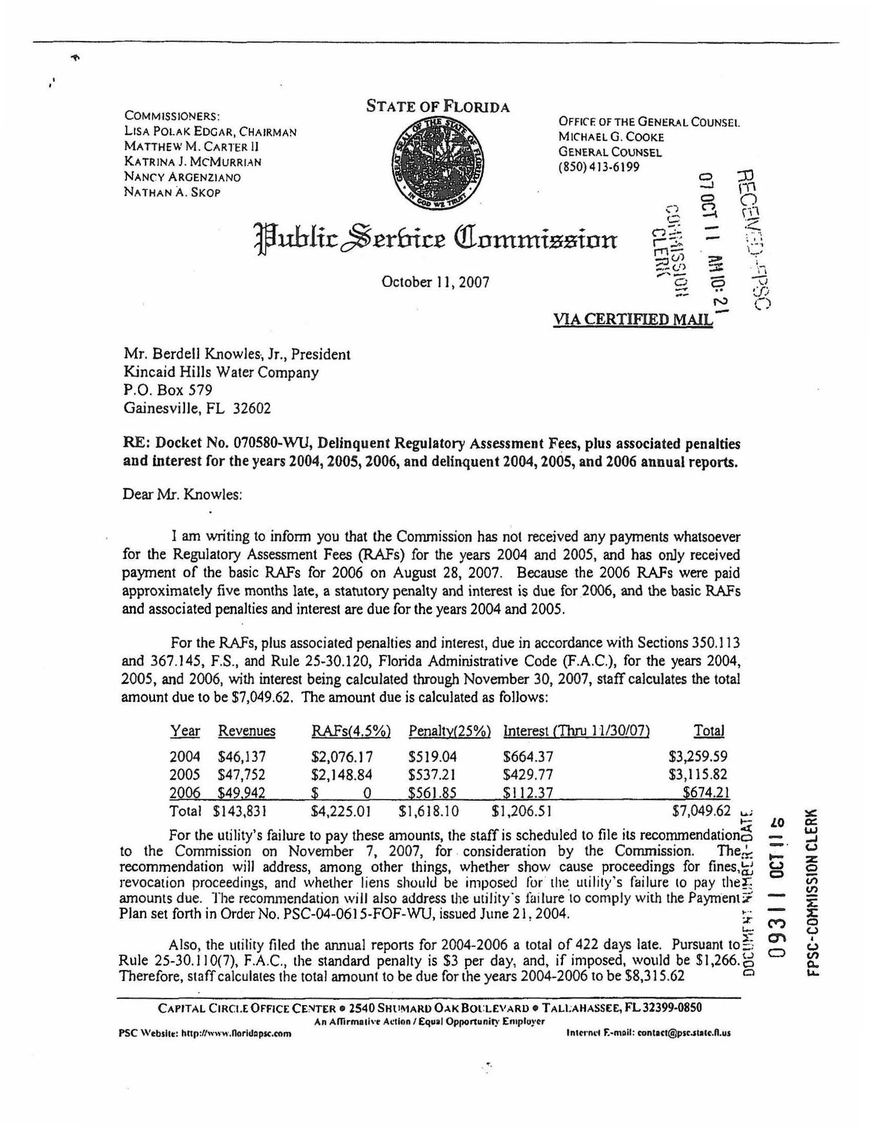

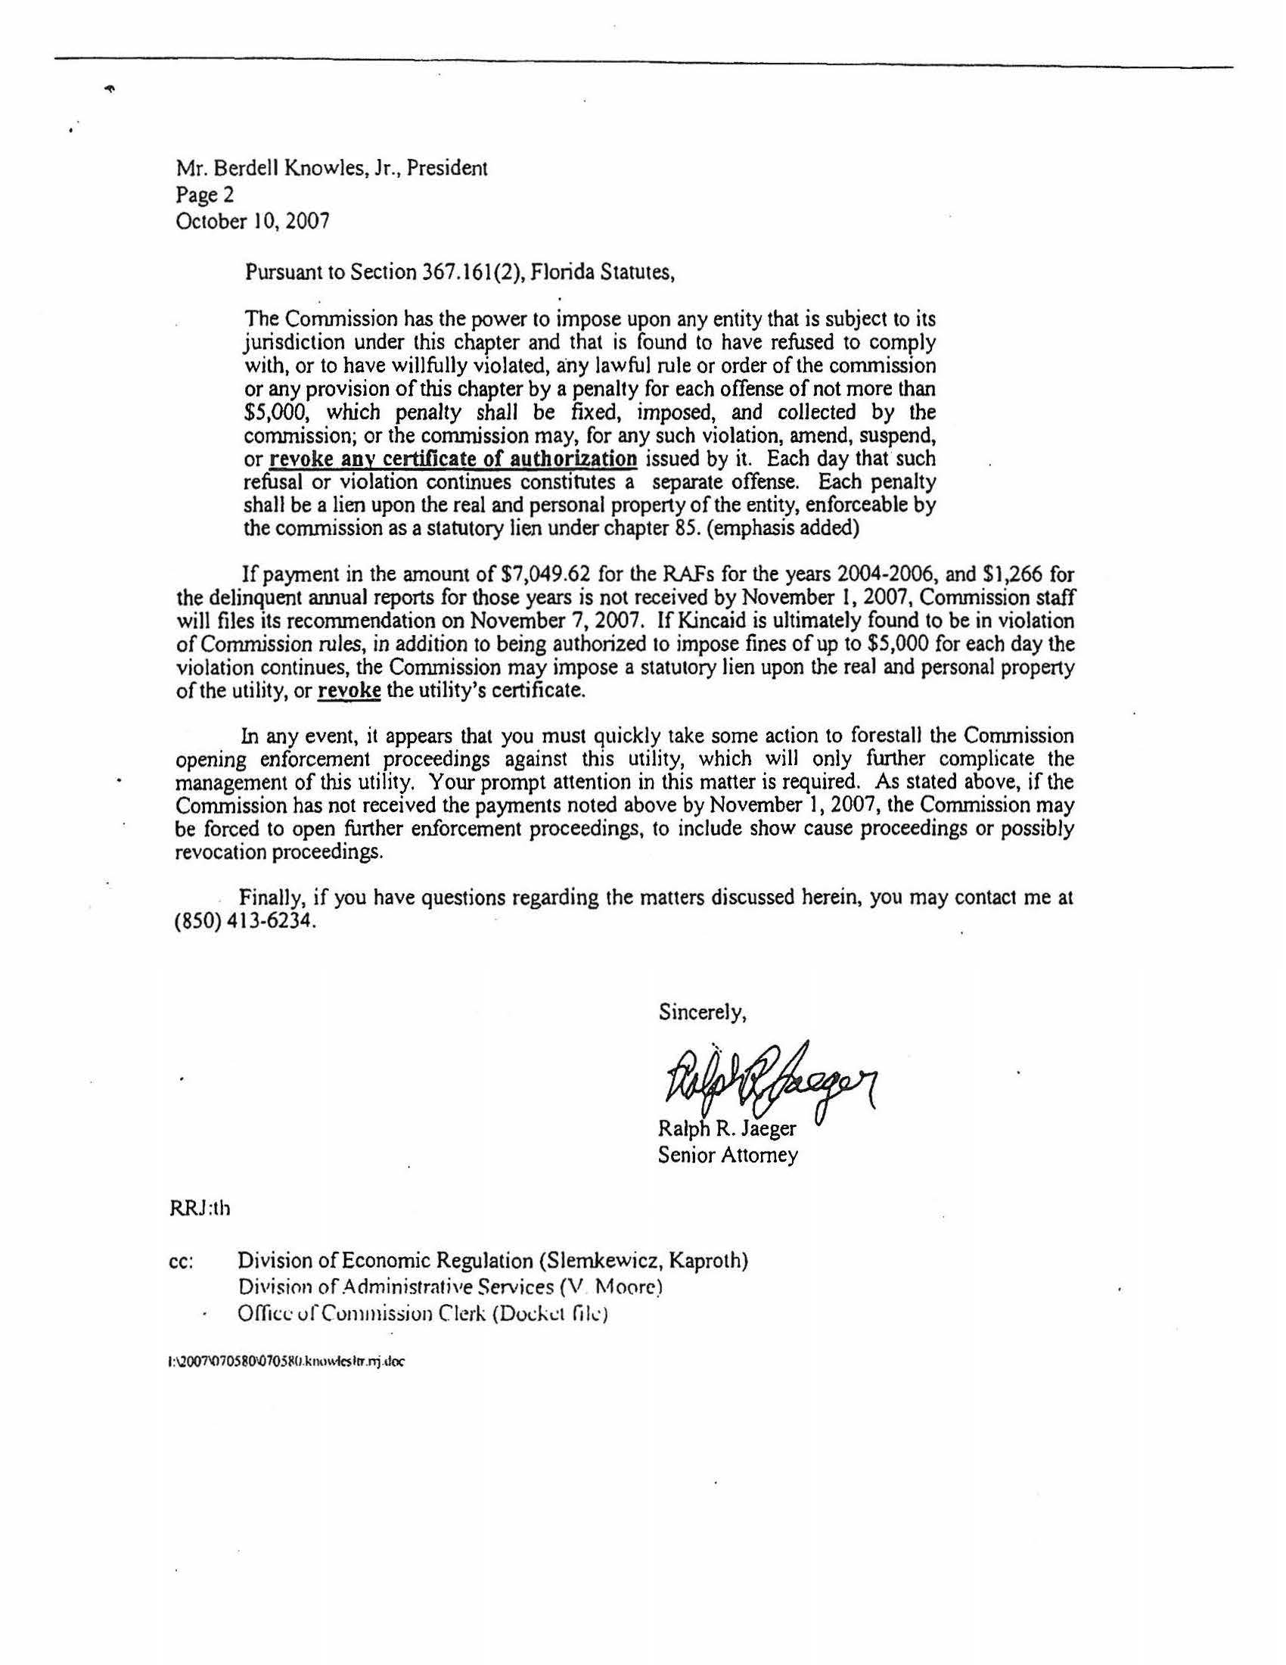

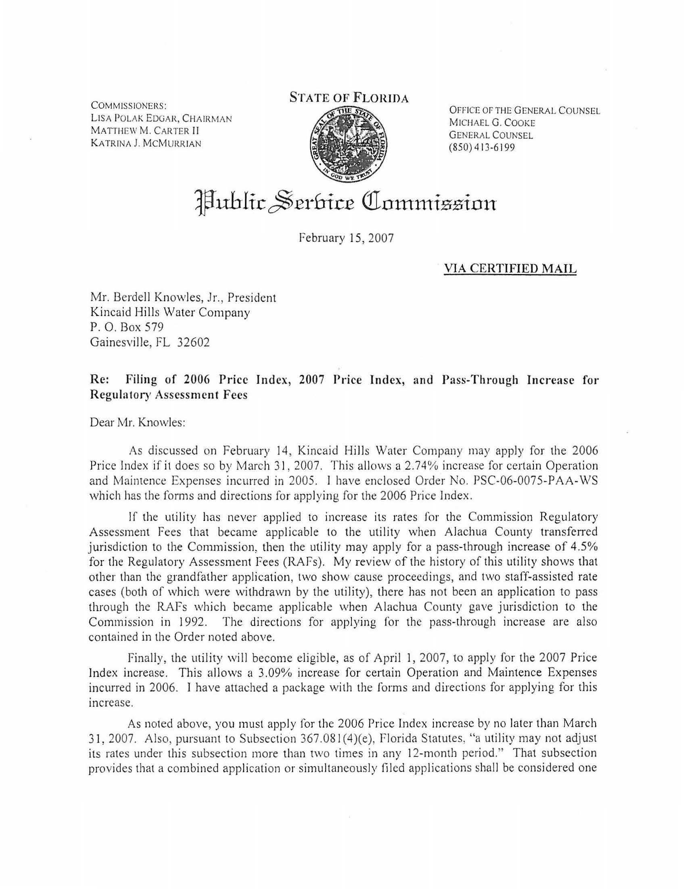

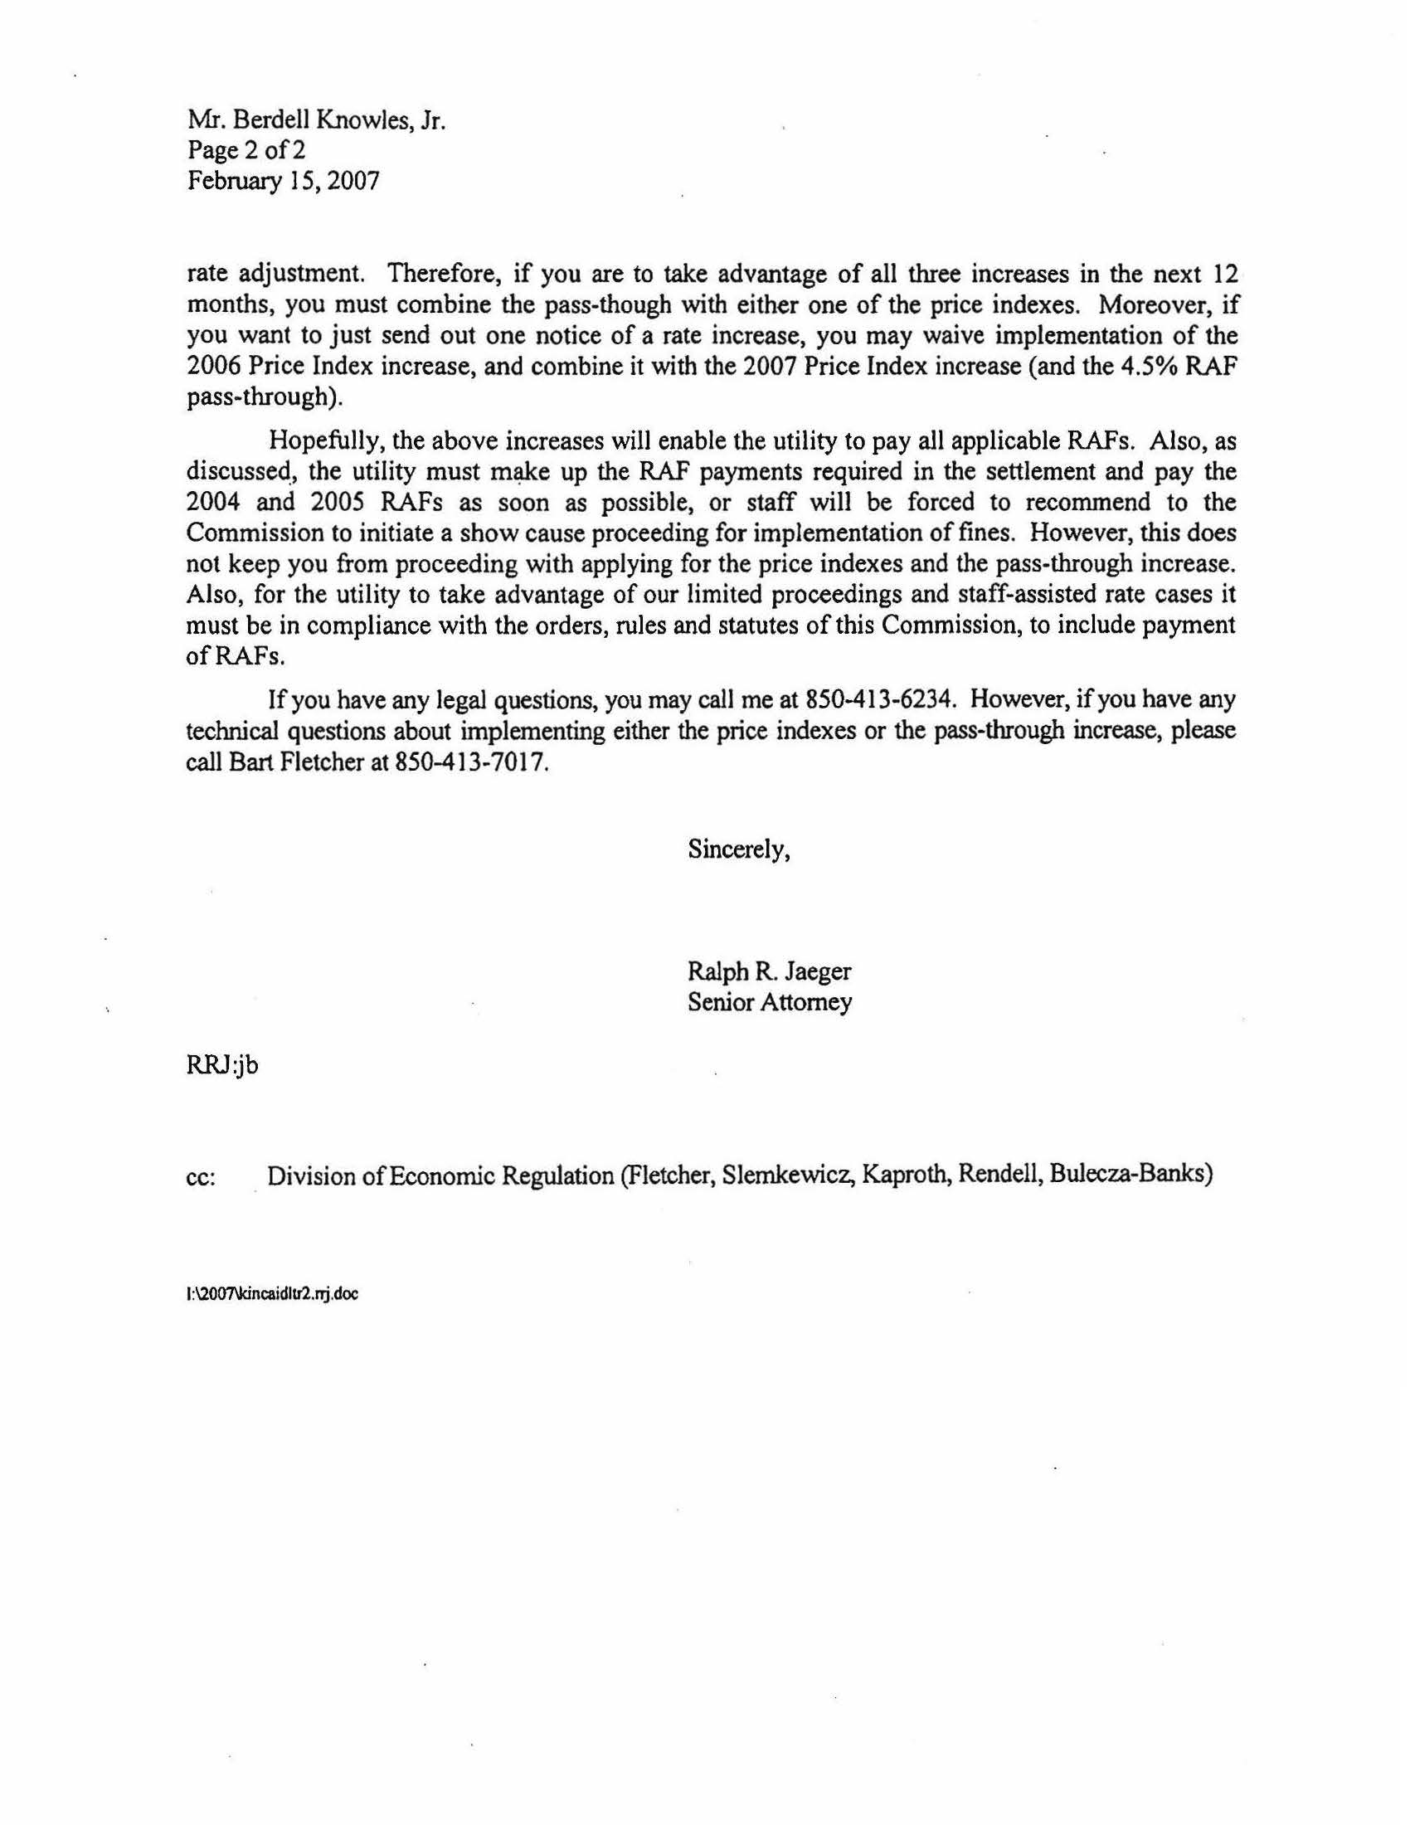

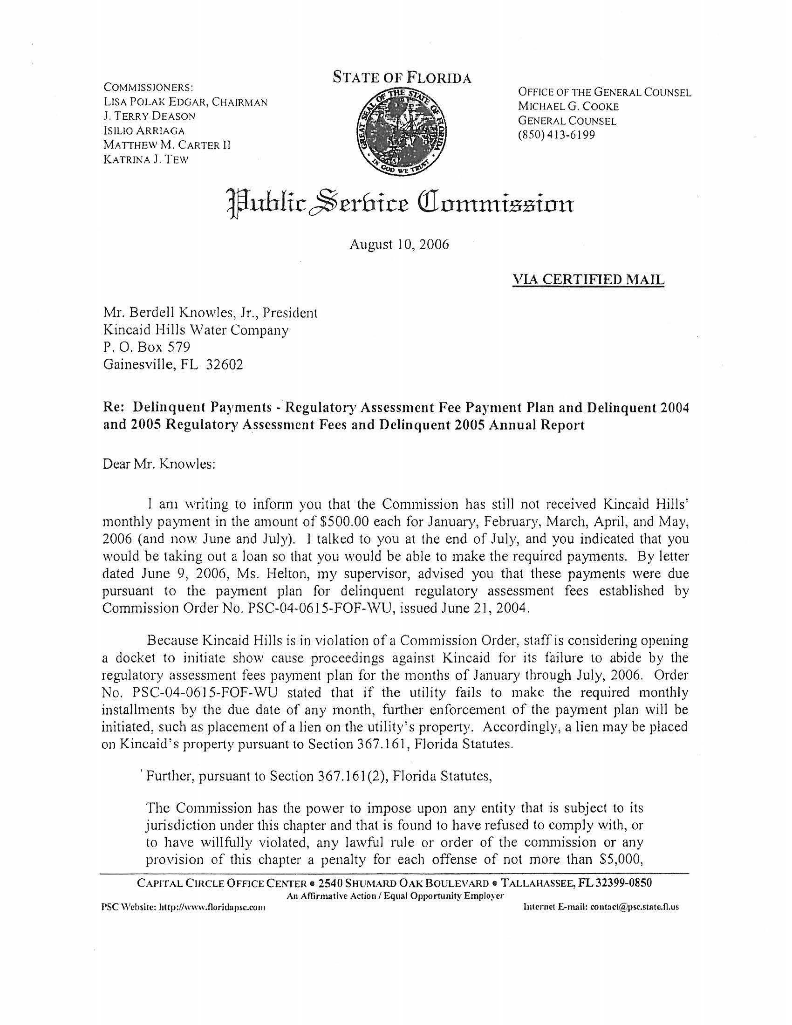

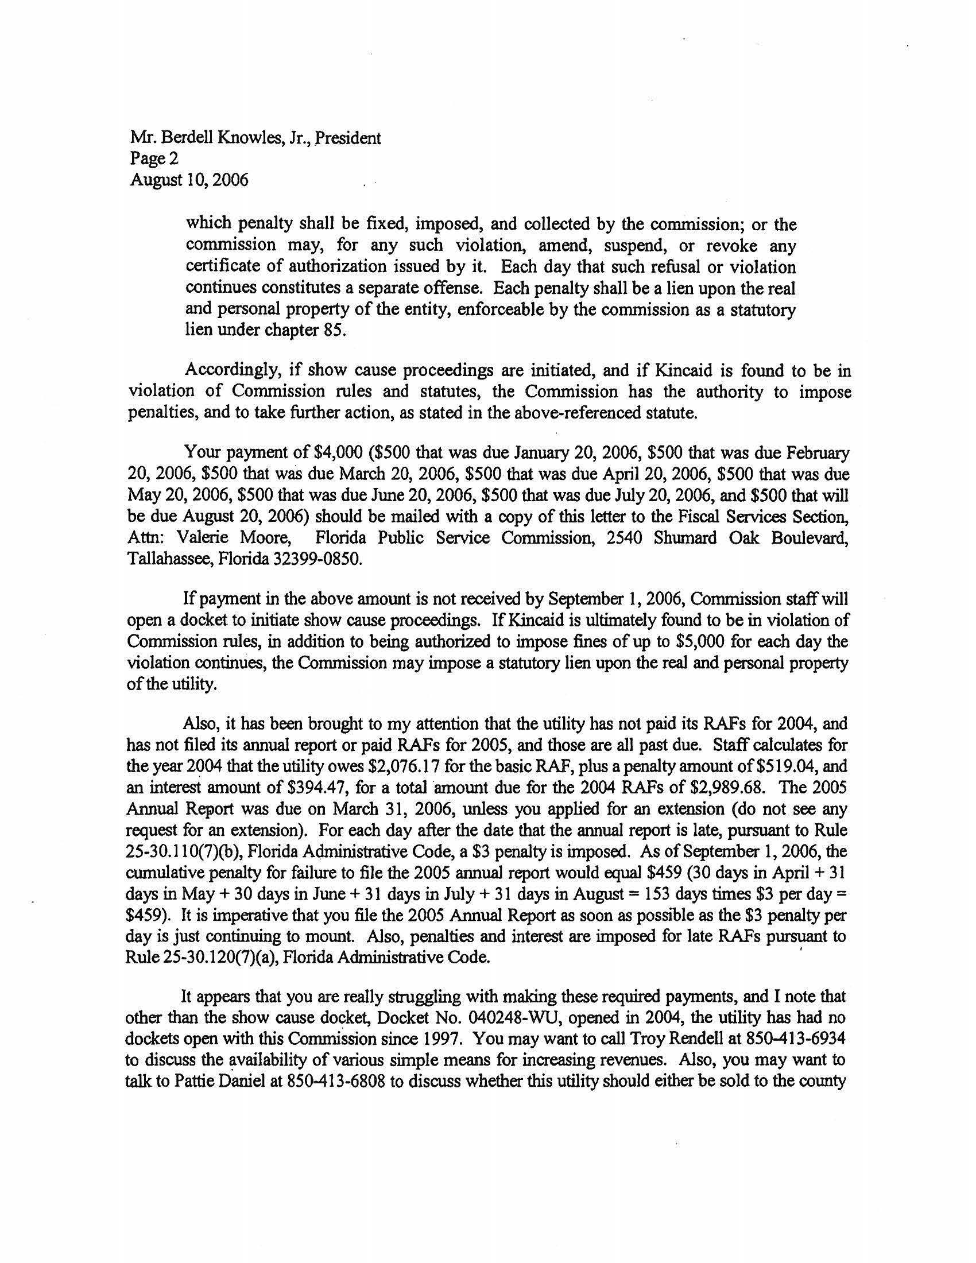

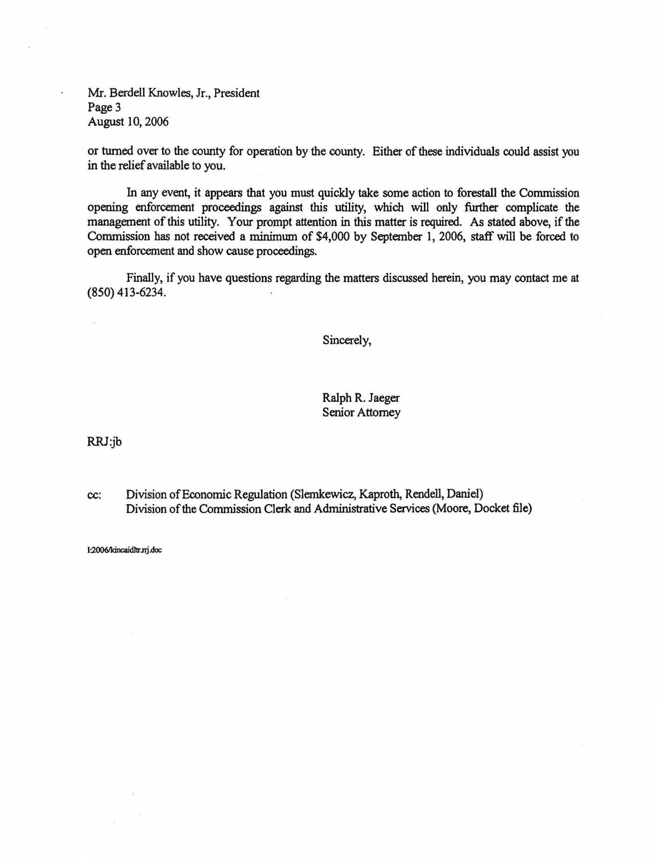

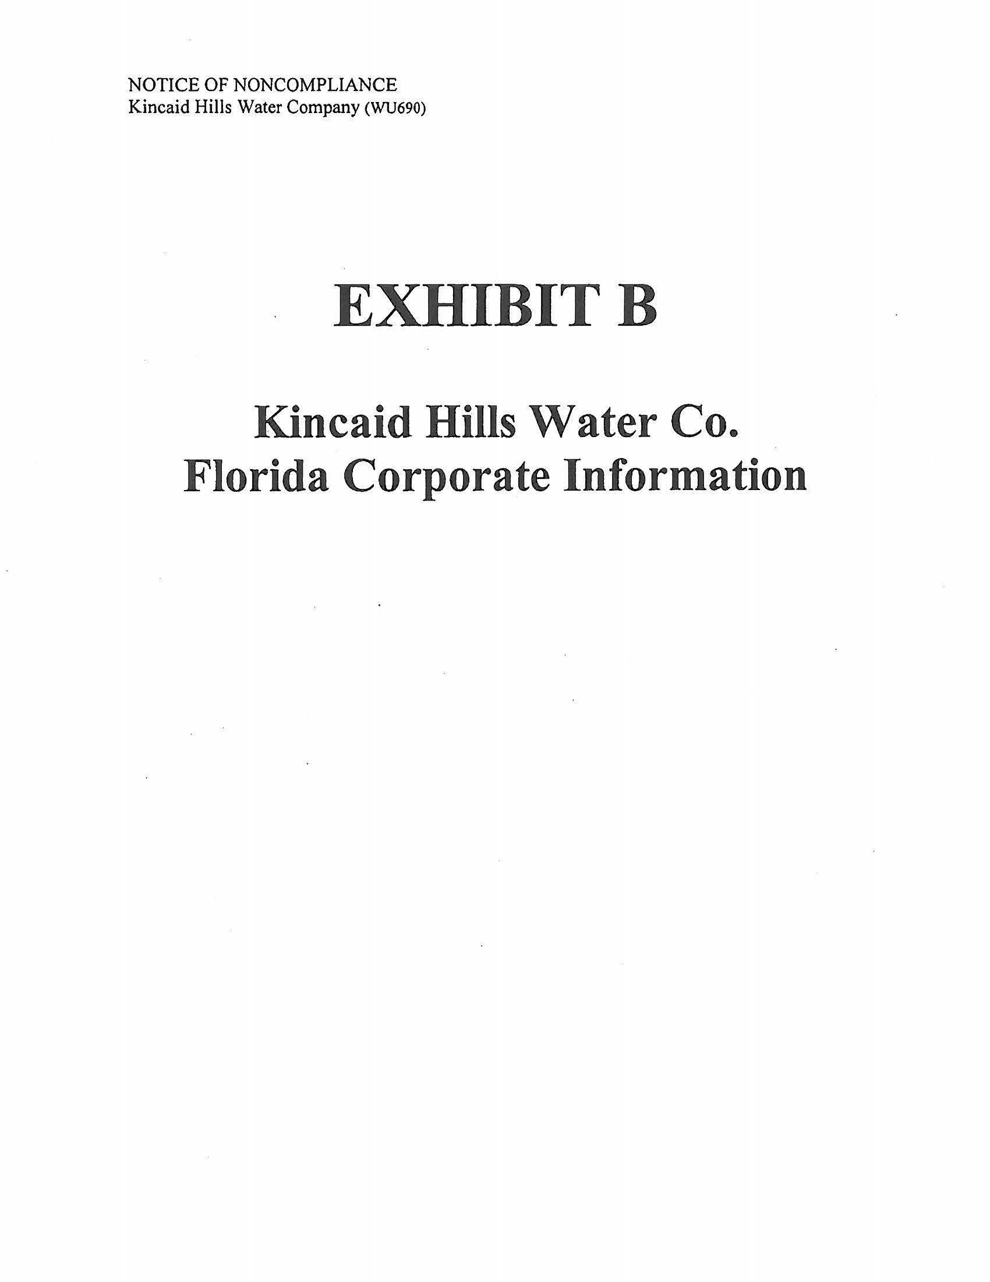

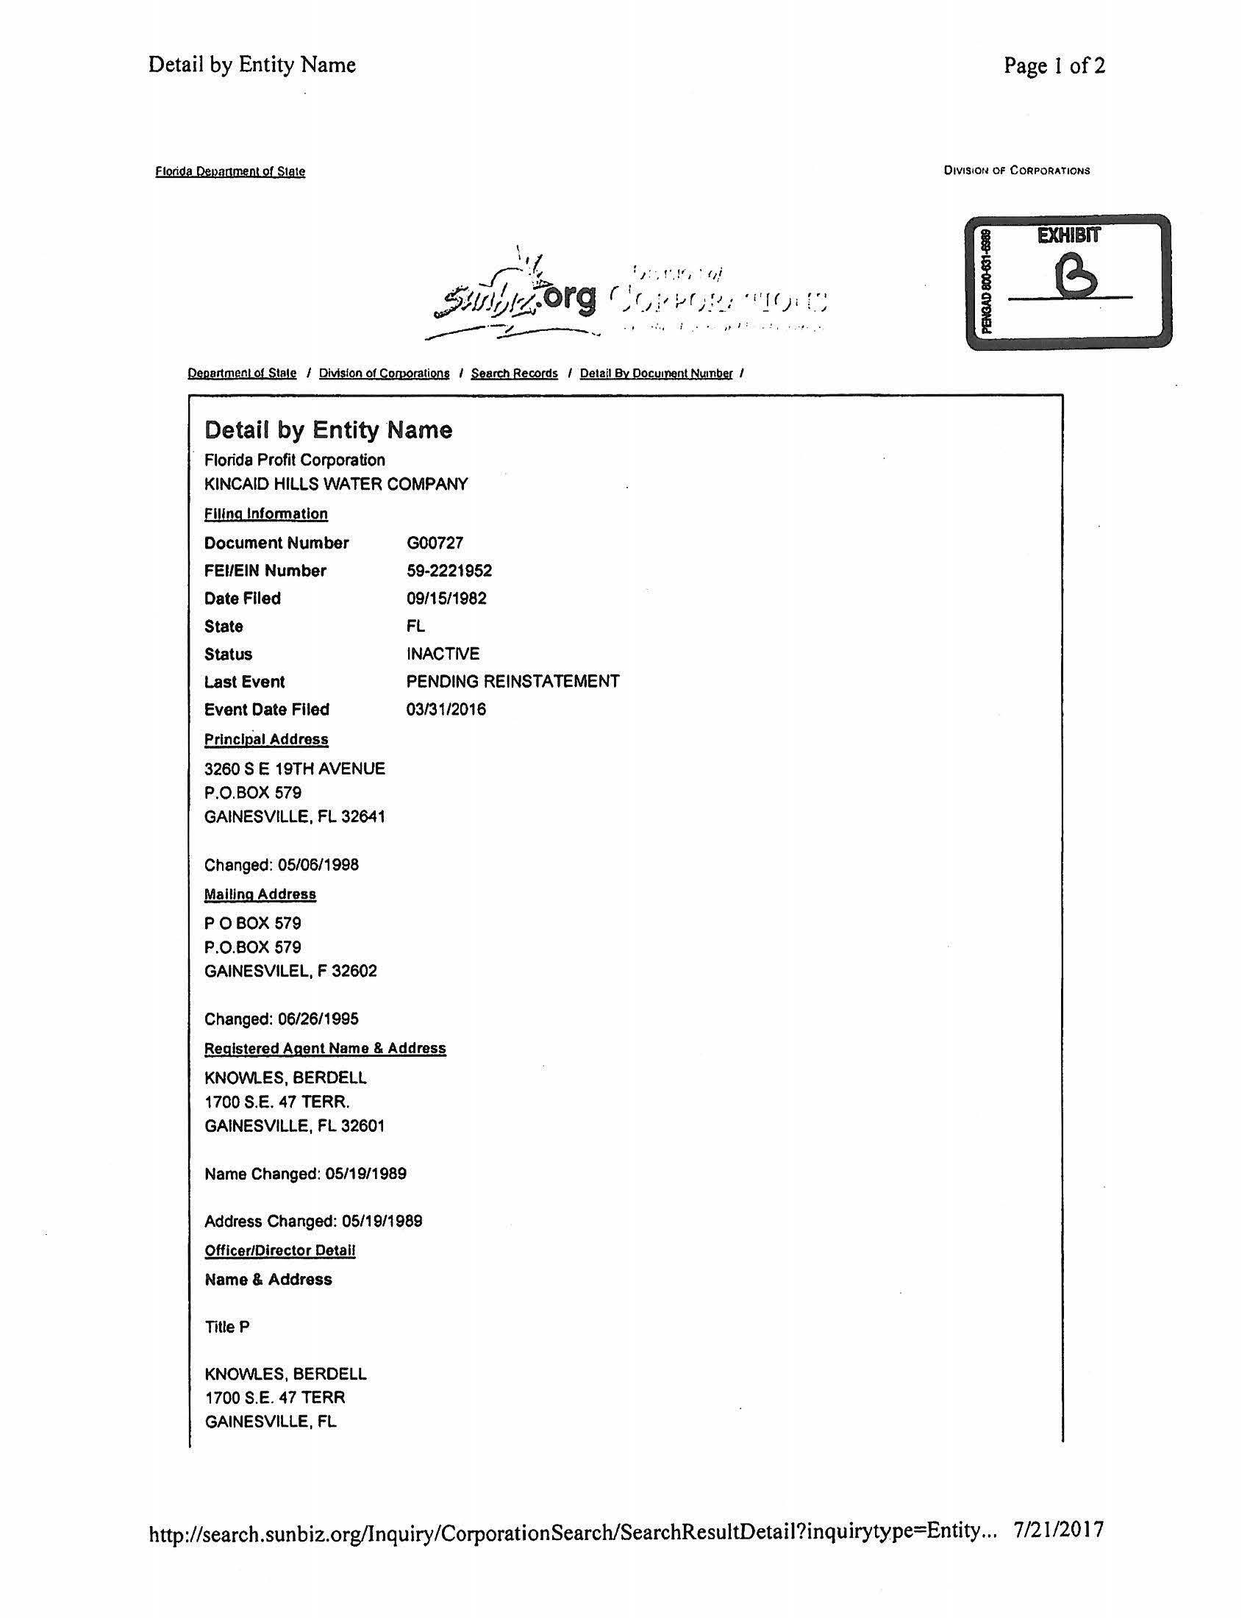

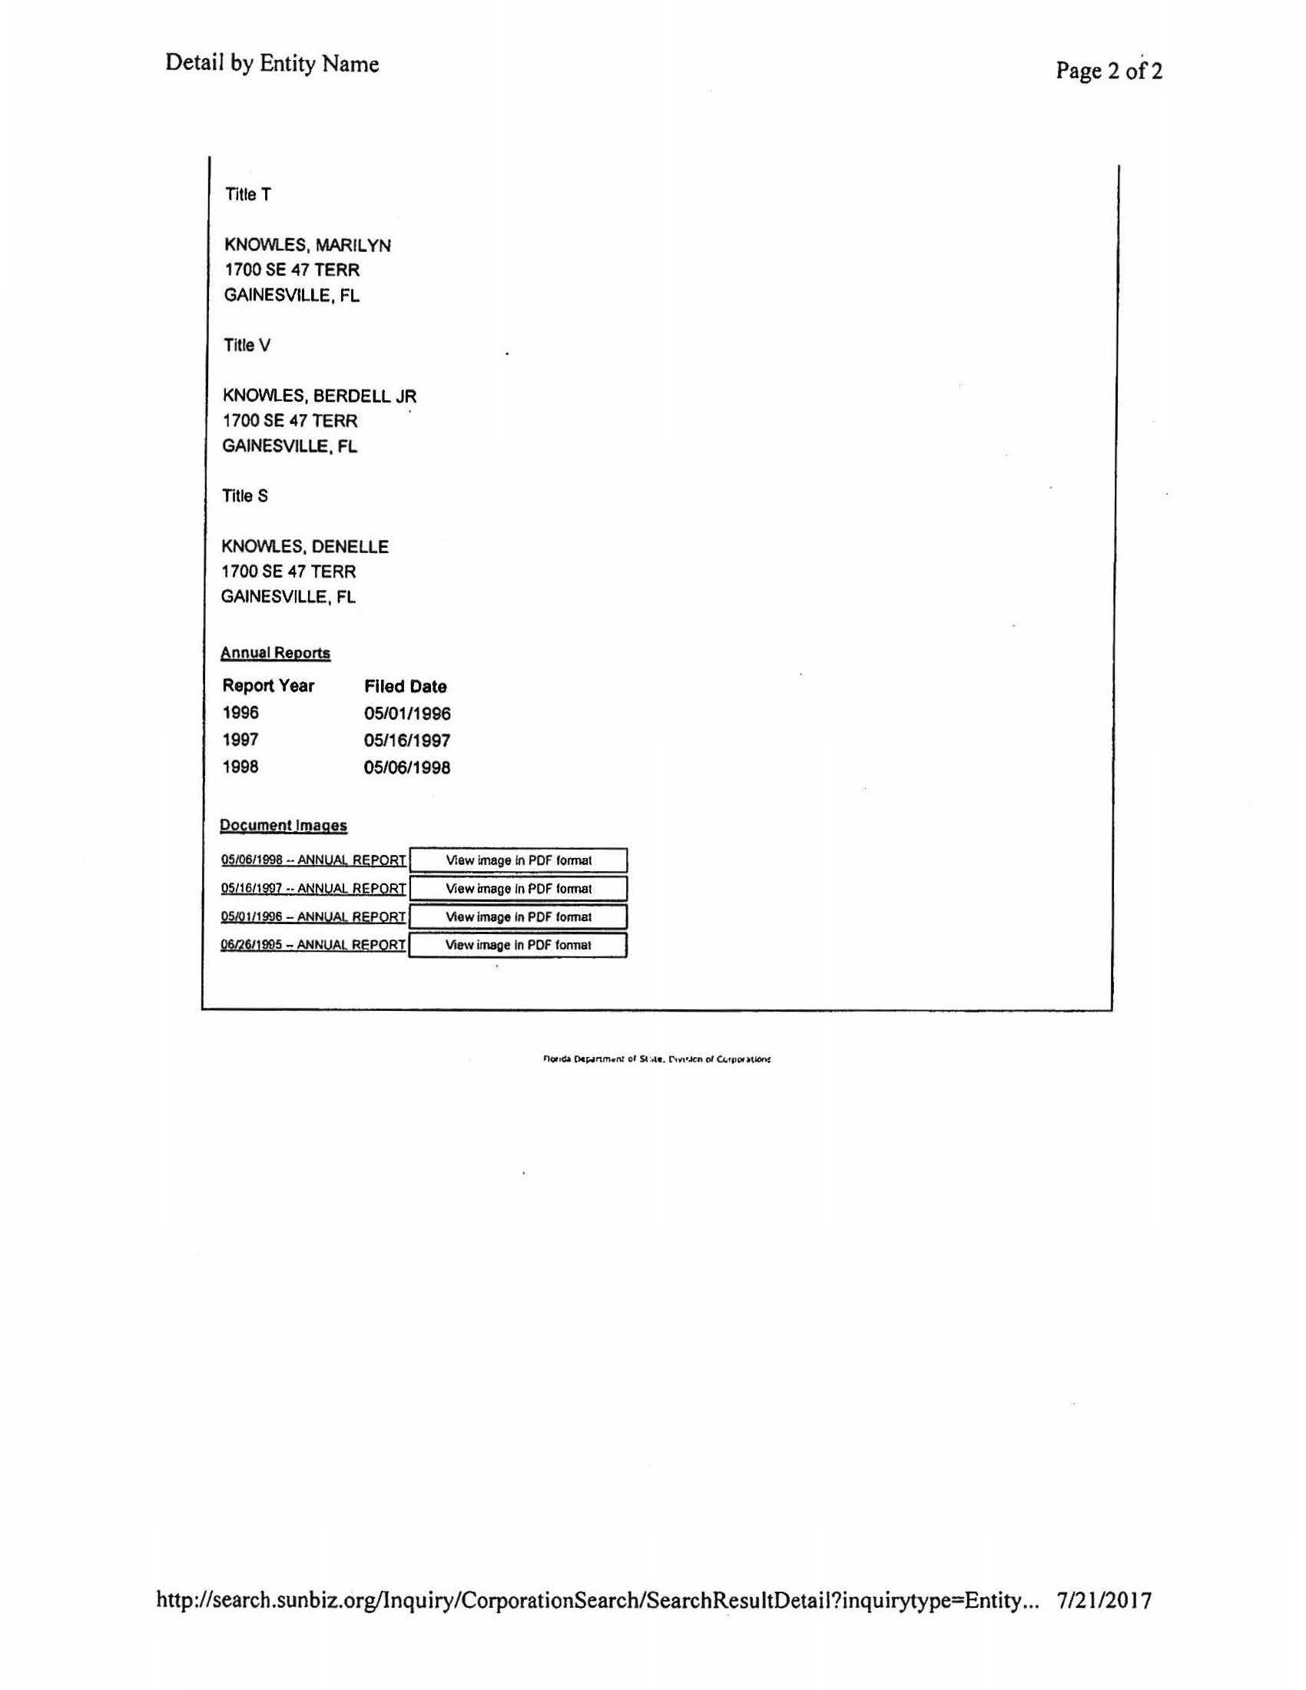

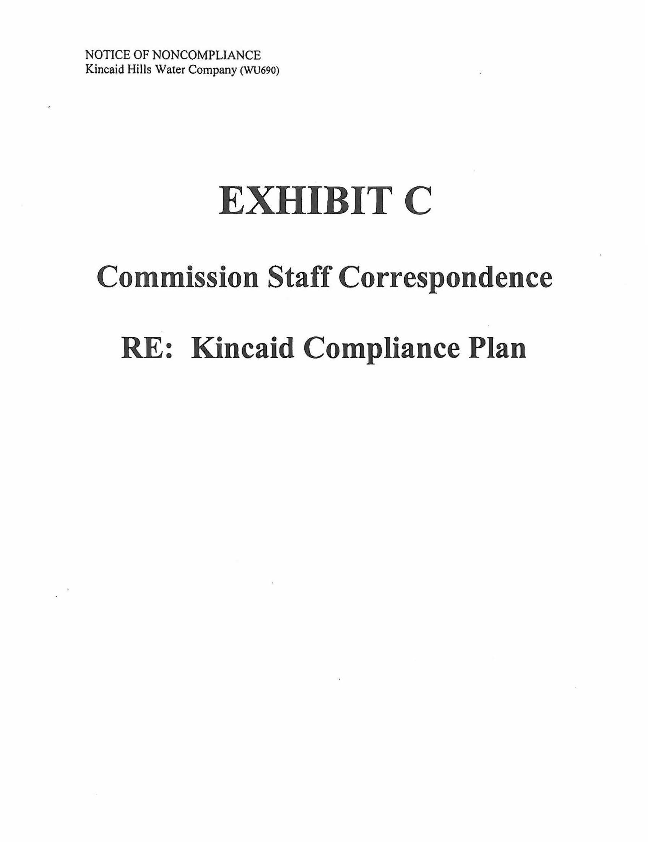

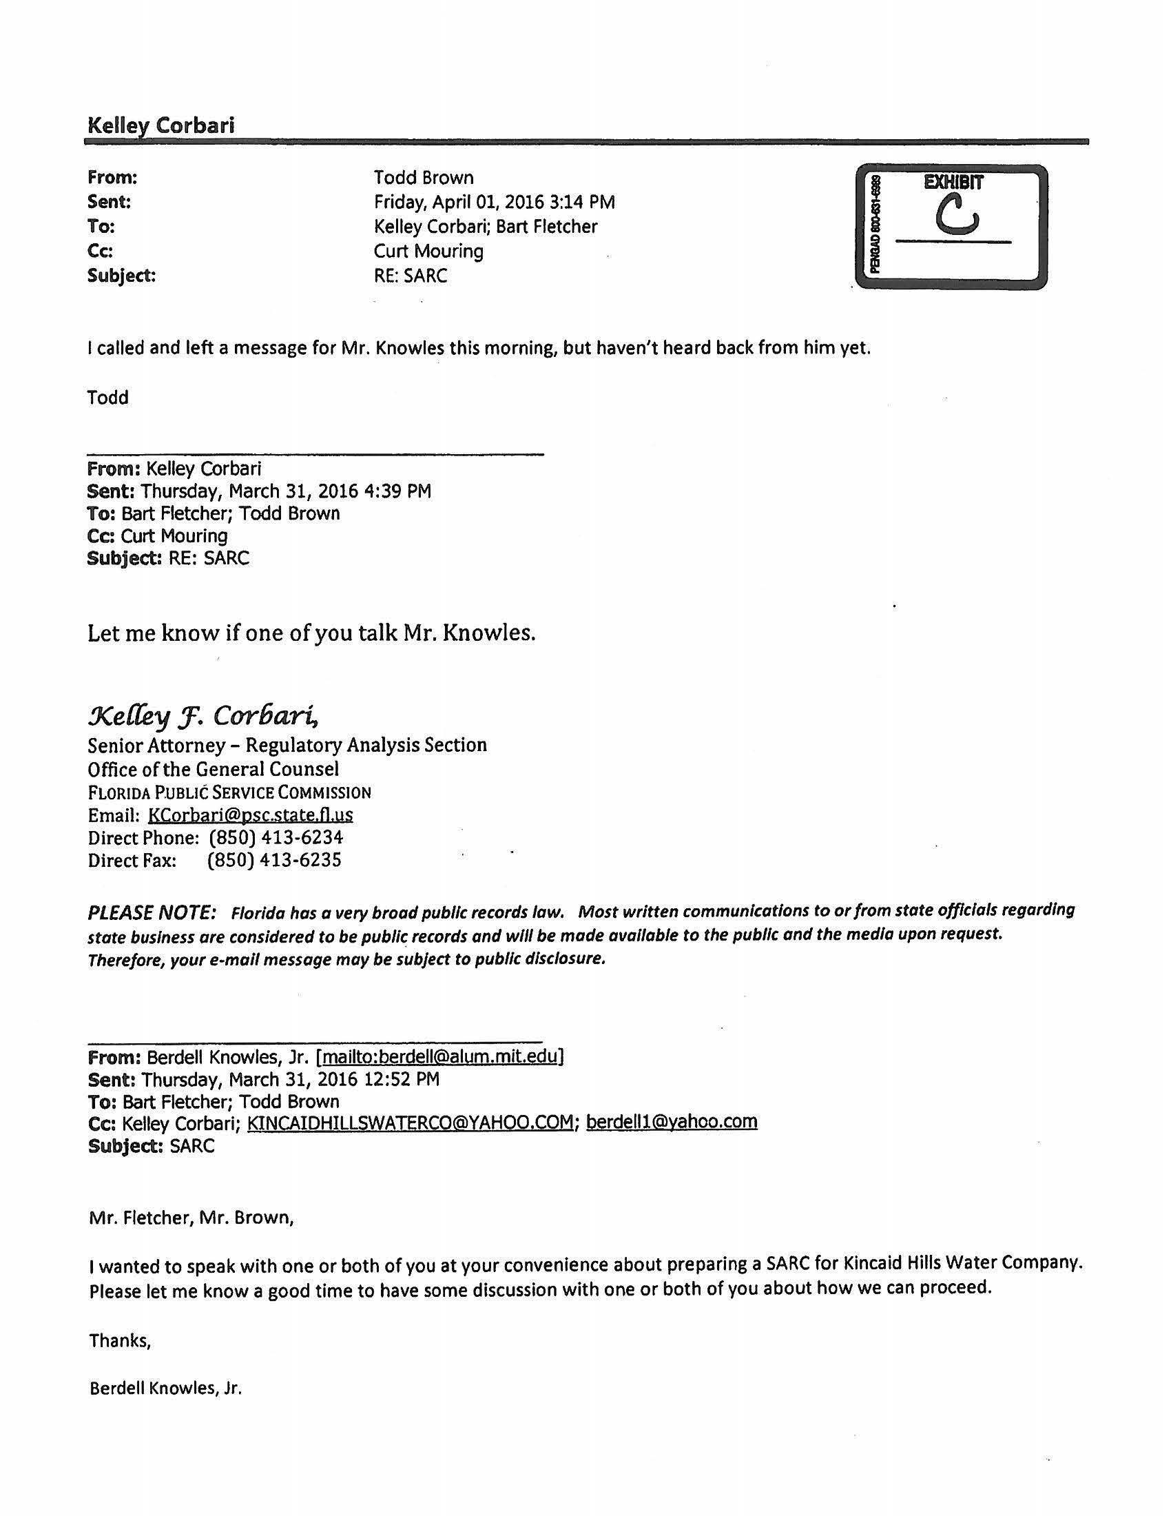

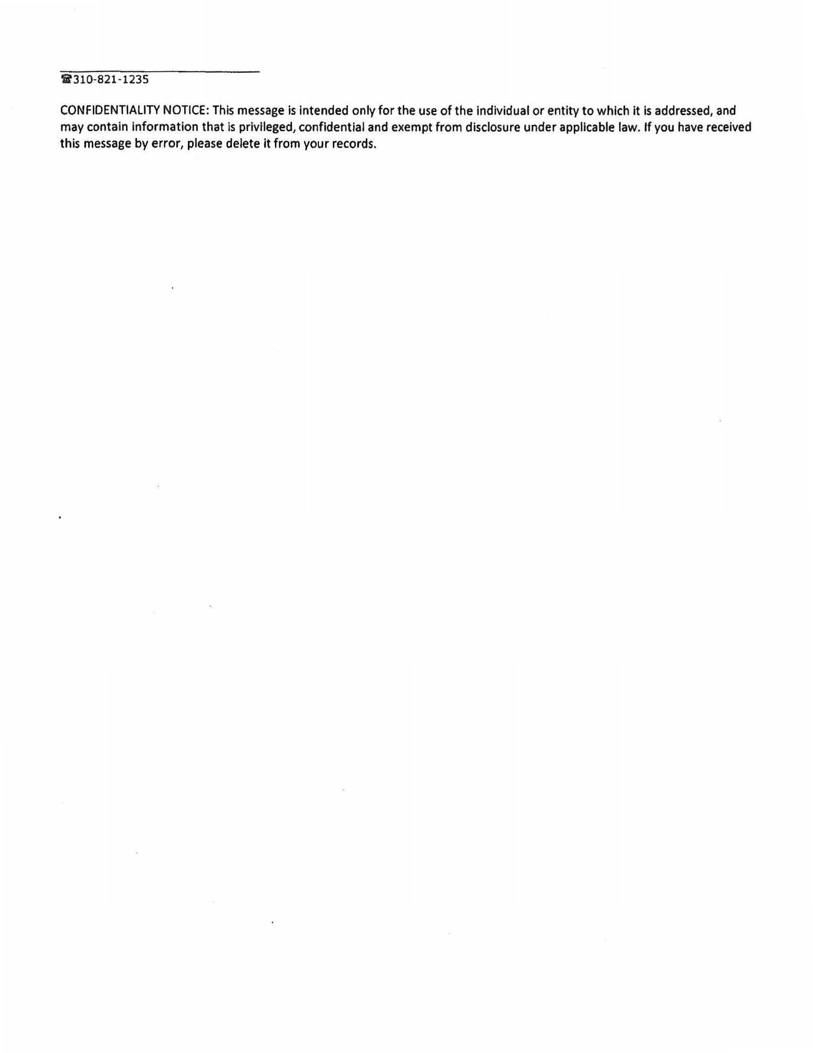

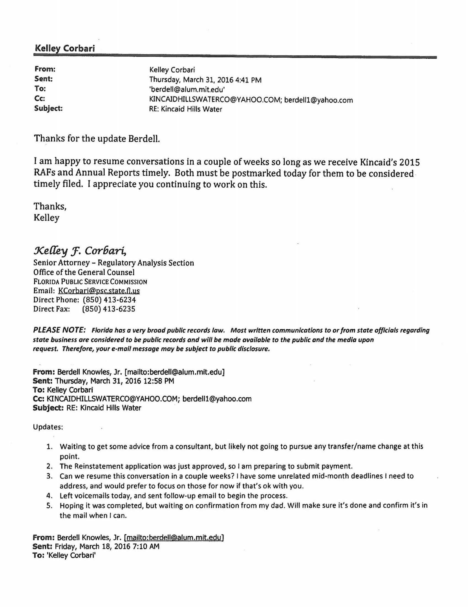

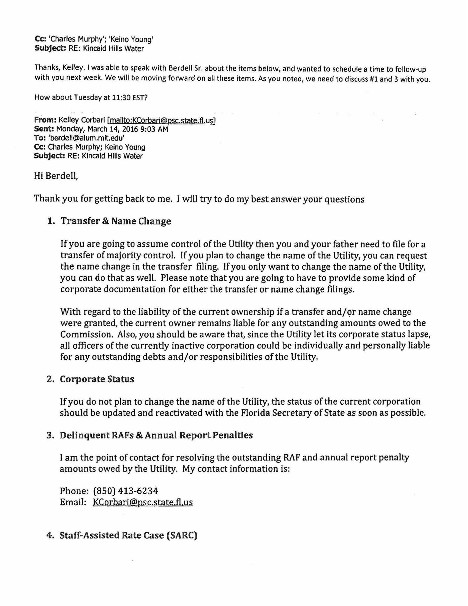

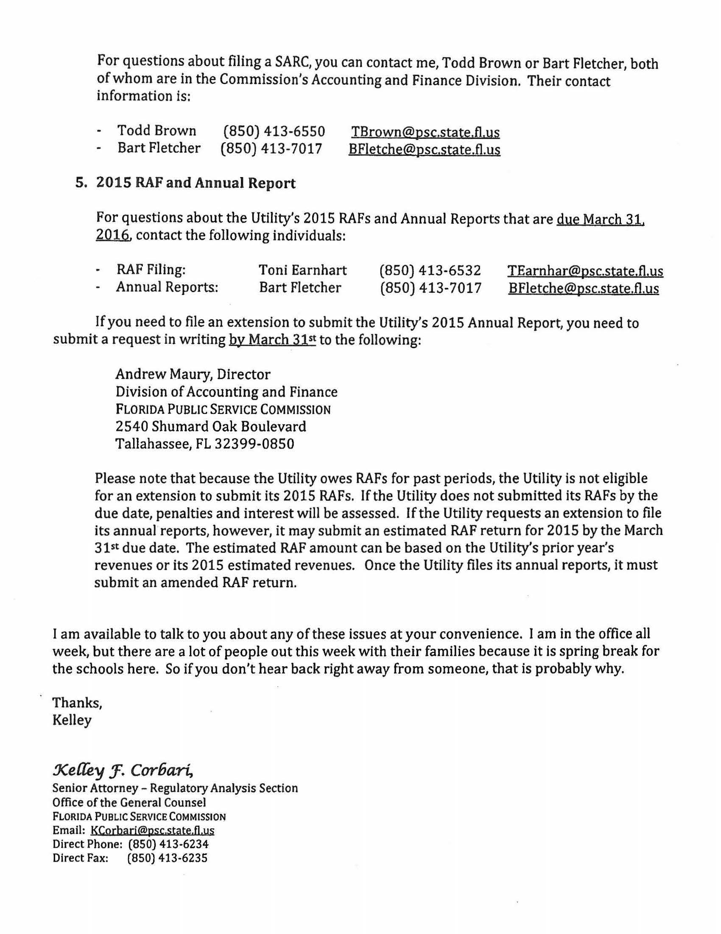

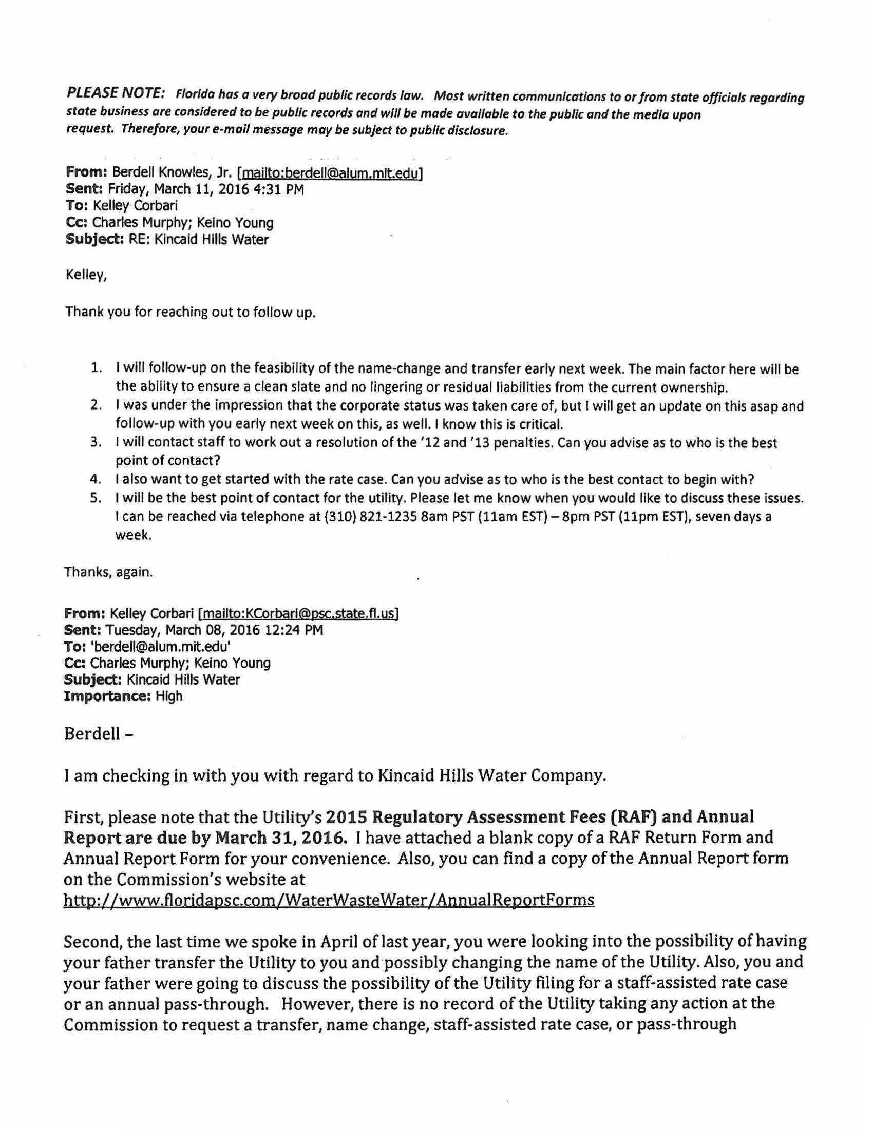

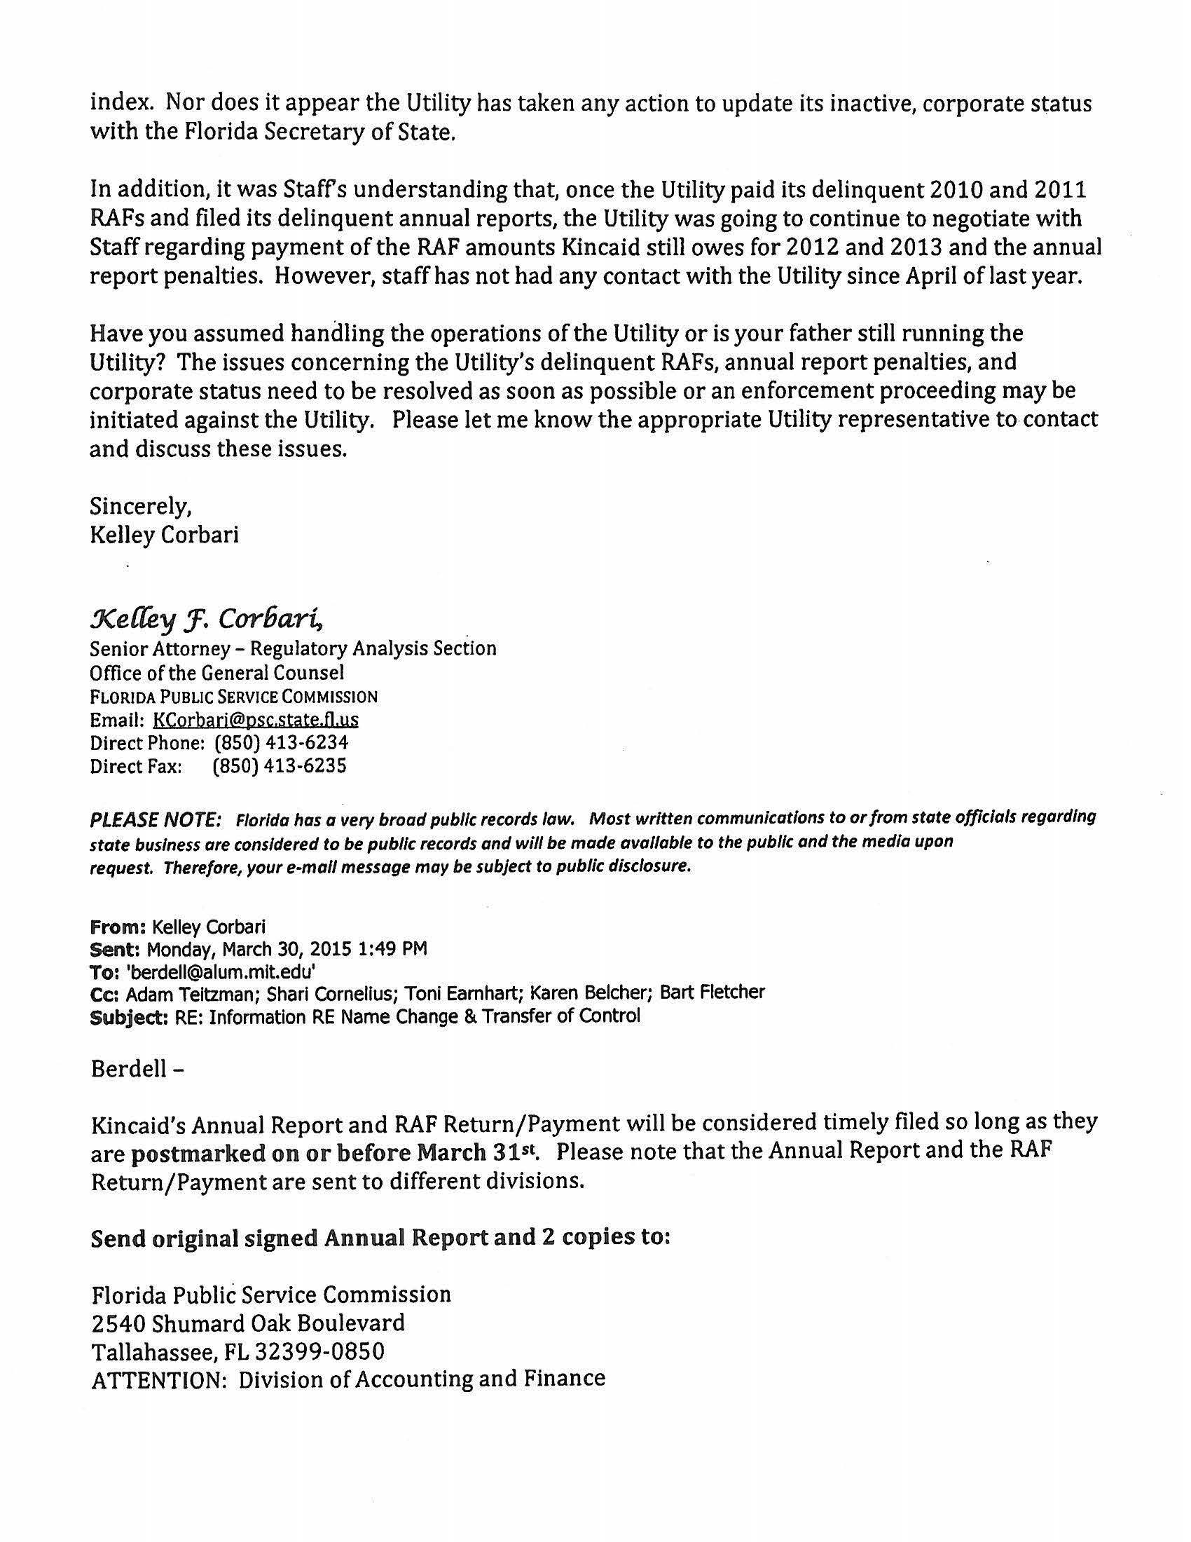

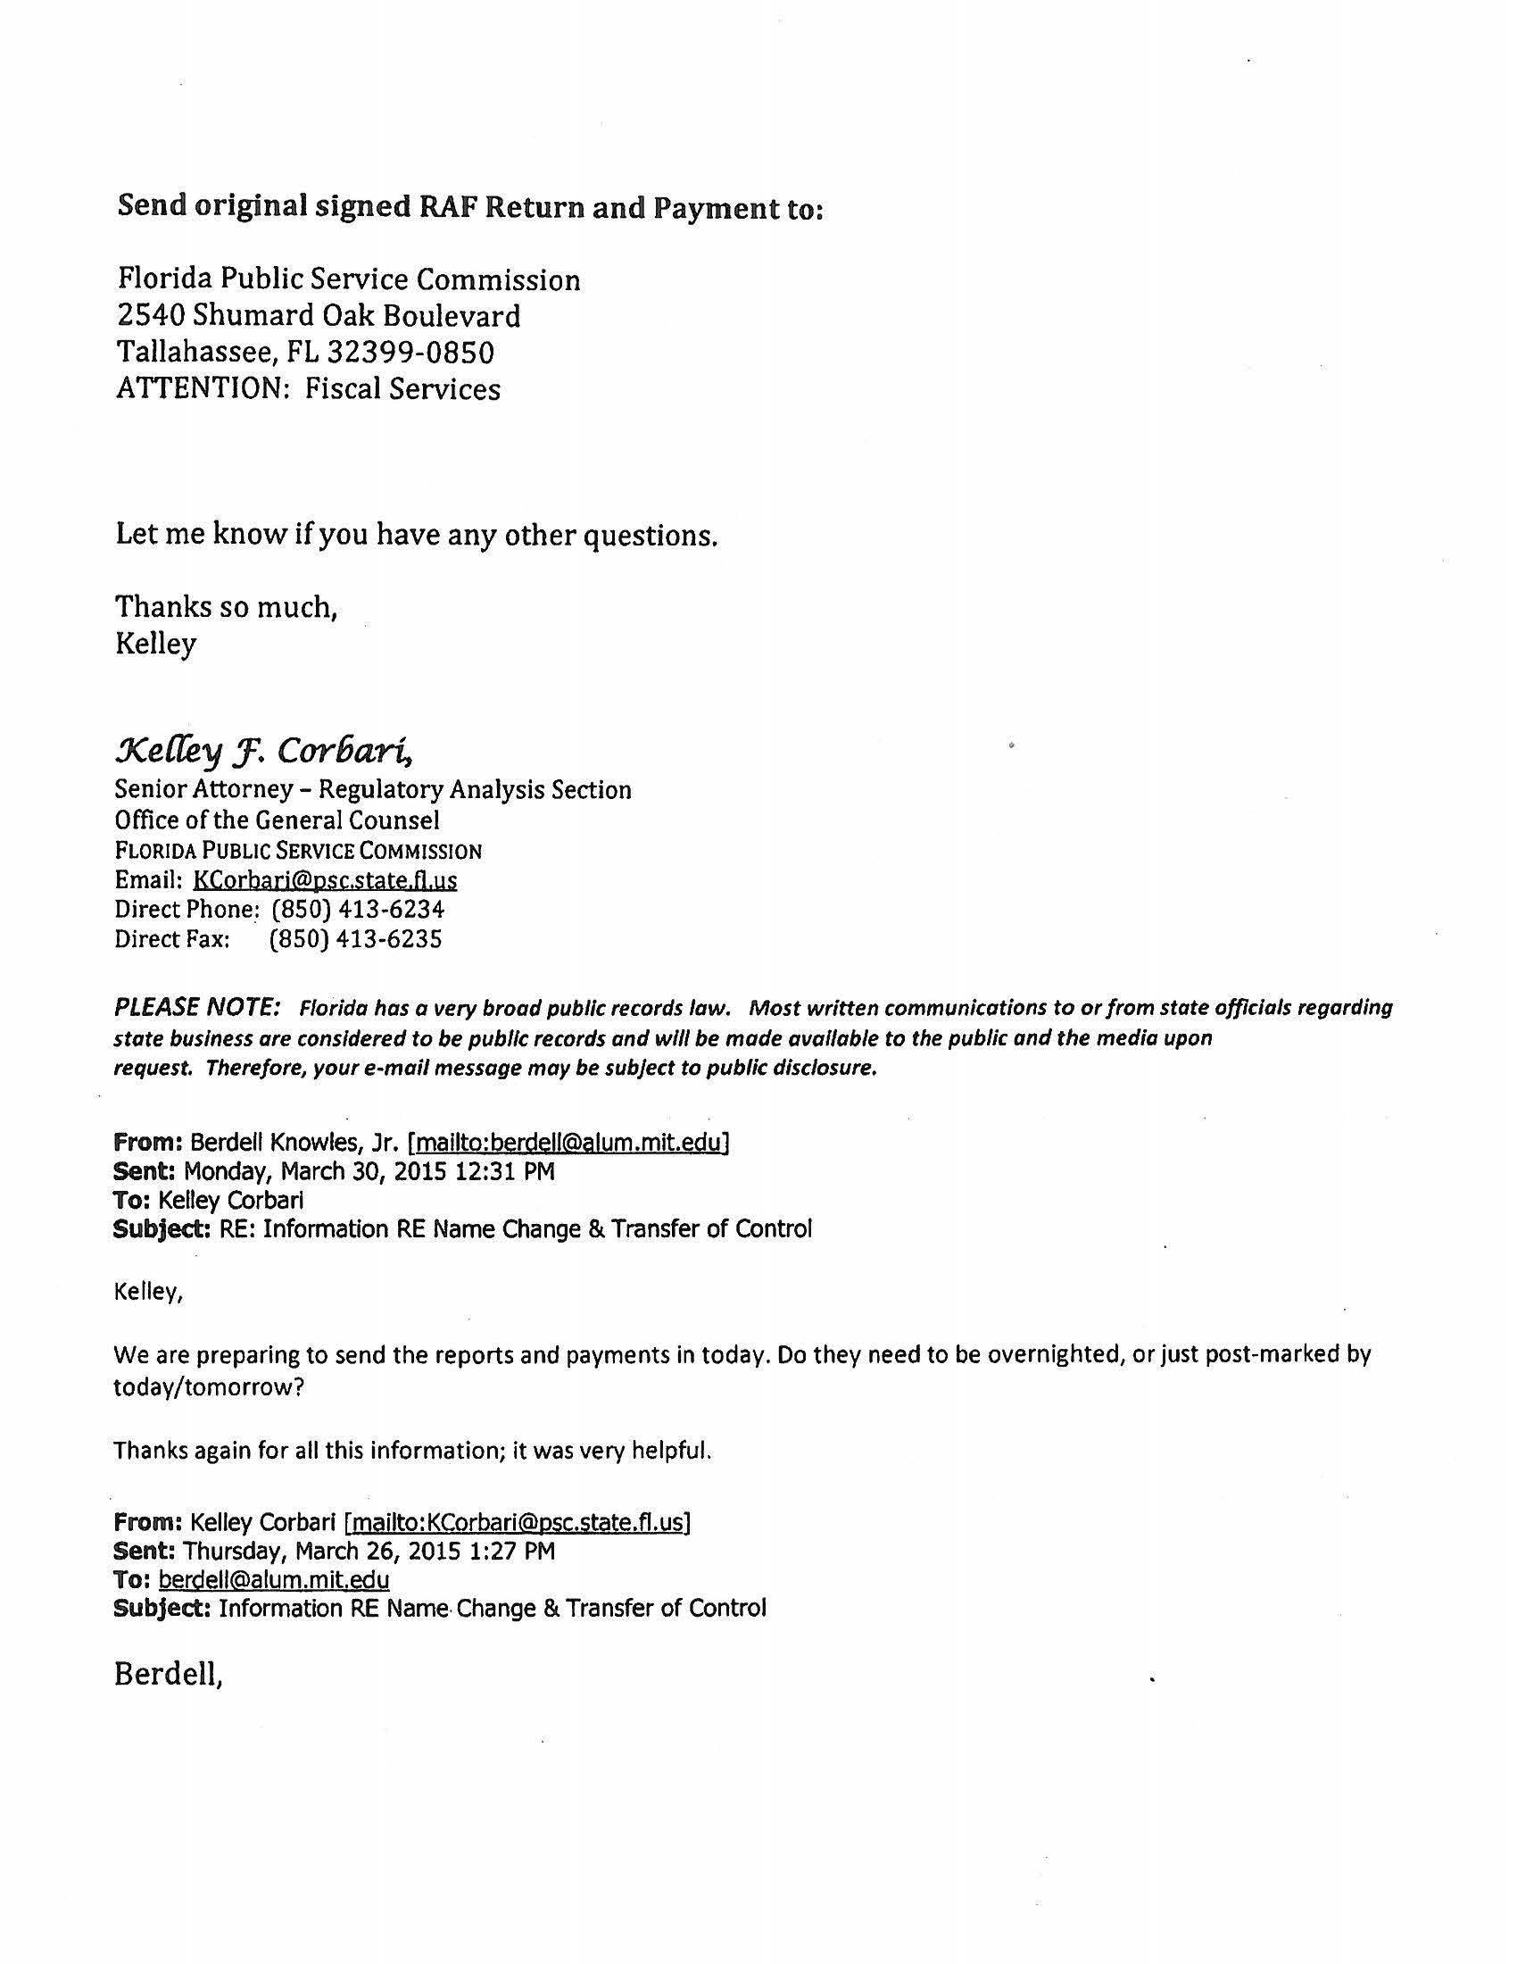

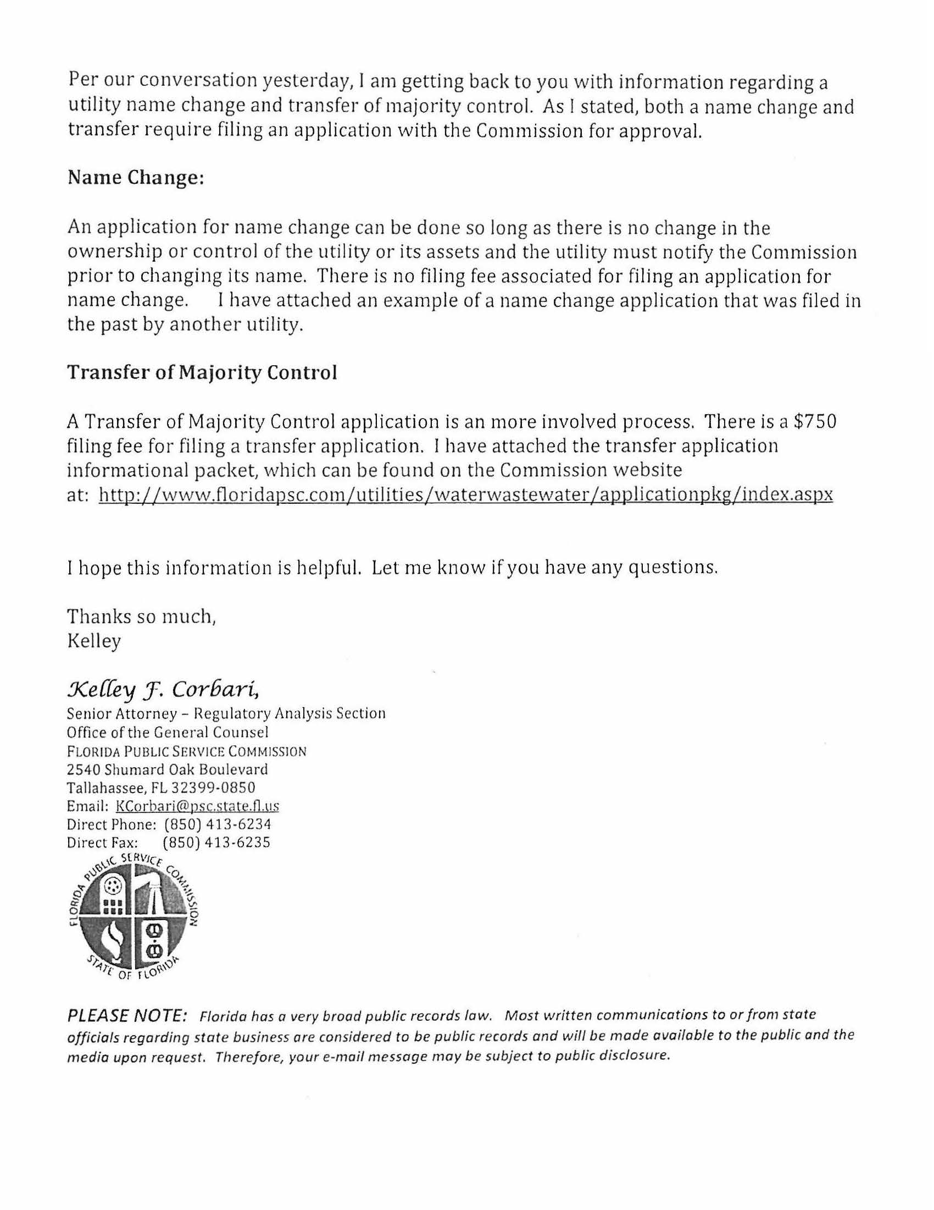

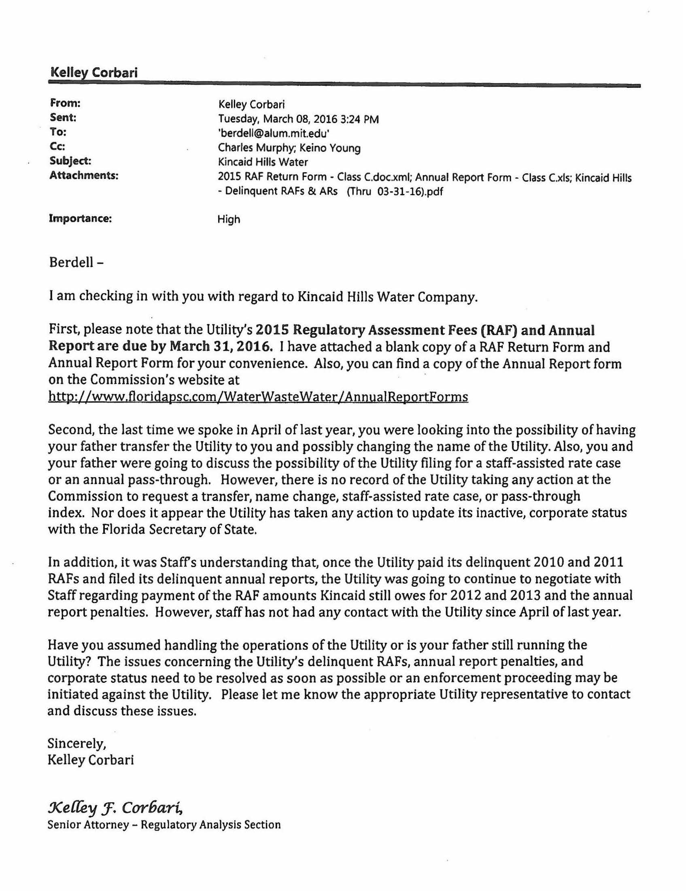

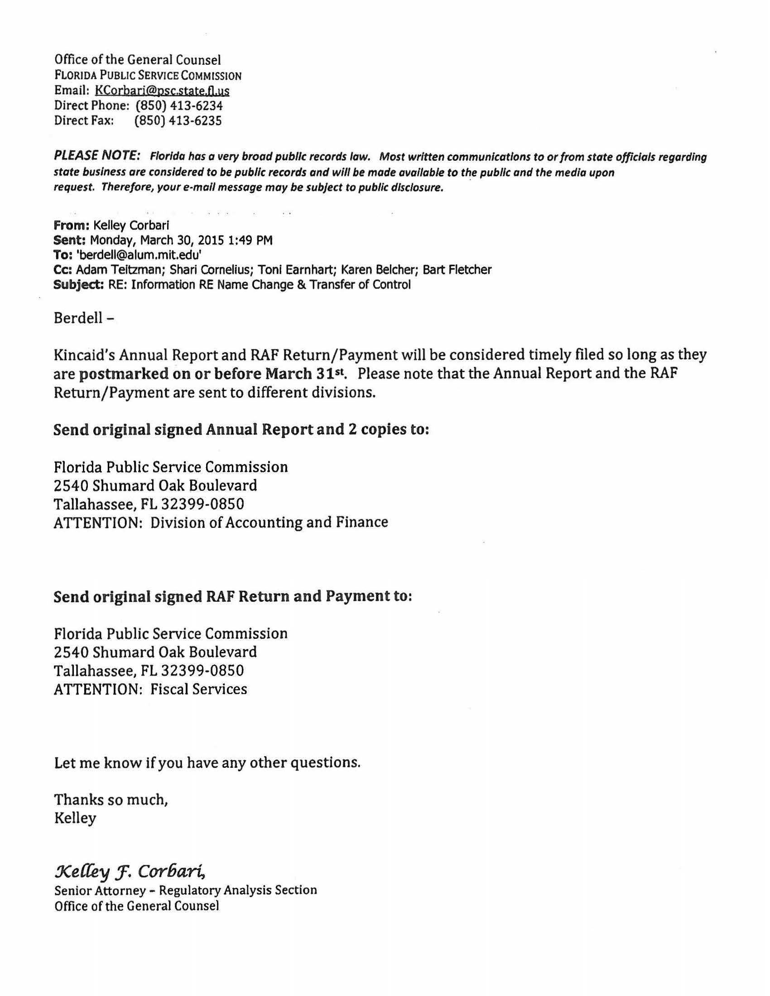

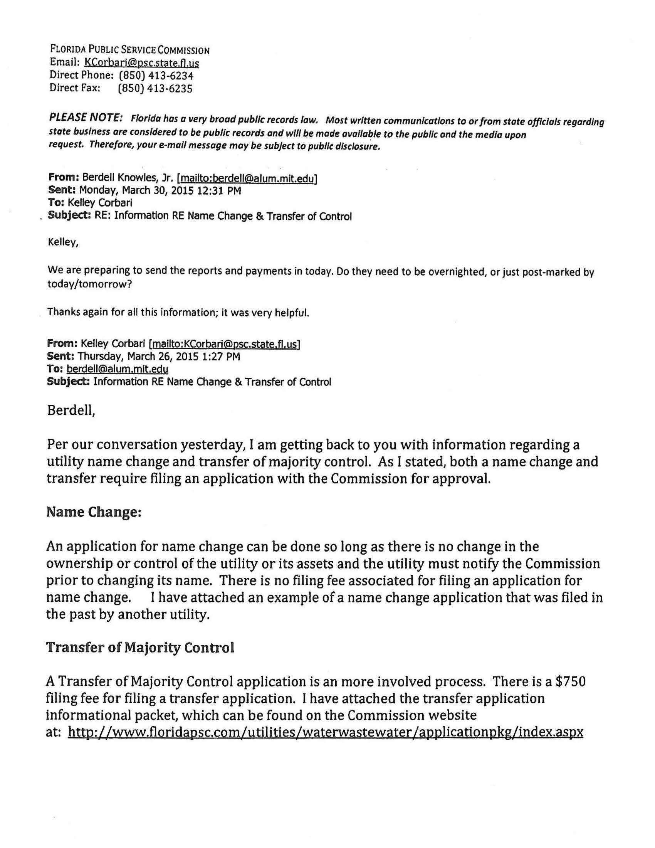

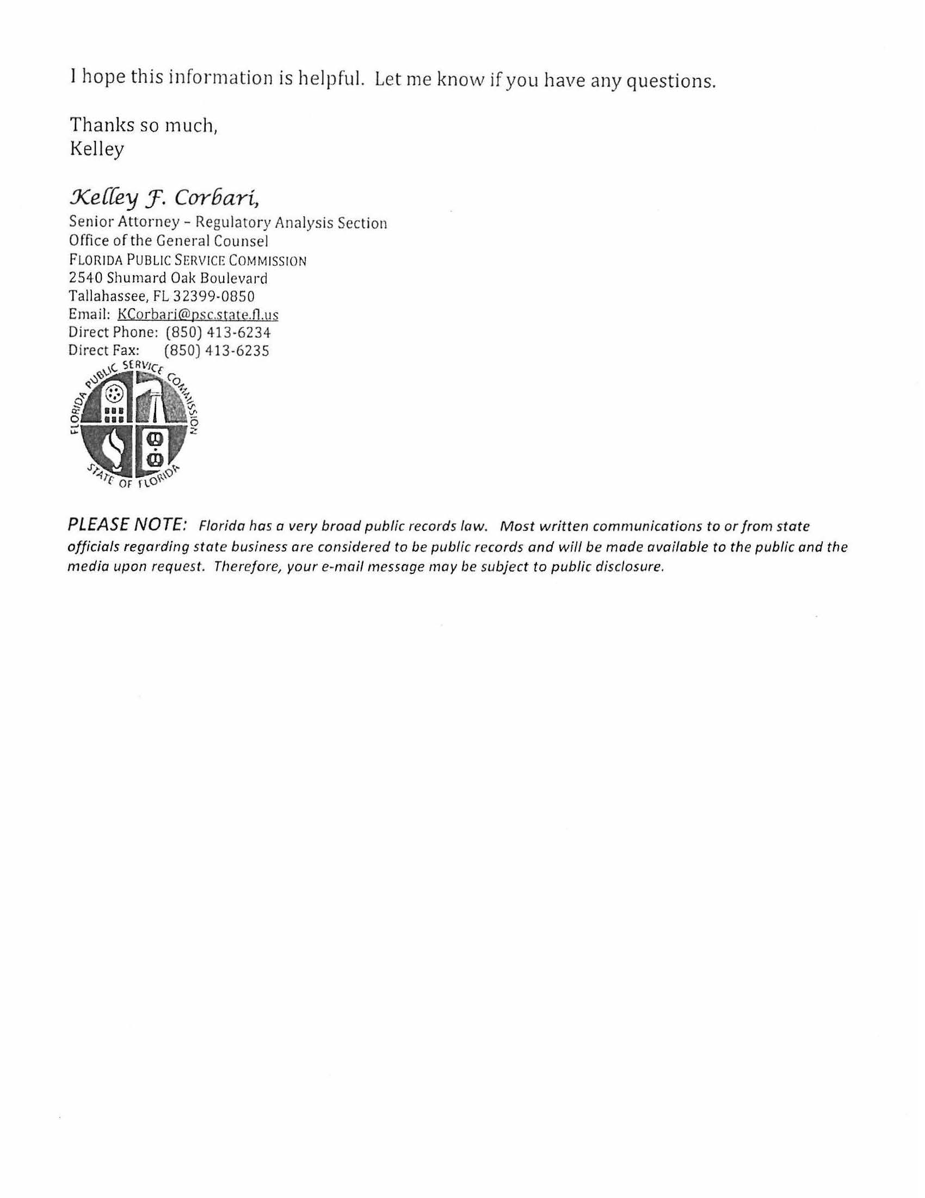

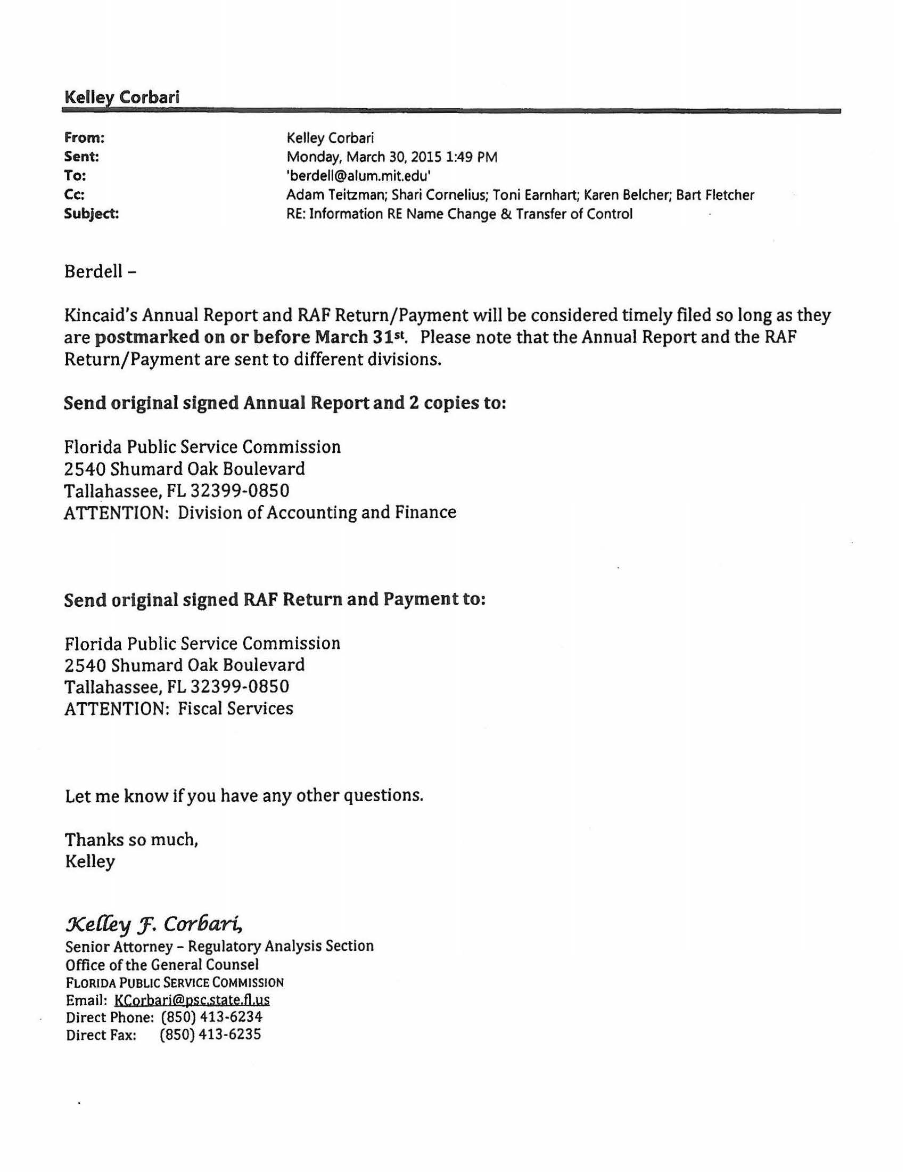

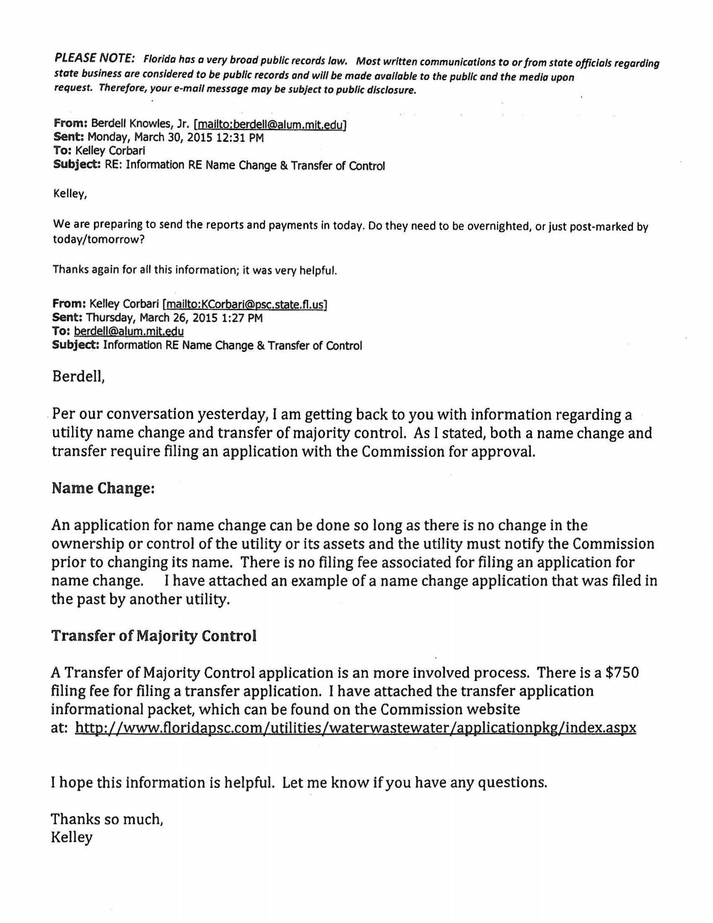

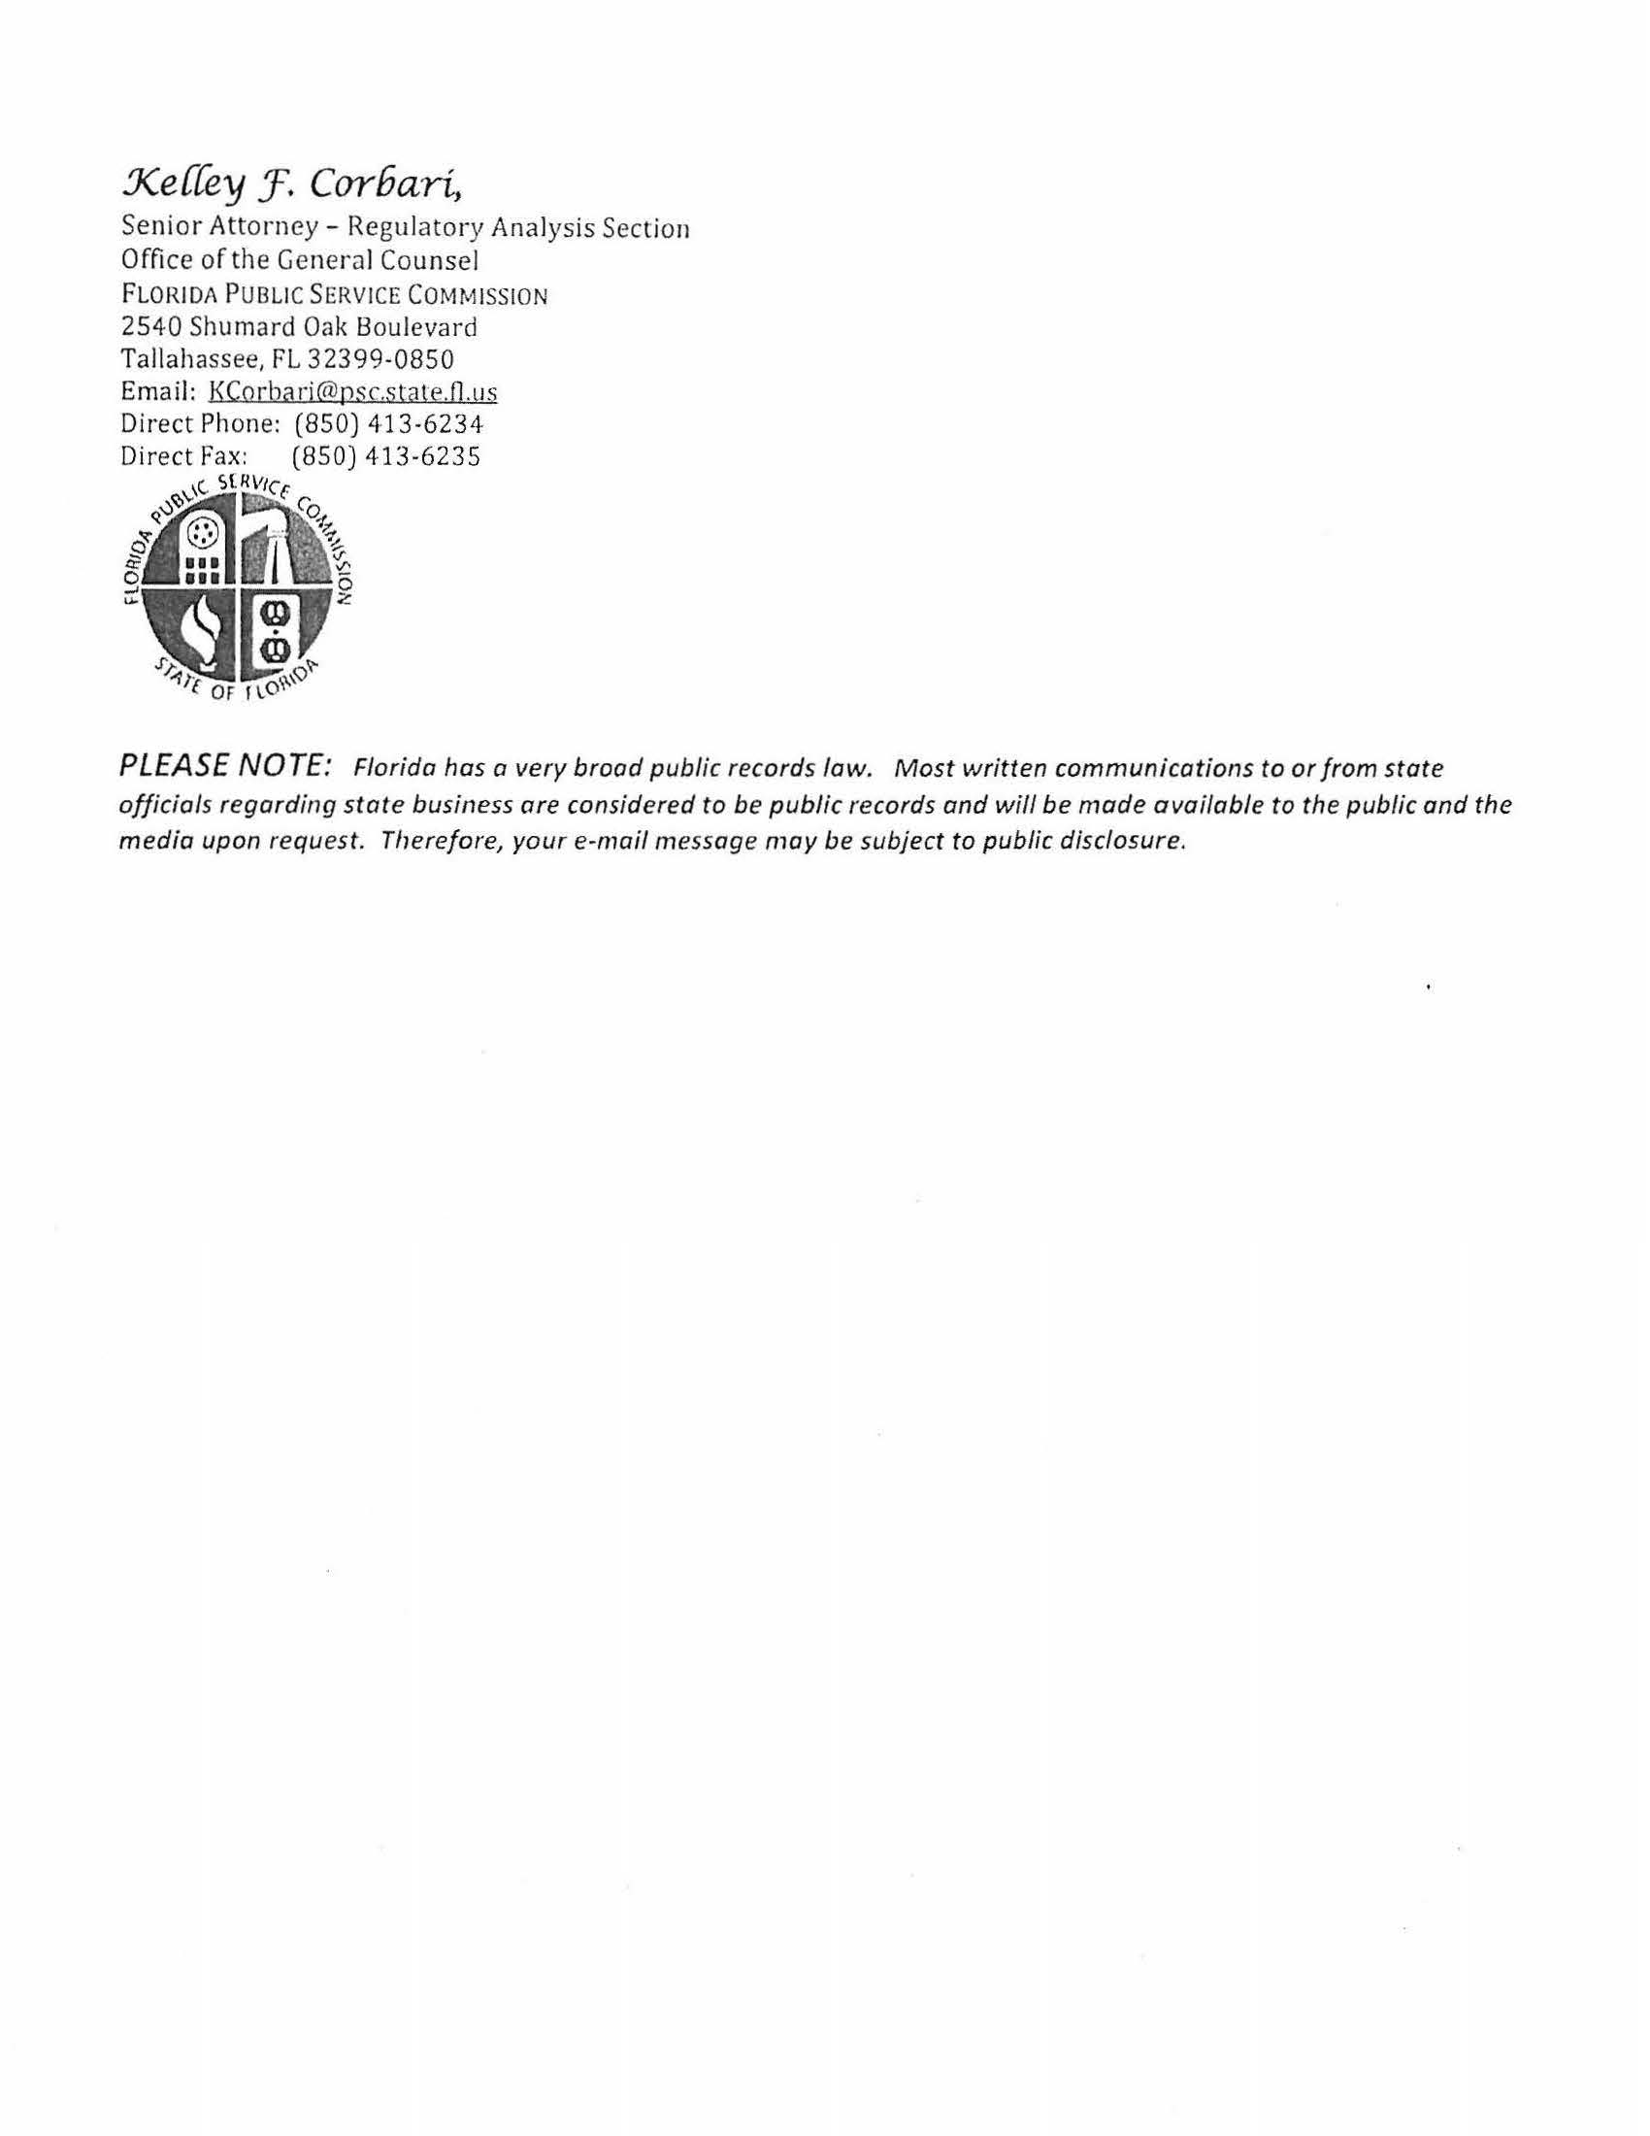

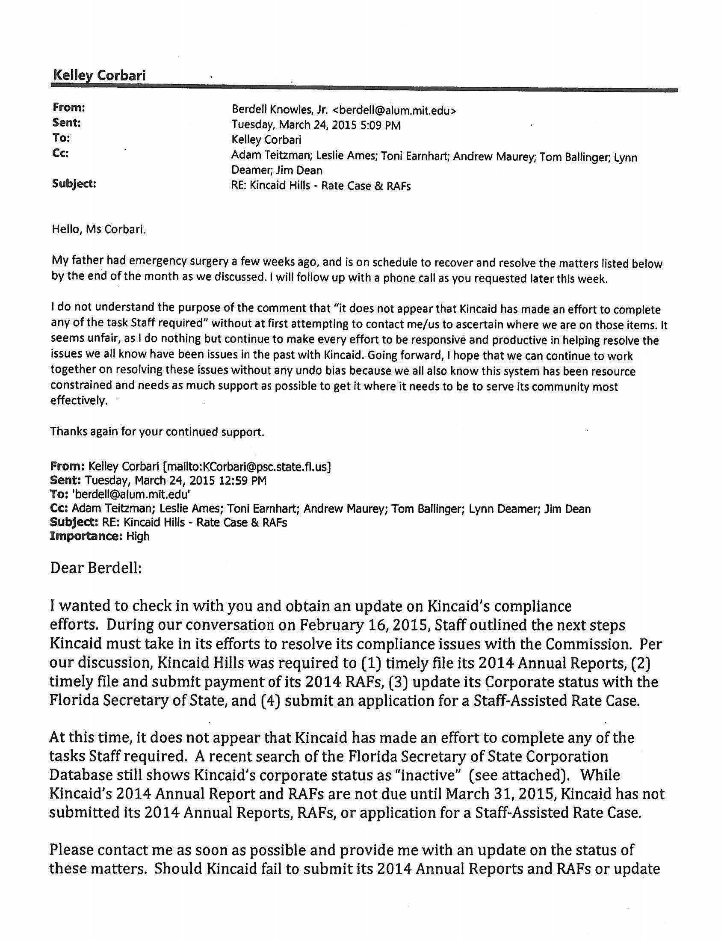

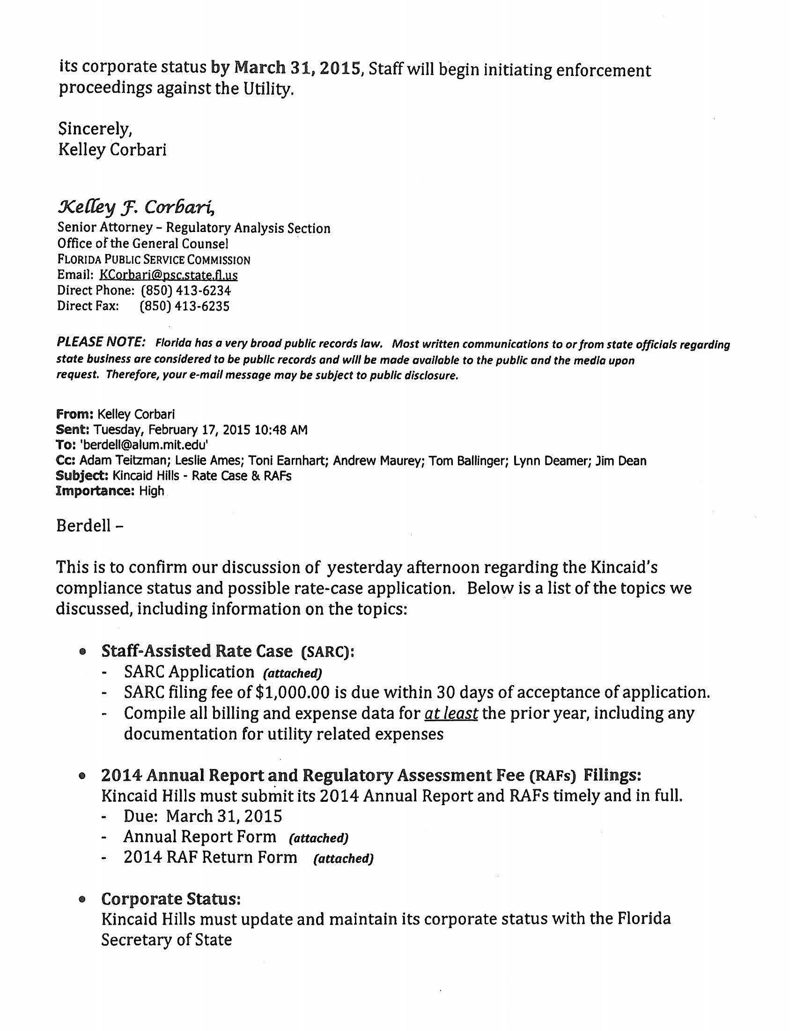

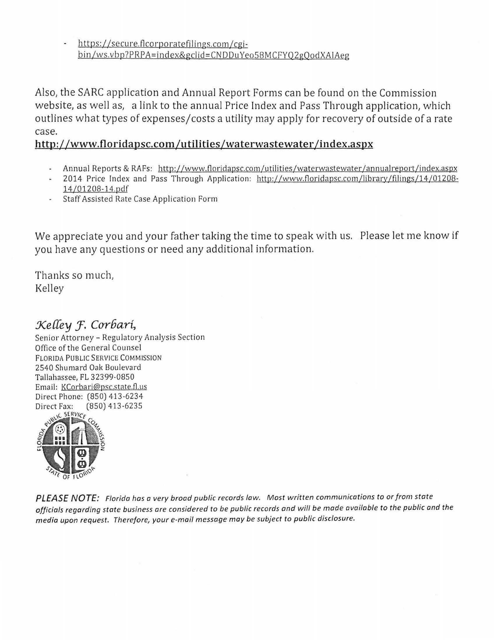

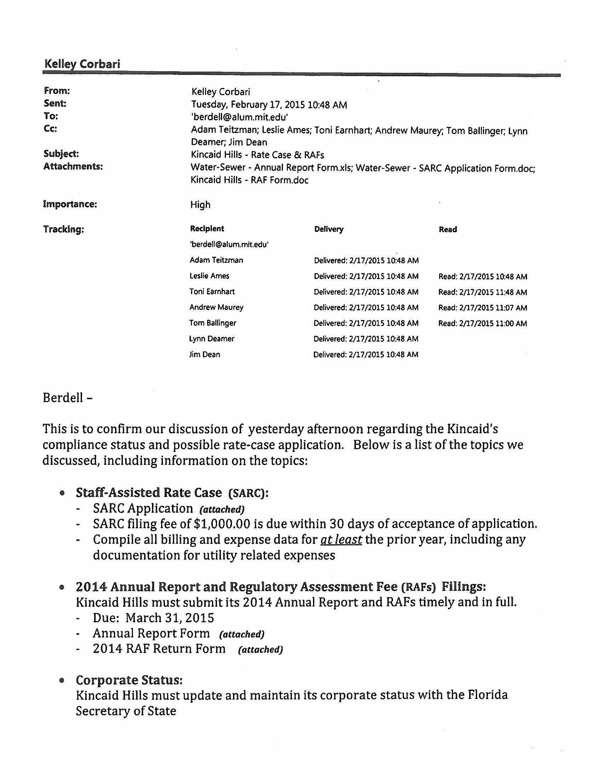

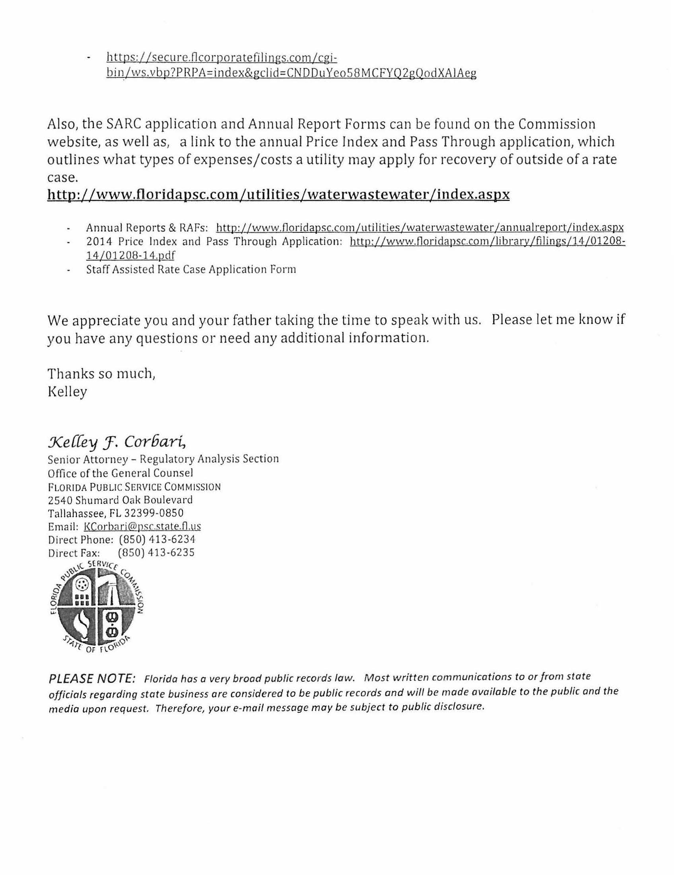

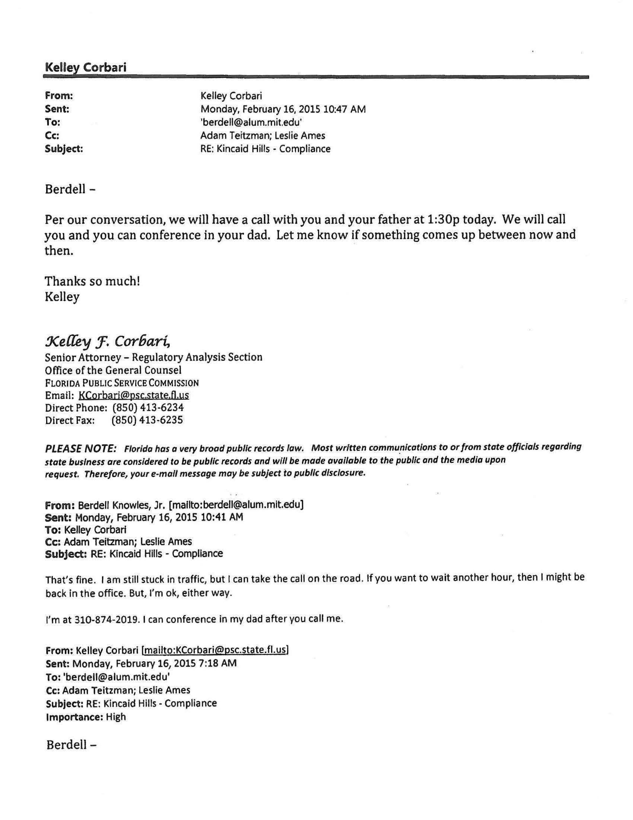

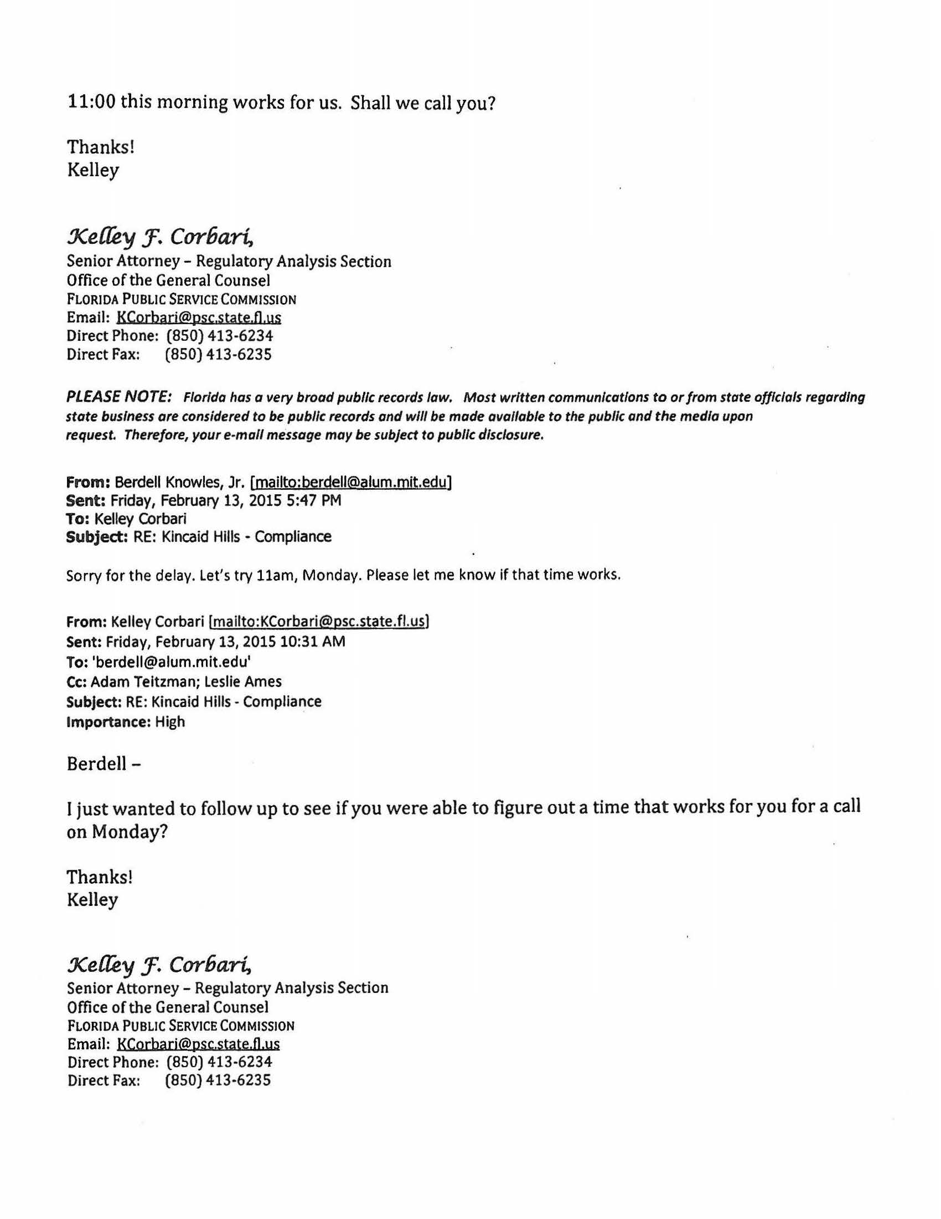

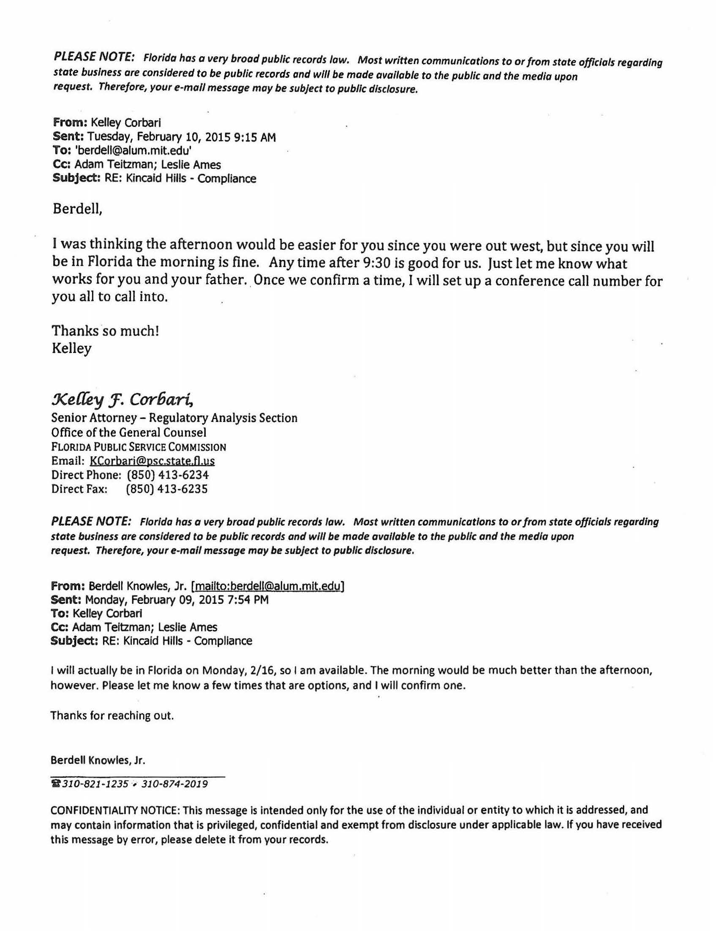

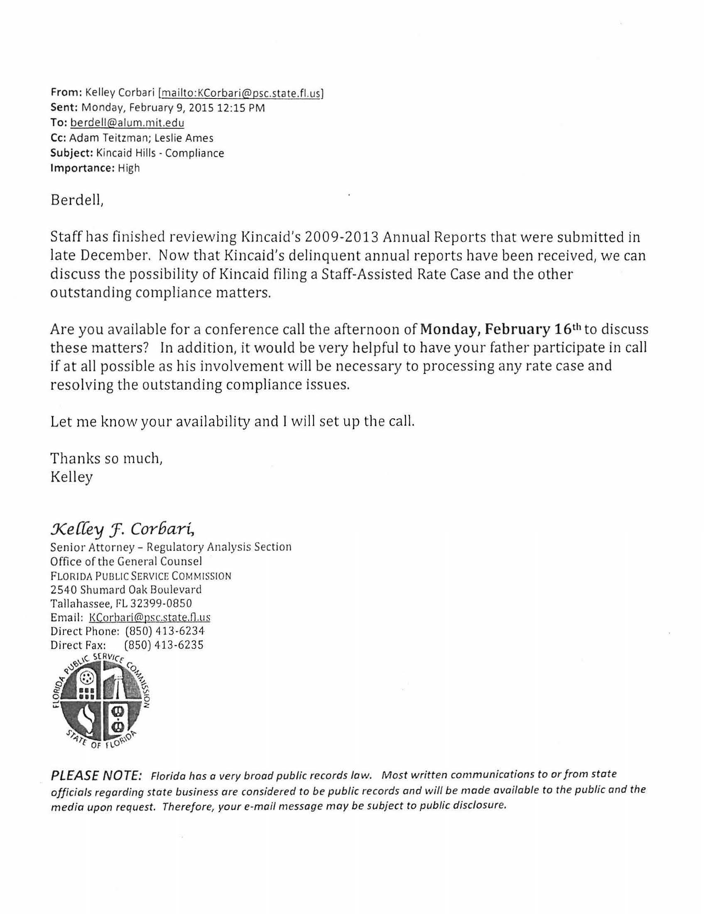

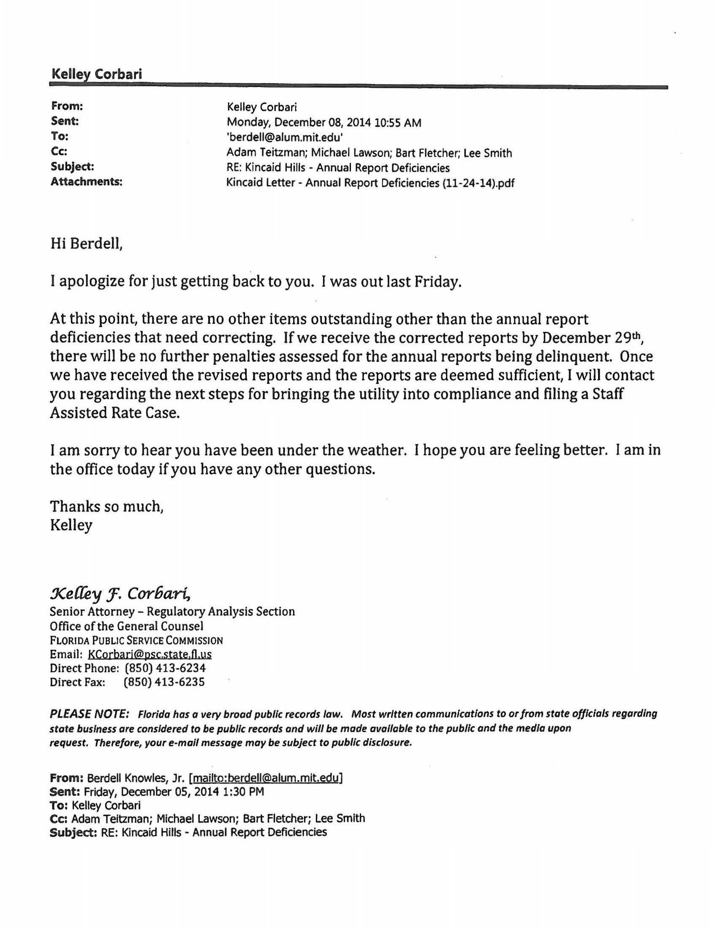

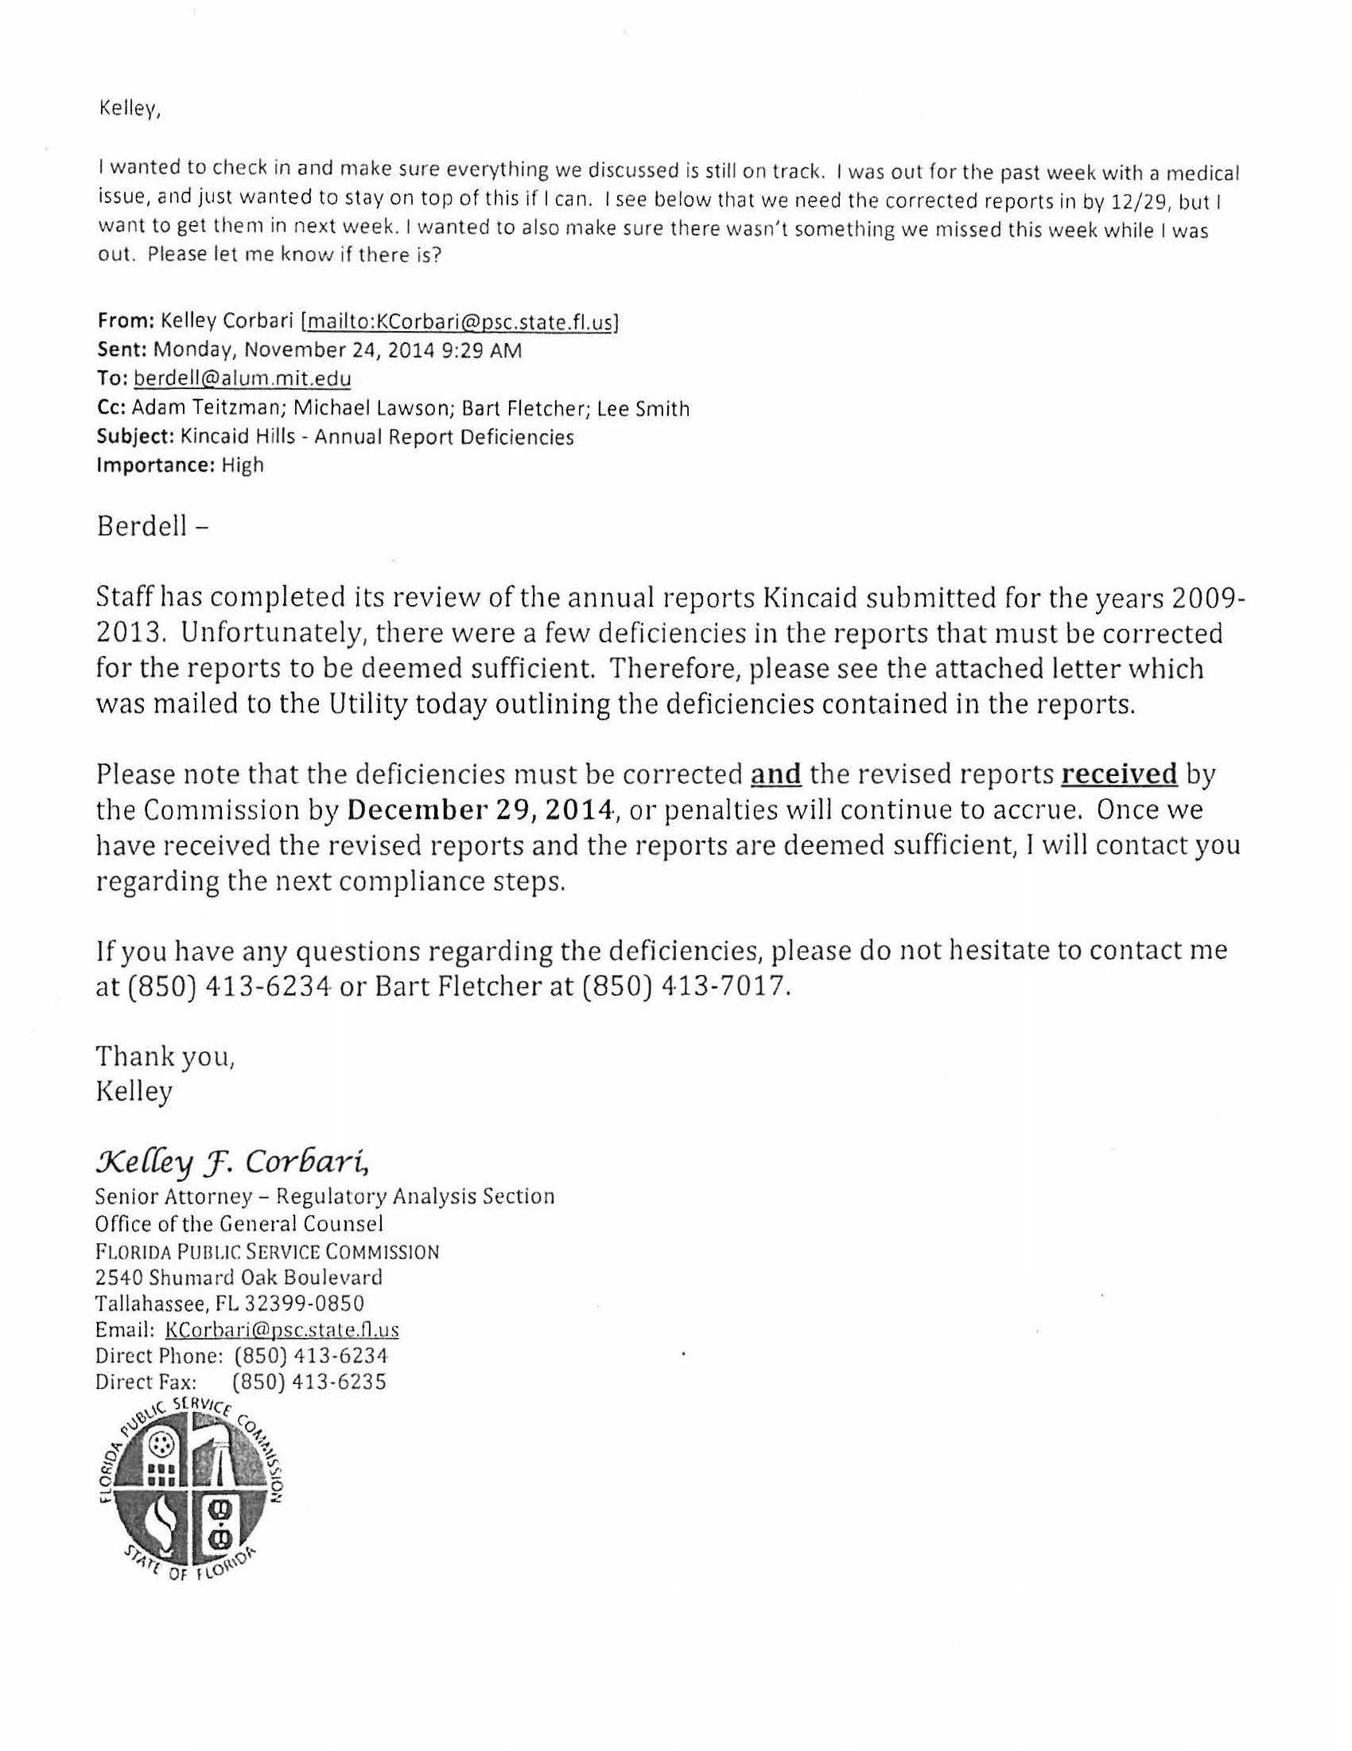

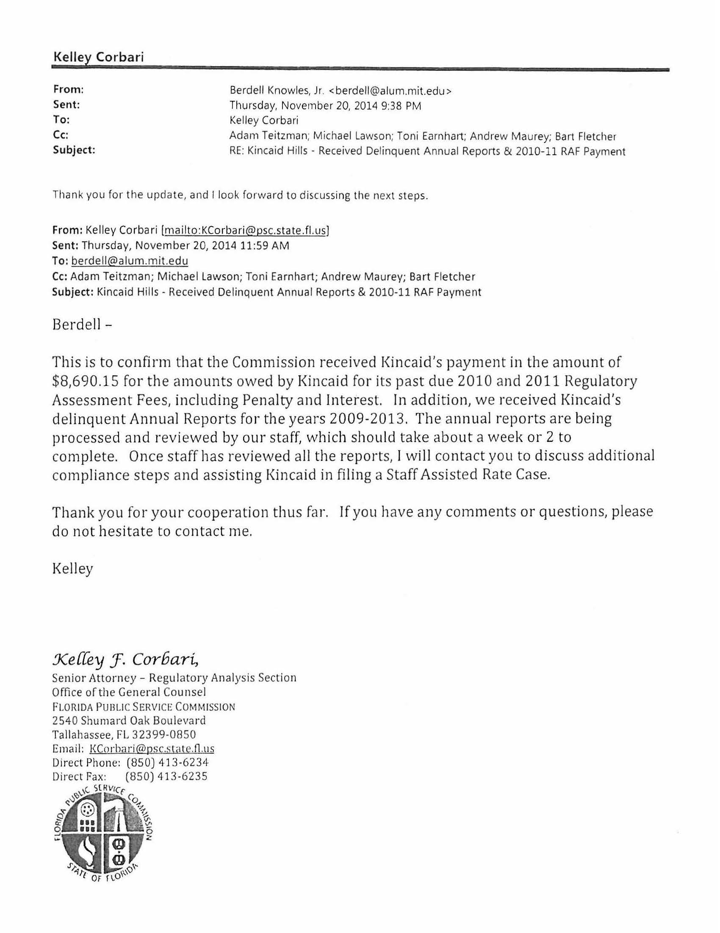

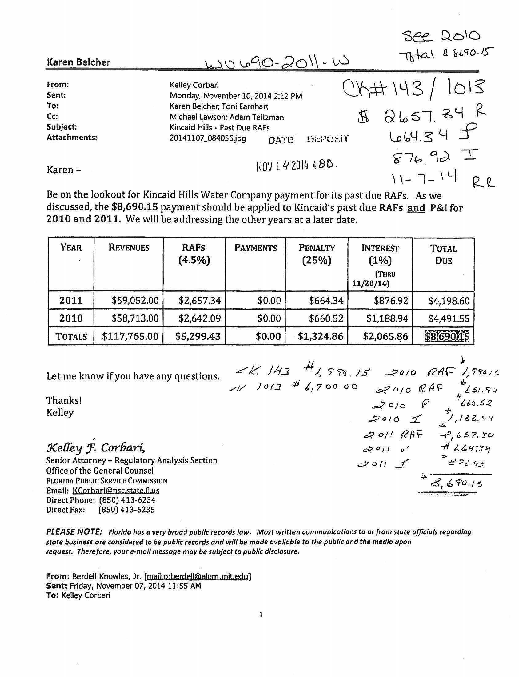

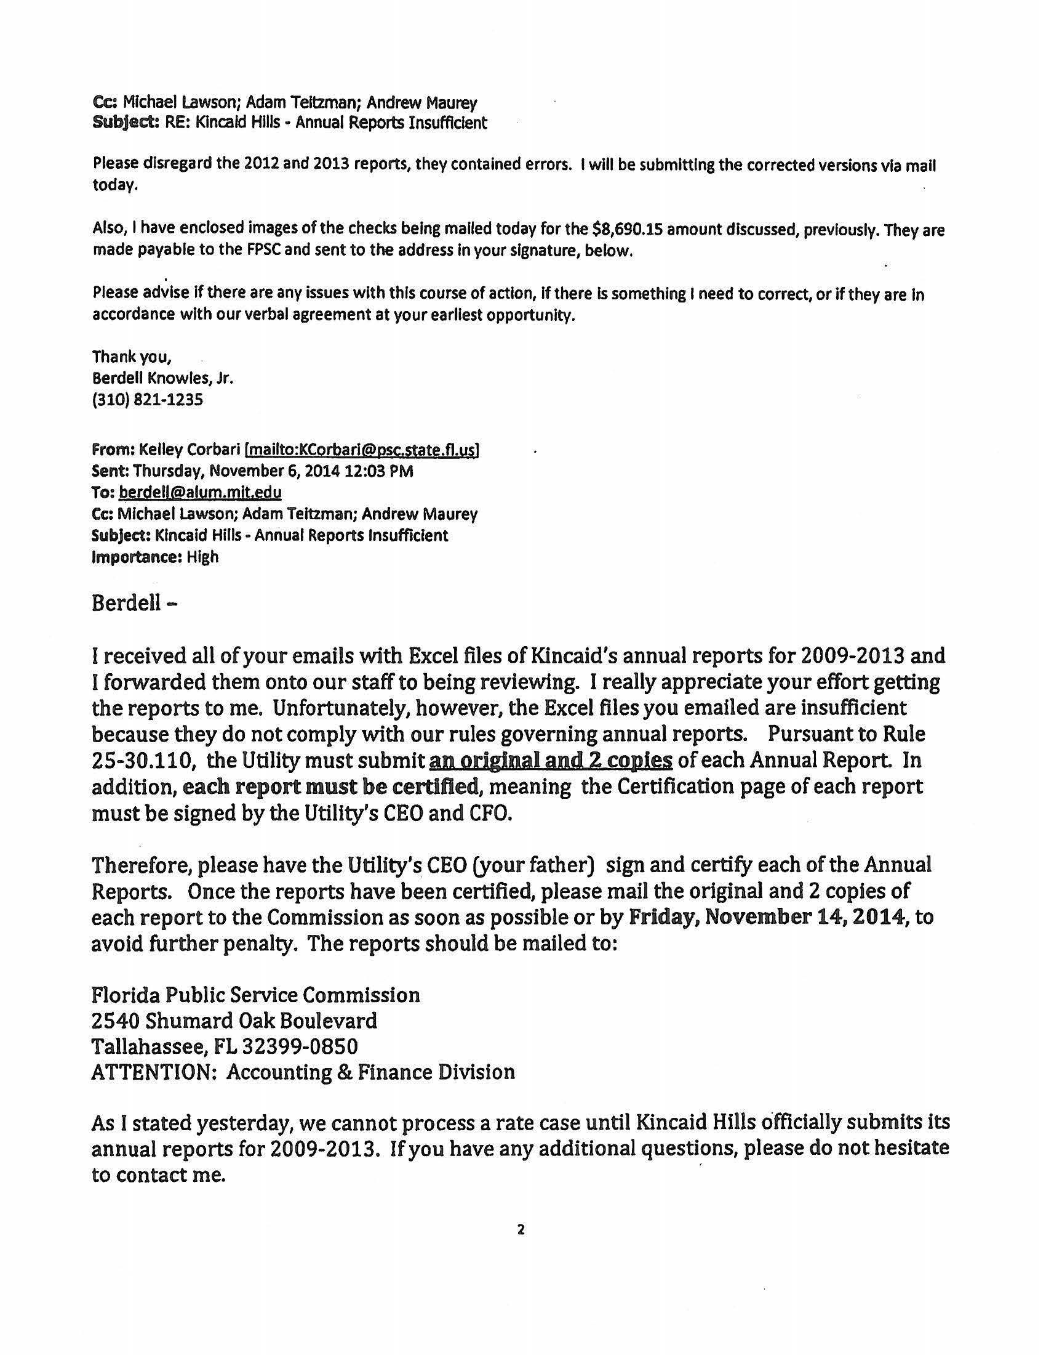

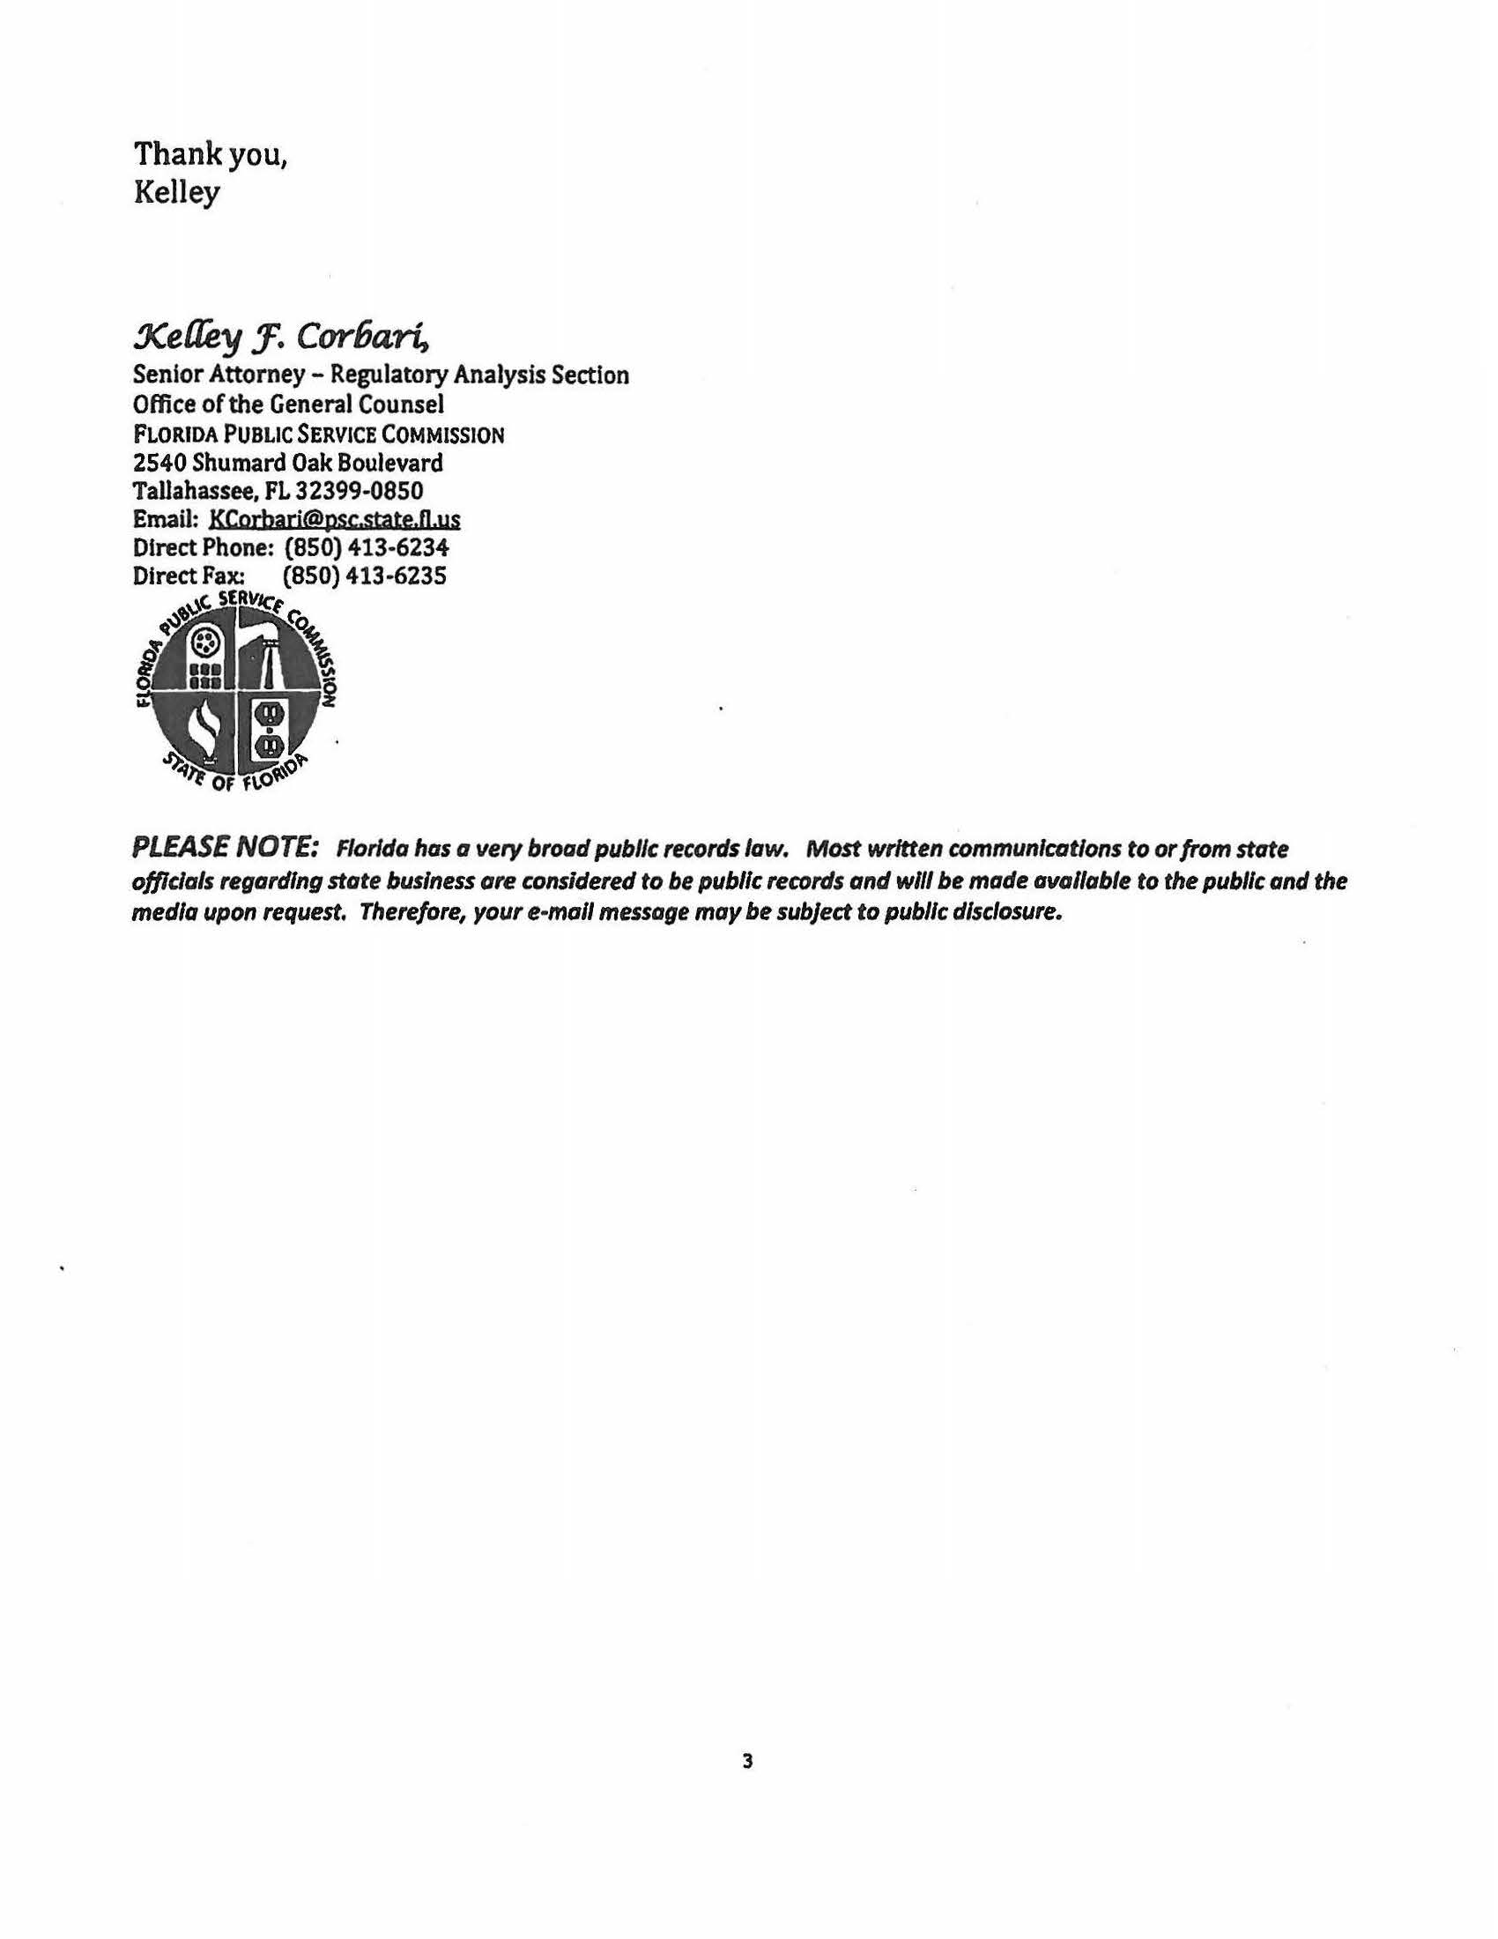

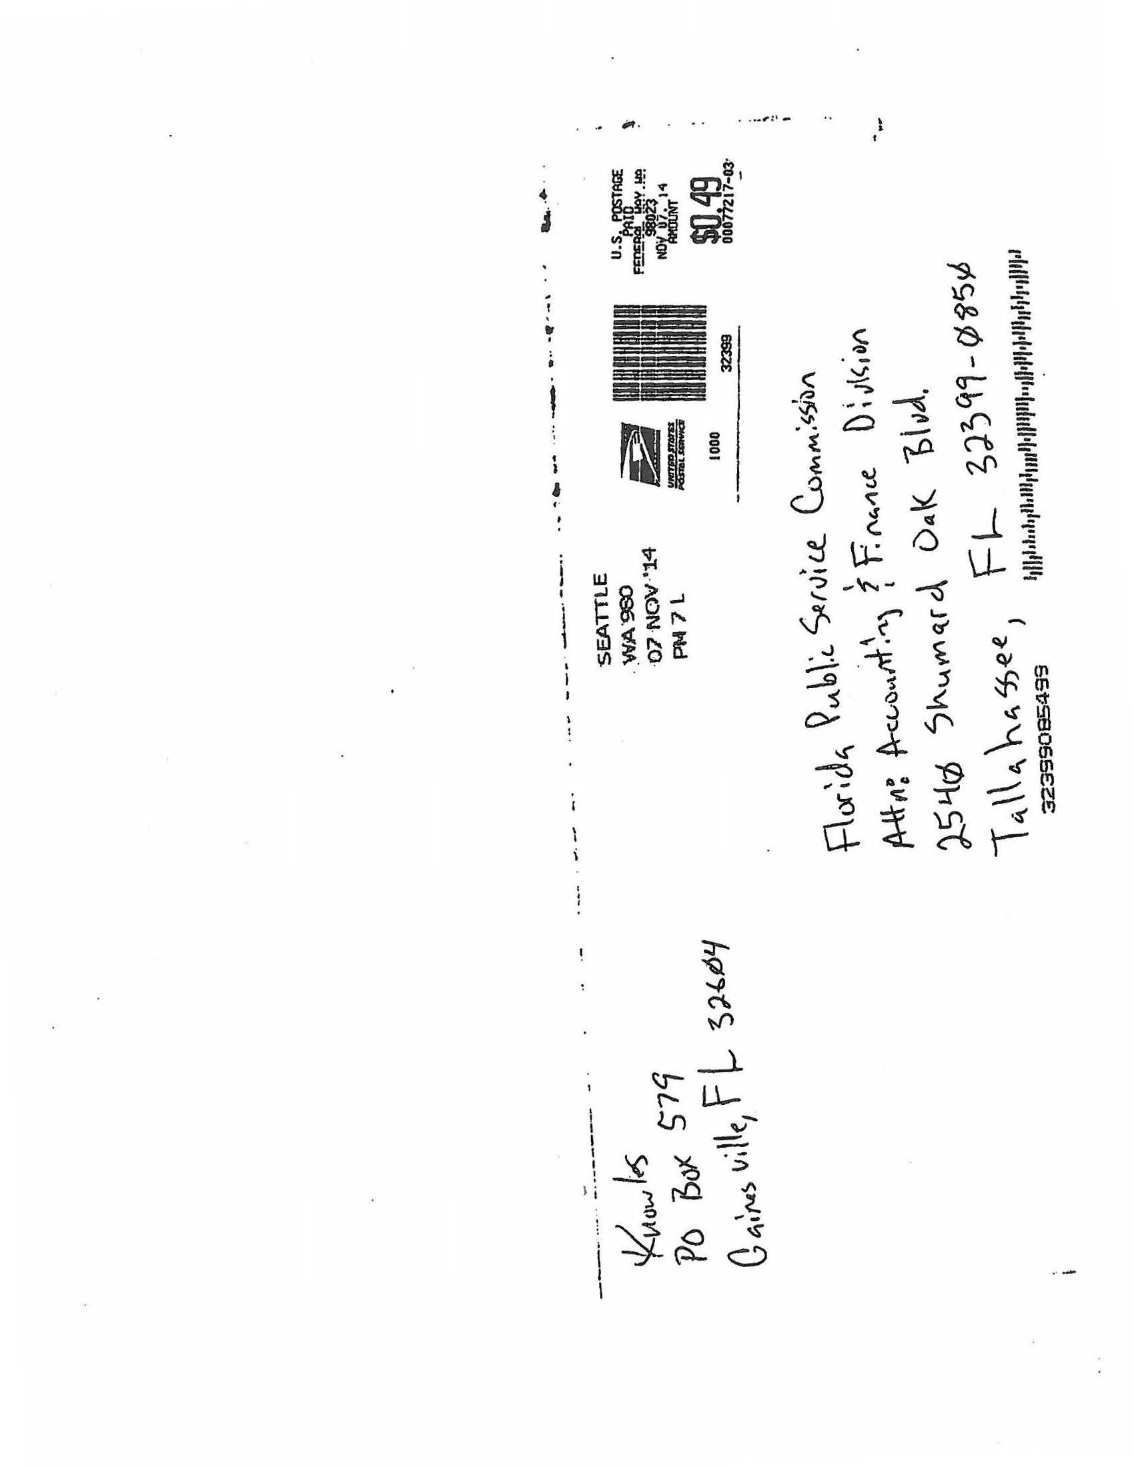

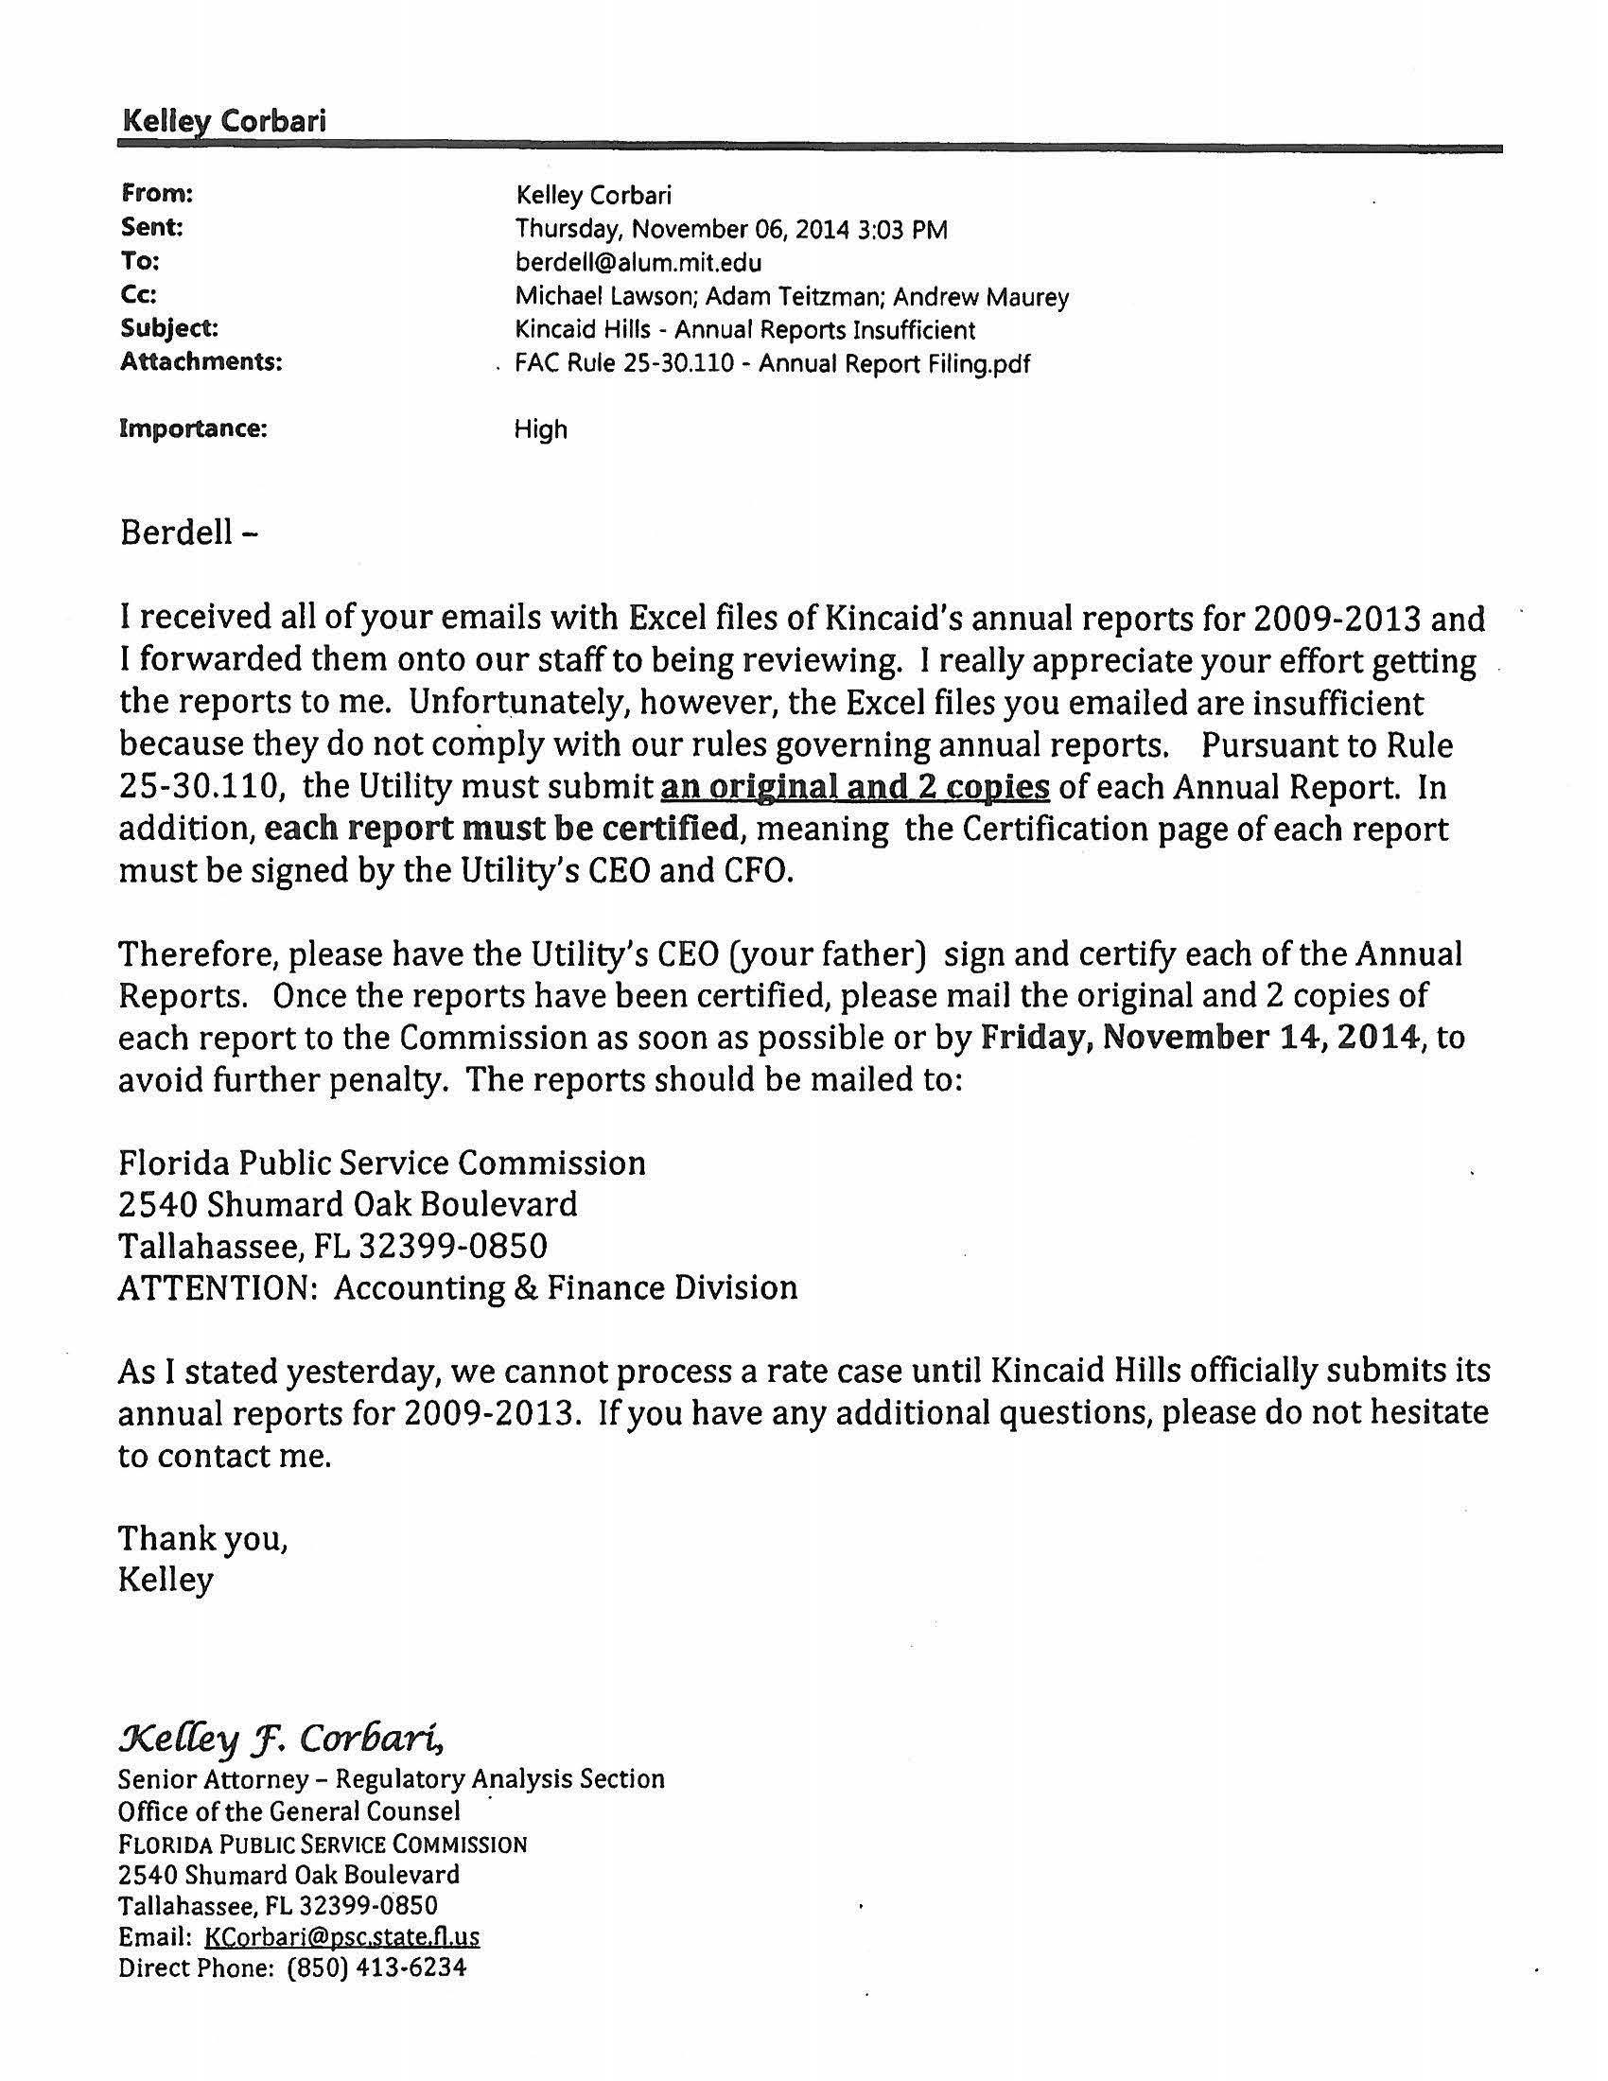

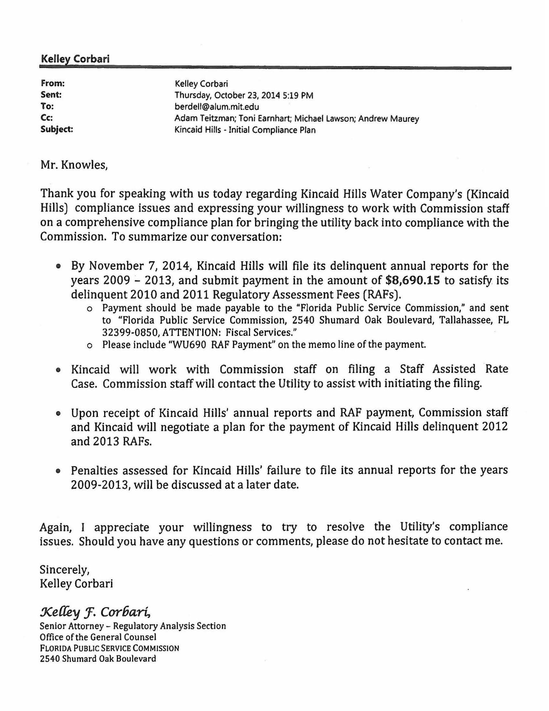

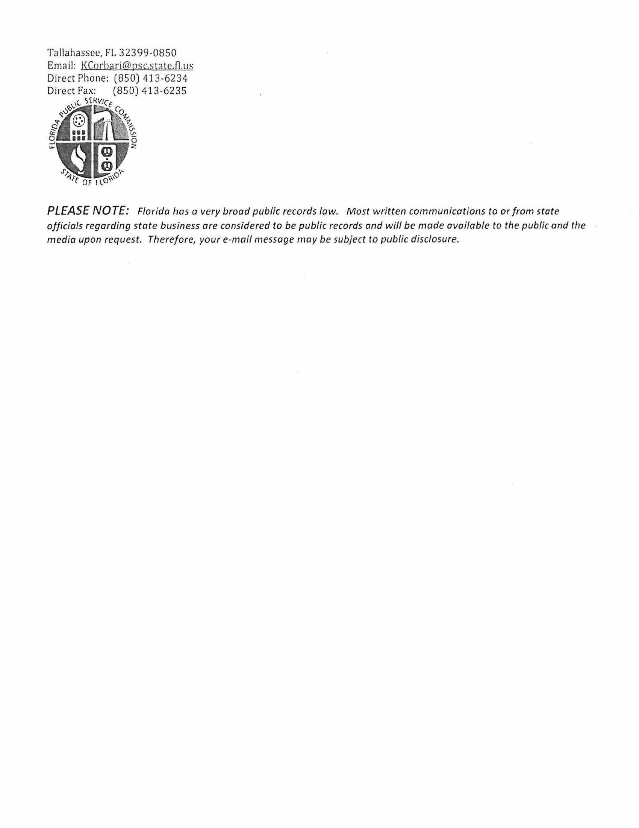

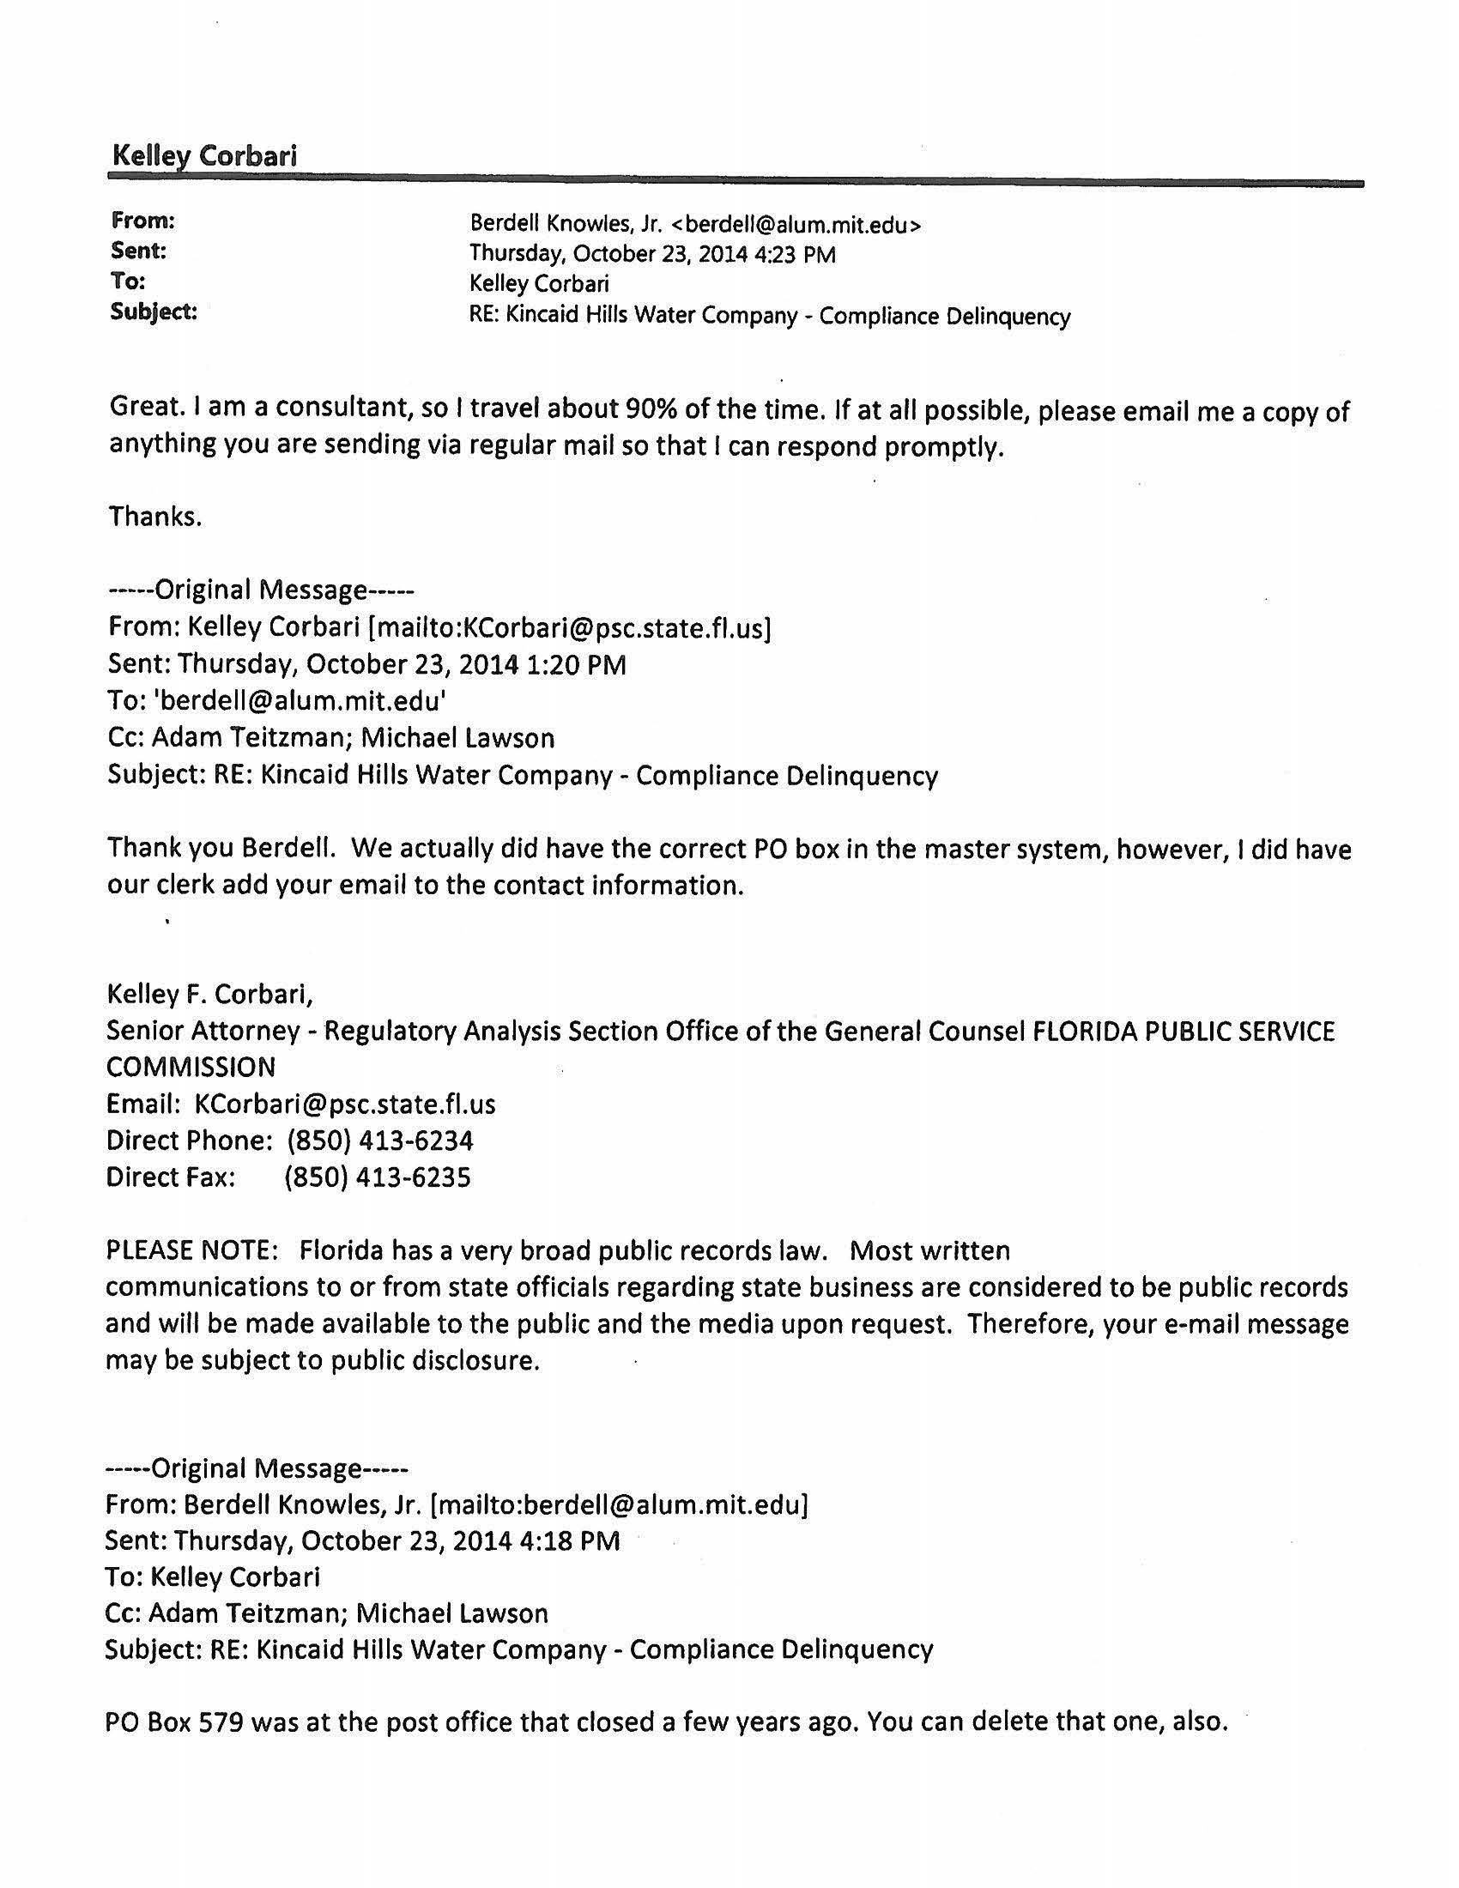

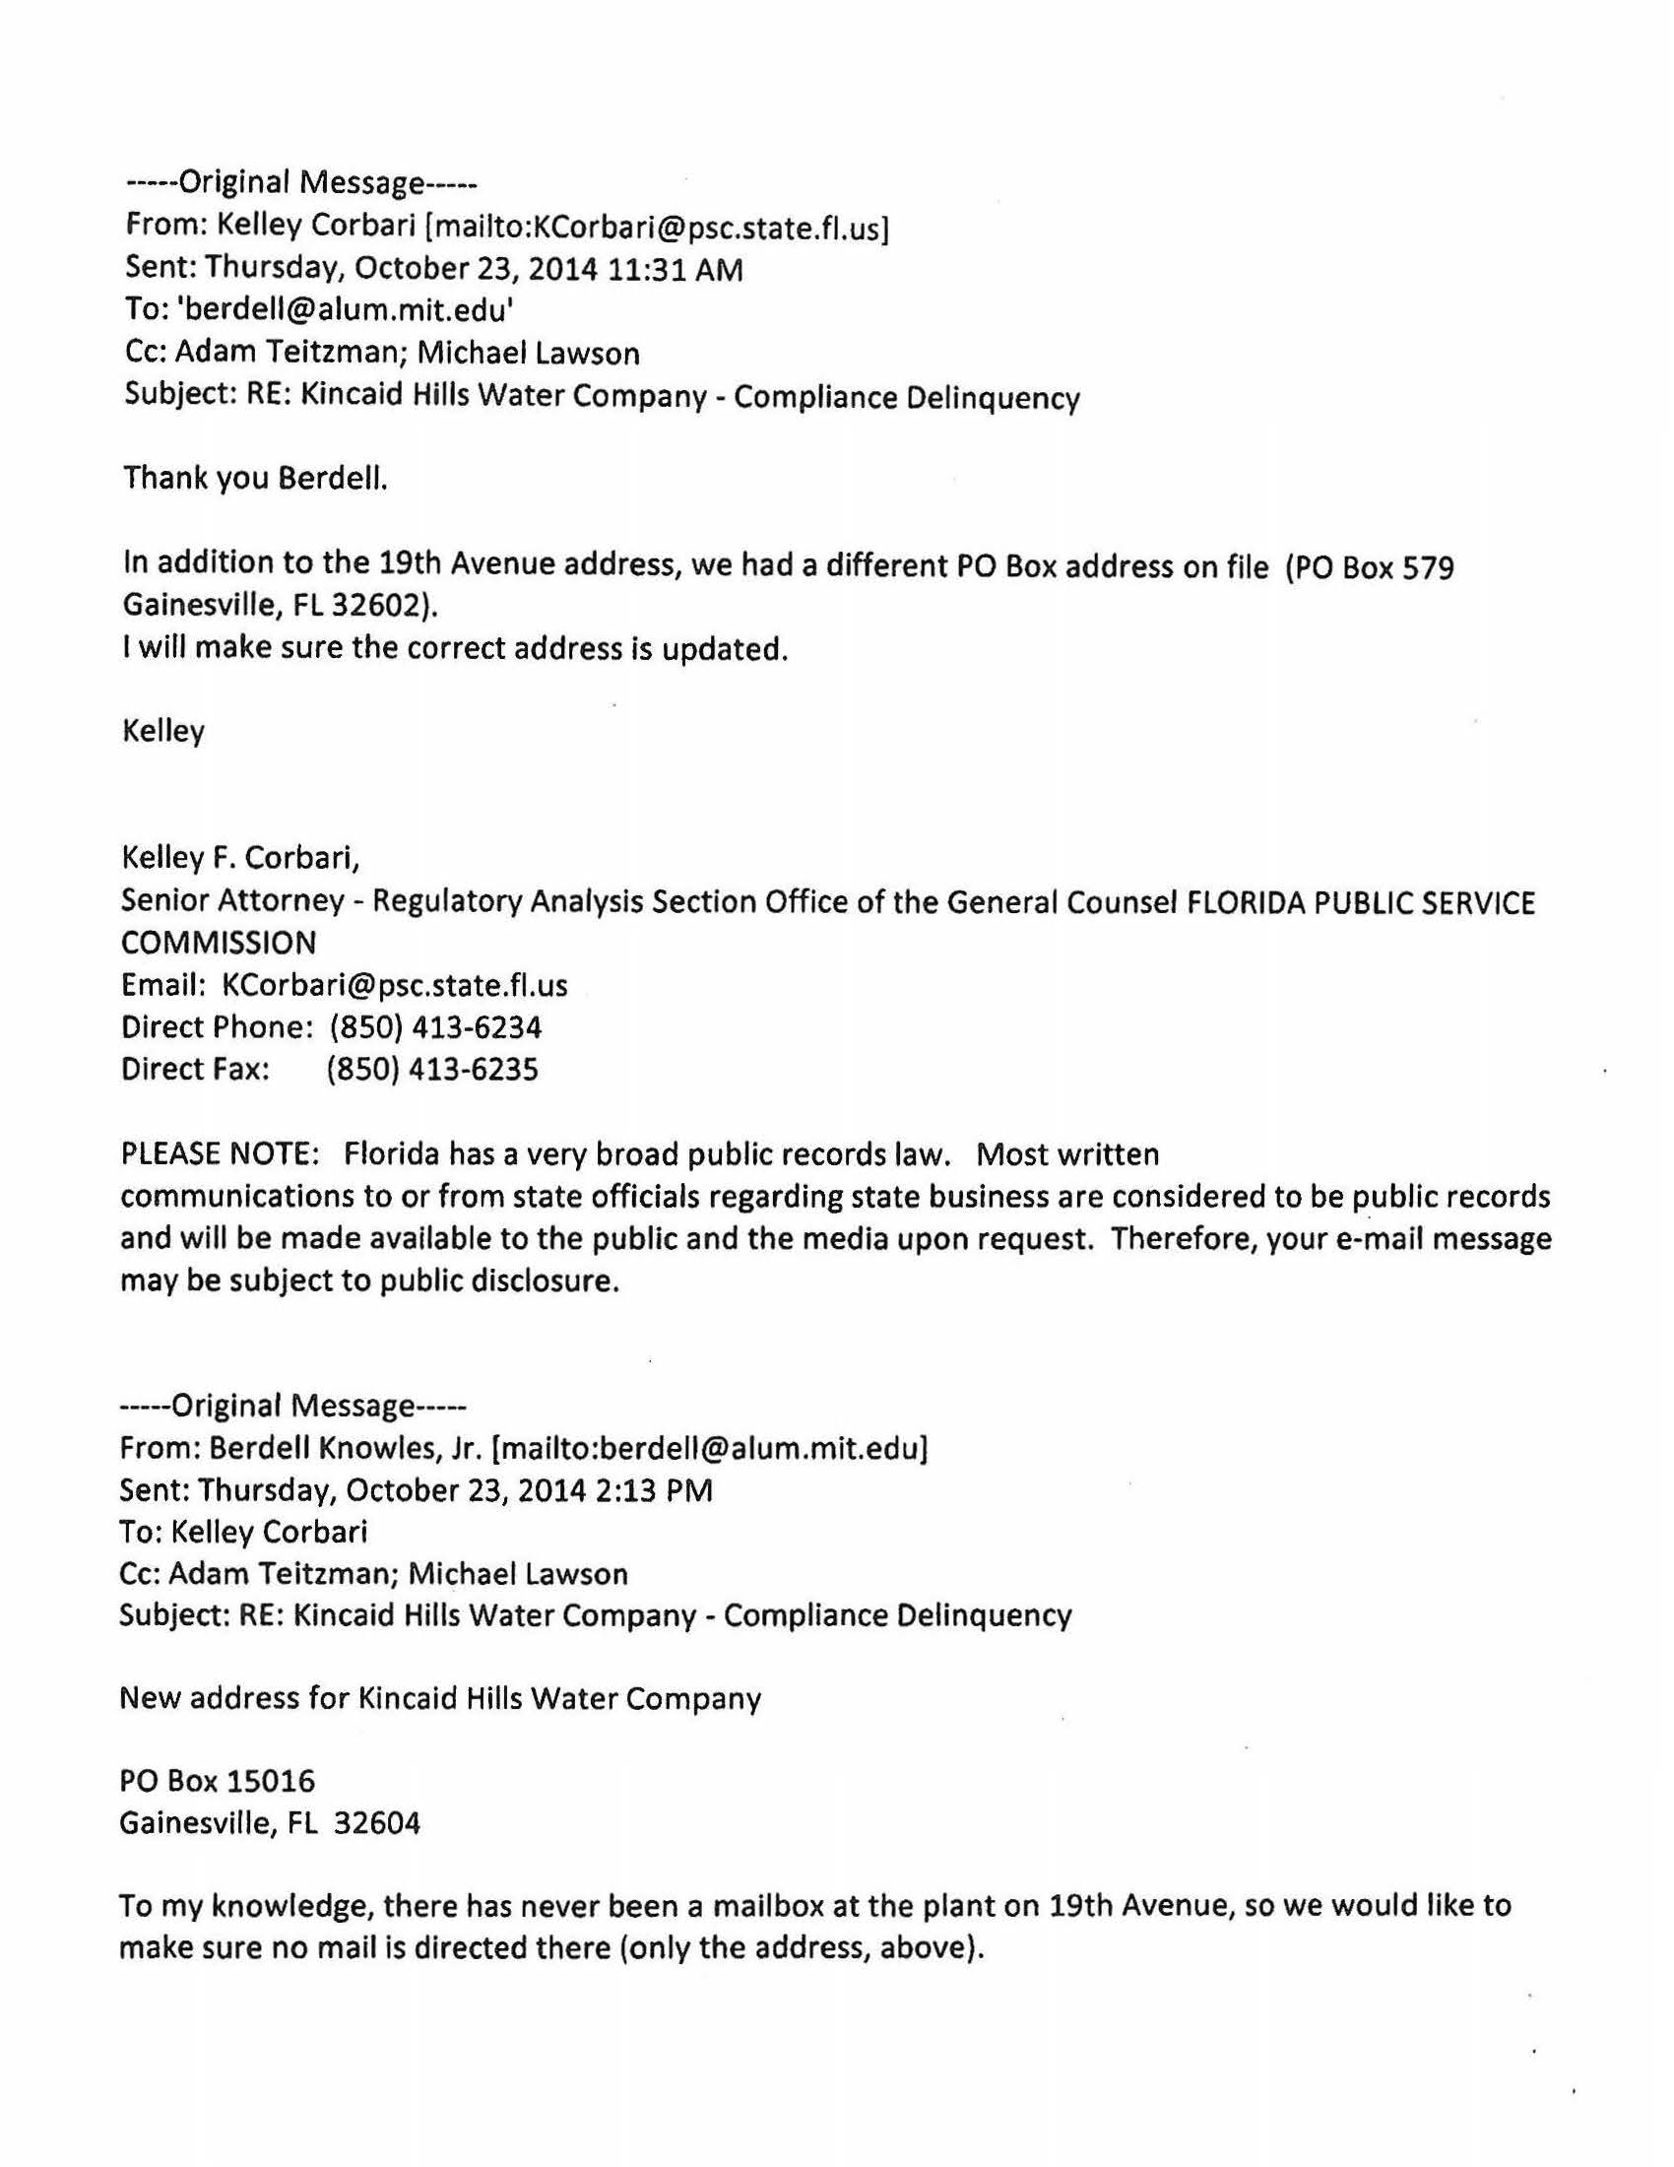

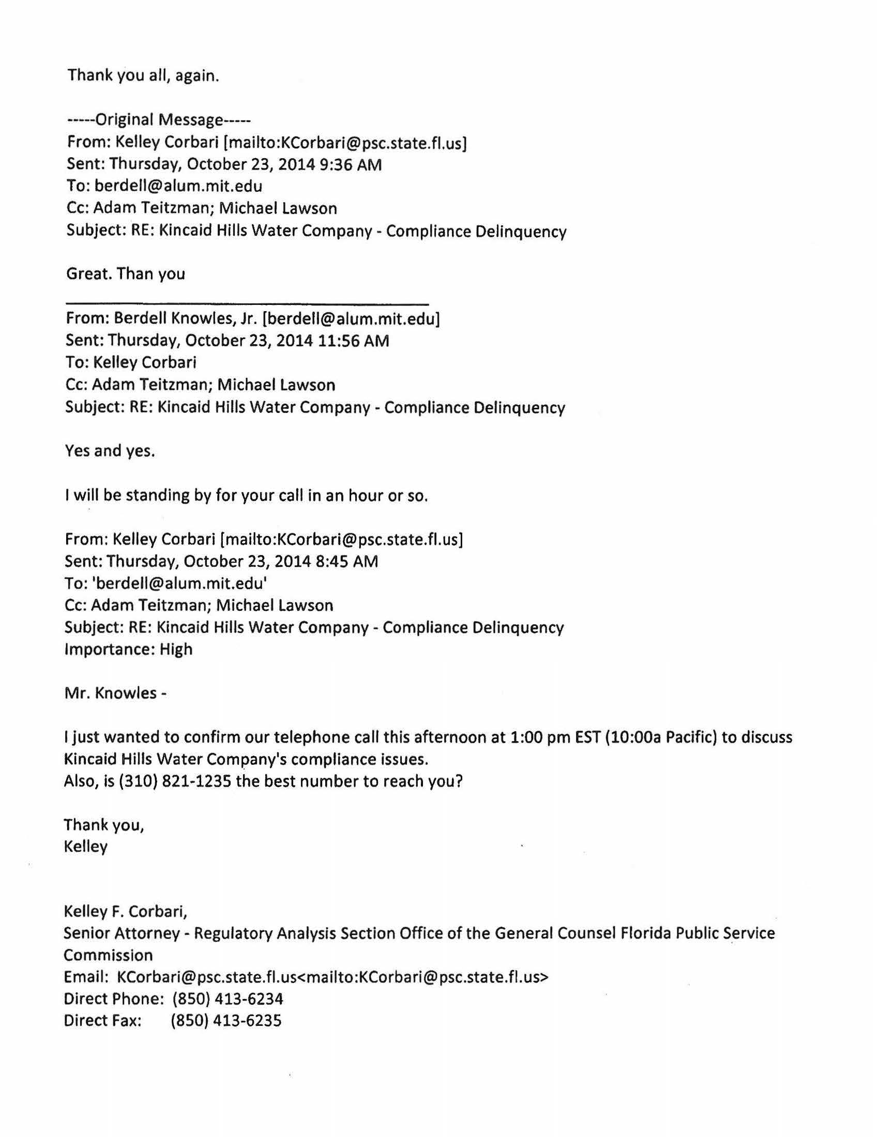

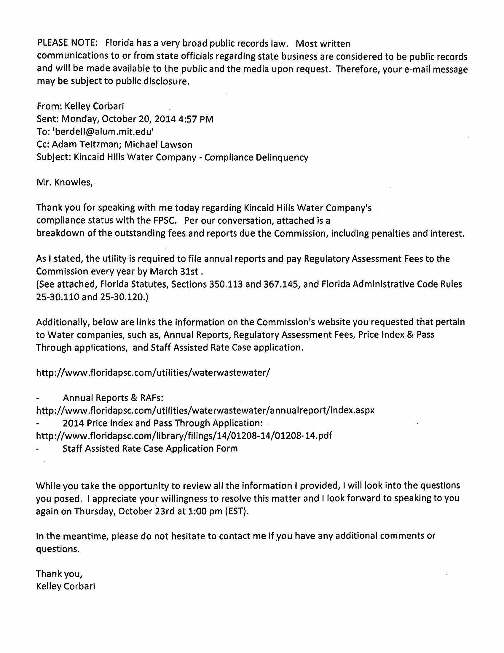

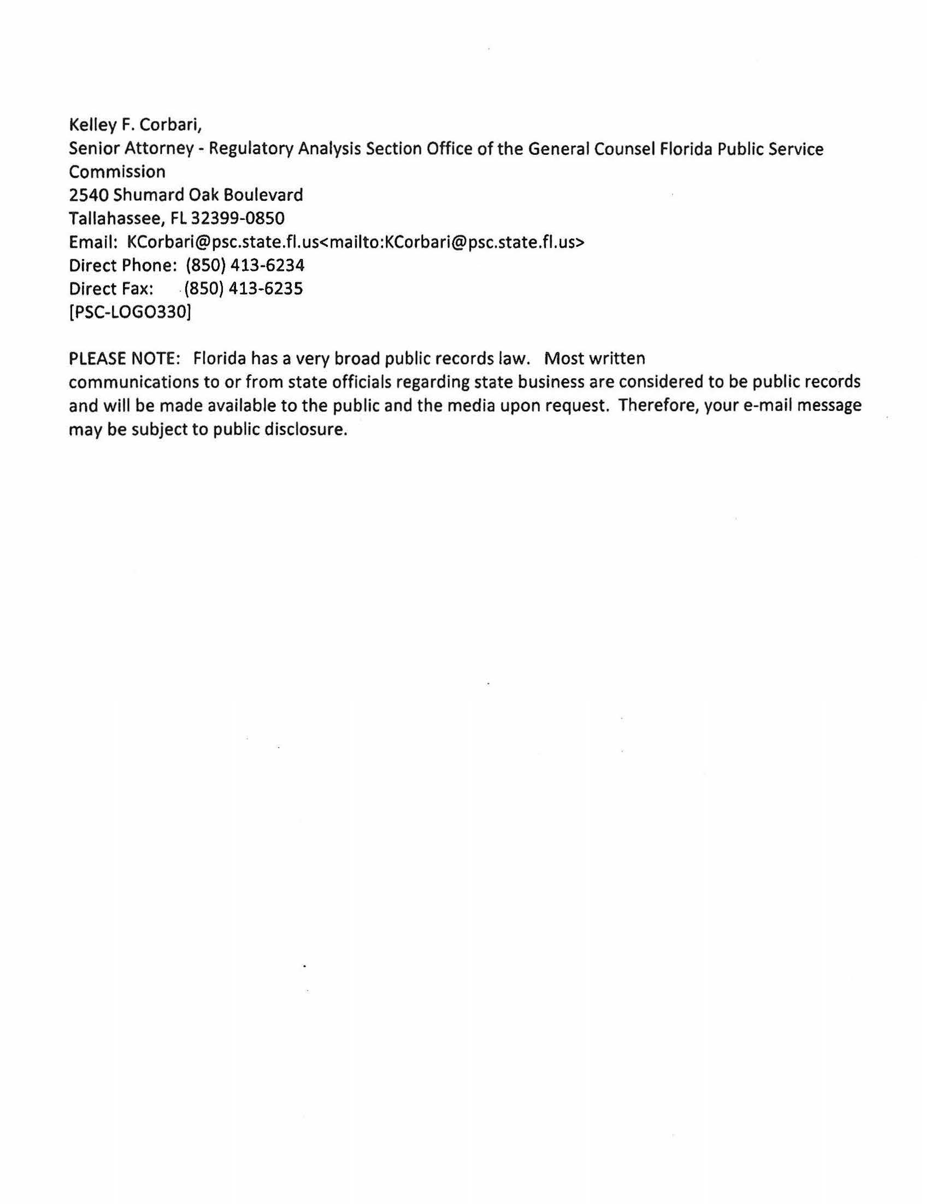

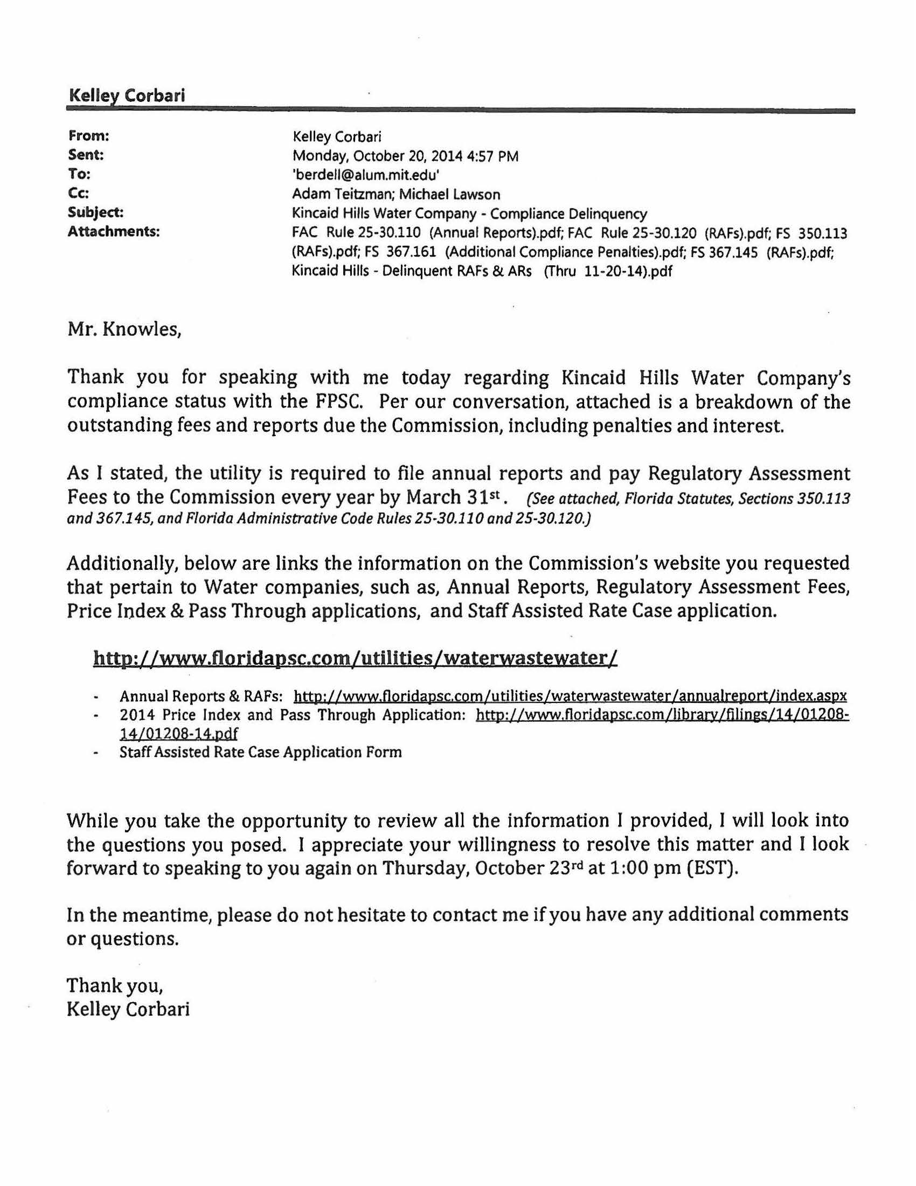

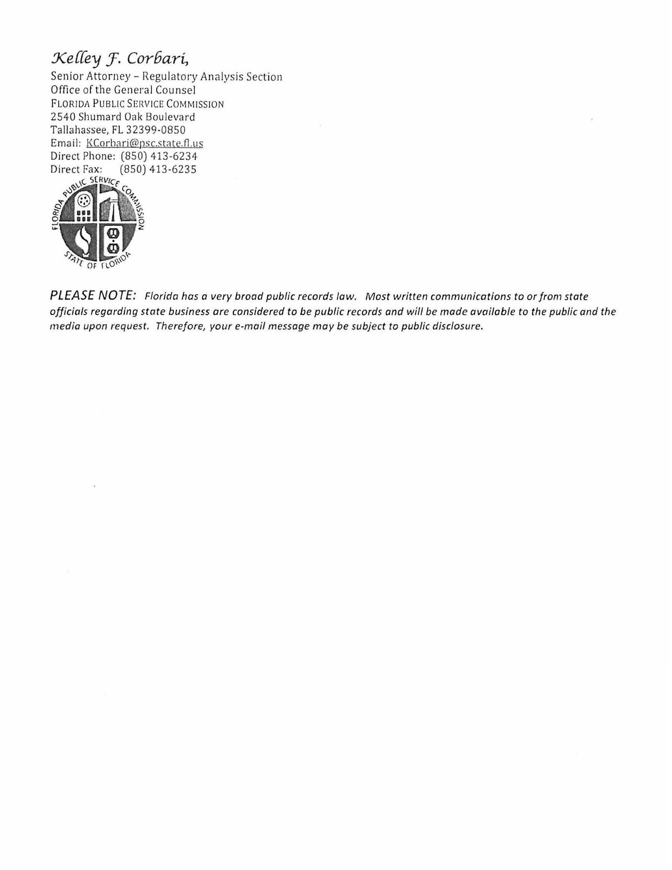

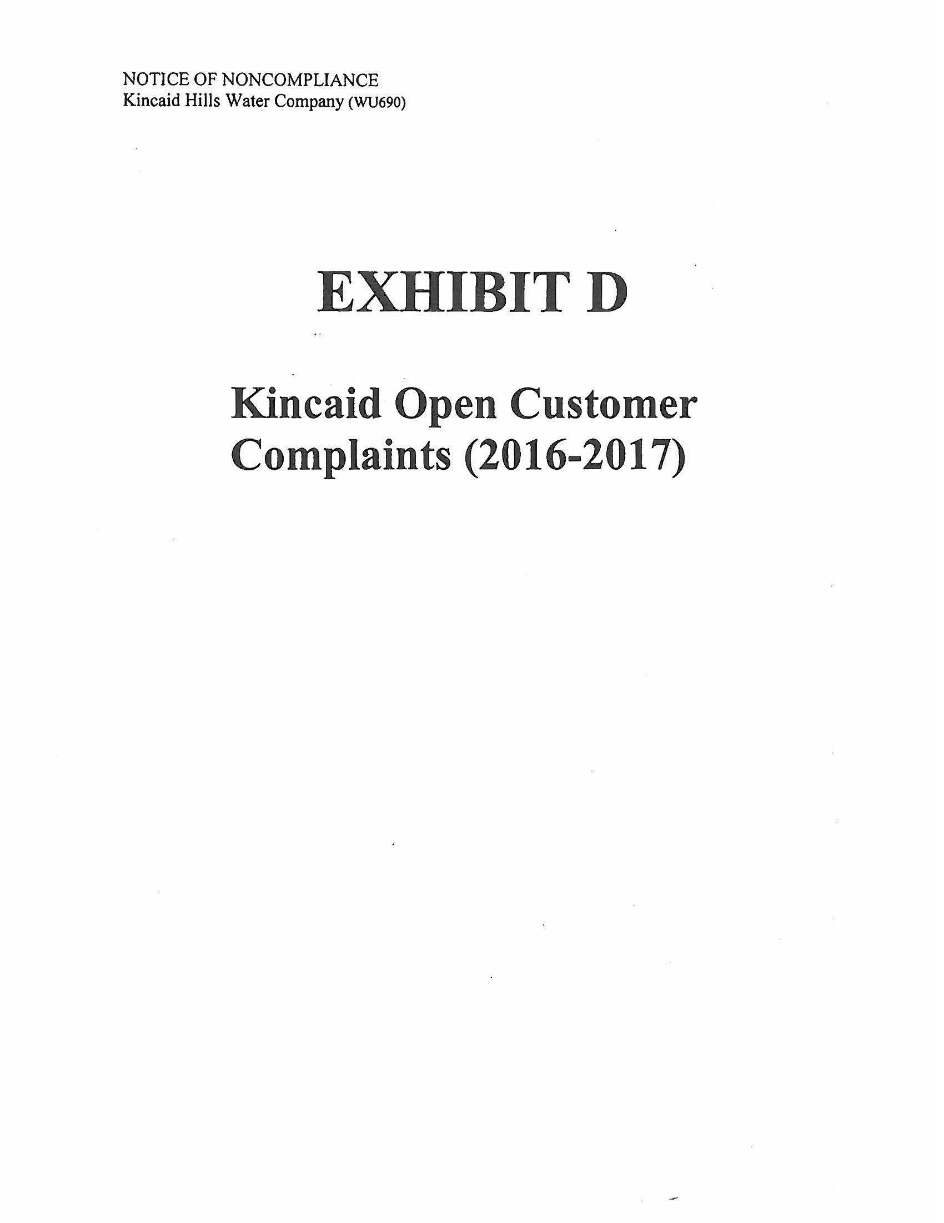

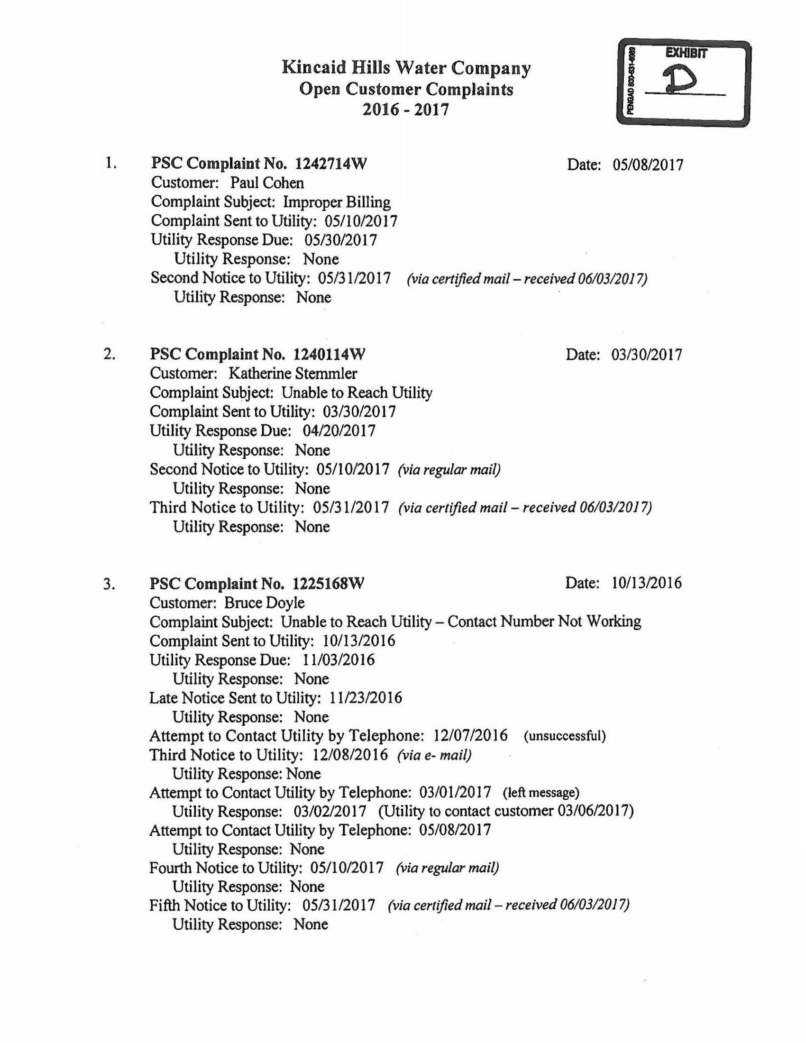

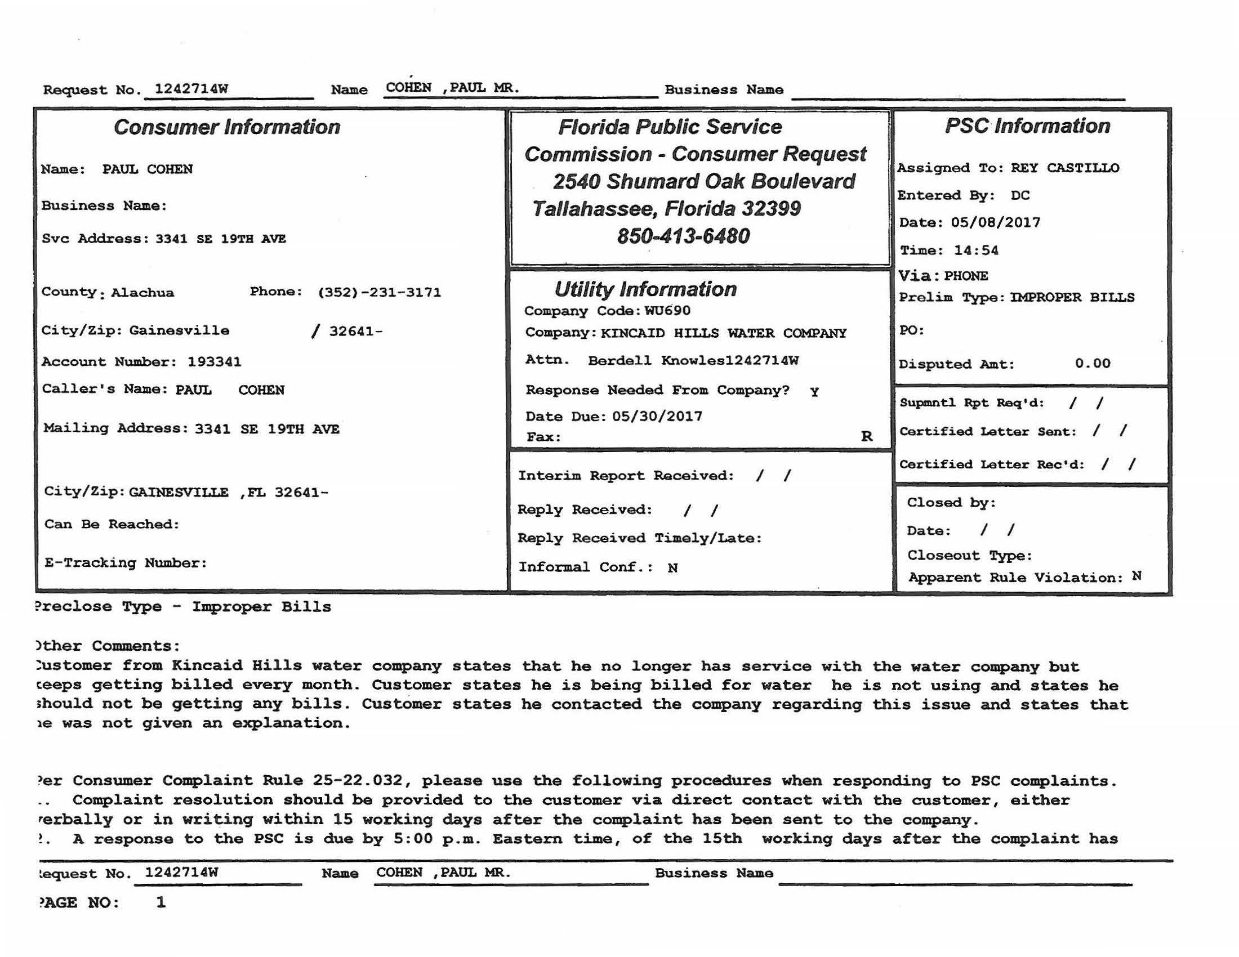

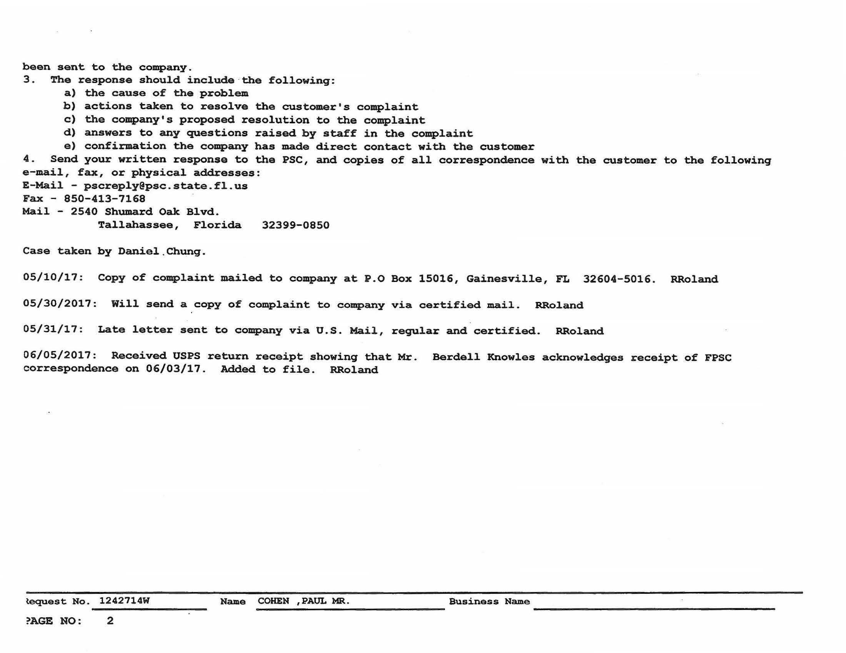

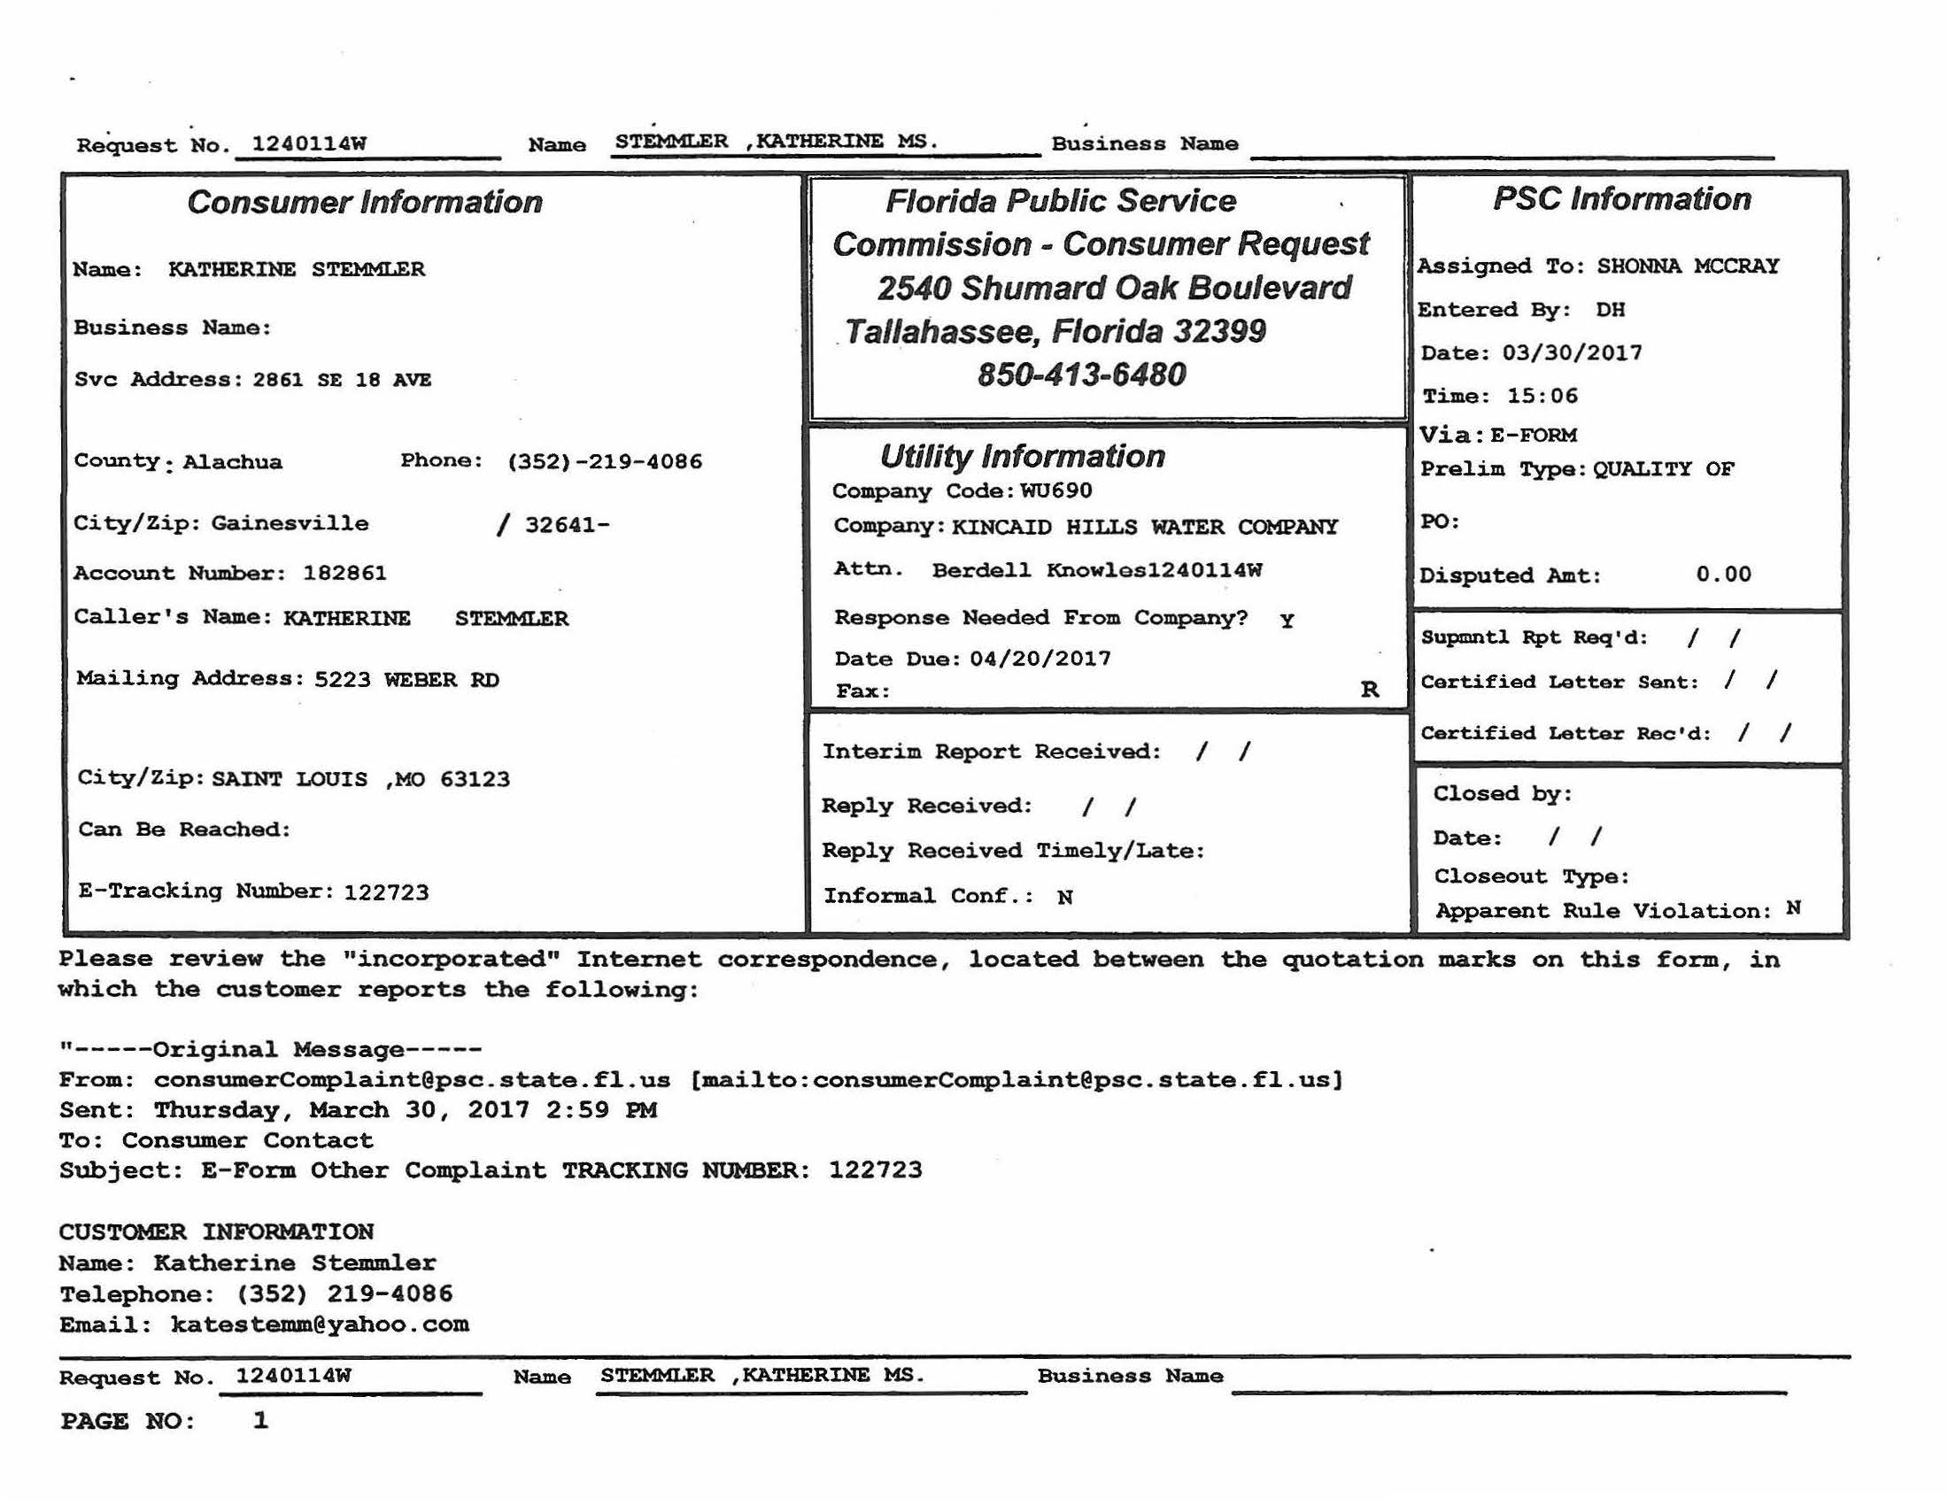

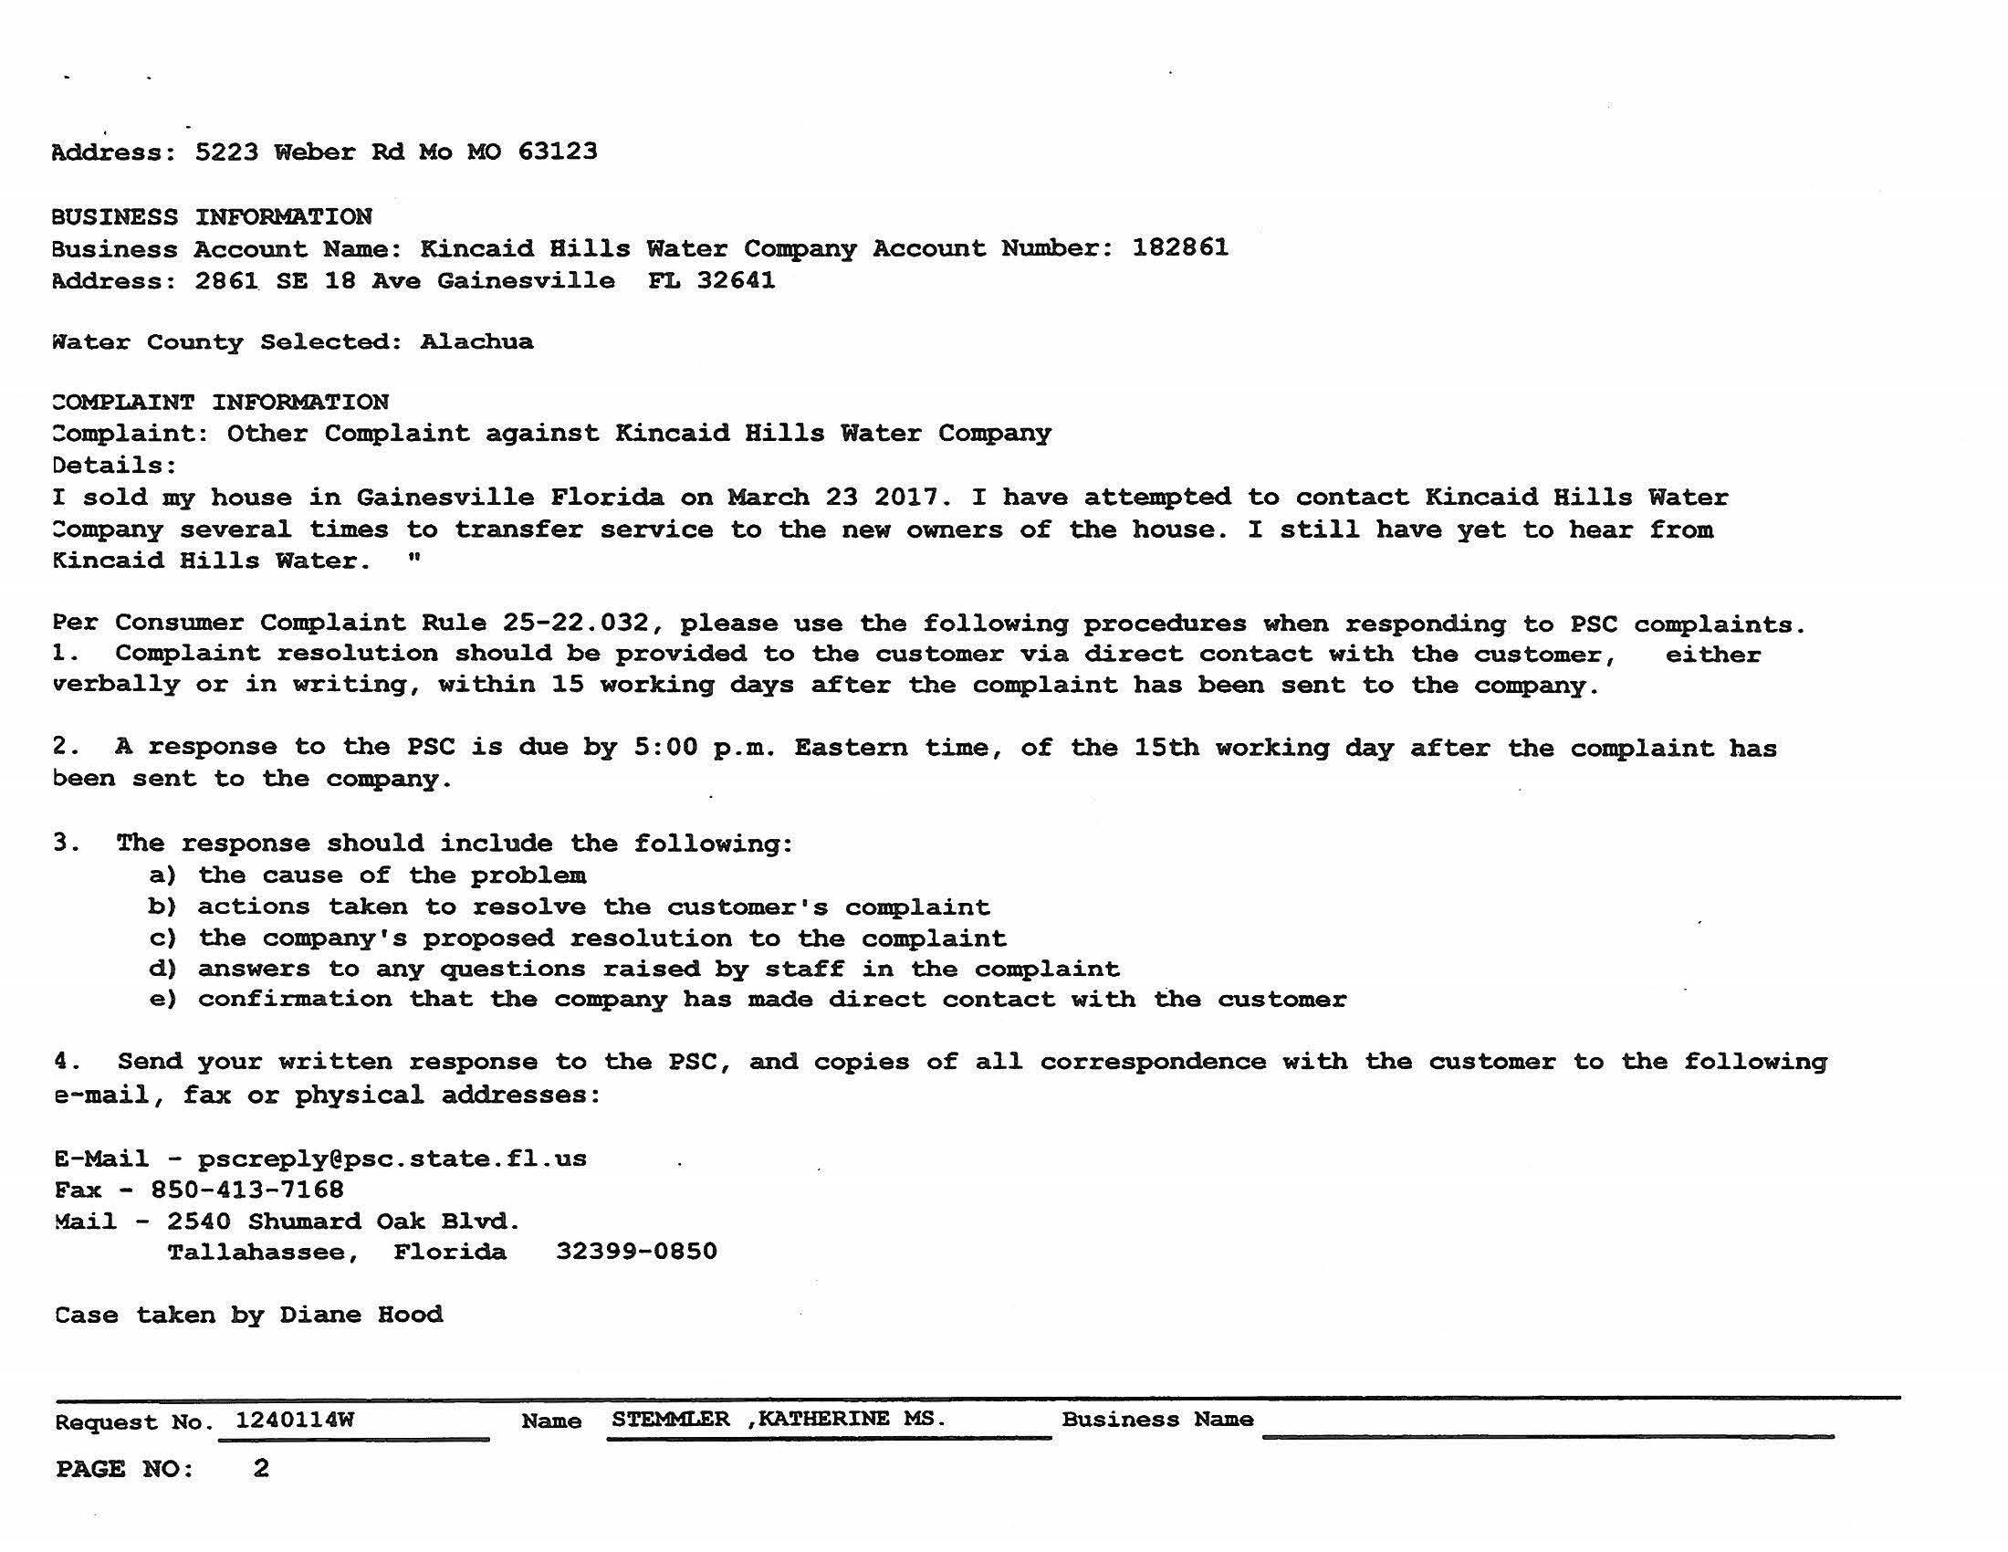

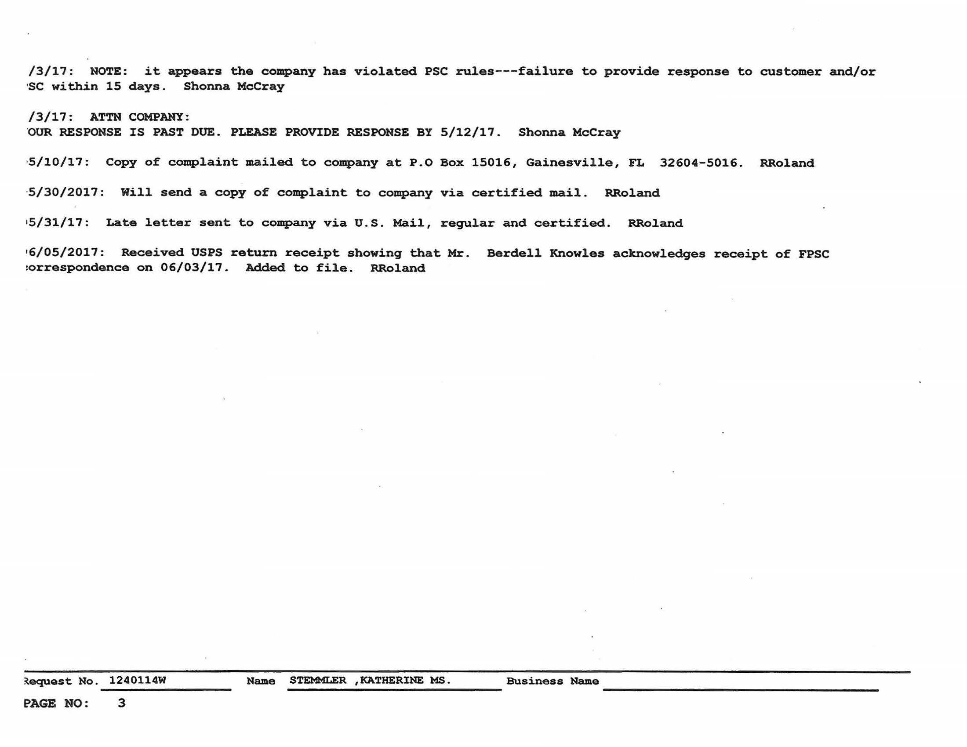

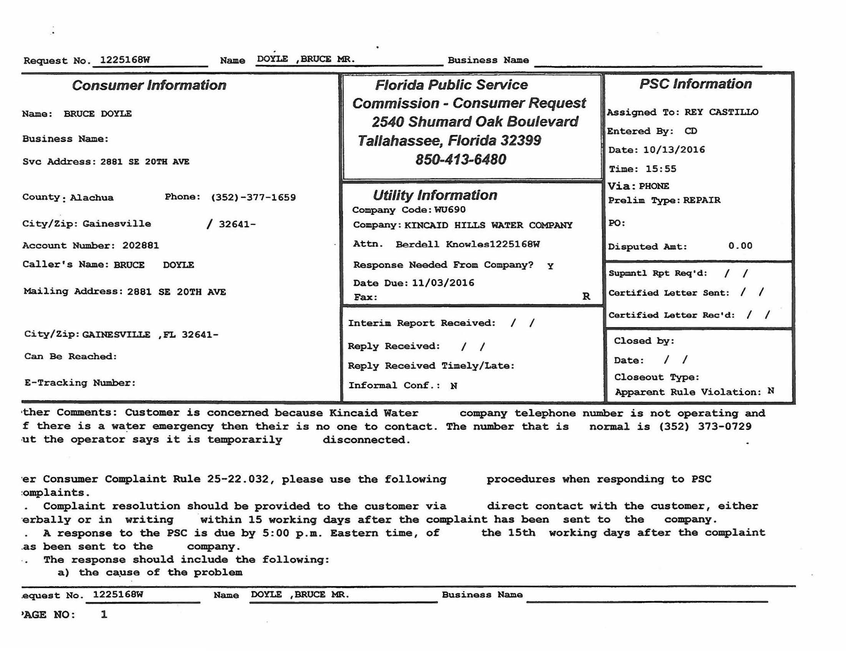

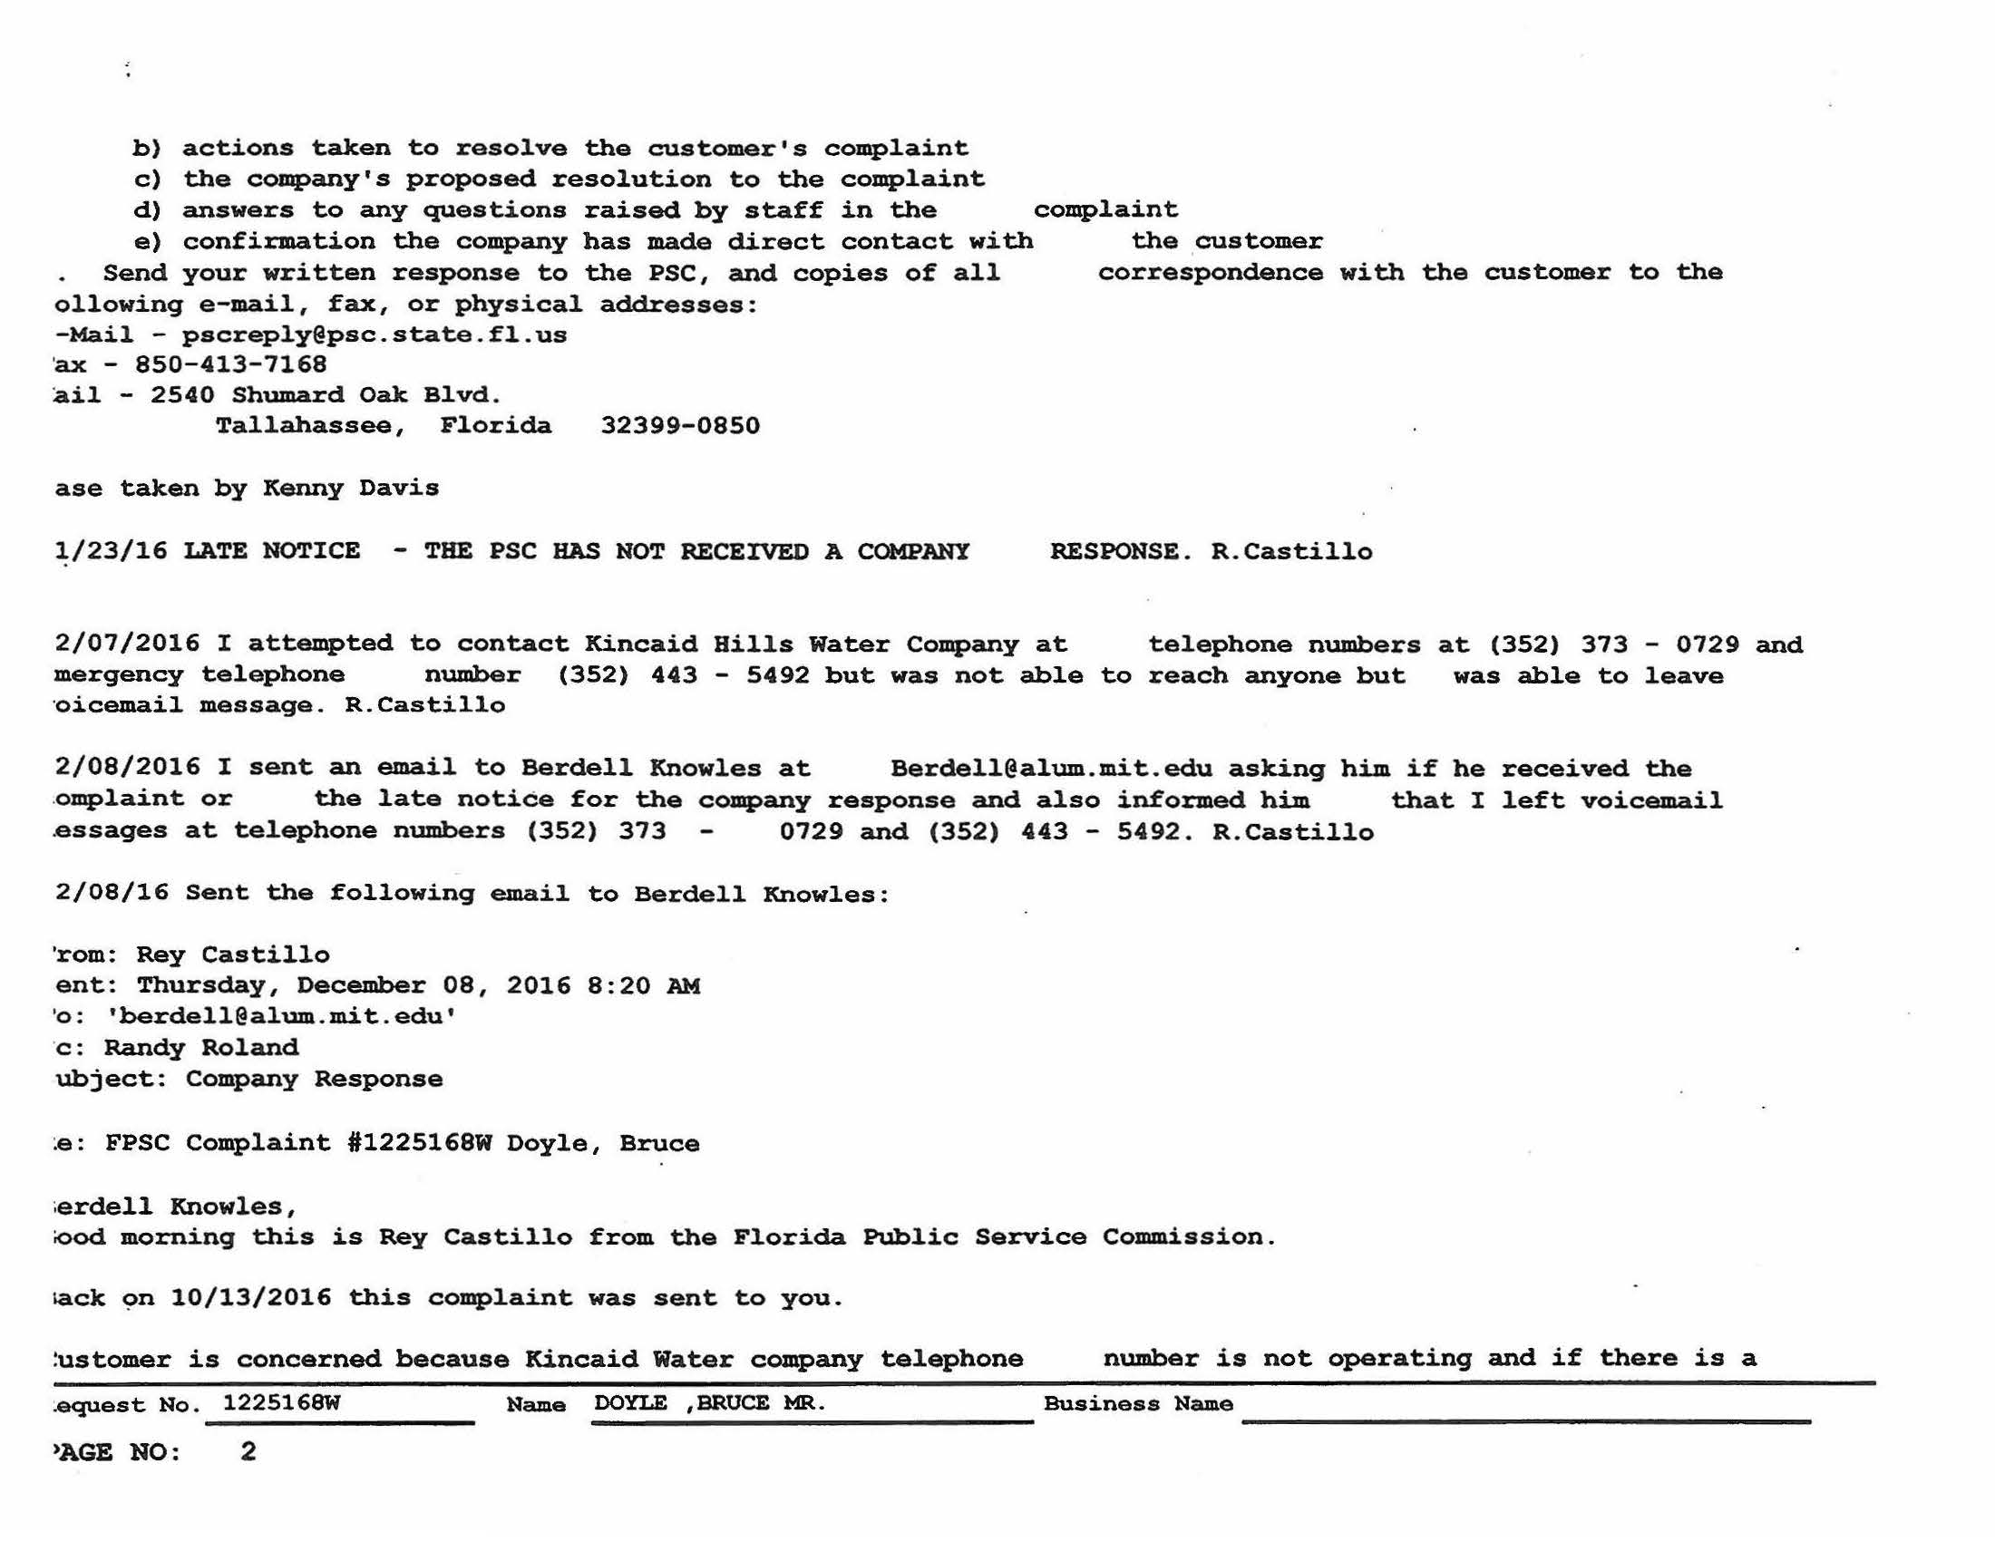

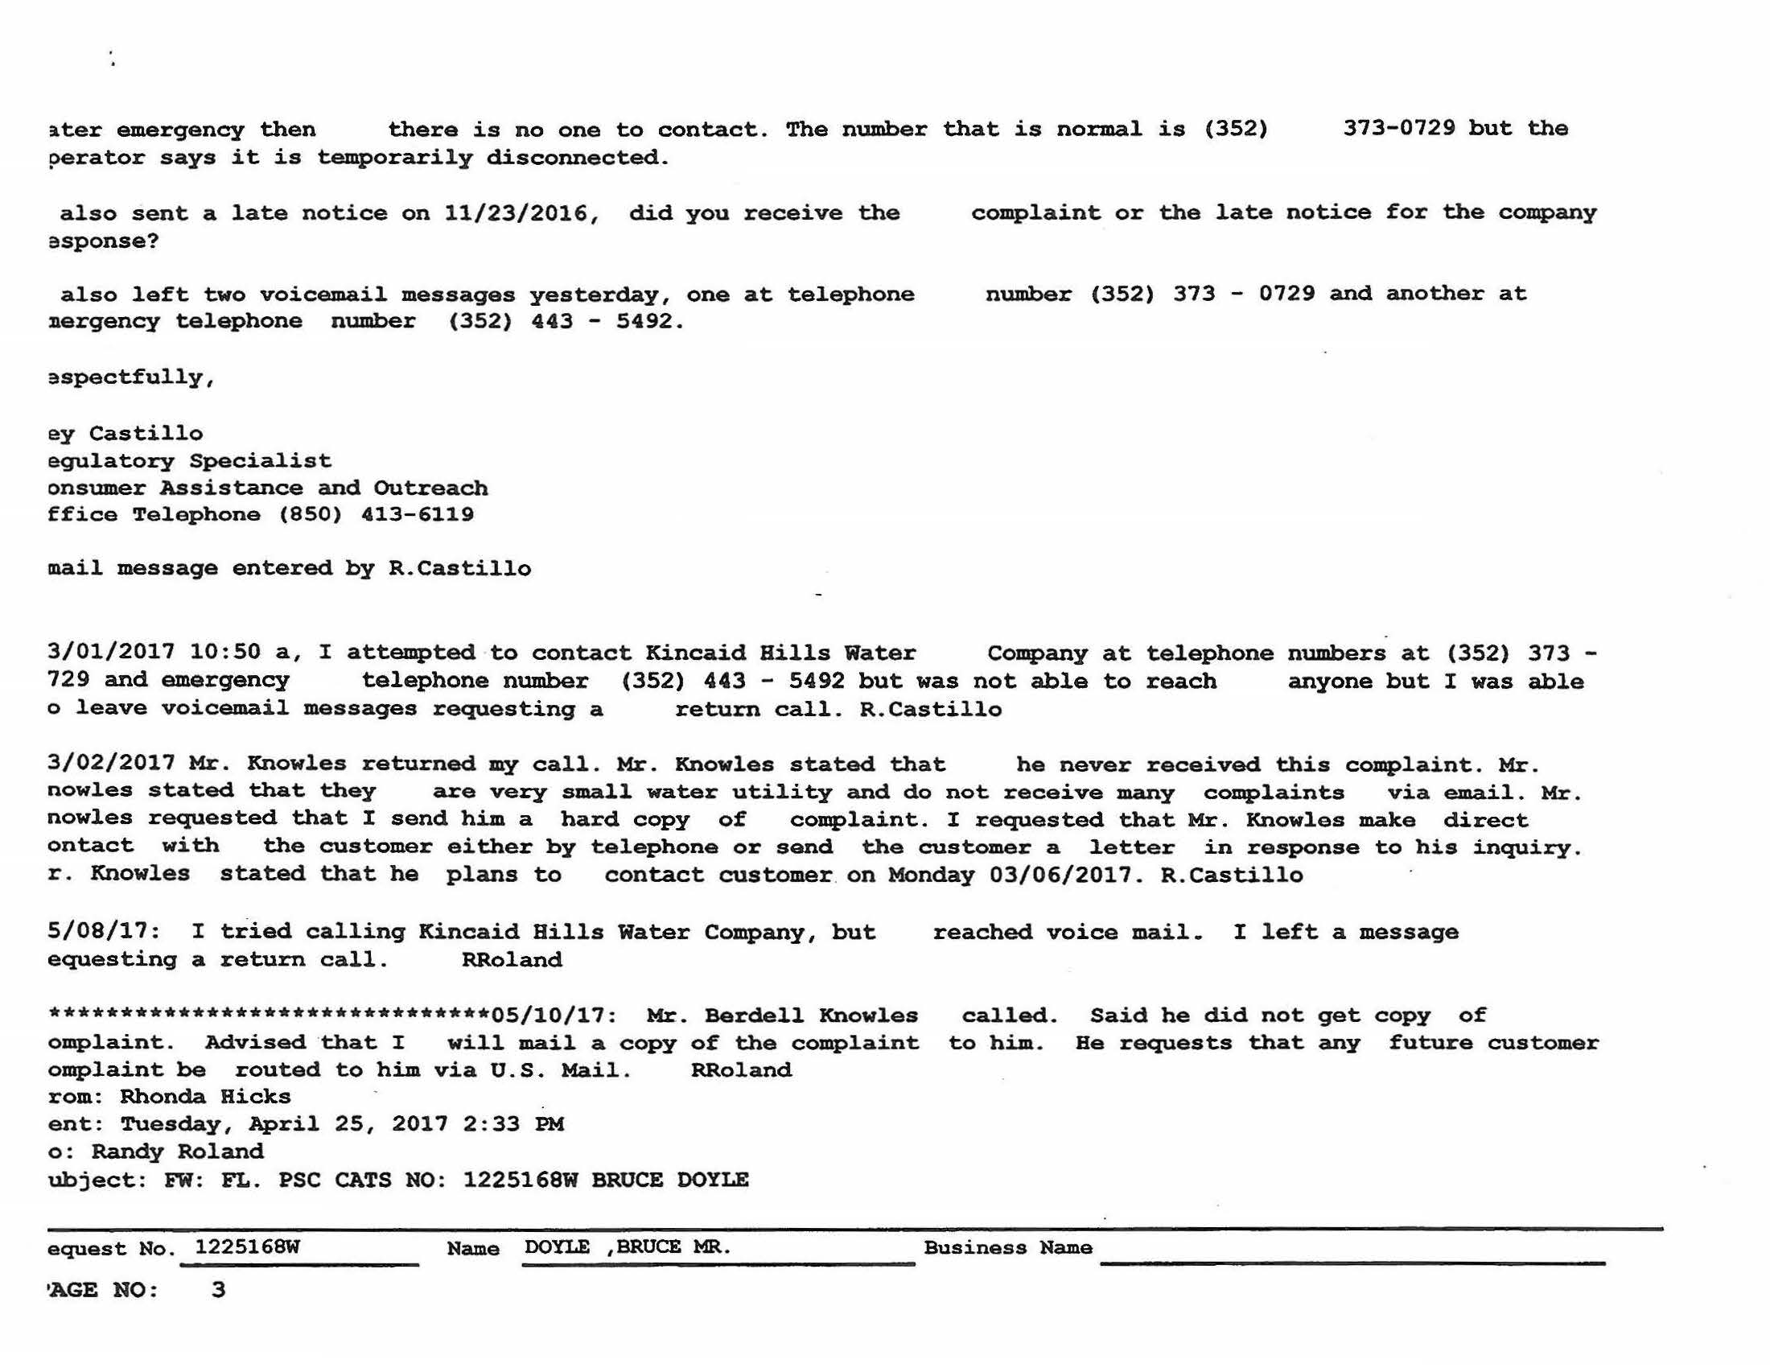

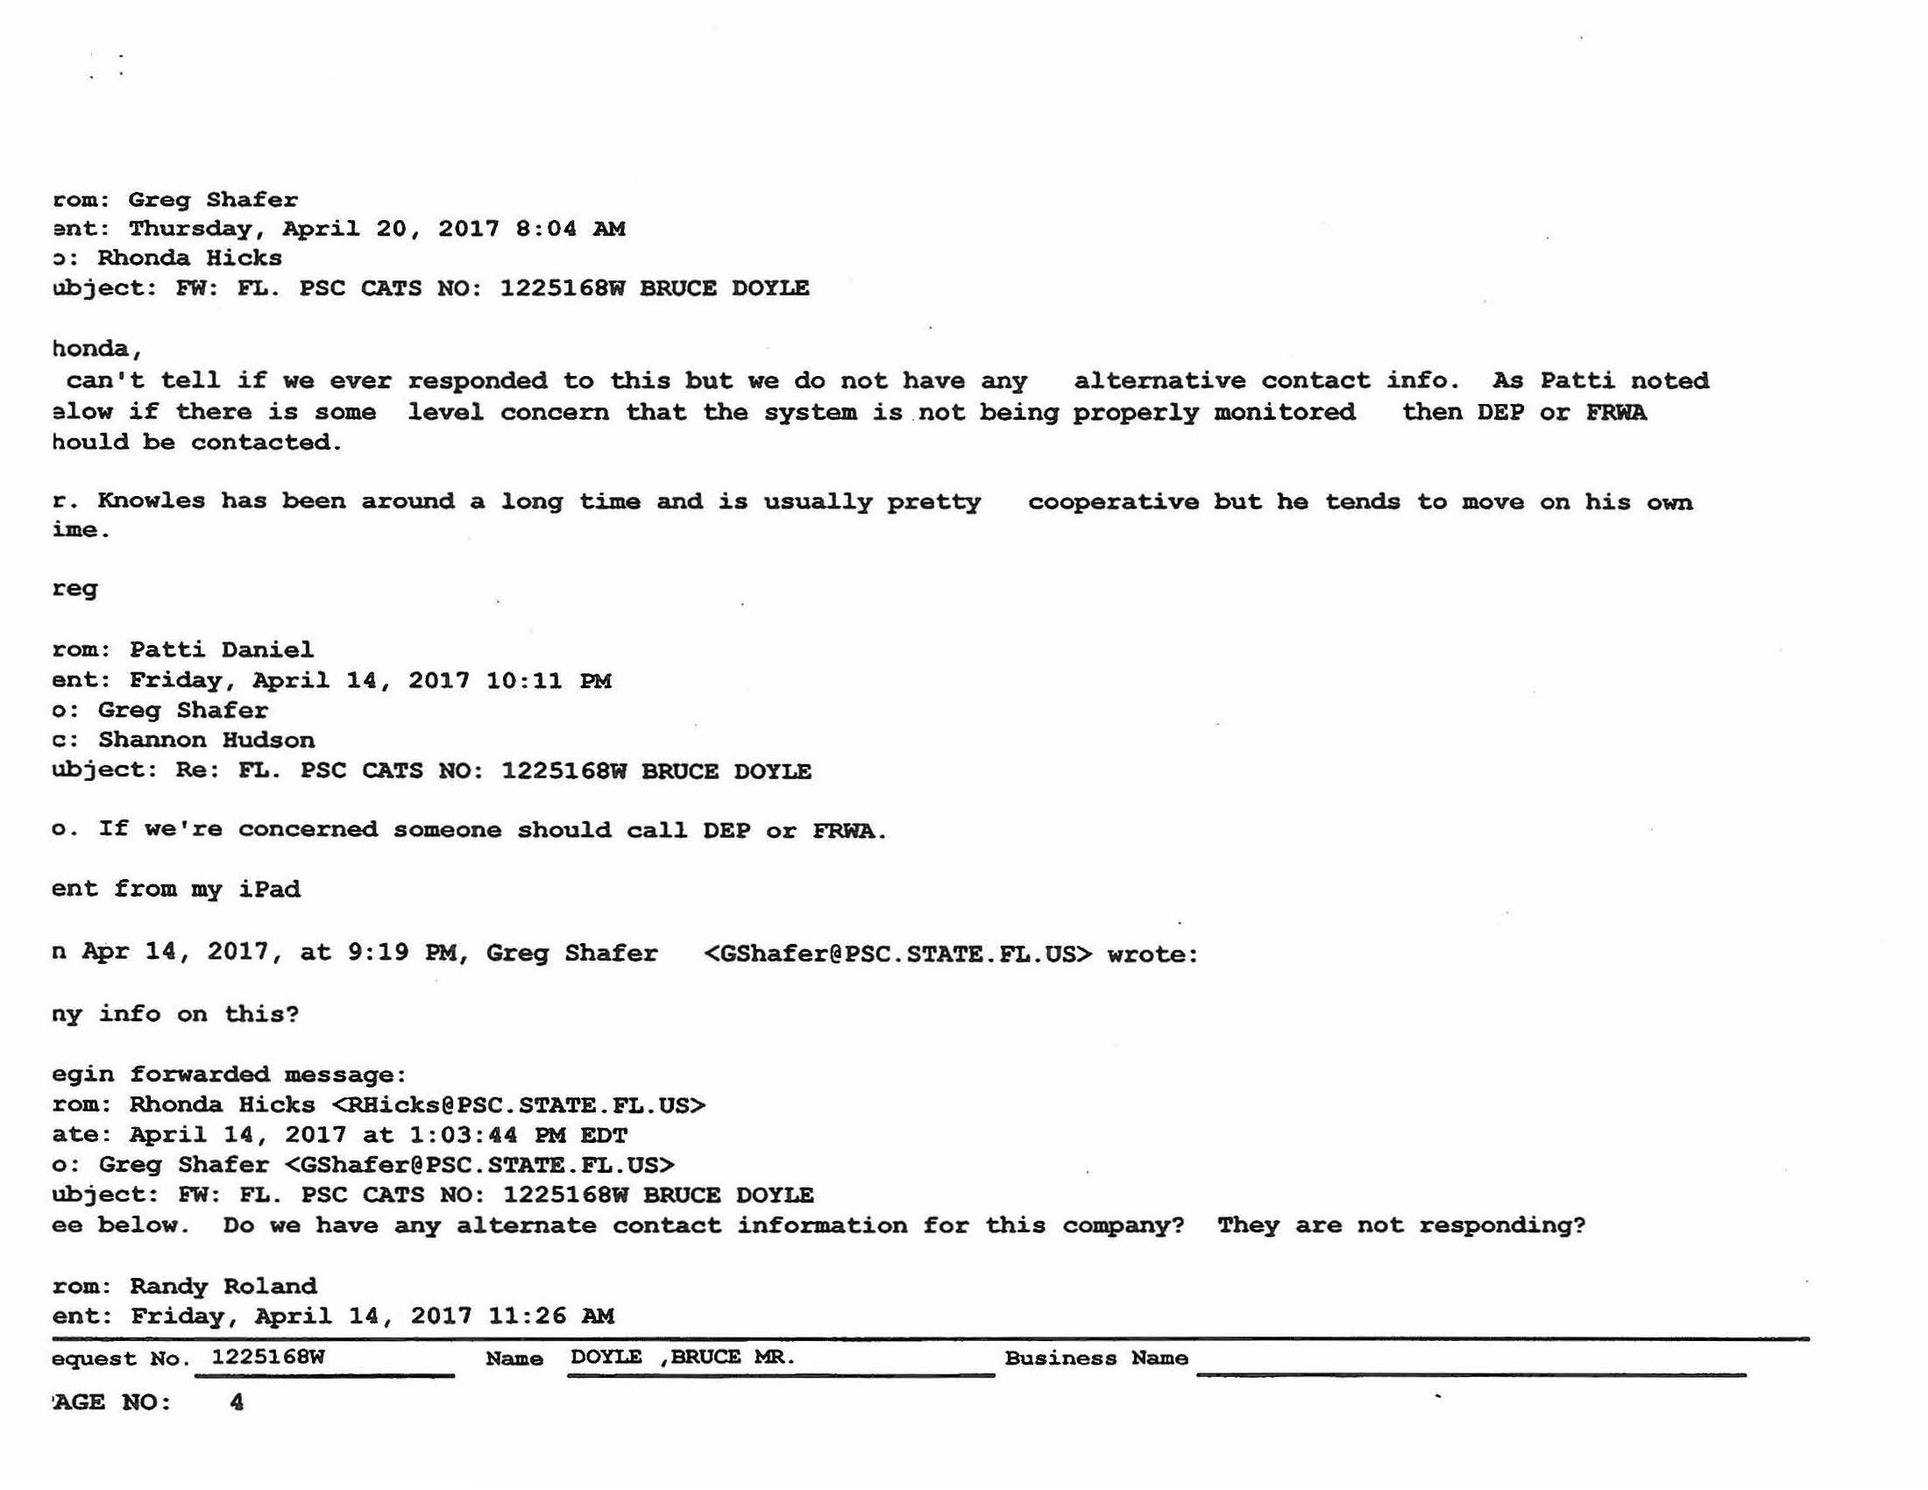

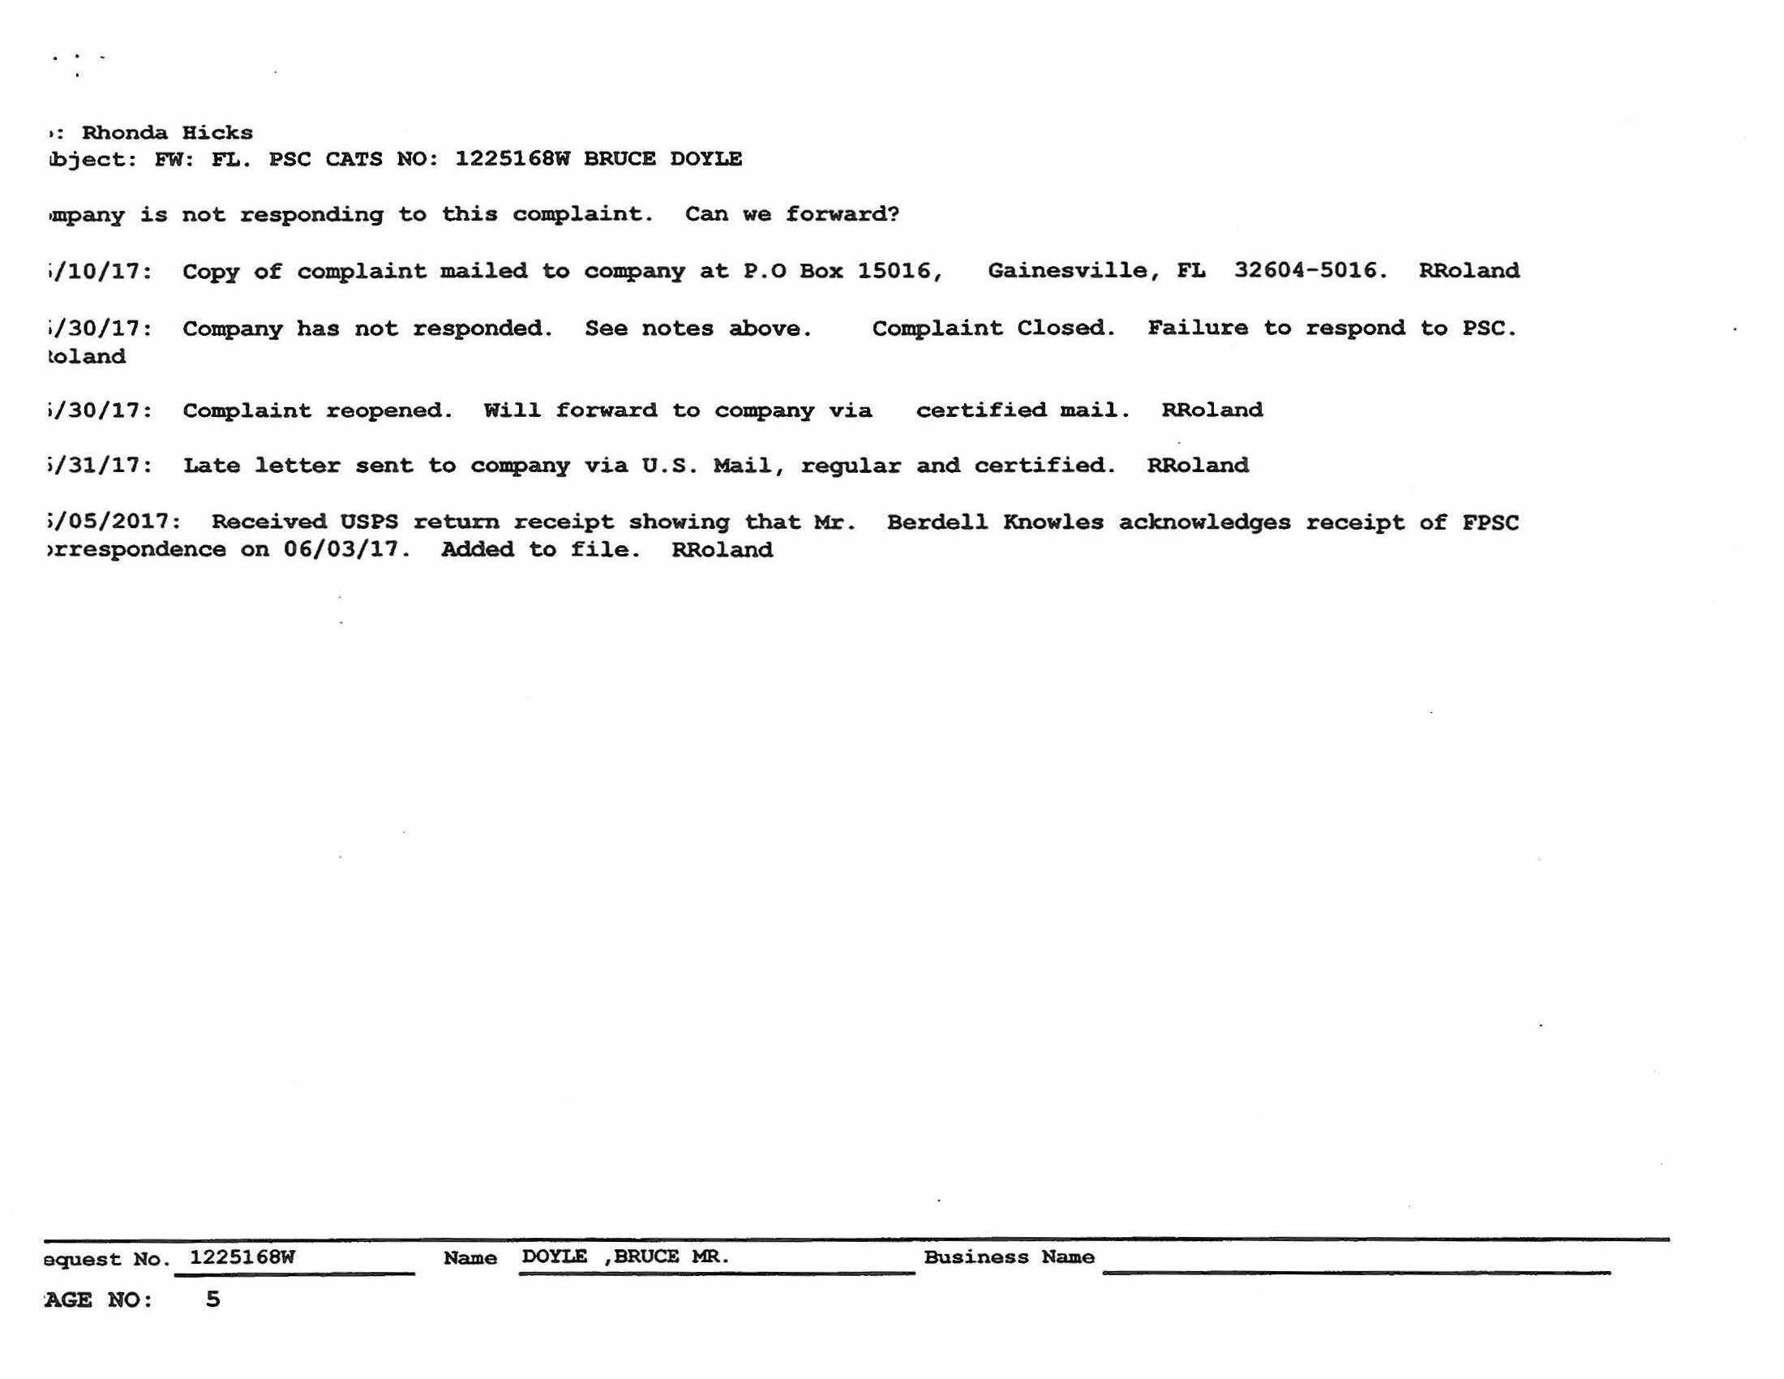

Order No. PSC-93-1027-FOF-WU, issued July 13, 1993, in Docket No. 921195-WU, In re: Application for certificate to provide water service in Alachua County under grandfather rights by Kincaid Hills Water Company.
Order No. PSC-98-0737-SC-WU, issued on May 28, 1998, in Docket No. 971623-WU, In Re: Initiation of show cause proceedings against Kincaid Hills Water Company in Alachua County for violation of Rule 25-30.110(3), F.A.C., Records and Reports; Annual Reports.
See, Docket No. 971623-WU.
See, Document No. 10810-98, in Docket No. 971623-WU.
Docket No. 040248-WU, In re: Initiation of show cause proceedings against Kincaid Hills Water Company in Alachua County for violation of Rule 25-30.110, F.A.C., Records and Reports; Annual Reports, and Rule 25-30.120, F.A.C., Regulatory Assessment Fees; Water and Wastewater Utilities.
Order No. PSC-04-0615-FOF-WU, issued June 21, 2004, in Docket No. 040248-WU, In re: Initiation of show cause proceedings against Kincaid Hills Water Company in Alachua County for violation of Rule 25-30.110, F.A.C., Records and Reports; Annual Reports, and Rule 25-30.120, F.A.C., Regulatory Assessment Fees; Water and Wastewater Utilities.
This Commission found the total amount of delinquent RAFs, penalty and interest, owed by Kincaid for years 1995-2003, to be $29,231.42. See Order No. PSC-04-0615-FOF-WU.
Between June 2004 and January 2006, Kincaid submitted $12,000.00 of the total $29,231.42 owed. $10,903.86 was applied to past due RAF principals and $1,096.14 to penalty and interest, which paid the entire RAF principal amounts owed for the years 1995 through 1999, and $1,410.92 of the $1,808.33 RAF principal owed for the year 2000.
Docket No. 070580-WU, In re: Initiation of Show Cause Proceedings against Kincaid Hills Water Company in Alachua County for violation of Rule 25-30.110, F.A.C., Records and Reports; Annual Reports; Rule 25-30.120, F.A.C., Regulatory Assessment Fees; Water and Wastewater Utilities; and of Order PSC-04-0615-FOF-WU.
Order No. PSC-08-0044-FOF-WU, issued January 22, 2008, in Docket No. 070580-WU, pages 9 and 11.
This Commission noted that “further collection efforts may cause the utility to abandon the system or cause it to be unable to make necessary repairs or maintain the safe provision of quality water to the customers of Kincaid.” Id., at pages 10 and 12; This Commission noted that, “in the last five months, the utility has worked diligently to pay off the 2004-2006 RAFs and has now filed all of its Annual Reports. Because of its financial problems and the need for maintenance, the utility has had problems with timely filing its Annual Reports and could not afford an accountant to assist it in such filing.” Id., at page 13.
Total amount to be written-off was $24,166.29. Id., at pages 10 and 12.
Id.
Id., at page 14.
Document No. 04657-08, filed in Docket No. 070580-WU.
Order No. PSC-08-0386-FOF-WU, issued June 10, 2008, in Docket No. 070580-WU, page 2.
Kincaid submitted its 2007 RAFs three days late and, was, therefore, assessed an additional $139.05, for statutory penalty and interest that accrued. Kincaid submitted the $139.05 penalty on May 1, 2008.
Order No. PSC-08-0386-FOF-WU.
Kincaid’s 2008 Annual Report was received 22 days late, on April 22, 2009.
Attachment A, Exhibit A (Commission Staff Correspondence re: Kincaid Delinquent RAFs and Annual Reports).
Attachment A, Exhibit A (Staff Email, dated June 17, 2014, RE: Kincaid Hills Water Company WU690 – First Collections Delinquent RAFs.)
Id.
Attachment A, Exhibit B (Kincaid Florida Corporate Information).
Attachment A, Exhibit C (Commission Staff Correspondence re: Kincaid Compliance Plan).
Attachment A, Exhibit C (Staff Emails with Mr. Knowles, Jr., RE: Kincaid Hills – Initial Compliance Plan.)
Id.
The payment was postmarked November 7, 2014. The payment breakdown was as follows: $4,491.55 (2010 RAFs $2,642.09 + Penalty $660.52 + Interest $1,188.94); and $4,198.60 (2011 RAFs $2657.34 + Penalty $664.34 + Interest $876.92)
Kincaid emailed its 2009-2013 Annual Reports to staff on November 7, 2014; however, Rule 25-30.110, F.A.C., requires reports be certified and submitted to this Commission in paper form. Our staff received the paper form of the Annual Reports on November 14, 2014. See Attachment A, Exhibit C (Staff Emails with Mr. Knowles, Jr., re: Kincaid Hills - Received Delinquent Annual Reports & 2010-11 RAF Payment; and Staff Emails with Mr. Knowles, Jr., re: Kincaid Hills - Annual Reports Insufficient.).
See Attachment A, Exhibit C (Staff Emails with Mr. Knowles, Jr., RE: Kincaid Hills – Rate Case & RAFs.).
See Attachment A, Exhibits B and C.
See Attachment A, Exhibits B and C.
See Attachment A.
See Document No. 07952-2017, in Docket No. 20170200-WU.
Fugate v. Fla. Elections Comm’n, 924 So. 2d 74, 75 (Fla. 1st DCA 2006), citing, Metro. Dade County v. State Dep't of Envtl. Prot., 714 So. 2d 512, 517 (Fla. 3d DCA 1998).
Fugate at 76.
Kincaid submitted its 2010 and 2011 RAFs, plus penalty and interest, on November 14, 2014, as part of on-going compliance/settlement negotiations with our staff.
Docket No. 040248-WU, In Re: Initiation of show cause proceedings against Kincaid Hills Water Company in Alachua County for violation of Rule 25-30.110, F.A.C., Records and Reports; Annual Reports, and Rule 25-30.120, F.A.C., Regulatory Assessment Fees; Water and Wastewater Utilities; and Docket No. 070580-WU, In Re: Initiation of Show Cause Proceedings against Kincaid Hills Water Company in Alachua County for violation of Rule 25-30.110, F.A.C., Records and Reports; Annual Reports; Rule 25-30.120, F.A.C., Regulatory Assessment Fees; Water and Wastewater Utilities; and of Order PSC-04-0615-FOF-WU.
Kincaid submitted its 2007 RAFs three days late and paid the associated penalty and interest.
Kincaid remitted payment of its 2010 and 2011 RAFs, including penalty and interest, on November 14, 2014. Additionally, Kincaid timely submitted its 2014 and 2015 RAFs.
Kincaid’s 2008 Annual Report was received 22 days late, on April 22, 2009.
Attachment A, Exhibit D (Open CATS Customer Complaints).
Id.
Id.
Order No. PSC-06-0349-SC-WS, issued April 25, 2006, in Docket No. 060057-WS and Order No. PSC-11-0541-SC-WS, issued November 22, 2011, in Docket No. 110254-WS.
Order No. PSC-93-0370-AS-WU.

