BEFORE THE FLORIDA PUBLIC SERVICE COMMISSION

In re: Petition for approval of transportation service agreement with Florida Public Utilities Company, by Peninsula Pipeline Company, Inc. | DOCKET NO. 20170193-GU  ORDER NO. PSC-2017-0498-PAA-GU  ISSUED: December 29, 2017

The following Commissioners participated in the disposition of this matter:

JULIE I. BROWN, Chairman
ART GRAHAM
RONALD A. BRISÉ
DONALD J. POLMANN
GARY F. CLARK

NOTICE OF PROPOSED AGENCY ACTION
ORDER APPROVING FIRM TRANSPORTATION AGREEMENT

BY THE COMMISSION:

NOTICE is hereby given by the Florida Public Service Commission (Commission) that the action discussed herein is preliminary in nature and will become final unless a person whose interests are substantially affected files a petition for a formal proceeding, pursuant to Rule 25-22.029, Florida Administrative Code (F.A.C.).

Background

On September 1, 2017, Peninsula Pipeline Company, Inc. (Peninsula) filed a petition seeking approval of a firm transportation service agreement (Agreement) between Peninsula and Florida Public Utilities Company (FPUC), collectively the parties, for an extension in New Smyrna Beach. Peninsula operates as a natural gas transmission company as defined by Section 368.103(4), Florida Statutes (F.S.). FPUC is a local distribution company (LDC) subject to our regulatory jurisdiction pursuant to Chapter 366, F.S.
By Order No. PSC-07-1012-TRF-GP, we approved Peninsula’s intrastate gas pipeline tariff that allows it to construct and operate intrastate pipeline facilities and to actively pursue agreements with gas customers. Peninsula provides transportation service only, and does not engage in the sale of natural gas. Pursuant to Order No. PSC-07-1012-TRF-GP, Peninsula is allowed to enter into certain gas transmission agreements without our prior approval; however, this Agreement does not fit any of the criteria enumerated in the tariff for which our approval would not be required. Both Peninsula and FPUC are subsidiaries of Chesapeake Utility Corporation (Chesapeake), and we must approve agreements between affiliated companies pursuant to Section 368.105, F.S., and Order No. PSC-07-1012-TRF-GP.
Pursuant to the Agreement (Attachment A to this Order), Peninsula will construct a new natural gas pipeline in the New Smyrna Beach area and relocate an existing gate station that is in a populated area. During the pendency of this proceeding, Commission staff issued a data request to both Peninsula and FPUC for which responses were received on October 2, 2017. We have jurisdiction over this matter pursuant to Sections 366.05(1), 366.06, and 368.105. F.S.
Decision
FPUC provides natural gas service to residential and commercial/industrial customers in the New Smyrna Beach area. FPUC is currently experiencing operational pressure issues on its distribution system which has hindered FPUC’s ability to provide adequate service to the outer edges of New Smyrna Beach during peak periods which typically occurs during the winter and cold weather and lowers the pressure of gas, causing delivery of gas issues. The pressure issues have also directly impacted economic growth development in both the large commercial and small industrial sectors. Additionally, a current FPUC gate station is located inside an active RV park, raising safety concerns.
FPUC and Peninsula entered into this Agreement to address these issues. The terms of the Agreement state that it will be in effect for an initial period of 20 years and shall be extended for additional 10-year increments, unless either party givens written notice of termination to the other party. The Agreement will provide resolution to the pressure problems, improve the reliability, and relocate the gate station from the RV park.
As per the Agreement, Peninsula will relocate the gate station that is currently inside an RV park to a new site adjacent to the Highway 92 right-of-way just north of the current site. Photographs of the gate station and adjacent RV park in Attachment B to the petition.
Additionally, Peninsula has agreed to construct and own a new pipeline, referred to as the New Smyrna Beach Line in the proposed Agreement. The new 14.7 mile pipeline will interconnect with the interstate Florida Gas Transmission (FGT) pipeline’s Daytona West gate station on US Highway 92, approximately one mile west of Interstate 95 in Volusia County. The pipeline will travel south where it will interconnect with FPUC’s existing pipeline in New Smyrna Beach. The New Smyrna Beach Line is shown in the map in Attachment A to this Order as the solid blue line. Peninsula stated that it is required to obtain approvals from the Florida Department of Transportation and the Florida Department of Environmental Protection for the pipeline, which Peninsula expects to receive soon. Construction is expected to be completed in early 2018.
FPUC’s existing 4 inch pipeline that has been serving the New Smyrna Beach area will remain in service as a distribution line. The New Smyrna Beach Line will be larger in diameter (8 inches) and will be located entirely within the public rights-of-way. The New Smyrna Beach Line will also operate at a higher delivery pressure than FPUC’s existing line to alleviate the existing pressure problems and support growth in the area.
The parties assert that the negotiated monthly reservation charge contained in the Agreement is consistent with a market rate in that they are within the ranges of rates set forth in similar agreements as required by Section 368.105(3)(b), F.S. In response to Commission staff’s data request, Peninsula provided a comparison of construction costs (confidential) for other similar agreements entered into by Peninsula. While construction costs vary for each project due to pipe size, construction conditions, permitting, etc., we find Peninsula’s construction and on-going maintenance costs for the proposed new line reasonable and comparable to other projects.
FPUC is proposing to recover the payments to Peninsula under this Agreement from its customers through its Purchased Gas Adjustment (PGA) and Swing Service Rider mechanisms consistent with other gas transmission pipeline costs incurred by FPUC. FPUC provided information showing that the impact on the PGA will be minor ($0.042 per therm for 2018). While FPUC will incur costs associated with this service expansion, any new load will help spread the costs over a larger customer base.
The benefit of Peninsula, as opposed to FPUC, constructing the new pipeline, is primarily that Peninsula’s construction and ownership of the pipeline will avoid FPUC undertaking the costs and risks for this project, which in turn protects FPUC’s ratepayers. Prior to entering into agreement with Peninsula, FPUC stated that it engaged in a conversation with FGT regarding the possibility of FGT building the new pipeline; however, the conversation did not produce an economically viable solution. In response to Commission staff’s data request, FPUC stated that FGT’s project estimate was higher than Peninsula’s cost.
Conclusion
Based on the petition and Commission staff data request responses, we find this Agreement cost effective, reasonable, in compliance with the requirements of Section 368.105, F.S., and benefits FPUC’s customers. Therefore, we hereby approve the Firm Transportation Agreement between Peninsula and FPUC, dated August 25, 2017.
Based on the foregoing, it is

ORDERED by the Florida Public Service Commission that the Firm Transportation Agreement between Peninsula Pipeline Company, Inc., and Florida Public Utilities Company is hereby approved. It is further

ORDERED that Attachment A to this Order is fully incorporated as set forth herein. It is further

ORDERED that the provisions of this Order, issued as proposed agency action, shall become final and effective upon the issuance of a Consummating Order unless an appropriate petition, in the form provided by Rule 28-106.201, Florida Administrative Code, is received by the Commission Clerk, 2540 Shumard Oak Boulevard, Tallahassee, Florida 32399-0850, by the close of business on the date set forth in the “Notice of Further Proceedings” attached hereto. It is further

ORDERED that in the event this Order becomes final, this docket shall be closed.

By ORDER of the Florida Public Service Commission this 29th day of December, 2017.

/s/ Hong Wang
HONG WANG
Chief Deputy Commission Clerk
Florida Public Service Commission
2540 Shumard Oak Boulevard
Tallahassee, Florida 32399
(850) 413-6770
www.floridapsc.com

Copies furnished: A copy of this document is provided to the parties of record at the time of issuance and, if applicable, interested persons.

KRM

NOTICE OF FURTHER PROCEEDINGS OR JUDICIAL REVIEW

The Florida Public Service Commission is required by Section 120.569(1), Florida Statutes, to notify parties of any administrative hearing that is available under Section 120.57, Florida Statutes, as well as the procedures and time limits that apply. This notice should not be construed to mean all requests for an administrative hearing will be granted or result in the relief sought.

Mediation may be available on a case-by-case basis. If mediation is conducted, it does not affect a substantially interested person's right to a hearing.

The action proposed herein is preliminary in nature. Any person whose substantial interests are affected by the action proposed by this order may file a petition for a formal proceeding, in the form provided by Rule 28-106.201, Florida Administrative Code. This petition must be received by the Office of Commission Clerk, 2540 Shumard Oak Boulevard, Tallahassee, Florida 32399-0850, by the close of business on January 19, 2018.

In the absence of such a petition, this order shall become final and effective upon the issuance of a Consummating Order.

Any objection or protest filed in this/these docket(s) before the issuance date of this order is considered abandoned unless it satisfies the foregoing conditions and is renewed within the specified protest period.

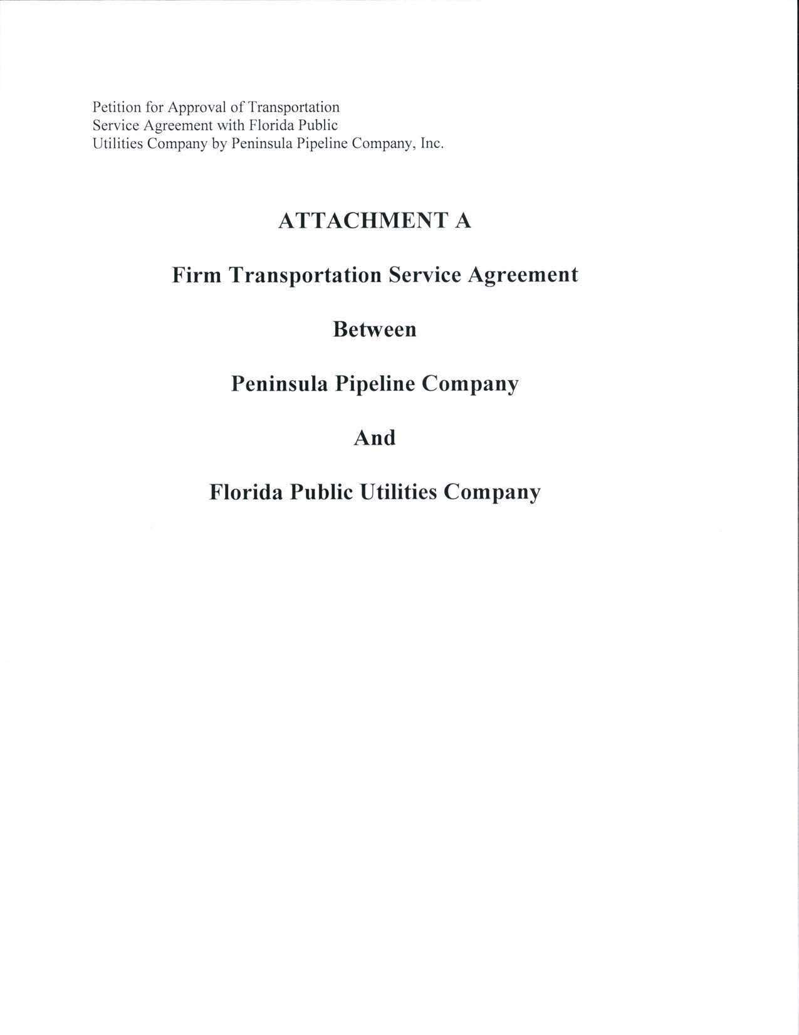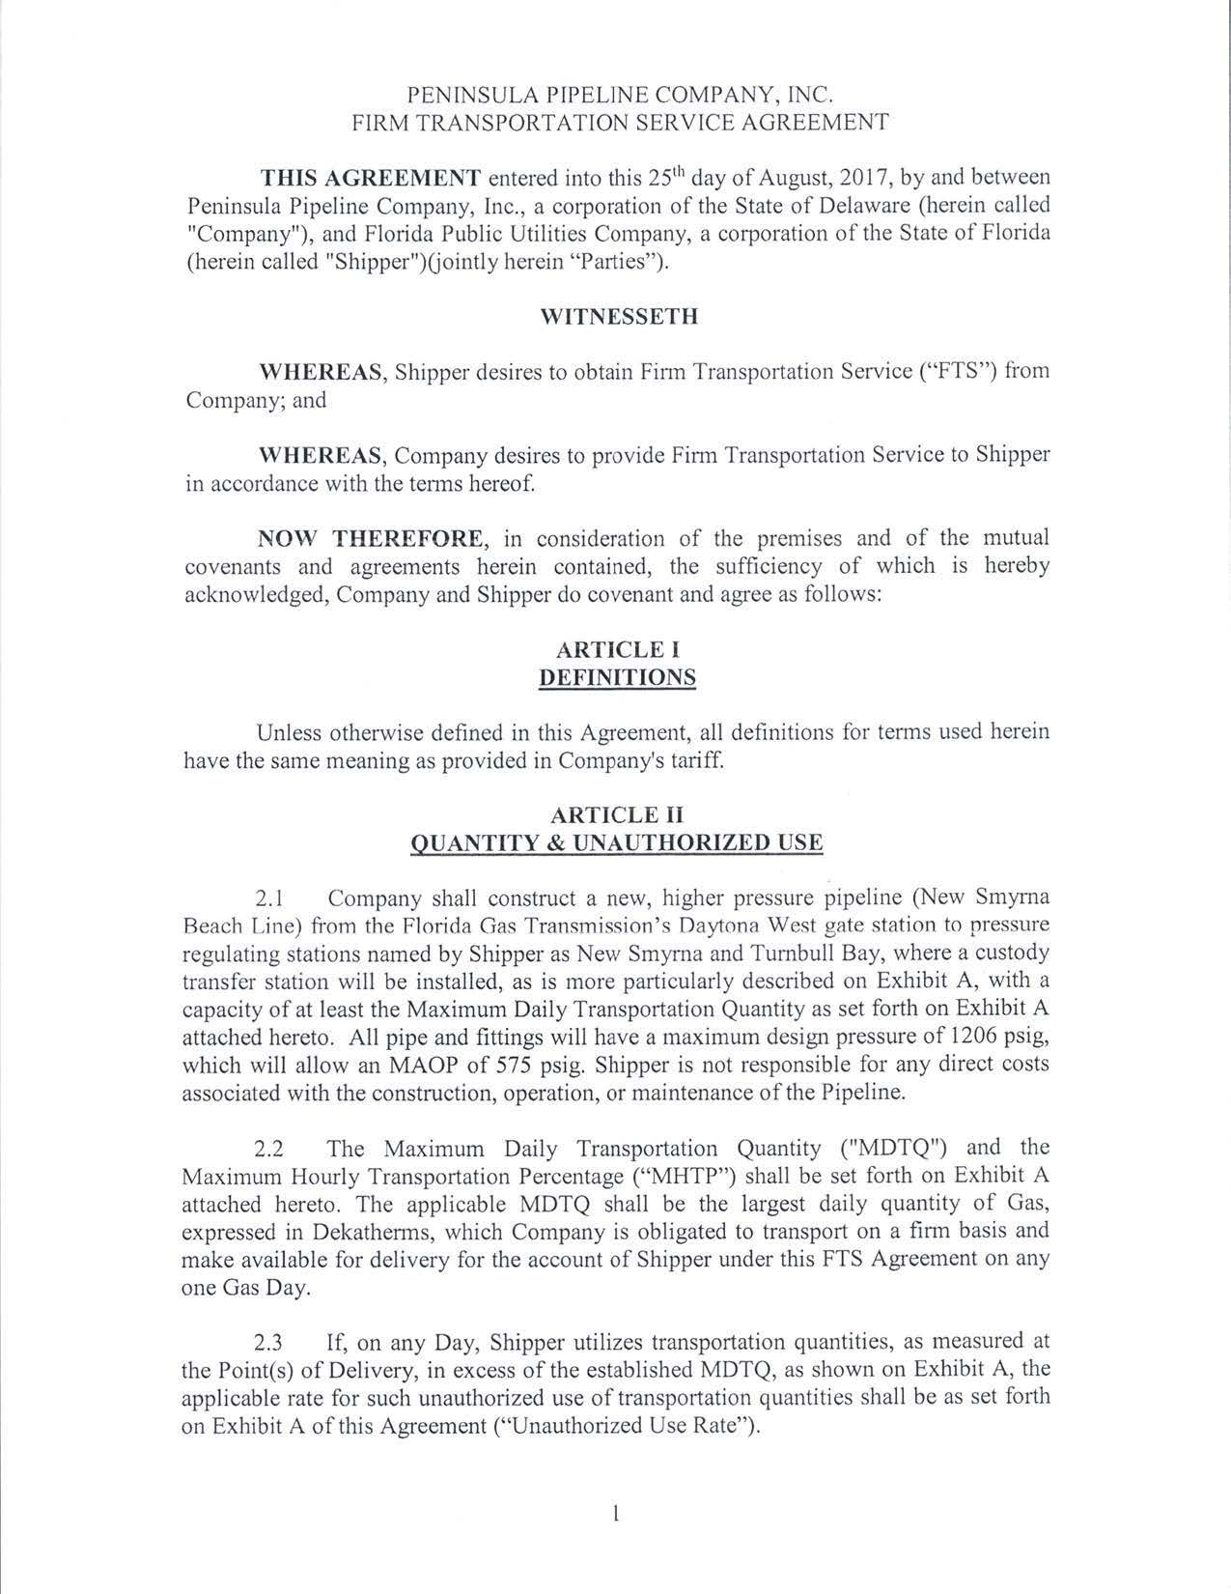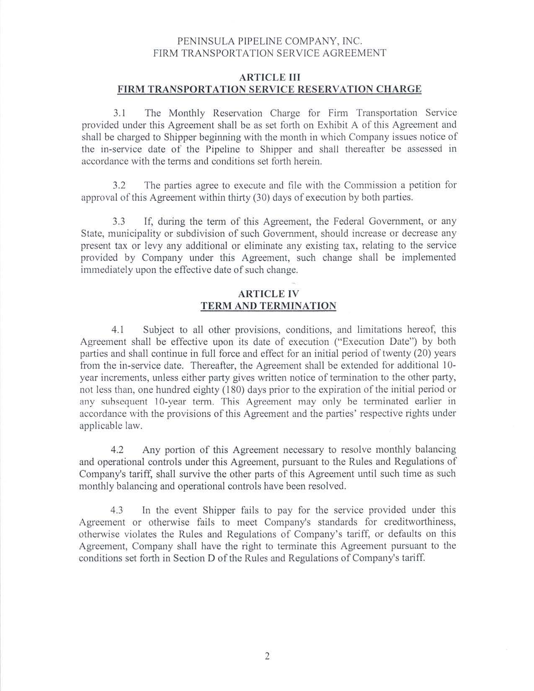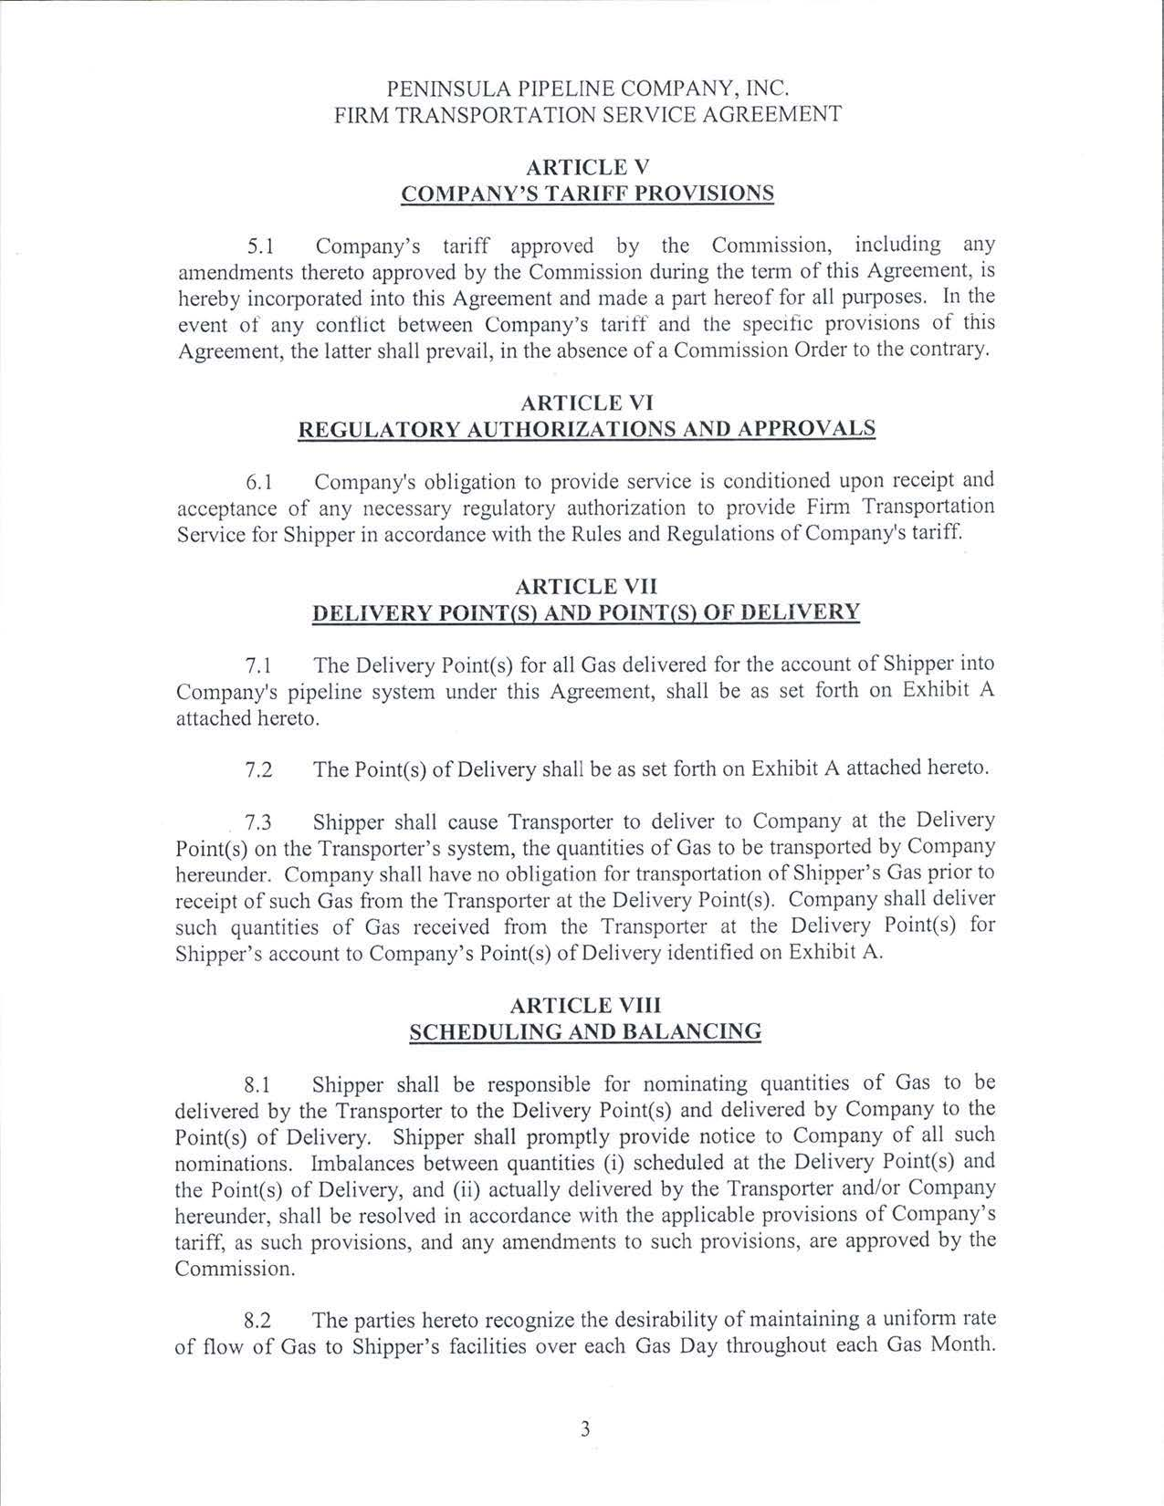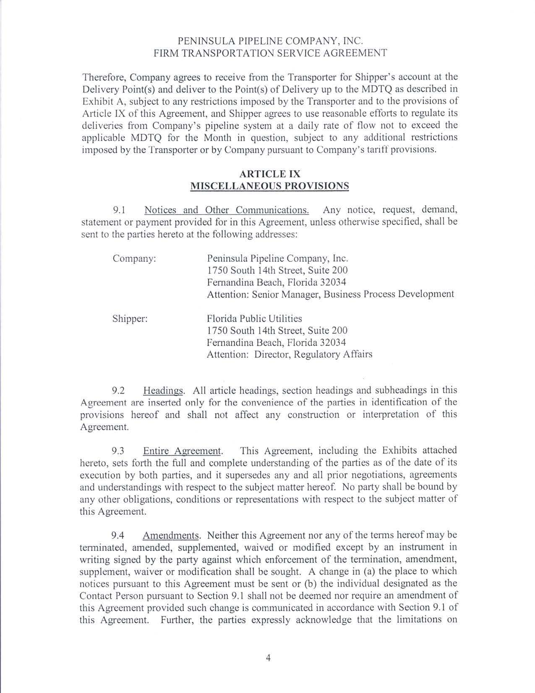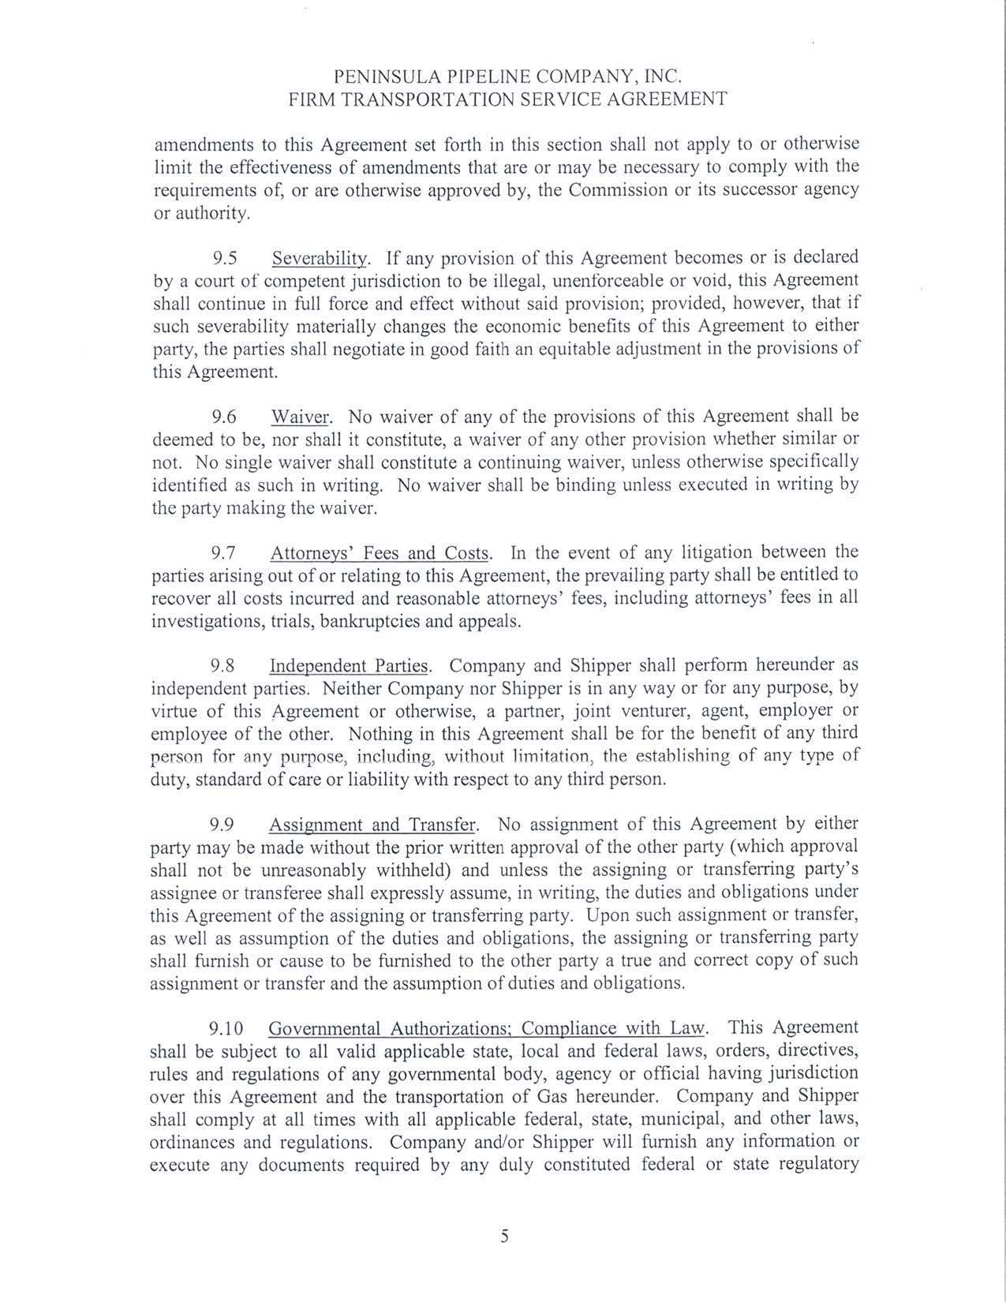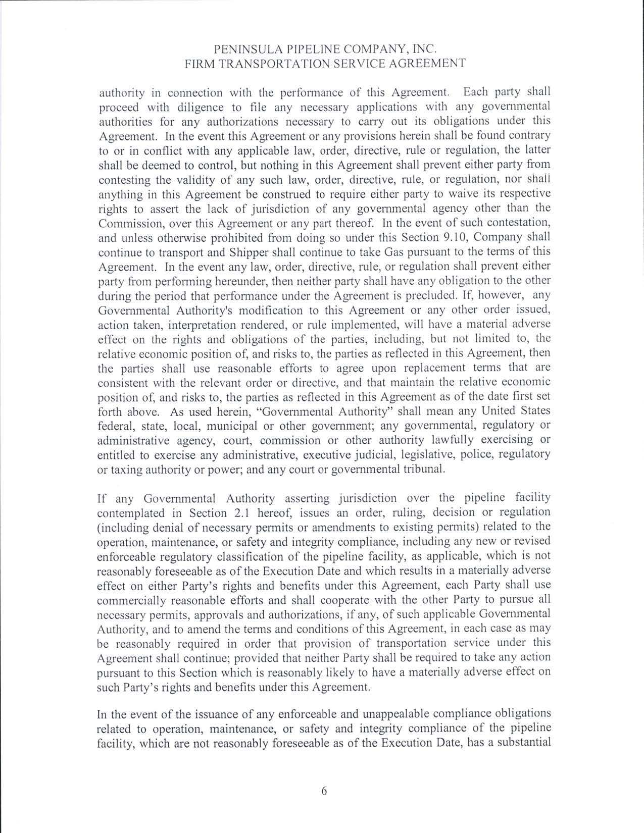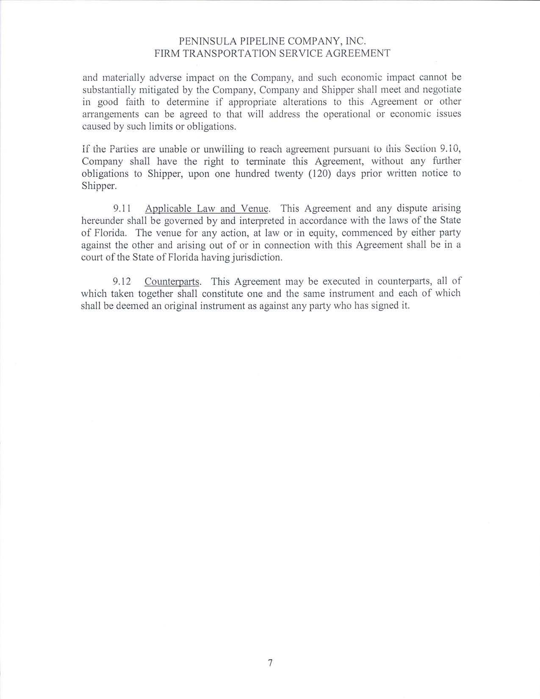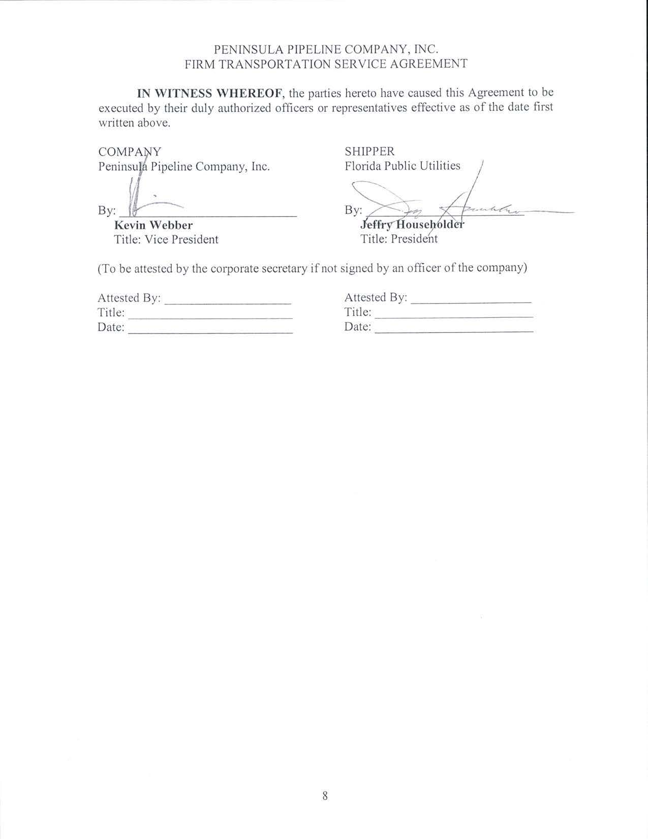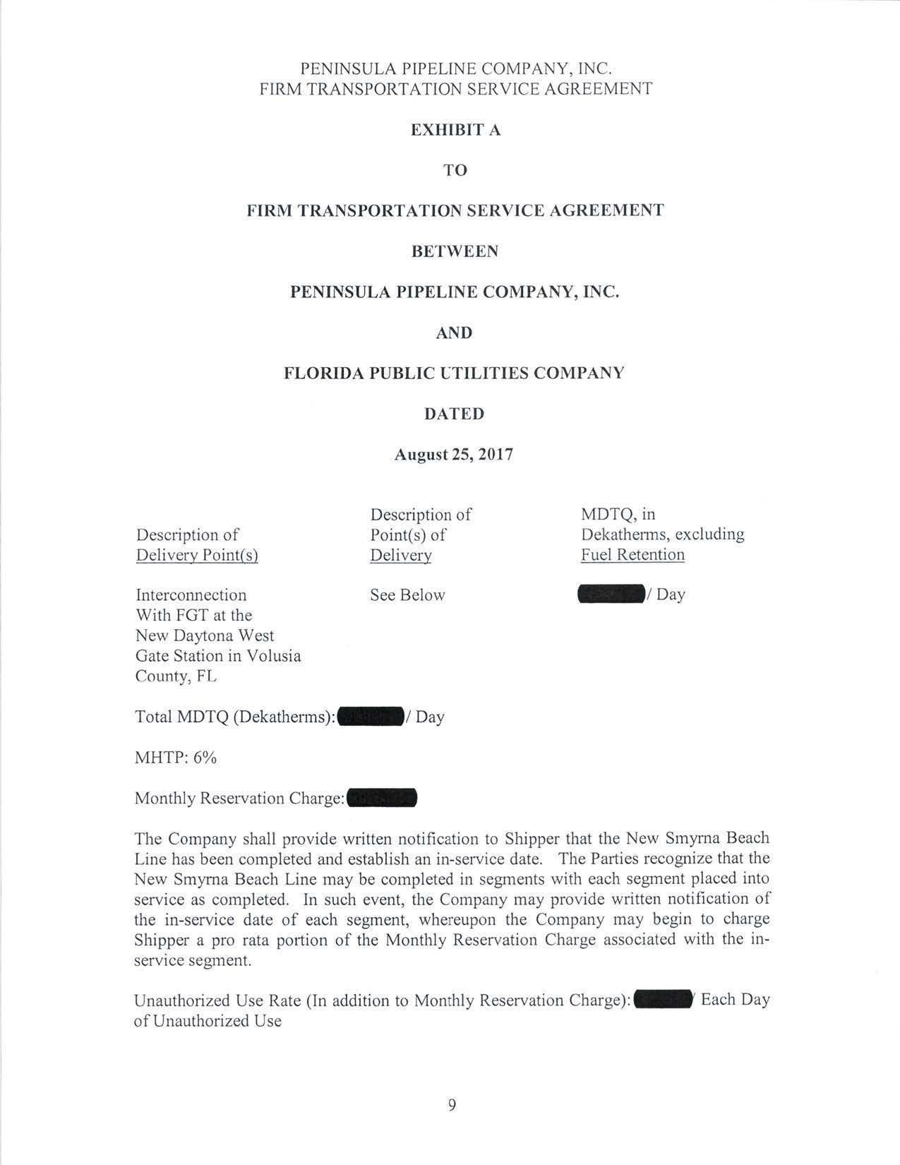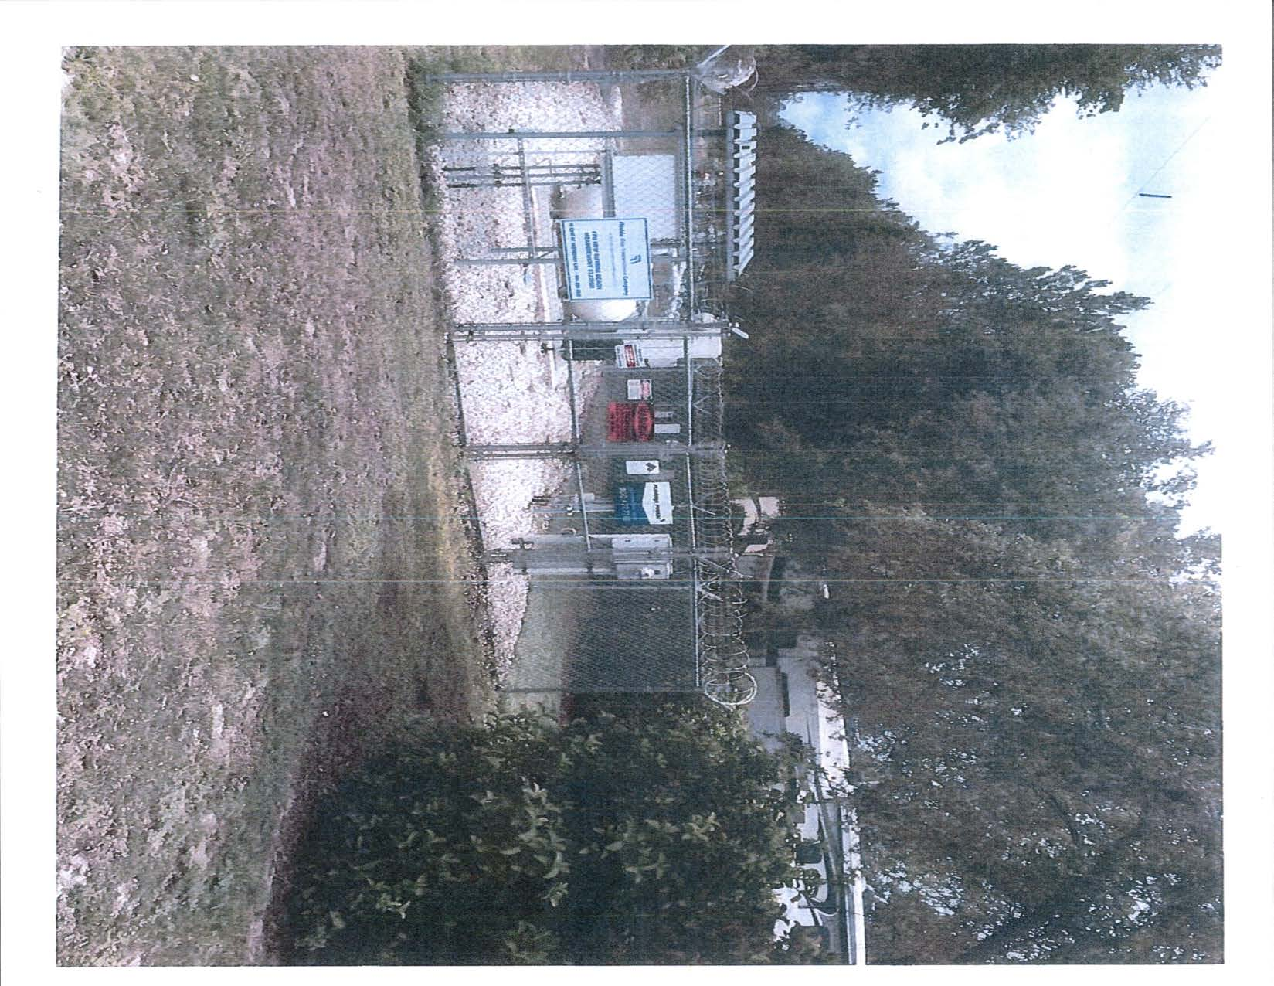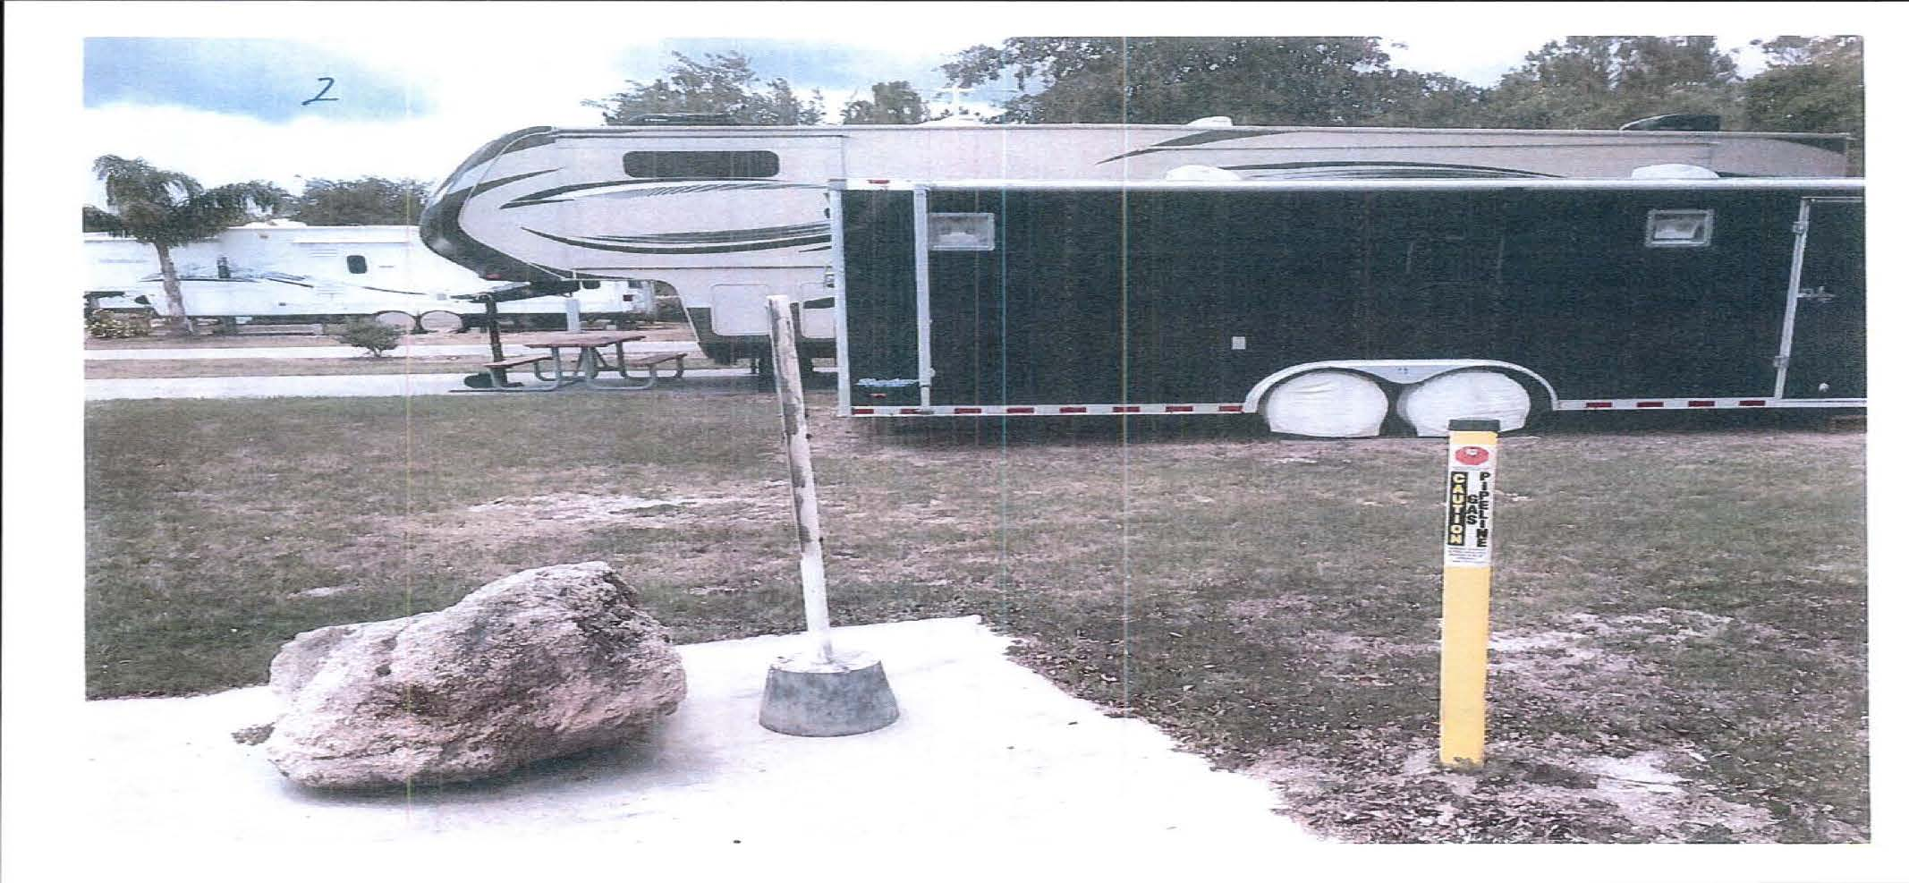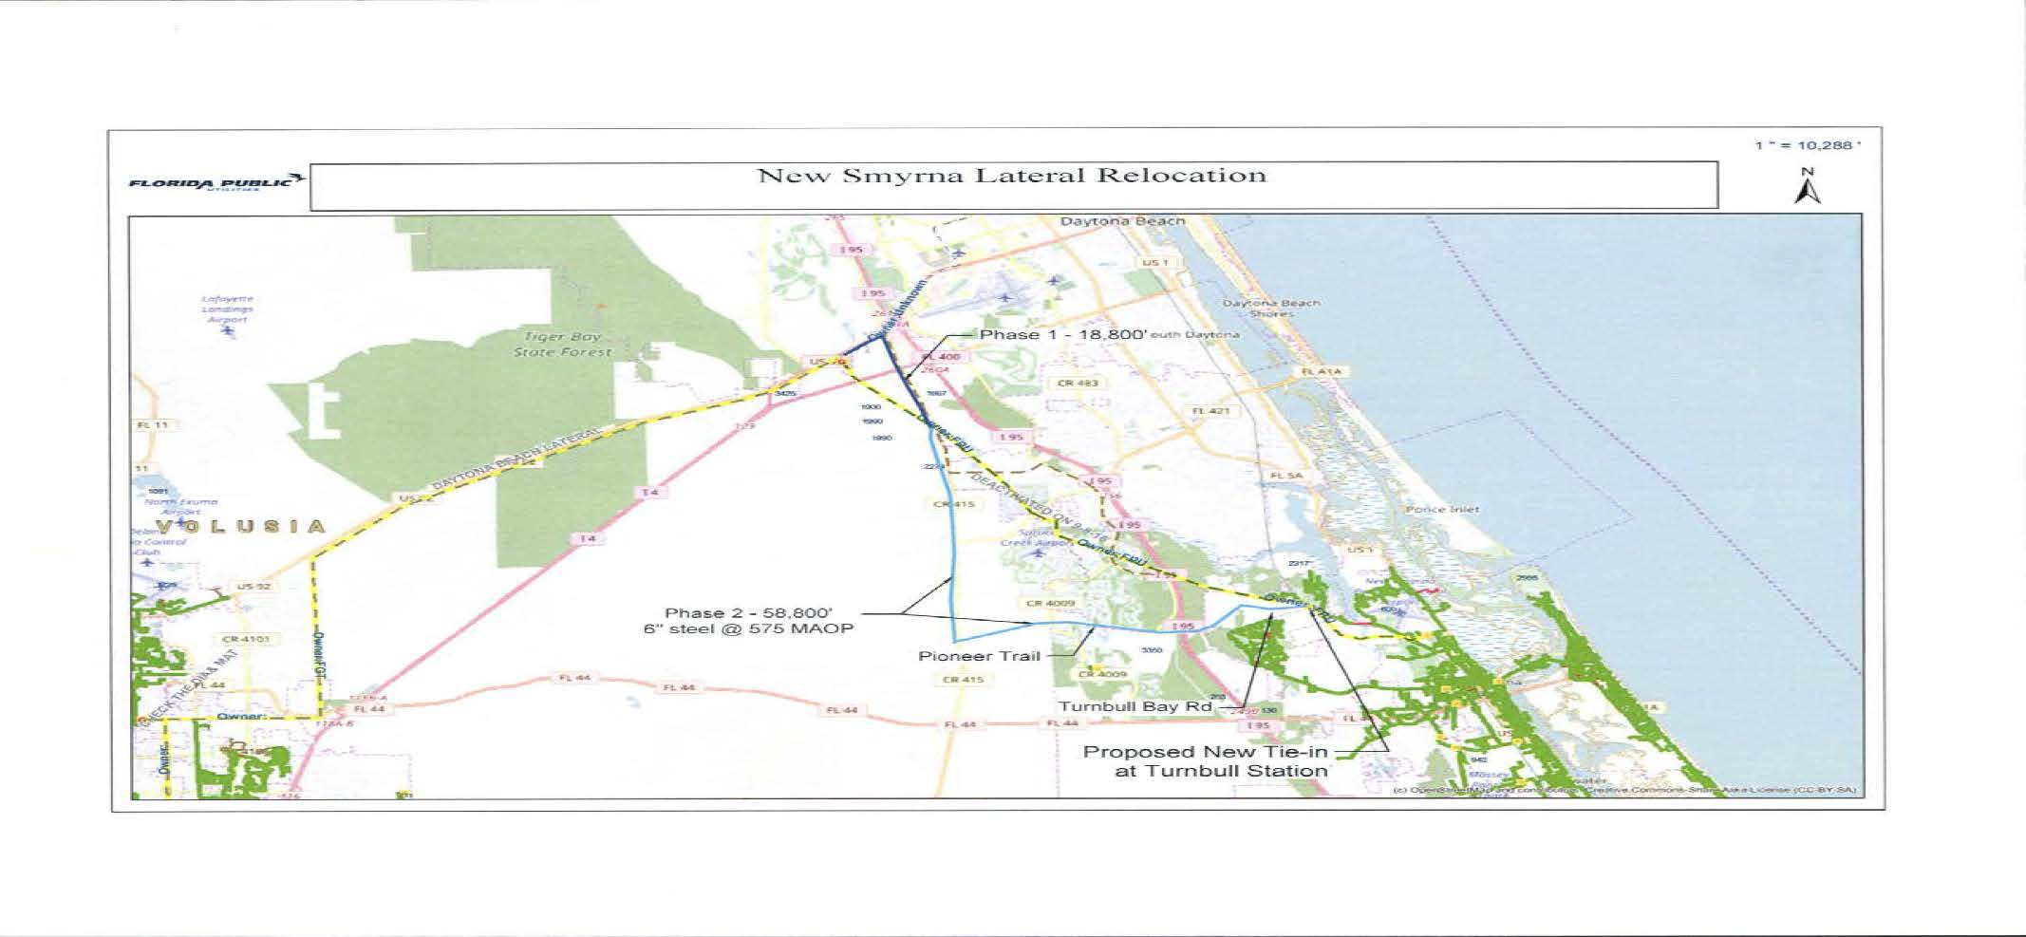

Order No. PSC-06-0023-DS-GP, issued January 9, 2006, in Docket No 050584-GP, In re: Petition for declaratory statement by Peninsula Pipeline Company, Inc. concerning recognition as a natural gas transmission company under Section 368.101, F.S., et seq.
Order No. PSC-07-1012-TRF-GP, issued December 21, 2007, in Docket No. 070570-GP, In re: Petition for approval of natural gas transmission pipeline tariff by Peninsula Pipeline Company, Inc.
Peninsula Pipeline Company, Inc., Intrastate Pipeline Tariff, Original Vol. 1, Sheet No. 12, Section 4.

