State of Florida |  | Public Service Commission  Capital Circle Office Center ● 2540 Shumard Oak Boulevard  Tallahassee, Florida 32399-0850  -M-E-M-O-R-A-N-D-U-M-
DATE: | January 25, 2018
TO: | Office of Commission Clerk (Stauffer)
FROM: | Division of Accounting and Finance (D. Smith, Mouring, D. Buys)  Division of Economics (Doherty, Draper)  Division of Engineering (P. Buys, Graves)  Office of the General Counsel (Crawford, Mapp, Janjic)
RE: | Docket No. 20170272-EI – Application for limited proceeding for recovery of incremental storm restoration costs related to Hurricanes Irma and Nate, by Duke Energy Florida, LLC.
AGENDA: | 02/06/18 – Regular Agenda –Interested Persons May Participate
COMMISSIONERS ASSIGNED: |  |  | All Commissioners
PREHEARING OFFICER: |  |  | Brown
CRITICAL DATES: |  |  | None
SPECIAL INSTRUCTIONS: |  |  | None

Case Background
On December 28, 2017, Duke Energy Florida, LLC (DEF) filed a petition for a limited proceeding seeking authority to implement an interim storm restoration recovery charge to recover a total of $513.2 million for the incremental restoration costs related to Hurricanes Irma and Nate and to replenish its storm reserve. In its petition, DEF asserted that, as a result of Hurricanes Irma and Nate, it incurred total retail recoverable costs of approximately $425 million, less its pre-storm reserve balance of $54 million, resulting in net recoverable costs of $371 million. In addition, DEF proposes to replenish its storm reserve to the $132 million balance that existed in February 2012. Interest, bond issuance expense, and the regulatory assessment fee gross-up adds an additional $10.2 million to the amount of recoverable costs.
DEF filed its petition pursuant to the provisions of the 2017 Second Revised and Restated Settlement Agreement (2017 Settlement) approved by the Commission in Order No. PSC-2017-0451-AS-EU. Pursuant to the 2017 Settlement, DEF can recover storm costs, without a cap on the level of charges on customer bills, on an interim basis beginning 60 days following the filing of a petition for recovery. Although the 2017 Settlement provides for a 12-month recovery period, DEF recognizes that the imposition of the full storm recovery amount over 12 months would result in an interim storm restoration recovery surcharge of over $15 per 1,000 kWh on a residential customer bill. Therefore, to mitigate this large rate increase, DEF proposes to spread the storm recovery amount over 36 months effective March 1, 2018, which would result in an interim storm restoration recovery surcharge of $5.20 per 1,000 kWh on a residential customer bill.

The Office of Public Counsel intervened in this docket on January 4, 2018.
The Commission has jurisdiction over this matter pursuant to Sections 366.04, 366.05, 366.06, and 366.076, Florida Statutes.

Discussion of Issues

Issue 1:
Should the Commission authorize DEF to implement an interim storm restoration recovery charge?

Recommendation:
Yes, the Commission should authorize DEF to implement an interim storm restoration recovery charge. Once the total actual storm costs are known, DEF should be required to file documentation of the total storm costs for Commission review and true-up of any excess or shortfall.
The appropriate security to guarantee the funds collected subject to refund is a corporate undertaking. (D. Smith, D. Buys)

Staff Analysis:
As stated in the case background, DEF filed a petition for a limited proceeding seeking authority to implement an interim storm restoration recovery charge to recover a total of $513.2 million for the incremental restoration costs related to Hurricanes Irma and Nate and to replenish its storm reserve. The requested recovery of $513.2 million represents net retail recoverable costs of approximately $371 million, plus an additional $132 million to replenish its storm reserve to the balance that existed in February 2012. In addition, the $513.2 million includes an additional $10.2 million for interest, bond issuance costs, and a regulatory assessment fee true-up. The petition was filed pursuant to the provisions of the 2017 Settlement approved by the Commission in Order No. PSC-2017-0451-AS-EU. Pursuant to Paragraph 38 of the 2017 Settlement, DEF can begin recovery of storm costs, without a cap, 60 days following the filing of a petition for recovery. In order to limit the monthly charge to customers, DEF has requested an interim storm restoration recovery charge of $5.20 on a monthly 1,000 kWh residential bill to be recovered over a 36-month period, effective March 1, 2018 through February 28, 2021.
In its petition, DEF asserts that it incurred total retail recoverable costs of approximately $371 million as a result of Hurricanes Irma and Nate. DEF further asserts that this amount was calculated in accordance with the Incremental Cost and Capitalization Approach (ICCA) methodology prescribed in Rule 25-6.0143, Florida Administrative Code (F.A.C.). The net retail recoverable costs of $371 million were determined by reducing the $425 million total recoverable costs by the pre-storm storm reserve balance of $54 million. Paragraph 38 of the 2017 Settlement also allows DEF to request the replenishment of its storm reserve to $132 million.
The approval of an interim storm restoration recovery charge is preliminary in nature and is subject to refund pending further review once the total actual storm restoration costs are known. After the actual costs are reviewed for prudence and reasonableness, and are compared to the actual amount recovered through the interim storm restoration recovery charge, a determination will be made whether any over/under recovery has occurred. The disposition of any over/under recovery, and associated interest, would be considered by the Commission at a later date.
Based on a review of the information provided by DEF in its petition, staff recommends that the Commission authorize DEF to implement an interim storm restoration recovery charge subject to refund. Once the total actual storm costs are known, DEF should be required to file documentation of the storm costs for Commission review and true-up of any excess or shortfall. Staff emphasizes that this recommendation is only for interim recovery charges and is not a confirmation or endorsement of the prudence of DEF’s forecasted costs and plans. This recommendation only allows DEF to begin recovery on an interim basis in accordance with the 2017 Settlement agreement. This interim recovery is subject to refund following a hearing or formal proceeding where the veracity and prudence of DEF’s actual restoration costs can be fully vetted.
Staff recommends that all funds collected subject to refund be secured by a corporate undertaking. The criteria for a corporate undertaking include sufficient liquidity, ownership equity, profitability, and interest coverage to guarantee any potential refund. Staff believes DEF has adequate resources to support a corporate undertaking in the amount requested.

Issue 2:
Should the Commission approve DEF’s proposed tariffs?

Recommendation:
Yes. The Commission should approve DEF’s proposed tariffs to go into effect February 6, 2018. (Doherty)

Staff Analysis:
DEF is seeking approval of interim storm recovery charges as shown in proposed Eighty-First Revised Tariff Sheet No. 6.105 (Attachment A to this recommendation). Appendix F to the petition includes revisions to all tariffs reflecting the addition of the interim storm recovery charges as shown on Tariff Sheet No. 6.105. A residential customer who uses 1,000 kilowatt-hours will see a $5.20 increase on the monthly bill starting in March 2018.

In response to staff’s request for additional information, DEF stated that customers will be notified of the interim storm recovery charge via bill inserts on the first billing cycle in February 2018 and has provided the notice for staff review. The interim storm recovery charges will start with the first billing cycle in March 2018 that occurs on February 27, 2018.

Staff recommends that the Commission approve DEF’s proposed tariffs to go into effect February 6, 2018.

Issue 3:
Should this docket be closed?

Recommendation:
This docket should remain open pending final reconciliation of actual recoverable storm costs with the amount collected pursuant to the interim storm restoration recovery charge, and the calculation of a refund or additional charge if warranted. (Mapp)

Staff Analysis:
This docket should remain open pending final reconciliation of actual recoverable storm costs with the amount collected pursuant to the interim storm restoration recovery charge, and the calculation of a refund or additional charge if warranted.

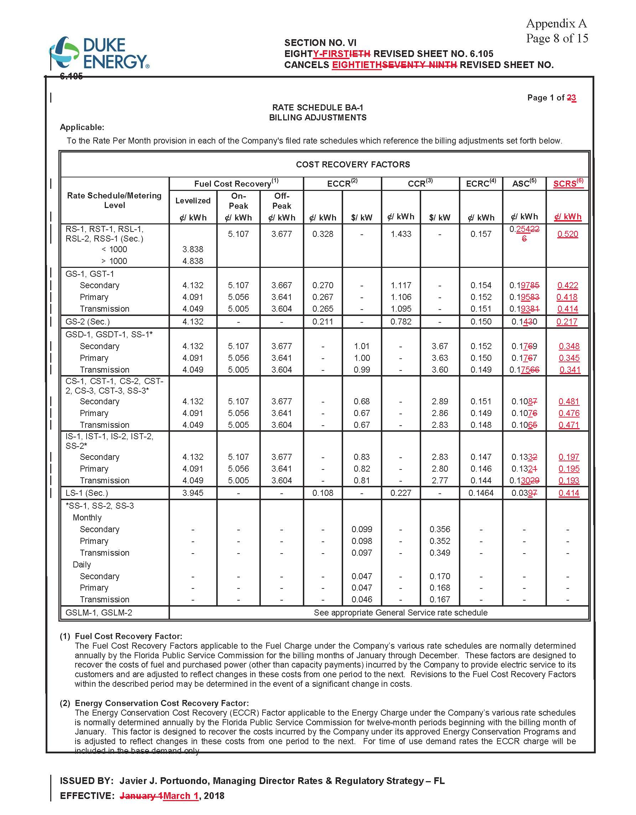

Order No. PSC-2017-0451-AS-EU, issued November 20, 2017, in Docket No. 20170183-EI, In re: Application for limited proceeding to approve 2017 second revised and restated settlement agreement, including certain rate adjustments, by Duke Energy Florida, LLC.
Document No. 00093-2018, in Docket No. 20170272-EI, In re: Application for limited proceeding for recovery of incremental storm restoration costs related to Hurricanes Irma and Nate, by Duke Energy Florida, LLC.

