State of Florida |  | Public Service Commission  Capital Circle Office Center ● 2540 Shumard Oak Boulevard  Tallahassee, Florida 32399-0850  -M-E-M-O-R-A-N-D-U-M-
DATE: | February 16, 2018
TO: | Office of Commission Clerk (Stauffer)
FROM: | Division of Engineering (Mtenga)  Division of Economics (Draper)  Office of the General Counsel (Dziechciarz)
RE: | Docket No. 20170252-EI – Petition for approval of experimental curtailable demand-side management program, by Gulf Power Company.
AGENDA: | 03/01/18 – Tariff Filing – Interested Persons May Participate
COMMISSIONERS ASSIGNED: |  |  | All Commissioners
PREHEARING OFFICER: |  |  | Clark
CRITICAL DATES: |  |  | 60-Day Tariff Suspension waived until 03/01/2018
SPECIAL INSTRUCTIONS: |  |  | None

Case Background
On May 16, 2017, the Florida Public Service Commission (Commission) issued Order No. PSC-2017-0178-S-EI, approving a Stipulation and Settlement Agreement (Settlement) which resolved all outstanding issues in the Gulf Power Company (Gulf or Company) 2016 base rate proceeding. On November 28, 2017, as a result of section 19 of the Settlement, Gulf filed a petition for approval of its experimental Curtailable Load program as part of its Demand-Side Management (DSM) plan. The proposed rate rider and associated tariffs are shown in Attachment A.
The Commission has jurisdiction over this matter pursuant to Sections 366.80 through 366.83 and 403.519, Florida Statutes.

Discussion of Issues

Issue 1:
Should the Commission approve Gulf Power Company’s request to include its experimental Curtailable Load program and associated tariffs in the Company’s DSM plan?

Recommendation:
Yes. The Curtailable Load program fulfills a requirement of the Settlement reached in Gulf’s 2016 base rate proceeding. It fulfills the policy objectives of the Florida Energy Efficiency and Conservation Act (FEECA), it is directly monitorable, yields measurable results and it is cost effective. Staff recommends approval of Gulf’s proposed experimental Curtailable Load program and associated tariffs. (Mtenga)

Staff Analysis:
The criteria used to review the appropriateness of DSM programs are: (1) whether the program advances the policy objectives of the FEECA and its implementing rules; (2) whether the program is directly monitorable and yields measurable results; and (3) whether the program is cost-effective. Staff has reviewed Gulf’s petition for its experimental Curtailable Load program and it appears to be consistent with these criteria.
Program Description
The Curtailable Load program is available to industrial and commercial customers who take service under rates LP, LPT, PX, or PXT. This program provides qualifying customers capacity payments for load which can be curtailed during certain conditions. Customers who qualify for the program must commit to a minimum non-firm demand reduction of 4,000 kilowatts (kW). A customer must execute a Curtailable Load Service Agreement (CL Service Agreement) for a term of 10 years beyond the anticipated in-service date of Gulf’s next generation capacity need in 2023. Multiple accounts may be combined to meet the demand and load factor requirements provided that the demand response is coordinated from a single location and a single point of contact is provided to Gulf for notification. The program is only applicable to locations at which the interruption of electric service will primarily affect only the customer and will not significantly affect members of the general public, nor interfere with functions performed for the protection of public health or safety unless adequate on-site backup generation is available. The program will be closed to additional customers when the total non-firm demand subject to CL Service Agreements reaches 50 megawatts.

A curtailment period may be designated by Gulf when non-firm demand curtailment is necessary to alleviate any conditions that could lead to the interruption of power supply in the local area or region. Gulf expects to provide at least 30 minutes advance notice of the curtailment period. Gulf may terminate service under the program at any time for the customer’s failure to comply with the terms and conditions of the CL Service Agreement. An incident of non-compliance will be considered to have occurred if the customer’s maximum integrated 15 minute demand to the nearest kW during a curtailment period is greater than the firm demand. Customers may terminate their CL Service Agreement without penalty or liability by providing the Company with at least five years advance written notice, which staff deems sufficient for planning purposes to acquire or build firm capacity. The program as described meets the requirement of the Settlement to offer a curtailable rate program. In response to staff’s data request, Gulf stated that the signatories to the Settlement did not indicate any material concerns with the petition.

FEECA Policy Objectives/Program Monitoring and Evaluation
FEECA emphasizes reducing the growth rate of peak demand and reducing and controlling growth rates of electricity consumption. The program allows qualified customers an incentive to decrease their firm peak demand. Customers taking service under the program will initially receive a monthly bill credit of $3.35 per kW which is subject to curtailment. This initial monthly credit was determined by Gulf to be the maximum recurring monthly credit that would not cause the programs costs to be higher than the benefits realized from the avoided capacity. The bill credit amount will be subject to review and adjustment in the Company’s Energy Conservation Cost Recovery (ECCR) Clause proceedings. The program is experimental in nature with a December 31, 2021, termination date unless Gulf files for an extension through the Commission. Gulf will use several criteria in evaluating this program. These include: customers’ interest in the program, customers’ responses to curtailment periods, program implementation and management costs and the Company’s capacity needs.
Cost-Effectiveness Review
Pursuant to Rule 25-17.008, Florida Administrative Code, Gulf provided a cost-effectiveness analysis of the program using the Participant test, the Rate Impact Measure (RIM) test, and the Total Resource Cost (TRC) test. The Participant test analyzes the costs and benefits from a program participants’ point of view. The RIM test ensures that all ratepayers will benefit from a proposed DSM program, not just the program participants. The TRC test measures the overall economic efficiency of a DSM program from a system perspective. Each test estimates the benefits and costs, and the program is determined to be cost-effective if the ratio of benefits to costs is greater than one. Staff has reviewed the assumptions associated with Gulf’s program savings and recommends that they are reasonable. Table 1-1 below shows the results for cost-effectiveness for the Rate Rider program.

Table 1-1
Cost-Effectiveness Test Results
Participant Test | RIM Test | TRC Test
∞ | 1.00 | 17.11
Source: Gulf’s Petition

Gulf anticipates current customers receiving service under the Critical Peak Option for Rate LPT to be likely participants in the program, which would result in an increase of approximately $134,000 to the ECCR clause in 2018. The estimated monthly rate impact to the ECCR factor for this scenario is $0.02/1,000 kWh for a residential customer. The impact to the ECCR clause for 1000 kWh if all 50 MW are subscribed is $0.15 per customer.

Conclusion
The Curtailable Load program fulfills a requirement of the Settlement reached in Gulf’s last base rate proceeding. It fulfills the policy objectives of FEECA, it is directly monitorable, yields measurable results and it is cost effective. Staff recommends approval of Gulf’s proposed experimental Curtailable Load program and associated tariffs.

Issue 2:
Should this docket be closed?

Recommendation:
Yes. This docket should be closed and the tariffs shall become effective upon the issuance of the consummating order unless a person whose substantial interests are affected by the Commission’s decision files a protest within 21 days of the issuance of the consummating order. If a timely protest is filed, the tariffs should not go into effect, pending resolution of the protest. (Dziechciarz)

Staff Analysis:
This docket should be closed and the tariffs shall become effective upon the issuance of the consummating order unless a person whose substantial interests are affected by the Commission’s decision files a protest within 21 days of the issuance of the consummating order. If a timely protest is filed, the tariffs should not go into effect, pending resolution of the protest.

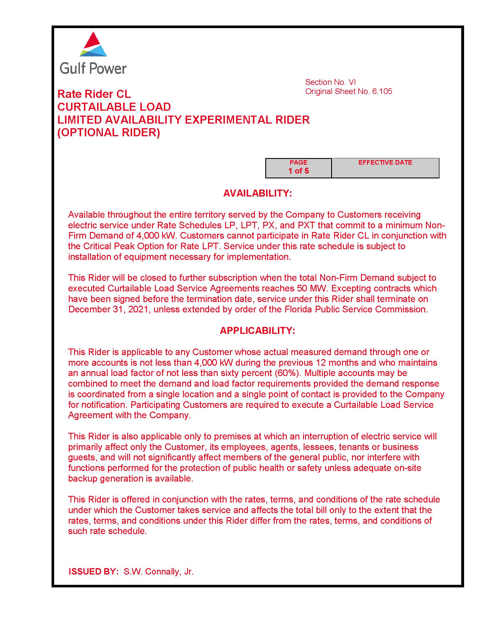

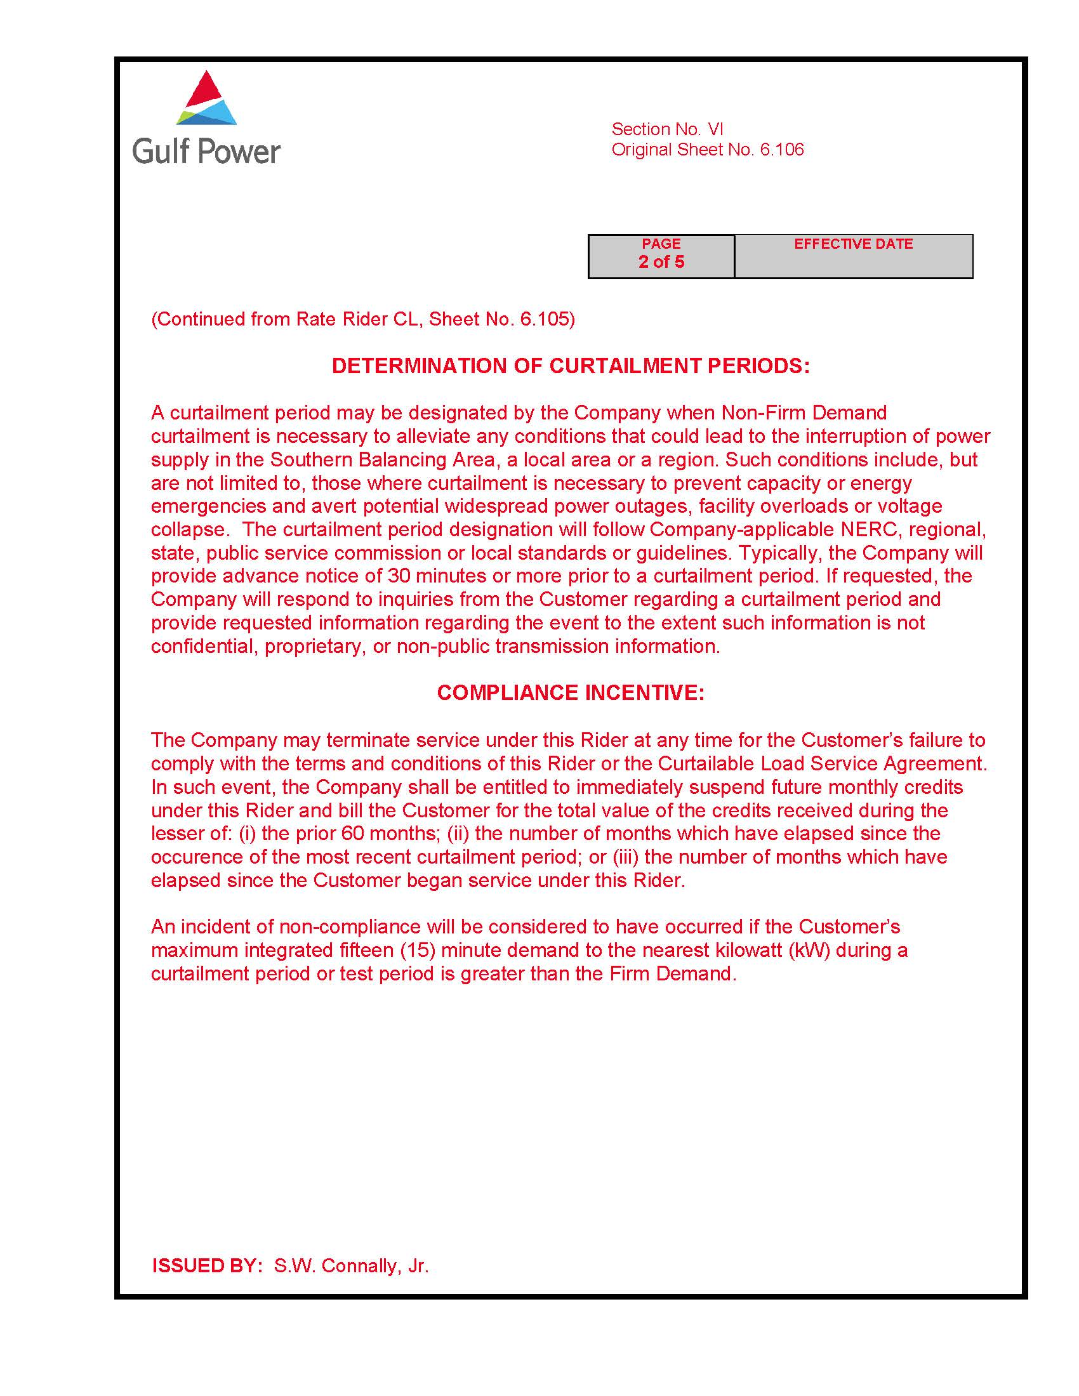

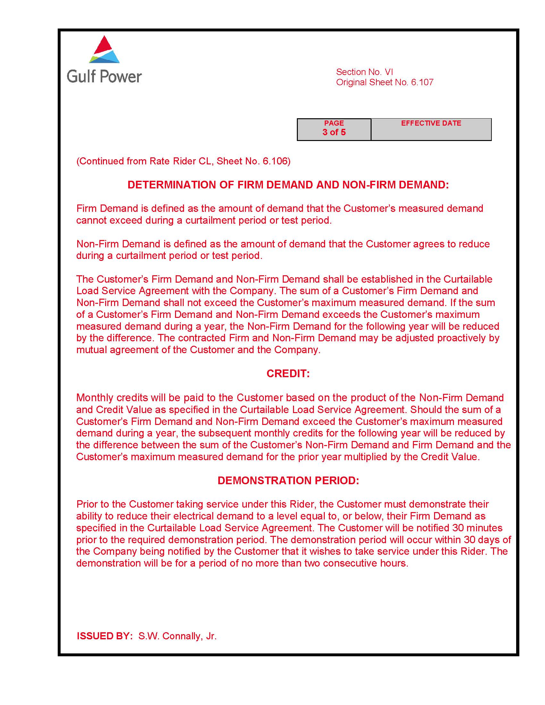

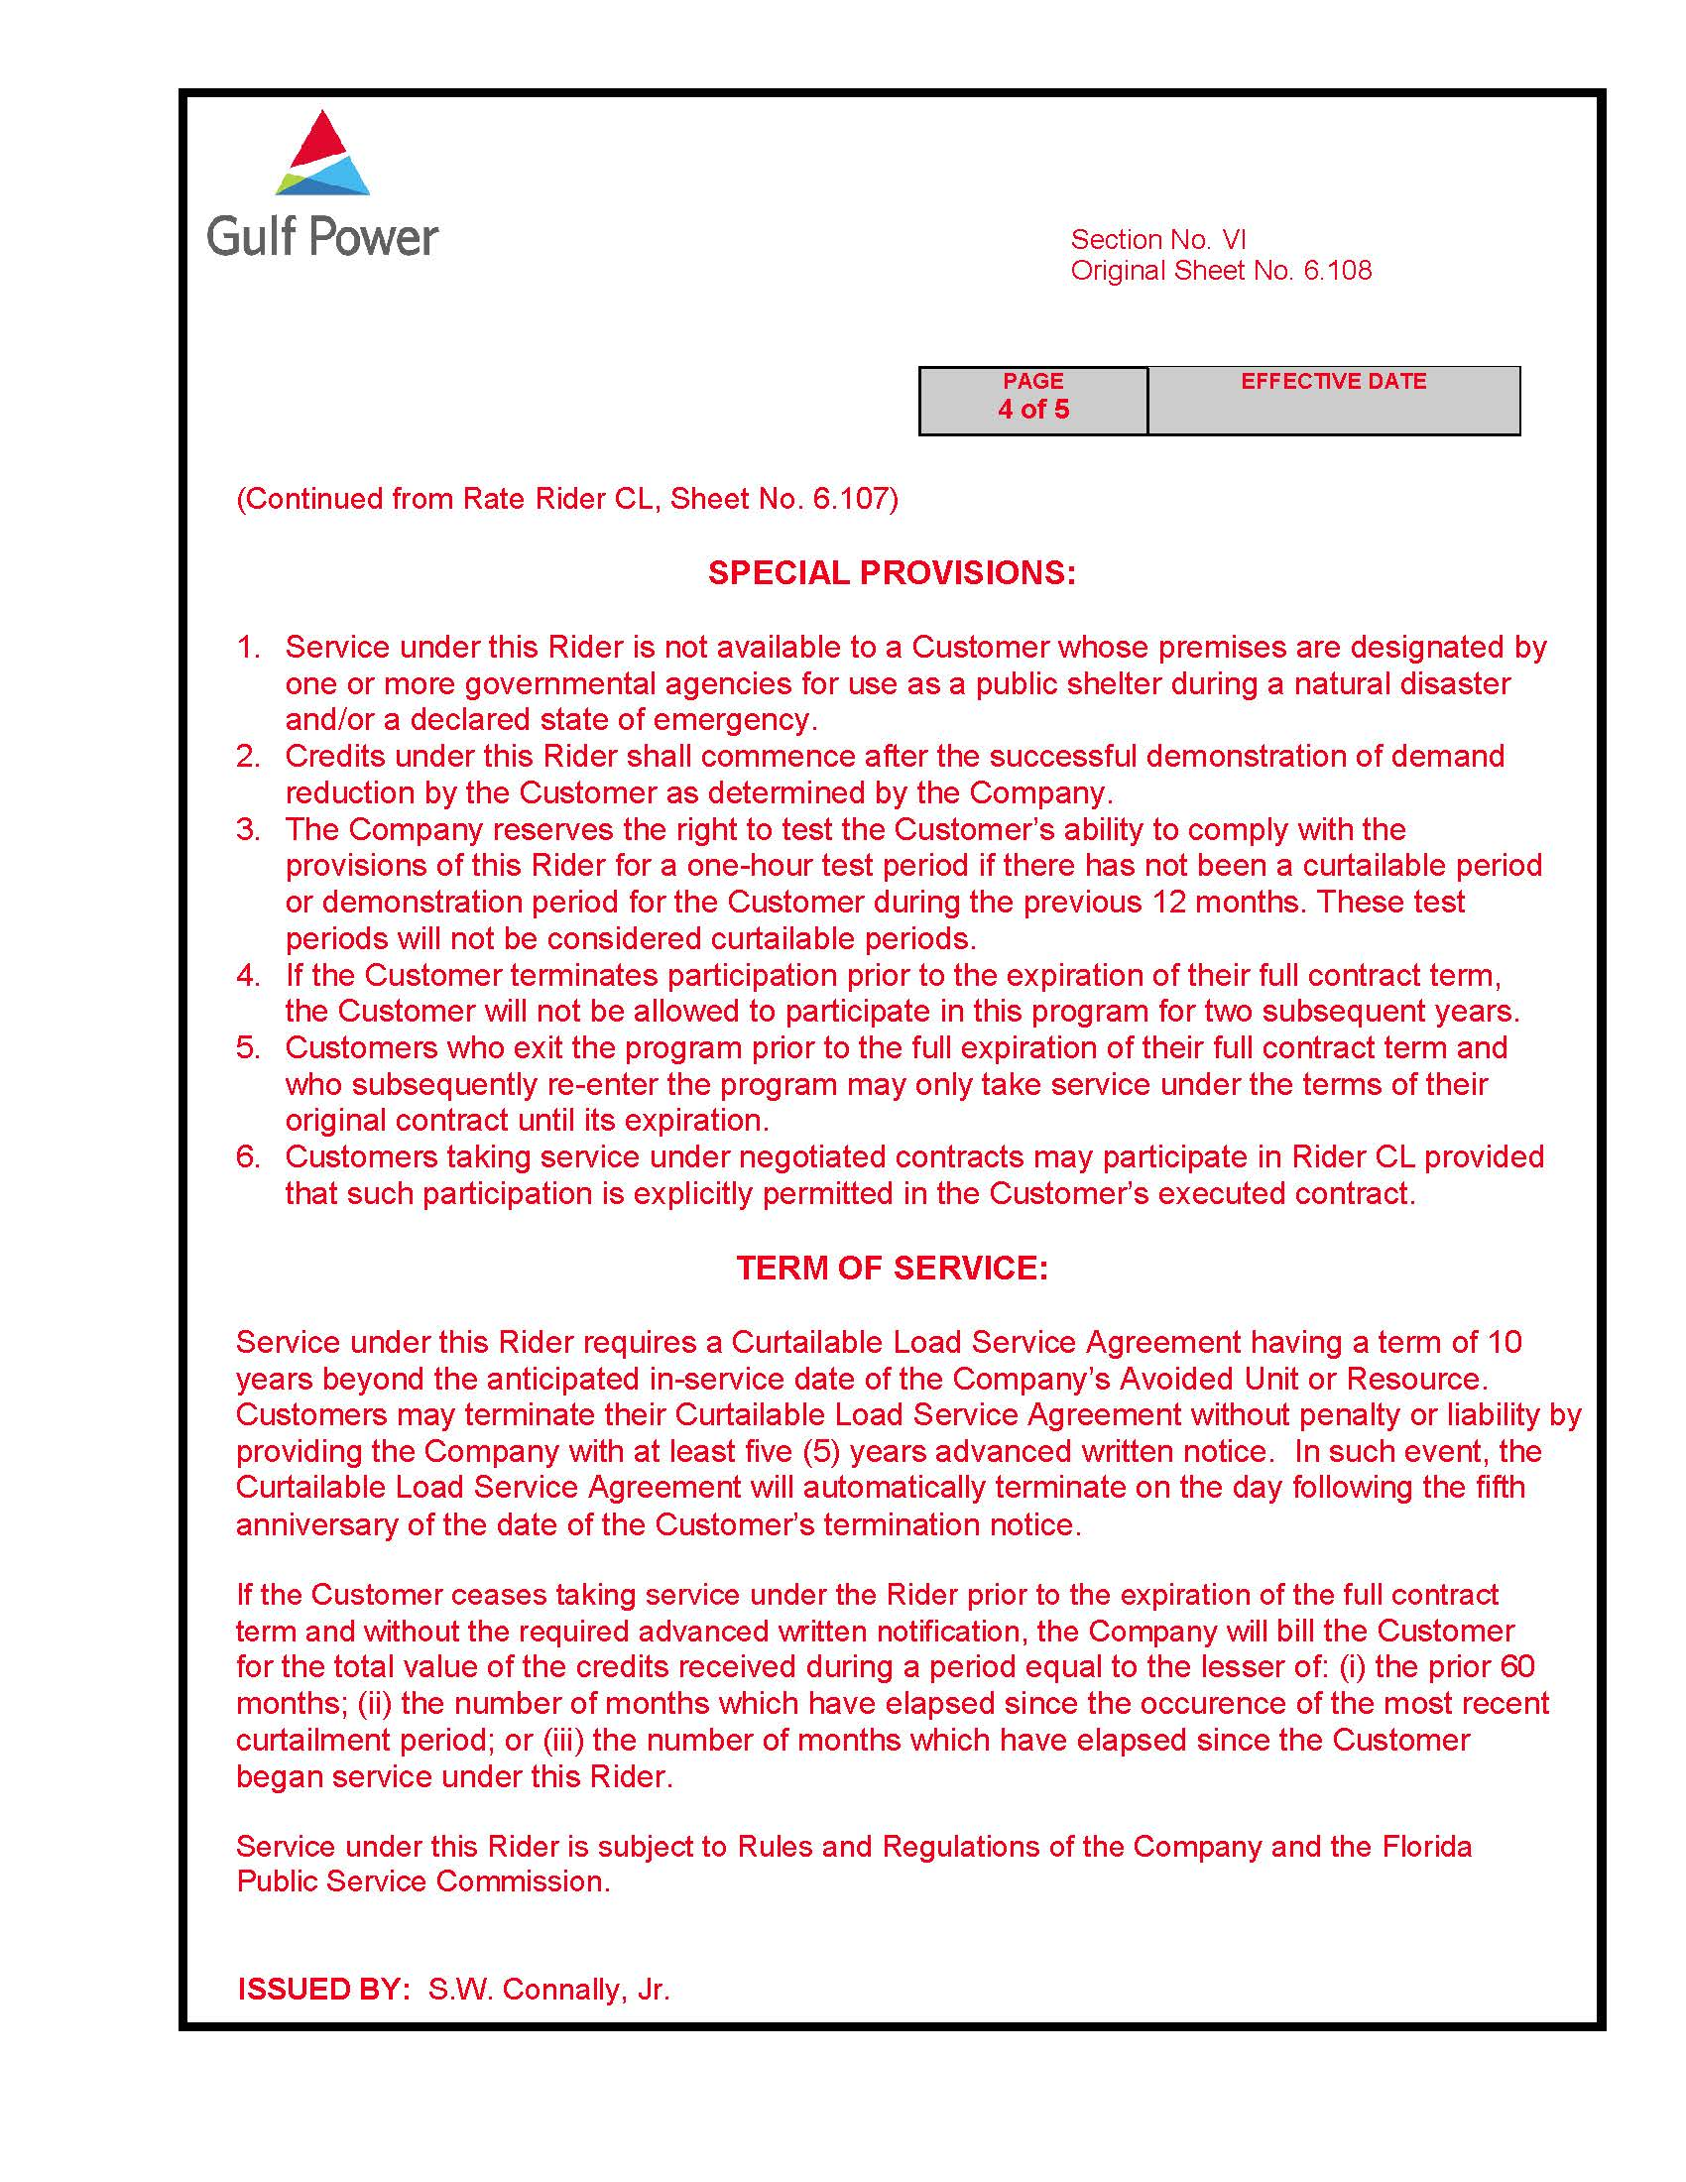

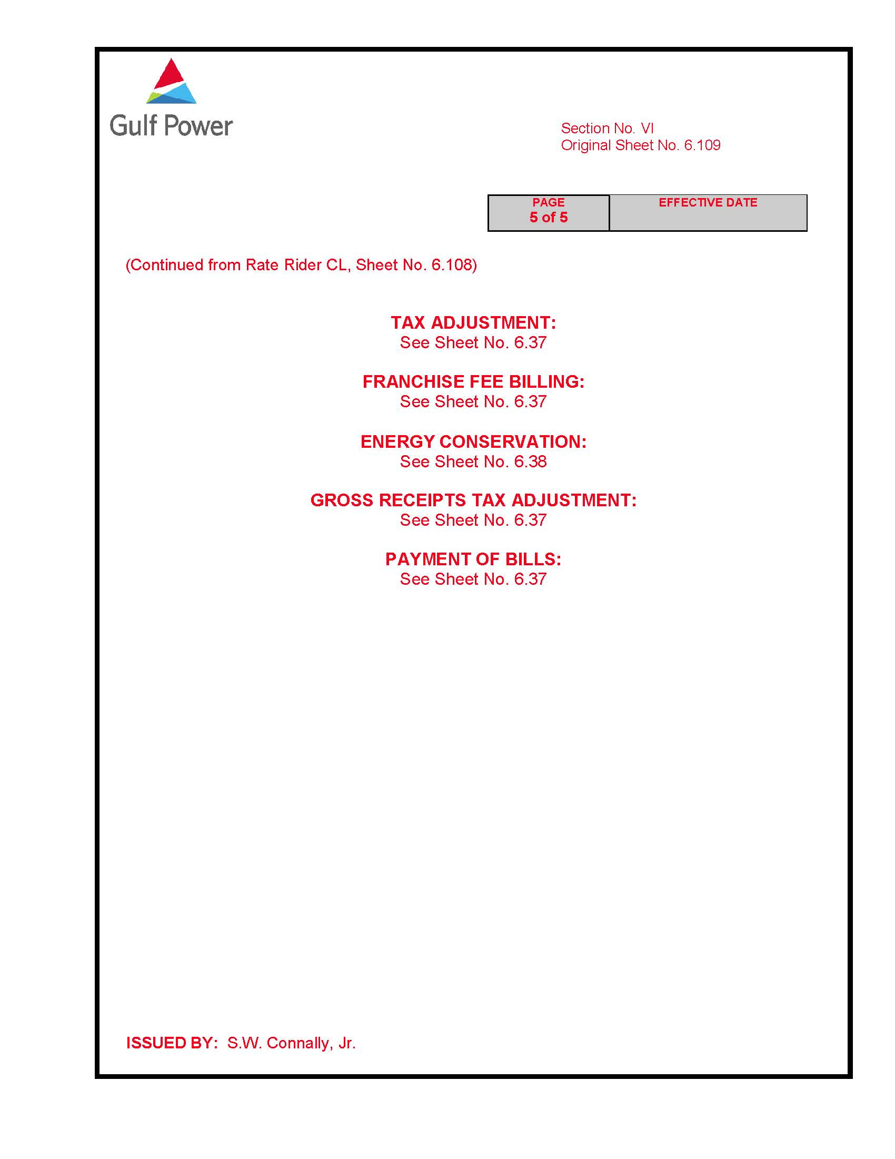

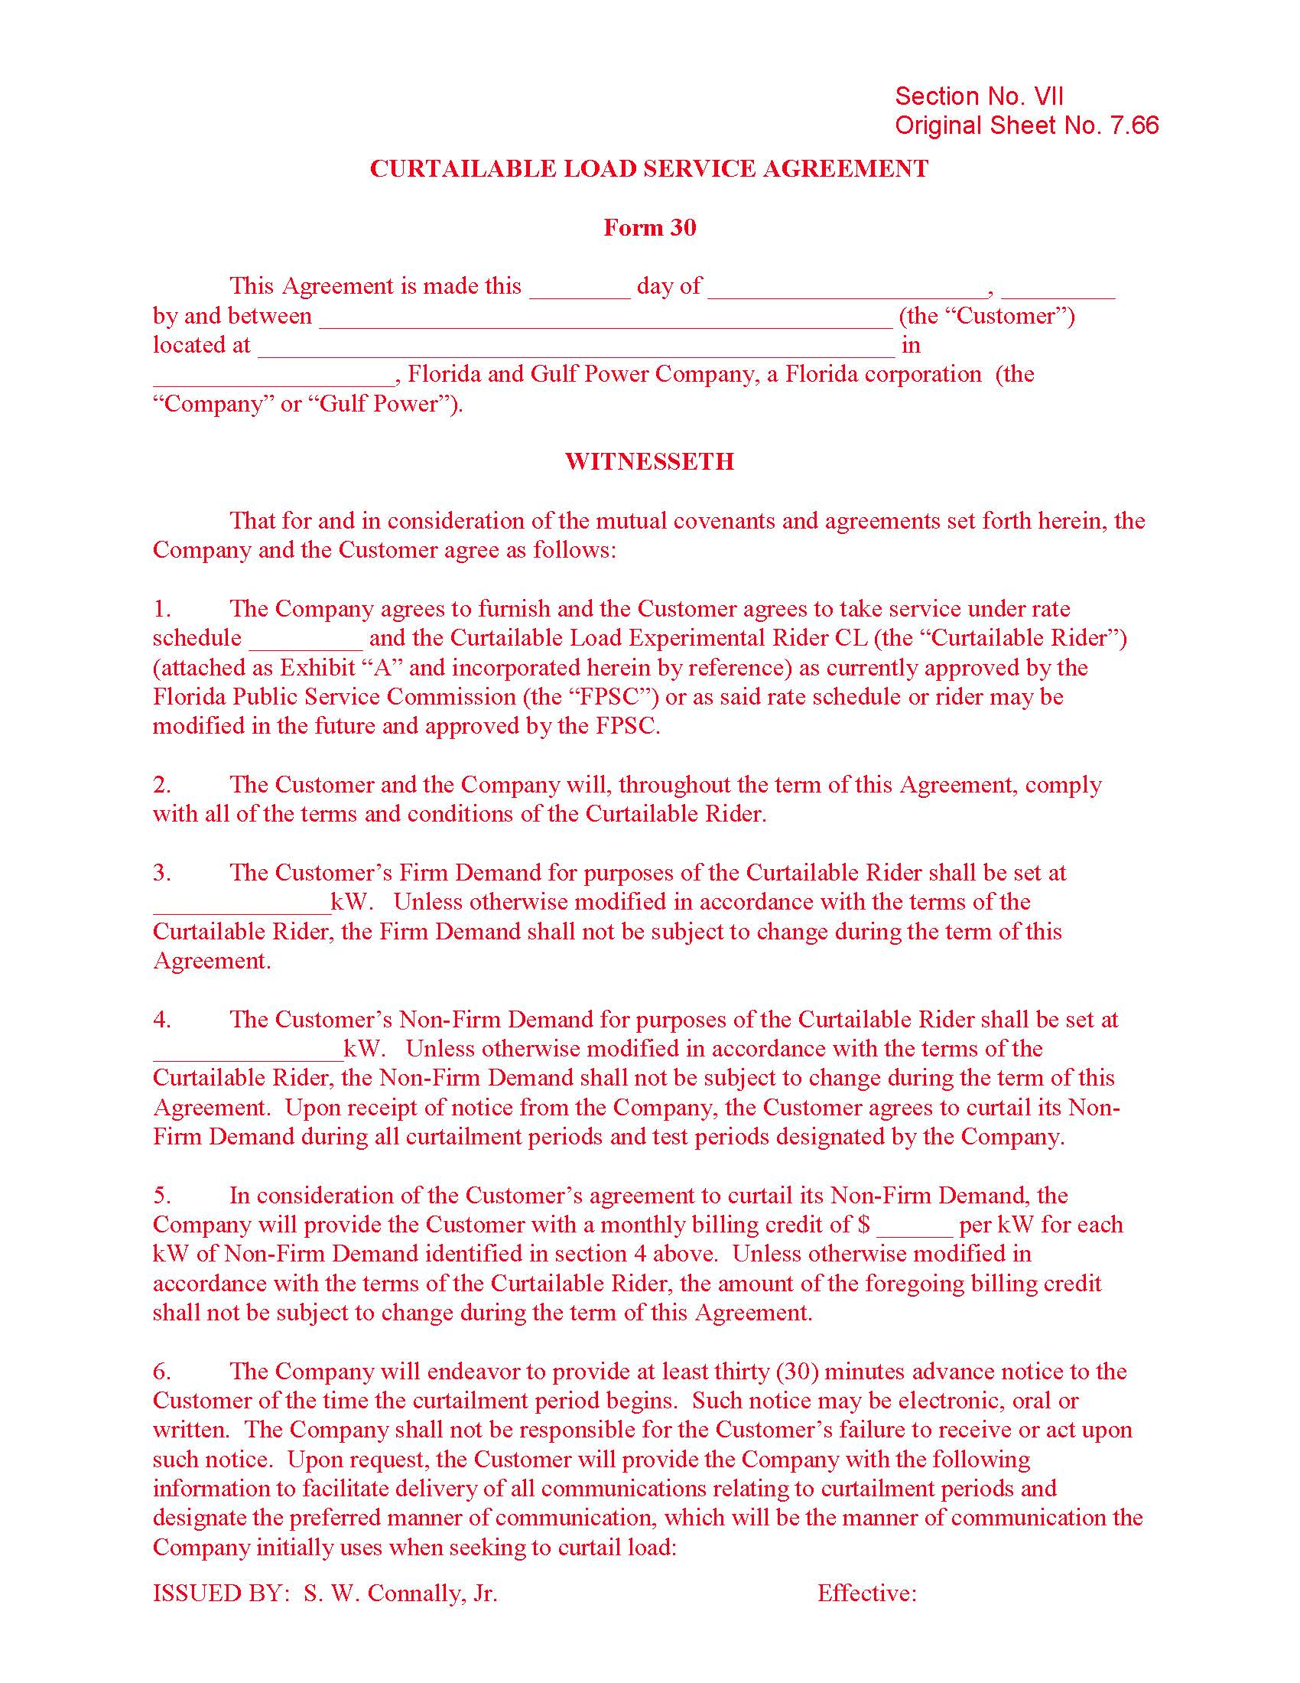

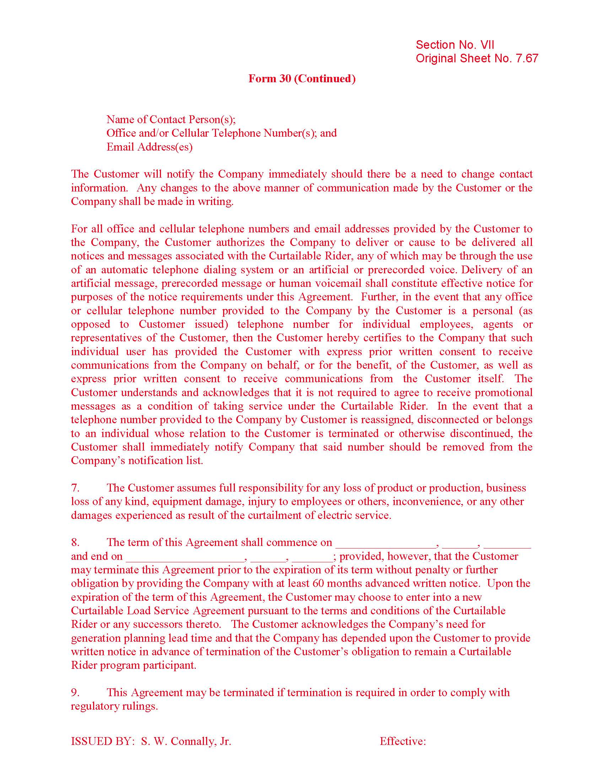

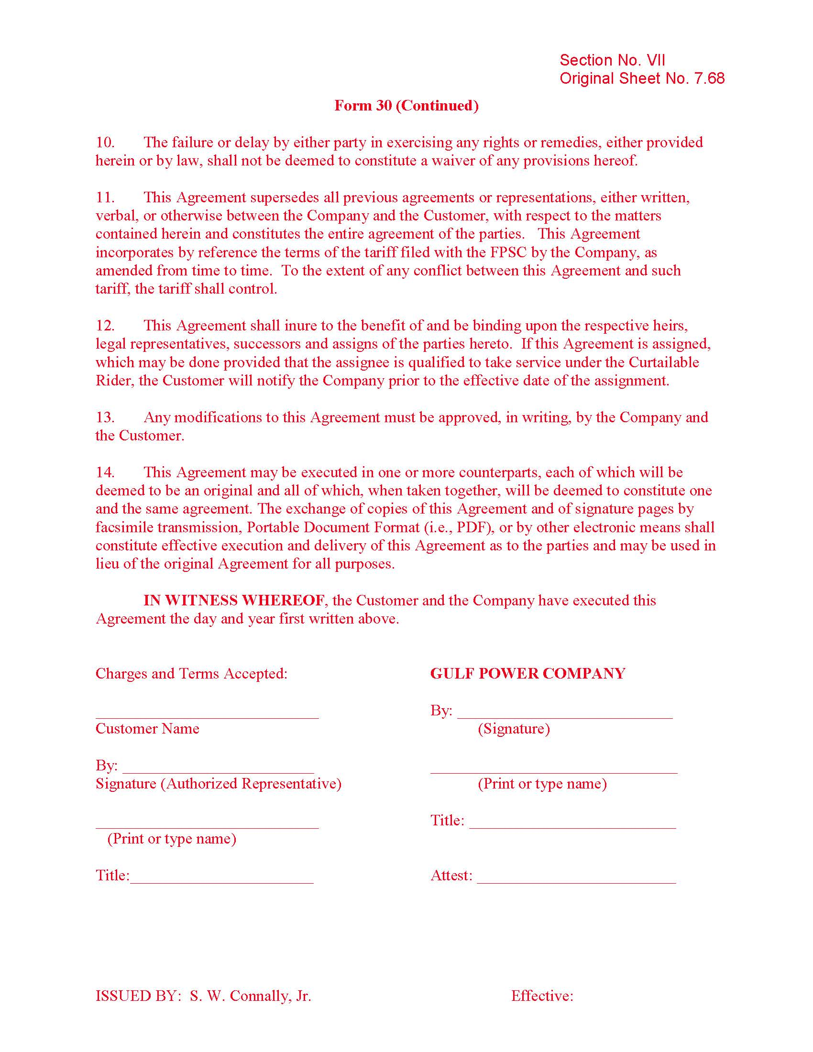

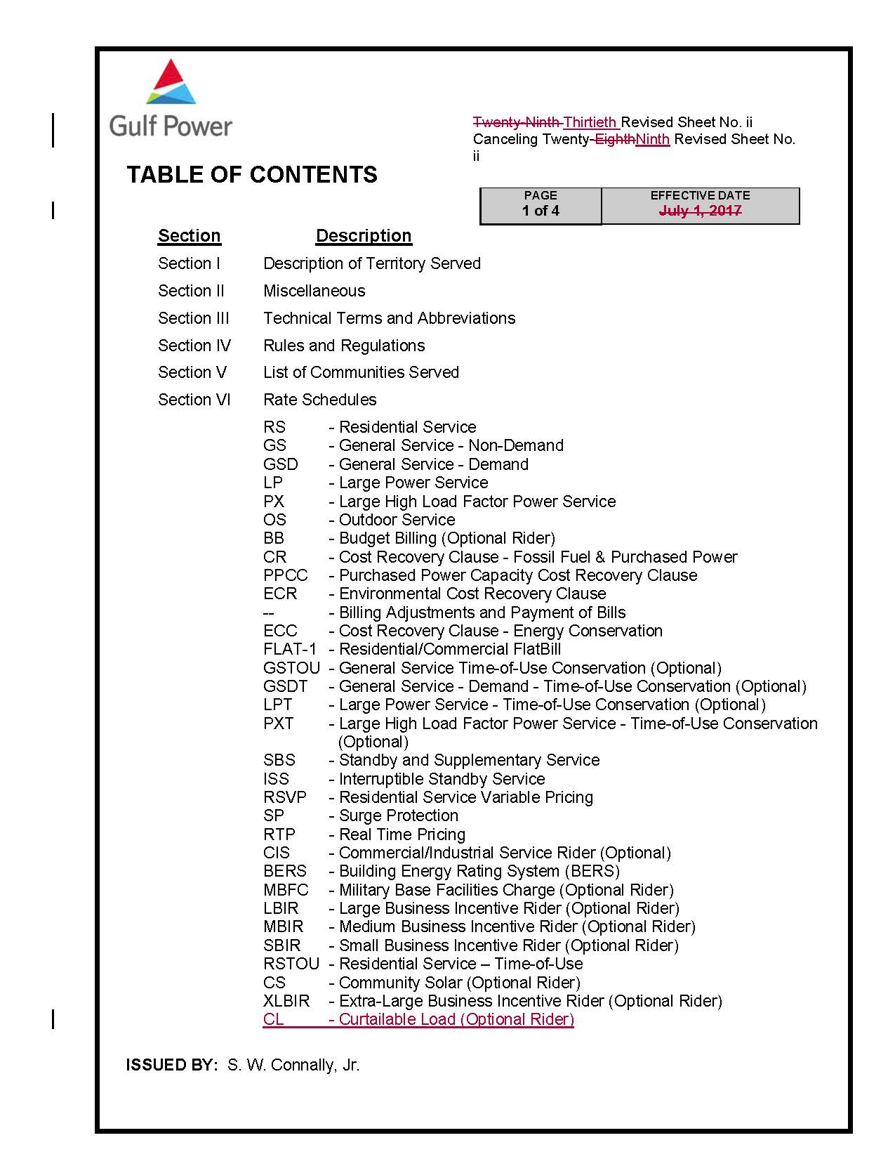

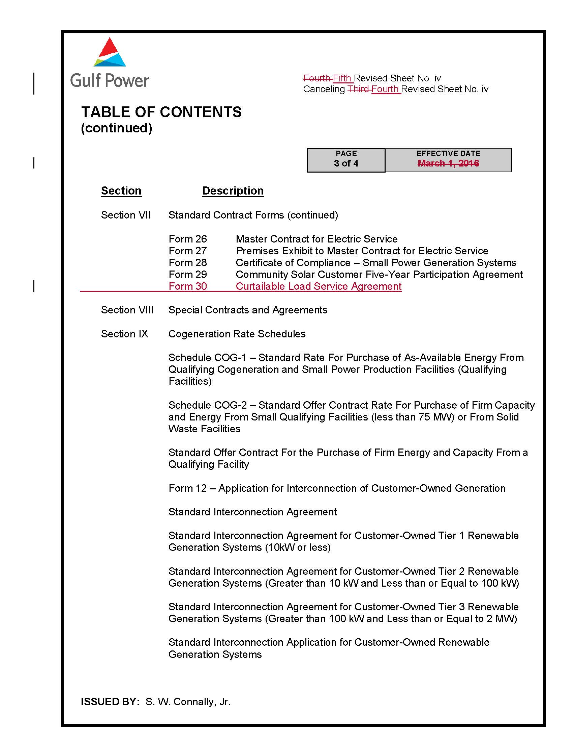

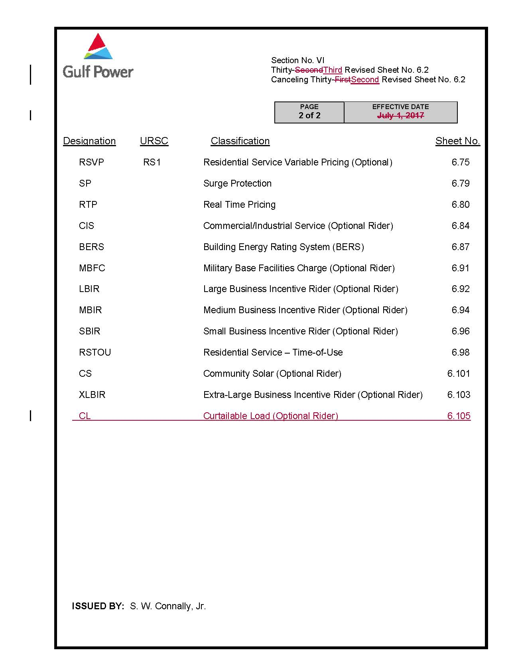

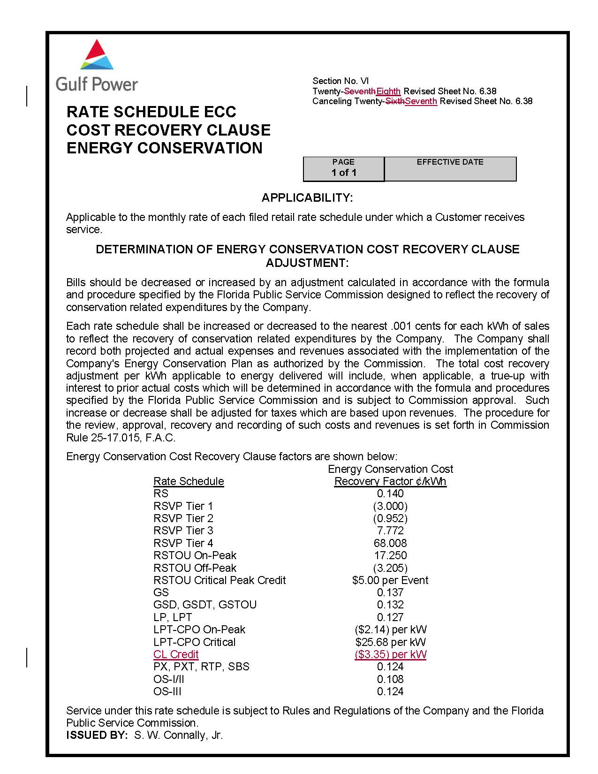

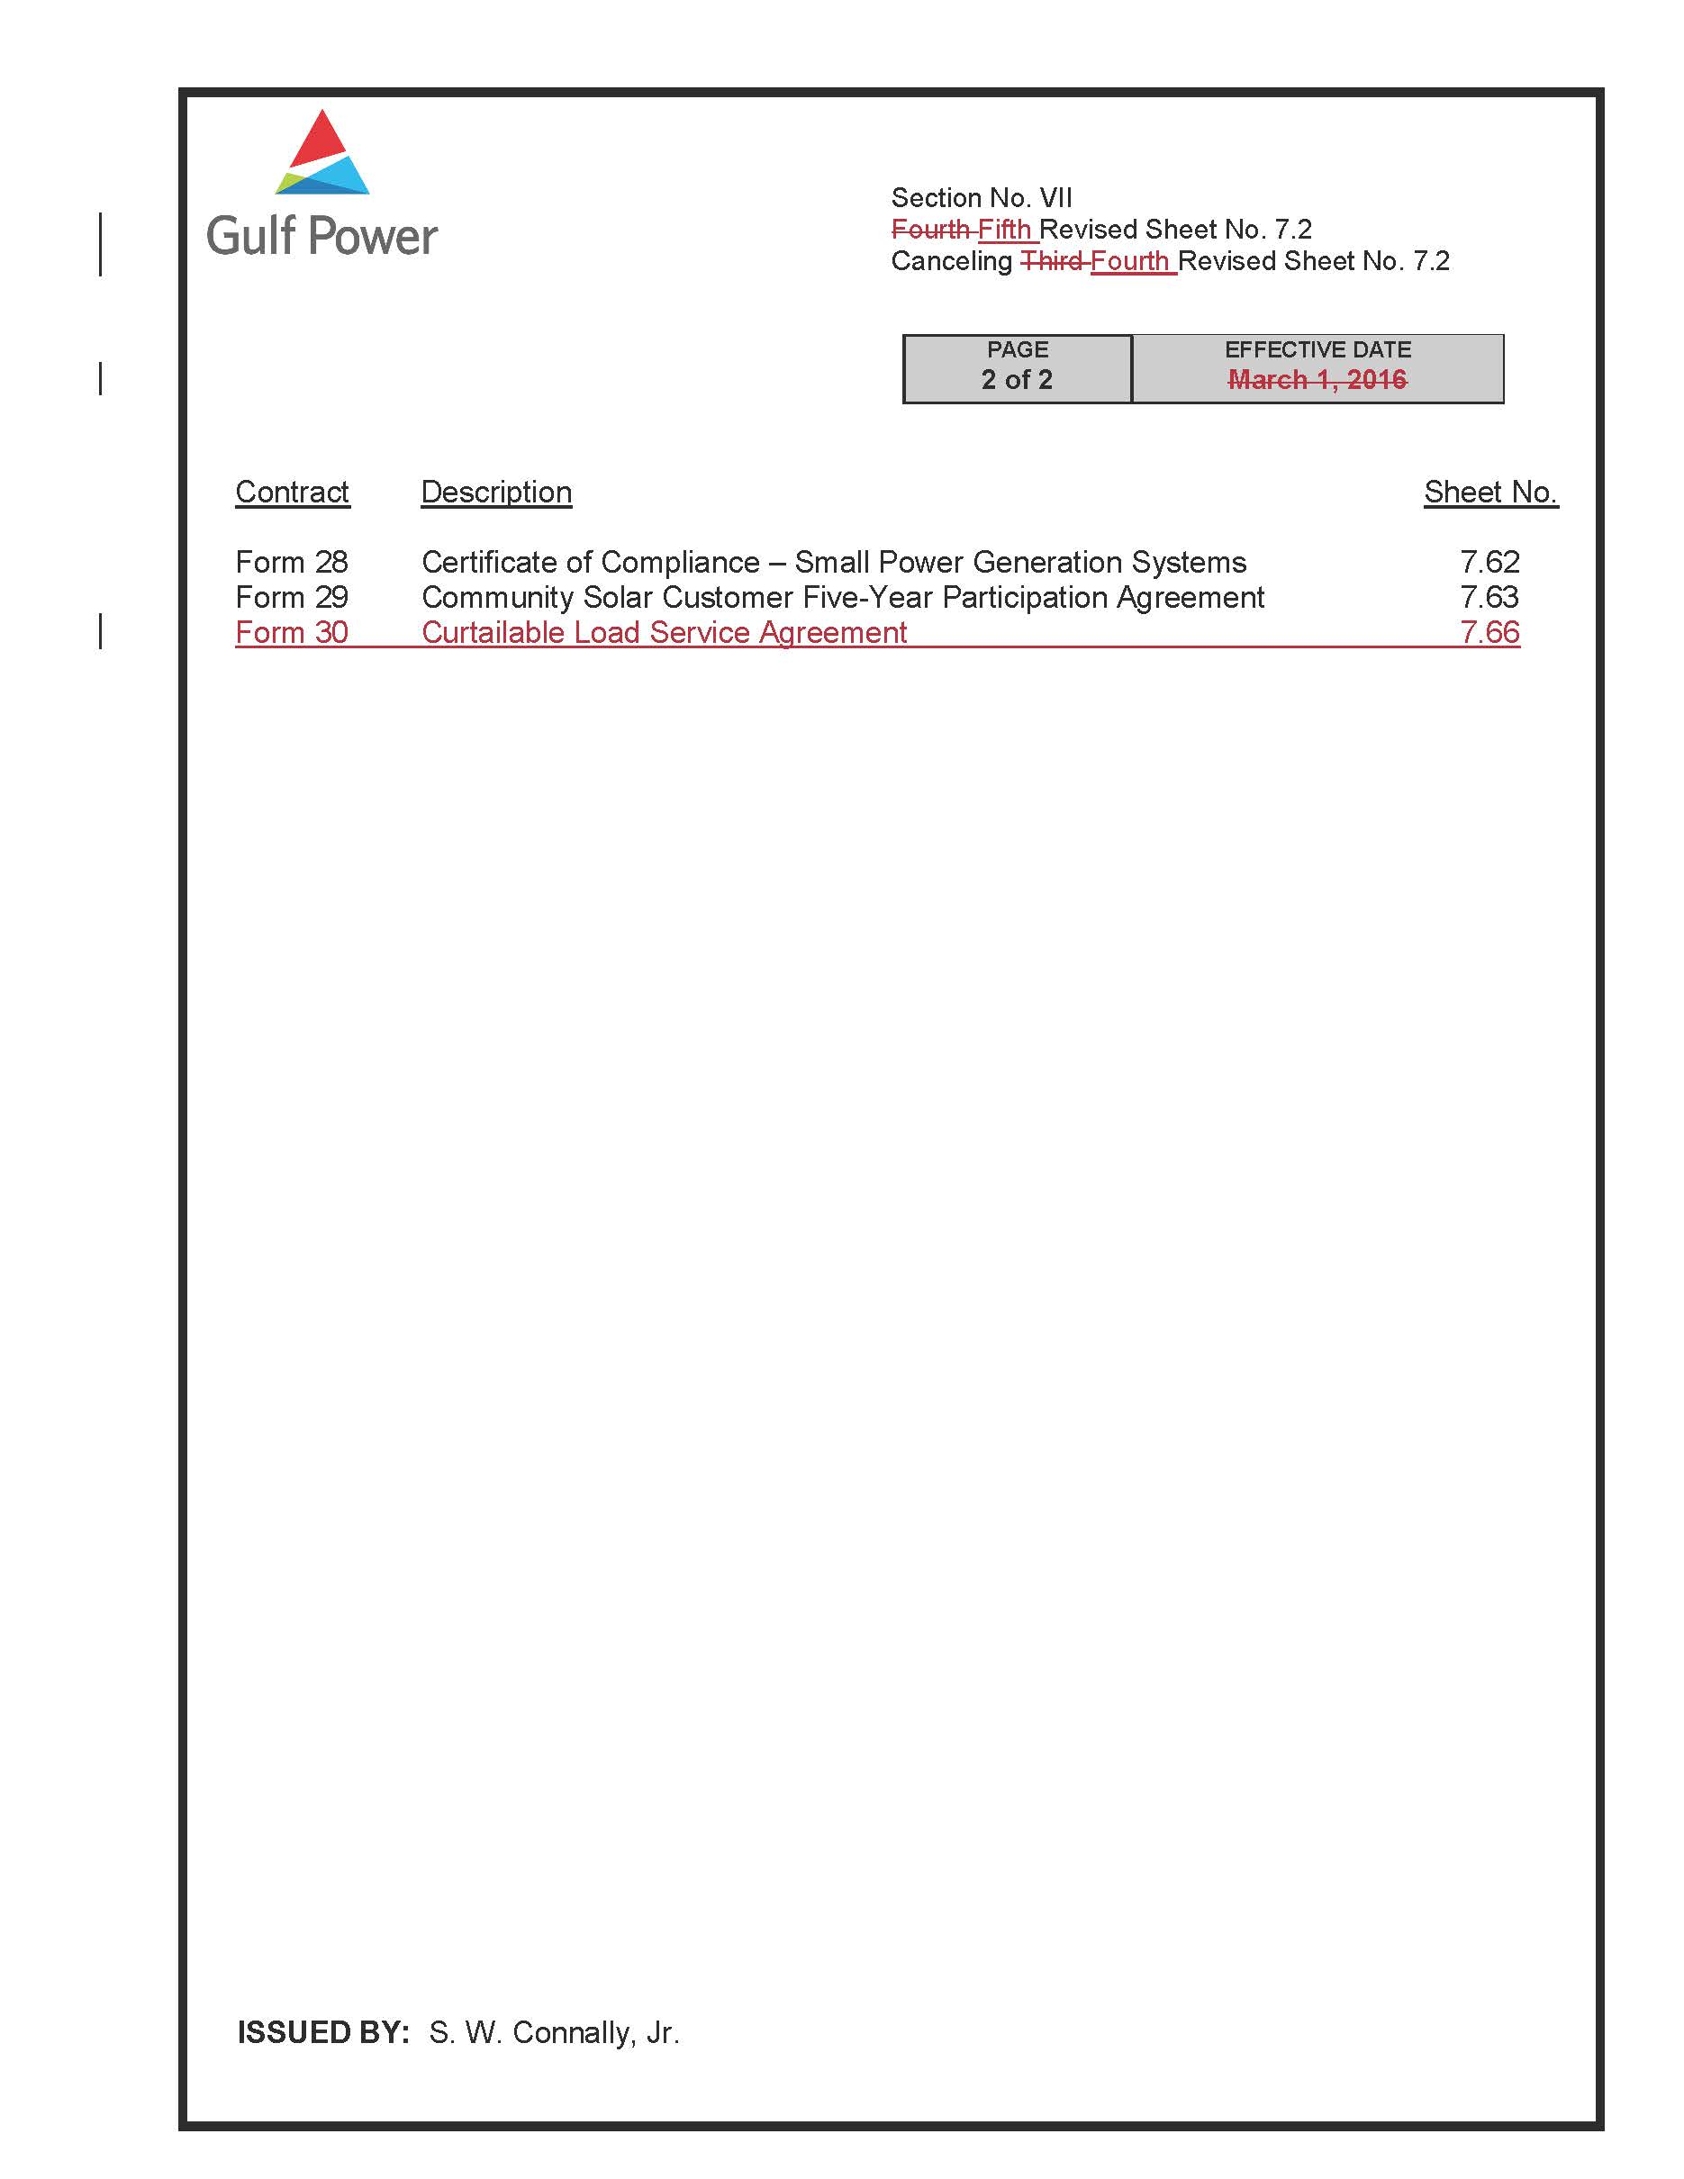

Order No. PSC-2017-0178-S-EI, issued May 16, 2017, in Docket No. 20160186-EI, In re: Petition for Rate Increase by Gulf Power Company. An updated settlement agreement was filed on February 14, 2018, in Docket Nos. 20160186-EI and 20160170-EI, which will be addressed at a later Commission proceeding. This agreement only addresses changes to the tax code and does not impact the program addressed here.
Order No. 22176, issued November 14, 1989, in Docket No. 890737-PU, In re: Implementation of section 366.80-85 Florida Statutes, Conservation Activities of Electric and Natural Gas Utilities.

