BEFORE THE FLORIDA PUBLIC SERVICE COMMISSION

In re: Fuel and purchased power cost recovery clause with generating performance incentive factor. | DOCKET NO. 20180001-EI  ORDER NO. PSC-2018-0105-PCO-EI  ISSUED: February 26, 2018

The following Commissioners participated in the disposition of this matter:

ART GRAHAM, Chairman
JULIE I. BROWN
DONALD J. POLMANN
GARY F. CLARK

ORDER APPROVING FLORIDA POWER & LIGHT COMPANY’S
PETITION FOR MID-COURSE CORRECTION

BY THE COMMISSION:

On November 17, 2017, Florida Power & Light Company (FPL) filed a Petition for Mid-Course Correction of Fuel Cost Recovery and Capacity Cost Recovery Factors and GPIF Targets for 2018 (Petition). The Petition seeks three things: 1) to reduce the respective 2018 fuel cost recovery factors approved in Order No. PSC-2018-0028-FOF-EI; 2) to approve the capacity factors; and 3) to approve the revisions to FPL’s generating performance incentive factor (GPIF) performance metrics. The requested approvals reflect the impact of the Commission-approved St. John’s River Power Park (SJRPP) transaction, pursuant to Order No. PSC-2017-0415-AS-EI.
Mid-course corrections are part of the fuel and purchased power cost recovery clause (fuel clause) proceeding, and such corrections are used by this Commission between fuel clause hearings whenever costs deviate from revenues by a significant margin. Petitions for mid-course corrections to fuel factors are addressed by Rule 25-6.0424, Florida Administrative Code (F.A.C.). Under this rule, a utility must notify the Commission whenever it expects to experience an under-recovery or over-recovery greater than 10 percent. Pursuant to Rule 25-6.0424, F.A.C., the mid-course percentage is the estimated end-of-period total net true-up amount divided by the current period’s total actual and estimated jurisdictional fuel revenue applicable to period amount. Mid-course corrections are considered preliminary procedural decisions, and any over-recoveries or under-recoveries caused by or resulting from the Commission-approved adjusted fuel factors may be included in the following year’s fuel factors.
If approved by this Commission, this mid-course correction will result in lower cost recovery factors for FPL’s customers. This mid-course correction was filed by FPL with the intention of the proposed decrease in rates becoming effective March 1, 2018. Typically, effective dates are set a minimum of 30 days after our vote modifying the charges as the result of a mid-course correction. This time limit is imposed in order to not have new rates applied to energy consumed before the effective date of our action, i.e., the date of the vote. However, we have also implemented charges in less than 30 days when circumstances warrant. In this instance, the interval between our vote on this matter (February 6, 2018) and the proposed implementation date (expected to be March 1, 2018) is 22 days. Since this filing, if approved, results in a decrease to rates, we find that the 22 day interval is sufficient.
This Commission’s jurisdiction to consider fuel clause proceedings derives from our authority to set fair and reasonable rates, found in Section 366.05, Florida Statutes.
DECISION
FPL’s projection testimony and schedules for 2018 were filed on August 24, 2017, which came before this Commission had considered a separately-docketed matter to approve an arrangement to mitigate unfavorable impacts stemming from its partial ownership of the St. Johns River Power Park (SJRPP Transaction). The impact of the SJRPP Transaction was not reflected in FPL’s calculations included in its projection testimony and schedules filed on August 24, 2017. On September 25, 2017, the Commission approved FPL’s and OPC’s stipulation and settlement resolving all issues concerning the SJRPP Transaction. Order No. PSC-2018-0028-FOF-EI, approved the stipulation requiring FPL to file a mid-course correction to reflect the impacts of the SJRPP Transaction no later than November 17, 2017, and FPL did so.
Midcourse Adjustment for Fuel Cost Recovery (FCR) Factors
FPL’s currently authorized 2018 fuel factors were set by this Commission following the October 25, 2017 fuel hearing, and codified in the 2017 Order. These factors are based on FPL’s projected fuel costs for 2018, plus the true-up amounts from 2017. Given the timing of our approval of the SJRPP Transaction, FPL is requesting that the current mid-course correction reflect its 2018 cost recovery factors. The Company notes, however, that its mid-course correction is limited to only the impact of the SJRPP Transaction. The accounting treatment approved in the SJRPP Order authorizes FPL to recover fuel-related costs associated with the SJRPP Transaction through the fuel cost recovery (FCR) clause.
The SJRPP Transaction closed and the plant was retired on January 5, 2018. As a result, purchased power payments and coal inventory balances will reflect decreases. FPL states in its mid-course correction filing that “these decreases are partially offset by an increase in natural gas consumption.” (FPL Petition, page 4, paragraph 9)
The accounting changes result in a total variance from the original 2018 projection filing of $22,933,601, or 0.799 percent. If FPL’s Petition is granted, this amount would be recovered through reduced fuel and capacity cost recovery factors for March–December 2018. The March-December 2018 FCR factor decreased from 2.630 cents per kWh to 2.606 cents per kWh, and results in a reduction of $0.24 for a residential customer using 1,000 kWh of electricity. The revised fuel cost recovery factors are reflected on Attachment A.
Midcourse Adjustment for Capacity Cost Recovery (CCR) Factors
Pursuant to the SJRPP Order, the SJRPP Transaction settlement authorized FPL to recover certain costs associated with the SJRPP shutdown through the Capacity Cost Recovery (CCR) clause. As stated in the SJRPP Order, FPL will create a Shutdown Payment Regulatory Asset in the amount of $90.4 million as FPL’s payment to JEA. As such, FPL is allowed to recover: 1) amortization of the regulatory asset over the remaining Power Purchase Agreement (PPA) it has with JEA, through its term (October 2021); and 2) a return on the unamortized balance calculated at FPL’s weighted cost of capital used for adjustment clause proceedings.
The SJRPP Order also authorized FPL to eliminate the annual capacity payment that would be due under the SJRPP PPA, and refund through the CCR clause the costs incurred for suspension liability and a return on the unamortized balance, which is calculated as above using FPL’s weighted cost of capital used for adjustment clause proceedings. As such, FPL will refund the costs incurred for deferred interest liability and dismantlement accrual, none of which FPL will be required to pay upon termination of the PPA.
This CCR mid-course correction reflects the SJRPP-related adjustments and also credits to customers the carrying charges associated with Nuclear Cost Recovery Clause 2015 and 2016 Final True-ups, approved by this Commission as the over-recovery for those periods. As a result, the total capacity cost over-recovery is approximately $20,410,866 or 7.2 percent. This amount reduces the CCR factors for each rate group for the period March-December 2018. The revised capacity cost recovery factors are reflected on Attachment B.
Revision of the GPIF Targets and Ranges for 2018
Consistent with the discussion on the revised fuel cost projection, appropriate adjustments to FPL’s GPIF targets/ranges for heat rate are needed due to the effects of the SJRPP transaction. The revised GPIF targets and ranges for the 12 GPIF units provided in Appendix 4 of FPL’s petition show a slightly lower average heat rate value, reflecting a higher performance target. Availabilities of the GPIF units are not changed by the SJRPP transaction, thus no revisions are needed for the GPIF targets/ranges for equivalent availabilities. The revised 2018 GPIF Targets and Ranges are reflected on Attachment C.
Bill Impact and Customer Notifications
Consistent with the 2017 Fuel Order, the bill for a residential customer using 1,000 kilowatt hours (kWh) of electricity for the period March-December, 2018, was projected to be $99.75 per month, with a fuel cost recovery component of $22.97 per month, and a capacity cost recovery component of $2.81 per month. As proposed, the fuel cost recovery component will be reduced by $0.24 per month, and a similar reduction will be applicable to capacity cost recovery factors as well. Both reductions are reflected in the typical bill comparison that is presented in Table 1 of Attachment E.
We find that implementing reduced fuel cost recovery factors is in the best interests of FPL’s customers because the factors would be decreasing, and customers would receive the benefit of reduced rates as quickly as administratively possible.
At a noticed informal conference between our staff and interested parties held January 4, 2018, FPL stated that it initially notified customers with bill inserts regarding this matter about the time its Petition was filed. In the January 2018 bill, the Company sent customers a quarterly newsletter that addressed the pending action in this matter. Beginning in February, FPL’s website will include links to show the proposed rate schedules for residential and business rate classes that are proposed to become effective March 1, 2018. The Company stated that physical restrictions on bill inserts limit the amount of detail that can be included in such notifications, but noted its customers can access detailed billing information from links on the Company’s website.
For the reasons discussed above, we approve FPL’s request for mid-course correction to its 2018 fuel and capacity cost recovery factors, associated tariff sheets, and a revised 2018 GPIF Target and Ranges. The revised fuel and capacity cost recovery factors and associated tariffs sh become effective March 1, 2018. The recommended fuel cost recovery factors are presented in Attachment A, the capacity cost recovery factors are presented in Attachment B, the GPIF Targets and Ranges are presented in Attachment C, the associated tariff sheets are shown as Attachment D, and, finally, a typical bill comparison is presented in Attachment E.

Based on the foregoing, it is

ORDERED by the Florida Public Service Commission that Florida Power & Light Company’s Petition for Mid-Course Correction of Fuel Cost Recovery and Capacity Cost Recovery Factors and GPIF Targets for 2018 is hereby approved. It is further
ORDERED that the fuel and capacity cost recovery factors are approved as stated in Attachments A and B, respectively. It is further

ORDERED that the revised 2018 GPIF Targets and Ranges as stated in Attachment C and the tariff sheets in Attachment D are hereby approved. It is further

ORDERED that the revised fuel and cost recovery factors, the associated tariff sheets, and the revised GPIF Target and Ranges shall become effective with the March 2018 billing cycle, which begins on March 1, 2018. It is further

ORDERED that this docket shall remain open.

By ORDER of the Florida Public Service Commission this 26th day of February, 2018.

CARLOTTA S. STAUFFER
Commission Clerk
Florida Public Service Commission
2540 Shumard Oak Boulevard
Tallahassee, Florida 32399
(850) 413-6770
www.floridapsc.com

Copies furnished: A copy of this document is provided to the parties of record at the time of issuance and, if applicable, interested persons.

SBr

NOTICE OF FURTHER PROCEEDINGS OR JUDICIAL REVIEW

The Florida Public Service Commission is required by Section 120.569(1), Florida Statutes, to notify parties of any administrative hearing or judicial review of Commission orders that is available under Sections 120.57 or 120.68, Florida Statutes, as well as the procedures and time limits that apply. This notice should not be construed to mean all requests for an administrative hearing or judicial review will be granted or result in the relief sought.

Mediation may be available on a case-by-case basis. If mediation is conducted, it does not affect a substantially interested person's right to a hearing.

Any party adversely affected by this order, which is preliminary, procedural or intermediate in nature, may request: (1) reconsideration within 10 days pursuant to Rule 25-22.0376, Florida Administrative Code; or (2) judicial review by the Florida Supreme Court, in the case of an electric, gas or telephone utility, or the First District Court of Appeal, in the case of a water or wastewater utility. A motion for reconsideration shall be filed with the Office of Commission Clerk, in the form prescribed by Rule 25-22.0376, Florida Administrative Code. Judicial review of a preliminary, procedural or intermediate ruling or order is available if review of the final action will not provide an adequate remedy. Such review may be requested from the appropriate court, as described above, pursuant to Rule 9.100, Florida Rules of Appellate Procedure.

Table 1
FPL Revised Fuel Cost Recovery Factors
for the Period March-December, 2018
Rate Group | Rate Schedule | Average Factor | Loss Multiplier | Fuel Recovery Factor
A | RS-1 first 1,000 kWh | 2.606 | 1.00206 | 2.273
 | RS-1, all addl. kWh | 2.606 | 1.00206 | 3.273
 | GS-1, SL-2, GSCU-1, WIES-1 | 2.606 | 1.00206 | 2.611
A-1 | SL-1, OL-1, PL-1 | 2.523 | 1.00206 | 2.528
B | GSD-1 | 2.606 | 1.00202 | 2.611
C | GSLD-1, CS-1 | 2.606 | 1.00150 | 2.610
D | GSLD-2, CS-2, OS-2, MET | 2.606 | 0.99635 | 2.596
E | GSLD-3, CS-3 | 2.606 | 0.97646 | 2.545
A | GST-1 On-Peak | 3.046 | 1.00206 | 3.052
 | GST-1 Off Peak | 2.424 | 1.00206 | 2.429
 | RTR-1 On-Peak | - | - | 0.441
 | RTR-1 Off-Peak | - | - | (0.182)
B | GSDT-1, CILC-1(G), HLFT-1 (21-499 kW) On Peak | 3.046 | 1.00202 | 3.052
 | GSDT-1, CILC-1(G), HLFT-1 (21-499 kW) Off Peak | 2.424 | 1.00202 | 2.429
C | GSDLT-1, CST-1, HLFT-2 (500-1,9999 kW) On Peak | 3.046 | 1.00150 | 3.051
 | GSDLT-1, CST-1, HLFT-2 (500-1,9999 kW) Off Peak | 2.424 | 1.00150 | 2.428
D | GSDLT-2, CST-2, HLFT-3 (2,000+ kW) On Peak | 3.046 | 0.99672 | 3.036
 | GSDLT-2, CST-2, HLFT-3 (2,000+ kW) Off Peak | 2.424 | 0.99672 | 2.416
E | GSDLT-3, CST-3, CILC-1(T), ISST-1(T) On Peak | 3.046 | 0.97646 | 2.974
 | GSDLT-3, CST-3, CILC-1(T), ISST-1(T) Off Peak | 2.424 | 0.97646 | 2.367
F | CILC-1(D), ISST-1(D) On Peak | 3.046 | 0.99627 | 3.035
 | CILC-1(D), ISST-1(D) Off Peak | 2.424 | 0.99627 | 2.415
Source: Schedule E1-E, Page 1 of 2 (Appendix I, Page 6 of 81)

Table 2
FPL Revised Seasonal Demand Time of Use Rider
Fuel Cost Recovery Factors for the Period June-September, 2018
Rate Group | Rate Schedule | Average Factor | Loss Multiplier | Fuel Recovery Factor
B | GSD(T)-1 On-Peak | 3.784 | 1.00202 | 3.792
 | GSD(T)-1 Off-Peak | 2.457 | 1.00202 | 2.462
C | GSLD(T)-1 On-Peak | 3.784 | 1.00150 | 3.790
 | GSLD(T)-1 Off-Peak | 2.457 | 1.00150 | 2.461
D | GSLD(T)-2 On-Peak | 3.784 | 0.99672 | 3.772
 | GSLD(T)-2 Off-Peak | 2.457 | 0.99672 | 2.449
Source: Schedule E1-E, Page 2 of 2 (Appendix I, Page 7 of 81)

Table 1
FPL Revised Capacity Cost Recovery Factors
for the Period March-December, 2018
Rate Schedule | $/kW | $/kWh | Reservation Demand Charge (RDC) $/kW | Sum of Daily Demand Charge (SDD) $/kW
RS1/RTR1 | - | 0.00257 | - | -
GS1/GST1 | - | 0.00241 | - | -
GSD1/GSDT1/HLFT1 | 0.77 | - | - | -
OS2 | - | 0.00108 | - | -
GSLD1/GSLDT1/CS1/CST1/HLFT2 | 0.91 | - | - | -
GSLD2/GSLDT2/CS2/CST2/HLFT3 | 0.85 | - | - | -
GSLD3/GSLDT3/CS3/CST3 | 0.87 | - | - | -
SST1T | - | - | $0.11 | $0.05
SST1D1/SST1D2/SST1D3 | - | - | $0.12 | $0.06
CILC D/CILC G | 0.97 | - | - | -
CILC T | 0.94 | - | - | -
MET | 0.96 | - | - | -
OL1/SL1/SL1M/PL1 | - | 0.00020 | - | -
SL2/SL2M/GSCU1 | - | 0.00168 | - | -
Source: Schedule E12-E, (Appendix 2, Page 5 of 10

Table 1
FPL Revised GPIF Targets/Ranges
for the period January-December, 2018
Plant/Unit | EAF |  |  | ANOHR
 | Target | Maximum |  | Target | Maximum
 | EAF  ( % ) | EAF  ( % ) | Savings  ($000's) | ANOHR  BTU/KWH | ANOHR  BTU/KWH | Savings  ($000's)
Canaveral 3 | 86.4 | 89.4 | 1,149 | 6,637 | 6,530 | 2,706
Manatee 3 | 92.9 | 94.9 | 435 | 6,935 | 6,756 | 3,067
Ft. Myers 2 | 85.9 | 88.4 | 418 | 7,241 | 7,125 | 2,555
Martin 8 | 80.5 | 83.0 | 555 | 6,998 | 6,841 | 2,833
Riviera 5 | 85.4 | 87.9 | 1,173 | 6,590 | 6,512 | 2,123
St. Lucie 1 | 85.0 | 88.0 | 3,803 | 10,441 | 10,337 | 481
St. Lucie 2 | 85.1 | 88.1 | 3,123 | 10,303 | 10,221 | 357
Turkey Point 3 | 82.1 | 85.1 | 3,037 | 11,044 | 10,853 | 718
Turkey Point 4 | 93.6 | 96.6 | 3,491 | 10,970 | 10,763 | 863
West County 1 | 79.1 | 82.1 | 1,109 | 6,963 | 6,833 | 3,088
West County 2 | 89.3 | 91.8 | 997 | 6,892 | 6,785 | 2,698
West County 3 | 80.4 | 82.9 | 908 | 6,970 | 6,866 | 2,422
Total |  |  | 20,198 |  |  | 23,911
Source: GPIF Target and Range Summary, Appendix 4, Pages 4, 6 of 19

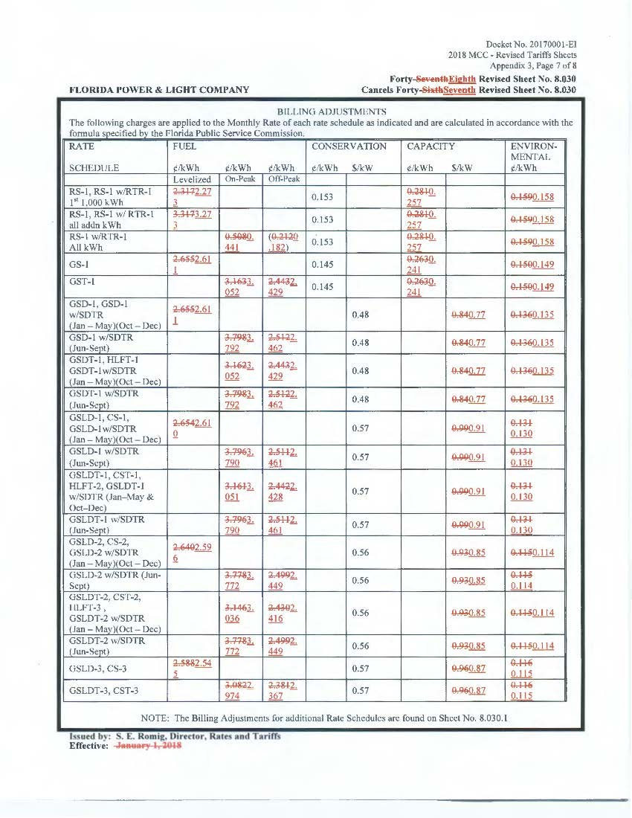

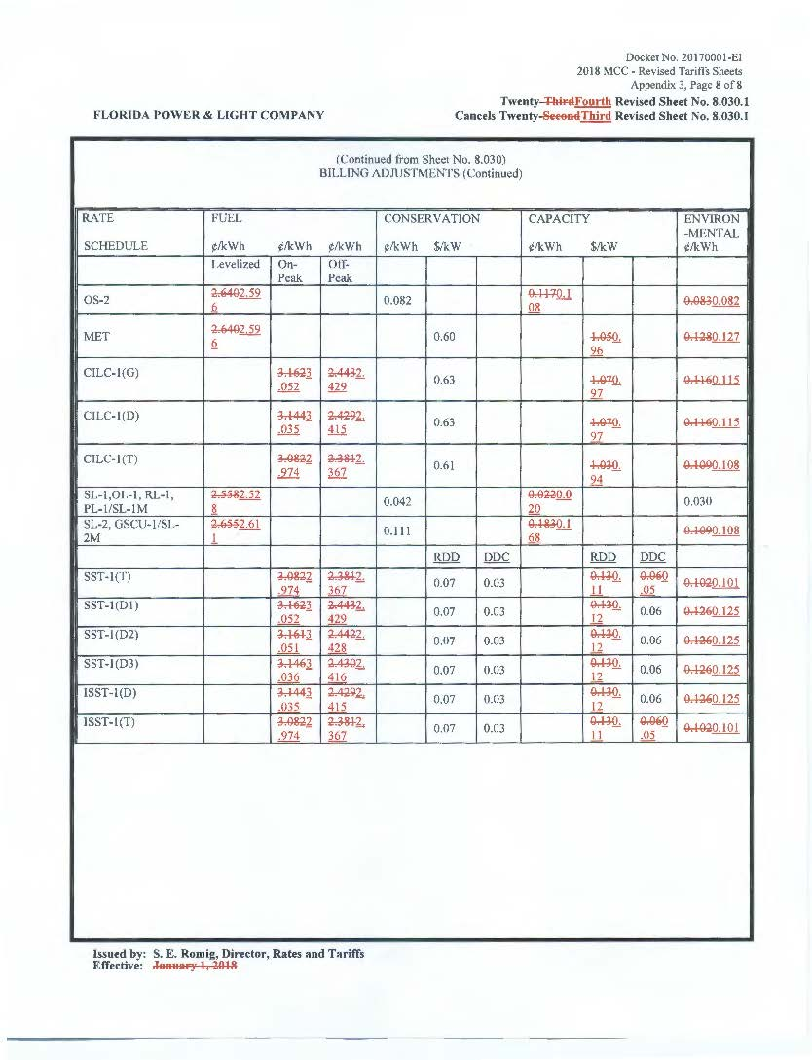

Table 1
FPL Typical 1,000-kWh Residential Customer Bill Comparison
for the period March-December, 2018
(1) | (2) | (3) | (4) | (5) | (6)
Component | January-February 2018  (Current) | Previously Approved  March – December 2018 | Proposed  March – December 2018  (Mid-Course  Correction, as originally filed in November, 2017) | Revised  March – December 2018  (Mid-Course  Correction, as revised in January, 2018) | Net Difference  (from Previously-Approved amounts to Revised Mid-Course Correction - March-December, 2018)
Base Charge | $66.49 | $67.10 | $67.10 | $67.10 | $0.00
Fuel Cost Recovery | $23.17 | $22.97 | $22.73 | $22.73 | ($0.24)
Energy Conservation Cost Recovery | $1.53 | $1.53 | $1.53 | $1.53 | $0.00
Capacity Cost Recovery | $2.81 | $2.81 | $2.57 | $2.57 | ($0.24)
Environmental Cost Recovery | $1.59 | $1.59 | $1.58 | $1.58 | ($0.01)
Storm Restoration Surcharge | $1.20 | 1.26 | 1.20 | 1.38 | $0.12
Interim Storm Restoration Surcharge | $3.36 | $0.00 | $0.00 | $0.00 | $0.00
Subtotal | $100.15 | $97.26 | $96.71 | $96.89 | ($0.37)
Gross Receipts Tax | $2.57 | $2.49 | $2.48 | $2.48 | (0.01)
Totals | $102.72 | $99.75 | $99.19 | $99.37 | ($0.38)
Source: Schedule E-10, provided in FPL’s Response to Staff’s 1st Data Request dated January 16, 2018,

Order No. PSC-2018-0028-FOF-EI, issued January 8, 2018, in Docket No: 20180001-EI (2017 Order), In re: Fuel and Purchased Power Cost Recovery Clause with Generating Performance Incentive Factor.
Order No. PSC-2017-0415-AS-EI, issued October 24, 2017, in Docket No: 20170123-EI, In re: Petition for approval of arrangement to mitigate unfavorable impact of St. John’s River Power Park, by Florida Power & Light Company.
Gulf Power Co. v. Cresse, 410 So. 2d 492 (Fla. 1982); Order No. PSC-96-0907-FOF-EI, issued on July 15, 1996, in Docket No. Docket No. 19960001-EI, In re: Fuel and purchased power cost recovery clause and generating performance incentive factor; Order No. PSC-1996-0908-FOF-EI, issued July 15, 1996, in Docket No. 19960001-EI, In re: Fuel and purchased power cost recovery clause and generating performance incentive factor; Order No. PSC-97-0021-FOF-EI, issued on January 6, 1997, in Docket No. 19970001-EI, In re: Fuel and purchased power cost recovery clause and generating performance incentive factor.
Order No. PSC-01-0963-PCO-EI, issued April 18, 2001, in Docket No. 20010001-EI, In re: Fuel and purchased power cost recovery clause and generating performance incentive factor (allowing recovery of increase in fuel factor in order to decrease the carrying costs and therefore the total amount ratepayers were ultimately required to repay.); Order No. PSC-00-2383-FOF-GU, issued December 12, 2000, in Docket No. 20000003-GU, In re: Purchased gas adjustment (PGA) true-up (allowing recovery of an increased gas fuel factor due to drastic increases in natural gas prices in winter of 2000-2001.); Order No. PSC-15-0161-PCO-EI, issued April 30, 2015, in Docket No. 20150001-EI, In re: Fuel and Purchased Power Cost Recovery Clause with Generating Performance Incentive Factor (approving FPL’s petition for a mid-course correction, thereby reducing fuel factors with less than 30 days notice).
Order No. PSC-2017-0415-AS-EI, issued October 24, 2017, in Docket No. 20170123-EI (SJRPP Order), In re: Petition for approval of arrangement to mitigate unfavorable impact of St. Johns River Power Park, by Florida Power & Light Company.
Order No. PSC-2018-0028-FOF-EI, issued January 8, 2018, in Docket No. 20180001-EI, In re: Fuel and purchased power cost recovery clause and generating performance incentive factor.
In FPL’s petition, it stated the SJRPP Transaction was projected to close on January 5, 2018. FPL’s January 16, 2018, response to Commission staff’s First Data Request, Question No. 7, the Company confirmed that the plant closure occurred as projected. The SJRPP was retired on January 5, 2018.
These amounts do not reflect any storm-related charges attributable to named storms that impacted FPL’s service territory in the 2017 hurricane season, nor do they reflect a true-up adjustment to the storm restoration surcharge FPL addressed in its January 16, 2018, response to Commission staff’s First Data Request, Question No. 13. In addition, these amounts do not reflect any changes that may be approved by this Commission in other docketed matters.
Commission staff reviewed the customer notification materials used for residential and business customers.
Weighted Average 16% On-Peak and 84% Off-Peak
RDC=((Total Capacity Costs )/(Projected Avg 12CP @gen)(.10)(demand loss expansion factor)/12 months
SDD=((Total Capacity Costs )/(Projected Avg 12CP @gen)(21 on peak days)(demand loss expn. factor)/12 months
On January 16, 2018, FPL filed responses to staff’s First Data Request. In the response to Question No. 13, FPL provided updated storm restoration information that is incorporated in Column 5 of Table 1. The revision changes the storm restoration surcharge for March-December, 2018, from $1.20 per month to $1.38 to reflect a true-up adjustment associated with the 2004-2005 hurricanes, effective March 1, 2018.

