BEFORE THE FLORIDA PUBLIC SERVICE COMMISSION

In re: Petition for approval of fuel cost proxy substitution to qualifying facility contract between Duke Energy Florida, LLC and CFR/Biogen (n/k/a Orange Cogeneration Limited Partners), Ridge Generating Station Limited Partnership, Mulberry Energy Company, Inc. (n/k/a Polk Power Partners), and Orlando Cogen Limited, L.P. | DOCKET NO. 20170248-EI  ORDER NO. PSC-2018-0107-PAA-EI  ISSUED: February 26, 2018

The following Commissioners participated in the disposition of this matter:

ART GRAHAM, Chairman
JULIE I. BROWN
DONALD J. POLMANN
GARY F. CLARK

NOTICE OF PROPOSED AGENCY ACTION
ORDER APPROVING FUEL COST PROXY SUBSTITUTION

BY THE COMMISSION:

NOTICE is hereby given by the Florida Public Service Commission that the action discussed herein is preliminary in nature and will become final unless a person whose interests are substantially affected files a petition for a formal proceeding, pursuant to Rule 25-22.029, Florida Administrative Code (F.A.C.).

Background
On July 1, 1991, the Florida Public Service Commission (Commission) approved a petition by Florida Power Corporation n/k/a Duke Energy Florida, LLC (Duke or Utility) requesting approval for cost recovery of negotiated contracts for purchase of firm capacity and energy with the following qualifying facilities: Ridge Generating Station Limited Partnership (Ridge), Mulberry Energy Company, Inc. n/k/a Polk Power Partners (Polk), and Orlando CoGen Limited, L.P. (Orlando), among others. Similarly, on March 31, 1992, this Commission approved a joint petition by another qualifying facility, CFR-Biogen Corp. n/k/a Orange Cogeneration Limited Partners (Orange), and Duke requesting approval for cost recovery of a negotiated contract for purchase of firm capacity and energy. (These contracts, as amended to date, are collectively referred to as the “QF PPAs”)
Pursuant to the QF PPAs, Duke’s coal-fired units Crystal River 1 and 2 (CR 1 and 2) comprise the avoided unit fuel reference plant that is used to calculate the energy payments for these qualifying facilities. This calculation includes the delivered price of coal burned at CR 1 and 2. However, Duke plans to retire these coal units in April 2018. Upon retirement of these units, the energy payments for these QF PPAs can no longer be calculated as previously called for.
Duke and the owners of the qualifying facilities have negotiated respective amendments to the QF PPAs to agree to substitute the delivered price of coal burned at CR 1 and 2 with a substitute index to act as a fuel cost proxy (Substitute Index), designed to approximate the delivered price of coal burned at CR 1 and 2. Each of the amendments utilizes the Substitute Index, with the index’s development methodology being identical among all amendments. On November 17, 2017, Duke filed a petition for approval of the amendments to the QF PPAs.
We have jurisdiction over this matter pursuant to Sections 366.04 and 366.051, Florida Statutes (F.S.).

Review
Duke’s petition requests approval of modifications to four existing contracts. The Utility has provided the information required in accordance with Rule 25-17.0836(1), Florida Administrative Code (F.A.C.). As required by Rule 25-17.0836(6), F.A.C., we have evaluated the modifications and concessions of the Utility and developer against both the existing contract and the current value of the purchasing Utility’s avoided cost.
Three of the four negotiated contracts for the purchase of firm capacity and energy under consideration in this docket were originally approved for cost recovery in 1991, with the fourth contract receiving approval in 1992. Since the original approvals, the Mulberry Energy Company, Inc. contract has been assigned to Polk Power Partners, with the agreement of Duke. Likewise, Duke agreed to the assignment of the contract originally with CFR-Biogen Corp. to Orange Cogeneration Limited Partners. The Ridge and Orlando QF PPAs expire in December 2023. The Polk QF PPA expires in August 2024, while the Orange QF PPA expires in December 2025. For all of the contracts, CR 1 and 2 comprise the avoided unit fuel reference plant. That is, the delivered price of coal burned at CR 1 and 2 is used as a fuel proxy for energy payment calculation purposes of the avoided unit. Duke plans to retire CR 1 and 2 in April 2018. Thus, after this date energy payment calculations could not be calculated pursuant to the terms of the contracts. Duke and the parties to each QF PPA have negotiated respective amendments to the contracts, attached as Attachment A, that seek to substitute the delivered price of coal burned at CR 1 and 2 with the Substitute Index, an index designed to approximate the delivered price of coal burned at CR 1 and 2. Each of the amendments utilizes the Substitute Index, with the index’s development methodology being identical among all amendments.
The Substitute Index is designed as a composite index, calculated as the sum of a coal price index and a transportation cost index, unitized in $/MMBtu. The coal price index is the unweighted monthly average of the weekly SNL Physical Market Survey Prompt Year price for NYMEX Big Sandy River Barge coal in $/ton published by SNL and converted to $/MMBtu. This index was chosen by Duke and the qualifying facilities because the characteristics of the coal, including heat rate and sulfur content, best matched that of the coal burned at CR 1 and 2 and because the index was public, transparent, and had historic values that were readily available. Following selection, the historic values of the coal price index were compared to the actual comprehensive fuel costs of CR 1 and 2 found on Duke’s A4 Schedule, System Net Generation and Fuel Cost Report. A variable, yet persistent, difference was identified over the eight years of data reviewed and was calculated to be approximately $52/ton. This difference was used as the foundation for the transportation cost index used in the Substitute Index. To account for future transportation cost variability, and to arrive at the final transportation cost index, the $52/ton rate is multiplied by a Rail Cost Adjustment Factor index, which sensitizes the transportation cost to the rate of inflation in railroad inputs such as labor and fuel. This Commission finds the Substitute Index is designed in a logical, fair, and robust manner and recognizes its use in the amendments to the QF PPAs as a good faith effort to maintain the cost-effectiveness of the QF PPAs as originally approved by this Commission.
Three years of historic monthly energy prices used to calculate payments to each of the qualifying facilities under current contractual obligations were compared to prices calculated utilizing the Substitute Index as a fuel cost proxy in order to evaluate the potential for future payment deviations. After removal of outliers, payments calculated utilizing the Substitute Index were on average 0.058 $/MMBtu higher than as-paid fuel prices, representing an average 1.49 percent increase. Duke determined that a 1 percent increase in the value of the Substitute Index would result in a $0.03/1000 kWh increase to customer bills. In light of this information, the use of the Substitute Index to approximate the delivered price of coal to CR 1 and 2 over the remaining durations of the contracts is expected to result in energy payments that would remain approximately equivalent to those that would have been made had CR 1 and 2 remained in-service. Furthermore, any potential payment deviations from use of the Substitute Index that ultimately reach the customer through cost recovery mechanisms were determined to have minimal impact to ratepayer’s bills. Therefore, we find that the amendments to the QF PPAs are cost effective.
While each amendment seeks to modify its respective QF PPA and implement use of the Substitute Index, the language used in each amendment naturally differs as a consequence of the differences in language used in each individual QF PPA. As a result of this, the amendments were also evaluated for their ability to accurately incorporate the Substitute Index as a fuel cost proxy in their respective QF PPA. Those amendments modifying the Orange, Polk, and Orlando contracts were determined to contain appropriate language. The amendment modifying the Ridge contract was found to omit language necessary to identify the use of the Substitute Index as a factor in the calculation of energy payments while simultaneously replacing its predecessor. Duke was notified of this omission and has filed a letter agreement between Duke and Ridge detailing the necessary amendment modifications, attached as Attachment B.
Decision

Duke currently plans to retire CR 1 and 2 in April 2018, coal units comprising the avoided unit fuel reference plant as defined in the QF PPAs. The amendments to the QF PPAs seek to substitute the delivered price of coal burned at CR 1 and 2 with the Substitute Index, a fuel cost proxy expected to approximate the delivered price of coal to CR 1 and 2. The remaining total annual payments under the modified QF PPAs are expected to remain approximately equivalent to those estimated prior to modification.
The amendments to the QF PPAs do not modify any other part of their respective contracts. Thus, the core provisions of the QF PPAs, including total energy delivery amounts, contract duration, reliability, security, and risk allocation remain unchanged. Therefore, we find that Duke’s petition for approval of the amendments to the QF PPAs shall be approved.

Based on the foregoing, it is

ORDERED by the Florida Public Service Commission that Duke Energy Florida’s petition for approval of the amendments to the QF PPAs is hereby approved. It is further
ORDERED that the provisions of this Order, issued as proposed agency action, shall become final and effective upon the issuance of a Consummating Order unless an appropriate petition, in the form provided by Rule 28-106.201, Florida Administrative Code, is received by the Commission Clerk, 2540 Shumard Oak Boulevard, Tallahassee, Florida 32399-0850, by the close of business on the date set forth in the “Notice of Further Proceedings” attached hereto. It is further

ORDERED that in the event this Order becomes final, this docket shall be closed.

By ORDER of the Florida Public Service Commission this 26th day of February, 2018.

CARLOTTA S. STAUFFER
Commission Clerk
Florida Public Service Commission
2540 Shumard Oak Boulevard
Tallahassee, Florida 32399
(850) 413-6770
www.floridapsc.com

Copies furnished: A copy of this document is provided to the parties of record at the time of issuance and, if applicable, interested persons.
SAC

NOTICE OF FURTHER PROCEEDINGS OR JUDICIAL REVIEW

The Florida Public Service Commission is required by Section 120.569(1), Florida Statutes, to notify parties of any administrative hearing that is available under Section 120.57, Florida Statutes, as well as the procedures and time limits that apply. This notice should
not be construed to mean all requests for an administrative hearing will be granted or result in the relief sought.

Mediation may be available on a case-by-case basis. If mediation is conducted, it does not affect a substantially interested person's right to a hearing.

The action proposed herein is preliminary in nature. Any person whose substantial interests are affected by the action proposed by this order may file a petition for a formal proceeding, in the form provided by Rule 28-106.201, Florida Administrative Code. This petition must be received by the Office of Commission Clerk, 2540 Shumard Oak Boulevard, Tallahassee, Florida 32399-0850, by the close of business on March 19, 2018.

In the absence of such a petition, this order shall become final and effective upon the issuance of a Consummating Order.

Any objection or protest filed in this/these docket(s) before the issuance date of this order is considered abandoned unless it satisfies the foregoing conditions and is renewed within the specified protest period.

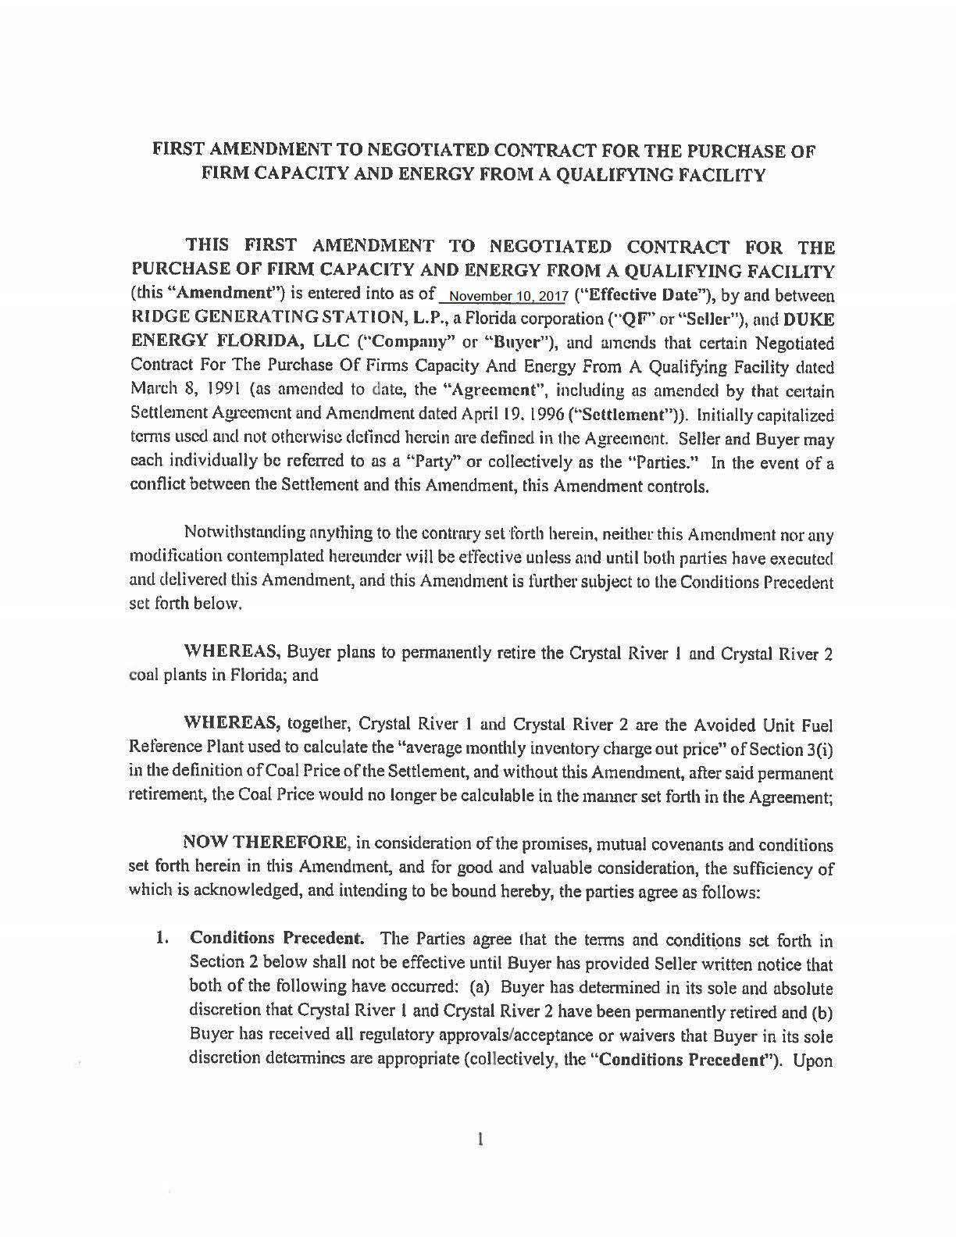
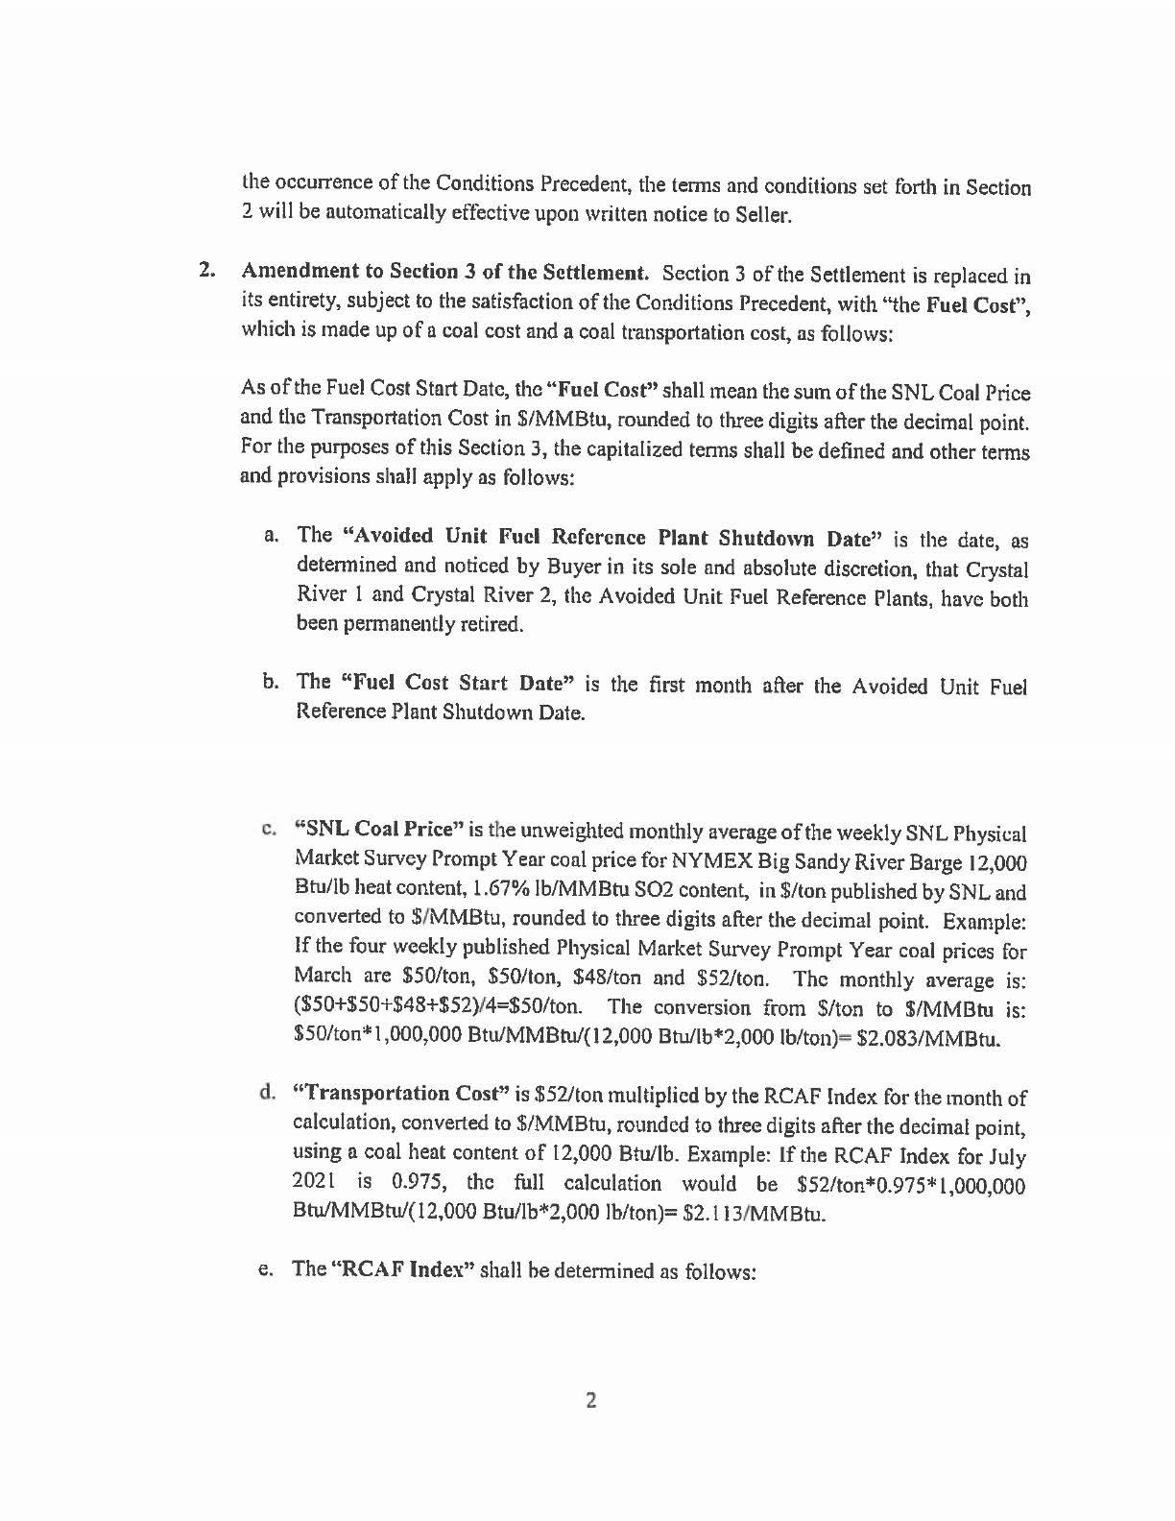
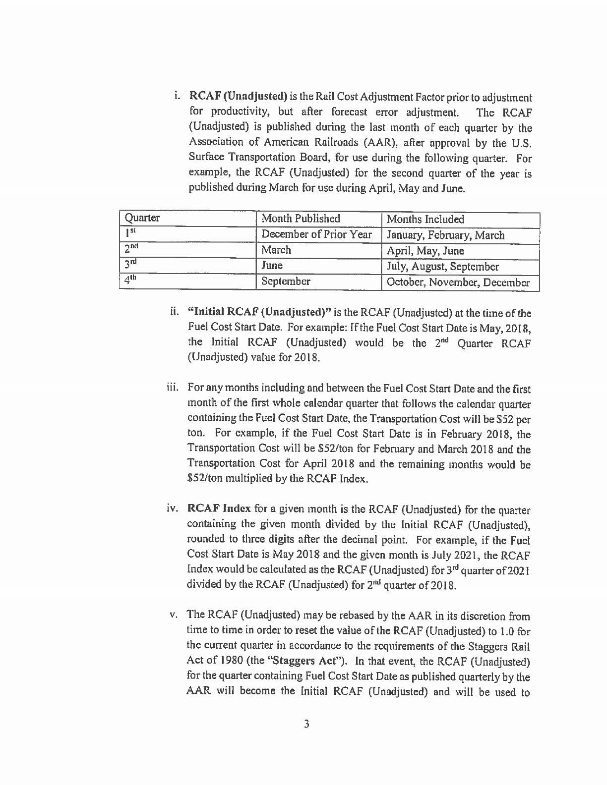
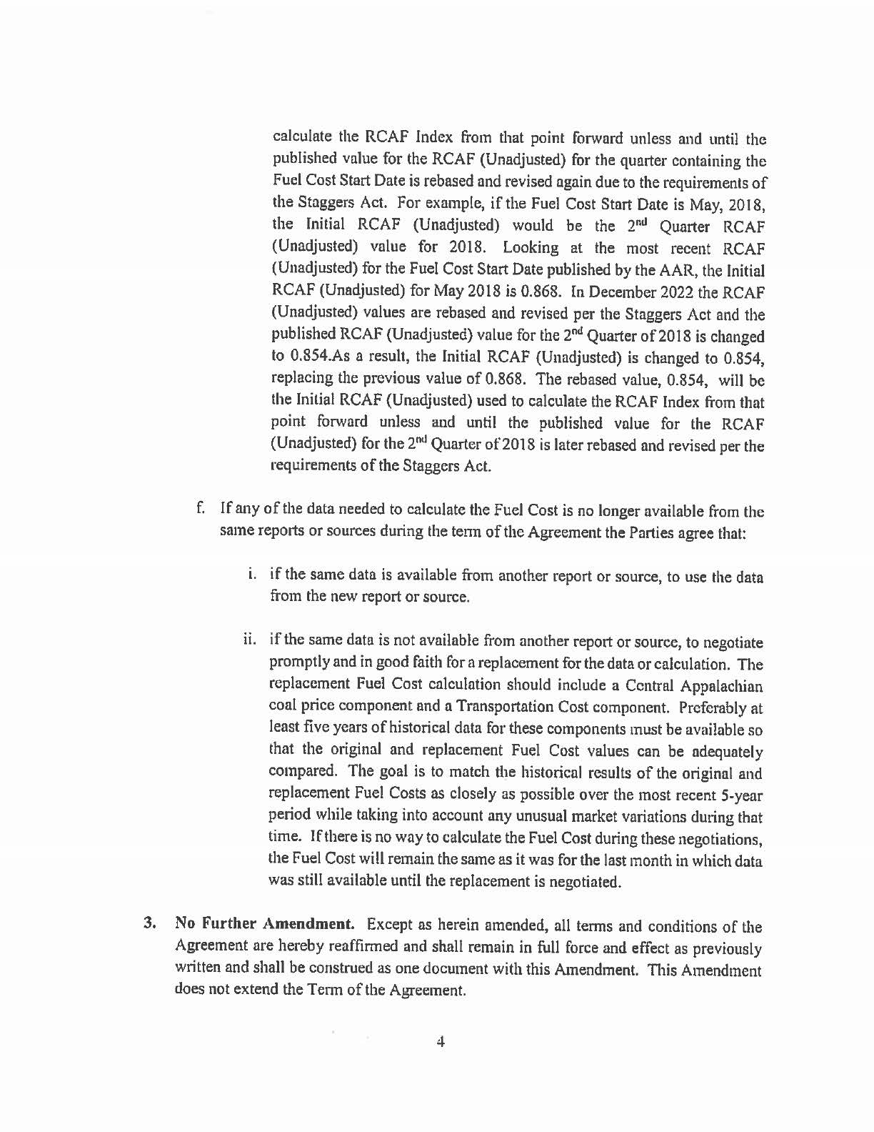
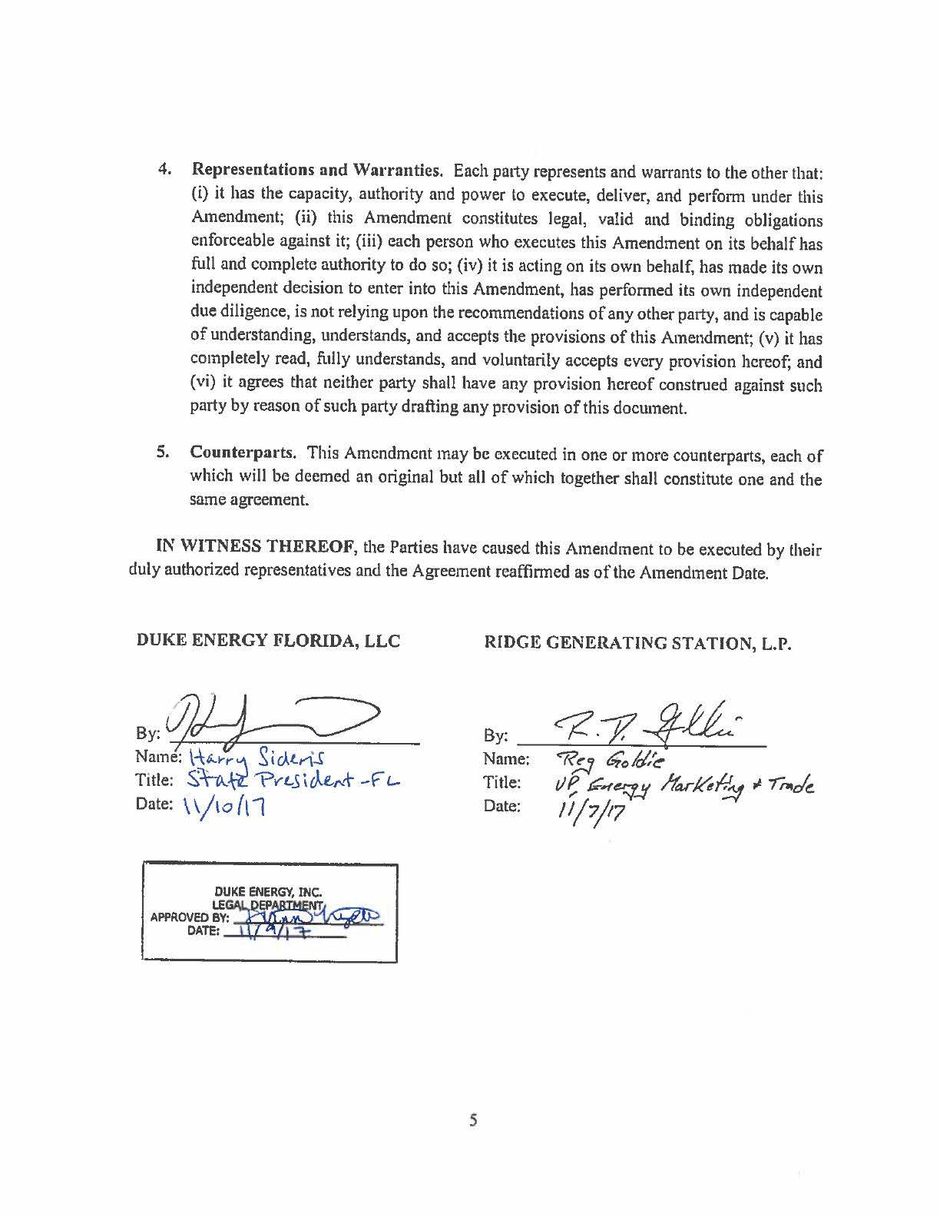
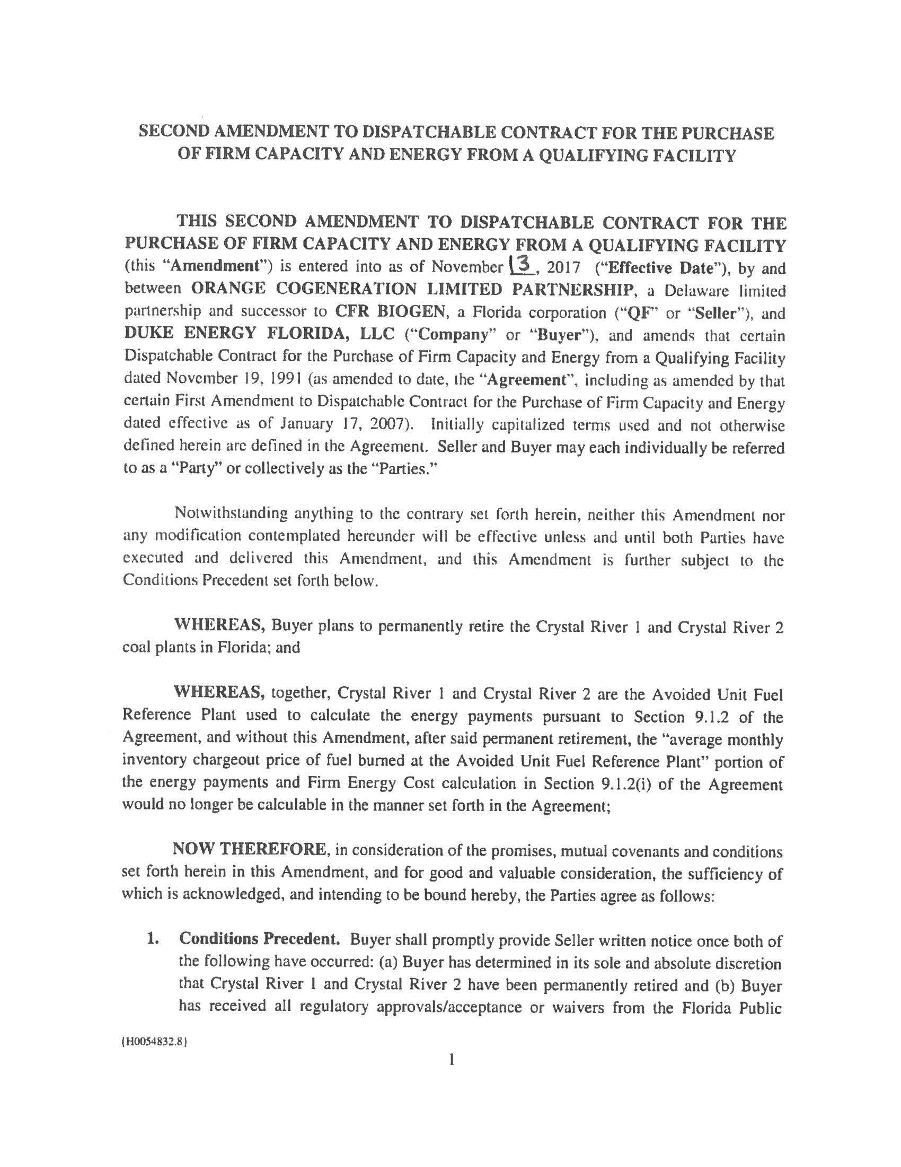
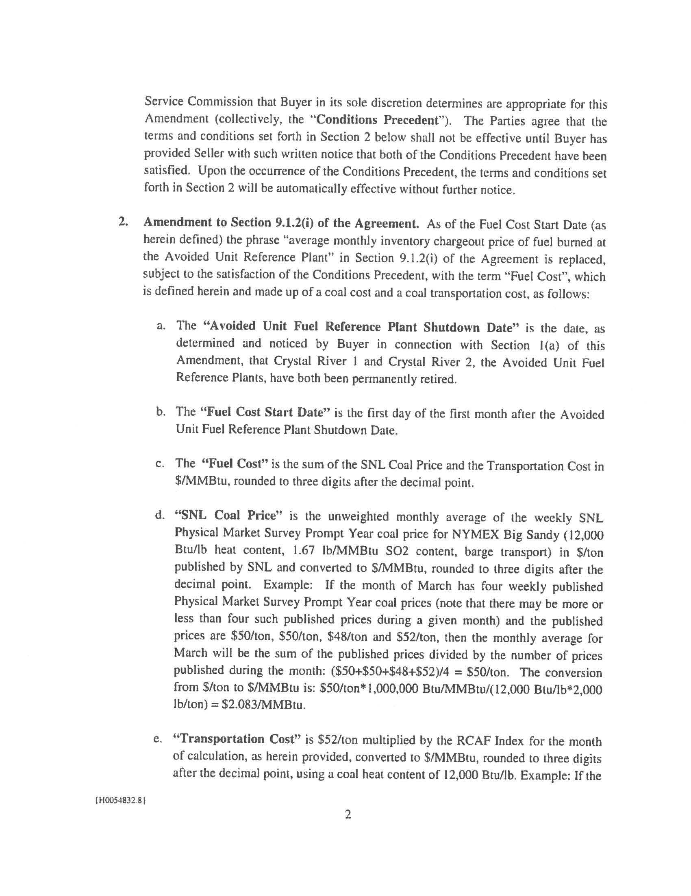
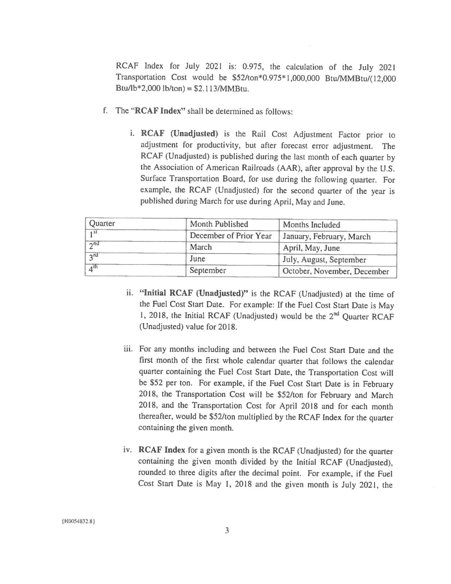
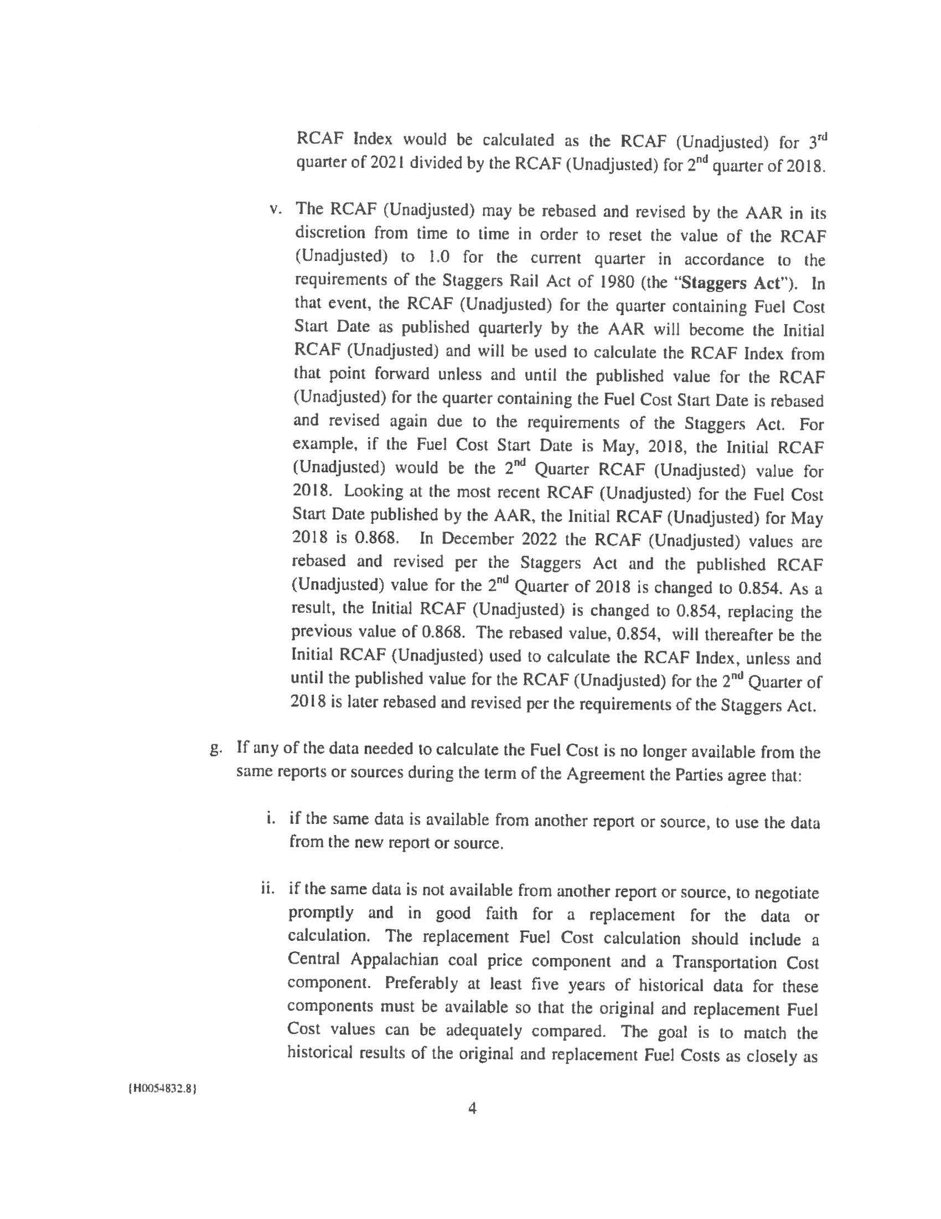
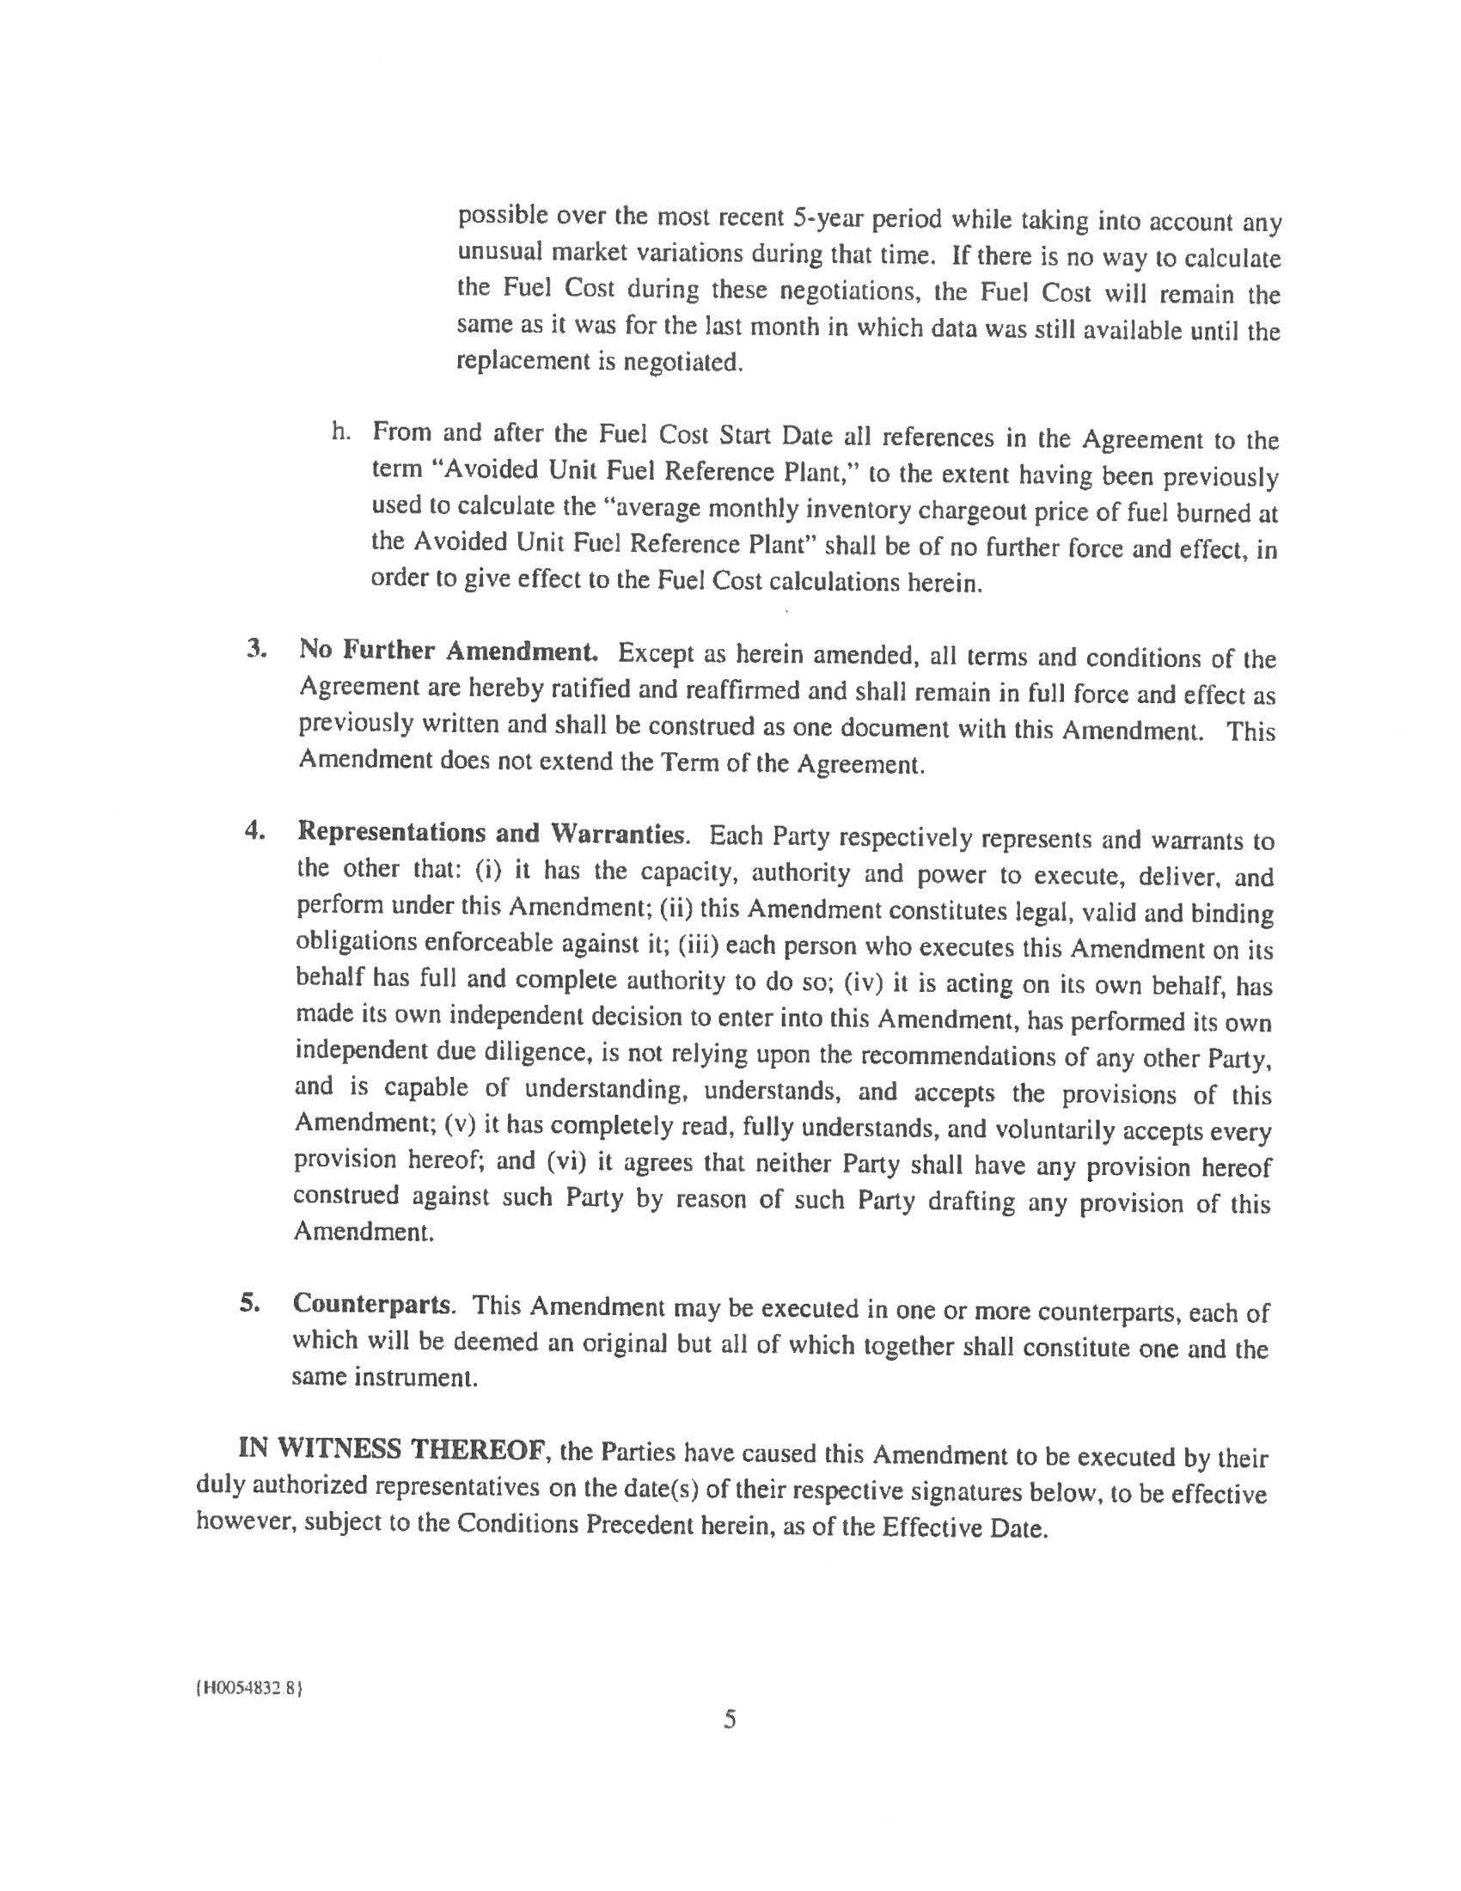
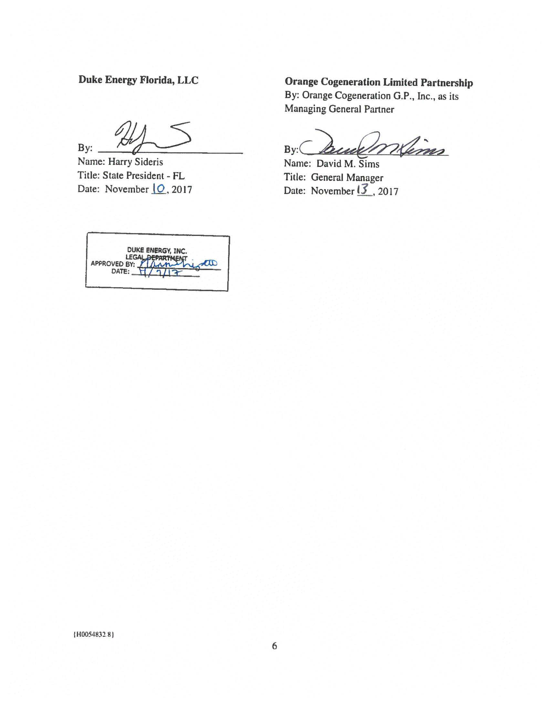
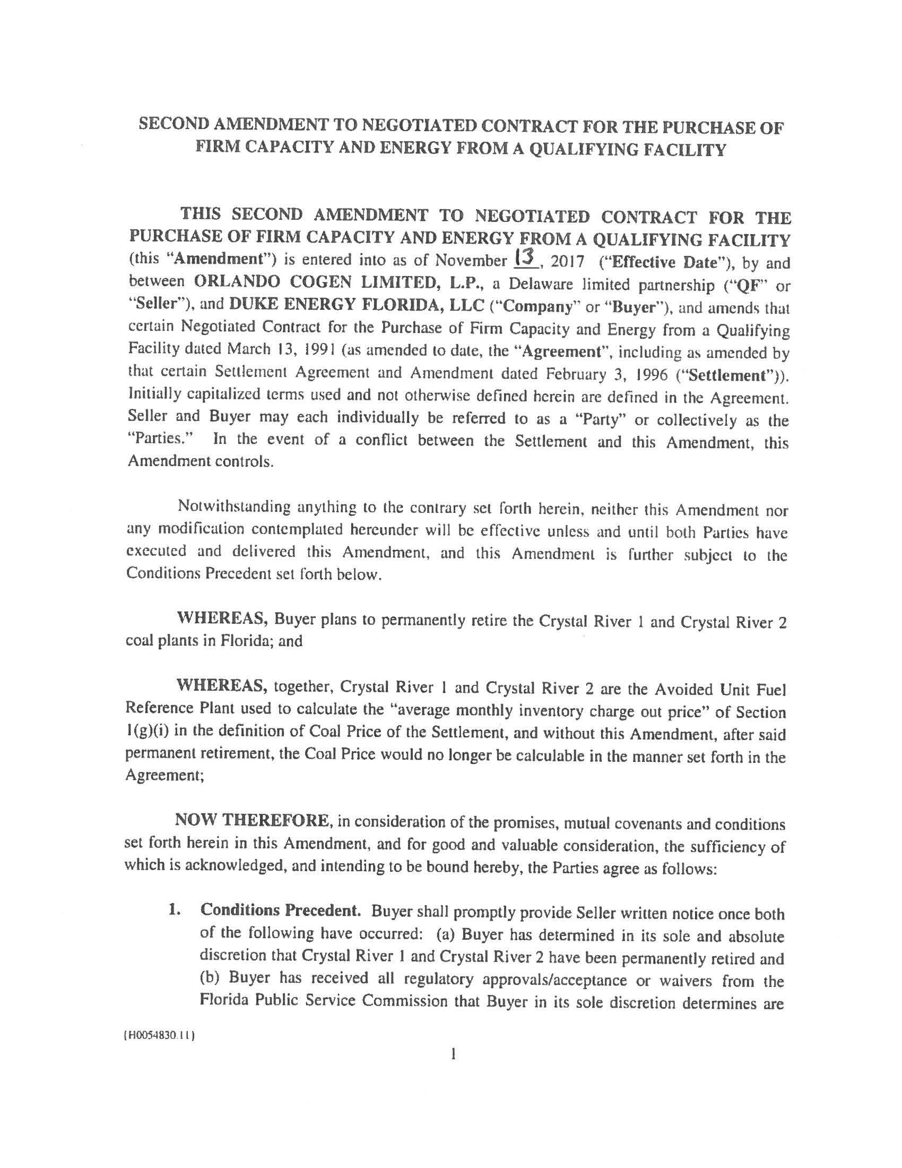
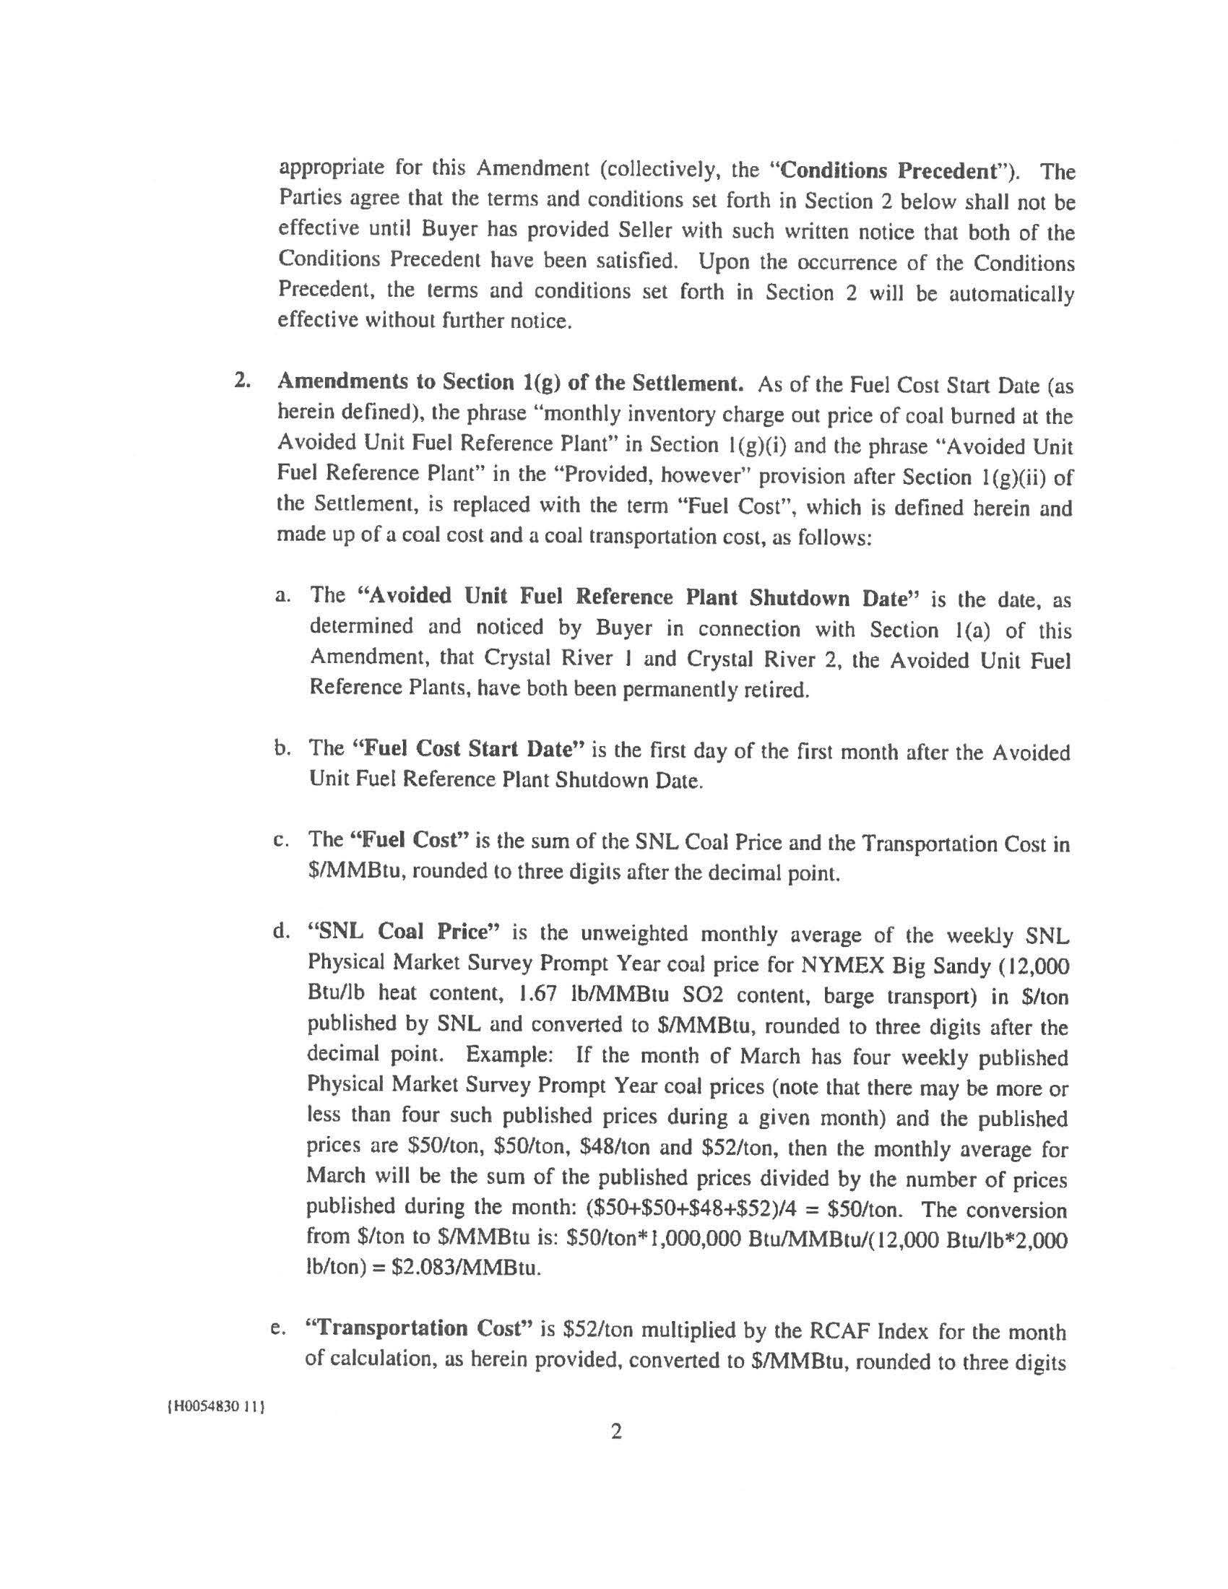
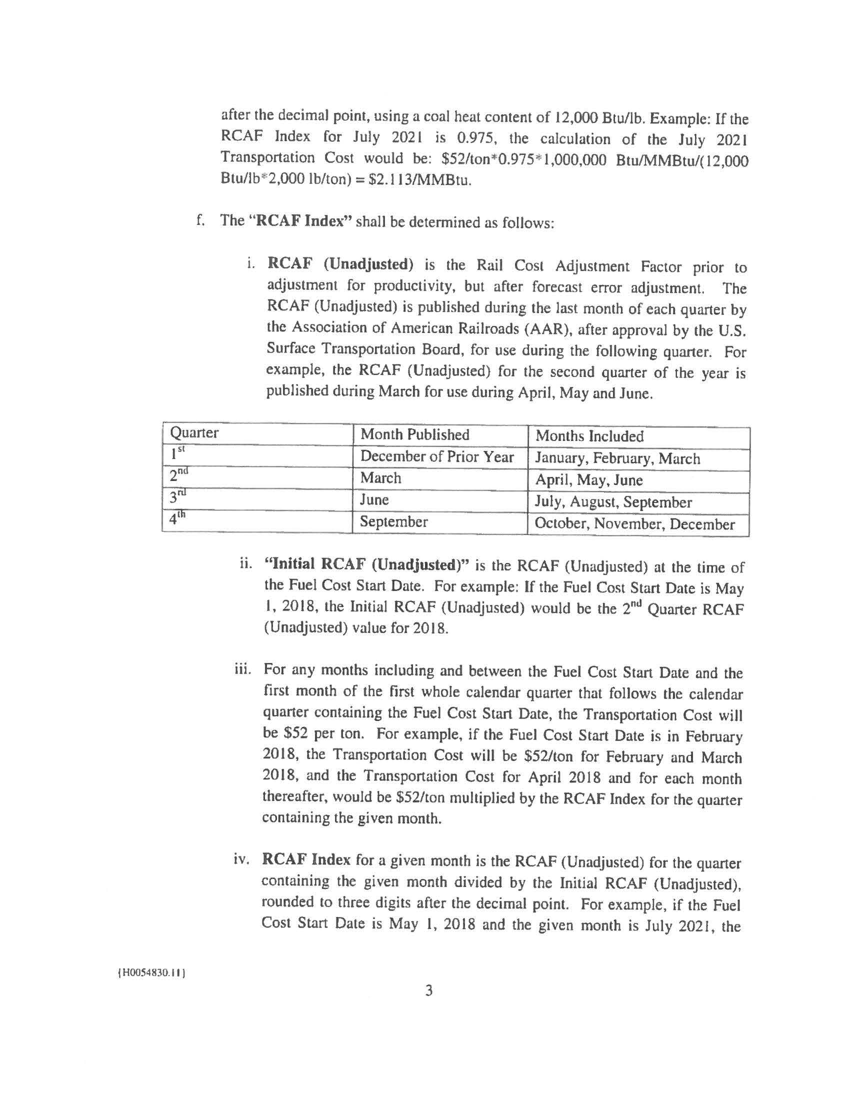
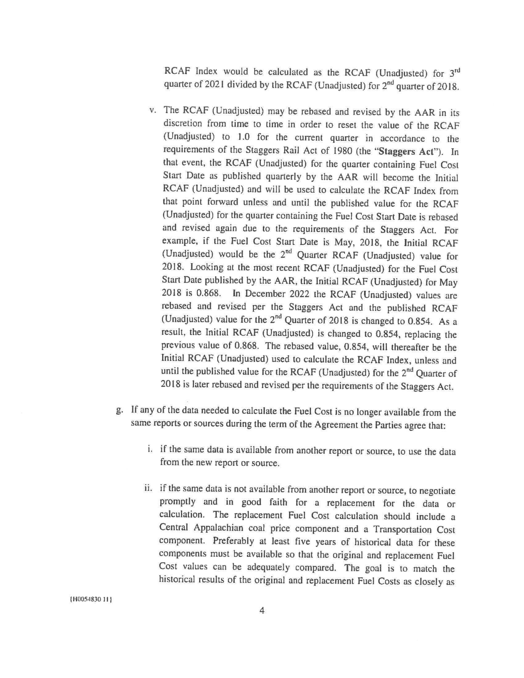
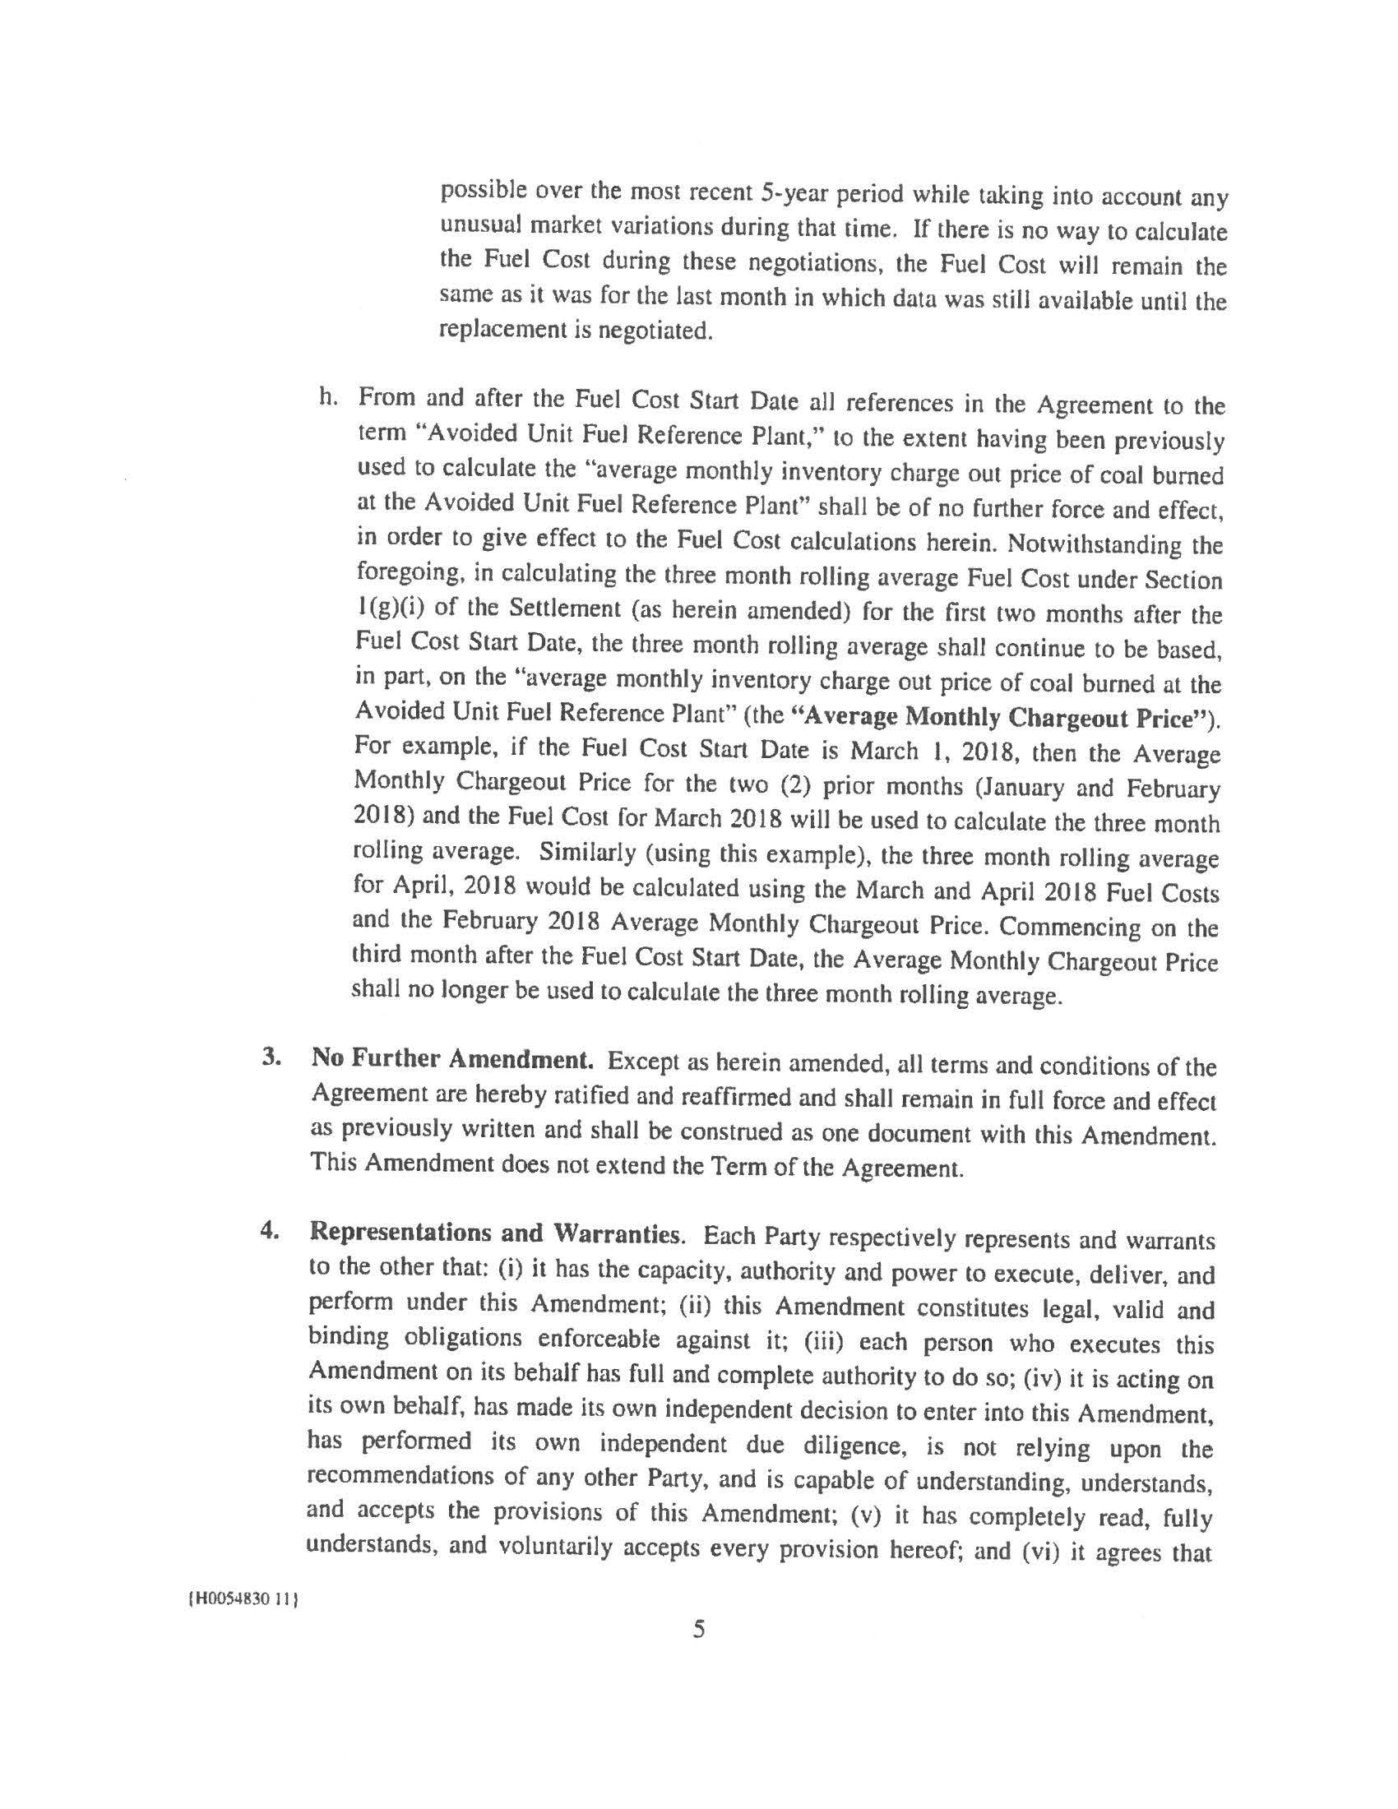
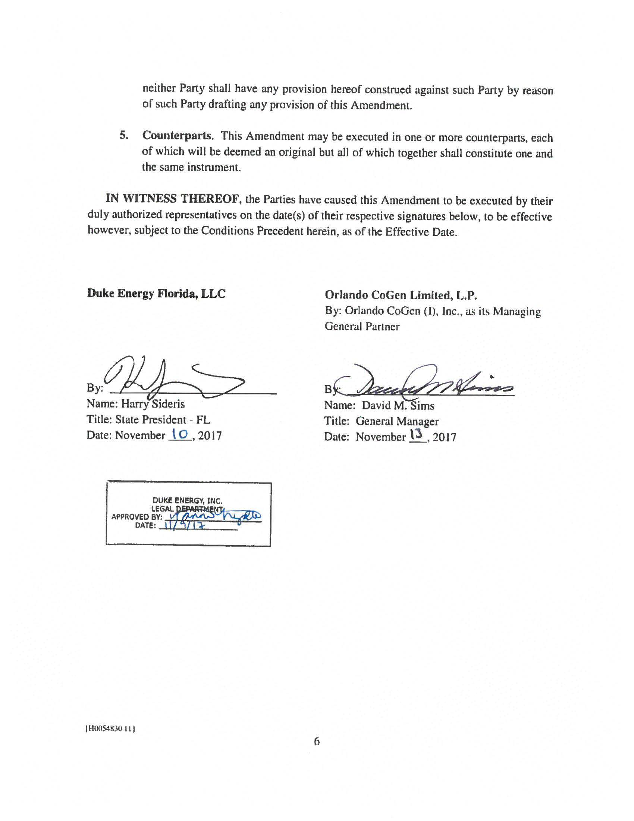
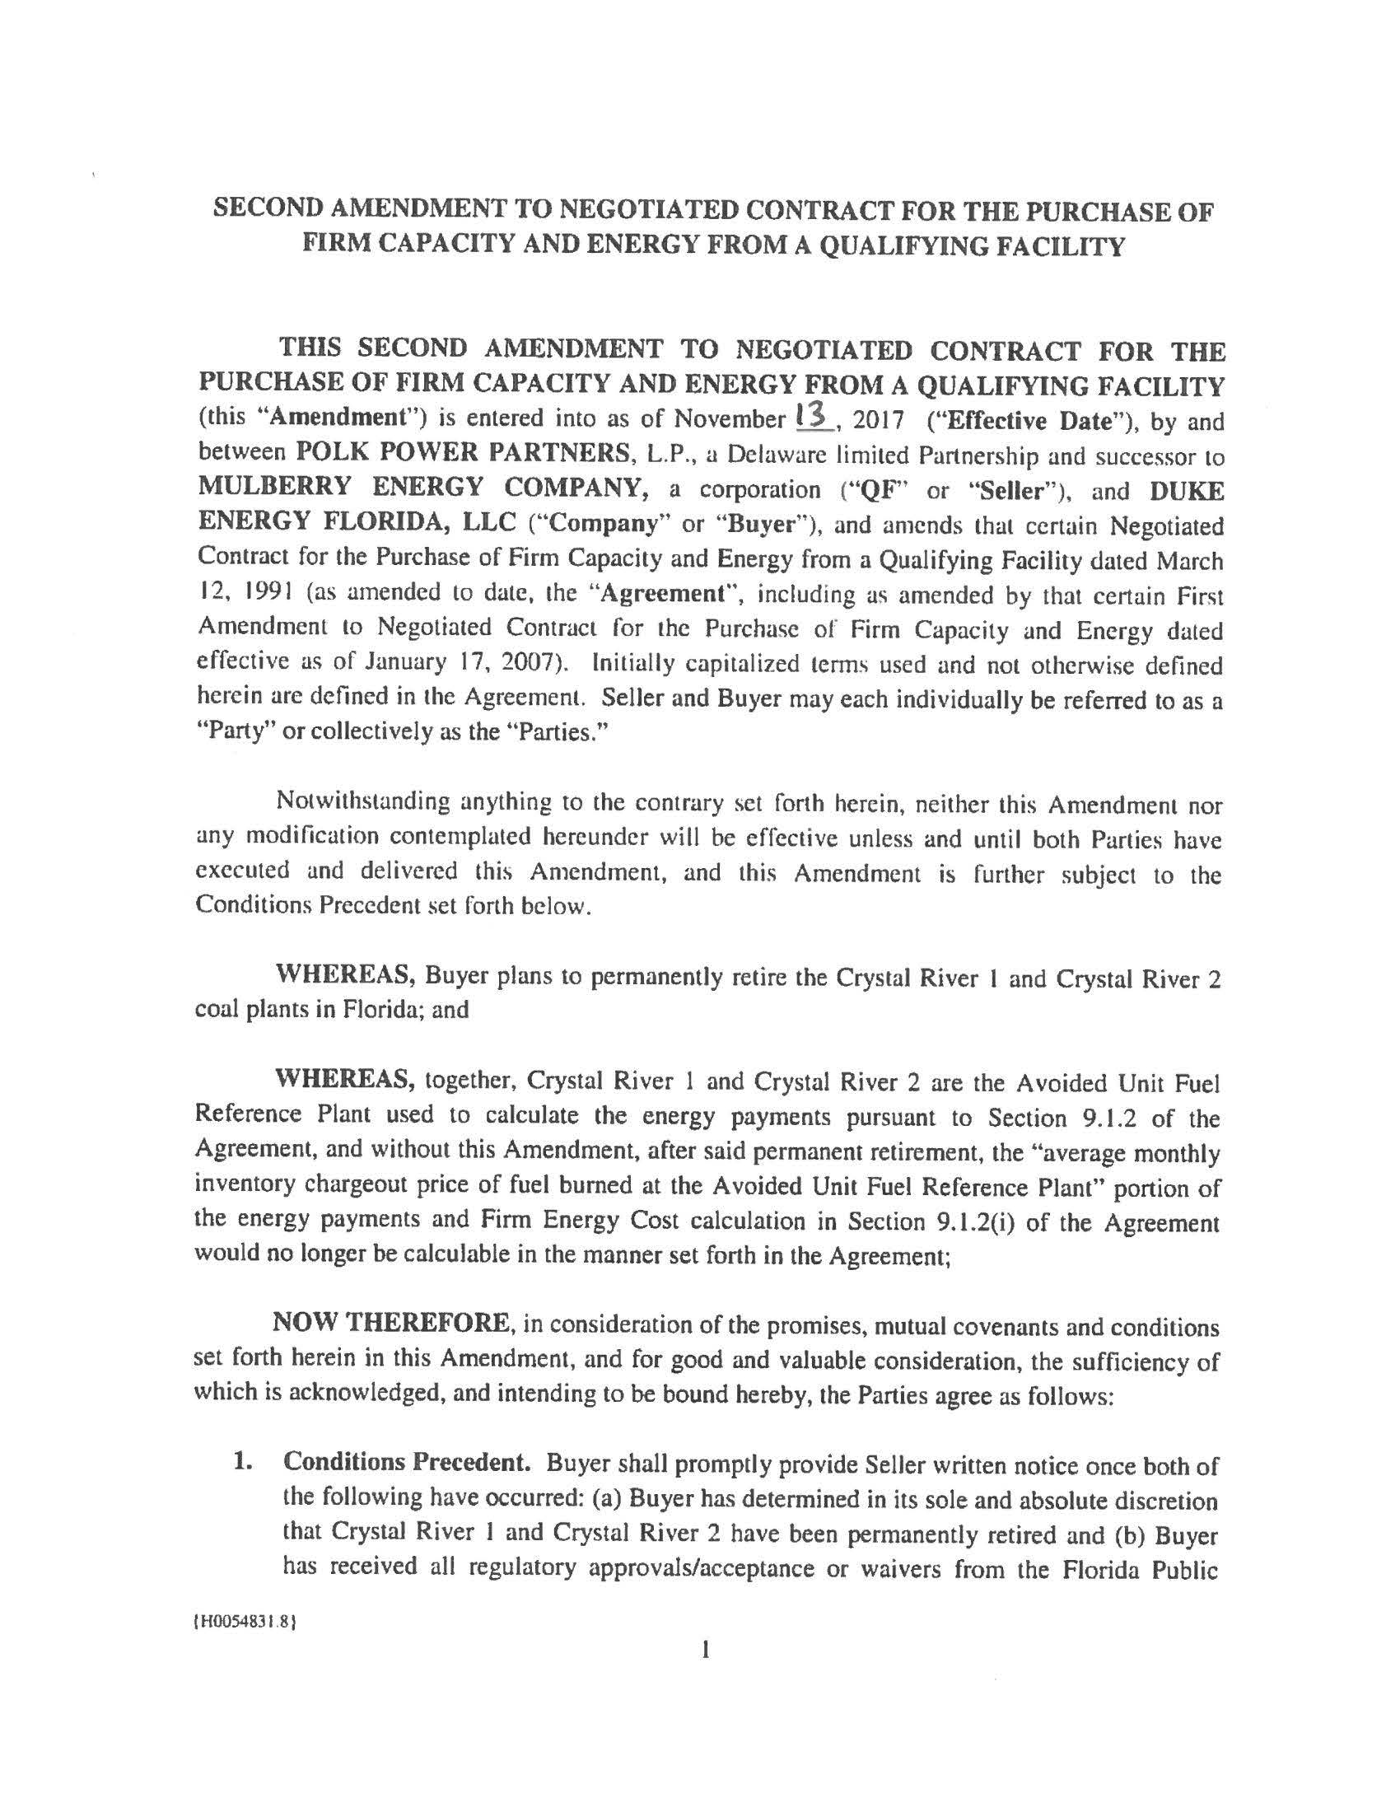
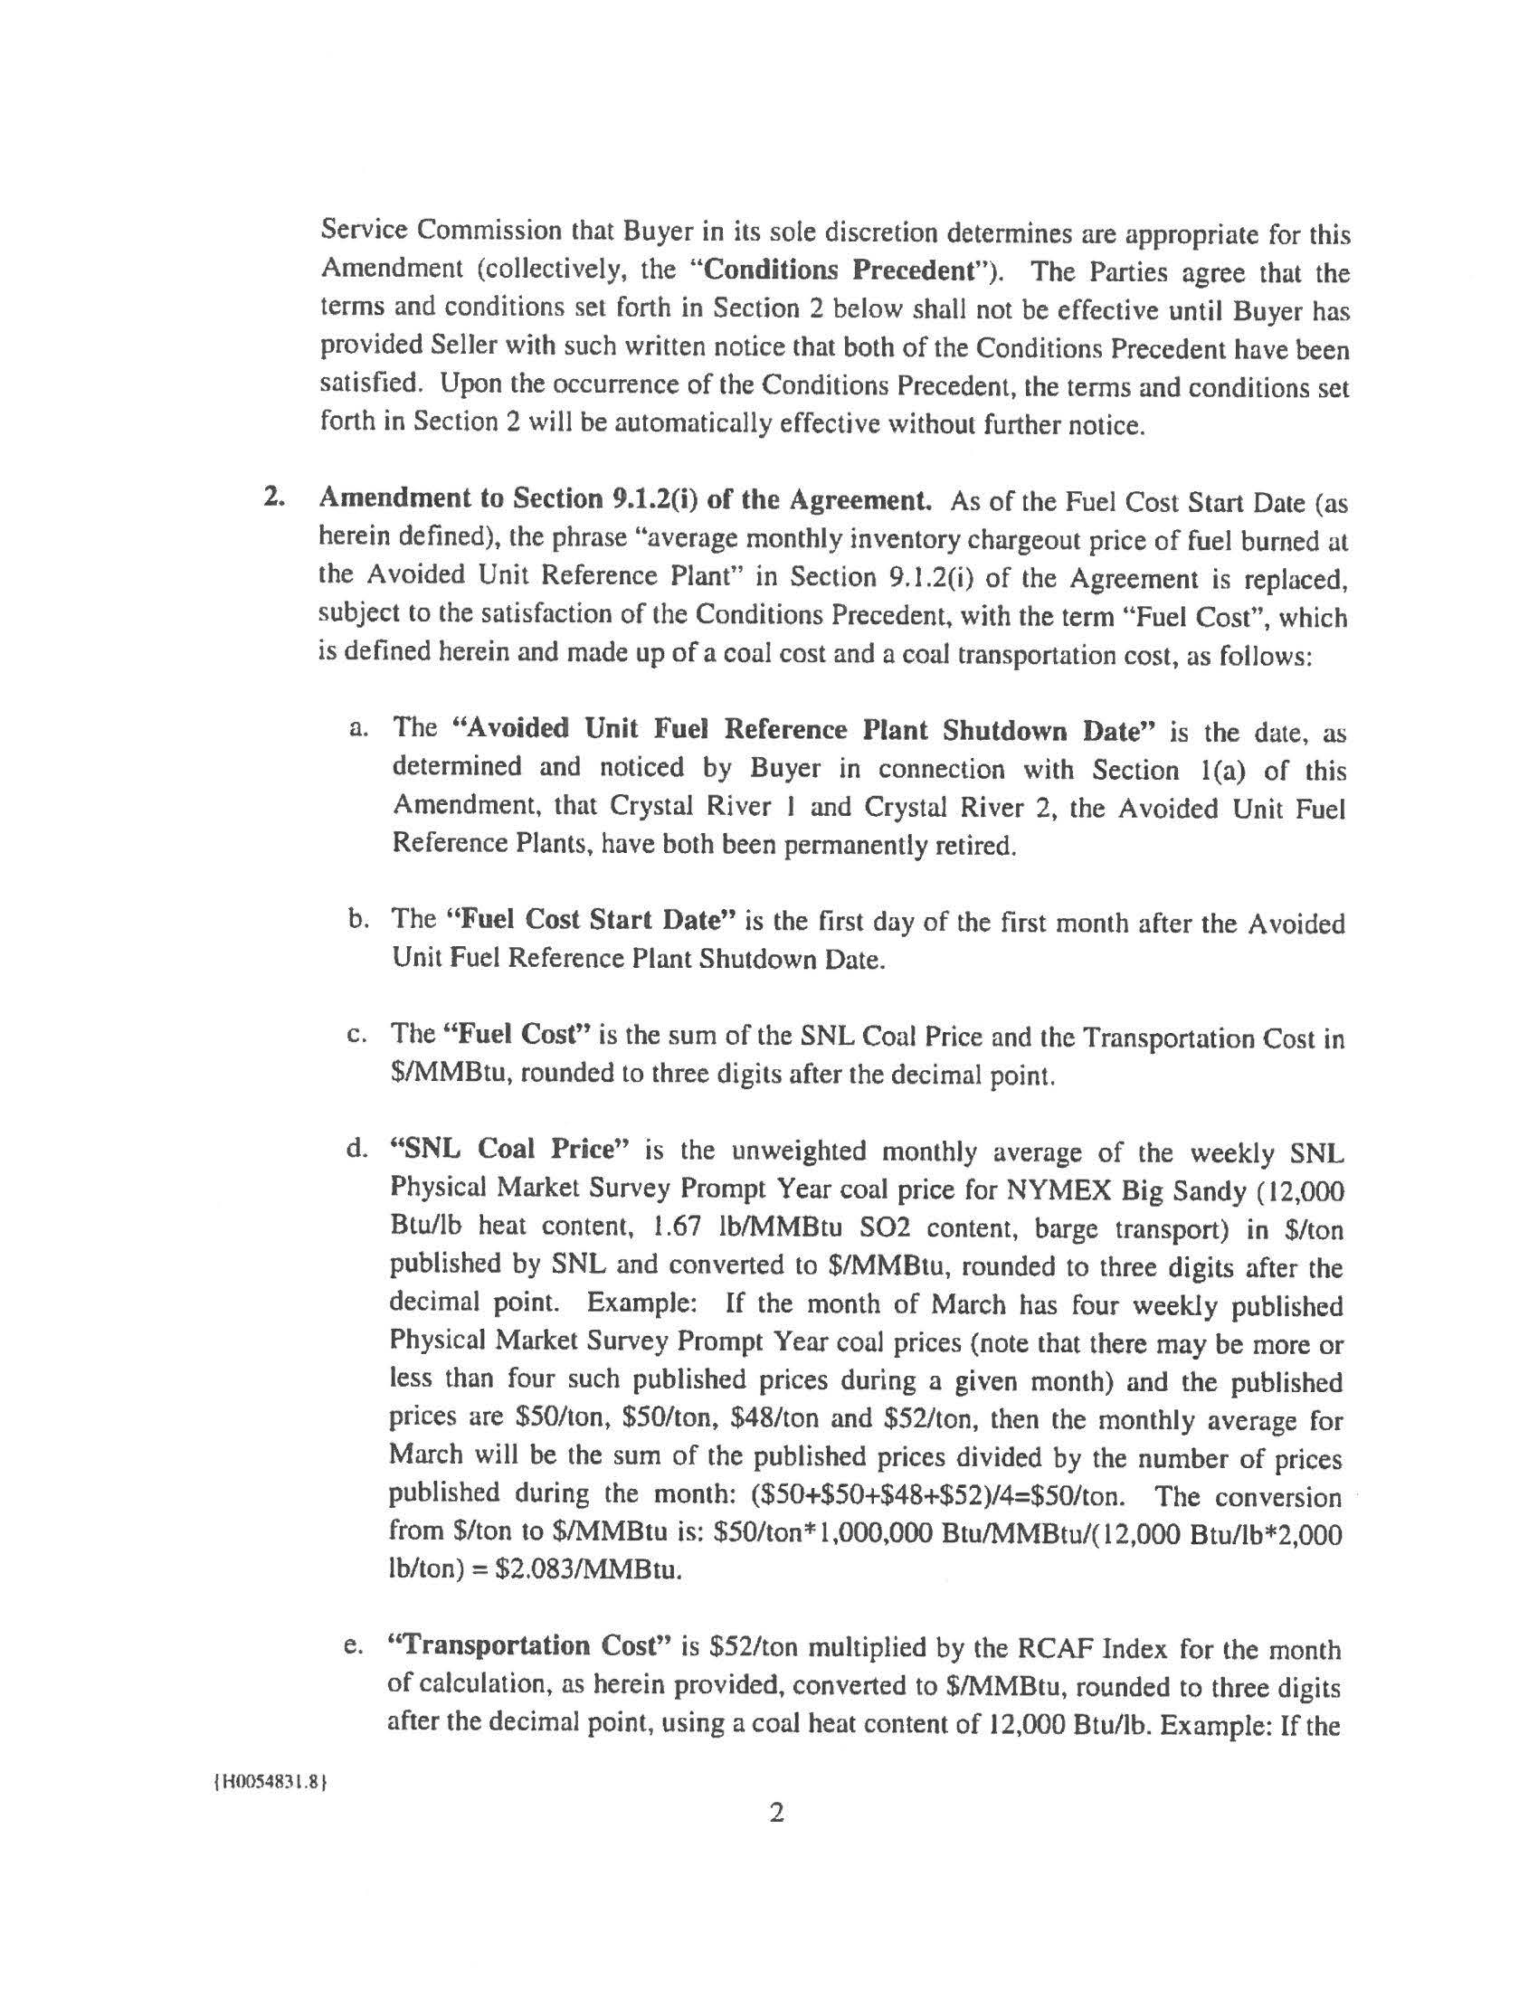
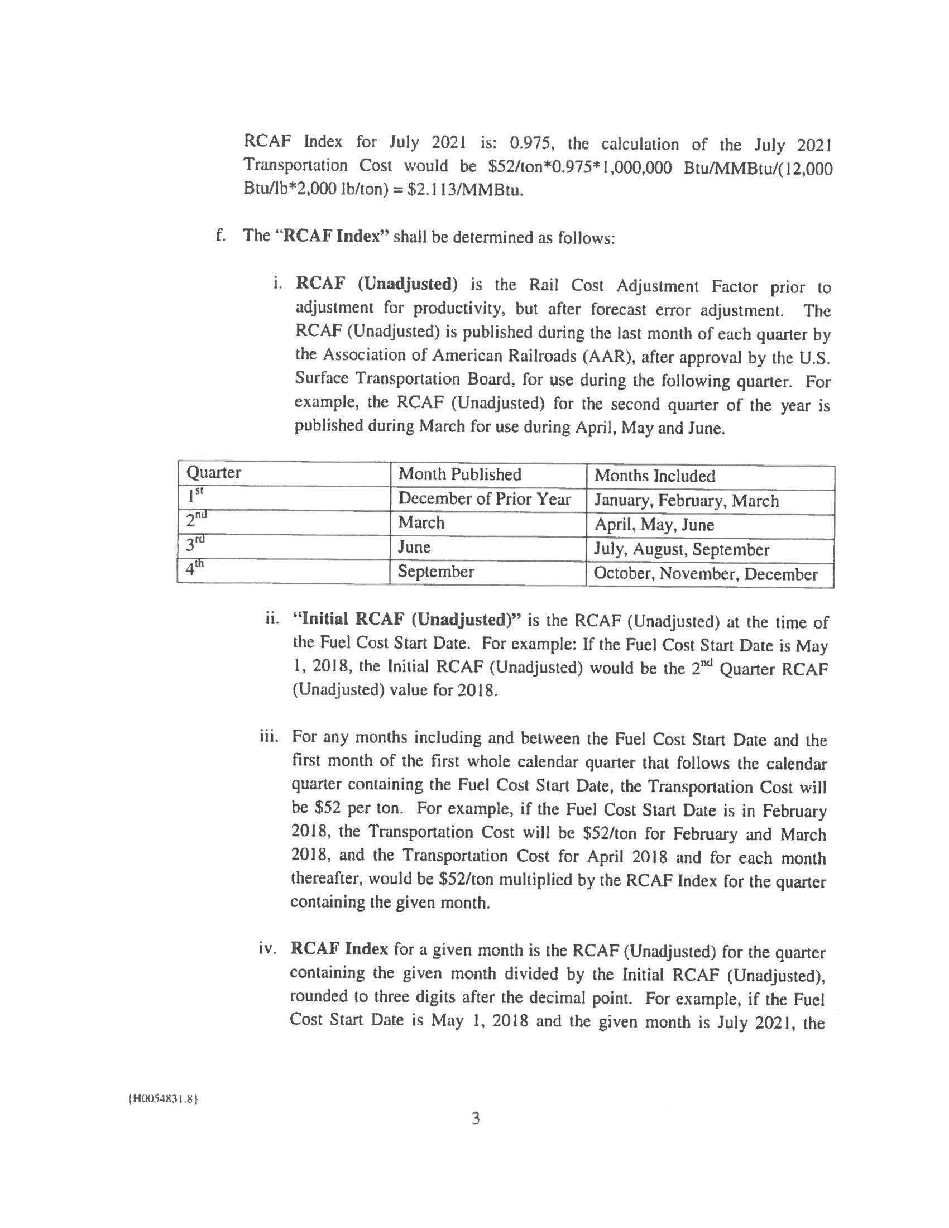
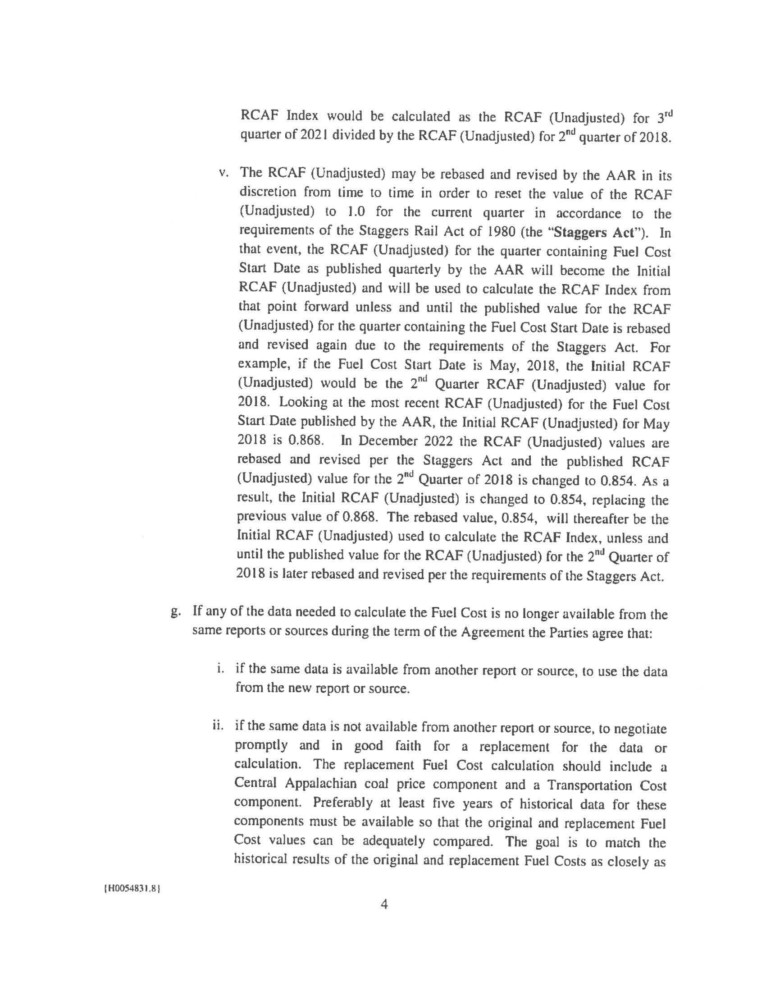
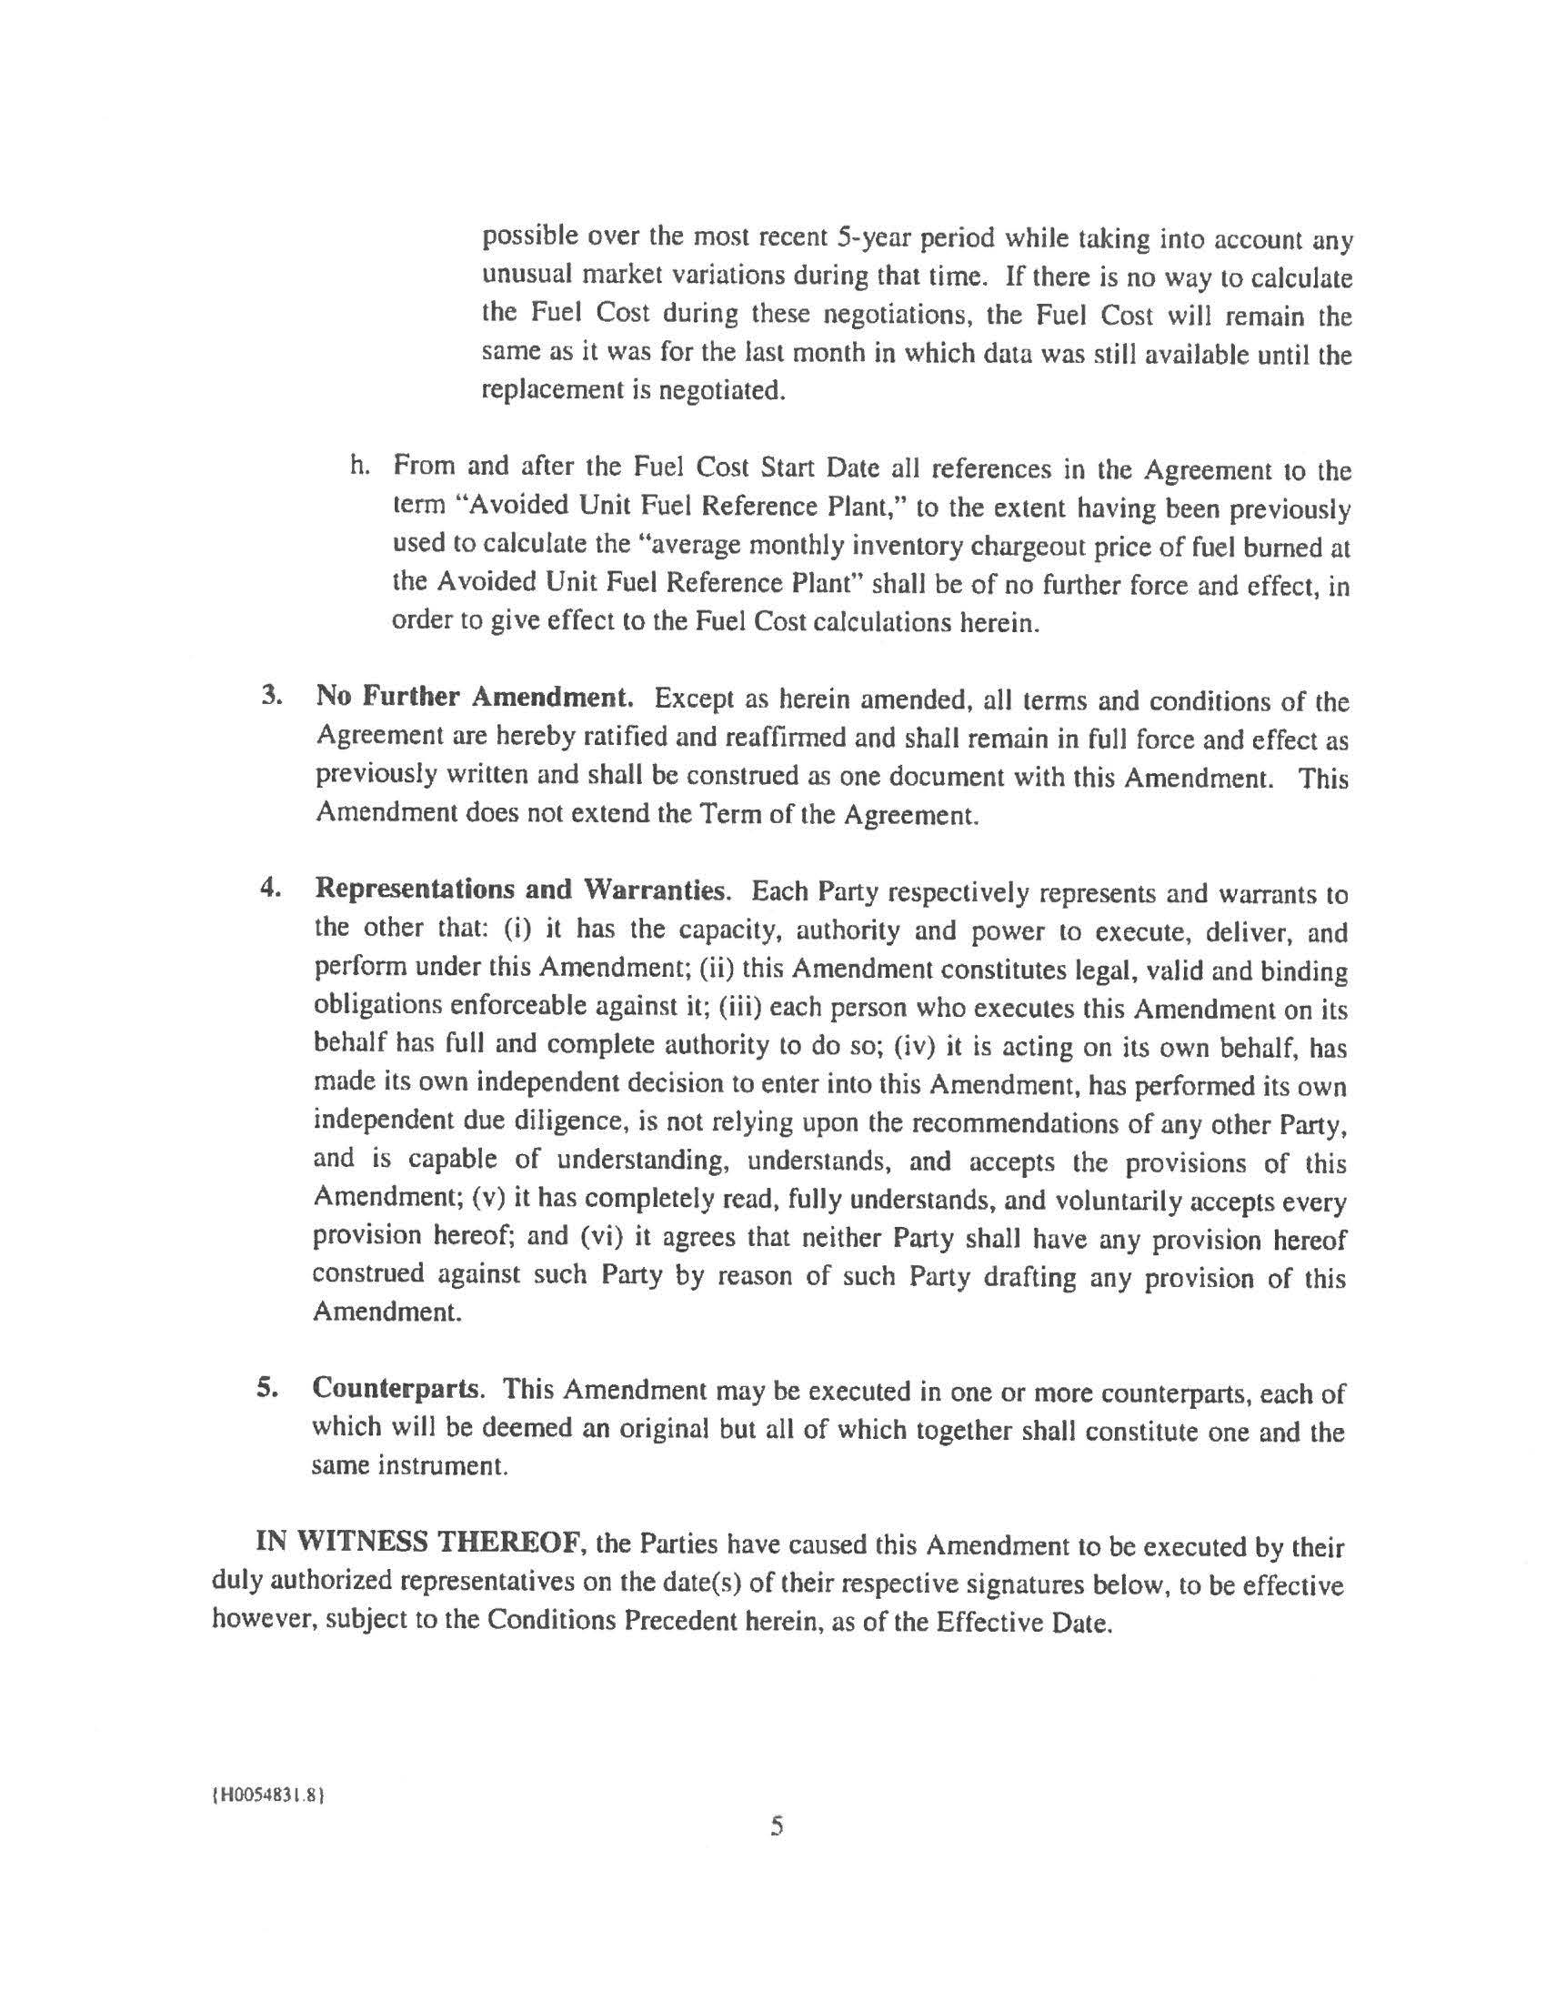
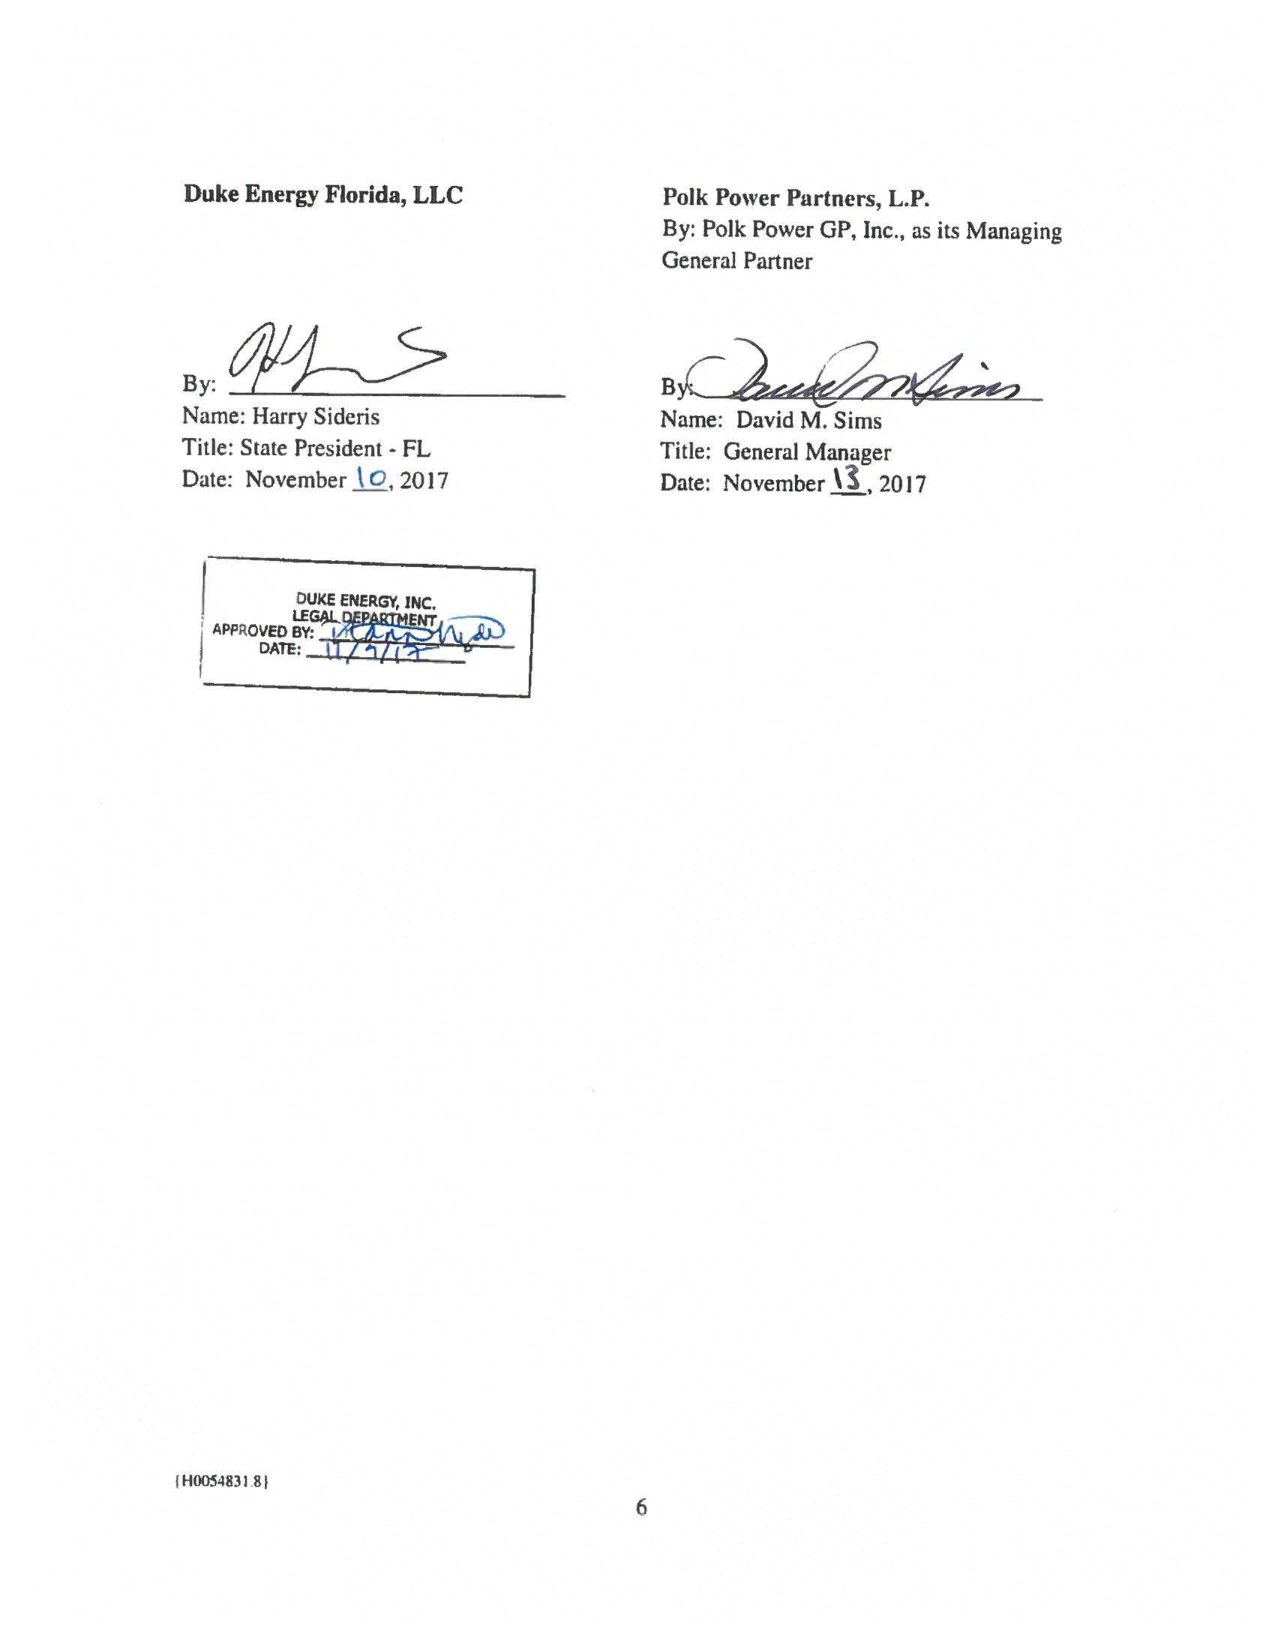
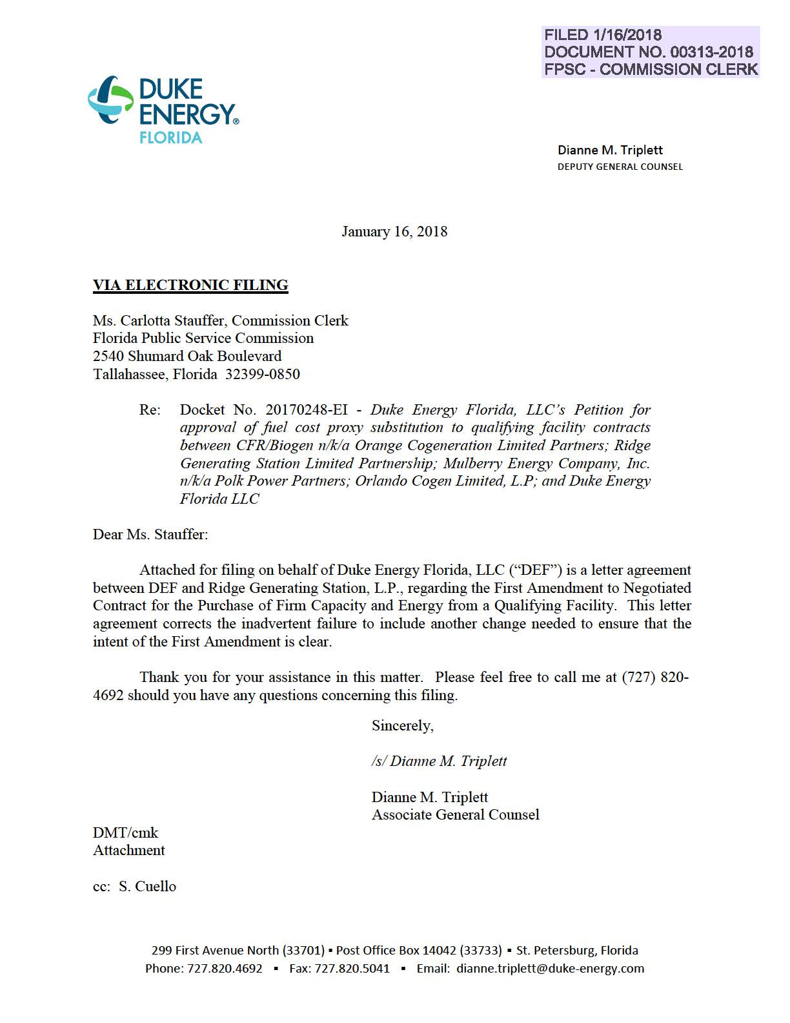
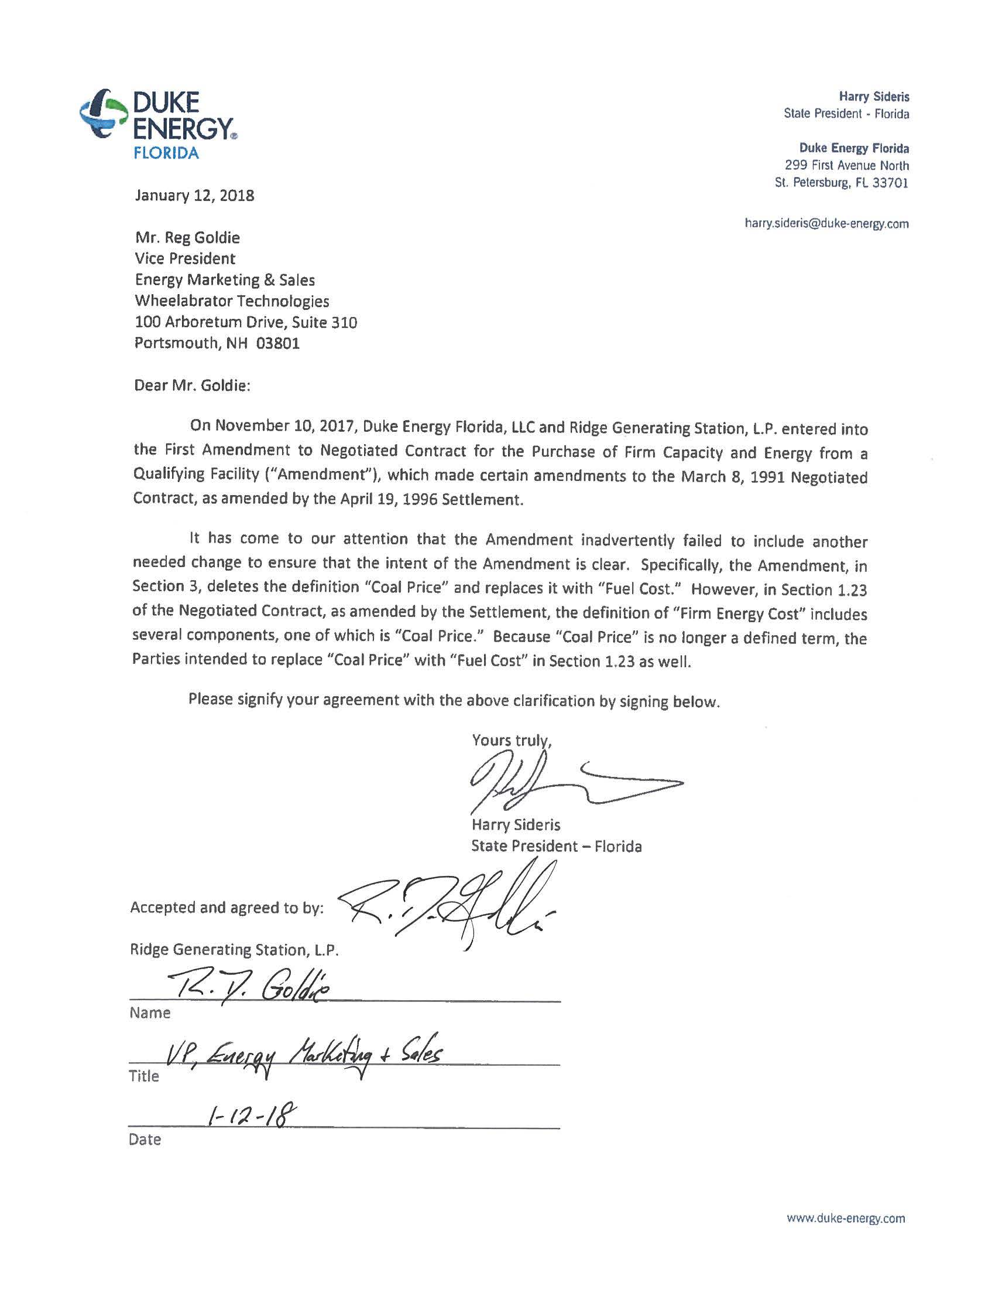

Order No. 24734, issued July 1, 1991, in Docket No. 910401-EQ, In re: Petition for approval of contracts for purchase of firm capacity and energy by Florida Power Corporation.
Order No. PSC-92-0129-FOF-EQ, issued March 31, 1992, in Docket No. 900383-EQ, In re: Complaint by CFR Bio-Gen Corporation against Florida Power Corporation for alleged violation of standard offer contract, and request for determination of substantial interests.

