State of Florida |  | Public Service Commission  Capital Circle Office Center ● 2540 Shumard Oak Boulevard  Tallahassee, Florida 32399-0850  -M-E-M-O-R-A-N-D-U-M-
DATE: | June 27, 2018
TO: | Office of Commission Clerk (Stauffer)
FROM: | Division of Economics (Doherty, Draper)  Division of Engineering (Salvador)  Office of the General Counsel (Trierweiler)
RE: | Docket No. 20180092-EQ – Petition for approval of arrangement for totalized meter interconnection service, by Tampa Electric Company.
AGENDA: | 07/10/18 – Regular Agenda – Proposed Agency Action – Interested Persons May Participate
COMMISSIONERS ASSIGNED: |  |  | All Commissioners
PREHEARING OFFICER: |  |  | Administrative
CRITICAL DATES: |  |  | None
SPECIAL INSTRUCTIONS: |  |  | None

Case Background
On April 9, 2018, Tampa Electric Company (TECO or utility) filed a petition for approval of an arrangement for totalized meter interconnection service (arrangement). The proposed arrangement is a special contract between TECO and MacDill Air Force Base (MacDill). MacDill is a United States Air Force Base located in Tampa, Florida. Pursuant to Rule 25-9.034, Florida Administrative Code, special contracts must be approved by the Commission.
On May 1, 2018, staff held a noticed informal meeting between staff and TECO to discuss the proposed arrangement. The Office of the Public Counsel participated in the meeting. The Commission has jurisdiction over this matter pursuant to Sections 366.04, 366.05, and 366.06, Florida Statutes.

Discussion of Issues

Issue 1:
Should the Commission approve the proposed arrangement between TECO and MacDill, as shown in Attachment A, effective July 10, 2018?

Recommendation:
Yes. The Commission should approve the proposed arrangement between TECO and MacDill, as shown in Attachment A, effective July 10, 2018 (Doherty, Draper)

Staff Analysis:
The proposed arrangement between TECO and MacDill provides for the application for totalized metering, which is the summation of adjacent metering equipment readings serving the same property. Totalized metering is permissible under TECO’s current tariff; however, TECO’s tariff does not address MacDill’s unique circumstances. Therefore, TECO filed the instant petition for an arrangement. The proposed arrangement does not contain a special rate for MacDill; MacDill will continue to pay TECO’s tariffed charges.

Overview of MacDill
MacDill is located south of Tampa at the end of the Interbay peninsula in Hillsborough County and receives electric service from TECO at the MacDill substation (shown on the map in Attachment B to this recommendation as MacDill – 23 D). MacDill is a federal enclave and owns and operates its distribution system behind the meter at the MacDill substation. TECO does not own any distribution system on the base and provides service to MacDill at primary voltage pursuant to rate schedule, General Service – Demand Time-of-Day.
The MacDill operations center operates continuously; therefore, reliability is a major concern. TECO explained that during hurricane season MacDill is at risk to storm surge and flooding due to being just four feet above sea level and at the end of a peninsula. MacDill owns a standby generator; however, the generator only has three days worth of diesel fuel as a reserve.
MacDill is planning to add new load which could exceed the existing MacDill substation’s capacity. To accommodate the incremental MacDill load as well as growth in the surrounding area, TECO is building a new substation (Interbay substation, shown on Attachment B). The Interbay substation is directly west 1.4 miles from the current MacDill 23 – D substation. Once the Interbay substation is constructed, MacDill will be served by both substations. TECO stated that the Interbay substation will be operational in July or August 2018.

Proposed Arrangement
TECO’s current tariff sheet No. 5.075 addresses totalized metering. Totalized metering can be provided by the utility when single circuit metering is impractical because the customer’s load exceeds the loading criteria of one standard transformer. To illustrate, a large warehouse’s demand cannot be served by one standard transformer. TECO, therefore, would install two transformers, and two metering circuits, and combine the readings from the two meters.
The tariff provides for certain criteria the customer must meet to qualify for totalized metering: (1) all the services totalized must be at the same voltage level; (2) the facility’s total demand load must exceed the loading criteria for the largest standard transformer; and (3) the facility must be comprised of one building containing a single business operated by one customer. In addition, the tariff states that totalized metering will normally be provided to a single geographical point.
MacDill’s circumstances vary from what is contemplated in TECO’s current tariff with respect to two criteria. First, the MacDill base, while it is on one unit of property, consists of multiple buildings. Second, MacDill will be served from two points of delivery (the two substations) which are 1.4 miles apart.
The application of totalized metering for the existing and the new interconnection, along with balancing of the MacDill load between the two substations, would provide more capacity and more reliable service to MacDill. In addition, the proposed arrangement would free up capacity at the MacDill substation allowing TECO to meet future capacity and energy needs outside the MacDill base. Currently, the MacDill substation only serves MacDill.
Under the totalized metering arrangement, MacDill will pay one customer charge and the kilowatt hours metered at the two substations will be added together. The demand billed will be the highest totalized (combined) demand registered at both substations.

Conclusion
The Commission recently approved a special contract between Florida City Gas and U.S. Sugar, a large industrial customer who is facing unique challenges. Similar to the instant petition, the Commission approved a variance from Florida City Gas’s tariff to address the challenges faced by U.S. Sugar through a special contract.
Staff has reviewed TECO and MacDill’s proposed arrangement, or special contract, and data provided during the informal meeting on Tuesday, May 1, 2018. Staff recommends that the Commission approve the proposed arrangement between TECO and MacDill, as shown in Attachment A, effective July 10, 2018.
Issue 2:
Should this docket be closed?

Recommendation:
Yes. If no protest is filed by a person whose substantial interests are affected within 21 days of the issuance of the Order, this docket should be closed upon the issuance of a Consummating Order. (Trierweiler)

Staff Analysis:
If no protest is filed by a person whose substantial interests are affected within 21 days of the issuance of the Order, this docket should be closed upon the issuance of a Consummating Order.

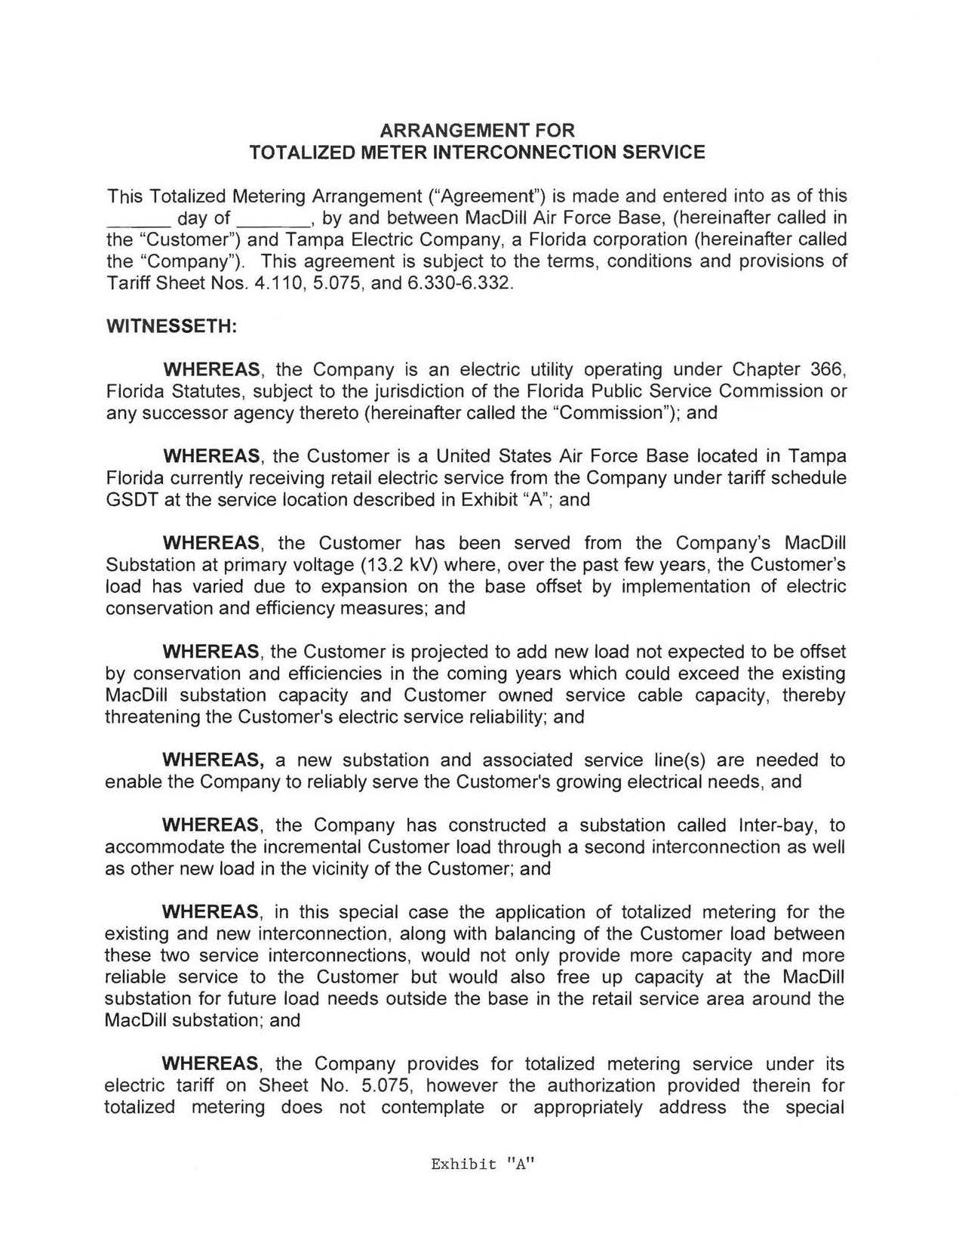

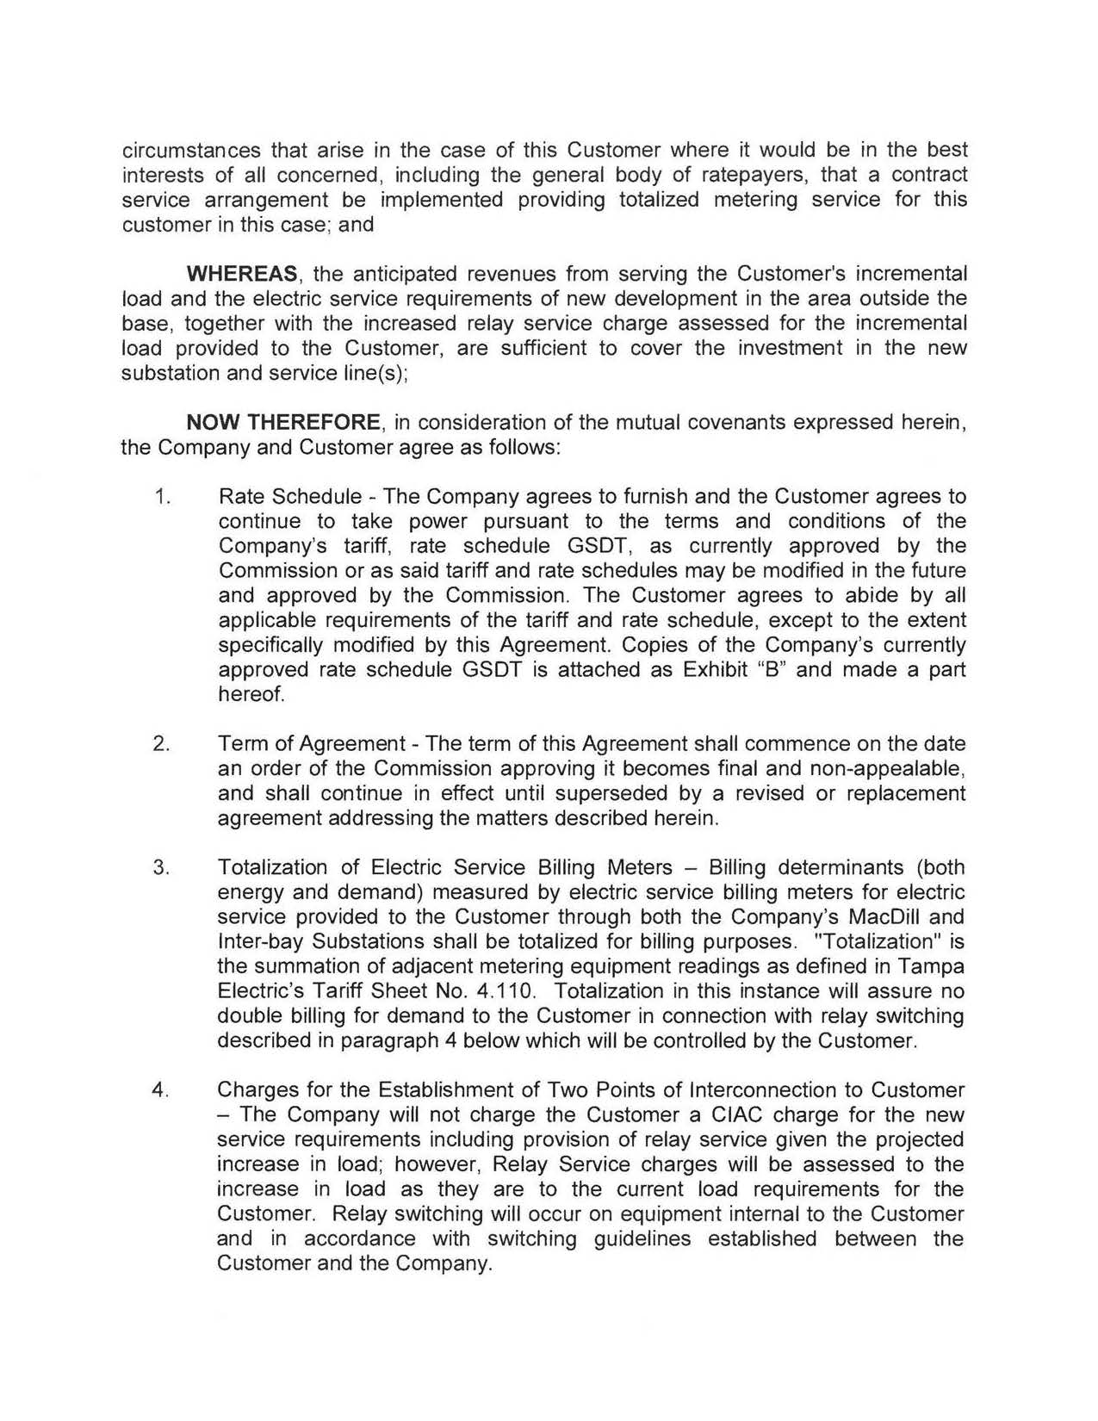

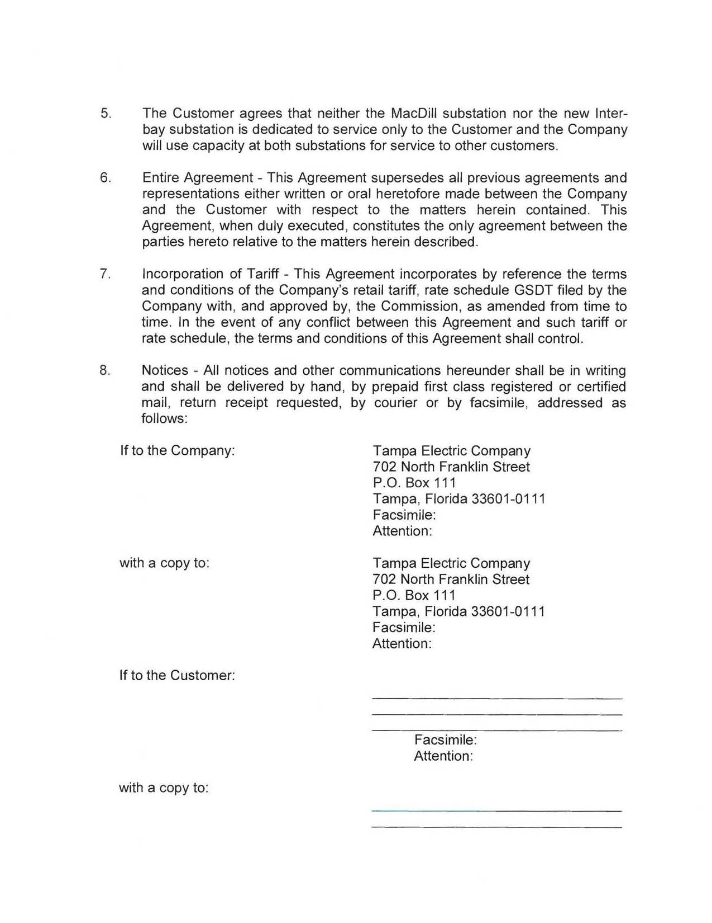

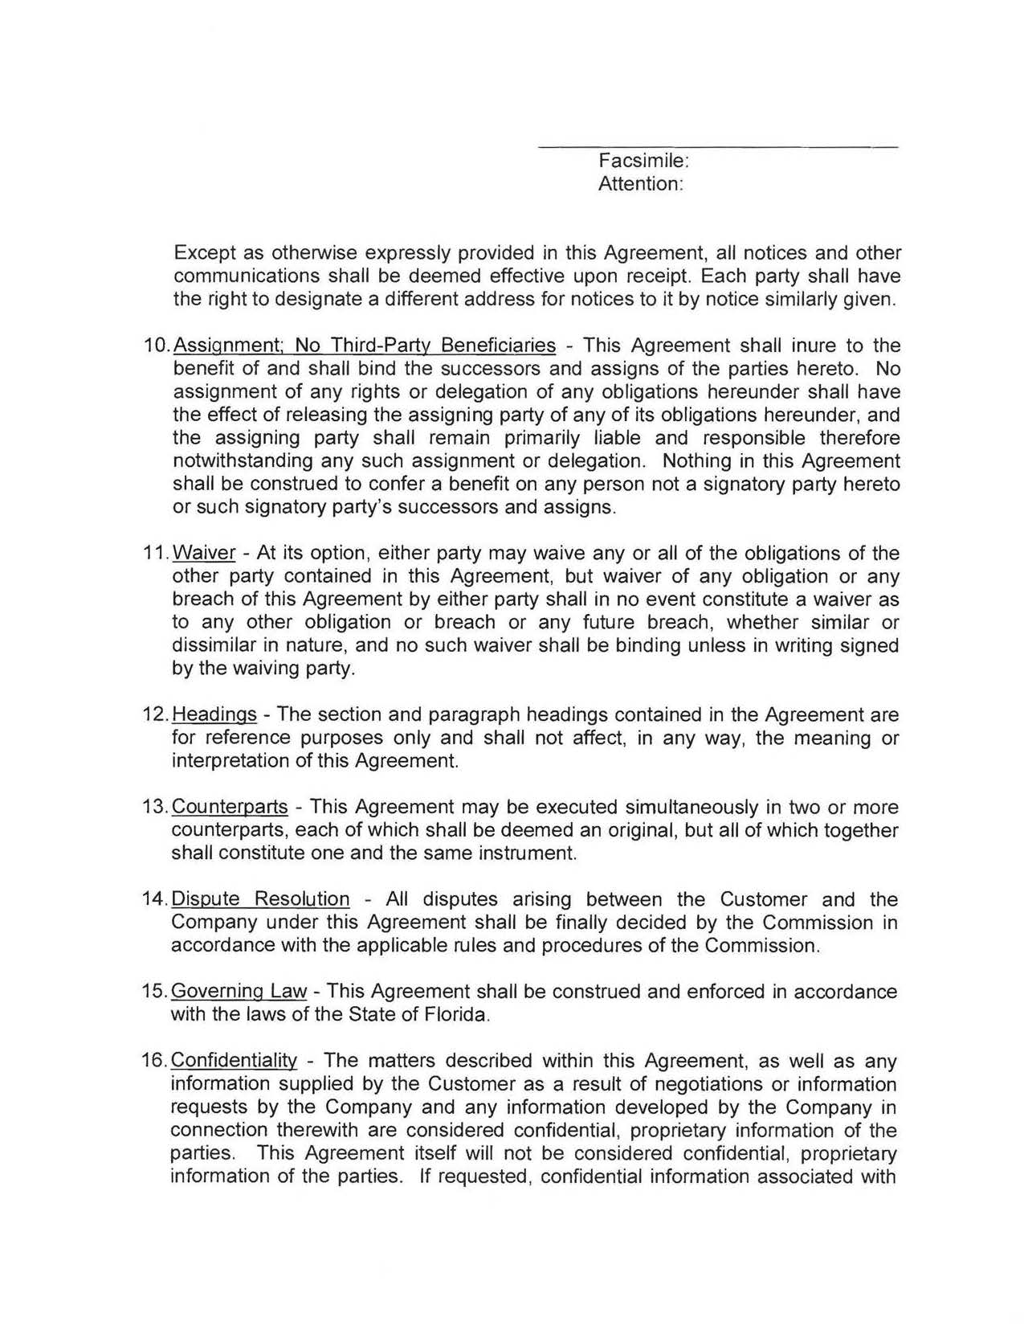
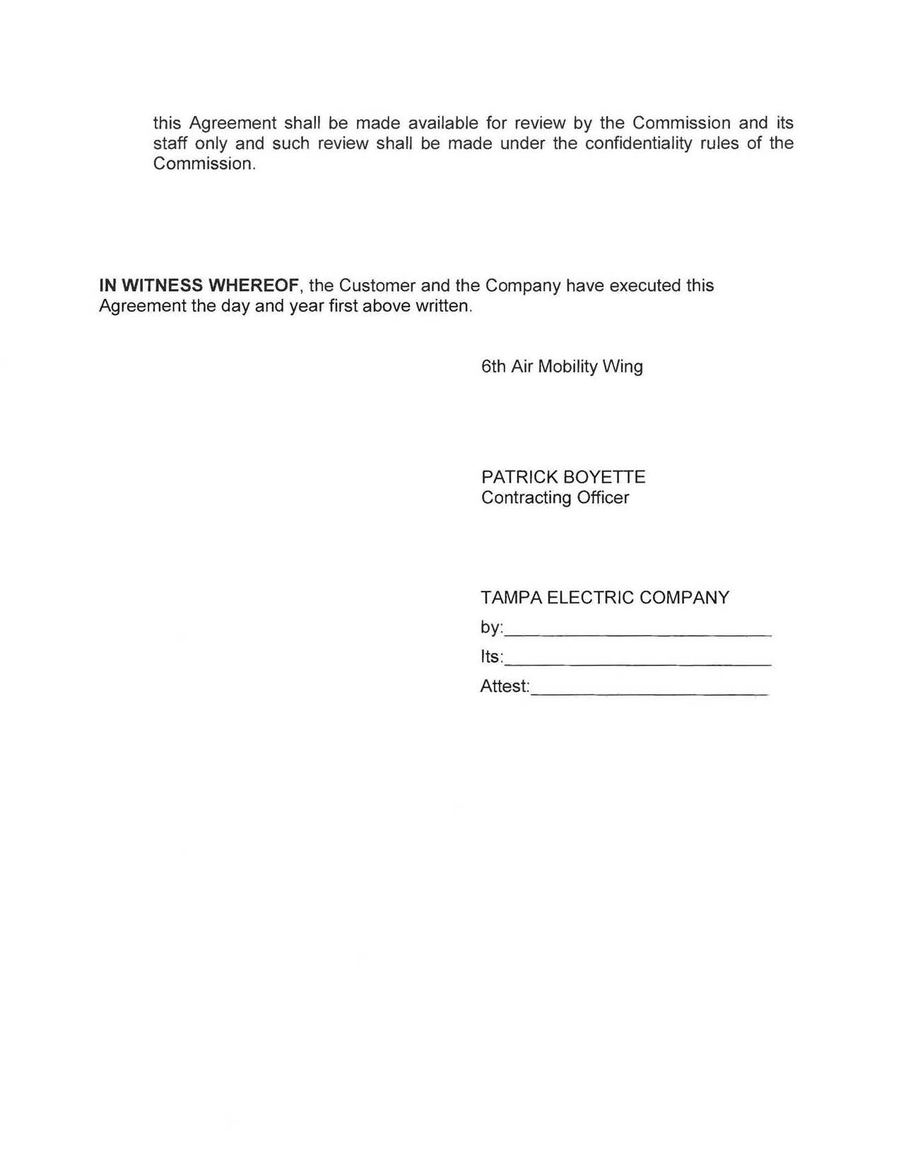

Map of MacDill Air Force Base
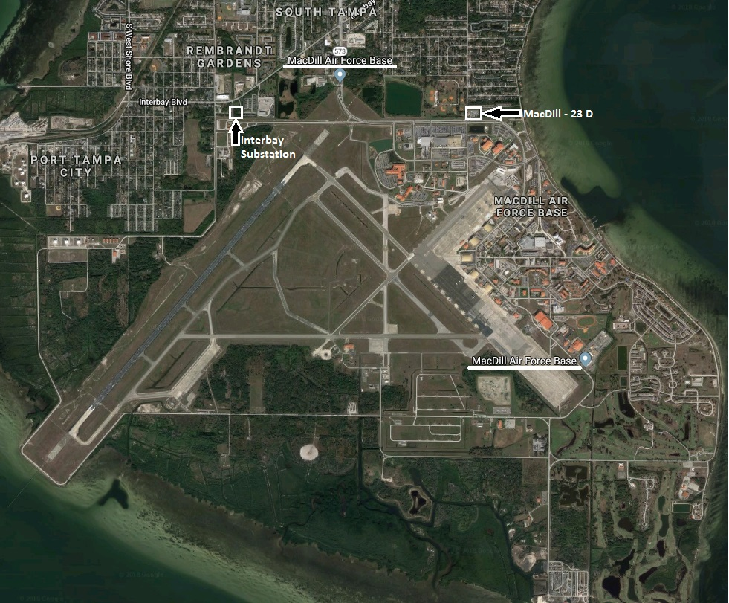

Order No. PSC-2018-0273-PAA-GU, issued May 31, 2018, in Docket No. 20180043-GU, In re: Petition for approval of area extension plan rate extension agreement with United States Sugar Corporation, by Florida City Gas.

