BEFORE THE FLORIDA PUBLIC SERVICE COMMISSION

In re: Application for approval of tariff for the gross-up of CIAC in Martin County, by Indiantown Company, Inc. | DOCKET NO. 20180042-WS  ORDER NO. PSC-2018-0330-TRF-WS  ISSUED: June 27, 2018

The following Commissioners participated in the disposition of this matter:

ART GRAHAM, Chairman
JULIE I. BROWN
DONALD J. POLMANN
GARY F. CLARK
ANDREW GILES FAY

ORDER APPROVING TARIFFS FOR GROSS-UP OF CIAC

BY THE COMMISSION:

Background
Indiantown Company, Inc. (Indiantown or utility) is a Class A utility providing water and wastewater services in Martin County to approximately 2,181 customers. The utility reported in its 2016 annual report operating revenues in the amount of $758,519 for water and $1,241,519 for wastewater. The utility did not collect any contributions in aid of construction (CIAC) for 2016.
On February 20, 2018, the utility filed an application for approval of tariffs to allow for gross-up of CIAC. As discussed below, the utility indicated that the change in tax law may cause it to risk the loss of its opportunity to earn a reasonable return on its used and useful property if it is not allowed to collect the tax impact on receipt of CIAC. On March 29, 2018, the utility filed revised tariff sheets that incorporate depreciation expense into the gross-up calculations.
At our April 20, 2018 Agenda Conference, we approved CIAC gross-up tariffs for the utility. After the approval of the gross-up tariffs, the utility found a typographical error found in the formula for land and cash contributions. On May 2, 2018, the utility filed tariffs reflecting the correction in the formula, which we subsequently approved at our June 5, 2018 Agenda Conference. Attachment A of this order shows the corrected tariffs in legislative format.
This order only addresses changes in the tax code related to CIAC. Any potential refund related to the change in the federal tax rate currently embedded in the utility’s rates is outside of this order and will be addressed in the generic Docket No. 20180013-PU. We have jurisdiction pursuant to Sections 367.081 and 367.091, Florida Statutes (F.S.).

Decision
Effective January 1, 2018, the Federal Tax Cuts and Jobs Act amended Section 118 of the Internal Revenue Code. Prior to the amendments, CIAC was exempt from taxable gross income for water and wastewater utilities. As a result of the amendments, both cash and property CIAC are now taxable gross income for water and wastewater utilities. In recognition of this change in the tax law, we have opened Docket No. 20180013-PU, In re: Petition to establish a generic docket to investigate and adjust rates for 2018 tax savings by Office of Public Counsel, to address the potential rate impacts on regulated electric, gas, water, and wastewater utilities.

A similar law, the Tax Reform Act of 1986, became effective in 1987. In Docket No. 19860184-PU, this Commission found that it was appropriate to allow water and wastewater utilities to recover the tax on CIAC from the contributor, including the tax associated with the additional tax that would also become taxable income. For those utilities that were approved to collect the gross-up on CIAC, the gross-up amounts collected were held subject to refund and were evaluated on a case-by-case basis as to whether any refunds were subsequently required.

As discussed above, the utility filed revised tariffs to gross-up cash service availability charges and property contributions to recover the federal and state corporate income taxes associated with those contributions. According to the utility, Indiantown could risk loss of its opportunity to earn a reasonable return on its property used and useful in the public service if it is not allowed to collect the tax impact on receipt of CIAC.
The revised tariffs recognize that, for depreciable property, depreciation expense is tax deductible and the utility’s tax liability will be reduced by the amount of depreciation claimed for tax purposes. The revised tariffs are mathematically the same, regarding the gross-up for taxes, as the tariff approved by the Commission following the hearing in Docket No. 860184-PU. Because the revised tariffs accurately depict the utility’s expected tax expense associated with CIAC, we find no further Commission action is required once the gross-up formula has been approved.
We note that in Order No. 23541 in Docket No. 860184-PU, this Commission required a reconciliation of CIAC tax collected to taxes paid. We will not require a reconciliation of tax collected on CIAC to taxes paid in this case for two reasons. First, the proposed formula more appropriately tracks the potential tax liability associated with the collection of CIAC. Second, expenses approved in base rates are not typically subject to reconciliation. For example, the utility’s revenue requirement is grossed-up for expected taxes and expected tax expense is included in rates, but there is no after-the-fact proceeding to reconcile taxes actually paid with tax expense allowed in case the utility experienced a loss and paid no taxes. Consequently, no after-the-fact proceeding is warranted to compare allowed tax expense for CIAC to actual tax expense and, therefore, no corporate undertaking is necessary.
Based on the above, we find that the revised tariffs, as reflected in Attachment A, is hereby approved. The approved gross-up charges shall be effective for connections made on or after the stamped approval date on the tariff sheets. The utility shall provide notice to all persons in the service areas included in the application who have filed a written request for service or who have been provided a written estimate for service within the 12 calendar months prior to the month the application was filed. The utility shall provide proof of noticing within 10 days of rendering its approved notice.
Based on the foregoing, it is

ORDERED by the Florida Public Service Commission that Indiantown Company, Inc.’s request for approval of tariffs to allow the gross-up of CIAC is approved as set forth herein. The utility shall provide notice to all persons in the service areas included in the application who have filed a written request for service or who have been provided a written estimate for service within the 12 calendar months prior to the month the application was filed. The approved gross-up charges shall be effective for connections made on or after the stamped approval date on the tariff sheets. The utility shall provide proof of noticing within 10 days of rendering its approved notice. It is further

ORDERED that if a protest is filed by a substantially affected person within 21 days of issuance of the order, the revised tariffs shall remain in effect, with any revenues held subject to refund, pending resolution of the protest. If no timely protest is filed, the order shall become final upon the issuance of a consummating order. However, the docket shall remain open to allow Commission staff to verify that the appropriate notice has been filed by the utility and approved by staff. Once the utility has provided proof of noticing, the docket shall be closed administratively.

By ORDER of the Florida Public Service Commission this 27th day of June, 2018.

/s/ Carlotta S. Stauffer
CARLOTTA S. STAUFFER
Commission Clerk
Florida Public Service Commission
2540 Shumard Oak Boulevard
Tallahassee, Florida 32399
(850) 413-6770
www.floridapsc.com

Copies furnished: A copy of this document is provided to the parties of record at the time of issuance and, if applicable, interested persons.

JSC

NOTICE OF FURTHER PROCEEDINGS

The Florida Public Service Commission is required by Section 120.569(1), Florida Statutes, to notify parties of any administrative hearing or judicial review of Commission orders that is available under Sections 120.57 or 120.68, Florida Statutes, as well as the procedures and time limits that apply. This notice should not be construed to mean all requests for an administrative hearing or judicial review will be granted or result in the relief sought.
Mediation may be available on a case-by-case basis. If mediation is conducted, it does not affect a substantially interested person's right to a hearing.

The Commission's decision on this tariff is interim in nature and will become final, unless a person whose substantial interests are affected by the proposed action files a petition for a formal proceeding, in the form provided by Rule 28-106.201, Florida Administrative Code. This petition must be received by the Office of Commission Clerk, 2540 Shumard Oak Boulevard, Tallahassee, Florida 32399-0850, by the close of business on July 18, 2018.

In the absence of such a petition, this Order shall become final and effective upon the issuance of a Consummating Order.

Any objection or protest filed in this docket before the issuance date of this order is considered abandoned unless it satisfies the foregoing conditions and is renewed within the specified protest period.

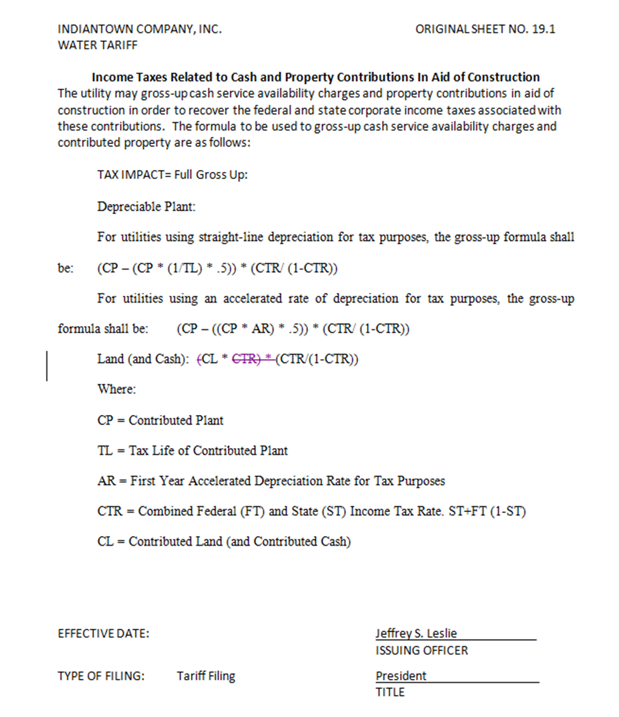

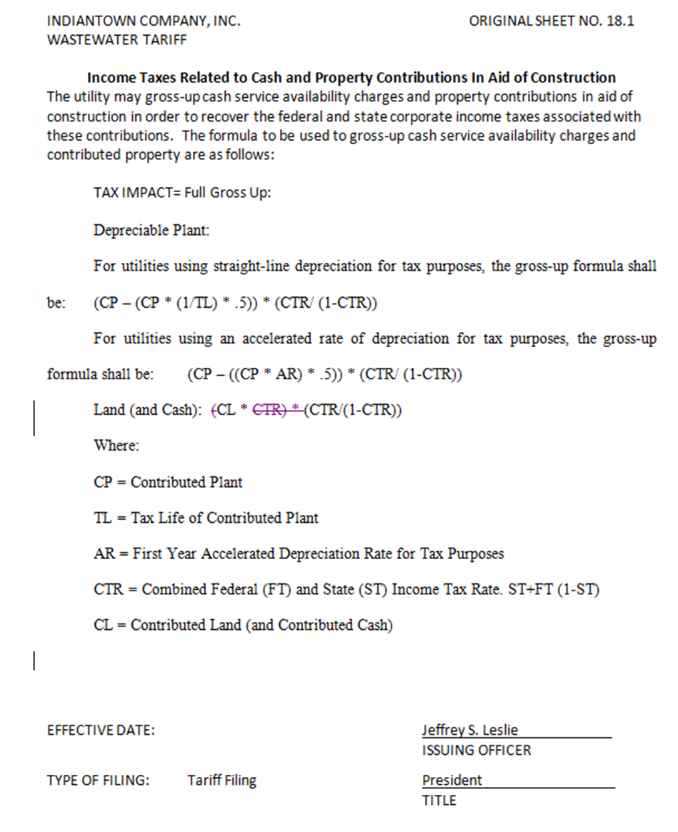

Docket No. 20180013-PU, In re: Petition to establish generic docket to investigate and adjust rates for 2018 tax savings, by Office of Public Counsel.
The amendment was repealed in 1996.
Order No. 23541, issued October 1, 1990, in Docket No. 860184-PU, In re: Request by Florida Waterworks Association for investigation of proposed repeal of Section 118(b), Internal Revenue Code [Contributions-in-aid-of-construction].

