State of Florida |  | Public Service Commission  Capital Circle Office Center ● 2540 Shumard Oak Boulevard  Tallahassee, Florida 32399-0850  -M-E-M-O-R-A-N-D-U-M-
DATE: | July 26, 2018
TO: | Office of Commission Clerk (Stauffer)
FROM: | Division of Economics (Merryday, Draper)  Office of the General Counsel (Mapp)
RE: | Docket No. 20180088-EI – Petition for limited proceeding for approval of a smart meter opt-out tariff, by Duke Energy Florida, LLC.
AGENDA: | 08/07/18 – Regular Agenda – Tariff Filing – Interested Persons May Participate
COMMISSIONERS ASSIGNED: |  |  | All Commissioners
PREHEARING OFFICER: |  |  | Administrative
CRITICAL DATES: |  |  | 12/04/18 (8-Month Effective Date)
SPECIAL INSTRUCTIONS: |  |  | None

Case Background
On April 4, 2018, Duke Energy Florida, LLC (Duke or utility) filed a petition for a limited proceeding for approval of a smart meter opt-out tariff (opt-out tariff). The proposed tariff would be available to customers who elect to receive a non-communicating meter in lieu of the standard smart meter, or Automated Meter Infrastructure (AMI) smart meter.
On November 11, 2017, the Commission approved Duke’s 2017 Second Revised and Restated Settlement Agreement (2017 Settlement), which includes a provision for a 15-year depreciable life for new AMI assets. On October 25, 2017, the Commission held a hearing to consider the 2017 Settlement. At the hearing, Duke witness Portuondo testified that the base rate adjustments contained in the 2017 Settlement include AMI smart meters to be deployed by 2021 and a replacement of Duke’s customer information system, or billing system, to maximize the benefits of the AMI smart meters and provide customers with better tools to manage their consumption. At the hearing, witness Portuondo also stated that Duke will file an opt-out tariff, which Duke has done with the instant petition.
Consistent with the testimony provided during the 2017 Settlement hearing, the utility states in the instant petition that smart meter deployment for residential and general service (small commercial) customers is set to begin in November 2018. Upon completion of the deployment, expected by December 2021, smart meters will become Duke’s standard meter. Associated with the AMI project is meter communication infrastructure needed to enable communication with the meters and Duke’s information technology system.
Duke’s current meters are Automated Meter Reading (AMR) meters that emit a radio frequency signal. That signal is picked up once a month by a meter reading vehicle driving by the neighborhood. Duke installed the AMR meters in 2005 and 2006 and states that at the time there was no public opposition to the AMR meter deployment. In the last five years, Duke received a small number of complaints regarding radio frequency transmission, which is similar between the AMR and AMI smart meters. In all complaints so far, the AMR meter was retained as Duke does not have an opt-out tariff. However, Duke stated some customers specifically requested an opt-out option and a meter that emits no radio frequency signal.
The utility anticipates that some customers will elect to forego the new AMI smart meters and request a non-communicating meter; therefore, Duke filed the instant petition and associated opt-out tariff. The opt-out tariff would be applicable to customers that request a non-communicating, i.e., non-standard, meter and includes an initial one-time set-up fee of $96.34 and a monthly surcharge of $15.60. The proposed charges are based on Duke’s incremental costs to provide the opt-out tariff.
The Commission approved a similar opt-out tariff and charges ($89.00 one-time set-up fee, $13.00 monthly surcharge) for Florida Power & Light Company (FPL) in 2015. Several municipal electric utilities (City of Lakeland and Orlando Utilities Commission) and rural electric cooperatives (Sumter Electric, Talquin Electric, Tri-County Electric, and Peace River) also provide optional opt-out tariffs.
On April 18, 2018, Duke waived the 60-day file and suspend provision per Section 366.06(3), Florida Statutes (F.S.) On May 3, June 4, June 20, and July 17, 2018, Duke responded to staff’s data requests. On May 23, 2018, Duke provided revised tariff sheets reflecting a minor correction. On July 23, 2018, Duke provided revised tariff sheet No. 6.400 to include language that an opt-out customer who already has a non-communicating meter installed would not be required to pay the $96.34 one-time set up fee. The legislative version of the revised opt-out tariff sheet No. 6.400 is shown in Attachment A to the recommendation. The Commission has jurisdiction pursuant to Sections 366.03, 366.04, 366.05, and 366.06, F.S.

Discussion of Issues

Issue 1:
Should the Commission approve Duke’s proposed opt-out tariff?

Recommendation:
Yes, the Commission should approve Duke’s proposed opt-out tariff. The effective date should be on the first billing cycle of December 2018. Within three months after the AMI smart meter deployment is completed, Duke should report to the Commission (with a filing in this docket) on the costs of the program, revenues, and actual participation. (Merryday)

Staff Analysis: Duke is offering this opt-out tariff ahead of AMI deployment after reviewing the experiences of other utilities with their customers and smart meters. In its petition, the utility states that FPL began deploying smart meters in 2010, but received customer complaints regarding smart meters and subsequently filed a petition for an opt-out tariff in August 2013. Duke notes that because it is not required to offer an alternative meter, all costs associated with the non-standard meters will be recovered from the participating customers.

The proposed tariff includes two separate fees: a one-time set-up fee of $96.34 (for the non-standard meter installation) and a monthly surcharge of $15.60 (for upfront IT costs and monthly meter readings). The set-up fee must be paid at the time the customer takes service under the opt-out tariff, regardless of the length of time the customer is enrolled. Customers can cancel service under the opt-out tariff at any time. These charges will be in addition to all other tariffed rates and charges applicable to an opt-out customer.

Customer Participation
Duke anticipates that approximately 0.15 percent of its AMI eligible customers will choose to opt out. The utility examined FPL’s opt-out tariff participation rates as the basis for its own participation predictions. Duke states that FPL originally forecasted that 0.26 percent of its 4.9 million customers would participate when developing an opt-out tariff; however, actual participation for FPL in 2017 was about 0.12 percent, or 5,966 customers. Duke rounded up to predict that 0.15 percent—about 2,700— of its 1.8 million eligible customers will opt-out. The projected number of opt-out customers is used in developing the monthly surcharge.

Set-up Fee
The one-time set-up fee of $96.34 reflects the labor and vehicle costs to install each non-standard meter. In response to staff’s data request, Duke stated that it is not creating any new positions to perform the incremental tasks associated with administering the opt-out tariff. However, Duke further stated that in the absence of the opt-out tariff, the current staffing of these positions may have been reduced.
The set-up fee is applicable to all opt-out tariff participants regardless of duration of service. The breakdown of the set-up fee components is as follows:

Table 1-1
Set-up Fee Cost Components
Task | Time Per Customer | Cost Per Customer | Description
Customer service | 3 minutes | $1.40 | Customer Care Specialist to handle calls and enrollment in opt-out tariff, explain tariff details, and set up customer’s account as an opt-out customer.
Metering services work order management | 5 minutes | $2.93 | Work Force Management Specialist II to create initial work orders for opt-out meter programming, meter exchange, and manual meter routing.
Meter programming and labelling | 30 minutes | $29.09 | Field Meter Tech to program the opt-out meter and apply opt-out label to help ensure an opt-out meter is not replaced with an AMI smart meter. This work is performed at a Duke lab.
Meter exchange | 45 minutes | $43.63 | Field Meter Tech to travel to customer premises, remove existing meter, replace with opt-out meter, and close work orders.
Meter exchange -vehicle | 45 minutes | $4.61 | Vehicle used by Field Meter Tech for meter exchange. The cost is based on Duke’s cost to operate the vehicle used by field technicians.
Manual meter reading route analysis | 20 minutes | $14.68 | Meter Route Analyst to determine location of opt-out participant and find efficient meter reading route.
Total one-time cost per customer |  | $96.34
Source: Exhibit A to Duke’s Petition
Duke explained that the time per customer is based on a conservative average time estimate for the specific tasks to be performed. Staff believes the time estimates to be reasonable. The cost per customer is calculated by multiplying the time to complete the task by the hourly rate of the job performer. Duke provided cost support for its hourly rates which includes the confidential annual salary, payroll tax, benefits, pension, and incentives (bonus payments). Staff reviewed hourly rate information provided by Duke in its 2009 rate case for customer service and field labor and believes the hourly rates included in this docket are reasonable. Furthermore, Duke’s salaries are comparable to those approved for FPL’s opt-out charges.
In response to staff’s data request, Duke clarified that if an opt-out customer already has a non-communicating meter installed at the premises, the customer would not be required to pay the $96.34 one-time set up fee as Duke would not incur the cost for the non-standard meter installation. This provision was not reflected in the original opt-out tariff filed by Duke; therefore, Duke filed a revised tariff to clearly state when the one-time fee would not be assessed.

Monthly Surcharge
The monthly surcharge to take service under the opt-out tariff is $15.60, which reflects a combination of upfront (IT related) and ongoing (meter reading related) service costs. Duke states that its upfront IT costs are predicted to be $374,014. This is the estimated cost to update the customer system and change business processes to accommodate the opt-out tariff program. Duke used a 5-year recovery period for its IT costs (which is the same recovery period the Commission approved for FPL’s opt-out tariff) to derive monthly IT related costs of $4.58 per customer.

After installation of a non-standard meter, the only ongoing costs to the utility will be the monthly meter readings, which the utility estimates to be $11.02 per customer. These costs reflect the meter reading position rates and the vehicle rates, both for an estimated 20 minutes per meter reading. In response to staff’s data request, Duke stated that assuming that opt-out customers are spread across the utility’s service territory, it is estimated to take 20 minutes to travel to the customer premises, get out of the vehicle, read the meter, log the read, and return to the vehicle to continue on the route.

Customer Notice and Deployment
The utility states that AMI deployment is set to begin November 2018; therefore, Duke is requesting that the opt-out tariff be available the first billing cycle of December 2018. Two weeks prior to a customer receiving a smart meter, Duke will mail a postcard to the customer informing them of the meter exchange and providing more information on smart meters. The postcard will include a toll-free number to call for questions regarding smart meters and the option to opt out. Information regarding smart meter deployment and the opt-out tariff will also be on the utility’s website.

Reporting
Staff recommends that within three months after the AMI smart meter deployment is completed (December 2021), Duke should report to the Commission on the costs of the program, revenues, and actual participation. Staff believes three months is a reasonable time to allow Duke to prepare and file a report in this docket, which should happen no later than March 31, 2022. If AMI smart meter deployment is significantly delayed beyond the utility’s anticipated completion date, the utility should notify the Commission with a filing in this docket.
Staff notes that FPL is required to file annual smart meter progress reports. Duke, in response to staff’s data request, stated that it does not believe a formal process of tracking costs is necessary. However, staff believes that actual participation rates and costs may vary, and that a comparison of estimated costs presented in this petition and actual costs incurred is important to ensure the opt-out tariff remains cost-based or else be adjusted through a revised tariff filing.

Conclusion
Staff believes that the incremental costs to offer the proposed opt-out tariff should be recovered by the participating customers. In the order approving FPL’s opt-out tariff, the Commission noted that “since significant incremental costs would be incurred in providing [an opt-out tariff], it would be discriminatory to require standard meter customers to subsidize that service.” Staff believes that Duke provided sufficient cost support in its petition and responses to staff’s data requests to support its assertion that the proposed tariff is cost-based. Therefore, the Commission should approve Duke’s proposed opt-out tariff. The effective date should be on the first billing cycle of December 2018. Within three months after the AMI smart meter deployment is completed, Duke should report to the Commission (with a filing in this docket) on the costs of the program, revenues, and actual participation.

Issue 2:
Should this docket be closed?

Recommendation:
Yes. If a protest is filed within 21 days of the issuance of the order, these tariffs should remain in effect with any increase held subject to refund pending resolution of the protest. If no timely protest is filed, this docket should be closed upon issuance of a consummating order. (Mapp)

Staff Analysis:
If a protest is filed within 21 days of the issuance of the order, these tariffs should remain in effect with any increase held subject to refund pending resolution of the protest. If no timely protest is filed, this docket should be closed upon issuance of a consummating order.
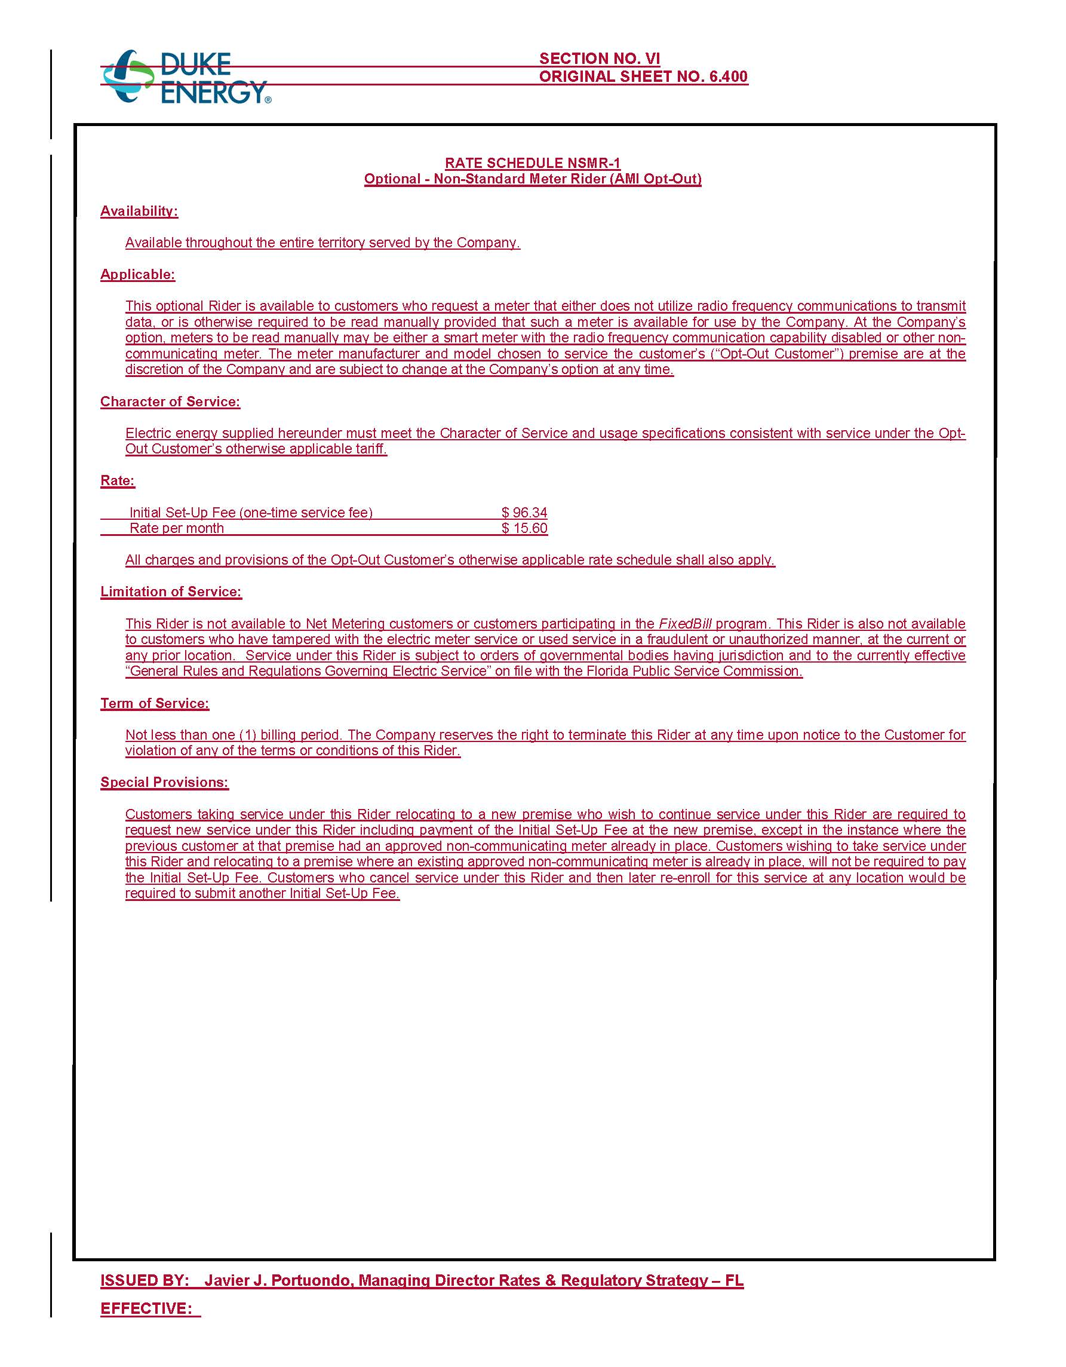

Order No. PSC-2017-0451-AS-EU, issued November 20, 2017, in Docket No. 20170183-EI; In re: Application for limited proceeding to approve 2017 second revised and restated settlement agreement, including certain rate adjustments, by Duke Energy Florida, LLC.
Document No. 09411-2017, filed on November 3, 2017, in Docket No. 20170183-EI.
Order No. PSC-15-0026-FOF-EI, issued on January 7, 2015, in Docket No. 130223-EI; In re: Petition for approval of optional non-standard meter rider, by Florida Power & Light Company.
Duke’s petition included other non-substantive tariff changes that have not been attached to the recommendation.
Id.

