State of Florida |  | Public Service Commission  Capital Circle Office Center ● 2540 Shumard Oak Boulevard  Tallahassee, Florida 32399-0850  -M-E-M-O-R-A-N-D-U-M-
DATE: | July 26, 2018
TO: | Office of Commission Clerk (Stauffer)
FROM: | Office of the General Counsel (Schrader, Crawford)  Office of Consumer Assistance and Outreach (Hicks, Plescow)  Division of Economics (Merryday)  Division of Engineering (Graves, Salvador)
RE: | Docket No. 20180109-EI – Petition for initiation of formal proceedings for relief against Florida Power & Light Company regarding backbilling for alleged meter tampering and disconnection, by Terry A. Avera.
AGENDA: | 08/07/18 – Regular Agenda – Proposed Agency Action – Interested Persons May Participate
COMMISSIONERS ASSIGNED: |  |  | All Commissioners
PREHEARING OFFICER: |  |  | Clark
CRITICAL DATES: |  |  | None
SPECIAL INSTRUCTIONS: |  |  | None

Case Background
Section 366.03, Florida Statutes (F.S.), states that each public utility shall furnish to each person applying for service, reasonably sufficient, adequate, and efficient service. The Commission has jurisdiction as set forth in Section 366.04, F.S., to regulate and supervise each public utility with respect to its rates and service.
Rule 25-22.032, Florida Administrative Code (F.A.C.), implements Chapter 366, F.S., and establishes informal customer complaint procedures that are designed to address disputes, subject to the Commission’s jurisdiction, that occur between regulated companies and individual customers. Pursuant to this rule, any customer of a Commission regulated company may file a complaint with the Commission’s Office of Consumer Assistance and Outreach whenever the customer has an unresolved dispute with the company regarding electric, gas, telephone, water, or wastewater service.
In October of 2017, Terry Avera filed informal complaint no. 1256510E with the Commission against Florida Power & Light Company (FPL). In his informal complaint, Mr. Avera stated that FPL had wrongfully accused him of meter tampering and improperly and excessively backbilled his account for unrecorded electric usage.

On April 12, 2018, staff advised Mr. Avera, through his attorney Frank L. Hollander, that his informal complaint and FPL’s backbilling calculations had been reviewed and that staff had determined that Mr. Avera’s account was fairly and reasonably backbilled. Staff also advised Mr. Avera that, based on staff’s investigation, FPL did not appear to violate any statute, rule, its company tariff, or orders in the investigation of meter tampering or in the backbilling of electricity used by Mr. Avera for which he did not pay due to unauthorized conditions. Staff advised Mr. Hollander that Mr. Avera had an opportunity to file a petition for formal proceedings.

On April 30, 2018, Mr. Avera, through his attorney Mr. Hollander, filed a petition for initiation of formal proceedings pursuant to Rule 25-22.036, F.A.C. In the formal complaint, Mr. Avera claims that FPL after an inspection of Mr. Avera’s property, “falsely claimed the inspection revealed illegal meter tampering with FPL’s equipment (smart meter) and that the tampering caused the meter to improperly under-register the electricity that the location was utilizing” and as a consequence, was “immediately disconnected service and back-billed...for 5 years, $10,205.55, plus investigation fees and a tamper penalty.” Mr. Avera claims that due to his sleep apnea condition,

[he] was constructively removed from his home in order for he [sic] and his family to obtain electricity elsewhere as necessitated to prevent Avera from dying of sleep apnea without the use of needed electricity-generated machinery and death by that machinery, forming deadly bacteria, only eliminated through employment of electricity denied Avera as constitutional rights, to life, property and the pursuit of happiness, as deprived by FPL as a monopolistic state agent.

Mr. Avera seeks for the Commission to find that no tampering occurred with the meter, to order FPL to restore service to his property, and to award damages in excess of $14 million.

This recommendation addresses the appropriate disposition of Mr. Avera’s complaint against FPL. The Commission has jurisdiction over this matter pursuant to Sections 366.04, F.S. The Commission does not have jurisdiction to consider claims for damages.

Discussion of Issues

Issue 1:
What is the appropriate disposition of Mr. Avera’s formal complaint?

Recommendation:
The appropriate disposition of Mr. Avera’s formal complaint is to deny the complaint. Mr. Avera’s account was properly billed in accordance with Commission statutes and rules and FPL’s tariffs, in the amount of $11,638.09. FPL did not violate any applicable statute, rule, company tariff or order of the Commission in the processing of Mr. Avera’s account. In addition, the Commission lacks the subject matter jurisdiction to award money damages. Thus, the Commission cannot rule on Mr. Avera’s claim for monetary damages. (Schrader)

Staff Analysis:

Mr. Avera alleges that FPL unjustly backbilled him, and improperly disconnected his service for non-payment of such backbilling, for meter tampering. He also alleges monetary damages from FPL’s unjust disconnection of his electric service. These allegations are discussed below.

Meter Tampering
On September 2, 2003, FPL established an account for Mr. Avera at his residence. On April 14, 2017, an analytical test of the communication from meter ACD5693, which was originally installed at Mr. Avera’s residence on May 18, 2010, revealed an isolated outage for approximately 9 minutes and 15 seconds on September 20, 2011. The analytical test showed that Mr. Avera’s residence experienced a loss of power, while no other premises served by the same transformer experienced an outage. This isolated outage was followed by a significant reduction in metered average daily kWh (kilowatt-hour) consumption (see graph 1.1 provided by FPL). After replacement of the meter on April 26, 2017, metered consumption significantly increased at Mr. Avera’s residence.
Graph 1.1
Average Metered Daily kWh Consumption at Mr. Avera’s Residence
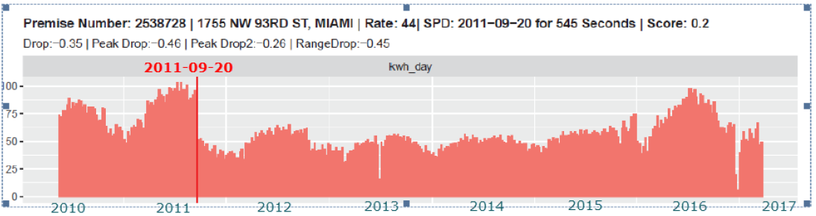
On April 26, 2017, an FPL meter electrician visited Mr. Avera’s residence and documented that the outer meter enclosure seal was missing, the inner meter seal was intact, there was a wire which the electrician initially coded as an unauthorized lineside tap, and that a plastic disconnect (DM) boot was on the meter.
FPL removed meter ACD5693 and installed a new meter, ACD5262. According to FPL, the electrician subsequently sent the DM boot, piece of wire, and meter ACD5693 to FPL’s Meter Technology Center. However, the meter electrician failed to take any photographs of meter ACD5693 in an unauthorized condition in the field. FPL did, however, provide a photo of the removed meter, along with the wire, to Commission staff (see Attachment B to this recommendation). However, by letter filed July 17, 2018, Mr. Avera’s counsel contended that the affidavit photo was not taken at the time and in the manner attested to by FPL.
Mr. Avera contends that, upon the arrival of the meter electrician on April 26, 2017, the outer meter enclosure seal was, in fact, intact and had to be cut open by the electrician. Mr. Avera also states that the electrician made no mention of a lineside tap, and if the electrician had witnessed such a condition, then law enforcement would have been called to file a report. Mr. Avera also states that “it was FPL who inserted the DM boot when the meter was rented by the prior owner years earlier. The DM disconnect boot was inherited.”

Backbilling
Section 366.03, F.S., provides that all rates and charges made or received by any public utility for service rendered by it and each rule and regulation of such public utility must be fair and reasonable. Rule 25-6.104, F.A.C., authorizes electric utilities to backbill the customer for a reasonable estimate of the electricity consumed, but not metered, due to meter tampering or fraudulent use.
FPL’s tariff sets forth its fees, services, and policies as approved by the Commission. FPL’s Fourth Revised Tariff Sheet No. 6.061, Section 8.3, Tampering with Meters, states:
Title to meters and metering equipment shall be and remain in the Company. Unauthorized connections to, or tampering with the Company's meter or meters, or meter seals, or indications or evidence thereof, subjects the Customer to immediate discontinuance of service, prosecution under the laws of Florida, adjustment of prior bills for services rendered, a tampering penalty of $200 for residential and non-demand commercial customers and $1,000 for all other customers, and reimbursement to the Company for all extra expenses incurred on this account..

On June 15, 2017, FPL tested meter ACD5693 with the DM boot present, but without the provided piece of wire, per FPL’s code “96” protocol for a lineside tap. FPL states that its test board does not recognize a meter with a single boot, since the test board only sees the 120 volts from one side of the meter and needs 240 volts to properly test a meter, which the plastic DM boot prevented. Because of this, the meter test results defaulted to zero.
The backbilling was calculated by FPL using the kWh use from the new meter and the Seasonal Average methodology. FPL used “the actual usage recorded by the meter for the partial month of May 2017, after the condition was corrected on April 26, 2017, and actual usage for the months of June and July 2017, as data points, to calculate the Average of Total Yearly kWh.” FPL further stated that “the average yearly total of kWh by the specific monthly seasonal average percentage of usage to determine the estimated usage for each month in the year. The original billed kWh is subtracted from the estimated monthly kWh, leaving the additional billed kWh.” Attachment A to this recommendation shows FPL’s calculations used to backbill Mr. Avera’s account. Given that Mr. Avera established service in 2003, that meter ACD5693 was installed at his residence in 2010, and that the isolated outage and drop in metered consumption occurred in September of 2011, FPL classified the unauthorized meter condition as non-inherited.
On August 28, 2017, FPL backbilled Mr. Avera for $10,746.21, which included investigative charges of $540.66, using this seasonal average methodology. FPL also added a tampering penalty of $200.00, as authorized by its tariff. When payment was not timely made, FPL disconnected electric service to Mr. Avera’s residence on August 31, 2017, having provided notice pursuant to Rule 25-6.105, F.A.C. Upon subsequent discussion with Mr. Avera, FPL offered to reconnect service for an initial payment of $8,200 and establish a payment arrangement for the remaining backbill balance.
Mr. Avera later contacted FPL and requested to establish service in another family member’s name. Then, on September 5, 2017, Mr. Avera contacted FPL requesting service to be reconnected after an initial payment of $600; however, FPL indicated to him that it still required an initial payment of $8,200. That same day, Mr. Avera requested via FPL’s website to close the account. On September 6, 2017, a refusal of service letter was mailed to Mr. Avera’s relative as that relative’s driver’s license was registered to Mr. Avera’s address during the time that Mr. Avera incurred the debt with FPL.
On September 15, 2017, with no payment received from Mr. Avera or an authorization to reconnect the service, FPL closed Mr. Avera’s account effective to August 31, 2017. FPL issued a final bill statement to Mr. Avera for $11,638.09, which consisted of current charges of $240.94, backbilling charges of $10,946.21, and past due balance of $450.94.

On October 2, 2017, Mr. Avera contacted Commission staff, contending that a judge had ordered that all charges be dismissed and requested service be reconnected as soon as possible; his call was subsequently warm transferred to FPL. On October 3, 2017, Mr. Avera contacted the Commission and stated that he had faxed the court documents to FPL but service was not reconnected; he was again warm transferred to FPL. FPL stated that he was told that FPL’s attorney reviewed the faxed documents and the attorney confirmed that Mr. Avera’s complaint was dismissed, not the backbill charges, and that the judge referred Mr. Avera to the Commission, which would have the proper jurisdiction over his complaint. Commission staff confirmed that this case was dismissed; however, the matter is pending appeal in the Circuit Court Appellate Division of the Eleventh Judicial Circuit for Miami–Dade County.

Since the filing of Mr. Avera’s informal complaint, FPL has offered additional payment arrangements to Mr. Avera. FPL’s most recent proposal, on October 17, 2017, was an initial payment from Mr. Avera of $2,000, a payment of $691.88 for the final bill balance, and the establishment of a new account in his name with payment of a deposit required before service can be reconnected. Mr. Avera declined this and stated that he had obtained legal representation and that he found many examples online where FPL had removed all charges. Given this, he stated that his attorney would petition the Commission to require all charges be removed and his service reconnected.

Subsequent Meter Tests
On November 7, 2017, after further inspection of the evidence, FPL determined that the meter electrician “incorrectly populated the ticket with an unauthorized condition code of “96,” denoting that a lineside tap was present” and that the meter electrician confused a jumper for a lineside tap.” FPL stated that the condition should have been documented with code “63” that would indicate that a single jumper was present with the DM boot. While a lineside tap and a jumper are similar methods of diversion, each requires a different testing protocol. FPL subsequently retested Meter ACD5693 with the proper protocol for a jumper (i.e. code “63”), with the unauthorized jumper and DM boot in place, and the meter registered a weighted average (WA) of 49.91 percent. The “as left” test (i.e., with the meter repaired to remove the unauthorized condition) registered a WA of 99.89 percent. Given this result, FPL considered adjusting the backbill by using the test results of 49.91 percent; however, the revised billing would have resulted in an additional 13,489 kWh of usage being billed to Mr. Avera over what he had been billed based on a seasonal average methodology.

Mr. Avera states that at the November 7, 2017 testing the locked box containing the meter did not contain any kind of wire that would have been used for a lineside tap or jumper. He also states that the test of a jumper conducted at this time was merely “recreated” and did not use any piece of wire obtained in the field from Mr. Avera’s residence.

On February 26, 2018, FPL and Commission staff conducted witnessed meter tests of meters ACD5693 and ACD5262. With the DM boot in place as found, according to the meter electrician, FPL’s meter test revealed that meter ACD5693 was registering WA 0.00 percent. Commission staff was unable to test with boot in place due to limitations of the Commission testing equipment. Performing such a test would have damaged the Commission testing equipment. Without the tampering condition in place, meter ACD5693 registered WA 99.88 percent upon testing by FPL, and 99.92 percent upon testing by Commission staff. Meter ACD5262 registered WA 100.00 percent upon testing by FPL, and 99.97 percent upon testing by Commission staff.

Staff believes that FPL should have better documented the condition of meter ACD 5693 in the field at Mr. Avera’s residence and that FPL did make an initial error in coding the meter’s unauthorized condition in the field. However, Mr. Avera’s consumption history (see graph 1.1 above and Appendix A attached to this recommendation), along with the preponderance of evidence including the Commission staff-witnessed tests of meters ACD5693 and ACD5262, demonstrates that Mr. Avera benefited from unauthorized conditions at his meter by paying less for electricity than he would have with a properly working meter without a jumper. Staff believes that Mr. Avera is responsible for payment of a reasonable estimate of the electricity used, but not originally billed, and that FPL may also recover the costs of its investigation of the meter tampering.

Staff reviewed FPL’s backbilling calculations and determined that Mr. Avera’s account was fairly and reasonably backbilled. Staff believes that FPL has violated no statute, rule, company tariff, or orders in the investigation of meter tampering or in the backbilling of electricity used by Mr. Avera for which he did not pay due to unauthorized conditions.

Claim for Damages
The Commission lacks the subject matter jurisdiction to award monetary damages. Thus, the Commission cannot rule on Mr. Avera’s claim for monetary damages. To seek such relief he must file such a claim in a court of appropriate jurisdiction.

Conclusion
The appropriate disposition of Mr. Avera’s formal complaint is to deny the complaint. Mr. Avera’s account was properly billed in accordance with Commission statutes, rules, orders, and FPL’s tariffs, in the amount of $11,638.09 (consisting of current charges of $240.94, backbilling charges of $10,946.21, and past due balance of $450.94). FPL did not violate any applicable statute, rule, company tariff or order of the Commission in the handling of Mr. Avera’s account. In addition, the Commission lacks the subject matter jurisdiction to award monetary damages. Thus, the Commission cannot rule on Mr. Avera’s claim for monetary damages.

Issue 2:
Should this docket be closed?

Recommendation:
If no person whose substantial interests are affected by the proposed agency action files a protest within 21 days of the issuance of the order, this docket should be closed upon the issuance of a consummating order. (Schrader)

Staff Analysis:
If no person whose substantial interests are affected by the proposed agency action files a protest within 21 days of the issuance of the order, this docket should be closed upon the issuance of a consummating order.
Attachment A:
FPL’s Calculation of backbilling of Mr. Avera 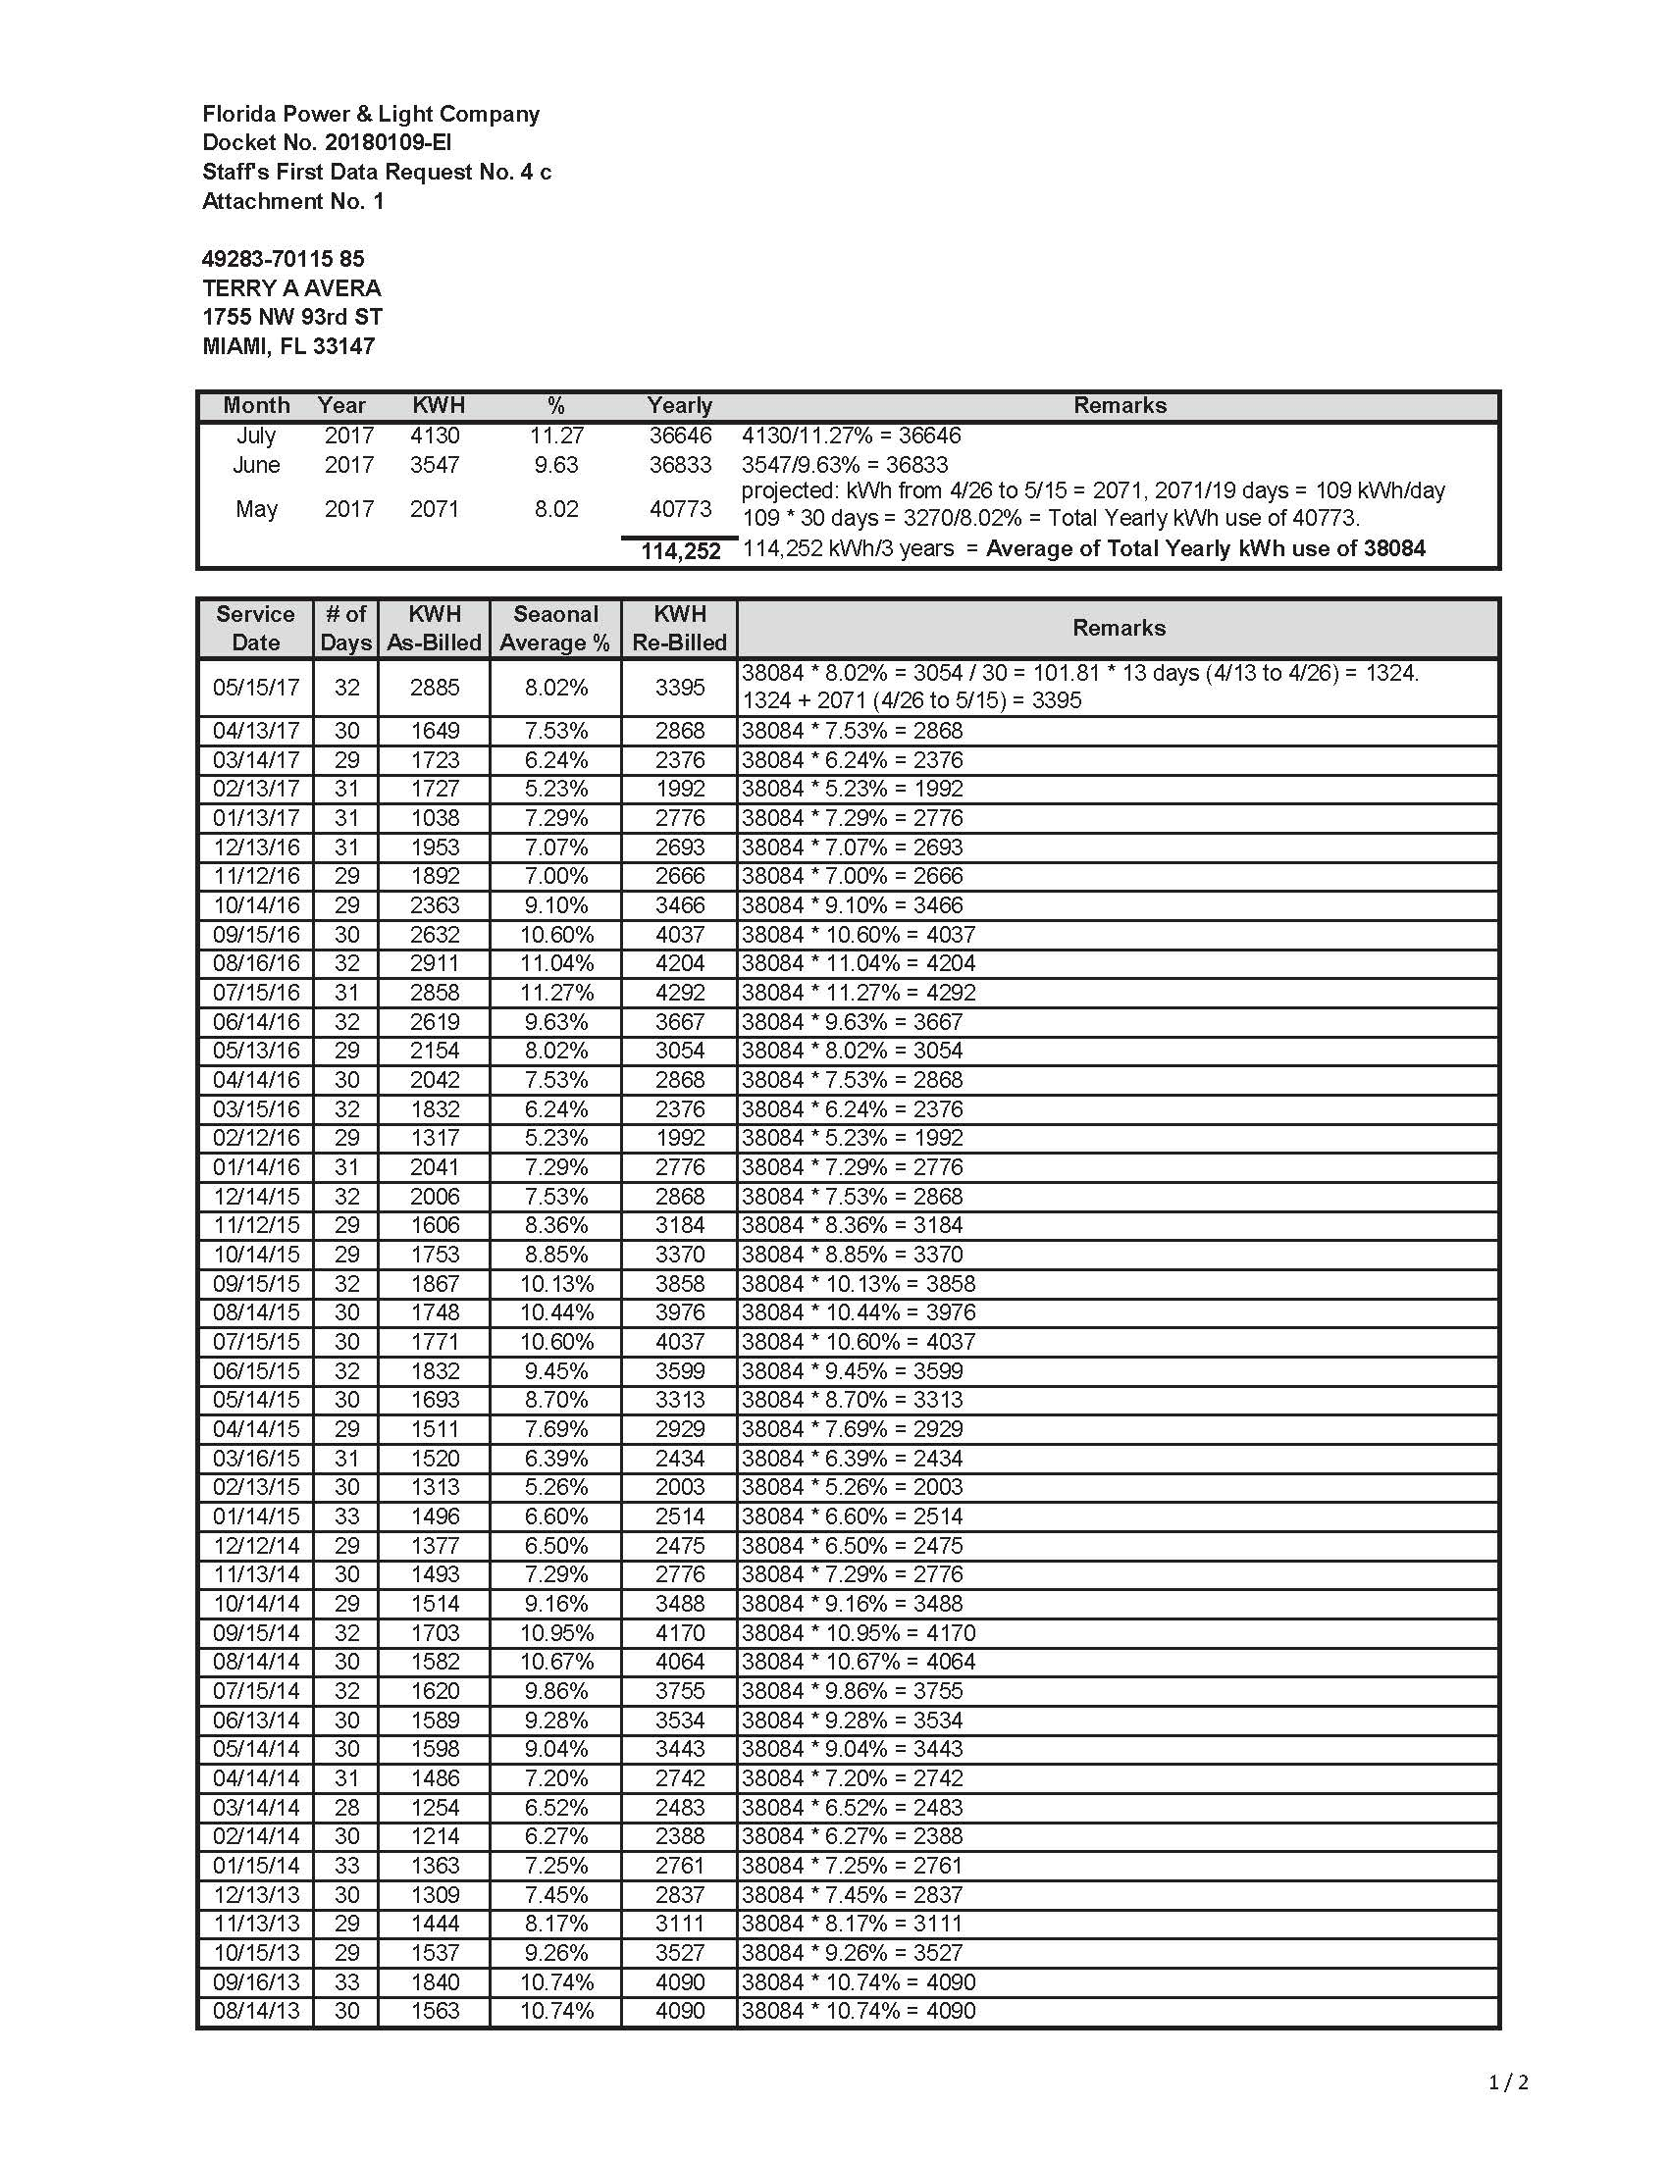
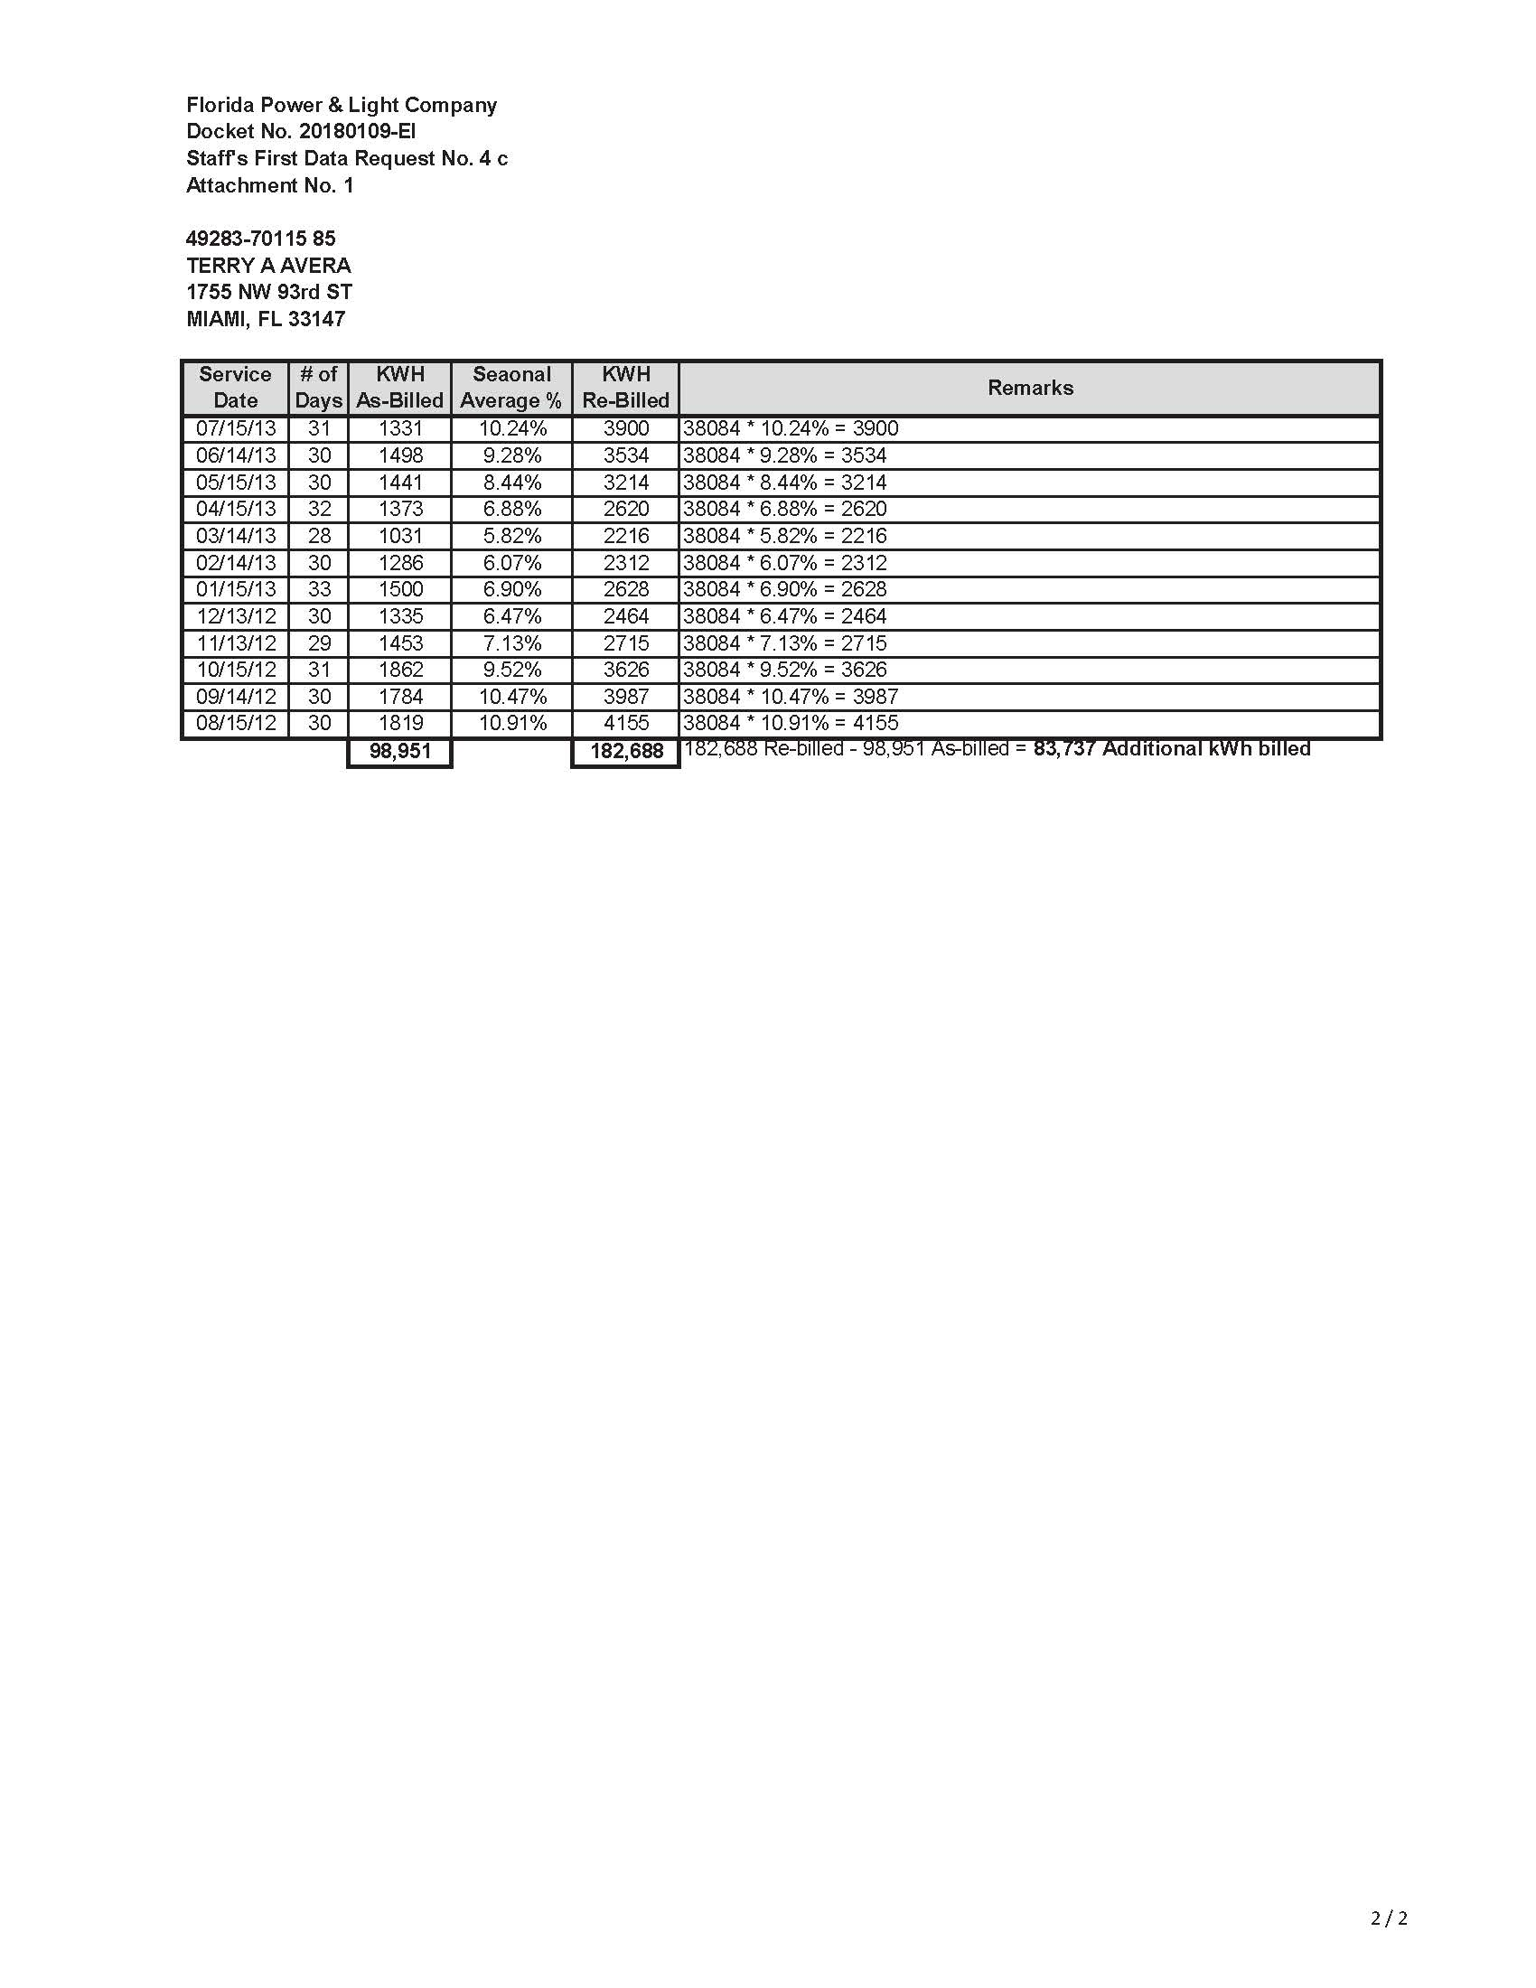
Attachment B:
Photograph of Meter ACD5693, with wire, provided by FPL

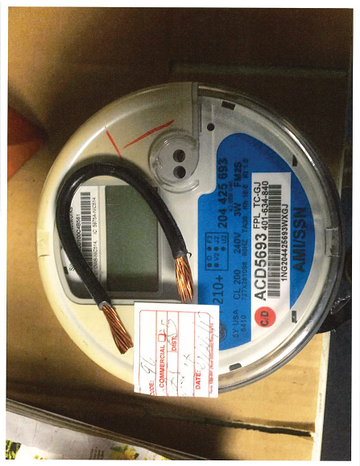

DN 03304-2018, Complaint of Mr. Avera, ¶ 29.
Id. at ¶ 31.
Id. at ¶ 35.
See, Southern Bell Telephone and Telegraph Company v. Mobile America Corporation. Inc., 291 So. 2d 199, 202 (Fla. 1974).
FPL states that its “Revenue Protection Department continuously refines and develops new analytic tests to better identify potential theft conditions in the field. Leveraging data from smart meters and analytic tools, a new algorithm was developed in 2017, which generated the lead to investigate a possible unauthorized condition at Mr. Avera’s residence.” See DN 04404-2018, FPL’s response to Staff’s First Data Request, ¶ 7.a.
DN 04404-2018, FPL’s Response to Staff’s First Data Request, ¶ 7.b.
See Attachment A to this recommendation. Mr. Avera claims that “based on personal knowledge and consultation with an expert, the increase in consumption was due to the meter not being grounded. Also during this time Mr. Avera’s sons grew older and their consumption increased. Finally the effectiveness of the disconnect boot (DM) became less as it deteriorated overtime.” DN 04406-2018, Avera’s Response to Staff’s First Data Request ¶ 1.
A lineside tap is a wire or cable coming from the customer's main panel or a particular appliance, spliced into the lineside cable before the meter, or installed into the lineside lug in the meter enclosure. In some cases, the customer's existing load cable has been rerouted directly to the lineside lug. A jumper, on the other hand, is a wire or other conductor that is attached to both the line side and load side meter blocks for the purpose of allowing electricity to flow to the premise without registering on the meter. FPL later found the wire at Mr. Avera’s residence to be a jumper, not a lineside tap (see subsection entitled “Subsequent Meter Tests,” below).
Disconnect boots are used by electric utilities to safely isolate a meter temporarily from the electrical service while keeping the meter in place. They act as insulating sheaths, temporarily disconnecting the blades of the meter from the receiving socket, when interruption of the electrical service is desired.
See DN 04404-2018, FPL’s Response to Staff’s First Data Request, ¶ 4.c.
See DN 04714-2018.
Mr. Avera states that the meter electrician told him “that if the meter was found to be in an unauthorized condition he would have had no choice but to call the police and have a police report filed as a crime by the meter tenant Mr. Avera. The inspector specified the DM was not an unauthorized condition in that it was inserted into the wall by FPL itself when the prior owner occupied the house.” See DN 04406-2018, Avera’s Response to Staff’s First Data Request, ¶ 2.
Id.
Commission rules also authorize the refusal or discontinuance of electric service “without notice in the event of tampering with meters or other facilities furnished and owned by the utility” and “without notice in the event of unauthorized or fraudulent use of service. Rule 25-6.105(5)(i-j), F.A.C.
DN 04667-2018, Affidavit of Alex Urquiaga ¶ 5.
DN 04404-2018, FPL’s Response to Staff’s First Data Request, ¶ 4.d.
Id.
Pursuant to Rule 25-6.105(8)(a), F.A.C., delinquency in payment for service by a previous occupant of the premises shall not constitute sufficient cause for refusal or discontinuance of service to an applicant or customer unless the current applicant or customer occupied the premises at the time the delinquency occurred and the previous customer continues to occupy the premises and such previous customer shall benefit from such service.
Order of Dismissal, Terry A Avera v. FPL Florida Power Light, No. 2017014730-CC-05 (Fla. Miami-Dade Cty. Ct. 2017)
See Avera v. Florida Power & Light Co., 2017 WL 6032562, at *1 (Fla. 3d DCA Nov. 21, 2017).
DN 04667-2018, Affidavit of Alex Urquiaga ¶ 3.
DN 04714-2018, Avera Response to Affidavit of Alex Urquiaga pgs. 3-4. However, FPL stated that it did have the wire, and the wire was stored in a testing technician’s desk at FPL’s Meter Technology Center after the November 7, 2017 test of meter ACD 5693. See DN 04667-2018, Affidavit of Alex Urquiaga ¶ 14.
Avera Response to Affidavit of Alex Urquiaga pg. 2.
See Affidavit of Alex Urquiaga ¶ 13.
See Order No. PSC-08-0380-PCO-EI, issue June 9, 2008 in Docket 080039-EI, In re: Complaint of Sallijo A. Freeman Against Florida Power & Light Co. for Violation of Rule 25-6.105, at p. 4. See also Southern Bell Telephone and Telegraph Company v. Mobile America Corporation, Inc., 291 So. 2d 199, 202 (Fla. 1974) and Order No. PSC-99-1054-FOF-EI, issued May 24, 1999, in Docket No. 981923-EI, In re: Complaint and petition of John Charles Heekin against Florida Power & Light Company.
Source: FPL’s Response to Staff’s First Data Request, pgs. 7-8.

