State of Florida |  | Public Service Commission  Capital Circle Office Center ● 2540 Shumard Oak Boulevard  Tallahassee, Florida 32399-0850  -M-E-M-O-R-A-N-D-U-M-
DATE: | August 17, 2018
TO: | Office of Commission Clerk (Stauffer)
FROM: | Division of Engineering (O. Wooten, Ellis)  Division of Accounting and Finance (Andrews, Fletcher, Norris)  Division of Economics (Bethea)  Office of the General Counsel (J. Crawford, Dziechciarz, DuVal)
RE: | Docket No. 20180066-WU – Application for transfer of facilities of Kincaid Hills Water Company and Water Certificate No. 555-W to Gator Waterworks, Inc.  Docket No. 20170200-WU – Initiation of show cause proceedings against Kincaid Hills Water Company, in Alachua County, for noncompliance with Sections 350.113, 350.117, 367.121, and 367.145, Florida Statutes, and Rules 25-30.110, 25-30.120, 25-30.355, and 25-22.032, Florida Administrative Code.
AGENDA: | 08/29/18 – Regular Agenda – Proposed Agency Action for Issue 2 – Interested Persons May Participate
COMMISSIONERS ASSIGNED: |  |  | All Commissioners
PREHEARING OFFICER: |  |  | Polmann
CRITICAL DATES: |  |  | None
SPECIAL INSTRUCTIONS: |  |  | None

Case Background
On March 12, 2018, Gator Waterworks, Inc. (Gator Waterworks or Buyer) filed an application for a transfer of Certificate No. 555-W from Kincaid Hills Water Company (Kincaid, Utility, or Seller) in Alachua County. According to the Utility’s 2016 Annual Report, Kincaid is a Class C utility serving approximately 324 water customers.
Kincaid has been providing service to customers since 1965. On June 30, 1992, the Board of County Commissioners of Alachua County adopted a resolution declaring water and wastewater utilities in that county shall become subject to the provisions of the Water and Wastewater Regulatory Law, Chapter 367, Florida Statutes (F.S). On July 13, 1993, the Florida Public Service Commission (Commission) granted the Utility its grandfather Certificate No. 555-W for water by Order No. PSC-93-1027-FOF-WU.
Docket No. 20170200-WU was established on September 7, 2017 to initiate a show cause proceeding against Kincaid for noncompliance with Sections 350.113, 350.117, 367.121, and 367.145, F.S., and Rules 25-30.110, 25-30.120, 25-30.355, and 25-22.032, Florida Administrative Code (F.A.C.). By Order No. PSC-2017-0470-PCO-WU, issued December 15, 2017, the Commission directed Commission staff to initiate certificate revocation proceedings against Kincaid, consistent with Chapter 120 and Section 367.161, F.S. On February 27, 2018, Commission staff received notice, by email, from Gator Waterworks that it acquired Kincaid on February 23, 2018. Also, on February 27, 2018, the Commission received a payment of $38,698.08 from Gator Waterworks which resolved Kincaid’s outstanding Regulatory Assessment Fees (RAFs), the associated penalties, and the penalties associated with Kincaid’s late-filed annual reports.

Docket No. 20180066-WU was established on March 12, 2018, when Gator Waterworks filed an application with the Commission for transfer of facilities and Water Certificate No. 555-W from Kincaid to Gator Waterworks. On March 20, 2018, Gator Waterworks filed a request to hold the certificate revocation proceedings in abeyance until such time as the Commission makes its ruling on the transfer application. By Order No. PSC-2018-0166-PCO-WU, issued March 27, 2018, Gator Waterworks’ request for abeyance was granted.
This recommendation addresses the transfer of the water system, the net book value of the water system at the time of the transfer, the need for an acquisition adjustment and the resolution of the show cause proceedings. The Commission has jurisdiction pursuant to Sections 367.071, 367.091 and 367.161 F.S.

Discussion of Issues

Issue 1:
Should the transfer of Certificate No. 555-W in Alachua County from Kincaid Hills Water Company to Gator Waterworks, Inc. be approved?

Recommendation:
Yes. The transfer of the water system and Certificate No. 555-W is in the public interest and should be approved effective the date of the Commission vote. The resultant order should serve as the Buyer’s certificate and should be retained by the Buyer. The existing rates and charges should remain in effect until a change is authorized by the Commission in a subsequent proceeding. The tariffs reflecting the transfer should be effective for services rendered or connections made on or after the stamped approval date on the tariffs, pursuant to Rule 25-30.475, F.A.C. Gator Waterworks should be responsible for filing the 2018 Annual Report, all future annual reports, and RAFs subsequent to the date of closing. (O. Wooten, Andrews, Bethea)

Staff Analysis:
On March 12, 2018, Gator Waterworks filed an application for the transfer of Certificate No. 555-W from Kincaid to Gator Waterworks pursuant to Rule 25-30.037, F.A.C. The application is in compliance with Section 367.071, F.S., and Commission rules concerning applications for transfer of certificates.
Noticing, Territory, and Land Ownership
Gator Waterworks provided notice of the application pursuant to Section 367.071, F.S., and Rule 25-30.030, F.A.C. No objections to the transfer were filed, and the time for doing so has expired. The application contains a description of the waster service territory which is appended to this recommendation as Attachment A. The application contains a copy of a warranty deed agreement that was executed on February 20, 2018, as evidence that Gator Waterworks owns or has rights to long-term use of the land upon which the water treatment facilities are located pursuant to Rule 25-30.037(2)(s), F.A.C.

Purchase Agreement and Financing
Pursuant to Rule 25-30.037(2)(i), and (j), F.A.C., the application contains a statement regarding financing and a copy of the Purchase Agreement, which includes the purchase price, terms of payment, and a list of the assets purchased. The Seller retained the customer deposits for appropriate disposition. There are no developer agreements or customer advances that must be disposed of with regard to the transfer. According to the purchase agreement, the total purchase price for the assets is $82,500. An appropriate portion of this purchase price equal to unpaid past due RAFs, fines, and interest was paid to the Commission at the date of closing. An appropriate portion of this purchase price equal to the unpaid property taxes due to Alachua County was paid to Alachua County at the date of closing. Eighty percent of the remaining purchase price was paid to the Seller at the date of closing with 20 percent of the remaining purchase price to be paid to the Seller after Commission approval of the transfer. According to the Buyer, the sale took place on February 23, 2018, subject to Commission approval, pursuant to Section 367.071(1), F.S.

Facility Description and Compliance
The water treatment system consists of two wells, with a pair of hydropneumatic tanks rated at 3,100 and 5,000 gallons, a contact storage tank rated at 1,000 gallons and uses hypo-chlorination for disinfection. The distribution system consists of 17,000 feet of 2 inch Galvanized Iron Pipe (GIP), 3,800 feet of 3 inch GIP, 3,400 feet of 4 inch GIP and 5,200 feet of 6 inch asbestos-cement pipe. The last sanitary survey of the facility was conducted on April 29, 2016, by the Department of Environmental Protection (DEP). There was one deficiency noted, which has been corrected. On December 22, 2016, the DEP deemed the Utility was in compliance with applicable rules.

Technical and Financial Ability
Pursuant to Rule 25-30.037(2)(l), F.A.C., the application contains statements describing the technical and financial ability of Gator Waterworks to provide service to the proposed service area. The application states that the President, Gary Deremer, has over 29 years of Florida related water and wastewater industry experience with previous private utility ownership of five utility systems. Further, the application indicates that the President has secured the services of U.S. Water Services Corporation to provide contract operating service, as well as, billing and collection services. Pursuant to Rule 25-30.037(2)(l), F.A.C., the application contains statements describing the financial ability of Gator Waterworks to provide service to the proposed service area. According to the application, the Buyer has acquired the assets of the Utility. Staff also reviewed the personal financial statements of the primary shareholder, which is the President. Based on the above, staff believes the Buyer has demonstrated the financial ability to provide service to the existing service territory.

Rates and Charges

The Utility’s rates, charges, and customer deposits were approved in the original grandfather certificate in 1993. The rates were subsequently amended through three price index increases. The Utility’s existing rates are shown on Attachment B. Rule 25-9.044(1), F.A.C., provides that, in the case of a change of ownership or control of a utility, the rates, classifications, and regulations of the former owner must continue unless authorized to change by this Commission. Therefore, staff recommends that the Utility’s existing rates and charges remain in effect until a change is authorized by this Commission in a subsequent proceeding.

Regulatory Assessment Fees and Annual Reports
Staff has verified that the Utility is current on the filing of RAFs through February 23, 2018. The Seller is responsible for filing the 2017 Annual Report. However, the filing is currently delinquent, and the Seller has not responded to two certified letters regarding the delinquency. The Buyer has indicated that it does not possess the records required to prepare the 2017 Annual Report.

The purpose of the annual report filing requirement is to monitor earnings and gather information. The RAFs due for the year 2017 were based on estimated earnings and were paid in full by the Buyer. Staff believes that the absence of the 2017 Annual Report will not impair the Commission from fulfilling its obligation to ensure safe and reliable utility service, and the 2017 RAFs have already been paid. Therefore, it is not crucial that the Commission obtain the 2017 Annual Report. The Commission has previously not enforced this requirement for a utility in a similar situation. Accordingly, staff recommends the Commission not seek enforcement of the annual report requirement for the year 2017. The Buyer will be responsible for filing Gator Waterworks’ 2018 and subsequent annual reports and paying RAFs from February 23, 2018, and all future years.

Conclusion
Staff recommends the transfer of the water system and Certificate No. 555-W is in the public interest and should be approved effective the date of the Commission vote. The resultant order should serve as the Buyer’s certificate and should be retained by the Buyer. The existing rates and charges should remain in effect until a change is authorized by the Commission in a subsequent proceeding. The tariffs reflecting the transfer should be effective for services rendered or connections made on or after the stamped approval date on the tariffs, pursuant to Rule 25-30.475, F.A.C. Gator Waterworks should be responsible for filing the 2018 Annual Report, all future annual reports, and RAFs subsequent to the date of closing.

Issue 2:
What is the appropriate net book value for the Gator Waterworks water system for transfer purposes and should an acquisition adjustment be approved?

Recommendation: The net book value of the water system for transfer purposes is $63,321 as of February 23, 2018. An acquisition adjustment should not be included in rate base. Within 90 days of the date of the final order, Gator Waterworks should be required to notify the Commission in writing that it has adjusted its books in accordance with the Commission’s decision. The adjustments should be reflected in Gator Waterworks’ 2018 Annual Report when filed. (D. Andrews)

Staff Analysis: Rate base has never been established for this Utility. Audit staff was able to obtain the Seller’s 1993 1120S Federal Tax Return. Thus, staff used the December 31, 1992, amounts for utility plant in service and accumulated depreciation beginning balances. The purpose of establishing net book value (NBV) for transfers is to determine whether an acquisition adjustment should be approved. The NBV does not include normal ratemaking adjustments for used and useful plant or working capital. The Utility’s NBV has been updated to reflect balances as of February 23, 2018. Staff’s recommended NBV, as described below, is shown on Schedule No. 1.

Utility Plant in Service (UPIS)
The Buyer’s plant value in its application for transfer reflected a water UPIS balance of $454,492. Staff reviewed UPIS additions since the 1993 tax return and has decreased UPIS by $73,593 to reflect unsupported plant additions. Therefore, staff recommends that the Utility’s UPIS balance as of February 23, 2018, should be $380,899.

Land
The Buyer’s application for transfer reflected a land balance of $14,000. In a warranty deed between Sheldon A. Brook, grantor, and Kincaid Hills Water Company, grantee, dated October 5, 1982, the documentary stamps supported $8,000 for utility land. There have been no additions to land purchased since that deed was granted. Therefore, staff has decreased land by $6,000. Staff recommends a land balance of $8,000, as of February 23, 2018.

Accumulated Depreciation
The Buyer’s application for transfer reflected an accumulated depreciation balance of $342,780. Based on the UPIS adjustment discussed earlier, staff calculated the appropriate accumulated depreciation balance to be $288,095. As a result, accumulated depreciation should be decreased by $54,685 to reflect an accumulated depreciation balance of $288,095 as of February 23, 2018.

Contributions-in-Aid-of-Construction (CIAC) and Accumulated Amortization of CIAC
As of February 23, 2018, the Buyer’s application for transfer reflected a CIAC balance of $0 and an accumulated amortization of CIAC balance of $0. The CIAC balance should be increased by $156,085, and the accumulated amortization of CIAC balance should be increased by $125,376, per Rule 25-30.570, F.A.C. This rule states that if the amount of CIAC has not been recorded on the utility’s books and the utility does not submit competent substantial evidence as to the amount of CIAC, the amount of CIAC shall be imputed to be the proportion of the cost of the facilities and plant attributable to the water transmission and distribution system.

Additionally, the CIAC balance should be increased by $9,600. Order No. PSC-1993-1027-FOF-WU approved service availability charges of $75 for tap-in fees, $75 for meter installations, and $450 for plant capacity charges for a total of $600. Audit staff scheduled customer activity as shown in the annual reports from 1992 through 2016, and noted that the customer count grew by 16 customers from December 31, 1992 to December 31, 2007. After 2007, the customer count diminished over time. Audit staff determined a balance of $9,600 ($600 x 16) for CIAC, and calculated a balance of $2,826 for accumulated amortization of CIAC using a composite rate of 2.5 percent as of February 23, 2018. Rule 25-30.570, F.A.C. relates to the imputation of CIAC based on the premise that the developer donated the transmission and distribution system when it was transferred. Cash CIAC collected from service availability charges is unrelated to the cost of the transmission and distribution system. Thus, cash CIAC should also be recognized for the tap-in fees, meter installations, and plant capacity charges. As such, staff increased CIAC by $165,685 ($156,085 + $9,600) and accumulated amortization of CIAC by $128,202 ($125,376 + $2,826) to reflect the appropriate balances. Therefore, staff recommends a CIAC balance of $165,685 and an accumulated amortization of CIAC balance of $128,202 as of February 23, 2018.

Net Book Value
The Buyer’s application for transfer reflected a NBV of $125,712. Based on the adjustments described above, staff recommends that the NBV is $63,321. Staff’s recommended NBV and the National Association of Regulatory Utility Commissioners, Uniform System of Accounts (NARUC USOA) balance for UPIS and accumulated depreciation as of February 23, 2018, are shown on Schedule No. 1.

Acquisition Adjustment
An acquisition adjustment results when the purchase price differs from the NBV of the assets at the time of the acquisition. The Utility and its assets were to be purchased for $82,500. However, the contract for sale stated that the “final purchase price will be determined by any change in Rate Base as determined by the FPSC during the approval of transfer application. The final purchase price will be adjusted for any reductions to the approved Rate Base as determined by the FPSC.” As stated above, staff has determined the appropriate NBV total to be $63,321. Therefore, the Utility and its assets were purchased for $63,321. Pursuant to Rule 25-30.0371, F.A.C., a positive acquisition adjustment may be appropriate when the purchase price is greater than the NBV, and a negative acquisition adjustment may be appropriate when the purchase price is less than NBV. However, pursuant to Rule 25-30.0371(2), F.A.C., a positive acquisition adjustment shall not be included in rate base unless there is proof of extraordinary circumstances. The Buyer did not request a positive acquisition adjustment. As such, staff recommends that no positive acquisition adjustment be approved.

Conclusion
Based on the above, staff recommends that the NBV of Kincaid Hills water system for transfer purposes is $63,321 as of February 23, 2018. No acquisition adjustment should be included in rate base. Within 90 days of the date of the final order, the Buyer should be required to notify the Commission in writing that it has adjusted its books in accordance with the Commission’s decision. The adjustments should be reflected in Gator Waterworks’ 2018 Annual Report when filed.

Issue 3:
Should the show cause proceeding against Kincaid Hills Water Company be dismissed, and Docket No. 20170200-WU, be closed?

Recommendation:
Yes. If the Commission approves Gator Waterworks, Inc.’s transfer application, then the show cause proceeding against Kincaid Hills Water Company should be dismissed and Docket No. 20170200-WU should be closed. (Dziechciarz, DuVal)

Staff Analysis:
By Order No. PSC-2017-0470-PCO-WU, issued December 15, 2017, the Commission ordered Docket No. 20170200-WU to remain open until certificate revocation proceedings were initiated. Gator Waterworks’ acquisition of Kincaid negates the need for a certificate revocation proceeding. Therefore, if the Commission approves staff’s recommendation in Issues 1 and 2, then the show cause proceeding against Kincaid Hills Water Company should be dismissed and Docket No. 20170200-WU should be closed.
Conclusion
If the Commission approves Gator Waterworks, Inc.’s transfer application, then the show cause proceeding against Kincaid Hills Water Company should be dismissed and Docket No. 20170200-WU should be closed.

Issue 4:
Should these dockets be closed?

Recommendation:
If no protest to the proposed agency action is filed by a substantially affected person within 21 days of the date of the issuance of the order, a consummating order should be issued and these dockets should be closed administratively upon Commission staff’s verification that the revised tariff sheets have been filed, the Buyer has notified the Commission in writing that it has adjusted its books in accordance with the Commission’s decision, and proof that appropriate noticing has been done pursuant to Rule 25-30.4345, F.A.C. (J. Crawford)

Staff Analysis:
If no protest to the proposed agency action is filed by a substantially affected person within 21 days of the date of the issuance of the order, a consummating order should be issued and these dockets should be closed administratively upon Commission staff’s verification that the revised tariff sheets have been filed, the Buyer has notified the Commission in writing that it has adjusted its books in accordance with the Commission’s decision and proof that appropriate noticing has been done pursuant to Rule 25-30.4345, F.A.C.

Gator Waterworks, Inc.
Water Territory Description
Alachua County
Alachua County, Florida, Kincaid Hills

The following described lands located in portions of Sections 11 and 12, Township 10-South,
Range 20-East, Alachua County, Florida:

Kincaid Road Subdivision - A subdivision lying within the southwest one-quarter of Section 11, Township 10 South, Range 20 East; encompassed within the boundary commencing 2,280 feet north of the southwest corner of Section 11 , Township 10 South, Range 20 East and on the eastern side of Florida Highway S-329A; thence running 1,880 feet east (to Southeast 33rd St.); thence running 600 feet south (to Southeast 18th Ave.); thence running 570 feet east (to Southeast 35th Street); thence running 600 feet south (to Southeast 21st Ave.); thence running 2450 feet west to Florida Highway S-329A; thence running 600 feet north (to Southeast 18th Ave.).

Devonshire Hills Subdivision - A subdivision lying within the northeast one-quarter of Section 11, Township 10 South, Range 20 East; encompassed within the boundary commencing at the point that is 600 feet northwest of the point on the western boundary of Section 12, Township 10 South, Range 20 East where it intersects Florida Highway 20; thence running 1,310 feet south (to Southeast 18th Ave.); thence running 1,100 feet east; thence running 300 feet north (to Southeast 17th Ave.); thence running 550 feet west (to Southeast 37th St.); thence running 540 feet north (to Southeast 15th Ave.); thence running 200 feet west (to Southeast 36th St.); thence running 560 feet north to Florida Highway 20; thence running 200 feet northwest along, and south of, Florida Highway 20.

Kreftwood Estates Subdivision - A subdivision lying within the southwest one-quarter of Section 12, Township 10 South, Range 20 East; encompassed within the boundary commencing at the southwest corner of Section 12, Township 10 South, Range 20 East; thence running 1,800 feet north to Florida Highway 20; thence running 750 feet southeast along the southern side of Florida Highway 20 to the northwest corner of the Shady Lawn subdivision (described below); thence running 1,350 feet south to Section 13, Township 10 south, Range 20 East; thence running 575 feet west to the southwest corner of Section 12, Township 10 South, Range 20 East.

Shady Lawn Estates - A subdivision lying within the southwest one-quarter of Section 12, Township 10 South, Range 20 East; encompassed within the boundary commencing at the northeast corner of the Kreftwood Estates subdivision (described above); thence running 750 feet southeast along the southern side of Florida Highway 20; thence running 1,200 feet south toSection 13, Township 10 South, Range 20 East; thence running 575 feet west to the southeastcorner of the Kreftwood Estate subdivision (described above).

FLORIDA PUBLIC SERVICE COMMISSION
Authorizes
Gator Waterworks, Inc.
Pursuant to
Certificate Number 555-W
To provide water service in Alachua County in accordance with the provisions of Chapter 367, Florida Statutes, and the Rules, regulations, and Orders of this Commission in the territory described by the Orders of this Commission. This authorization shall remain in force and effect until superseded, suspended, cancelled or revoked by Order of this Commission.
Order Number Date Issued Docket Number Filing Type
PSC-93-1027-FOF-WU 07/13/1993 921195 -WU Grandfather Certificate
* * 20180066-WU Transfer of Certificate
* Order Numbers and dates to be provided at time of issuance

Kincaid Hills Water Company
Monthly Water Rates
Residential and General Service
Base Facility Charge - All Meter Sizes $6.94
Charge per 1,000 Gallons - Residential and General Service |  |  | $0.92
Initial Customer Deposits
Residential and General Service - All Meters |  | $25.00
Miscellaneous Service Charges
 | Business Hours |  | After Hours
Initial Connection Charge | $20.00 |  | $30.00
Normal Reconnection Charge | $20.00 |  | $30.00
Violation Reconnection Charge | $40.00 |  | $50.00
Premises Visit Charge (in lieu of disconnection) | $20.00 |  | $30.00
Late Payment Charge |  |  | $2.00
Service Availability Charges
Customer Connection Charge |  |  | $75.00
Main Extension Charge |  |  | Actual Cost
Meter Installation Charge |  |  | $75.00
Plant Capacity Charge |  |  | $450.00

Kincaid Hills Water Company Water System Schedule
Water System

Schedule of Net Book Value as of February 23, 2018
Description | Balance Per Utility | Adjustments | Staff Recommendation
Utility Plant in Service | $454,492 | ($73,593) | $380,899
Land & Land Rights | 14,000 | (6,000) | 8,000
Accumulated Depreciation | (342,780) | 54,685 | (288,095)
CIAC | 0 | (165,685) | (165,685)
Amortization of CIAC | 0 | 128,202 | 128,202
Total | $125,712 | ($62,391) | $63,321

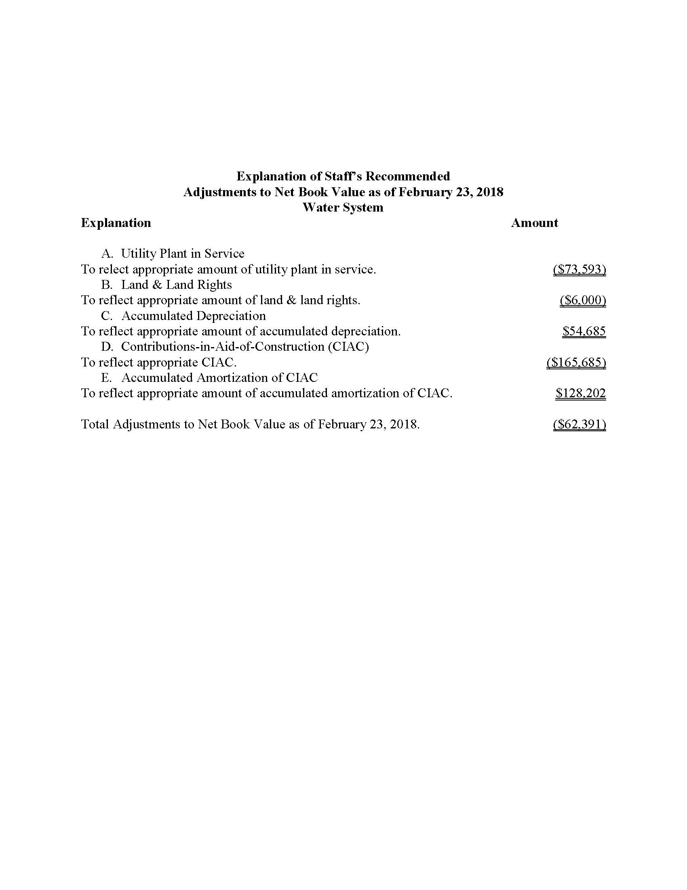
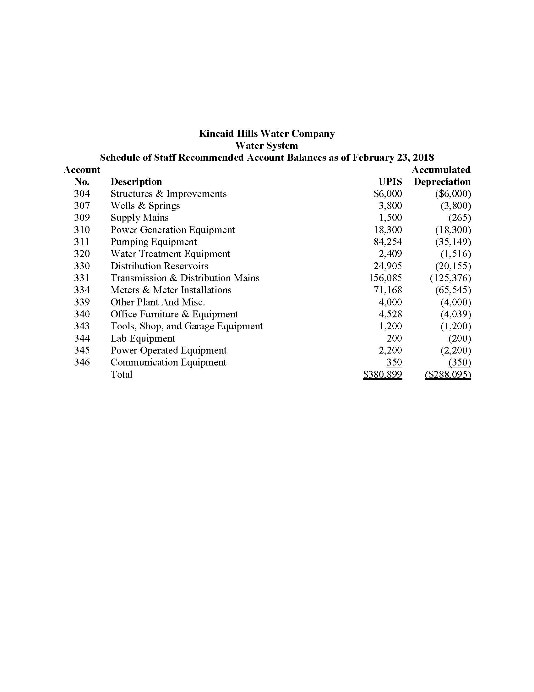

Docket No. 19921195-WU, In re: Application for certificate to provide water service in Alachua County under grandfather rights by Kincaid Hills Water Company.
Order No. PSC-2017-0470-PCO-WU, issued December 15, 2017, in Docket No. 20170200-WU, In re: Initiation of show cause proceedings against Kincaid Hills Water Company, in Alachua County, for noncompliance with Sections 350.113, 350.117, 367.121, and 367.145, Florida Statutes, and Rules 25-30.110, 25-30.120, 25-30.355, and 25-22.032, Florida Administrative Code.
See Document No. 02094-2018, filed in Docket No. 20170200-WU.
Id.
See Document No. 02417-2018, filed in Docket Nos. 20170200-WU and 20180066-WU.
Order No. PSC-2018-0166-PCO-WU, issued March 27, 2018, in Docket No. 20170200-WU, In re: Initiation of show cause proceedings against Kincaid Hills Water Company, in Alachua County, for noncompliance with Sections 350.113, 350.117, 367.121, and 367.145, Florida Statutes, and Rules 25-30.110, 25-30.120, 25-30.355, and 25-22.032, Florida Administrative Code.
Document No. 05042-2018 (Confidential), in Docket No. 20180066-WU.
Order No. PSC-93-1027-FOF-WU, issued July 13, 1998, in Docket No. 19921195-WU, In re: Application for certificate to provide water service in Alachua County under grandfather rights by Kincaid Hills Water Company.
Order No. 24157, issued February 25, 1991, in Docket No. 19900911-WU, In re: Initiation of show proceeding against Sebring County Estates Water Company in Highlands County for failure to file 1988 annual report in compliance with Rule 25-30.110, F.A.C.

