BEFORE THE FLORIDA PUBLIC SERVICE COMMISSION

In re: Petition for approval of tariff modifications for use of natural gas for gas heat pumps by customers, by Peoples Gas System. | DOCKET NO. 20180117-GU  ORDER NO. PSC-2018-0428-TRF-GU  ISSUED: August 27, 2018

The following Commissioners participated in the disposition of this matter:

ART GRAHAM, Chairman
JULIE I. BROWN
DONALD J. POLMANN
GARY F. CLARK
ANDREW GILES FAY

ORDER APPROVING TARIFF MODIFICATIONS FOR USE OF NATURAL GAS FOR GAS HEAT PUMPS

BY THE COMMISSION:

Background
On May 9, 2018, Peoples Gas System (Peoples or utility) filed a petition for approval of tariff modifications for the use of natural gas for gas heat pumps. The proposed tariff modifications would provide new tariff provisions and charges applicable to residential and commercial customers utilizing gas heat pump (GHP) systems. A GHP system heats and cools a building using natural gas. The legislative version of the proposed tariffs is shown as Attachment A to this Order.
Commission staff issued two data requests to Peoples, one on May 22, and the other on June 12, 2018. Commission staff received responses to these requests on June 5 and on June 26, 2018, respectively. During the review period, Peoples submitted revised tariff sheet Nos. 7.201, 7.405, and 7.405-1 to correct certain errors. Peoples waived the 60-day file and suspend provision of Section 366.06(3), Florida Statutes (F.S.). We have jurisdiction over this matter pursuant to Section 366.04, F.S.

Decision
Peoples' petition to modify tariffs for the use of natural gas for GHP systems
Peoples’ proposed tariff modifications provide new residential and commercial tariff provisions and charges for the use of GHP systems. The proposed new GHP charges are based upon the cost of providing service and anticipated GHP customer gas usage. The GHP technology and proposed charges are discussed below.

Gas Heat Pump Technology
Peoples explained that the GHP technology is new to Florida and that there is a growing interest in the use of GHPs, particularly from commercial customers. There are two types of GHP systems: (1) a basic GHP system that utilizes a natural gas powered engine to drive the compressor for either cooling or heating a building and (2) a power producing GHP system that includes internal back-up electric generation ability and can fully operate during electric power loss. Peoples stated that it had communications with GHP manufacturers and inquiries from residential and commercial customers, prompting Peoples to develop the proposed tariffs to serve GHP load.
Peoples stated that the GHP technology provides for increased energy efficiency when compared to traditional electric heating, ventilation, and air conditioning (HVAC) systems. The GHP systems can be installed during construction or as a retrofit to existing buildings. Peoples currently offers a Commission-approved gas space conditioning program which offers piping and venting allowances to reduce the generally higher cost of installing gas space conditioning equipment. However, Peoples’ Energy Conservation Cost Recovery (ECCR) clause docket filings from 2009 to 2017 indicate that the allowance has not been utilized by any of People’s customers.
In response to Commission staff’s first data request, Peoples explained that the installed cost for a GHP system ranges between $4,400 and $8,000 per ton, based on individual design and the manufacturer. Peoples stated that an 8-ton system is expected to satisfy the heating and cooling needs of a 4,000-4,800 square foot house, and expects that customers with larger houses are more likely to install a GHP system. Peoples stated that, currently, three GHP manufacturers are available Peoples’ customers: M Trigen, Yanmar, and Blue Mountain.

Proposed Residential and Commercial GHP Tariffs and Charges

Residential Customers
For residential customers utilizing a GHP system, the proposed new GHP charges are shown on tariff sheet No. 7.201 (Attachment A, page 4). Current residential customer charges are based on annual usage, with a $20 customer charge applying to large residential customers (RS-3 billing class using 250-1,999 therms per year). The current distribution charge is $0.26782 per therm.
Residential customers in the proposed new RS-GHP billing class will pay a monthly customer charge of $20 and a distribution charge of $0.0999 per therm. The lower RS-GHP distribution charge reflects the increased natural gas consumption of a GHP customer compared to a residential customer who consumes natural gas for traditional gas appliances only. In addition to the customer and distribution charges, all residential customers pay Commission-approved ECCR and Cast Iron Bare Steel Replacement Rider clause charges.
Residential customers who have traditional gas appliances and a GHP system would be billed for all of their natural gas usage at the GHP rate. Peoples explained that by not metering and billing residential GHP usage separately, the utility can reduce unnecessary metering costs.
The derivation of the proposed new RS-GHP $0.0999 per therm distribution charge is shown in response to Commission staff’s first data request No. 17. The RS-GHP distribution charge is formulated using a weighted average of (1) the projected cost to provide service to customers who only have a GHP system and (2) the currently approved cost to provide service to customers with only traditional gas appliances. This ensures that GHP customers pay the costs associated with natural gas service, since the RS-GHP distribution charge would apply to GHP usage and any other natural gas appliance(s) the customer may have.
To develop the projected cost to provide service to GHP systems, Peoples utilized the cost of service study approved in the utility’s 2008 rate case (the utility’s most recent rate case) and projected residential GHP usage. Based on information provided by GHP manufacturers, Peoples projects that a residential 8-ton GHP system would use 160 therms per month. Average monthly residential consumption for Peoples’ customers without a GHP system is approximately 18 therms.
Currently, residential customers with consumption in excess of 1,999 therms per year are eligible for gas transportation service. Under transportation service, the customer purchases the natural gas commodity from a pool manger (third party marketer). Residential customers taking service under the GHP rate will also qualify for transportation service if they use more than 1,999 therms per year.

Commercial Customers
For commercial GHP customers, Peoples proposed a new Commercial Gas Heat Pump Service (CS-GHP) rate schedule as shown on tariff sheet Nos. 7.405 and 7.405-1 (Attachment A, pages 6-7). The proposed CS-GHP monthly customer charge is $35 and the proposed per therm distribution charge is $0.2063. In comparison, the current the GS-1 distribution charge is $0.2680 per therm. The derivation of the proposed CS-GHP charges is shown in Exhibit B to People’s petition.
The proposed CS-GHP customer charge is set at the same level as the currently approved GS-1 customer charge ($35). To calculate the CS-GHP distribution charge, Peoples utilized the cost of service study approved in the utility’s 2008 rate case and the projected commercial GHP natural gas usage. Based on the information provided by GHP manufacturers, Peoples projects that a commercial GHP system would use 627 therms per month.
Under the CS-GHP rate schedule, the gas provided for GHP usage will be separately metered from other natural gas usage and will be a separate item on customer bills. The utility proposes separate GHP metering for commercial customers in order to ensure that the reduced GHP distribution charge is applied only to GHP consumption, as non-GHP natural gas usage varies significantly for commercial customers. In addition, GHP use by commercial customers could vary depending on the type of customer and size of GHP equipment installed.
Peoples explained that the types of commercial customers who could take gas service under the CS-GHP tariff includes senior living facilities, nursing homes, convenience stores, restaurants, and office buildings. In addition to customer and distribution charges, CS-GHP customers would pay all other Commission-approved cost recovery clause charges (Purchased Gas Adjustment, ECCR, Swing Service Charge, Competitive Rate Adjustment, and Cast Iron Bare Steel Replacement Rider). CS-CHP customers would pay the same cost recovery clause charges as those approved for the commercial GS-1 rate schedule.

Customer Notification
The utility proposes to inform its customers of the availability of the new heating and cooling options via public relations outreach, advertising, bill inserts, and the utility’s website. Peoples’ sales team will communicate with specific commercial and industrial customers and with distributors, installers, and service contractors to inform them of the availability of the GHP technology. Peoples stated that it will provide a copy of its customer notifications to this Commission prior to use.

Conclusion

Based on the petition and People’s responses, we find the proposed GHP tariffs to be cost-based. Therefore, we approve Peoples' petition to modify its tariffs shown in Attachment A, for the use of natural gas for GHP systems. The proposed tariffs are effective August 7, 2018.
Based on the foregoing, it is
ORDERED by the Florida Public Service Commission that Peoples Gas System’s (Peoples) petition to modify its tariffs, as shown in Attachment A, for the use of natural gas for GHP systems, is approved. The proposed tariffs are effective August 7, 2018. It is further
ORDERED that if a protest is filed within 21 days of issuance of this Order, the tariff shall remain in effect with any charges held subject to refund pending resolution of the protest. It is further
ORDERED that if no timely protest is filed, this docket shall be closed upon the issuance of a Consummating Order.

By ORDER of the Florida Public Service Commission this 27th day of August, 2018.

/s/ Carlotta S. Stauffer
CARLOTTA S. STAUFFER
Commission Clerk
Florida Public Service Commission
2540 Shumard Oak Boulevard
Tallahassee, Florida 32399
(850) 413-6770
www.floridapsc.com

Copies furnished: A copy of this document is provided to the parties of record at the time of issuance and, if applicable, interested persons.
KMS

NOTICE OF FURTHER PROCEEDINGS

The Florida Public Service Commission is required by Section 120.569(1), Florida Statutes, to notify parties of any administrative hearing or judicial review of Commission orders that is available under Sections 120.57 or 120.68, Florida Statutes, as well as the procedures and time limits that apply. This notice should not be construed to mean all requests for an administrative hearing or judicial review will be granted or result in the relief sought.

Mediation may be available on a case-by-case basis. If mediation is conducted, it does not affect a substantially interested person's right to a hearing.

The Commission's decision on this tariff is interim in nature and will become final, unless a person whose substantial interests are affected by the proposed action files a petition for a formal proceeding, in the form provided by Rule 28-106.201, Florida Administrative Code. This petition must be received by the Office of Commission Clerk, 2540 Shumard Oak Boulevard, Tallahassee, Florida 32399-0850, by the close of business on September 17, 2018.

In the absence of such a petition, this Order shall become final and effective upon the issuance of a Consummating Order.

Any objection or protest filed in this docket before the issuance date of this Order is considered abandoned unless it satisfies the foregoing conditions and is renewed within the specified protest period.

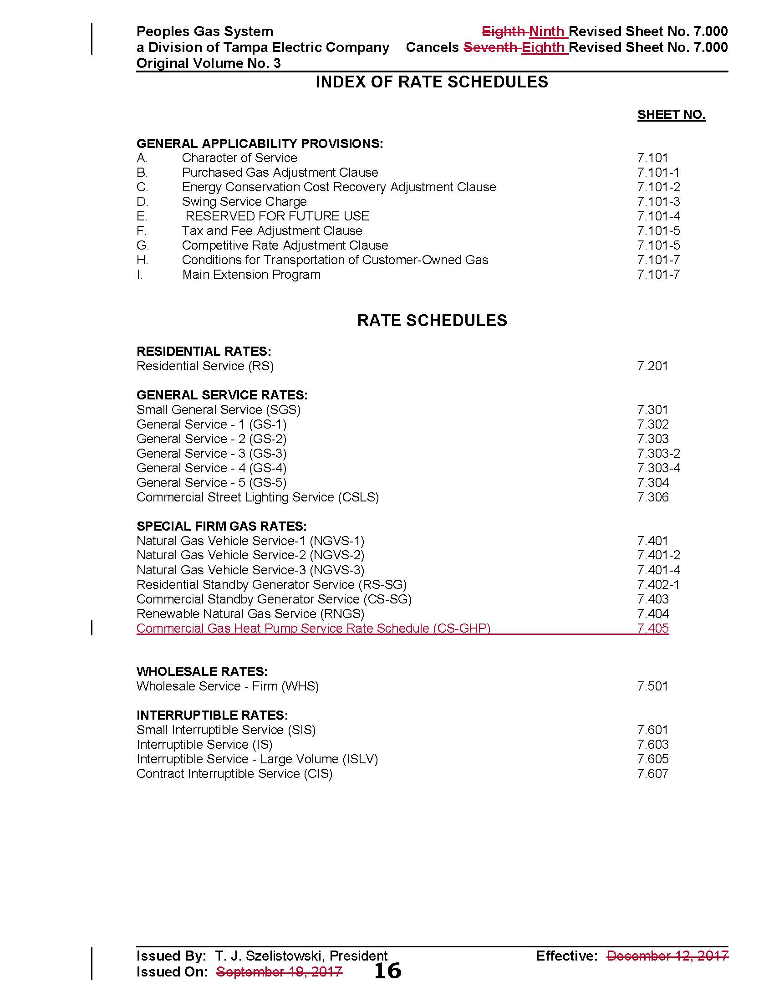

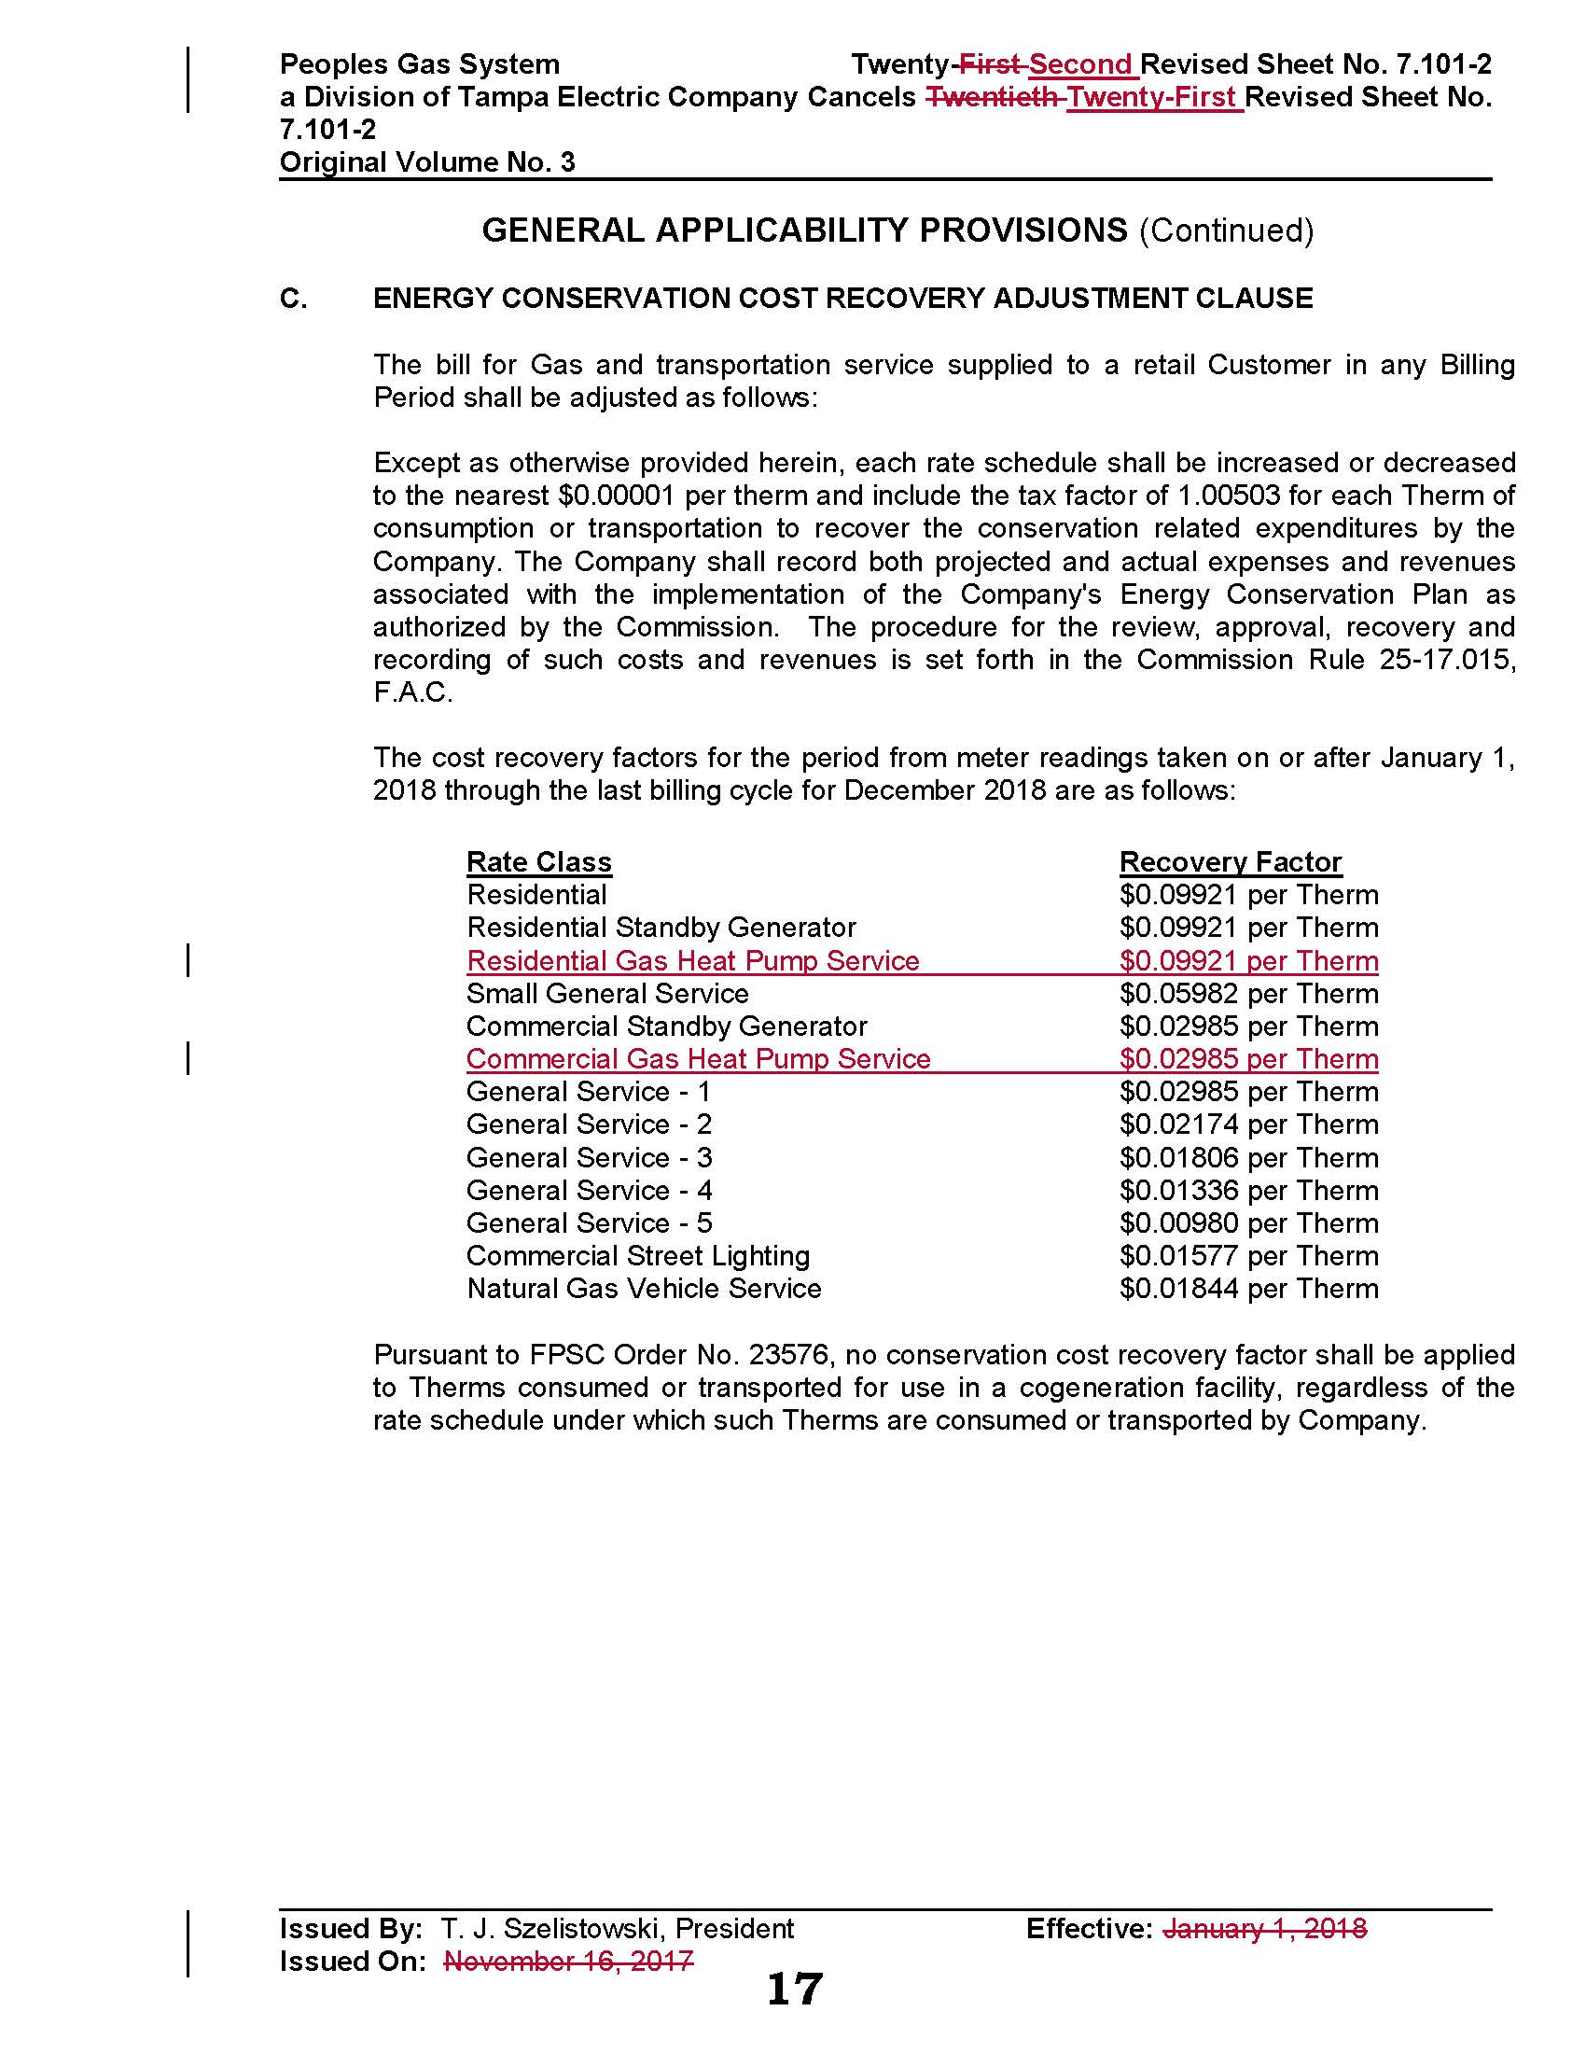

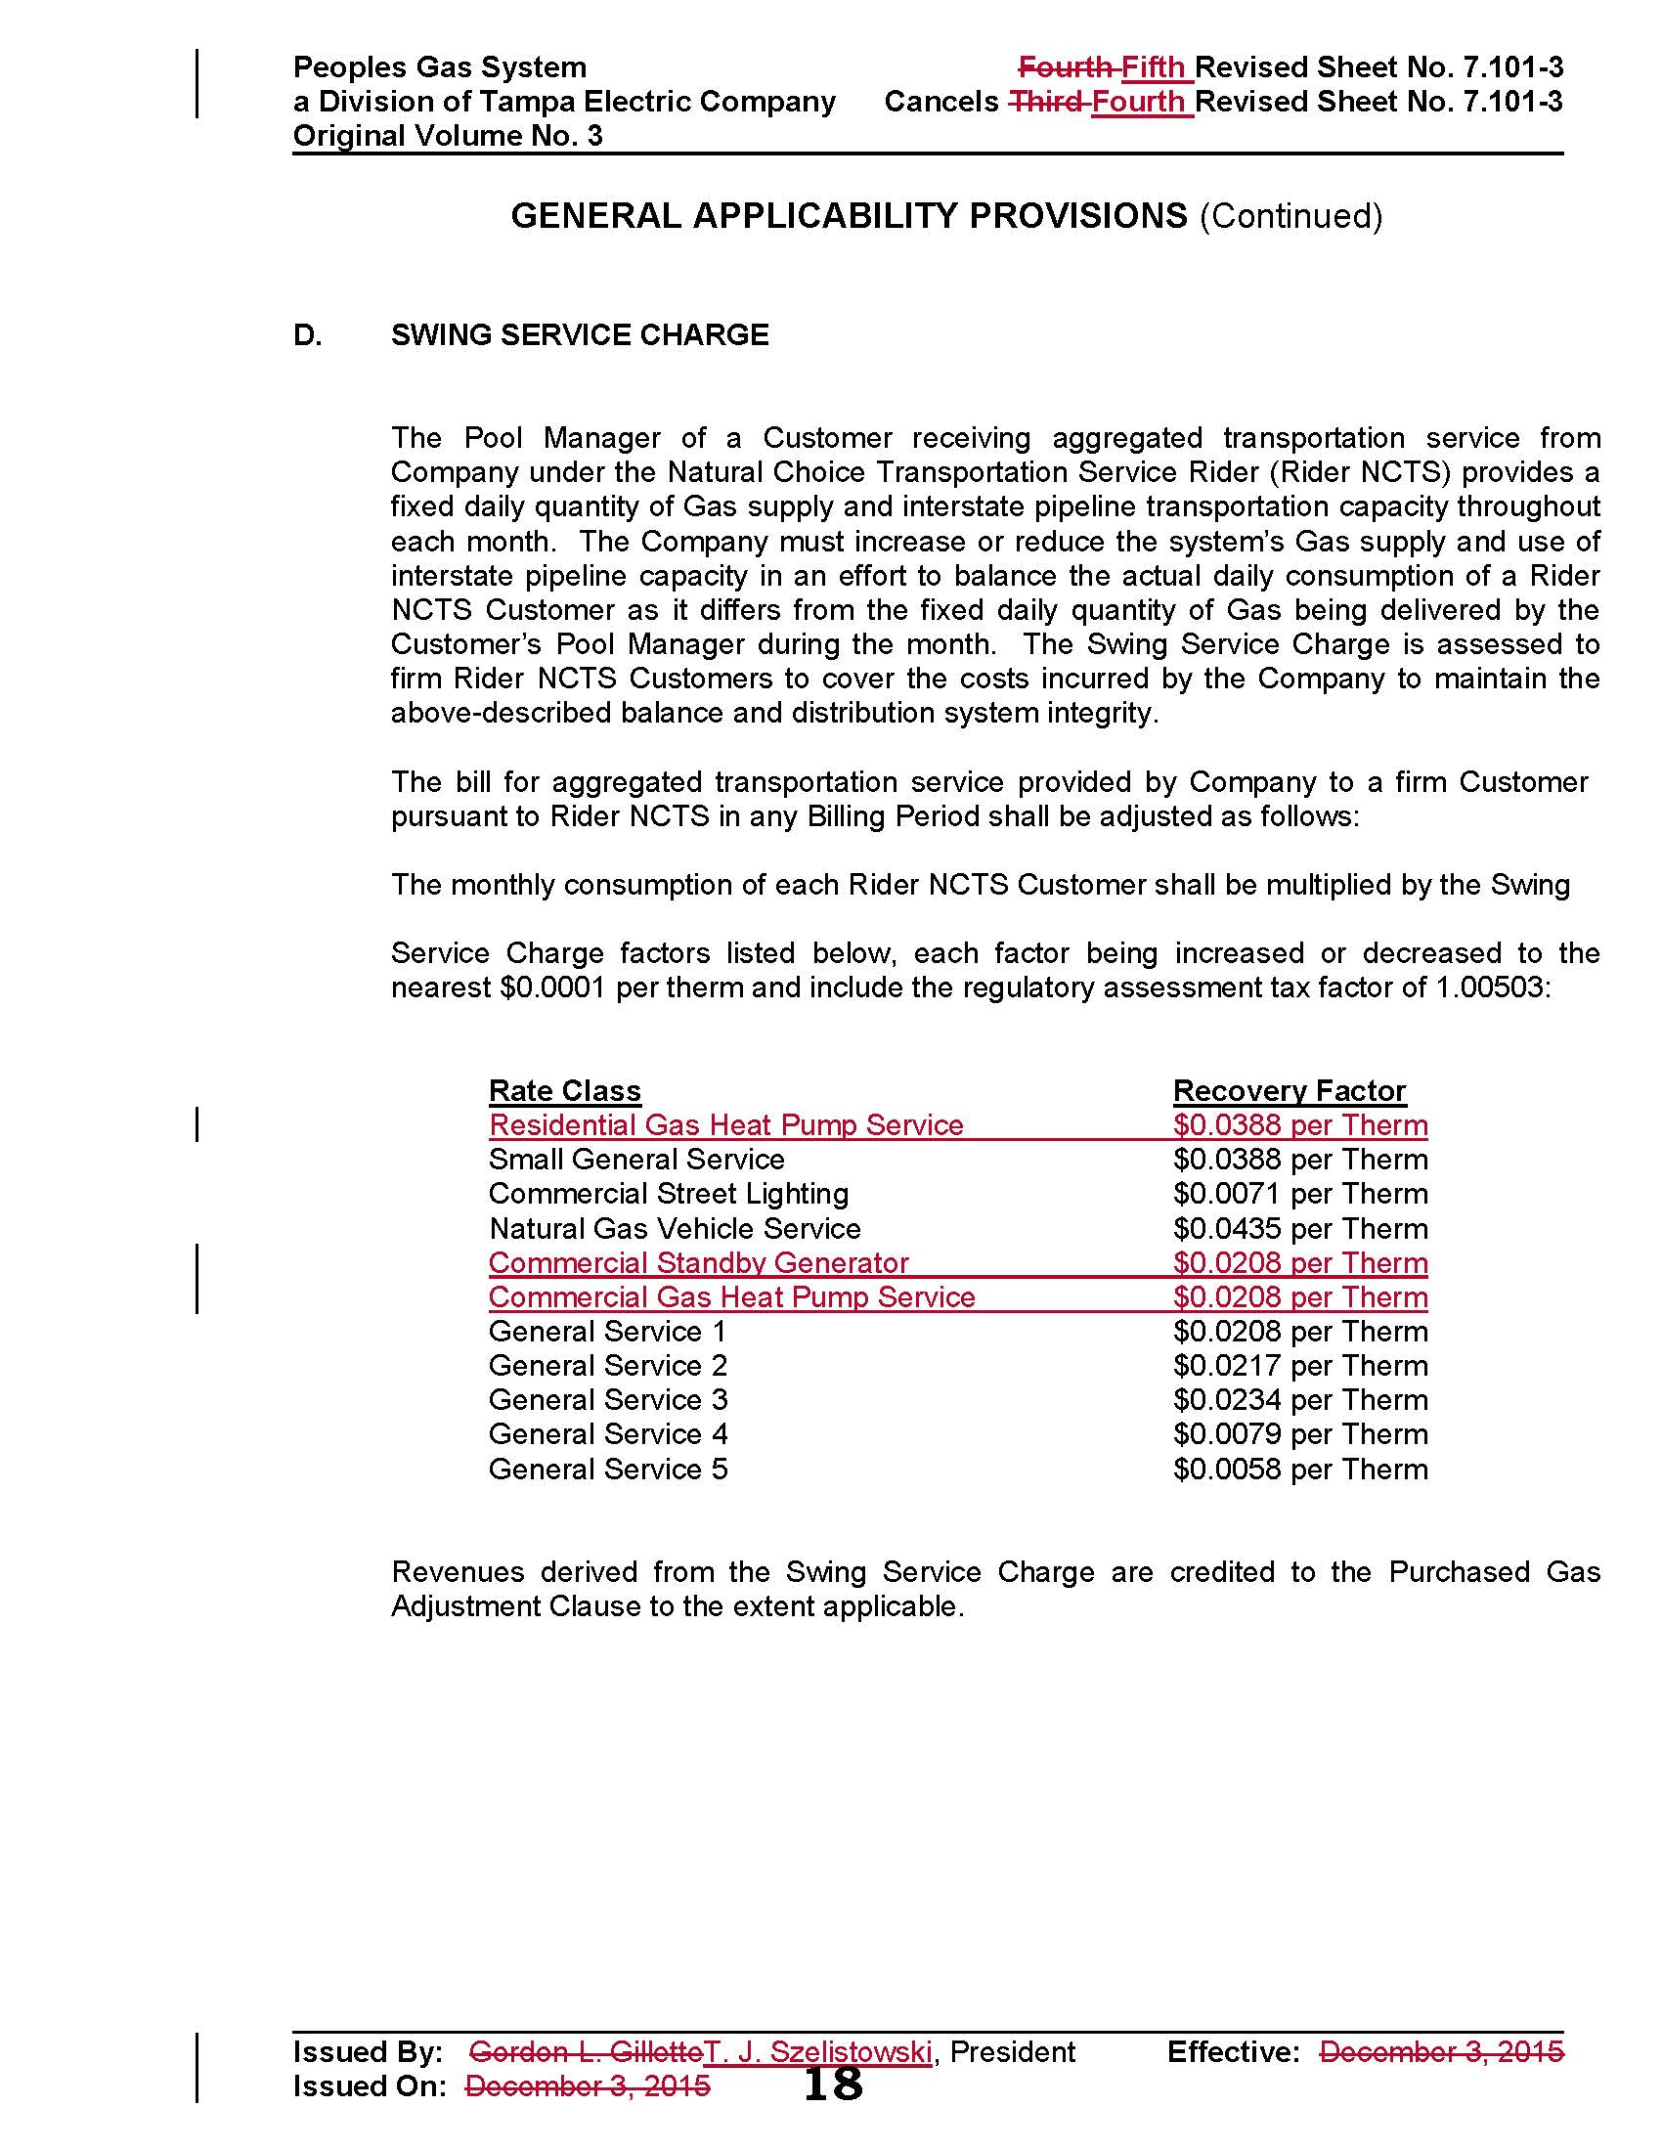

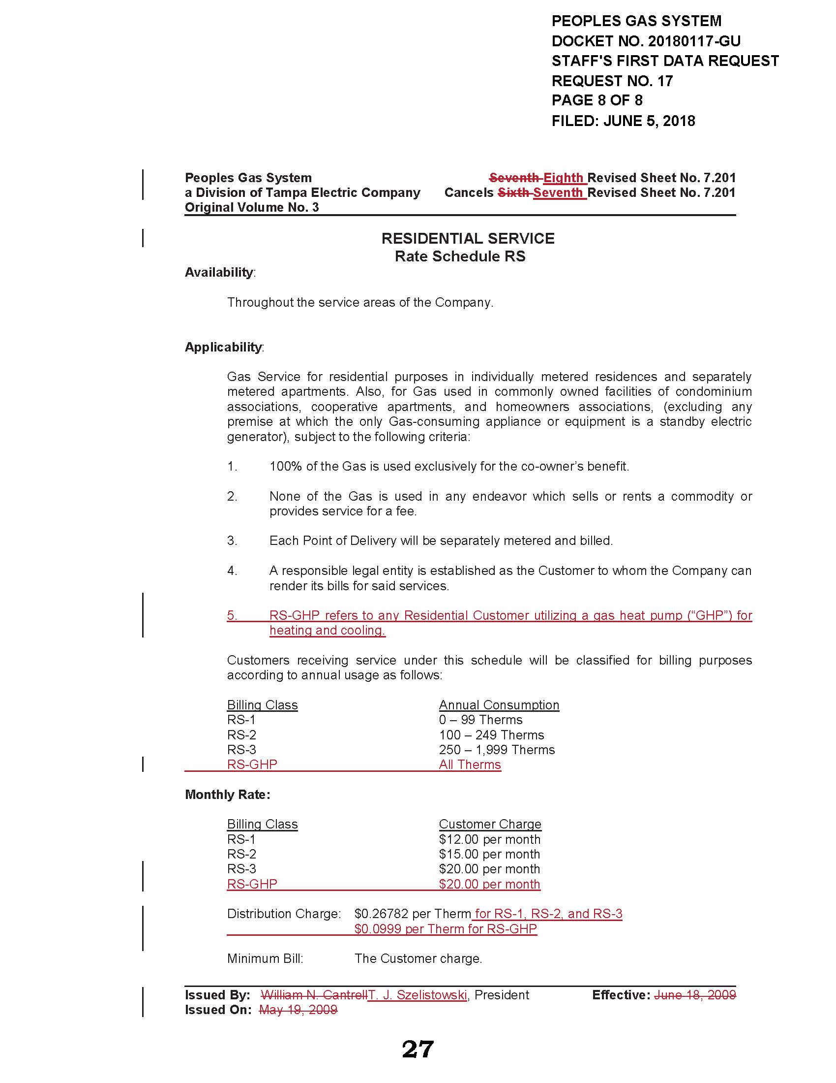

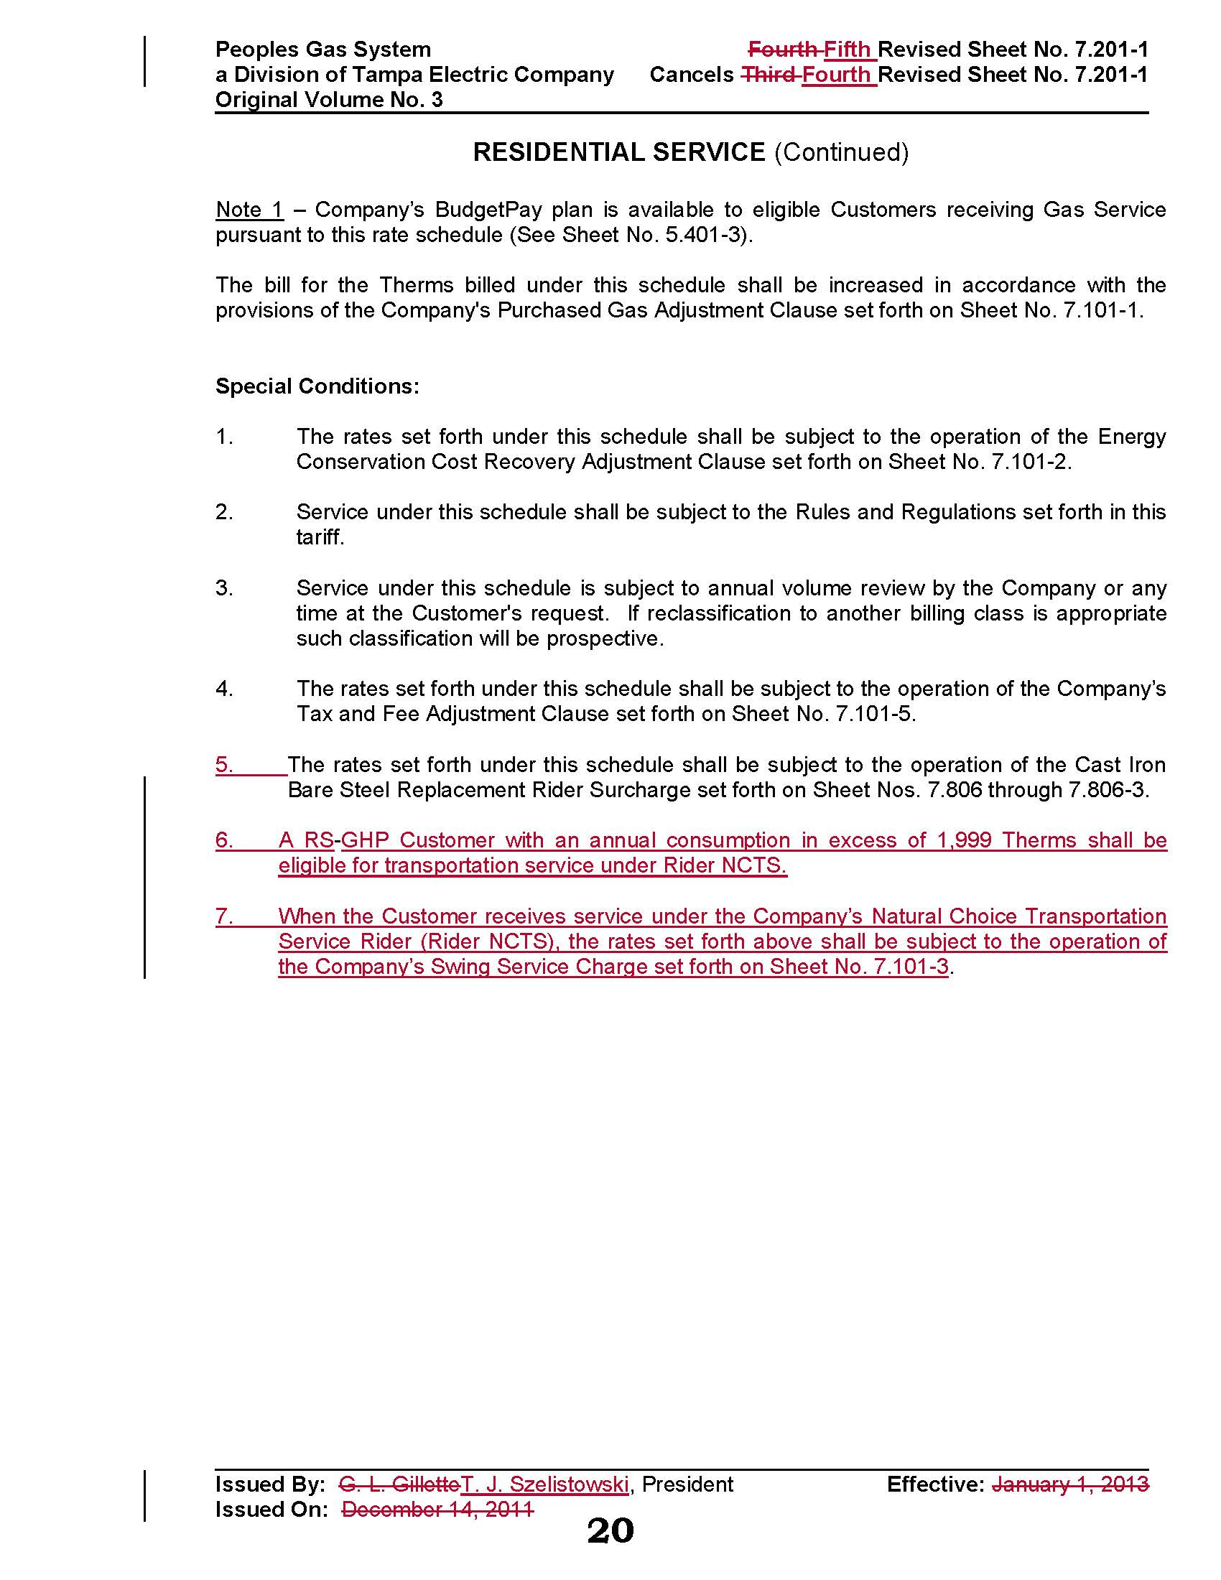

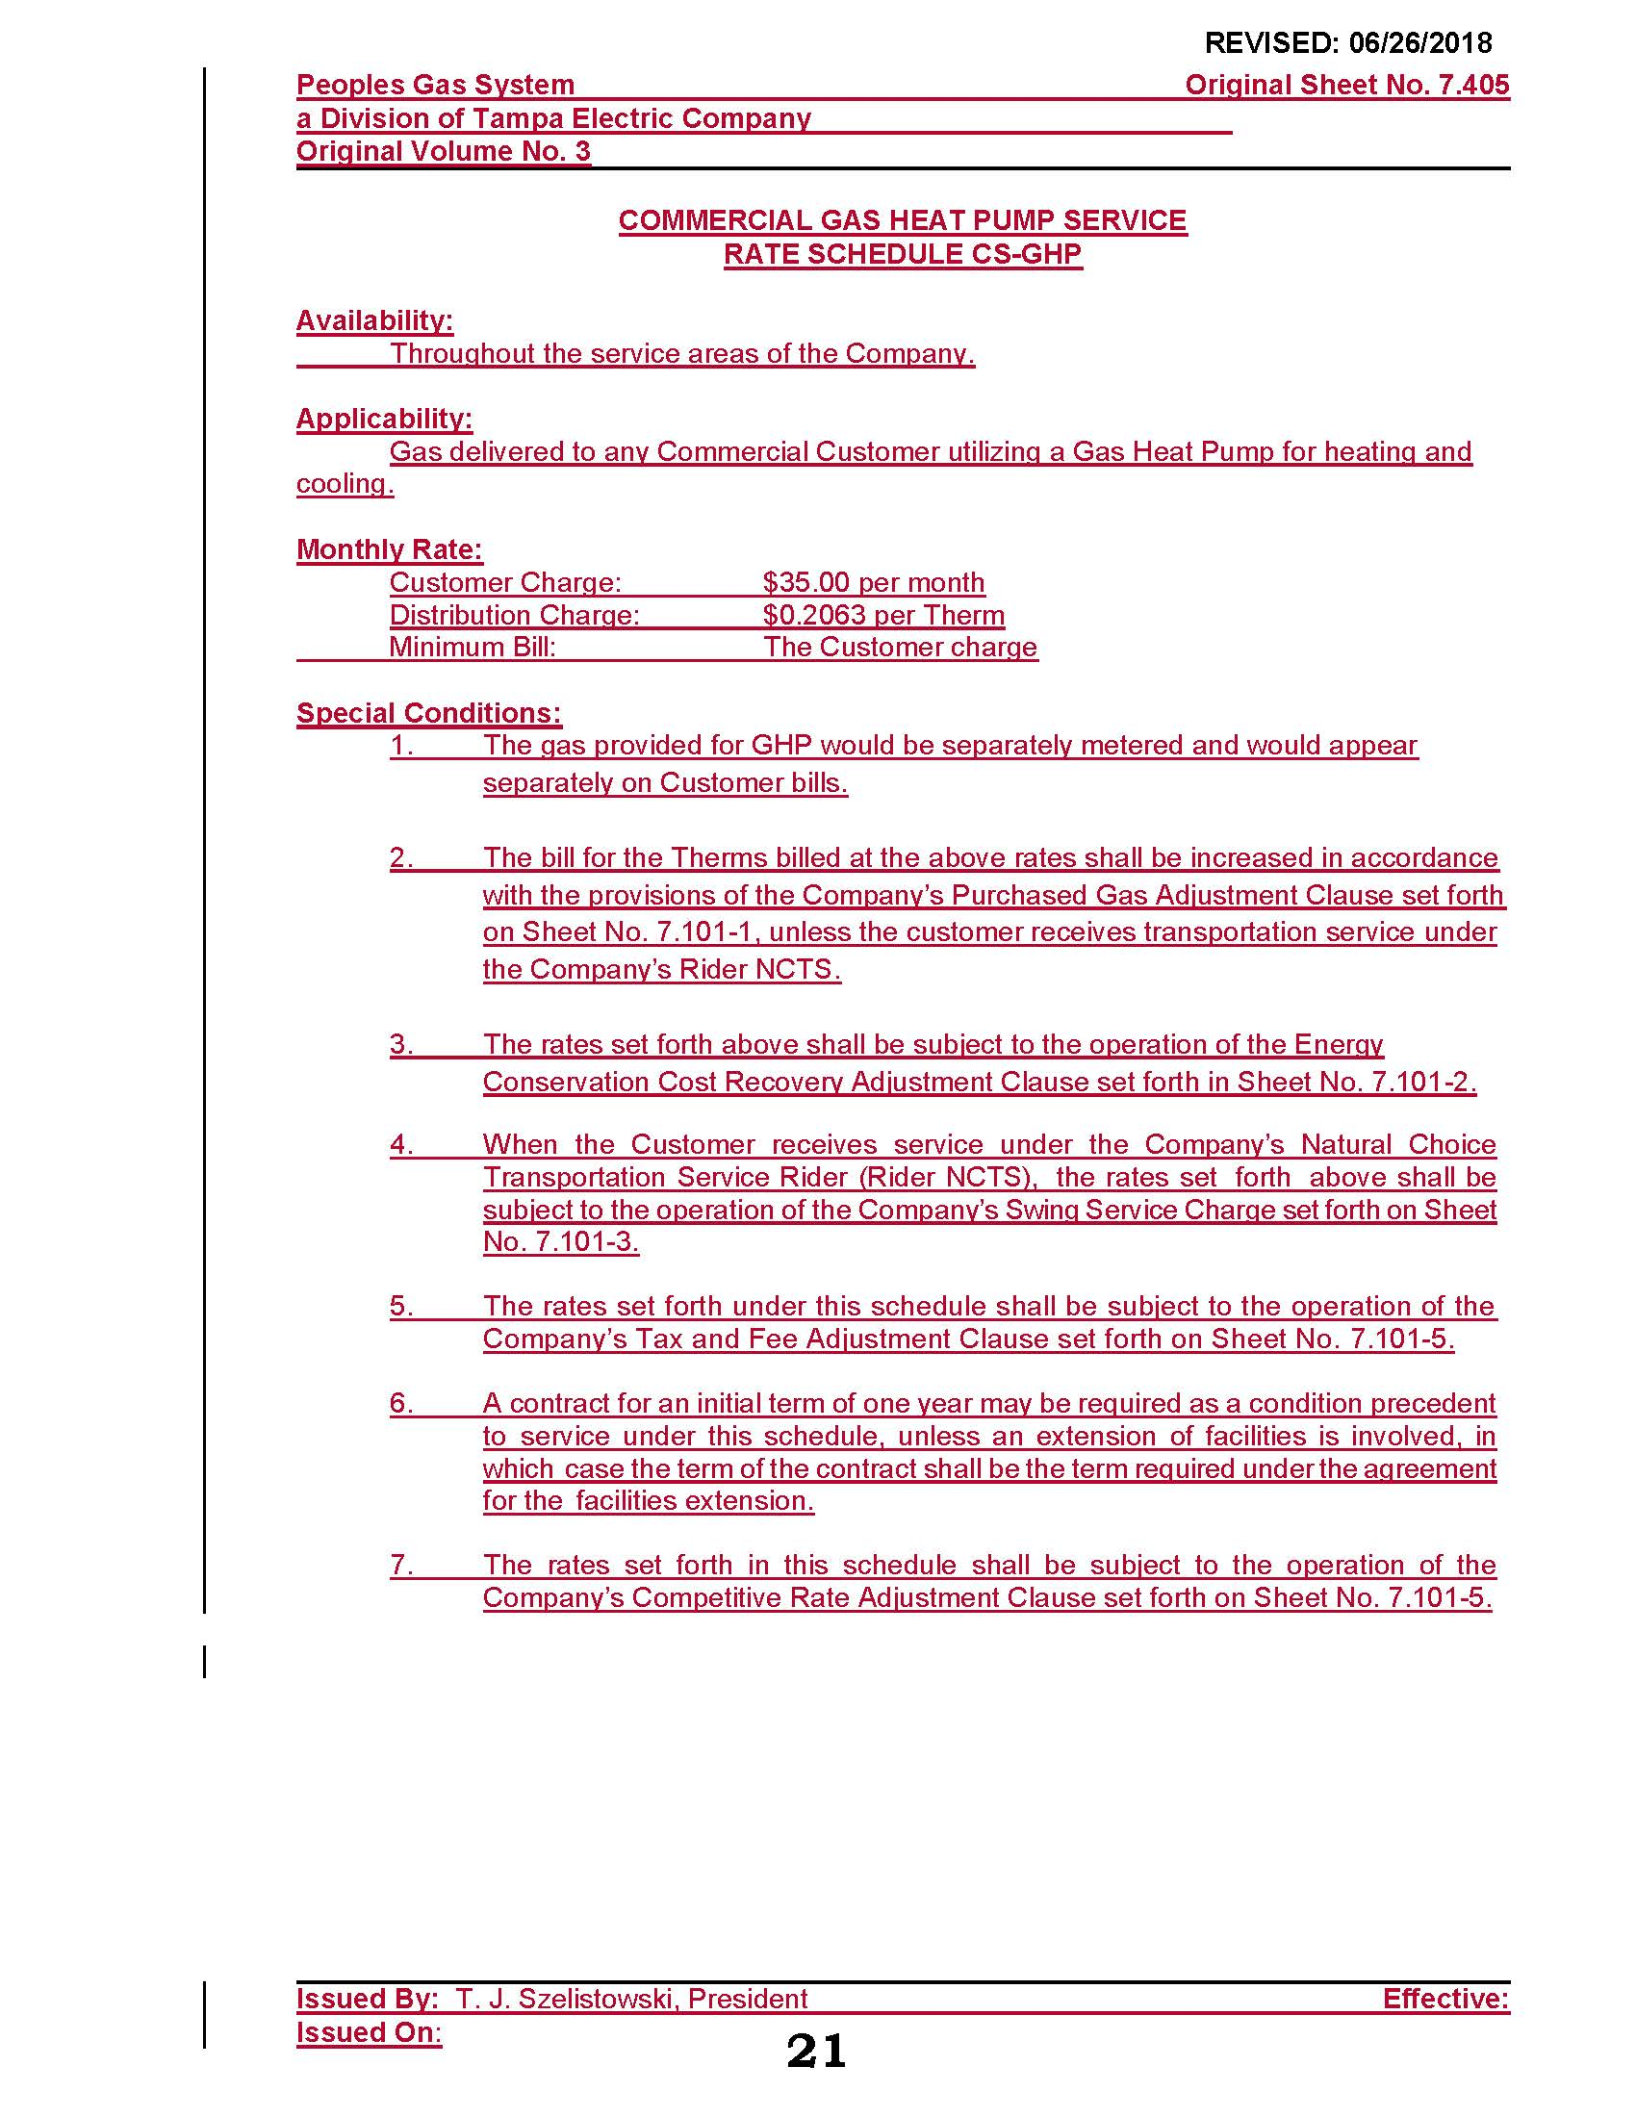

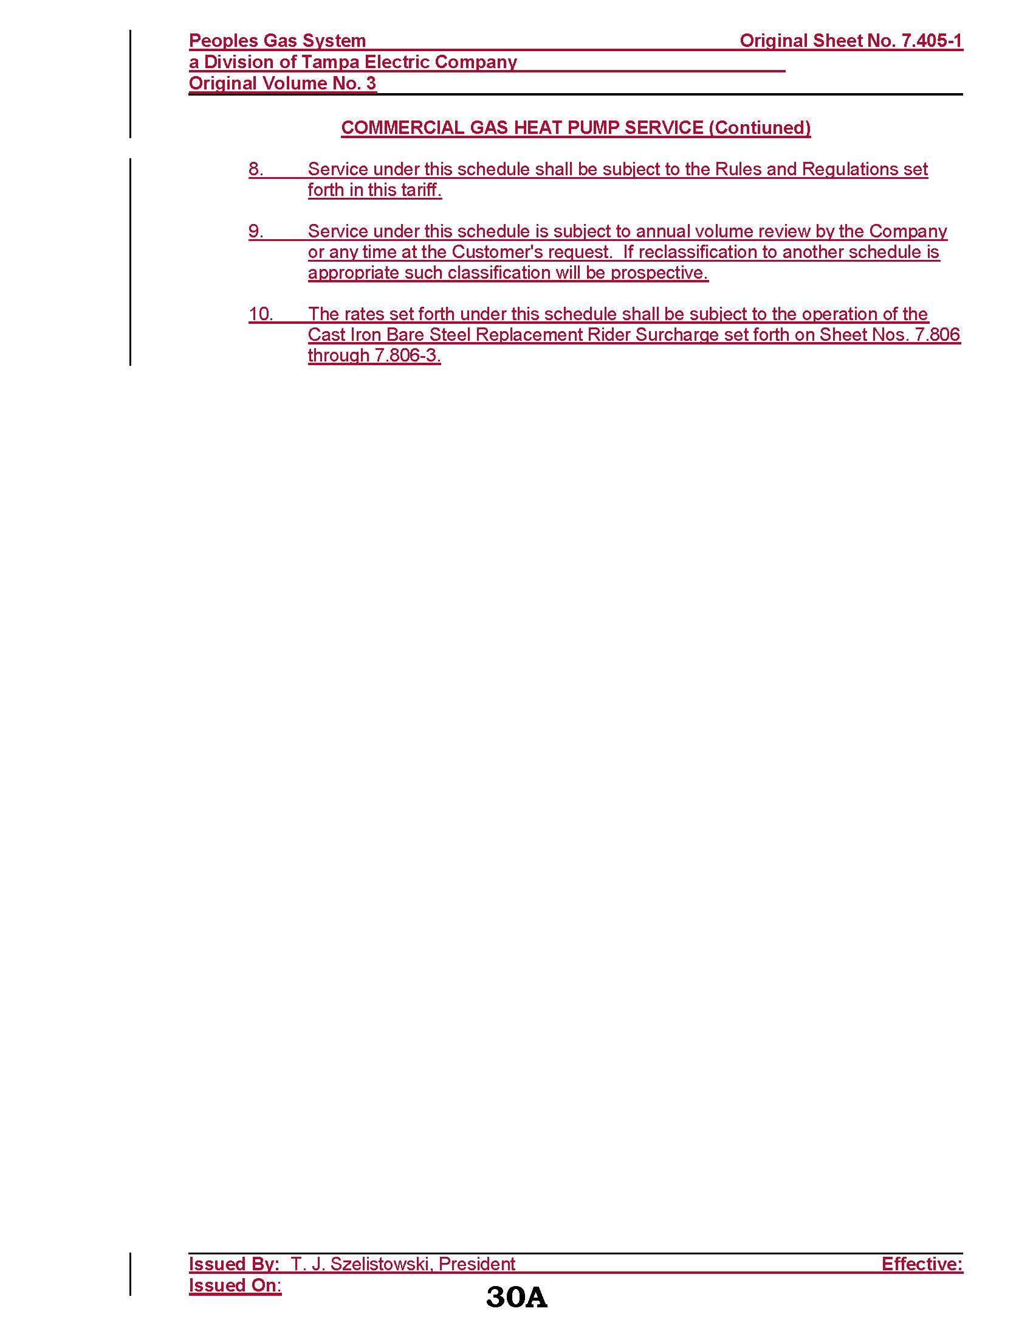

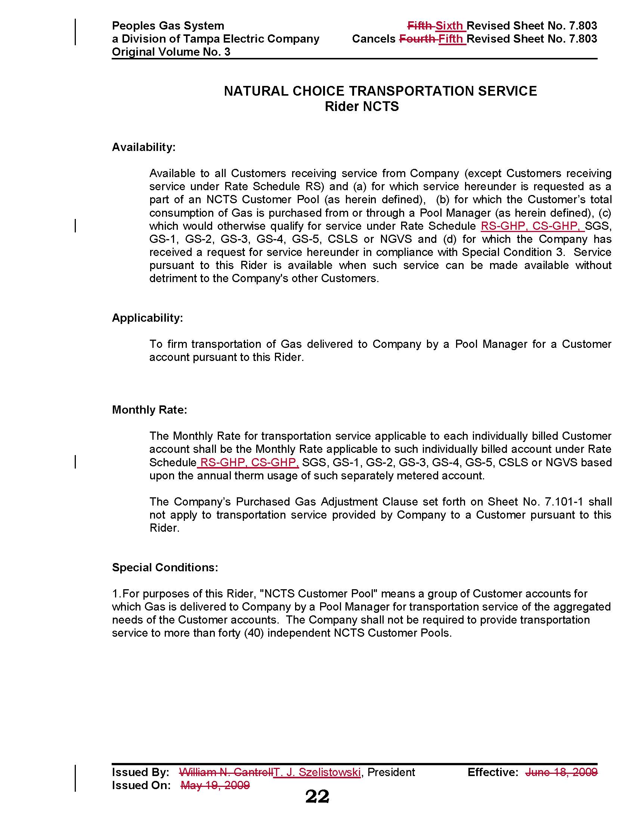

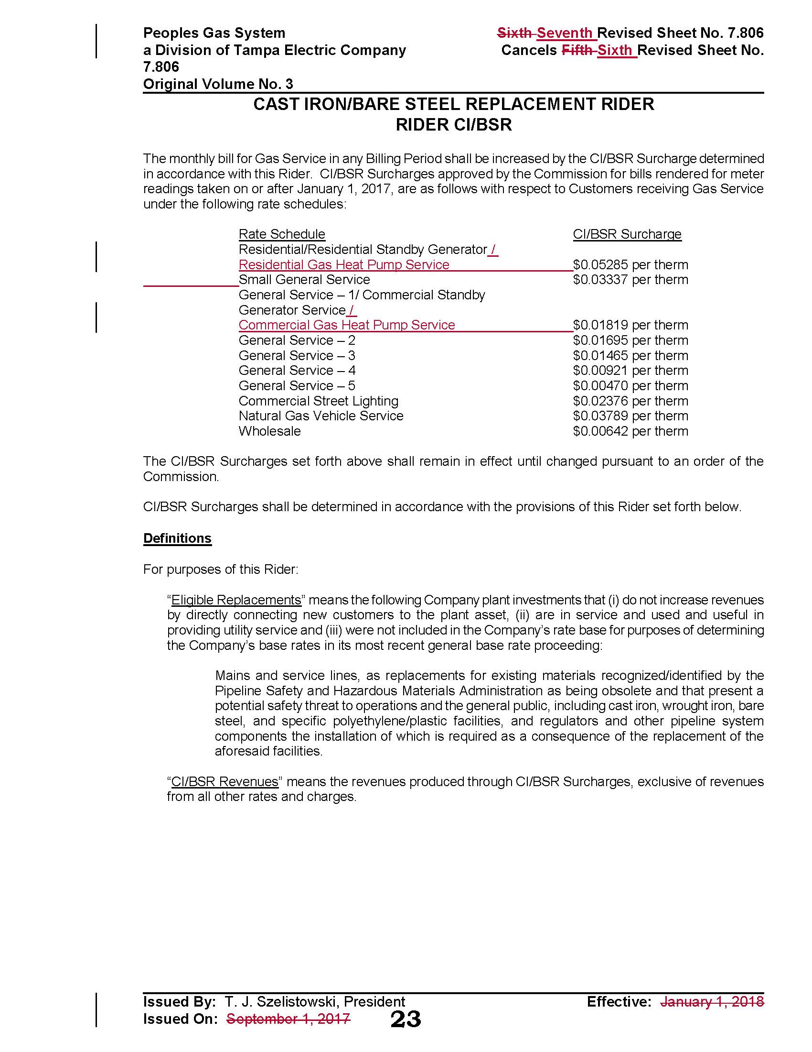

The calculation was included in Exhibit A to the petition; however, Peoples submitted a revised calculation to correct a minor error in response to Commission staff’s first data request No. 17.
Order No. PSC-10-0208-S-GU, issued April 5, 2010, in Docket No. 080318-GU, In re: Petition for rate increase by Peoples Gas System.
Proposed tariff sheet No. 7.101-3 also adds the Swing Service Charge for the Commercial Standby Generator rate class, which was approved in Order PSC-07-0530-TRF-GU. The utility states that this charge was inadvertently left off of the tariff sheet, therefore, the utility is including it at this time.

