BEFORE THE FLORIDA PUBLIC SERVICE COMMISSION

In re: Joint petition for approval of swing service rider, by Florida Public Utilities Company, Florida Public Utilities Company-Indiantown Division, Florida Public Utilities Company-Fort Meade, and Florida Division of Chesapeake Utilities Corporation. | DOCKET NO. 20180158-GU  ORDER NO. PSC-2018-0557-TRF-GU  ISSUED: November 20, 2018

The following Commissioners participated in the disposition of this matter:

ART GRAHAM, Chairman
JULIE I. BROWN
DONALD J. POLMANN
GARY F. CLARK
ANDREW GILES FAY

ORDER APPROVING SWING SERVICE RIDER

BY THE COMMISSION:

Background
On August 31, 2018, Florida Public Utilities Company, Florida Public Utilities Company – Indiantown Division, and Florida Public Utilities Company – Fort Meade (jointly, FPUC), as well as the Florida Division of Chesapeake Utilities Corporation (Chesapeake) (jointly, companies), filed a petition for approval of a revised swing service rider tariff for the period January through December 2019. FPUC is a local distribution company (LDC) subject to the regulatory jurisdiction of this Commission pursuant to Chapter 366, Florida Statutes (F.S.). FPUC is a wholly-owned subsidiary of Chesapeake Utilities Corporation, which is headquartered in Dover, Delaware. Chesapeake is also an LDC subject to this Commission’s jurisdiction under Chapter 366, F.S., and is an operating division of Chesapeake Utilities Corporation.
We first approved the companies’ swing service rider tariff by Order No. PSC-16-0422-TRF-GU (swing service order) and the initial swing service rider rates were in effect for the period March through December 2017. As required in the swing service order, the companies submitted the instant petition with revised 2019 swing service rider rates for our approval by September 1, 2018. The swing service rider is a cents per therm charge that is included in the monthly gas bill of transportation customers.
During its evaluation of the petition, Commission staff issued two data requests to the companies for which responses were received on September 24, 2018 and October 4, 2018. The revised tariff sheets, approved herein, are shown in Attachment A to this order. We have jurisdiction over this matter pursuant to Sections 366.04, 366.05, and 366.06, F.S.

Decision
The companies incur intrastate capacity costs when they transport natural gas on intrastate pipelines (i.e., pipelines operating within Florida only). The companies have two types of natural gas customers: sales and transportation customers. The swing service rider allows the companies to recover the intrastate capacity costs directly from all transportation customers as intrastate pipeline projects benefit all customers.
Sales customers are primarily residential and small commercial customers that purchase natural gas from an LDC and receive allocations of intrastate capacity costs through the Purchased Gas Adjustment (PGA) charge. Only Florida Public Utilities Company and Florida Public Utilities Company – Fort Meade have sales customers.
Transportation customers receive natural gas from third party marketers or shippers and, therefore, do not pay the PGA charge to the LDC. The companies’ transportation customers can be categorized as TTS (Transitional Transportation Service) or non-TTS. TTS program shippers purchase gas for residential and small commercial customers, in aggregated customer pools, who do not contract directly with a shipper for their gas supply. Only Florida Public Utilities Company – Indiantown Division (Indiantown) and Chesapeake have TTS customers.
TTS customers receive allocations of intrastate capacity costs through the swing service rider. Prior to the approval of the swing service rider, TTS customers received allocations of intrastate capacity cost through the Operational Balancing Account (OBA) mechanism. The OBA mechanism allowed Indiantown and Chesapeake to assign intrastate capacity costs to TTS shippers, who then passed the costs on to the TTS customers for whom they purchase gas. With the approval of the swing service rider, TTS customers are now charged directly their allocated portion of the intrastate capacity costs (rather than Indiantown and Chesapeake charging the shippers who then passed the costs on to the TTS customers).
Non-TTS customers are primarily large commercial or industrial customers who contract directly with a shipper for their natural gas supply. Prior to the approval of the swing service rider, non-TTS customers were not paying a share of the intrastate capacity costs. We approved a stepped implementation process for the swing service rider for non-TTS customers because the implementation of the swing service rider could have a significant financial impact on those customers who previously had not been allocated any portion of the intrastate capacity costs.
Specifically, the swing service order approved a five-year implementation period for non-TTS customers with a 20 percent per year stepped allocation. Accordingly, the 2018 swing service charges included a 40 percent allocation of intrastate capacity costs to the non-TTS customers; the instant petition includes a 60 percent allocation of intrastate capacity costs to the non-TTS customers. Therefore, the proposed 2019 swing service rider rates for the non-TTS transportation customers increased. The proposed 2019 swing service rider rates for TTS transportation customers, on the other hand, decreased as a result of the increased allocation of costs to the non-TTS customers.

Proposed Swing Service Rider Rates

The proposed 2019 swing service rider rates were calculated based on the same methodology approved in the swing service order. As shown in the companies’ petition, the total intrastate capacity costs for the period July 2017 through June 2018 are $7,396,034. The total intrastate capacity costs reflect payments by FPUC to intrastate pipelines for the transportation of natural gas pursuant to Commission approved transportation agreements. In addition, the intrastate capacity costs include payments for outside contractors FPUC hired to provide expertise on the purchase of commodity and capacity.
Some of these costs ($3,620,456) will be billed directly to certain large special contract customers. The remaining costs, $3,775,578 ($7,396,034 - $3,620,456), are allocated between sales and transportation customers.
The companies used actual therm usage data for the period July 2017 through June 2018 to allocate the intrastate capacity costs. Based on the usage data, the appropriate split for allocating the cost is 70.16 percent ($2,648,874) to transportation customers and 29.84 percent ($1,126,704) to sales customers. The sales customers’ share of the cost is embedded in the PGA.
The transportation customers’ share is allocated to the various transportation rate schedules in proportion with each rate schedule’s share of the companies’ total throughput. The cost allocated to each rate schedule is then divided by the rate schedule’s number of therms to calculate the swing service rider rates.
As stated previously, TTS customers are charged their allocated portion of the intrastate capacity costs, while non-TTS customers are subject to a phased implementation. Since non-TTS customers are only allocated 60 percent of the total intrastate capacity costs, the 2019 swing service revenues the companies will receive will total $1,702,175; the remaining $946,699 ($2,648,874 - $1,702,175) of intrastate capacity costs allocated to transportation customers will be recovered through the PGA cost recovery clause from sales customers.

Credit to the PGA

The total intrastate capacity costs are embedded in the PGA with the projected 2019 swing service rider revenues incorporated as a credit in the calculation of the 2019 PGA. The amount credited to the 2019 PGA is $1,702,175, plus $3,620,456 received from special contract customers, for a total of $5,322,631. At the end of the stepped implementation period in year five, non-TTS customers will no longer receive a reduced allocation of the intrastate capacity cost, the credit to the PGA will increase accordingly, and sales customers will no longer absorb a portion of the non-TTS intrastate capacity costs.

Conclusion

Based on our review of the information provided in the petition and in response to Commission staff’s data requests, we find that the companies’ proposed swing service rider is reasonable. We reviewed the total projected intrastate capacity costs and verified that the costs included are appropriate. We therefore approve the proposed swing service rider rates for the period January through December 2019. The costs included are appropriate and the methodology for calculating the swing service rider rates is consistent with the swing service order.

Based on the foregoing, it is

ORDERED by the Florida Public Service Commission that the revised swing service rider rates for Florida Public Utilities Company, Florida Public Utilities Company – Indiantown Division, and Florida Public Utilities Company – Fort Meade, and the Florida Division of Chesapeake Utilities Corporation are approved for the period January through December 2019. The costs included are appropriate and the methodology for calculating the swing service rider rates is consistent with the swing service order. It is further

ORDERED that if a protest is filed within 21 days of issuance of the Order, the tariff shall remain in effect with any charges held subject to refund pending resolution of the protest. It is further

ORDERED that if no timely protest is filed, this docket shall be closed upon the issuance of a Consummating Order.

By ORDER of the Florida Public Service Commission this 20th day of November, 2018.

/s/ Carlotta S. Stauffer
CARLOTTA S. STAUFFER
Commission Clerk
Florida Public Service Commission
2540 Shumard Oak Boulevard
Tallahassee, Florida 32399
(850) 413-6770
www.floridapsc.com

Copies furnished: A copy of this document is provided to the parties of record at the time of issuance and, if applicable, interested persons.

JSC

NOTICE OF FURTHER PROCEEDINGS

The Florida Public Service Commission is required by Section 120.569(1), Florida Statutes, to notify parties of any administrative hearing or judicial review of Commission orders that is available under Sections 120.57 or 120.68, Florida Statutes, as well as the procedures and time limits that apply. This notice should not be construed to mean all requests for an administrative hearing or judicial review will be granted or result in the relief sought.
Mediation may be available on a case-by-case basis. If mediation is conducted, it does not affect a substantially interested person's right to a hearing.

The Commission's decision on this tariff is interim in nature and will become final, unless a person whose substantial interests are affected by the proposed action files a petition for a formal proceeding, in the form provided by Rule 28-106.201, Florida Administrative Code. This petition must be received by the Office of Commission Clerk, 2540 Shumard Oak Boulevard, Tallahassee, Florida 32399-0850, by the close of business on December 11, 2018.

In the absence of such a petition, this Order shall become final and effective upon the issuance of a Consummating Order.

Any objection or protest filed in this docket before the issuance date of this order is considered abandoned unless it satisfies the foregoing conditions and is renewed within the specified protest period.

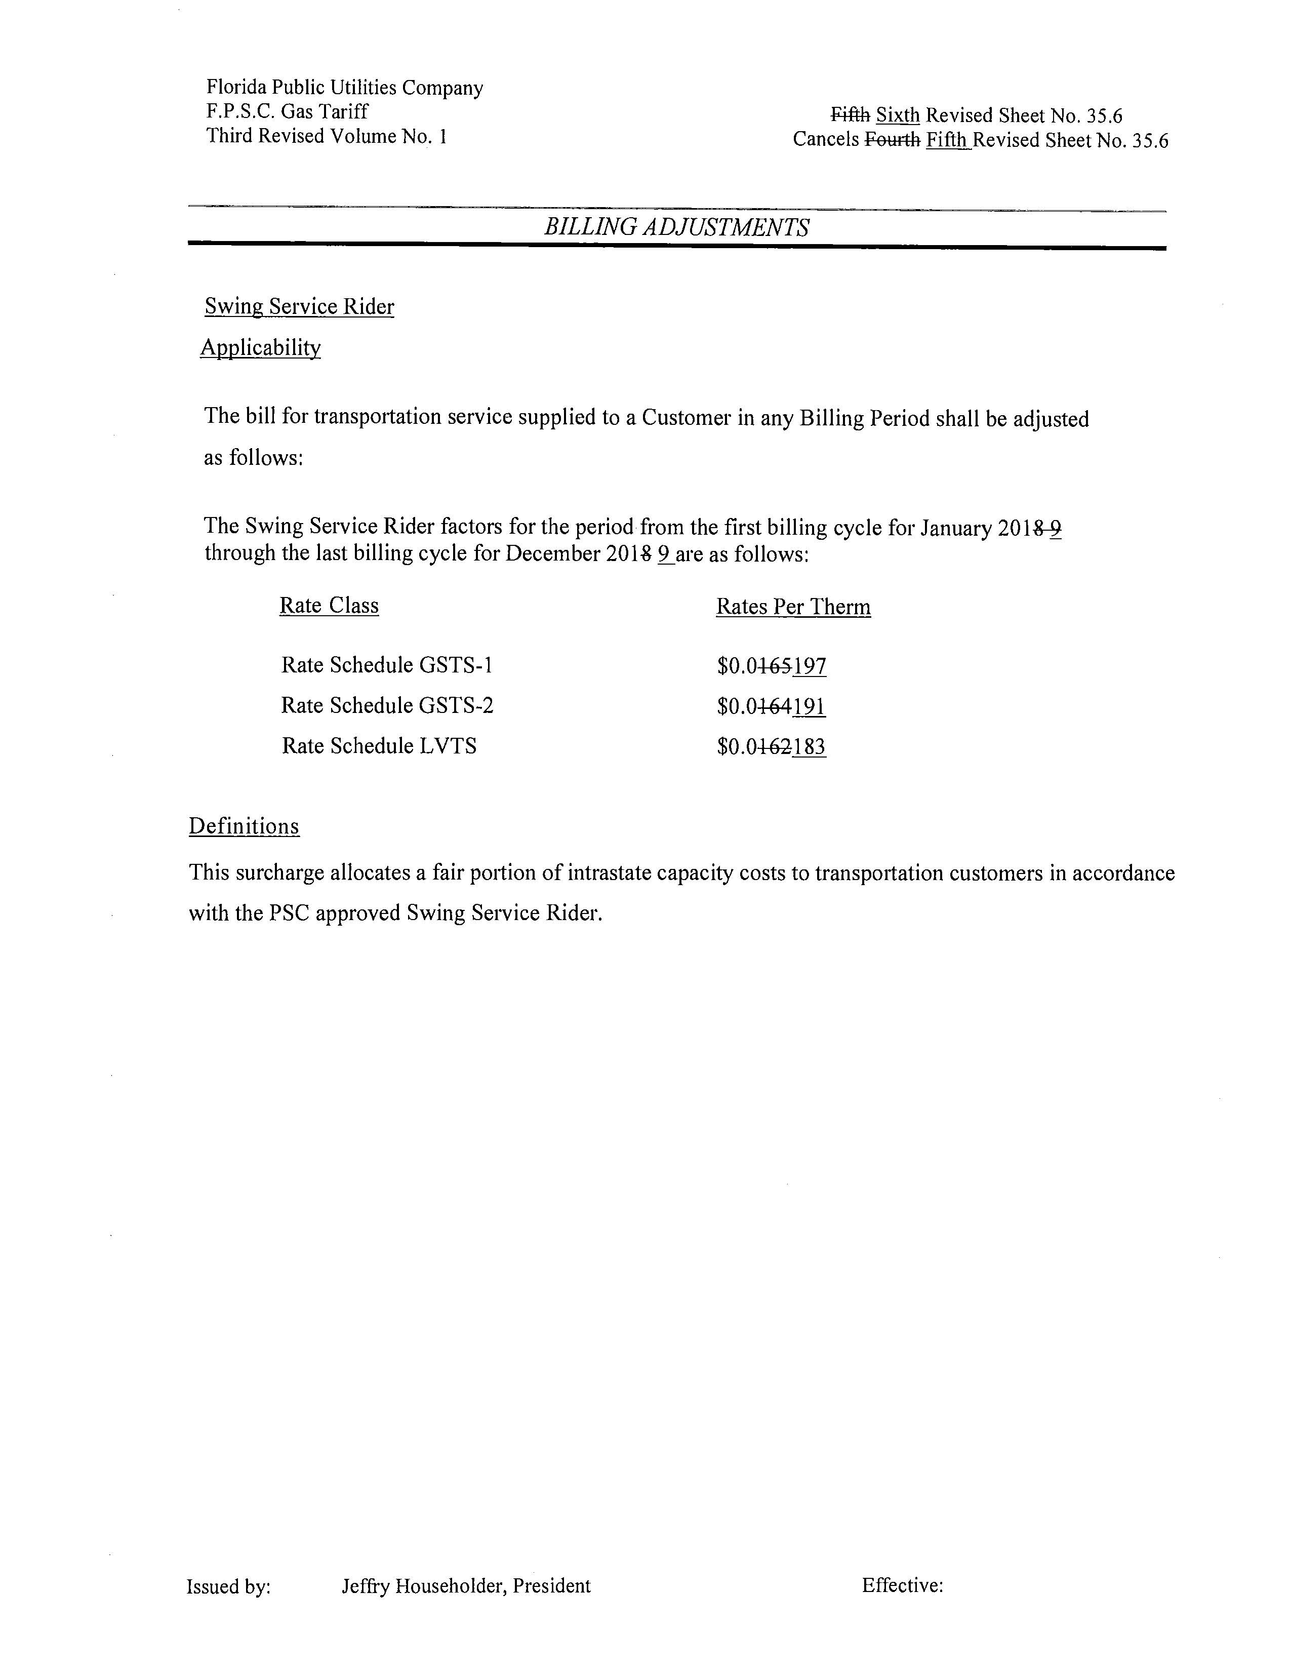

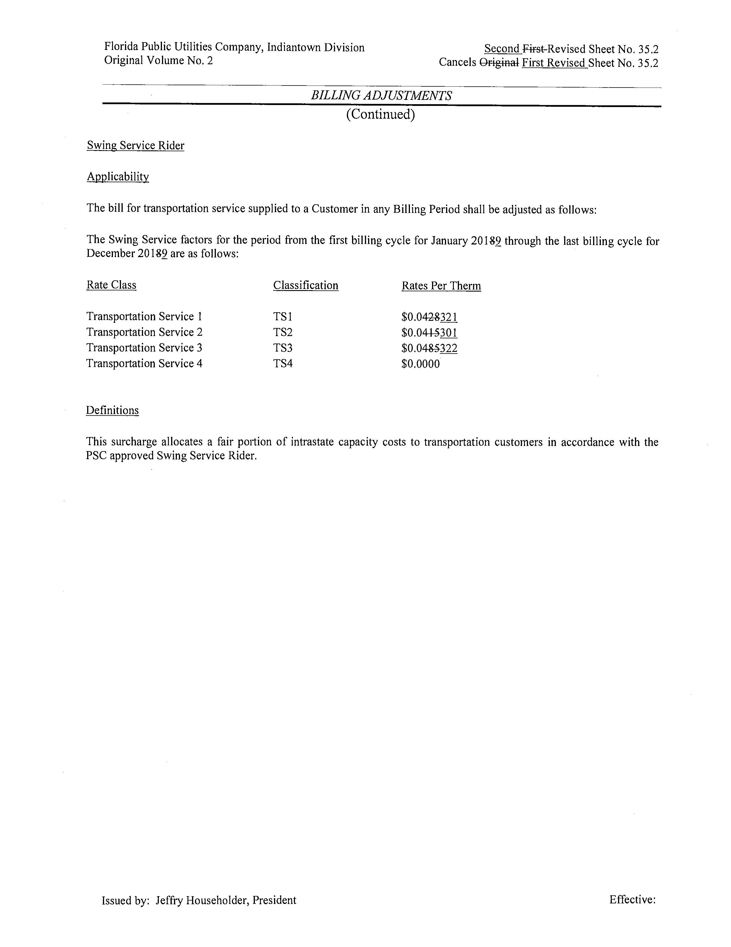
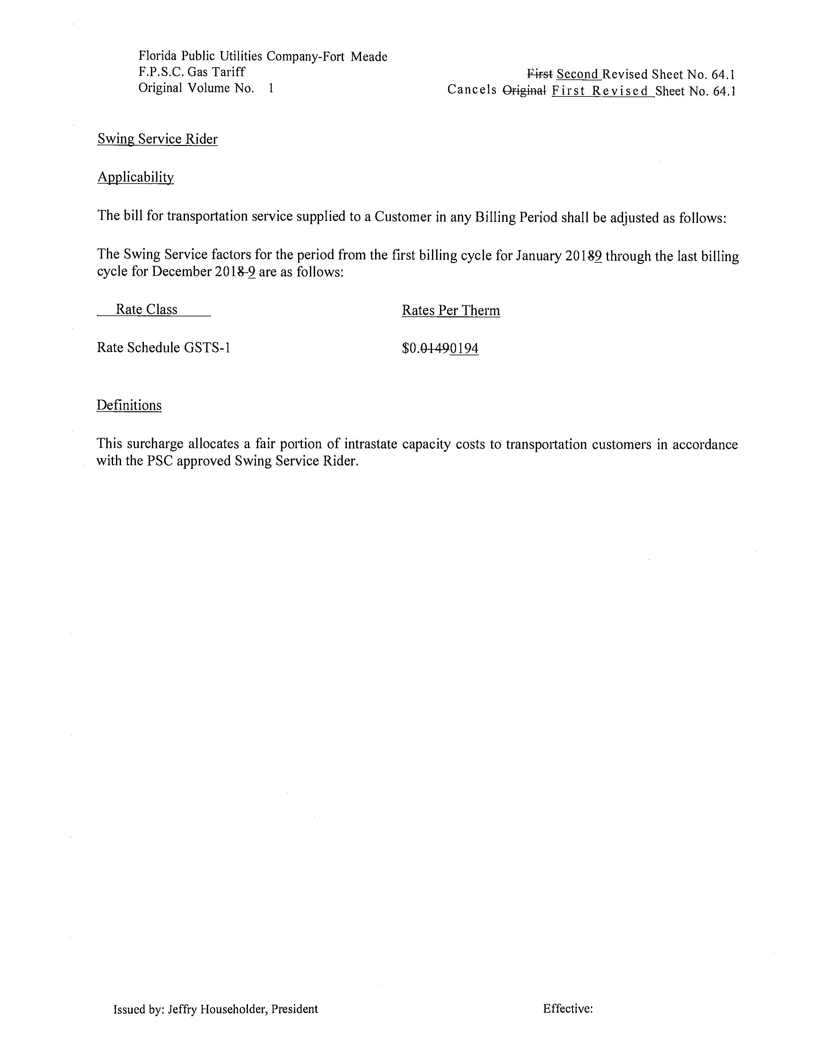

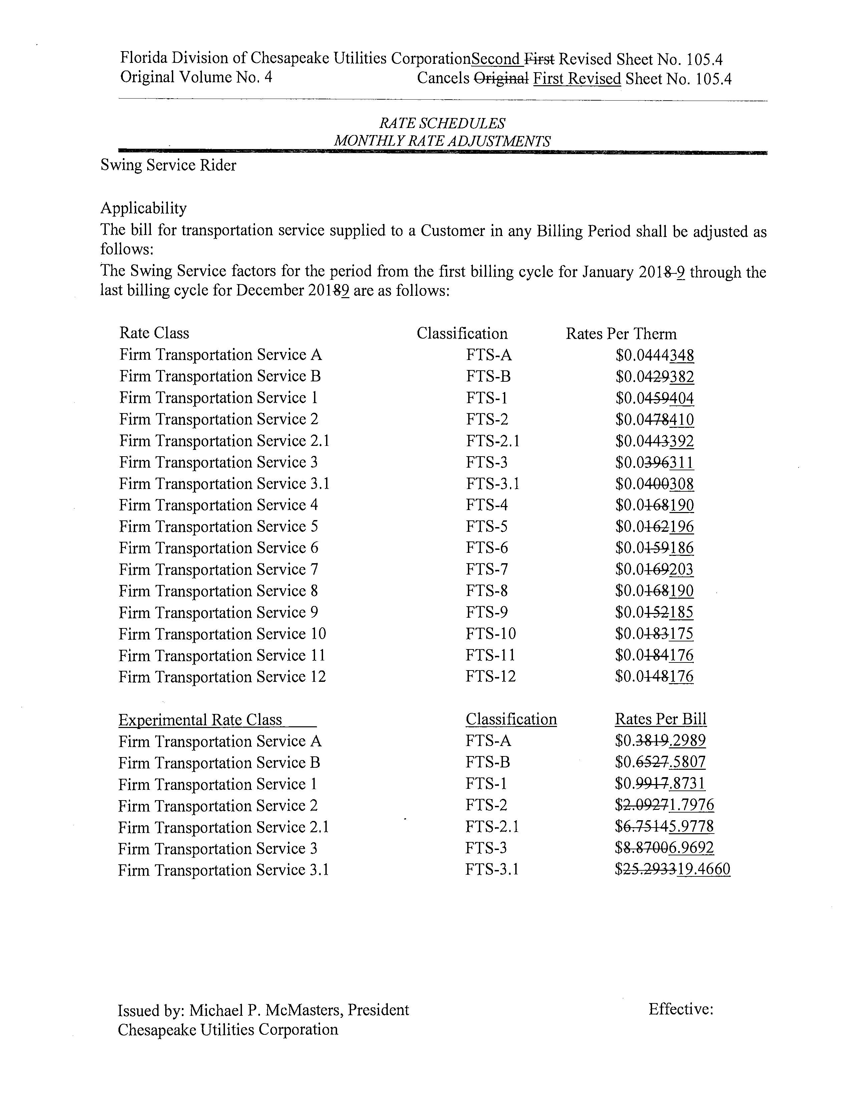

Order No. PSC-16-0422-TRF-GU, issued October 3, 2016, Docket No. 160085-GU, In re: Joint petition for approval of swing service rider, by Florida Public Utilities Company, Florida Public Utilities Company-Indiantown Division, Florida Public Utilities Company-Fort Meade, and Florida Division of Chesapeake Utilities Corporation.
The PGA charge is set by this Commission in the annual PGA proceeding.
This Commission does not regulate the shippers and their charges for the gas commodity.
The proposed swing service rider rates for Chesapeake’s non-TTS rate schedules FTS-10 and FTS-11 decreased due to a decline in volumes and allocated costs to those two rate classes.
See the Direct Testimony of Geoffrey Wight on behalf of FPUC, filed on August 20, 2018, Document No. 05422-2018, in Docket No. 20180003-GU, Exhibit No. GAW-2, page 1 of 6.

