State of Florida |  | Public Service Commission  Capital Circle Office Center ● 2540 Shumard Oak Boulevard  Tallahassee, Florida 32399-0850  -M-E-M-O-R-A-N-D-U-M-
DATE: | November 29, 2018
TO: | Office of Commission Clerk (Stauffer)
FROM: | Office of the General Counsel (Harper)  Division of Accounting and Finance (Galloway, Wilson)  Division of Economics (Guffey)
RE: | Docket No. 20180141-WS – Proposed adoption of Rule 25-30.4575, F.A.C., Operating Ratio Methodology.
AGENDA: | 12/11/18 – Regular Agenda – Interested Persons May Participate
COMMISSIONERS ASSIGNED: |  |  | All Commissioners
PREHEARING OFFICER: |  |  | Polmann
RULE STATUS: |  |  | Proposal May Be Deferred
SPECIAL INSTRUCTIONS: |  |  | None

Introduction and Summary of Changes
At the October 30, 2018 Agenda Conference, the Office of Public Counsel (OPC) asked the Commission to defer the item so that OPC and staff could further discuss a potential compromise on the rule language. The Commission deferred the item. On November 8, 2018, staff held an informal meeting on the rule, which included representatives from OPC, U.S. Water, OCBOA Consulting, LLC, and Florida Utility Services 1, LLC. As a result of the informal meeting with OPC and the interested persons, staff made changes to subsection (1) of the proposed rule which are summarized as follows:

- Including a $15,000 cap in subsection (1) of the rule (rather than no cap as staff initially proposed).
- In determining the revenue requirement, staff will apply a margin of 12 percent of the utility’s operation and maintenance expenses (rather than 15 percent as initially proposed by staff).

Staff believes these changes will not affect the number of utilities who should qualify for the operating ratio methodology. As a result of these changes made to the rule arising out of staff’s November 8, 2018 meeting, staff also made minor changes to this analysis, which are reflected below in type and strike.

Case Background
Pursuant to Section 367.0814(9), Florida Statutes (F.S.), the Commission may by rule establish standards and procedures whereby rates and charges of small utilities are set using criteria other than those set forth in Sections 367.081(1), (2)(a) and (3), F.S. Rule 25-30.4575, Operating Ratio Methodology, Florida Administrative Code (F.A.C.), will be a new rule that sets forth the Commission’s policy on the use of the operating ratio methodology in staff-assisted rate cases (SARC). The proposed rule is included as Attachment A. The operating ratio methodology is used to determine the revenue requirement in certain staff-assisted water and wastewater rate cases and is an alternative to the traditional calculation of revenue requirement for smaller water and wastewater utilities. The operating ratio methodology substitutes the utility’s operation and maintenance expenses for rate base in calculating the amount of return.

The operating ratio methodology was first introduced in Docket No. 950641-WU, an application for a SARC in Palm Beach County by Lake Osborne Utilities Company, Inc. (Lake Osborne). In a SARC, the Commission is charged with approving a revenue requirement that will provide a utility with the opportunity not only to recover its operating expenses, but also to earn a fair return on its investment (or margin).

However, when a utility’s rate base is small or negative, as was the case for Lake Osborne, the utility could be subject to an inadequate margin or no margin at all. As such, the utility is unable to effectively deal with extraordinary events, unexpected expenses and repairs, and has a reduced incentive for further investment. A utility that lacks the funds to make necessary repairs has a significantly reduced ability to provide safe and reliable service to its customers. To assist these water and wastewater utilities with these circumstances and protect the customers’ ability to receive safe and reliable service, after approval of the Lake Osborne case, the Commission began utilizing the operating ratio methodology as an alternative to the traditional calculation of revenue requirement for smaller water and wastewater utilities that apply for a SARC.

Before considering applying the operating ratio methodology for subsequent SARCs, the Commission established the following threshold qualifying criteria in the Lake Osborne Order: (1) whether the utility’s operation and maintenance (O&M) expense exceeds rate base, and (2) whether the utility is expected to become a Class B utility in the foreseeable future. The Commission noted that additional factors could be considered such as: (1) quality of service and condition of plant, (2) whether the utility is developer-owned, and (3) whether the utility operates treatment facilities or is simply a distribution and/or collection system. Collectively, these criteria have been used in subsequent SARCs in order to determine whether or not the operating ratio methodology was appropriate.

In the Lake Osborne Order, the Commission recognized that by implementing Section 367.0814, F.S. (the SARC statute), the Legislature recognized that the segment of the water and wastewater industry comprised of Class C utilities is significantly different from the remainder of regulated water and wastewater utilities. That Order also established that an alternative to the traditional calculation of revenue requirement was within the Commission’s jurisdiction.

Since the Lake Osborne Order, approximately 167 SARCs have been filed with the Commission. Staff recommended applying the operating ratio methodology in 23 dockets, and the Commission has approved the methodology in 21 of those dockets. A summary of these dockets is included as Attachment B. Staff initiated this rulemaking to codify the Commission’s long-standing practice regarding the operating ratio methodology and to evaluate the necessary components needed in the rule to reflect the conditions currently faced by small water and wastewater utilities.

The Commission’s Notice of Development of Rulemaking for Rule 25-30.4575, F.A.C., Operating Ratio Methodology, was published in Volume 43, No. 229, of the Florida Administrative Register on November 29, 2017. On December 14, 2017, staff held a Rule Development Workshop. Representatives from the Office of Public Counsel (OPC) and U.S. Water Services Corporation (U.S. Water) participated at the workshop and submitted post-workshop comments. Additionally, representatives from Utilities Inc. of Florida attended the workshop but did not submit post-workshop comments.

This recommendation addresses whether the Commission should propose the adoption of Rule 25-30.4575, F.A.C. The Commission has jurisdiction pursuant to Section 120.54, F.S., and Section 367.0814, F.S.

Discussion of Issues

Issue 1:
Should the Commission propose the adoption of Rule 25-30.4575, F.A.C., Operating Ratio Methodology?

Recommendation:
Yes, the Commission should propose the adoption of Rule 25-30.4575, F.A.C., as set forth in Attachment A. The Commission should certify Rule 25-30.4575, F.A.C., as a minor violation rule. (Harper, Galloway)

Staff Analysis:
In a staff-assisted rate case (SARC), a calculation is made to determine the utility’s revenue requirement. The revenue requirement reflects the monies a utility needs to recover its operating expenses and provide it with an opportunity to earn a fair rate of return on its investment.

The traditional calculation of revenue requirement for smaller water and wastewater utilities is achieved by adding the operation and maintenance (O&M) expenses to the net depreciation expense, amortization expense, taxes other than income taxes, income taxes, and a return on investment. The “return on investment” for SARCs is the overall rate of return multiplied by the amount of rate base. All of these components added together make up the revenue requirement in a SARC through traditional ratemaking. However, in some SARCs, traditional ratemaking, also referred to as the rate of return methodology, does not always provide sufficient revenue to protect against potential variances in revenue and expenses. In these cases, the utility may qualify for the operating ratio methodology.

When the operating ratio methodology is applied, instead of calculating the revenue requirement by including the return on investment (rate of return x rate base), the “return on investment” has been replaced by an operating margin. The operating margin is calculated by multiplying a defined percentage by the amount of O&M expenses. As stated in the Lake Osborne Order, the operating ratio methodology substitutes O&M expenses for rate base in calculating the amount of return (or margin).

The table below shows the difference between the two methodologies, the use of a rate of return times rate base (traditional rate base methodology), as compared to the margin percentage times operation and maintenance expenses (operating ratio methodology).

Table 1-1
Comparison of Traditional and Operating Ratio Methodologies*
Traditional Revenue Requirement Calculation | Operating Ratio Methodology
Operation and Maintenance Expense | Same
Net Depreciation Expense | Same
Amortization | Same
Taxes Other than Income Taxes (less RAFs) | Same
Income Taxes | Same
Rate of Return percent x Rate Base | Margin percent x O&M expense
= Revenue Requirement before RAFs | = Revenue Requirement before RAFs
*This table applies to non-reseller utilities
Many utilities that apply for a SARC are financially troubled systems. Many times, these are not utilities that are simply earning below the bottom of their authorized rate of return range; these are utilities that are losing money. Often, these are utilities that have been losing money on a consistent basis over a prolonged period of time. The operating ratio methodology is intended to act as a bridge for these troubled systems to become financially viable and return to the traditional revenue requirement calculation. The operating ratio methodology also provides a lifeline for them to stay in business and remain viable entities that can provide safe and reliable water and wastewater services to their customers.

At the staff workshop and in its post-workshop comments, OPC indicated its preference for the proposed Commission rule to codify the operating ratio methodology set forth in the Lake Osborne Order. OPC stated that because the proposed rule does not incorporate the exact same criteria set forth in the Lake Osborne Order, it defies the purpose of rulemaking and allows for the development of new policy based on non-existent difficulties. OPC further stated that the Commission’s policy on the operating ratio methodology had been clearly and consistently applied over 21 years.

The Lake Osborne Order recognized that determining whether to utilize the operating ratio methodology required a great deal of judgement. In keeping with the spirit of the Lake Osborne Order, staff considered whether to include each of the five criteria from the Lake Osborne Order in the proposed rule. However, because the Lake Osborne Order states that the Commission “may” consider the factors listed in the order, this would give the Commission too much discretion in the context of rulemaking under Section 120.545(1), F.S. Therefore, staff began the process of scrutinizing each criteria in hope of finding a way to enable the same understanding that judgement is critical in determining which SARCs should qualify for the operating ratio methodology.

For smaller water and wastewater utilities whose resources are very limited, a SARC is a daunting process, even though staff provides the expertise. Staff notes that some utilities that apply for a SARC have never been before the Commission for a rate case or applied for a rate increase, despite having been in existence for decades. Because many small water and wastewater utilities that are eligible for SARCs are financially troubled systems, staff believes the suggestion that there is are non-existent difficulties is misplaced. Staff believes there is no evidence of a need to make the proposed adjustments contained in the proposed rule is misplaced.

Staff believes the attached proposed rule is an opportunity to be proactive rather than reactive. Staff disagrees with OPC’s assertion that provisions of the proposed rule address “non-existent difficulties.” Instead, staff believes if the Commission codifies the practice in a rule, the proposed rule should reflect the Commission practice that has applied for over 20 years, the Commission’s experience gained from implementing the operating ratio methodology, and the current economic and operational conditions that small water and wastewater utilities face. Staff’s analysis below discusses in more detail the areas where the Commission’s policy on the operating ratio methodology should be refined from the Commission’s policy set forth in the Lake Osborne Order.

Subsection (1) of the Rule – How the Operating Ratio Methodology Should be Calculated
Subsection (1) of Rule 25-30.4575, F.A.C., provides that the operating ratio methodology will calculate the water or wastewater utility’s revenue requirement based on the utility’s operating expenses plus a margin of 12 15 percent of the utility’s operation and maintenance expenses.

12 15 Percent Margin and No $10,000 $15,000 Cap
OPC’s initial comments commented were that the margin percentage should be 10 percent with a $10,000 cap, consistent with the Lake Osborne Order. It should be noted that this cap, which originated in the Lake Osborne Order, has been applied at the Commission’s discretion in other cases since 1996. The Commission has always had the discretion to alter or remove the cap in any particular docket in the use and application of the operating ratio methodology.

In its comments, OPC alleged there is no evidence that the Commission’s current practice is ineffective or causing harm. Contrary to OPC’s view, staff believes that there is Again, staff disagrees with OPC’s suggestion that there is no evidence to support an increase in the margin percentage and the removal of $10,000 cap. While the Commission has never applied a margin greater than 10 percent in any of the cases where operating ratio has been approved, staff believes the rule should promote a policy that allows utilities to provide the safest and most reliable service to customers. Staff believes that changes in circumstances have occurred since the Lake Osborne Order and the changes must be considered and evaluated. U.S. Water Services stated in its comments that:

Many of the utilities that I manage have little to no rate base through no fault of the acquiring utility and are faced with financial difficulties meeting day-to-day operations. Just as many of these utilities were financially non-viable, distressed utilities that were acquired in order to turn them around and provide safe and reliable service to customers. Without the operating margin, several of these utilities would either not have been acquired and/or would remain financially non-viable.

U.S. Water also stated that the 10 percent margin that was established more than 20 years ago in the Lake Osborne Order should be further evaluated. Staff agrees, and believes that the proposed rule’s 12 15 percent margin represents a natural evolution of the practice addressed in the Lake Osborne Order.

Other states’ policies regarding use of an operating ratio and the associated percentage applied to achieve a margin were analyzed in the Lake Osborne Order. As part of this rule docket, staff sent out a request through the National Association of Regulatory Utility Commissioners (NARUC) to learn what other states have been doing since the Commission’s initial decision in 1996. The specific states referenced in the Lake Osborne Order included Kentucky, North Carolina, South Carolina, California, and Michigan. With the exception of Michigan, which no longer regulates water and wastewater utilities, and California, which did not respond to the request, the states referenced in the Lake Osborne Order have not changed from their 1995-1996 alternative rate setting policies. These states are very interested in what the Florida Commission will decide. Below is a synopsis of current policies for these states:

- Kentucky has been using a 12 percent margin since 1995-1996 and also allows a dollar-for-dollar coverage for short-term interest expense.

- North Carolina continues to use a margin based on the yield on the 5 year U.S. Treasury Bond plus 3 percent for risk.

- South Carolina sets operating margins for each water and wastewater utility regardless of size and recent rulings have been above the 15 percent margin level. However, the typical range is 10 – 15 percent. Two cases in 2018 were settled with one margin of 12.32 percent and the other margin was 14.99 percent.

While it is important to be informed about what other states are doing with regard to alternative rate making, staff believes that Florida is in a unique situation with respect to regulation of water and wastewater utilities. For example, water and wastewater utilities operating in Florida must contend with a seasonal customer base, saltwater intrusion, sinkholes, and hurricanes. Therefore, while consideration of other states’ policies is informative, it is not necessarily conclusive for the Commission’s determination of what is appropriate for this proposed rule.

OPC initially argued commented that the 10 percent margin is not a fixed dollar amount, and that it increases as expenses increase. OPC also asserted that asserts the proposed rule should include the same $10,000 cap that was in the Lake Osborne Order. Staff disagrees. Docket No. 160176-WS, Application for staff assisted rate case in Polk County by Four Lakes Golf Club, Ltd., is a recent example of a utility being negatively impacted by the limitation of the $10,000 cap. Due to the cap, the utility’s allowed margin was reduced from 10 percent to 5.41 percent. Had the 10 percent margin been used, an operating margin of $18,476 would have been included in the revenue requirement rather than only $10,000. In this case, even if the full 10 percent margin had been used when the operating ratio methodology was applied, the utility’s ability to provide safe and reliable service was still compromised as evidenced by the $64,000 operating loss it reported for the year. Thus, contrary to OPC’s argument, to include a $10,000 cap and 10 percent margin in the proposed rule would be harmful to the utilities and their ability to provide safe and reliable service.

Docket No. 160165-WS, In re: Application for staff assisted rate case in Gulf County by ESAD Enterprises, Inc. d/b/a Beaches Sewer Systems, Inc., is another recent example of a utility being negatively impacted by the limitation of the $10,000 cap. Due to the cap, the utility’s allowed margin was reduced from 10 percent to 7.25 percent. Had the 10 percent margin been used, an operating margin of $13,801 would have been included in the revenue requirement rather than only $10,000.

While staff believes that these two examples were pertinent to the argument for removing the cap, OPC believes that these two examples were anomalies. As discussed in the case background, at the October 30, 2018 Agenda Conference, OPC expressed a desire to meet with staff and interested parties and perhaps come to a compromise regarding the differences existing between their position and staff’s initial proposed rule. Staff met with OPC and interested persons on November 8, 2018, and reached a compromise regarding the issue of a cap. Initially, staff was proposing that no explicit cap be included in the rule. Staff believes that the rule contains an implicit cap because it requires that a utility qualify for a SARC in order for the operating ratio methodology to be applied. However, OPC expressed concerns about the removal of the $10,000 cap that originated in the Lake Osborne Order. OPC reiterated this concern at the informal meeting, commenting that there could be unintended consequences associated with removal of an explicit cap and that possibility was of great concern for their office. Staff believes that the utilities with revenues below $300,000 may occasionally exceed a $10,000 cap, so a $10,000 cap may be too disqualifying. On the other hand, staff believes that the utilities would rarely exceed a $15,000 cap. It is staff’s view that the $15,000 proposed cap is not materially different from staff’s initial proposed “no cap” because most small utilities that are eligible for the use of the operating ratio methodology will have margin amounts that fall below the $15,000 cap. In addition, an increase in the cap to $15,000 (from the Lake Osborne cap of $10,000) is a significant improvement which both updates and better reflects current and future needs of the small water and wastewater utilities. Thus, after discussions with OPC and in the spirit of compromise, staff is proposing a $15,000 cap.

The Lake Osborne Order stated that it may be appropriate to apply a margin greater than 10 percent in the case of a fully depreciated system where there would be an expectation of greater than average volatility in operation and maintenance costs. However, of the 23 cases where the operating ratio methodology was recommended, staff did not pursue a margin greater than 10 percent in any of them. The caveat contained in the Lake Osborne Order served to discourage application of a higher margin by the instruction to prove “an expectation of greater than average volatility in operation and maintenance costs.” Staff has found that it has been a difficult task to prove “greater than average volatility” prior to the volatility occurring.

Recently, in Order No. PSC-2018-0327-PAA-WS, the Commission recognized that smaller water and wastewater utilities are more risky than other utilities. In the order, the Commission listed a variety of reasons that make smaller water and wastewater utilities more risky in nature:

(1) WAW utilities are more capital intensive than electric or natural gas utilities; (2) WAW utilities experience lower relative depreciation rates than other utilities, thereby providing less cash flow; (3) WAW utilities experience consistently negative free cash flow, thereby increasing their financing requirements; (4) WAW utilities’ credit metrics are inferior to those of electric and natural gas utilities; (5) Florida WAW utilities are substantially smaller than electric and natural gas utilities by virtually any measure including total revenues, total assets, and market capitalization; (6) WAW utilities’ earnings are much more volatile (uncertain) than electric and natural gas utilities’ earnings; and (7) WAW utilities experience many more business failures than electric and natural gas utilities.

Staff disagrees with OPC’s initial opinion that the margin should remain unaffected by the Consumer Price Index (CPI) or other inflationary factors. Staff believes that the percentage should increase from 10 percent to 15 percent reflect reflects not only inflationary factors, but also to compensate compensates for the riskier nature and true plight of smaller water and wastewater utilities that qualify and apply for a SARC. Initially, staff proposed an increase in the margin from 10 percent to 15 percent. At the November 8, 2018 meeting with OPC and interested parties, a compromise was reached resulting in an increase in the margin from 10 percent to 12 percent. Staff believes that a 12 percent vs. 15 percent margin will not affect the number of utilities who should qualify for the operating ratio methodology. Regarding any underlying argument of potential overearnings, staff believes the Commission’s annual in-house review of Annual Reports, which are required to be filed by all regulated water and wastewater utilities, will alert the Commission of any potential overearnings.

As discussed below, Subsection (2) of the proposed rule includes limiting criteria. Subsection (2) would limit the use of the operating ratio methodology to only those utilities that are eligible for a SARC, and those utilities must continue to be eligible for a SARC when the methodology is applied.

Water and Wastewater Utilities that are Resellers
Subsection (1) of proposed Rule 25-30.4575, F.A.C., further provides that for water and wastewater utilities that are resellers, purchased water and purchased wastewater expenses will be removed from operation and maintenance expense before the 12 15 percent margin is applied. As stated in the Lake Osborne Order, if a utility is a reseller, the issue is whether or not purchased water and/or wastewater costs should be excluded in the computation of the operating margin. Staff believes that this qualification continues to remain valid, and thus, it is reflected in Subsection (1) of proposed Rule 25-30.4575, F.A.C.

Subsection (2) of the Rule – Criteria for Use of Operating Ratio Methodology
Subsection (2) of the proposed rule addresses the criteria the Commission would use to determine whether to use the operating ratio methodology.

125 Percent of O&M Expenses
Subsection (2)(a) of proposed Rule 25-30.4575, F.A.C., provides that the operating ratio methodology may only be used for those utilities whose rate base is no greater than 125 percent of operation and maintenance expenses. In its post-workshop comments, OPC initially took issue with this language in the proposed rule. While the Lake Osborne Order limits eligibility to utilities with O&M expenses equal to or greater than rate base, the Commission also stated in the Order that the initial eligibility criteria for the operating ratio methodology was purposely limited until more experience was gained.

While this rule is designed for small water and wastewater utilities, particularly those utilities where investment in rate base is limited relative to the level of O&M expenses, it is informative to compare what the typical relationship between rate base and the level of O&M expenses is for larger, more financially viable systems. For Class A water utilities in Florida, average rate base is three times greater than the average level of O&M expenses. For Class A wastewater systems, average rate base is five times greater than the average level of O&M expenses. Staff believes that requiring the investment in rate base to be less than the level of O&M expenses for purposes of this rule appears overly restrictive when compared to the typical relationship between rate base and the level of O&M expenses in this industry. Because the exigent conditions that exist for water and wastewater utilities whose rate base equals O&M expenses also exist for utilities with rate base marginally greater than O&M expenses, staff recommends that the proposed rule should modestly increase the threshold that was set forth in the Lake Osborne Order.

Based on information from the 2017 Annual Reports, under the current practice, the operating ratio methodology is available to 30 water and 29 wastewater systems. If the threshold for rate base is increased to 125 percent of O&M expenses, an additional 6 water and 8 wastewater systems will be eligible for the operating ratio methodology. While this change represents a modest increase in the number of eligible utilities, staff believes it is a reasonable evolution of the eligibility criteria for use of the operating ratio methodology. At the November 8, 2018 meeting, OPC agreed to this provision remaining in the rule.

Limit on the Application of the Operating Ratio Methodology to Only the Utilities that Qualify for a SARC
Subsection (2) of the proposed rule provides that the operating ratio methodology may only be used for utilities that qualify for a SARC under Rule 25-30.455, F.A.C. The current threshold for SARC eligibility under Rule 25-30.455(1), F.A.C., applies to water and wastewater utilities whose total gross annual operating revenues are $300,000 or less per system, and $600,000 or less on a combined basis. At the time of the Lake Osborne Order, the SARC threshold was for utilities with revenue of $150,000 or less per system, which precluded any Class B utilities from qualifying for a SARC.

OPC commented that the proposed rule should remain consistent with the Lake Osborne Order and that only Class C utilities should be eligible for the operating ratio methodology. However, since the Lake Osborne Order, the Florida Legislature has amended Section 367.0814, F.S., to increase the SARC threshold and to add language providing that the threshold for SARC eligibility must be adjusted on July 1, 2013, and every five years thereafter. As a result, the SARC threshold increased to $275,000 in July 2013 and then to $300,000 in July 2018. This means Section 367.0814, F.S., allows SARCs for utilities with revenue of $300,000 or less per system, which may include some Class B utilities. Accordingly, staff believes OPC’s position to exclude all Class B utilities for eligibility for the operating ratio methodology is contrary to Section 367.0814, F.S. To be consistent with the statute and because exigent conditions that exist for many Class C utilities may also exist for smaller Class B utilities, staff believes utilities with
revenue of $300,000 or less per system that qualify for a SARC should be eligible for the use of the operating ratio methodology.

Limit on the Use of the Operating Ratio Methodology to Only Utilities that Continue to Qualify for a SARC
Subsection (2)(b) of the proposed rule provides that if the application of the operating ratio methodology changes the utilities' qualification for a SARC, the operating ratio methodology may not be applied. Thus, this provision ensures that only utilities that qualify for a SARC will benefit from the rule.

Quality of Service and Condition of Plant
OPC also takes issue with the fact that the proposed rule does not include the Lake Osborne Order’s considerations of the quality of service and condition of the plant. OPC seems to suggest these considerations should be included in the rule as a means to disqualify certain utilities from the use of the operating ratio methodology. Staff disagrees. Staff believes that the Lake Osborne Order recognized that quality of service or condition of the plant are always considerations in a SARC and that, in fact, poor quality of service or condition of the plant may be indicative of a utility that would benefit from the use of the operating ratio methodology. As stated in the Lake Osborne Order, “poor condition of plant and/or unsatisfactory quality may be due to a variety of factors such as age of the system, poor maintenance” and these factors may “highlight the need for an adequate revenue stream to properly test and treat the water and maintain/renovate the system.”

Because evaluation of the quality of service and condition of the plant are standard considerations in every SARC, staff believes it is unnecessary to include this criteria in the proposed rule. Moreover, it stands to reason that unsatisfactory quality of service and condition of the plant may be a result of insufficient revenues. To identify poor quality of service or condition of the plant in the proposed rule may cause a utility to be denied the opportunity to use the operating ratio methodology, which would not be in the long-term interest of the utility or its customers. If poor conditions are a direct result of the owner directly contributing to the system’s decline, the Commission can pursue revocation of the certificate and/or an escrow of operating ratio methodology funds when improvements are needed to restore the utility system. Therefore, staff believes that because quality of service and condition of the plant are considered in every SARC, these factors do not need to be included and used as disqualifying criteria in proposed Rule 25-30.4575, F.A.C.

Developer-Owned Utilities
OPC also took issue with the proposed rule because it did not include the criteria from the Lake Osborne Order regarding developer-owned water and wastewater utilities. In the Lake Osborne Order, the Commission stated that being developer-owned should not disqualify a utility from the operating ratio method. The Commission also acknowledged in the Order that it may not be appropriate to use the operating ratio if the development is in the early stages of growth. The Commission stated:

Other factors that may be considered when determining eligibility for the operating ratio method are customer growth, the developer’s financial condition, the utility’s financial and operational condition, government mandated improvements and/or other unanticipated expenses. The level of CIAC collected by the utility may also be considered.

The points contemplated in this criteria are standard considerations in every SARC. Therefore, staff believes it is duplicative and unnecessary to include these criteria in the rule.

Summary
The proposed rule codifies the Commission’s practice of applying the operating ratio methodology. As discussed above, OPC expressed concerns about not seeing the long-standing Commission practice of using the five criteria set forth in the Lake Osborne Order in the attached proposed rule. However, staff believes the proposed rule sufficiently and clearly addresses the necessary qualifications for implementing the operating ratio methodology on a going forward basis. Simply restating the same criteria and considerations of the Lake Osborne Order in the proposed rule as OPC initially suggested suggests ignores the discretionary nature of the Lake Osborne Order criteria as well as the current requirements for rulemaking under Section 120.545(1), F.S., and the 20 years of Commission experience and practice in implementing the operating ratio methodology. Simply put, shoehorning the same discretionary criteria and considerations from the Lake Osborne Order into a rule would be contrary to the rulemaking requirements. Moreover, the proposed rule is not only well within the Commission’s delegated grant of legislative authority but is also necessary to avoid violating the prohibition against unadopted rules.

Even with the adoption of the rule, staff will continue to present to the Commission both the option of the traditional and the operating ratio methodologies and the potential effect on the revenue requirement. The ultimate decision to use the operating ratio methodology will remain with the Commission. Staff believes the proposed rule captures the purpose and criteria necessary for the use of the operating ratio methodology for determining the revenue requirement and recommends that that the proposed rule as set forth in Attachment A should be approved.

Minor Violation Rules Certification
Pursuant to Section 120.695, F.S., beginning July 1, 2017, for each rule filed for adoption the agency head shall certify whether any part of the rule is designated as a rule the violation of which would be a minor violation. Rule 25-30.4575, F.A.C., is a rule for which a violation would be minor because violation of the rule would not result in economic or physical harm to a person or an adverse effect on the public health, safety, or welfare or create a significant threat of such harm. Thus, staff recommends that the Commission certify Rule 25-30.4575, F.A.C., as a minor violation rule.

Statement of Estimated Regulatory Costs
Pursuant to Section 120.54, F.S., agencies are encouraged to prepare a statement of estimated regulatory costs (SERC) before the adoption, amendment, or repeal of any rule. The SERC is appended as Attachment C to this recommendation. The SERC analysis also includes whether the rule is likely to have an adverse impact on growth, private sector job creation or employment, or private sector investment in excess of $1 million in the aggregate within five years of implementation.
The SERC concludes that the rule will not likely directly or indirectly increase regulatory costs in excess of $200,000 in the aggregate in Florida within one year after implementation. Further, the SERC concludes that the rule will not likely have an adverse impact on economic growth, private sector job creation or employment, private sector investment, business competitiveness, productivity, or innovation in excess of $1 million in the aggregate within five years of implementation. Thus, the rule does not require legislative ratification pursuant to Section 120.541(3), F.S. In addition, the SERC states that the rule will not have an adverse impact on small business and will have no impact on small cities or counties. No regulatory alternatives were submitted pursuant to paragraph 120.541(1)(a), F.S. None of the impact/cost criteria established in paragraph 120.541(2)(a), F.S., will be exceeded as a result of the recommended revision.

Conclusion
Based on the foregoing, staff recommends the Commission propose the adoption of Rule 25-30.4575, F.A.C., as set forth in Attachment A. In addition, staff recommends the Commission certify Rule 25-30.4575, F.A.C., as a minor violation rule.

Issue 2:
Should this docket be closed?

Recommendation:
Yes. If no requests for hearing or comments are filed, the rule may be filed with the Department of State, and this docket should be closed. (Harper)

Staff Analysis:
If no requests for hearing or comments are filed, the rule may be filed with the Department of State, and this docket should be closed.

25-30.4575 Operating Ratio Methodology.
(1) Under the operating ratio methodology, instead of calculating the utility’s revenue requirement based on a rate of return on the utility’s rate base, the revenue requirement includes the utility’s operating expenses plus a margin of 12 percent of the utility’s operation and maintenance expenses. For utilities that are resellers, purchased water and purchased wastewater expenses will be removed from operation and maintenance expense before the 12 percent margin is applied. The operating ratio adjustment shall be no more than $15,000.
(2) In rate cases processed under Rule 25-30.455, F.A.C, the Commission will use the operating ratio methodology to establish the utility’s revenue requirement when:
(a) The utility’s rate base is no greater than 125% of operation and maintenance expenses; and
(b) The use of the operating ratio methodology does not change the utility’s qualification for a staff assisted rate case under subsection 25-30.455(1), F.A.C.
Rulemaking Authority 367.0814(9) FS. Law Implemented 367.0814(9) FS. History- New______.
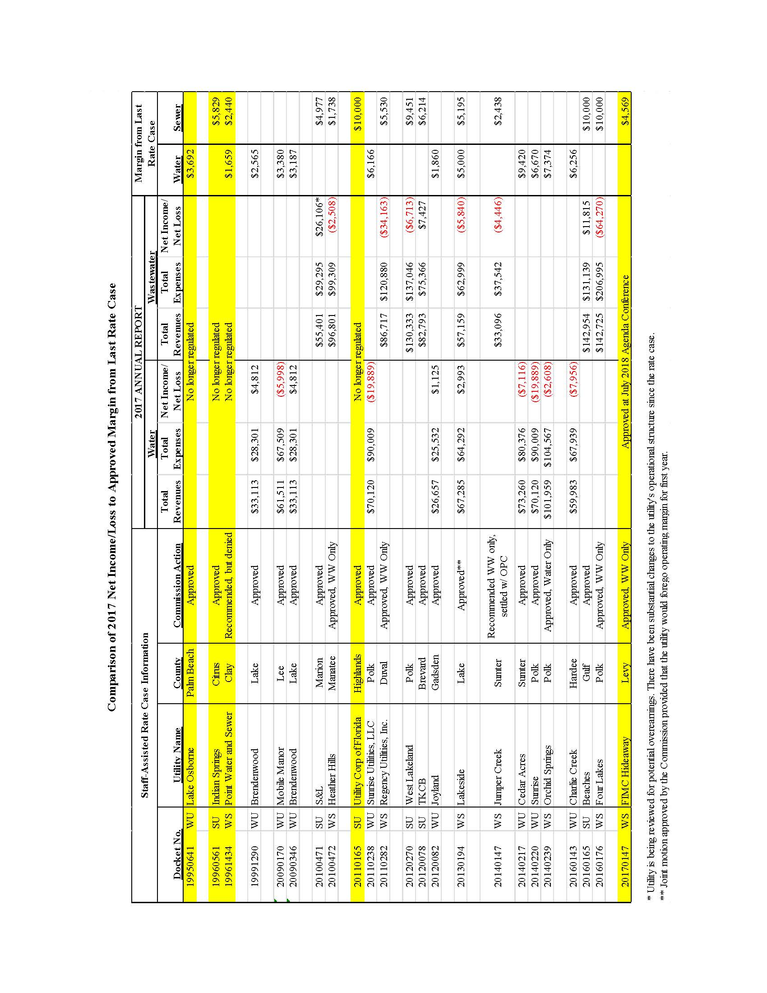

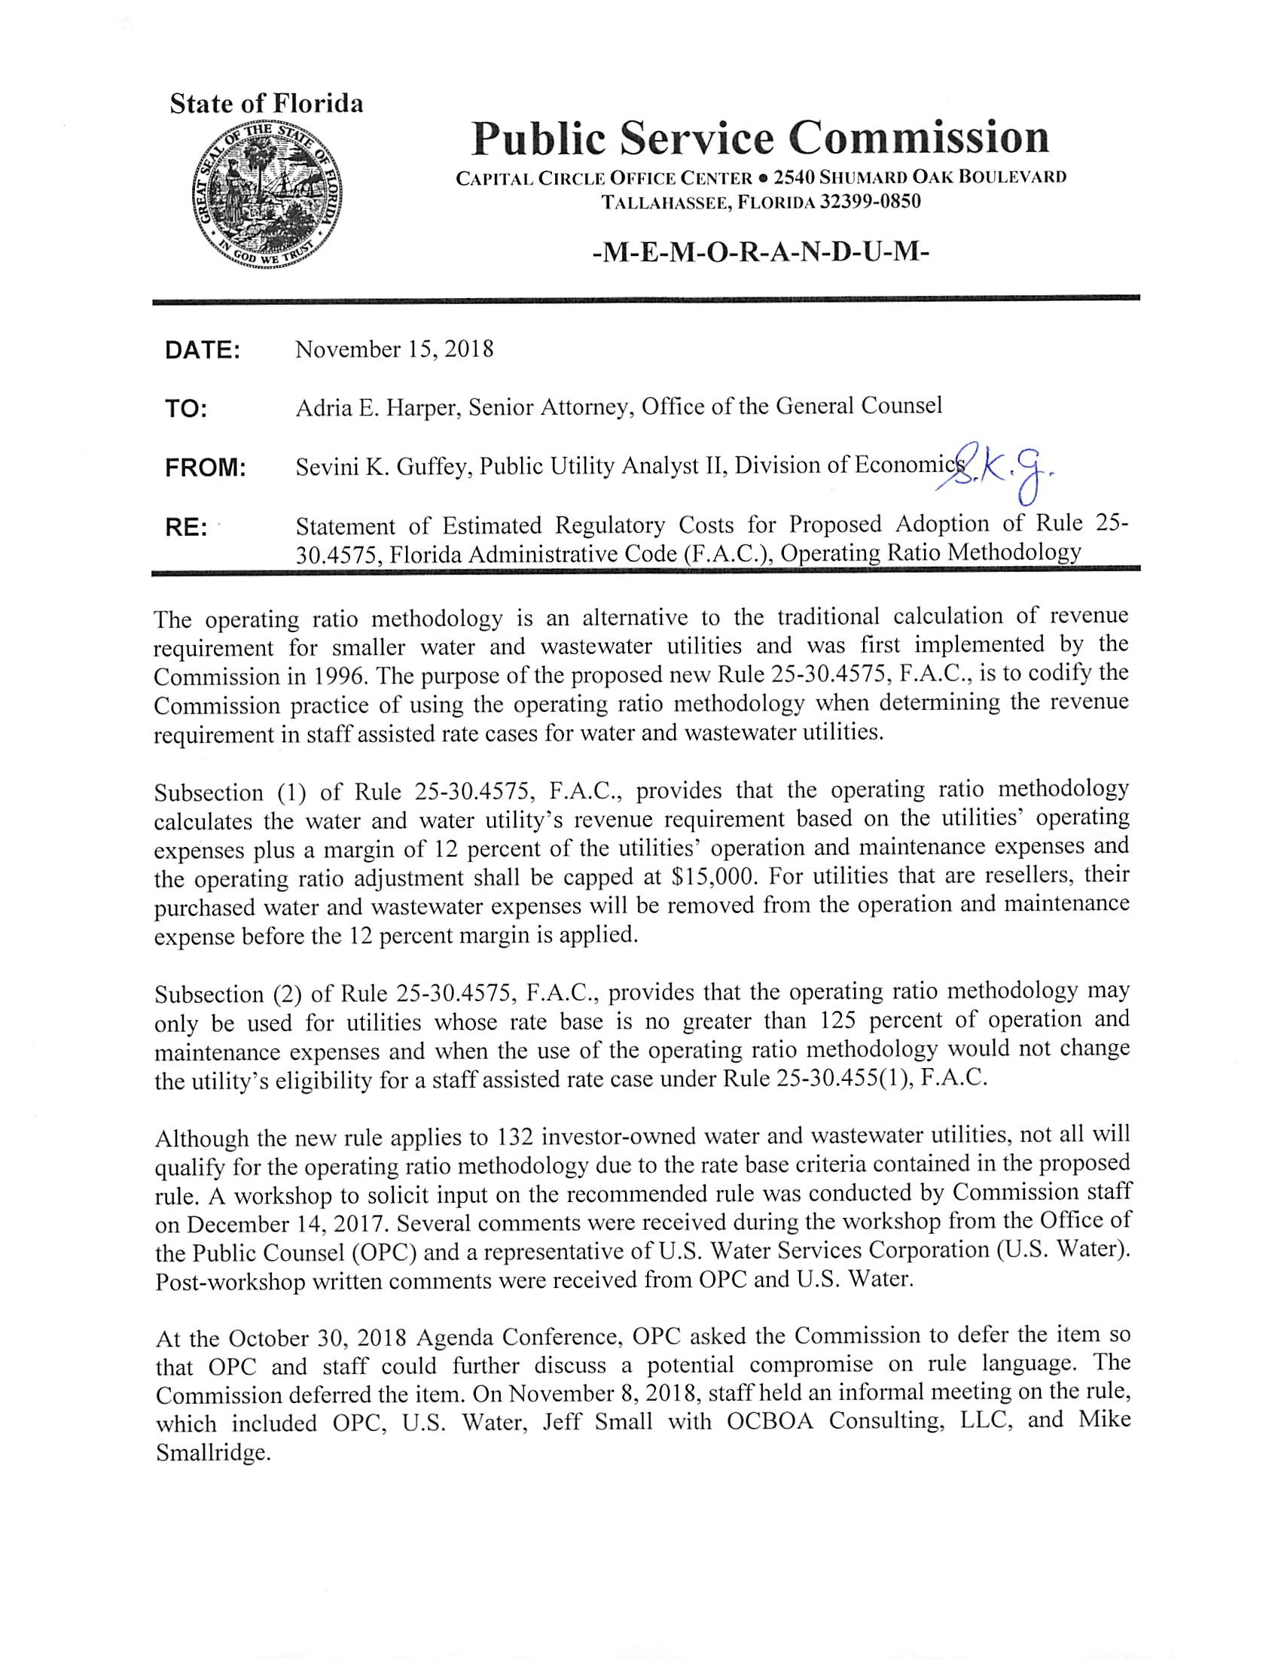

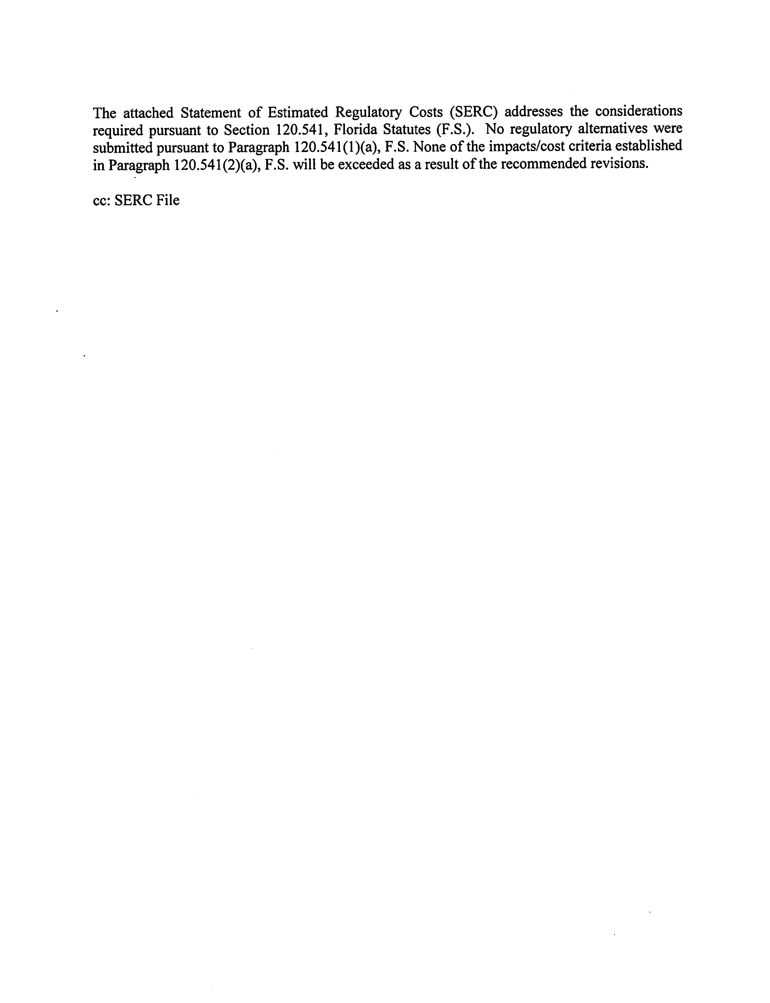

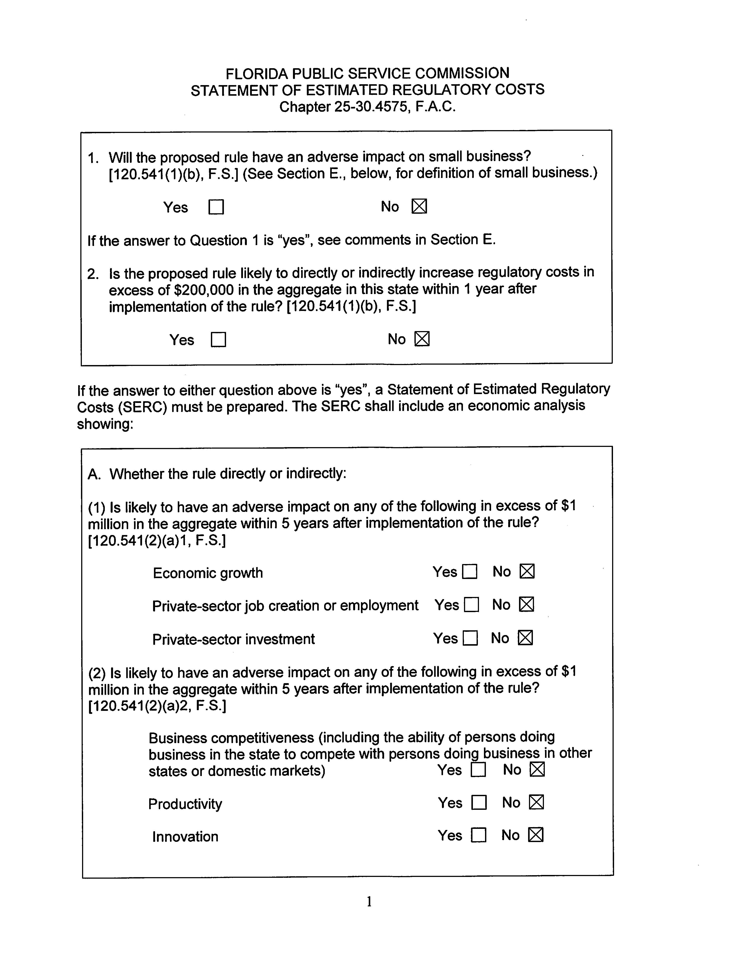

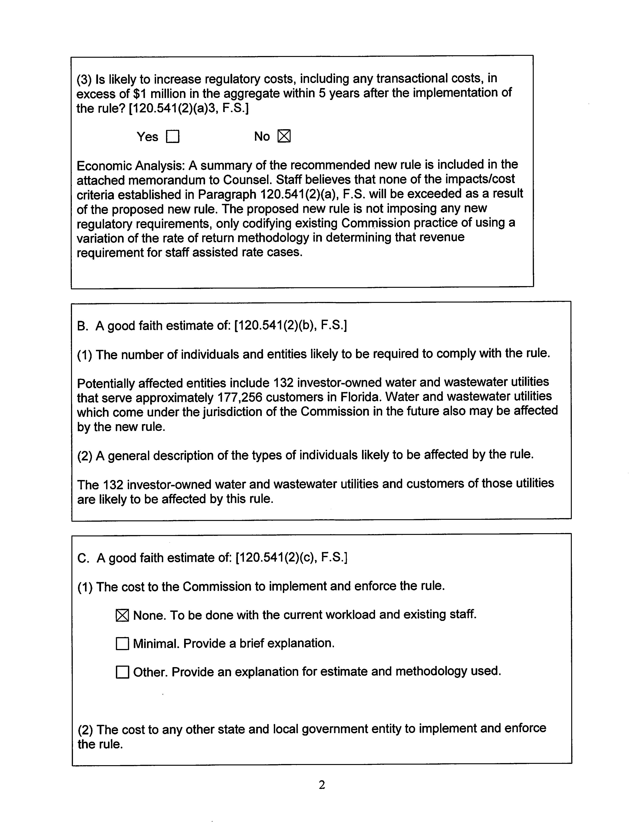

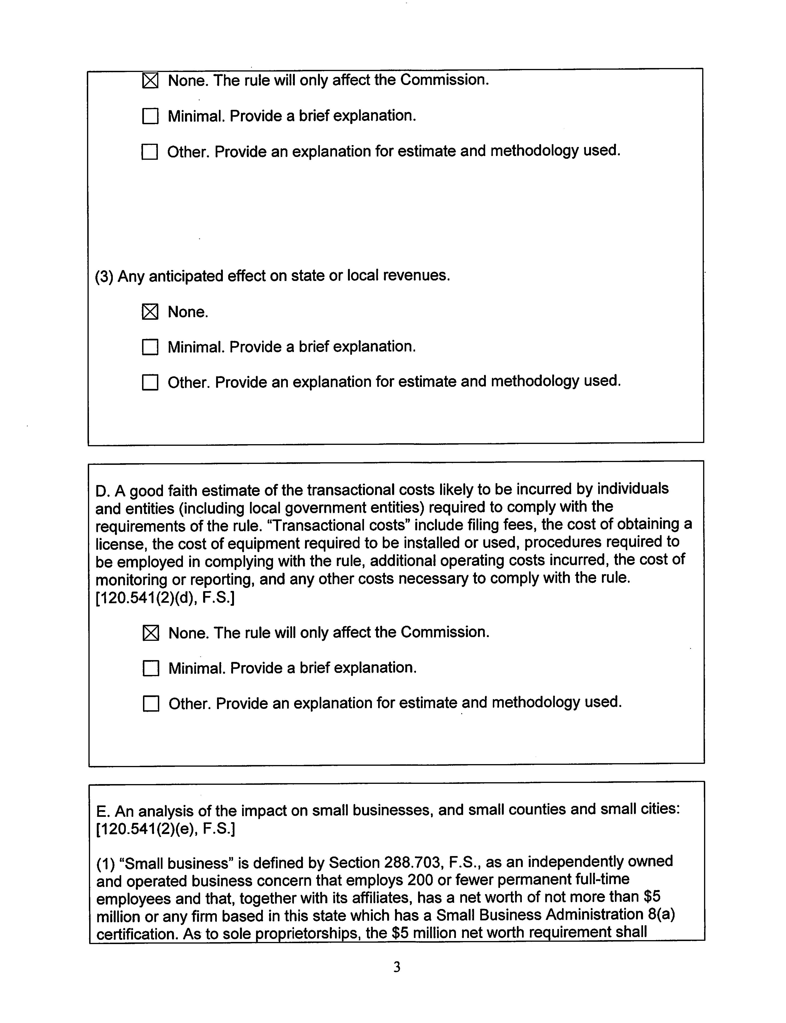

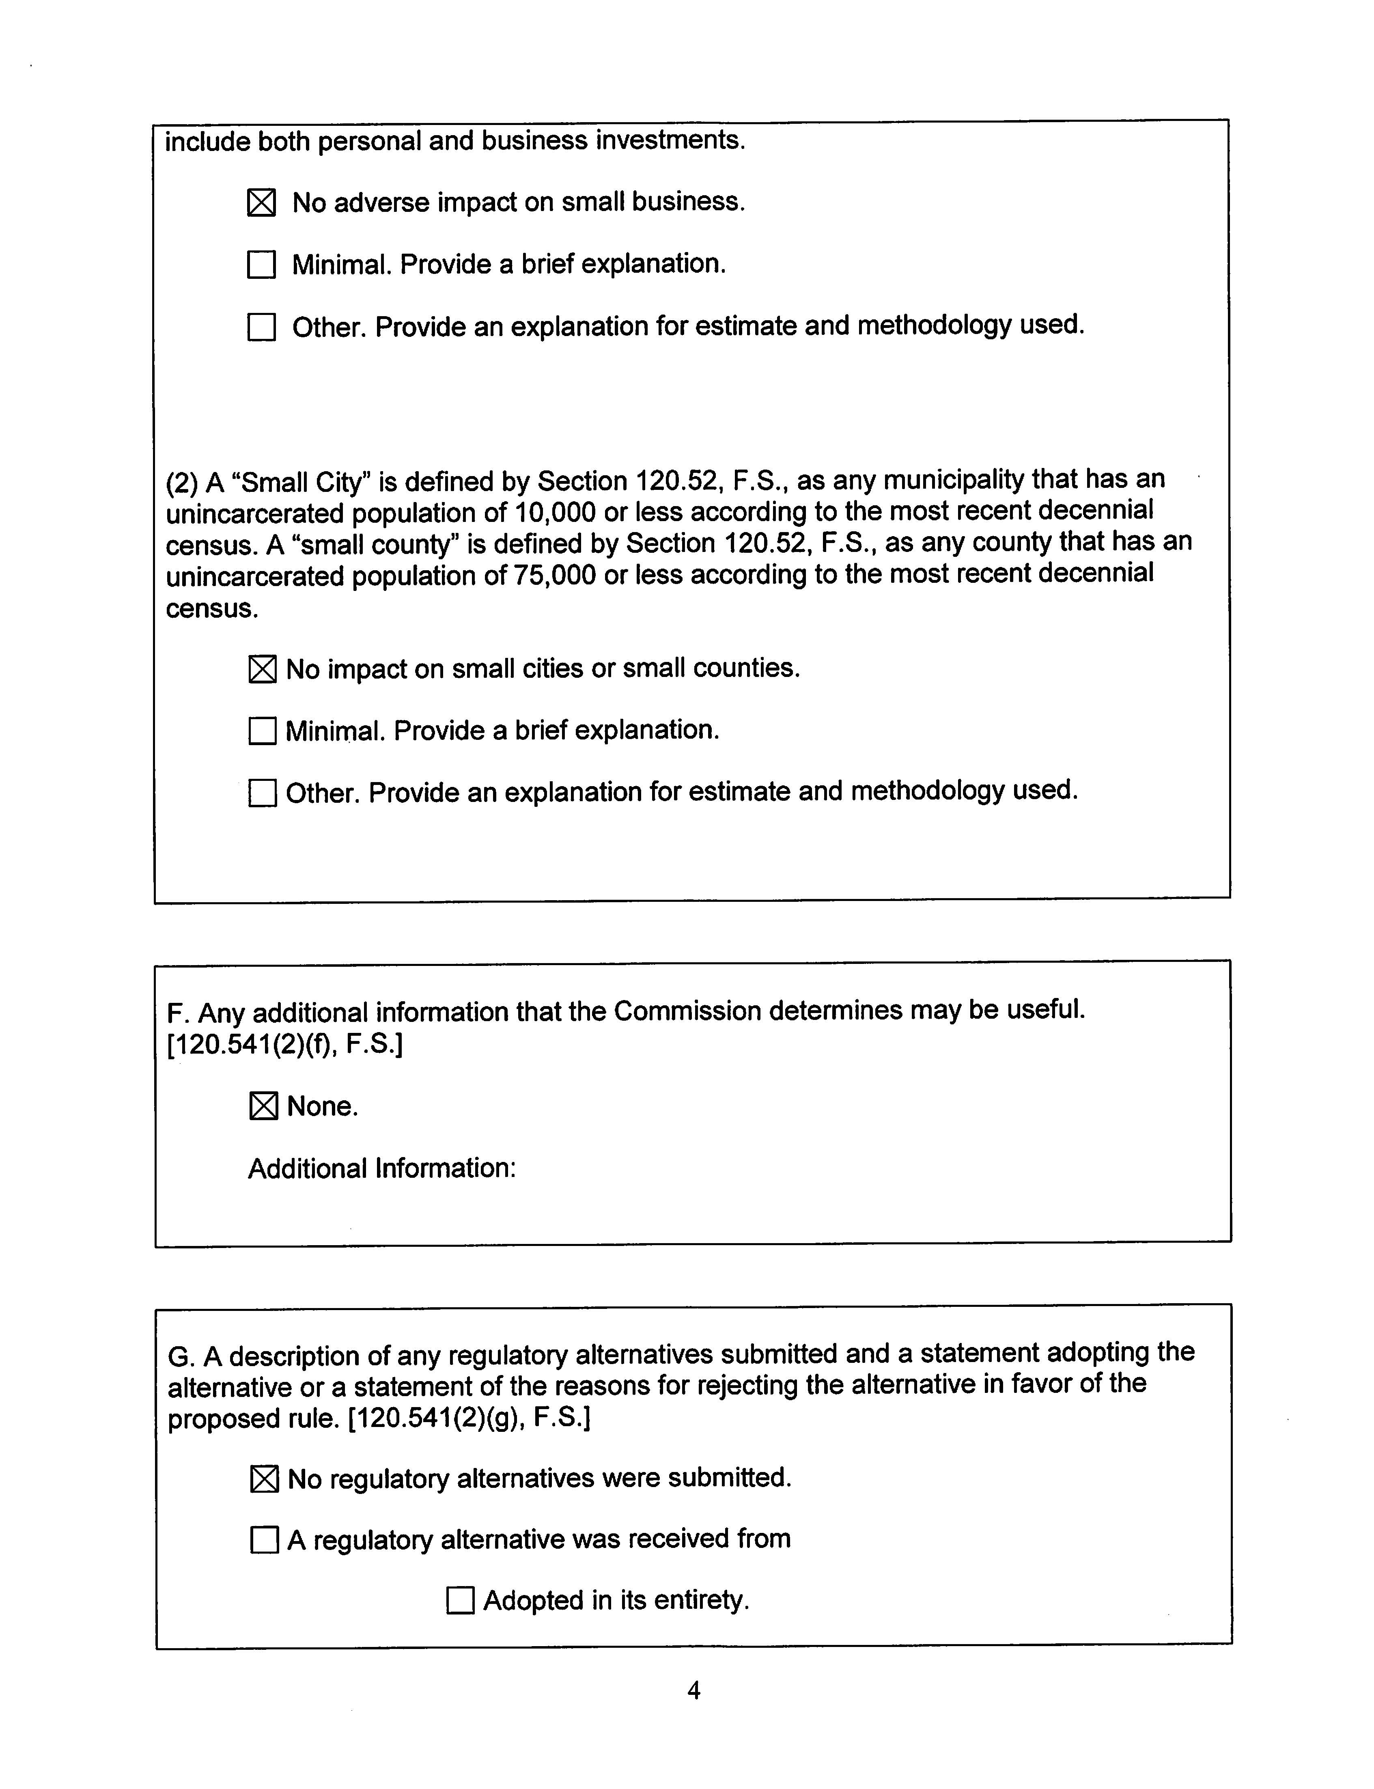

Order No. PSC-96-0357-FOF-WU, issued March 13, 1996, in Docket No. 950641-WU, In re: Application for staff assisted rate case in Palm Beach County by Lake Osborne Utilities Company, Inc. (Lake Osborne Order).
Lake Osborne Order, pg. 3.
Order No. PSC-2017-0459-PAA-WS, issued November 30, 2017, in Docket No. 20160176-WS, In re: Application for staff-assisted rate case in Polk County by Four Lakes Golf Club, Ltd.
See Attachment B.
Order No. PSC-2017-0383-PAA-SU, issued October 4, 2017, in Docket No. 20160165-SU, In re: Application for staff-assisted rate case in Gulf County by ESAD Enterprises, Inc. d/b/a Beaches Sewer Systems, Inc.
Section 367.0814, F.S., provides a revenue threshold of $300,000 or less per system before a utility may qualify for a SARC.
Order No. PSC-2018-0327-PAA-WS, issued June 26, 2018, in Docket No. 20180006-WS, In re: Water and wastewater industry annual reestablishment of authorized range of return on common equity for water and wastewater utilities pursuant to Section 367.081(4)(f), F.S.
While these costs are removed specifically for the calculation of the operating margin, these costs are still included in the O&M expenses for the calculation of the revenue requirement.
Lake Osborne Order, pg. 6-7.
Section 367.081(2)(a), F.S.
Lake Osborne Order, pg. 7.
Section 120.541(2), F.S.

