BEFORE THE FLORIDA PUBLIC SERVICE COMMISSION

In re: Petition for 12-month extension of voluntary solar partnership rider and program, by Florida Power & Light Company. | DOCKET NO. 20180160-EI  ORDER NO. PSC-2018-0581-TRF-EI  ISSUED: December 17, 2018

The following Commissioners participated in the disposition of this matter:

ART GRAHAM, Chairman
JULIE I. BROWN
DONALD J. POLMANN
GARY F. CLARK
ANDREW GILES FAY

ORDER APPROVING VOLUNTARY SOLAR PARTNERSHIP EXTENSION

BY THE COMMISSION:

Background
On August 31, 2018, Florida Power & Light Company (FPL) filed a petition for a one-year extension of its Voluntary Solar Partnership (VSP) program and associated tariff. The VSP program was first approved in Order No. PSC-14-0468-TRF-EI (initial VSP order) as a pilot program that would terminate on December 31, 2017. Due to the time needed for FPL to complete billing system modifications, the billing of VSP program participants for the monthly $9 charge did not start until May 2015. In Order No. PSC-2017-0499-TRF-EI, this Commission approved a one-year extension (from December 31, 2017 to December 31, 2018) to allow FPL to gather additional data regarding the durability of customer interest over a more substantial period of time.
The VSP program offers all FPL customers an opportunity, for $9 per month, to participate voluntarily in a program designed to contribute to the construction and operation of solar photovoltaic generation facilities located in communities throughout FPL’s service territory. FPL markets the VSP program to its customers as FPL SolarNow. Customers may enroll or cancel their enrollment at any time. FPL’s proposed tariff revision, as shown in Attachment A to the order, changes the termination date for service under the VSP program from December 31, 2018 to December 31, 2019. This Commission has approved similar community solar tariffs for Gulf Power Company and Duke Energy Florida, LLC.
FPL waived the 60-day file and suspend provision of Section 366.06(3), Florida Statutes (F.S.), until our December 11, 2018 Agenda Conference. During the evaluation of the petition, Commission staff issued two data requests to FPL for which responses were received on October 15, 2018 and November 14, 2018. This Commission has jurisdiction in the matter pursuant to Sections 366.05, 366.06, and 366.075, F.S.

Decision

The VSP program was designed for FPL to use the voluntary customer contributions to support the revenue requirement associated with constructing and operating the solar facilities supported under the program so that non-participants are not required to subsidize these solar facilities. The revenue requirement includes a return, depreciation, operations and maintenance (O&M) expenses, and other costs such as property taxes and insurance. As required by the initial VSP order, marketing and administrative expenses are capped at 20 percent of participant contributions.
The voluntary contributions did not cover the revenue requirement in 2015; however, for 2016 through 2018, FPL showed that the revenues received under the VSP program are greater than the revenue requirement of the solar facilities. Thus, the net impact to all customers has been positive since 2016. FPL projects that the voluntary customer contributions will total $6,717,000 by December 2018, while the total revenue requirement for the VSP program will total $5,100,000. The electricity generated by the solar facilities displaces fuel that otherwise would have been used for generation, resulting in avoided fuel costs. FPL calculated the fuel savings to be $43,000, resulting in a positive net impact to all customers of $1,660,000, which will be used to support additional solar facilities under the program.
As discussed in the initial VSP order, FPL is sizing the solar projects supported by the program based on the level of participation. FPL currently has 84 solar structures at 39 locations completed for a total of 1,395 direct current kilowatts (kW) of solar capacity. An additional 53 solar structures are under construction at 22 locations. FPL stated that the completed and planned solar projects comprise a diverse set of assets, including ground-mount structures, rooftop installations, covered walkways, parking canopies, and tree-like structures. The installation size of the projects ranges from three kW to 200 kW.
The O&M expenses for the VSP program include the land lease payments made to host locations. In response to Commission staff’s data request, FPL explained that the solar facilities incurred minimal damage as a result of storms or hurricanes. FPL stated that the solar facilities are being built to comply with the local building and wind codes and there are no specific pre-storm preparations required. FPL ensures the facilities are operational and safe through regular maintenance and inspections.
Table 1 below shows the total number of customers participating in the VSP program for the period May 2015 through December 2018. As of August 2018, there are 36,024 participants and FPL projects 40,550 participants by year end. FPL stated that, on average, the monthly new enrollments have more than offset the number of participants who have elected to unsubscribe.
Table 1
VSP Participants
Total Participants
(Residential and Commercial)
May 2015 | 156
May 2016 | 3,070
May 2017 | 19,309
May 2018 | 34,646
August 2018 | 36,024
December 2018* | 40,550
Source: FPL response to Commission staff’s first and second data requests *forecasted number

Marketing and Participant Preference
FPL stated that it markets the VSP program through monthly email campaigns, eNewsletters, bill inserts, social media, and flyers. Monthly blogs are used to keep an ongoing dialogue with program participants and the eNewsletters provide project updates to the participants. FPL explained that it has learned the importance of creating ties with the communities and host locations to keep participants’ interested and aware of ongoing projects in the area.
Based on feedback from participants, FPL stated that the solar canopies and trees are the participants’ preferred solar projects. The solar canopy generates more power and offers the additional function of providing shaded seating and shaded parking lots. The solar trees were well received for their artistic appearance and provision of shade, as well as seating, and serving as a convenient charging station.

FPL’s Planned New Shared Solar Program
In last year’s petition for a one-year extension of the VSP program (Docket No. 20170212-EI), FPL stated that it is developing, for our approval within the next year (2018), a new large scale solar program (shared solar program). The shared solar program would provide participants with direct credits on their electric bill associated with energy generated by the blocks of solar capacity. FPL stated in the instant petition that the reason for the delayed filing for its shared solar program is that FPL needs more time to better assess market support for the new program. In addition, FPL expects to collect additional data on how the new program would impact the existing VSP program and to finalize the design and implementation plans for the shared solar program in 2019.
Specifically, FPL stated that it will be examining three areas: (1) the market potential for each program, (2) which aspects of each program appeal to various customer groups, and (3) whether introducing the shared solar program could cause customers to migrate out of the VSP program and, if so, at what rates. This research will assist FPL in making an informed recommendation regarding the future of the VSP program.

Conclusion
We agree with FPL that a one-year extension of the tariff will allow FPL to complete and evaluate its research regarding how the VSP program and the planned shared solar program would impact one another. We, therefore approve the one-year extension of the VSP program and tariff. The revised tariff, as shown in Attachment A, shall be effective January 1 to December 31, 2019. Prior to the expiration of the VSP program (December 31, 2019), FPL shall petition this Commission regarding the future of the VSP program.
Based on the foregoing, it is

ORDERED by the Florida Public Service Commission that the one-year extension of Florida Power & Light Company’s VSP program is approved. It is further

ORDERED that the revised tariff, as shown in Attachment A, shall be effective January 1 to December 31, 2019. It is further

ORDERED that prior to the expiration of the VSP program (December 31, 2019), FPL shall petition this Commission regarding the future of the VSP program. It is further

ORDERED that if a protest is filed within 21 days of issuance of the Order, the tariff shall remain in effect with any charges held subject to refund pending resolution of the protest. It is further

ORDERED that if no timely protest is filed, this docket shall be closed upon the issuance of a Consummating Order.

By ORDER of the Florida Public Service Commission this 17th day of December, 2018.

/s/ Carlotta S. Stauffer
CARLOTTA S. STAUFFER
Commission Clerk
Florida Public Service Commission
2540 Shumard Oak Boulevard
Tallahassee, Florida 32399
(850) 413-6770
www.floridapsc.com

Copies furnished: A copy of this document is provided to the parties of record at the time of issuance and, if applicable, interested persons.

JEN

NOTICE OF FURTHER PROCEEDINGS

The Florida Public Service Commission is required by Section 120.569(1), Florida Statutes, to notify parties of any administrative hearing or judicial review of Commission orders that is available under Sections 120.57 or 120.68, Florida Statutes, as well as the procedures and time limits that apply. This notice should not be construed to mean all requests for an administrative hearing or judicial review will be granted or result in the relief sought.

Mediation may be available on a case-by-case basis. If mediation is conducted, it does not affect a substantially interested person's right to a hearing.

The Commission's decision on this tariff is interim in nature and will become final, unless a person whose substantial interests are affected by the proposed action files a petition for a formal proceeding, in the form provided by Rule 28-106.201, Florida Administrative Code. This petition must be received by the Office of Commission Clerk, 2540 Shumard Oak Boulevard, Tallahassee, Florida 32399-0850, by the close of business on January 7, 2019.

In the absence of such a petition, this Order shall become final and effective upon the issuance of a Consummating Order.

Any objection or protest filed in this docket before the issuance date of this order is considered abandoned unless it satisfies the foregoing conditions and is renewed within the specified protest period.

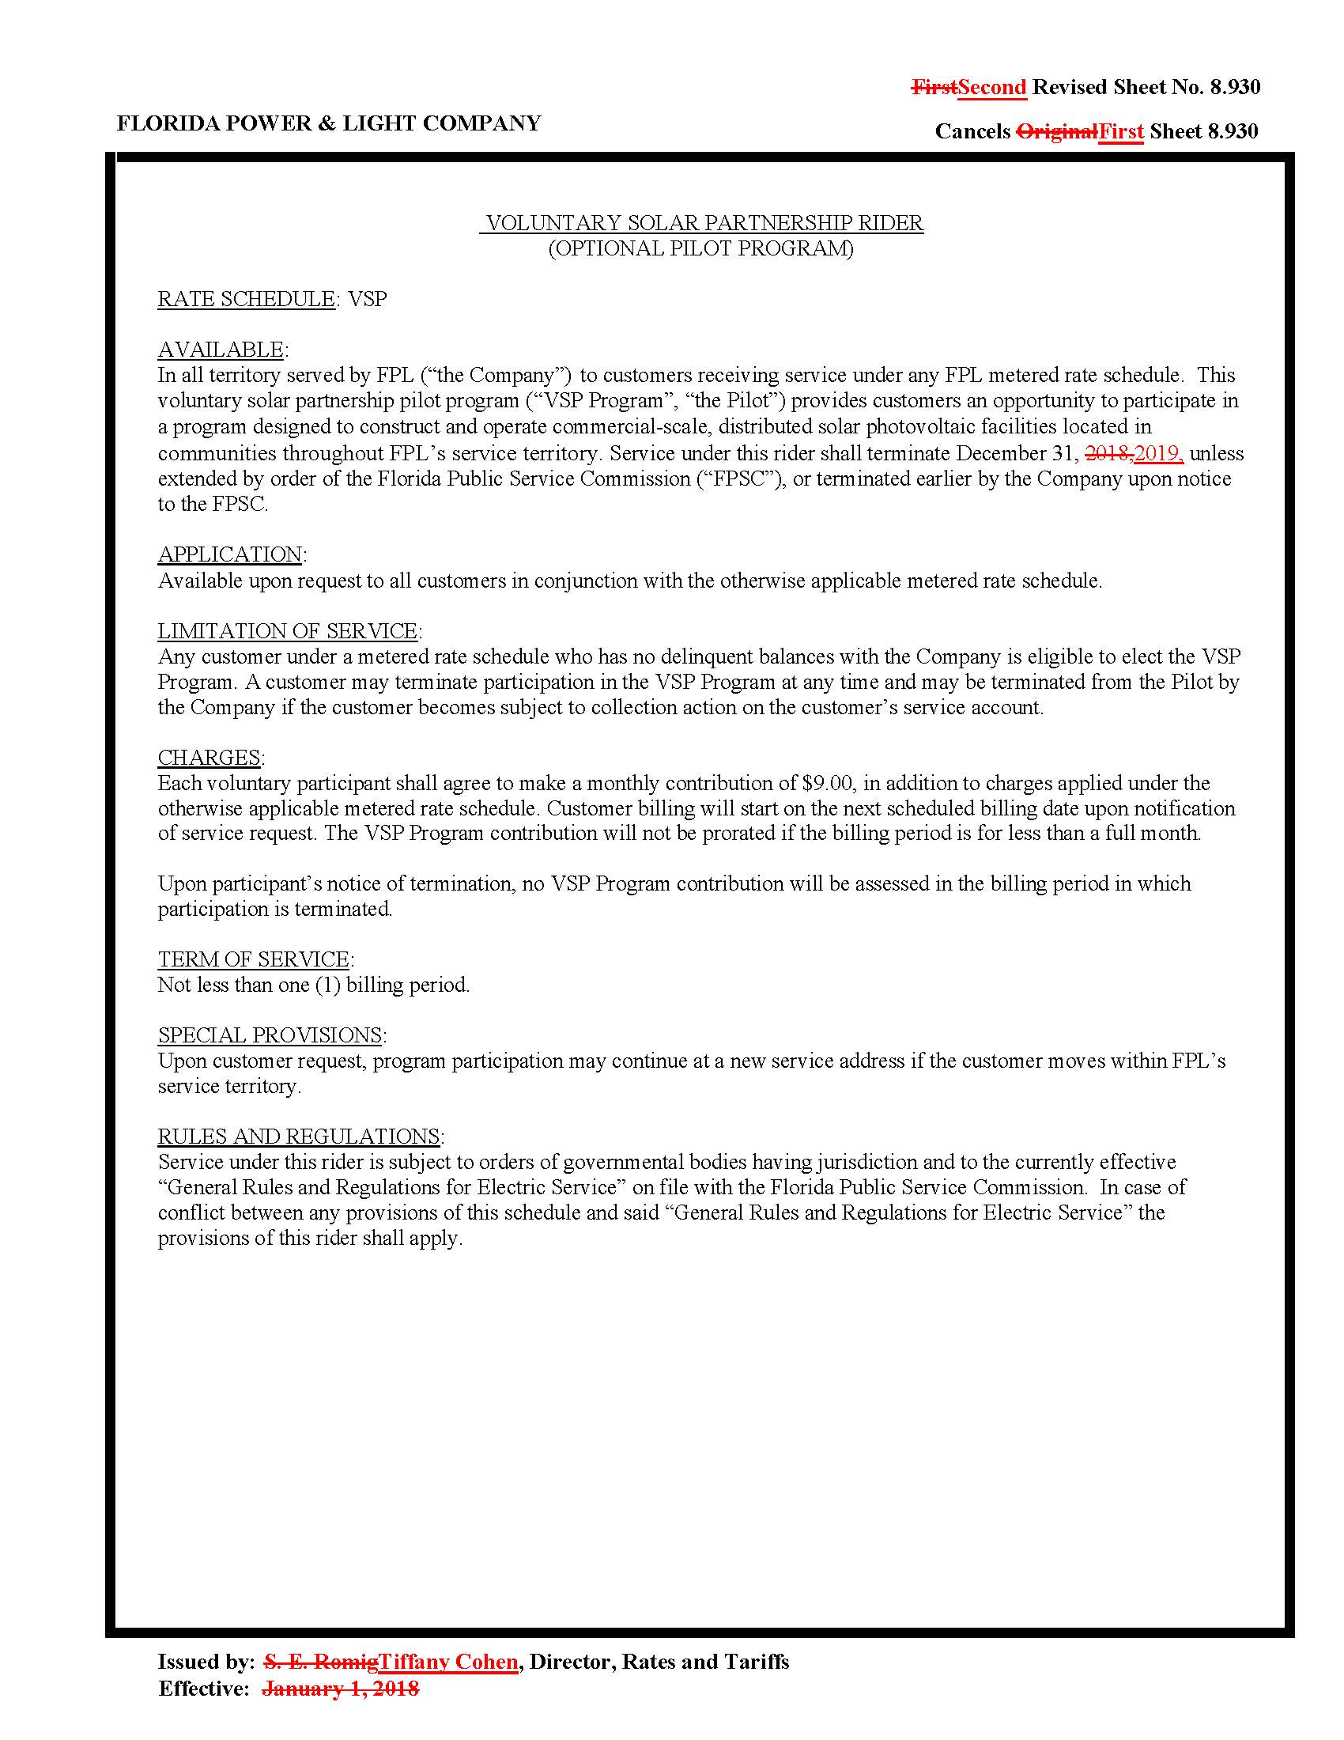

Order No. PSC-14-0468-TRF-EI, issued August 29, 2014, in Docket No. 140070-EI, In re: Petition for approval of voluntary solar partnership pilot program and tariff, by Florida Power & Light Company.
Order No. PSC-2017-0499-TRF-EI, issued December 29, 2017, in Docket No. 20170212-EI, In re: Petition for one-year extension of voluntary solar partnership rider and program, by Florida Power & Light Company.
Order No. PSC-16-0119-TRF-EG, issued March 21, 2016, in Docket No. 150248-EG, In re: Petition for approval of community solar pilot program, by Gulf Power Company.
Order No. PSC-2017-0451-AS-EU, issued November 20, 2017, in Docket No. 20170183-EI, In re: Application for limited proceeding to approve 2017 second revised and restated settlement agreement, including certain rate adjustments, by Duke Energy Florida, LLC.
Amounts reflect actuals through June 2018 and forecasted data for July 2018 – December 2018. See FPL’s response to Commission staff’s first set of data request No. 1.
$6,717,000 – $5,100,000 + $43,000 = $1,660,000.
FPL provided a complete listing of all completed and planned solar projects in response to Commission staff’s first data request, No. 4.

