Safety Orientation
And Information Transfer
For Incoming Crews

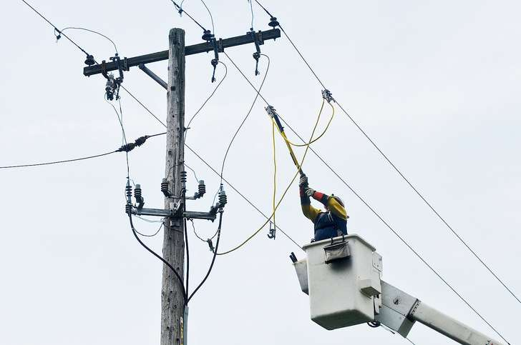

Welcome to Florida Public Utilities (FPU)
Florida Public Utilities’ employees and customers greatly appreciate your assistance. FPU would like to provide you with some basic information to help you while working on our system. Please review the following information and share it with all the employees working with you.

Contractor Orientation
Prior to beginning work, the Contractor Site Safety Representative receives an orientation briefing from the Florida Public Utilities representative regarding requirements for working at the site. This briefing would include the following:
- Emergency Contact Information
- All work on site requires the contractor to provide an on-site supervisor.
- All work performed on-site will be with contractor’s tools and equipment. FPU Electric tools and equipment will not be used.
- Site Smoking Policy
- Site Housekeeping Requirements
- Parking and Site Access Restrictions
- FPU Electric’s Safety Rules and Practices (Location Safety Handbook)
- Overview of the FPU Environmental policy including management of all generated wastes.
- Overview of Zero Tolerance Policy regarding harassment and use of alcohol and/or drugs
- Emergency response information (alarm signals, location of shelter areas, etc.)
- Notification requirements regarding accidents, incidents and near misses
- Requirements regarding use of chemicals at the site and means of obtaining a Material Safety Data Sheet.
- Required Personal Protective Equipment (PPE) while on the site
- Required permits for performing the work and means of obtaining permits, i.e. hot work permit.
- Use of ladders, scaffolding or rigging.
- Fall protection policy at heights of 6 feet or higher.
- Requirements regarding lockout/tagout
- Electrical safety requirements, including live work and appropriate PPE.
- Location and hazards of confined spaces in the vicinity of the work area(s)
- Use of electrical equipment and Ground Fault Circuit Interrupters (GFCI)

FPU Safety Commitment
Florida Public Utilities is dedicated to the safety of our employees, contractors, customers, in coming crews, and the general public. If there are conditions encountered that are not completely understood by the employees performing the work, contact an FPU representative regarding the safest way to complete the task.
Absolutely no job should be started without a complete understanding of the work to be performed by all those involved to include a pre-job briefing for all assigned jobs. Safety shall take precedence over any other requirement and unsafe behavior will not be tolerated.

Disclaimer Notice
Information in this packet cannot cover every situation that one may encounter during restoration work. Any questions concerning situations not covered in this packet should be directed to your assigned FPU representative. All personnel are responsible for their personal safety and adherence to basic electric industry work practices — Occupational Safety and Health Administration (OSHA).
Information from Incoming Crew

The incoming company shall inform their FPU contact of any unanticipated hazardous conditions that have not been previously communicated or that are found while working on FPU’s system. The incoming company representative shall provide hazardous condition information to their FPU representative as soon as possible, but not more than 48 hours after discovering the hazardous condition per OSHA 1910.269(a)(3)(ii)(C).

TABLE OF CONTENTS PAGE
Contact Information……………………………………………………………………………………………….. 5
General Safety………………………………………………………………………………………………………. 6
Job Safety Briefing…………………………………………………………………………………………………. 6
Personal Protective Equipment Requirements………………………………………………….…… 7
Medical/Injury Reporting……………………………………………………………………………………... 8
Public Relations………………………………………………………………………………………….……….... 9
Vehicles/Drivers ………………..………………………………………………………………………............ 9
Switching/Tagging/Clearances ……………………………………………………………………………... 9
Minimum Approach Distances ………………………………………………………………………….….. 10
Personal Protective Grounding……………………………….…………………………………………….. 11
Pole Structure Climbing ………………………………………………………………………………..………. 11
Testing Wood Poles …………………………………………………………………………………..…………. 12
Confined Spaces …………………………………………………………………………………………………… 12
Trenching ………………………………………………………………………………………..…………………… 13
Environmental Hazards ………………………………………………………………………………………… 13
Generator Safety ……………………………………………………………………………………………..…... 14
FPU Incident Report Form ………………………………………………………………………….………… 16
Information Transfer Contractor ……………………………………………………………………….…. 20
FPU Confirmation ……………………………………………………………………………………………..…. 22

Florida Public Utilities Contact Information

FPU Contact: _________________________________________

Job Title: _____________________________________________

Phone: _______________________________________________

FPU Contact: _________________________________________

Job Title: _____________________________________________

Phone: _______________________________________________

FPU Contact: _________________________________________

Job Title: _____________________________________________

Phone: _______________________________________________

General Safety
YOUR SAFETY IS OUR PRIMARY CONCERN!
NO JOB IS SO IMPORTANT THAT WE CANNOT TAKE TIME TO DO IT SAFELY!
FPU expects all onsite contractors to abide by the following:
- Comply with all Occupational Safety & Health Administration (OSHA) laws and regulations
- Conduct a job briefing prior to commencement of each project
- If the size or scope of a job changes, stop and perform another job briefing
- Wear appropriate PPE for the hazards involved in the work
- Wear rubber gloves and sleeves as required when within the minimum approach distance
- All lines and equipment shall be considered energized until it has been isolated, tested, tagged, and grounded
- All work on lines or equipment presumed de-energized shall have a visible air gap, tested for voltage, locked or tagged, and grounded
- Work zones shall be established where traffic is a hazard
- Cell phone usage and texting while operating a Commercial Motor Vehicle (CMV) is illegal in Florida
- Wear seatbelts, follow posted speed limits, and comply with all other motor vehicle regulations
- Possession, use, sale, distribution of or being under the influence of alcohol, illegal drugs or controlled substances on any FPU property, or any time while working on duty in the field is strictly prohibited
- When in doubt, direct questions to the assigned FPU representative

Job Safety Briefing

- Before starting every job, conduct a job briefing to assure that all crew members are aware and knowledgeable of hazards and safeguards required to safely complete the job. It is recommended that a job briefing be held as follows:
  - Prior to starting work
  - After any interruption in work
  - Upon discovering any unforeseen situation
  - Any time any member of the crew is unsure how to proceed safely
- Sectionalizing sketches should be reviewed and clearances discussed. Work should not proceed until each person understands what they are to do.
- The briefing should contain the hazards and how the hazards will be mitigated to perform the job in the safest possible way.
- The following subjects should be discussed:
  - Identify the person in charge
  - Hazards associated with the job
  - Work procedures involved
  - Special precautions
  - Energy source controls
  - Personal protective equipment (PPE)
  - Emergency procedures
  - The exact location of the jobsite, county you are working in, and the nearest medical facility

Personal Protective Equipment (PPE)

The following PPE shall be used as required by OSHA:
- Fall Protection – Above 6’
- Hard Hats - When there is a potential for head injury
- Safety Glasses - When in the work zone to guard against flying objects and arc flash
- Leather Gloves - When there is a potential for cuts and abrasions
- Traffic Vest - In right-of-way, and in staging area
- Personal Flotation Device - When there is a potential for drowning
- Chaps - Out-of-the-bucket chainsaw use
- Hearing Protection - When noise exceeds 85 decibels, or when specified by manufacturer
- FR Clothing- Where there is a potential for arc flash
- Appropriate Footwear - Shall have protective toe cap and good ankle support
- Rubber Gloves - Shall be properly rated and tested and shall be worn when in reach or extended reach of an energized conductor using the Minimum Approach Distance (MAD) table in this document

Medical Emergency
In the event of a medical emergency, attend to the injured employee and provide immediate first aid. If the injury is life threatening or needs immediate medical attention, call 911.

Injury Reporting
Each visiting company is responsible for their reporting procedures for their Company. In addition, all injuries must be reported as soon as possible to FPU Safety and Training. The information to be reported must include, at minimum, the injured person’s name, Company, treating physician/hospital name and location, nature of the injury and status (if known), and supervision to be followed up with.

Nearest Medical Facilities
Information on emergency numbers, hospitals and doctors, and the availability of 911 numbers can be found in this document or can be obtained from the Safety and Training representative at FPU.
Florida Public Utilities Safety Manager………….Francene Diehl – 352.250.7279
FPU Fernandina Beach Safety Coordinator…........Kevin Metts – 904.831.6014
FPU Marianna Safety Coordinator ……..Rhondon Gray – 850.557.6490

Area Hospitals
Fernandina Beach
Baptist Nassau Hospital | 1700 East Lime Street | 904.321.3500 | 24/7
Marianna
Jackson Hospital | 4250 Hospital Drive  Marianna, FL 32446 | 850.526.2200 | 24/7

Public Relations – News Media
- Do not respond to inquiries from the news media.
Please send inquiries to:
- Aleida Socarras – 863.885.1806
- Bonnie Erdek – 561.313.6994
- Fran Scott-Diehl- 352-250-7279
- Mike McCarty – 863.224.0417
- Please understand that our customers are experiencing hardships and may take their frustration out on you and your company in spite of your best efforts – please be patient
- Report any confrontational issues
Vehicles and Drivers
- Follow all requirements of Department of Transportation (DOT) and Federal Motor Carrier Safety Regulations (FMCSR)
- Drivers must also have a proper Commercial Driver License (CDL)
- Drivers must perform truck inspections daily according to the DOT
- All loads must be secured in accordance with the FMCSR
- Always walk around vehicle before moving vehicle
- Avoid backing, but if necessary, use a spotter
- Vehicles must not exceed 10 mph while driving on FPU property
- When vehicle is in motion, all passengers must be wearing a seat belt
- When vehicle is in motion, there shall be no riders in the bucket

Switching, Tagging, Clearances
- All switching must be documented
- Switching tags (hold tags) shall be used to identify sections of lines that are in an abnormal state or have a clearance associated with them
- All switches that are unlocked to operate must be relocked
- If it is necessary to cut a FPU lock from a switch, An FPU lock must be readily available and reinstalled before the switch can be left unguarded
- All distribution primary, secondary and service facilities shall be patrolled before any line is re-energized
Minimum Approach Distances (MAD)
Florida Public Utilities Company’s distribution voltage is 12kv and transmission voltages are 69kv and 138kv. Verify the voltage with an FPU representative before beginning work, in order to determine the appropriate minimum approach distances. The following table is provided for reference.
ALTERNATIVE MINIMUM APPROACH DISTANCES FOR VOLTAGES OF 72.5 KV AND LESS ¹
Nominal voltage (kV)
phase-to-phase
 | Distance
 | Phase-to-ground exposure |  | Phase-to-phase exposure
 | m | ft | m | ft
0.050 to 0.300 ² ................................................................................................. | Avoid Contact |  | Avoid Contact
0.301 to 0.750 ² ............................................................................................... | 0.33 | 1.09 | 0.33 | 1.09
0.751 to 5.0 ..................................................................................................... | 0.63 | 2.07 | 0.63 | 2.07
5.1 to 15.0 ....................................................................................................... | 0.65 | 2.14 | 0.68 | 2.24
15.1 to 36.0 ..................................................................................................... | 0.77 | 2.53 | 0.89 | 2.92
36.1 to 46.0 ..................................................................................................... | 0.84 | 2.76 | 0.98 | 3.22
46.1 to 72.5 ..................................................................................................... | 1.00 | 3.29 | 1.20 | 3.94

PERSONAL PROTECTIVE GROUNDING

- You must work under your own company’s grounds. You are responsible for following your company’s grounding practices at all times and when handling a grounded down conductor
- All conductors are to be considered to be ENERGIZED unless they are de-energized, tested for the absence of voltage and EFFECTIVELY GROUNDED!
- Assume that all de-energized lines have induced voltage, back-feed or residual voltage present
- All clearance points shall be tagged and rendered inoperable
- Hold tags shall be used to identify sections of lines that have clearances associated with them
- It is recommended that a RED FLAG be hung at the location where grounds are to be installed. The red flag is not to be used in place of a hold tag
- Because of the calculated available fault current, 2/0 copper is the minimum size ground accepted on FPU’s system
- Be alert for feedback from generators and induced voltage. All conductors should be considered energized until effectively tested and grounded
- Be alert for the potential of induced voltage on de-energized conductors running parallel to energized section of line

Pole/Structure Climbing

Verify the condition of poles/structures by using an OSHA approved method before subjecting them to additional stress, such as climbing or installing or removing equipment or conductors.
  - Other utility companies may share common poles/structures (multiple circuits on pole).
  - Each pole/structure shall be inspected prior to work being performed or subjecting it to additional stress. This includes:
- Climbing
- Installing or removing equipment
- Installing or removing conductors
- Changing guying tensions
- Performing work on adjacent poles
- Any other situation that could change the amount or direction of force applied to the pole
  - Prior to climbing any wood pole, a visual inspection and hammer test shall be performed. The hammer test shall consist of:
- Rapping the pole with a hammer starting near the ground line
- Continuing upwards circumferentially around the pole to a height of approximately 6 feet
- Prodding the pole as near the ground line as possible using a pole prod or screwdriver to check for decay per OSHA 1910.269 appendix D

Testing Wood Poles

The following tests, which are from § 1910.268(n)(3), are acceptable methods of testing wood poles:
- Hammer test- Rap the pole sharply with a hammer weighing about 1.4 kg (3 pounds), starting near the ground line and continuing upwards circumferentially around the pole to a height of approximately 1.8 meters (6 feet). The hammer will produce a clear sound and rebound sharply when striking sound wood. Decay pockets will be indicated by a dull sound or a less pronounced hammer rebound. Also, prod the pole as near the ground line as possible using a pole prod or a screwdriver with a blade at least 127 millimeters (5 inches) long. If substantial decay is present, the pole is unsafe.
- Rocking test- Apply a horizontal force to the pole and attempt to rock it back and forth in a direction perpendicular to the line. Exercise caution to avoid causing power lines to swing together. Apply the force to the pole either by pushing it with a pike pole or pulling the pole with a rope. If the pole cracks during the test, it is unsafe.

Enclosed/Confined Spaces

- Enclosed/Confined Space Program and any work in those spaces shall be coordinated through FPU Safety and Training
- Do not enter any underground spaces without consulting with your company supervision and FPU Safety and Training personnel

Excavations and Trenching

- Prior to any excavation work, take all reasonable steps to identify underground utilities
- The restoration work that FPU would perform during or after an emergency does NOT require us to call Sunshine 811 before we do any pole locates. However, Sunshine 811 encourages us to submit courtesy tickets after the fact and noting in the “Remarks” section that the work was already completed (and what action was taken) simply to make other utilities (cable, telephone, etc.) aware that work was done.
- Any excavation work performed when the depth exceeds five feet shall be shored, sloped, or shielded to prevent cave-in or entrapment

Environmental

- Report all oil spills to your FPU Company representative
- Do not transport leaking oil-filled equipment without proper containment measures
- All hazardous environmental concerns will be relayed to you by your FPU Company contact as they are discovered

Report the following information:
Street address
City
Equipment type
Equipment serial number
Estimated quantity of oil released
PCB contaminated?(see name plate)
Oil spilled on water, soil, asphalt, gravel?
Can oil reach water or a storm drain?

Generator Safety

Many customers have installed generators for both residential and commercial use to supply temporary power during extended outages. The following points related to generators should be considered at all times and even more so during restoration efforts.
- Generators can create a dangerous hazard called “backfeed” if a de-energized line becomes energized by a secondary power source, sending electricity back onto the utility lines
- Generator hazards include carbon monoxide poisoning, electric shock or electrocution, and fire
- Portable generators should never be connected directly to the main electrical panel or plugged into a dryer outlet
- Appliances should be plugged directly into portable generators
- Follow all work methods and safety guidelines from the manufacturer
- Include backfeed discussions in each job safety briefing
- While it is important to listen for generators running in work areas, remember that there are “whisper quiet” units that are difficult to hear
- Treat all power lines as energized until the lines are de-energized, tested for the absence of voltage, and effectively grounded
- Even with transfer switches designed to de-energize conductors inside the meter base, always assume the conductors are energized until a visible opening can be established and the conductors are verified as de-energized
- Isolation means removing the meter, removing transformer leads, or cutting the facilities at the weather head
- If a generator is running at a residence or business when we are trying to re-establish service, ask the customer to turn the generator off or isolate the generator from our equipment and perform a voltage test before proceeding with restoration work
- If you leave a generator in place until all repairs are completed and the customer’s power can be restored, there must be a visual air gap between the generator and FPU’s equipment. Test for voltage and follow isolation procedures
- If the customer is not available to shut down the generator, repairs can be made on our distribution equipment if the generator is isolated from our facilities. If you cannot determine or secure isolation, wait until you can make arrangements with the customer.
- Whole house generators should be treated the same as portable generators

Parallel Generation

- It is important to be aware of parallel generation. If not interconnected properly, these installations have the potential to back-feed onto our system
- Customer-owned renewable generation shall include a utility-interactive inverter, or other certified device that performs the function of automatically isolating the customer-owned generation equipment from the electrical grid in the event the electrical grid loses power
- FPU customer-owned renewable generation meters are marked with a green band.
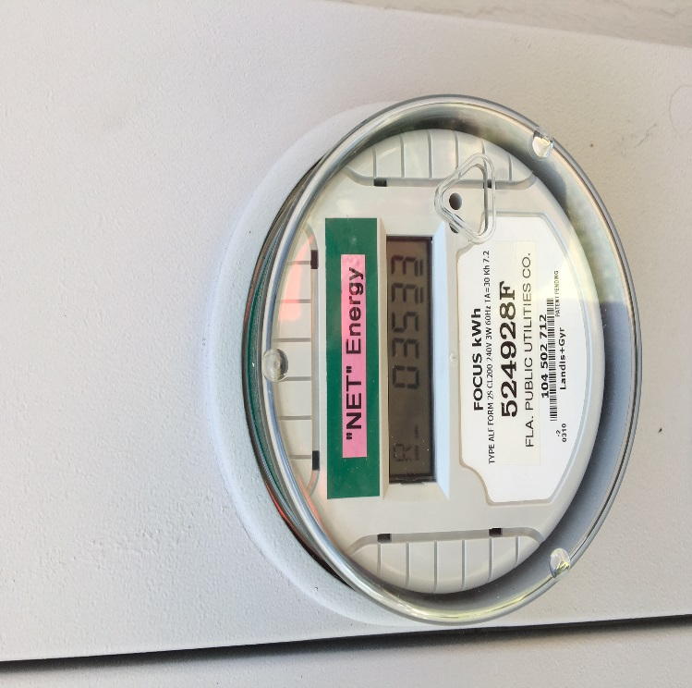
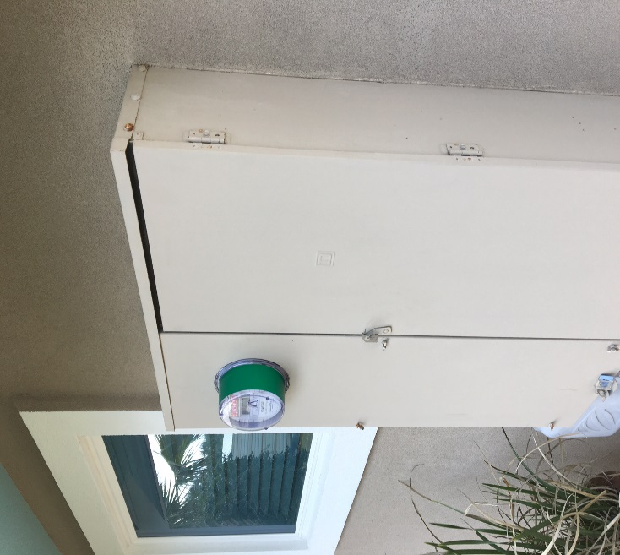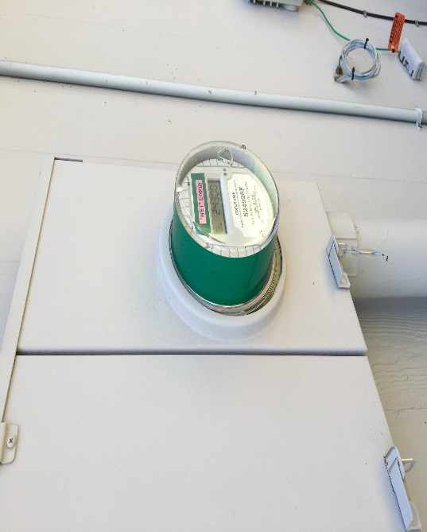

REPORT INCIDENT OR PROPERTY DAMAGE IMMEDIATELY TO YOUR FPU CONTACT PERSON OR SAFETY REPRESENTATIVE
VEHICLE ACCIDENT / INJURY FORM
Date Incident Reported: Time Incident Reported to Supervisor:
- Incident Type: Automobile General Liability Workers Comp Property

- Employee Information: Male Female
Name: |  |  |  | Email:
Business Unit: |  |  |  | Job Title:
Address:
City: | State: |  | Zip: |  |  | County:
Home Phone: |  |  | Work Phone:
DOB: |  | Age:
Drivers License State: |  | Drivers License #: |  |  | Start Time:
Business Unit: Natural Gas Propane Electric
Supervisor: |  |  | Supervisor Phone Number:

- Incident Information:
Date of Incident: |  |  |  | Day of Week: |  |  | Time of Incident:
Weather: |  |  |  |  | Road Conditions:
Location of Incident/Address:
Claimant Name: |  |  |  |  | Claimant Phone #:
Claimant Address:
City: |  | State: |  |  | Zip: |  |  | County:
Drug & Alcohol Test Performed: Yes No |  |  |  |  | Wearing Seatbelt: Yes No
Employee Waiver of Acknowledgement/ Medical Care: Yes No Employee initial: _______
Employee Advised of Supervisory Discretion of Driving Company Vehicle/Pending Alcohol/Drug Test:
Yes No Employee initial: _______
Employee Waiver of Acknowledgement/Pending Review of Personal Phone Records:
Yes No Employee initial: _______

Description of Damage:

Citation(s) Issued: Employee Yes No Other Operator: Yes No
Vehicle(s) Towed: Company Yes No Other Vehicle: Yes No
Injury |  | Re-injury |  |  | Occupational Illness |  |  | Other
Type of Injury: |  |  |  |  | Body Part(s) Involved:
Side of Body: Left Right |  |  |  |  | P.P.E in use at time of Incident:
Task being performed at time of injury:
Off-site First Aid Treatment provided by: Hospital Physician Other
Physician Name, Address, and Phone #:
Hospital Name and Address:
Injury Severity: Threatening Serious Minor Documentation Only
Lost Time | Medical Only |  | Total Days Lost: |  |  | Last day worked:
Fatality |  |  |  |  | Date of Death:

- Injured Party (Use additional paper if more than one person is injured):
If the injured party if the same as Employee in Section B, skip this section.
Name: |  |  | Email:
Business Unit: |  |  | Job Title:
Address:
City: | State: | Zip: |  | County:
Home Phone: |  | Work Phone:
DOB: |  | Age:

- Vehicle(s) Involved (Use additional paper if more than one vehicle is involved):
Company Vehicle:
Year: | Make: |  | Model: | VIN #:
Color: |  | Body Type: |  |  | Tag #: | State:
Describe Damage:
Other Vehicle:
Year: | Make: |  |  | Model: | VIN #:
Color: |  | Body Type: |  |  |  | Tag #: |  | State:
Describe Damage:
Driver Name, Address, Driver’s License, and Phone #:

Owner Name, Address, Driver’s License, and Phone #:

Insurance Co.: |  |  | Phone #: |  |  |  | Policy #:

- Other equipment/tools involved:
Equipment/Tool: | Model: | S/N:
Other:

- Officer Responding:
Name: | Badge Number:
Department Name and Address:

- Witness(es), if any:
Name: | Name:
Address: | Address:
Phone #: | Phone #:
Affiliation: | Affiliation:

- Signature Section (Manager to Sign):
Signature:
Name (Printed):
Job Title: | Date:

- Account of the Incident (to be completed by the Employee):

Employee Signature:
Employee Name (Printed):
Date:

- Vehicle Damage Diagram:

Company Vehicle (1) – Circle the area closest to the damaged areas:

Damage Estimate
$

Other Vehicle (2) – Circle the area closest to the damaged areas:

Damage Estimate
$

- Incident Scene Diagram:

Draw a diagram using outlines or sketch the scene of the incident:
- Number each vehicle and show direction of travel by arrow.
- Use solid lines to show patterns before incident and use dotted lines to show path after the incident.
- Show all relevant pedestrian(s), railroads, traffic signs, and/or signals, etc.
- Show distance and direction to landmarks and identify by name or number.
- Indicate North by an arrow with an N.

INFORMATION TRANSFER CONFIRMATION (Contractor Copy)
Contractor Company Information
(PLEASE PRINT) | Line Crew_____ | Tree Crew_____
Your Company Name:________________________________ |  | # People:_____
Your Company Representative:_________________________ |  | # Buckets:_____
Your Company Representative Cell:______________________ |  | # Diggers:_____
Your Safety Representative:____________________________ |  | # Service Truck:_____
Your Safety Representative Cell:________________________ |  | Other Equipment:_____

CONFIRMATION
Safety Orientation package delivered to ______________________________________
Contractor Representative (Print)
with __________________________________________________________________
Contractor Name (Print)
by ______________________________________________on _____/______/_______
FPU Representative (Print) Date

I have read and discussed FPU’s Information Transfer. I have also received a printed copy of this information.

I understand that it is my responsibility to ensure this information is shared with my company’s employees and any subcontractors so they will understand all applicable provisions (additional copies available upon request).

______________________________________________ | ________________
Company Representative Printed Name | Date
______________________________________________
Company Representative Signature

INFORMATION TRANSFER CONFIRMATION (FPU Copy)
Contractor Company Information
(PLEASE PRINT) | Line Crew_____ | Tree Crew_____
Your Company Name:________________________________ |  | # People:_____
Your Company Representative:_________________________ |  | # Buckets:_____
Your Company Representative Cell:______________________ |  | # Diggers:_____
Your Safety Representative:____________________________ |  | # Service Truck:_____
Your Safety Representative Cell:________________________ |  | Other Equipment:_____

CONFIRMATION

Safety Orientation package delivered to ______________________________________
Contractor Representative (Print)

with __________________________________________________________________
Contractor Name (Print)
by ______________________________________________on _____/______/_______
FPU Representative (Print) Date

I have read and discussed Florida Public Utilities Information Transfer and Construction Manual. I have also received a printed copy of this information.

I understand that it is my responsibility to ensure this information is shared with my company’s employees and any subcontractors so they will understand all applicable provisions (additional copies available upon request).

______________________________________________ | ________________
Company Rep Printed Name | Date
______________________________________________ | _________________
Company Rep Signature | Date

