BEFORE THE FLORIDA PUBLIC SERVICE COMMISSION

In re: Petition for limited proceeding to consider the tax impacts associated with the Tax Cuts and Jobs Act of 2017 for Florida City Gas. | DOCKET NO. 20180154-GU  ORDER NO. PSC-2018-0596-S-GU  ISSUED: December 20, 2018

The following Commissioners participated in the disposition of this matter:

ART GRAHAM, Chairman
JULIE I. BROWN
DONALD J. POLMANN
GARY F. CLARK
ANDREW GILES FAY

ORDER APPROVING STIPULATION AND SETTLEMENT AGREEMENT

BY THE COMMISSION:

Background
On March 12, 2018, the Office of Public Counsel (OPC), the Federal Executive Agencies (FEA), and Florida City Gas (FCG) filed a joint motion in support of their Stipulation and Settlement Agreement (SSA) to resolve all matters in Docket No. 20170179-GU, FCG’s petition for a rate increase and approval of their depreciation study. This Commission approved the SSA in Order No. PSC-2018-0190-FOF-GU. The SSA, among other things, reflected the Parties’ agreement that the issue of the finalized amount of “protected” and unprotected” excess deferred taxes and the flow back period of the excess “protected” deferred taxes, would be determined and trued-up either by submission of a later agreement or the initiation of a limited scope proceeding.

We opened Docket No. 20180154-GU on August 13, 2018 to consider the tax impacts affecting FCG as a result of the passage of the Tax Cuts and Jobs Act of 2017. The Order Establishing Procedure, Order No. PSC-2018-0472-PCO-GU, was issued on September 24, 2018, in which controlling dates were set for filing testimony, exhibits, and discovery.

On October 8, 2018, FCG, OPC, and FEA (collectively, Parties) filed a Joint Motion for Approval of Stipulation and Settlement Regarding Remaining Excess Accumulated Deferred Income Tax Issues (2018 EADIT Agreement), which is appended to this Order in Attachment A. In their Joint Motion, the Parties asserted that our approval of the 2018 EADIT Agreement would resolve the issues in this docket and thereby avoid the need for any further expensive and time-consuming litigation before this Commission. On October 15, 2018, the Parties filed another Joint Motion with this Commission to temporarily suspend the procedural schedule in this Docket (Joint Motion). Order No. PSC-2018-0509-PCO-GU approved the parties’ Joint Motion and the procedural schedule in this docket was suspended.

Decision

The 2018 EADIT Agreement reclassified $1.6 million of excess accumulated deferred income taxes from “protected” to “unprotected” with an amortization period of five (5) years resulting in an annual amortization of $304,943. For 2018, FCG agreed to request authority to apply a levelized Purchased Gas Adjustment credit each month during 2019 to reflect the 2018 amortization of $304,943. FCG agreed to implement a base rate reduction of $304,943, beginning January 1, 2019. FCG classified the deficient deferred taxes relating to cost of removal/negative net salvage as protected. FCG agreed that if the IRS issues guidance that cost of removal/negative net salvage is to be treated as “unprotected,” it is agreed that the cost of removal/ net salvage shall be accounted for using the Average Rate Assumption Method and the deficient deferred taxes will be recovered over the remaining life of the asset.

The standard for approval of a settlement agreement is whether it is in the public interest. A determination of public interest requires a case-specific analysis based on consideration of the proposed settlement taken as a whole.

The Parties, in their Joint Motion, assert that the 2018 EADIT Agreement is “the result of good faith efforts to address the issues in this proceeding in a manner that will provide regulatory certainty with regard to FCG’s rates and avoid the unnecessary expense and uncertainty associated with further litigation.” The Parties further assert that the “2018 EADIT Agreement results in a fair, just, and reasonable disposition of the tax benefits arising from the TCJA to the benefit of FCG’s customers.”
We agree with the Parties and find that the 2018 EADIT Agreement allows FCG’s customers to fairly, justly, and reasonably benefit from the tax benefits arising from the TCJA. Based on our review of the 2018 EADIT Agreement; the exhibits entered into the record; the support and assertions of the Parties; and the benefits to FCG customers, we find that the 2018 EADIT Agreement, as a whole, is in the public interest. Therefore, the 2018 EADIT Agreement is hereby approved.

Based on the foregoing, it is

ORDERED by the Florida Public Service Commission that the attached 2018 Stipulation and Settlement Regarding Remaining Excess Accumulated Deferred Income Tax Issues is approved. It is further

ORDERED that this docket shall be closed.

By ORDER of the Florida Public Service Commission this 20th day of December, 2018.

/s/ Carlotta S. Stauffer
CARLOTTA S. STAUFFER
Commission Clerk
Florida Public Service Commission
2540 Shumard Oak Boulevard
Tallahassee, Florida 32399
(850) 413-6770
www.floridapsc.com

Copies furnished: A copy of this document is provided to the parties of record at the time of issuance and, if applicable, interested persons.
JEN

NOTICE OF FURTHER PROCEEDINGS OR JUDICIAL REVIEW

The Florida Public Service Commission is required by Section 120.569(1), Florida Statutes, to notify parties of any administrative hearing or judicial review of Commission orders that is available under Sections 120.57 or 120.68, Florida Statutes, as well as the procedures and time limits that apply. This notice should not be construed to mean all requests for an administrative hearing or judicial review will be granted or result in the relief sought.

Any party adversely affected by the Commission's final action in this matter may request: 1) reconsideration of the decision by filing a motion for reconsideration with the Office of Commission Clerk, 2540 Shumard Oak Boulevard, Tallahassee, Florida 32399-0850, within fifteen (15) days of the issuance of this order in the form prescribed by Rule 25-22.060, Florida Administrative Code; or 2) judicial review by the Florida Supreme Court in the case of an electric, gas or telephone utility or the First District Court of Appeal in the case of a water and/or wastewater utility by filing a notice of appeal with the Office of Commission Clerk, and filing a copy of the notice of appeal and the filing fee with the appropriate court. This filing must be completed within thirty (30) days after the issuance of this order, pursuant to Rule 9.110, Florida Rules of Appellate Procedure. The notice of appeal must be in the form specified in Rule 9.900(a), Florida Rules of Appellate Procedure.

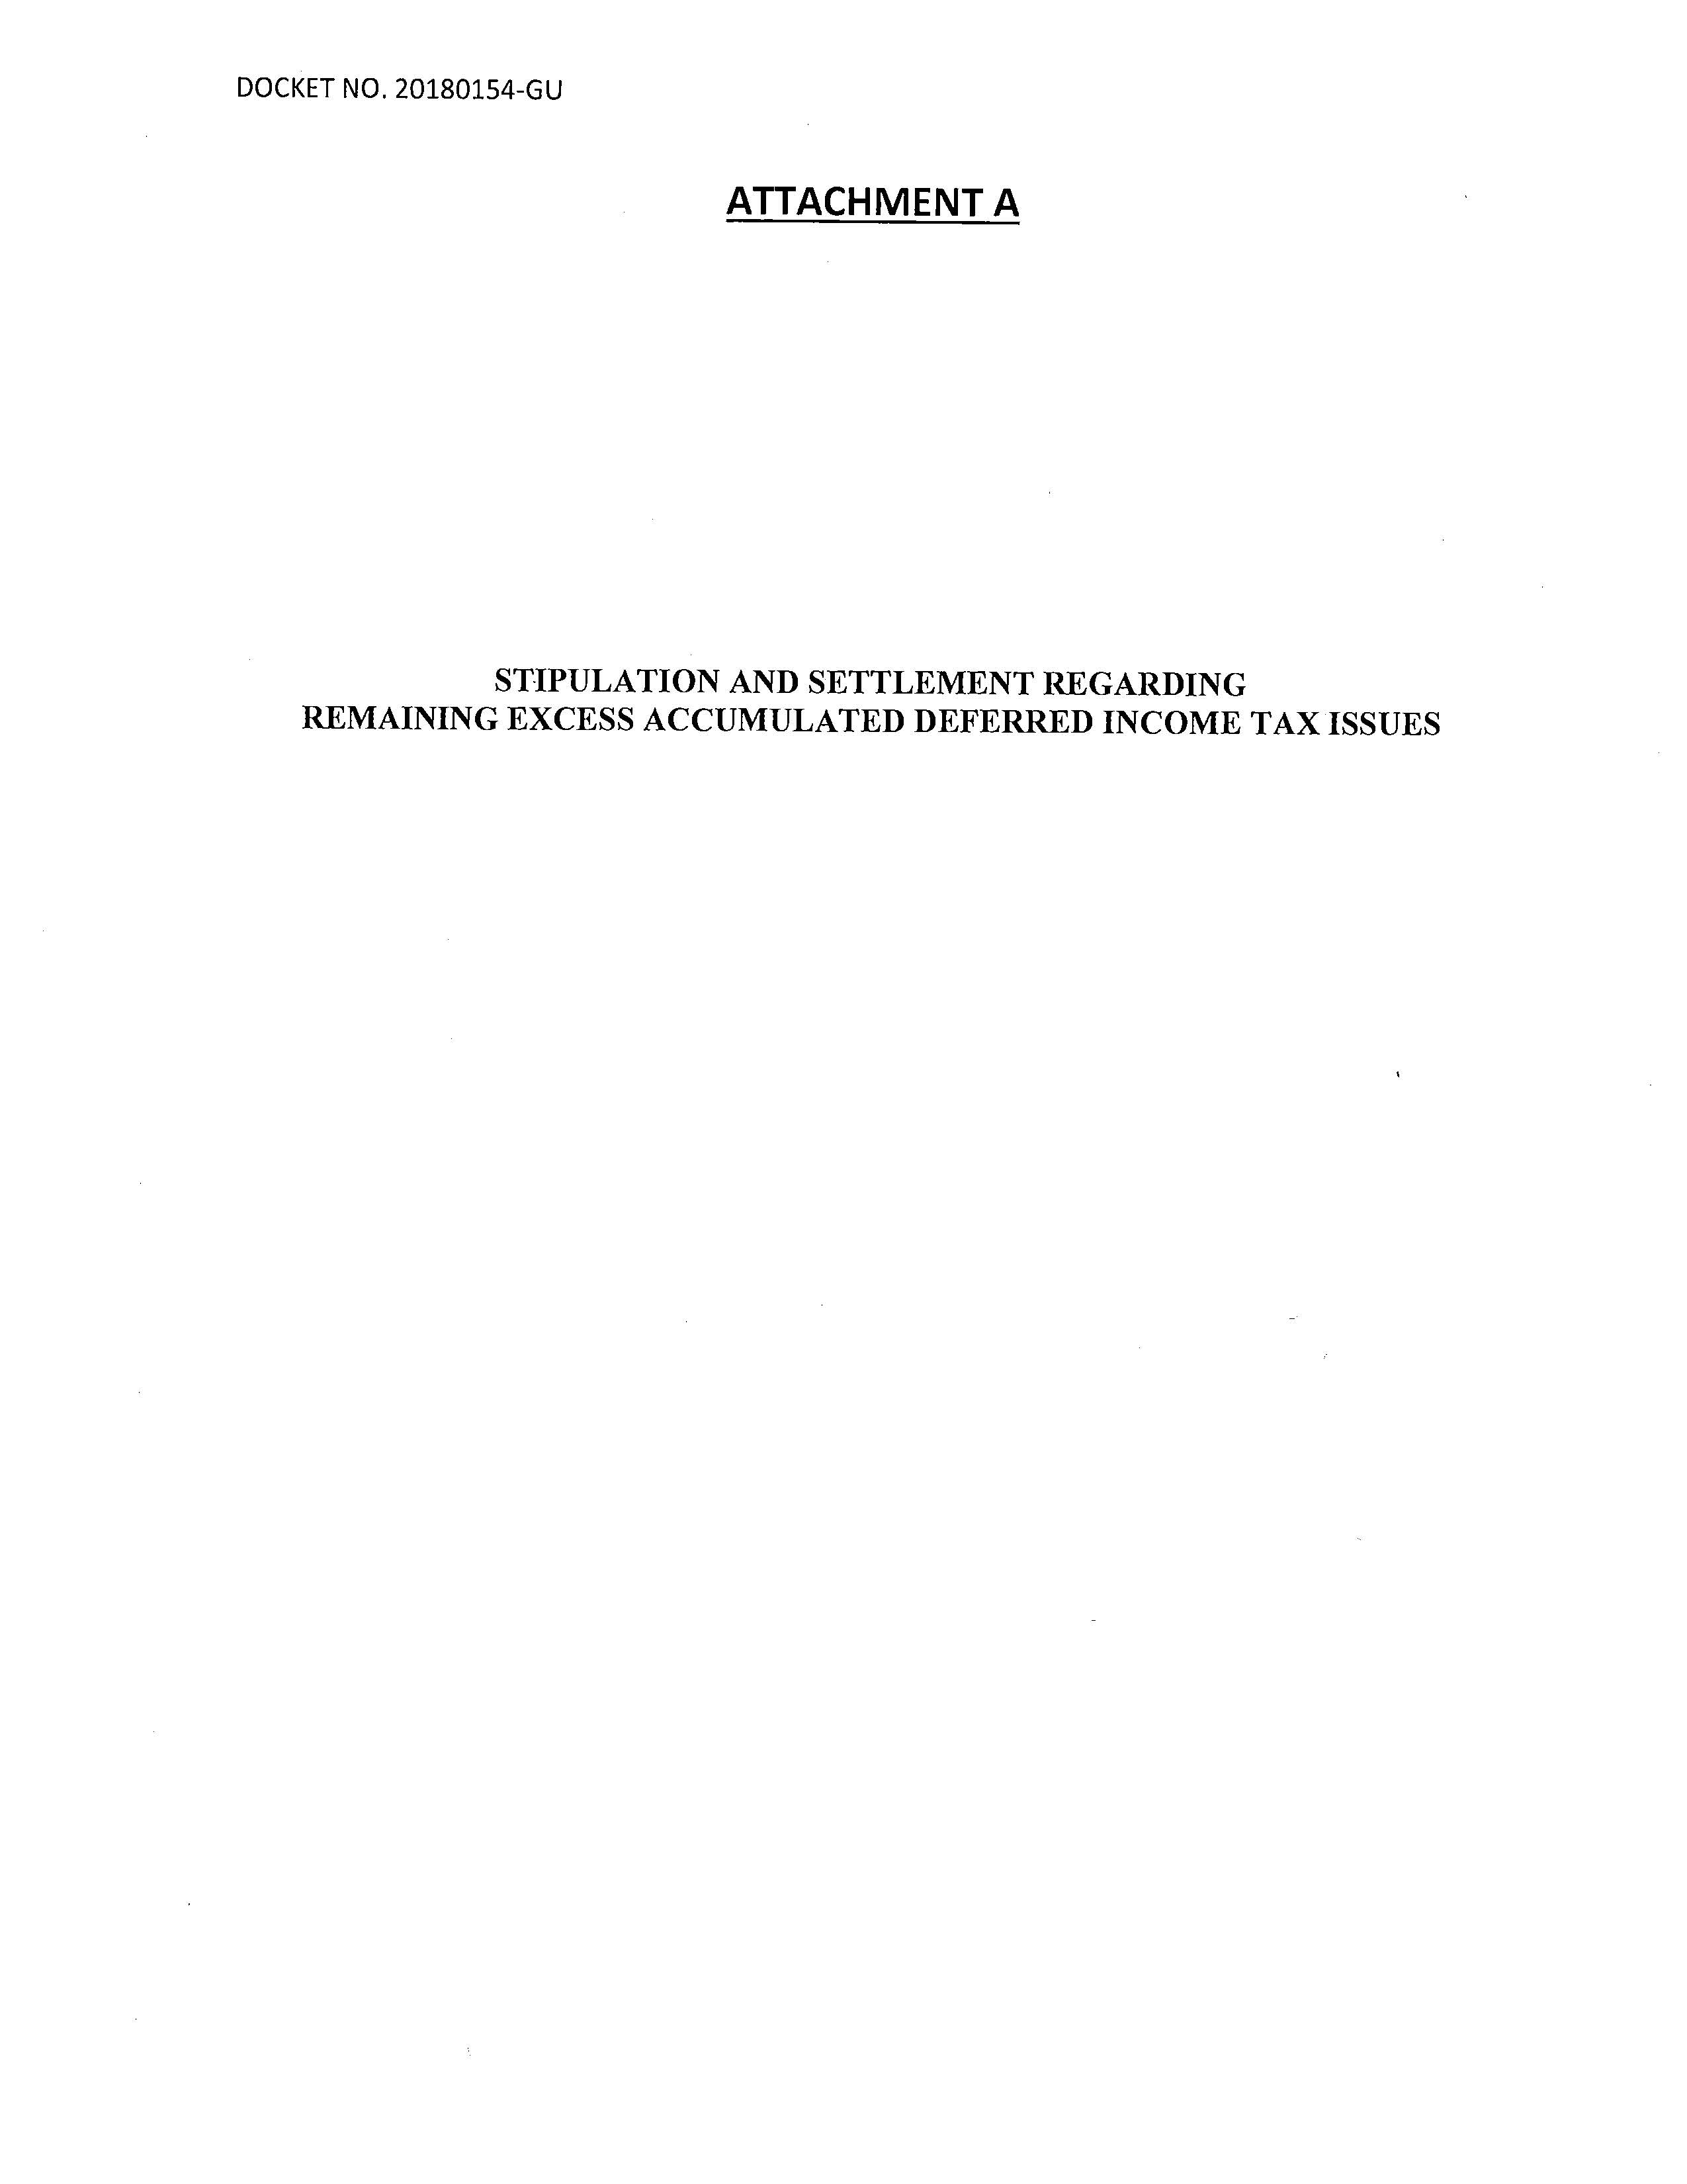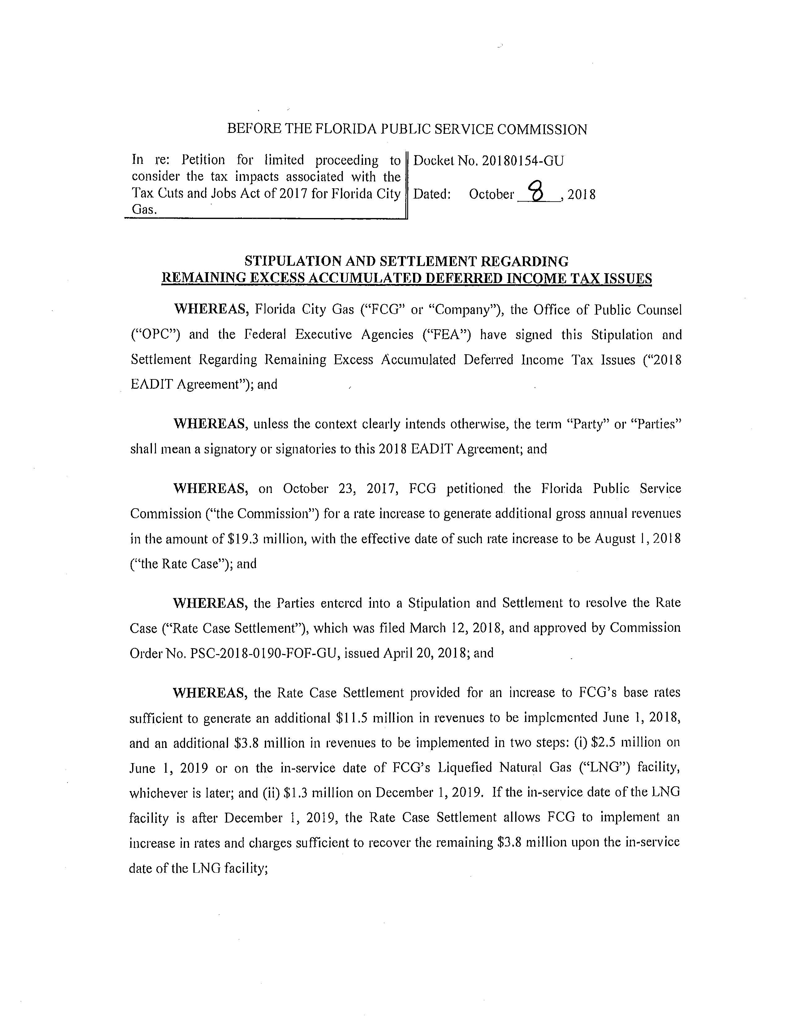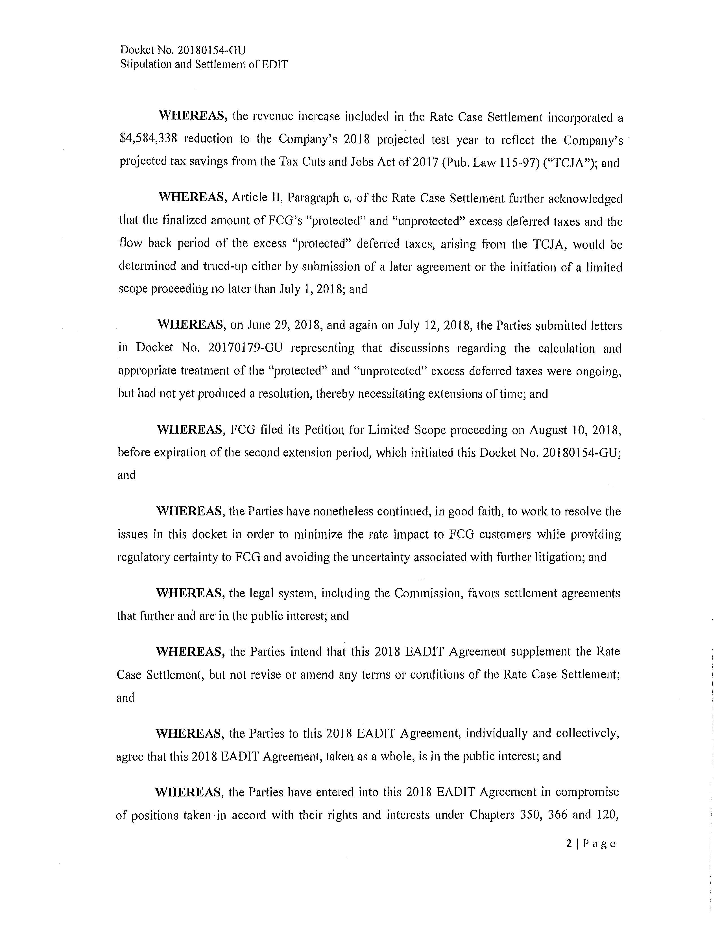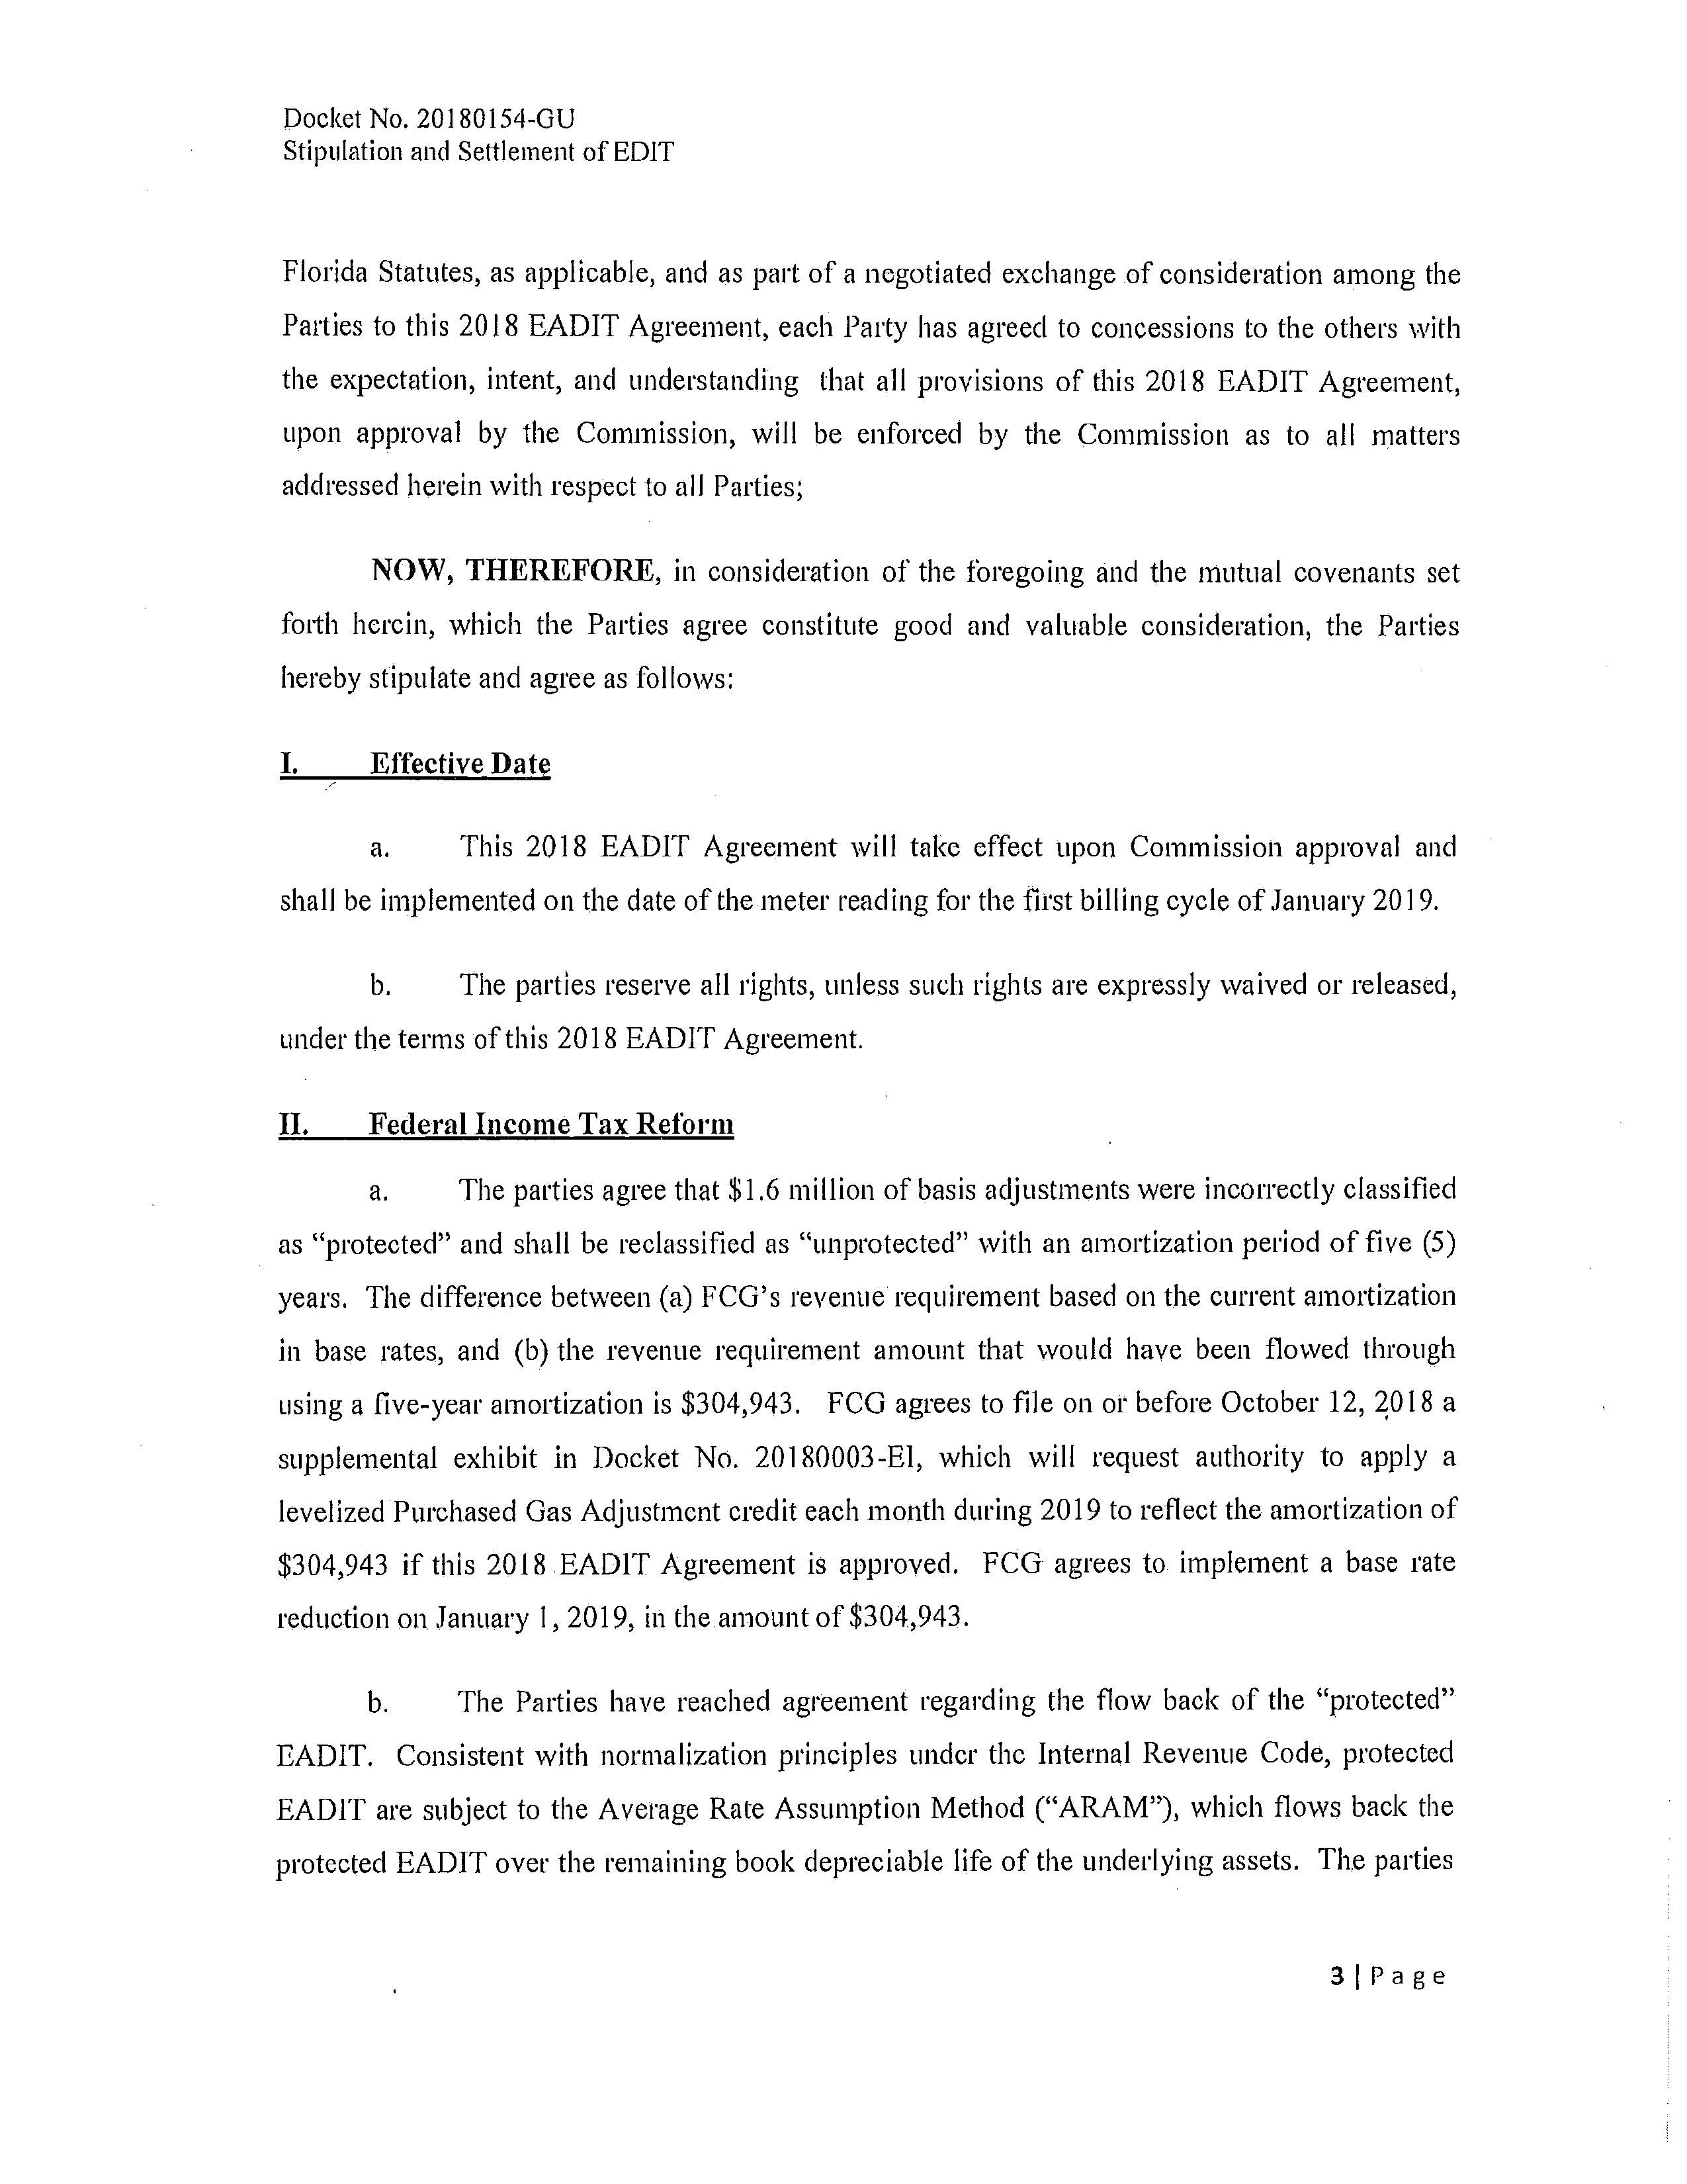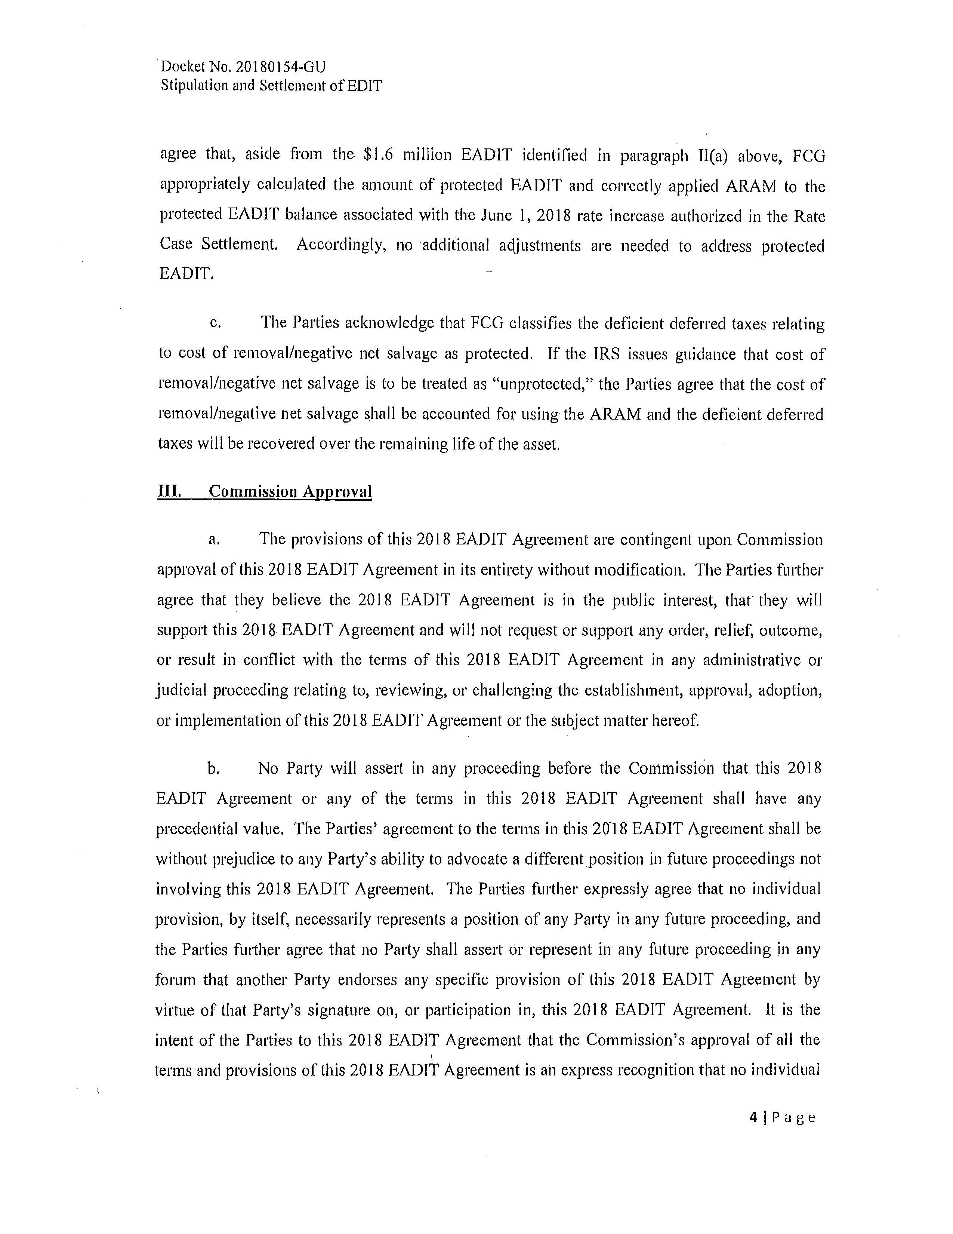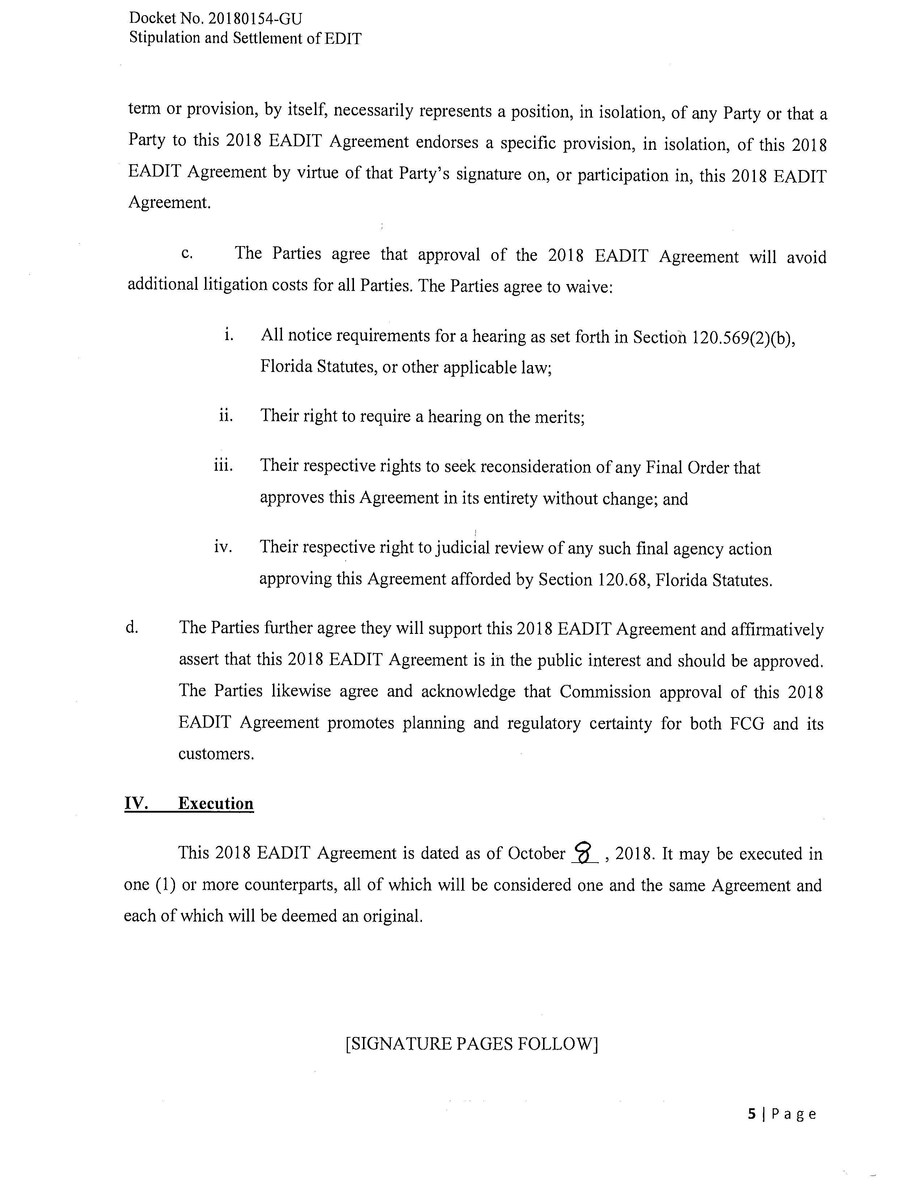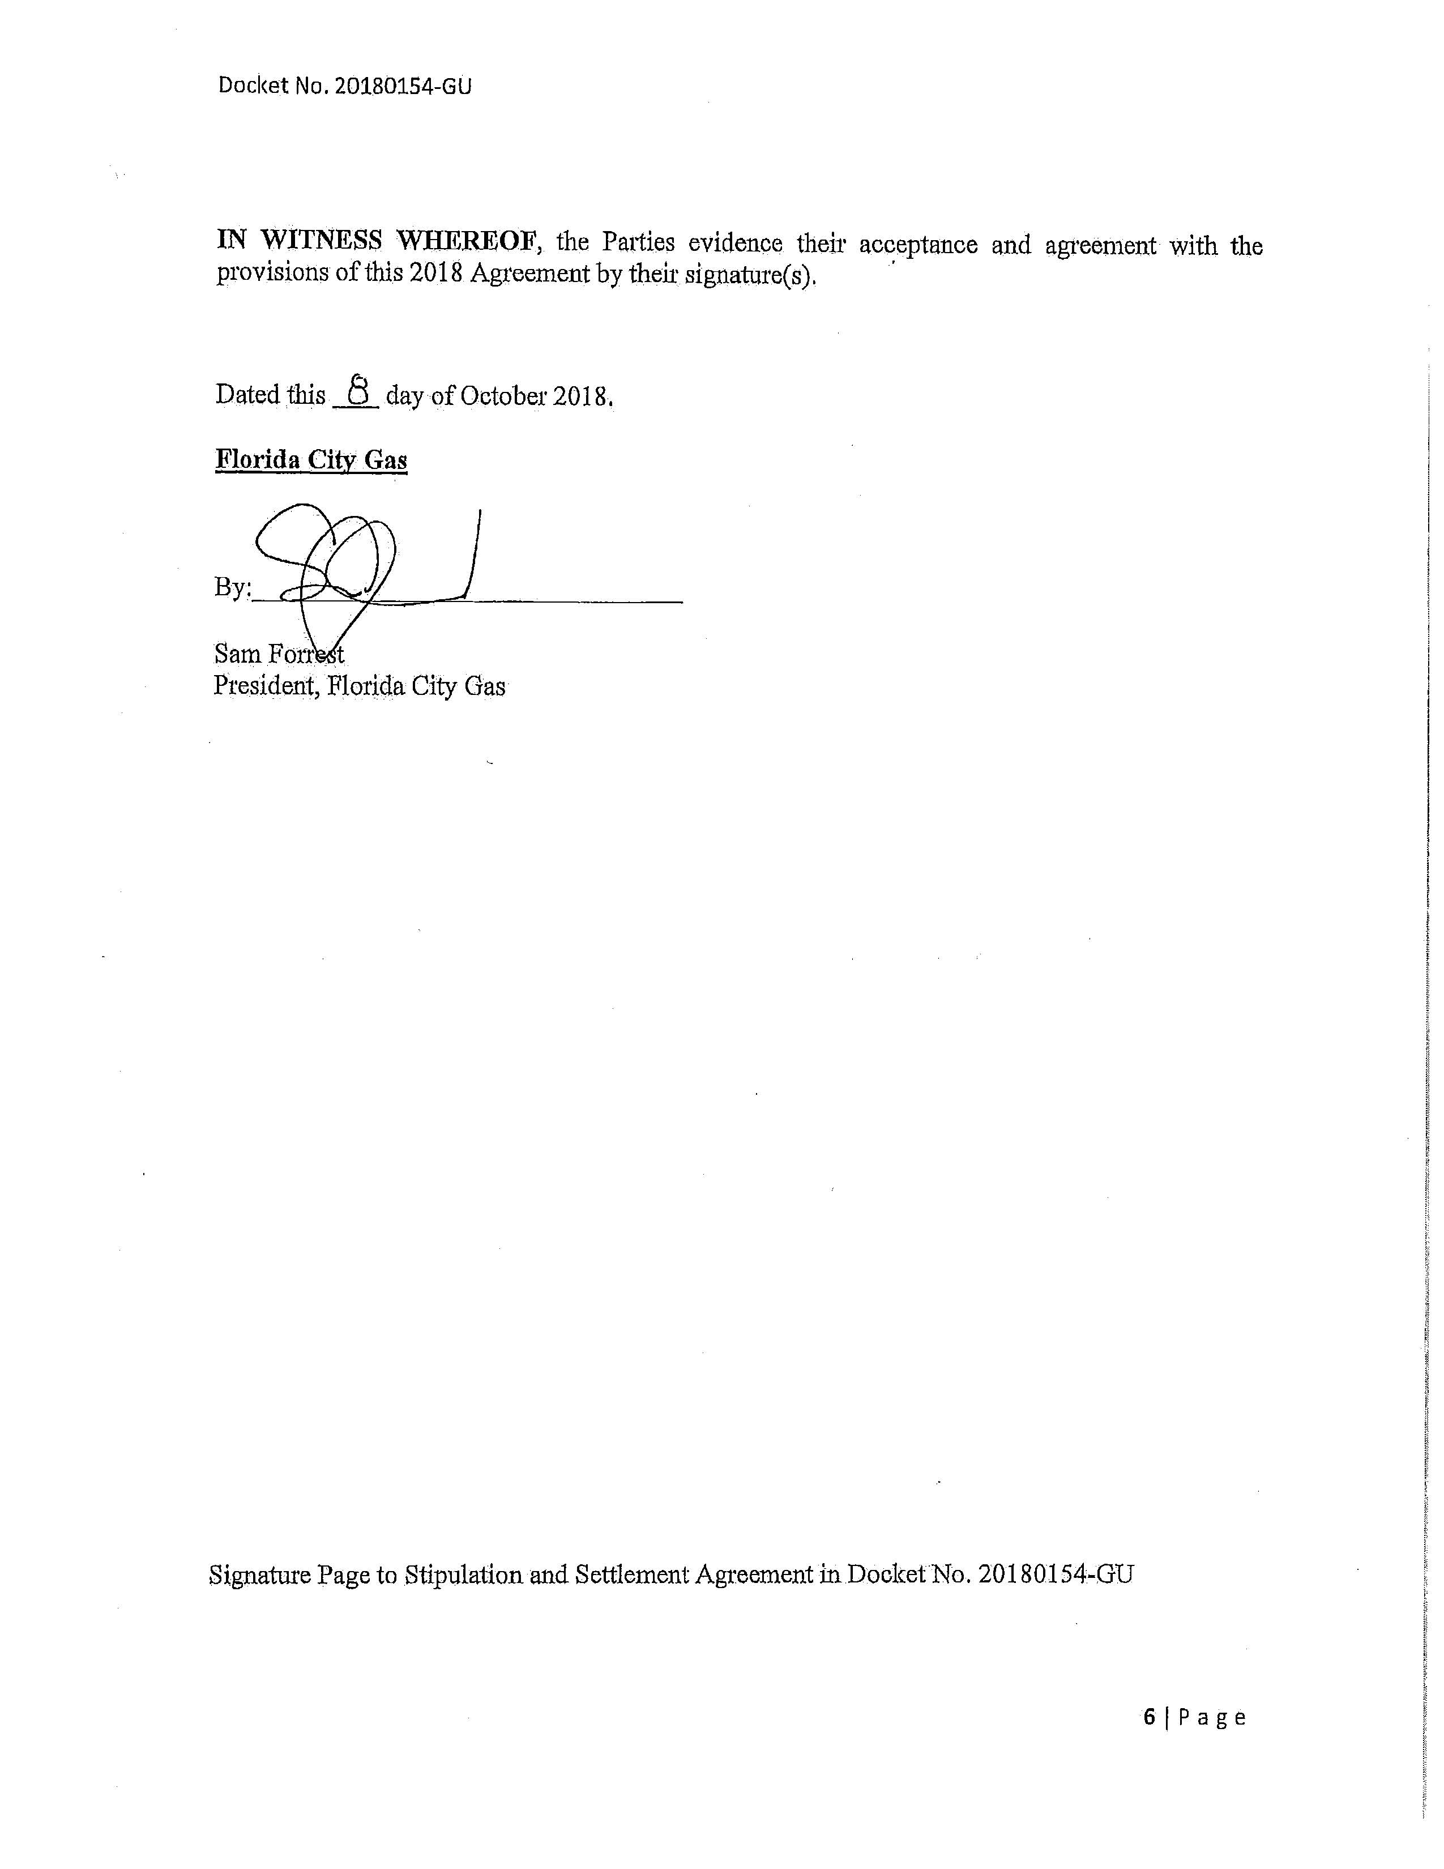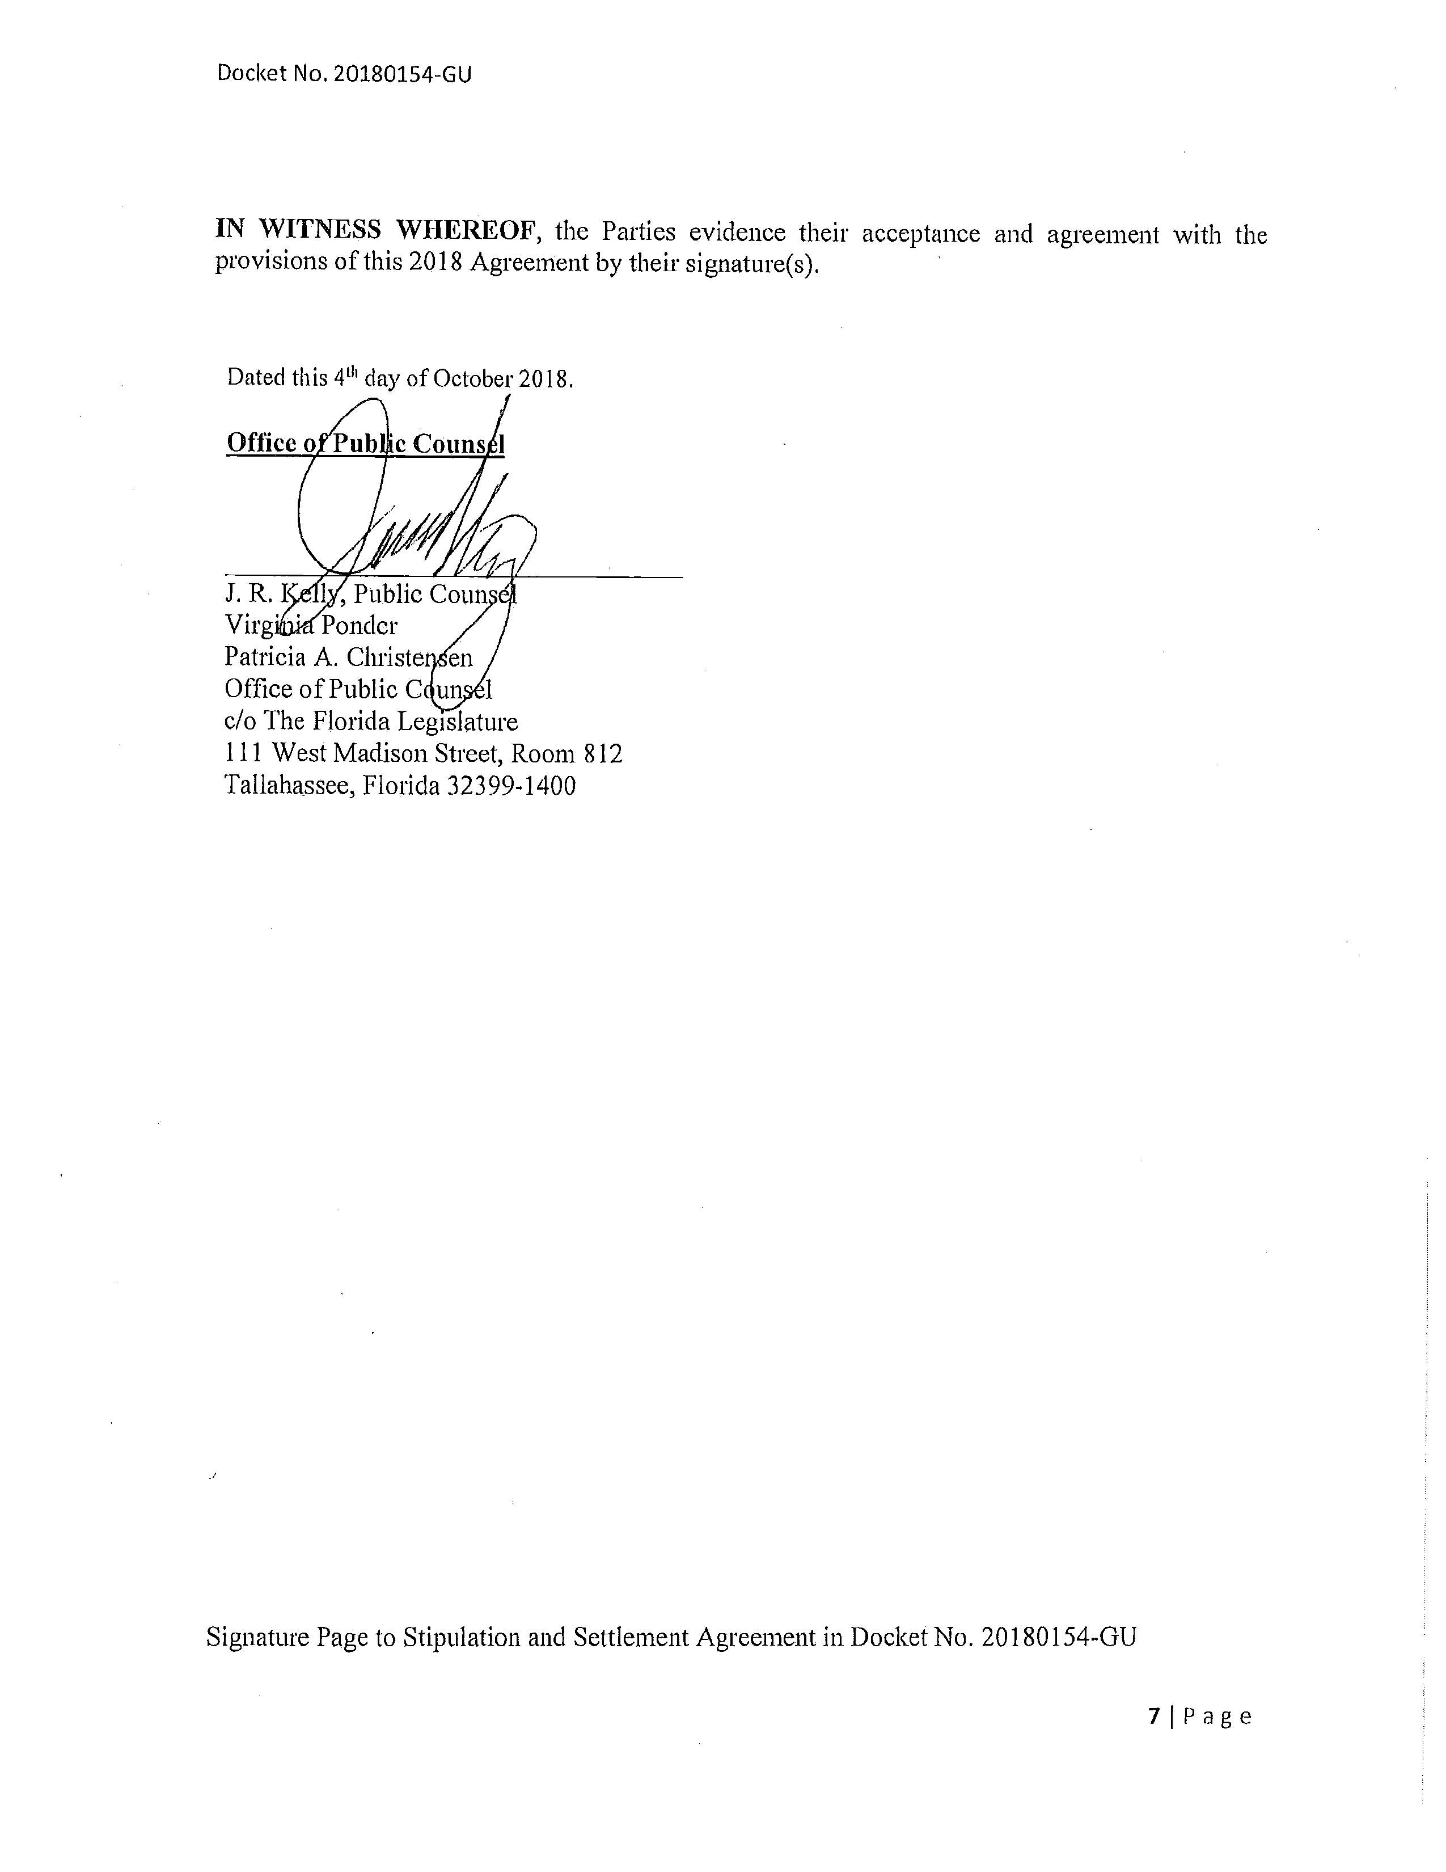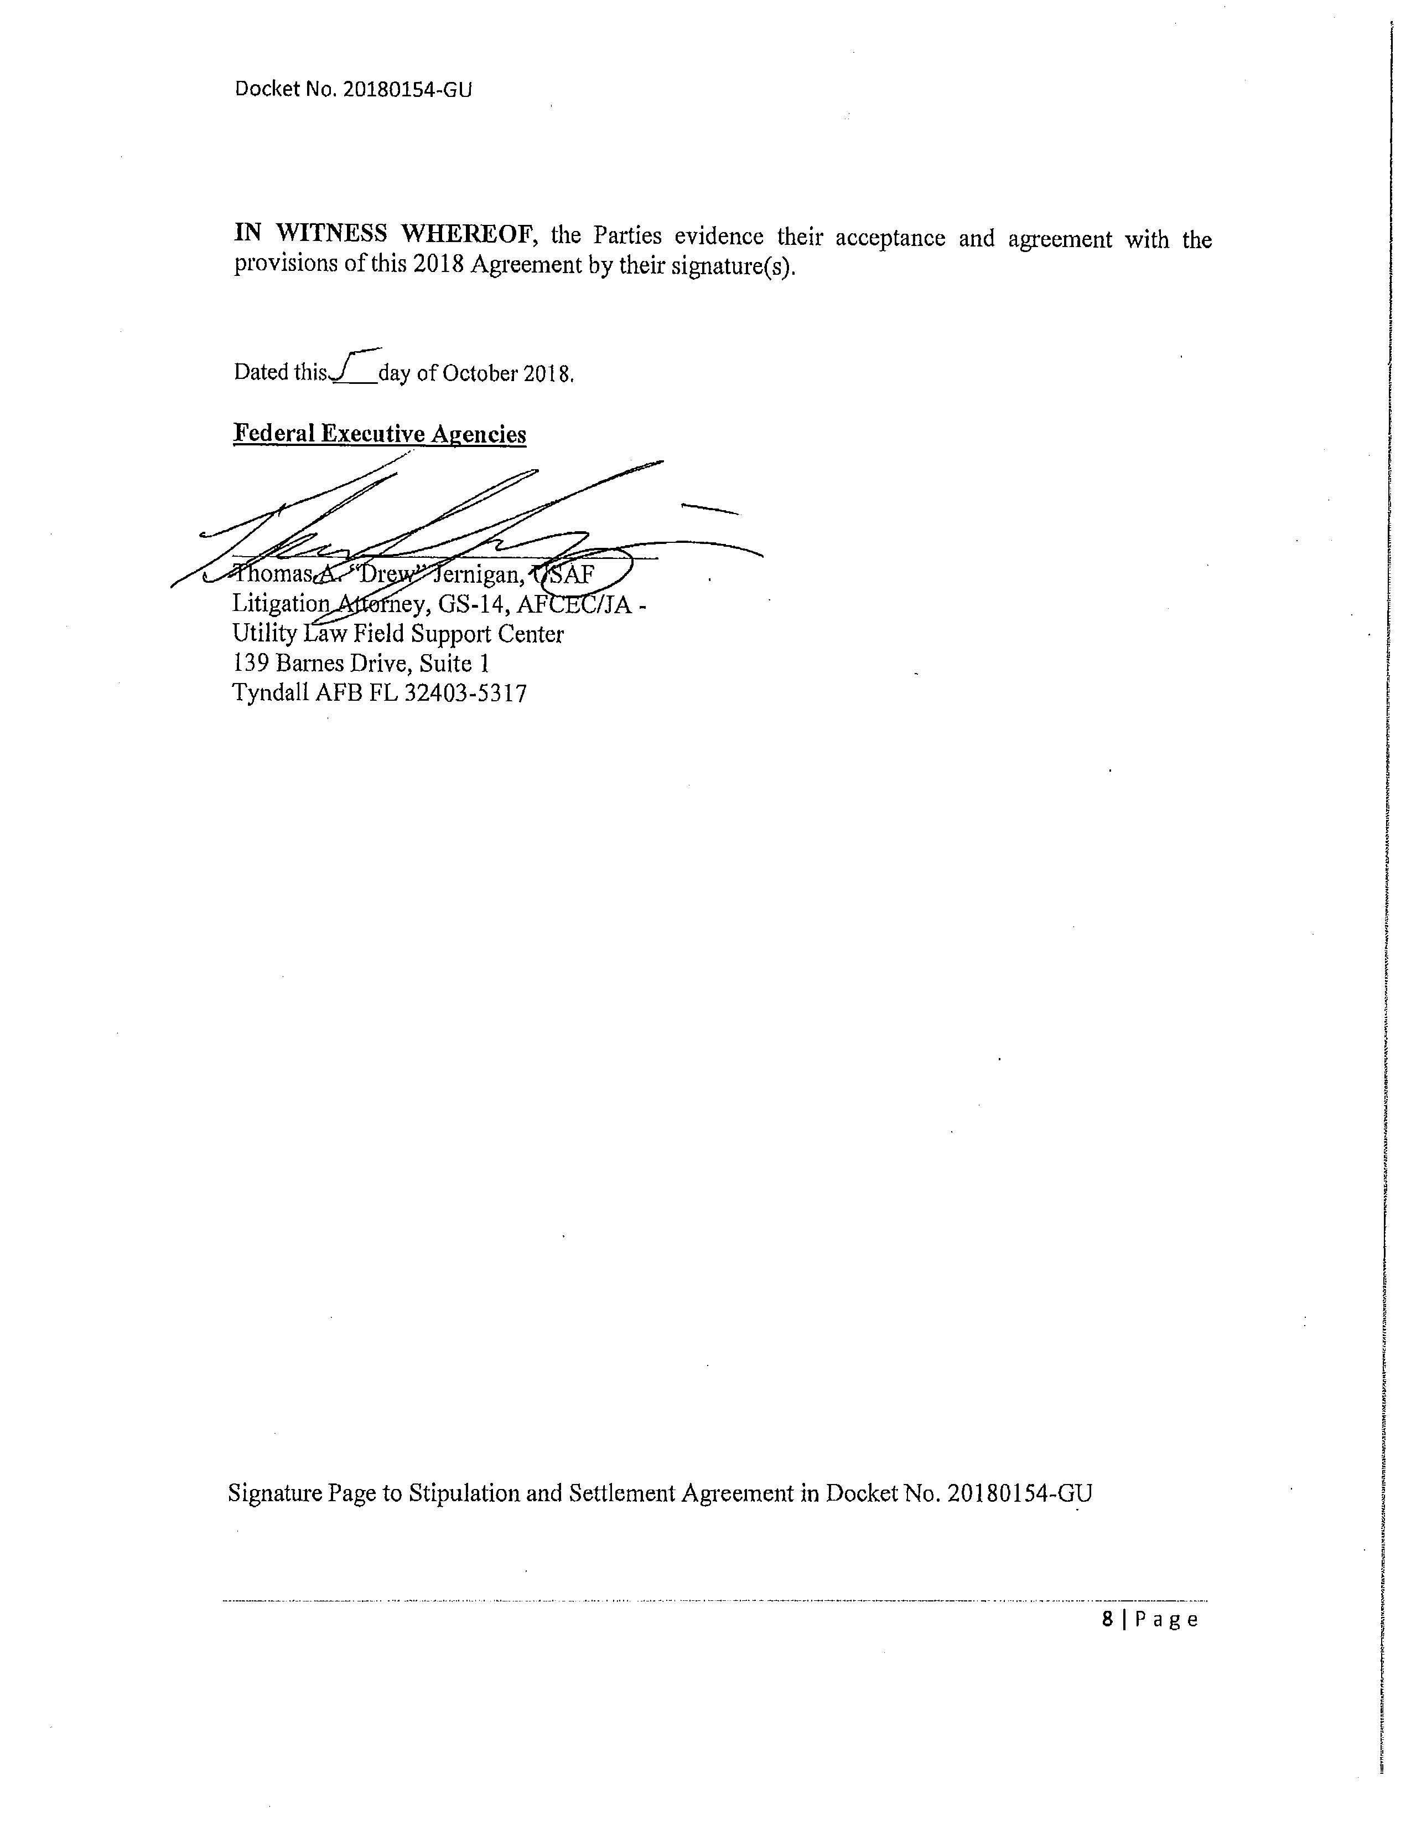

Order No. PSC-13-0023-S-EI, issued January 14, 2013, in Docket No. 120015-EI, In re: Petition for increase in rates by Florida Power & Light Company; Order No. PSC-11-0089-S-EI, issued February 1, 2011, in Docket Nos. 080677 and 090130, In re: Petition for increase in rates by Florida Power & Light Company and In re: 2009 depreciation and dismantlement study by Florida Power & Light Company; Order No. PSC-13-0023-S-EI, issued January 14, 2013, in Docket No. 120015-EI, In re: Petition for increase in rates by Florida Power & Light Company; PSC-10-0398-S-EI, issued June 18, 2010, in Docket Nos. 090079-EI, 090144-EI, 090145-EI, 100136-EI, In re: Petition for increase in rates by Progress Energy Florida, Inc., In re: Petition for limited proceeding to include Bartow repowering project in base rates, by Progress Energy Florida, Inc., In re: Petition for expedited approval of the deferral of pension expenses, authorization to charge storm hardening expenses to the storm damage reserve, and variance from or waiver of Rule 25-6.0143(1)(c), (d), and (f), F.A.C., by Progress Energy Florida, Inc., and In re: Petition for approval of an accounting order to record a depreciation expense credit, by Progress Energy Florida, Inc.; Order No. PSC-05-0945-S-EI, issued September 28, 2005, in Docket No. 050078-EI, In re: Petition for rate increase by Progress Energy Florida, Inc.
Order No. PSC-13-0023-S-EI, at p. 7.

