BEFORE THE FLORIDA PUBLIC SERVICE COMMISSION

In re: Application for gross-up of CIAC in Brevard County, by Aquarina Utilities, Inc. | DOCKET NO. 20180212-WS  ORDER NO. PSC-2019-0027-TRF-WS  ISSUED: January 11, 2019

The following Commissioners participated in the disposition of this matter:

ART GRAHAM, Chairman
JULIE I. BROWN
DONALD J. POLMANN
GARY F. CLARK
ANDREW GILES FAY

ORDER GRANTING GROSS-UP OF CIAC TARIFFS

BY THE COMMISSION:

BACKGROUND

Aquarina Utilities, Inc. (Aquarina or utility) is a Class B utility providing water and wastewater services in Brevard County to approximately 301 water, 123 non-potable, and 335 wastewater customers. The utility reported in its 2017 annual report operating revenues in the amount of $437,201 for water and $176,053 for wastewater. The utility did not collect contributions in aid of construction (CIAC) for water or wastewater in 2017.
On November 15, 2018, the utility filed an application for approval of tariffs to allow for gross-up of CIAC. As indicated in the utility’s application, the recent change in tax law may cause it to risk the loss of its opportunity to earn a reasonable return on its used and useful property if it is not allowed to collect the tax impact on receipt of CIAC. This order addresses the utility’s request for approval of gross-up tariffs related to changes in the federal tax code effective in 2018. Any potential refund related to the change in the federal tax rate currently embedded in the utility’s rates is outside the scope of this order and will be addressed in generic Docket No. 20180013-PU. This Commission has jurisdiction pursuant to Sections 367.081 and 367.091, Florida Statutes (F.S.).

DECISION

Effective January 1, 2018, the Federal Tax Cuts and Jobs Act amended Section 118 of the Internal Revenue Code. Prior to the amendments, CIAC was exempt from taxable gross income for water and wastewater utilities. As a result of the amendments, both cash and property CIAC are now taxable gross income for water and wastewater utilities. In recognition of this change in the tax law, we opened Docket No. 20180013-PU, In re: Petition to establish a generic docket to investigate and adjust rates for 2018 tax savings by Office of Public Counsel to address the potential rate impacts on regulated electric, gas, water, and wastewater utilities.

A similar law, the Tax Reform Act of 1986, became effective in 1987. In Docket No. 19860184-PU, this Commission found that it was appropriate to allow water and wastewater utilities to recover the tax on CIAC from the contributor, including the tax associated with the gross-up tax on CIAC that would also become taxable income. For those utilities that were approved to collect the gross-up on CIAC, the gross-up amounts collected were held subject to refund and were evaluated on a case-by-case basis as to whether any refunds were subsequently required.

On November 15, 2018, the utility filed tariffs (Attachment A hereto) to gross-up cash service availability charges and property contributions to recover the federal and state corporate income taxes associated with those contributions for water. However, for wastewater, Aquarina filed a tariff to gross-up only contributed wastewater property since it is not authorized to collect cash CIAC for wastewater service. According to the utility, Aquarina could risk loss of its opportunity to earn a reasonable return on its property used and useful in the public service if it is not allowed to collect the tax impact on receipt of CIAC.

The tariffs recognize that, for depreciable property, depreciation expense is tax deductible and the utility’s tax liability will be reduced by depreciation claimed for tax purposes. The proposed tariffs are mathematically the same, regarding the gross-up for taxes, as the tariff approved by this Commission following the hearing in Docket No. 19860184-PU.

Because the proposed tariffs accurately depict the utility’s expected tax expense associated with CIAC, we find that no further Commission action is required once the gross-up formula has been approved. The proposed tariffs are the same as those approved in Order Nos. PSC-2018-0330-TRF-WS, PSC-2018-0331-TRF-WS, and PSC-2018-0269-TRF-WS.

Based on the above, we hereby approve the tariffs. The approved gross-up charges shall be effective for connections made on or after the stamped approval date on the tariff sheets. The utility shall provide notice to all persons in the service areas included in the application who have filed a written request for service or who have been provided a written estimate for service within the 12 calendar months prior to the month the application was filed. The utility shall provide proof of noticing within 10 days of rendering its approved notice.

Based on the foregoing, it is

ORDERED by the Florida Public Service Commission that Aquarina Utilities, Inc.’s request for approval of tariffs to allow the gross-up of CIAC is hereby granted. It is further

ORDERED that the utility shall provide notice to all persons in the service areas included in the application who have filed a written request for service or who have been provided a written estimate for service within the 12 calendar months prior to the month the application was filed. The approved gross-up charges shall be effective for connections made on or after the stamped approval date on the tariff sheets. The utility shall provide proof of noticing within 10 days of rendering its approved notice. It is further

ORDERED that if a protest is filed by a substantially affected person within 21 days of issuance of the order, the tariffs shall remain in effect, with any revenues held subject to refund, pending resolution of the protest. It is further

ORDERED that if no timely protest is filed, this order shall become final upon the issuance of a consummating order. However, the docket shall remain open to allow Commission staff to verify that the appropriate notice has been filed by the utility and approved by staff. Once the utility has provided proof of noticing, the docket shall be closed administratively.

By ORDER of the Florida Public Service Commission this 11th day of January, 2019.

/s/ Adam J. Teitzman
ADAM J. TEITZMAN
Commission Clerk
Florida Public Service Commission
2540 Shumard Oak Boulevard
Tallahassee, Florida 32399
(850) 413-6770
www.floridapsc.com

Copies furnished: A copy of this document is provided to the parties of record at the time of issuance and, if applicable, interested persons.

JSC

NOTICE OF FURTHER PROCEEDINGS

The Florida Public Service Commission is required by Section 120.569(1), Florida Statutes, to notify parties of any administrative hearing or judicial review of Commission orders that is available under Sections 120.57 or 120.68, Florida Statutes, as well as the procedures and time limits that apply. This notice should not be construed to mean all requests for an administrative hearing or judicial review will be granted or result in the relief sought.

Mediation may be available on a case-by-case basis. If mediation is conducted, it does not affect a substantially interested person's right to a hearing.

The Commission's decision on this tariff is interim in nature and will become final, unless a person whose substantial interests are affected by the proposed action files a petition for a formal proceeding, in the form provided by Rule 28-106.201, Florida Administrative Code. This petition must be received by the Office of Commission Clerk, 2540 Shumard Oak Boulevard, Tallahassee, Florida 32399-0850, by the close of business on February 1, 2019.

In the absence of such a petition, this Order shall become final and effective upon the issuance of a Consummating Order.

Any objection or protest filed in this docket before the issuance date of this order is considered abandoned unless it satisfies the foregoing conditions and is renewed within the specified protest period.

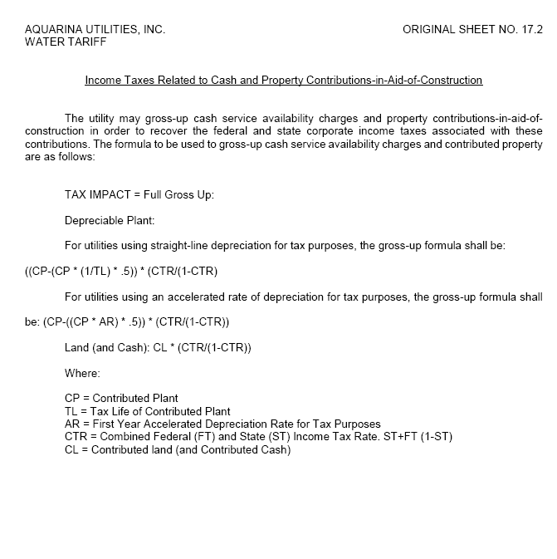

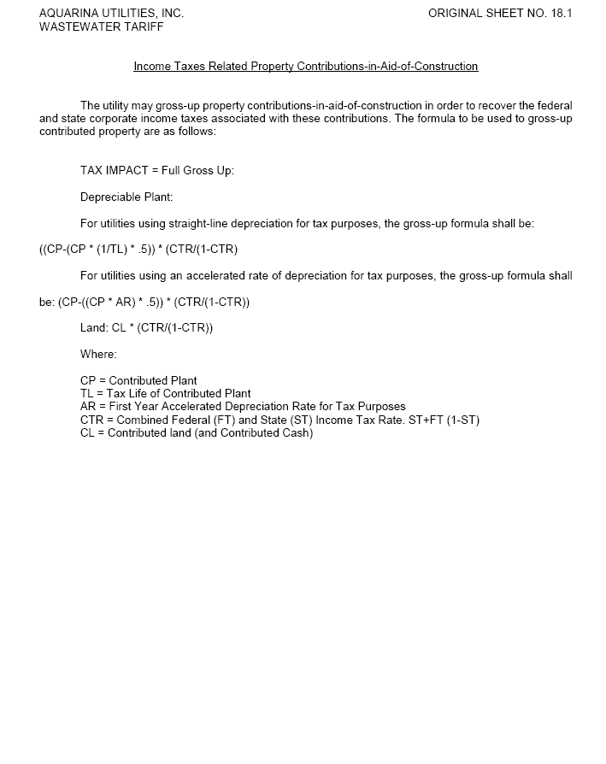

Docket No. 20180013-PU, In re: Petition to establish a generic docket to investigate and adjust rates for 2018 tax savings, by Office of Public Counsel.
The act was repealed in 1996.
Order No. 23541, issued October 1, 1990, in Docket No. 860184-PU, In re: Request by Florida Waterworks Association for investigation of proposed repeal of Section 118(b), Internal Revenue Code [Contributions-in-aid-of-construction].
Order No. PSC-2018-0330-TRF-WS, issued June 27, 2018, in Docket No. 20180042-WS, In re: Application for approval of tariff for the gross-up of CIAC in Martin County by Indiantown Company, Inc.; Order No. PSC-2018-0331-TRF-WS, issued June 27, 2018, in Docket No. 20180059-WS, In re: Application for approval of tariff for the gross-up of CIAC in Escambia County by Peoples Water Service Company of Florida, Inc.; and Order No. PSC-2018-0269-TRF-WS, issued May 30, 2018, in Docket No. 20180100-WS, In re: Application for approval of tariff for the gross-up of CIAC for water rates in Lee County and wastewater rates in Pasco County, by Ni Florida, LLC.

