BEFORE THE FLORIDA PUBLIC SERVICE COMMISSION

In re: Joint petition for approval of amendment to territorial agreement in Hardee, Highlands, Polk, and Osceola Counties, by Peace River Electric Cooperative and Duke Energy Florida, LLC. | DOCKET NO. 20180159-EU  ORDER NO. PSC-2019-0048-PAA-EU  ISSUED: January 28, 2019

The following Commissioners participated in the disposition of this matter:

ART GRAHAM, Chairman
JULIE I. BROWN
DONALD J. POLMANN
GARY F. CLARK
ANDREW GILES FAY

NOTICE OF PROPOSED AGENCY ACTION
ORDER APPROVING AMENDED TERRITORIAL AGREEMENT

BY THE COMMISSION:

NOTICE is hereby given by the Florida Public Service Commission that the action discussed herein is preliminary in nature and will become final unless a person whose interests are substantially affected files a petition for a formal proceeding, pursuant to Rule 25-22.029, Florida Administrative Code (F.A.C.).

Background

On August 31, 2018, Peace River Electric Cooperative (PRECO) and Duke Energy Florida, LLC (DEF) filed a joint petition for approval of an amendment to their current territorial agreement in Hardee, Highlands, Polk, and Osceola Counties. The proposed agreement is shown in Attachment A and a map depicting the current service territories and proposed changes is shown in Attachment B to this Order. Detailed maps delineating the service boundaries and their written descriptions are provided in Exhibits A and B to this Order, respectively.

In 1994, this Commission approved a territorial agreement that established the boundaries for the utilities’ service territories in the counties mentioned above. The 1994 agreement contained a provision permitting DEF (Florida Power Corporation at the time) to provide transmission level electric service (69 kilovolt and higher) to certain phosphate mining companies in PRECO’s service territory. The mining companies have unique service requirements and PRECO did not have the appropriate facilities to meet the phosphate customers’ transmission level electric needs.

In 2006, this Commission approved an amendment to Sections 1.9 and 2.4 of the 1994 territorial agreement. These sections address the provision of electric service to the phosphate mining companies in PRECO’s service territory and the 2006 amendment clarified the parties’ obligations with respect to the existing phosphate mining customers in PRECO’s service territory. The number of phosphate mining customers served by DEF in PRECO’s service territory, pursuant to the 1994 territorial agreement, decreased from nine customers in 1994 to two customers in 2006. The 2006 agreement will expire on December 12, 2019.

PRECO and DEF entered into the proposed territorial agreement and filed the instant petition. The proposed agreement replaces the current 2006 agreement in its entirety while incorporating many provisions of the current agreement. Under the proposed agreement the territorial boundaries have been modified and will result in the transfer of 2,858 customers from DEF to PRECO and 28 customers from PRECO to DEF.

During the review of this joint petition, Commission staff issued a joint data request to DEF and PRECO on November 8, 2018, for which responses were received on November 20, 2018. Commission staff also had follow-up questions for which responses were received on December 20, 2018. The responses have been placed in the docket file. We have jurisdiction over this matter pursuant to Section 366.04(2)(d), Florida Statutes (F.S.)

Decision

Pursuant to Section 366.04(2)(d), F.S., and Rule 25-6.0440, Florida Administrative Code (F.A.C.), this Commission has the jurisdiction to approve territorial agreements between and among rural electric cooperatives, municipal electric utilities, and other electric utilities. Unless we determine that the agreement will cause a detriment to the public interest, the agreement shall be approved.

Through the proposed agreement, the service area boundaries within the four-county area will be revised in order to serve customers more reliably and economically. Under the proposed agreement, 2,858 customers in Hardee County and a small area in southern Polk County will be transferred from DEF to PRECO (409 commercial, 6 industrial, and 2,443 residential customers). The petitioners explained in their response to Commission staff’s data request that over the years the service areas of the two utilities have overlapped and resulted in duplicate electric service facilities and that such evolution is not unusual in rural areas. As an example, the petitioners stated that in Hardee County, DEF has facilities on one side and PRECO has facilities on the other side of the same road. The petitioners stated that transferring customers from DEF to PRECO will eliminate the duplication of services, create operational efficiencies for both utilities, and will ensure customers continue to receive safe and reliable service.

In addition to the customer transfers discussed above, 28 PRECO customers will be transferred to DEF (two commercial and 26 residential customers). The petitioners stated that during due diligence field surveys of the service territory, 28 customers located in DEF’s service territory were identified as being inadvertently being served by PRECO. All the customers will be transferred within 36 months of the effective date of this agreement and the petitioners will notify this Commission in writing if additional time is needed. The territorial boundary maps have been modified to reflect the customer transfers and have been updated to a GIS format to show the lines in greater detail. Additionally, parcels that were divided (between the two electric providers) by the prior territorial boundary lines have been modified to eliminate split parcels.

The petitioners explained that the customer transfer process includes the following steps: planning and coordinating between multiple departments of each utility, seeking this Commission’s approval of the proposed agreement, conducting engineering studies, developing customer communications plan, evaluating facilities, conducting various field reviews, and conducting individual engineering work requests designed for each customer being transferred.

In accordance with Rule 25-6.0440(1)(d), F.A.C., the petitioners state that prior to the filing of this petition, the impacted customers were notified by mail of the transfer and provided a description of the differences in rates between DEF and PRECO. As of July 2018, the bill for a residential customer using 1,000 kilowatt hours (kWh) was $128.78 for PRECO and $124.16 for DEF. As of July 2018, the bill for a commercial non-demand customer using 1,500 kWhs was $207.63 for PRECO and $189.41 for DEF. Customer deposits for DEF and PRECO customers will be applied to their last electric bill and any surplus will be refunded directly to the customers.

Additionally, the joint petitioners held an open house in Wauchula on August 14, 2018, for customers affected by the proposed transfers. Issues and concerns discussed at the open house were regarding differences in rates, billing, customer deposits, and residential seasonal service programs. The petitioners stated that PRECO and DEF had several representatives present to answer questions and there were no outstanding concerns after the open house. The petition includes customer notification letters and a summary of customer issues and concerns stated at the open house.

Pursuant to Section 2.5 of the proposed agreement, DEF provides electric service to a phosphate mining customer in PRECO’s service territory. DEF’s service to the mining customer is limited to the electric requirements directly associated with the mining operations. The phosphate mining customer is referred to as a Special Industrial Customer in the agreement. The agreement provides that once the Special Industrial Customer operating in PRECO’s service territory completes its mining operations, all rights to serve the Special Industrial Customer in PRECO’s service territory will revert back to PRECO.

Pursuant to Section 3.4 of the proposed agreement, either utility may elect to purchase electric distribution facilities exclusively for providing electric service to the transferred customers. To determine the facilities’ value, the utilities will use a common engineering cost estimation methodology such as the Handy-Whitman index. In response to Commission staff’s data request, the joint petitioners stated that they have not yet made a final decision regarding transferring or purchasing facilities, but will undertake a valuation of facilities once the proposed agreement is approved by this Commission.

Pursuant to Section 1.14 of the proposed agreement, the effective date of the agreement will be the date on which a final Order is issued by this Commission. The proposed agreement has been negotiated for an initial term of 30 years and may automatically be extended for succeeding periods of five years. After the expiration of the 30-year term of the proposed agreement in 2049, the agreement would remain in effect for succeeding periods of five years until and unless either party provides written notice of termination no less than 12 months prior to the termination date. Section 5.1 of the agreement states that any modifications to the agreement must be submitted to this Commission for approval.

After review of the petition, the proposed territorial agreement, and the joint petitioners’ responses to Commission staff’s data requests, we believe that the proposed amendments to the territorial agreement are in the public interest and will enable DEF and PRECO to serve their customers in an efficient manner. The joint petitioners in their responses state that they have worked collaboratively to structure the proposed amendments to their territorial agreement and that it furthers the goals of avoiding duplication of service and enables them to achieve operational efficiency. We find that the proposed amendments will eliminate any potential uneconomic duplication of facilities and will not cause a decrease in the reliability of electric service to the customers. As such, we conclude that the proposed territorial agreement between DEF and PRECO will not cause a detriment to the public interest and it shall be approved.

Based on the foregoing, it is

ORDERED by the Florida Public Service Commission that the joint petition by Duke Energy Florida, LLC and Peace River Electric Cooperative for approval of an amended territorial agreement in Hardee, Highlands, Polk, and Osceola Counties is approved. It is further

ORDERED that the provisions of this Order, issued as proposed agency action, shall become final and effective upon the issuance of a Consummating Order unless an appropriate petition, in the form provided by Rule 28-106.201, Florida Administrative Code, is received by the Commission Clerk, 2540 Shumard Oak Boulevard, Tallahassee, Florida 32399-0850, by the close of business on the date set forth in the “Notice of Further Proceedings” attached hereto. It is further

ORDERED that in the event this Order becomes final, this docket shall be closed.

By ORDER of the Florida Public Service Commission this 28th day of January, 2019.

/s/ Adam J. Teitzman
ADAM J. TEITZMAN
Commission Clerk
Florida Public Service Commission
2540 Shumard Oak Boulevard
Tallahassee, Florida 32399
(850) 413-6770
www.floridapsc.com

Copies furnished: A copy of this document is provided to the parties of record at the time of issuance and, if applicable, interested persons.

JEN

NOTICE OF FURTHER PROCEEDINGS OR JUDICIAL REVIEW

The Florida Public Service Commission is required by Section 120.569(1), Florida Statutes, to notify parties of any administrative hearing or judicial review of Commission orders that is available under Sections 120.57 or 120.68, Florida Statutes, as well as the procedures and time limits that apply. This notice should not be construed to mean all requests for an administrative hearing or judicial review will be granted or result in the relief sought.

As identified in the body of this order, our action proposed herein is preliminary in nature. Any person whose substantial interests are affected by the action proposed by this order may file a petition for a formal proceeding, in the form provided by Rule 28-106.201, Florida Administrative Code. This petition must be received by the Office of Commission Clerk, at 2540 Shumard Oak Boulevard, Tallahassee, Florida 32399-0850, by the close of business on February 18, 2019. If such a petition is filed, mediation may be available on a case-by-case basis. If mediation is conducted, it does not affect a substantially interested person's right to a hearing. In the absence of such a petition, this order shall become effective and final upon the issuance of a Consummating Order.

Any objection or protest filed in this docket before the issuance date of this order is considered abandoned unless it satisfies the foregoing conditions and is renewed within the specified protest period.

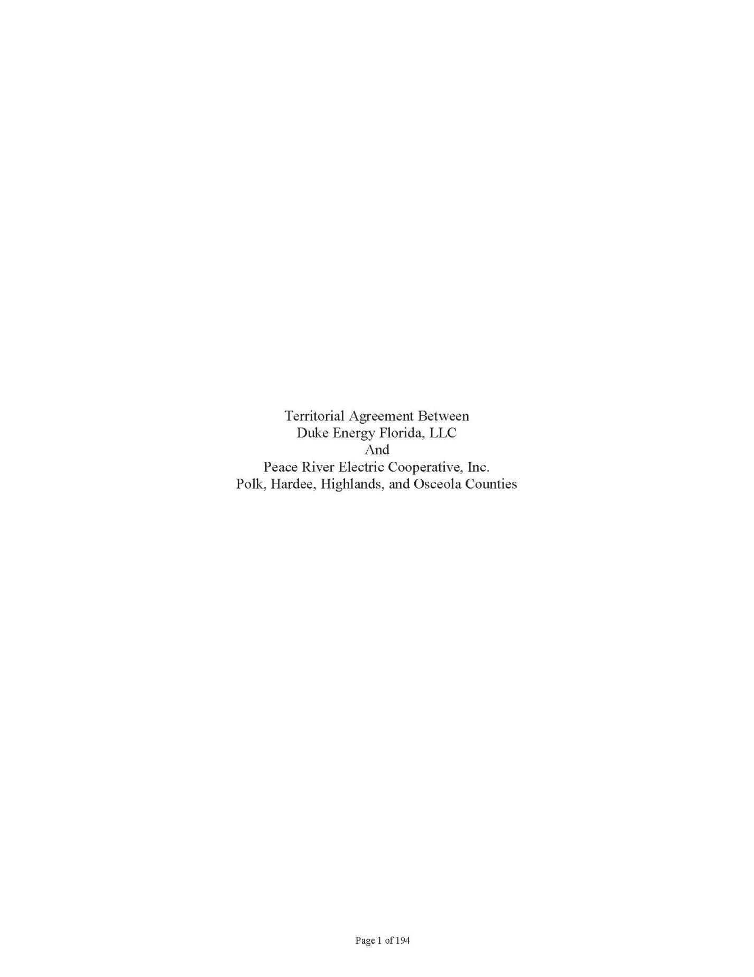

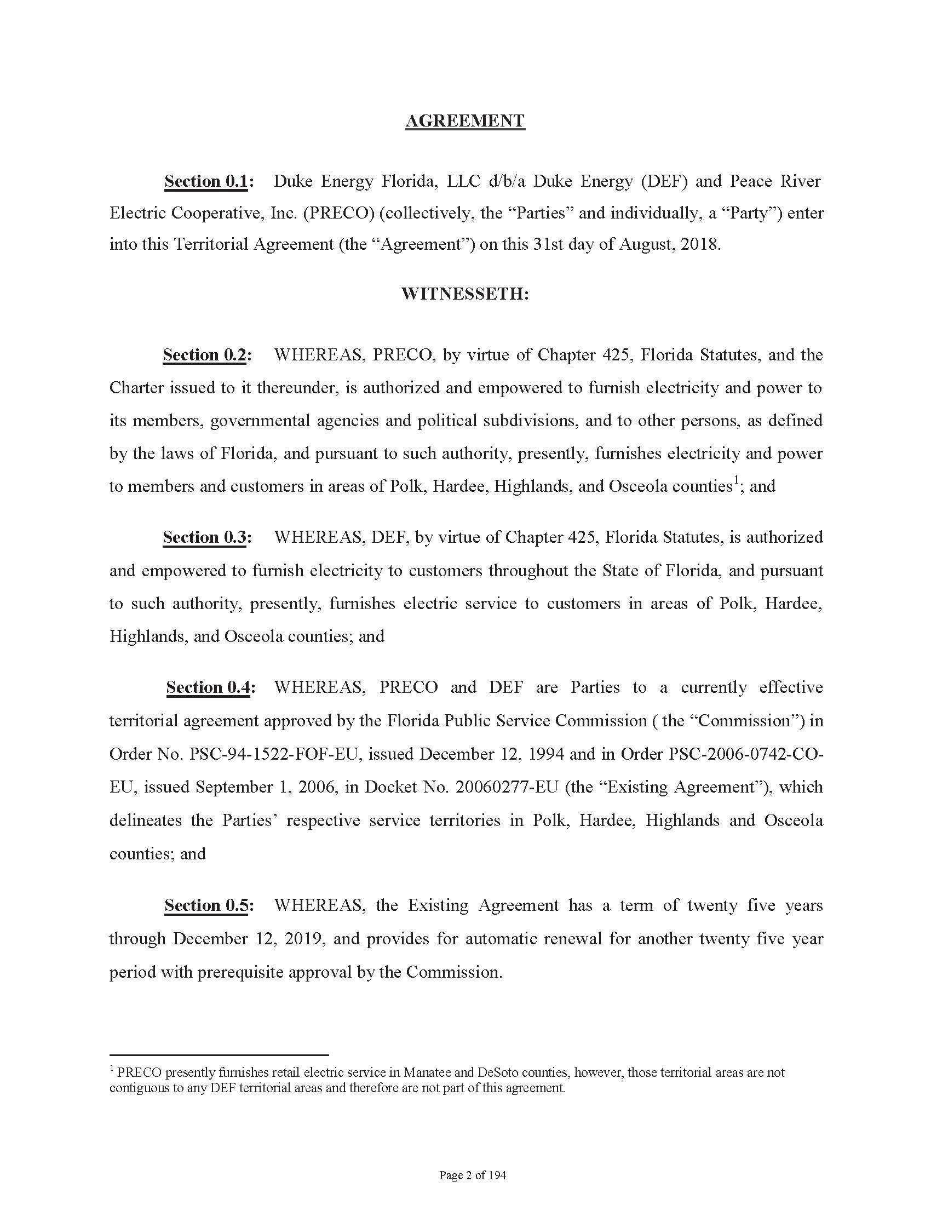

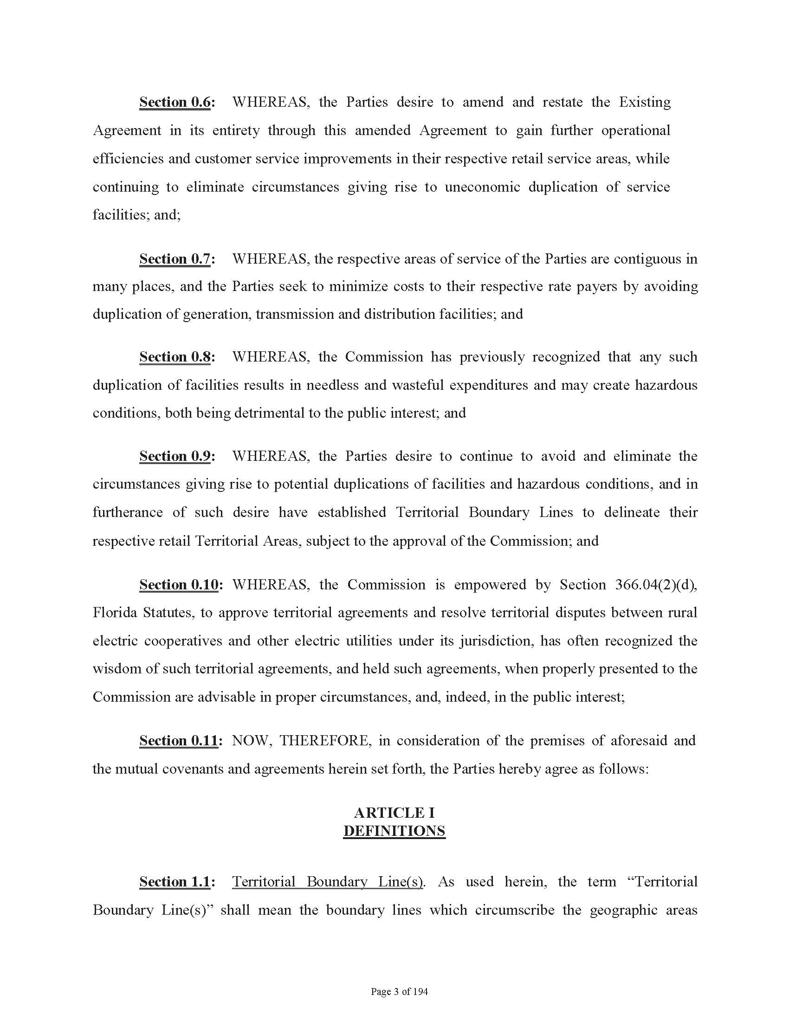

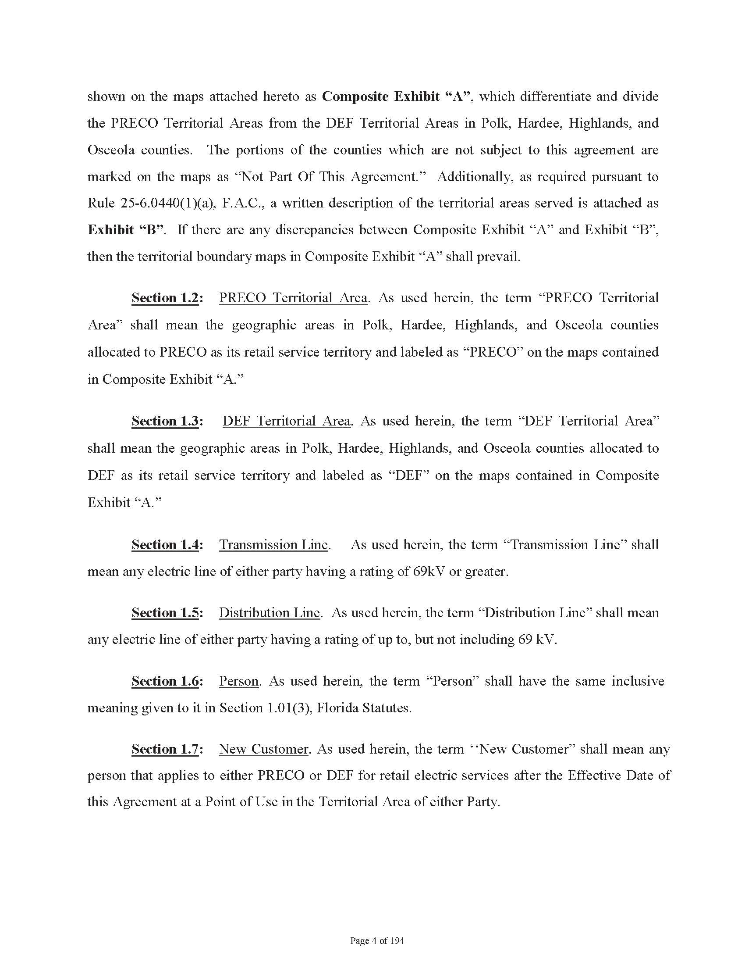

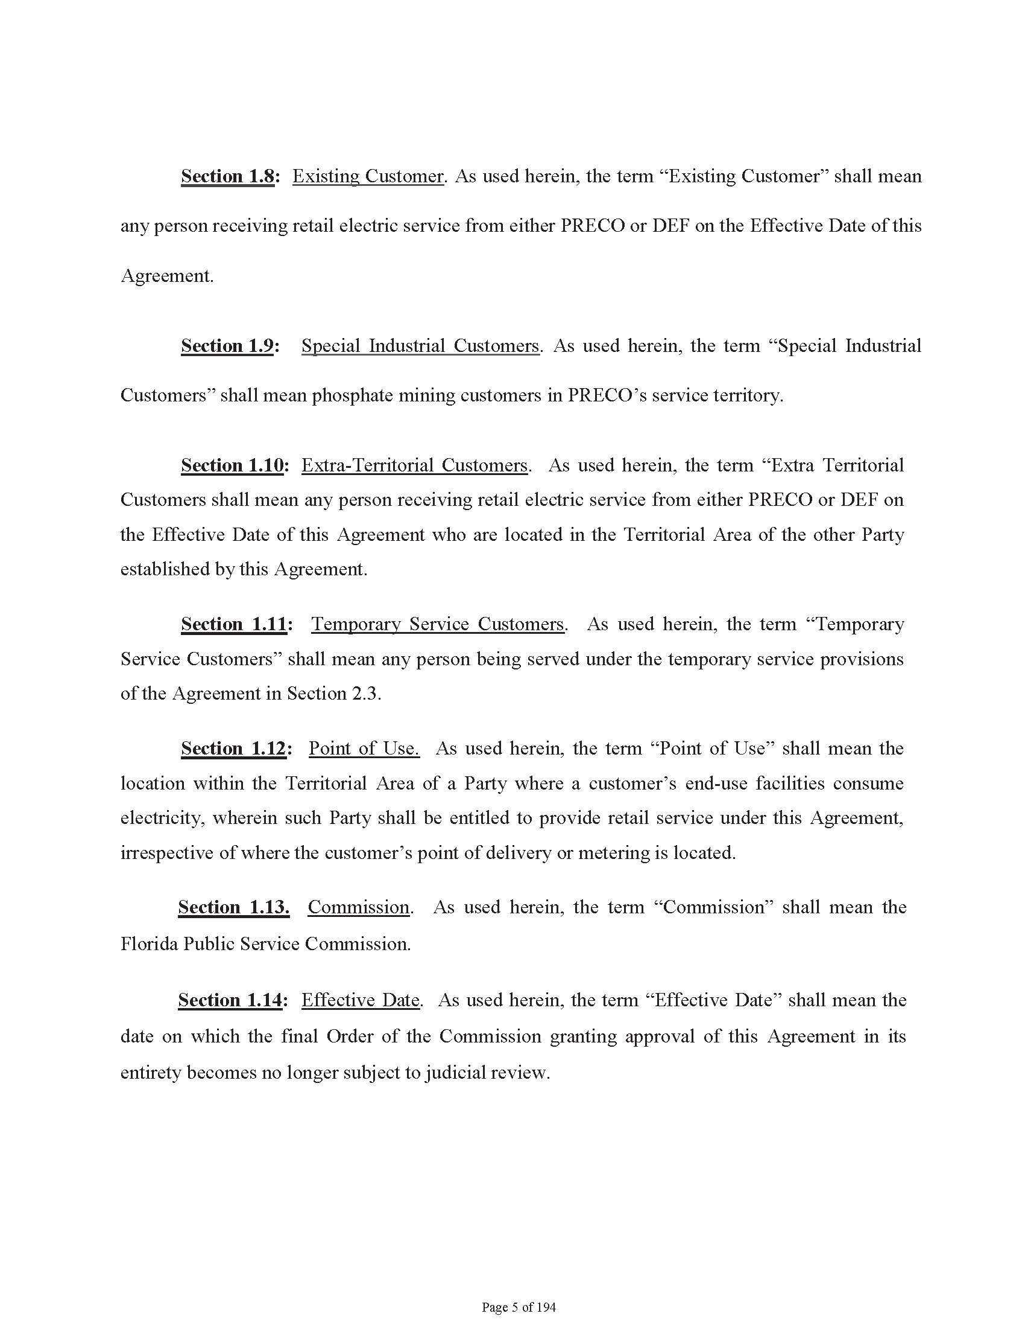

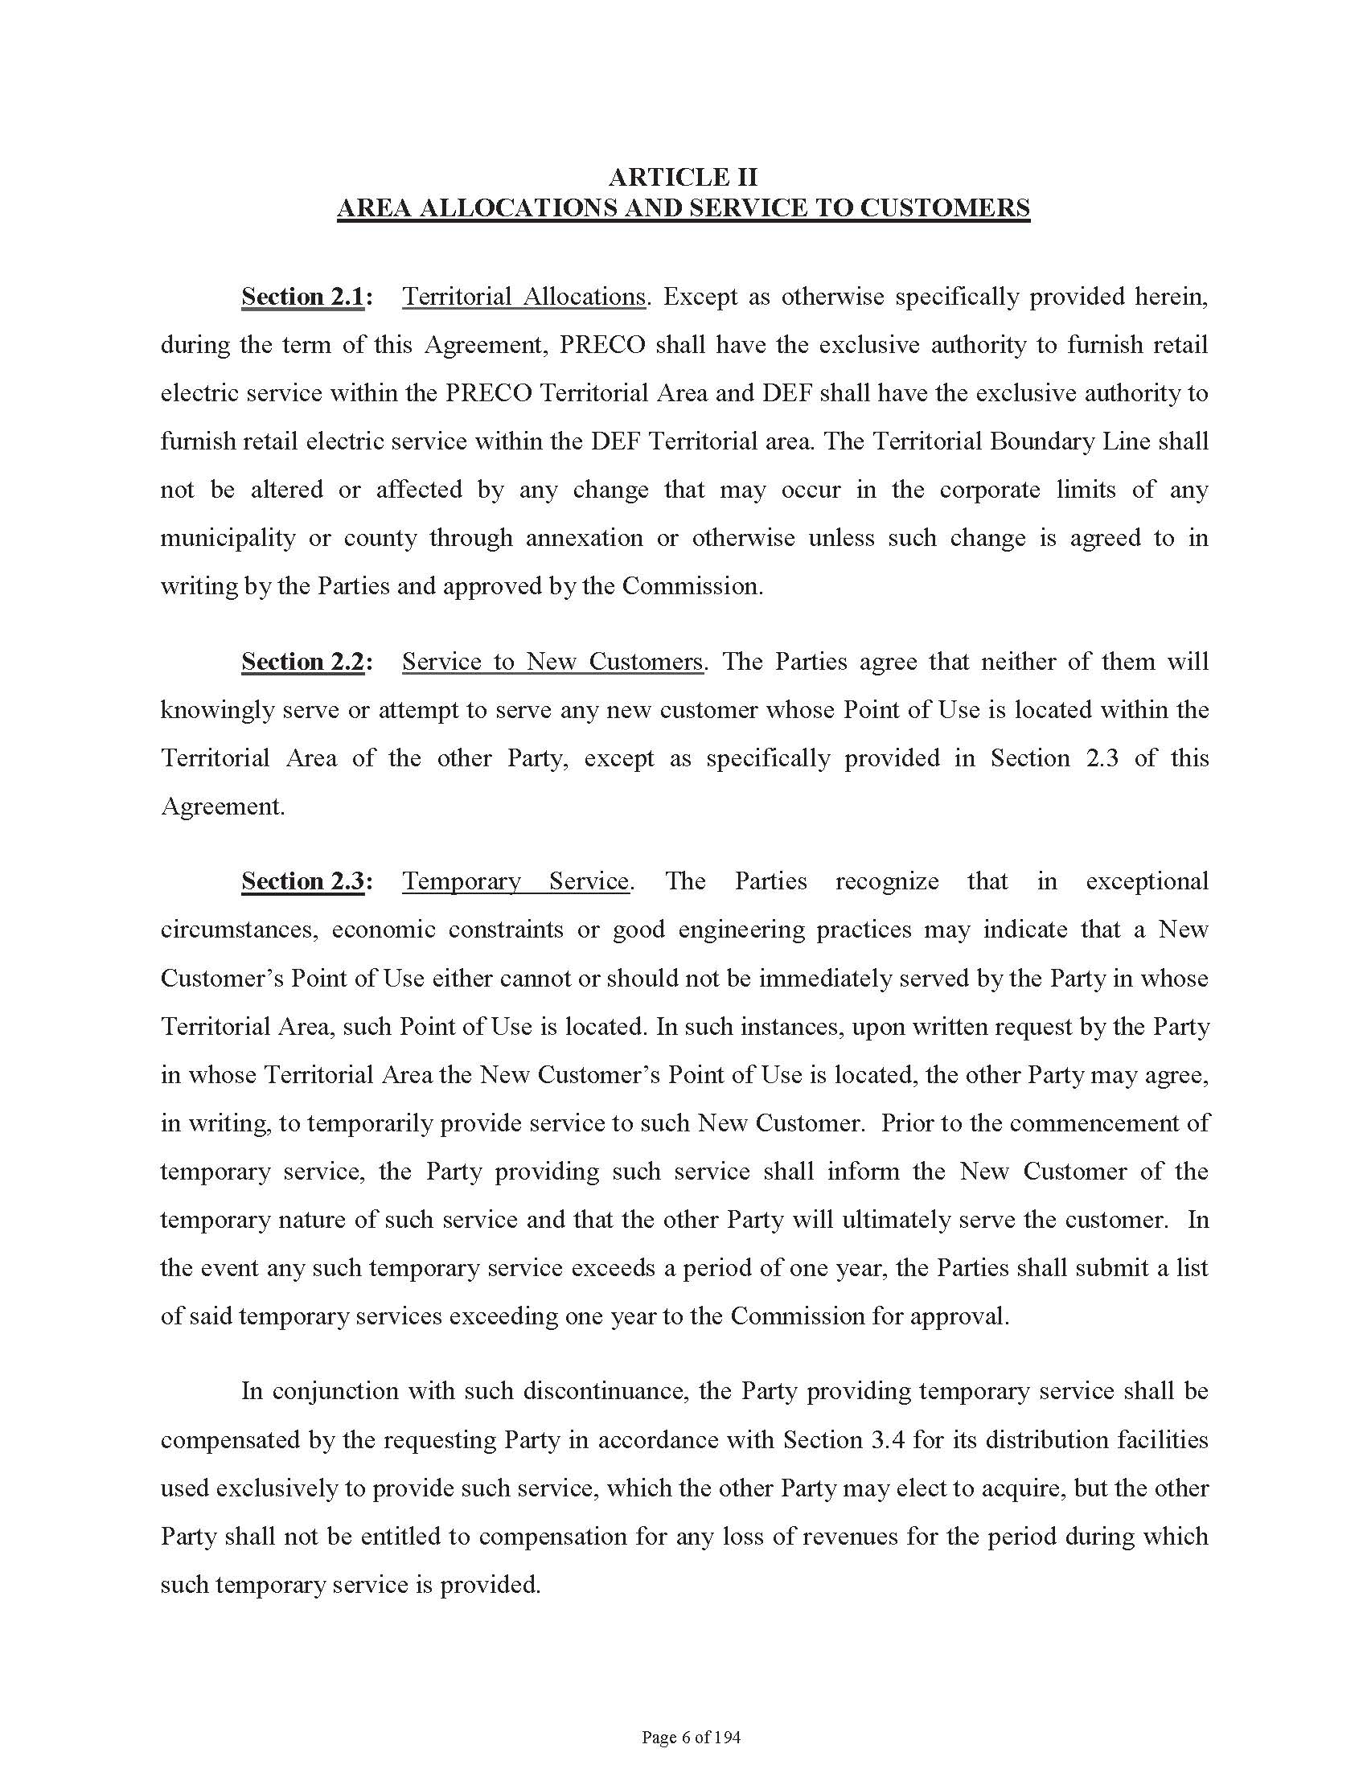

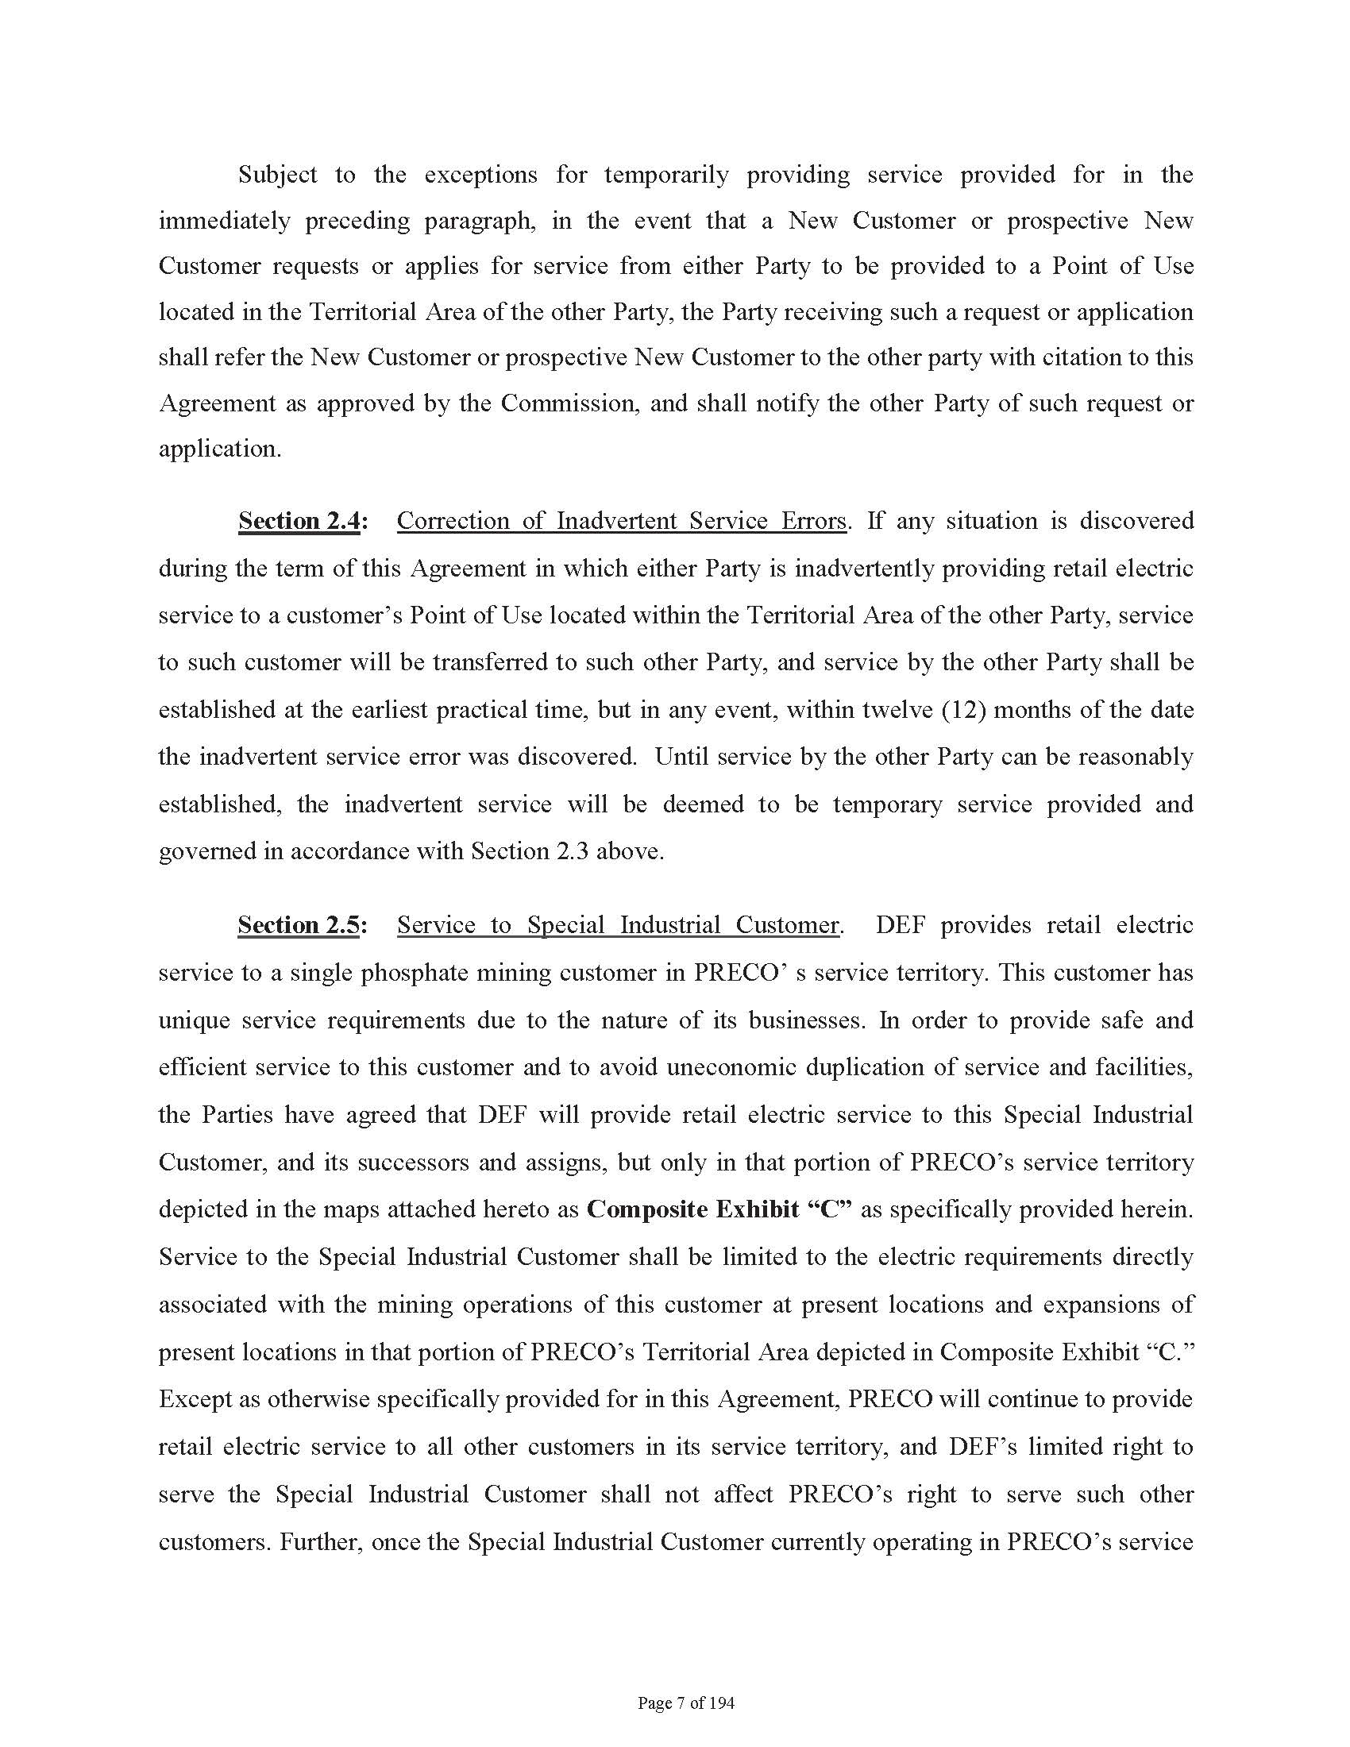
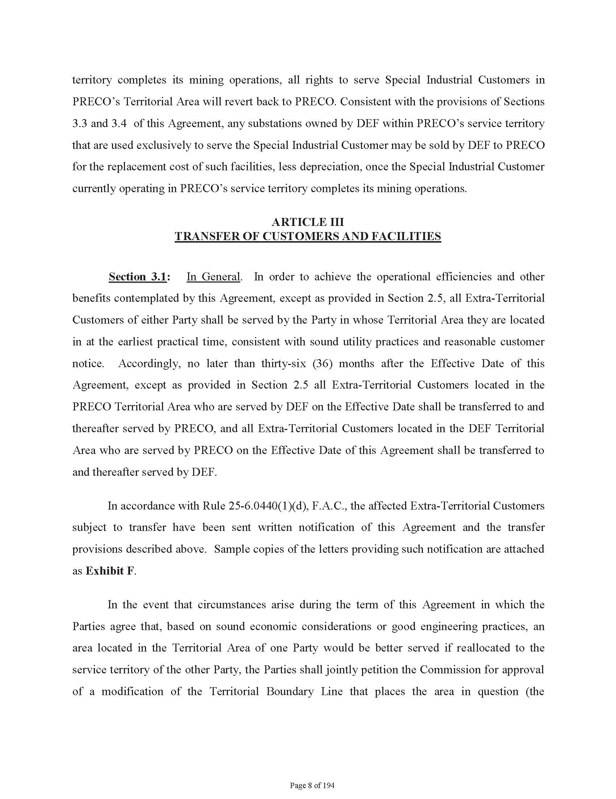

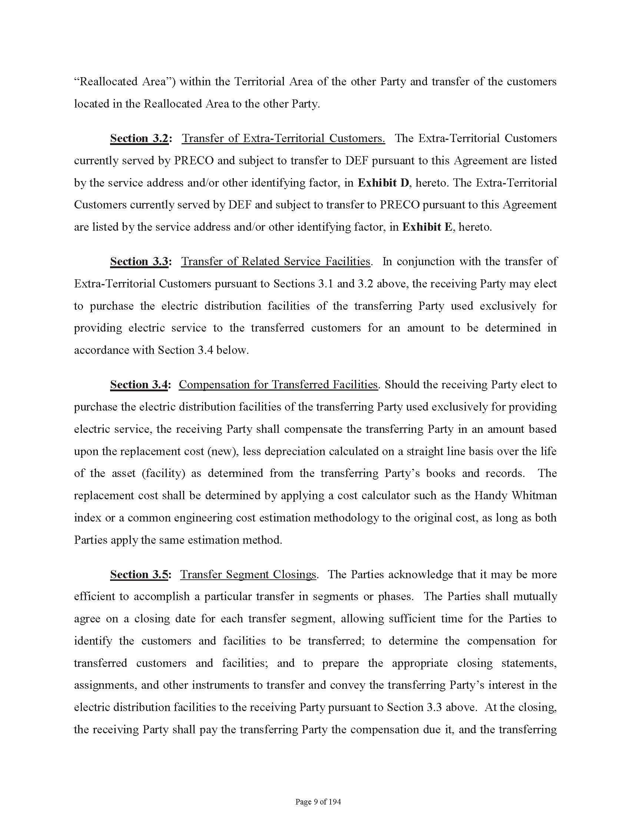
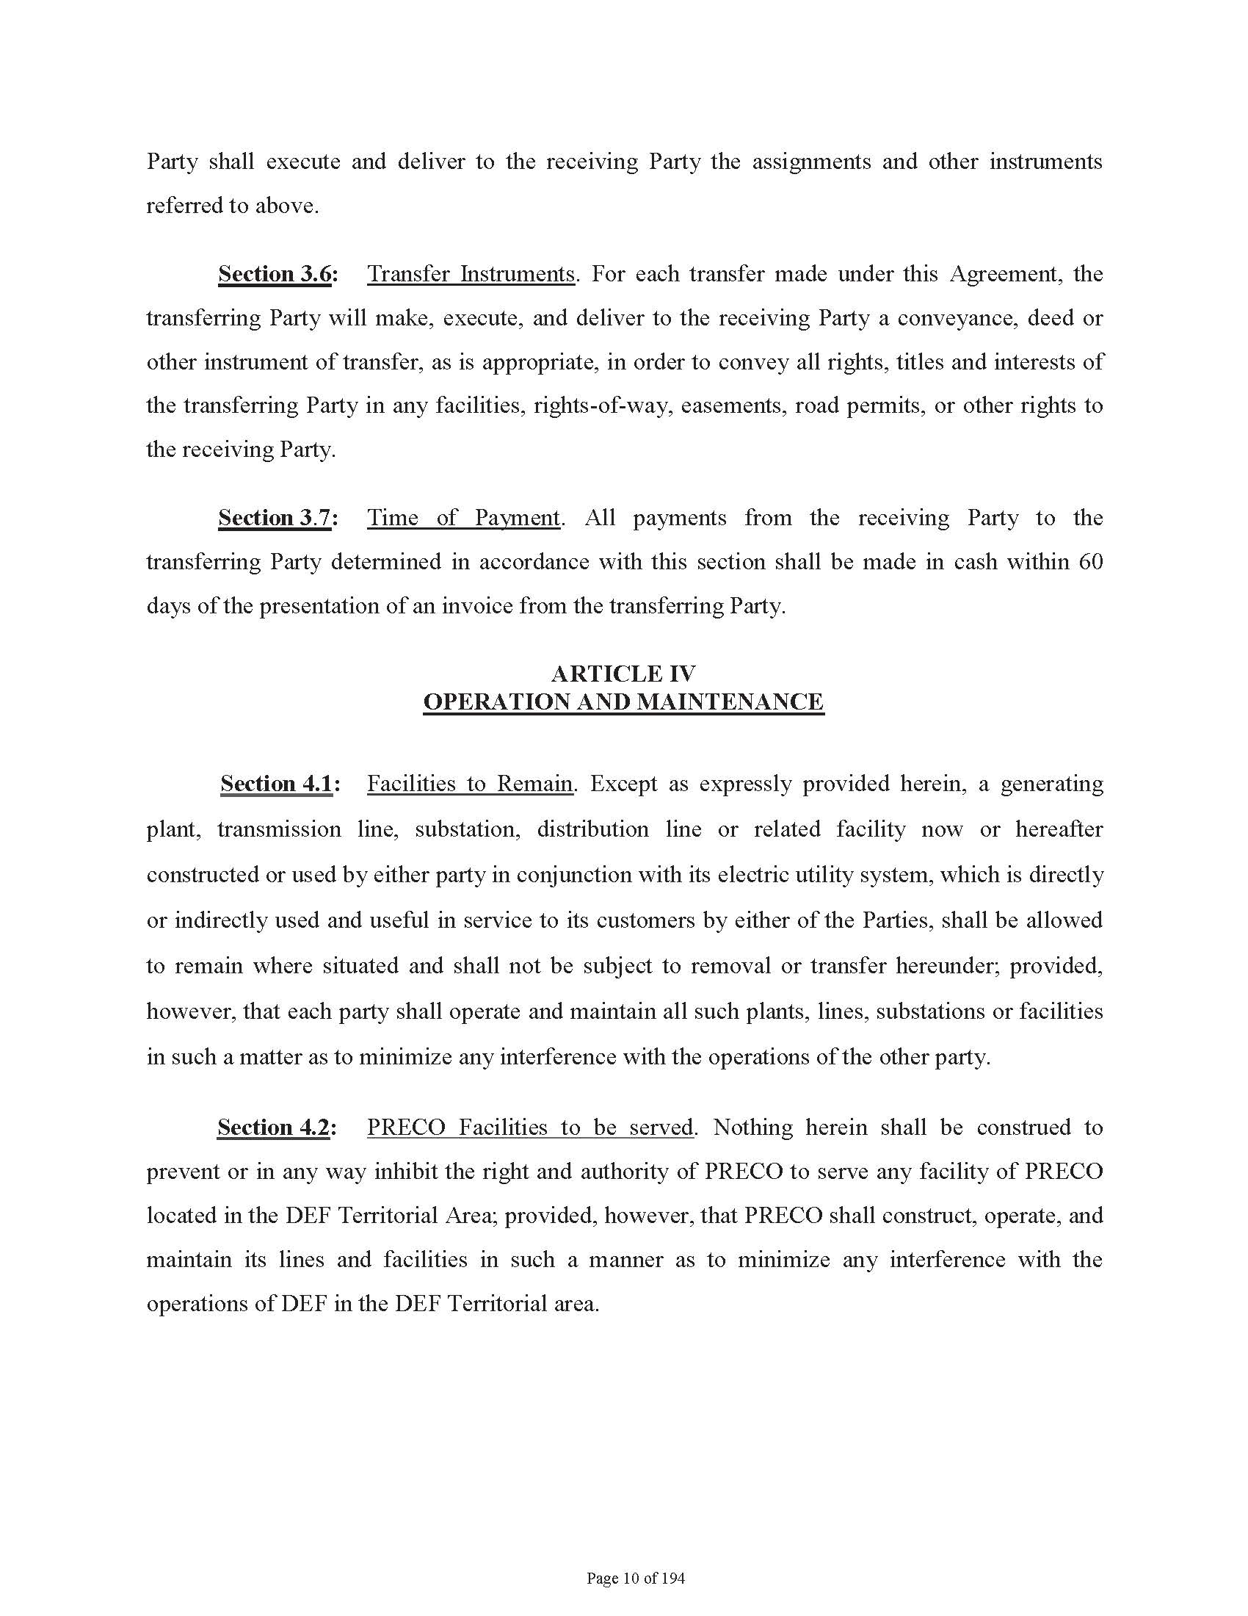
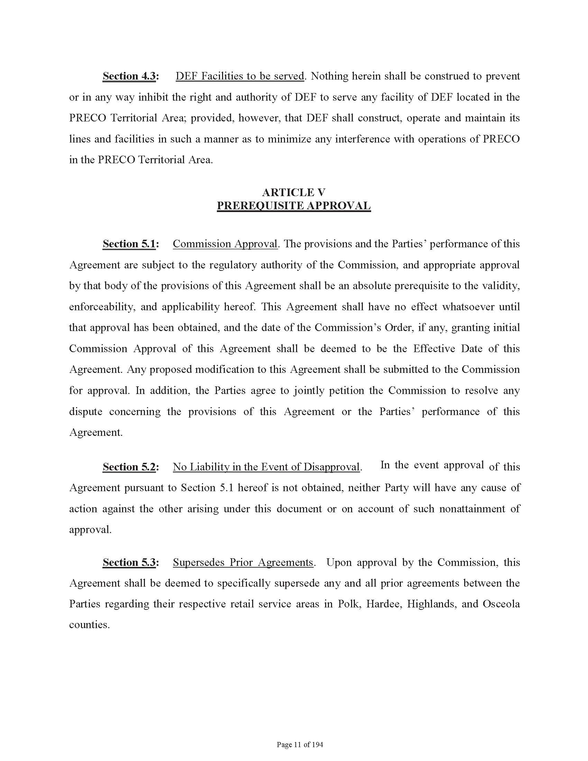
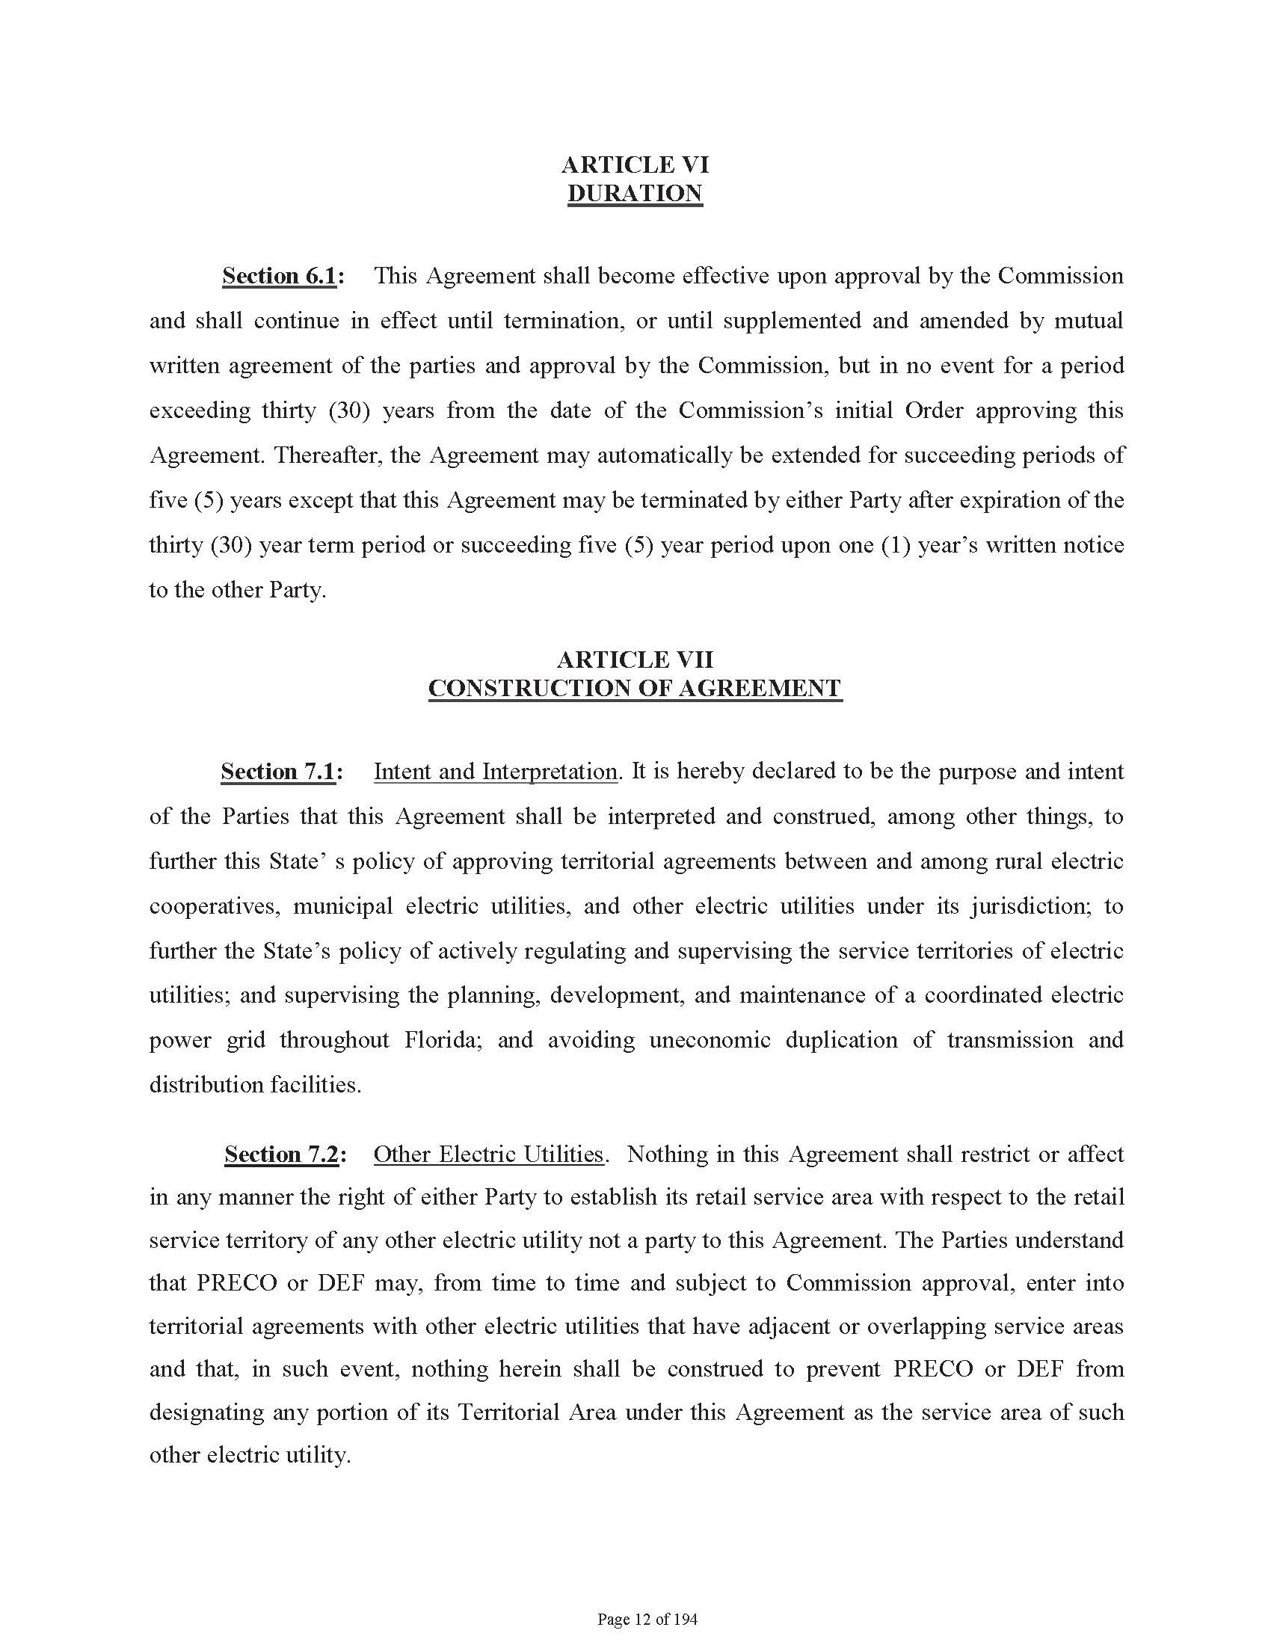
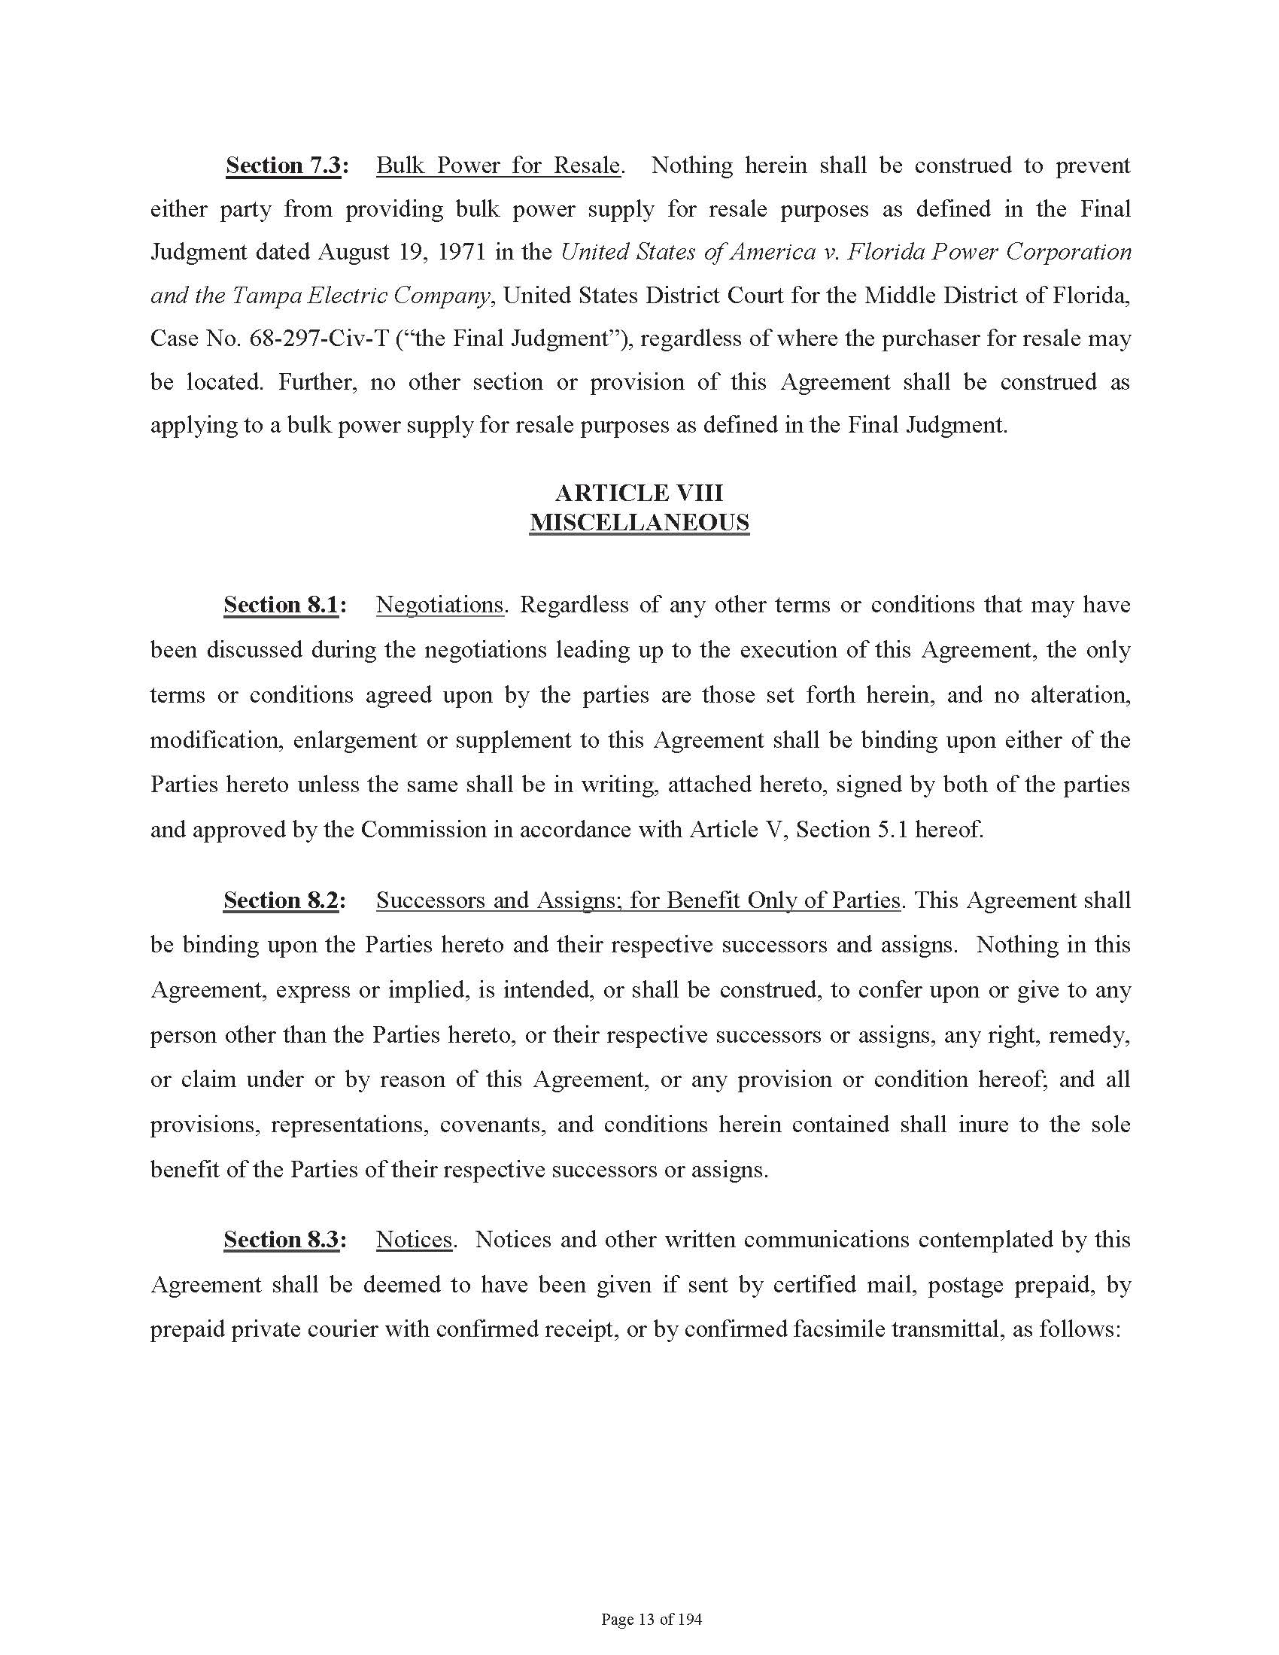
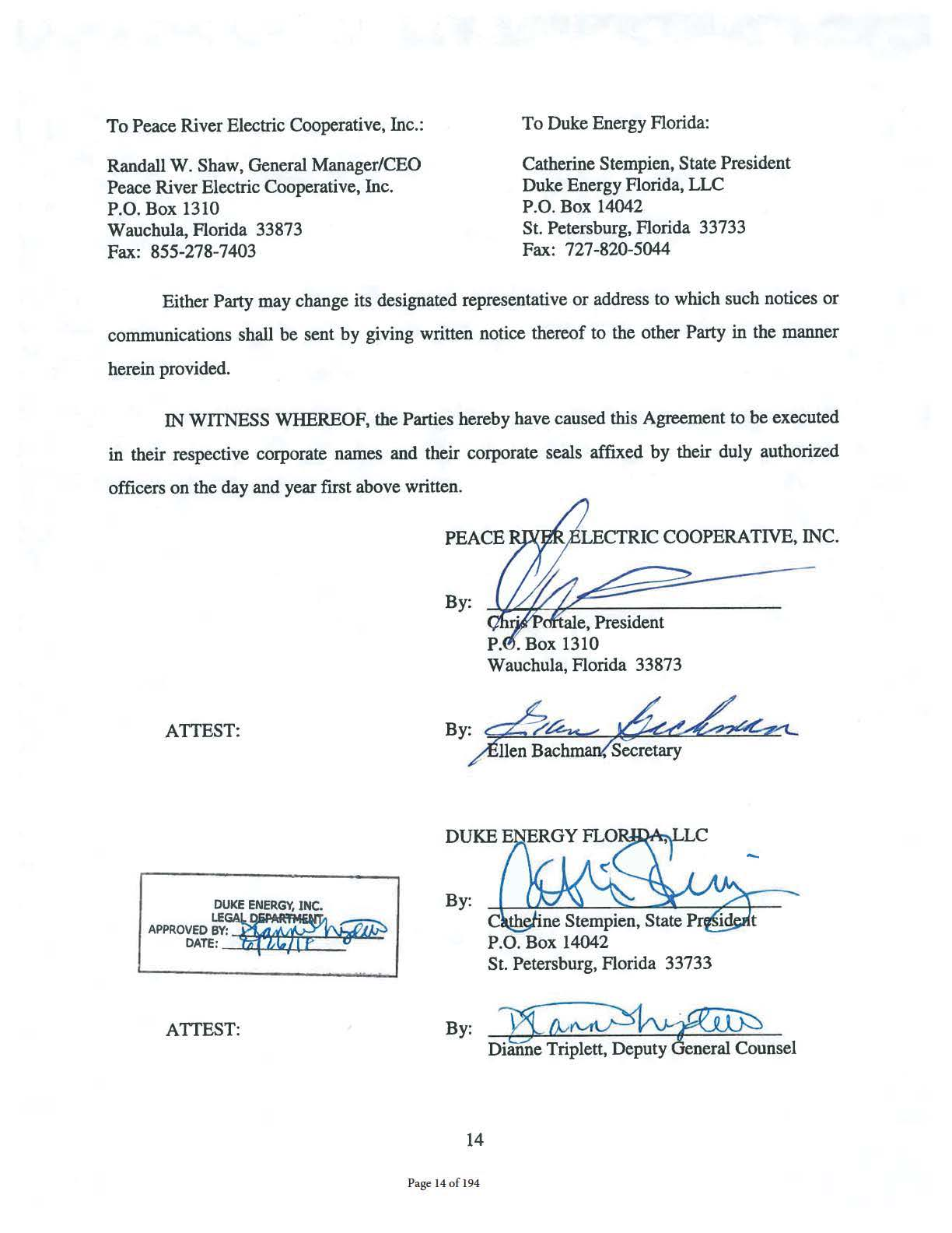
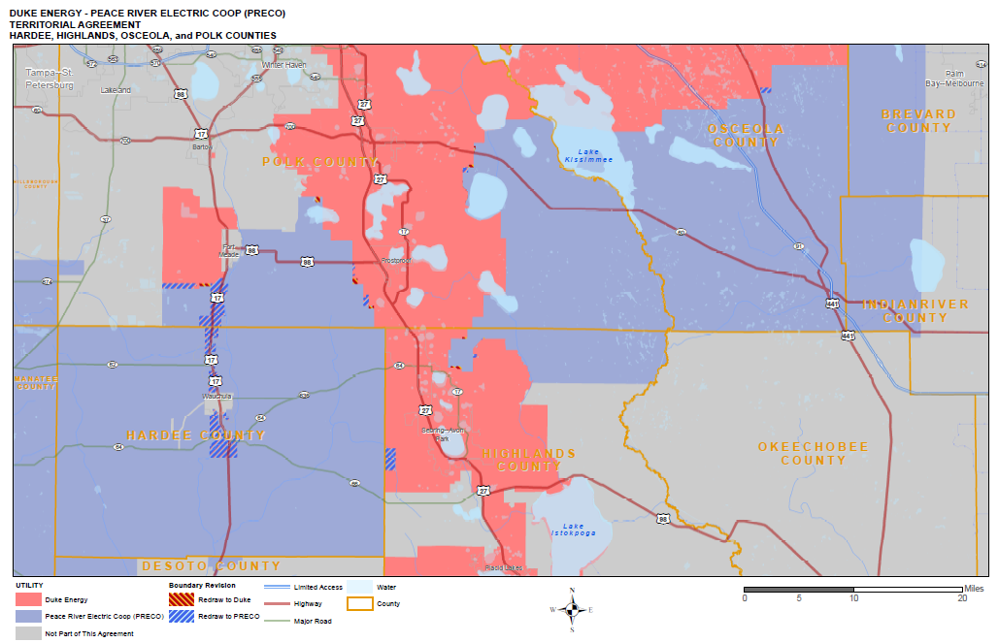
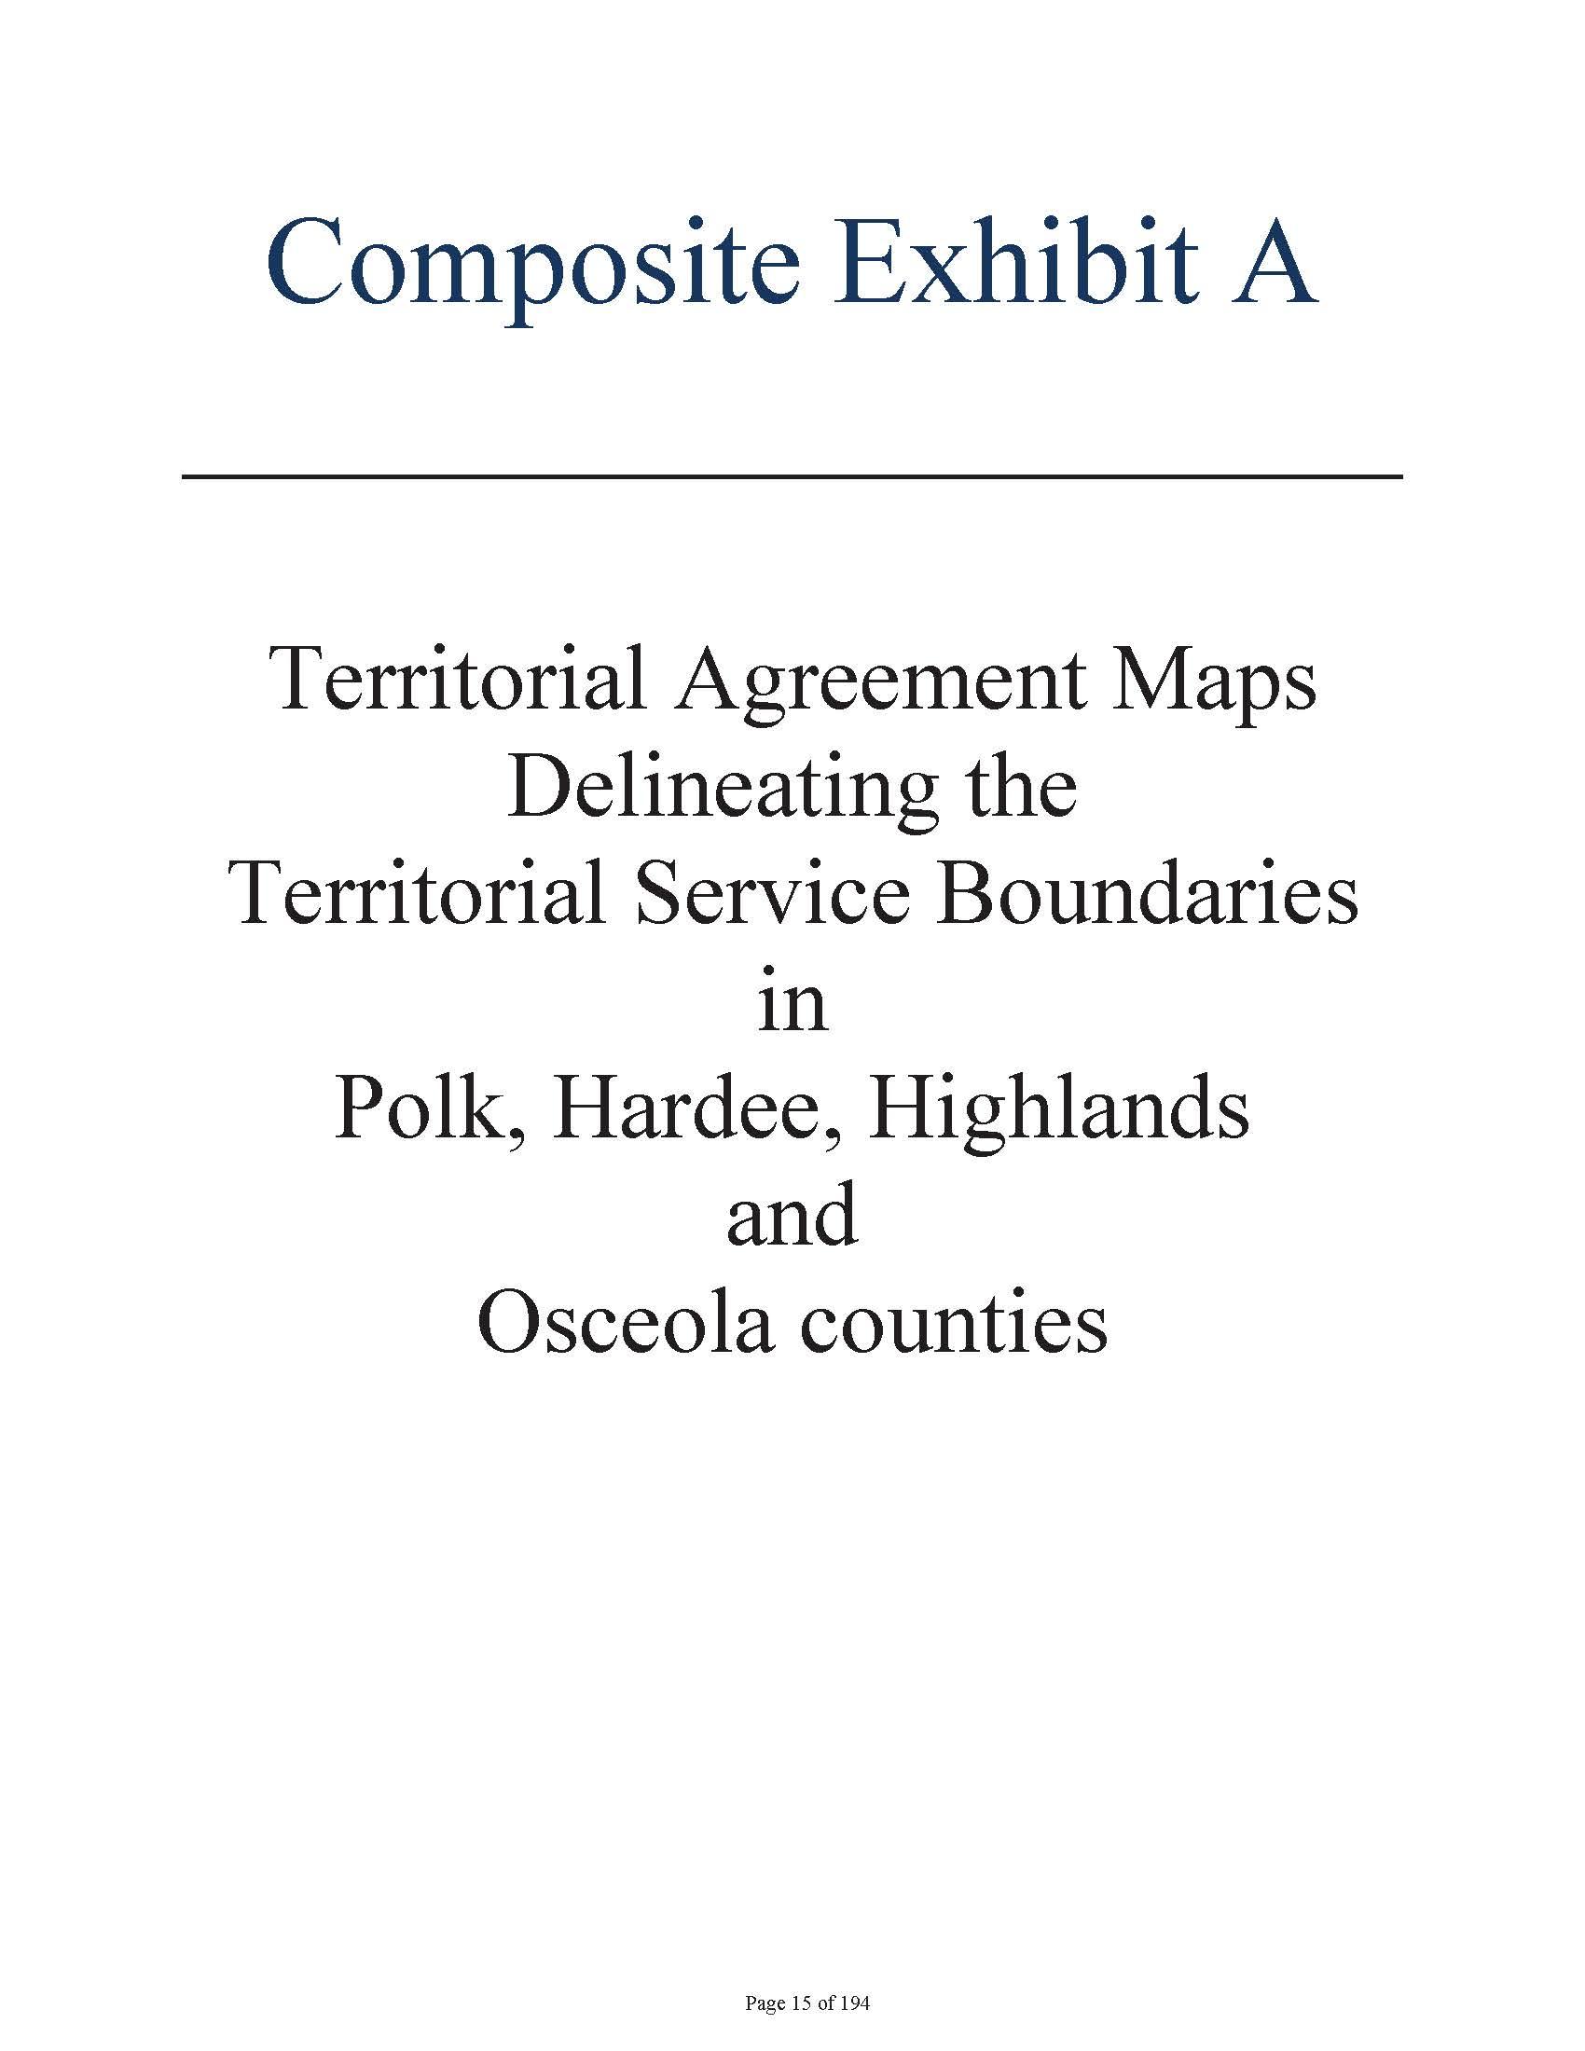
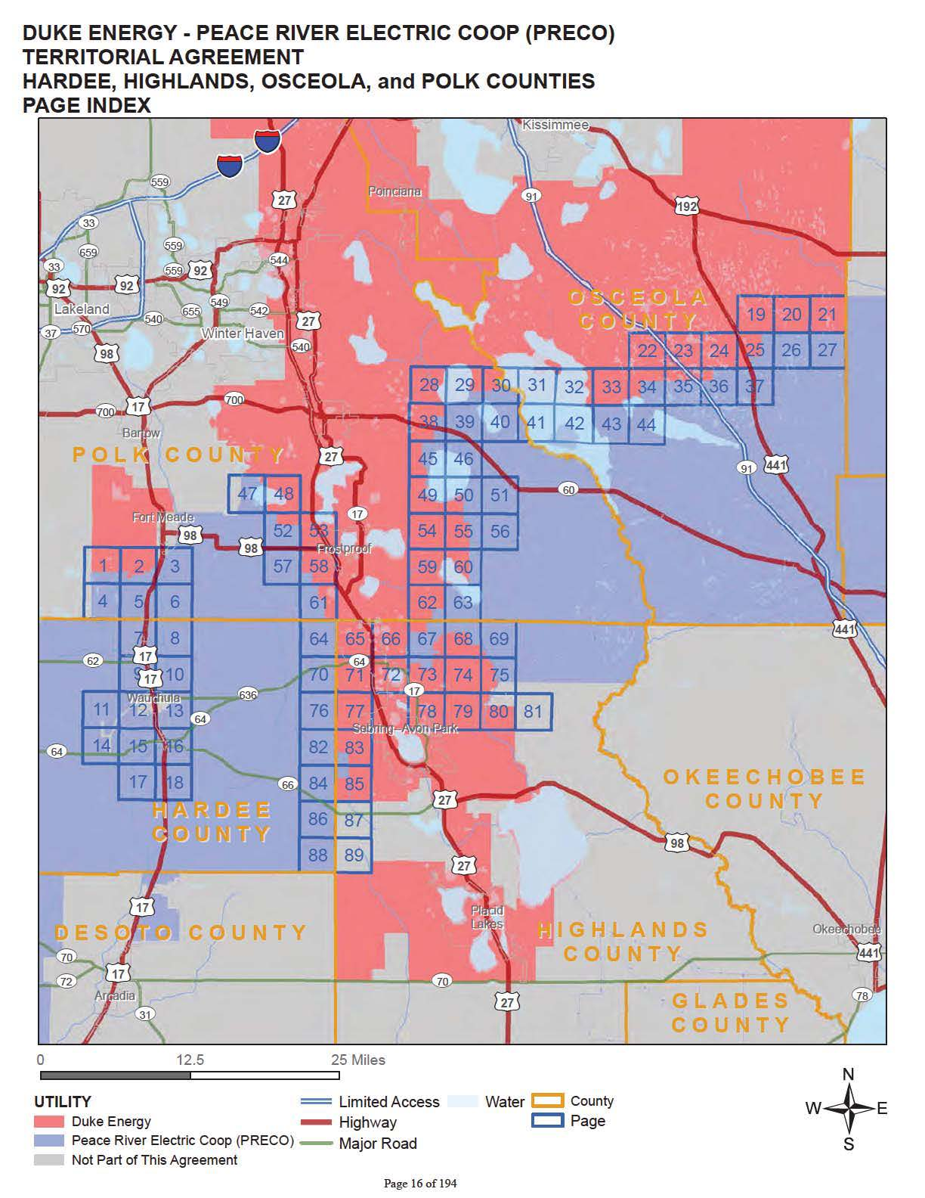

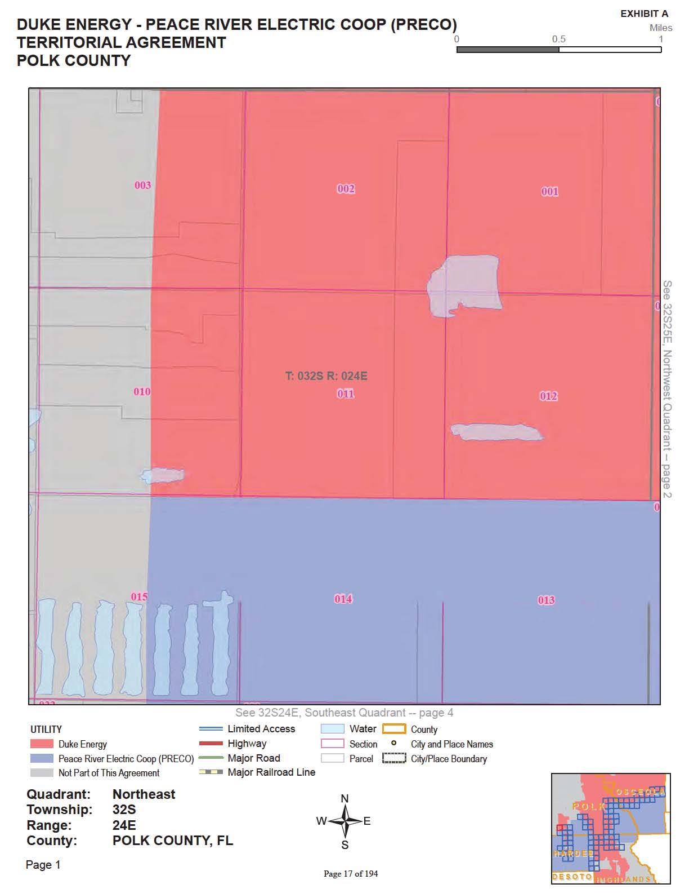

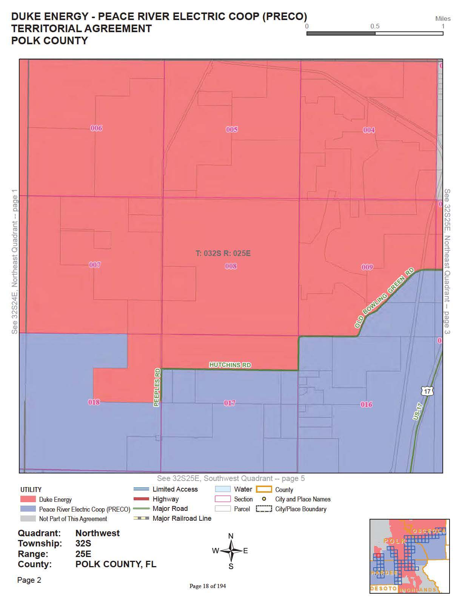

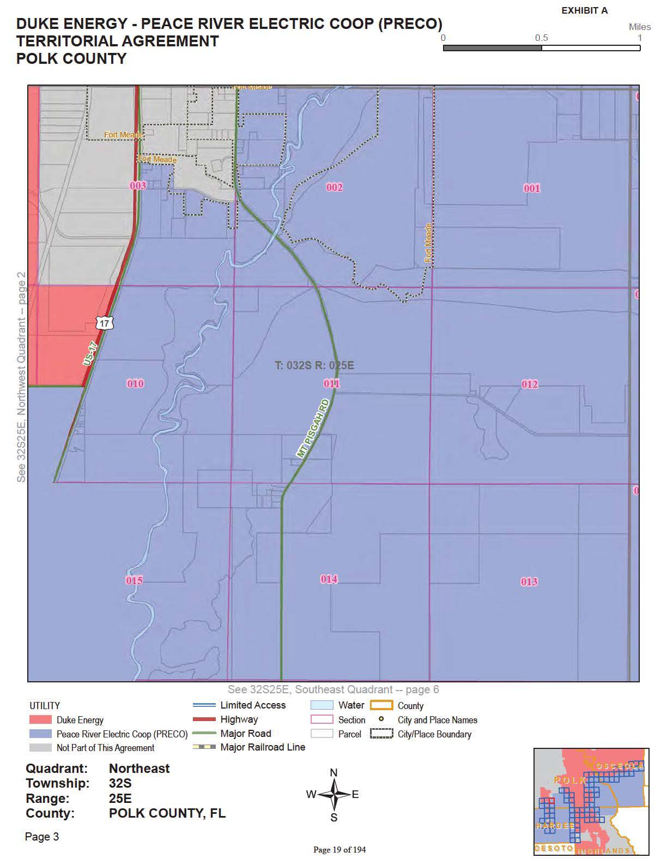

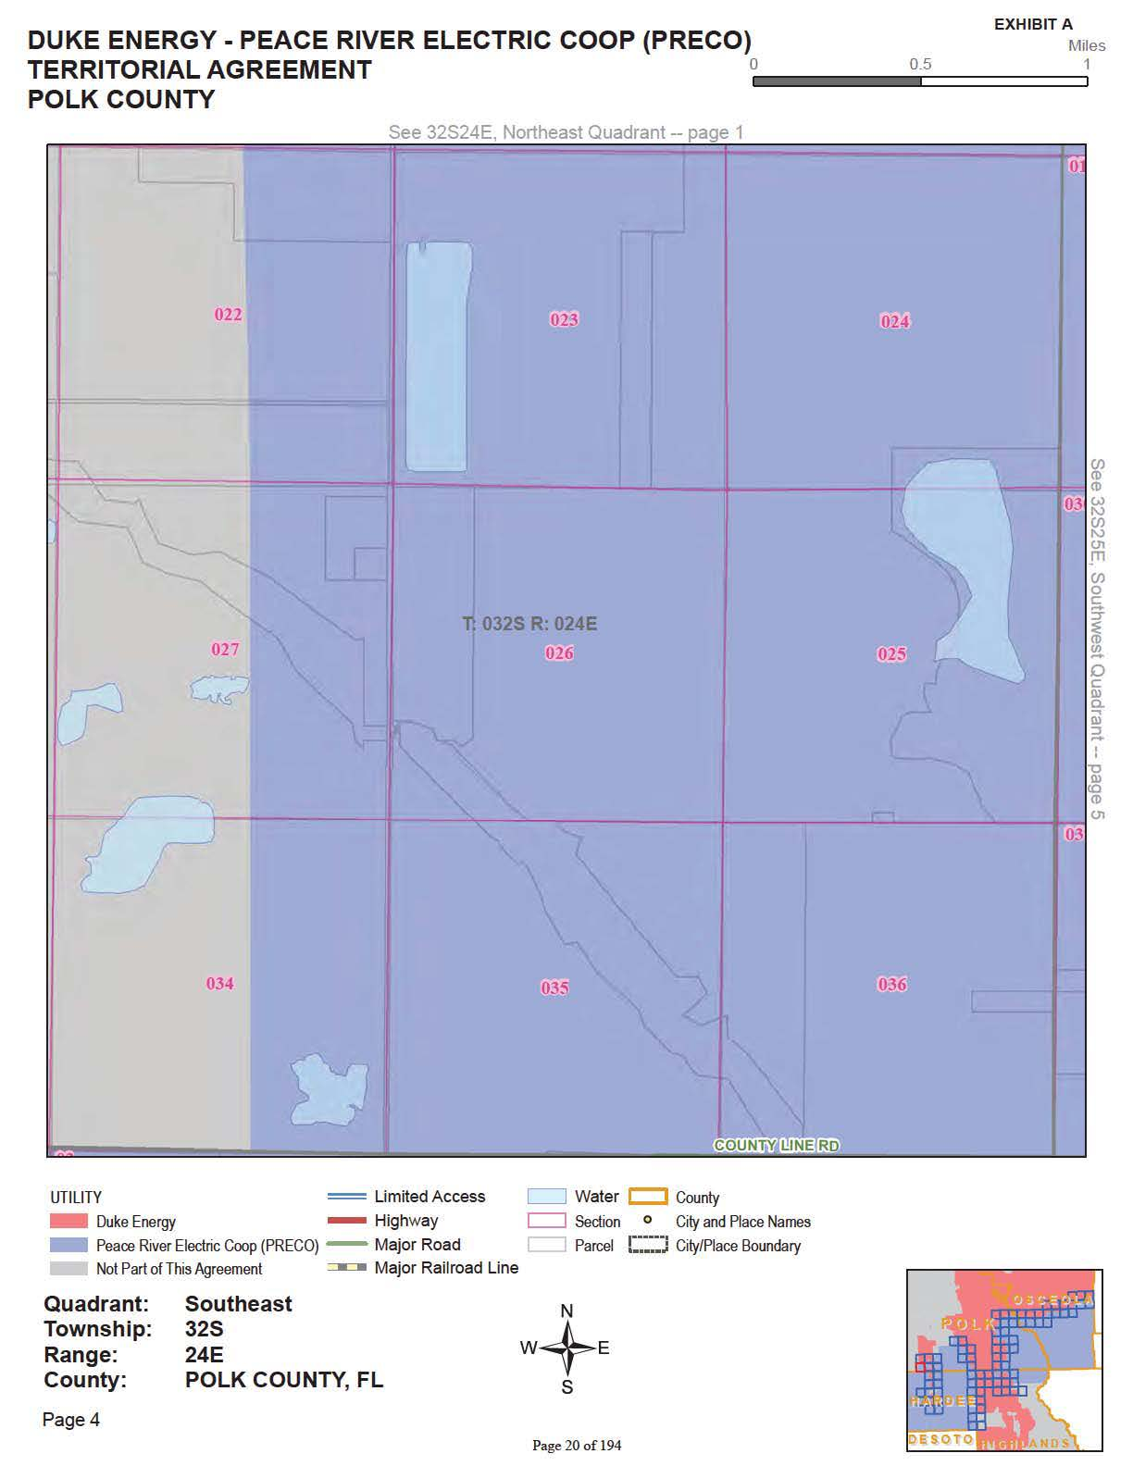

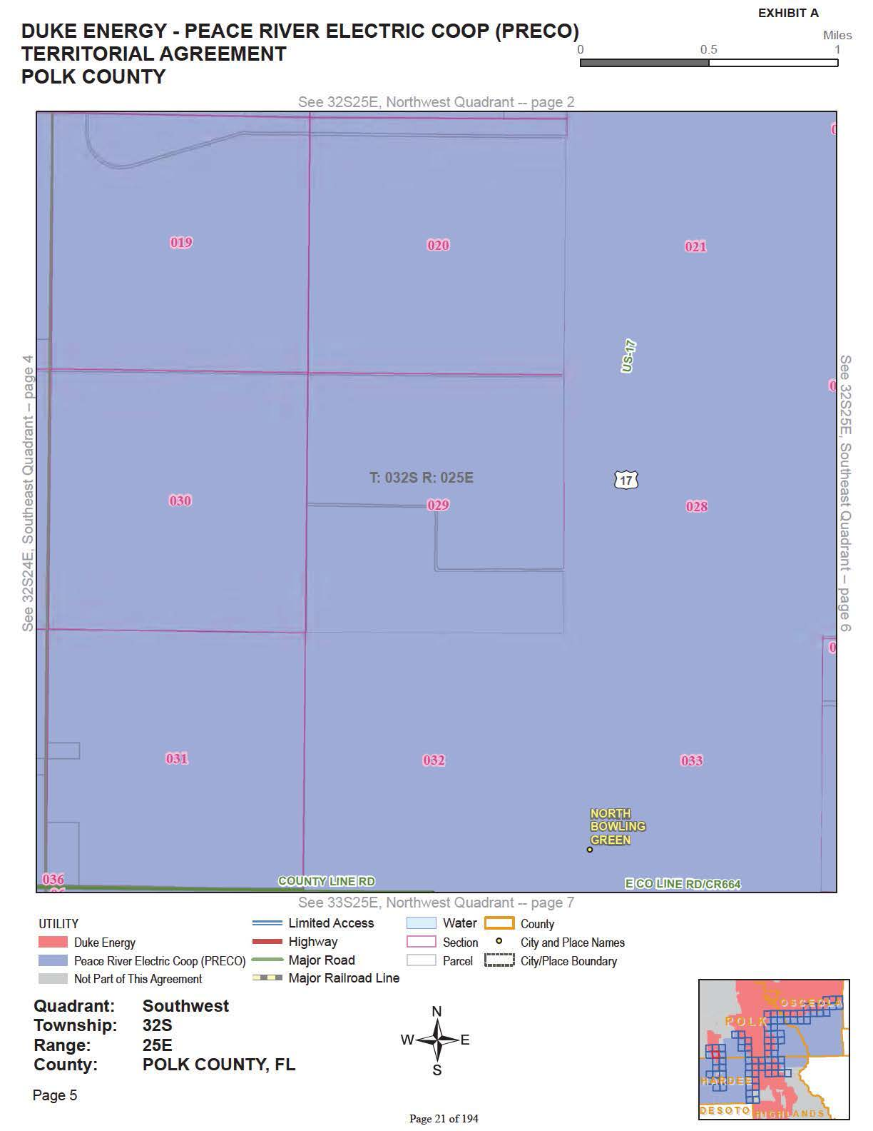

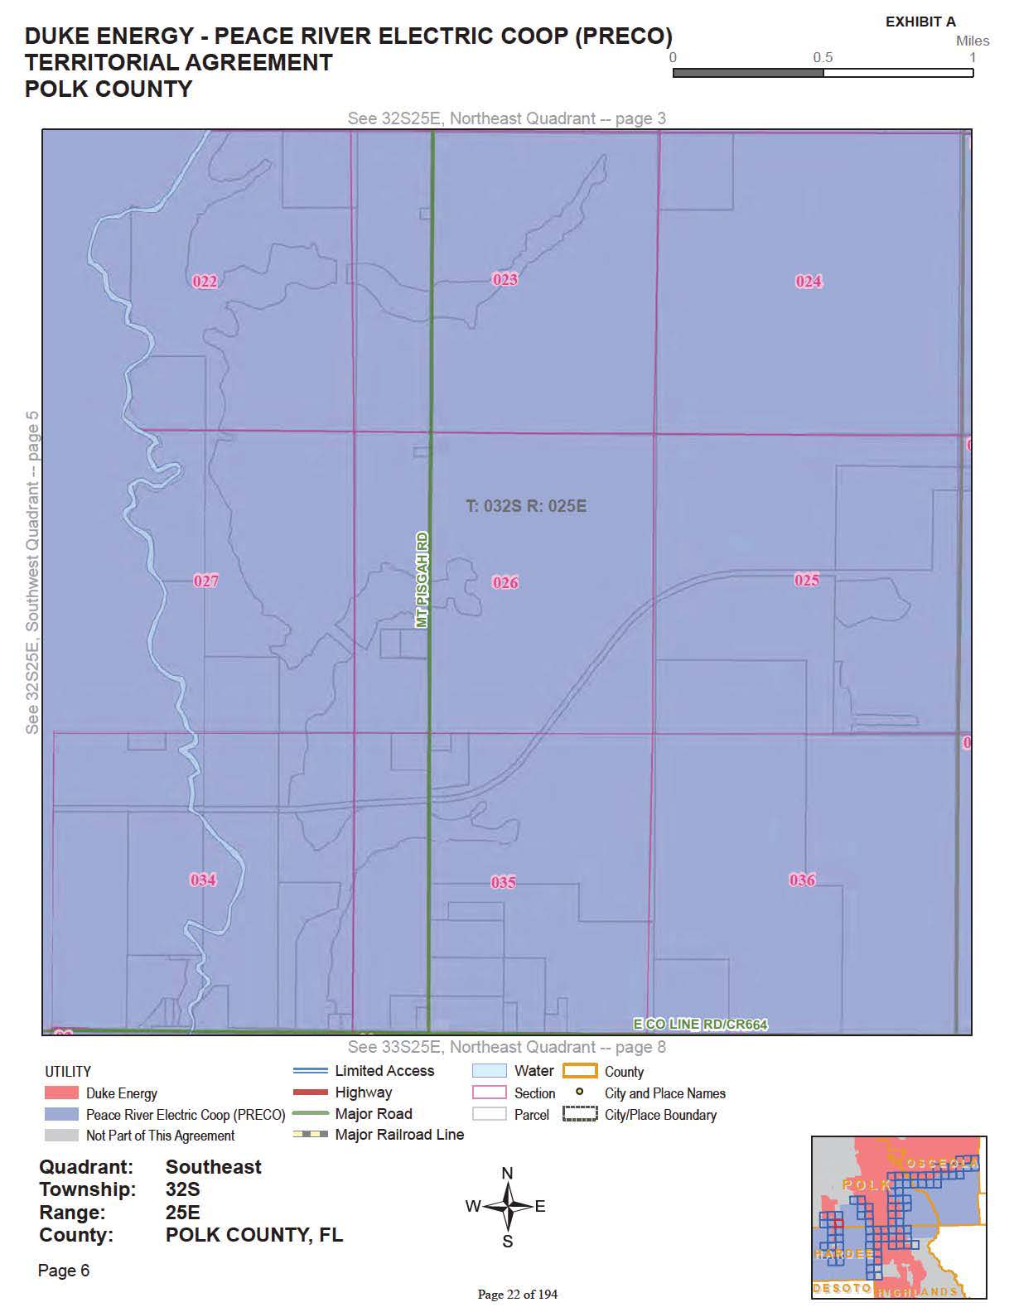

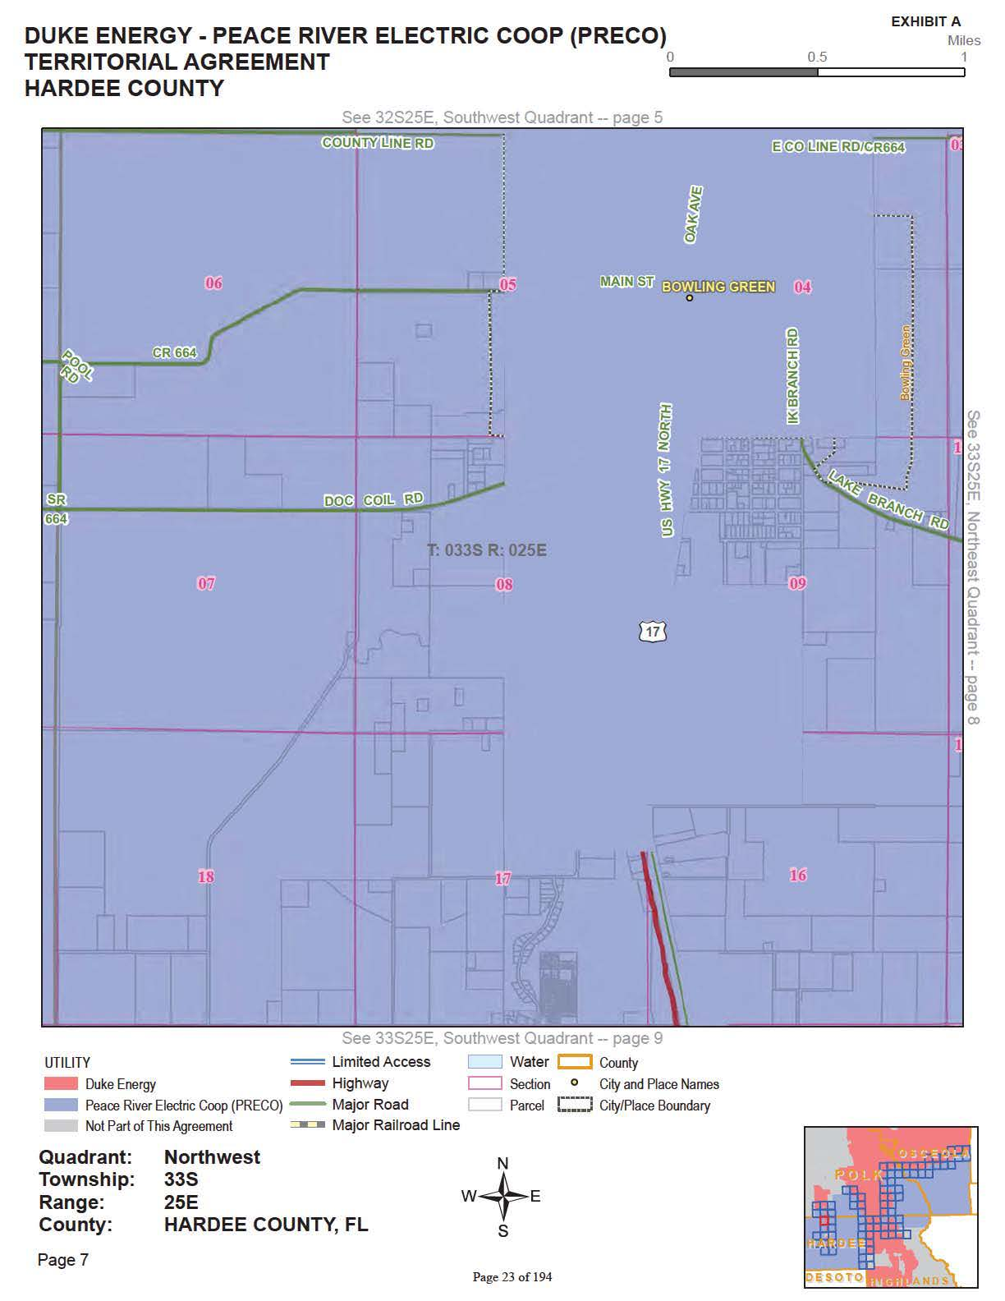

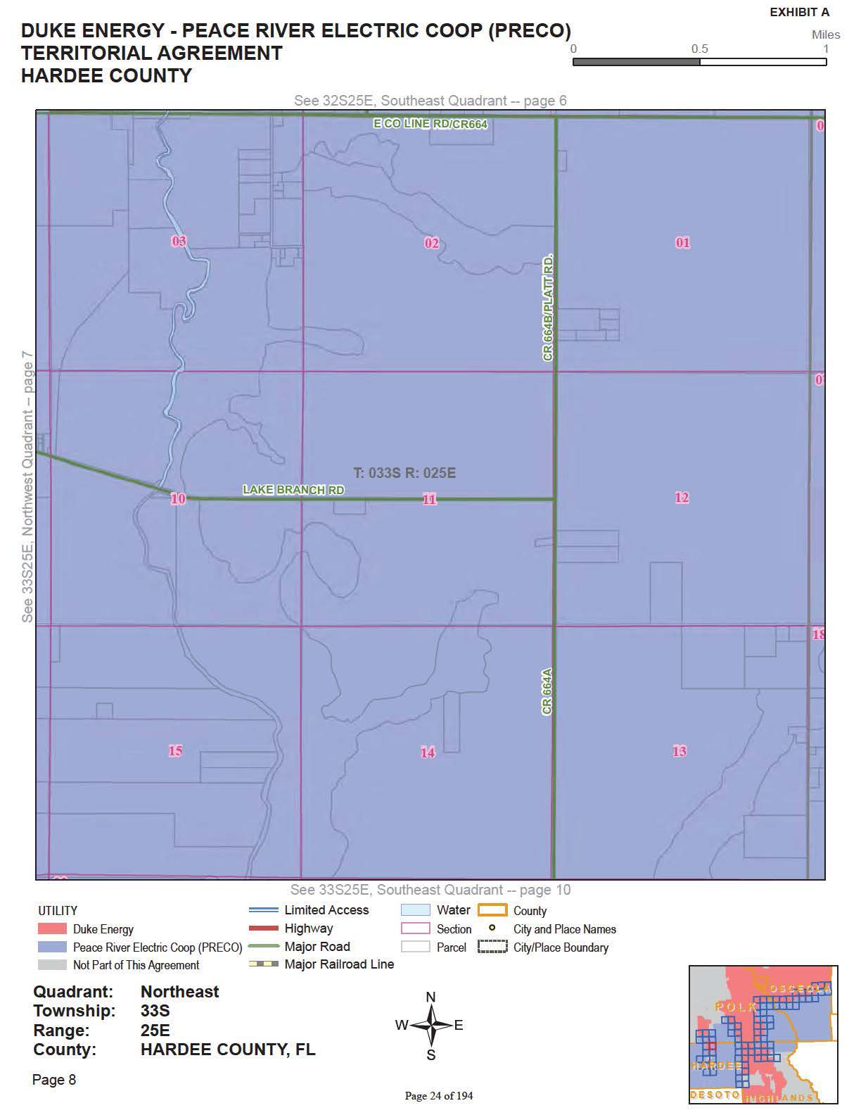

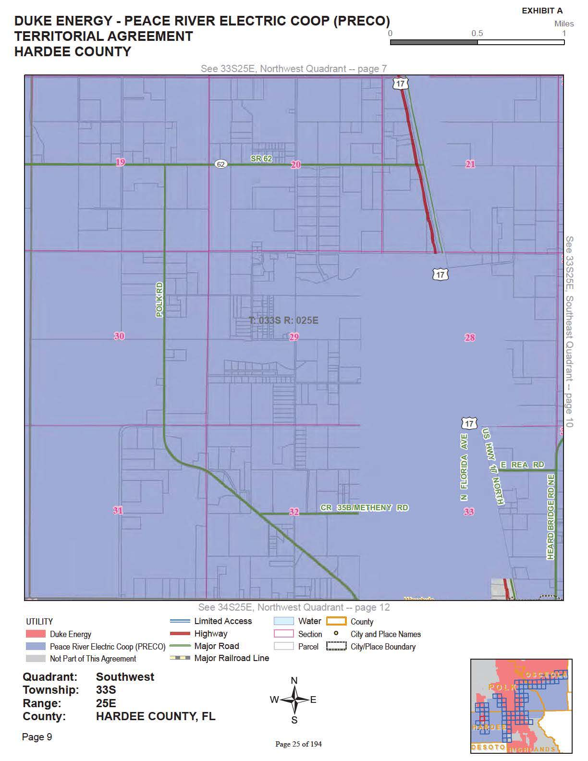

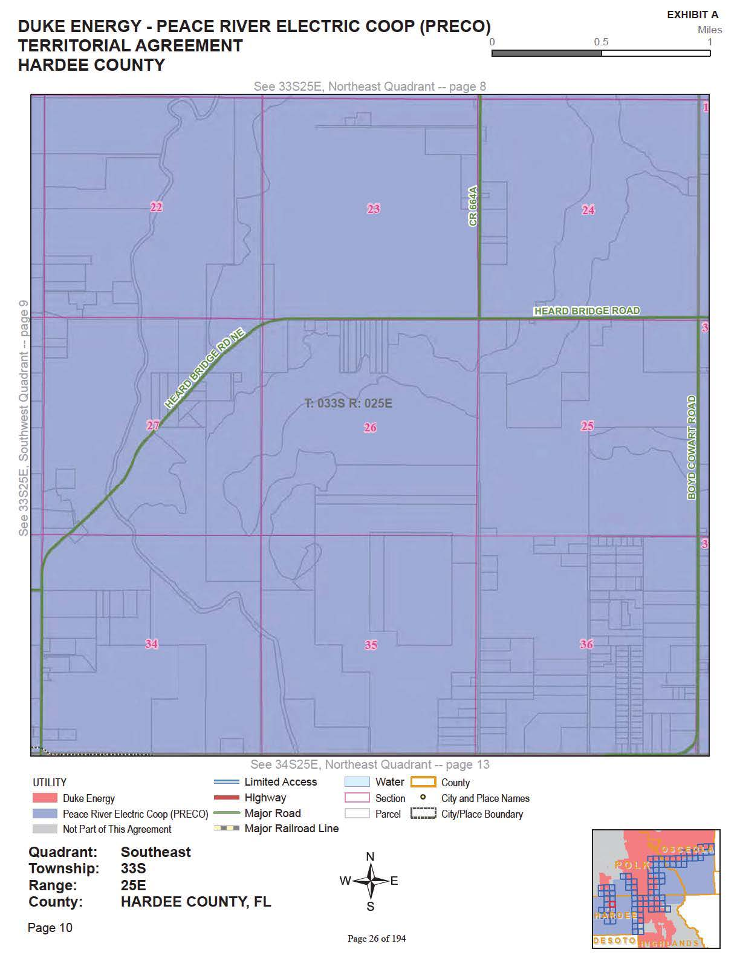

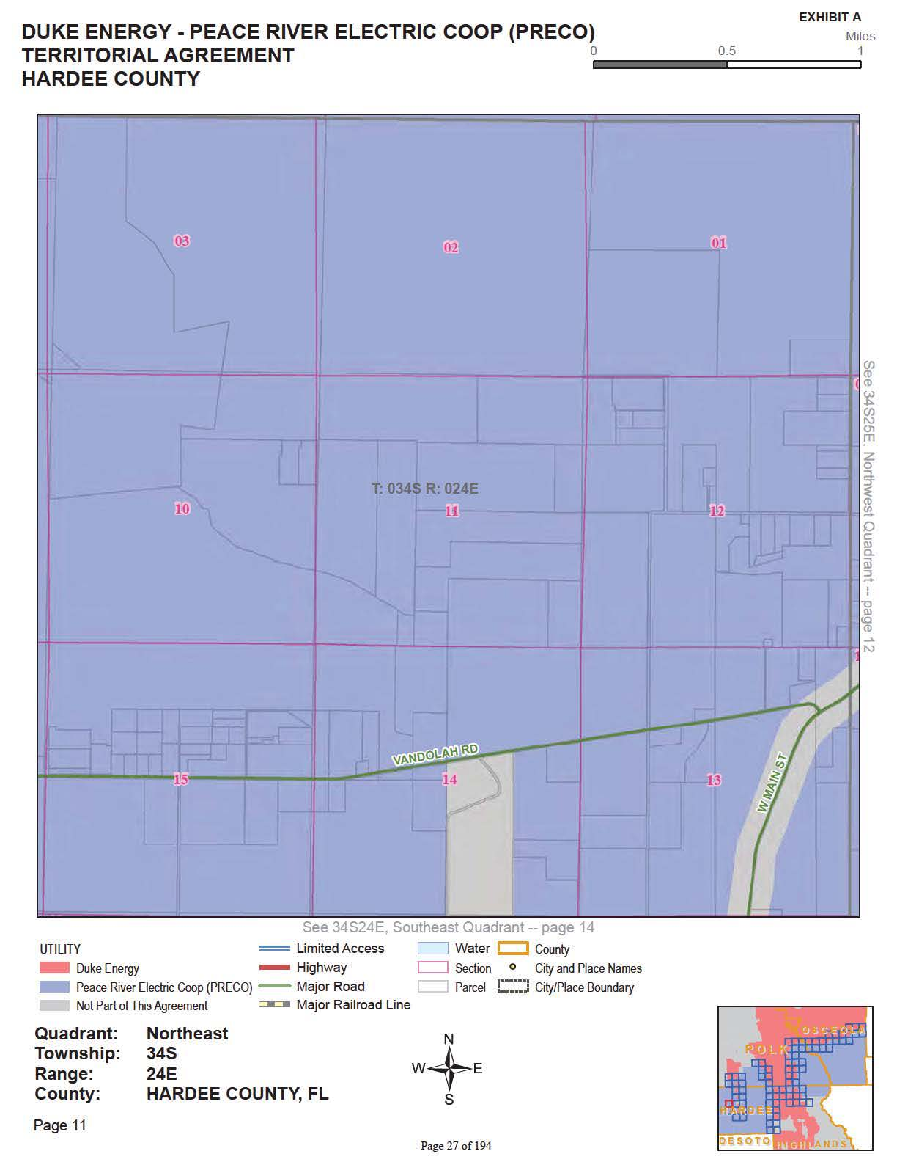

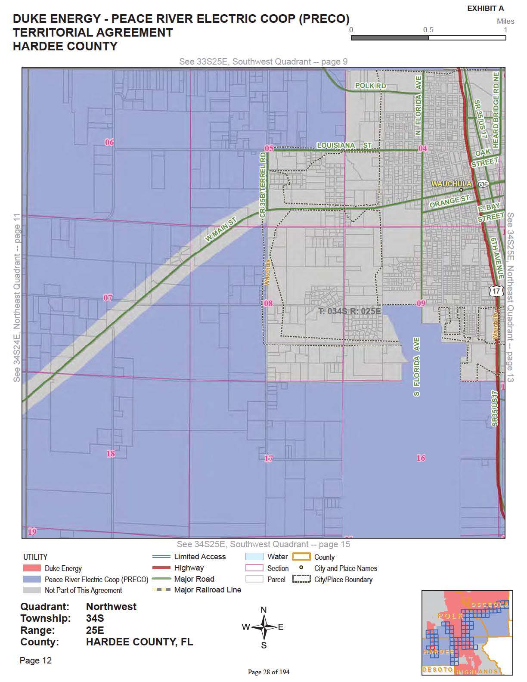

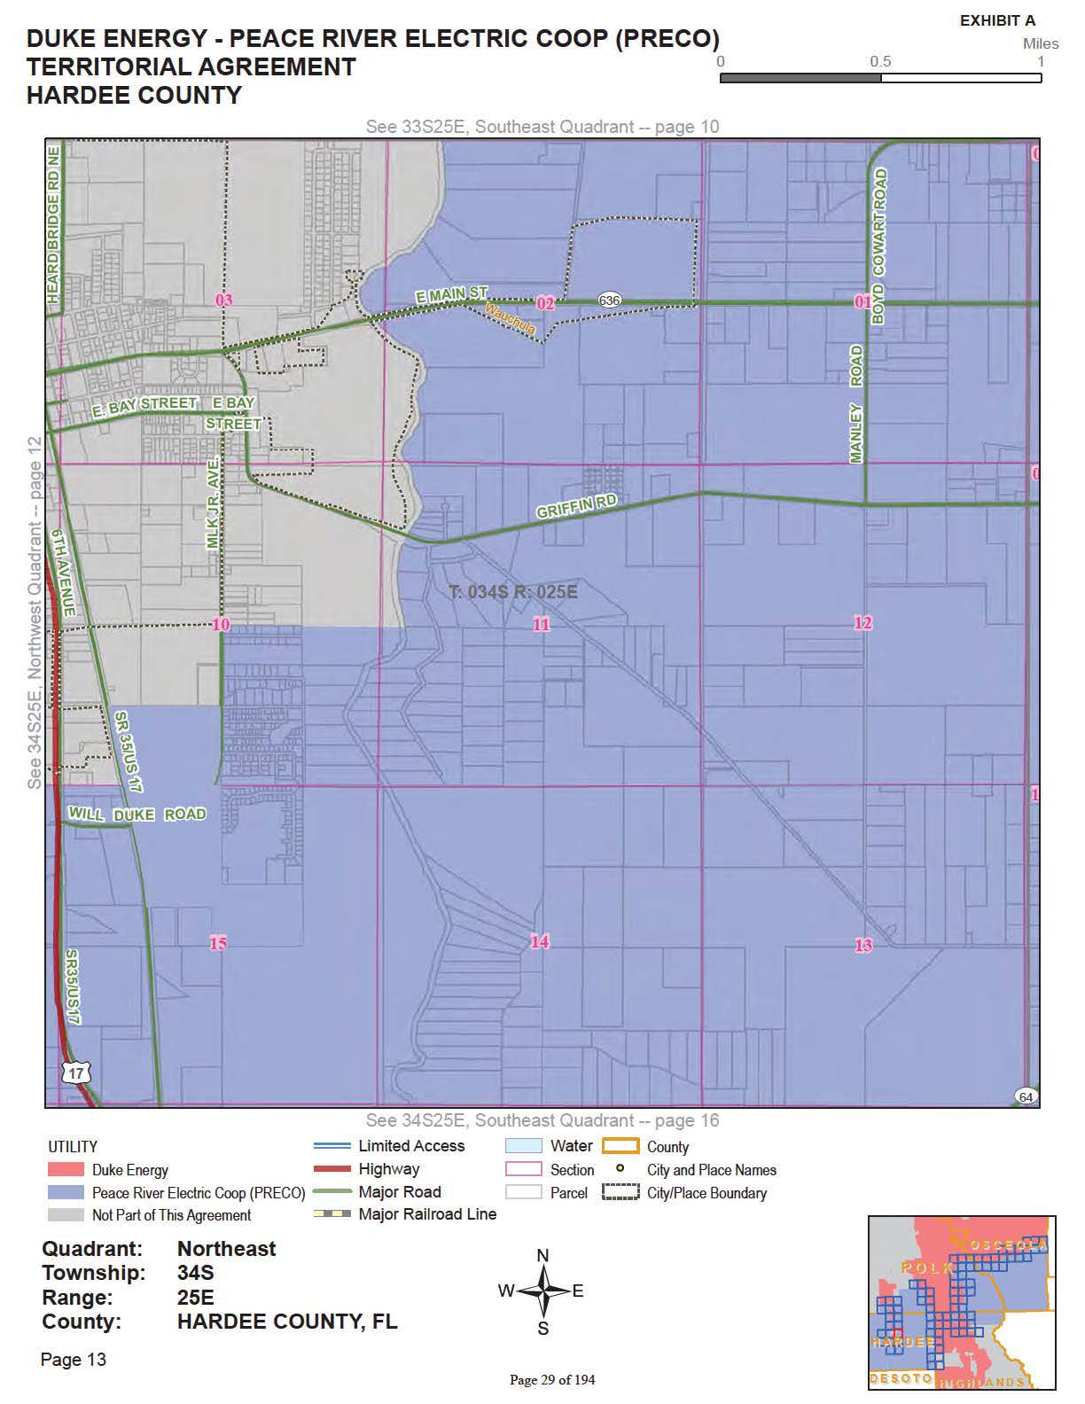

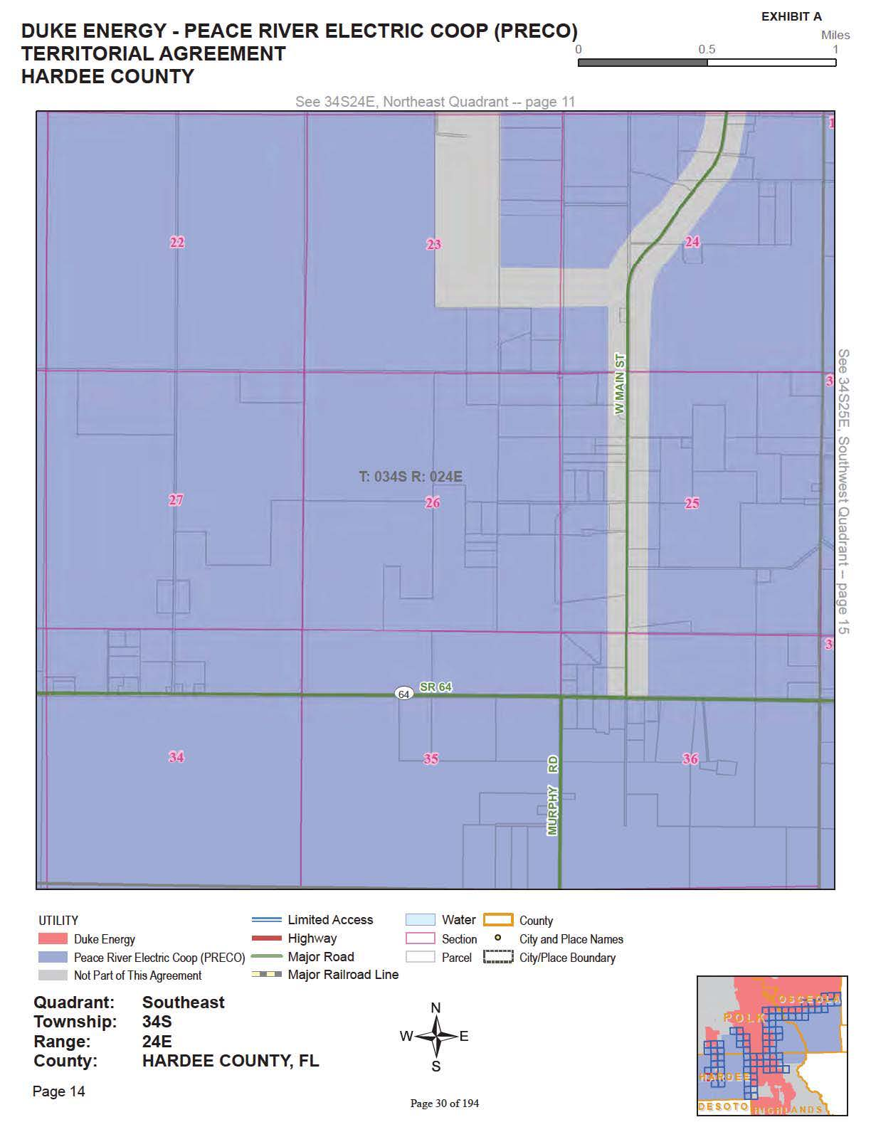

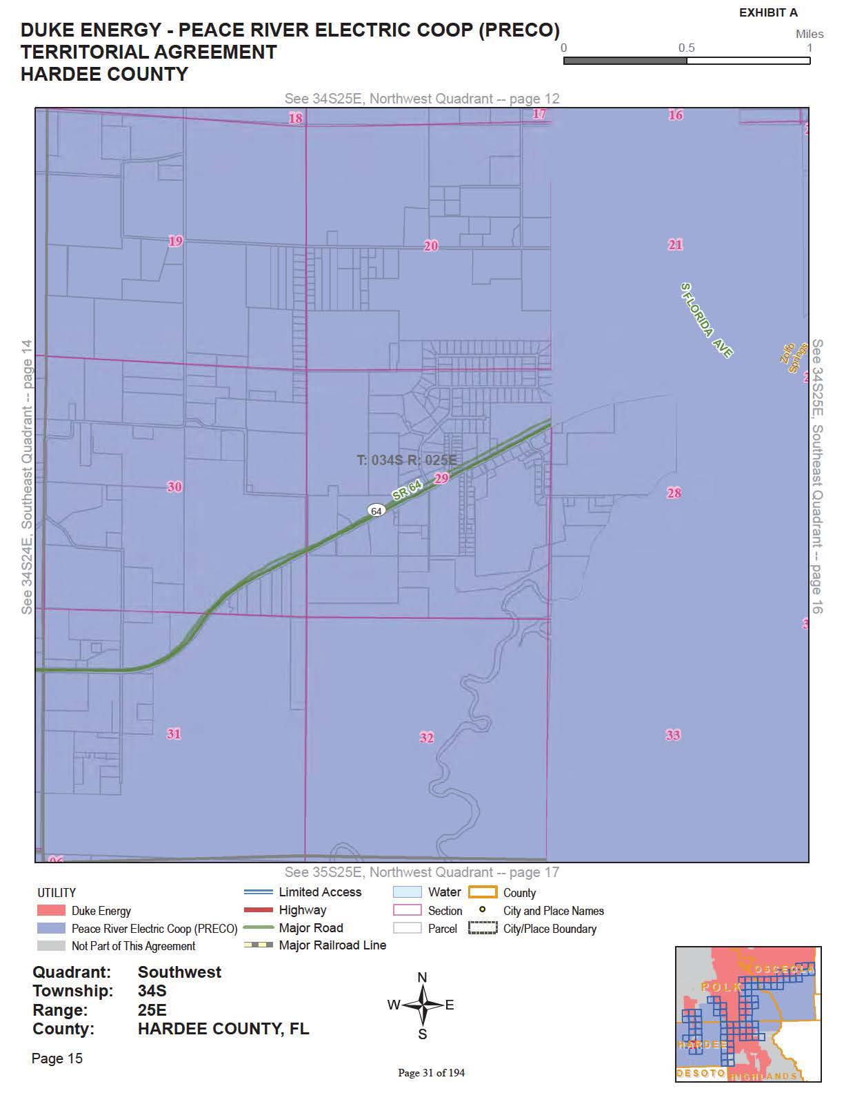

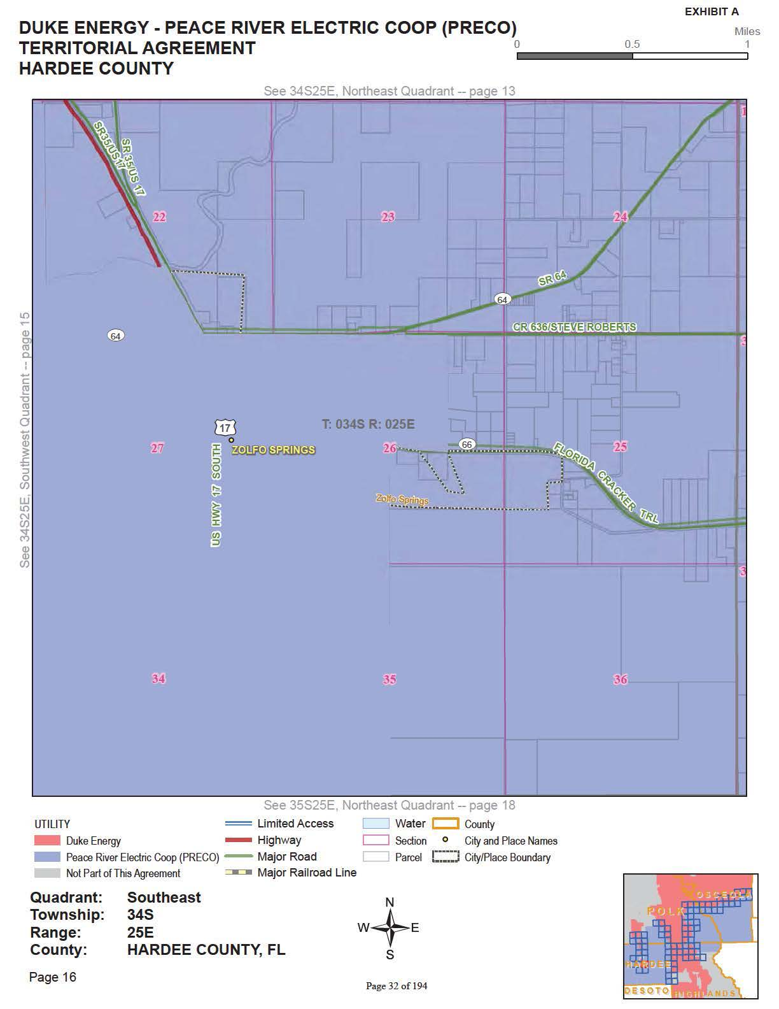

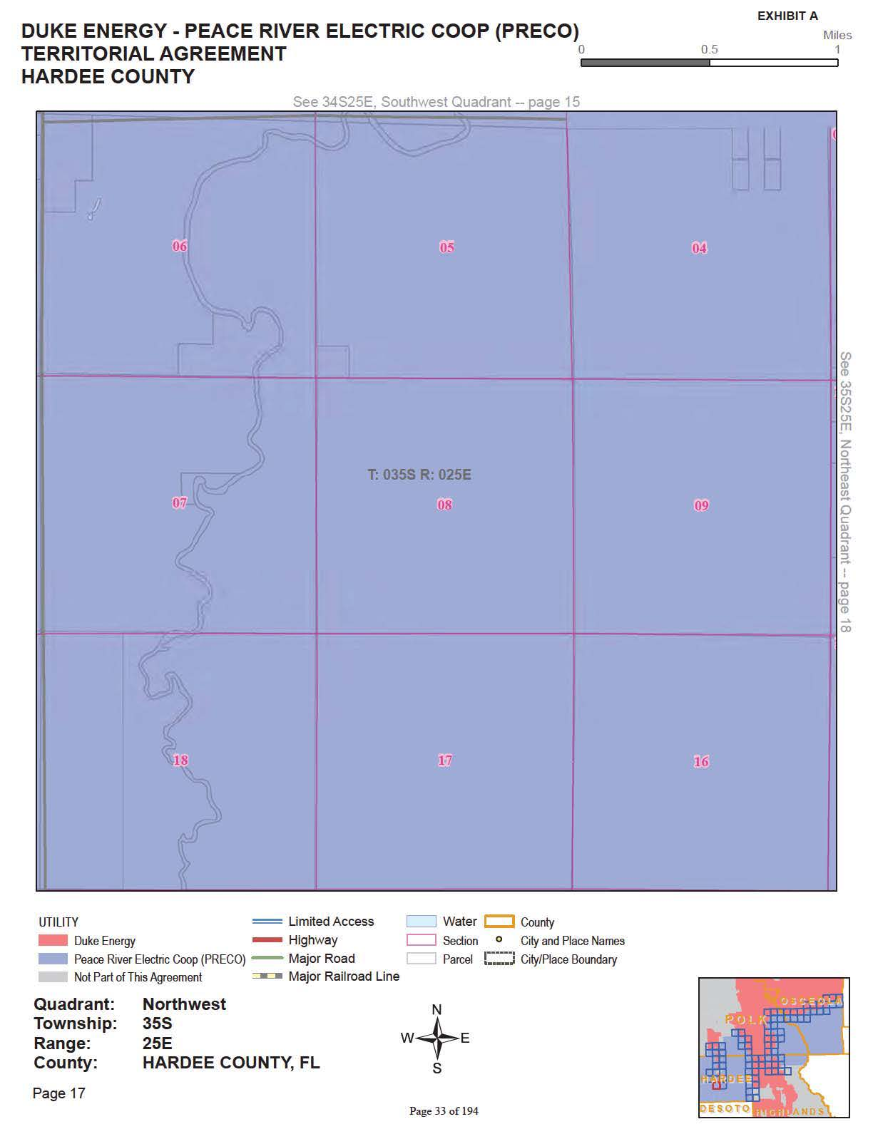

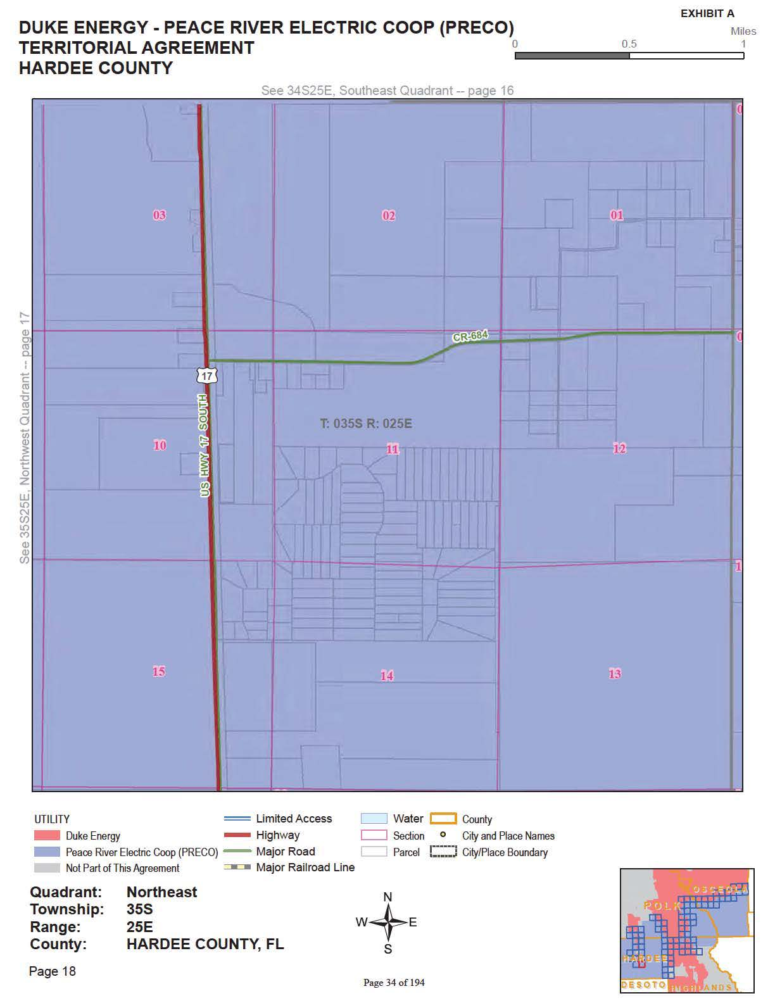

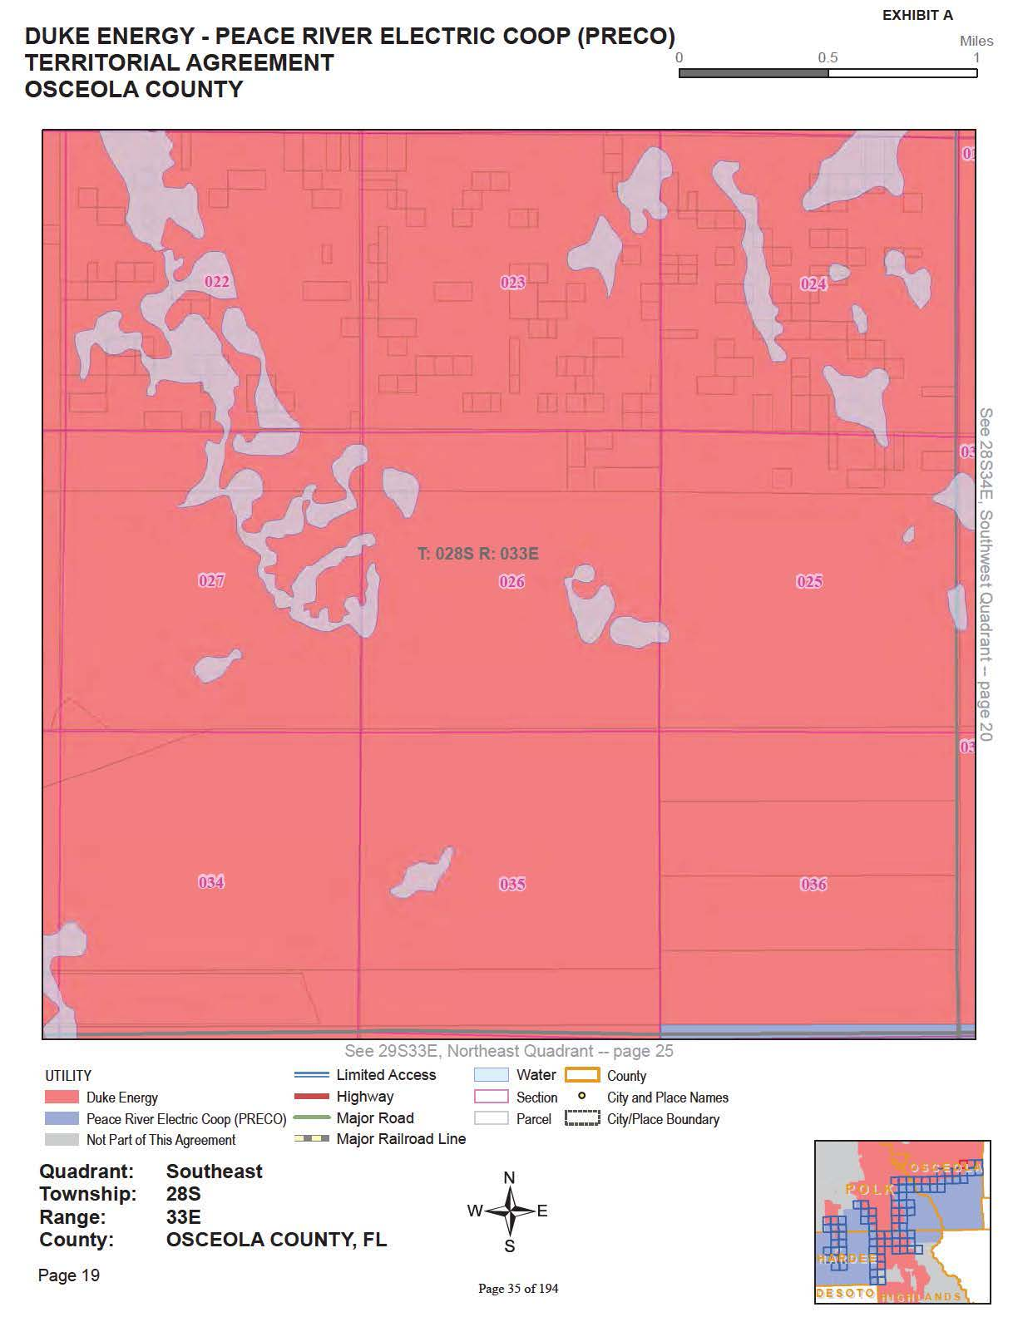

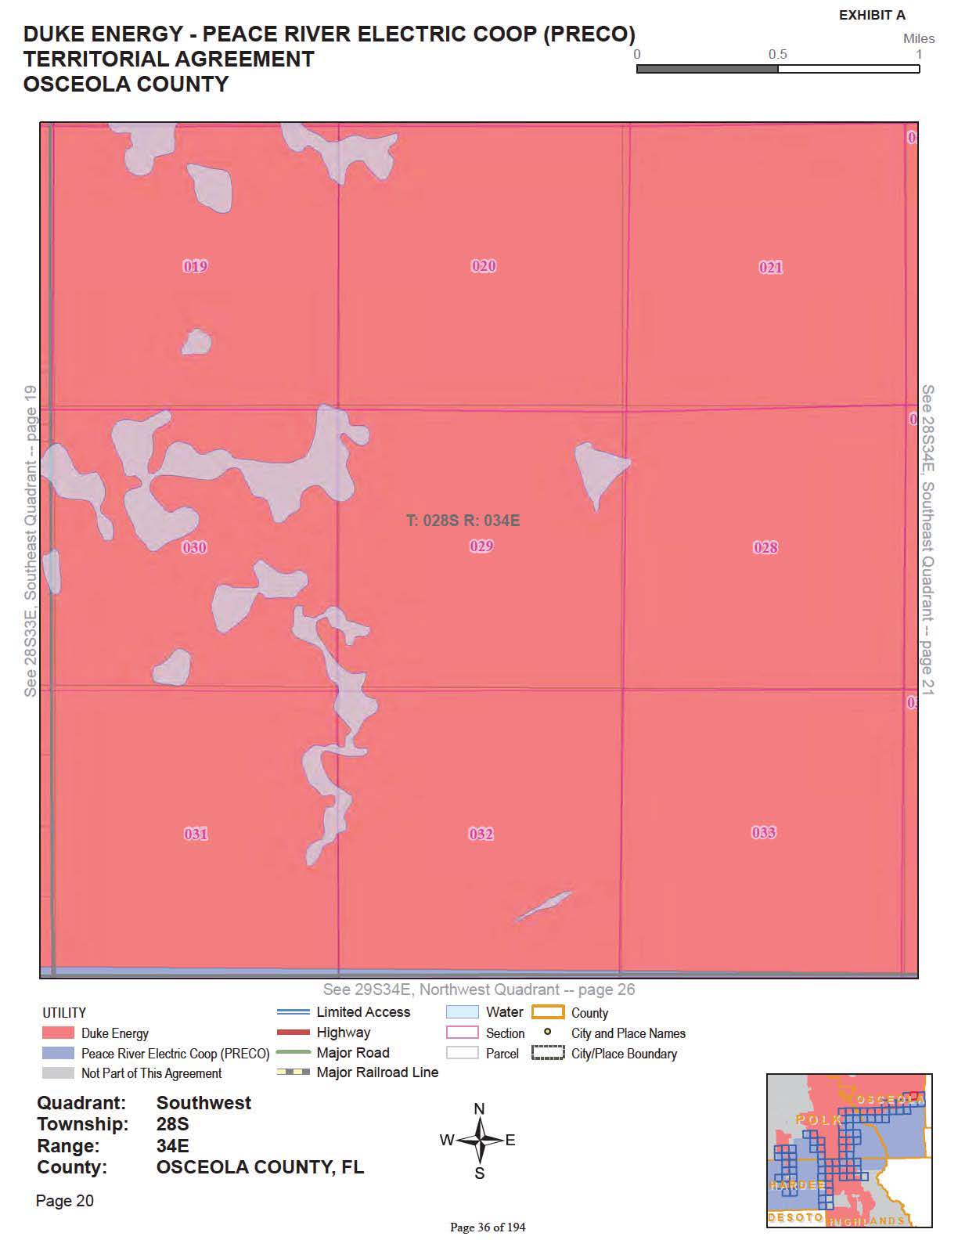

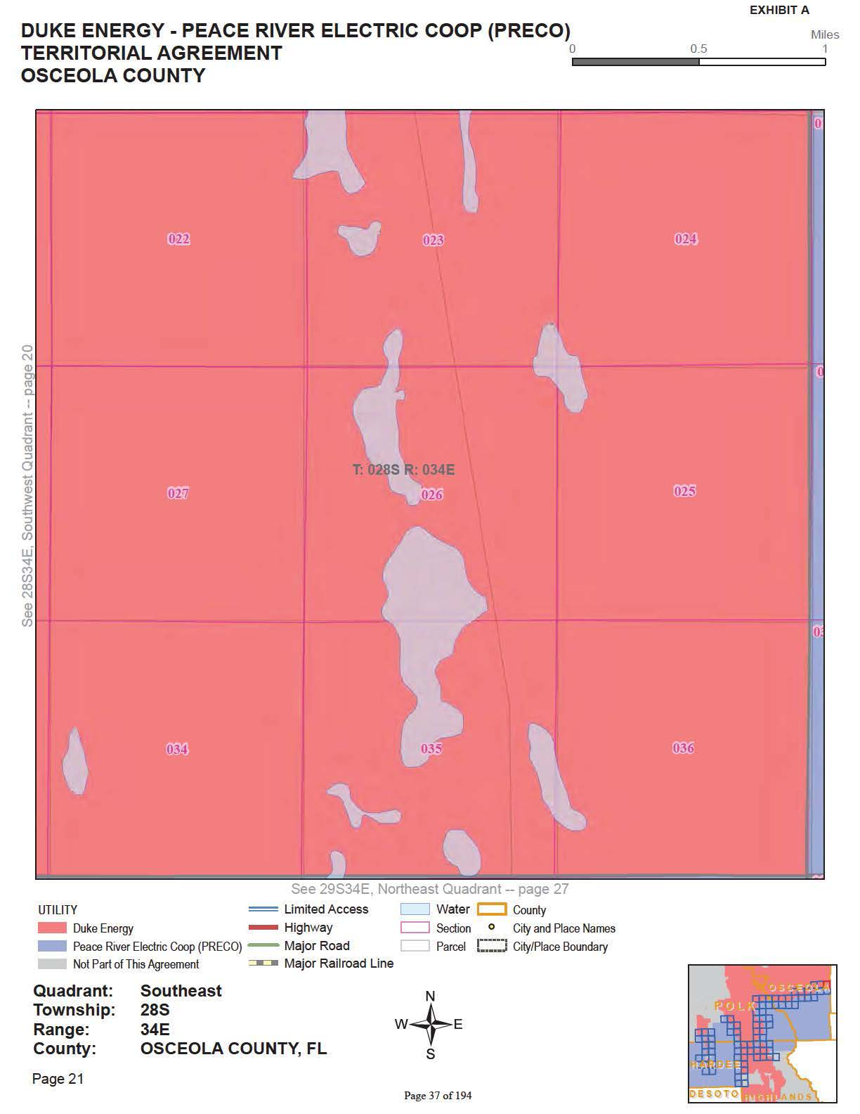

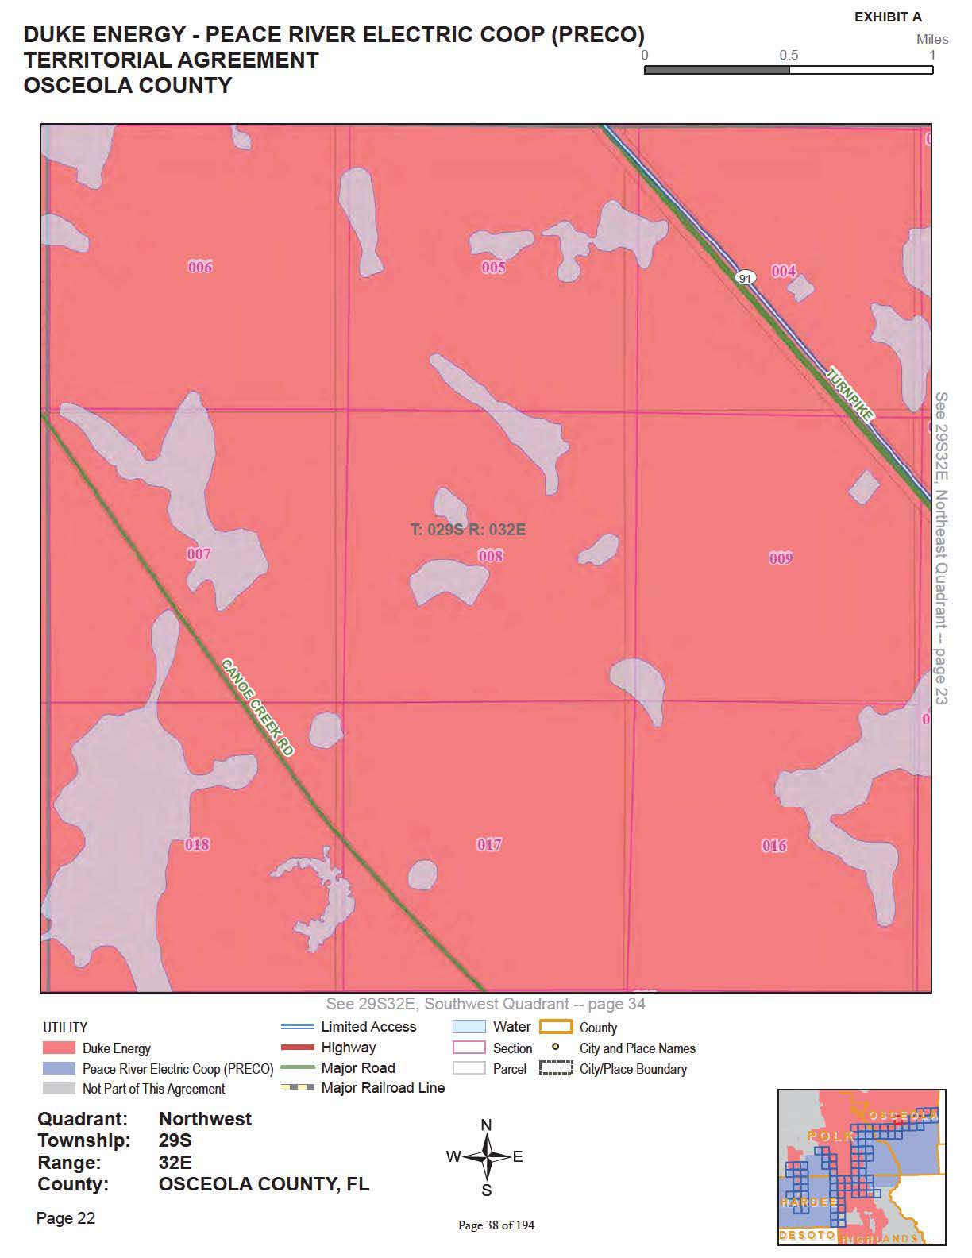

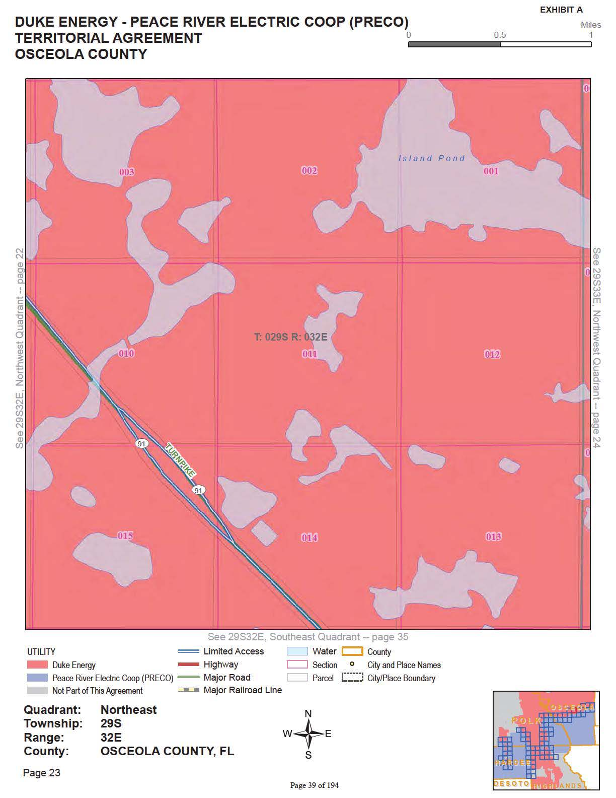

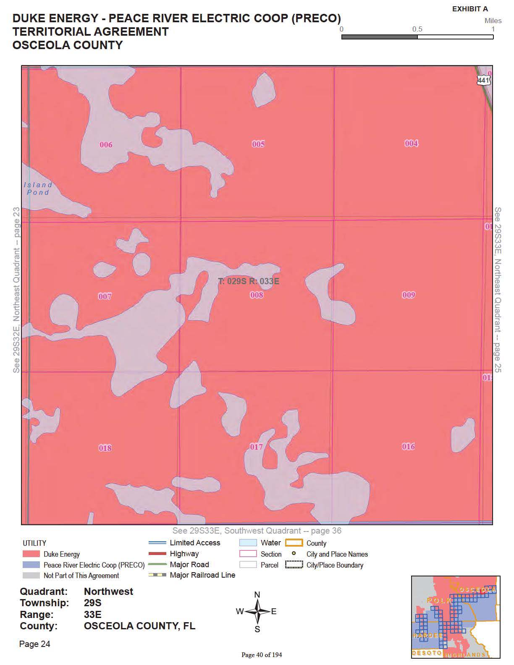

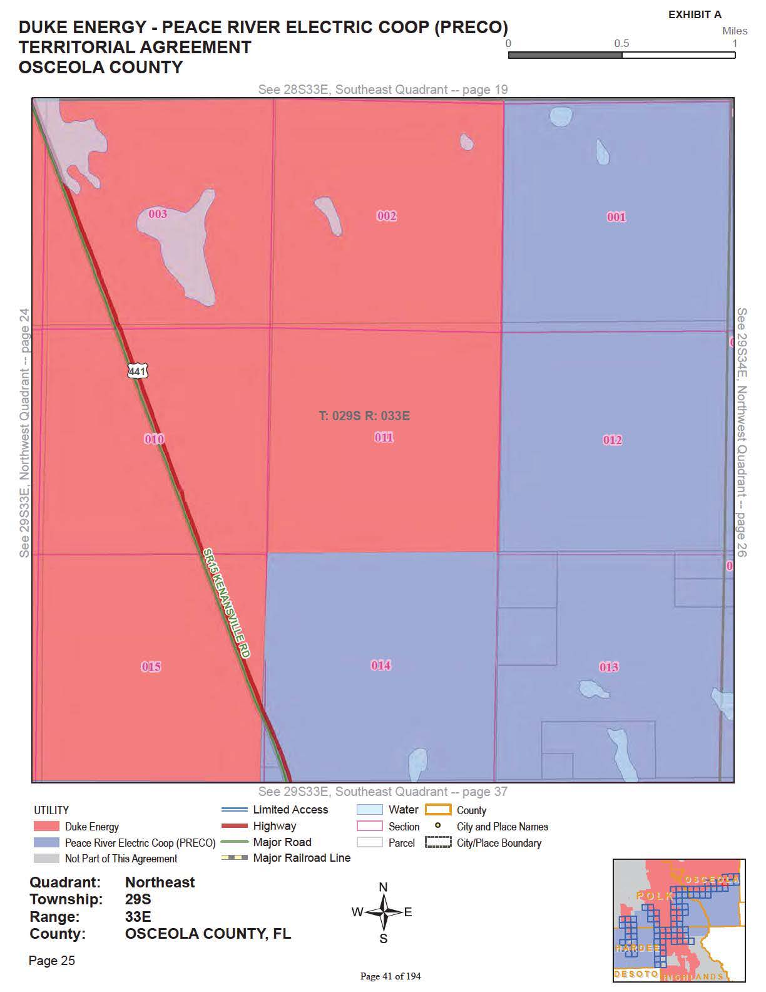

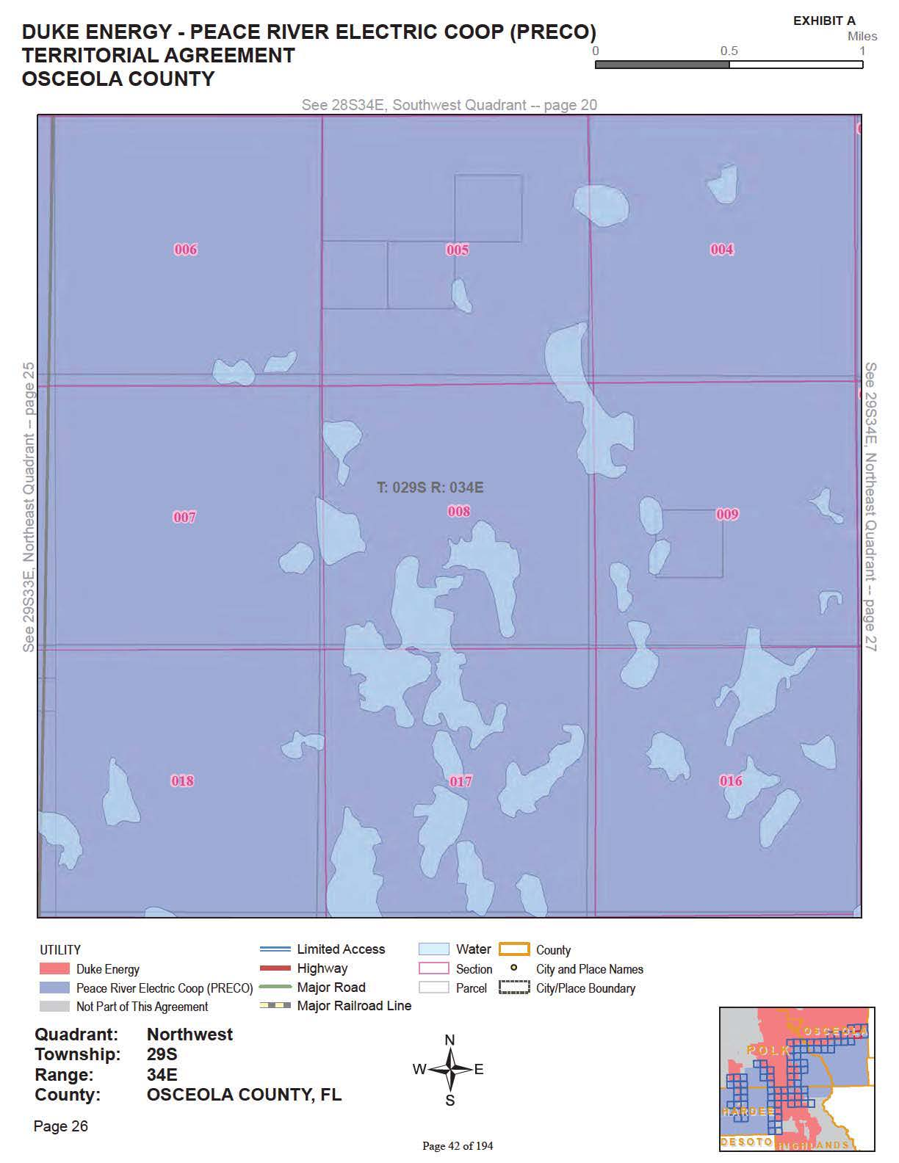

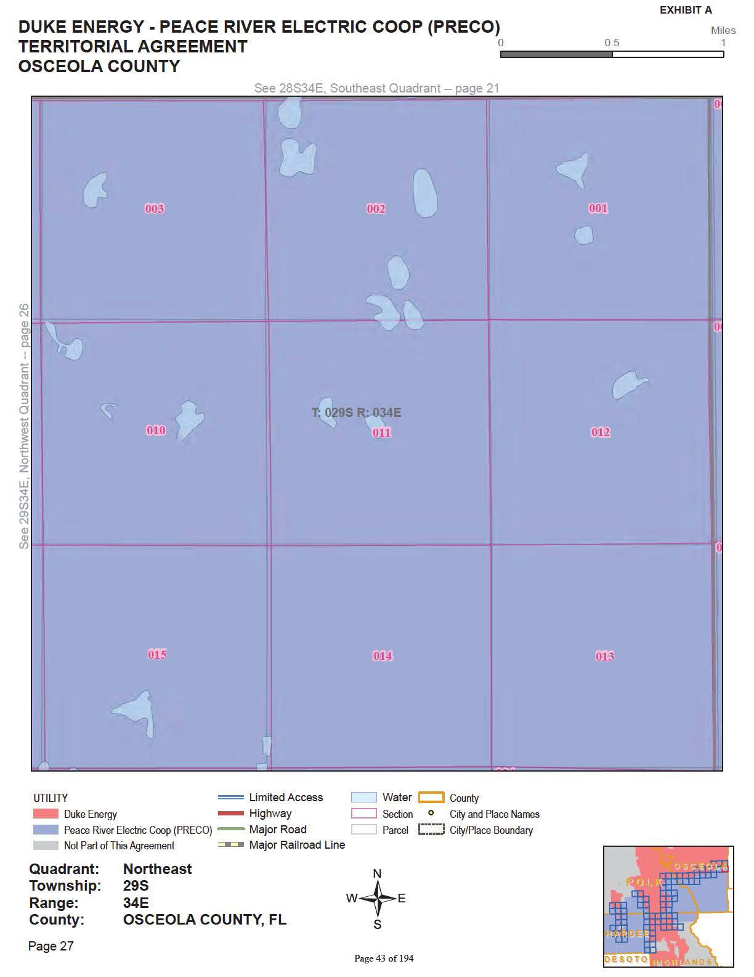

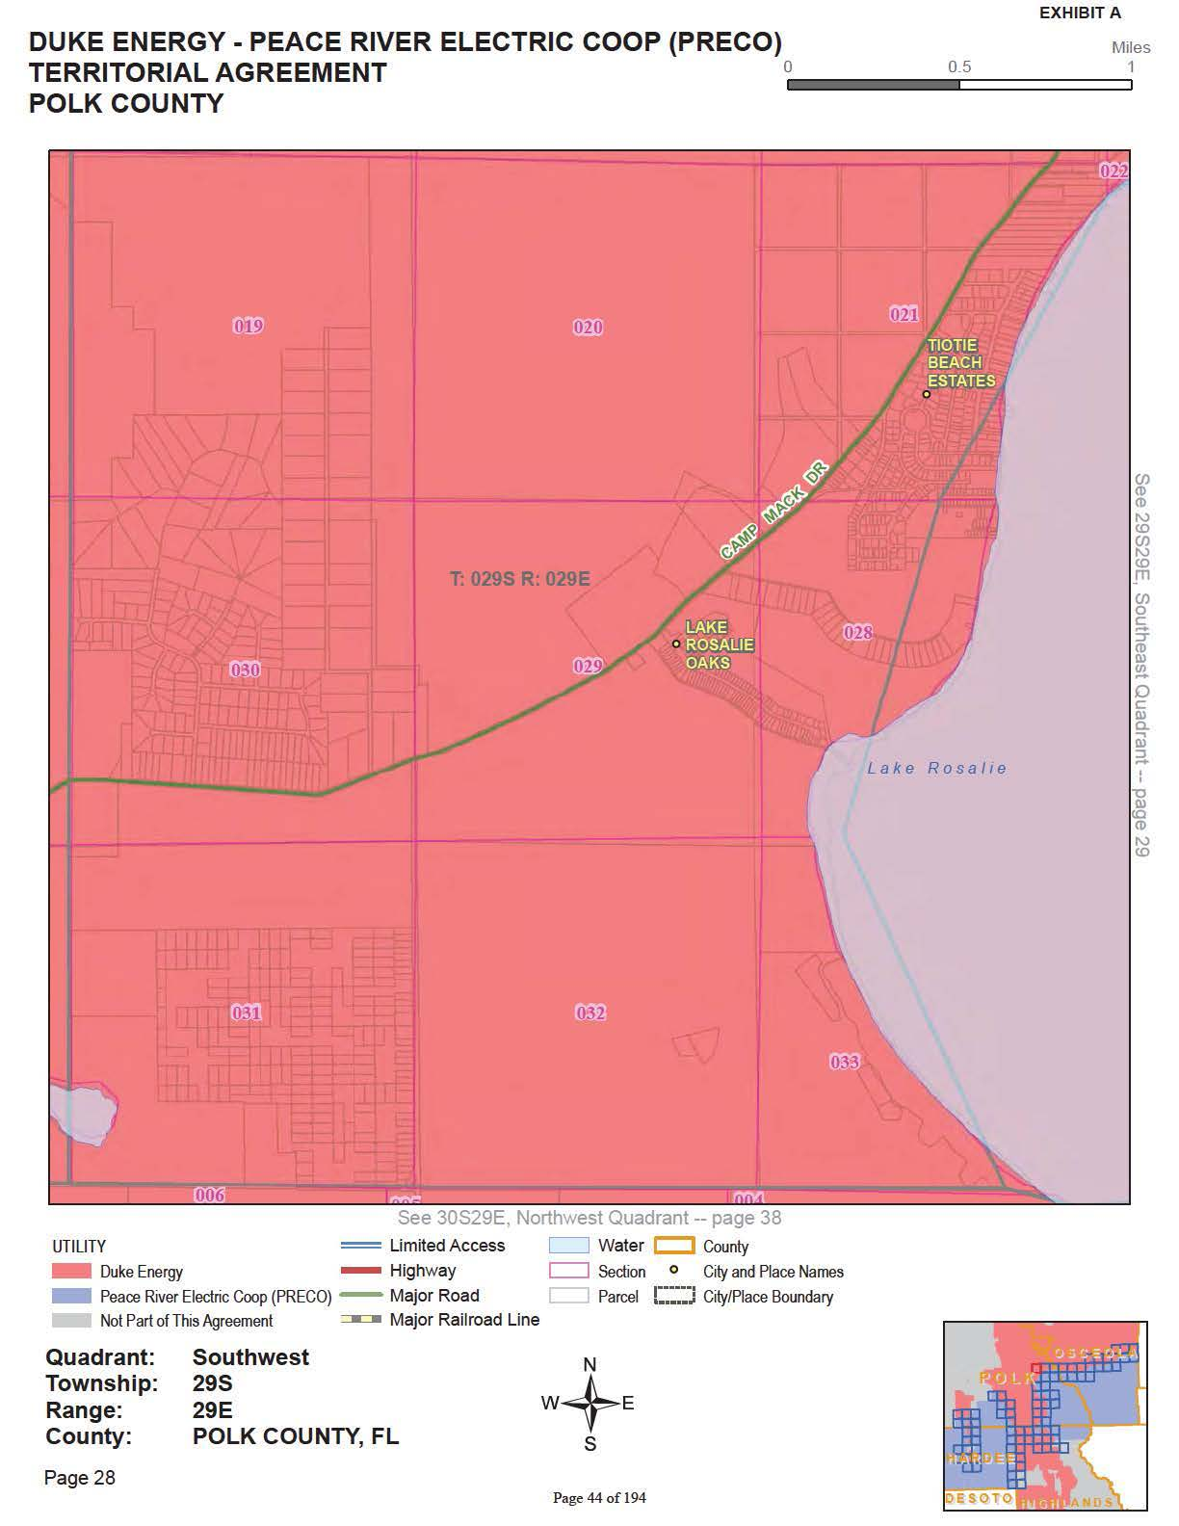

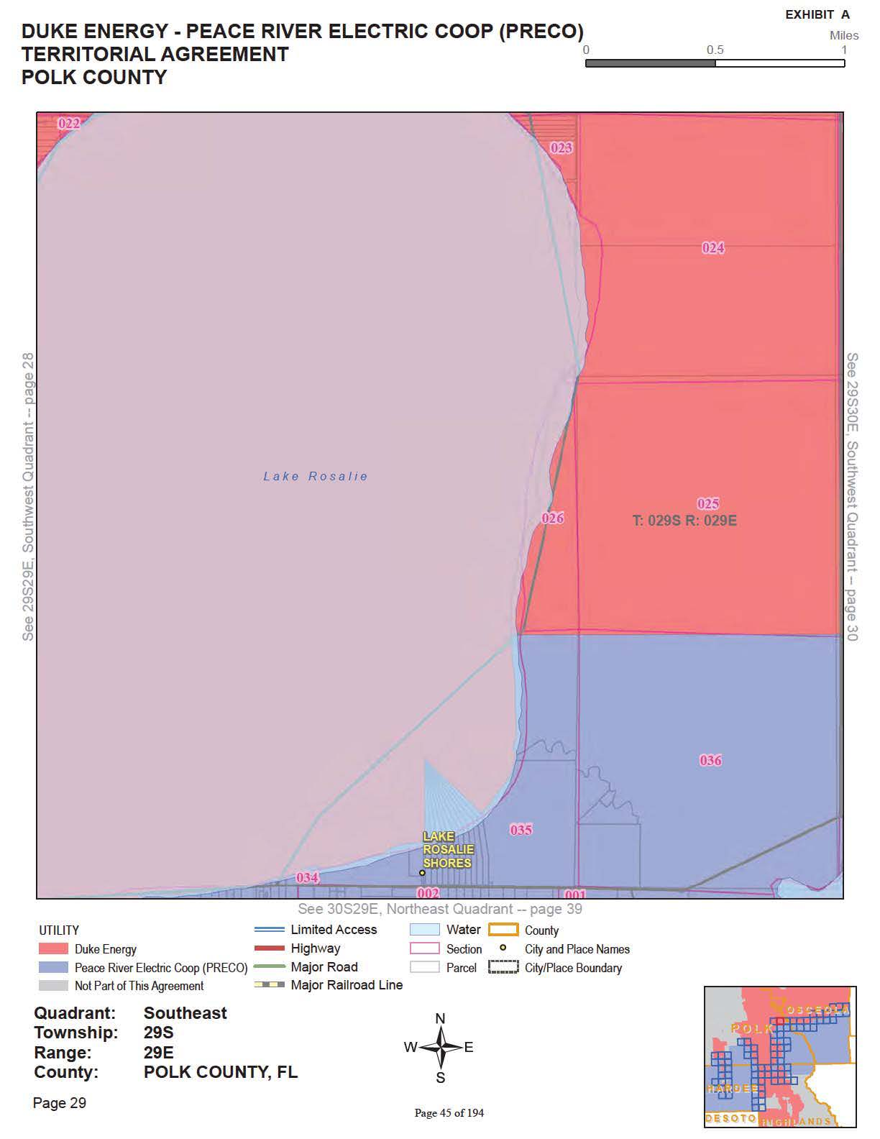

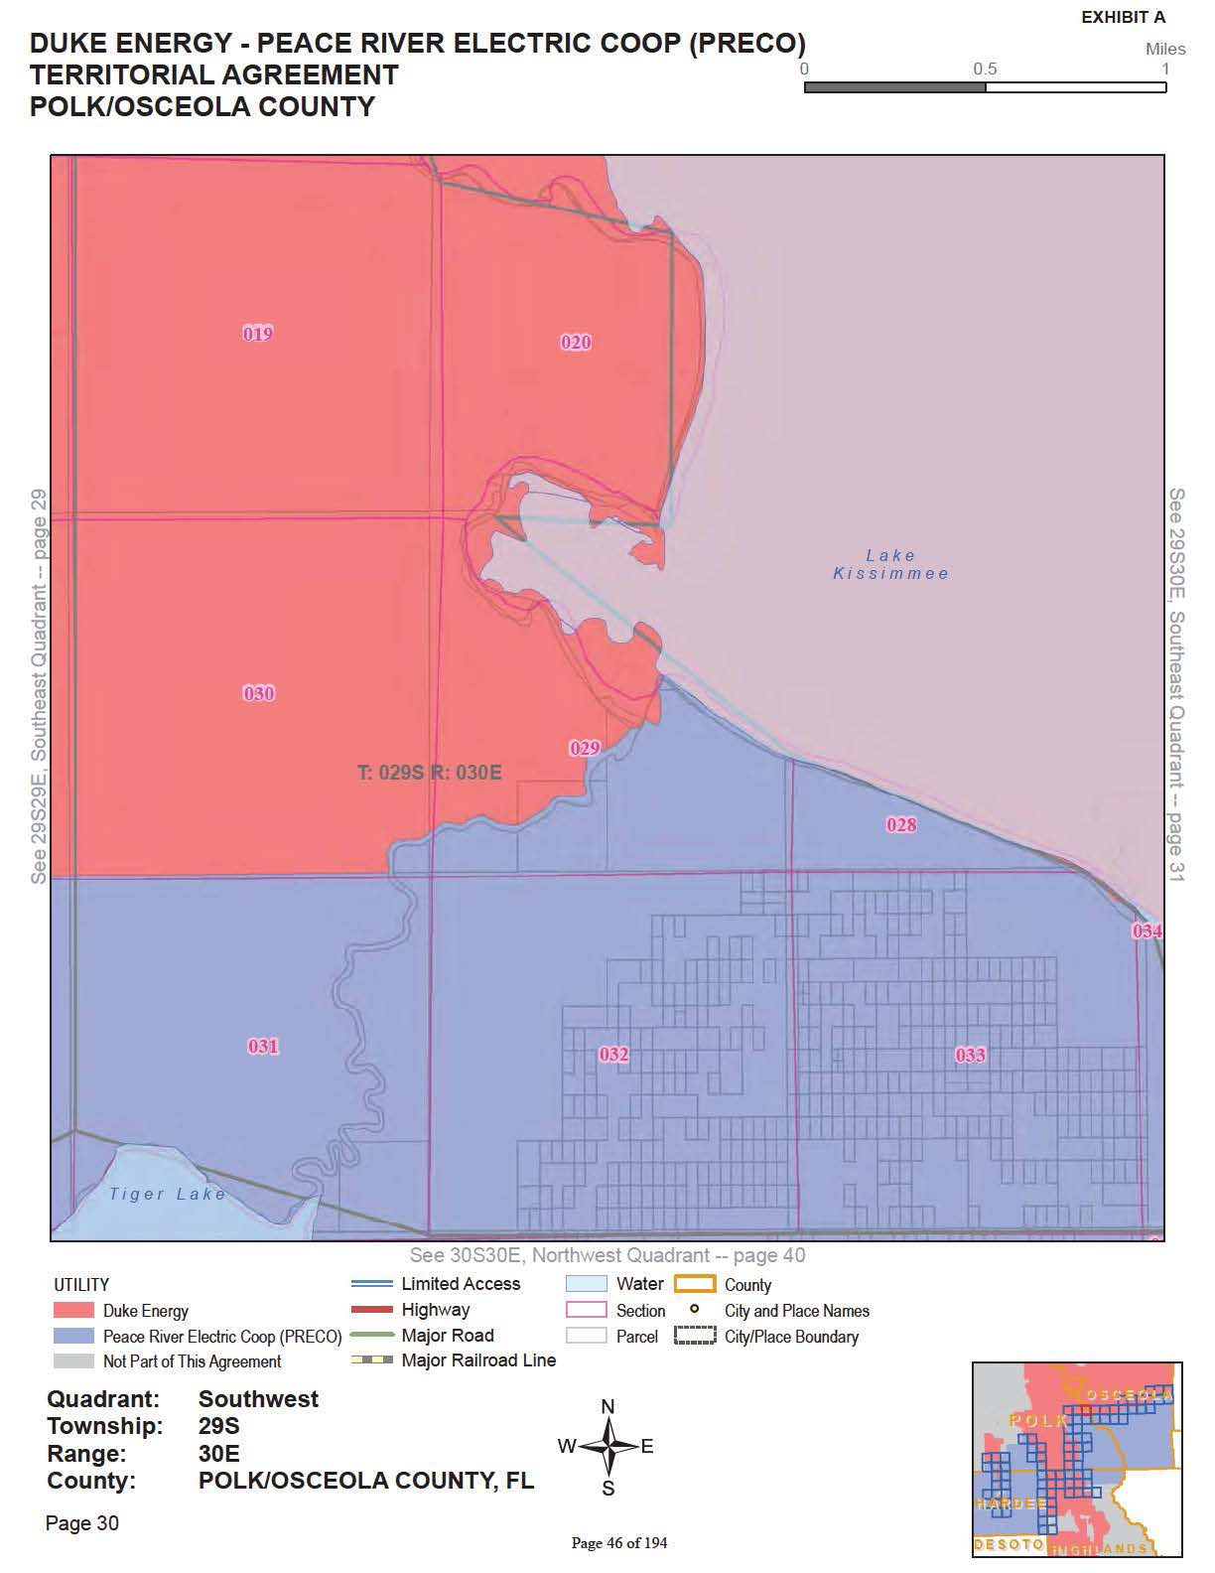

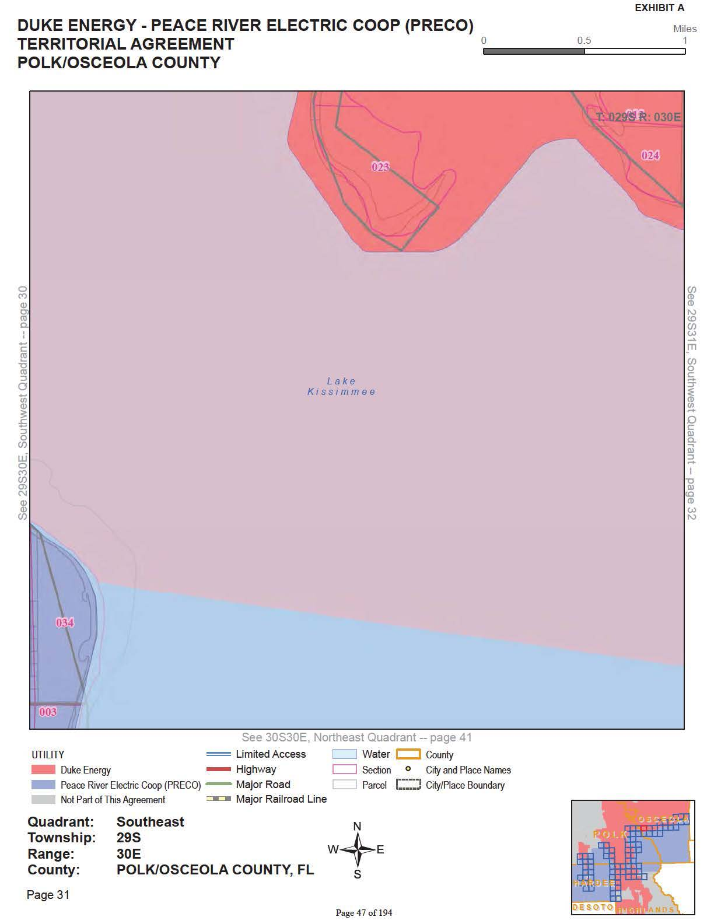

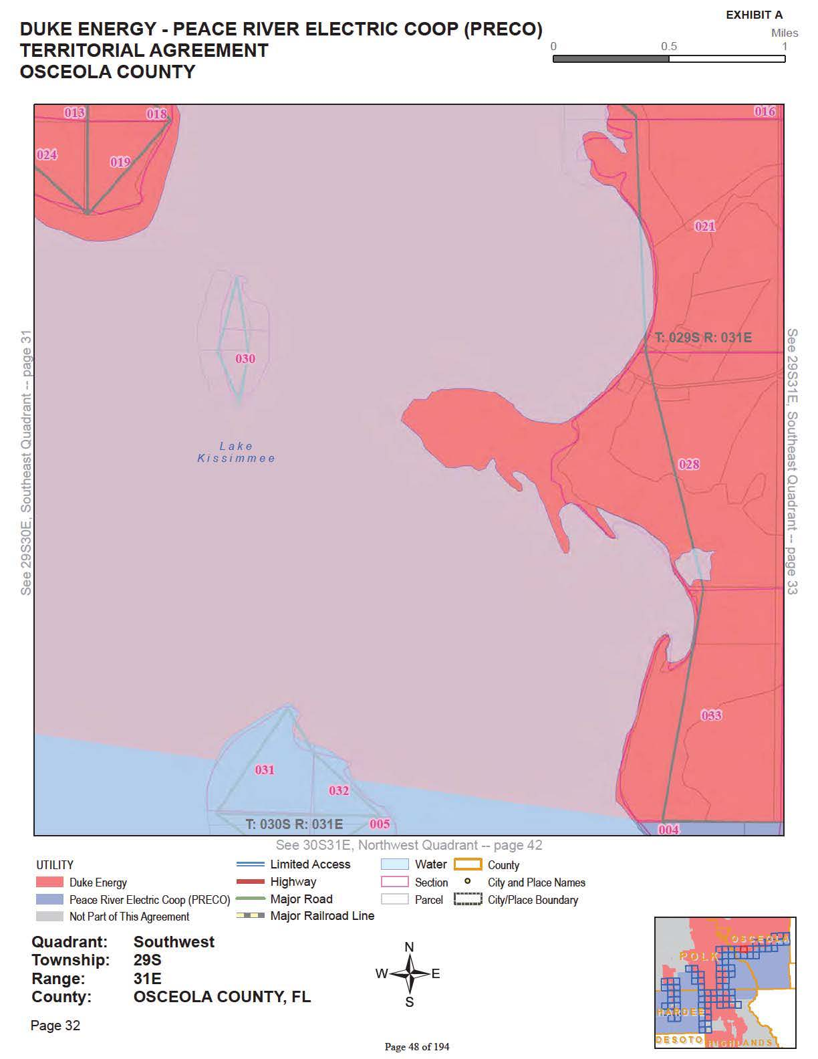

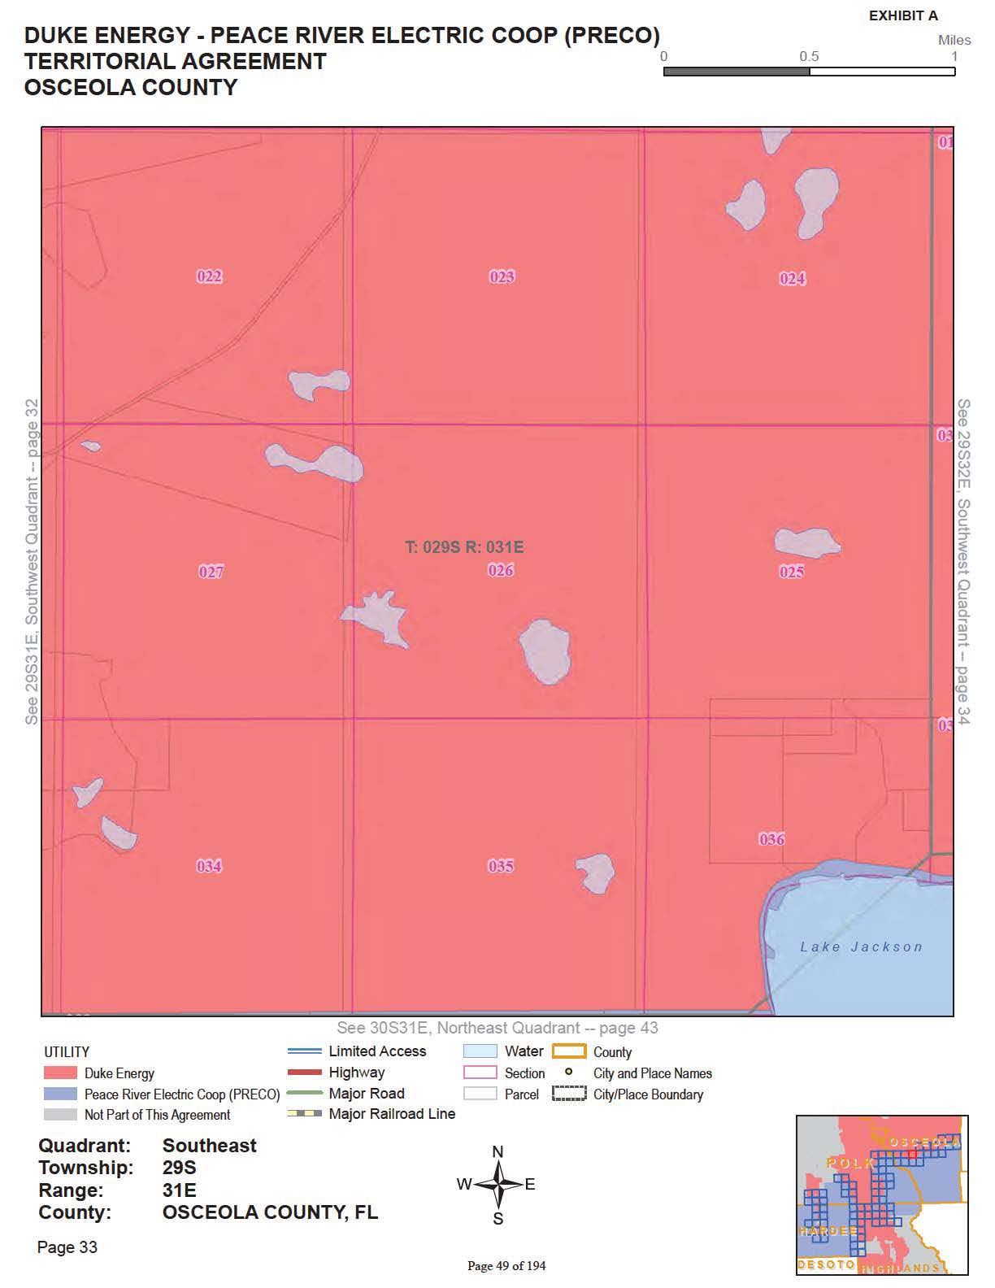

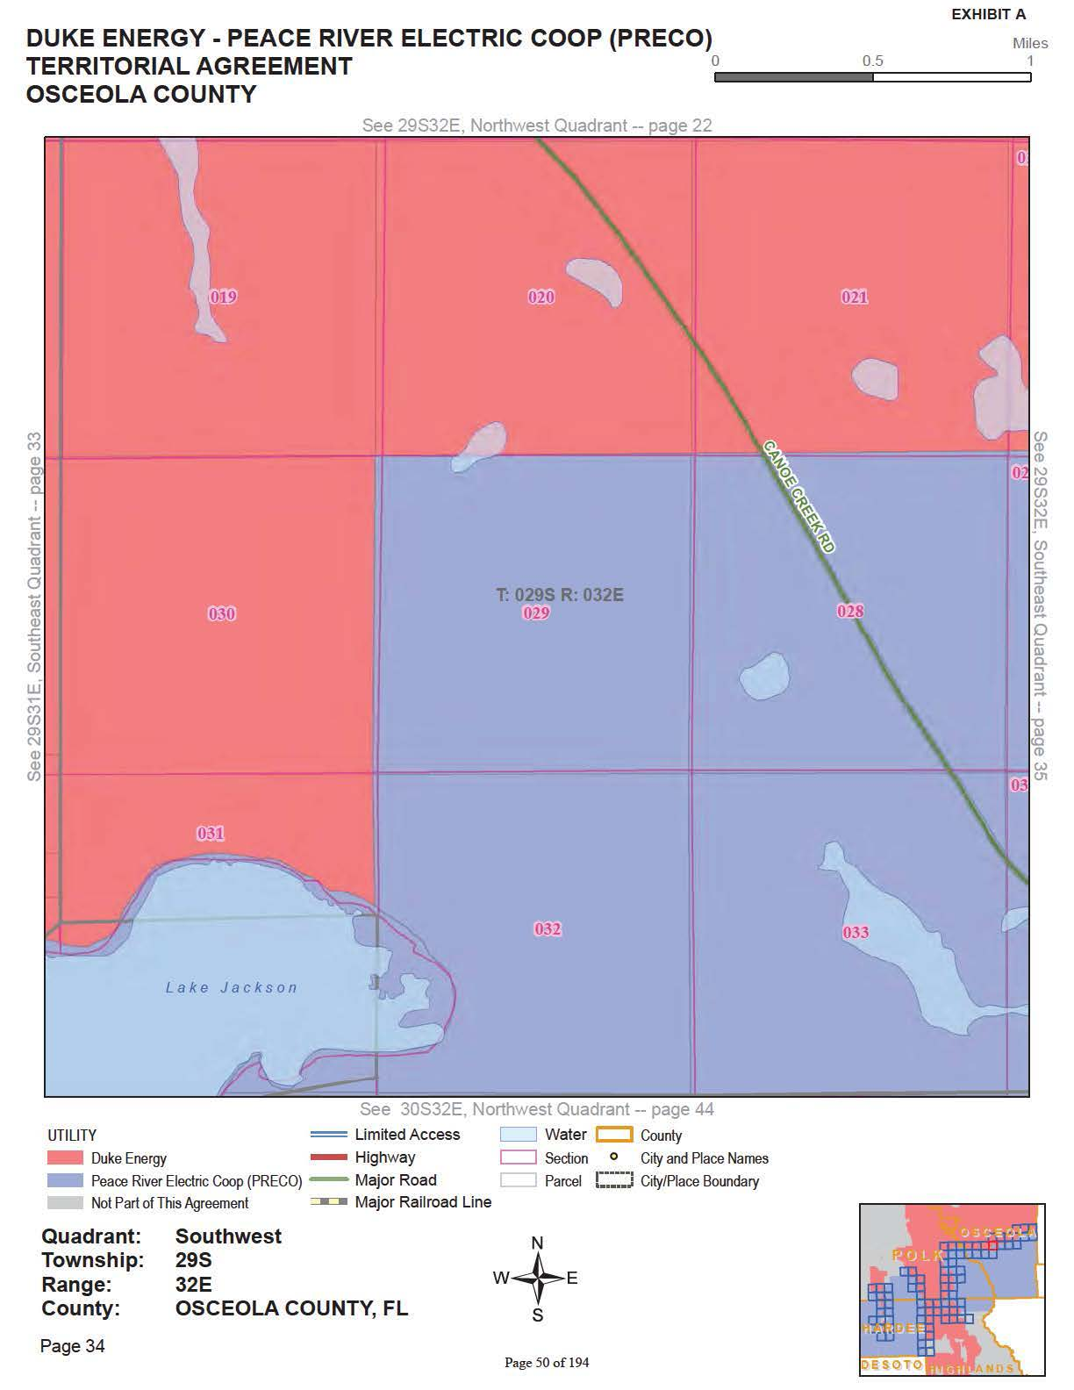

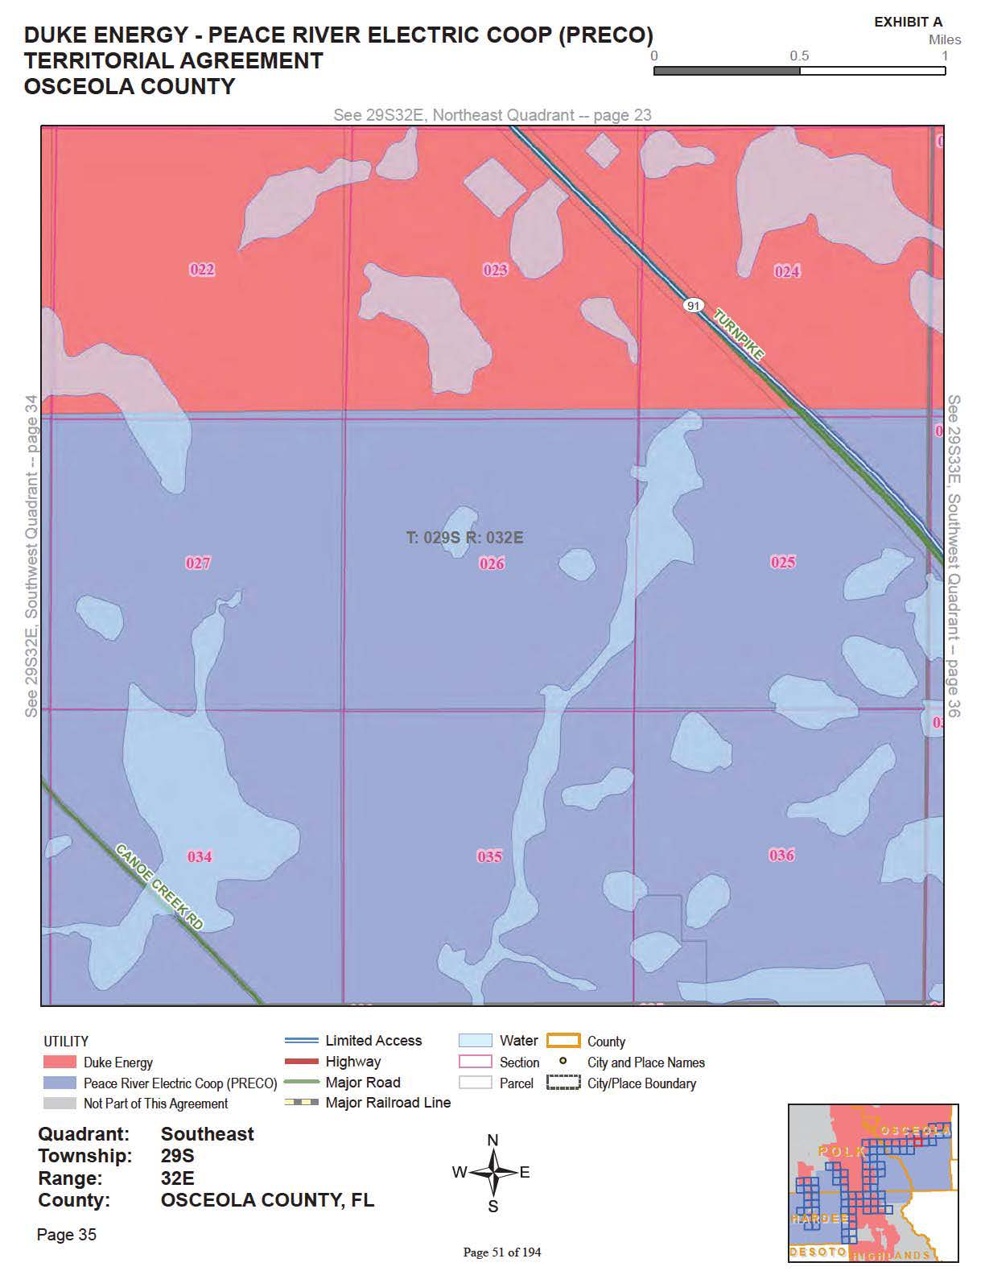

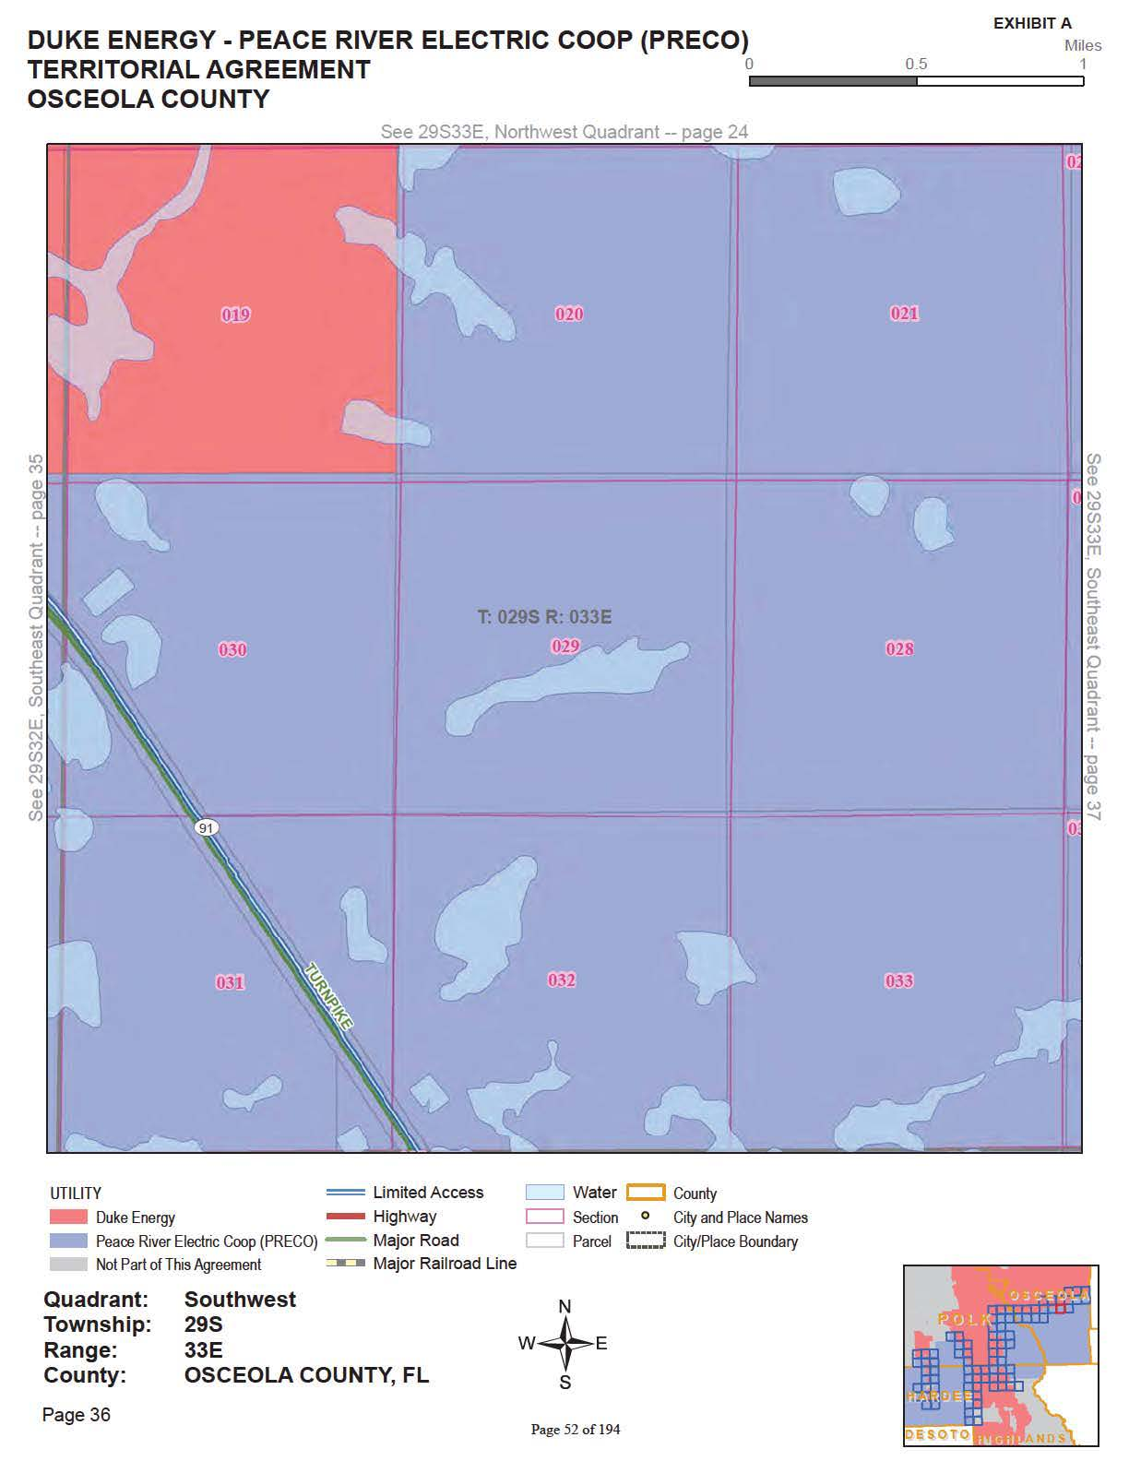

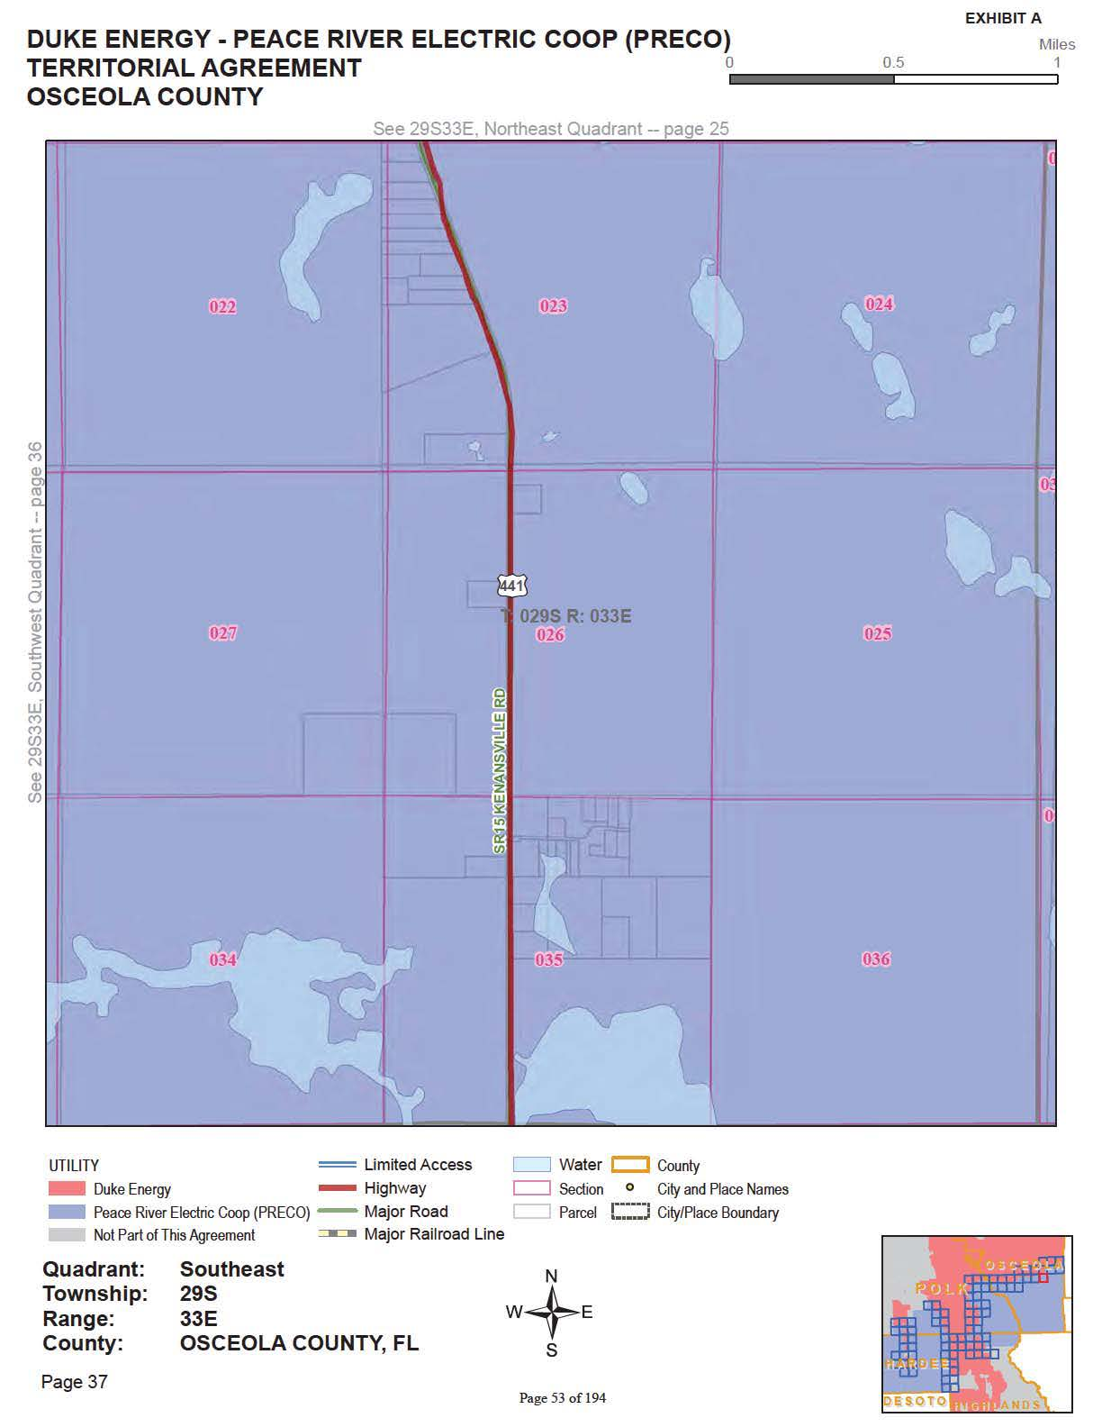

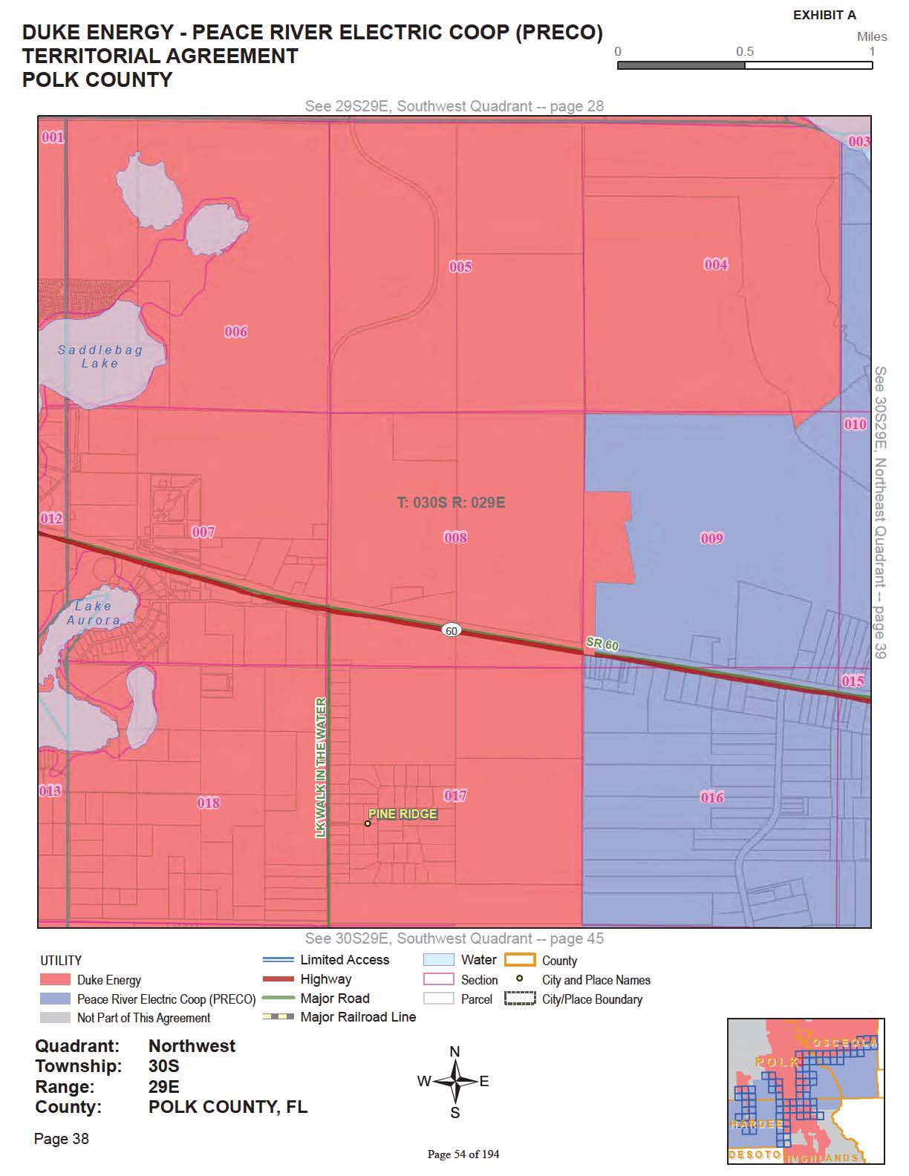

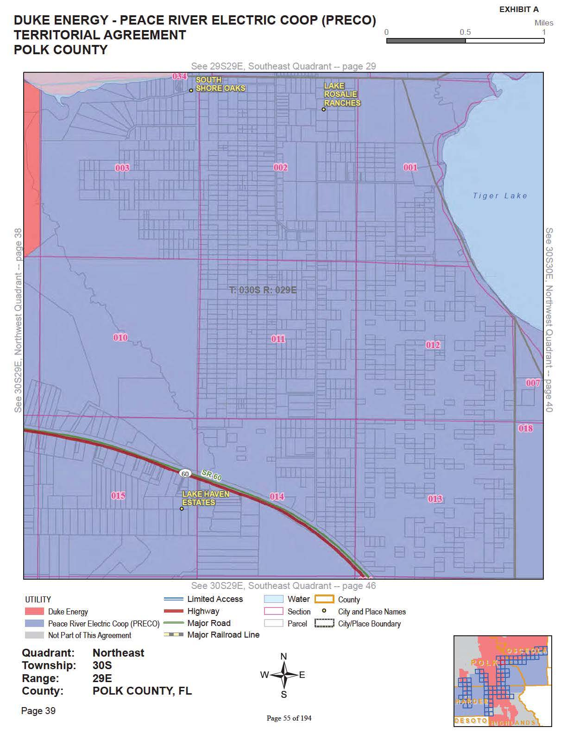

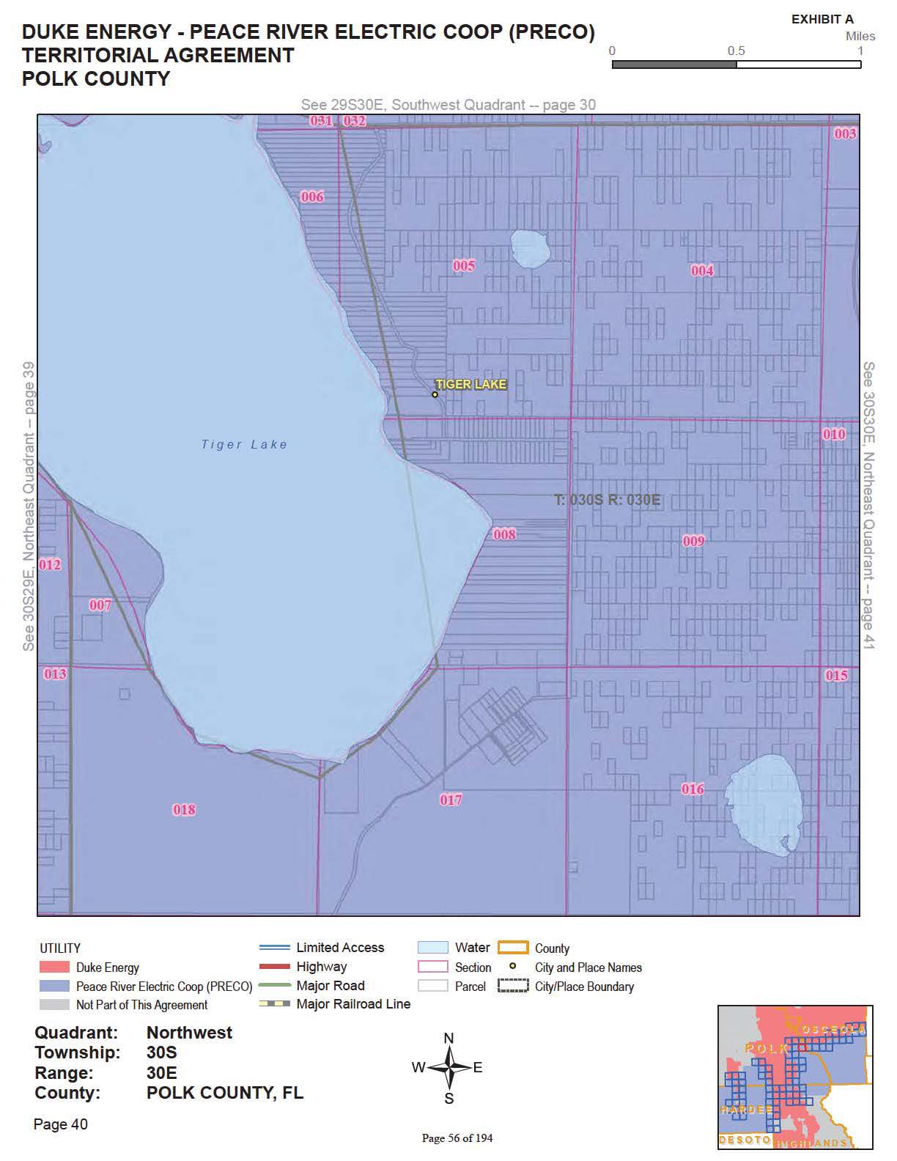

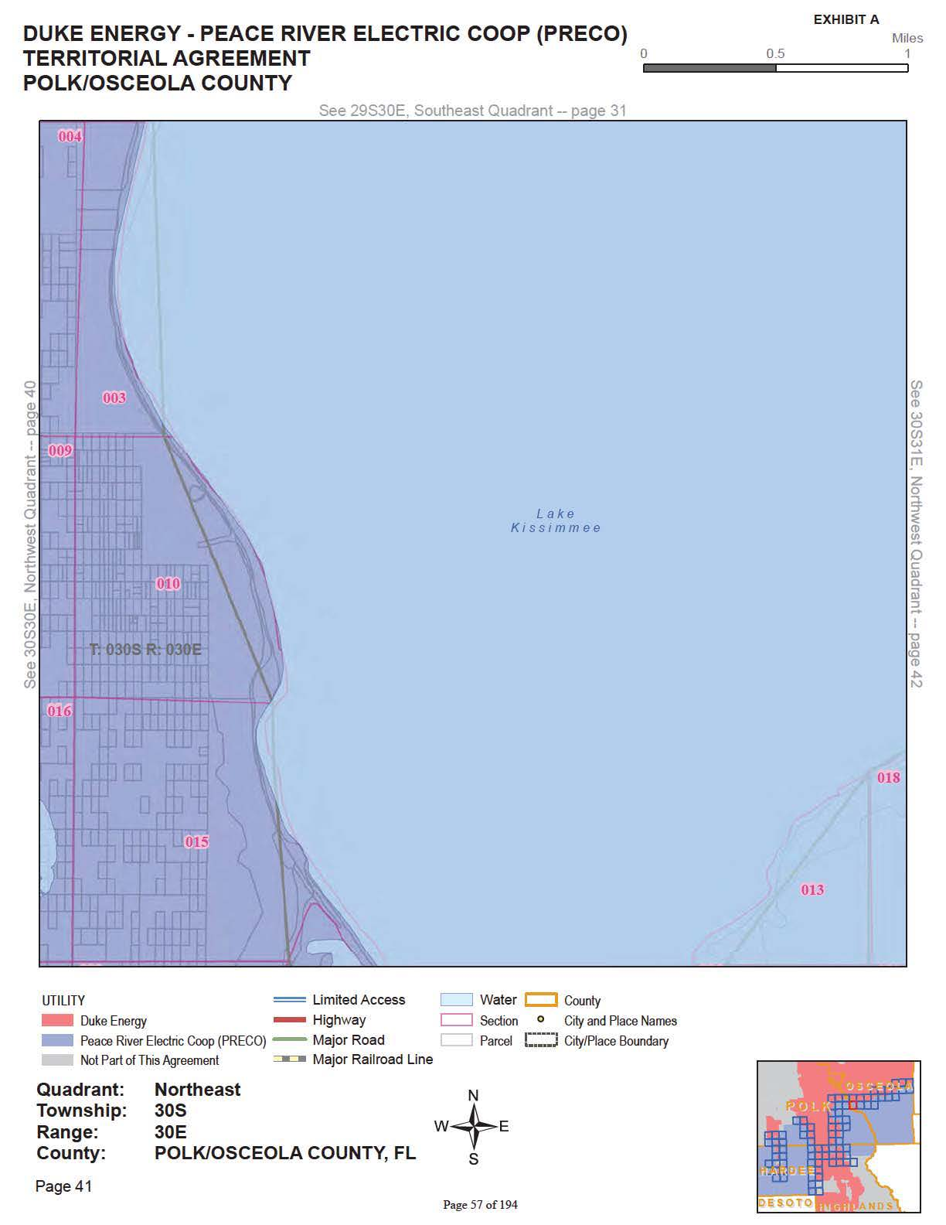

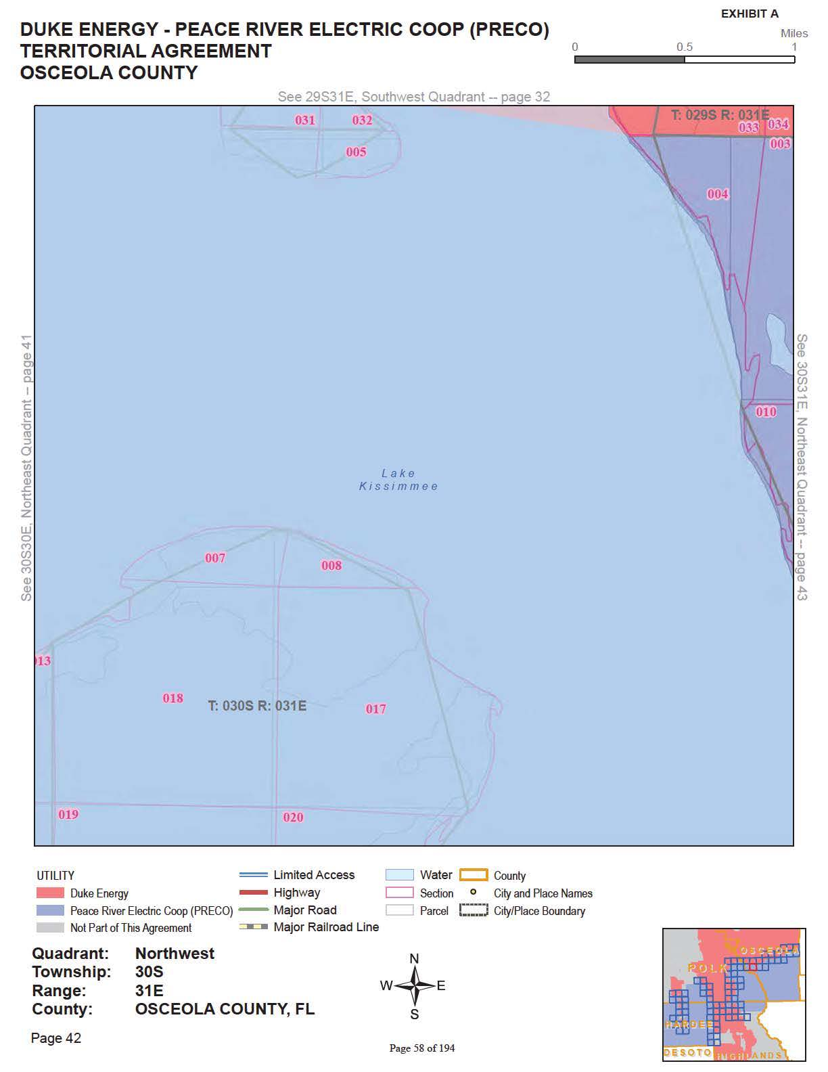

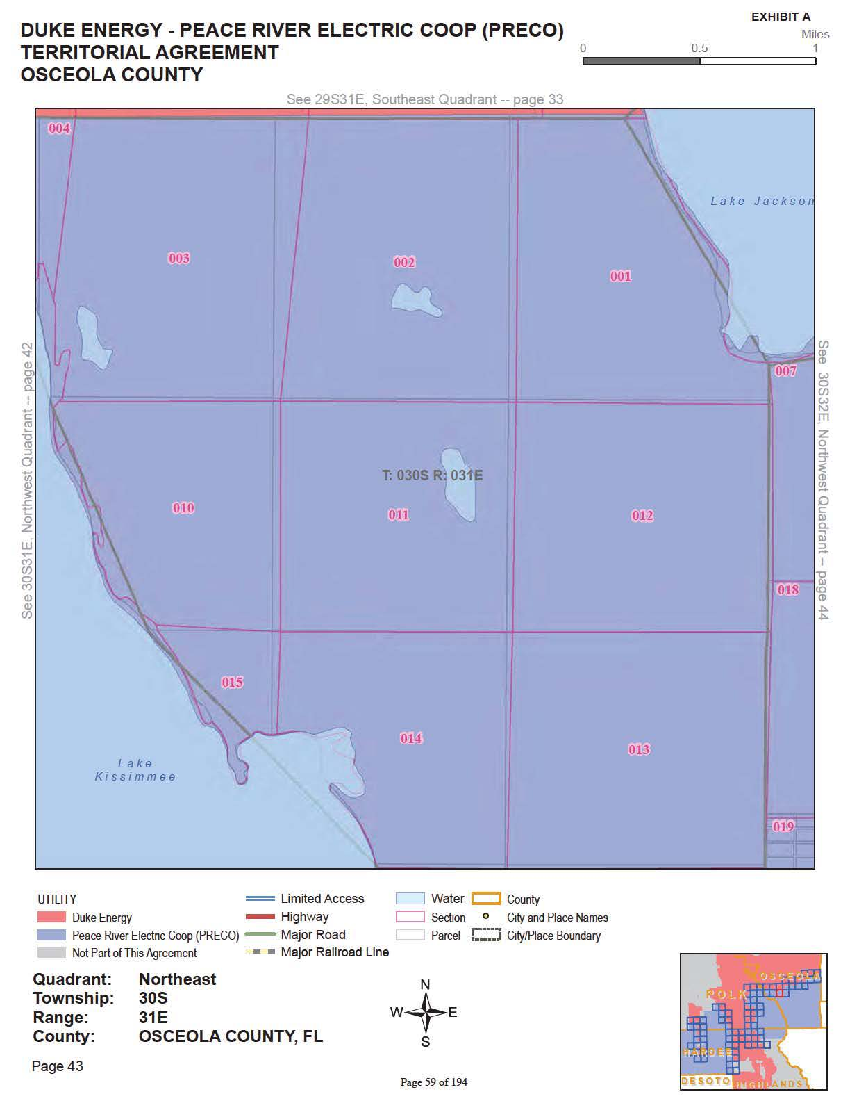

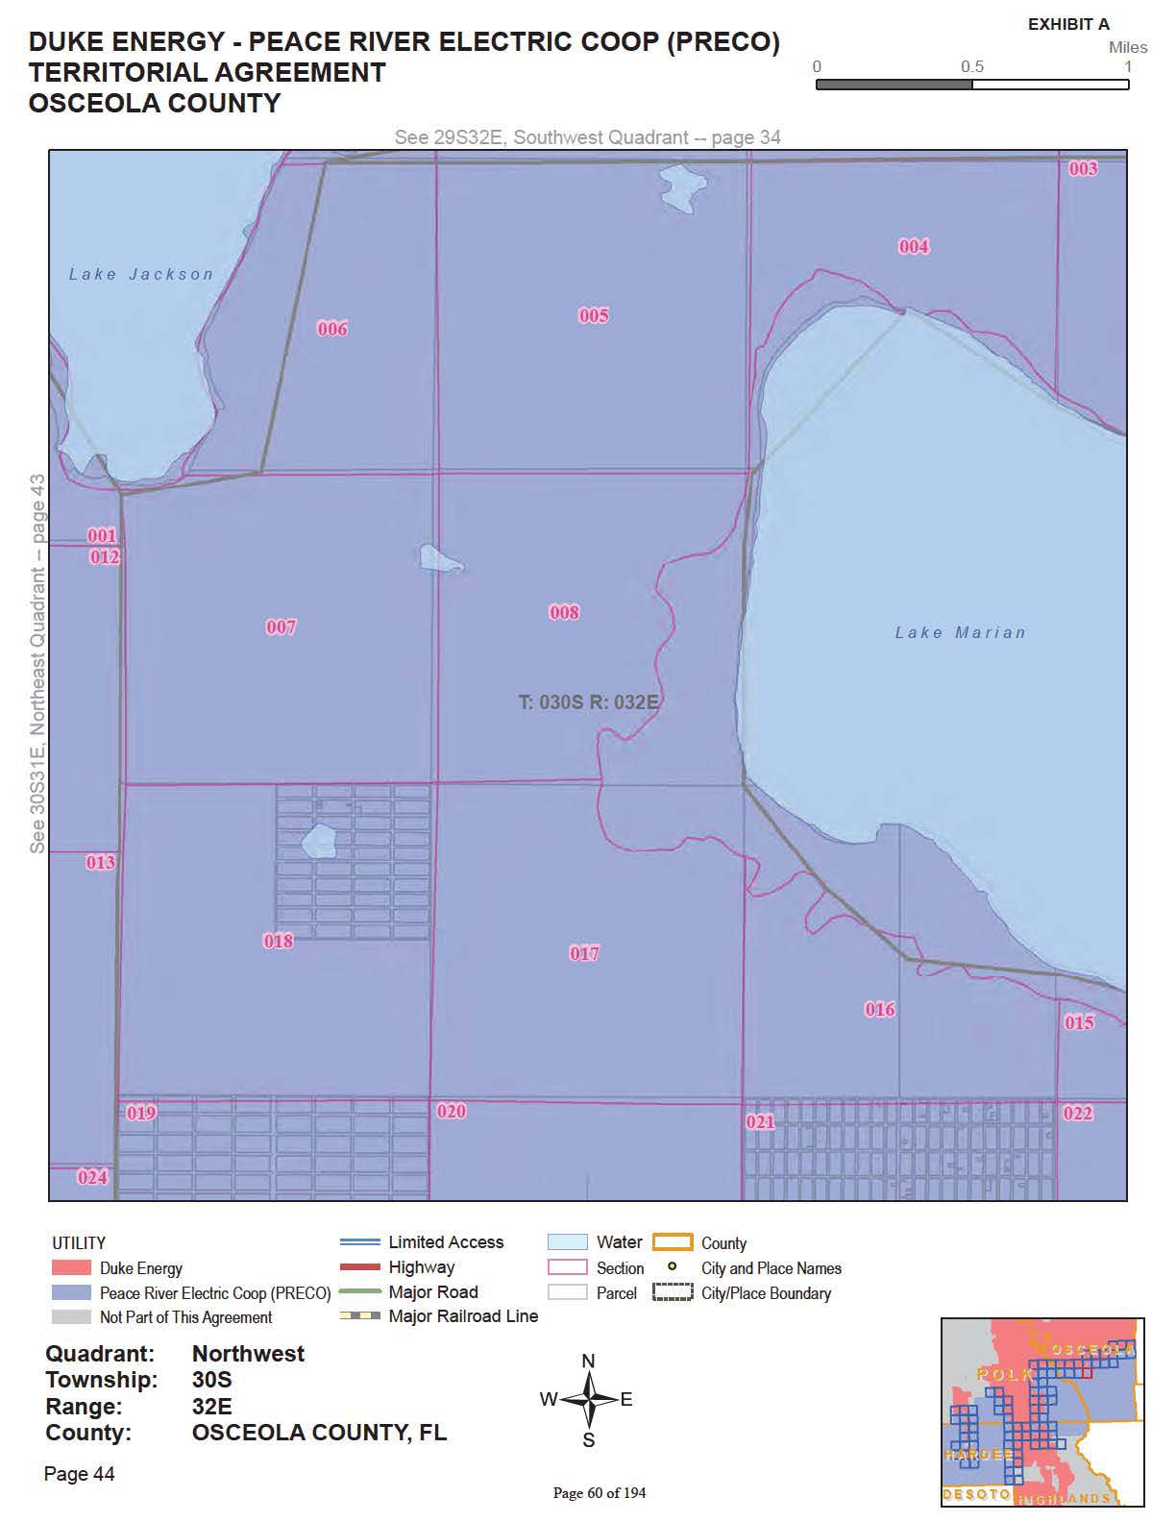

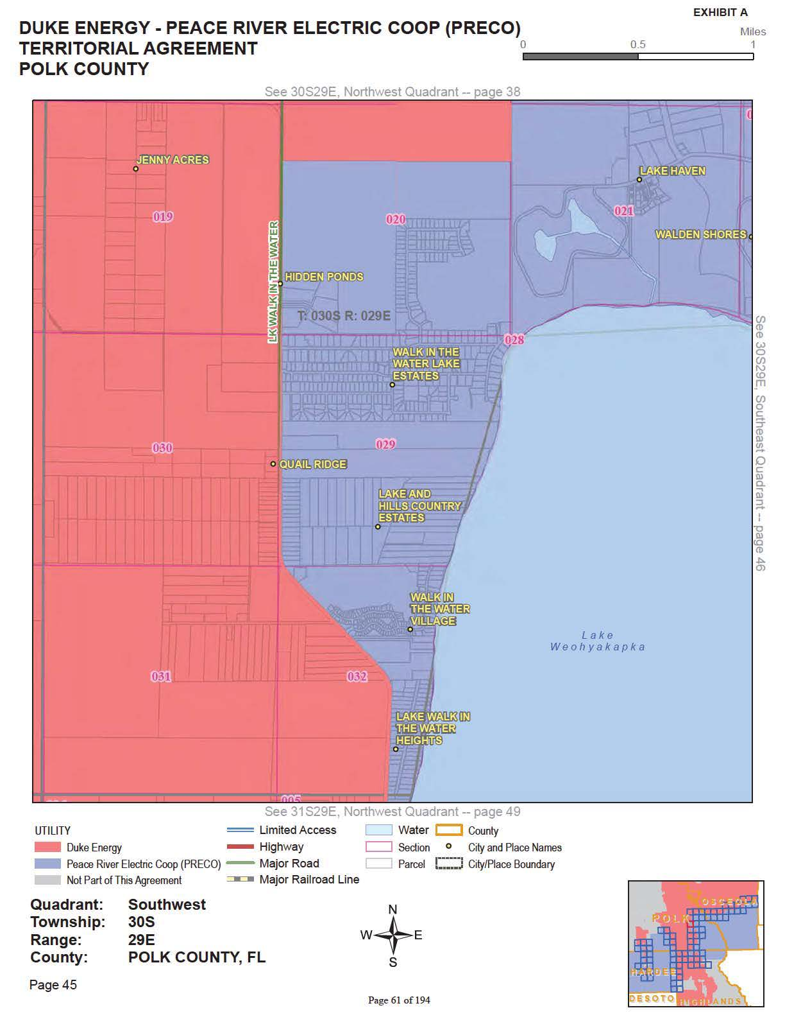

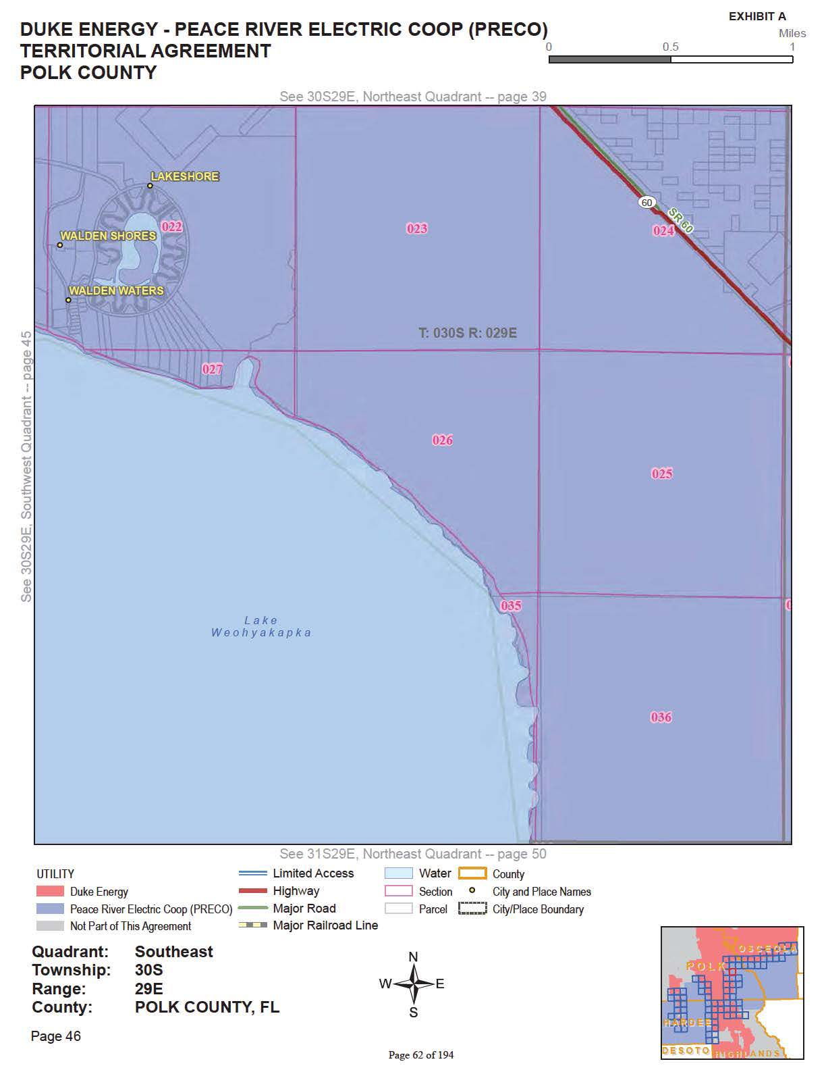

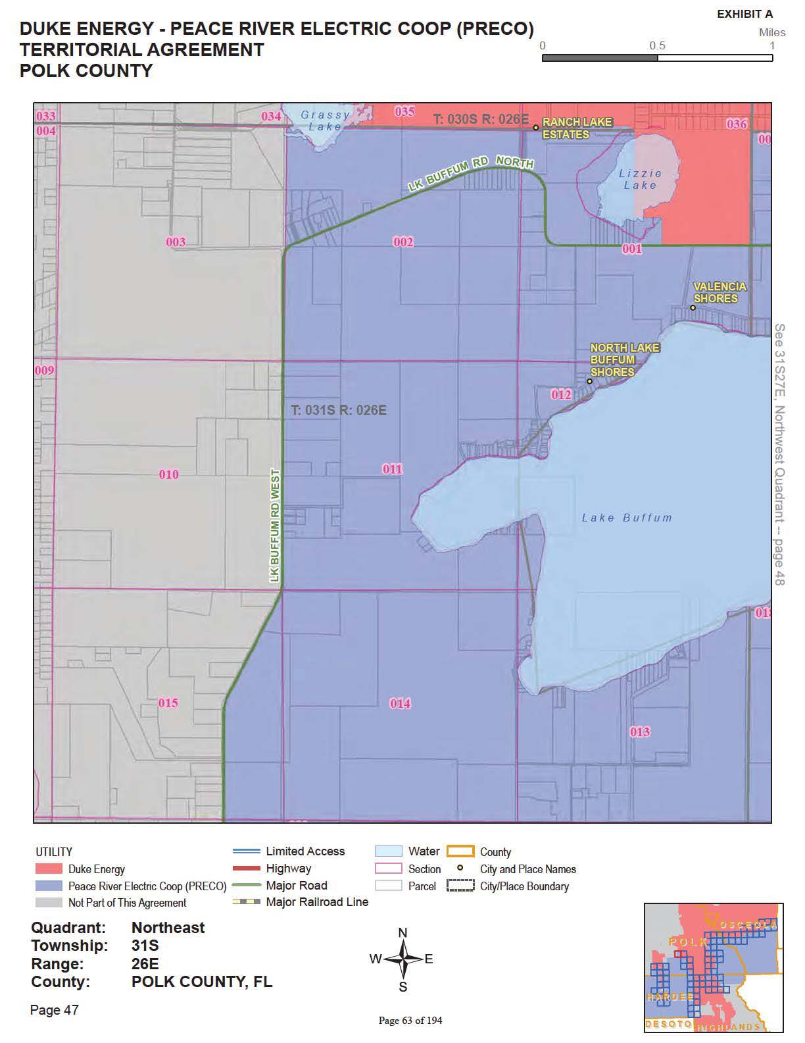

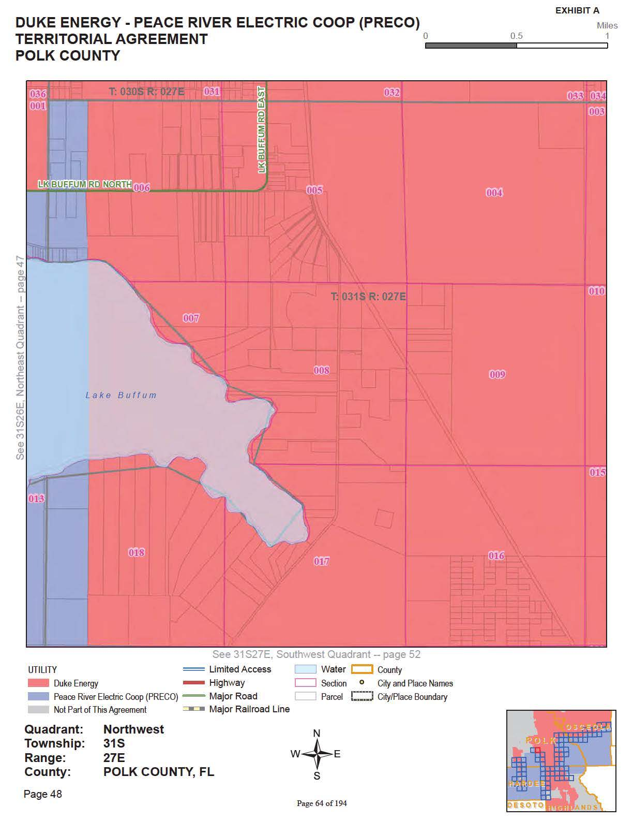

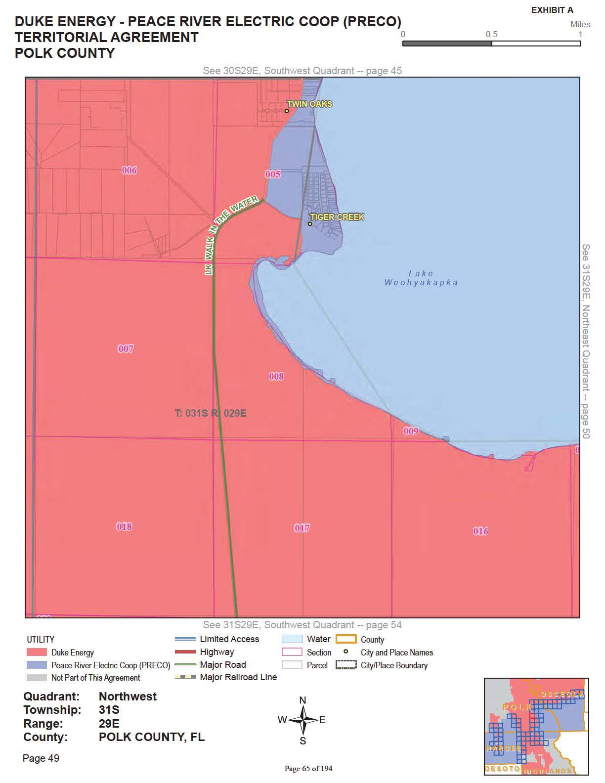

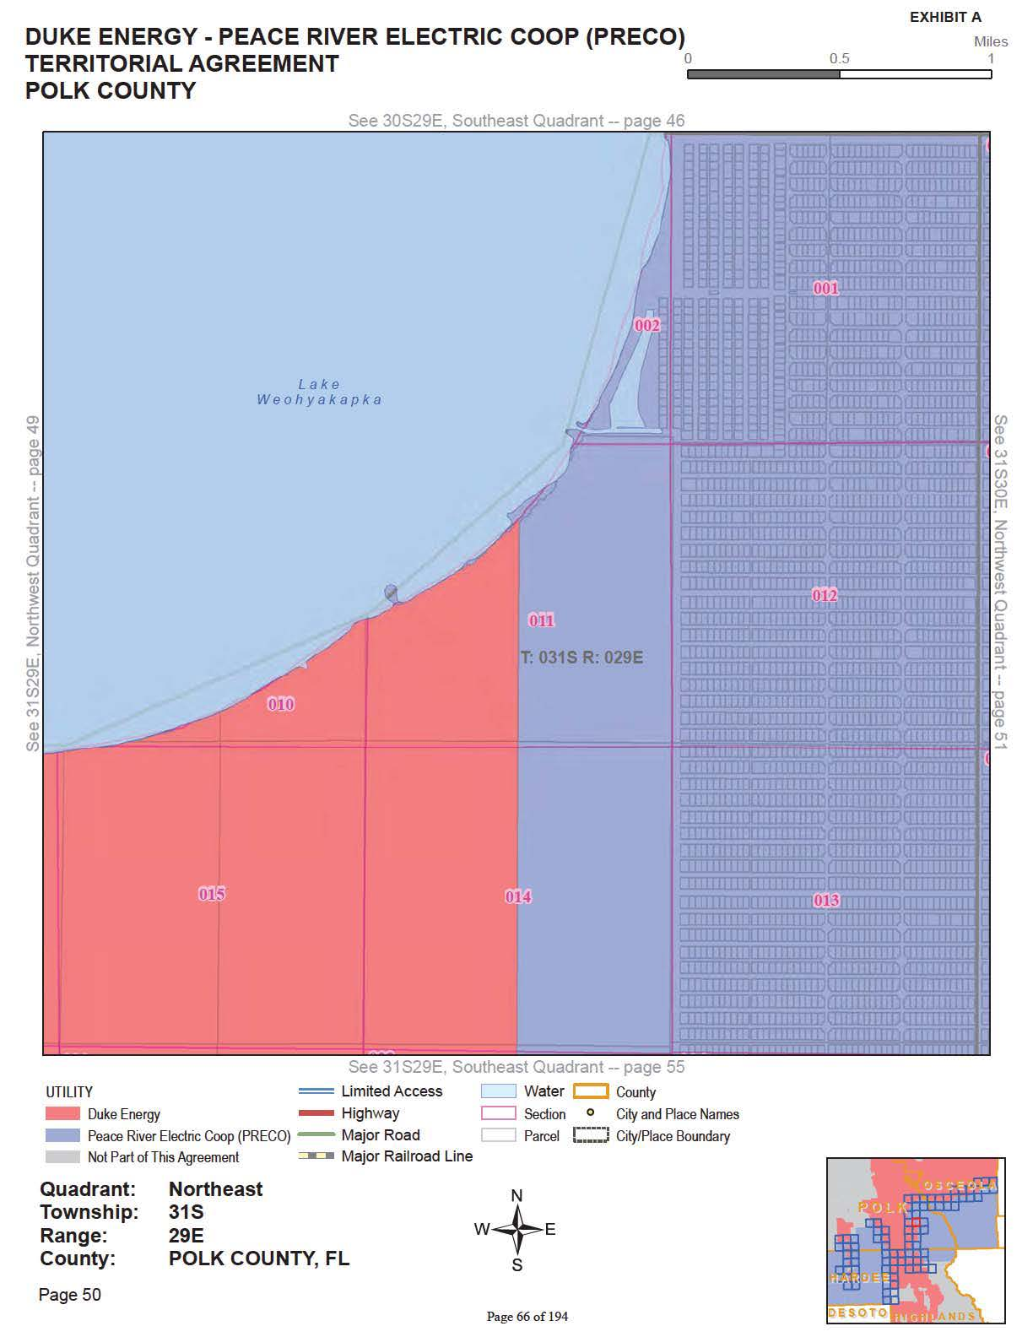

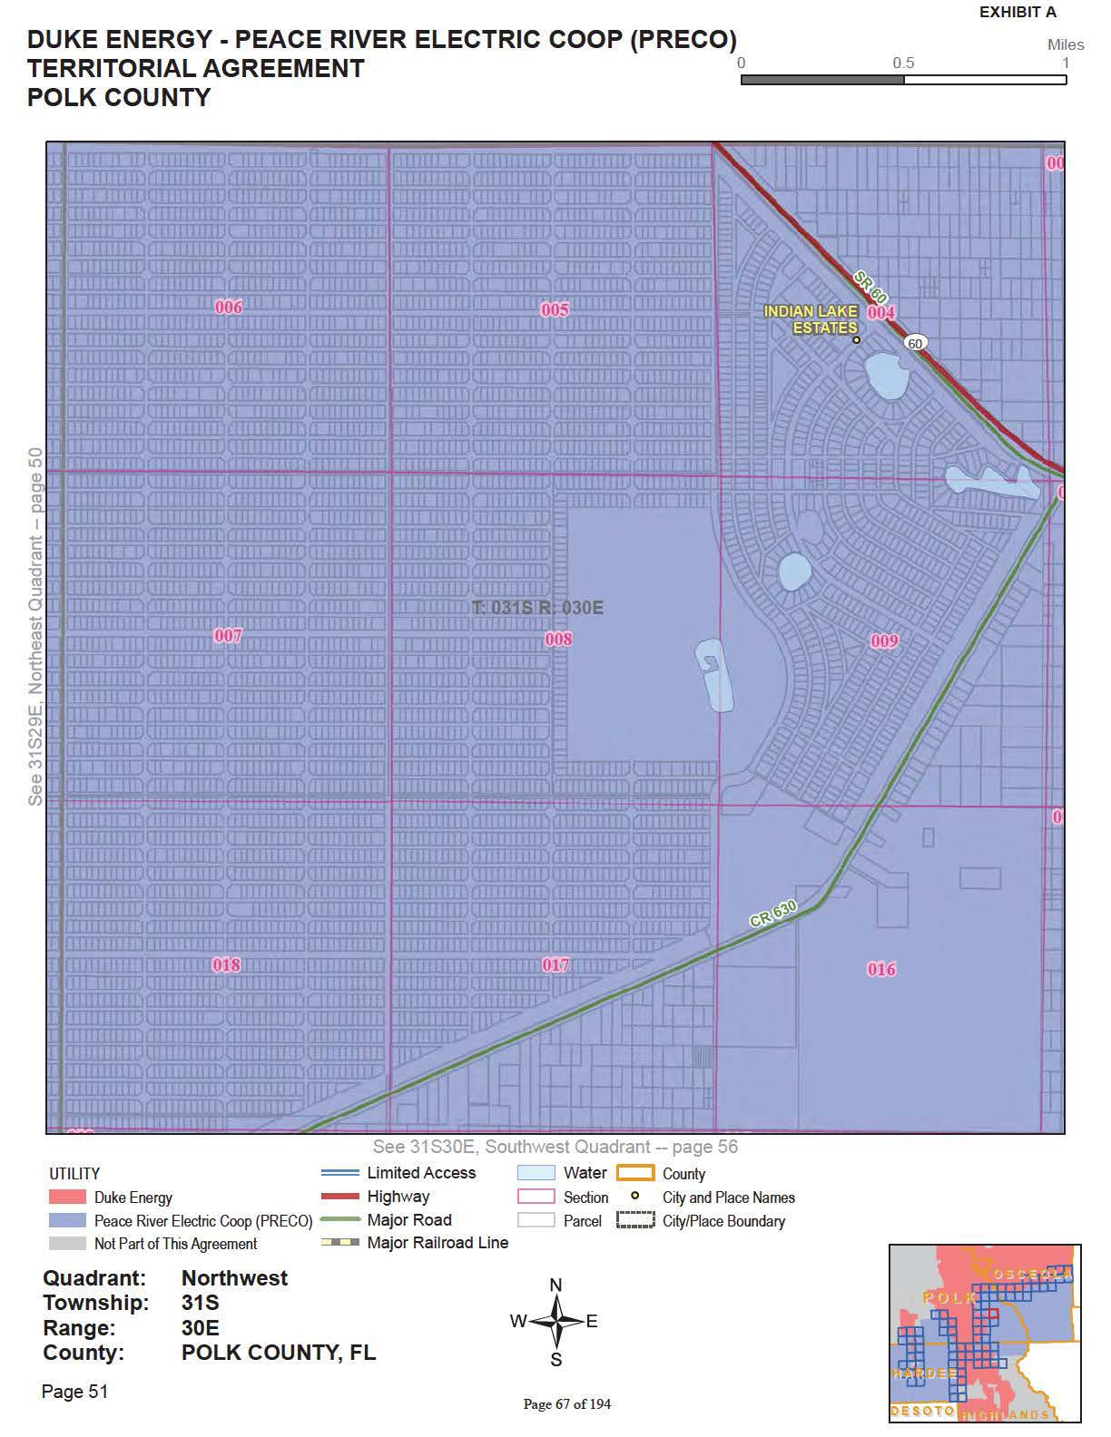

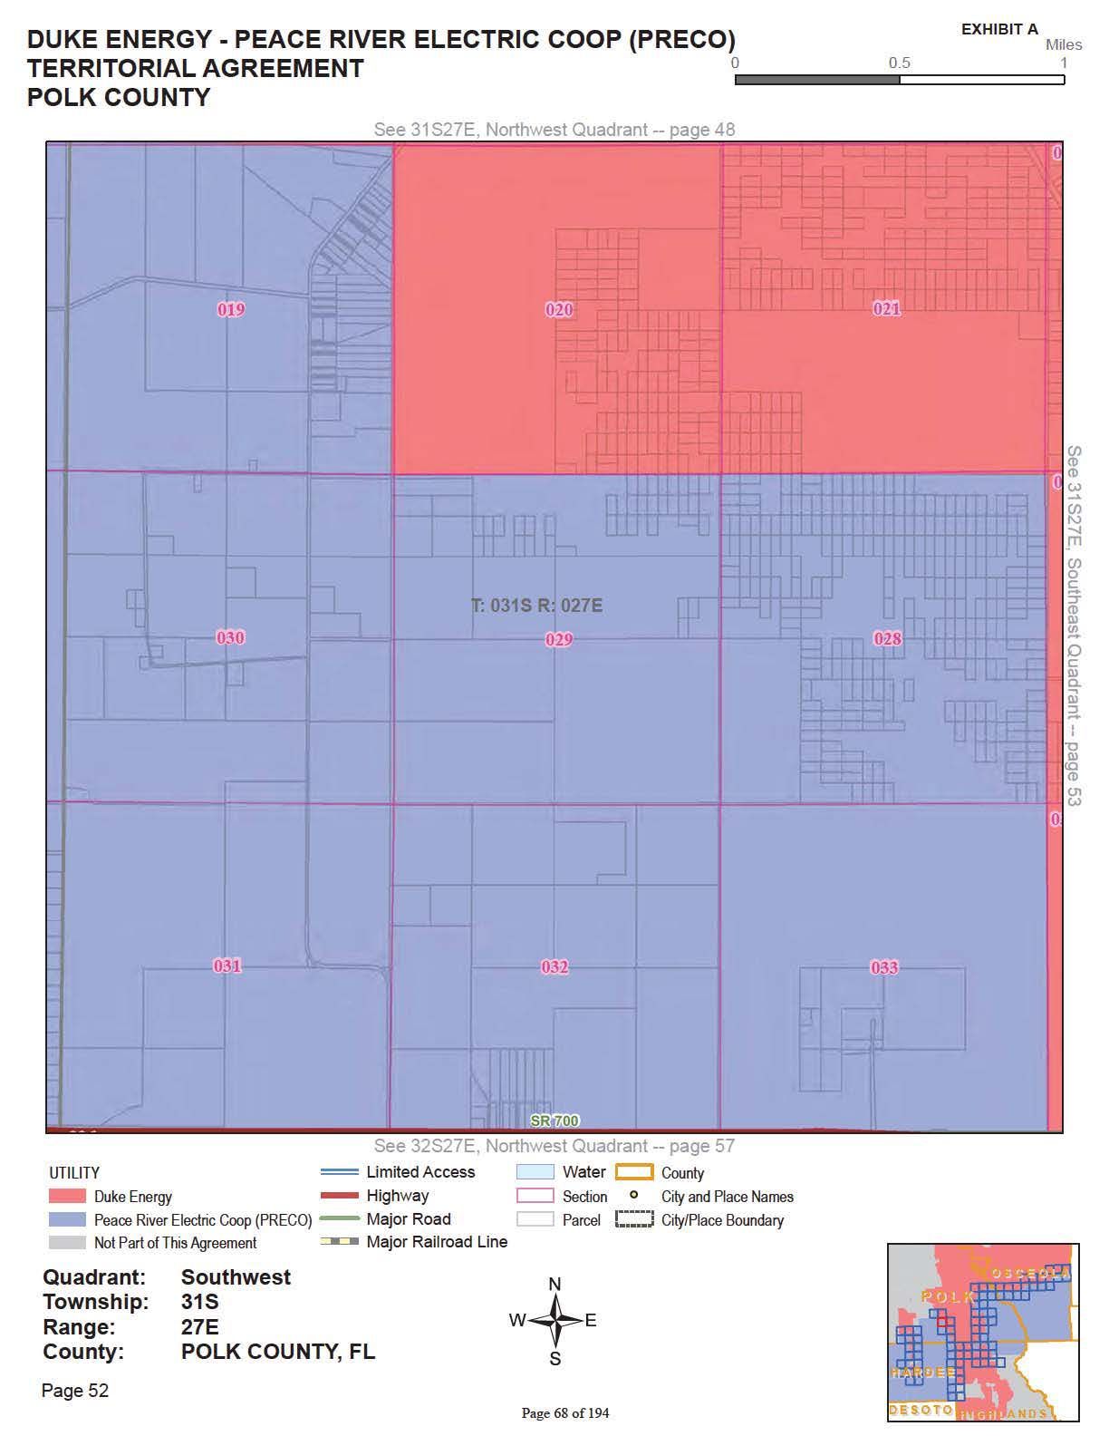

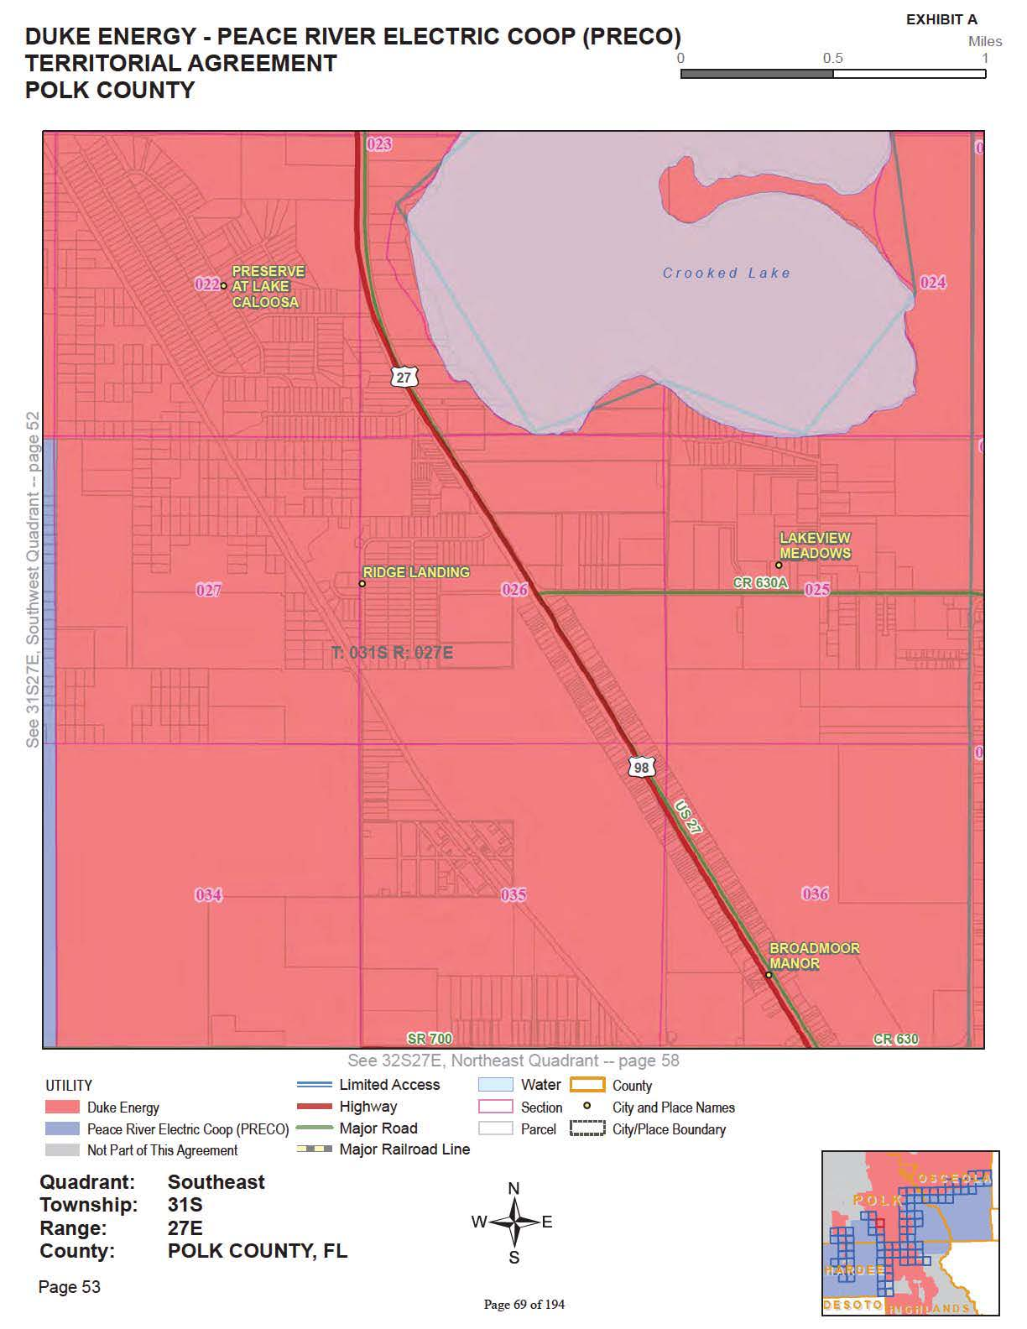

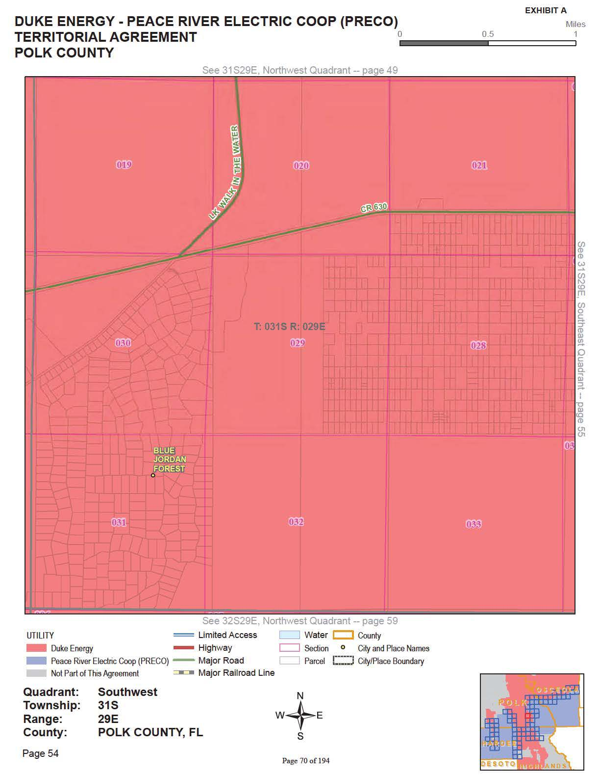

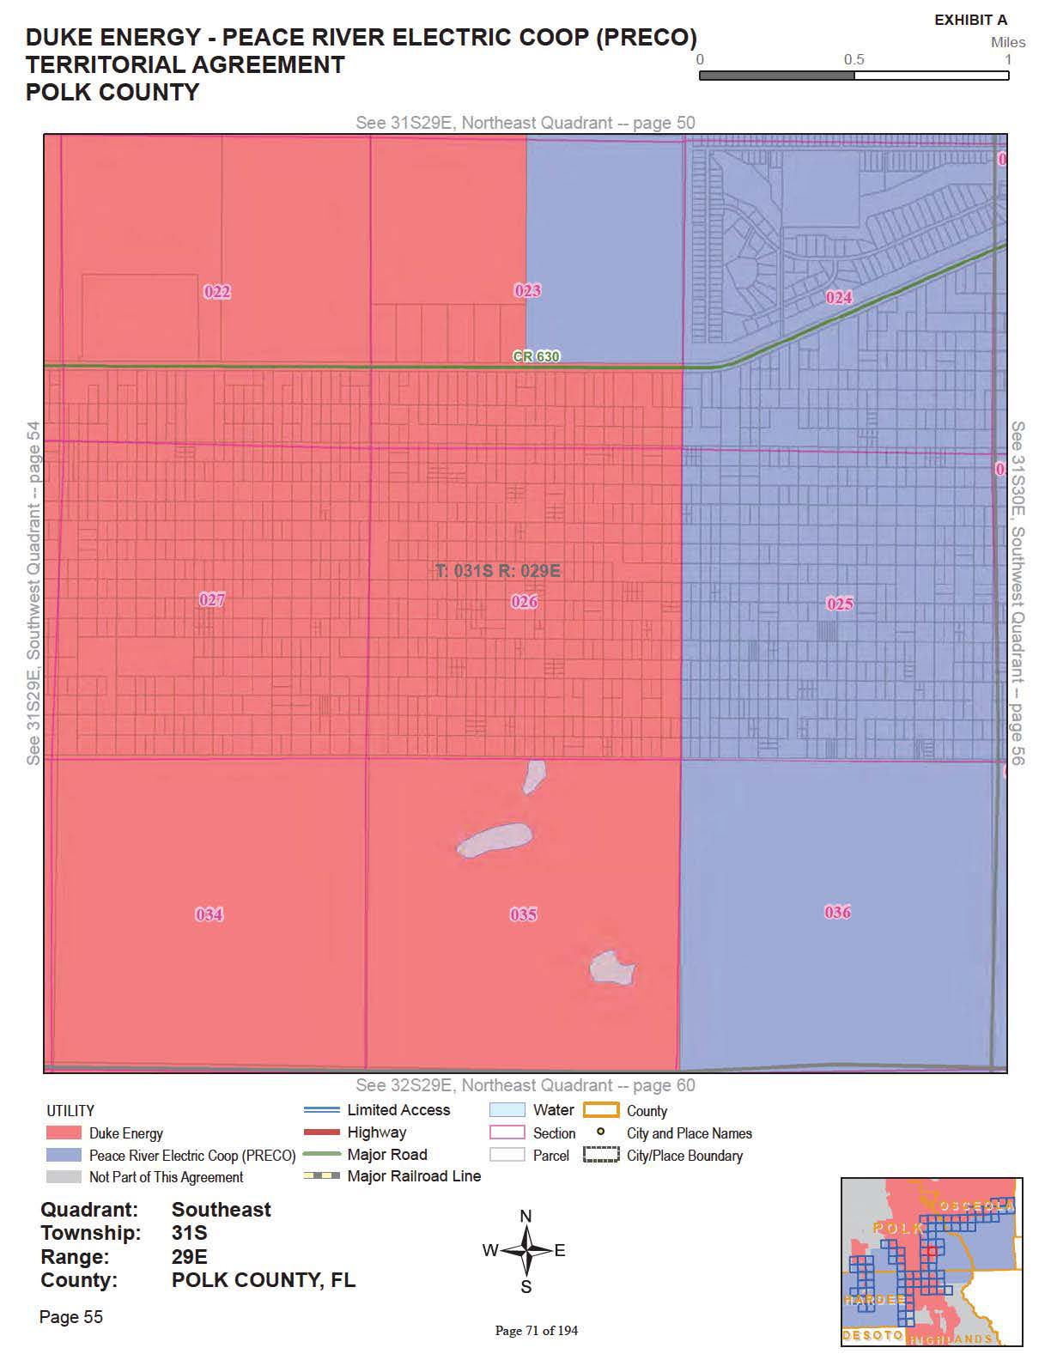

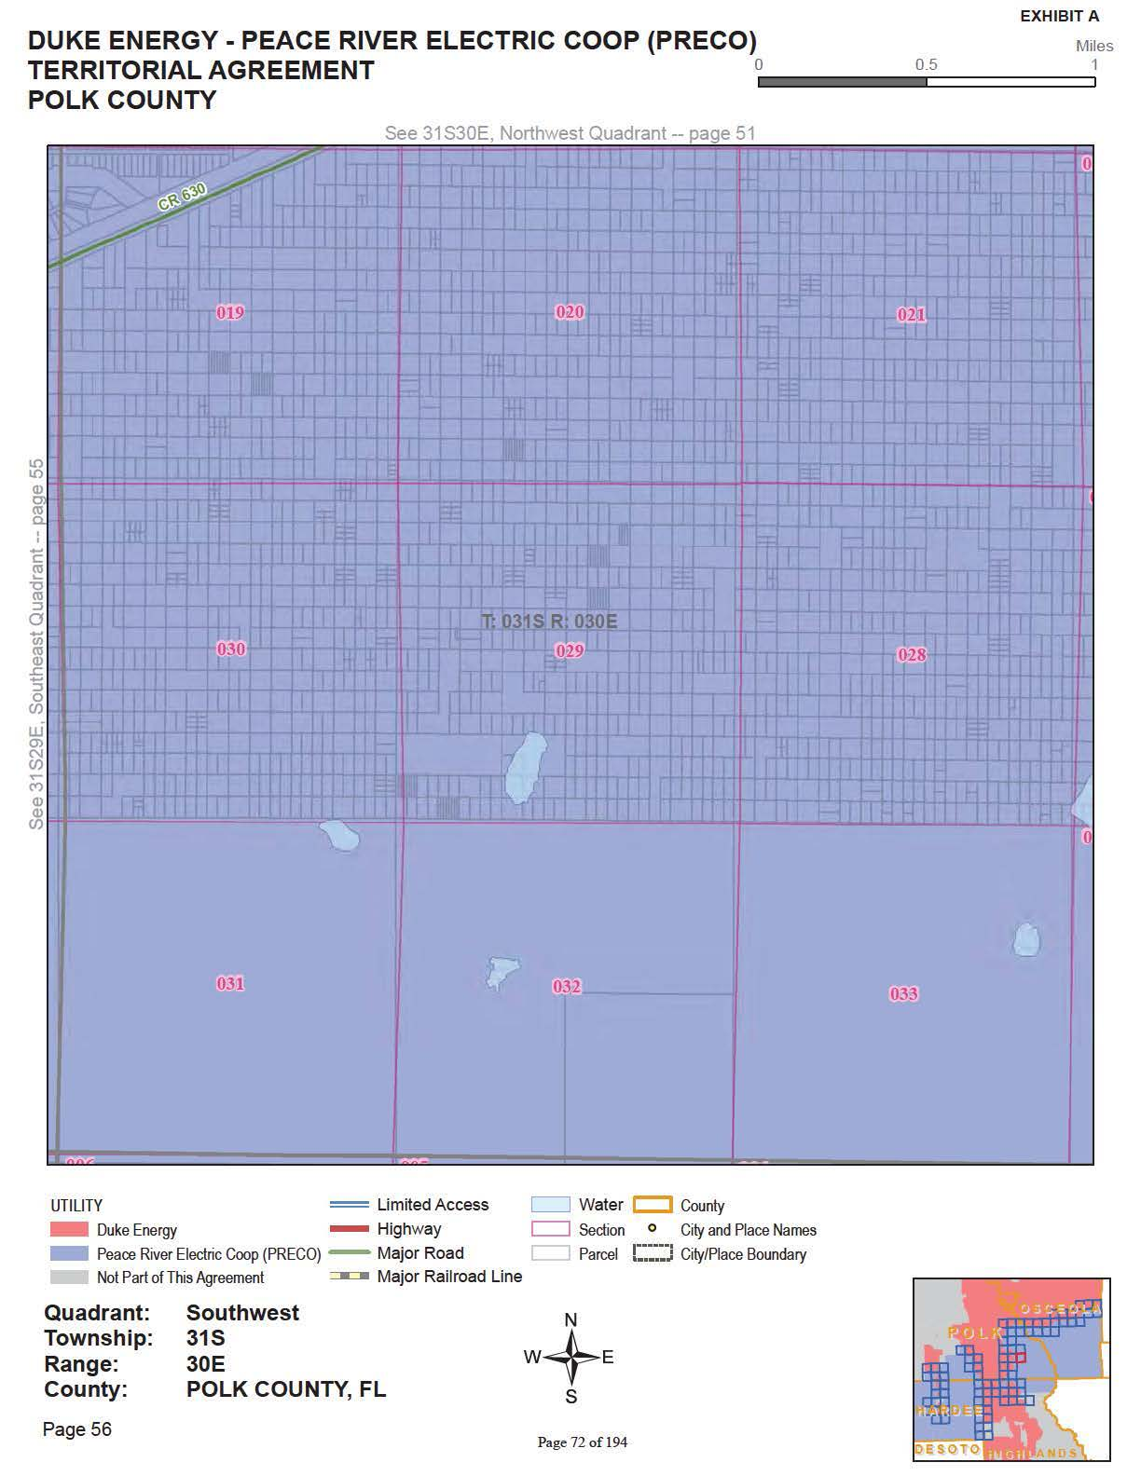

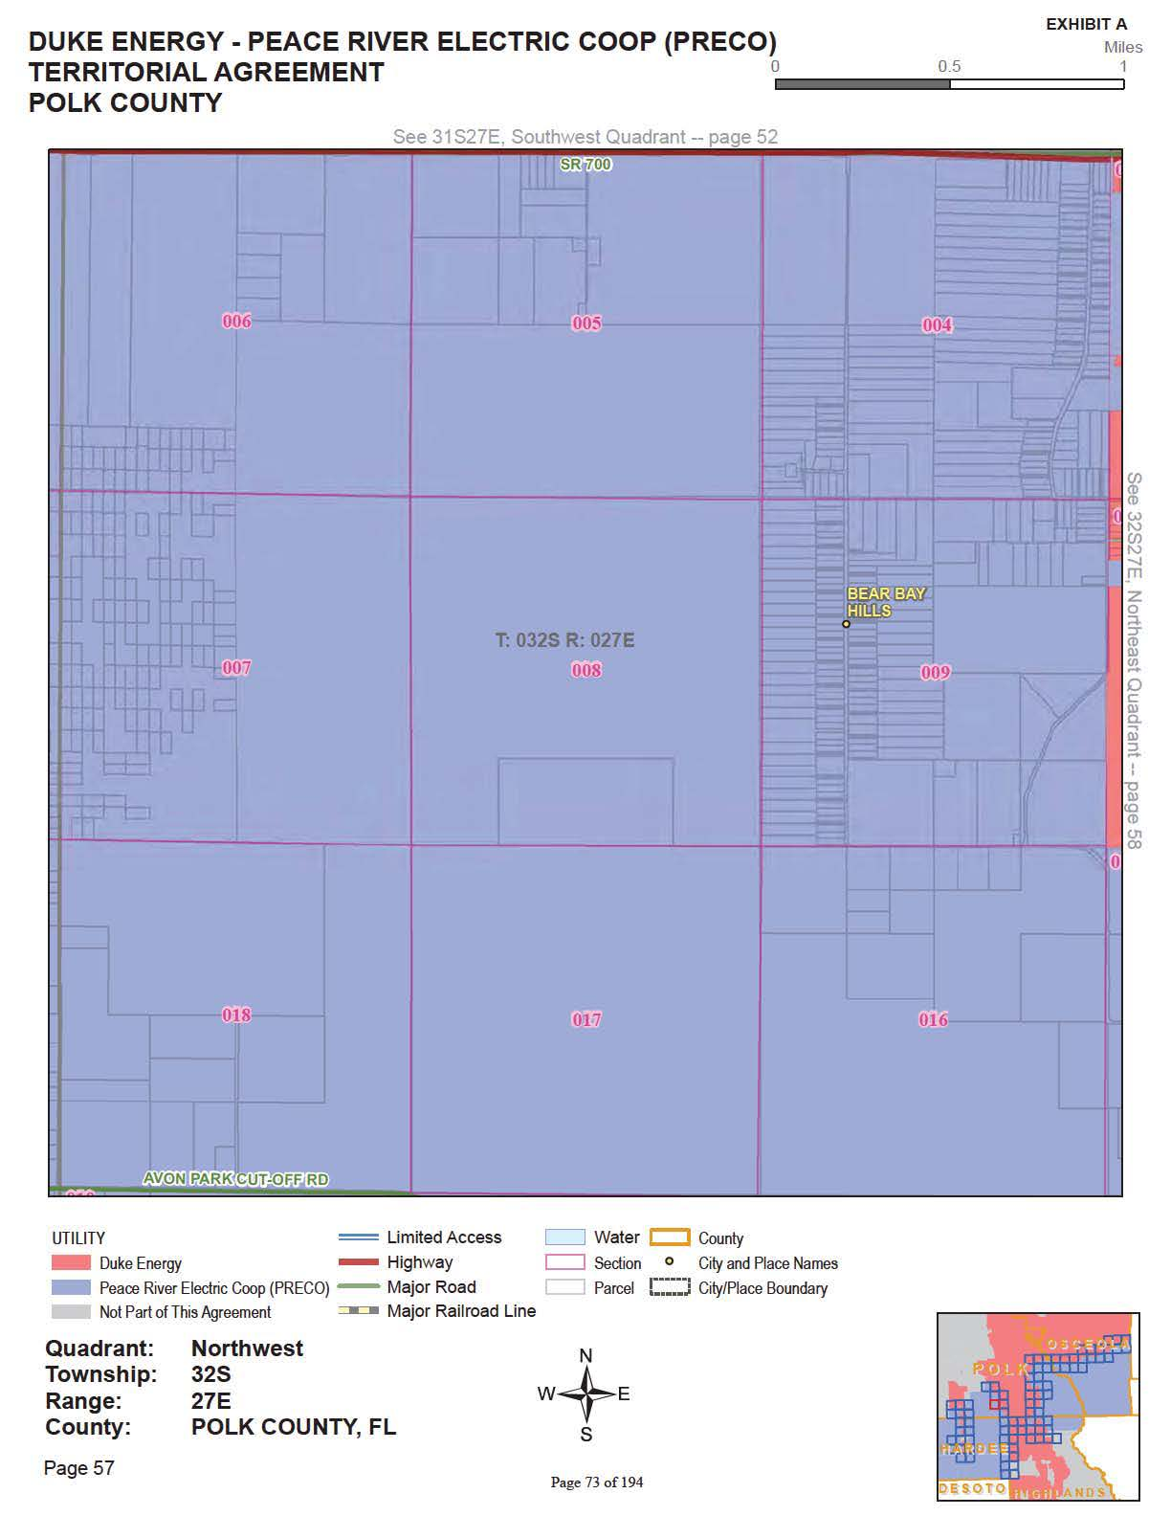

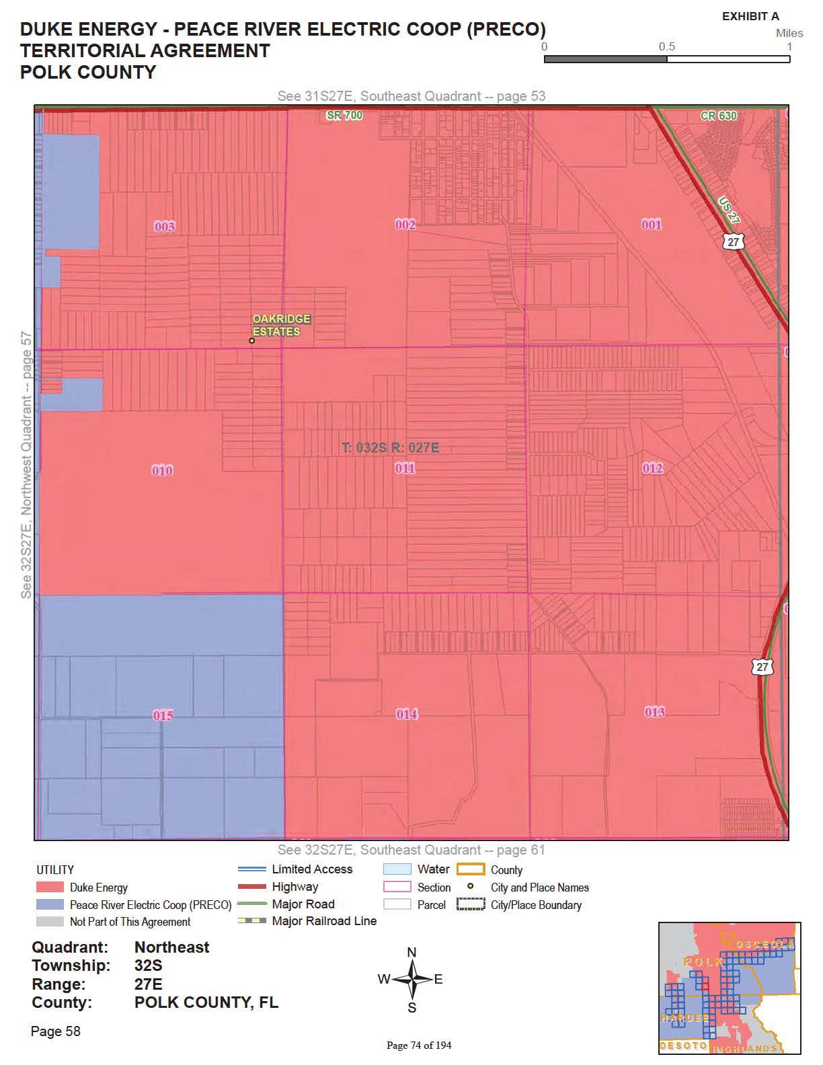

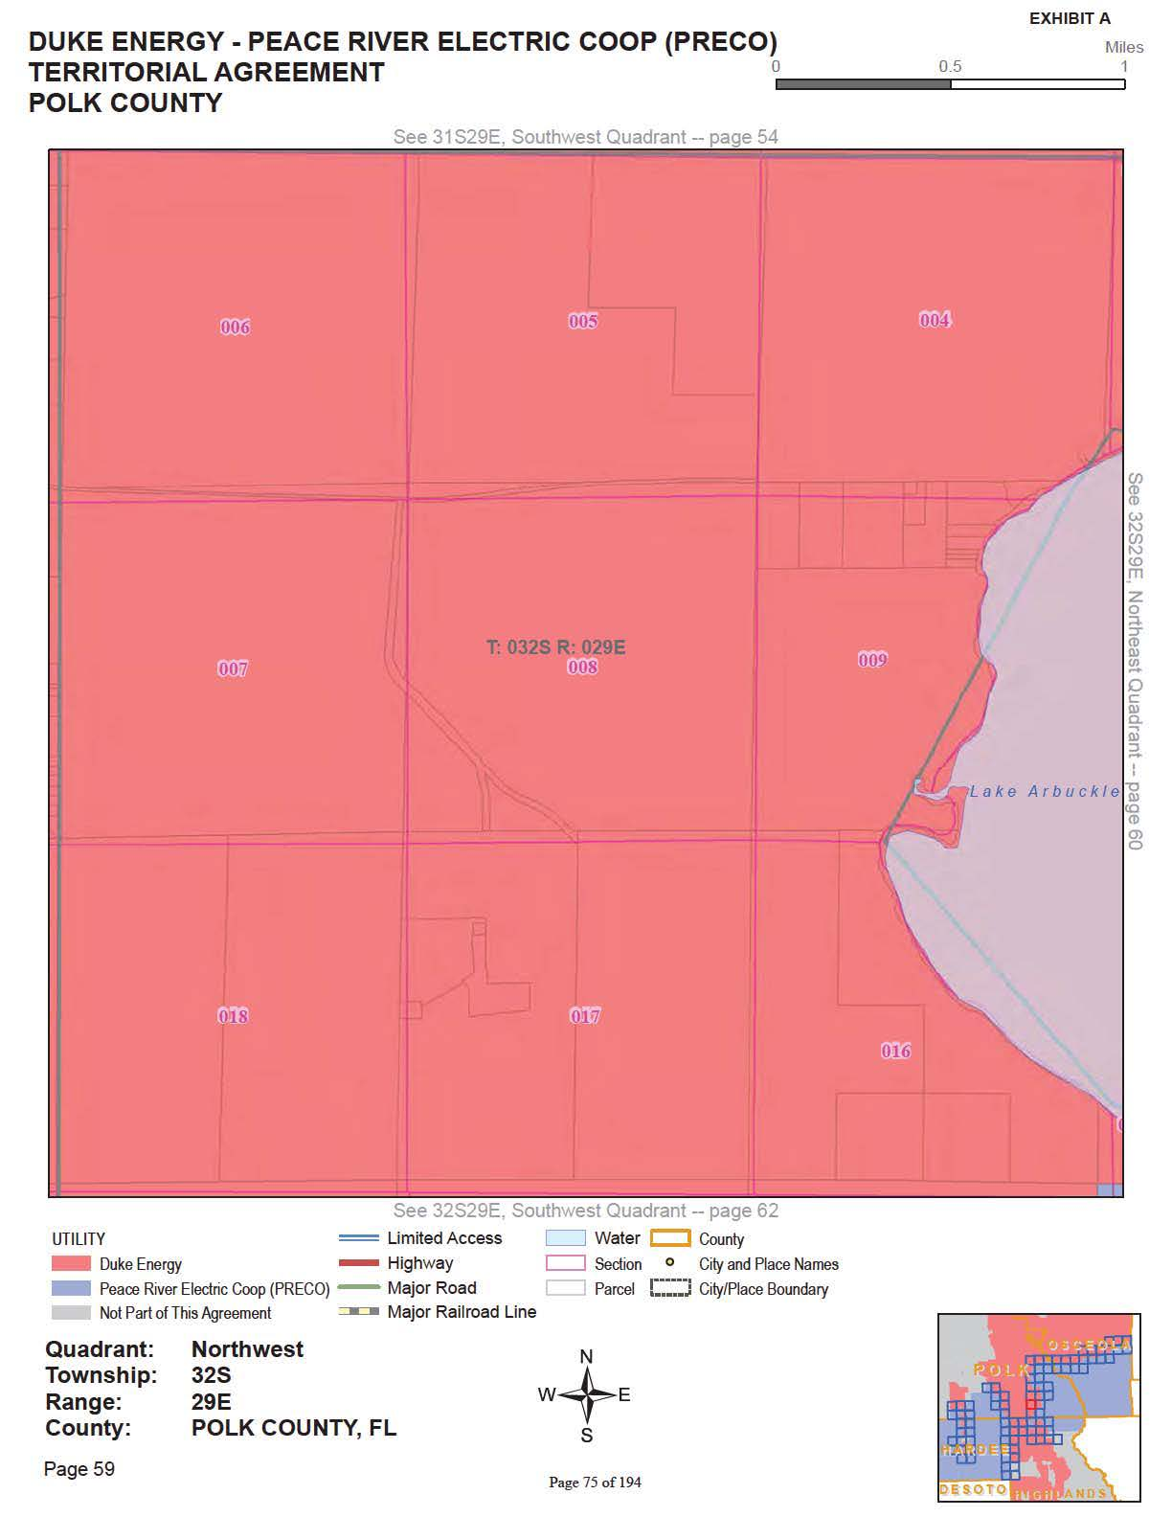

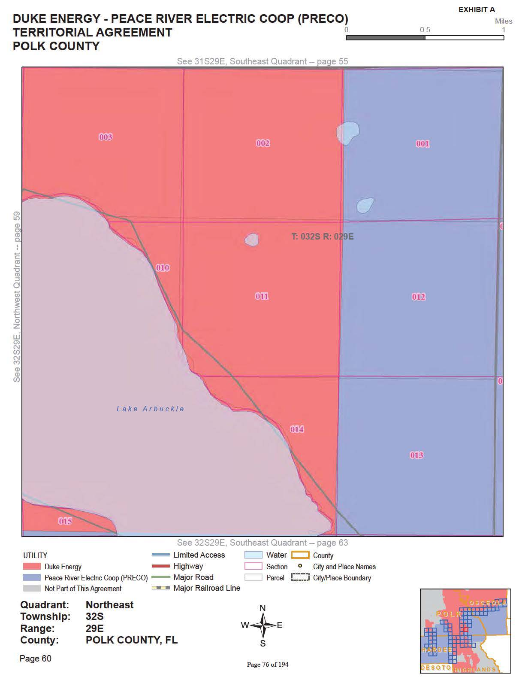

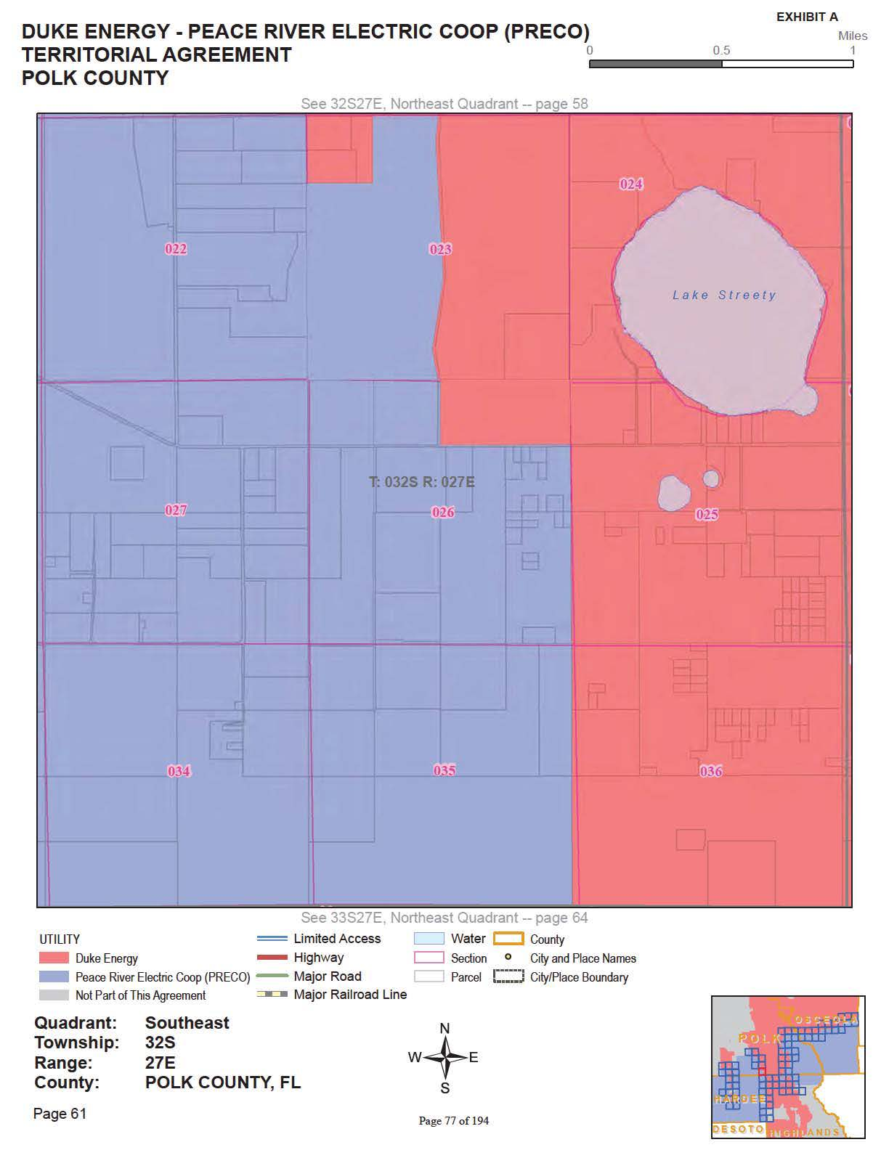

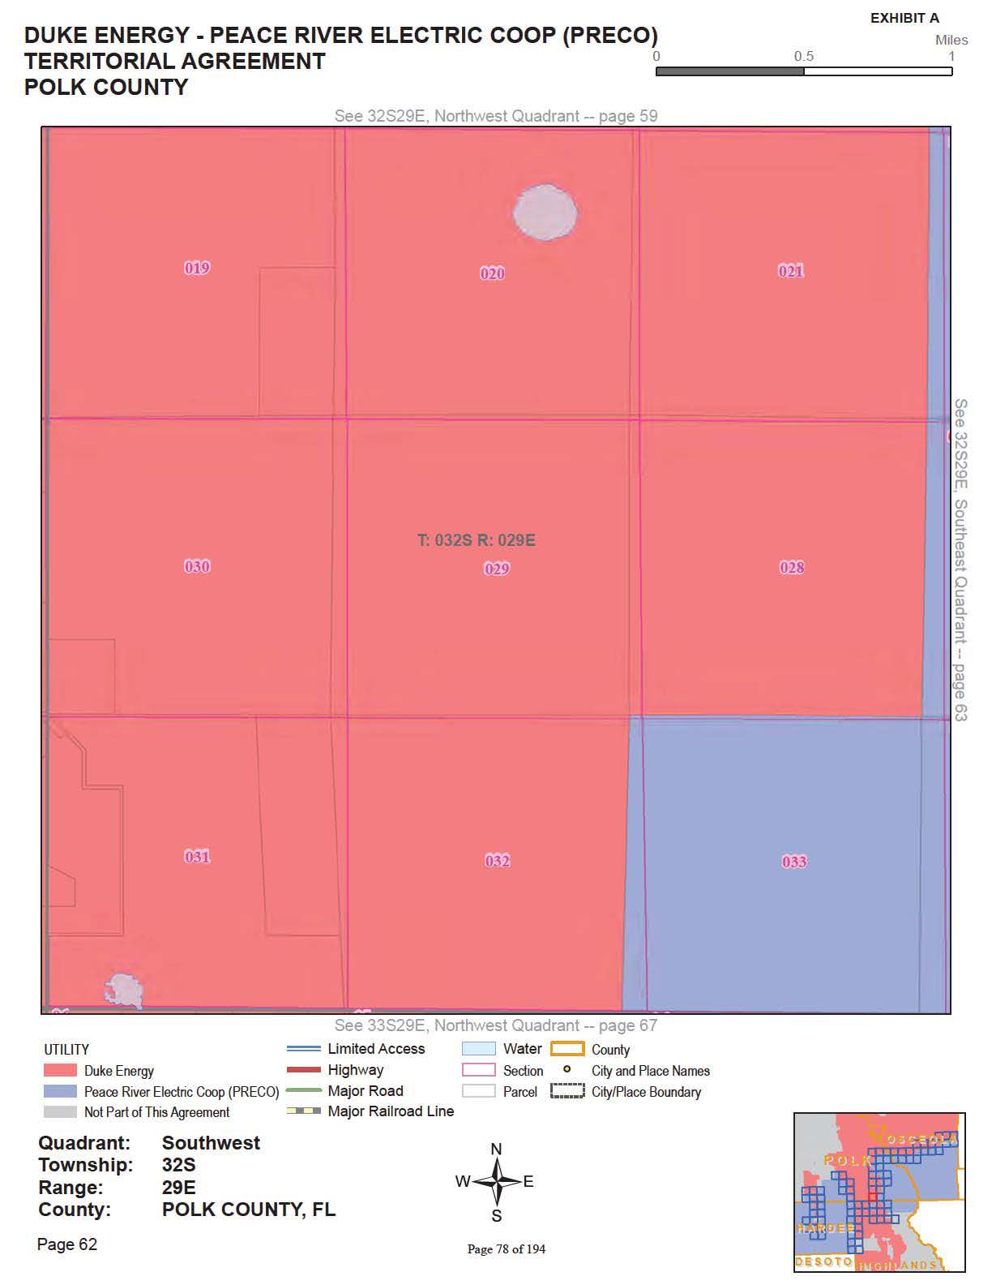

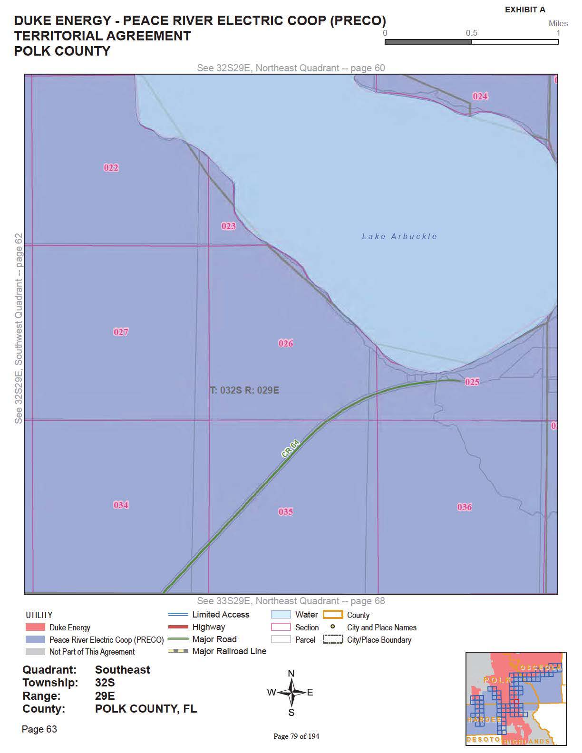

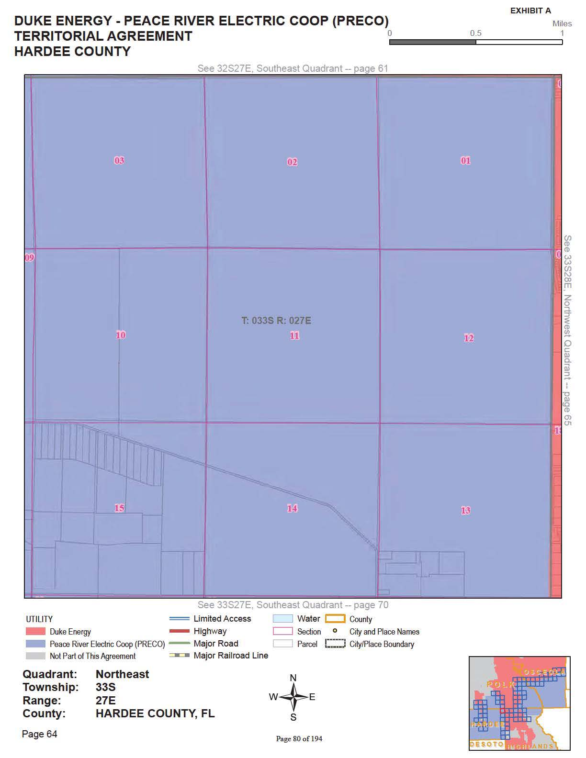

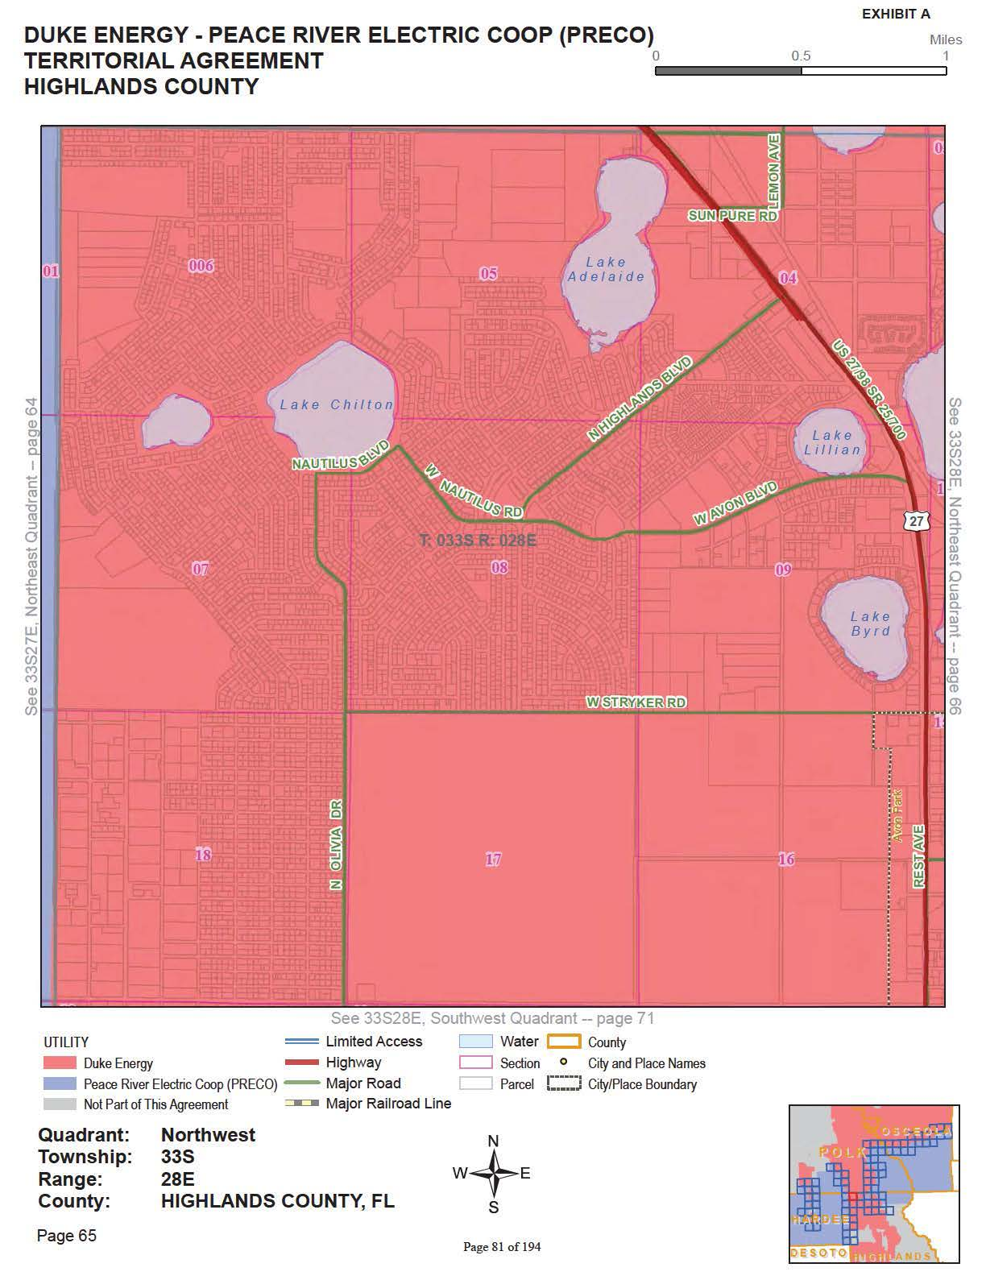

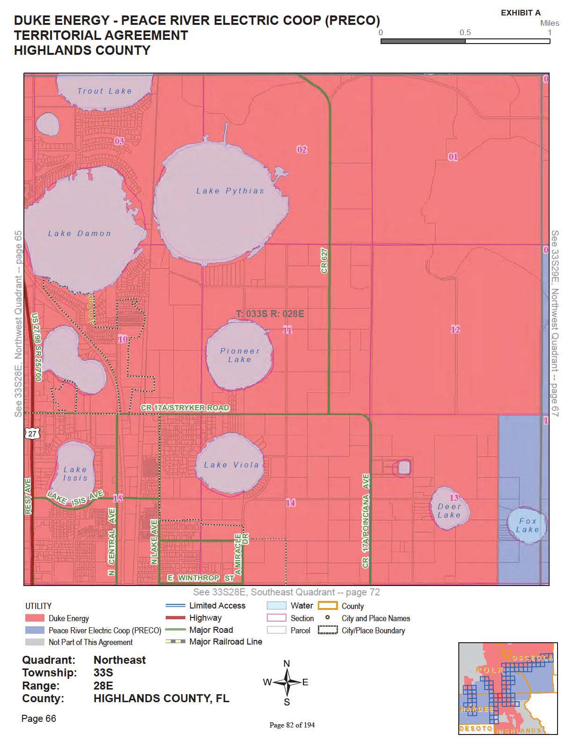

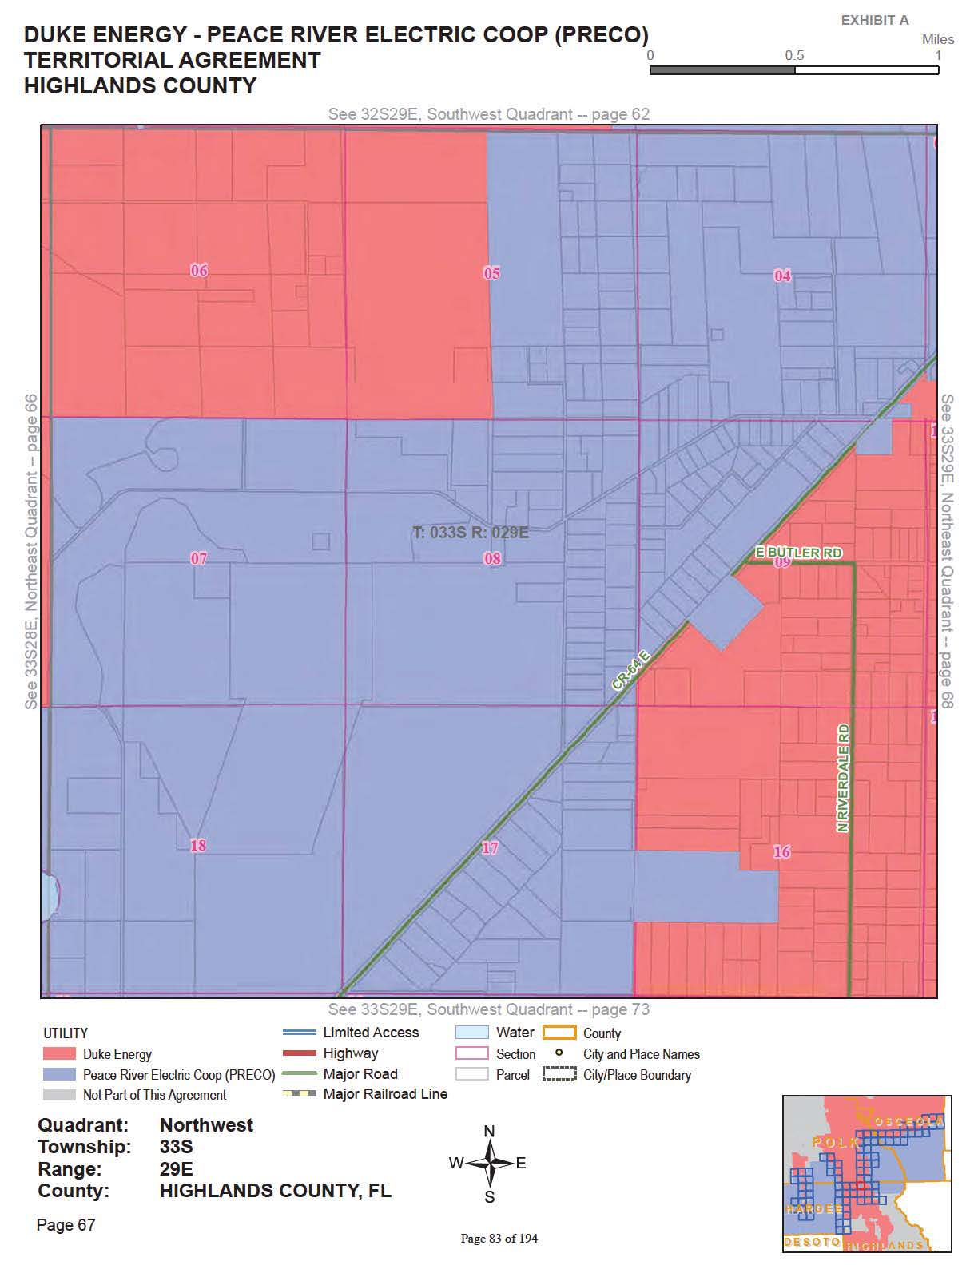

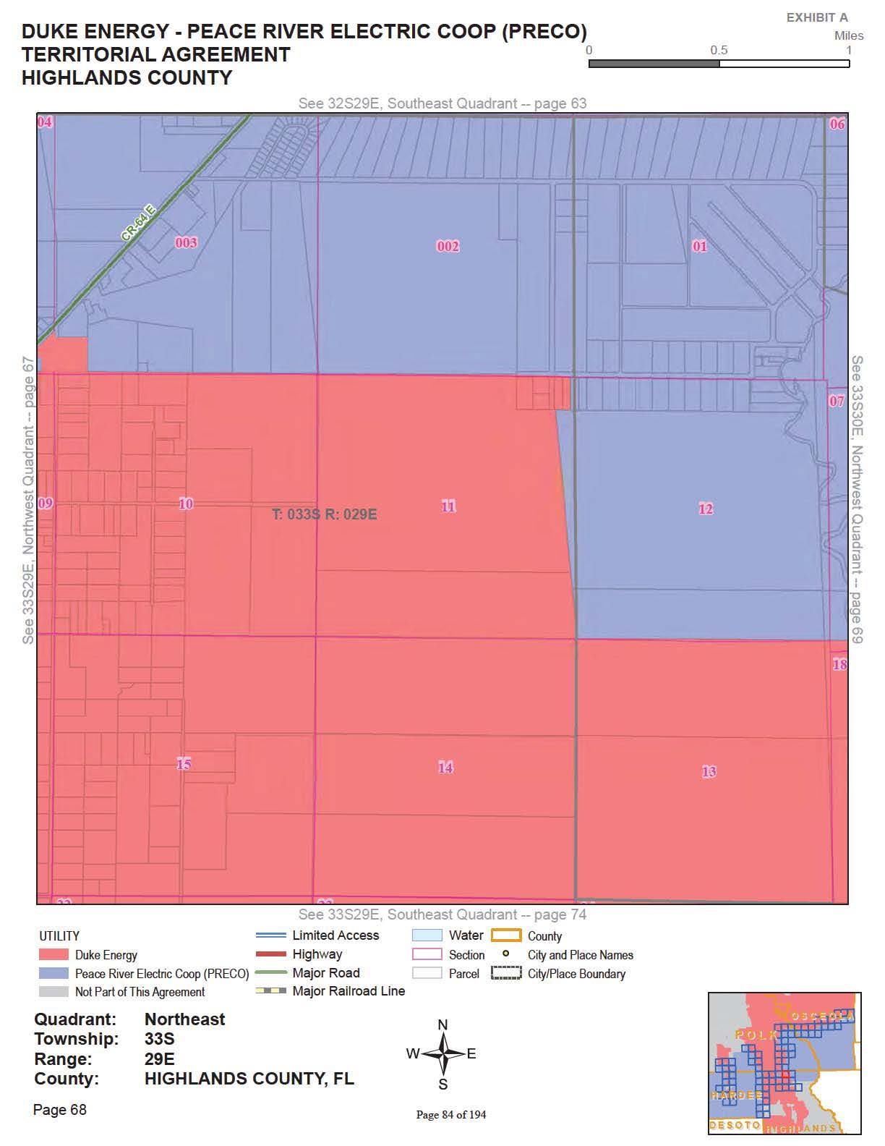

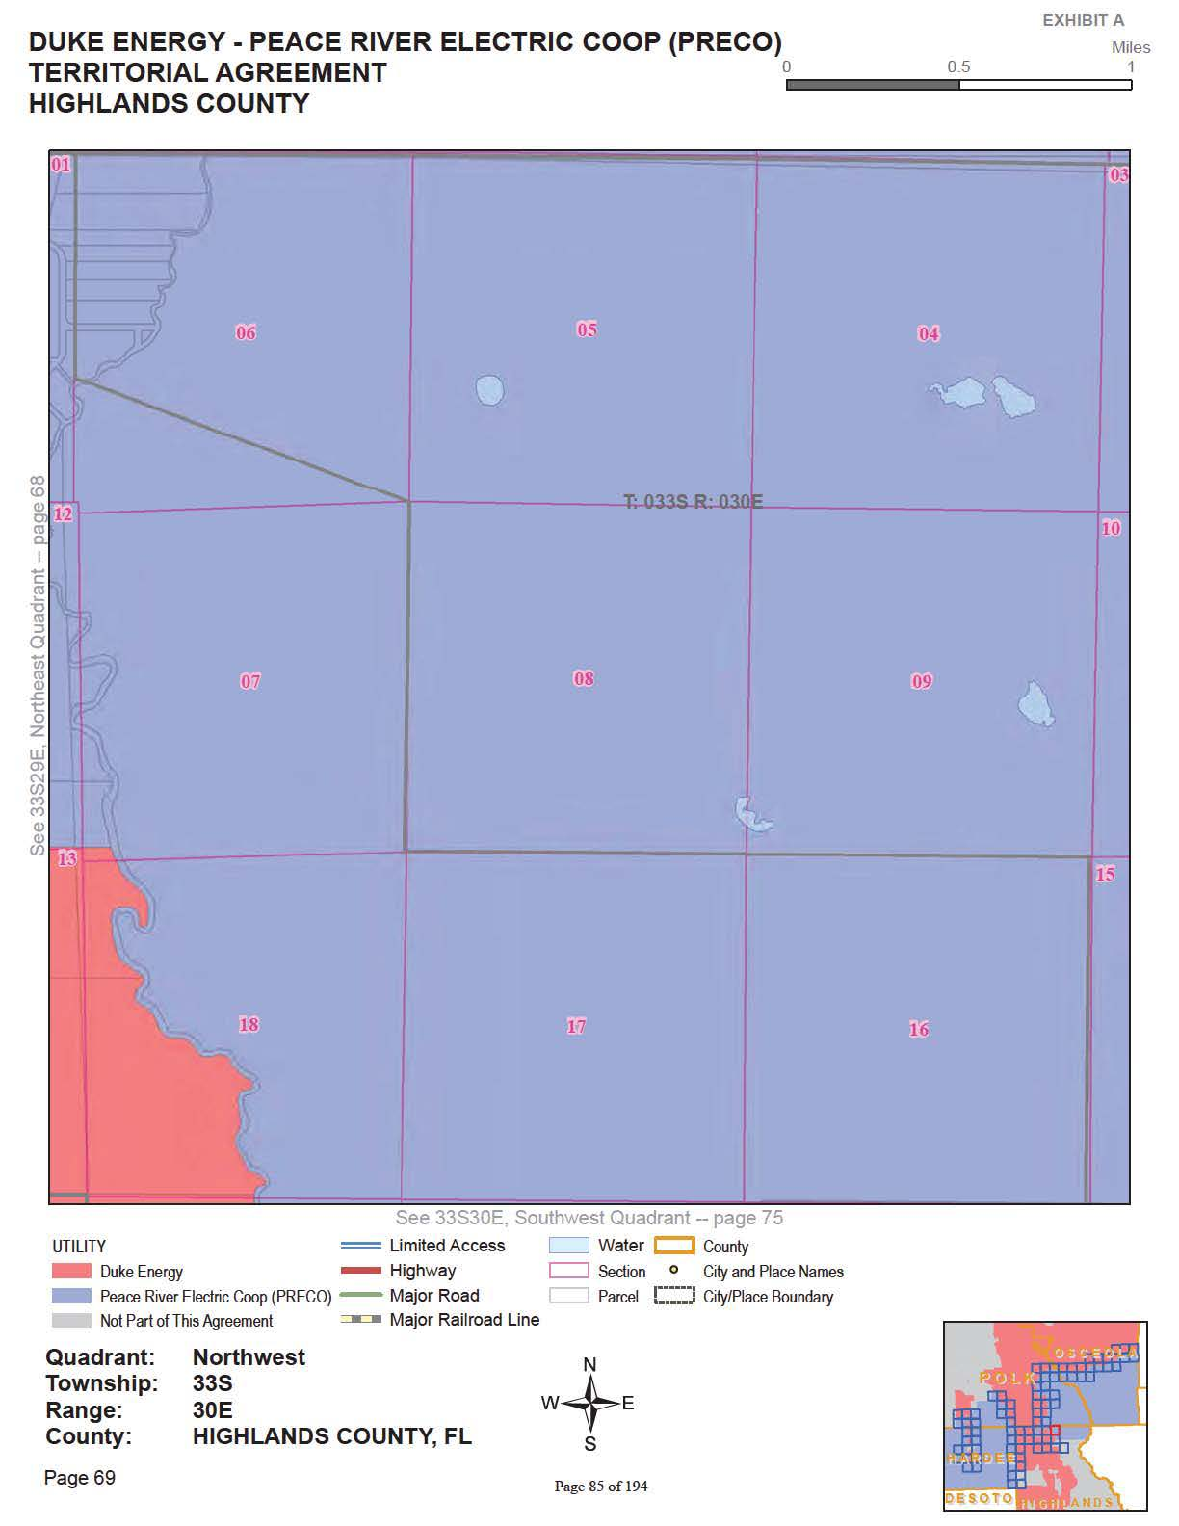

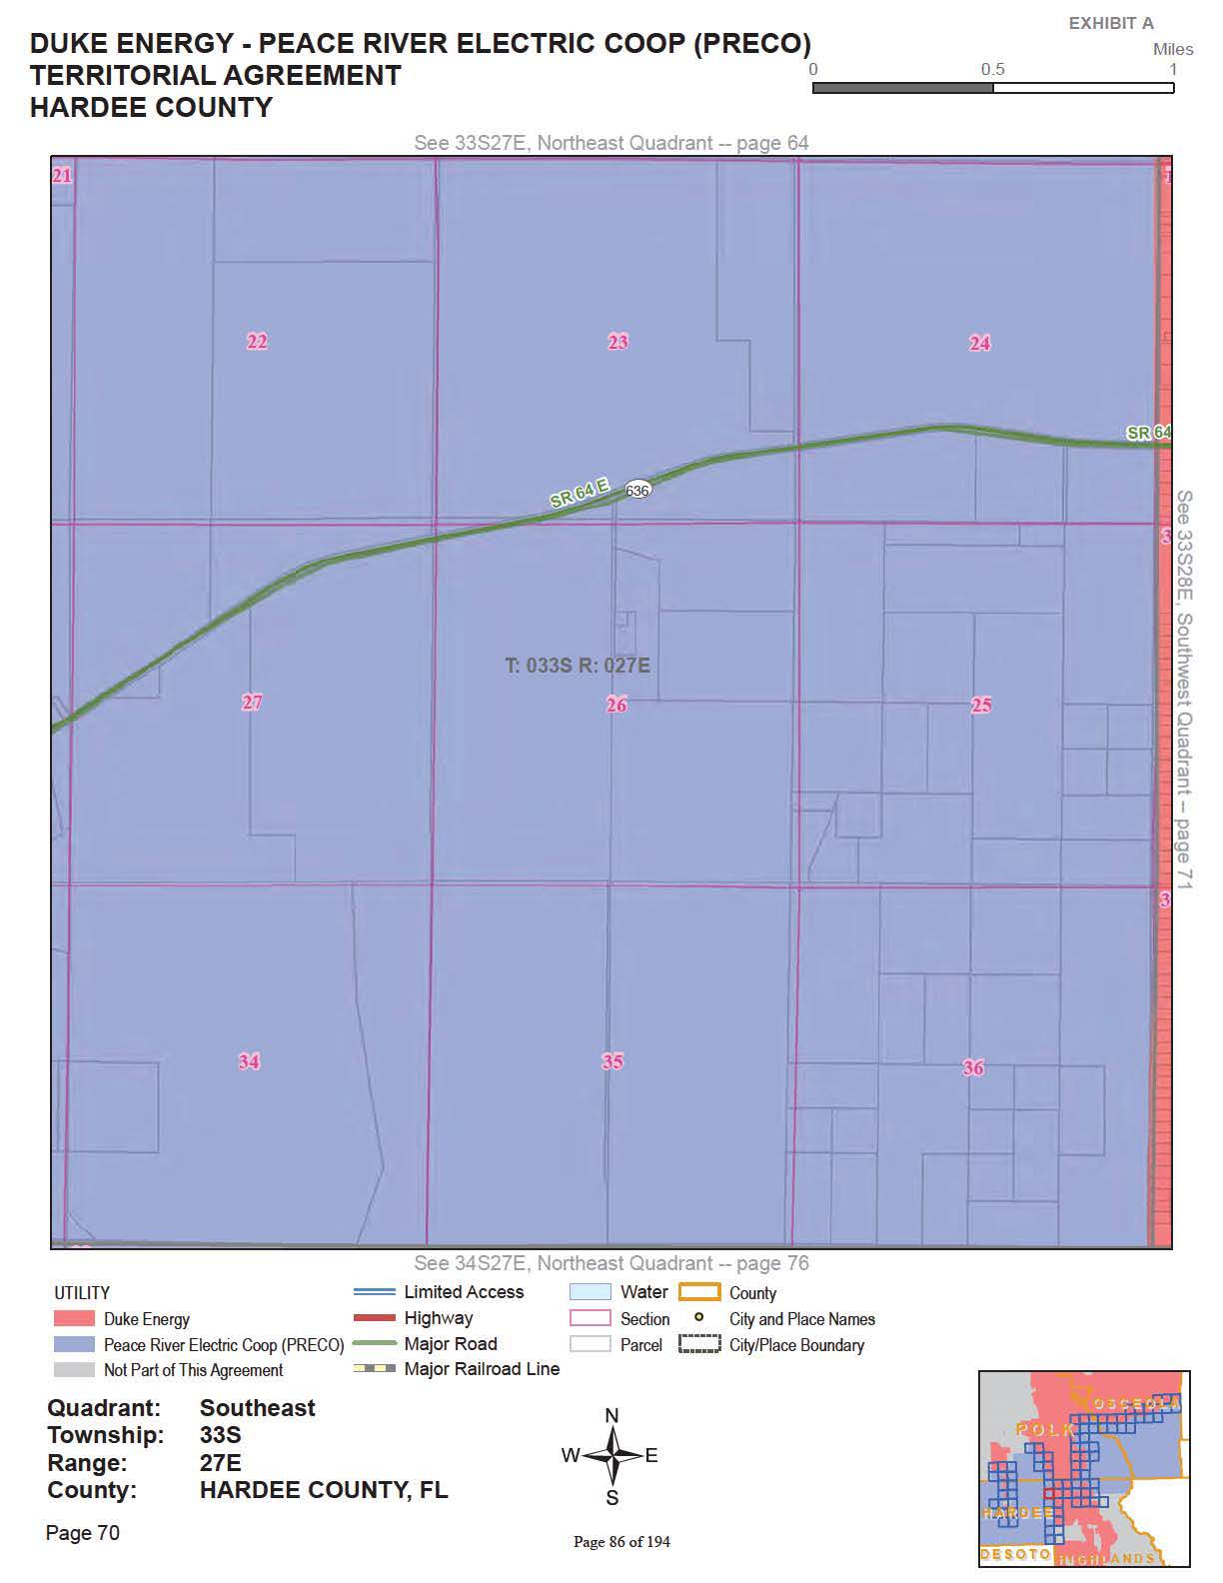

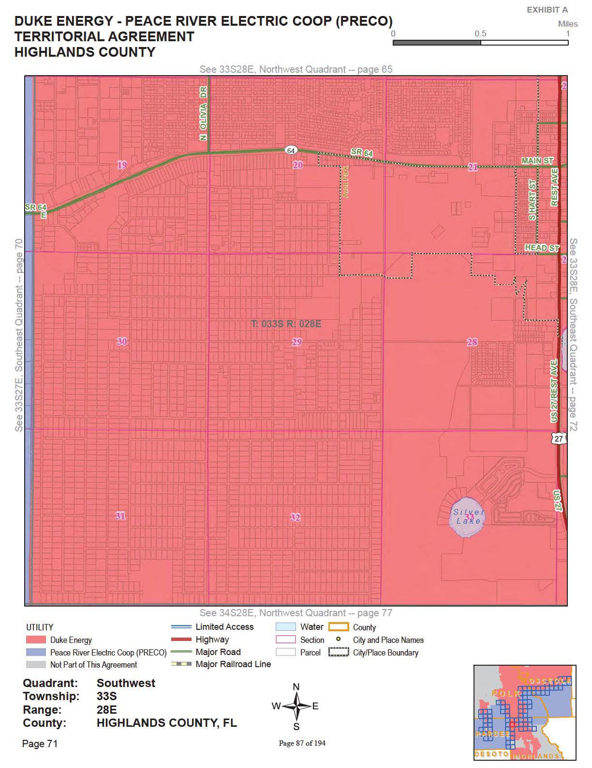

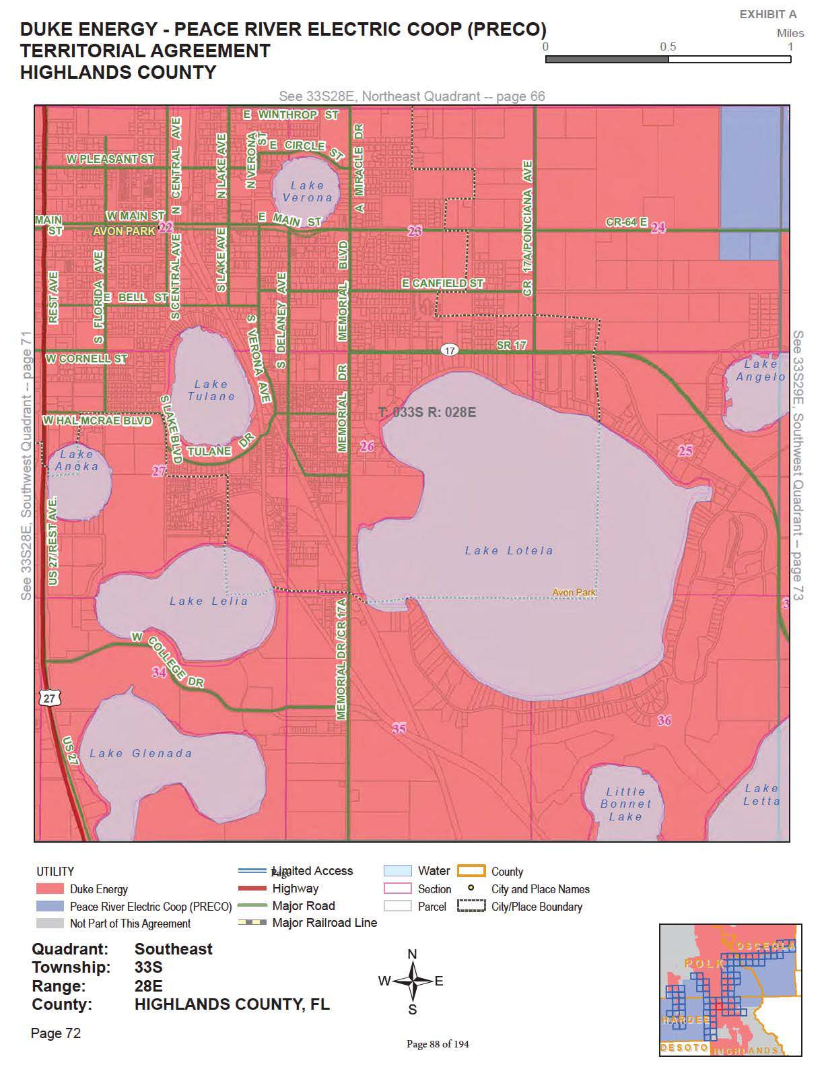

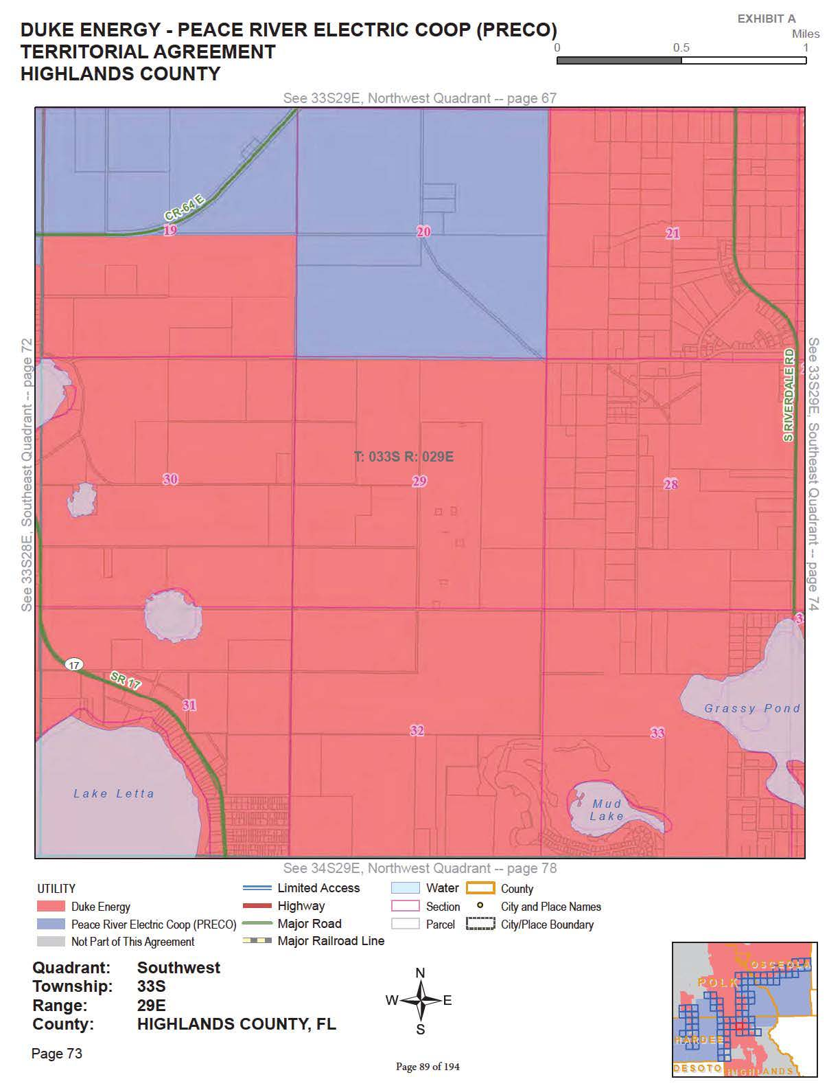

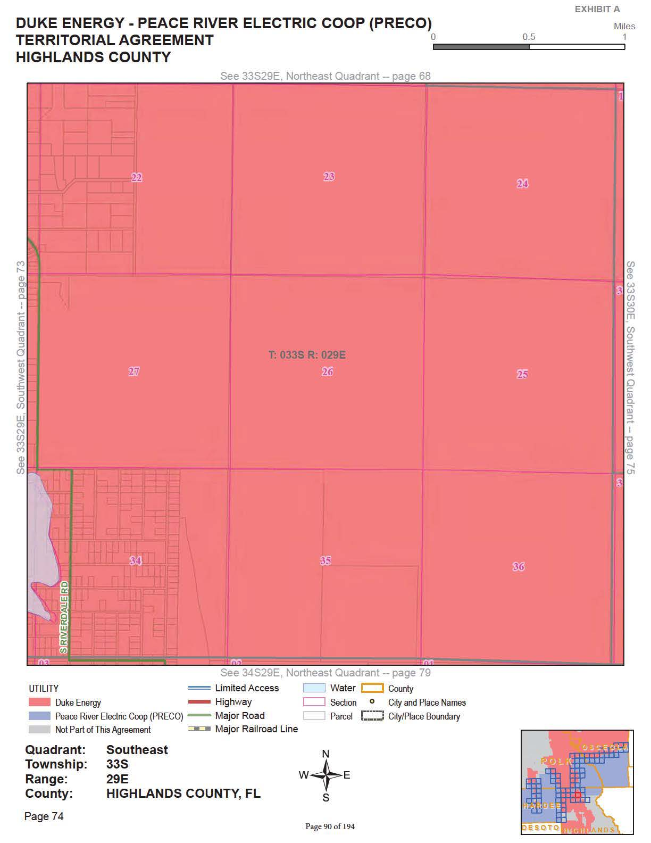

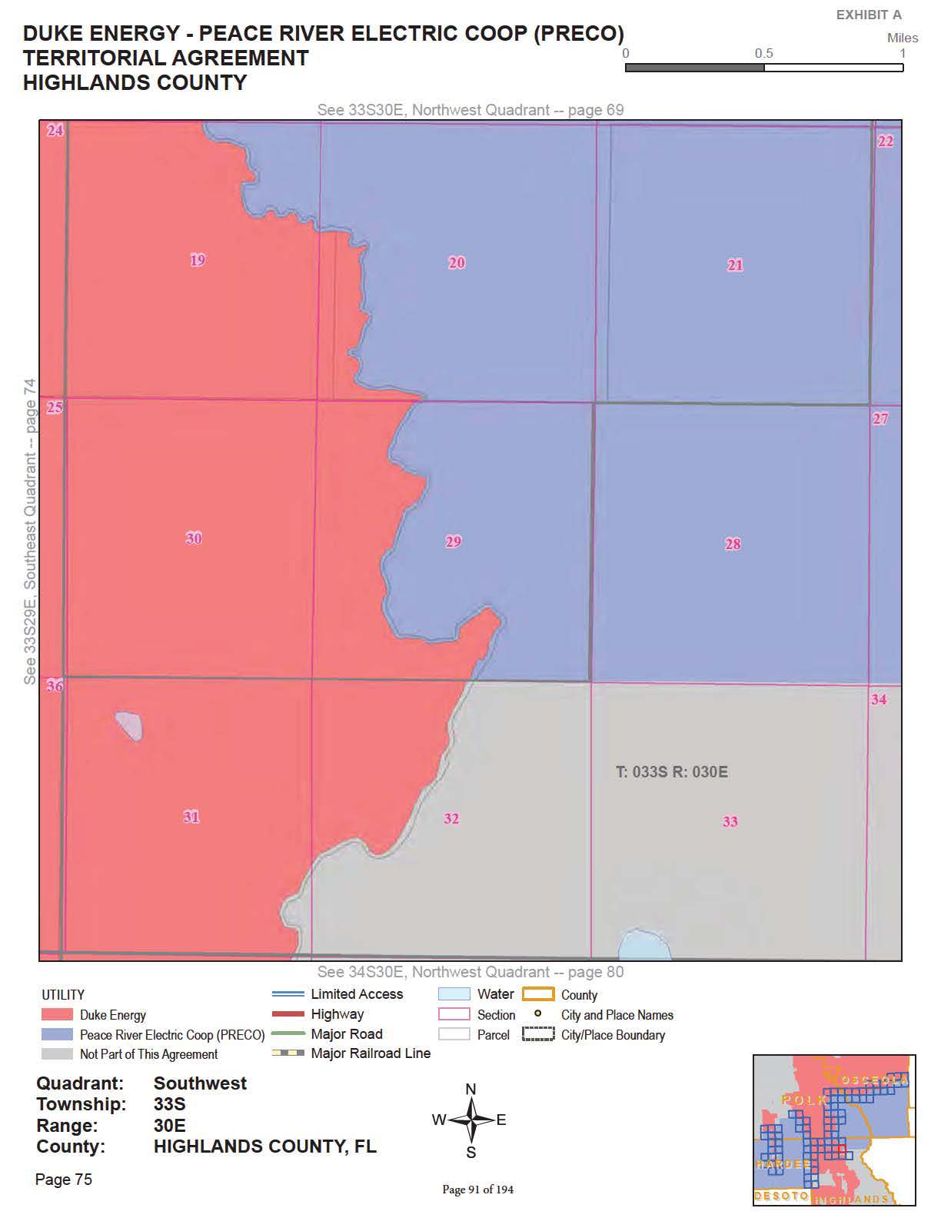

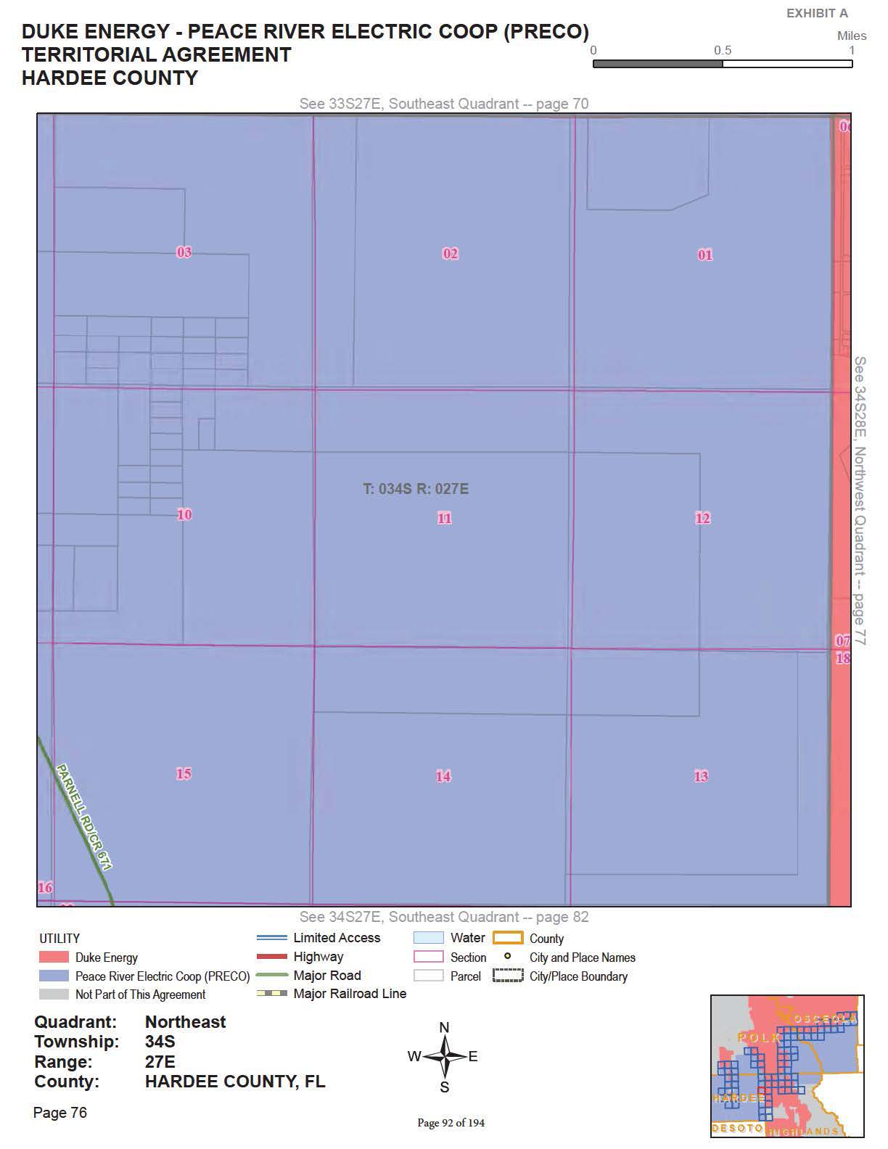

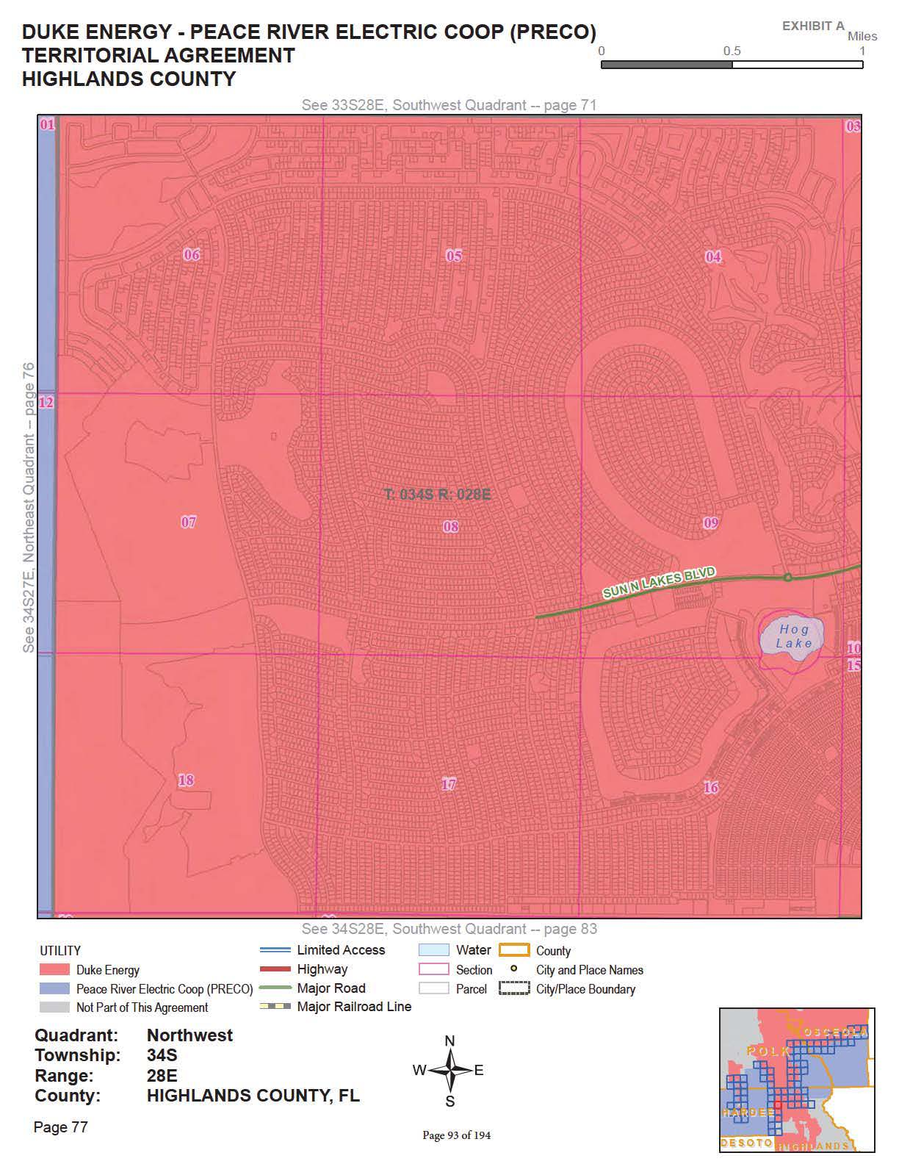

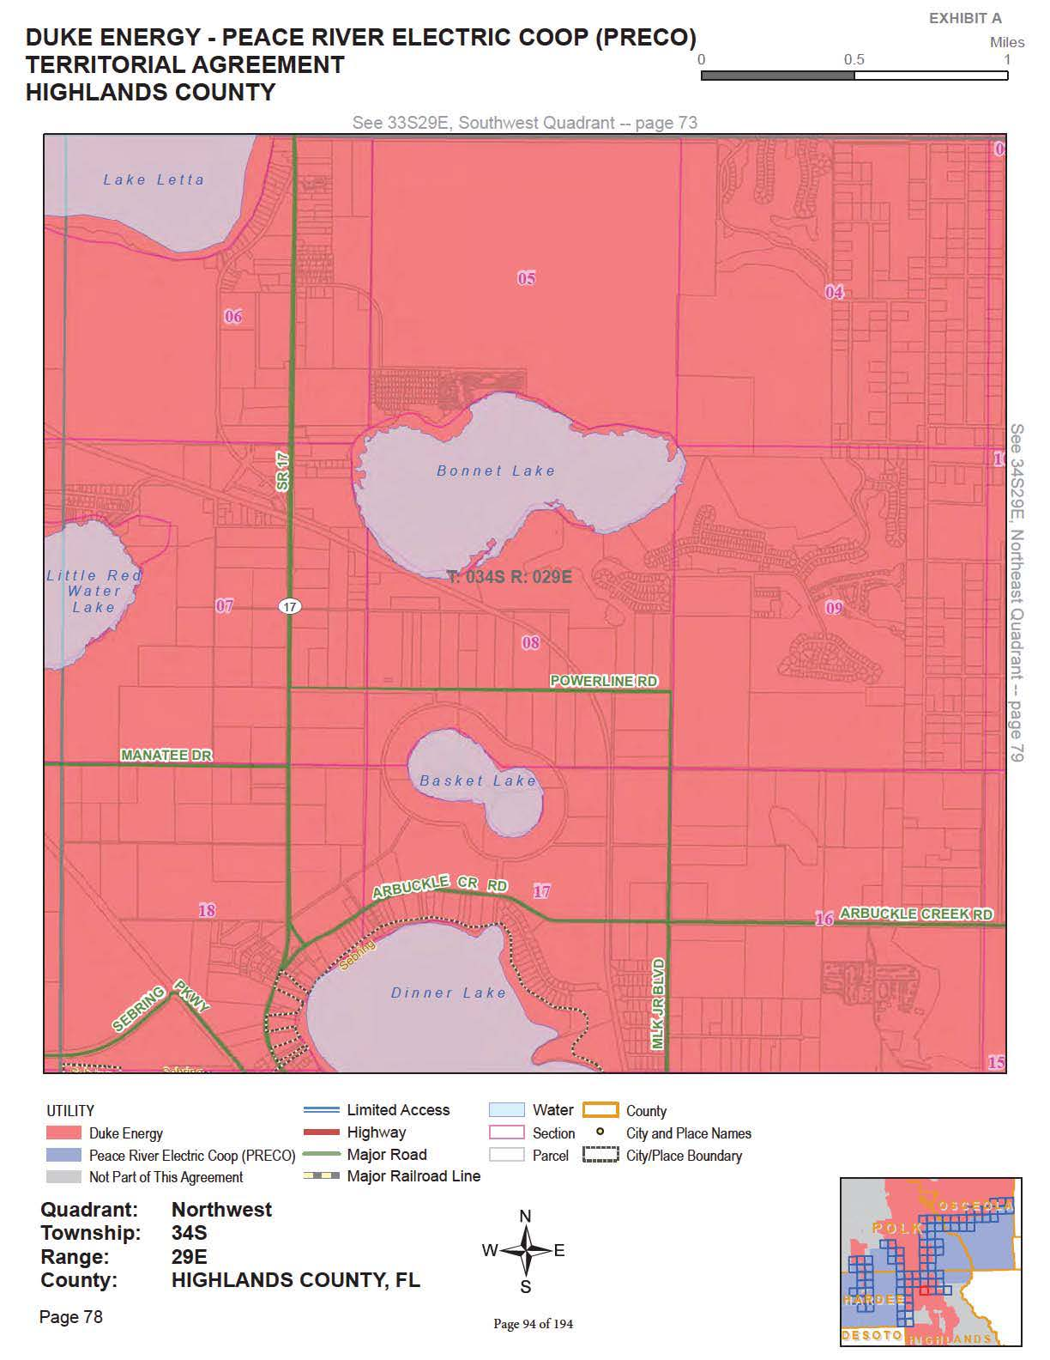

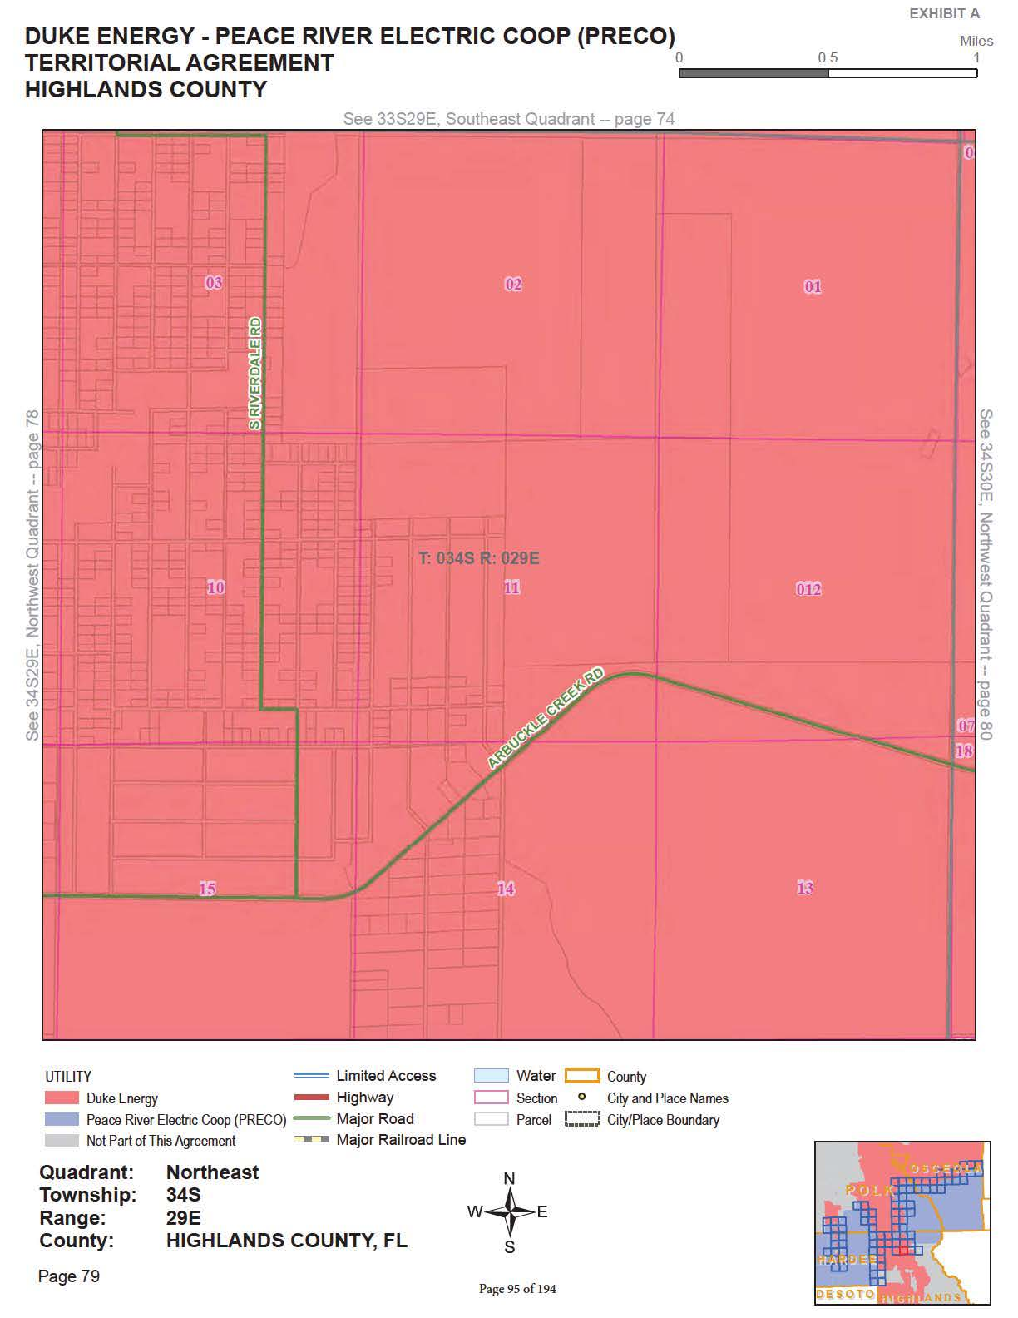

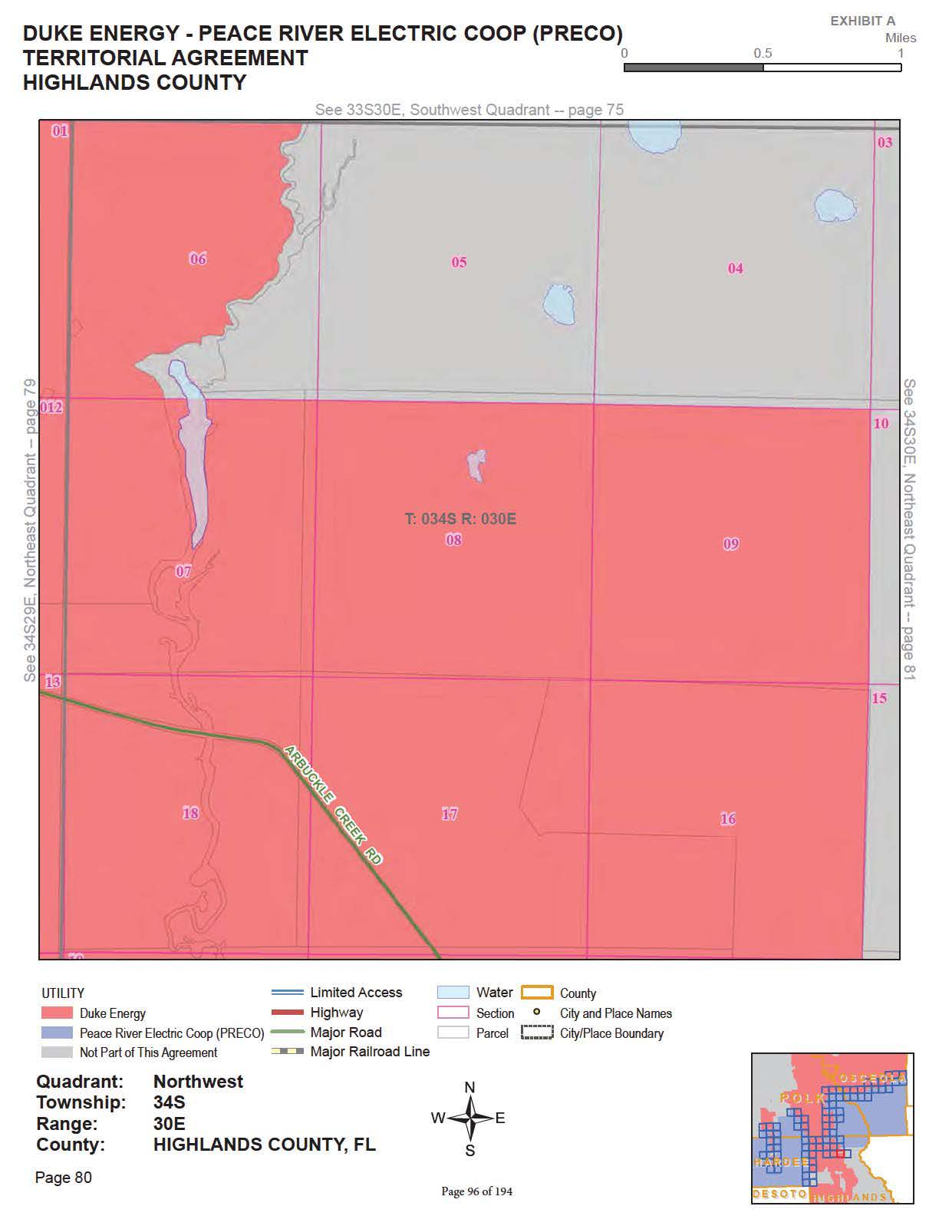

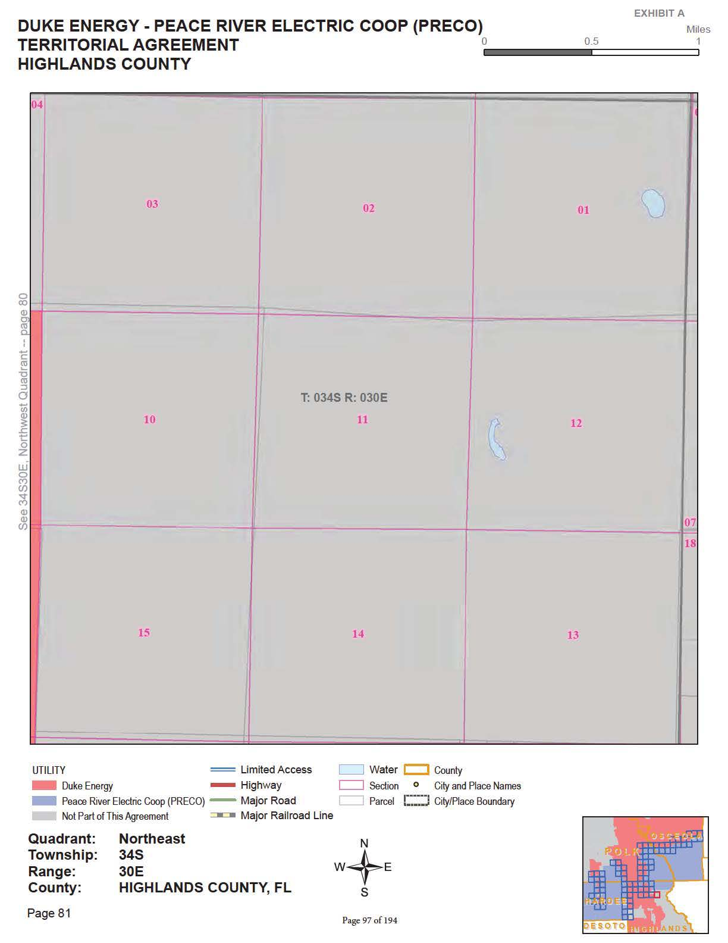

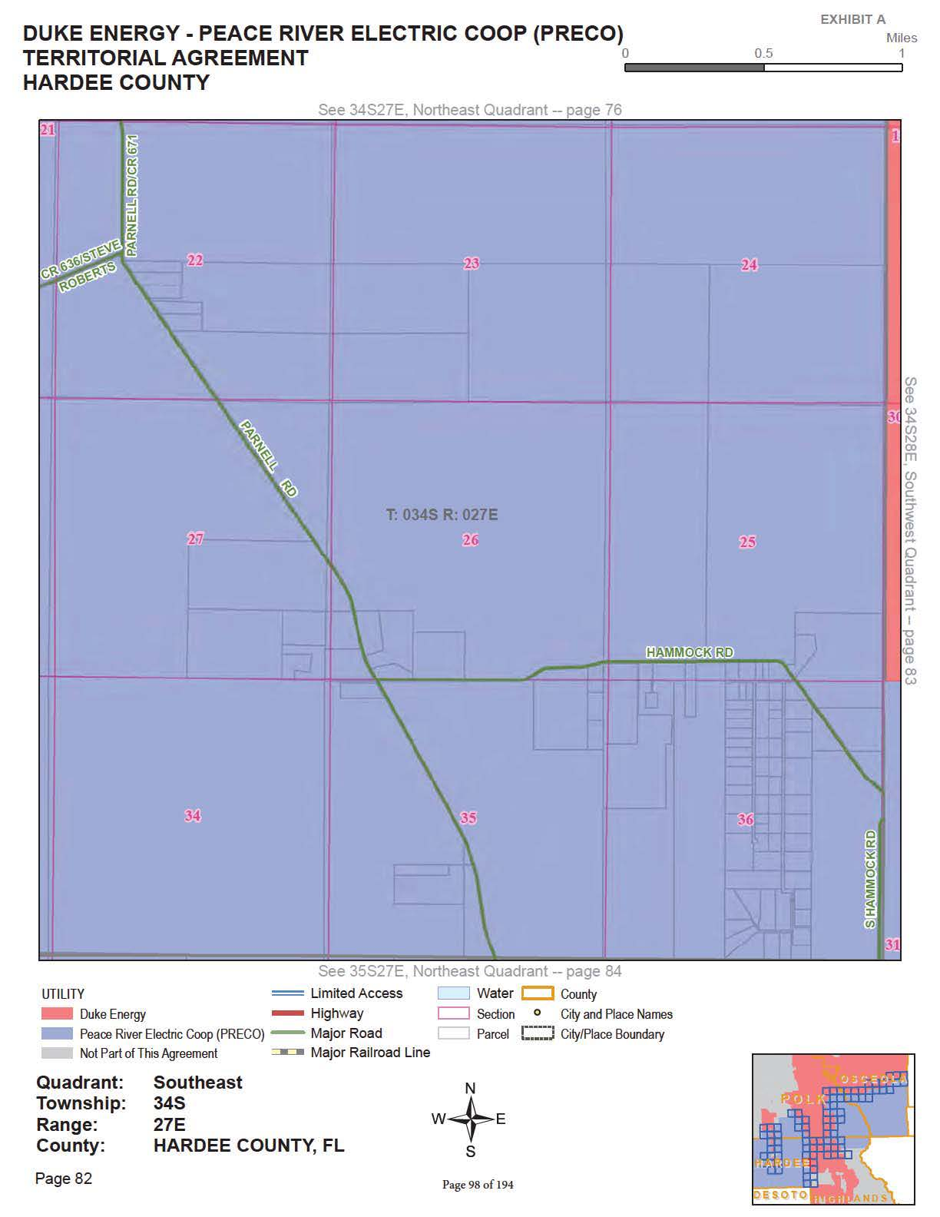

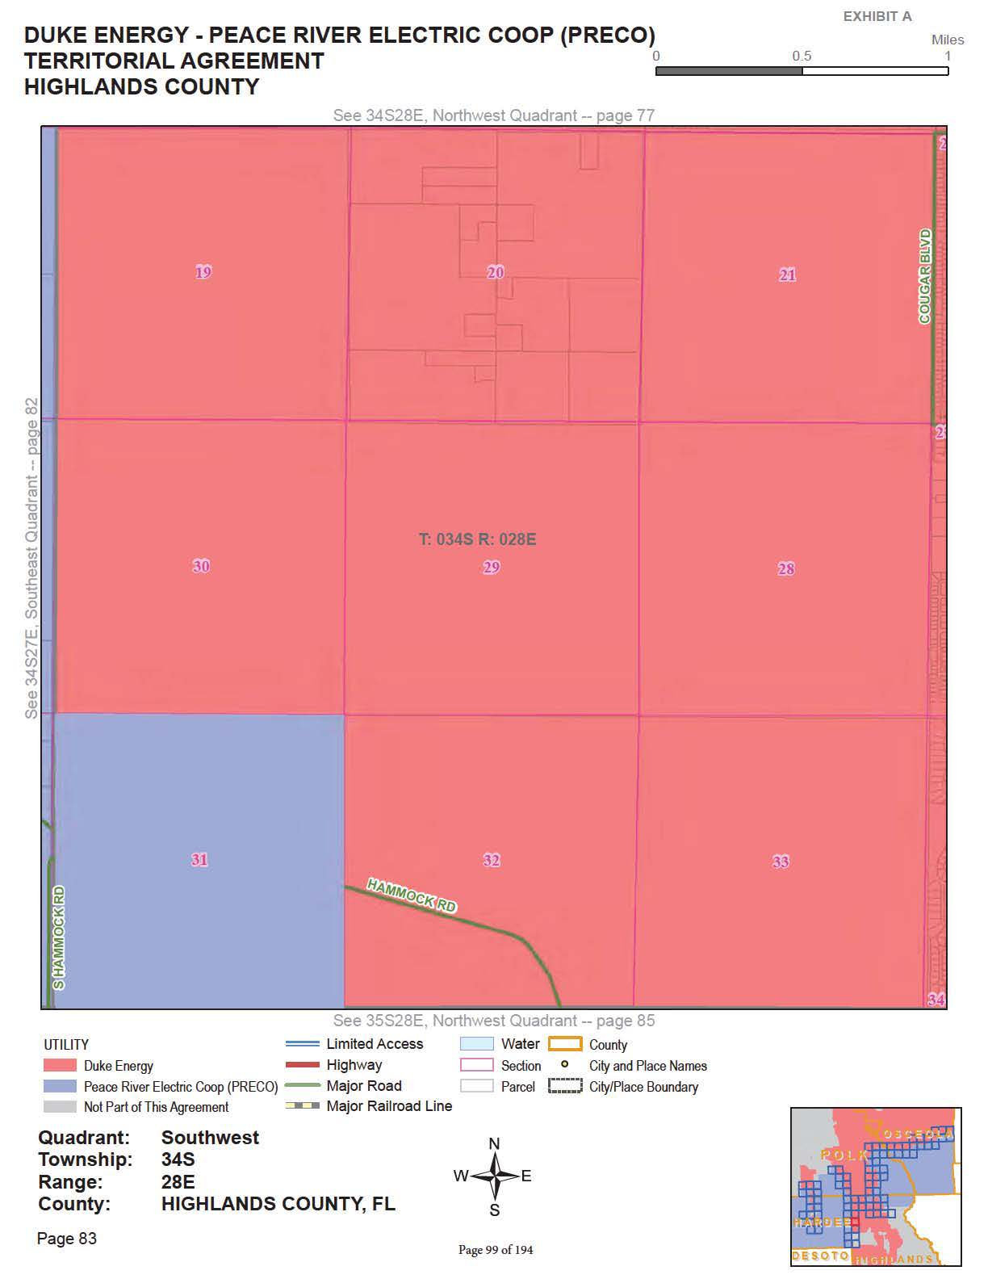

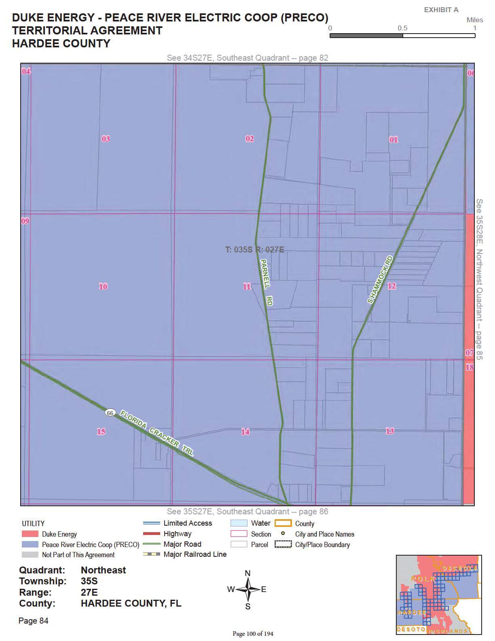

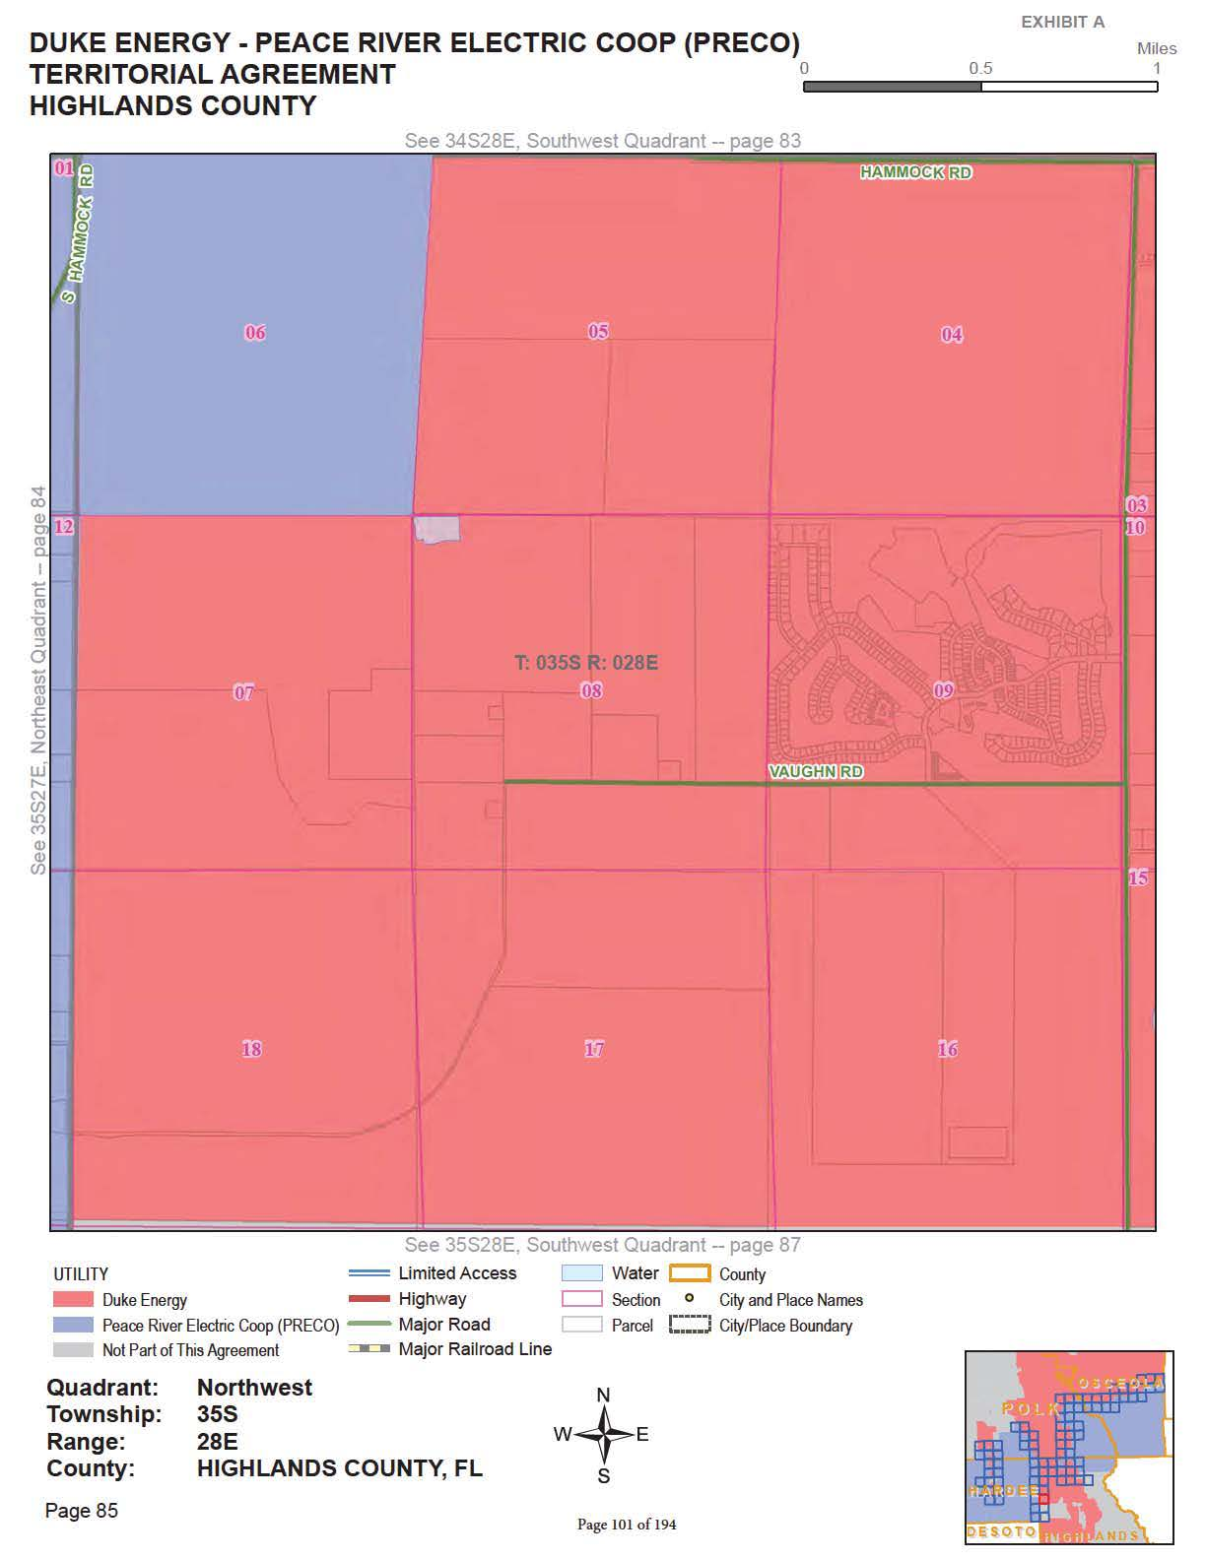

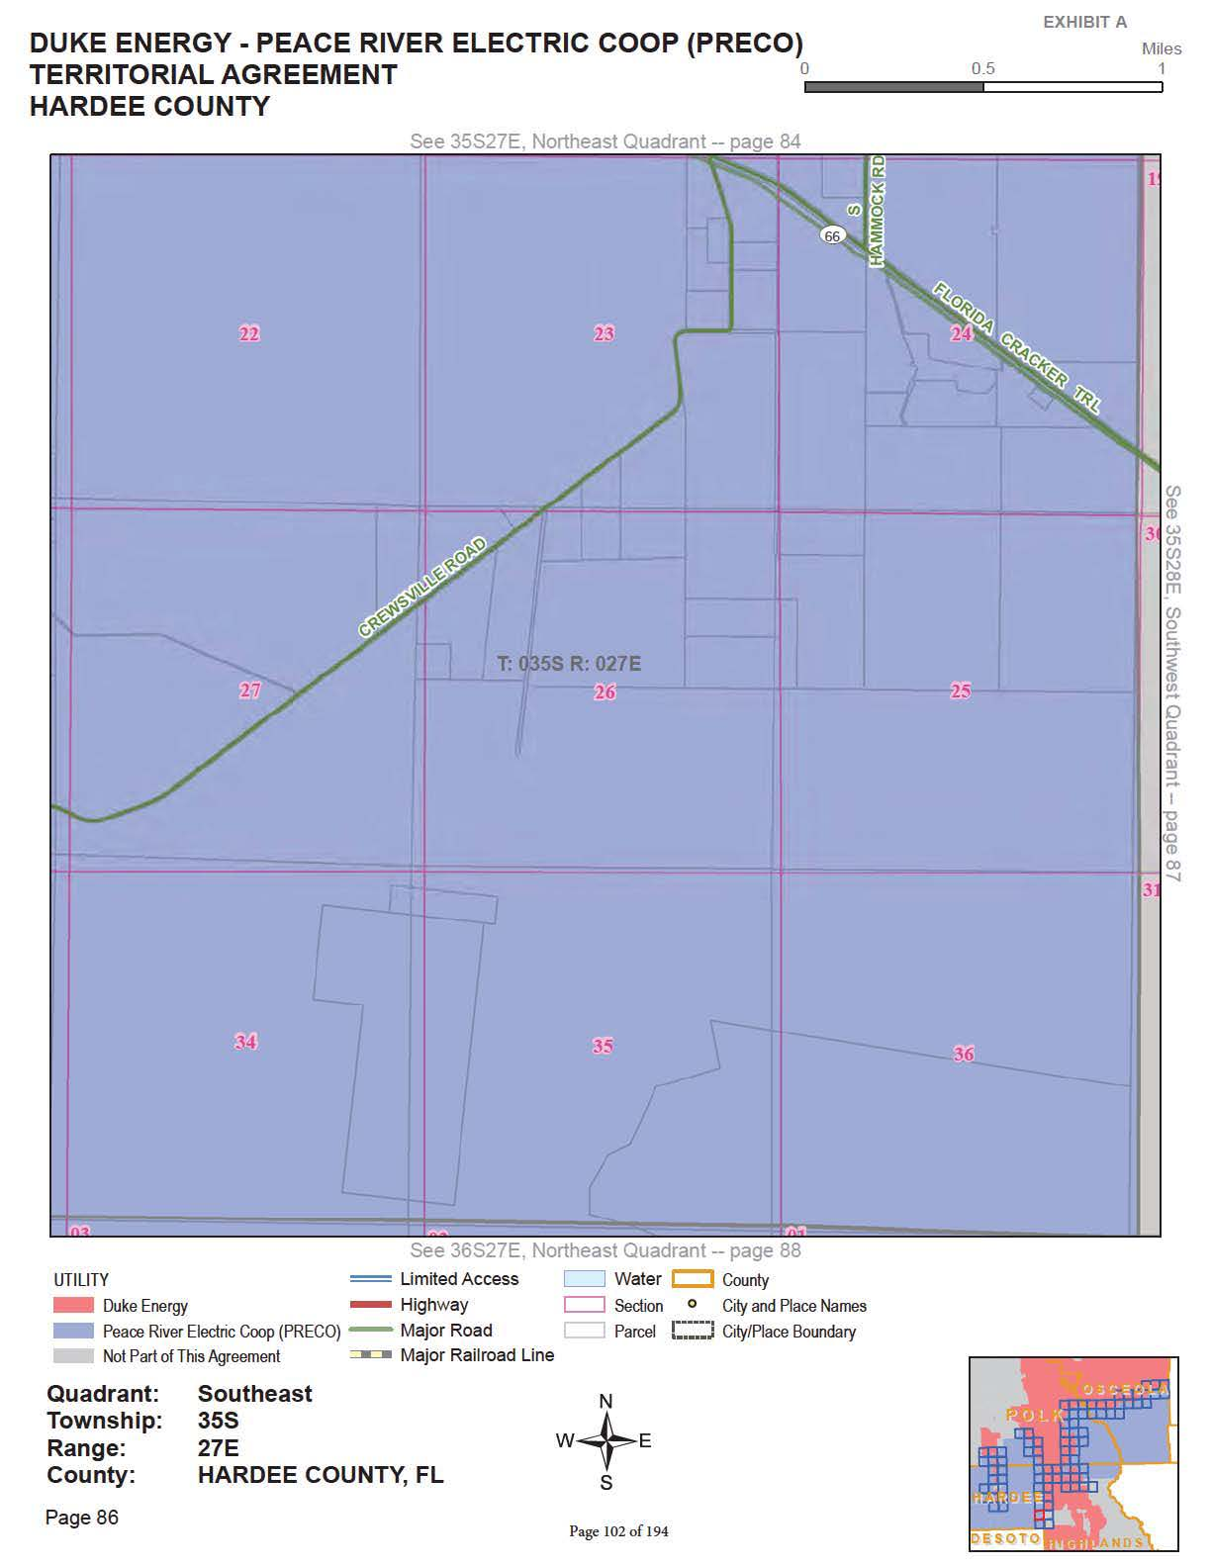

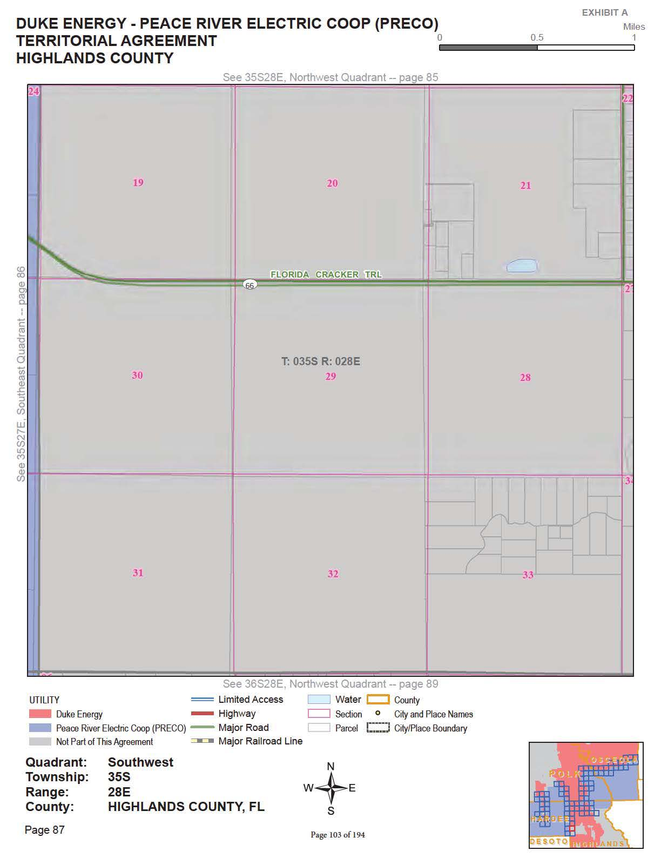

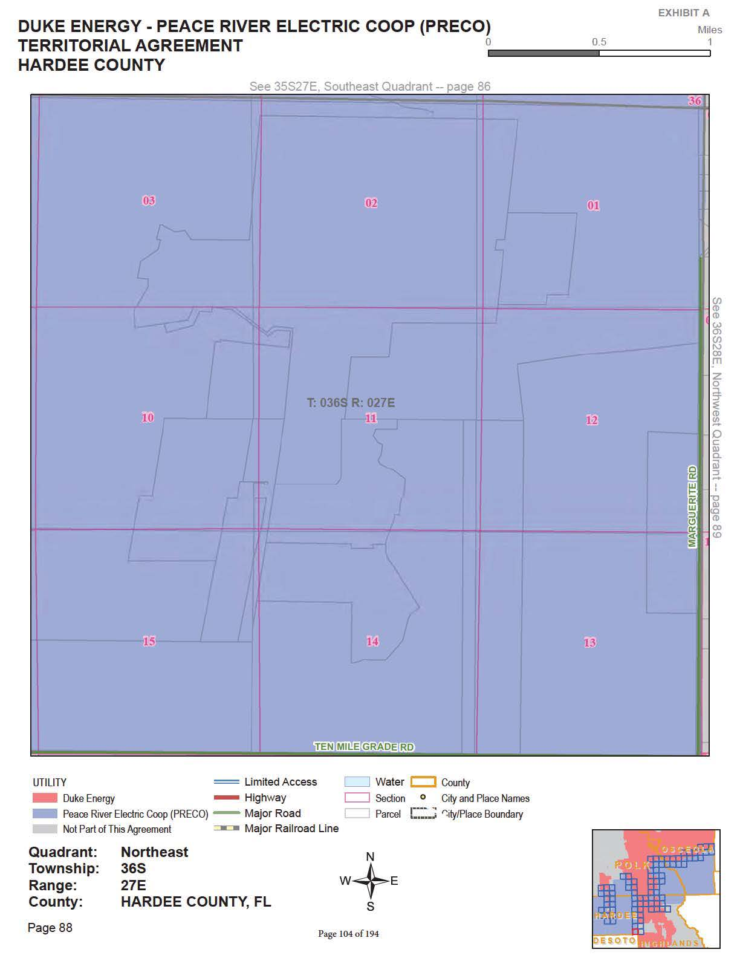

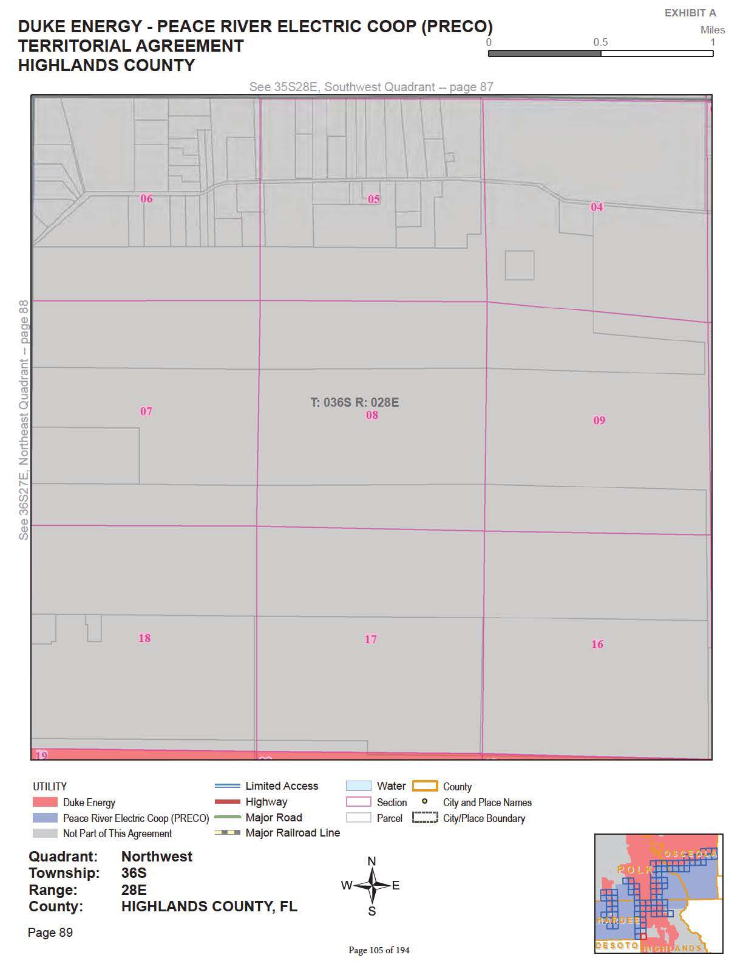

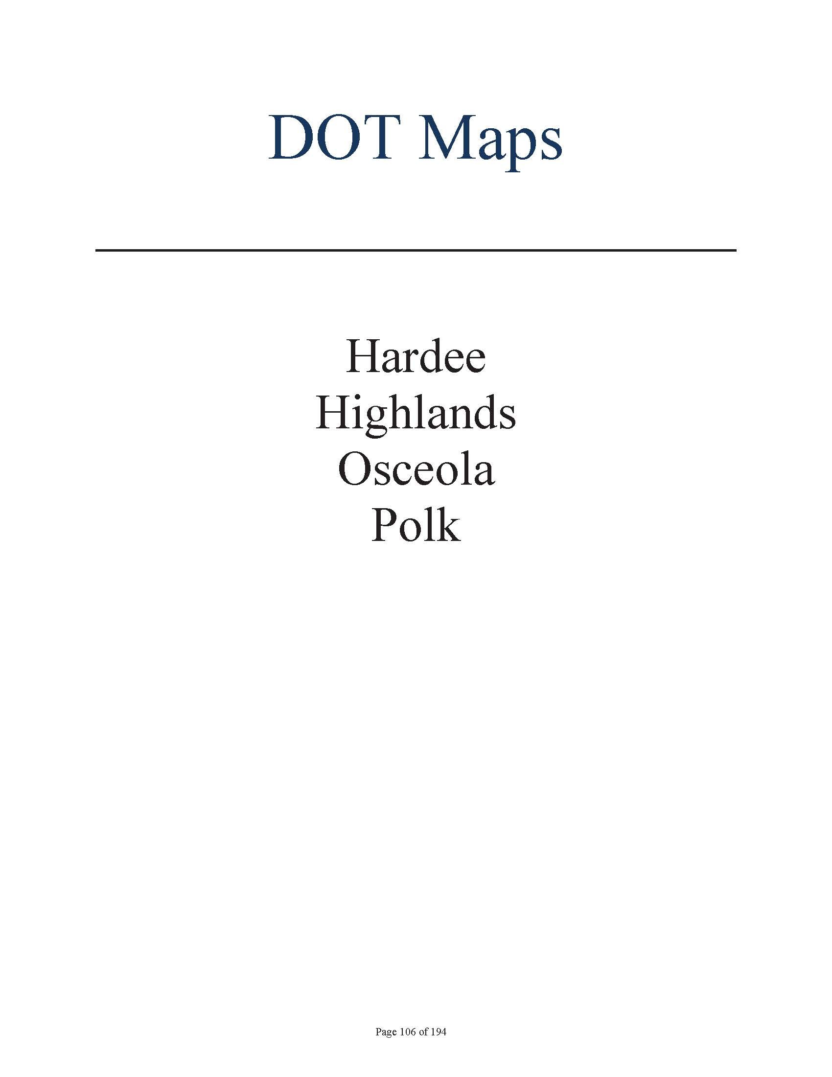

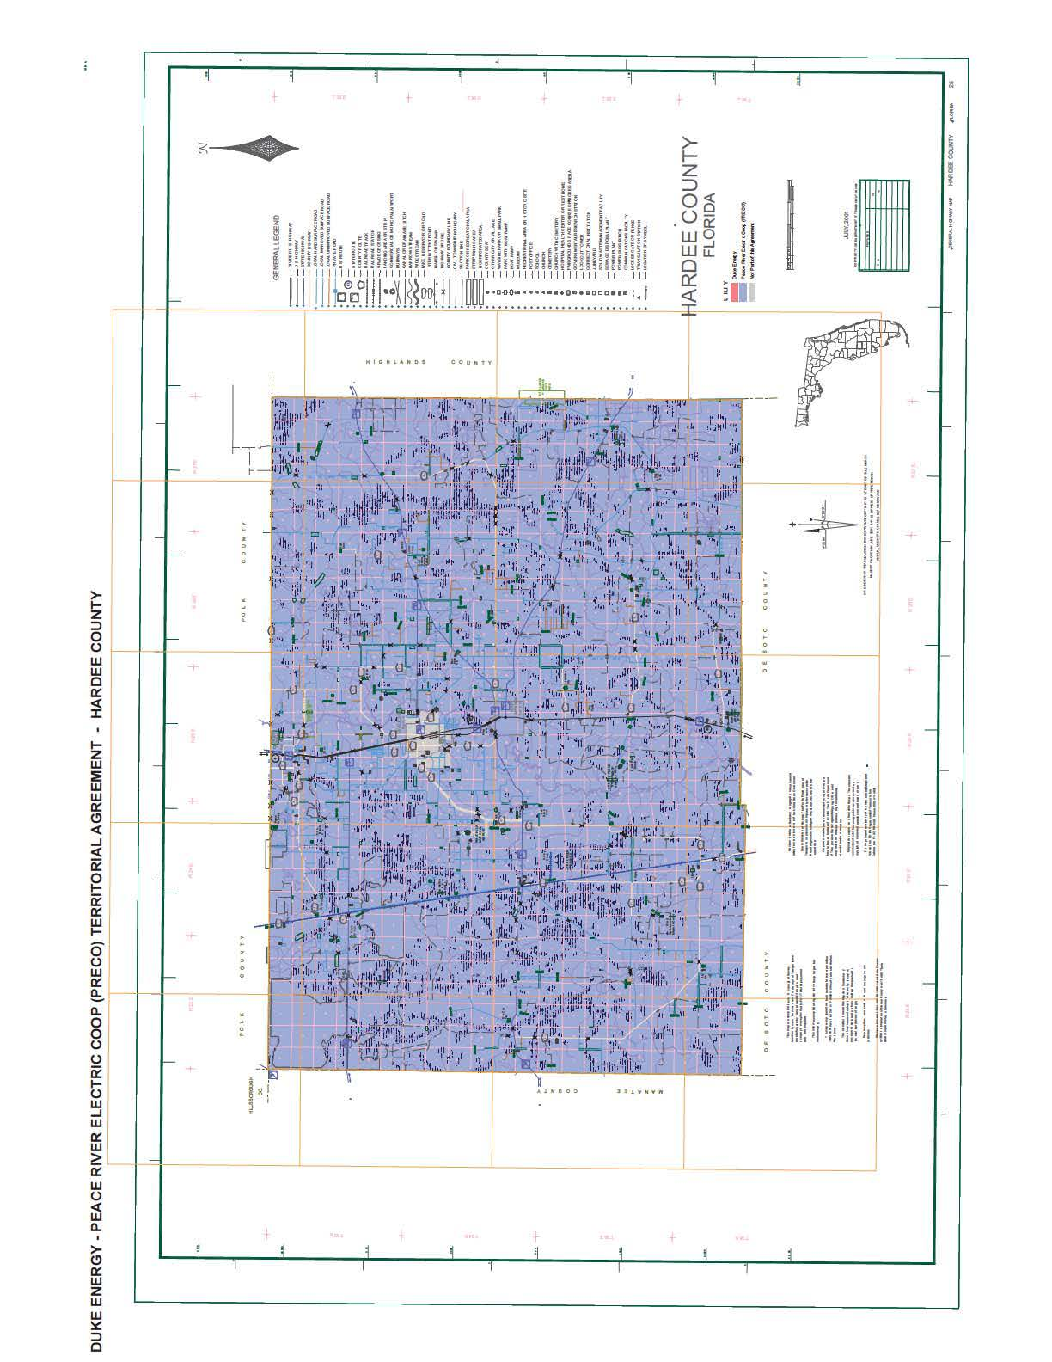

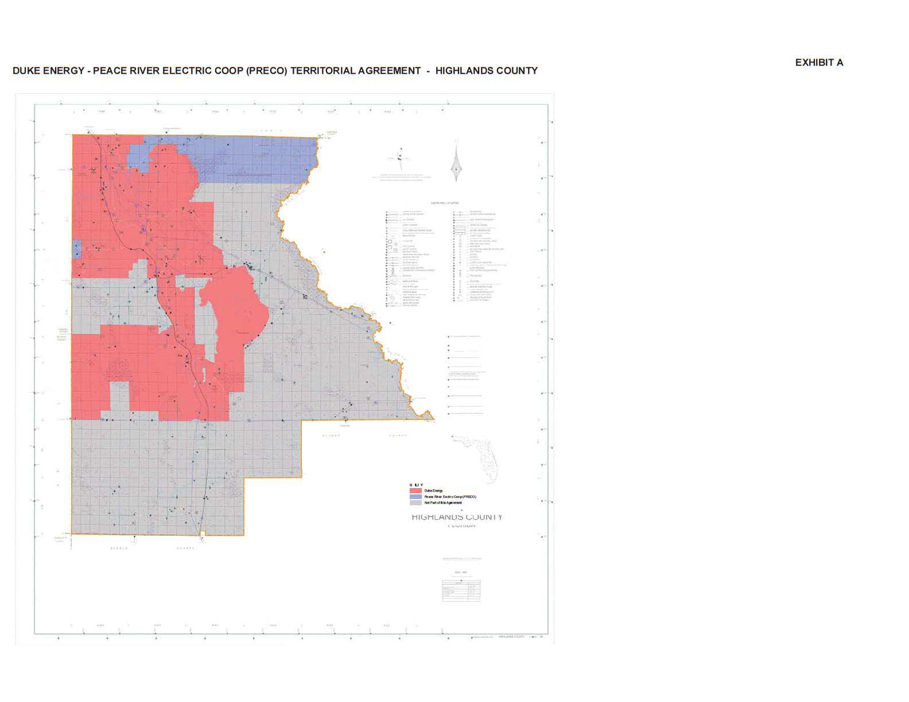

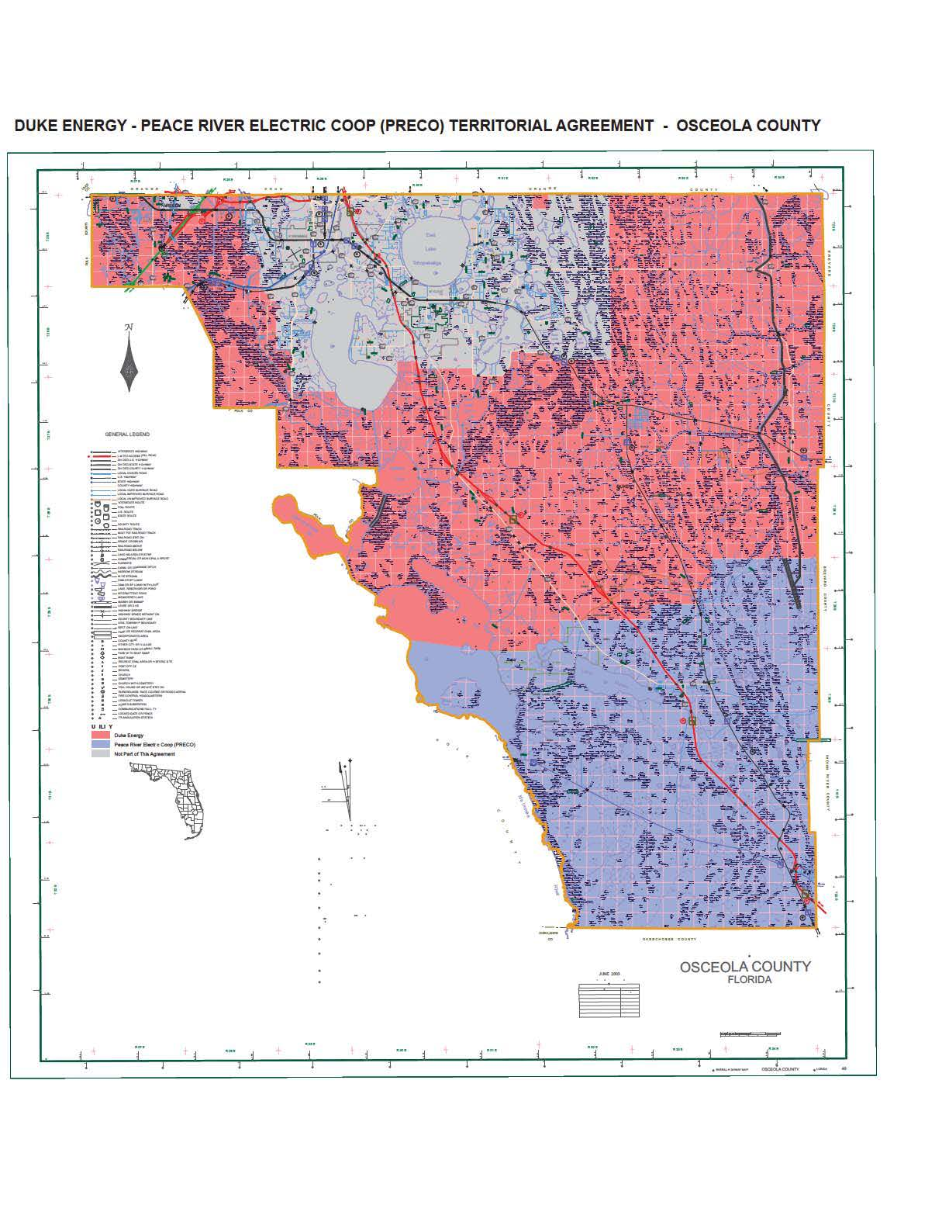

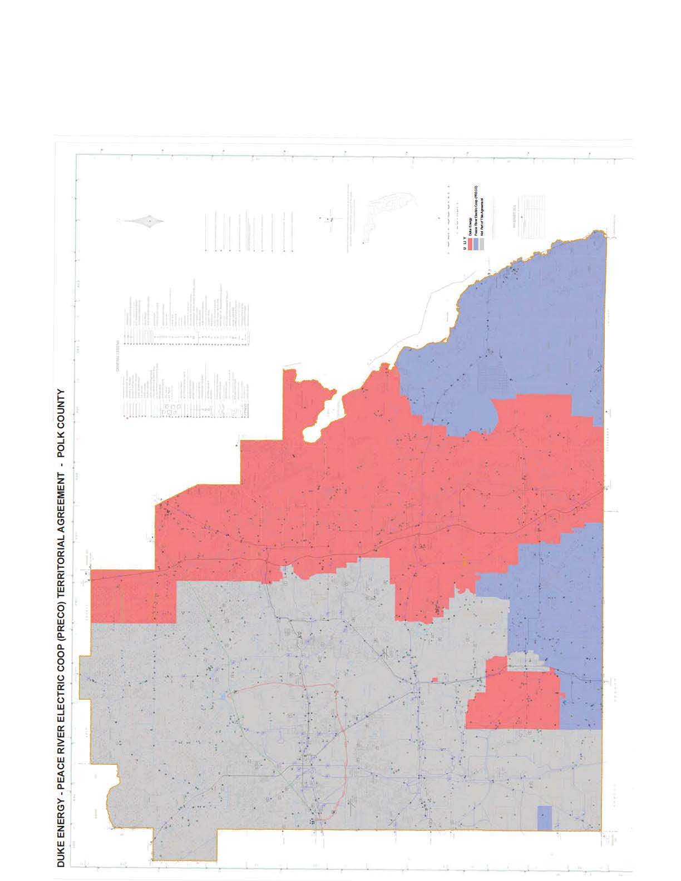

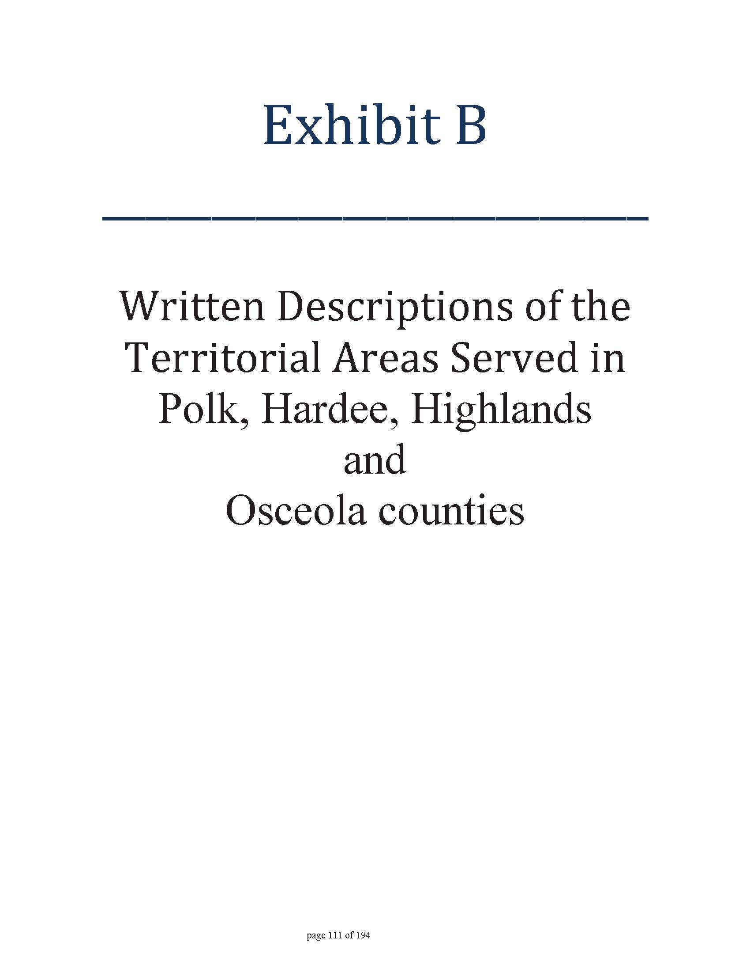

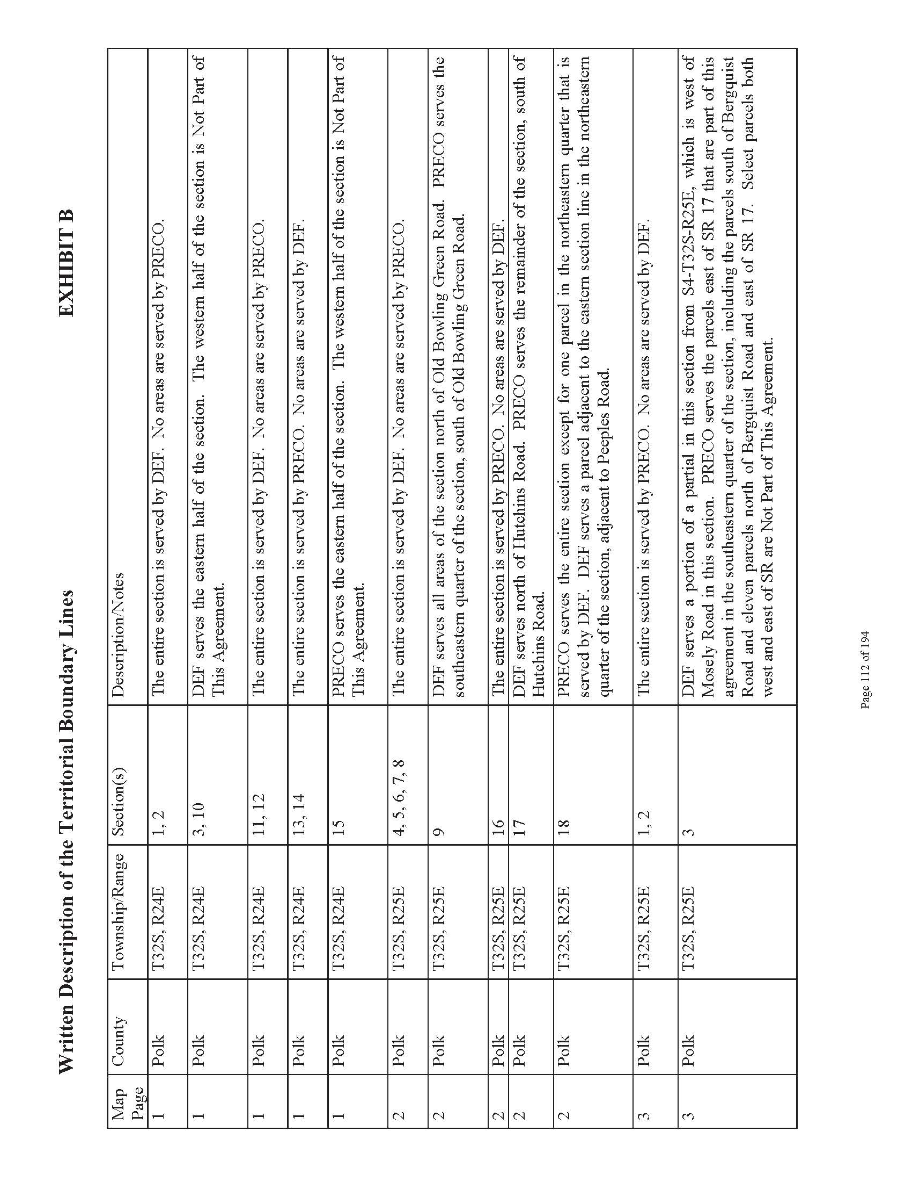

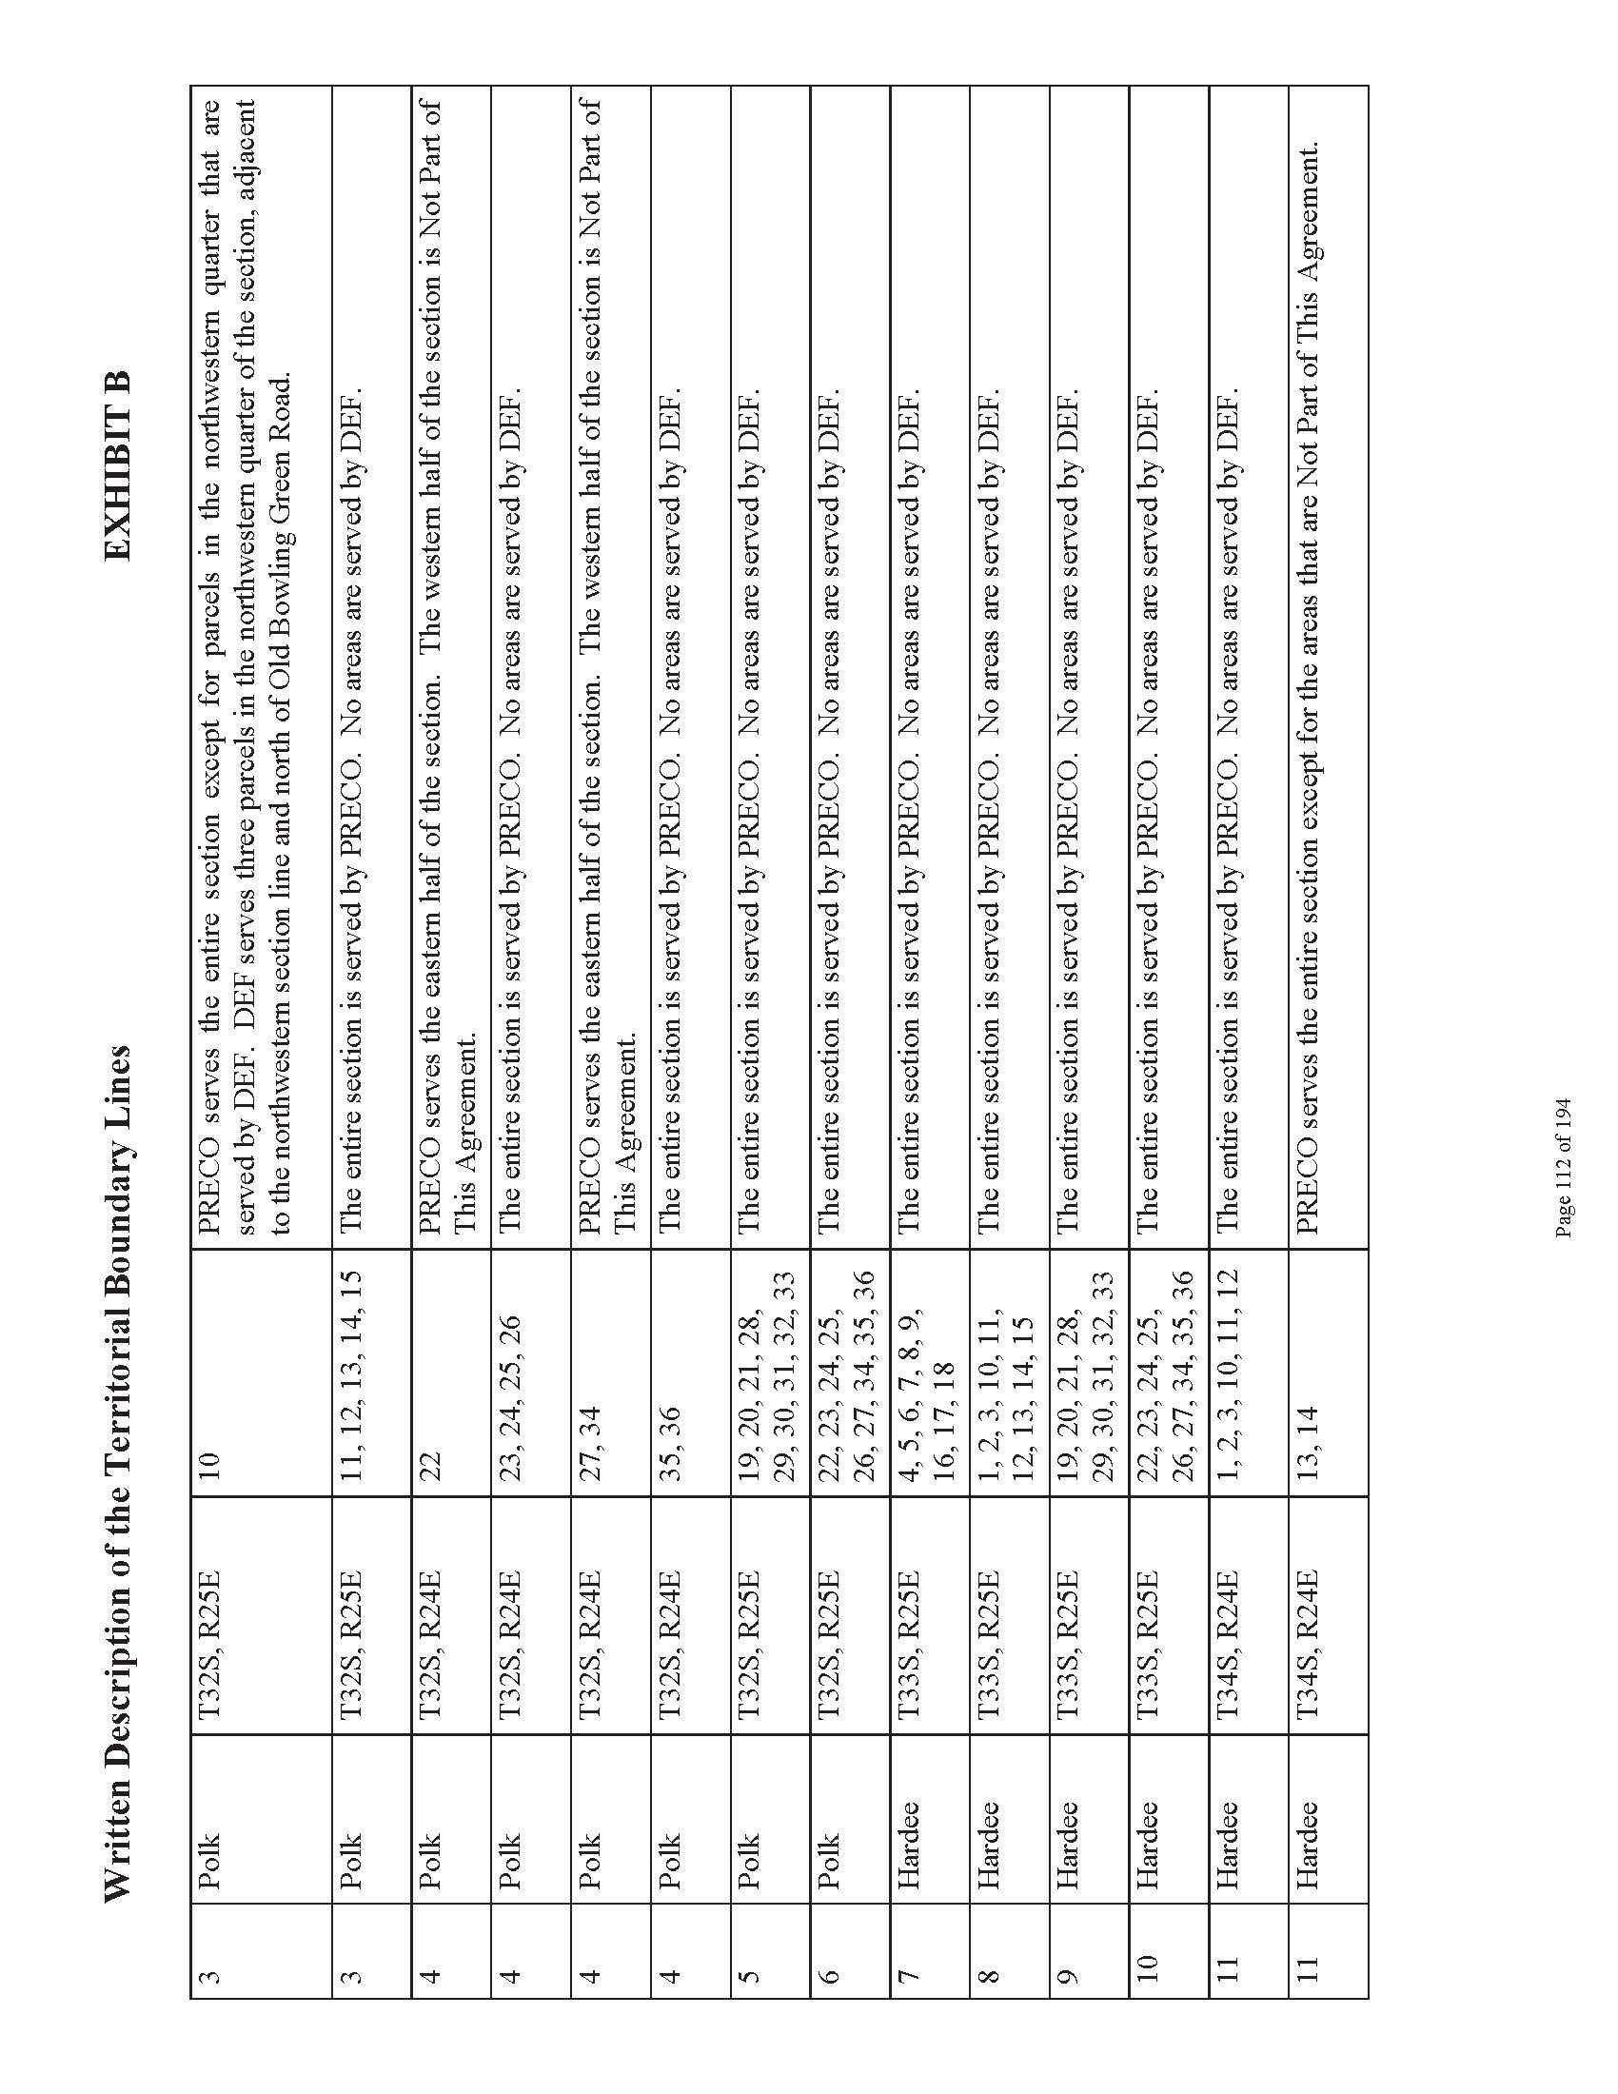

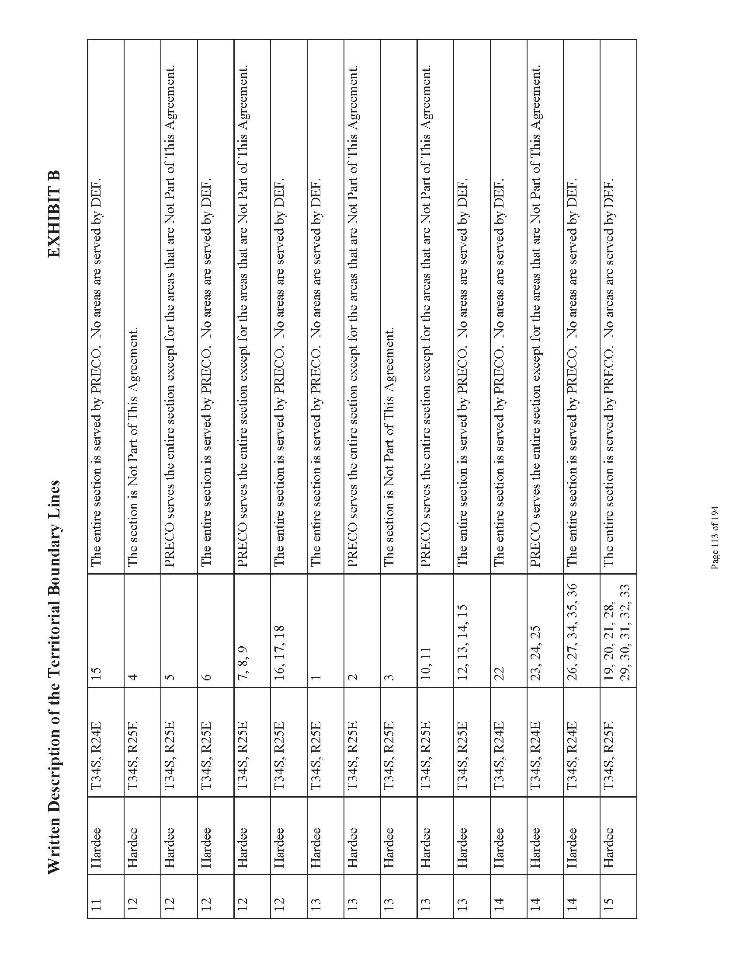

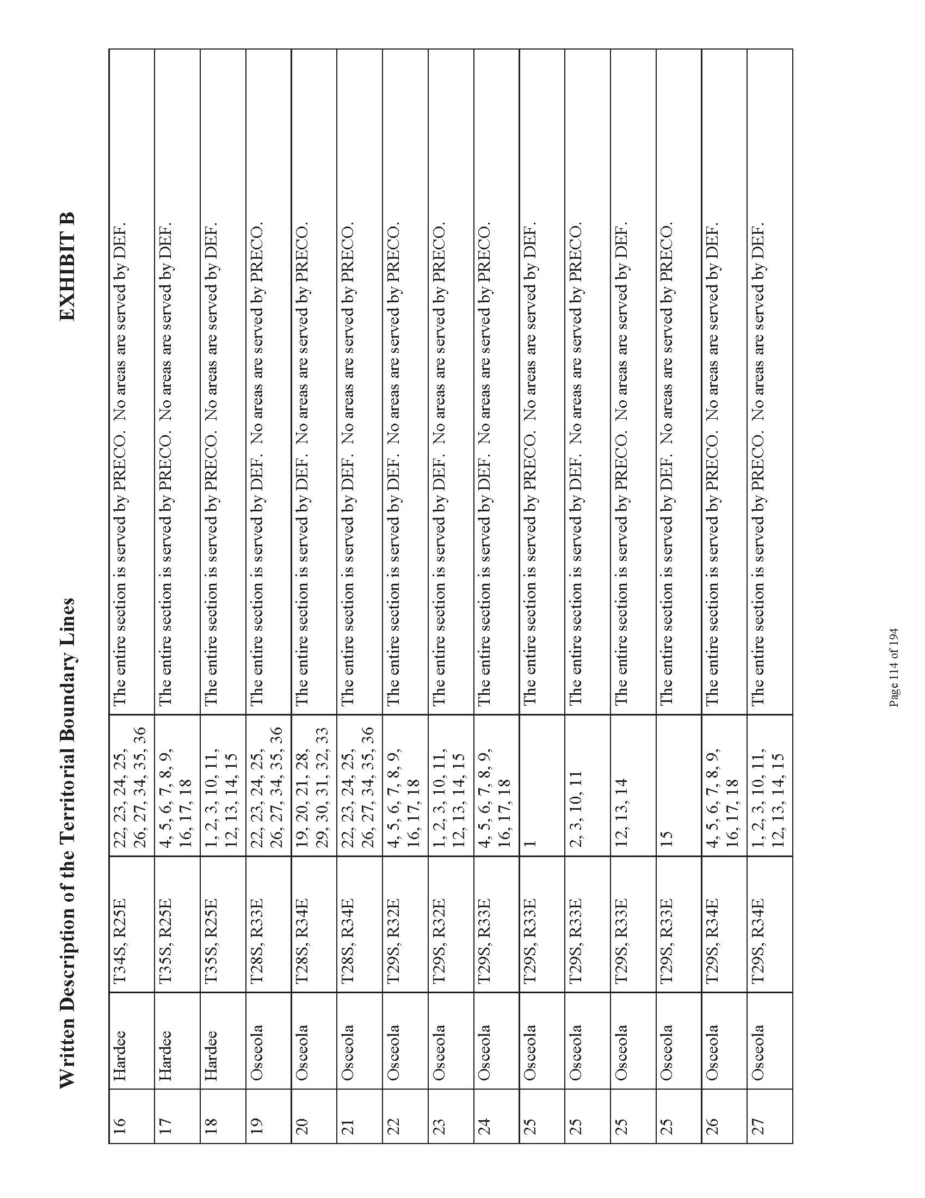

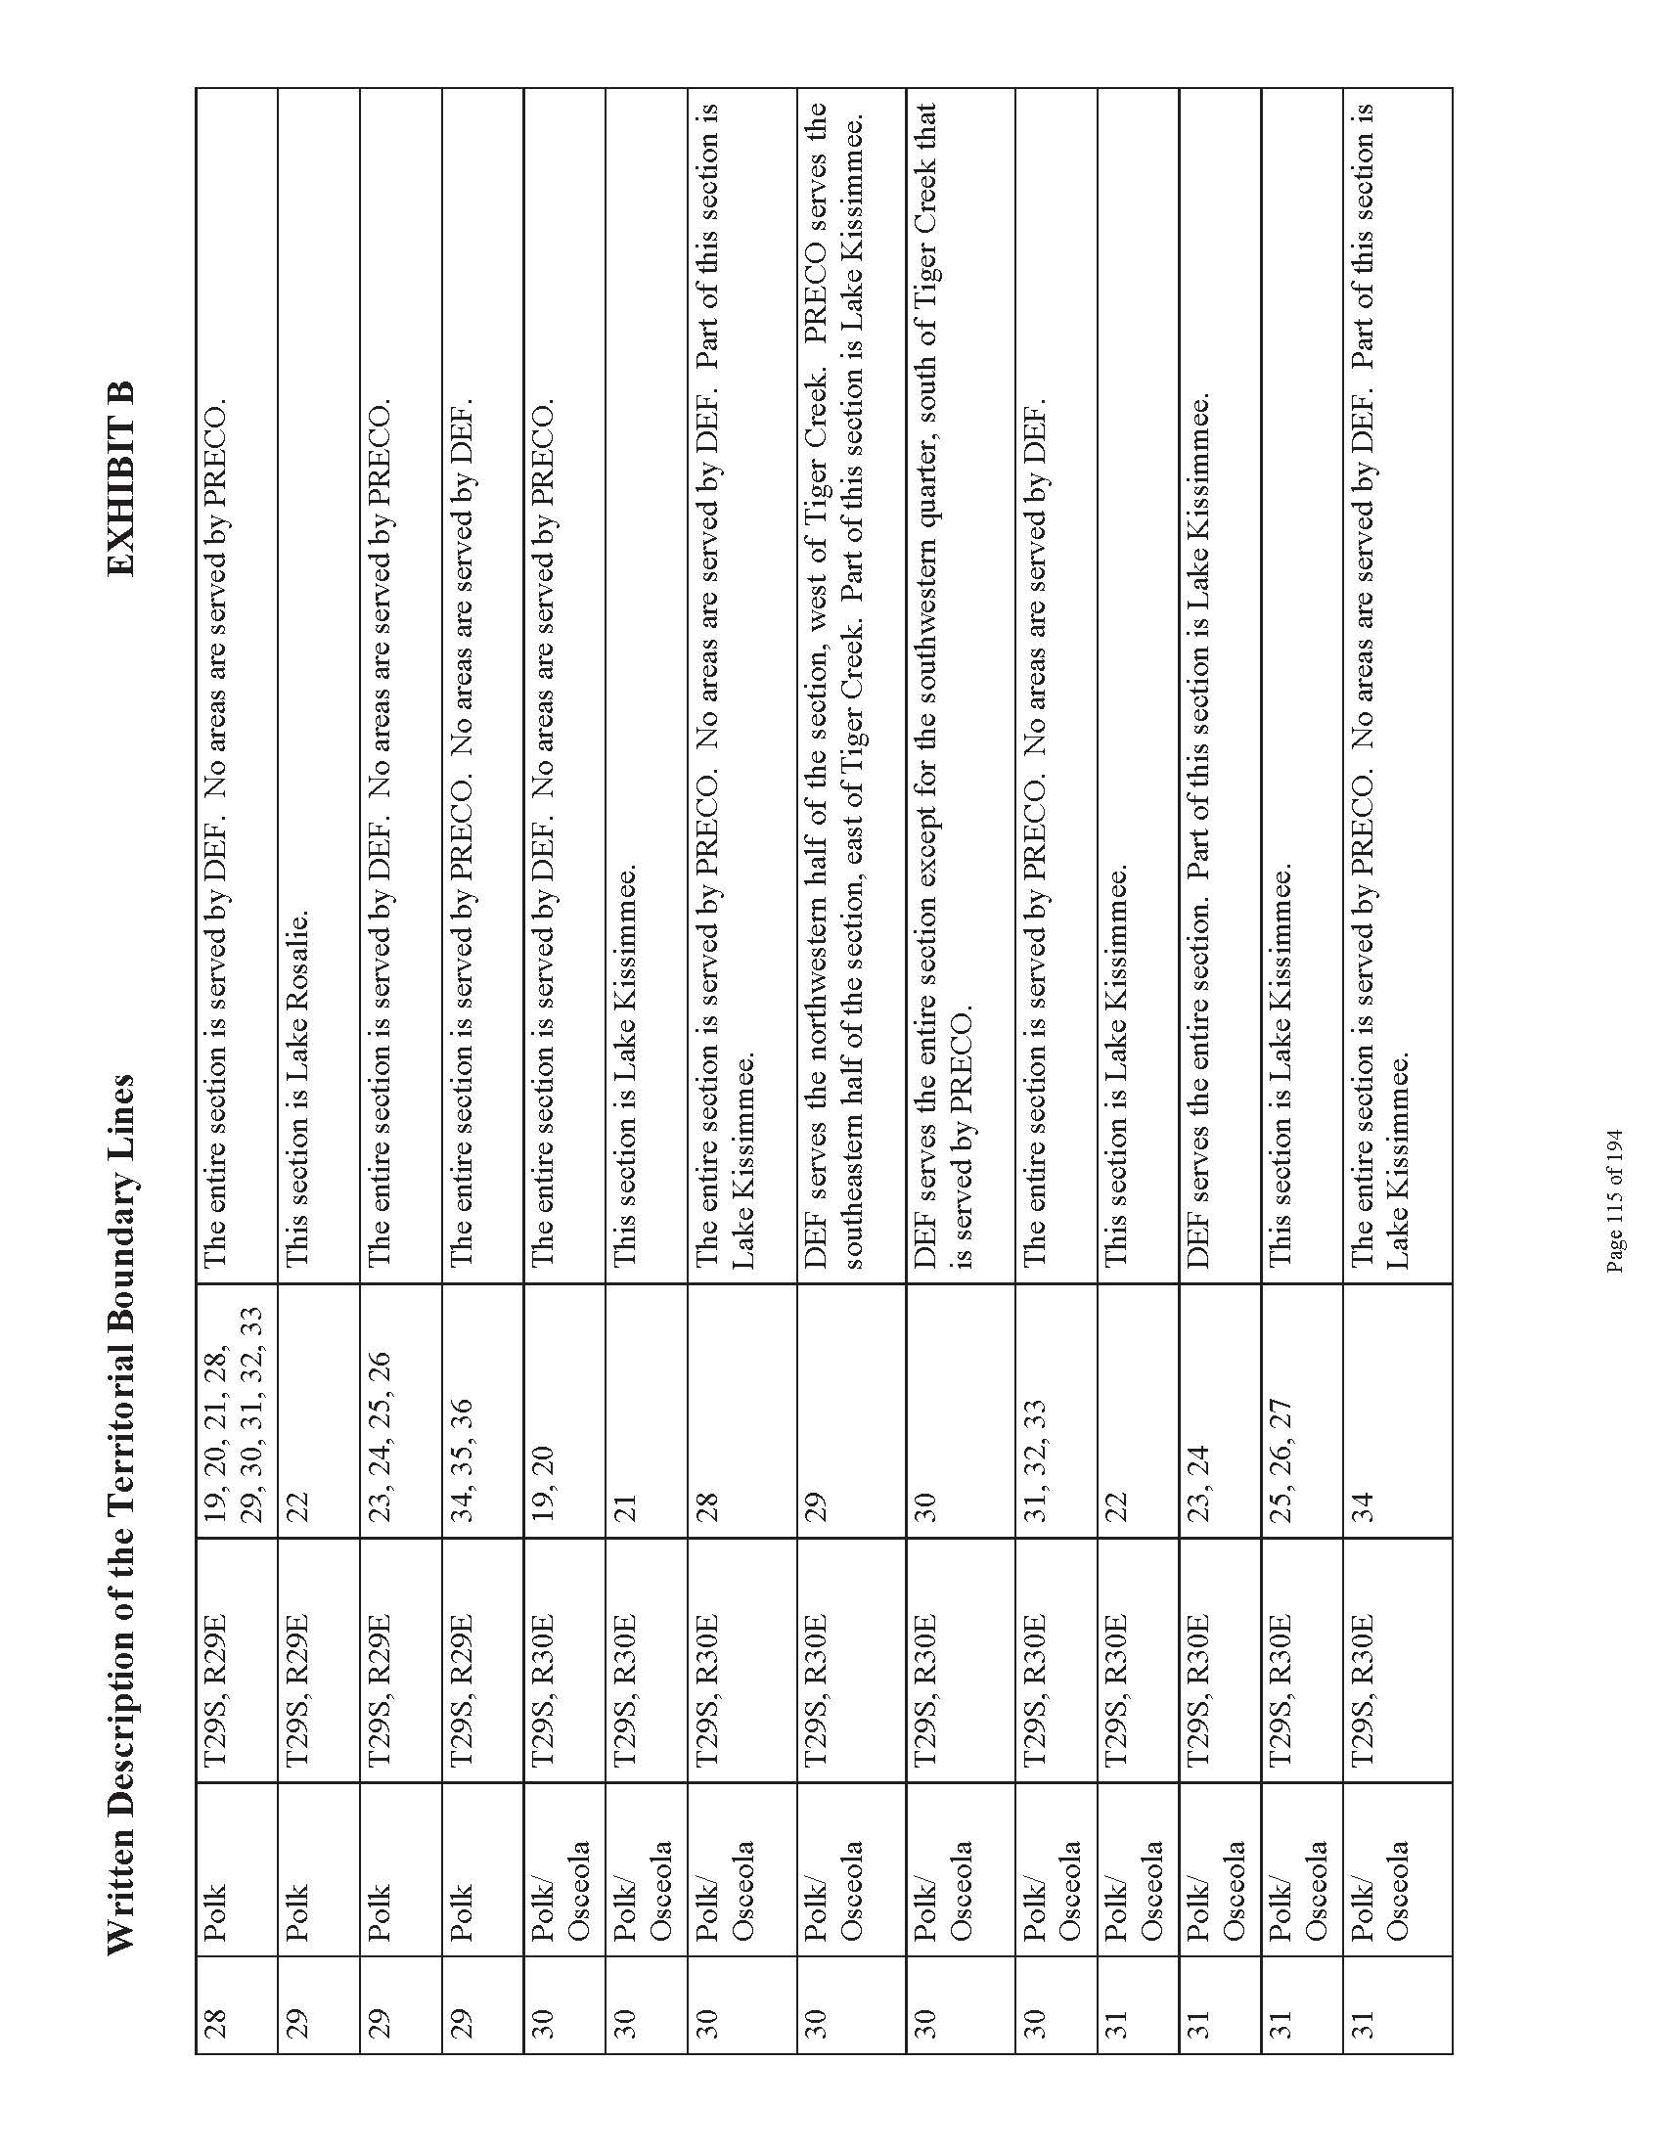

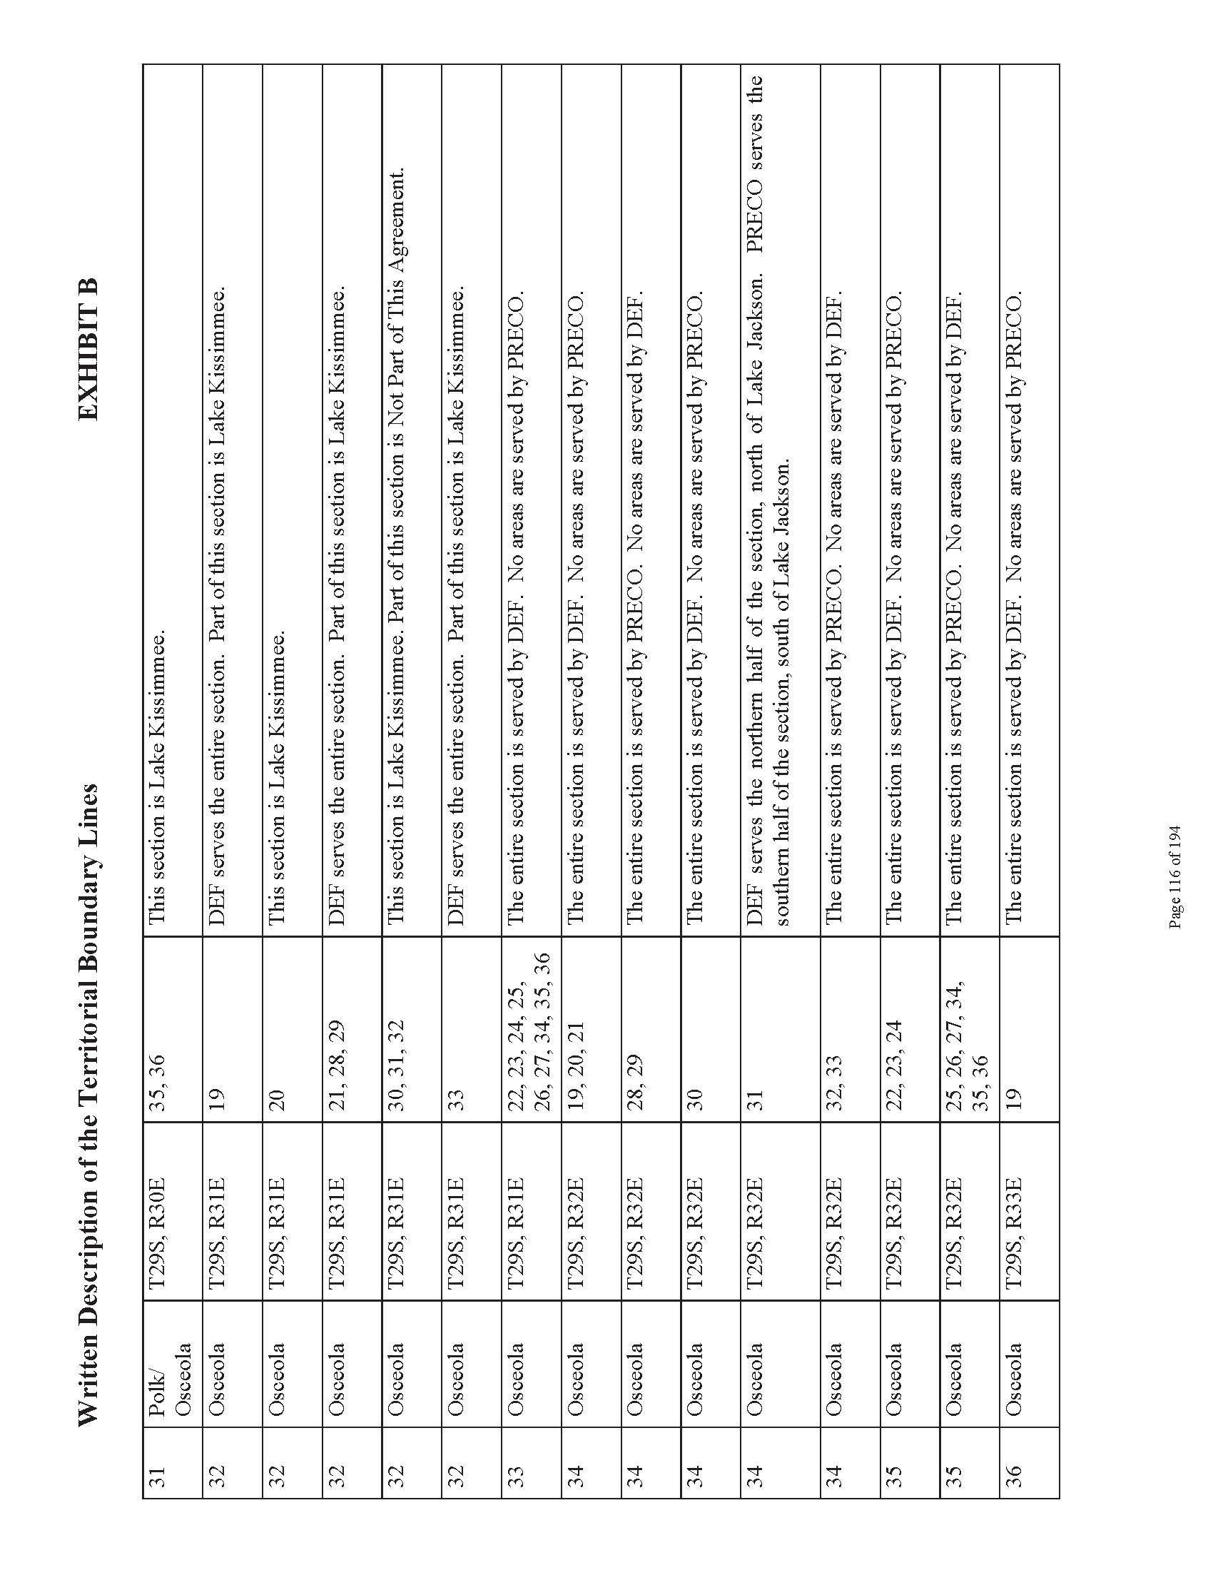

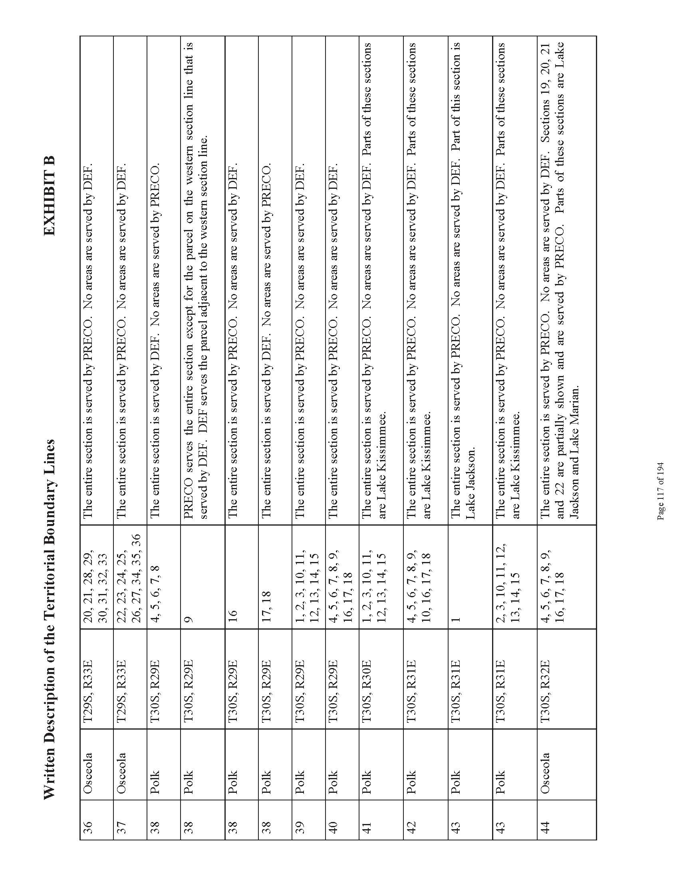

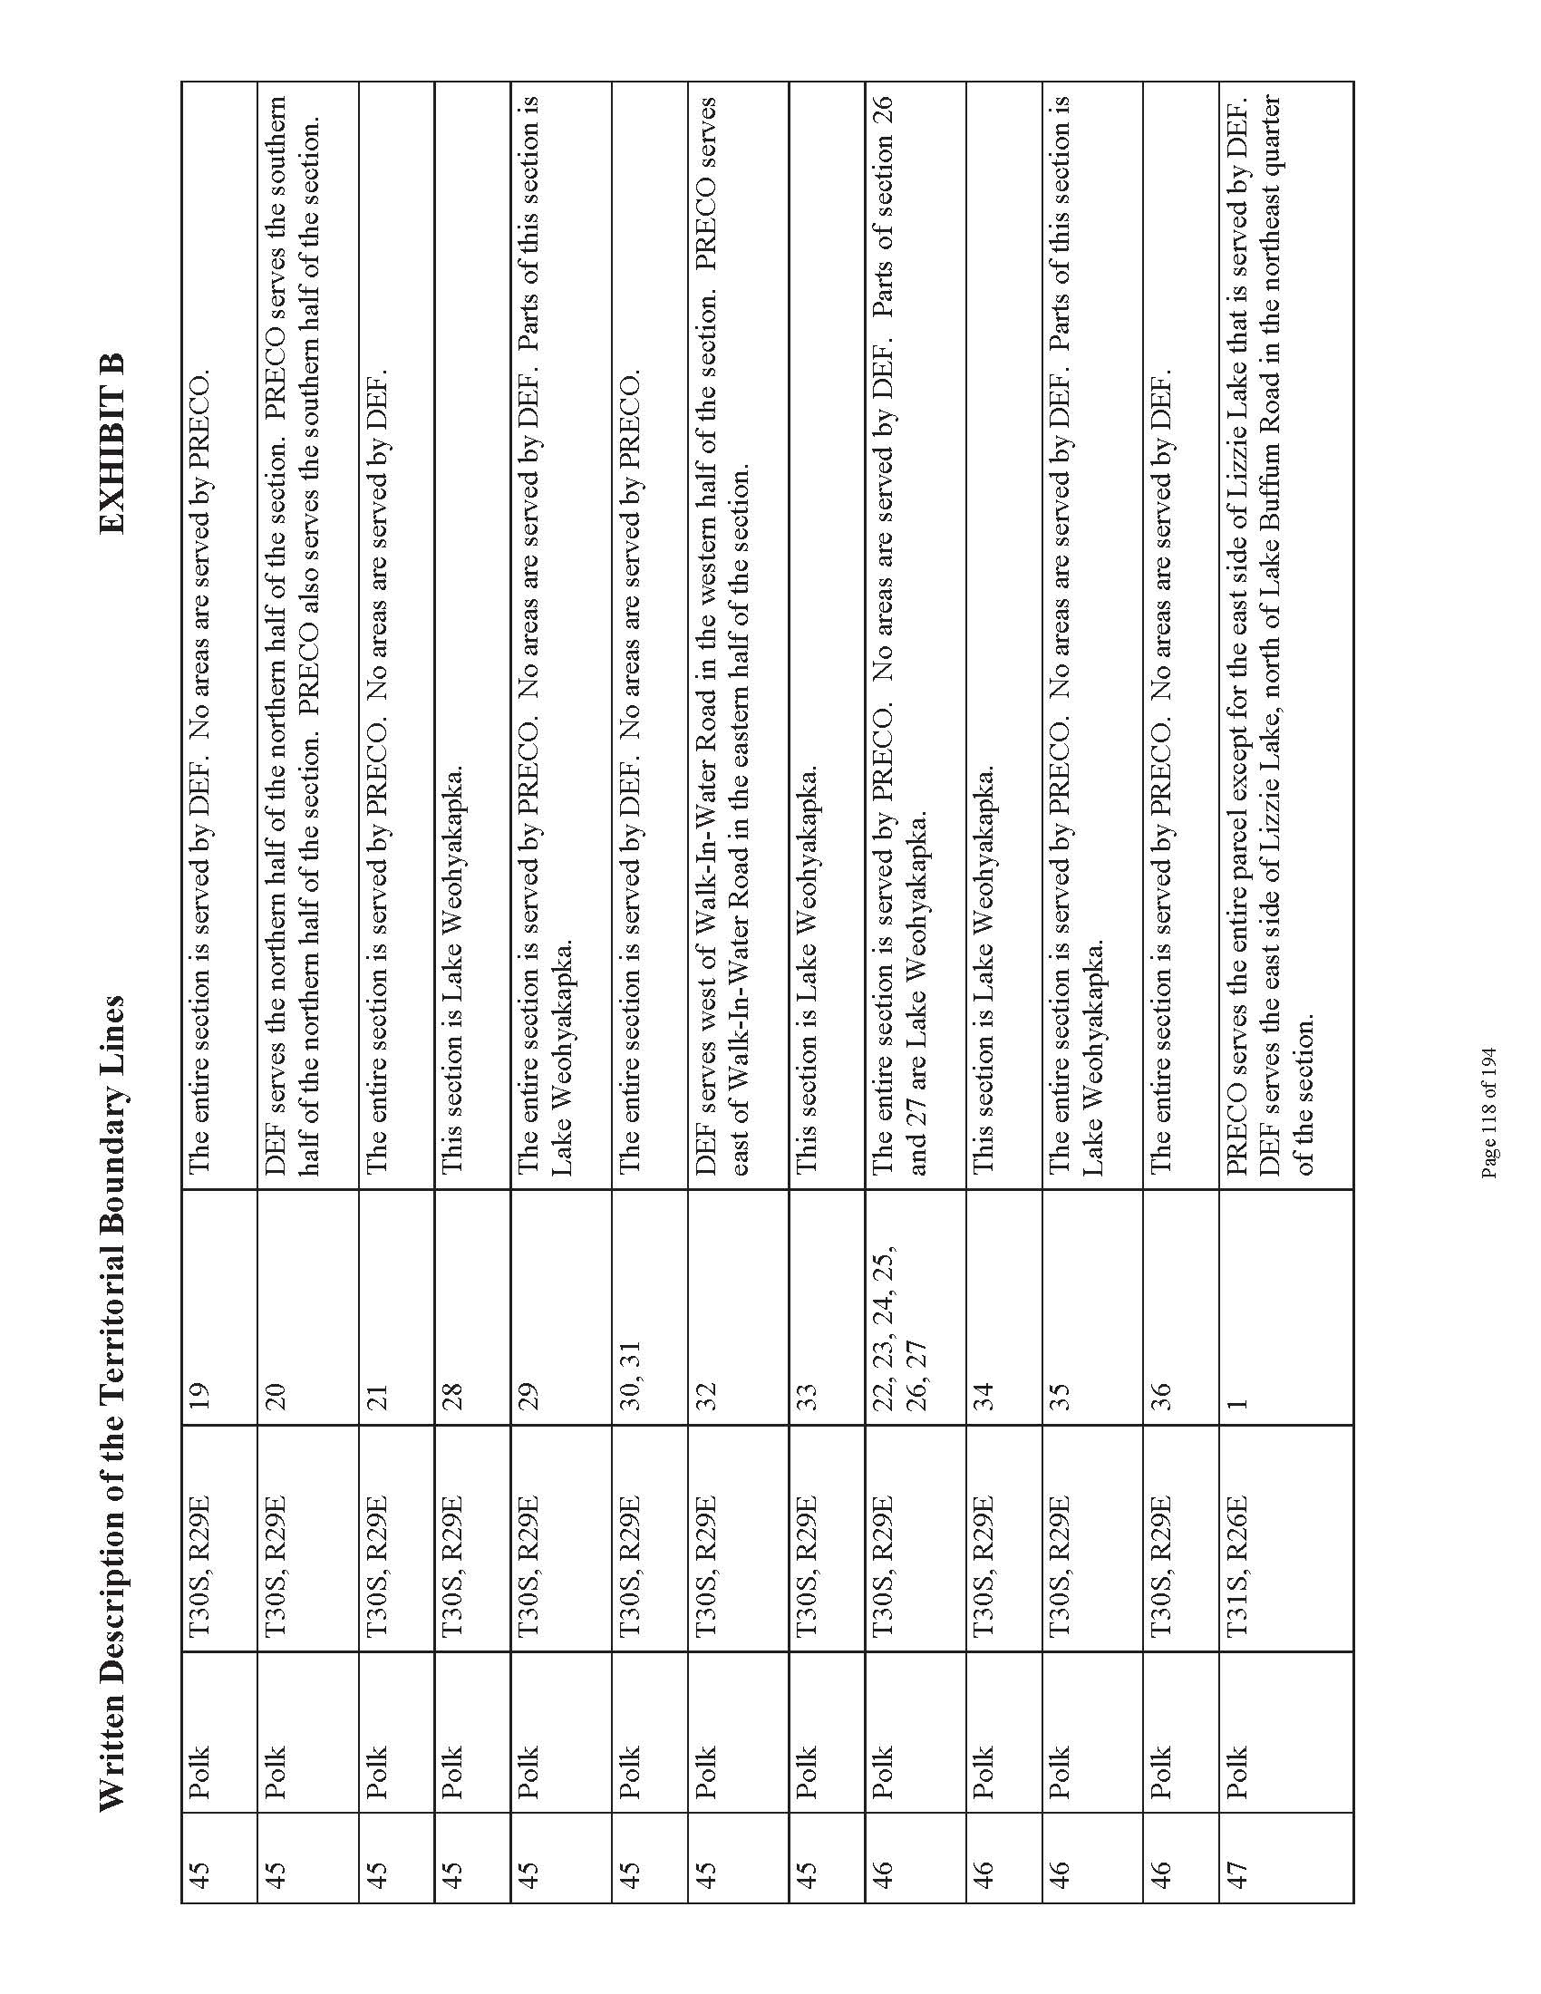

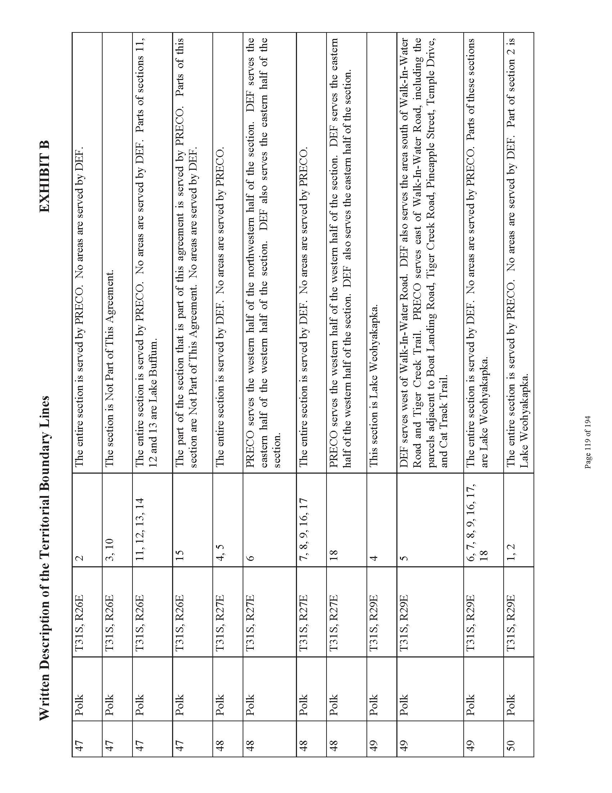

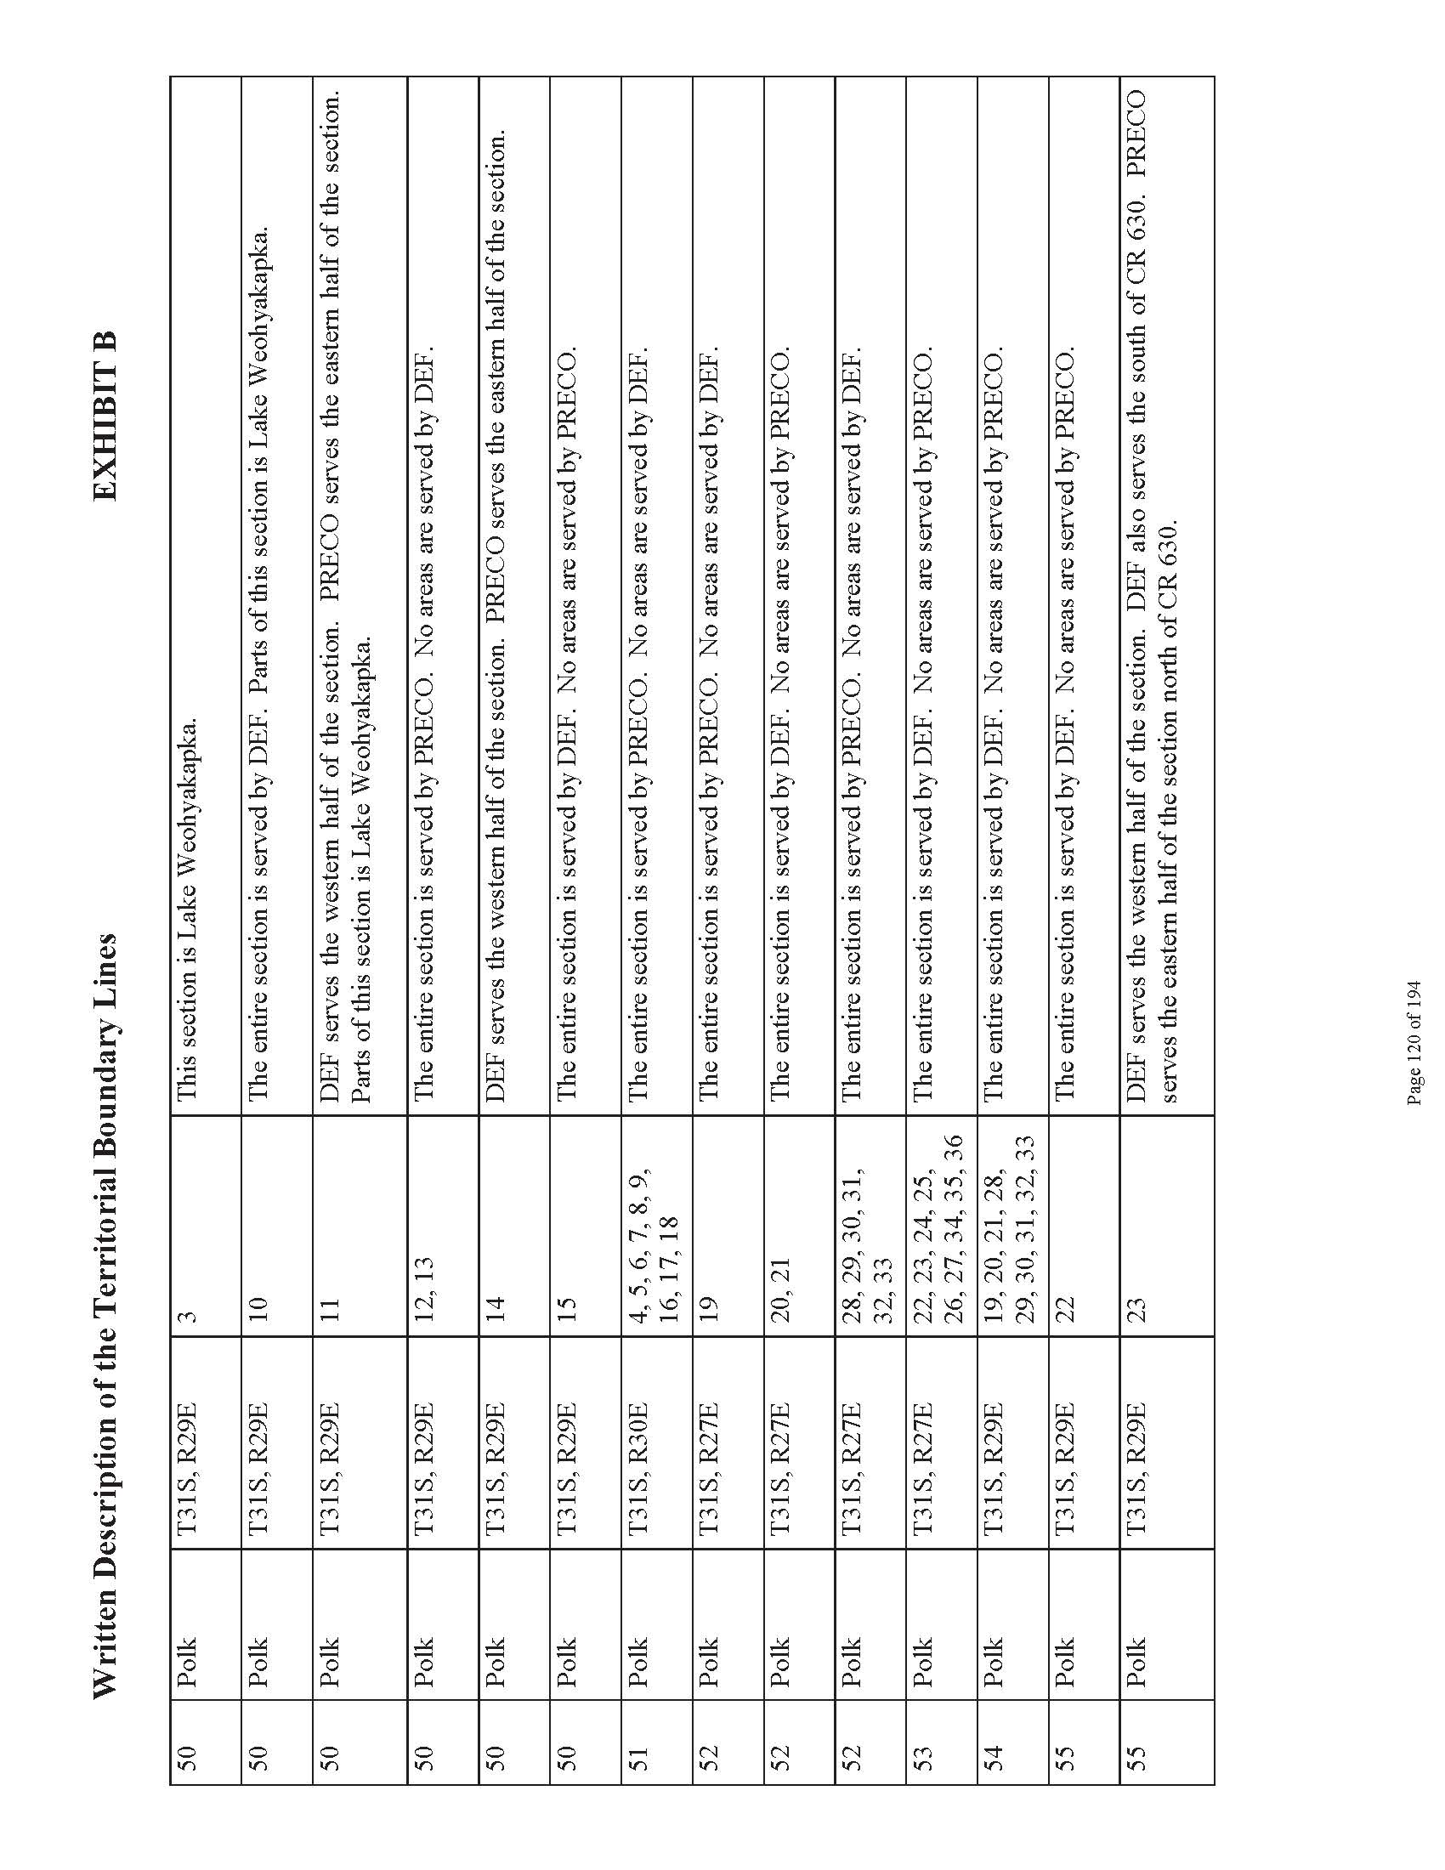

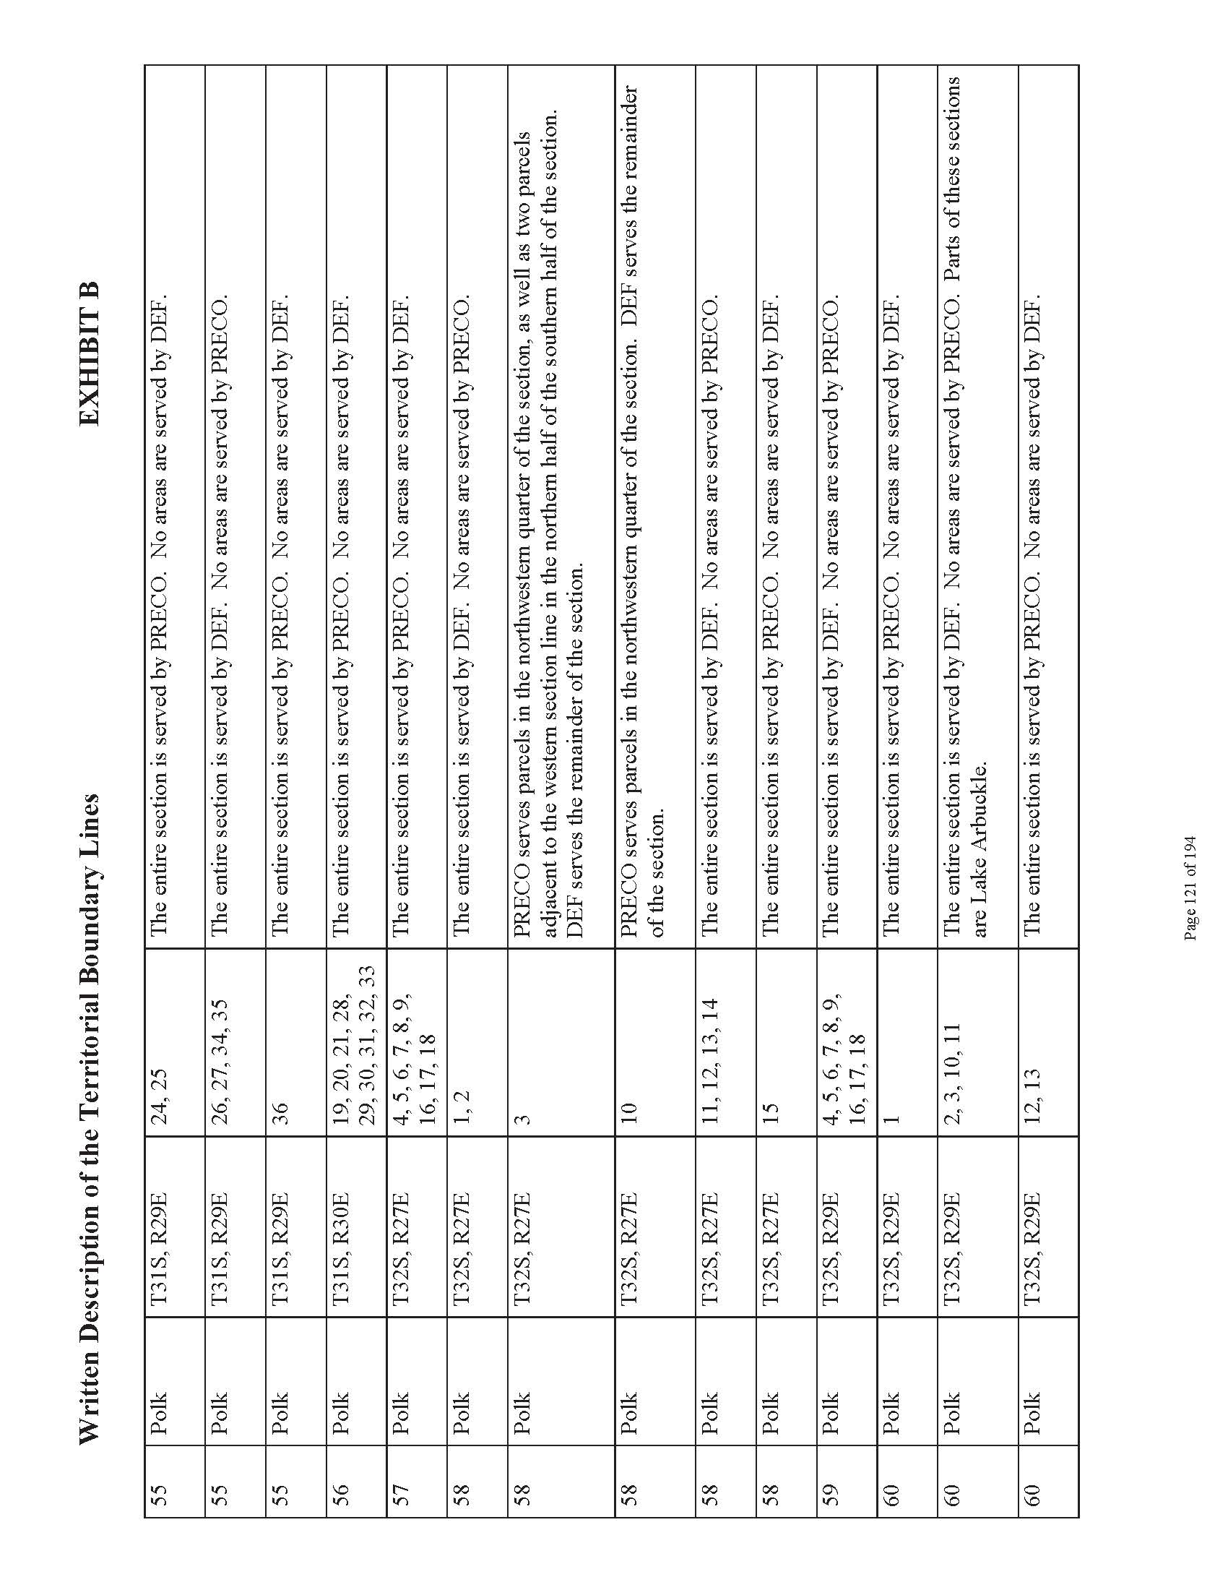

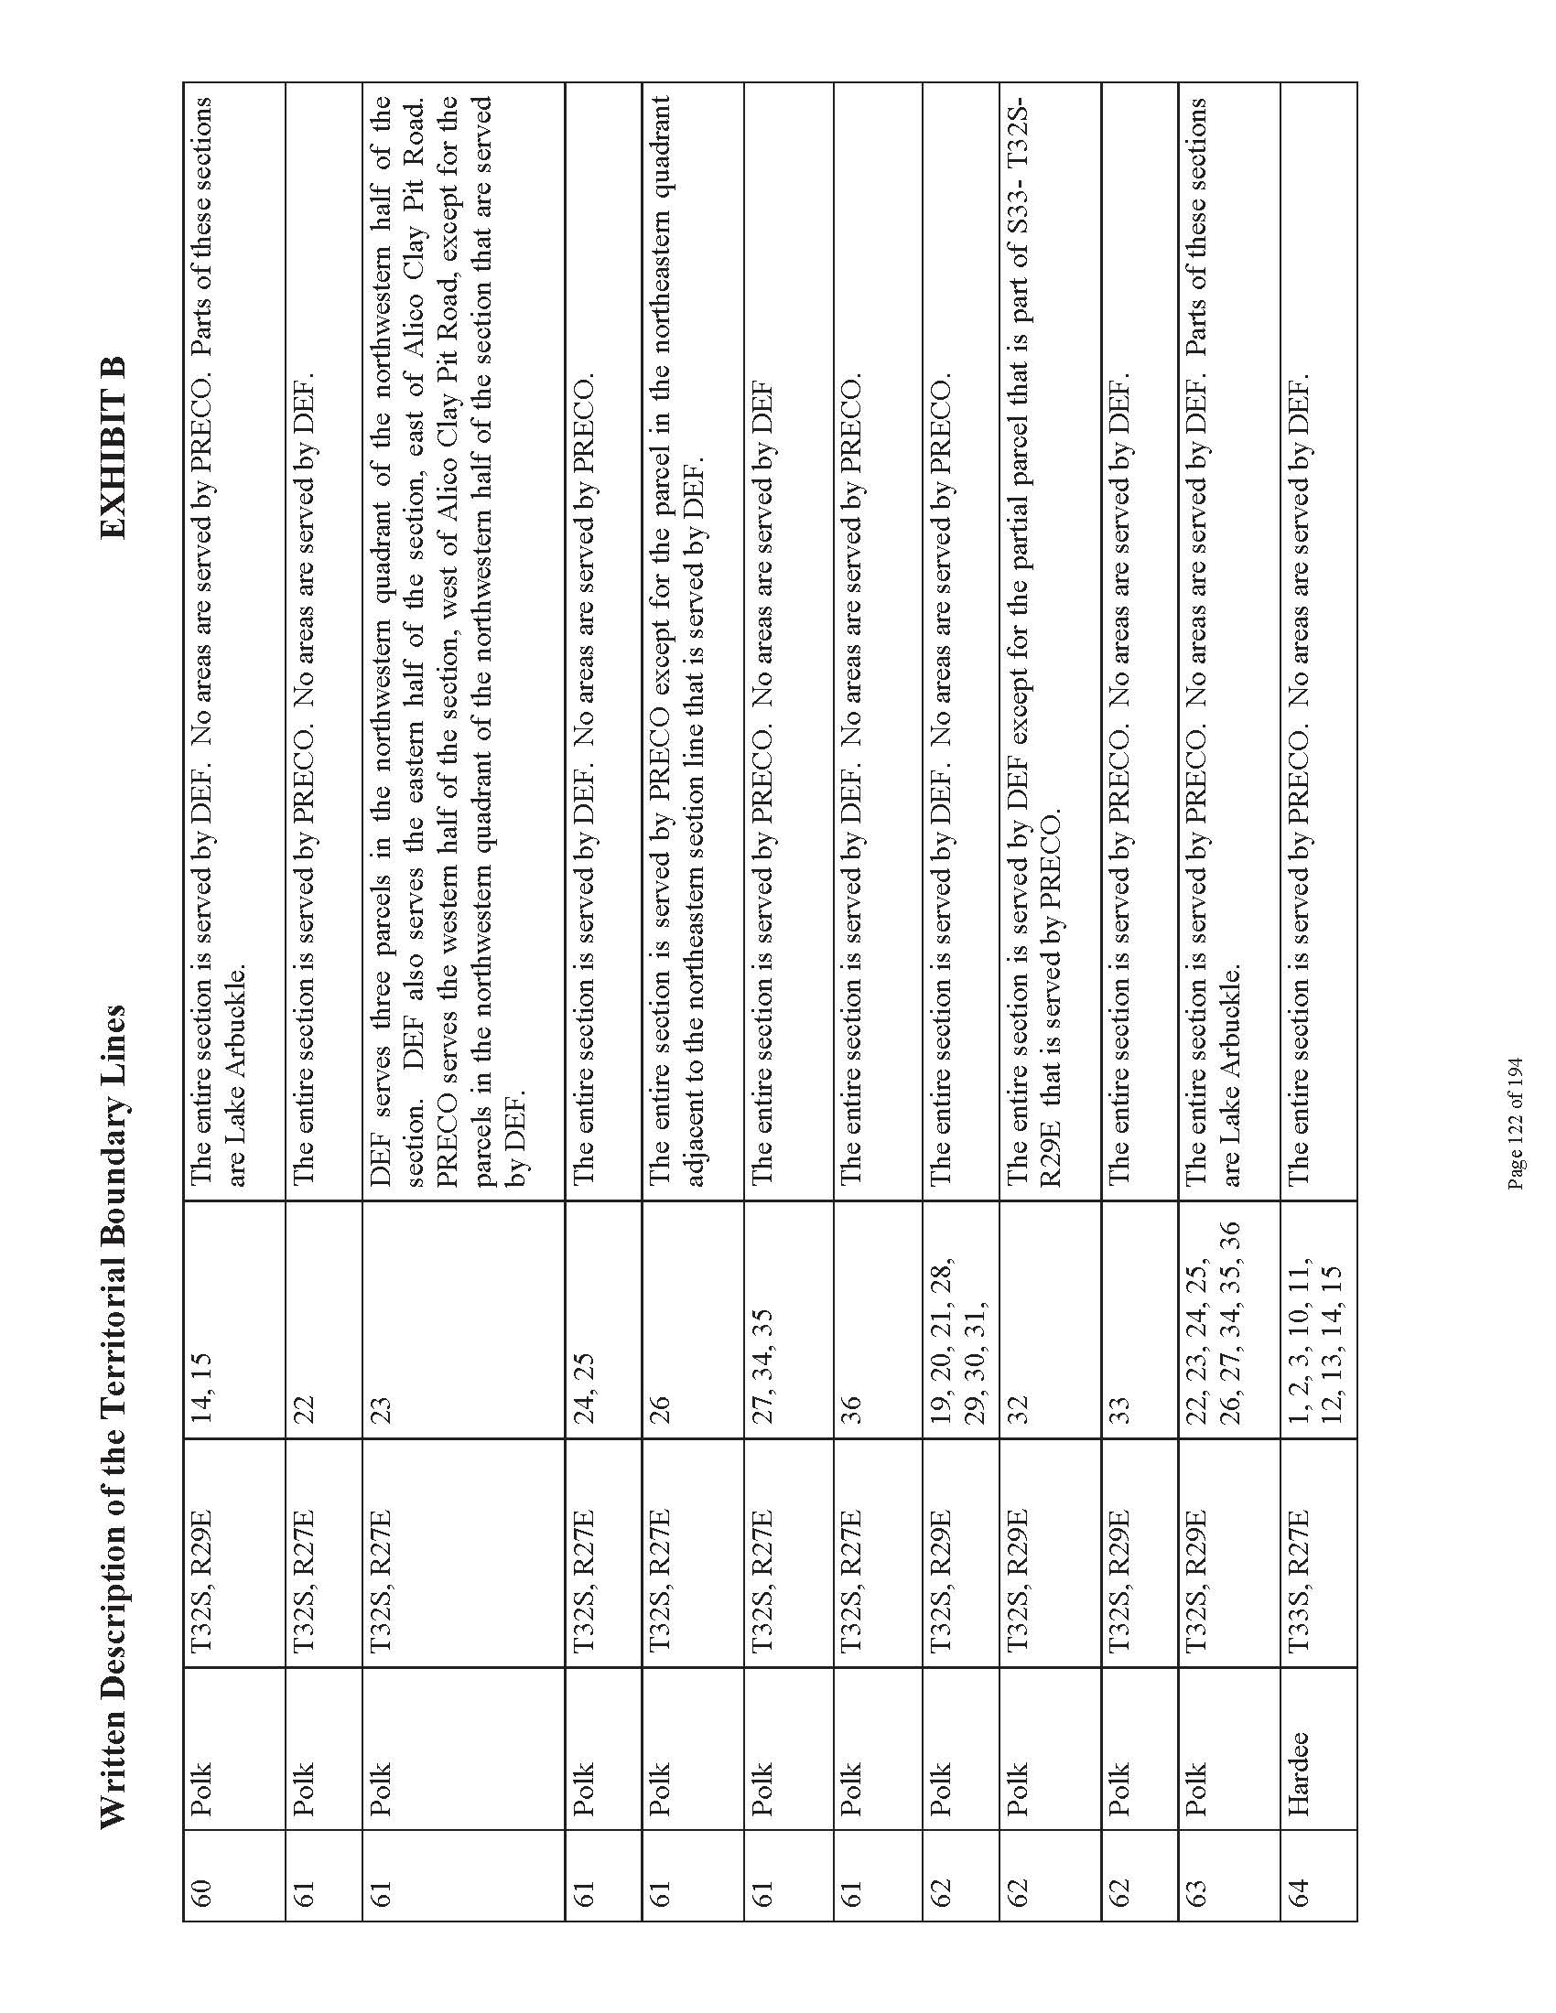

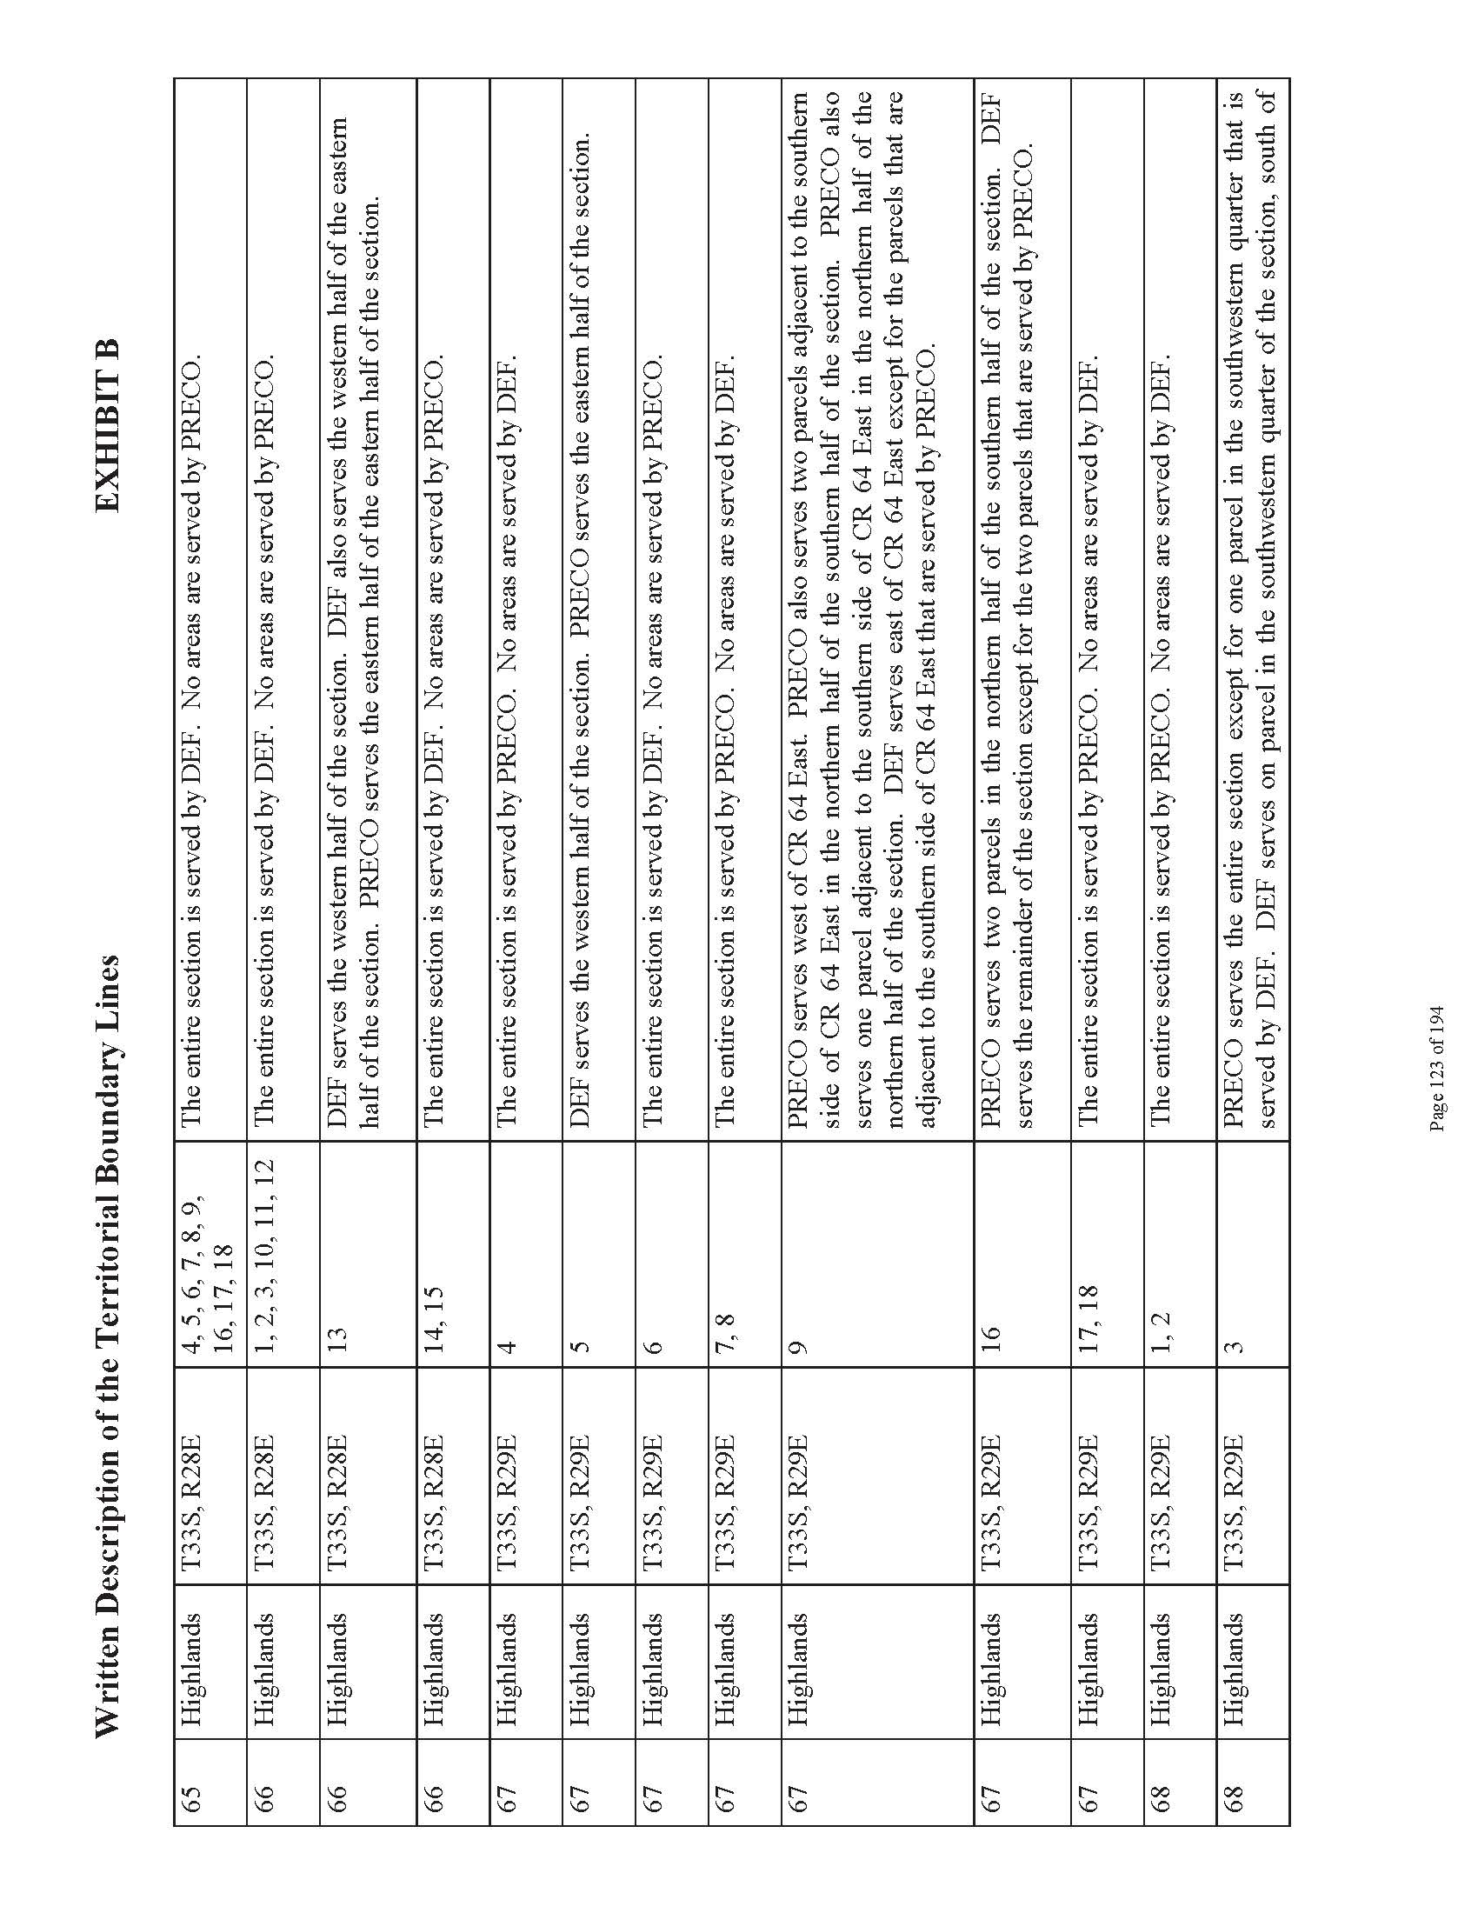

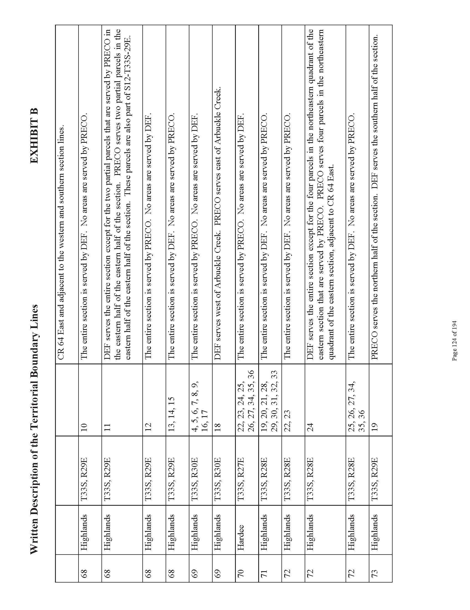

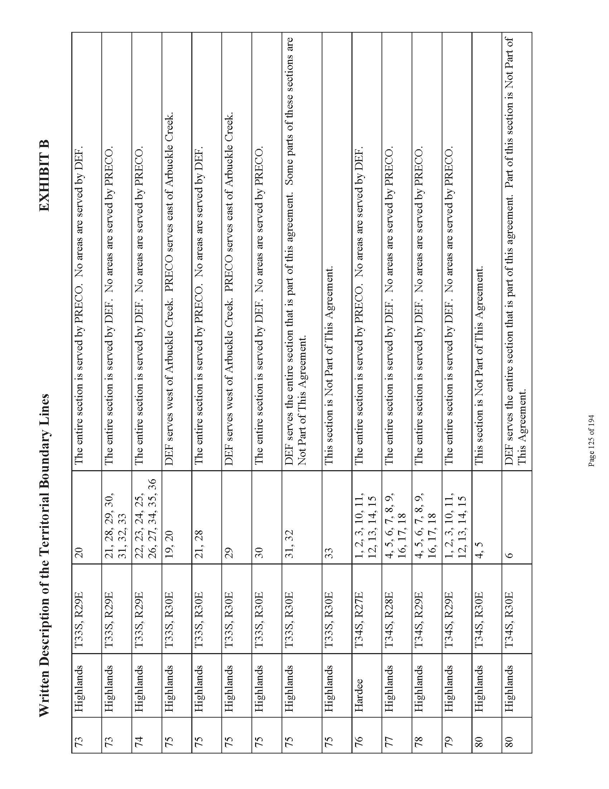

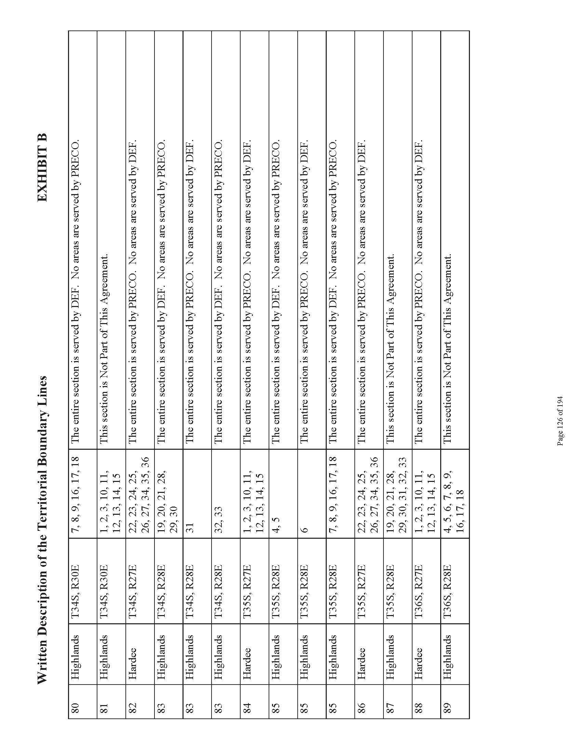

Order No. PSC-94-1522-FOF-EU, issued December 12, 1994, in Docket No. 940376-EU, In re: Joint Petition for approval of territorial agreement between Florida Power Corporation and Peace River Electric Cooperative, Inc.
Order No. PSC-06-0673-PAA-EU, issued August 7, 2006, in Docket No. 060277-EU, In re: Joint petition for approval of territorial amendment in Polk, Hardee, Highlands, Manatee, and Osceola Counties by Progress Energy Florida, Inc. and Peace River Electric Cooperative, Inc.
Utilities Commission of the City of New Smyrna Beach v. Florida Public Service Commission, 469 So. 2d 731 (Fla. 1985).
Composite Exhibit A of the petition.
Exhibit F of the petition.
Attachment 1 of the petition.

