BEFORE THE FLORIDA PUBLIC SERVICE COMMISSION

In re: Petition for approval of customer specified lighting tariff by Tampa Electric Company. | DOCKET NO. 20180222-EI  ORDER NO. PSC-2019-0063-TRF-EI  ISSUED: February 18, 2019

The following Commissioners participated in the disposition of this matter:

ART GRAHAM, Chairman
JULIE I. BROWN
DONALD J. POLMANN
GARY F. CLARK
ANDREW GILES FAY

ORDER APPROVING TAMPA ELECTRIC COMPANY’S
CUSTOMER SPECIFIED LIGHTING TARIFF

BY THE COMMISSION:

Background
On December 3, 2018, Tampa Electric Company (TECO or utility) filed a petition for approval of a new optional customer specified lighting tariff (LS-2 tariff). TECO proposed the new LS-2 tariff in response to customers requesting special lighting fixtures or poles. TECO provided a letter waiving the 60-day file and suspend provision of Section 366.06(3), Florida Statutes (F.S.), until the February 5, 2019, Agenda Conference.
On January 15, 2019, TECO filed two corrections to the tariffs filed with the petition. The first correction was made to tariff sheet No. 6.835, reflecting the addition of the LS-2 energy charge, which was inadvertently omitted. The second correction was made to the cost recovery clause tariff sheet No. 6.020 to include the LS-2 tariff as LS-2 customers will be billed all cost recovery clauses. The tariff sheets approved herein are included as Attachment A. We have jurisdiction over this matter pursuant to Sections 366.03, 366.04, 366.05, and 366.06, F.S.
Decision
TECO currently offers a list of specific fixtures and poles a customer can choose from under its Lighting Service-1 (LS-1) tariff. The LS-1 charges for each fixture are comprised of three components: a fixture charge, a maintenance charge, and an energy charge. Charges for poles include a pole and maintenance charge. Customers taking service under the LS-1 tariff are required to sign the Bright Choices Outdoor Lighting Agreement for a minimum of 10 years. After the initial 10-year term, this Agreement can be terminated by either party upon providing the other party with 90 days written notice of termination.
Customers occasionally request a fixture or pole that is not offered under the LS-1 tariff. Upon such request, TECO may seek our approval to add the requested fixture or pole to the LS-1 tariff. In the alternative, customers may install customer-owned fixtures or poles and utilize TECO’s energy-only rate offering under the LS-1 tariff.
TECO proposed the LS-2 tariff to address customer requests for special fixtures or poles, not offered under the LS-1 tariff, in a timely and efficient manner. TECO will only apply the LS-2 tariff in response to a special lighting request and will not actively market the tariff. The utility will purchase and install the requested lighting facilities if they meet TECO’s reliability standards. The utility stated that customers are seeking distinctive lighting fixtures or poles that would be a signature of or attraction for their location. TECO believes that as economic development continues in the Tampa Bay area, the LS-2 tariff will be predominantly used by subdivisions, shopping centers, and other new developments. The utility currently has one request from a subdivision for lighting service using a unique style of pole that would be best accommodated under the LS-2 tariff.
The lighting requests under the LS-2 tariff will be unique to each customer; therefore, TECO proposes that a different rate setting approach be applied. To bill customers for the fixture and maintenance costs, TECO proposes to apply a monthly factor of 1.19 percent to the in-place value of the facilities. The in-place value is determined by TECO’s cost to purchase and install the requested facilities. The Commission-approved monthly factor of 1.19 percent is currently contained in the Facilities Rental Agreement (tariff sheet Nos. 7.760 – 7.775) and was approved in TECO’s last rate case. The monthly factor of 1.19 percent assures recovery of TECO’s lighting facilities investment (depreciation, taxes, maintenance cost, and return). All other Commission-approved street lighting energy charge and cost recovery factors, such as fuel, will apply.
Customers will be required to sign the Bright Choices Outdoor Lighting Agreement. The initial term for LS-2 customers will be 20 years to allow for full cost recovery over the expected life of the facilities. TECO explained that the 20 years is justified because the lighting facilities installed are specific to a customer’s request and may not be of value to a subsequent customer at that location. To accommodate the 20-year term associated with the proposed LS-2 tariff, TECO modified one page of the Agreement (see page 6 of 7 of Attachment A).
We approved a similar lighting tariff (Form 4, tariff sheet No. 7.13) for Gulf Power Company in its 2001 rate case in response to customers requesting more fixture and pole options. We more recently approved an optional LT-1 streetlight tariff for Florida Power & Light Company (FPL). The LT-1 tariff allows FPL to offer a wide range of fixtures through a catalogue on the FPL website as opposed to in the tariff itself.
We have reviewed TECO’s petition and find the proposed LS-2 tariff is reasonable and appropriate. The LS-2 tariff allows TECO to respond to customer requests for special fixtures or poles in a timely and efficient manner. The general body of ratepayers will be protected as LS-2 customers will be responsible for all costs associated with their request.
Given the information discussed above, we find that TECO’s proposed customer specified lighting tariff is reasonable and is hereby approved, effective February 5, 2019, the date of our vote on this matter.
Based on the foregoing, it is

ORDERED by the Florida Public Service Commission that Tampa Electric Company’s proposed customer specified lighting tariff, as discussed in the body of this Order, is hereby approved, effective February 5, 2019. It is further

ORDERED that if a protest is filed within 21 days of the issuance of this Order, the tariff shall remain in effect with any charges held subject to refund pending resolution of the protest. It is further

ORDERED that if no timely protest is filed, this docket shall be closed upon the issuance of a Consummating Order.

By ORDER of the Florida Public Service Commission this 18th day of February, 2019.

/s/ Adam J. Teitzman
ADAM J. TEITZMAN
Commission Clerk
Florida Public Service Commission
2540 Shumard Oak Boulevard
Tallahassee, Florida 32399
(850) 413-6770
www.floridapsc.com

Copies furnished: A copy of this document is provided to the parties of record at the time of issuance and, if applicable, interested persons.

KBS

NOTICE OF FURTHER PROCEEDINGS

The Florida Public Service Commission is required by Section 120.569(1), Florida Statutes, to notify parties of any administrative hearing or judicial review of Commission orders that is available under Sections 120.57 or 120.68, Florida Statutes, as well as the procedures and time limits that apply. This notice should not be construed to mean all requests for an administrative hearing or judicial review will be granted or result in the relief sought.

Mediation may be available on a case-by-case basis. If mediation is conducted, it does not affect a substantially interested person's right to a hearing.

The Commission's decision on this tariff is interim in nature and will become final, unless a person whose substantial interests are affected by the proposed action files a petition for a formal proceeding, in the form provided by Rule 28-106.201, Florida Administrative Code. This petition must be received by the Office of Commission Clerk, 2540 Shumard Oak Boulevard, Tallahassee, Florida 32399-0850, by the close of business on March 11, 2019. In the absence of such a petition, this Order shall become final and effective upon the issuance of a Consummating Order.

Any objection or protest filed in this docket before the issuance date of this Order is considered abandoned unless it satisfies the foregoing conditions and is renewed within the specified protest period.

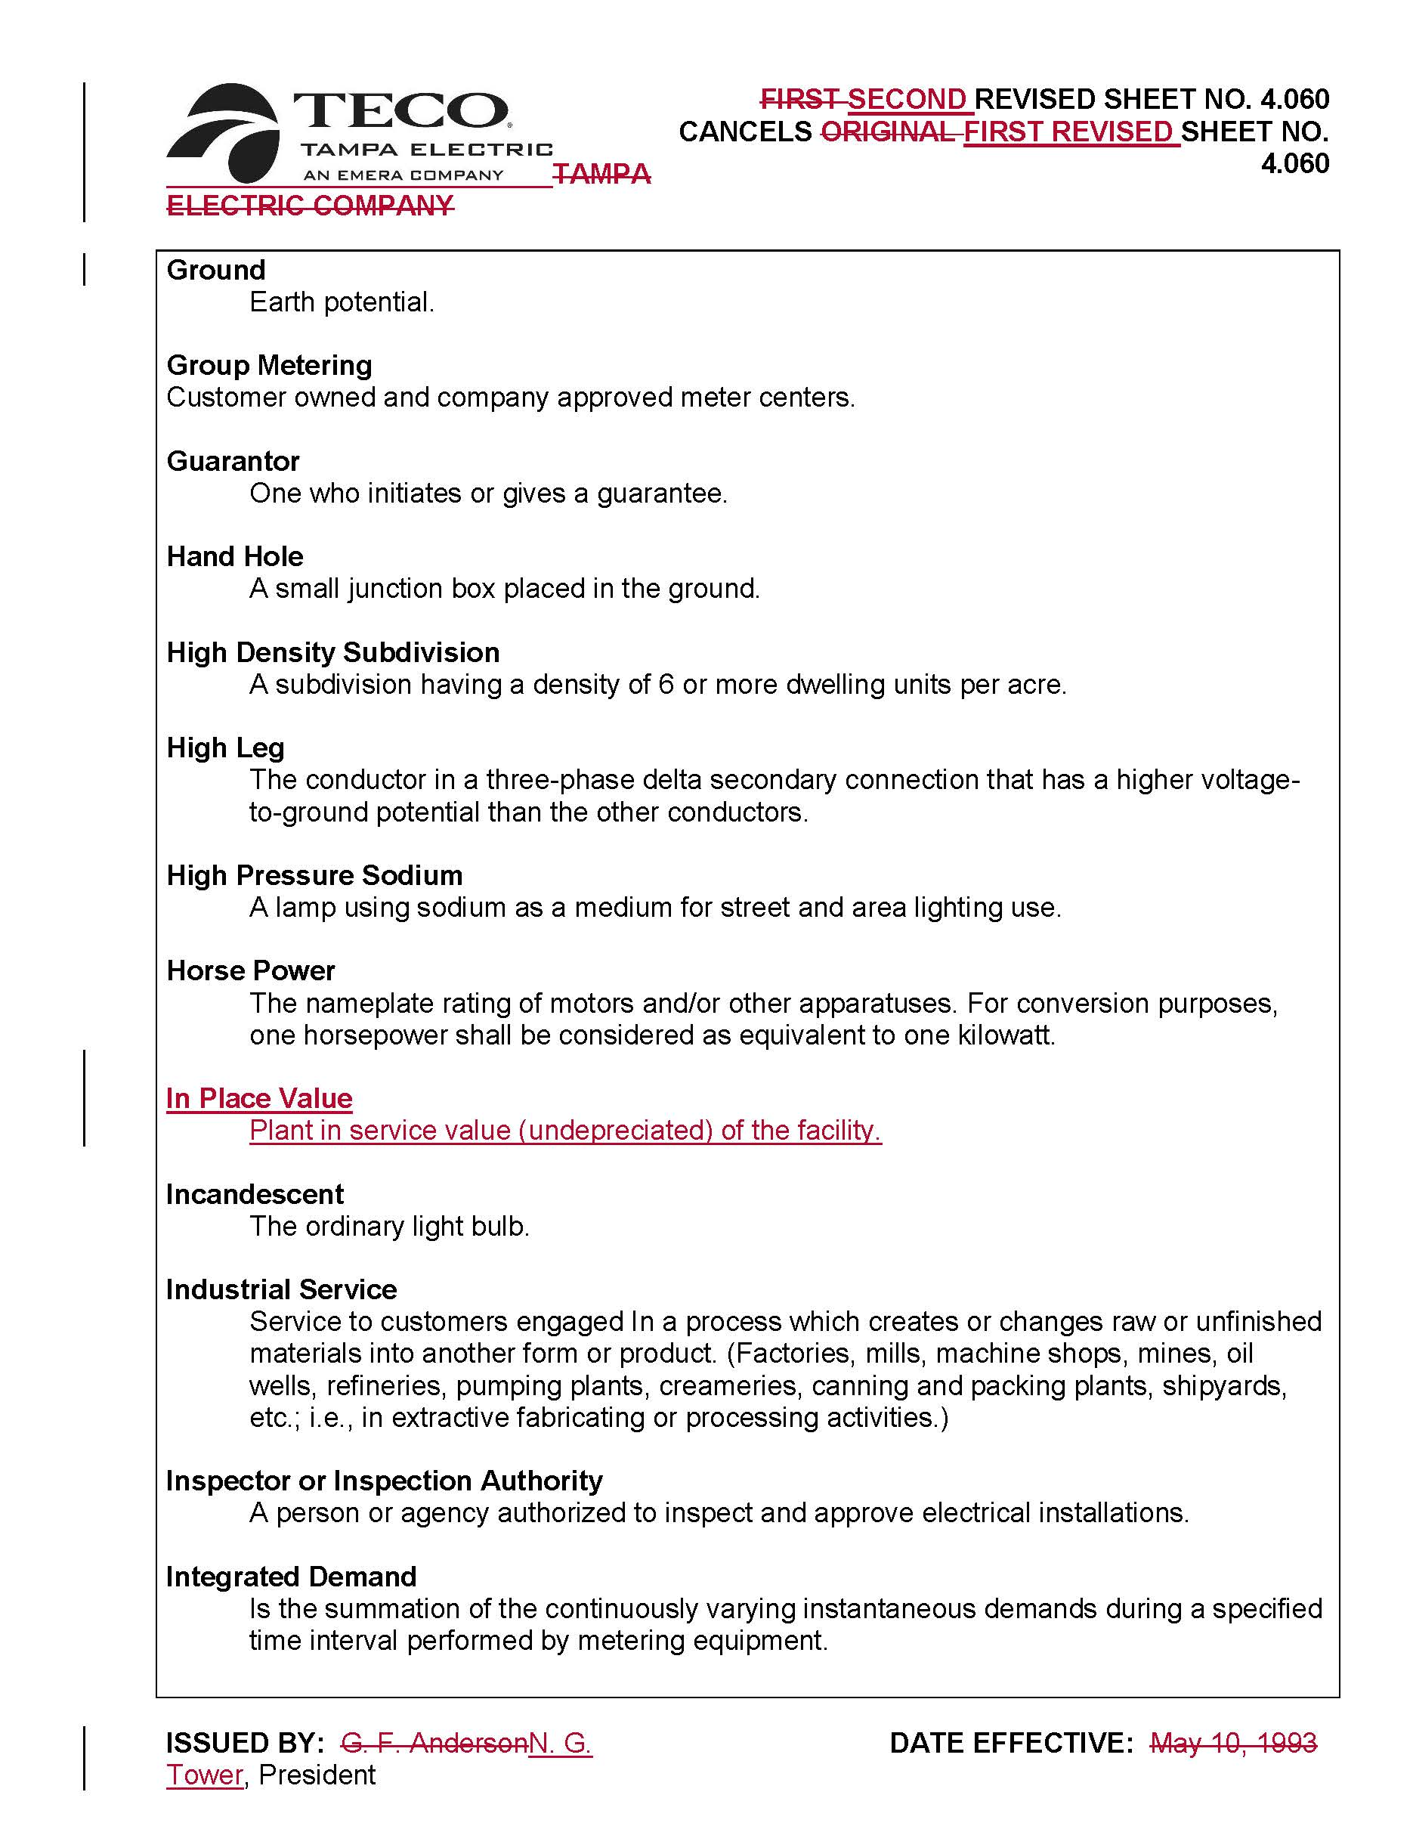

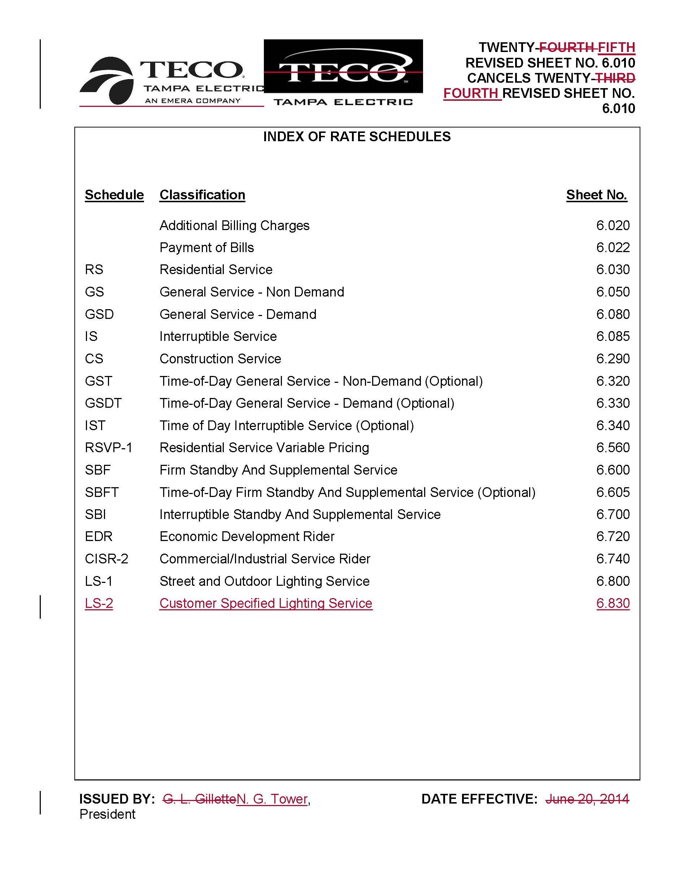

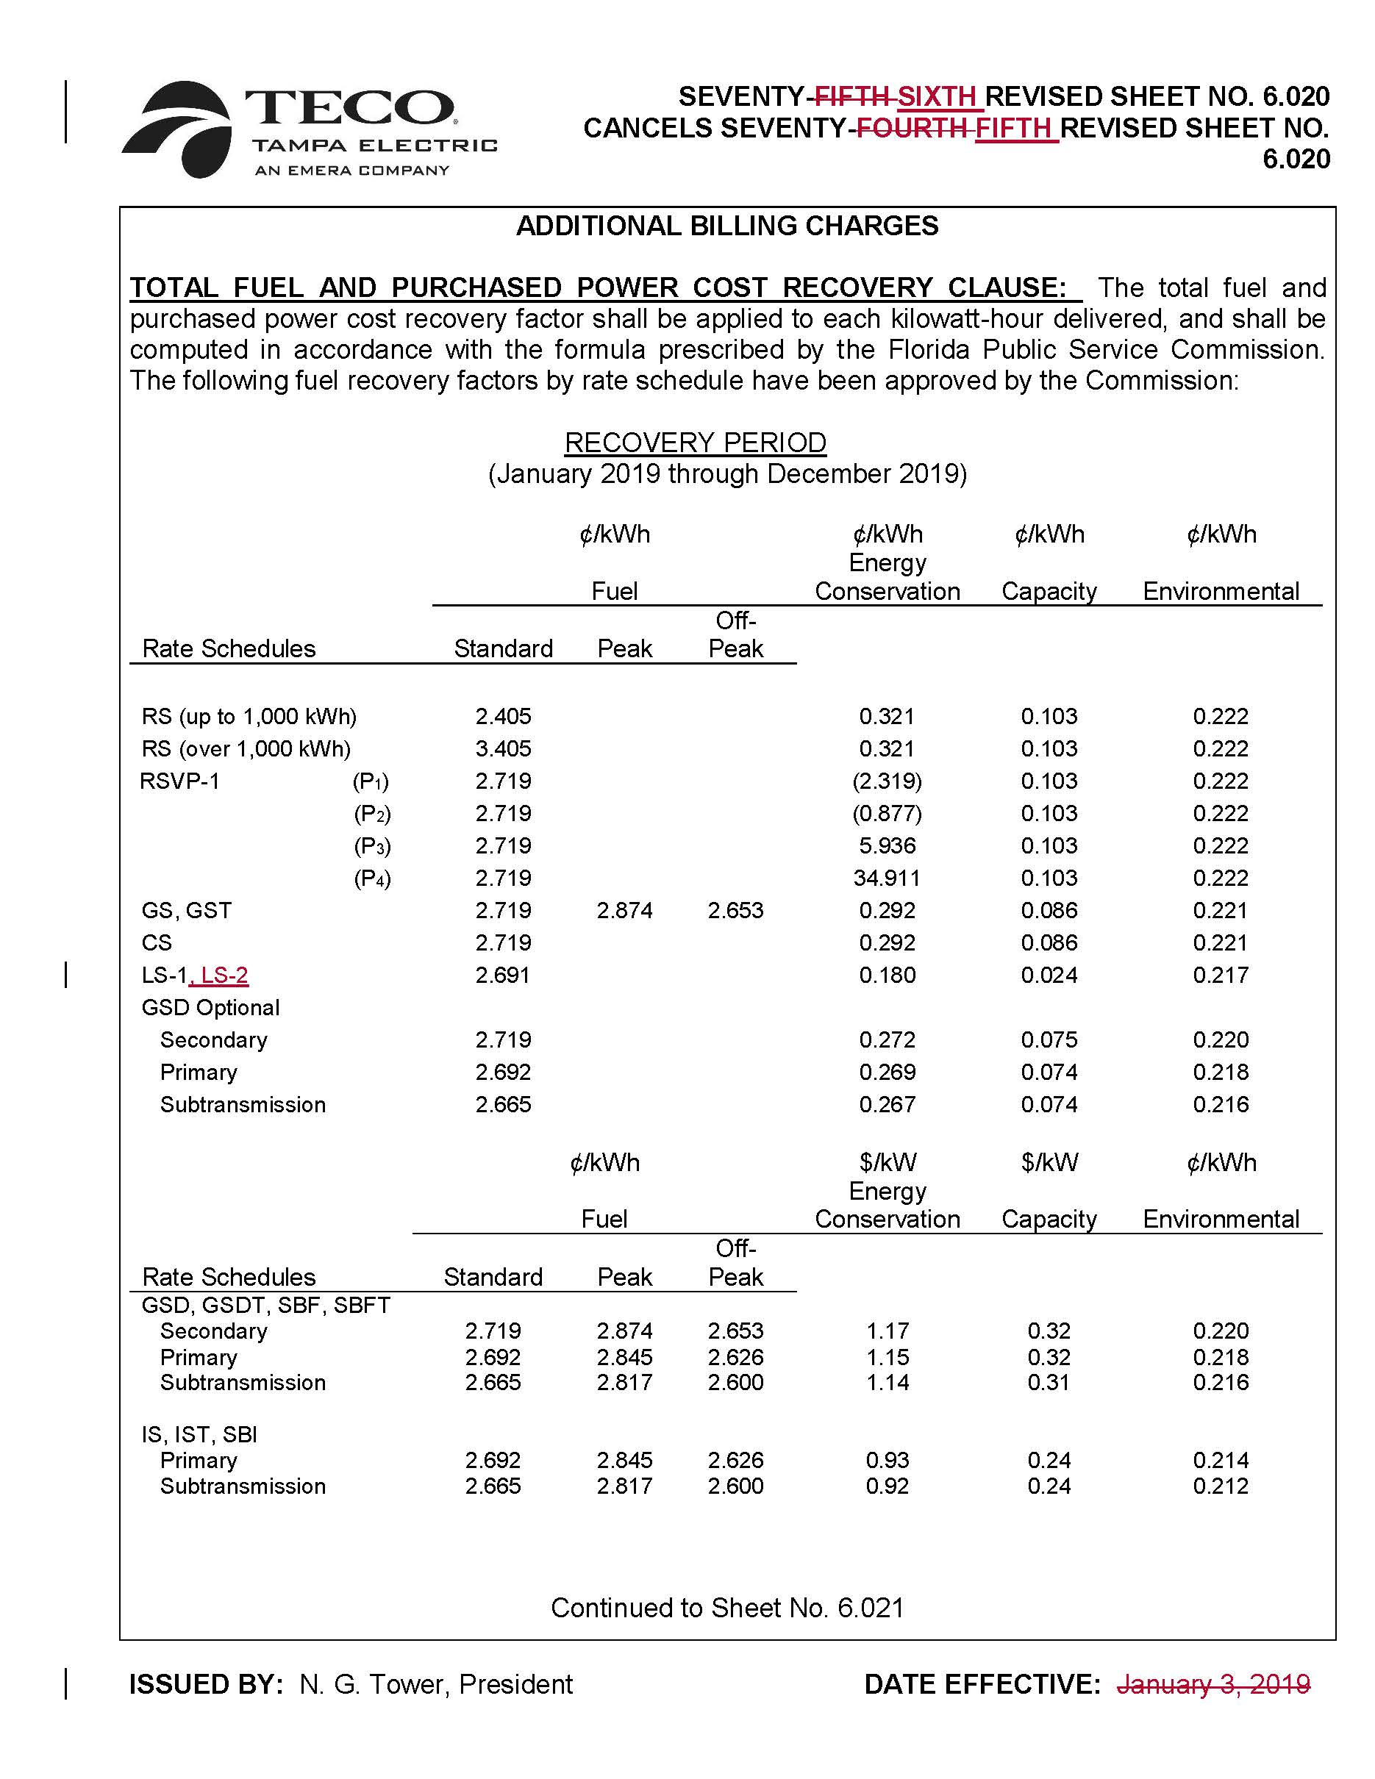

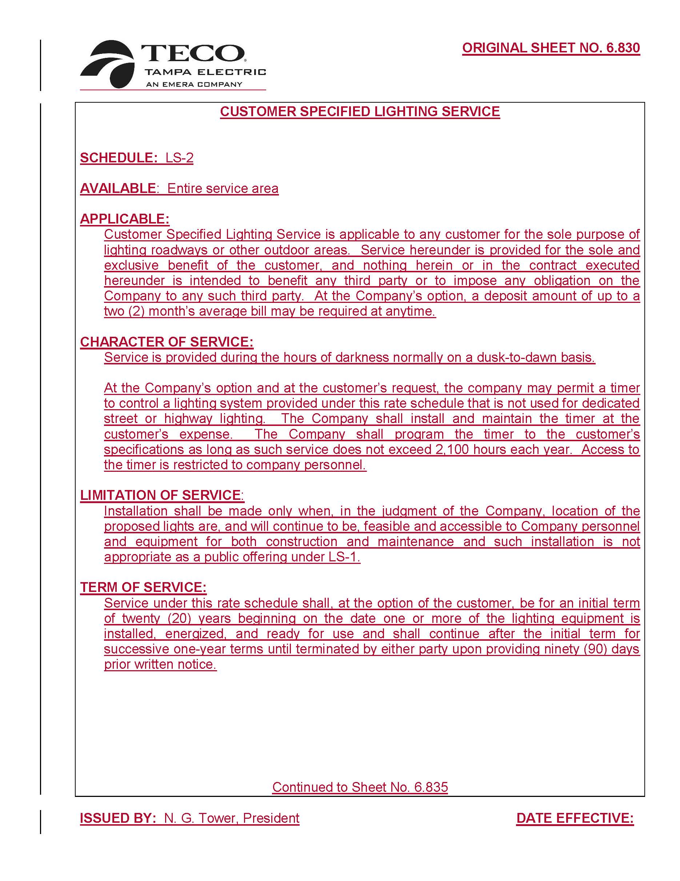

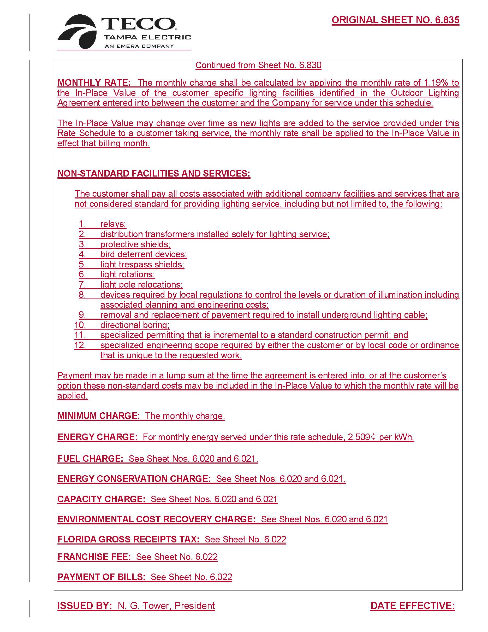

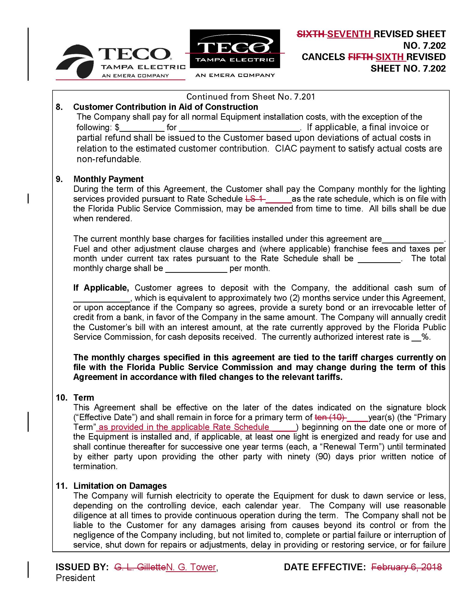

Order No. PSC-13-0443-FOF-EI, issued September 30, 2013, Docket No. 130040-EI, In re: Petition for rate increase by Tampa Electric Company.
Order No. PSC-02-0787-FOF-EI, issued June 10, 2002, Docket No. 010949-EI, In re: Request for rate increase by Gulf Power Company.
Order No. PSC-17-0115-TRF-EI, issued March 28, 2017, Docket No. 160245-EI, In re: Petition for approval of a new optional pilot LED streetlight tariff, by Florida Power & Light Company.

