State of Florida |  | Public Service Commission  Capital Circle Office Center ● 2540 Shumard Oak Boulevard  Tallahassee, Florida 32399-0850  -M-E-M-O-R-A-N-D-U-M-
DATE: | February 21, 2019
TO: | Office of Commission Clerk (Teitzman)
FROM: | Division of Economics (Merryday)  Office of the General Counsel (Nieves)
RE: | Docket No. 20190024-EI – Petition for approval of a smart meter opt-out tariff, by Tampa Electric Company.
AGENDA: | 03/05/19 – Regular Agenda – Tariff Filing – Interested Persons May Participate
COMMISSIONERS ASSIGNED: |  |  | All Commissioners
PREHEARING OFFICER: |  |  | Administrative
CRITICAL DATES: |  |  | 03/18/19 (60-day Suspension Date)
SPECIAL INSTRUCTIONS: |  |  | None

Case Background
On January 18, 2019, Tampa Electric Company (TECO or utility) filed a petition for approval of a smart meter opt-out tariff (opt-out tariff). The proposed tariff would be available to customers who choose to receive a non-communicating meter in lieu of the standard smart meter, or Automated Meter Infrastructure (AMI) smart meter.
On November 16, 2017, the Commission approved TECO’s 2017 Amended and Restated Stipulation and Settlement Agreement (2017 Settlement), which allows TECO to apply existing depreciation rates to AMI meters if they are installed before the utility’s next depreciation study. Paragraph 12 of the 2017 Settlement allows the utility to file the proposed opt-out tariff as the tariff and associated charges are optional to customers.
TECO’s current residential meters are Automated Meter Reading (AMR) meters that emit a radio frequency signal. That signal is picked up by a meter reading vehicle driving by the neighborhood. Current commercial customers primarily have digital, non-communicating meters that require monthly meter reading visits. The utility states that the scope of the AMI project is to upgrade all meters in TECO’s service territory to AMI meters.
The utility expects that some customers will elect to forego the new AMI meters and request a non-communicating meter; therefore, TECO filed the instant petition and associated opt-out tariff. The opt-out tariff would be applicable to customers that request a non-communicating, i.e., non-standard, meter and includes an initial one-time set-up fee of $96.27 and a monthly surcharge of $20.64. The proposed charges are based on TECO’s incremental costs to provide the opt-out service.
The Commission approved similar opt-out tariffs and charges for Florida Power & Light Company (FPL) in 2015 and Duke Energy Florida, LLC (Duke) in 2018. FPL’s opt-out tariff includes an $89.00 one-time set-up fee with a $13.00 monthly surcharge. Duke’s opt-out tariff includes a $96.34 one-time set-up fee with a $15.60 monthly surcharge. Several municipal electric utilities (City of Lakeland and Orlando Utilities Commission) and rural electric cooperatives (Sumter Electric, Talquin Electric, Tri-County Electric, and Peace River) also provide opt-out tariffs.
On February 8 and 15, 2019, TECO responded to staff’s data requests. The legislative version of the opt-out tariff sheet No. 3.280 is shown in Attachment A to the recommendation. The Commission has jurisdiction pursuant to Sections 366.03, 366.04, 366.05, and 366.06, Florida Statutes.

Discussion of Issues

Issue 1:
Should the Commission approve TECO's proposed opt-out tariff?

Recommendation:
Yes, the Commission should approve TECO’s proposed opt-out tariff as shown in Attachment A. This tariff allows TECO to respond to customer requests for a non-communicating meter. Opt-out customers will be responsible for all costs associated with their request, thus protecting the general body of ratepayers. Additionally, the proposed opt-out tariff is in accordance with previous Commission decisions.
The tariff should become effective when TECO completes the billing system changes to implement the tariff, which is expected to be in the third quarter of 2019. TECO should notify Commission staff when the billing system changes are completed. Within three months after the AMI smart meter deployment is completed, TECO should report to the Commission (with a filing in this docket) on the costs of the program, revenues, and actual participation. (Merryday)

Staff Analysis:
TECO began installing AMI meters in January 2017 with the goal of converting all of its existing drive-by AMR meters to AMI meters by 2021. The utility states that customers are currently being granted the option of not having their meters replaced and are being told that there are currently no charges imposed for taking advantage of this option; however, they are being informed that it is expected that such charges will be authorized and collected in the future. The instant petition seeks to approve the tariff to implement such charges at a later date.
The proposed tariff includes two separate fees: a one-time set-up fee of $96.27 (for the non-standard meter installation) and a monthly surcharge of $20.64 (for upfront IT costs and monthly meter readings). The set-up fee must be paid at the time the customer takes service under the opt-out tariff, regardless of the length of time the customer is enrolled; however, the utility explained that customers that have already rejected an AMI meter will not be assessed any opt-out tariff fees until the tariff is effective and a non-standard meter is installed (expected to be sometime in the third quarter of 2019). TECO states that this will allow customers time to elect to either continue or abandon their prior opt-out selection. These charges will be in addition to all other tariffed rates and charges applicable to an opt-out customer.

Customer Participation
TECO anticipates that approximately 0.2 percent – or 1,620 – of its approximate 810,000 customers will elect to opt out. The utility explained that TECO is experiencing a current opt-out rate of 0.27 percent and anticipates a reduction in participation if the fees in the instant petition are introduced. As of December 31, 2017, FPL had 5,966 customers enrolled in its smart meter opt-out tariff, which represented a 0.12 percent customer participation rate. Duke anticipated 0.15 percent – about 2,700 – of its 1.8 million eligible customers would opt out. The projected number of opt-out customers is used in developing the monthly surcharge.

Set-up Fee
The one-time set-up fee of $96.27 reflects the labor, transportation, and initial IT set-up costs to install each non-standard meter and enroll the customer in the opt-out program. In response to staff’s data request, TECO indicated that no new positions would be created to perform the incremental tasks associated with administering the opt-out tariff. Customers would not be required to pay the $96.27 set-up fee if an approved non-communicating meter already exists at customer premises or if customers relocate to premises with an approved non-communicating meter.
The set-up fee is applicable to all opt-out tariff participants regardless of duration of service under the opt-out tariff. The breakdown of the set-up fee components is as follows:
Table 1-1
Set-up Fee Cost Components
Task | Time Per Customer | Cost Per Customer | Description
Customer Service | 10 minutes | $5.28 | Customer Care Specialist to take calls for opt-out participants, explain tariff details, set up account, and handle initial questions/issues to support re-route.
Perform analysis to re-route meter | 45 minutes | $27.00 | Billing Specialist to analyze and plan approach to re-route meters, move meters to new route, and validate billing is correct.
Planner Dispatcher to reroute meter | 5 minutes | $4.05 | Planner/Dispatcher to move meter into new route upon direction from Billing Specialist.
Meter Field Rep to exchange meter | 40 minutes | $29.15 | Meter Field Rep to travel to customer premise, remove existing meter and replace with opt-out meter, close work orders.
Vehicle to exchange meter | 40 minutes | $2.76 | Use of a vehicle to change out meter.
IT developer to complete initial setup for opt-out customer | n/a | $28.03 | IT development work to prepare for customer sign-up for the opt-out program
Total one-time cost per customer |  | $96.27
Source: Exhibit A to TECO’s petition
TECO provided support for the time per customer based on each of the tasks to be performed. Staff believes the time estimates to be reasonable. The cost per customer is calculated by multiplying the time to complete the task by the hourly rate of the job performer. TECO provided cost support for its hourly rates which includes the confidential annual salary, payroll tax, benefits, pension, and incentives (bonus payments). Staff reviewed hourly rate information provided by TECO in its 2013 rate case and believes the hourly rates included in this docket are reasonable. Furthermore, TECO’s salaries and vehicle rates are comparable to those approved for FPL’s and Duke’s opt-out charges.

Monthly Surcharge
The monthly surcharge to take service under the opt-out tariff is $20.64, which reflects a combination of ongoing IT and meter reading related costs. TECO’s IT costs to update the customer system to enable and support the opt-out program are predicted to be $407,966. TECO used a 5-year recovery period for these IT costs (which is the same recovery period the Commission approved for FPL’s and Duke’s opt-out tariff) to derive monthly IT related costs of $6.35 per customer.
After installation of a non-standard meter, the only ongoing costs to the utility will be the monthly meter readings, which the utility estimates to be $14.29 per customer. These costs reflect the meter reading position rates and the vehicle rates, both for an estimated 20 minutes per meter reading.

Customer Notice and Deployment
The utility states that AMI deployment began in January 2017 with the goal of converting all of its existing drive-by AMR meters to AMI meters by 2021. TECO explained that customers are currently being granted the option of not having their AMR meters replaced with an AMI meter and are being told that there are currently no charges for taking advantage of this option. TECO also informed customers that if the Commission approves an opt-out tariff, any approved opt-out charges will apply. TECO states that customers who have opted out during the AMI deployment process will be contacted when the opt-out tariff becomes effective. If the customers continue to desire to opt out, they will be enrolled in the opt-out tariff, receive a non-communicating meter, and be assessed the applicable tariffed charges.
TECO states that the utility will communicate to customers the deployment logistics of the AMI meters and provide them with facts to help them understand AMI technology. TECO’s communication process includes information on the utility’s website, door hangers, and mail notifications.

Reporting
Staff recommends that within three months after the AMI meter deployment is completed, TECO should report to the Commission on the costs of the program, revenues, and actual participation. Staff believes three months is a reasonable time to allow TECO to prepare and file a report in this docket, which should happen no later than May 31, 2022. IF AMI meter deployment is significantly delayed beyond the utility’s anticipated completion date, the utility should notify the Commission with a filing in this docket.
Staff notes that FPL is required to file annual smart meter progress reports. The Commission did not require Duke to file annual smart meter progress reports, but rather submit a filing in that docket three months after the AMI meter deployment is completed. As with Duke, staff believes that actual participation rates and costs may vary, and that a comparison of estimated costs presented in this petition and actual costs incurred is important to ensure the opt-out tariff remains cost-based or else should be adjusted through a revised tariff filing.

Conclusion
In the order approving FPL’s opt-out tariff, the Commission noted that “since significant incremental costs would be incurred in providing [an opt-out tariff], it would be discriminatory to require standard meter customers to subsidize that service.” Staff believes that TECO provided sufficient cost support in its petition and responses to staff’s data requests to support its assertion that the proposed tariff is cost-based.
The Commission should approve TECO’s proposed opt-out tariff as shown in Attachment A. This tariff allows TECO to respond to customer requests for a non-communicating meter. Opt-out customers will be responsible for all costs associated with their request, thus protecting the general body of ratepayers. Additionally, the proposed opt-out tariff is in accordance with previous Commission decisions.
The tariff should become effective when TECO completes the billing system changes to implement the tariff, which is expected to be in the third quarter of 2019. TECO should notify Commission staff when the billing system changes are completed. Within three months after the AMI smart meter deployment is completed, TECO should report to the Commission (with a filing in this docket) on the costs of the program, revenues, and actual participation.

Issue 2:
Should this docket be closed?

Recommendation:
If a protest is filed within 21 days of the issuance of the order, this tariff should remain in effect with any increase held subject to refund pending resolution of the protest. If no timely protest is filed, this docket should be closed upon issuance of a consummating order. (Nieves)

Staff Analysis:
If a protest is filed within 21 days of the issuance of the order, this tariff should remain in effect with any increase held subject to refund pending resolution of the protest. If no timely protest is filed, this docket should be closed upon issuance of a consummating order.

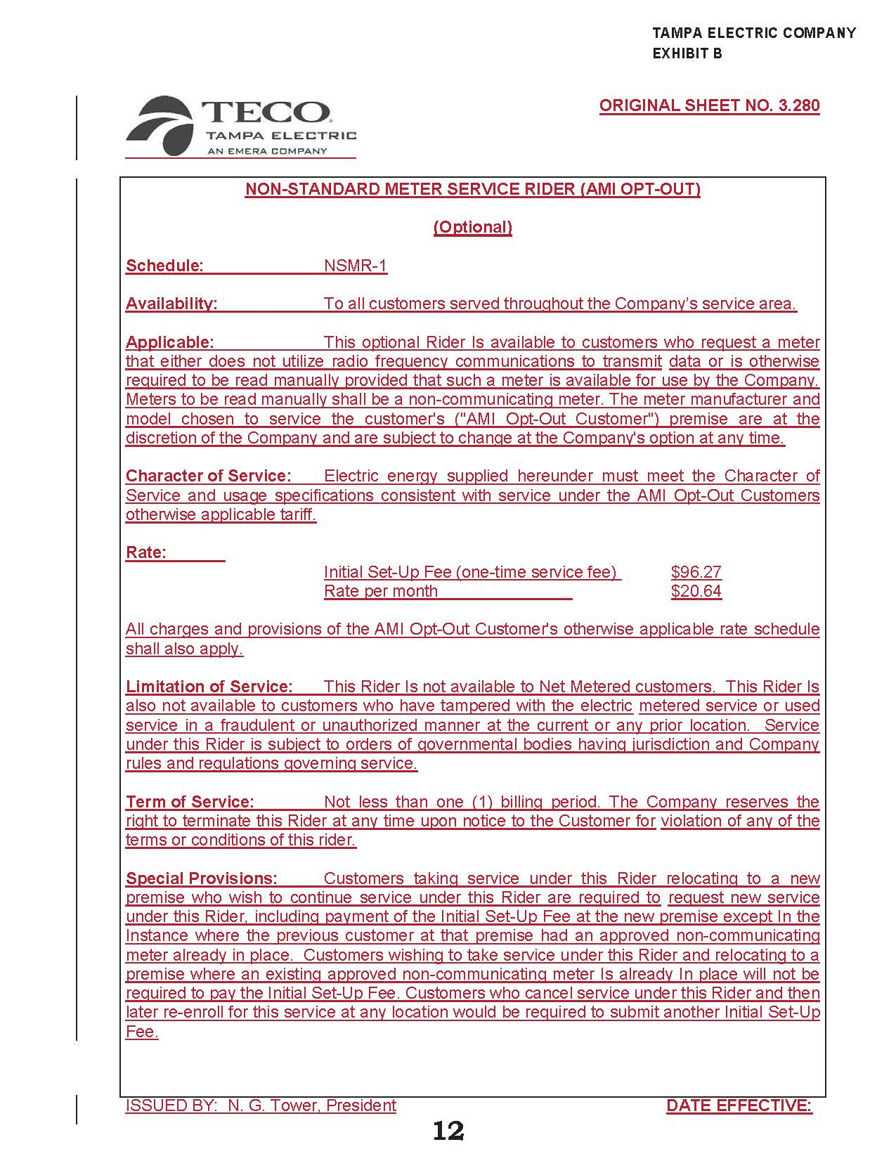

Order No. PSC-2017-0456-S-EI, issued November 27, 2017, in Docket No. 20170210-EI; In re: Petition for limited proceeding to approve 2017 amended and restated stipulation and settlement agreement, by Tampa Electric Company.
Order No. PSC-15-0026-FOF-EI, issued on January 7, 2015, in Docket No. 130223-EI; In re: Petition for approval of optional non-standard meter rider, by Florida Power & Light Company.
Order No. Order PSC-2018-0435-TRF-EI, issued on August 28, 2018, in Docket No. 180088-EI; In re: Petition for limited proceeding for approval of a smart meter opt-out tariff, by Duke Energy Florida, LLC.
TECO’s petition included other non-substantive tariff changes that have not been attached to the recommendation.
TECO requested confidentiality on the negotiated IT contractor information.
Docket No. 130040-EI; In re: Petition for rate increase by Tampa Electric Company.
Order No. PSC-15-0026-FOF-EI, issued on January 7, 2015, in Docket No. 130223-EI; In re: Petition for approval of optional non-standard meter rider, by Florida Power & Light Company.

