BEFORE THE FLORIDA PUBLIC SERVICE COMMISSION

In re: Petition for approval of amended standard offer contract (Schedule COG-2) based on a combustion turbine avoided unit, by Duke Energy Florida, LLC. | DOCKET NO. 20180073-EQ  ORDER NO. PSC-2019-0092-PAA-EQ  ISSUED: March 8, 2019

The following Commissioners participated in the disposition of this matter:

ART GRAHAM, Chairman
JULIE I. BROWN
DONALD J. POLMANN
GARY F. CLARK
ANDREW GILES FAY

NOTICE OF PROPOSED AGENCY ACTION ORDER
APPROVING DUKE ENERGY FLORIDA, LLC’S
PETITION TO AMEND SHEET 9.458 OF ITS
STANDARD OFFER CONTRACT

BY THE COMMISSION:

NOTICE is hereby given by the Florida Public Service Commission (Commission) that the action discussed herein is preliminary in nature and will become final unless a person whose interests are substantially affected files a petition for a formal proceeding, pursuant to Rule 25-22.029, Florida Administrative Code (F.A.C.).

Background
Section 366.91(3), Florida Statutes (F.S.), requires that each investor-owned utility (IOU) continuously offer to purchase capacity and energy from renewable energy generators and small qualifying facilities. Rules 25-17.200 through 25-17.310, F.A.C., implement Section 366.91(3), F.S., and require each IOU to file with the Commission, by April 1 of each year, a standard offer contract based on the next avoidable fossil fueled generating unit of each technology type identified in the utility’s current Ten-Year Site Plan. On March 29, 2018, Duke Energy Florida, LLC (DEF) filed a petition for approval of its amended standard offer contract and rate schedule COG-2 based on its 2018 Ten-Year Site Plan. On June 19, 2018, we issued Order No. PSC-2018-0314-PAA-EQ approving DEF’s petition.
On November 16, 2018, DEF filed a petition for approval to modify the delivery voltage adjustment factors (DVAFs) found on Sheet 9.458 of its standard offer contract. Pursuant to DEF’s standard offer contract, these voltage factors adjust the energy payments made to renewable energy generators and qualifying facilities located within DEF’s service territory. The adjustments reflect line losses avoided by DEF based on the delivery voltage level at which the facility’s energy is received by DEF. DEF uses a value that is filed with the Federal Energy Regulatory Commission (FERC) every year on May 1 as a component of the DVAFs. On October 31, 2018, a settlement agreement was filed on behalf of DEF that alters DEF’s DVAFs beginning January 1, 2019. On January 28, 2019, the FERC issued a letter order, Duke Energy Fla., LLC, 166 FERC ¶ 61,057 (2019), approving the settlement agreement. DEF is not requesting modification of any other tariff sheets.
We have jurisdiction over this standard offer contract pursuant to Sections 366.04 through 366.06 and 366.91, F.S.

Review and Decision
DEF conducts an annual system line loss study for the prior calendar year to determine delivery efficiencies throughout its transmission and distribution network. The results of this study are used to derive system line loss factors for its transmission, primary distribution, and secondary distribution voltage levels, which are filed with the FERC every year on May 1. These efficiency factors are used in the calculation of the DVAFs found on Sheet 9.458 of DEF’s standard offer contract. The current DVAFs are based on DEF’s 2017 line loss study and are 1.0150 for transmission, 1.0254 for primary distribution, and 1.0627 for secondary distribution.
On October 31, 2018, a settlement agreement was filed on behalf of DEF that alters DEF’s DVAFs beginning January 1, 2019. On January 28, 2019, FERC issued a letter order approving the settlement agreement. In the settlement, DEF agreed to remove facilities owned by Seminole Electric Cooperative, Inc. (Seminole) and its members from the losses calculation. The result was an increase in the derived transmission delivery efficiency of 0.01 percent, or a change from 98.52 percent to 98.53 percent. This change necessitates adjustment of two of the three DVAFs found on Sheet 9.458 of DEF’s standard offer contract. The updated DVAFs consist of a transmission DVAF of 1.0149 and a primary distribution DVAF of 1.0253. The revised Sheet 9.458, in type-and-strike format, is included as Attachment A of this Order. We have reviewed these updated values and hereby approve DEF’s petition to amend Sheet 9.458 of its standard offer contract.

Based on the foregoing, it is
ORDERED by the Florida Public Service Commission that Duke Energy Florida, LLC’s petition to amend its standard offer contract to change the delivery voltage adjustment factors found on Sheet 9.458 is approved; accordingly, Duke Energy Florida, LLC’s revised Sheet 9.458 is approved. It is further
ORDERED that the provisions of this Order, issued as proposed agency action, shall become final and effective upon the issuance of a Consummating Order unless an appropriate petition, in the form provided by Rule 28-106.201, Florida Administrative Code, is received by the Commission Clerk, 2540 Shumard Oak Boulevard, Tallahassee, Florida 32399-0850, by the close of business on the date set forth in the “Notice of Further Proceedings” attached hereto. Potential signatories should be aware that, if a timely protest is filed, Duke Energy Florida, LLC’s standard offer contract may subsequently be revised. It is further
ORDERED that in the event this Order becomes final, this docket shall be closed.

By ORDER of the Florida Public Service Commission this 8th day of March, 2019.

/s/ Adam J. Teitzman
ADAM J. TEITZMAN
Commission Clerk
Florida Public Service Commission
2540 Shumard Oak Boulevard
Tallahassee, Florida 32399
(850) 413-6770
www.floridapsc.com

Copies furnished: A copy of this document is provided to the parties of record at the time of issuance and, if applicable, interested persons.

CWM

NOTICE OF FURTHER PROCEEDINGS OR JUDICIAL REVIEW

The Florida Public Service Commission is required by Section 120.569(1), Florida Statutes, to notify parties of any administrative hearing that is available under Section 120.57, Florida Statutes, as well as the procedures and time limits that apply. This notice should not be construed to mean all requests for an administrative hearing will be granted or result in the relief sought.

Mediation may be available on a case-by-case basis. If mediation is conducted, it does not affect a substantially interested person's right to a hearing.

The action proposed herein is preliminary in nature. Any person whose substantial interests are affected by the action proposed by this order may file a petition for a formal proceeding, in the form provided by Rule 28-106.201, Florida Administrative Code. This petition must be received by the Office of Commission Clerk, 2540 Shumard Oak Boulevard, Tallahassee, Florida 32399-0850, by the close of business on March 29, 2019.

In the absence of such a petition, this order shall become final and effective upon the issuance of a Consummating Order.

Any objection or protest filed in this/these docket(s) before the issuance date of this order is considered abandoned unless it satisfies the foregoing conditions and is renewed within the specified protest period.

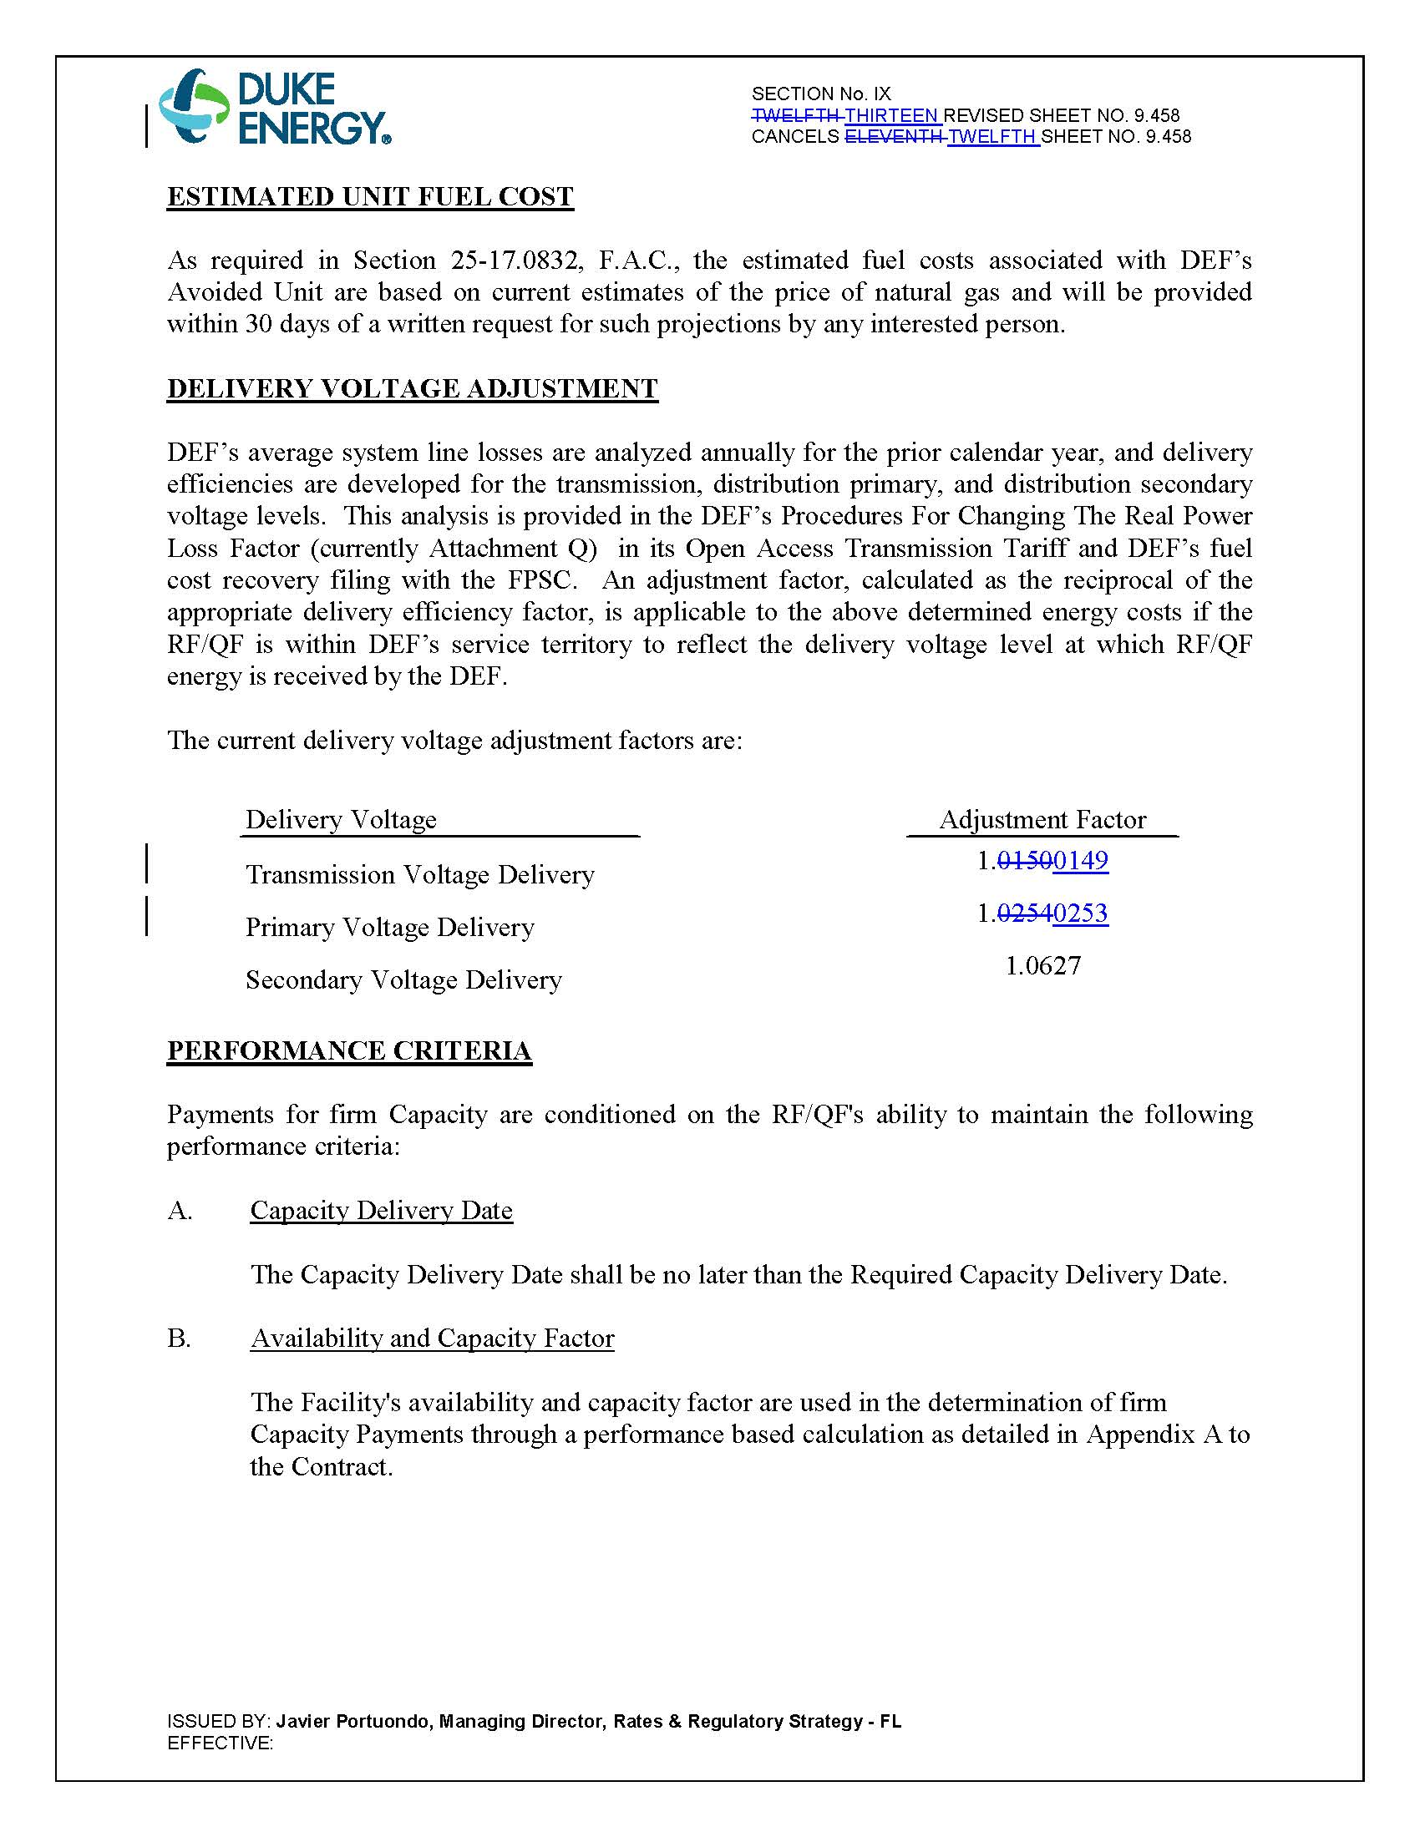

Order No. PSC-2018-0314-PAA-EQ, issued June 19, 2018, in Docket No. 20180073-EQ, In re: Petition for approval of amended standard offer contract (Schedule COG-2) based on a combustion turbine avoided unit, by Duke Energy Florida, LLC.
FERC Docket No. ER18-1458-002.
Duke Energy Fla., LLC, 166 FERC ¶ 61,057 (2019).

