BEFORE THE FLORIDA PUBLIC SERVICE COMMISSION

In re: Application for amendment of water and wastewater Certificate Nos. 669-W and 571-S, to extend service area to include certain additional land in Lake and Sumter Counties, by South Sumter Utility Company, LLC. | DOCKET NO. 20180131-WS  ORDER NO. PSC-2019-0154-FOF-WS  ISSUED: April 24, 2019

The following Commissioners participated in the disposition of this matter:

ART GRAHAM, Chairman
DONALD J. POLMANN
ANDREW GILES FAY

ORDER AMENDING CERTIFICATE NOS. 669-W AND 571-S
IN LAKE AND SUMTER COUNTIES

BY THE COMMISSION:

Background
On June 20, 2018, South Sumter Utility Company, LLC (South Sumter or Utility) filed an application with the Commission to amend Certificate Nos. 669-W and 571-S to add territory in Sumter and Lake Counties. South Sumter was initially granted certificates in 2017. The proposed service area is being developed by an affiliate of South Sumter as part of The Villages development, which is a retirement community being developed in Sumter, Lake, and Marion Counties. The retirement community will consist of both residential and general service customers. The residential customers will consist of single-family homes. The general service customers will include a variety of uses such as retail, office, medical, recreation, restaurants, assisted living, and golf course facilities.
This order addresses the Utility’s request to extend its water and wastewater service territory. We have jurisdiction pursuant to Section 367.045, Florida Statutes (F.S.).

Decision
The Utility’s application to amend its authorized service territory is in compliance with the governing statute, Section 367.045, F.S., and Rule 25-30.036, Florida Administrative Code (F.A.C.). The application contains proof of compliance with the noticing provisions set forth in Rule 25-30.030, F.A.C. No objections to the application have been received and the time for filing such has expired.
South Sumter provided adequate service territory maps and territory descriptions. According to the Utility’s January 9, 2019 response to Commission staff’s December 7, 2018 deficiency letter (deficiency letter), the proposed service area crosses different jurisdictions with respect to local comprehensive plans. South Sumter provided a map that corresponds to the areas governed by the respective local comprehensive plans. The provision of water and wastewater services in the proposed service territory is consistent with the local comprehensive plans for the majority of Sumter County, the City of Wildwood, and the City of Leesburg. A small portion of the proposed service territory located in both Sumter County and the City of Wildwood is not currently in compliance with the respective local comprehensive plans. It is anticipated that the Sumter County portion of this area will be annexed into the City of Wildwood. South Sumter will then file a Large Scale Comprehensive Plan Amendment on the portions of the proposed territory in the City of Wildwood and Sumter County that are currently zoned for agricultural use to change them to residential use. This will make the Utility’s planned development consistent with the local comprehensive plans.
Also in its response to Commission staff’s deficiency letter, South Sumter addressed land use restrictions. The Utility stated that there are no known land use restrictions that would prevent the proposed territory from being developed as planned. However, the proposed and existing service territories include conservation lands and environmentally sensitive areas, such as wetlands, as has been the case for previous development areas of The Villages. The Utility affirmed that any impacts to these lands or areas, if necessary, will comply with applicable regulatory requirements.

The Utility was granted initial rates and charges on May 30, 2018. At that time, we found the financial viability of South Sumter to be adequate. In its application, the Utility indicated that it believes that any anticipated construction undertaken will not impact the Utility’s capital structure. South Sumter also included proposed methods of financing for anticipated construction in its filing. Additionally, the Utility provided a letter from Holding Company of The Villages, Inc. (The Villages, Inc.), the real estate developer of the proposed service area, indicating that The Villages, Inc. has the ability to provide financial support to South Sumter, if necessary. Based upon review of the information provided in this docket, we find the Utility has provided the proper documentation of the impact on its capital structure and proposed methods of financing for anticipated future construction. We note that all components of rate setting affected by future construction would be fully vetted in any future rate case filed by the Utility.

The Utility stated in its application that the existing service area is to be served by a water treatment plant that will be conveyed to the City of Wildwood, from whom South Sumter will then receive bulk water service. A portion of the proposed service area will be served by the bulk water service purchased from the City of Wildwood, with the remainder served by a second water treatment plant that will be built as the area is developed. As with the existing service area, wastewater treatment service for the proposed service area will be purchased from the City of Leesburg. The Utility estimates that the proposed service area will have 7,041 water equivalent residential connections (ERCs) and 6,441 wastewater ERCs.
There are currently no outstanding Consent Orders or Notices of Violation from the Florida Department of Environmental Protection. The Utility has filed its 2017 Annual Report and plans to request an automatic extension for filing its 2018 Annual Report. South Sumter anticipates that the 2018 Annual Report will be filed by the end of May 2019. The Utility has paid its 2018 Regulatory Assessment Fees. Based on the foregoing analysis, we find that South Sumter has the financial and technical ability to serve the amended territory.
Conclusion

Based on the information above, Certificate Nos. 669-W and 571-S shall be amended to include the territory as described in Attachment A, effective the date of our vote, April 2, 2109. The resultant order shall serve as South Sumter’s amended certificate and shall be retained by the Utility. The Utility shall charge future customers in the territory added herein the rates and charges contained in its current tariffs until a change is authorized by this Commission in a subsequent proceeding.
Based on the foregoing, it is

ORDERED by the Florida Public Service Commission that South Sumter Utility Company, LLC’s application for amendment of Certificate Nos. 669-W and 571-S is hereby approved. Certificate Nos. 669-W and 571-S shall be amended to include the territory as described in Attachment A, effective April 2, 2019. The resultant order shall serve as the Utility’s amended certificate and shall be retained by the Utility. The Utility shall charge future customers in the territory added herein the rates and charges contained in its current tariffs until a change is authorized by this Commission in a subsequent proceeding. It is further

ORDERED that no further action is necessary, and this docket shall be closed upon issuance of the order.
By ORDER of the Florida Public Service Commission this 24th day of April, 2019.

/s/ Adam J. Teitzman
ADAM J. TEITZMAN
Commission Clerk
Florida Public Service Commission
2540 Shumard Oak Boulevard
Tallahassee, Florida 32399
(850) 413-6770
www.floridapsc.com

Copies furnished: A copy of this document is provided to the parties of record at the time of issuance and, if applicable, interested persons.

JSC

NOTICE OF FURTHER PROCEEDINGS OR JUDICIAL REVIEW

The Florida Public Service Commission is required by Section 120.569(1), Florida Statutes, to notify parties of any administrative hearing or judicial review of Commission orders that is available under Sections 120.57 or 120.68, Florida Statutes, as well as the procedures and time limits that apply. This notice should not be construed to mean all requests for an administrative hearing or judicial review will be granted or result in the relief sought.

Any party adversely affected by the Commission's final action in this matter may request: 1) reconsideration of the decision by filing a motion for reconsideration with the Office of Commission Clerk, 2540 Shumard Oak Boulevard, Tallahassee, Florida 32399-0850, within fifteen (15) days of the issuance of this order in the form prescribed by Rule 25-22.060, Florida Administrative Code; or 2) judicial review by the Florida Supreme Court in the case of an electric, gas or telephone utility or the First District Court of Appeal in the case of a water and/or wastewater utility by filing a notice of appeal with the Office of Commission Clerk, and filing a copy of the notice of appeal and the filing fee with the appropriate court. This filing must be completed within thirty (30) days after the issuance of this order, pursuant to Rule 9.110, Florida Rules of Appellate Procedure. The notice of appeal must be in the form specified in Rule 9.900(a), Florida Rules of Appellate Procedure.

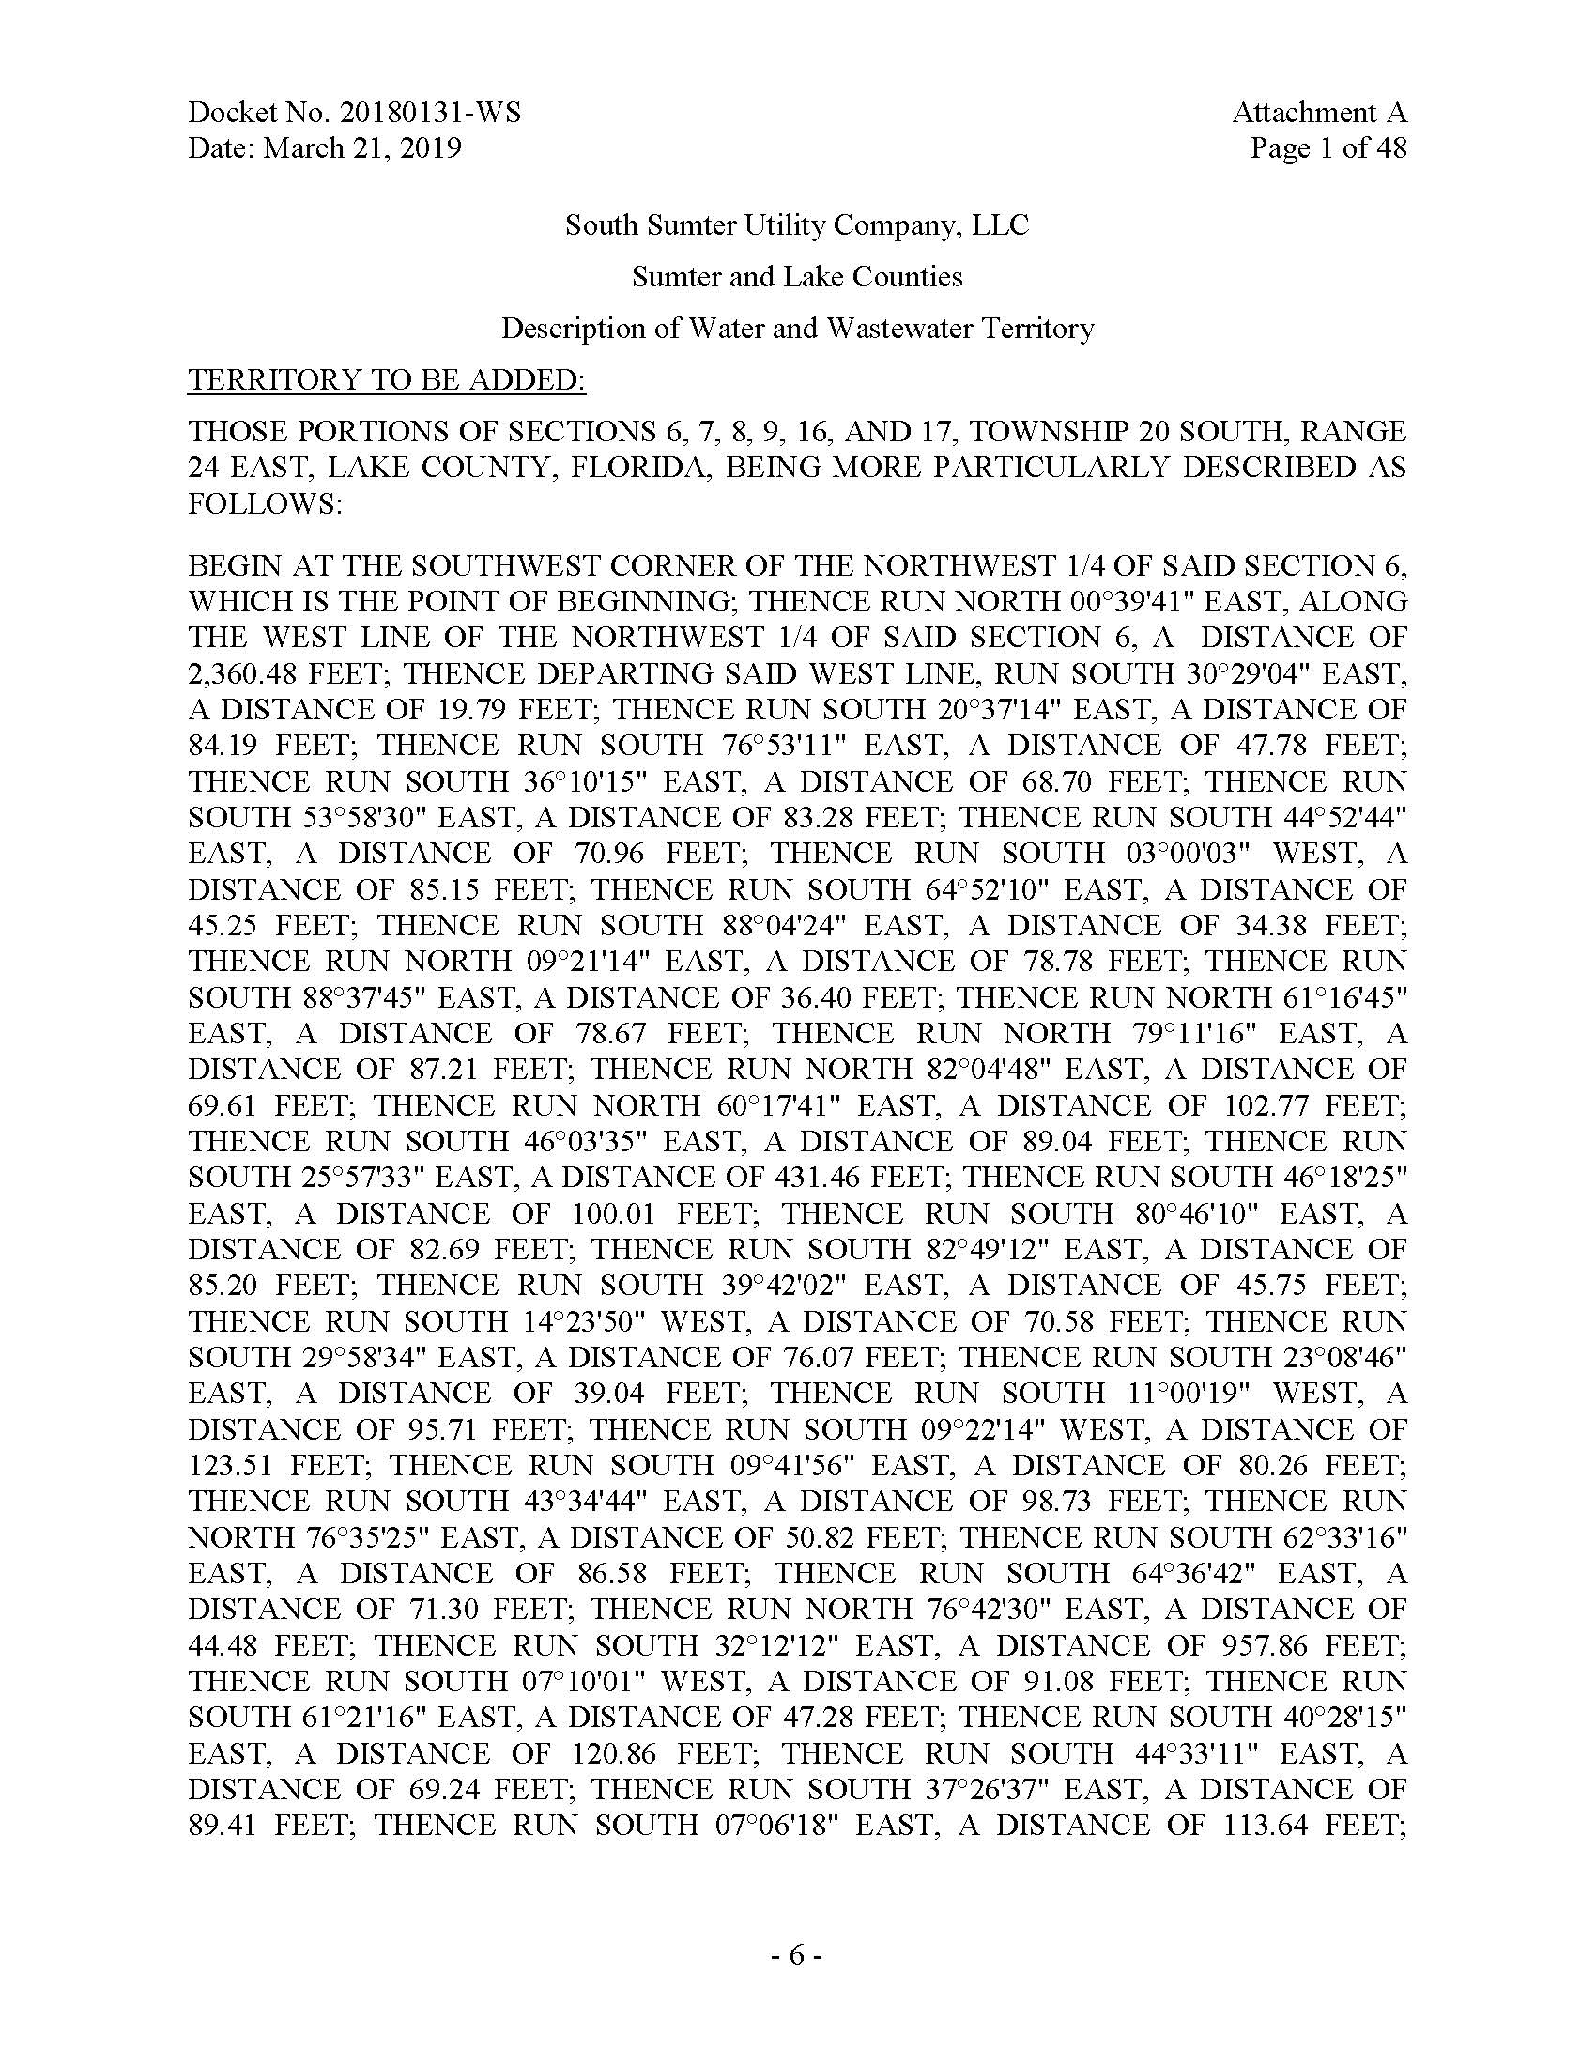

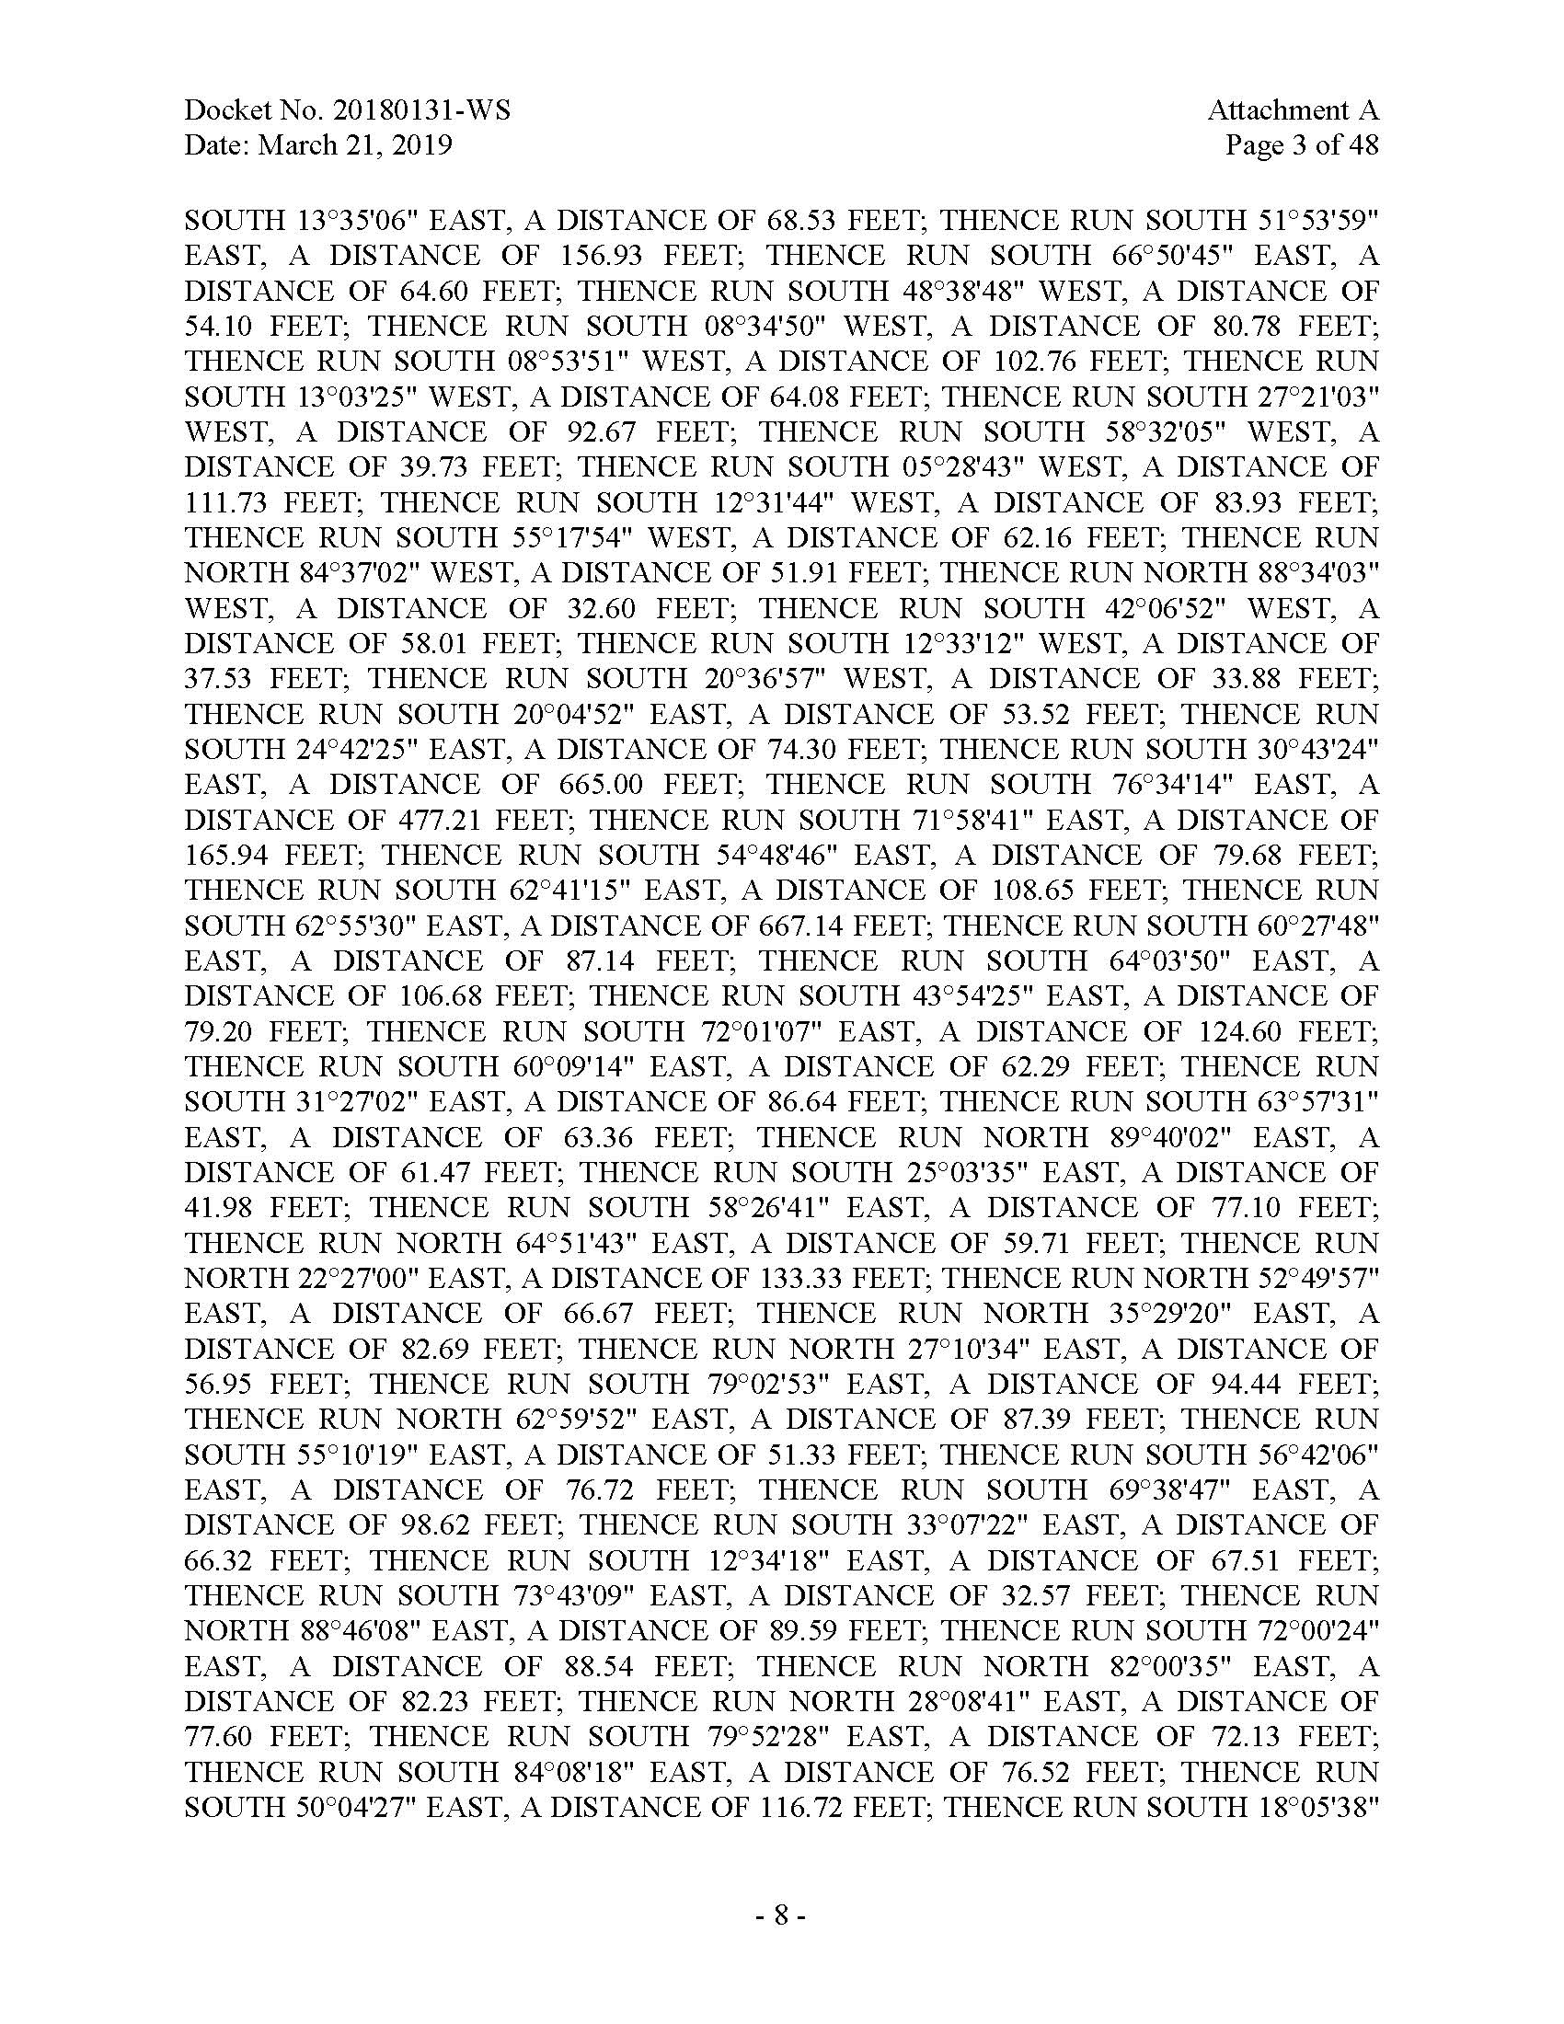

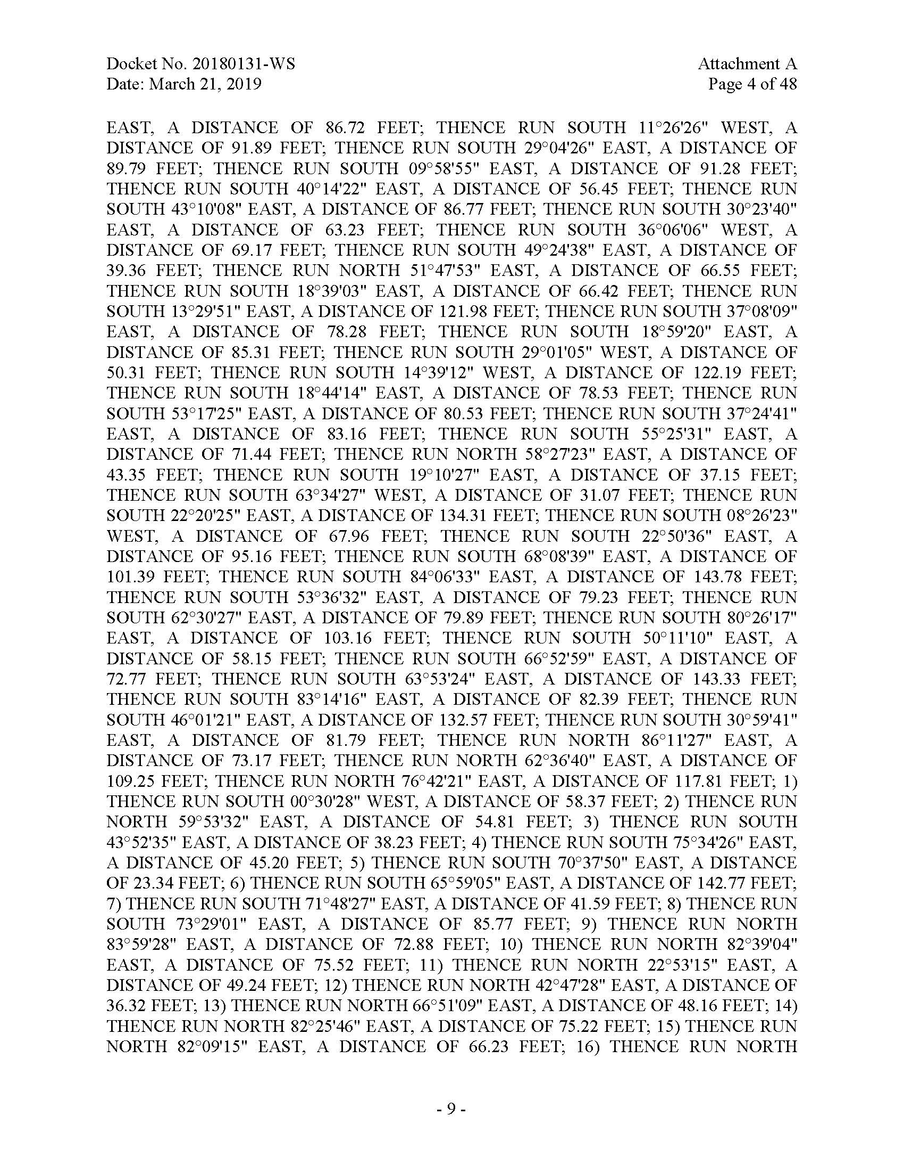

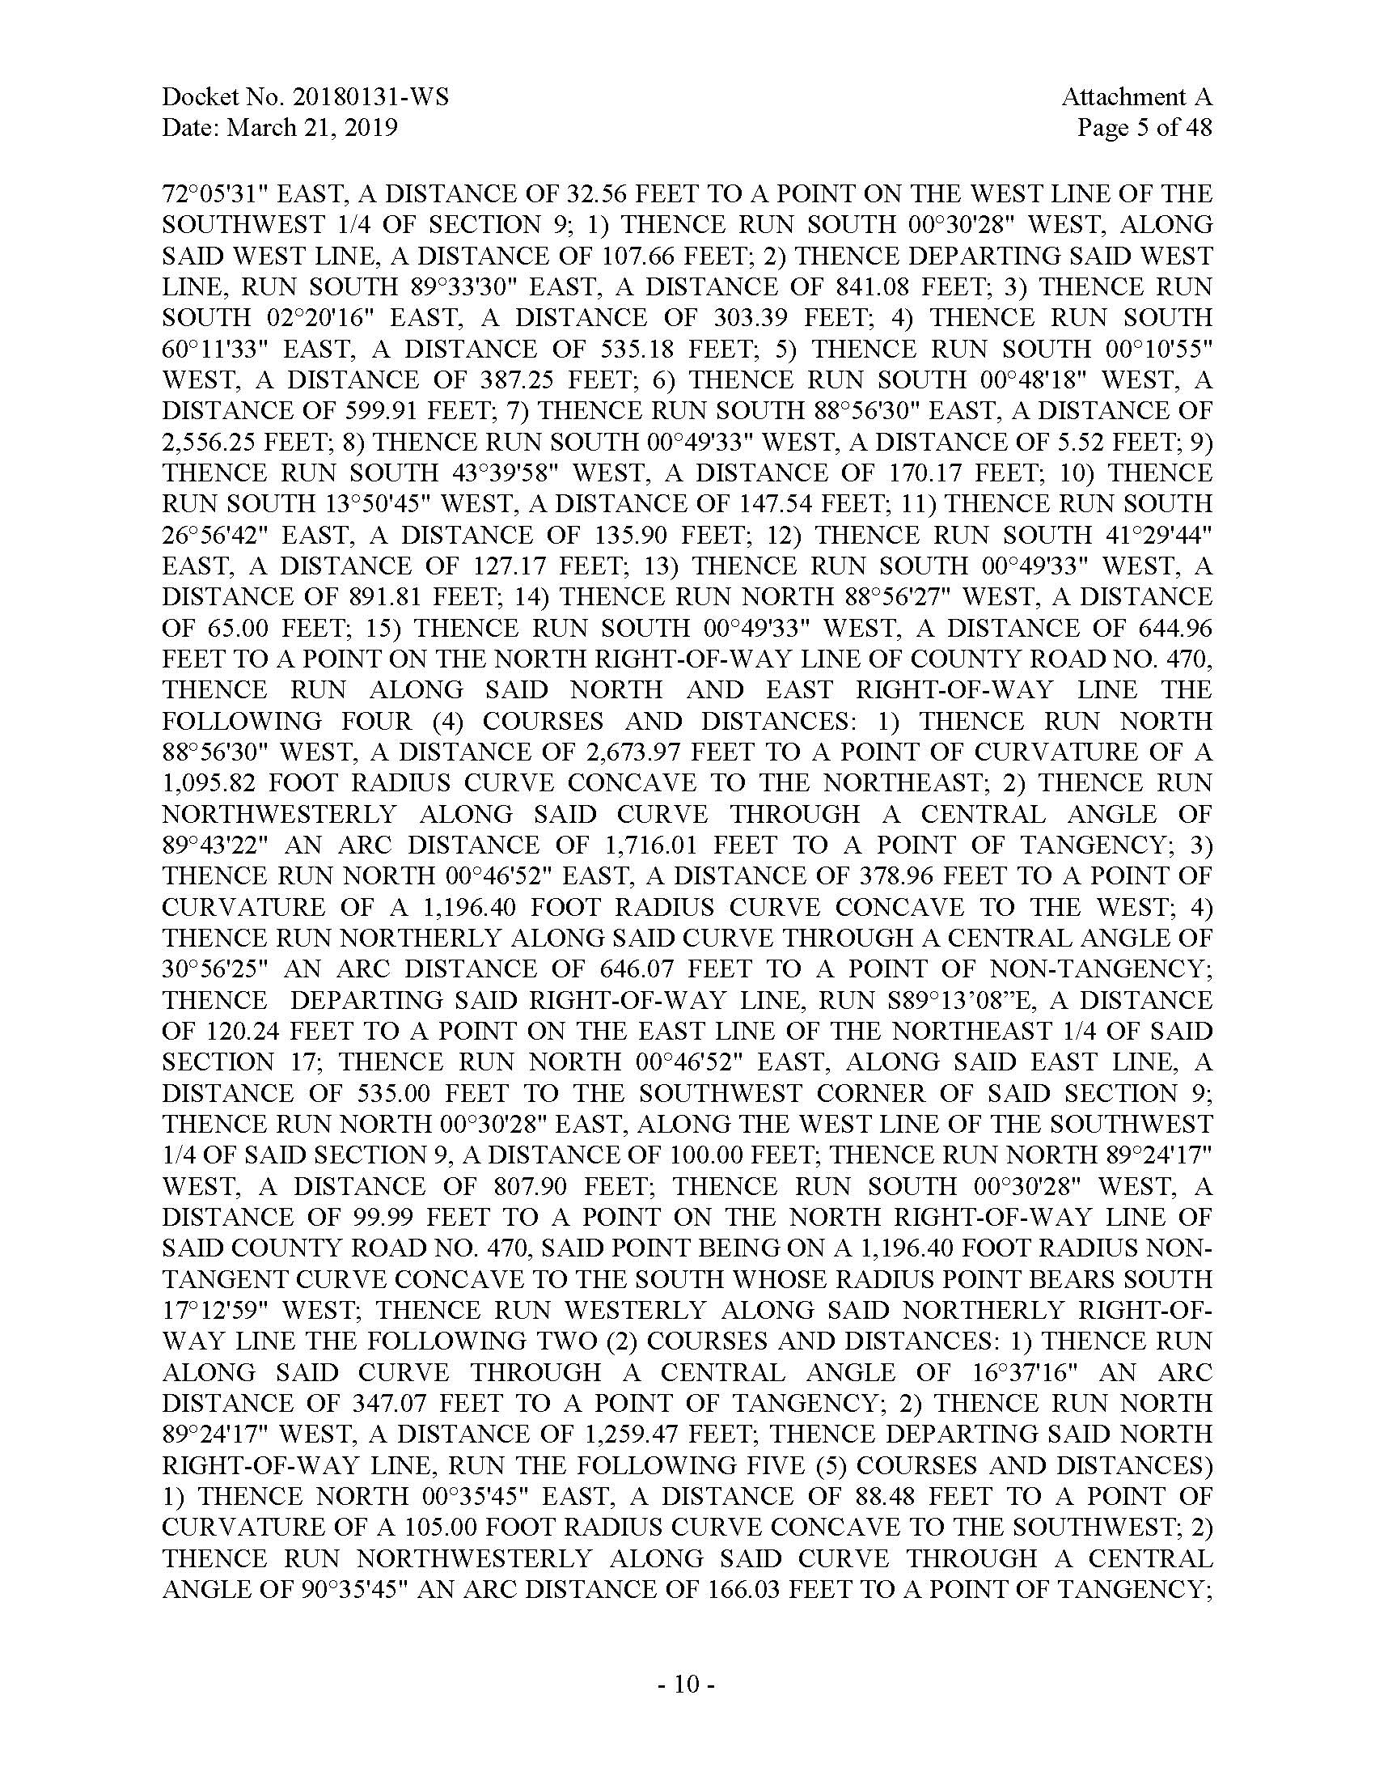

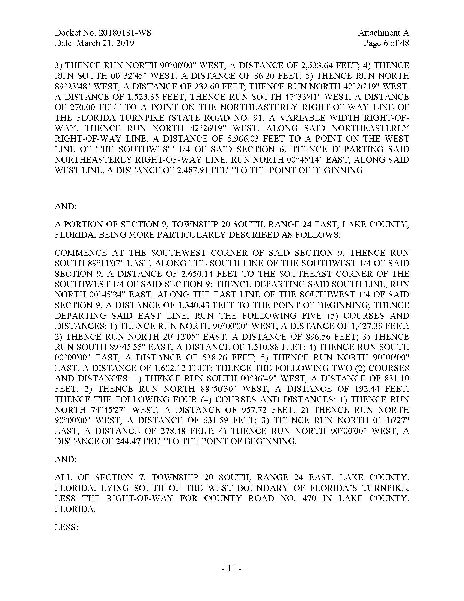

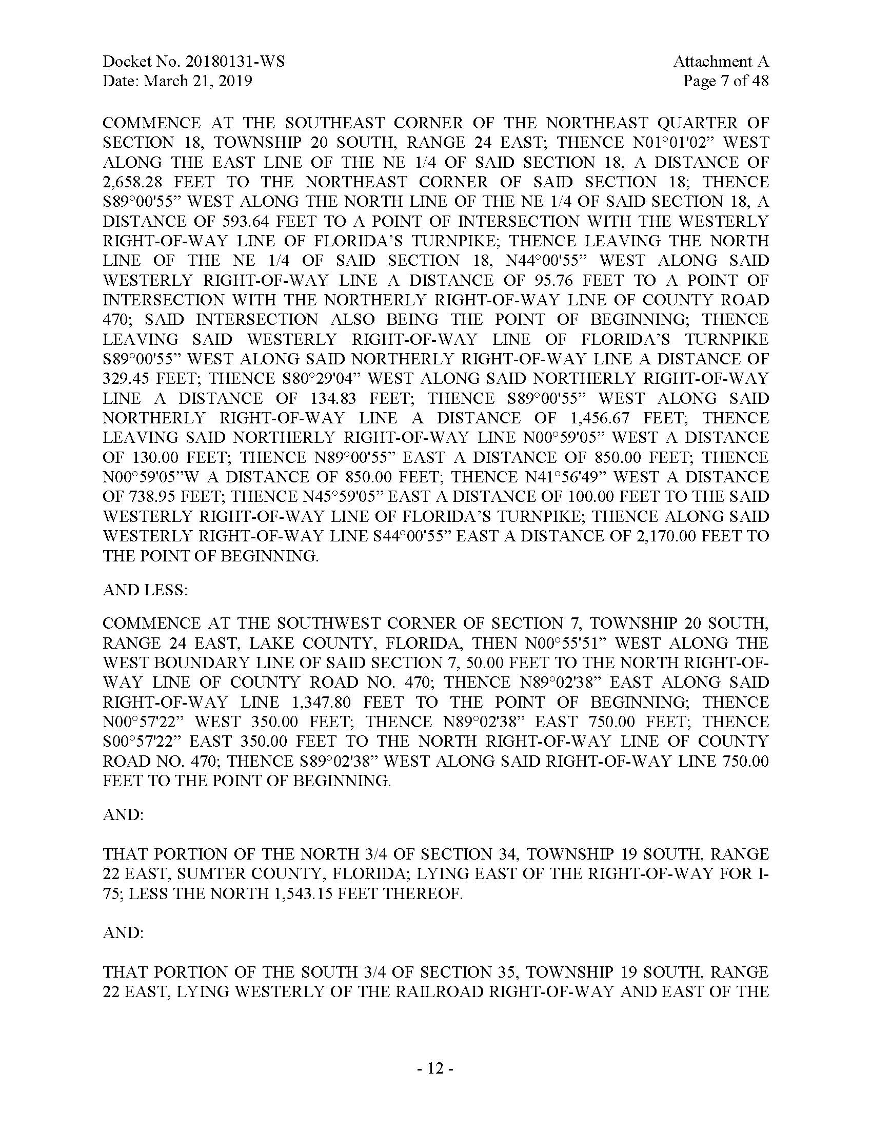

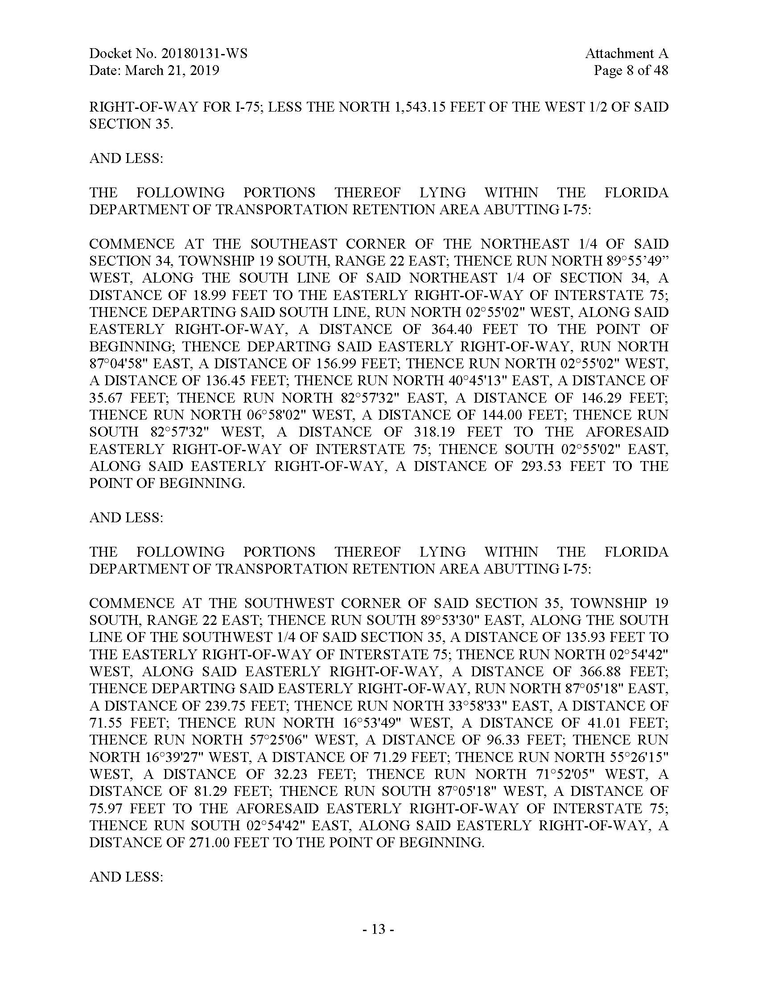

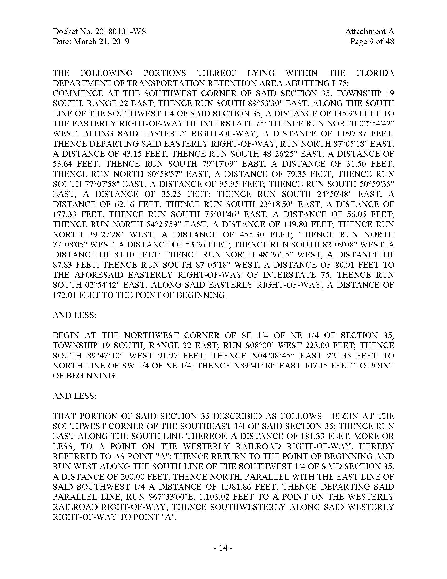

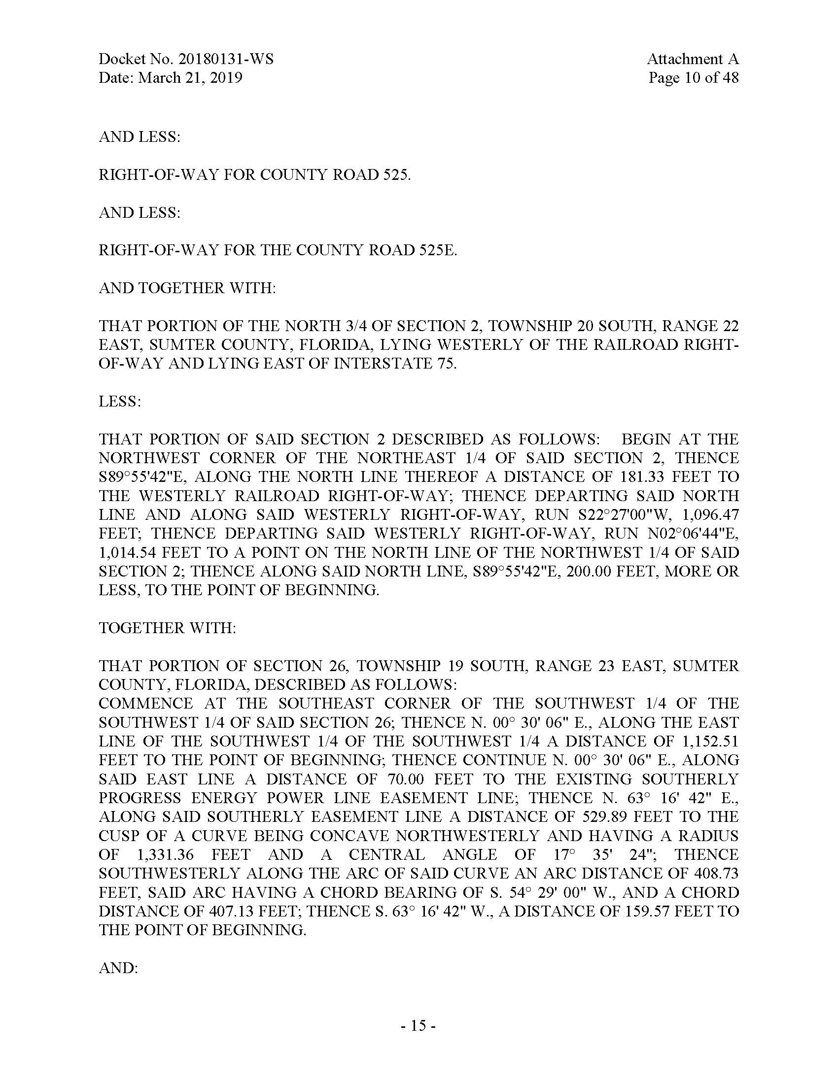

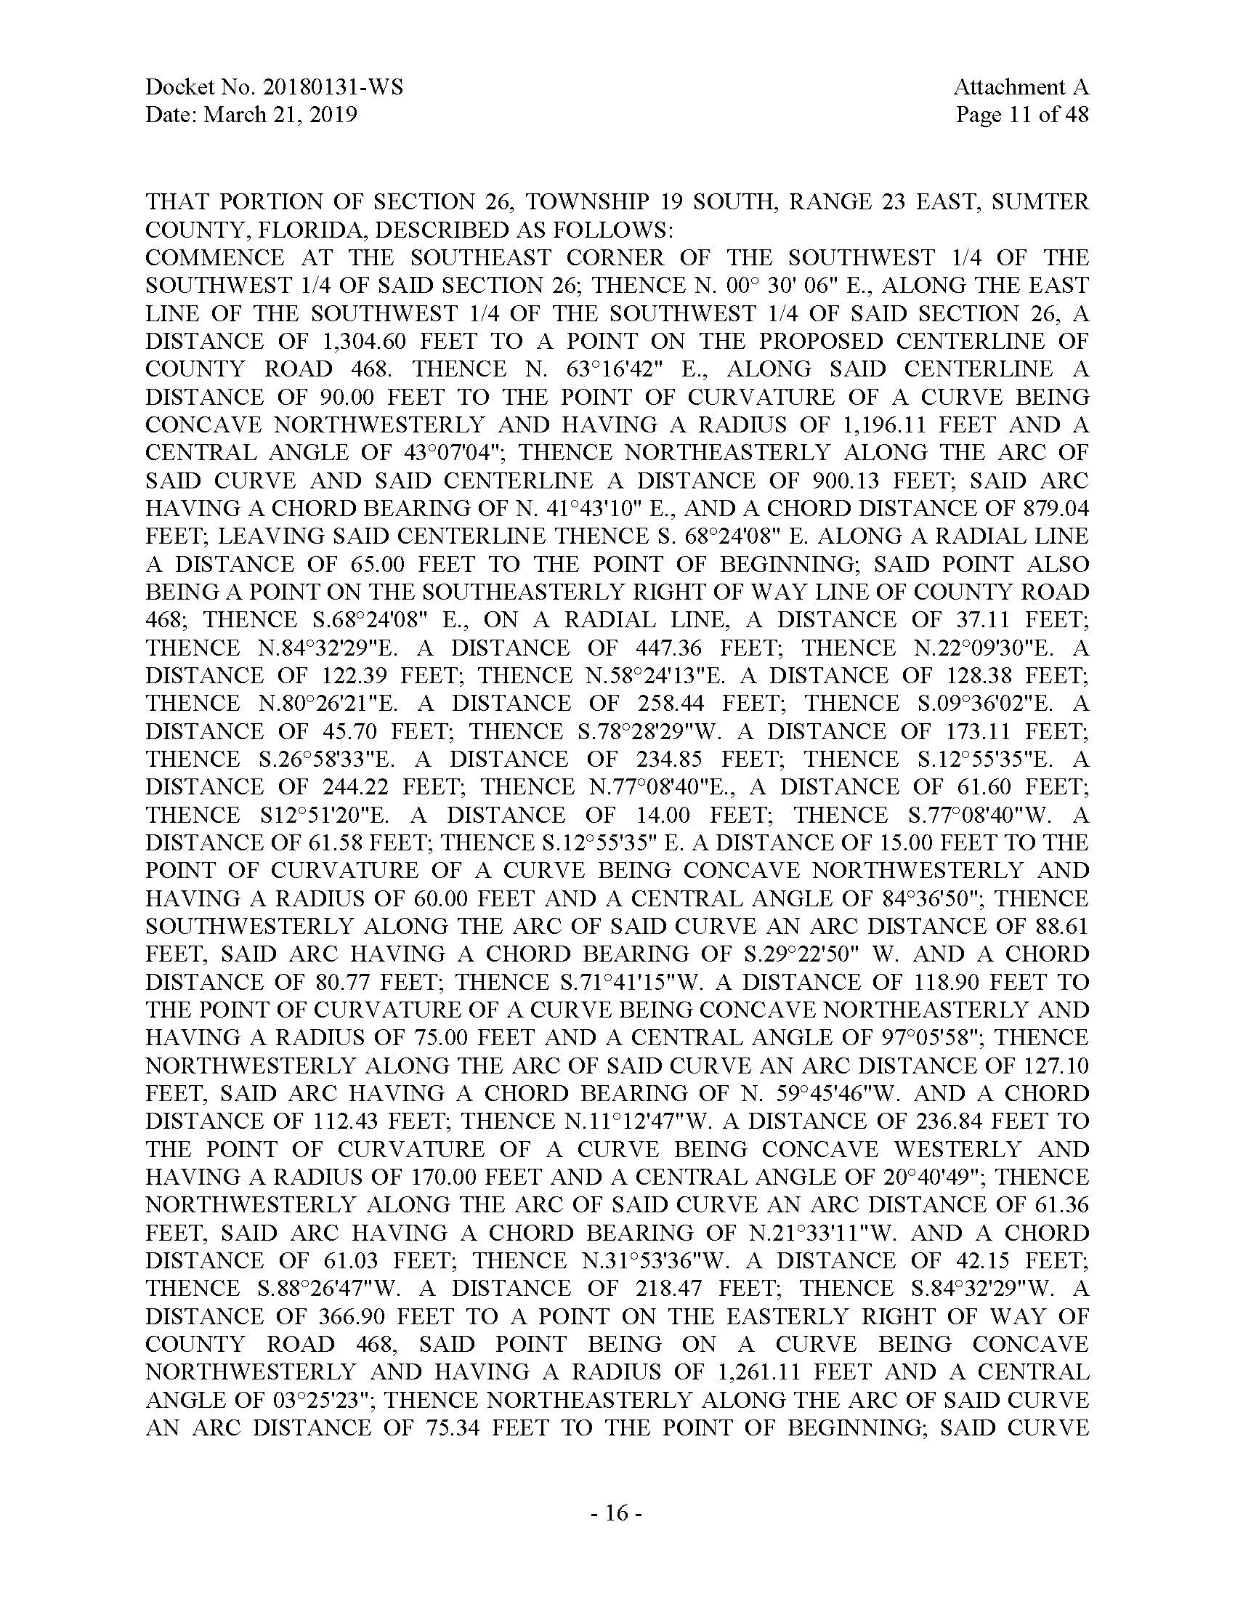

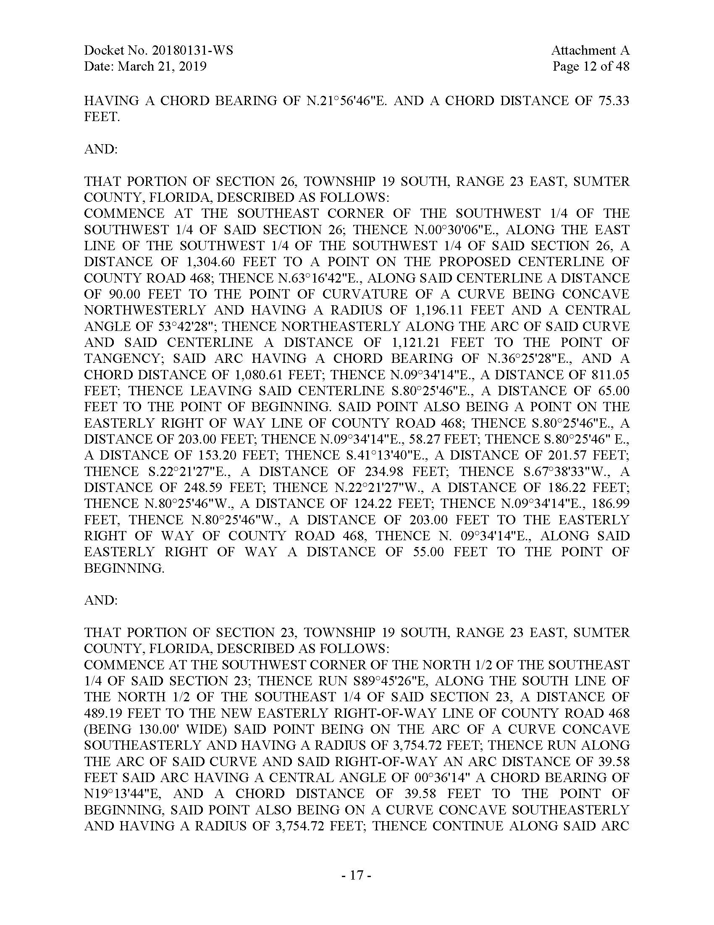

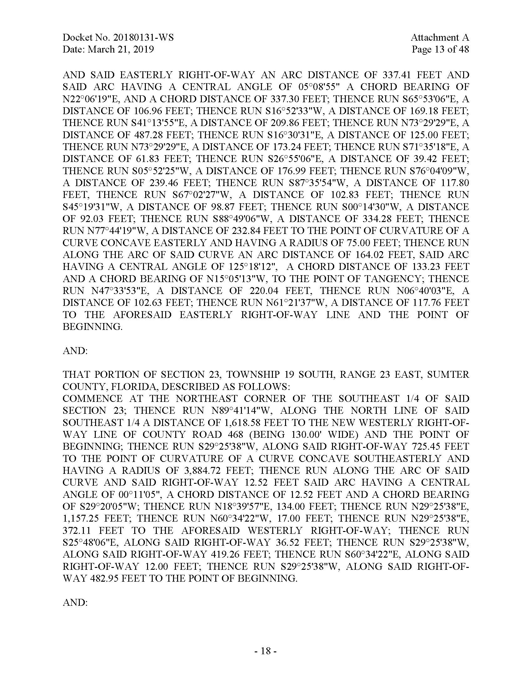

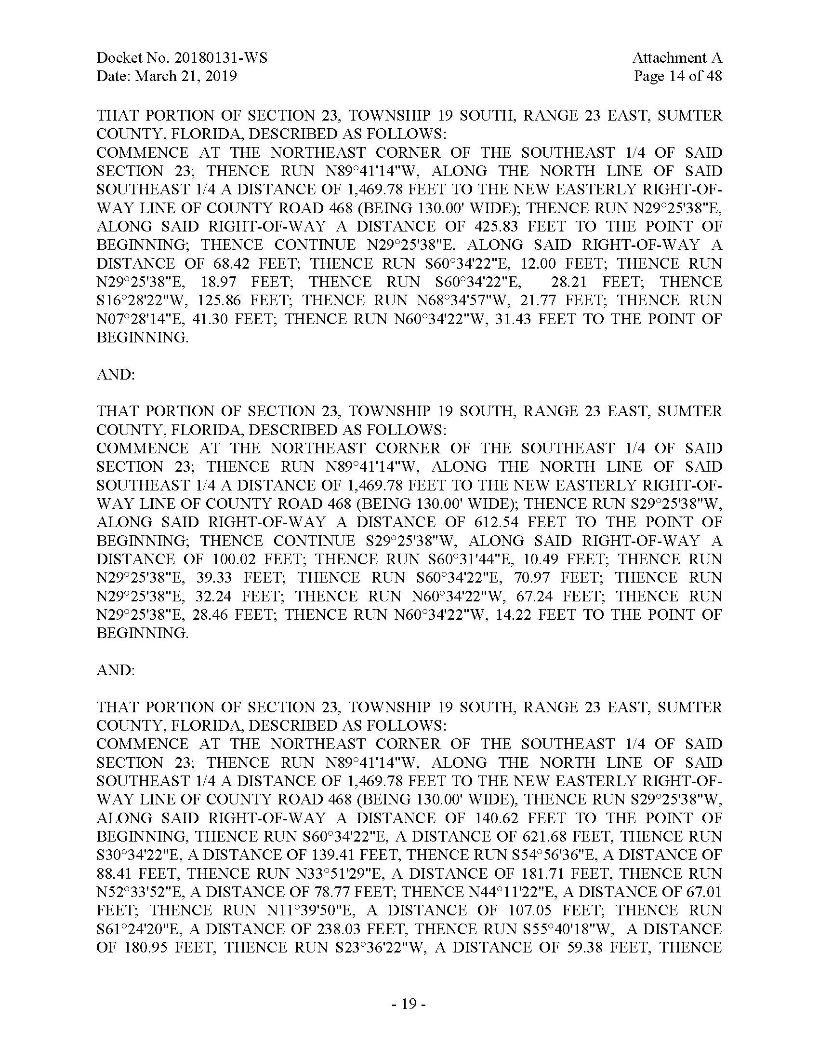

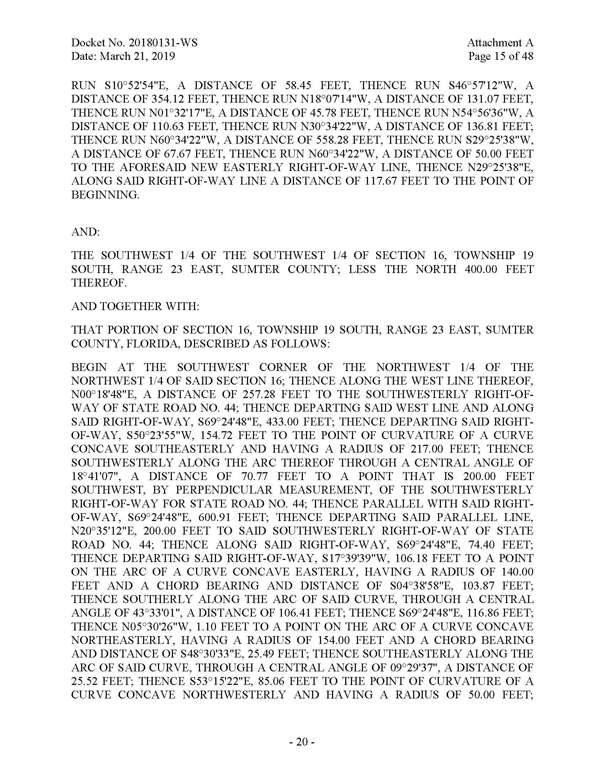

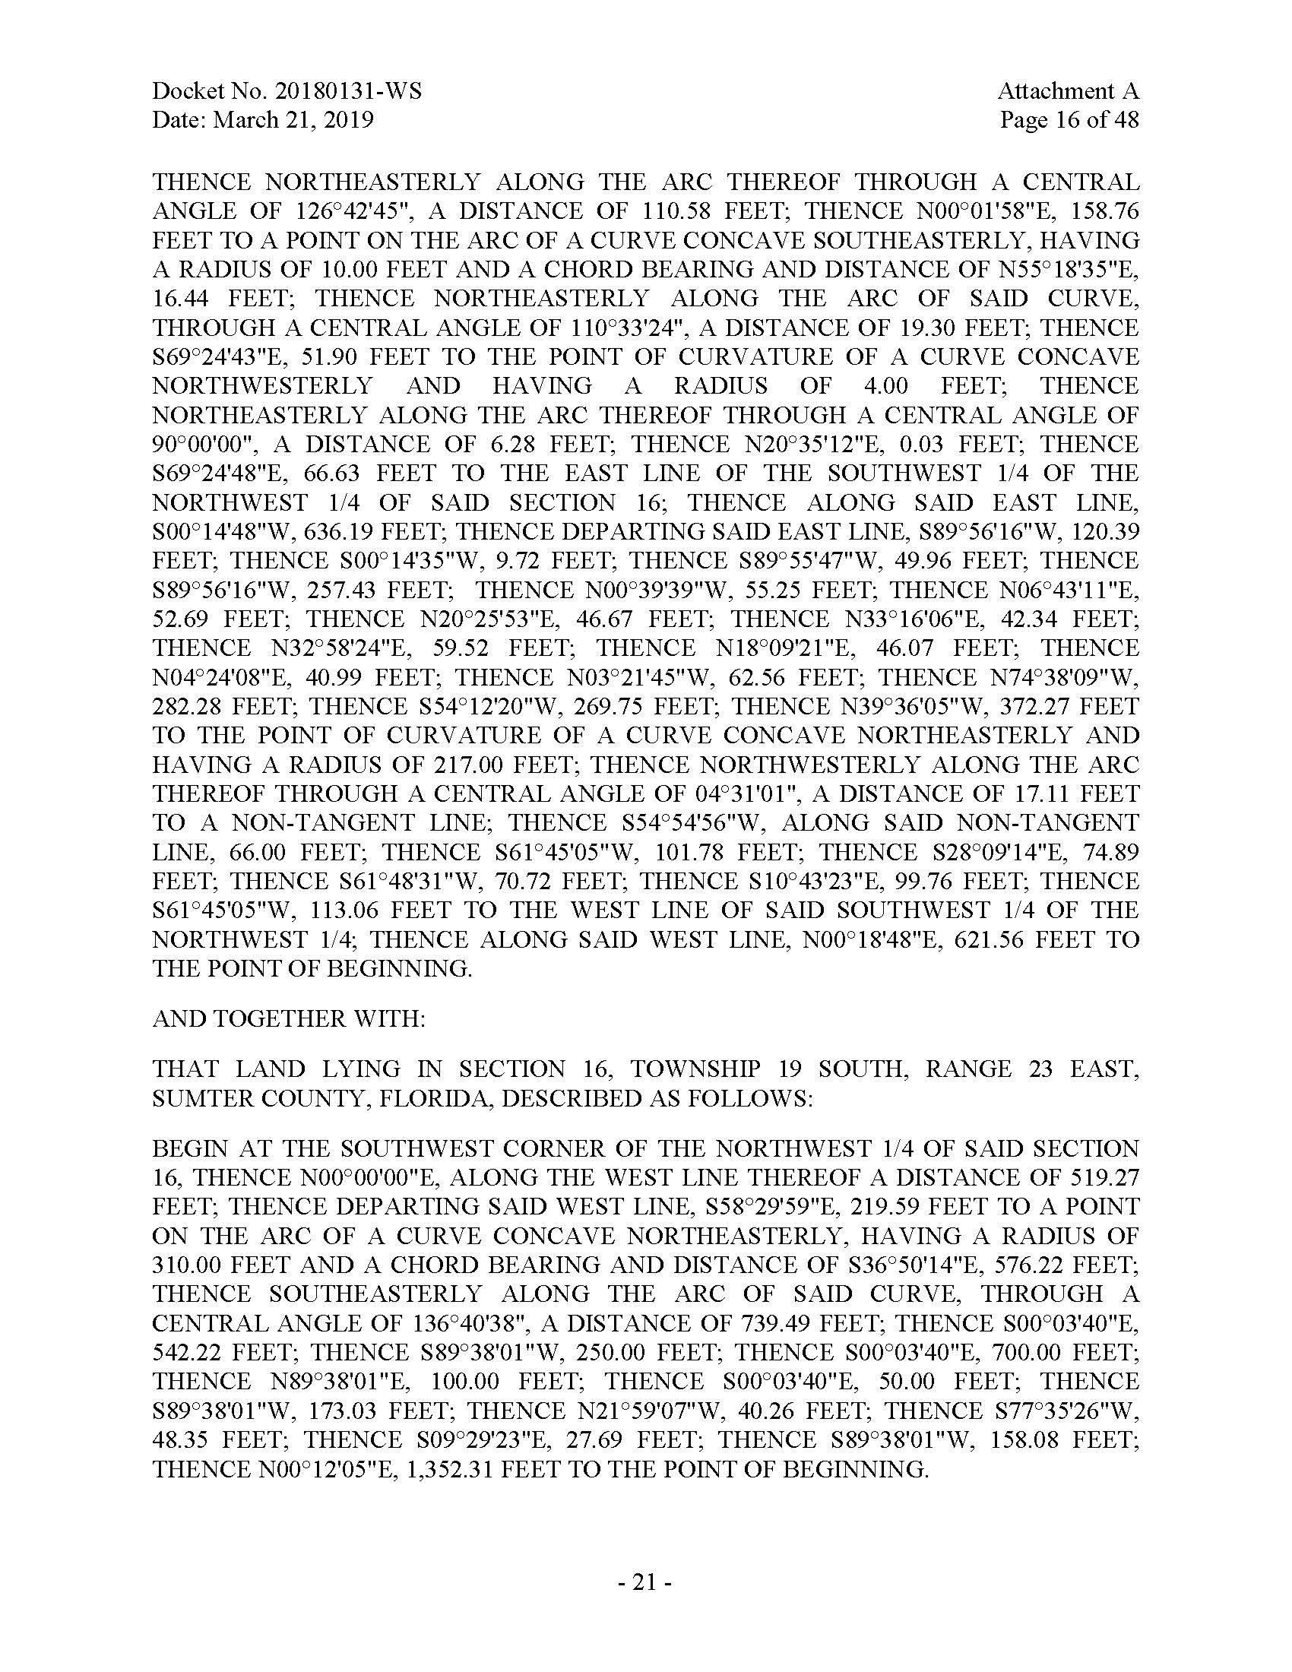

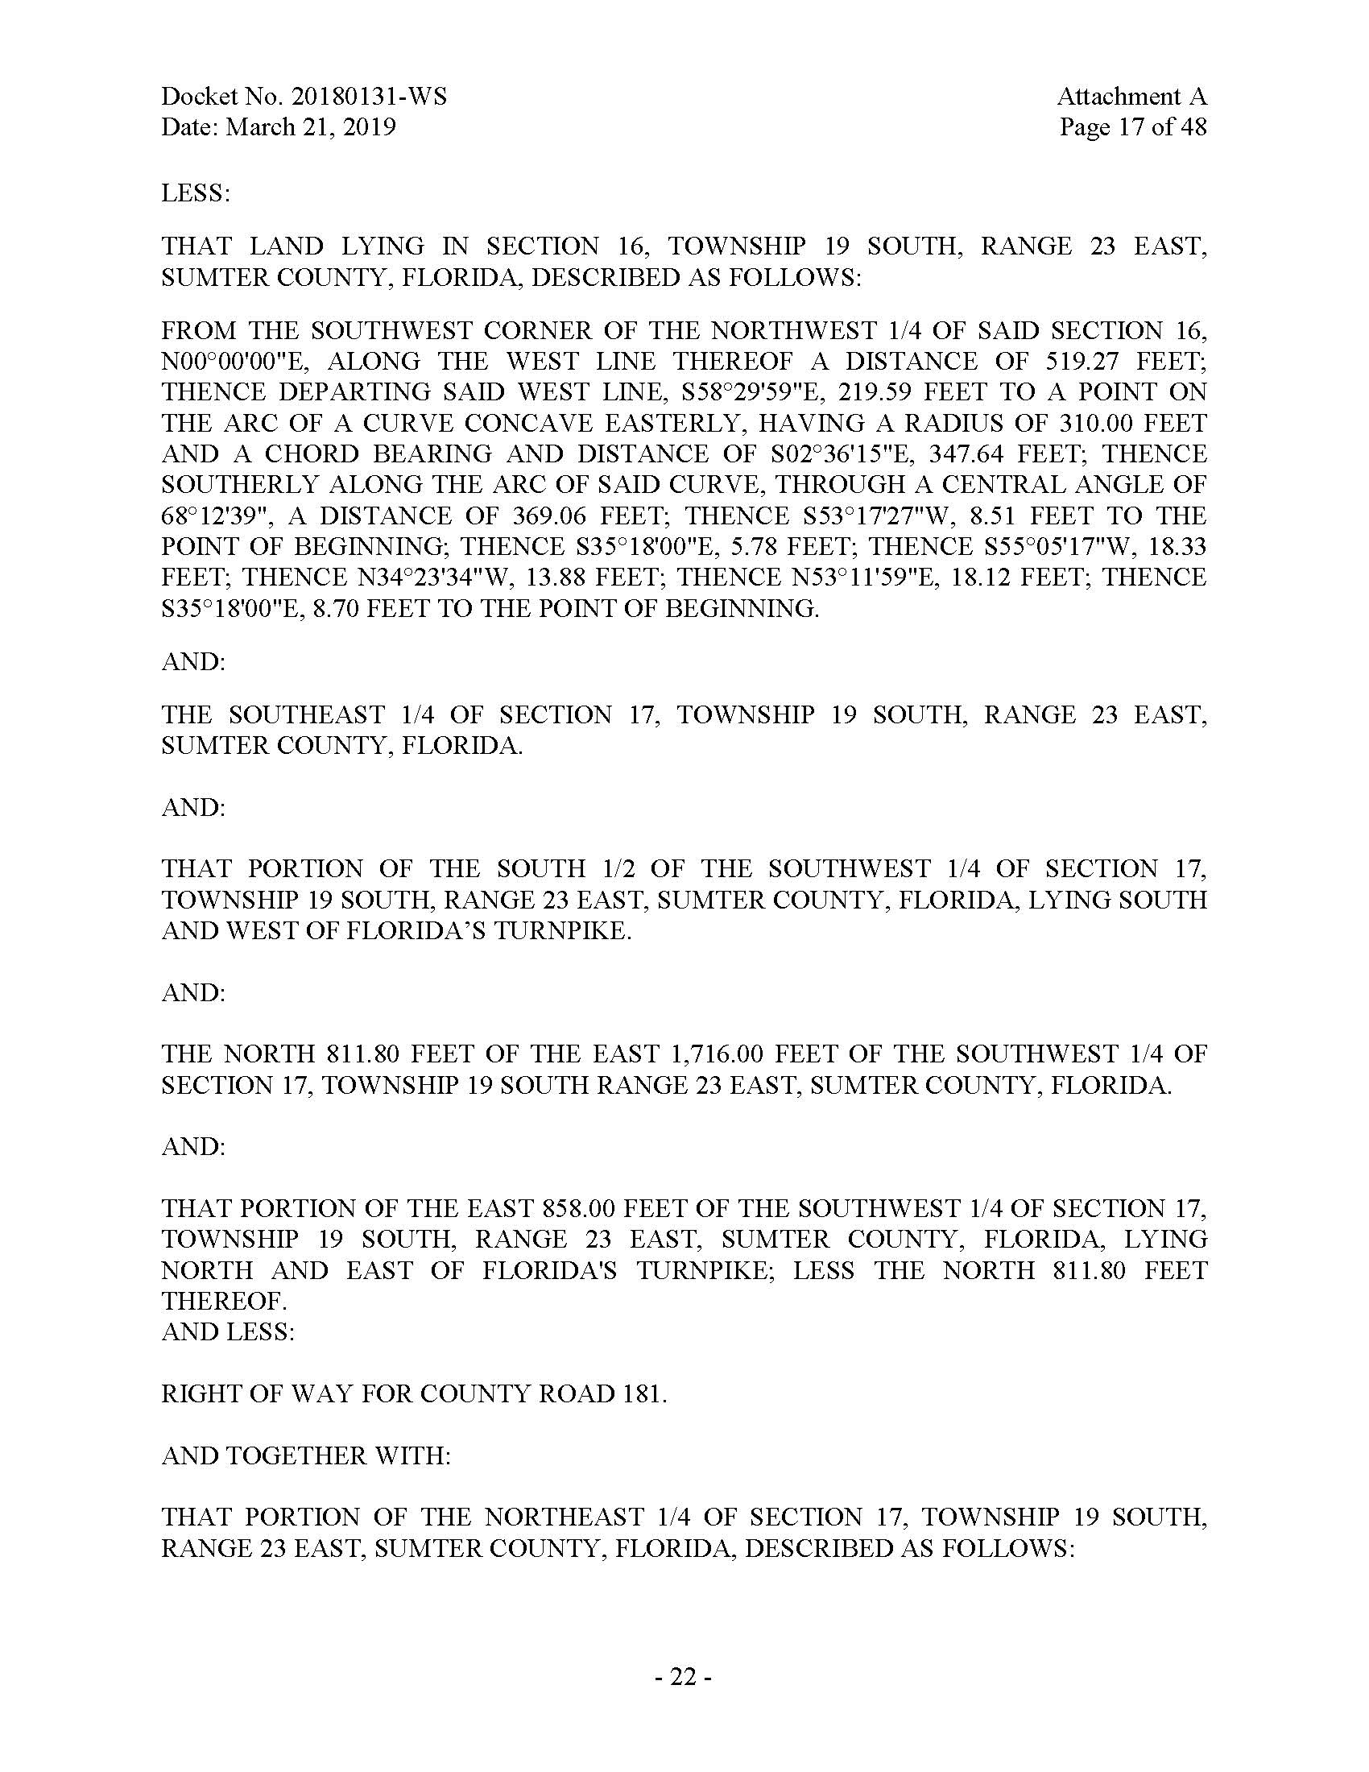

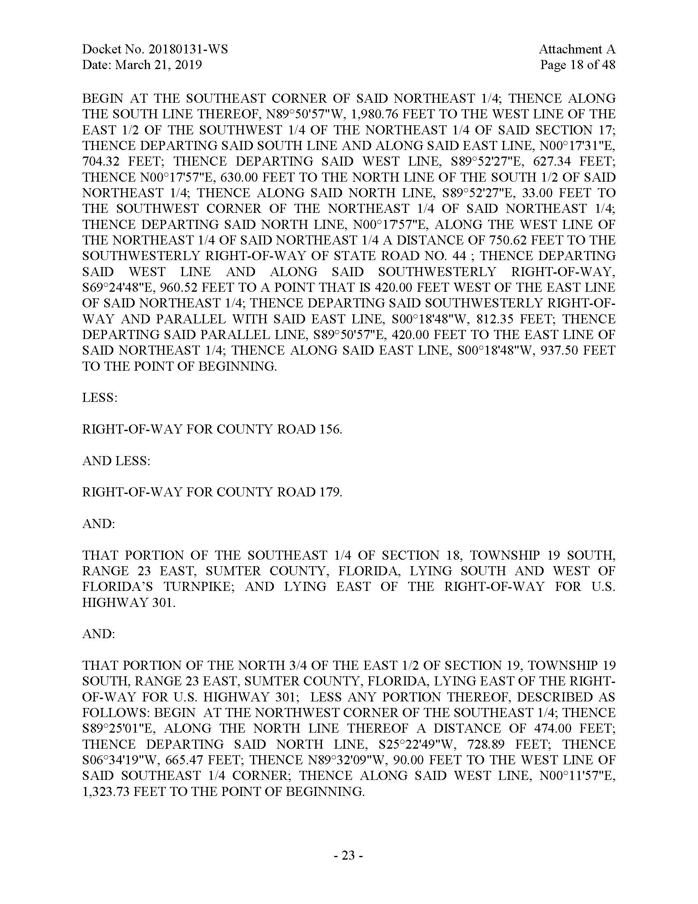

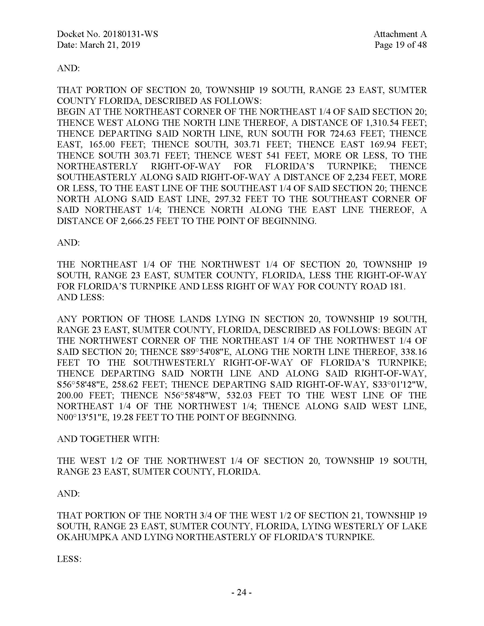

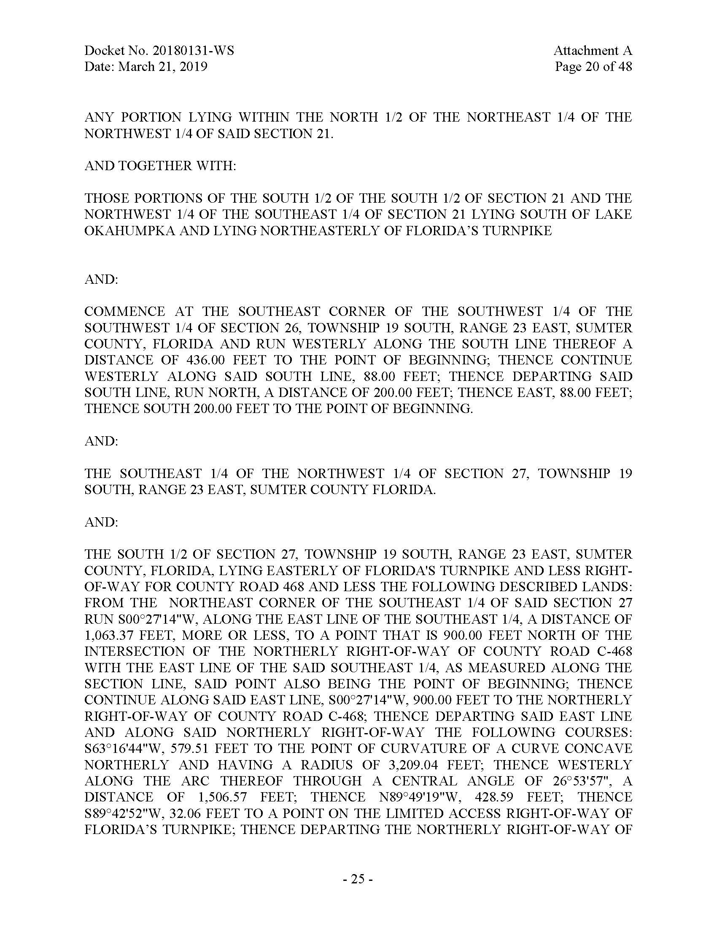

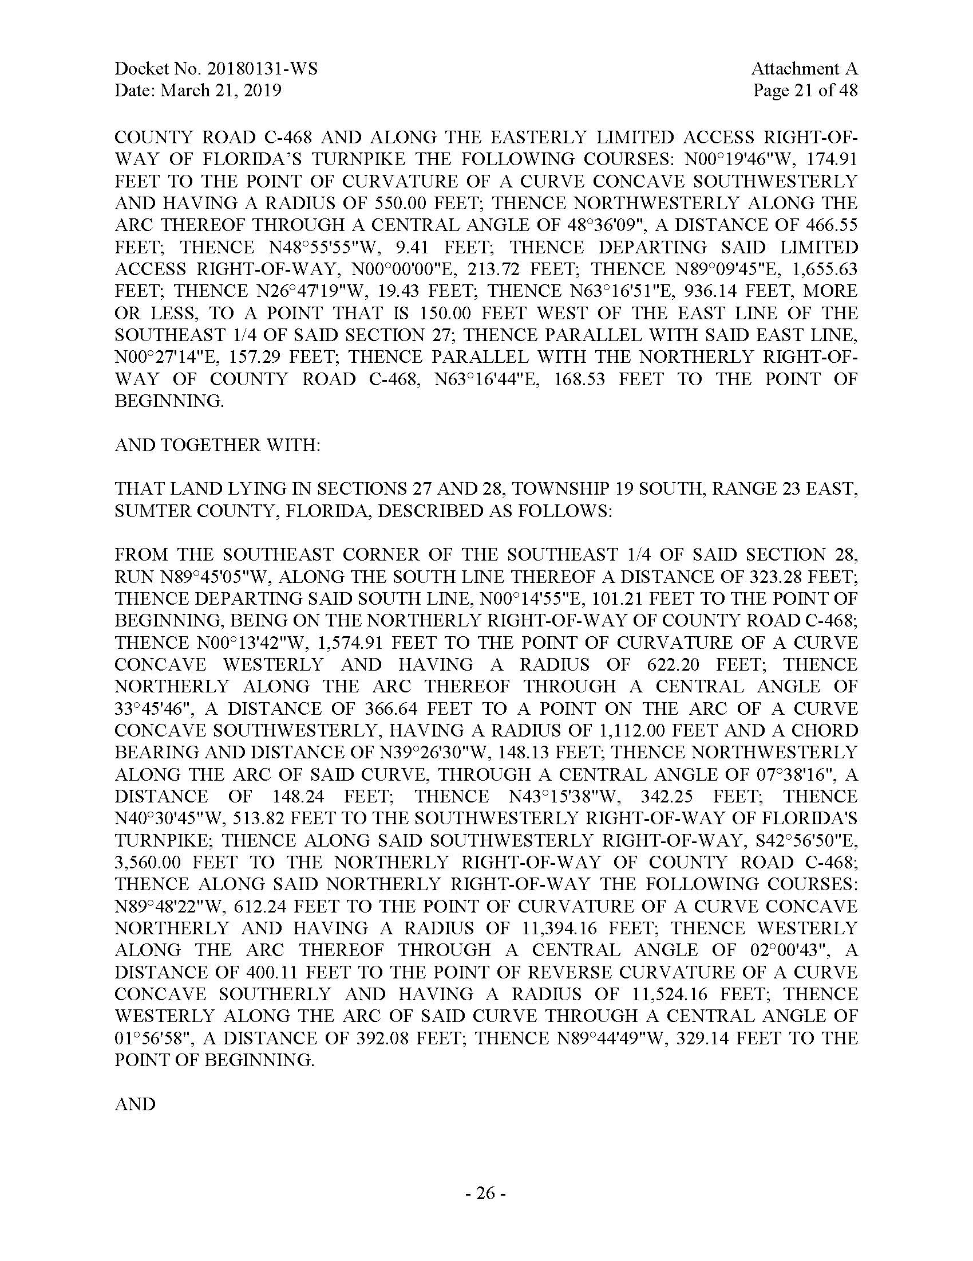

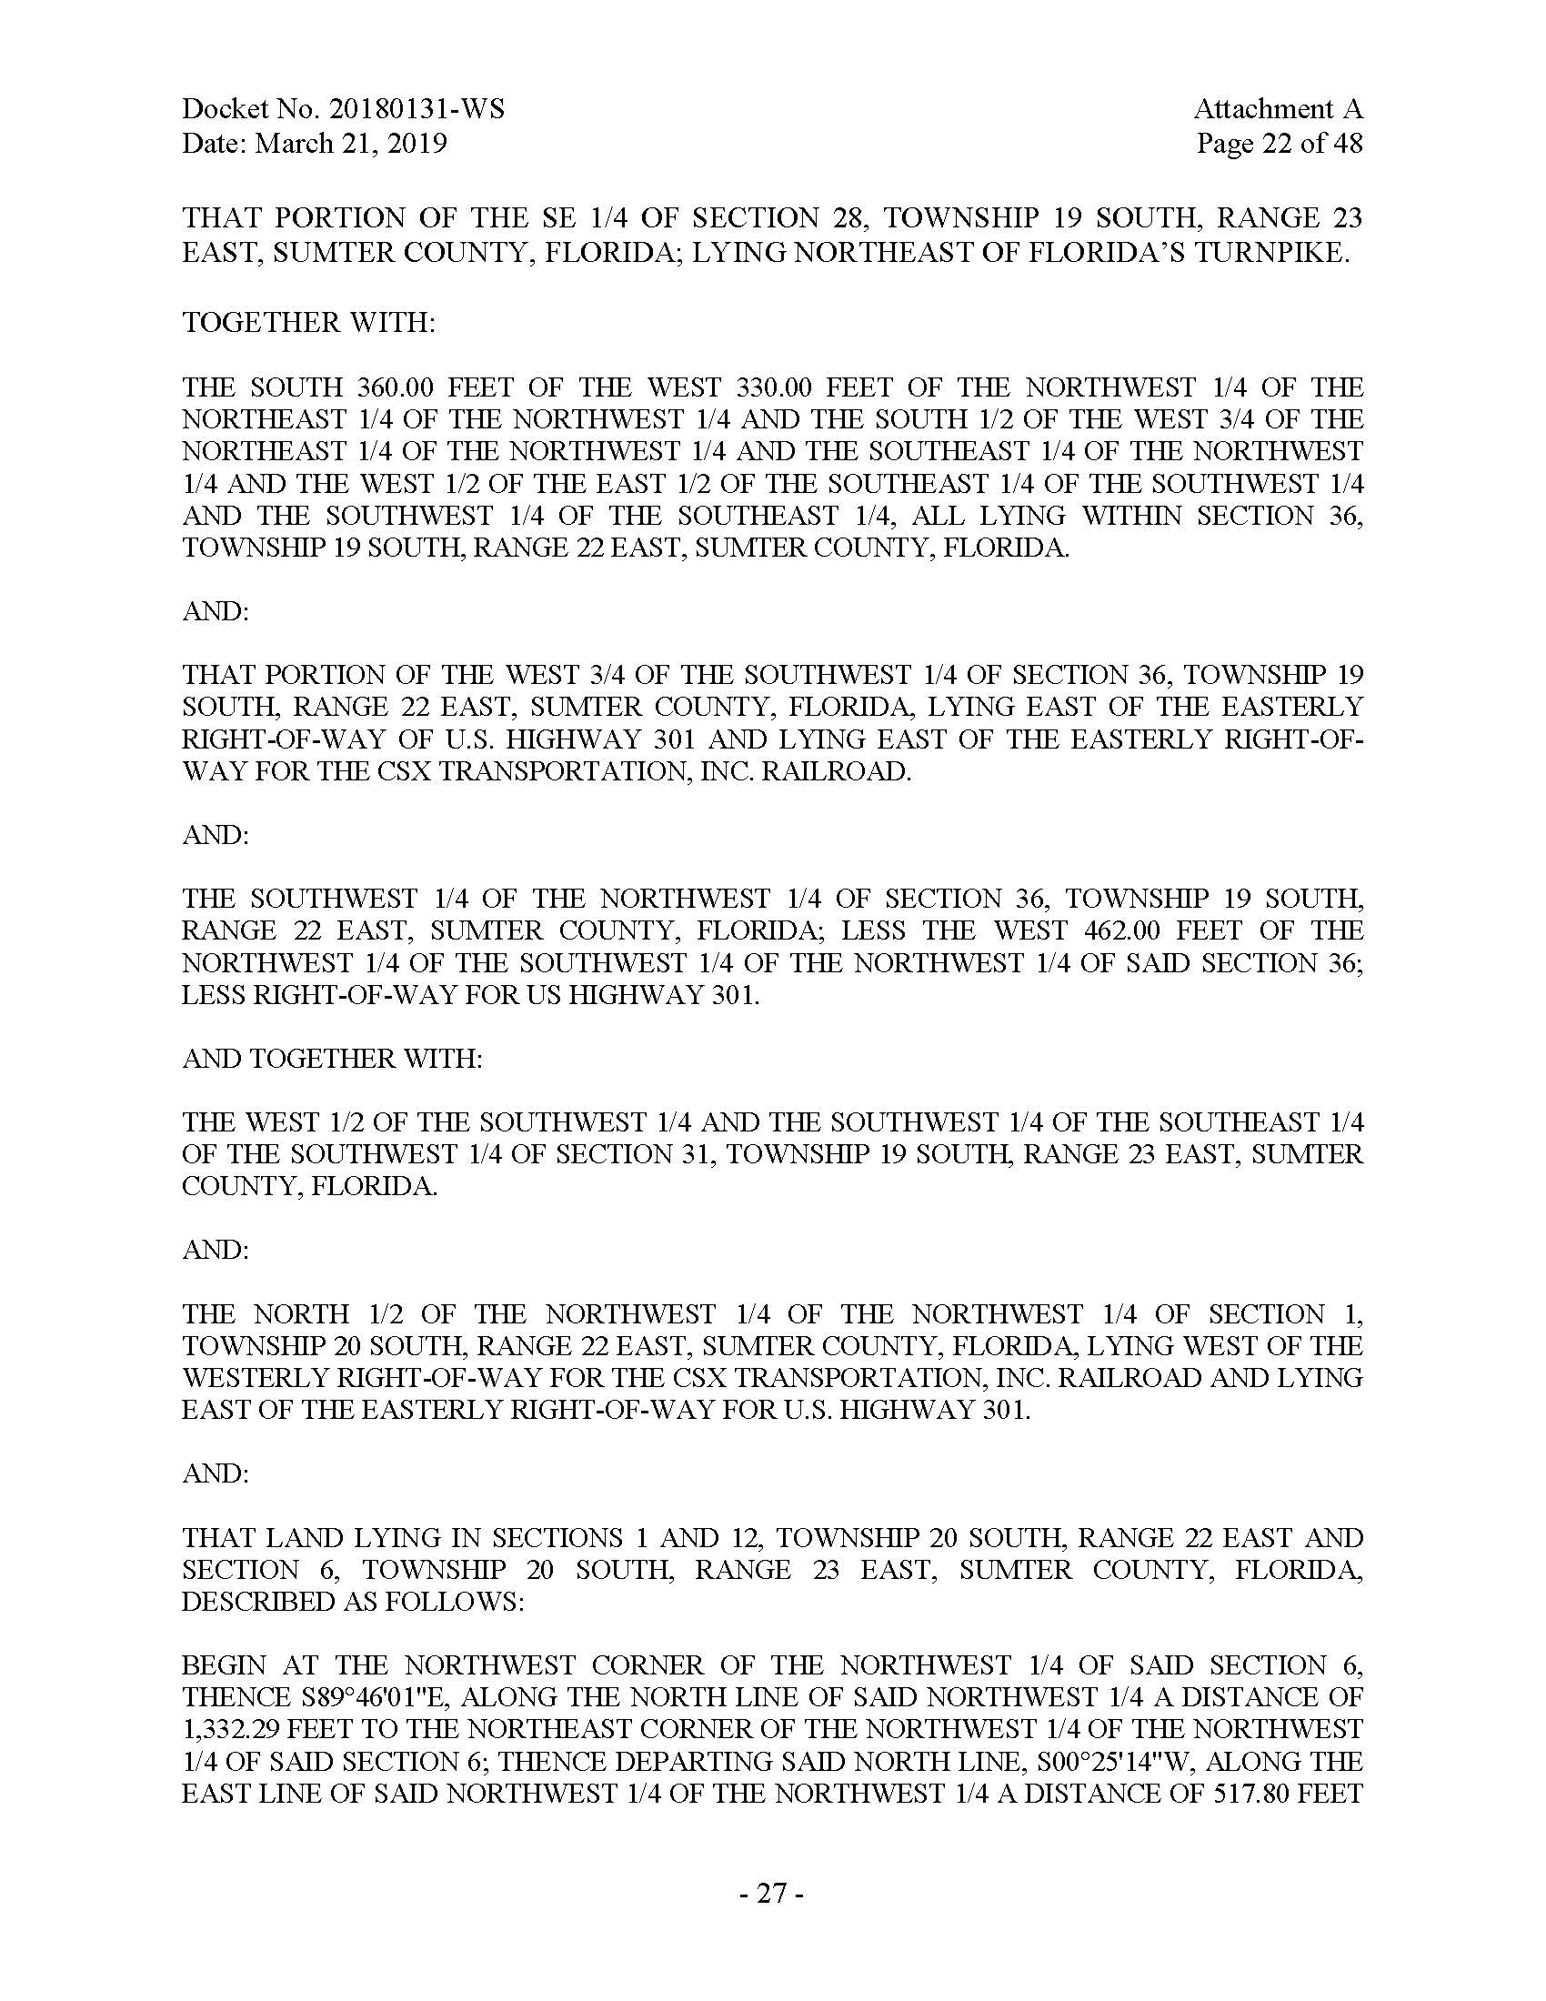

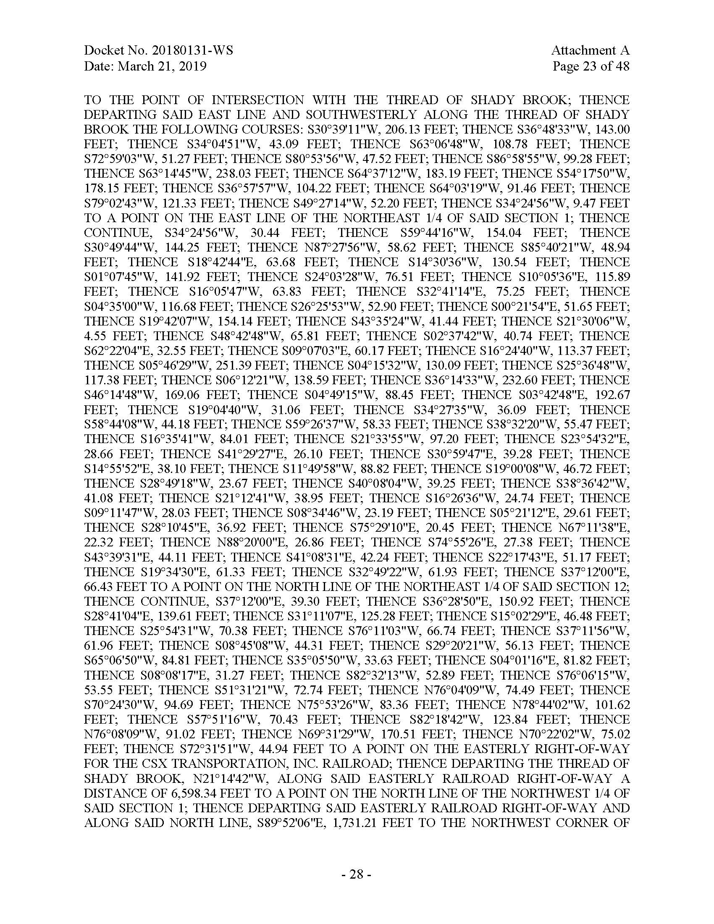

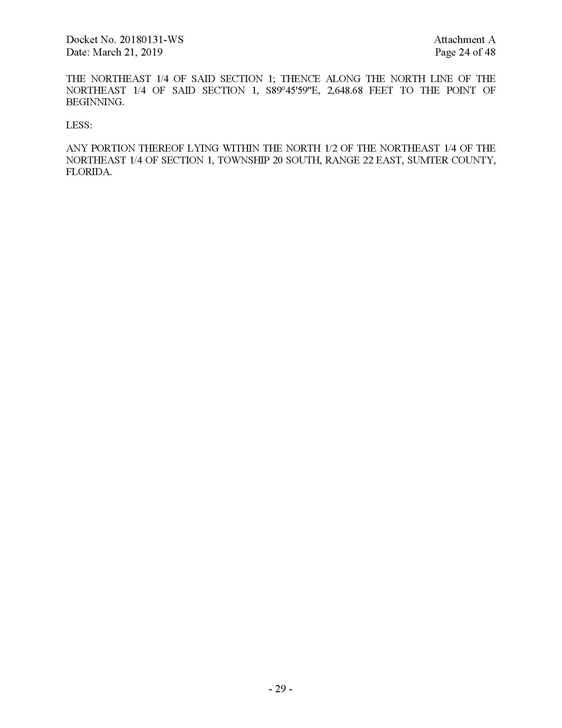

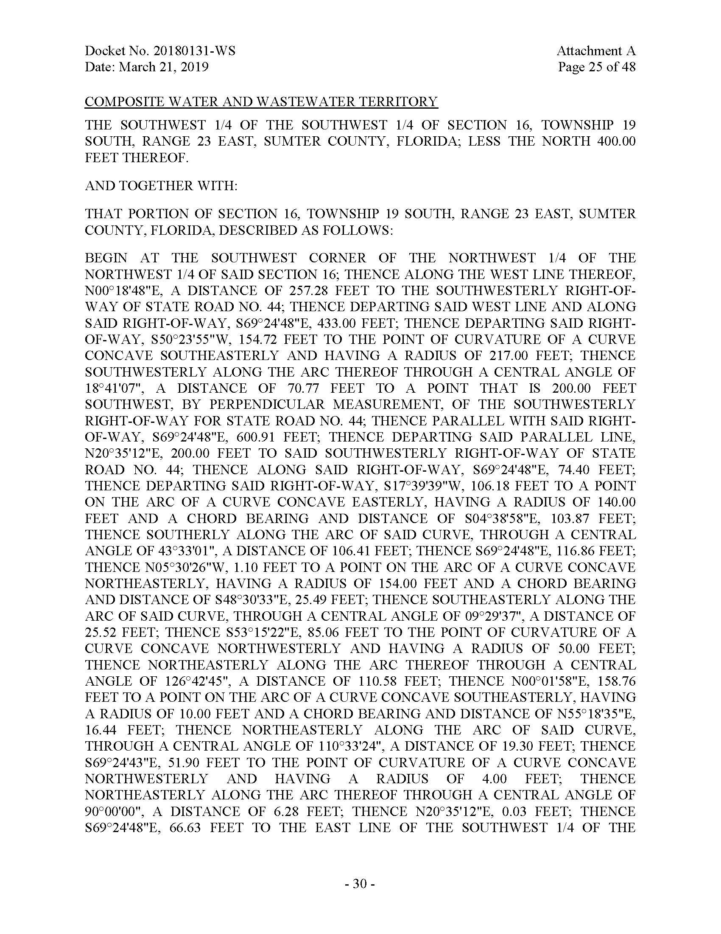

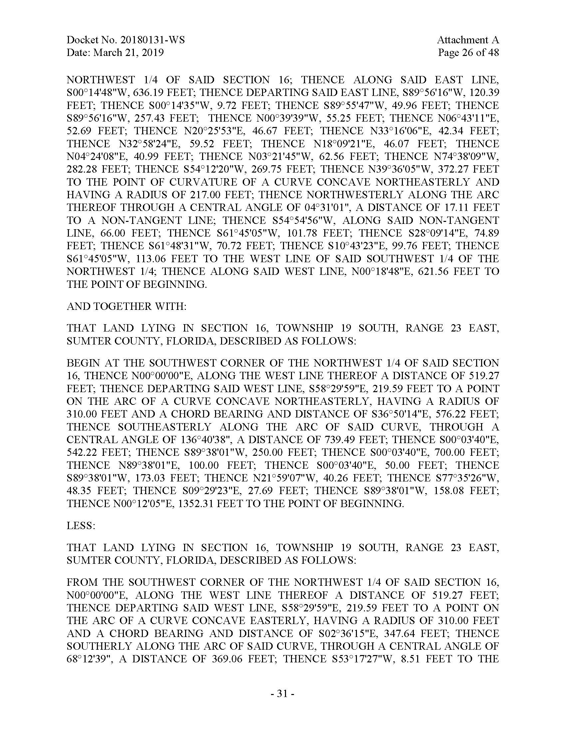

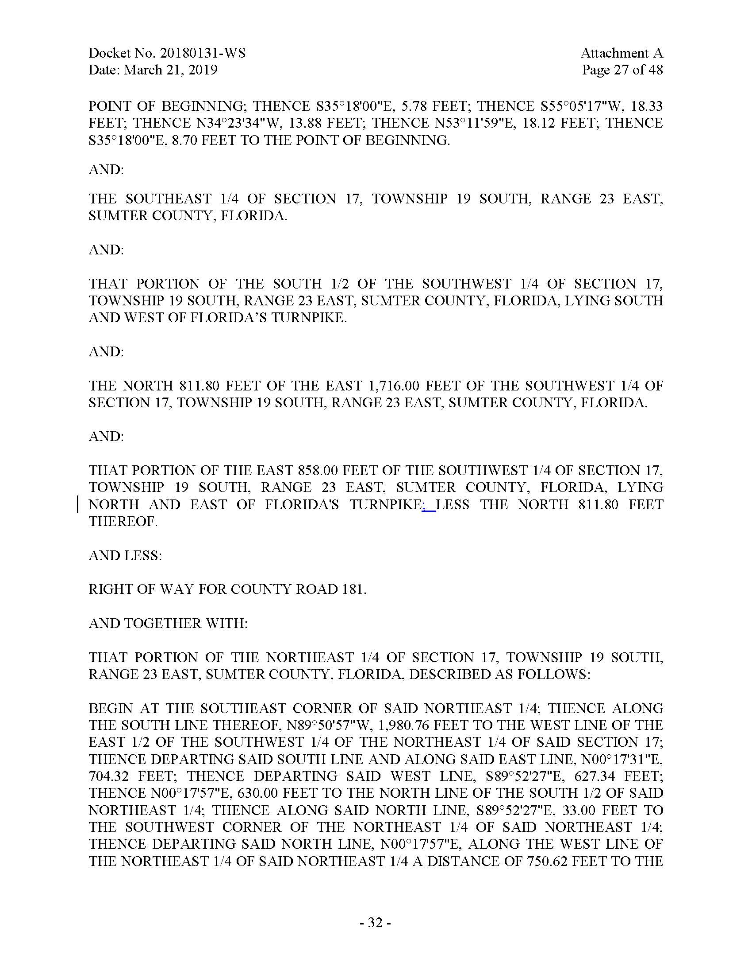

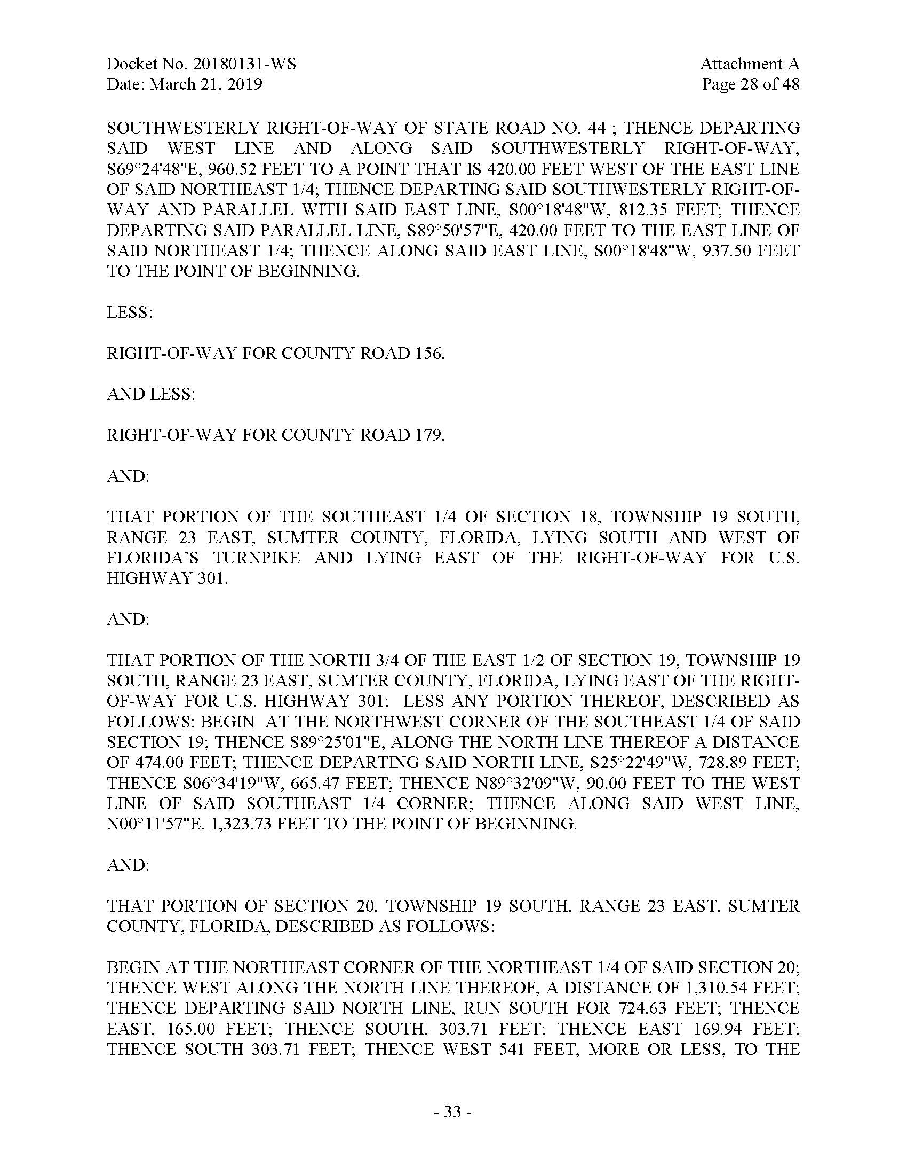

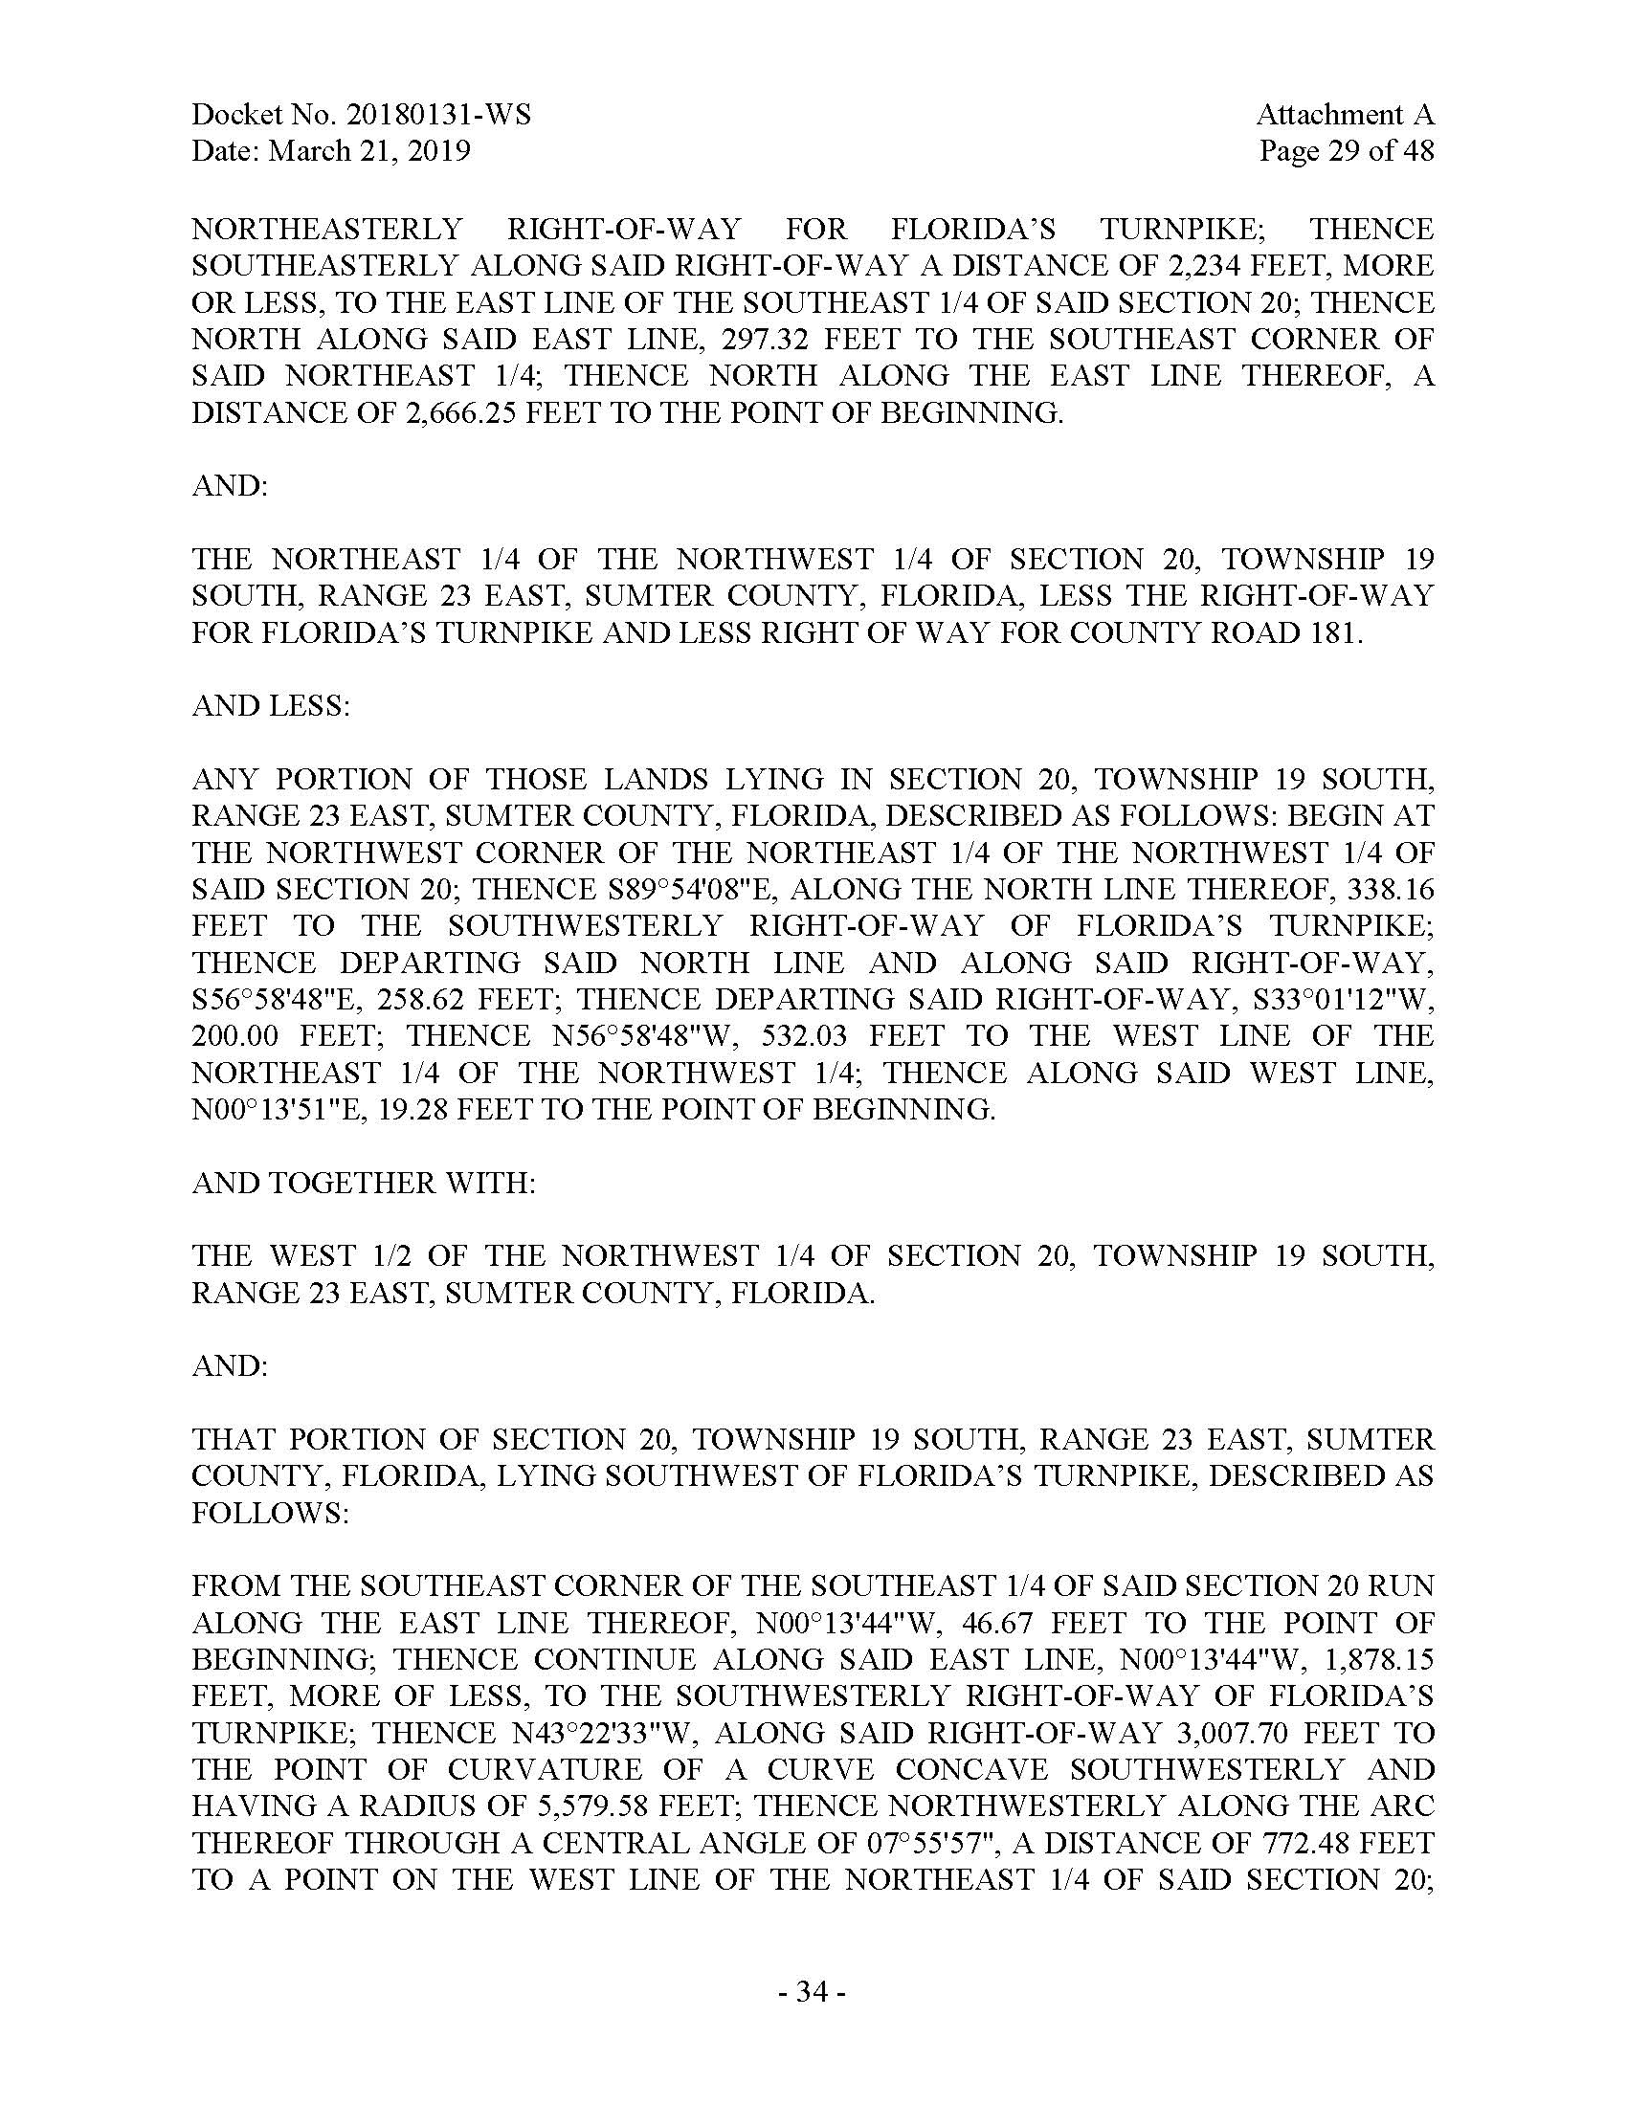

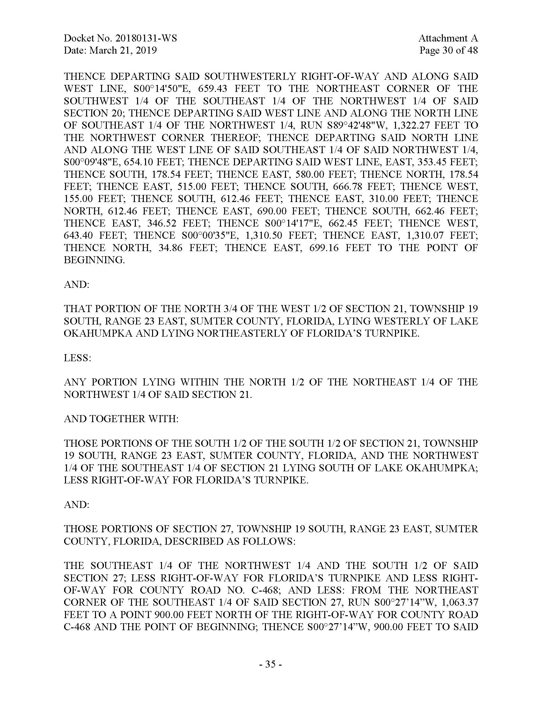

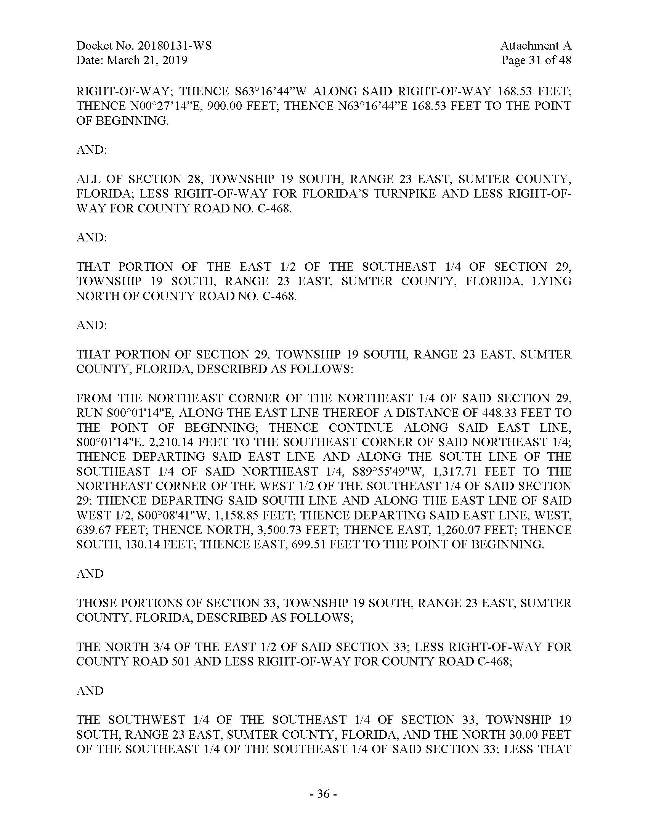

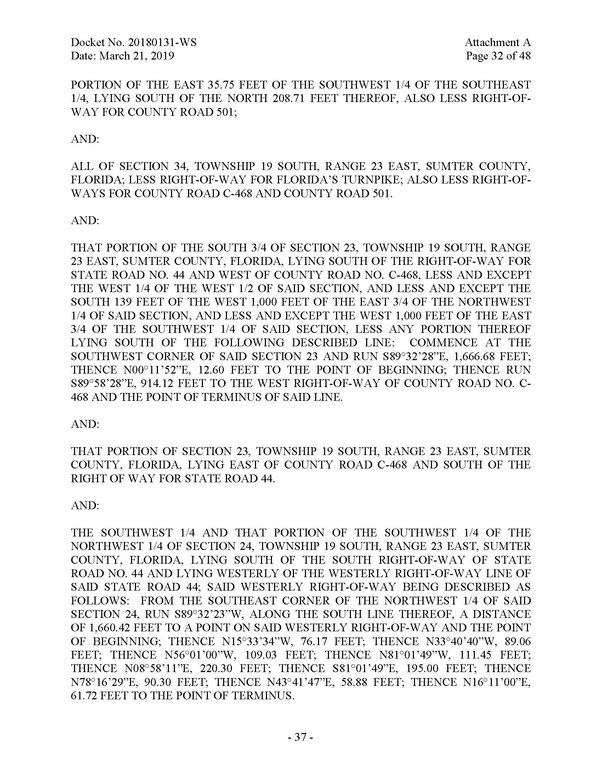

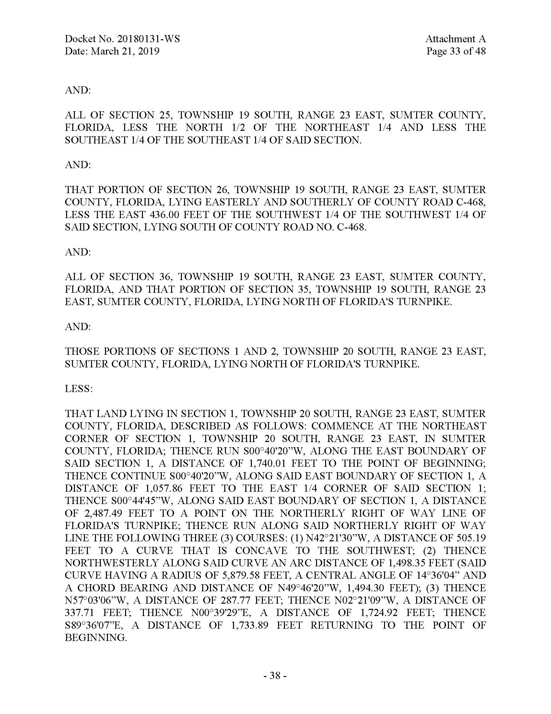

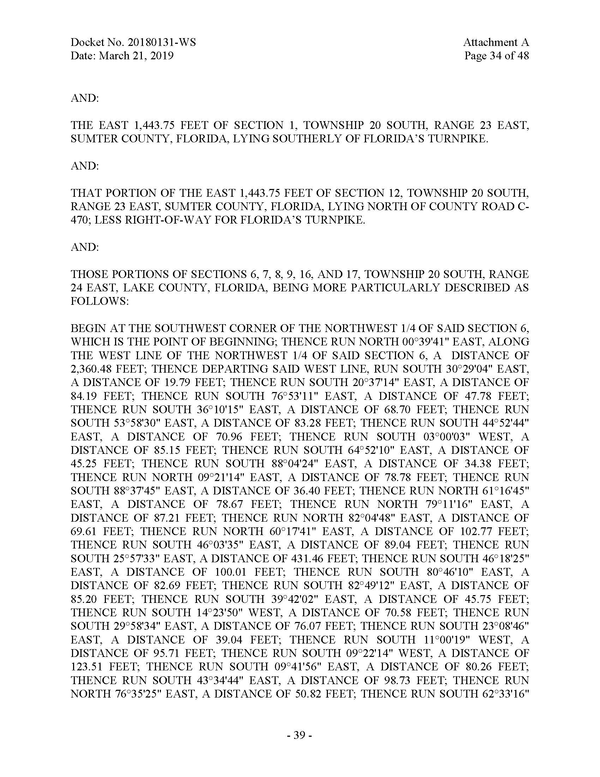

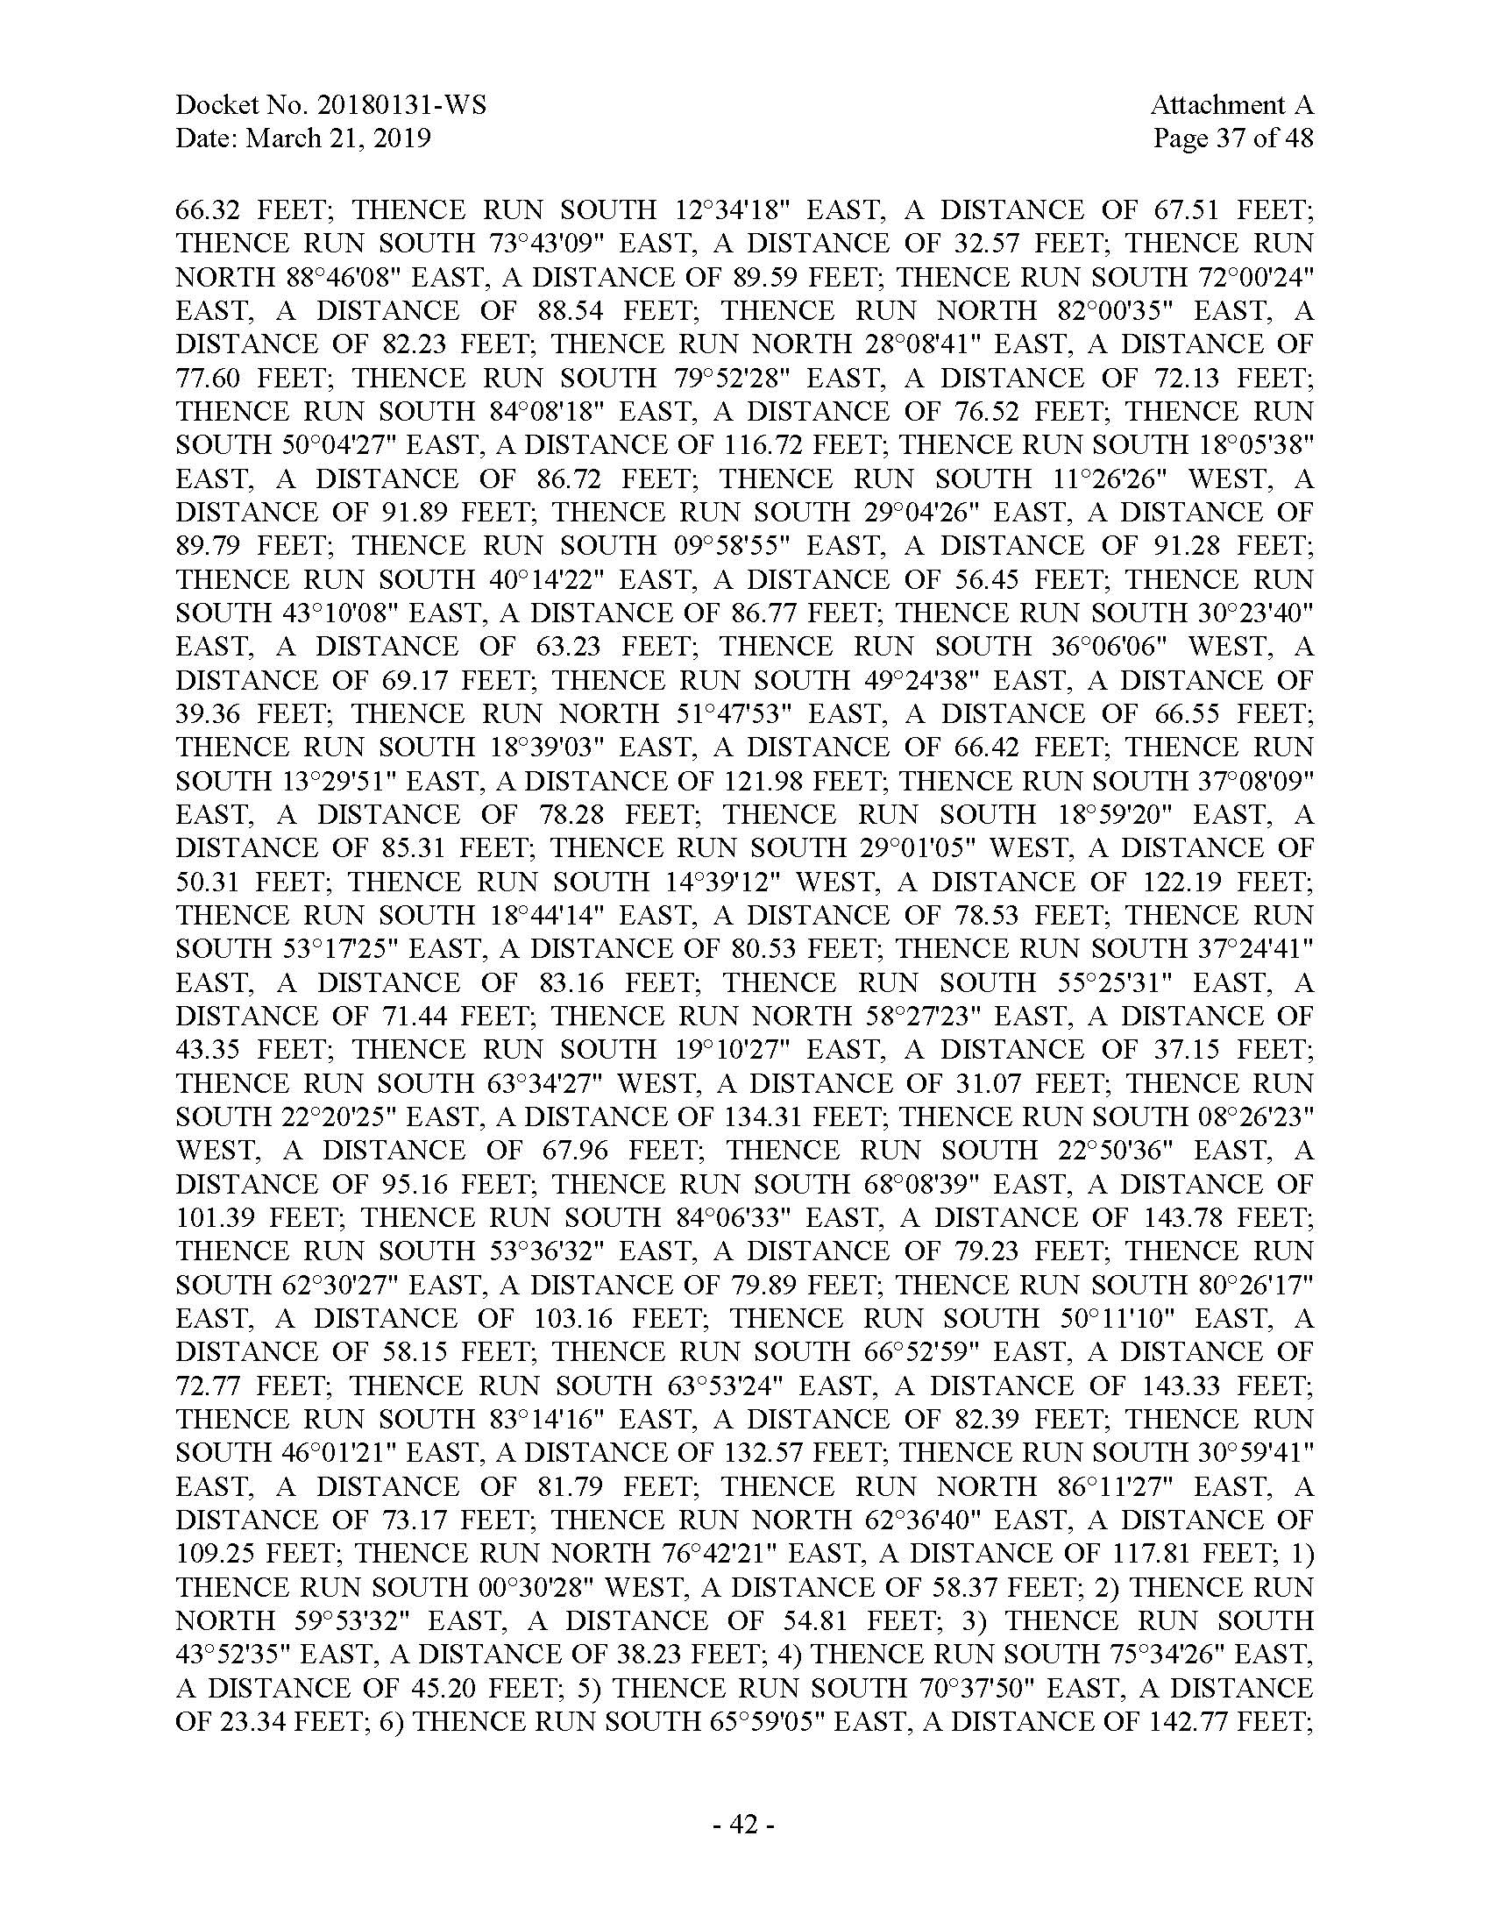

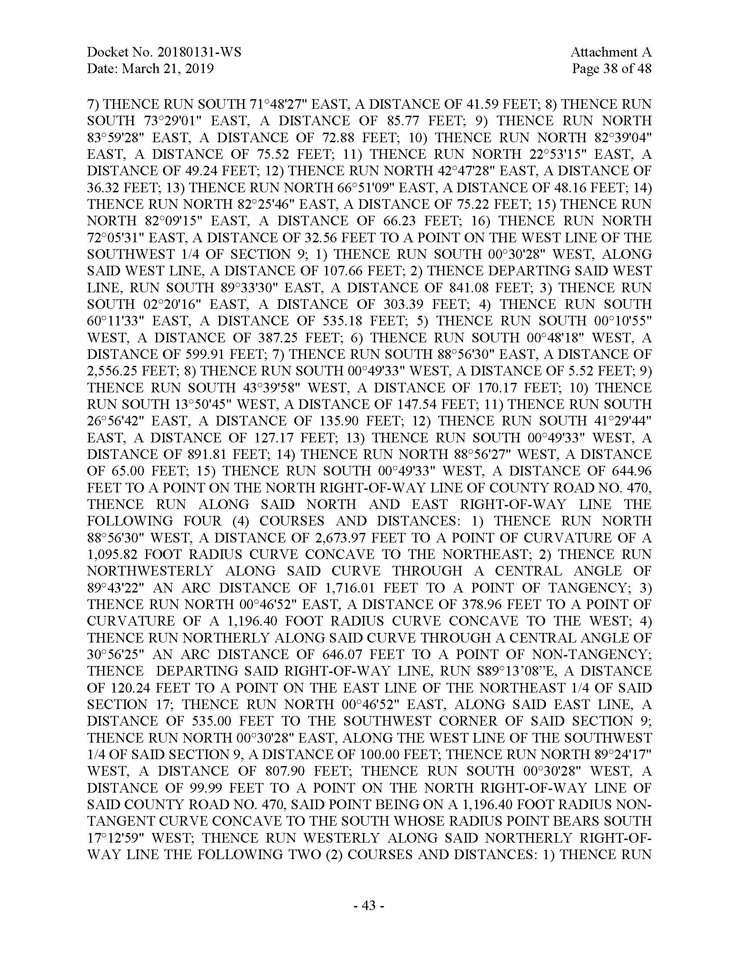

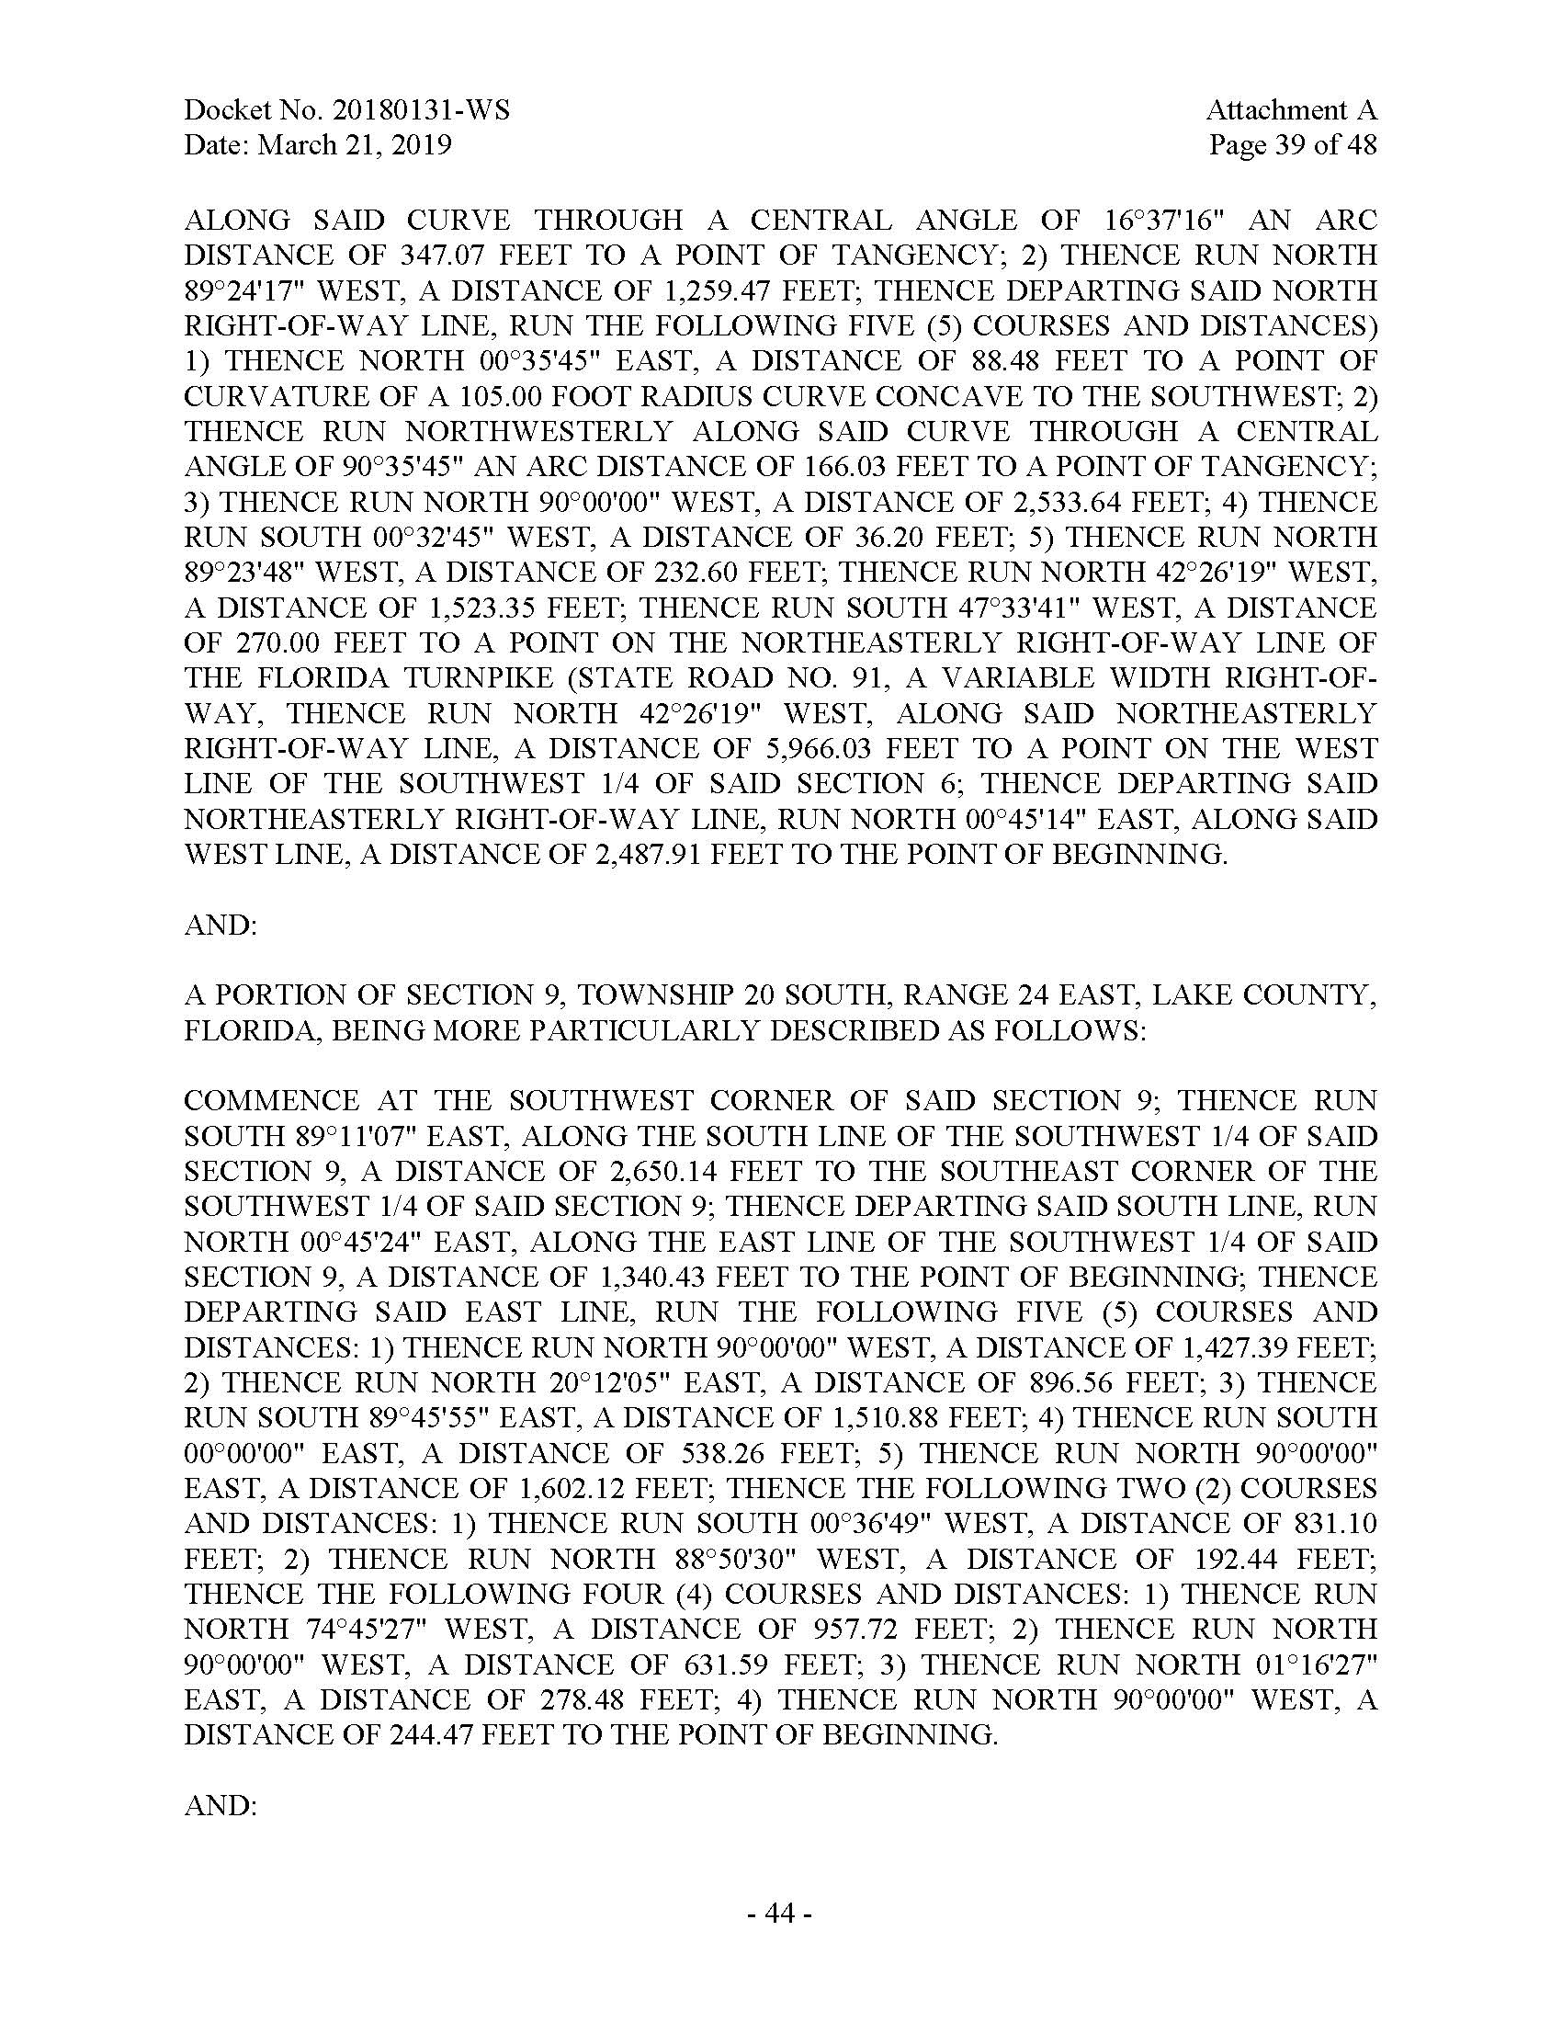

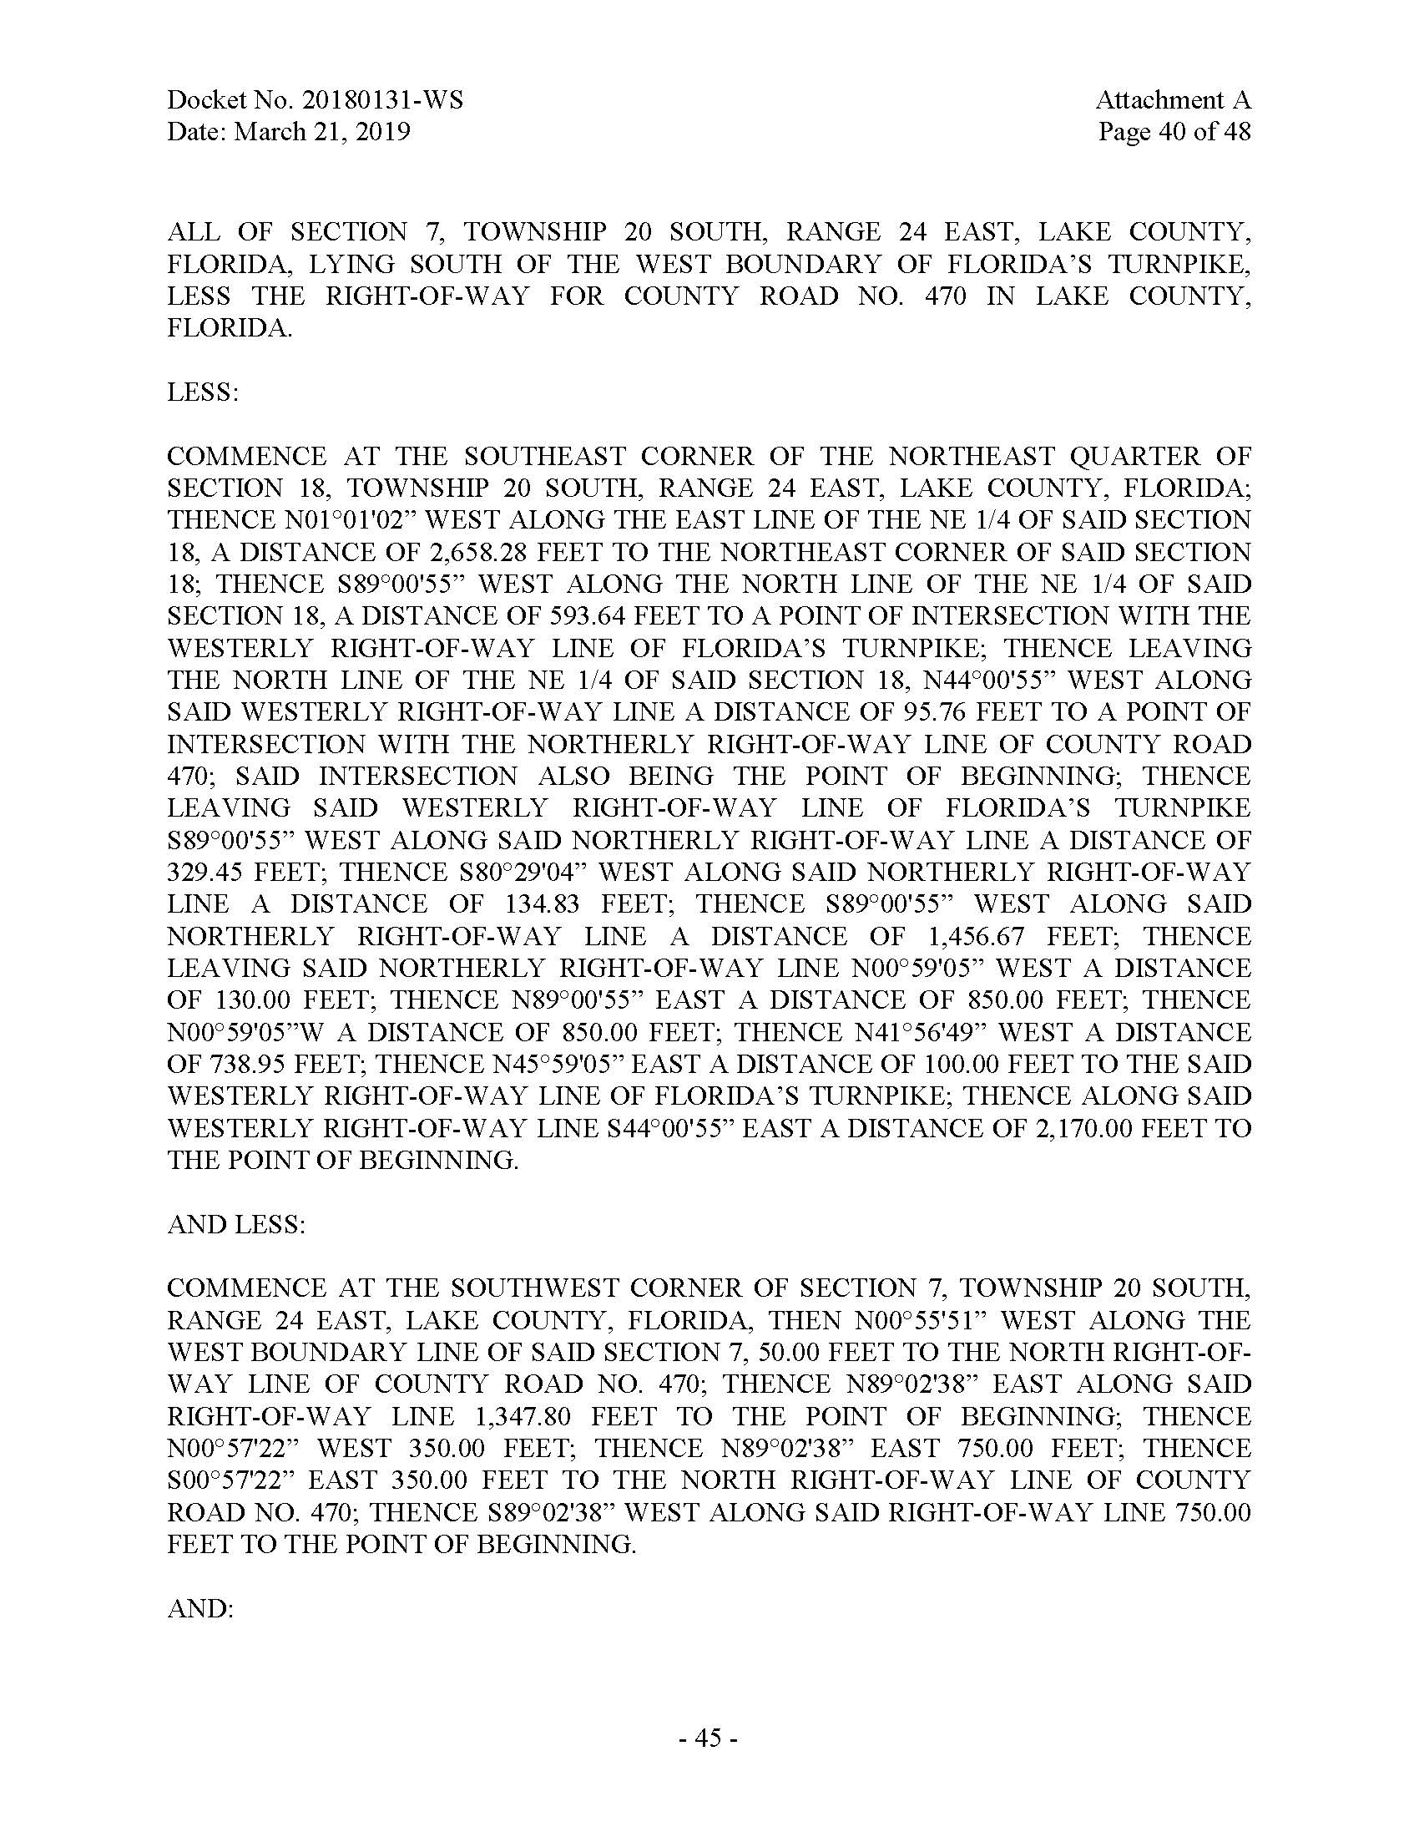

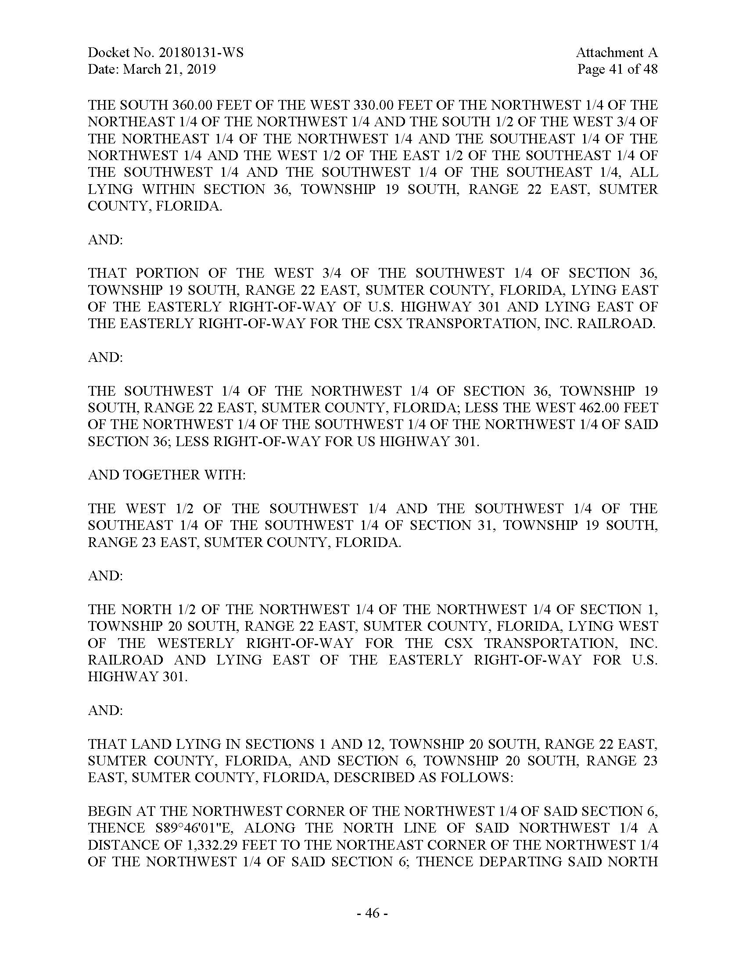

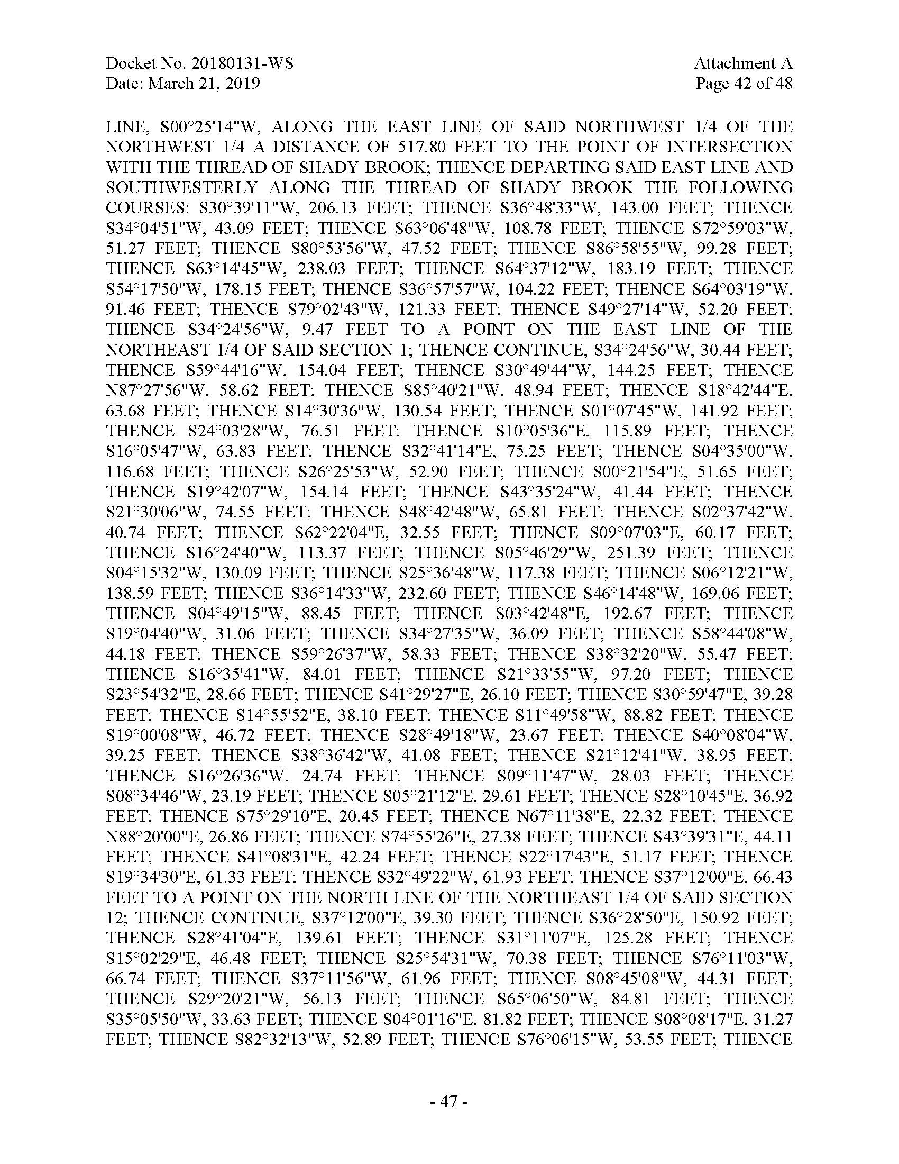

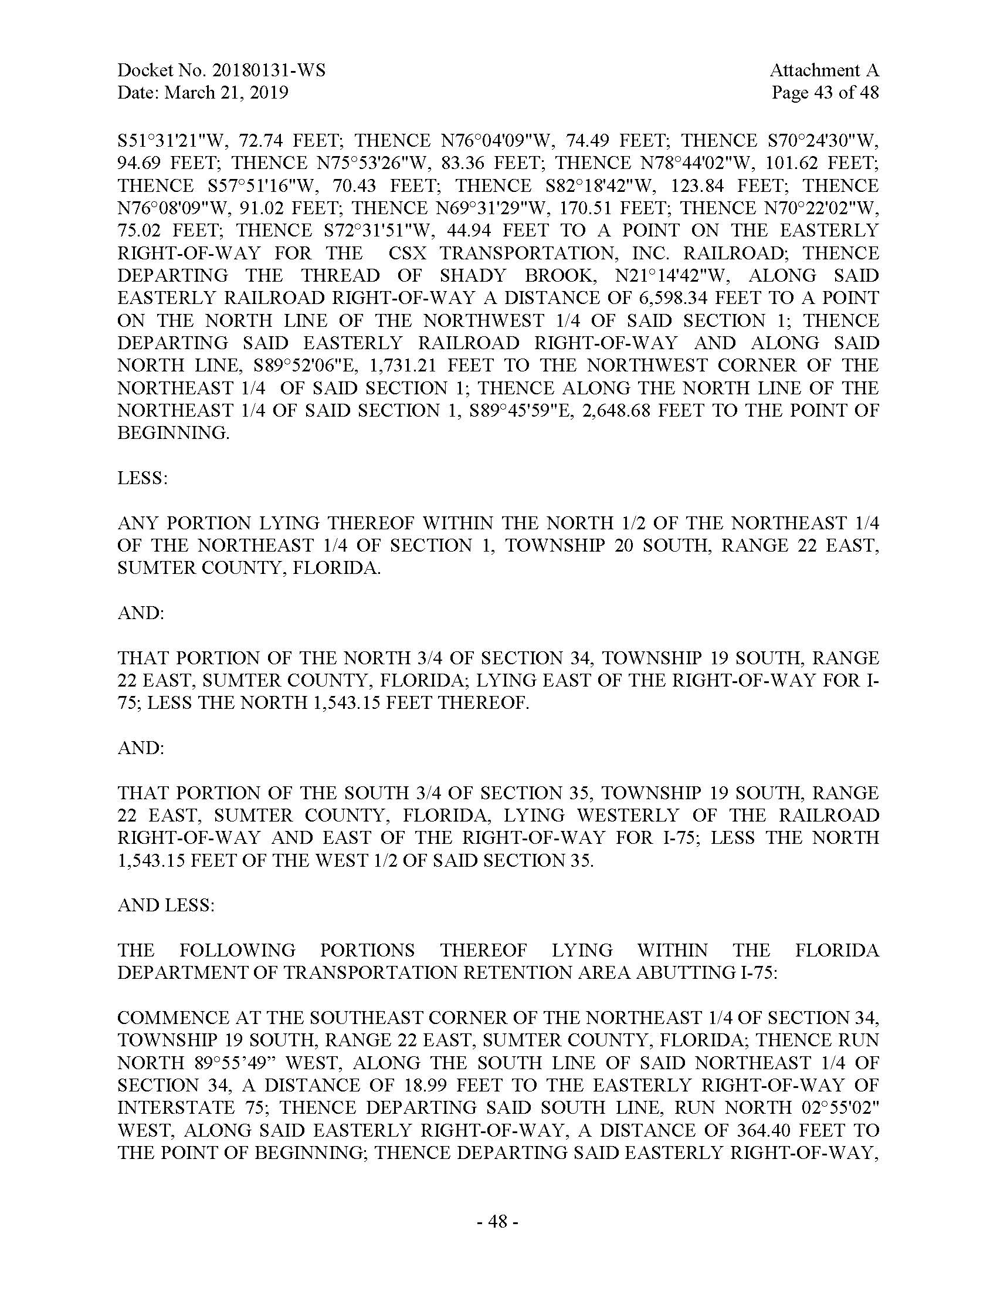

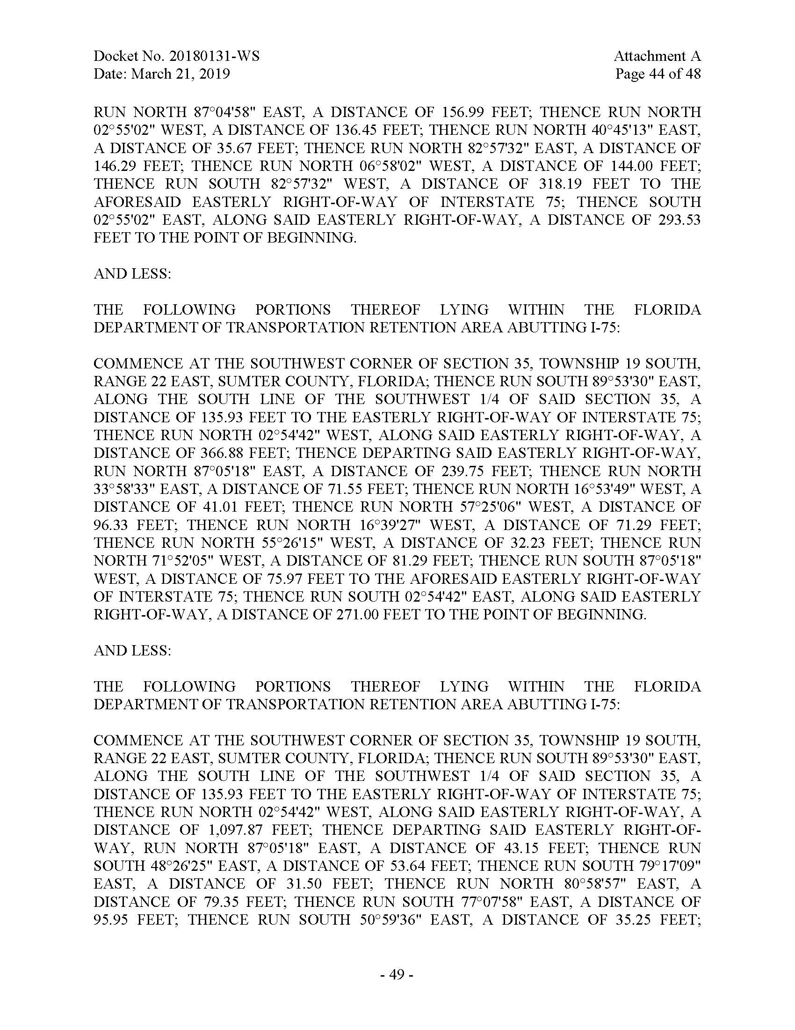

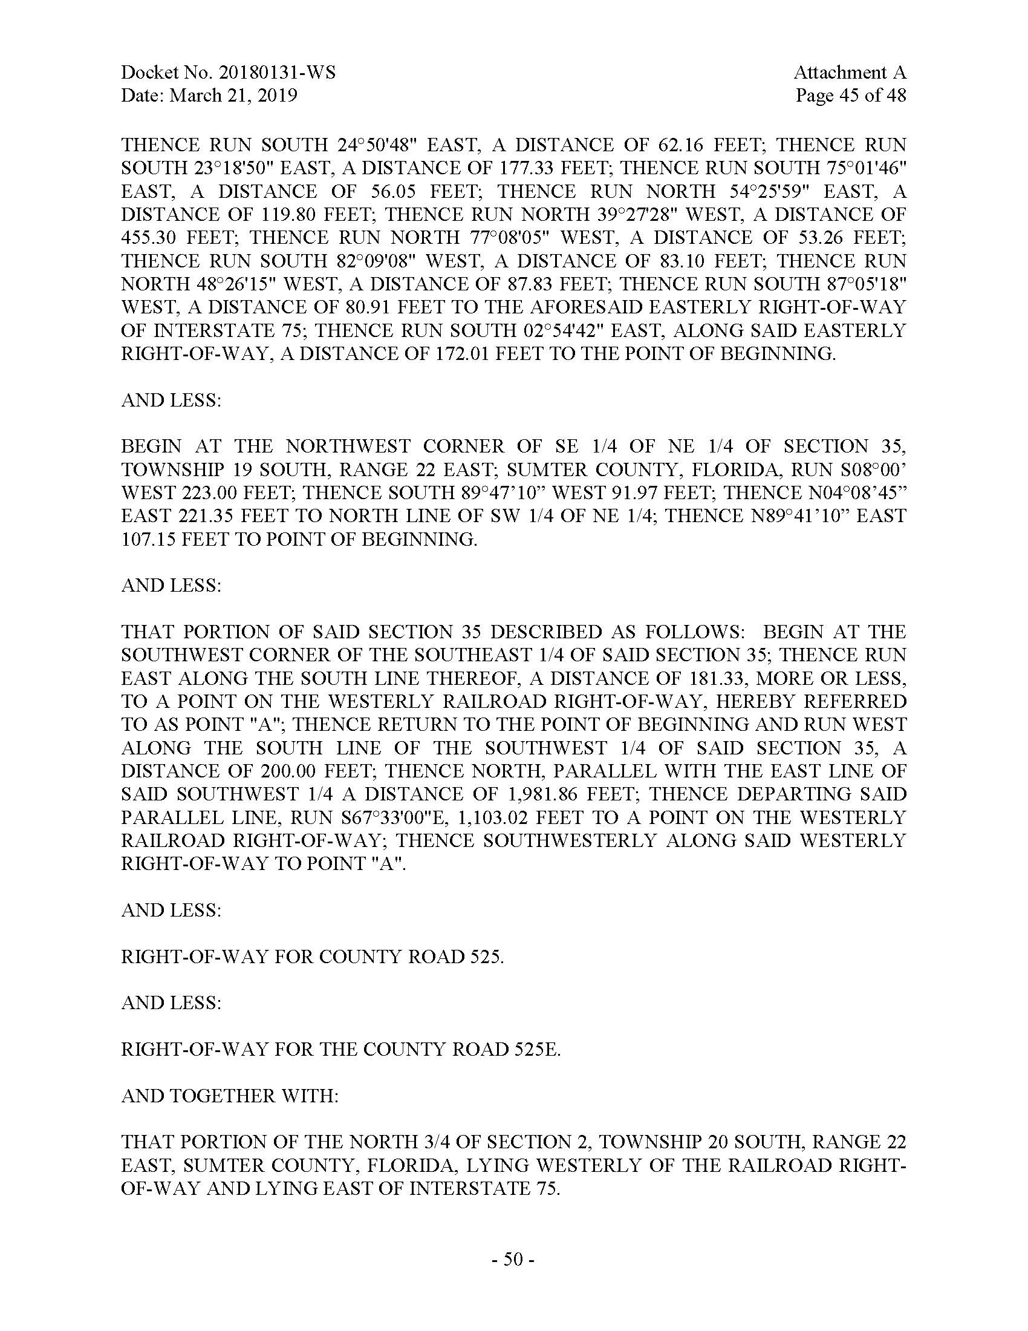

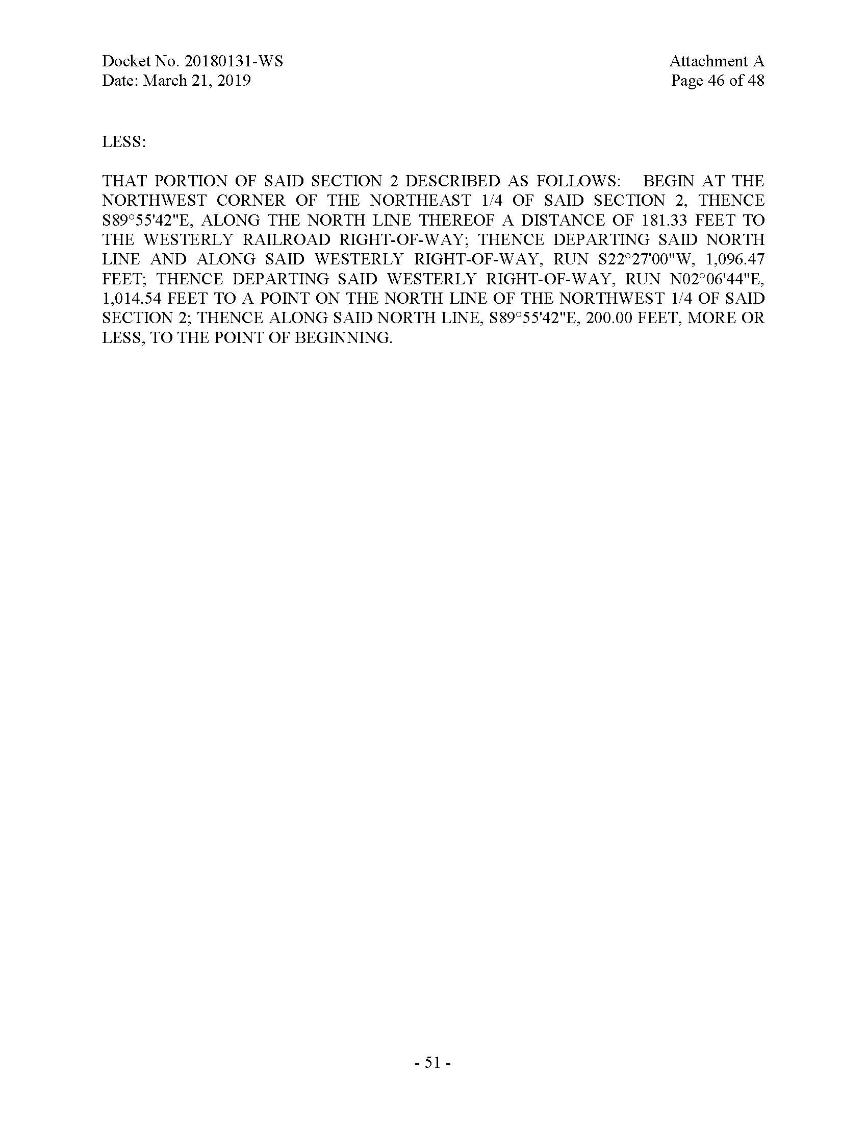

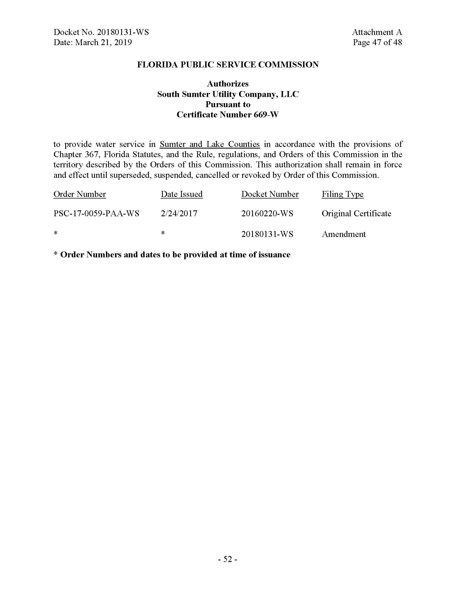

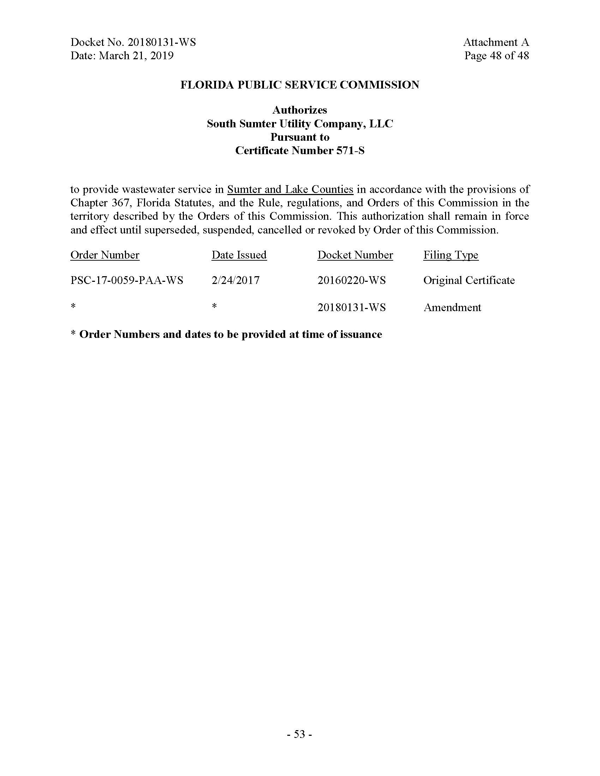

Order No. PSC-17-0059-PAA-WS, issued February 24, 2017, in Docket No. 20160220-WS, In re: Application for original water and wastewater certificates in Sumter County, by South Sumter Utility Company, LLC.
Order No. PSC-2018-0271-PAA-WS, issued May 30, 2018, in Docket No. 20160220-WS, In re: Application for original water and wastewater certificates in Sumter County, by South Sumter Utility Company, LLC.

