State of Florida |  | Public Service Commission  Capital Circle Office Center ● 2540 Shumard Oak Boulevard  Tallahassee, Florida 32399-0850  -M-E-M-O-R-A-N-D-U-M-
DATE: | May 2, 2019
TO: | Office of Commission Clerk (Teitzman)
FROM: | Division of Engineering (Thompson, Doehling, Ellis)  Office of the General Counsel (Dziechciarz)
RE: | Docket No. 20190084-EQ – Petition for approval of new standard offer for purchase of firm capacity and energy from renewable energy facilities or small qualifying facilities and approval of tariff schedule REF-1, by Gulf Power Company.
AGENDA: | 05/14/19 – Regular Agenda – Proposed Agency Action – Interested Persons May Participate
COMMISSIONERS ASSIGNED: |  |  | All Commissioners
PREHEARING OFFICER: |  |  | Administrative
CRITICAL DATES: |  |  | None
SPECIAL INSTRUCTIONS: |  |  | Staff recommends the Commission simultaneously consider Docket No. 20190077-EQ.

Case Background

Section 366.91(3), Florida Statutes (F.S.), requires that each investor-owned utility (IOU) continuously offer to purchase capacity and energy from renewable energy generators and small qualifying facilities. Florida Public Service Commission (Commission) Rules 25-17.200 through 25-17.310, Florida Administrative Code (F.A.C.), implement the statute and require each IOU to file with the Commission by April 1 of each year, a standard offer contract based on the next avoidable fossil fueled generating unit of each technology type identified in the utility’s current Ten-Year Site Plan. On April 1, 2019, Gulf Power Company (Gulf) filed a petition for approval of its revised standard offer contract and rate schedule REF-1 for renewable energy facilities or small qualifying facilities based on its 2019 Ten-Year Site Plan. The Commission has jurisdiction over this standard offer contract pursuant to Sections 366.04 through 366.055 and 366.91, F.S.

Discussion of Issues

Issue 1:
Should the Commission approve the revised standard offer contract and schedule REF-1 filed by Gulf Power Company?

Recommendation:
Yes. The provisions of Gulf’s revised standard offer contract and schedule REF-1 conform to all requirements of Rules 25-17.200 through 25-17.310, F.A.C. Gulf’s revised standard offer contract provides flexibility in the arrangements for payments so that a developer of renewable generation may select the payment stream best suited to its financial needs. Staff recommends that Gulf’s revised standard offer contract and schedule REF-1 be approved as filed. (Thompson)

Staff Analysis:
Rule 25-17.250, F.A.C., requires that Gulf, an IOU, continuously make available a standard offer contract for the purchase of firm capacity and energy from renewable generating facilities (RF) and small qualifying facilities (QF) with design capacities of 100 kilowatts (kW) or less. Pursuant to Rule 25-17.250(1) and (3), F.A.C., the standard offer contract must provide a term of at least 10-years, and the payment terms must be based on the utility’s next avoidable fossil-fueled generating unit identified in its most recent Ten-Year Site Plan or, if no avoided unit is identified, its next avoidable planned purchase. Gulf has identified a 595 megawatt (MW) natural gas combined cycle generating facility as its next planned fossil-fueled generating unit in its 2019 Ten-Year Site Plan. The projected in-service date of this facility is June 1, 2024.
The RF/QF operator may elect to make no commitment as to the quantity or timing of its deliveries to Gulf, and to have a committed capacity of zero (0) MW. Under such a scenario, the energy is delivered on an as-available basis, and the operator receives only an energy payment. Alternatively, the RF/QF operator may elect to commit to certain minimum performance requirements based on the identified avoided unit, such as being operational and delivering an agreed upon amount of capacity by the in-service date of the avoided unit, and thereby becomes eligible for capacity payments in addition to payments received for energy. The standard offer contract may also serve as a starting point for negotiation of contract terms by providing payment information to an RF/QF operator, in a situation where one or both parties desire particular contract terms other than those established in the standard offer.
In order to promote renewable generation, the Commission requires the IOU to offer multiple options for capacity payments, including the options to receive early or levelized payments. If the RF/QF operator elects to receive capacity payments under the normal or levelized contract options, it will receive as-available energy payments only until the in-service date of the avoided unit (in this case June 1, 2024), and thereafter begin receiving capacity payments in addition to the energy payments. If either the early or levelized option is selected, then the operator will begin receiving capacity payments earlier than the in-service date of the avoided unit. However, payments made under the early capacity payment options tend to be lower in the later years of the contract term because the net present value (NPV) of the total payments must remain equal for all contract payment options.

Table 1 contains estimates of the annual payments for each payment option available under the revised standard offer contract to an operator with a 50 MW facility, operating at a capacity factor of 88 percent, which is the minimum capacity factor required under the contract to qualify for full capacity payments. Normal and levelized capacity payments begin in 2024, reflecting the projected in-service date of the avoided unit (June 1, 2024).

Table 1 – Estimated Annual Payments to a 50 MW Renewable Facility
88 Percent Capacity Factor
Year | Energy Payment | Capacity Payment (By Type)
 |  | Normal | Levelized | Early | Early Levelized
 | $(000) | $(000) | $(000) | $(000) | $(000)
2020 | 10,265 | - | - | 3,894 | 4,277
2021 | 11,424 | - | - | 3,975 | 4,311
2022 | 12,099 | - | - | 4,058 | 4,346
2023 | 13,128 | - | - | 4,143 | 4,381
2024 | 13,612 | 3,735 | 4,021 | 4,230 | 4,418
2025 | 13,941 | 6,460 | 6,906 | 4,318 | 4,455
2026 | 14,442 | 6,558 | 6,927 | 4,408 | 4,492
2027 | 15,059 | 6,659 | 6,949 | 4,500 | 4,531
2028 | 15,460 | 6,761 | 6,972 | 4,594 | 4,570
2029 | 15,992 | 6,866 | 6,995 | 4,690 | 4,611
2030 | 17,114 | 6,973 | 7,018 | 4,788 | 4,652
2031 | 17,511 | 7,082 | 7,042 | 4,888 | 4,693
2032 | 18,409 | 7,193 | 7,066 | 4,991 | 4,736
2033 | 19,353 | 7,307 | 7,091 | 5,095 | 4,780
2034 | 20,205 | 7,424 | 7,116 | 5,201 | 4,824
2035 | 20,733 | 7,542 | 7,142 | 5,310 | 4,870
2036 | 21,362 | 7,663 | 7,169 | 5,421 | 4,916
2037 | 21,750 | 7,787 | 7,196 | 5,534 | 4,964
2038 | 22,039 | 7,913 | 7,223 | 5,650 | 5,012
2039 | 23,080 | 8,042 | 7,252 | 5,768 | 5,062
Total | 336,979 | 111,967 | 110,086 | 95,458 | 92,901
NPV (2020$) | 171,388 | 50,742 | 50,742 | 50,742 | 50,742
Source: Gulf’s Response to Staff’s First Data Request
Gulf’s standard offer contract and schedule REF-1, in type-and-strike format, are included as Attachment A. All of the changes made to the tariff sheets are consistent with the avoided unit. Revisions include updates to calendar dates and payment information which reflect the current economic and financial assumptions for the avoided unit costs.

Conclusion
The provisions of Gulf’s revised standard offer contract and schedule REF-1 conform to all requirements of Rules 25-17.200 through 25-17.310, F.A.C. The revised standard offer contract provides flexibility in the arrangements for payments so that a developer of renewable generation may select the payment stream best suited to its financial needs. Staff recommends that Gulf’s revised standard offer contract and schedule REF-1 be approved as filed.

Issue 2:
Should this docket be closed?

Recommendation:
Yes. This docket should be closed upon issuance of a consummating order, unless a person whose substantial interests are affected by the Commission’s decision files a protest within 21 days of the issuance of the Commission’s Proposed Agency Action Order. Potential signatories should be aware that, if a timely protest is filed, Gulf’s standard offer contract may subsequently be revised. (Dziechciarz)

Staff Analysis:
This docket should be closed upon the issuance of a consummating order, unless a person whose substantial interests are affected by the Commission’s decision files a protest within 21 days of the issuance of the Commission’s Proposed Agency Action Order. Potential signatories should be aware that, if a timely protest is filed, Gulf’s standard offer contract may subsequently be revised.

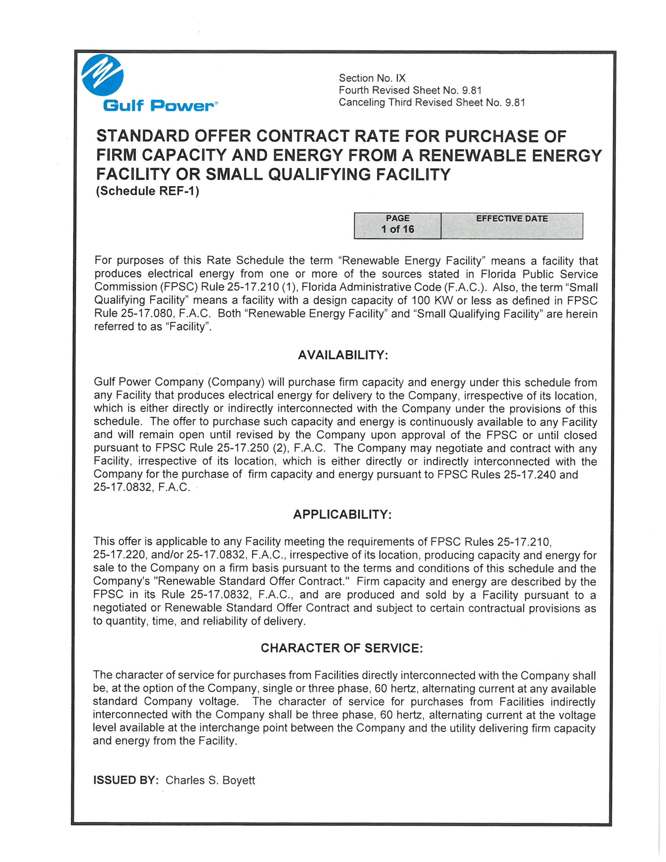

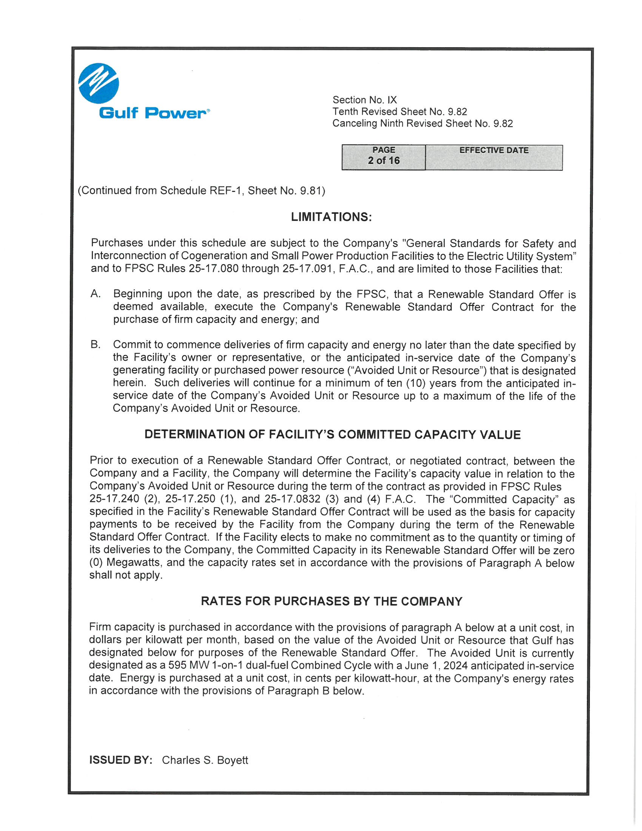

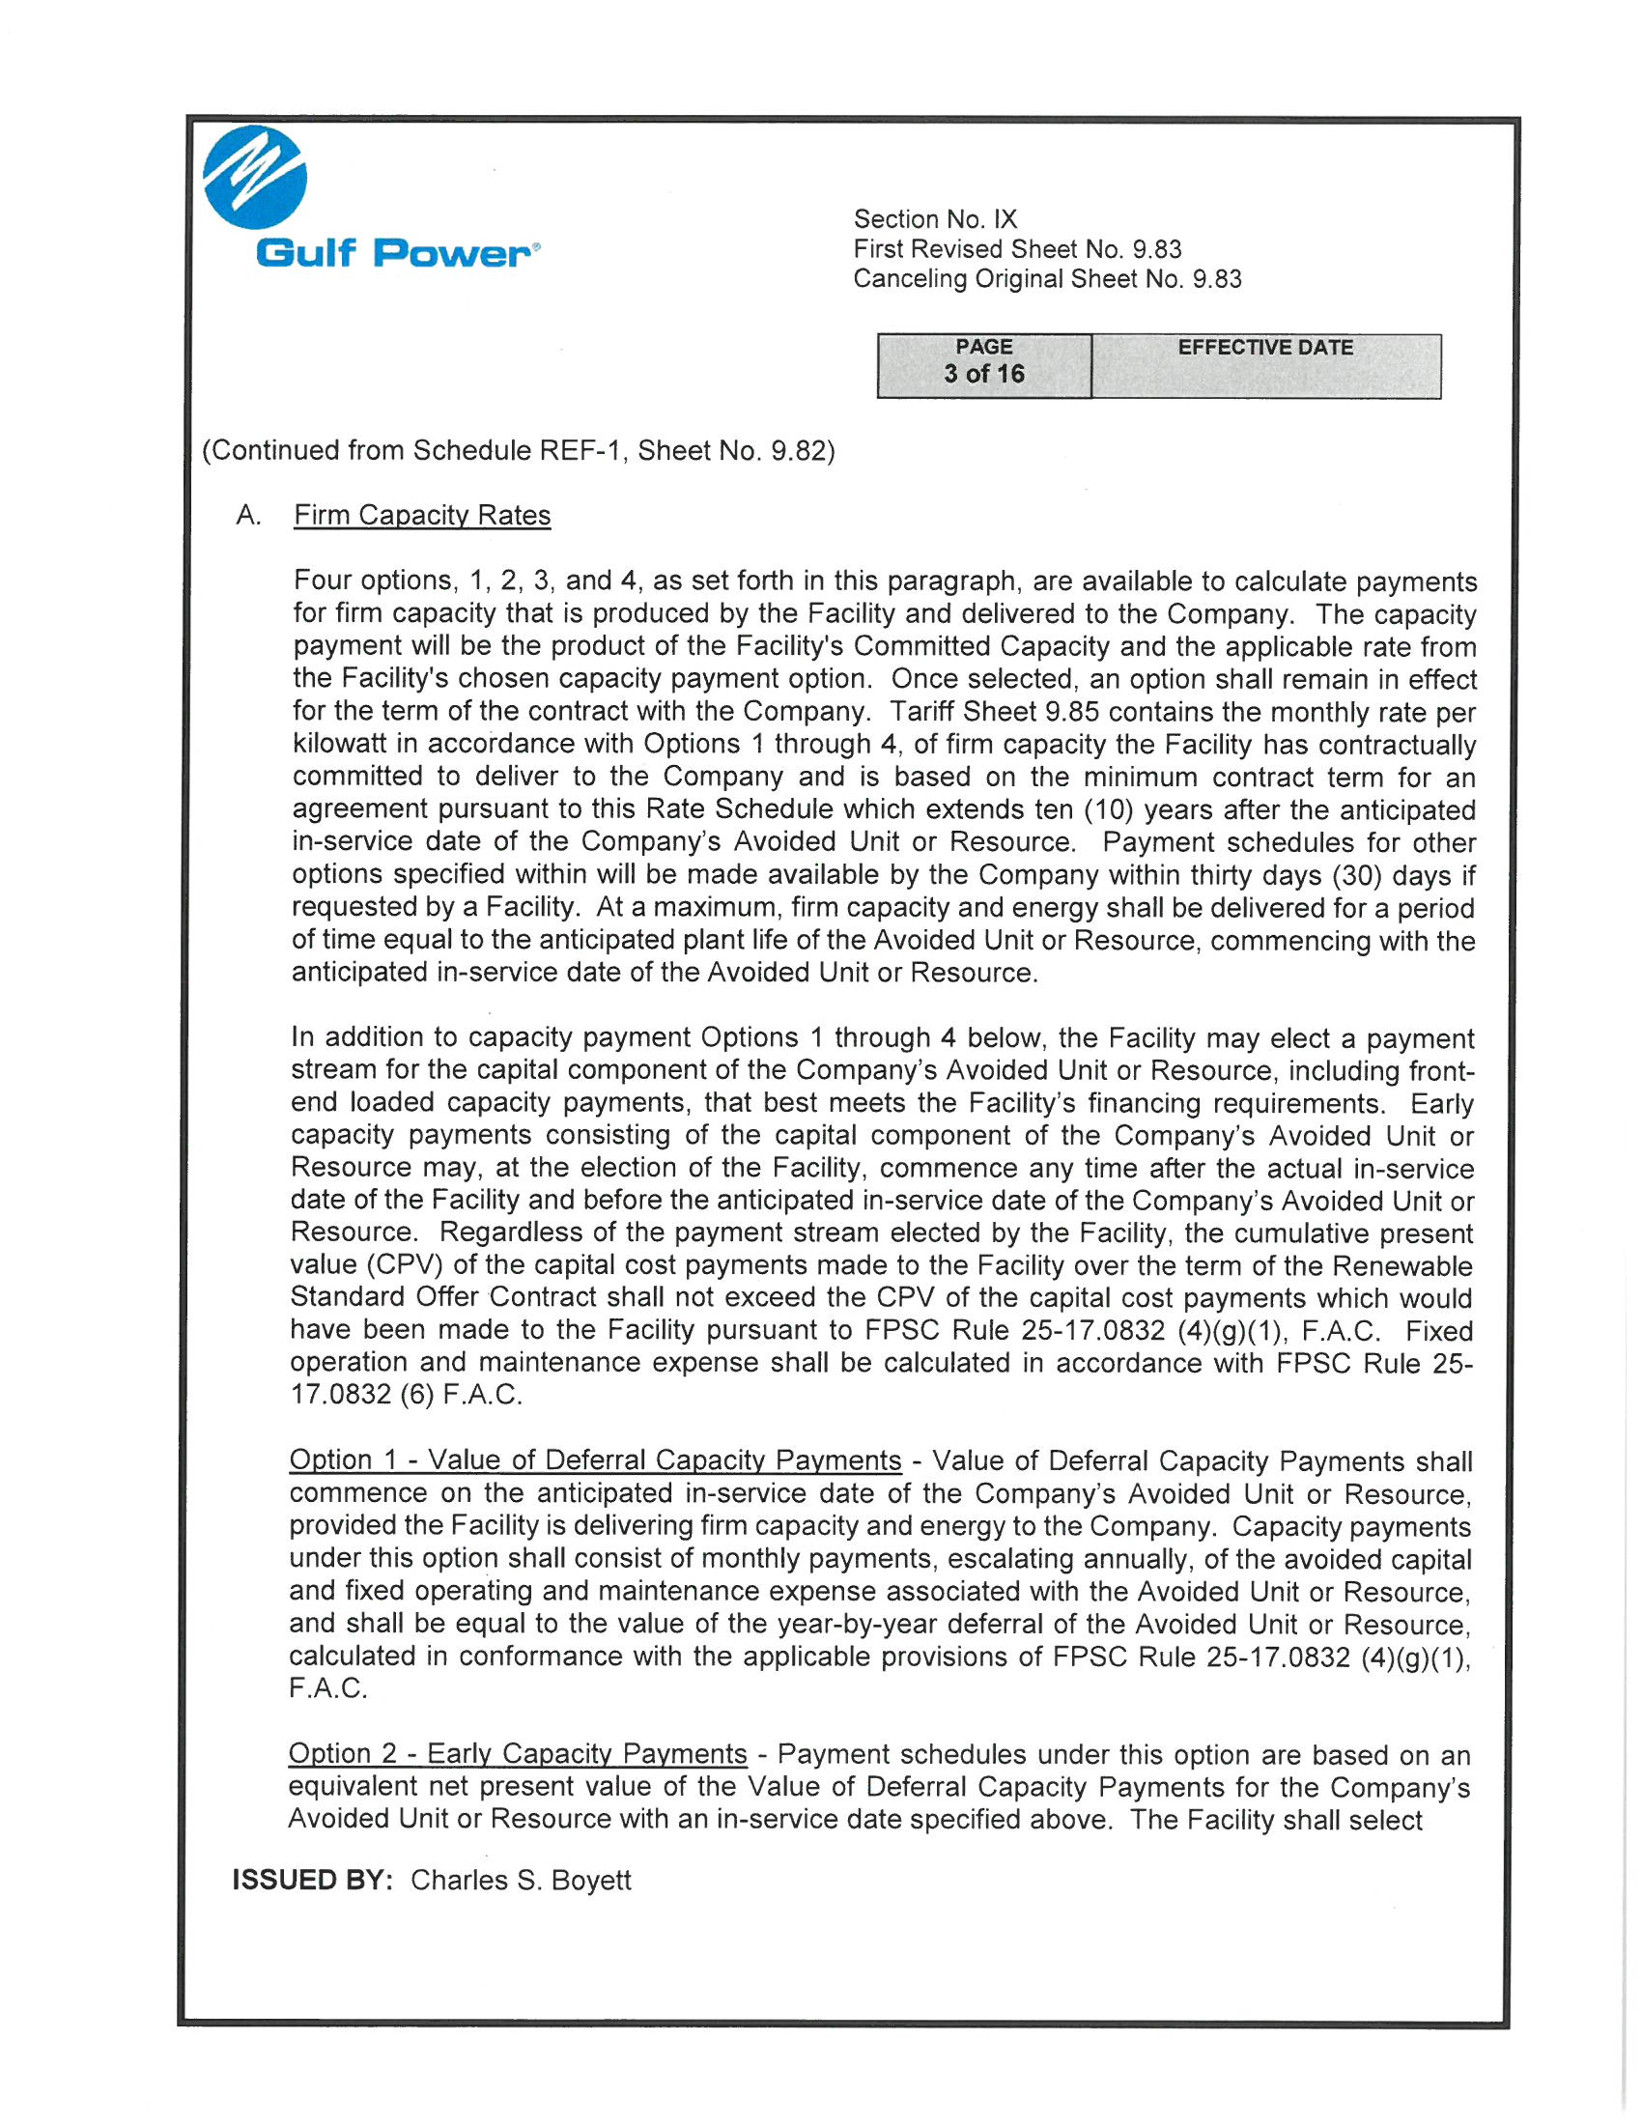

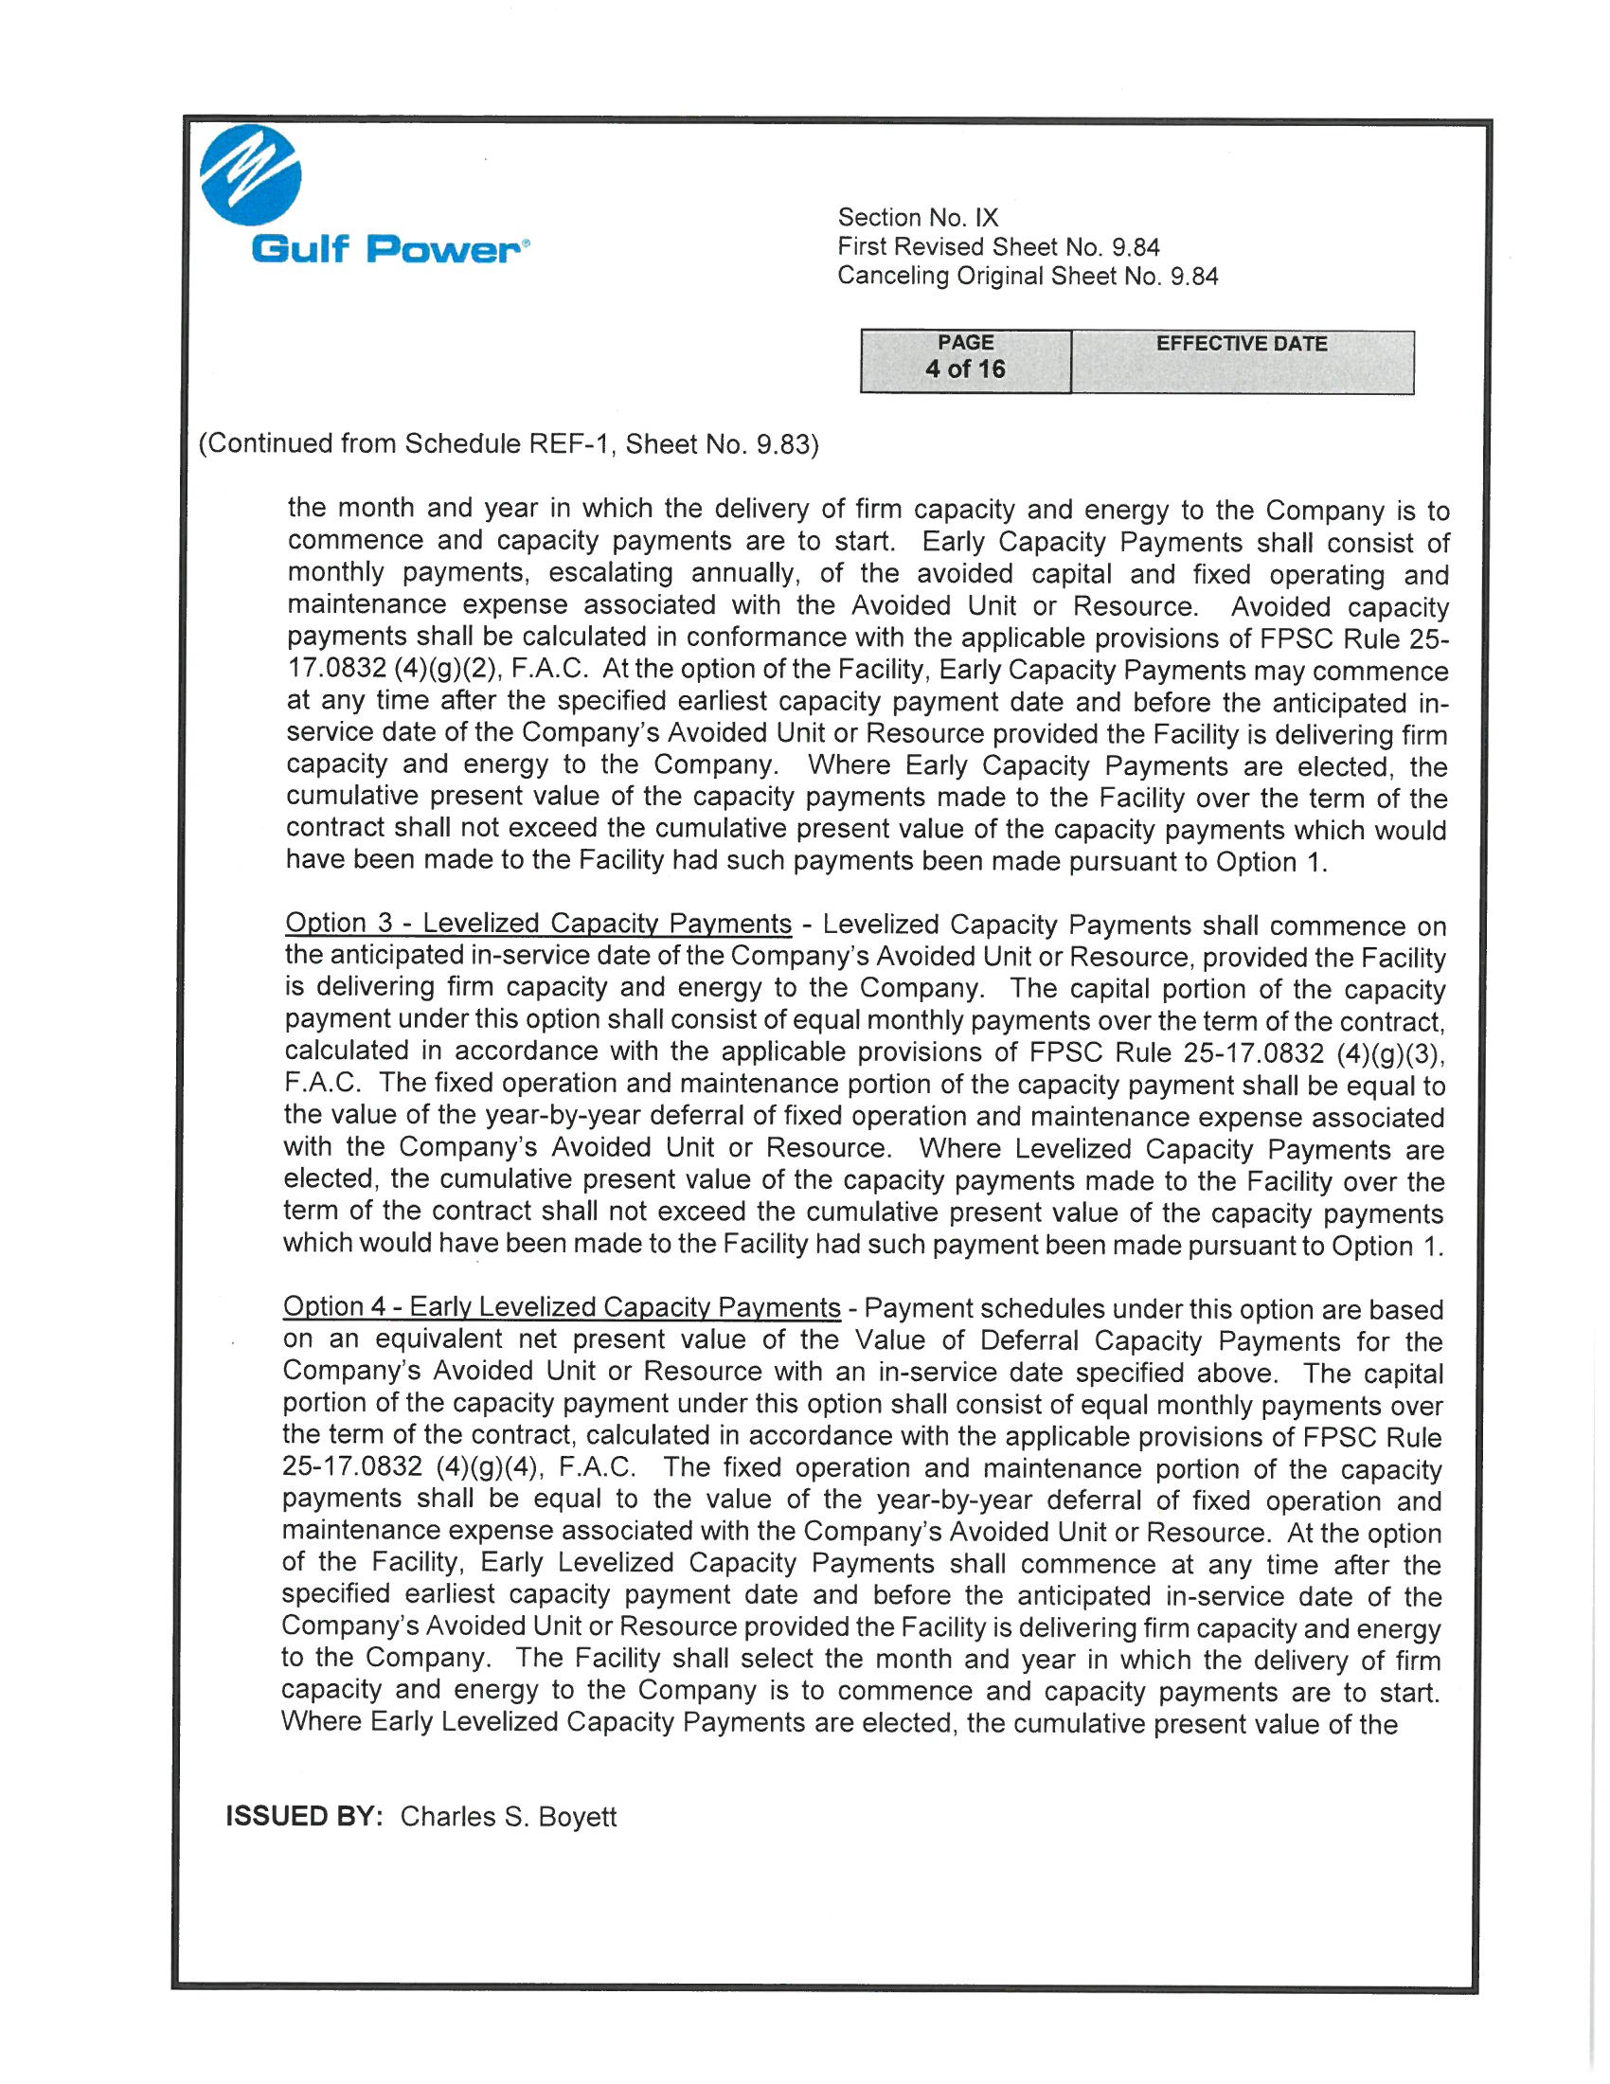

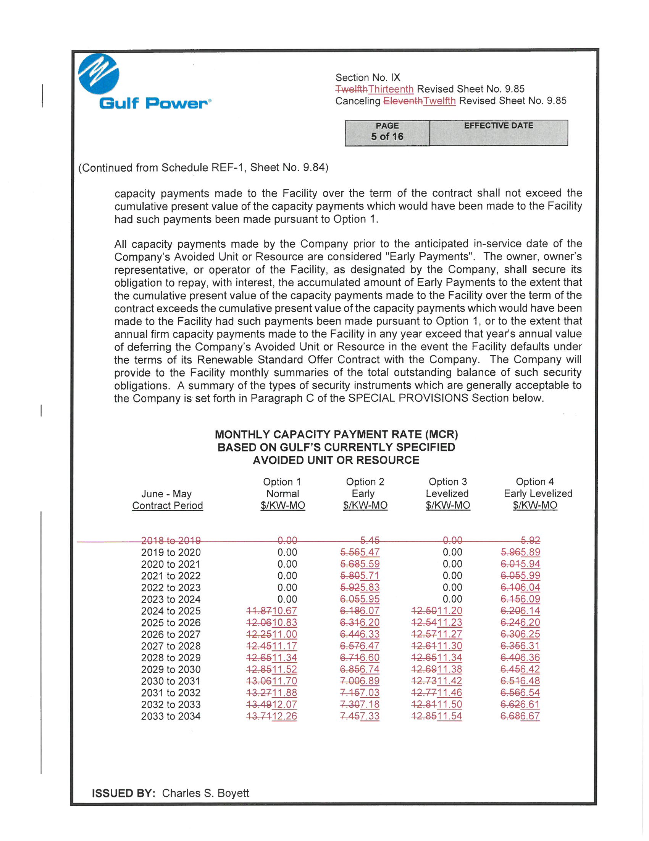

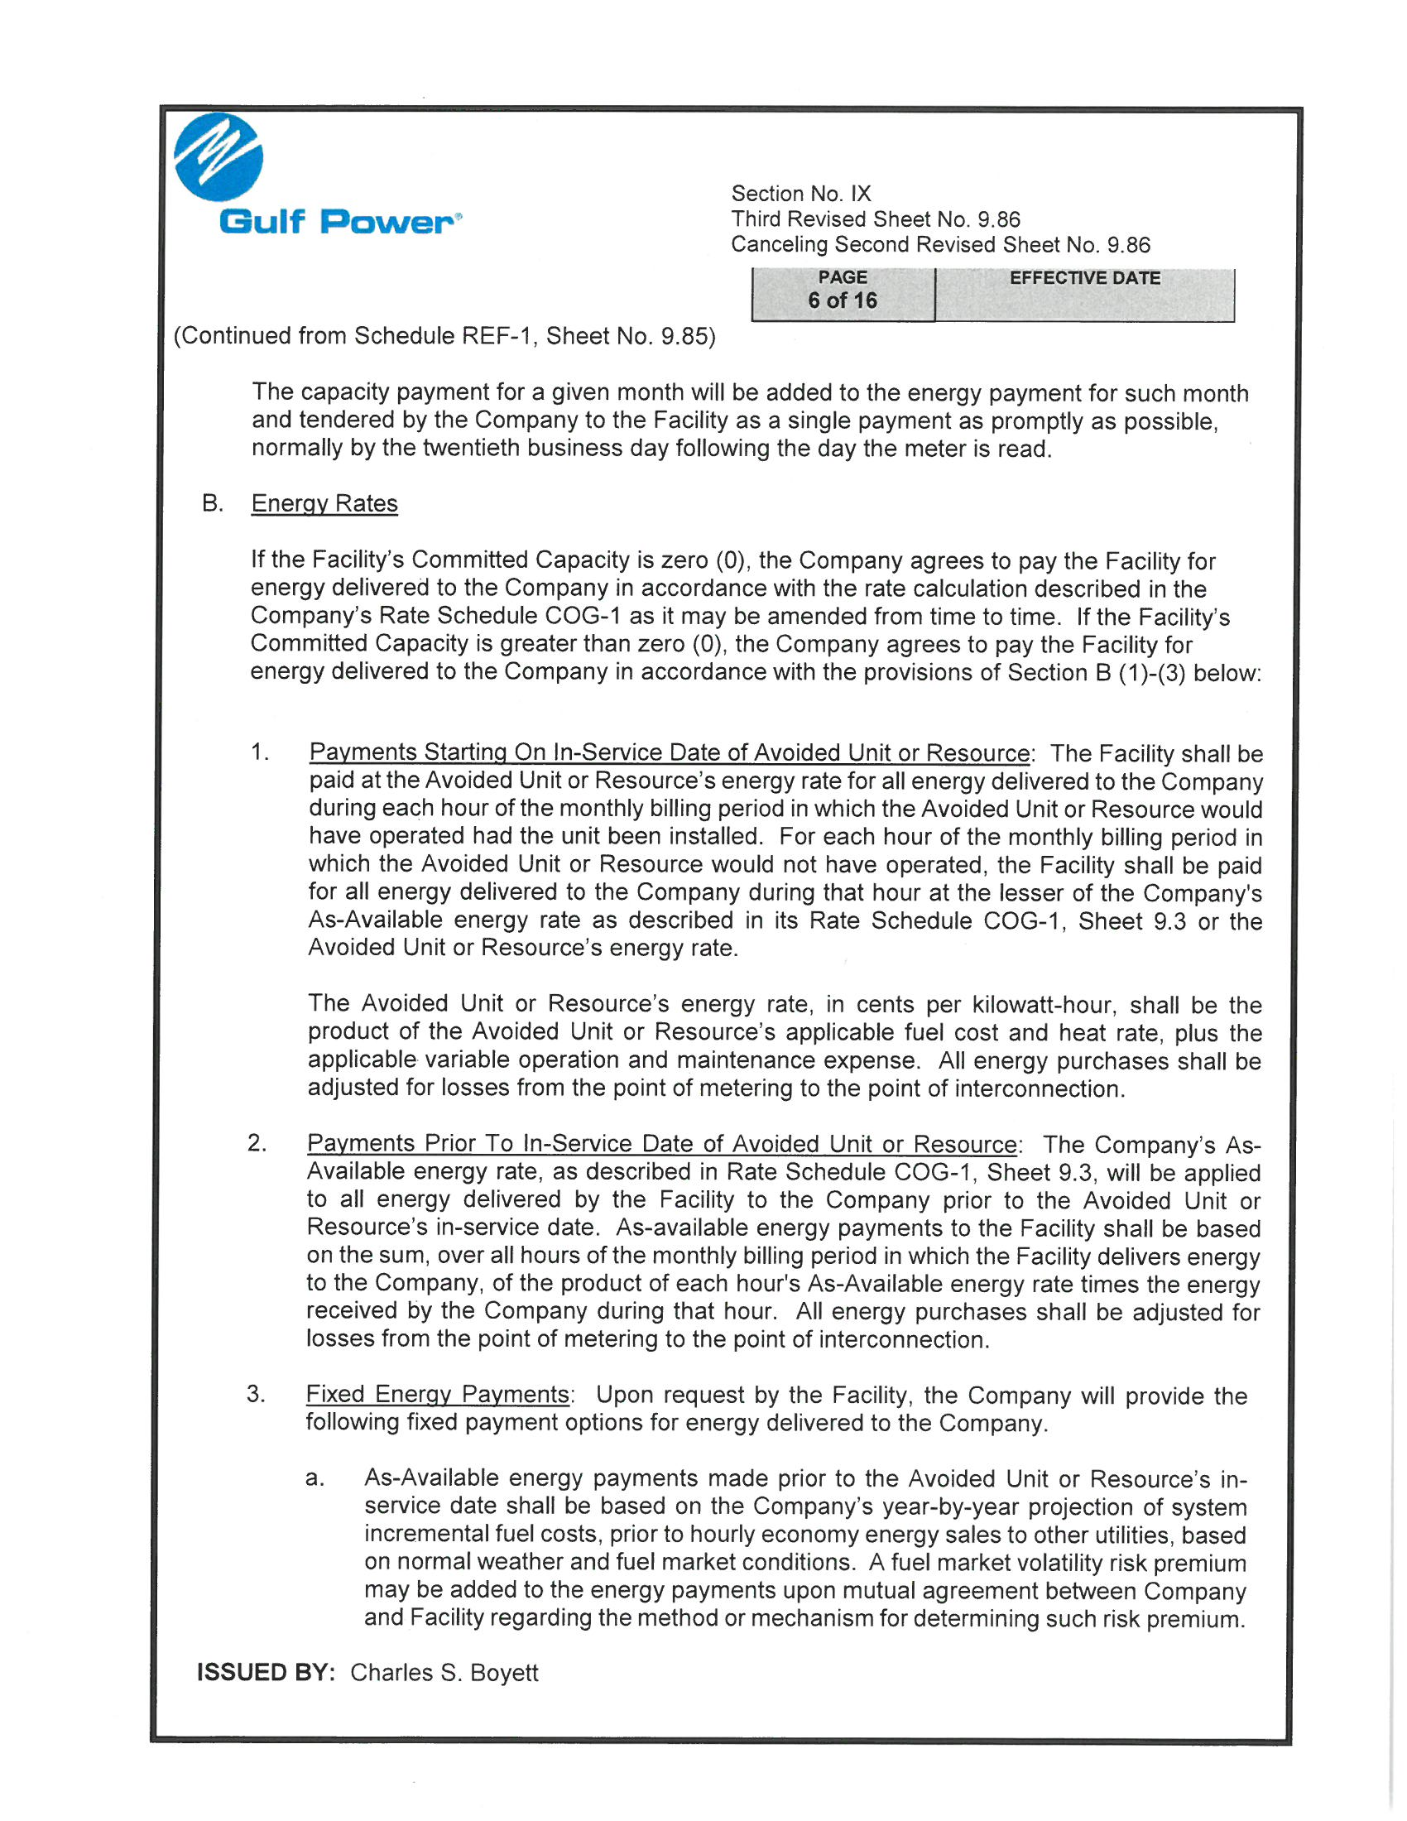

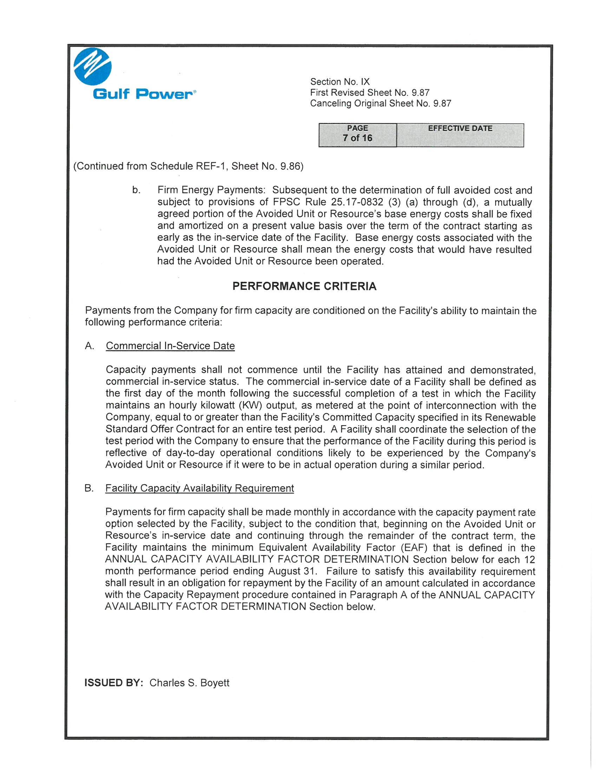

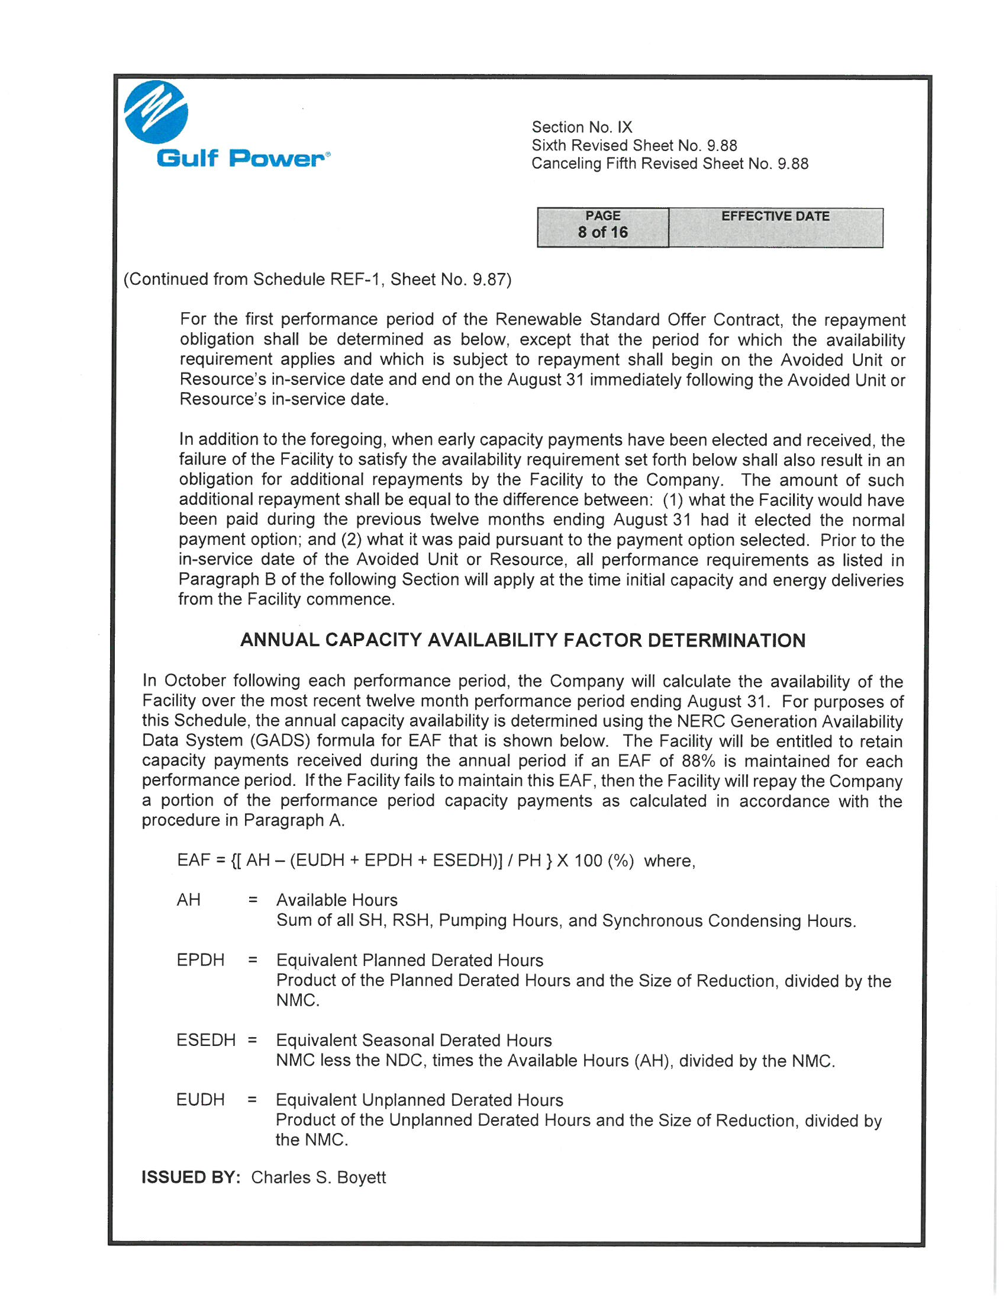

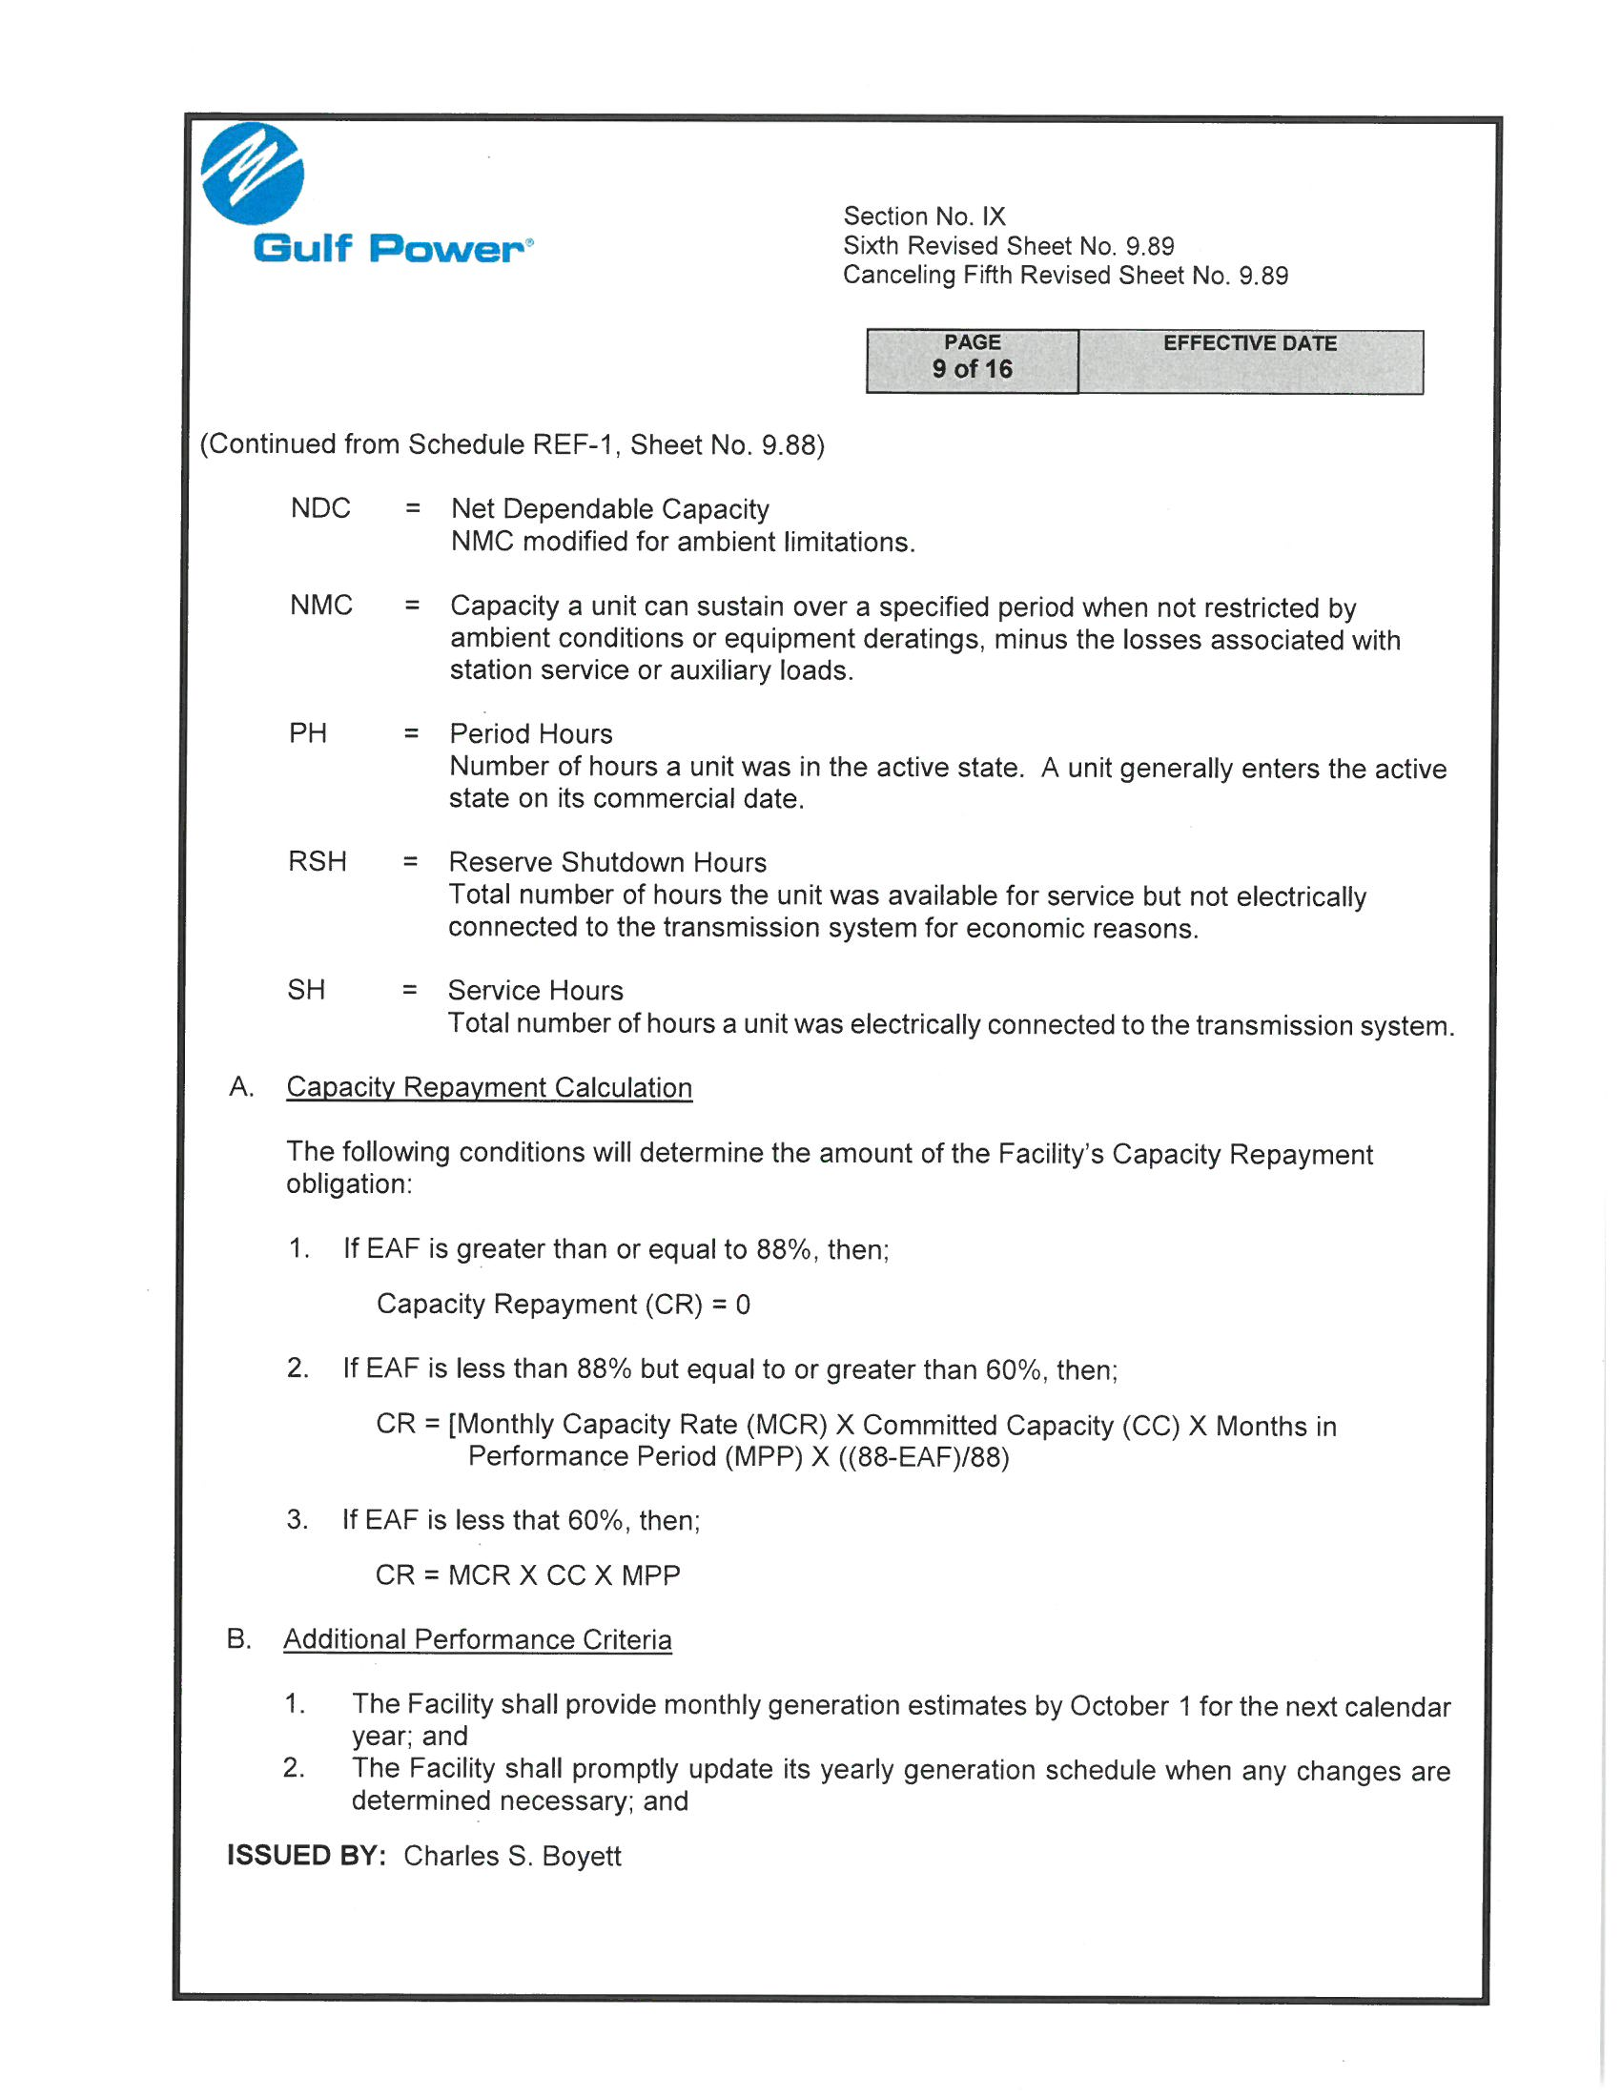

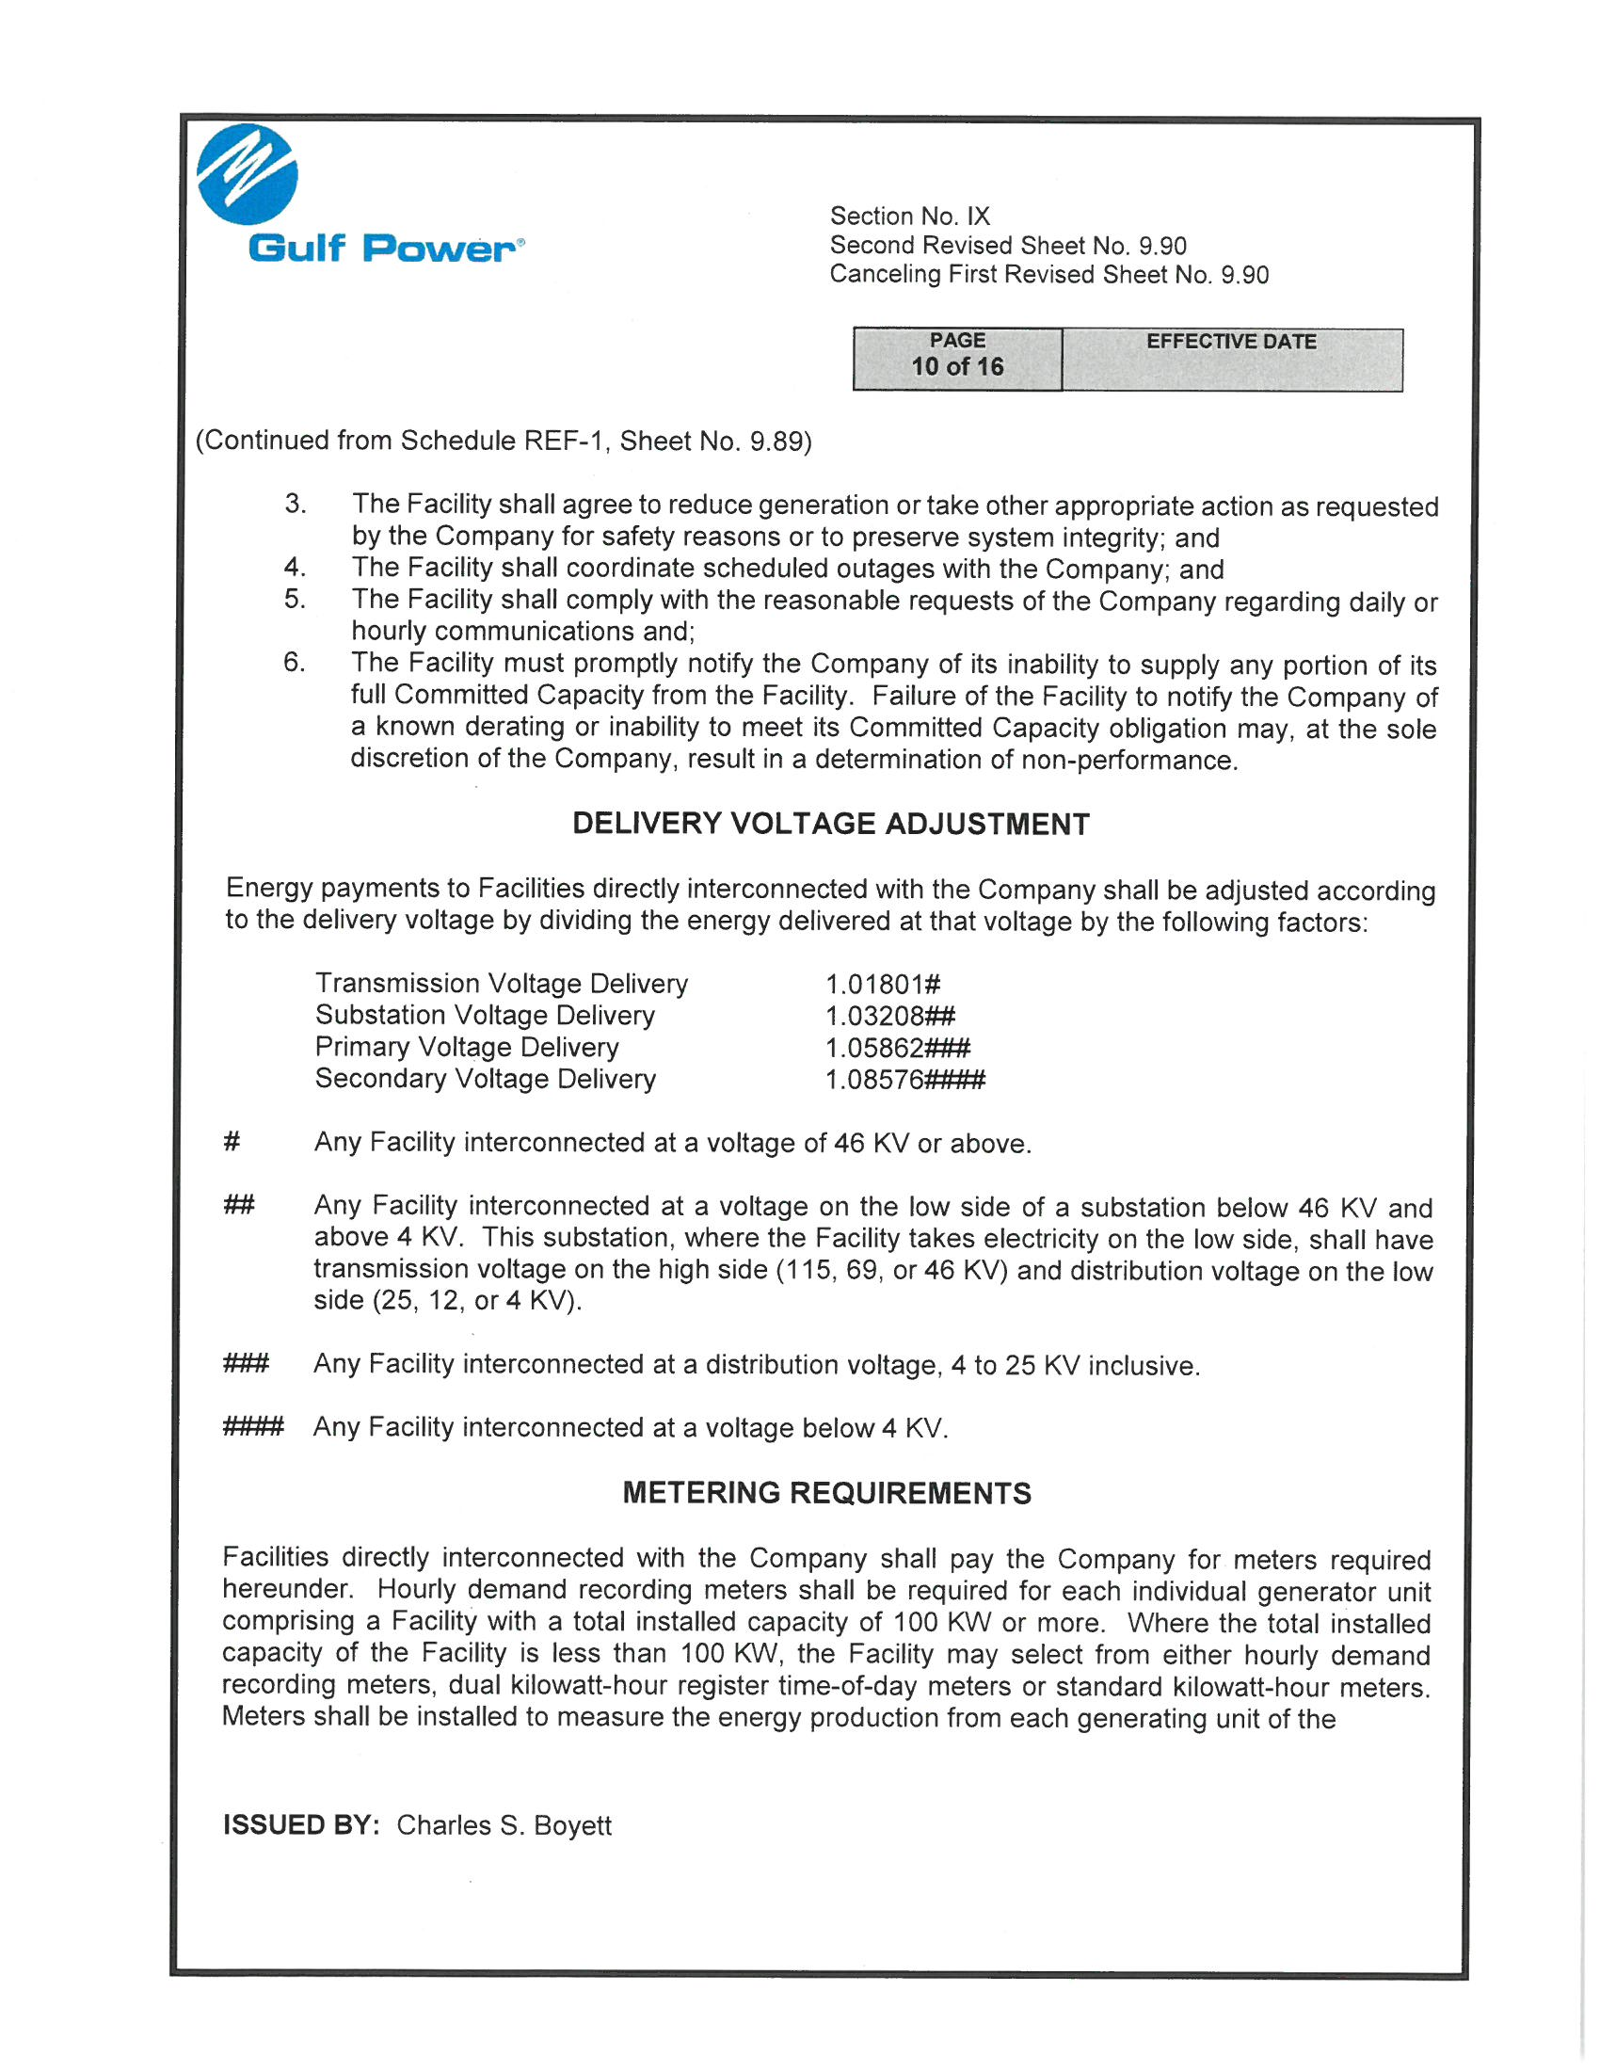

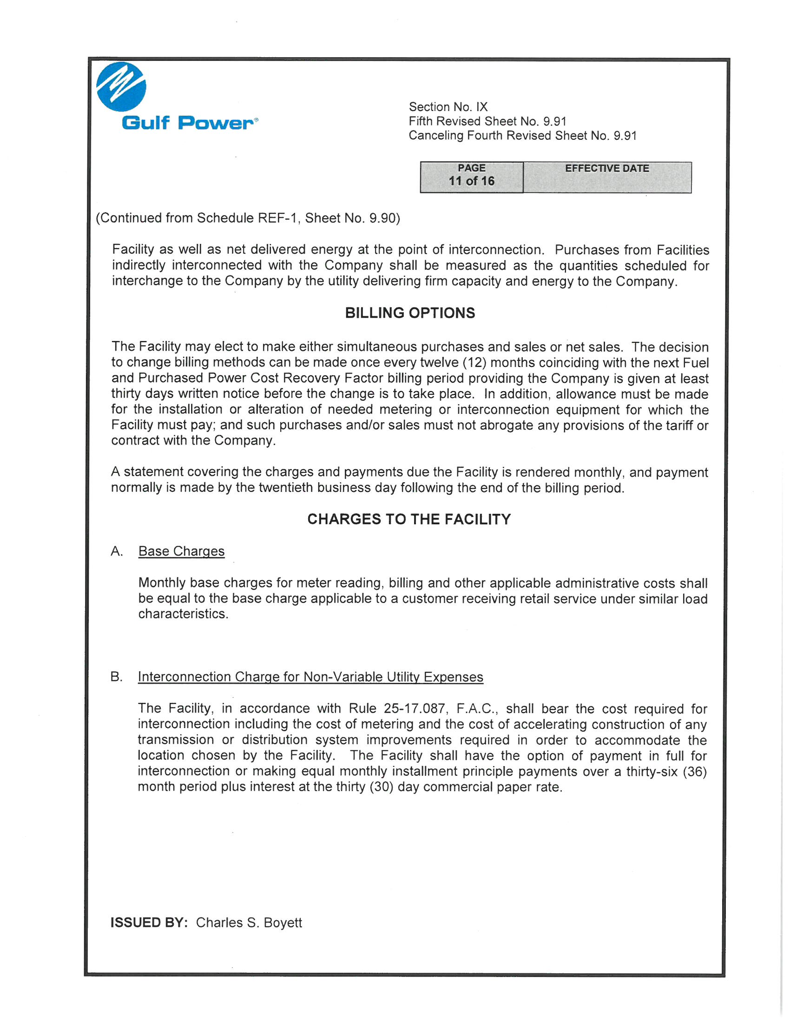

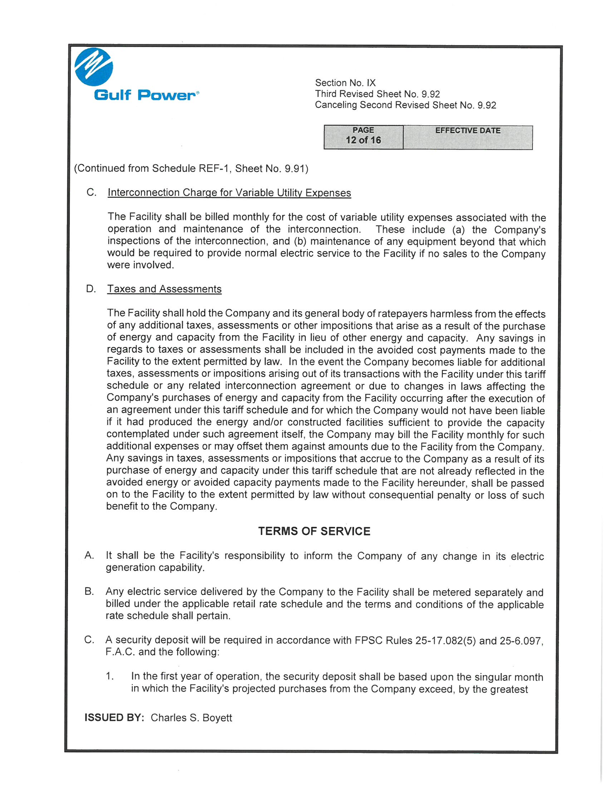

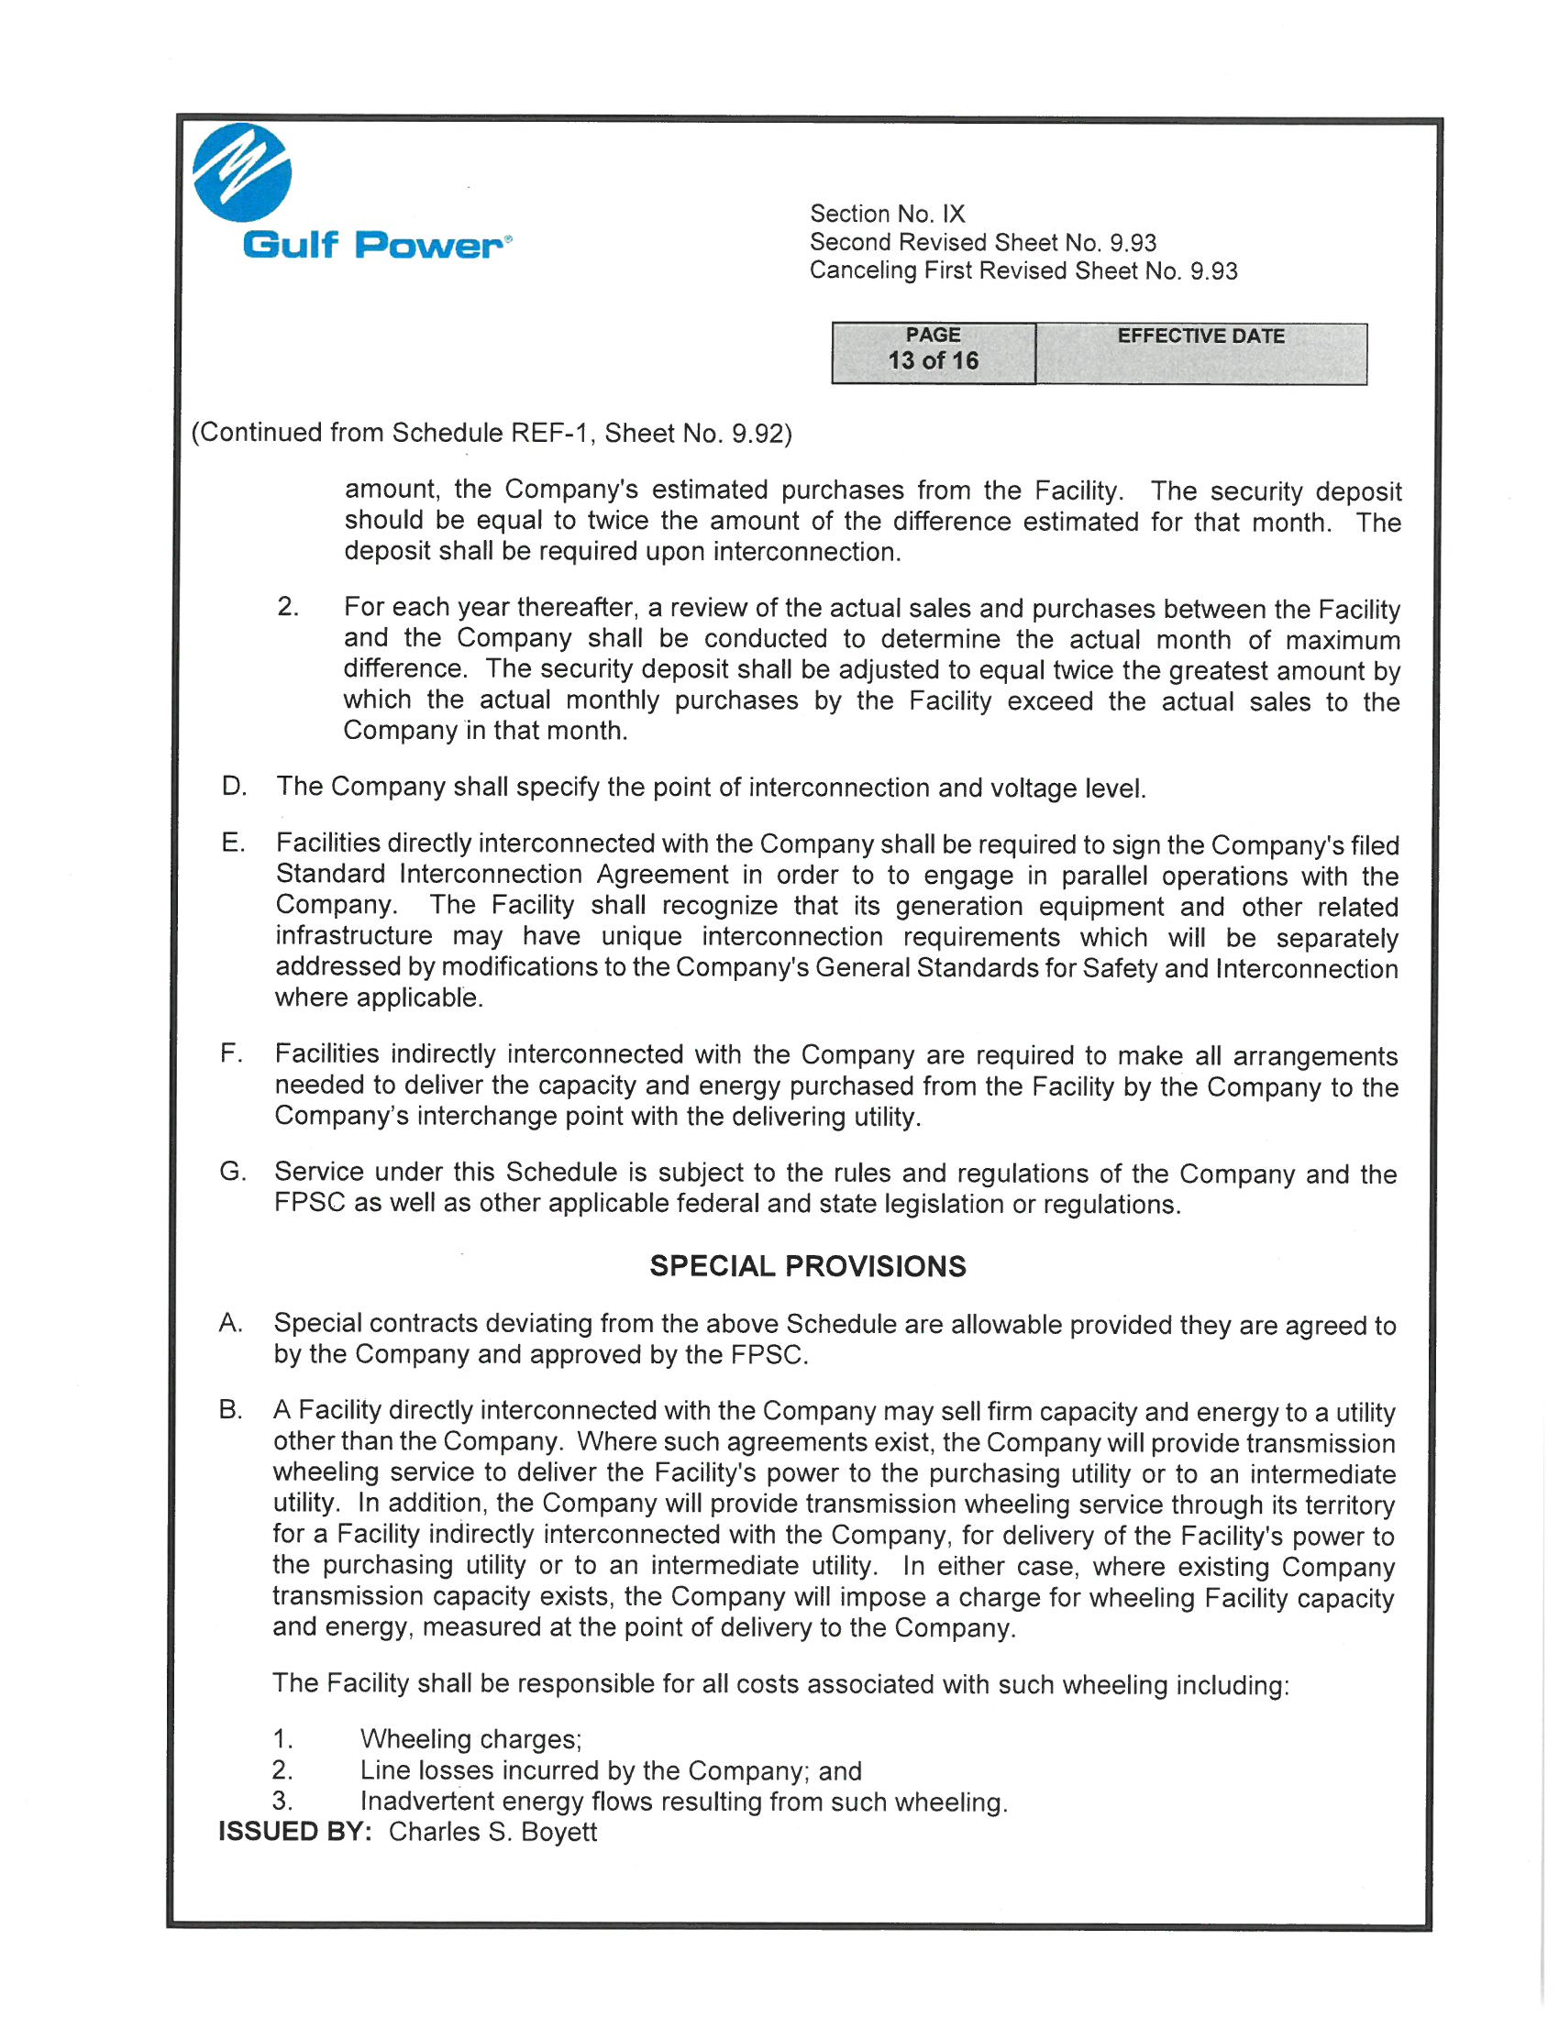

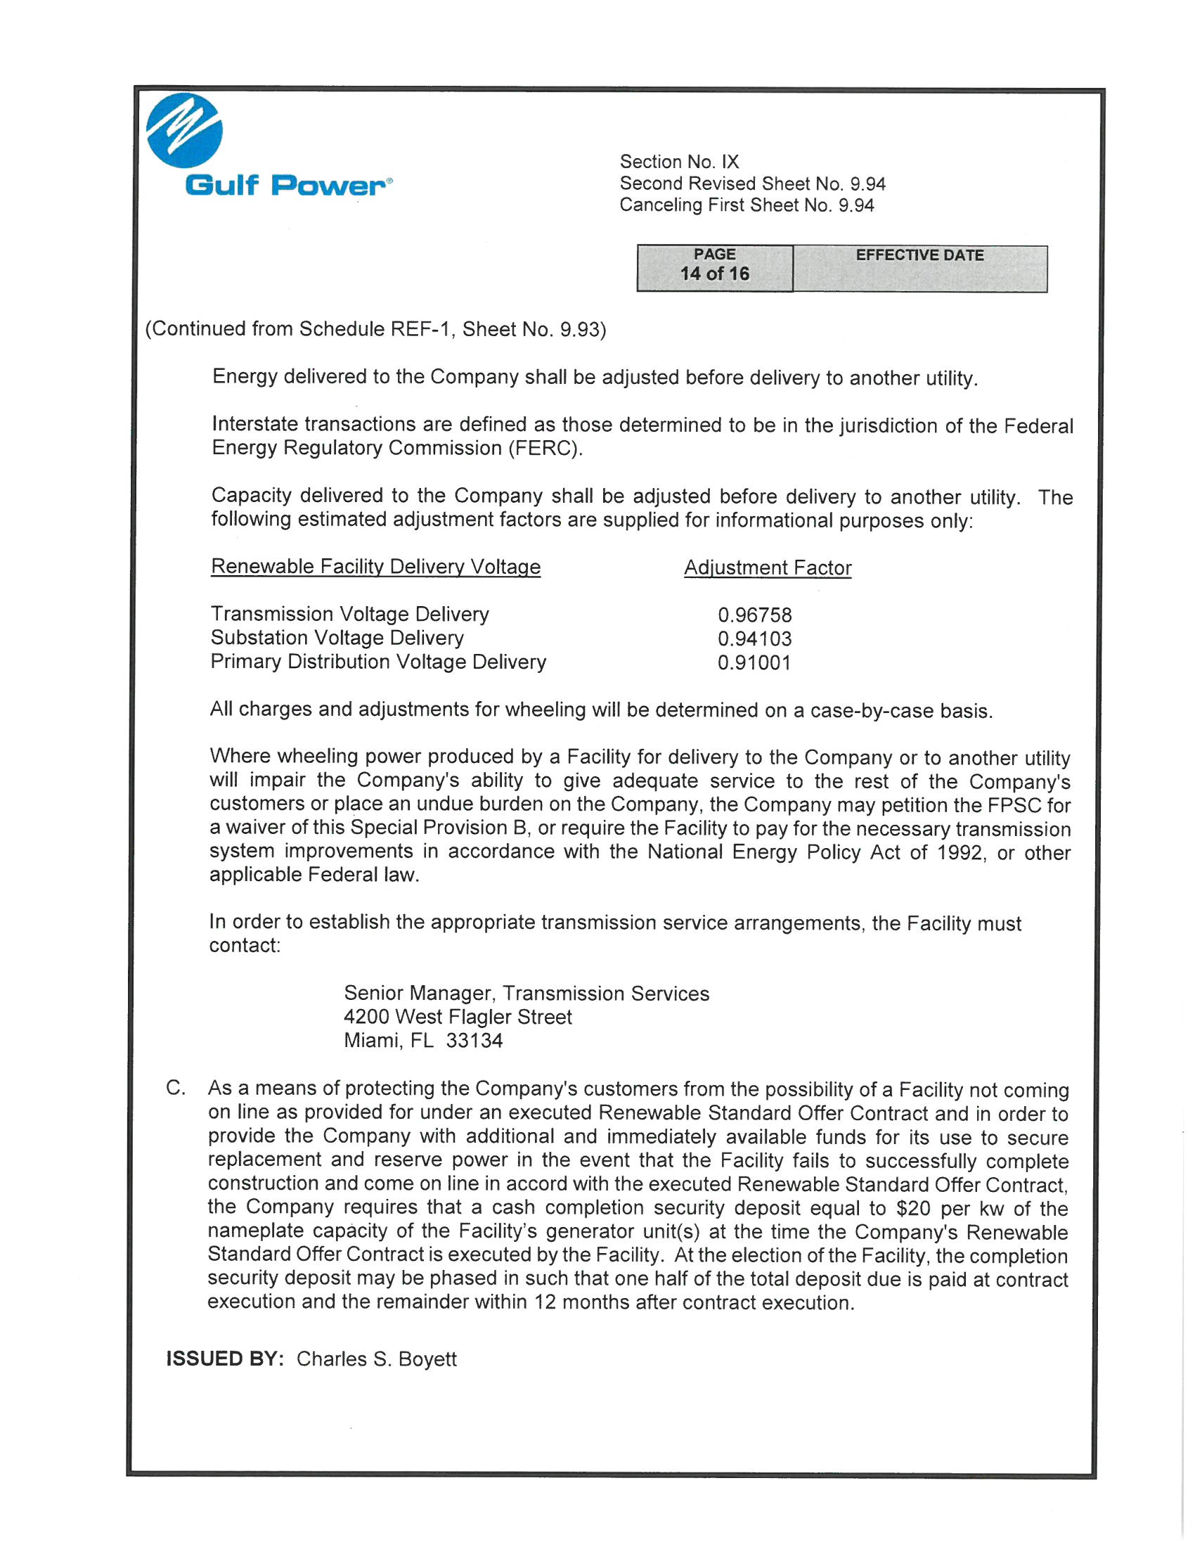

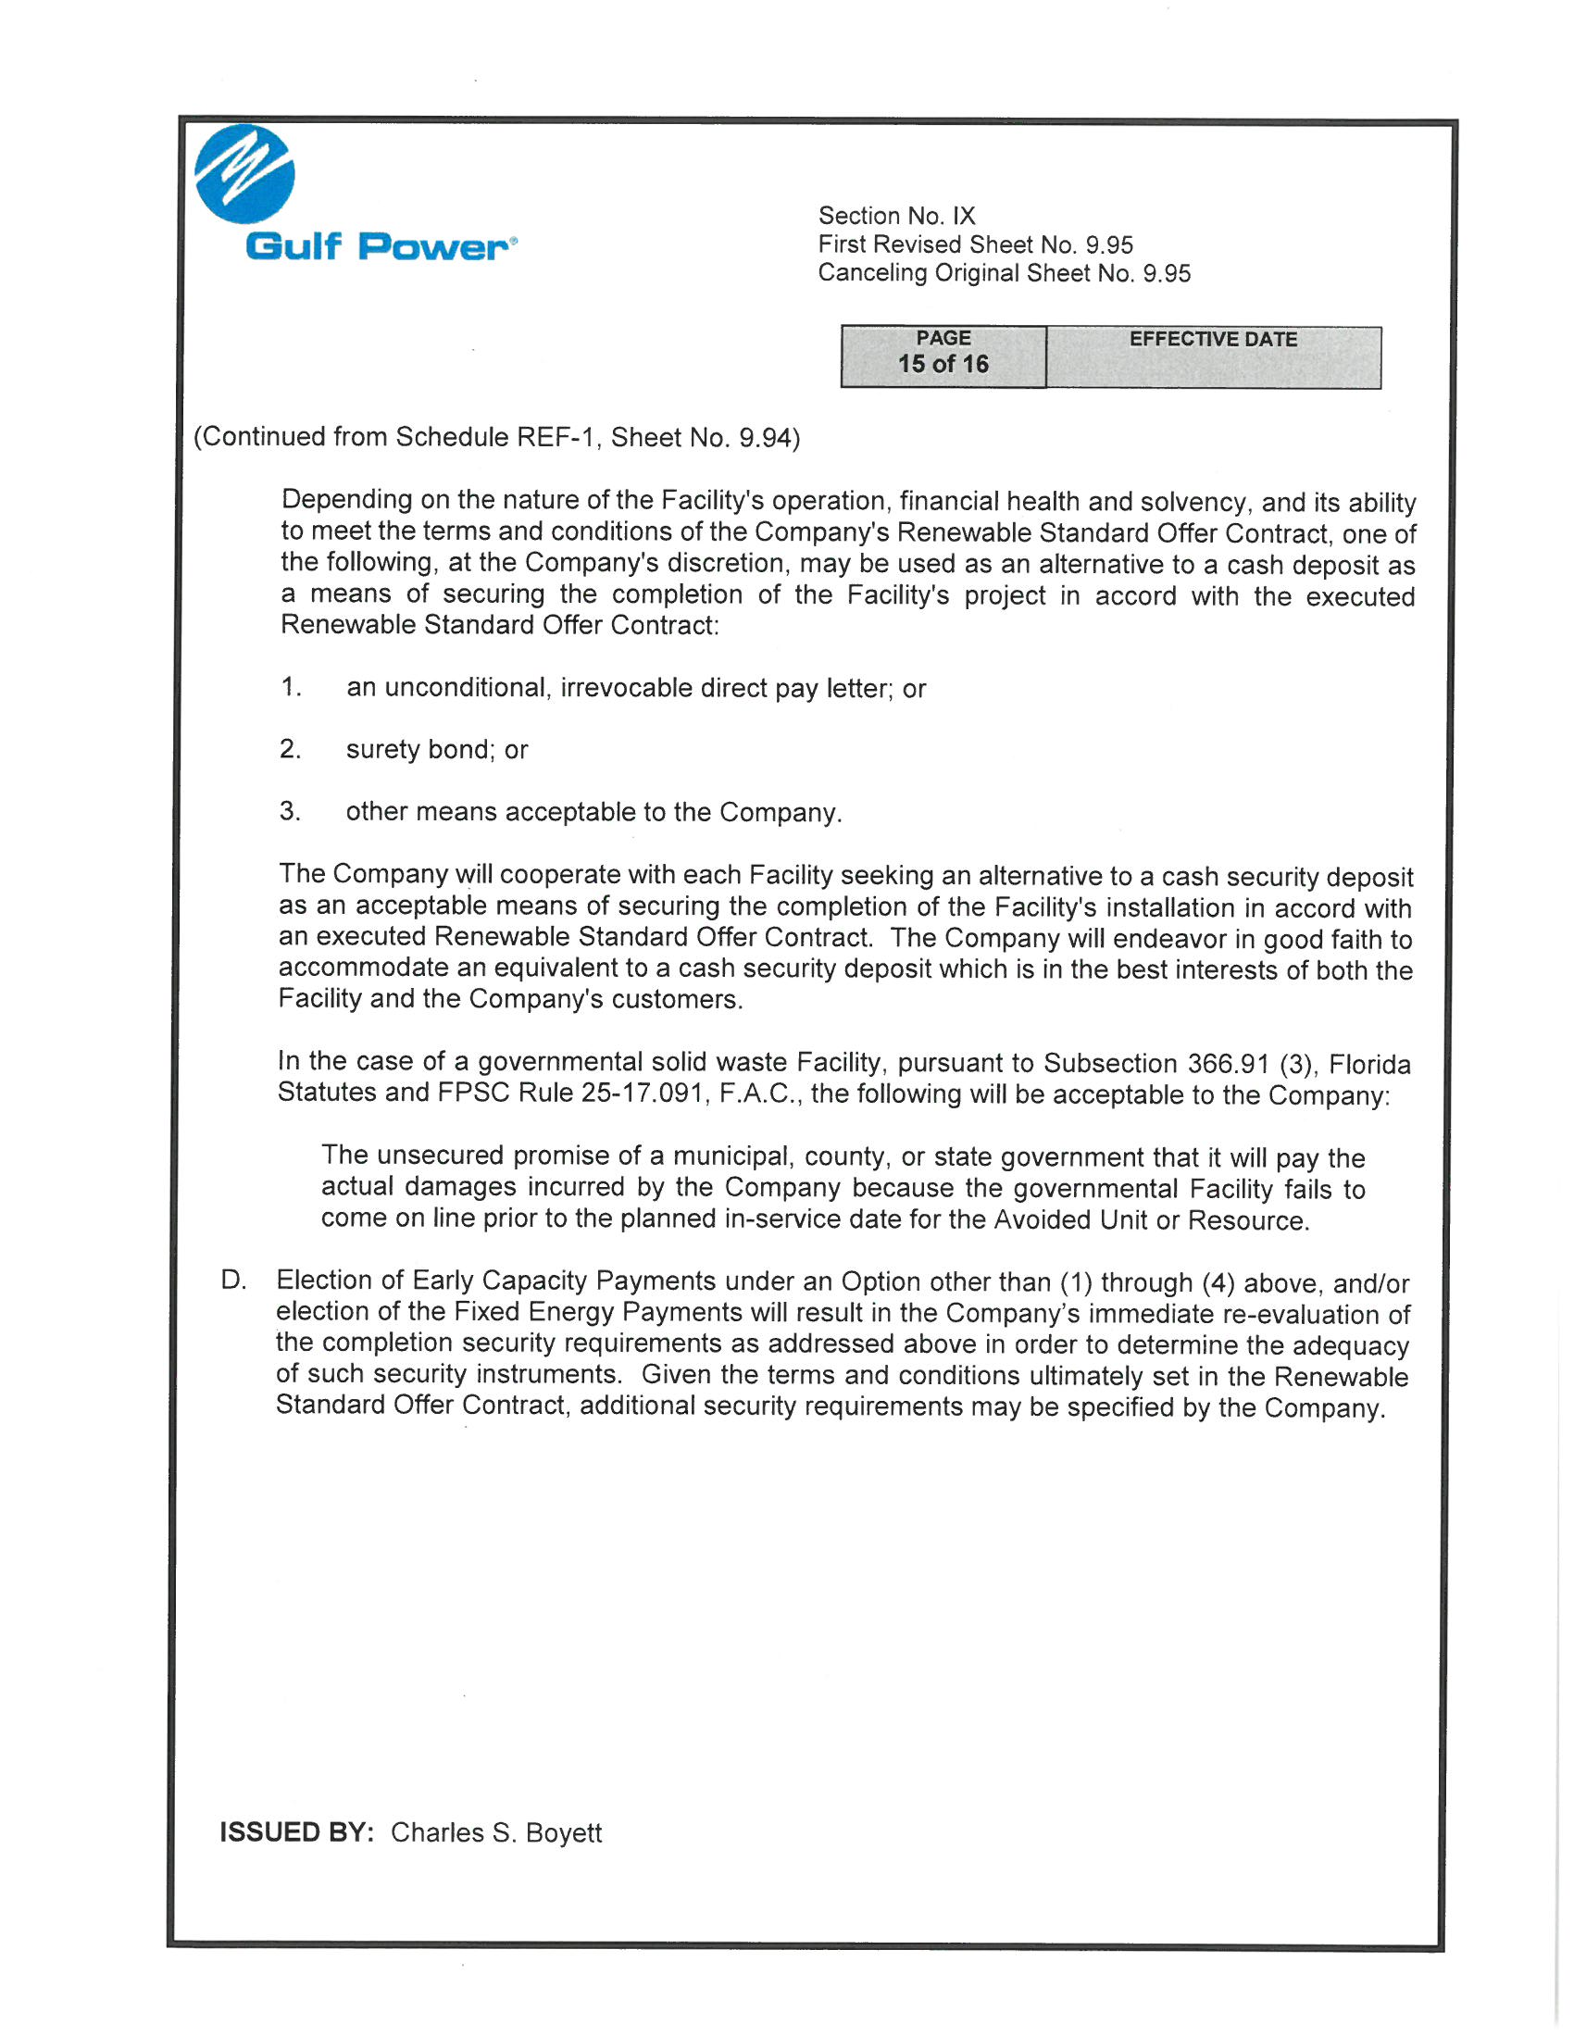

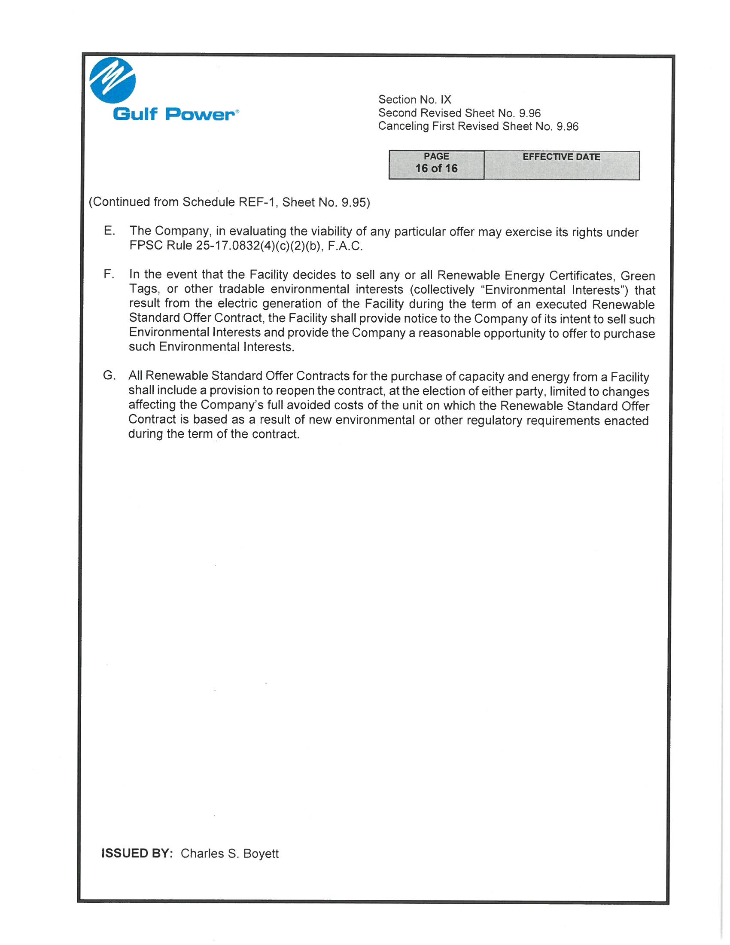

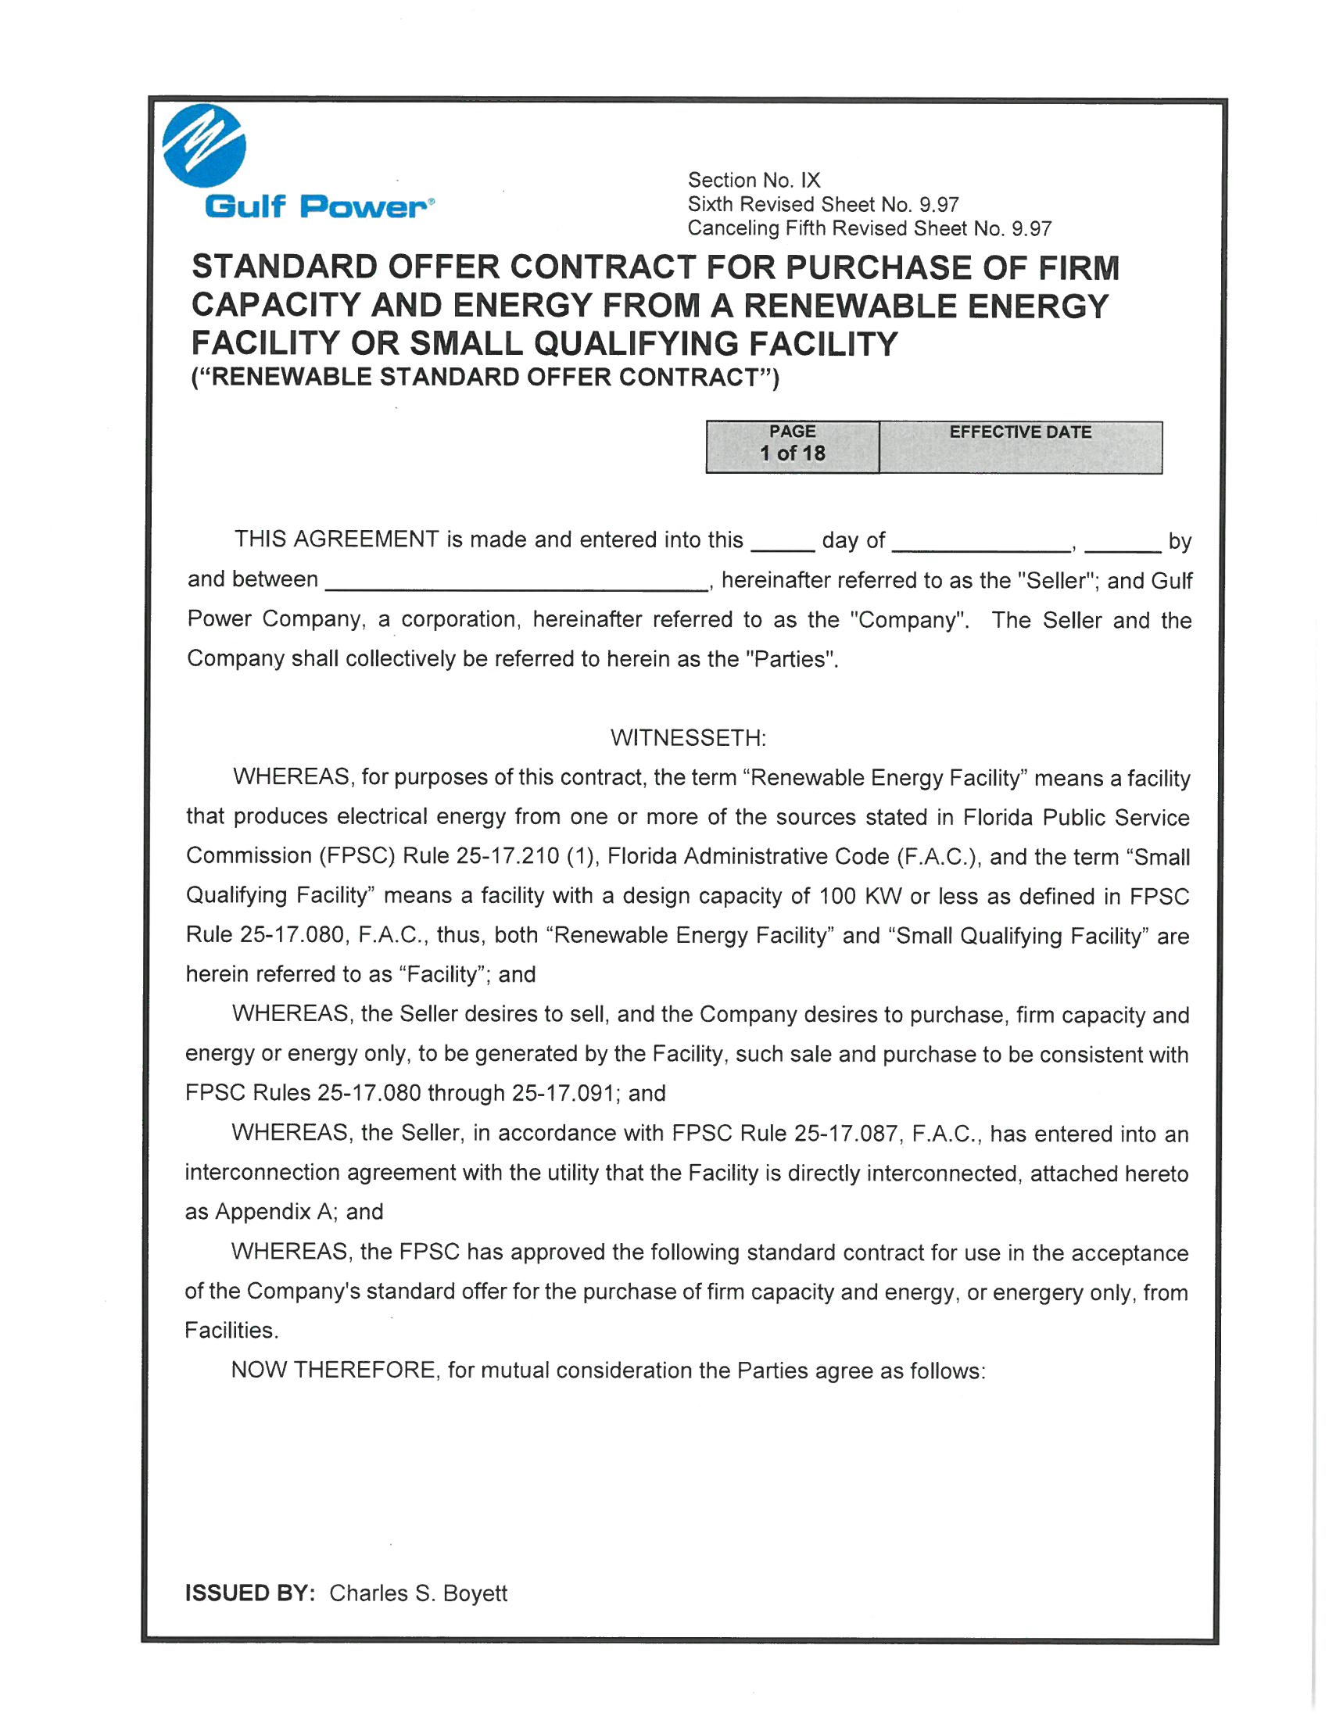

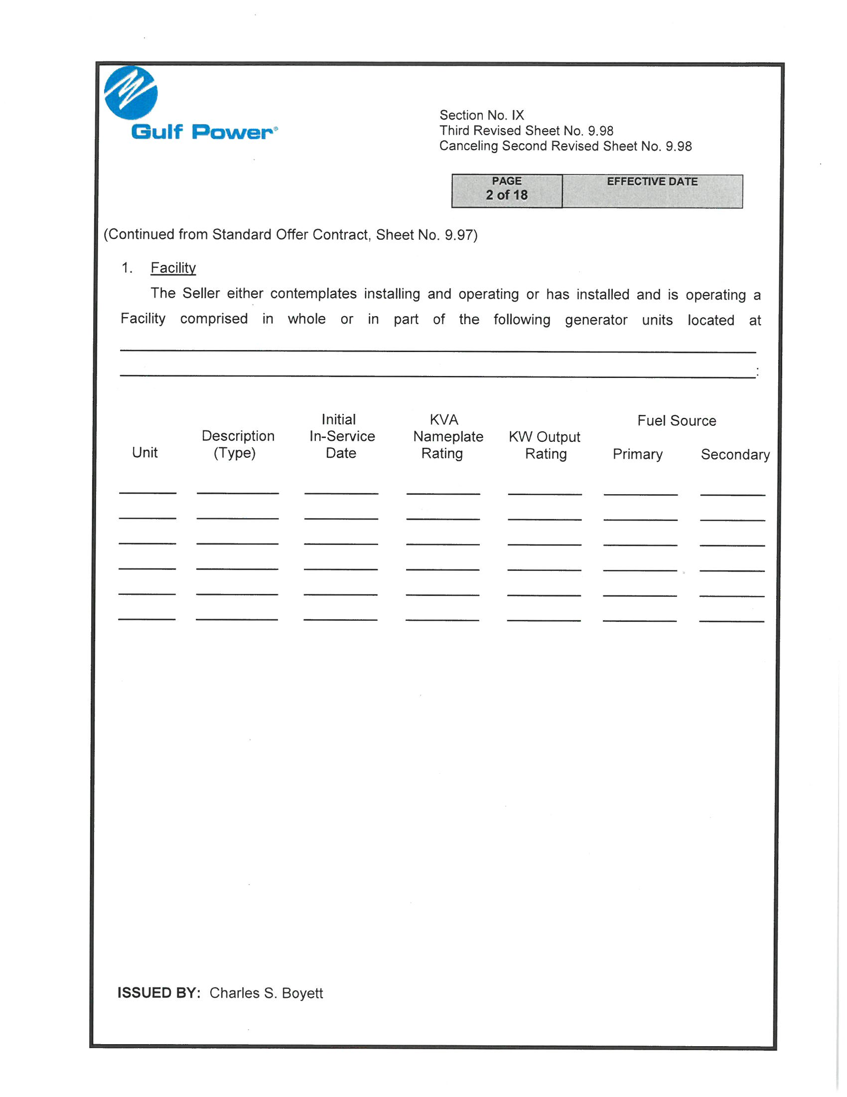

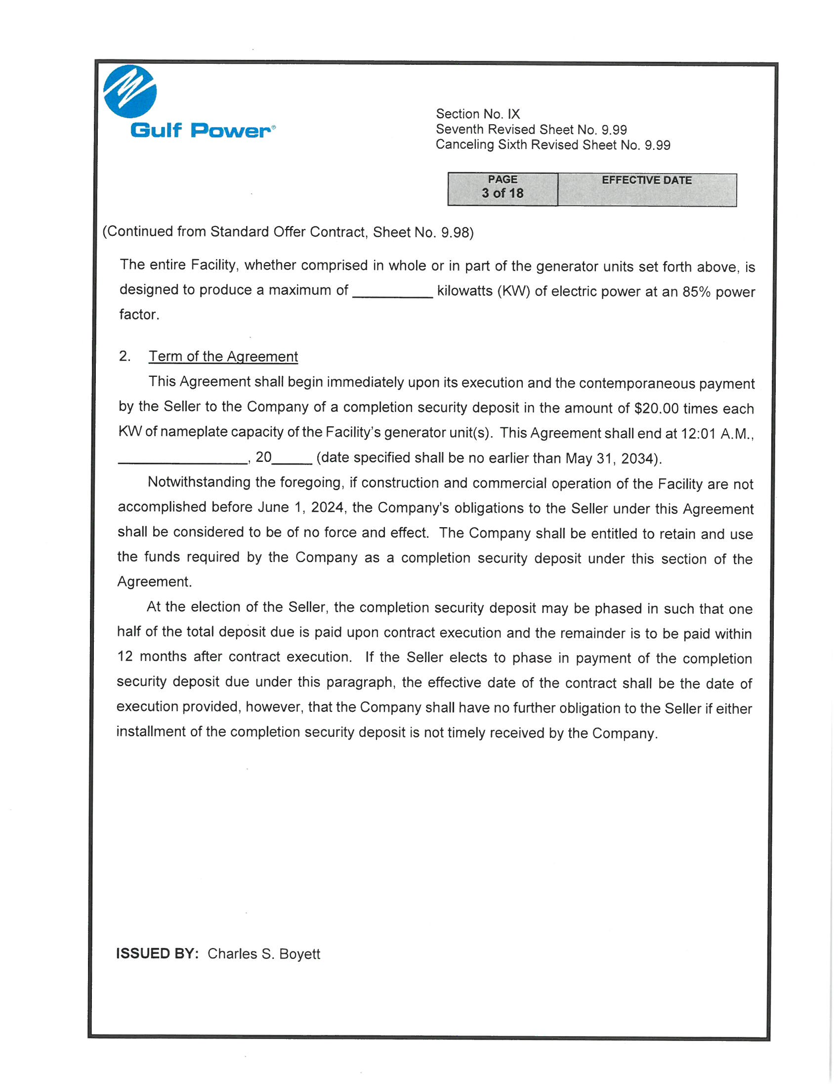

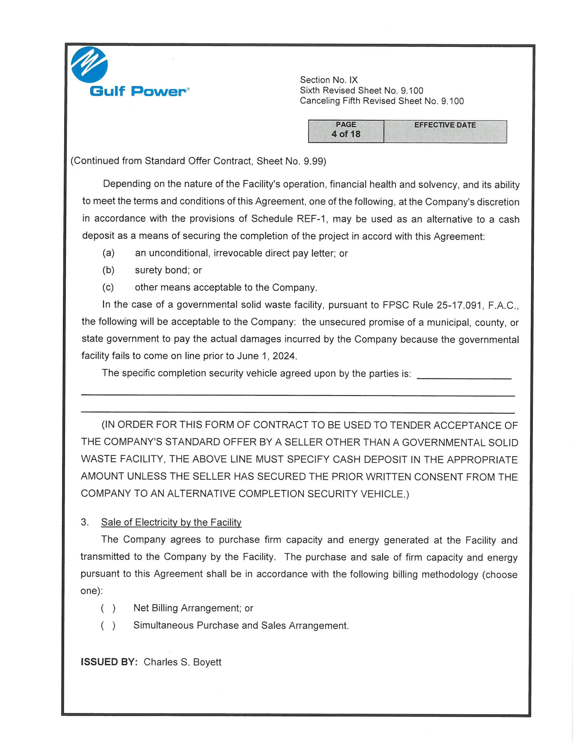

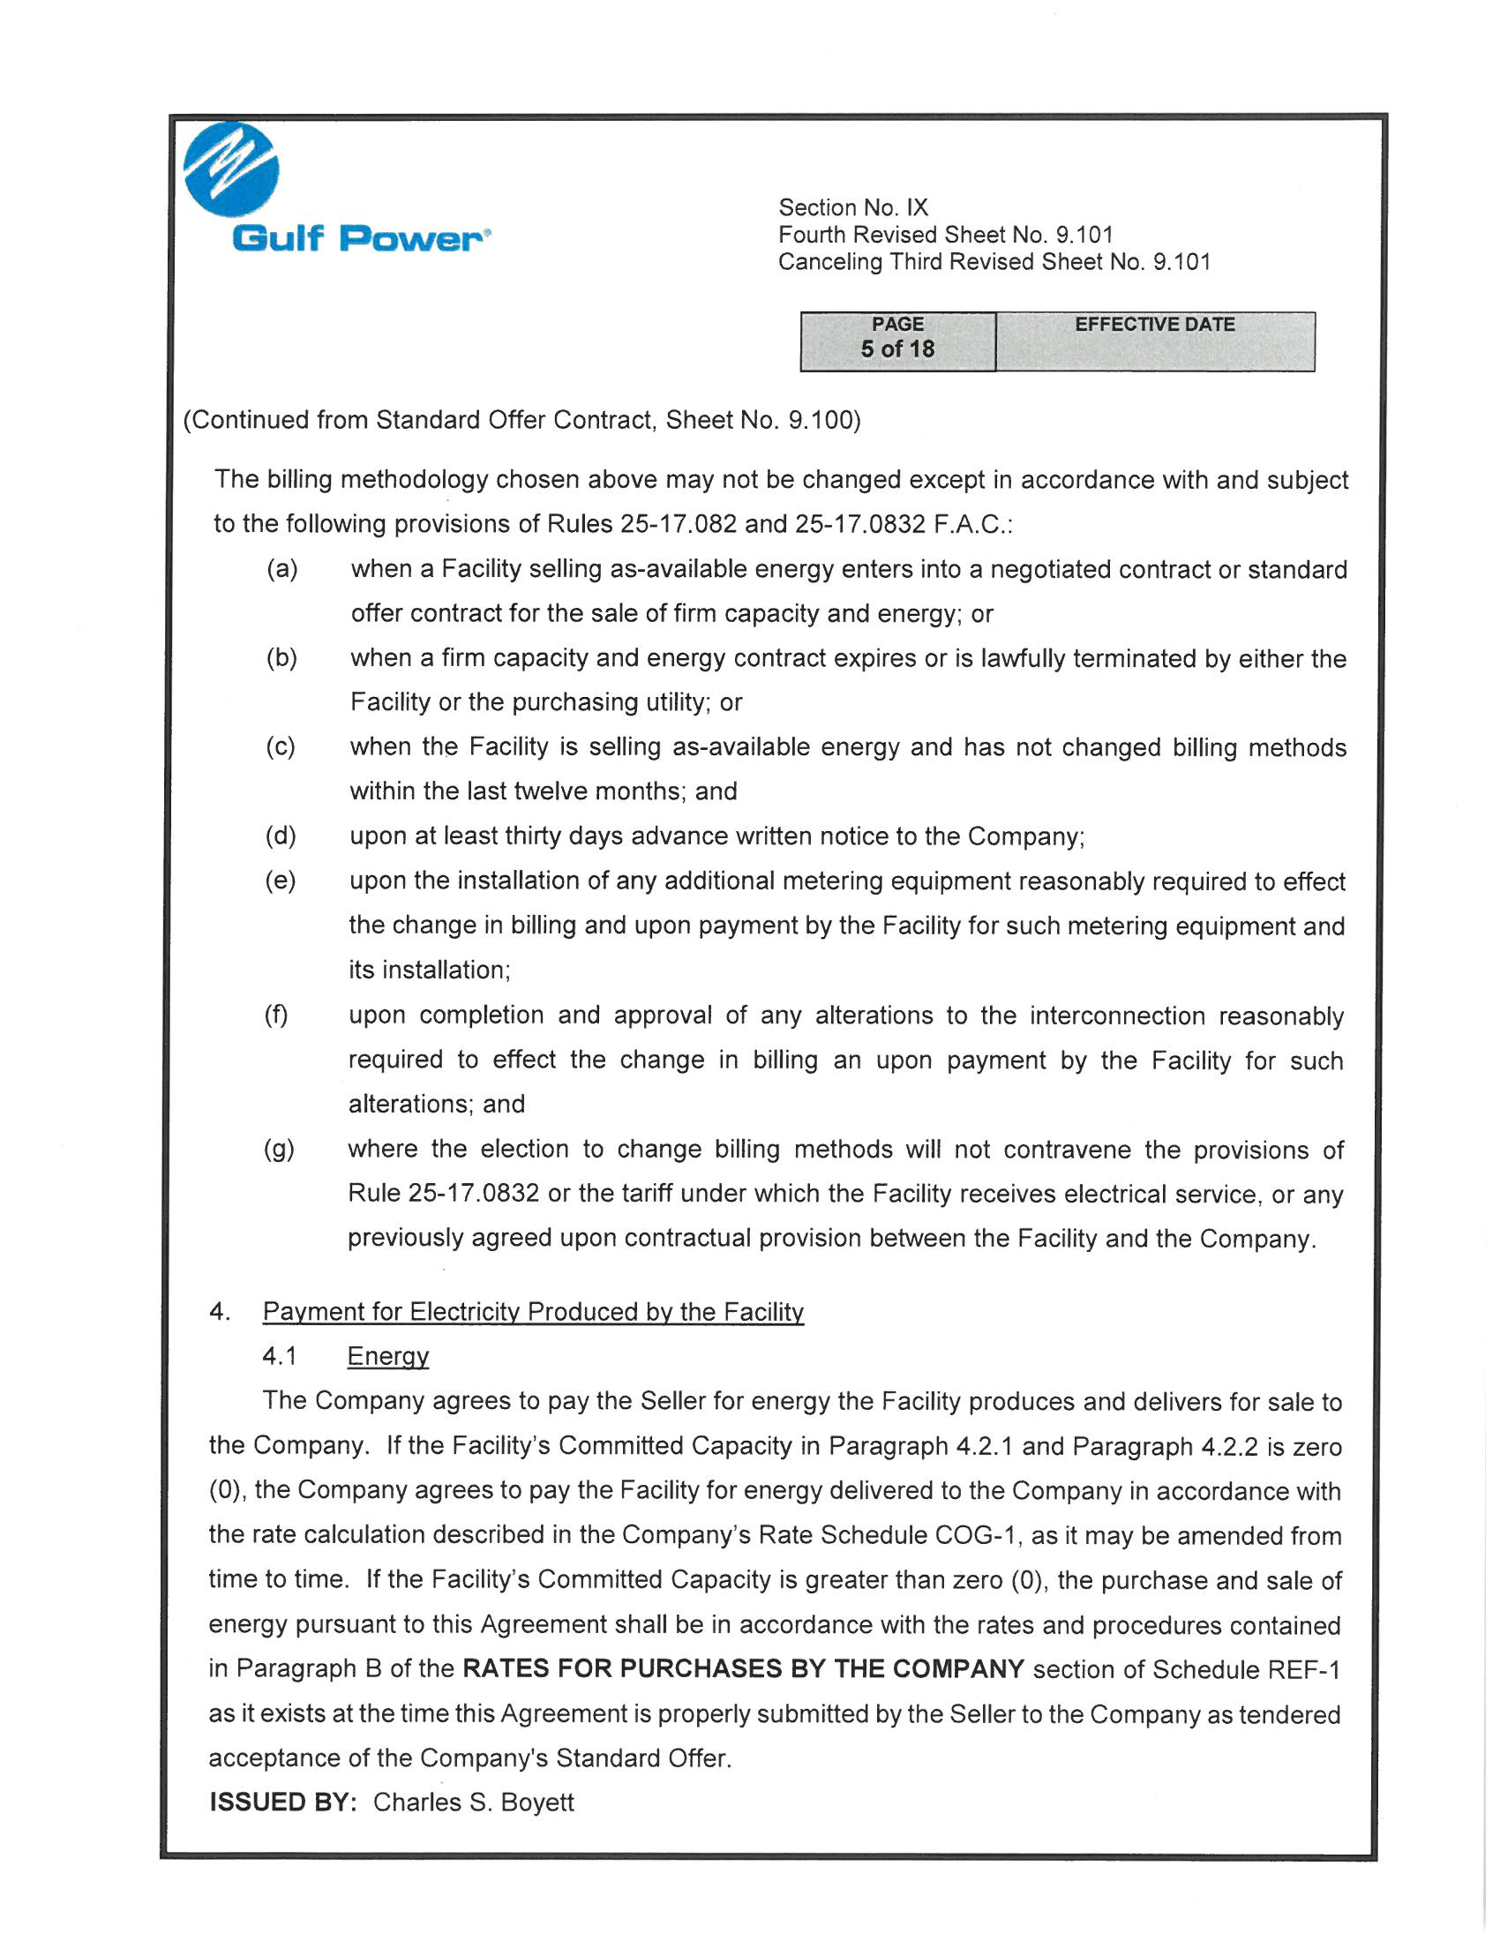

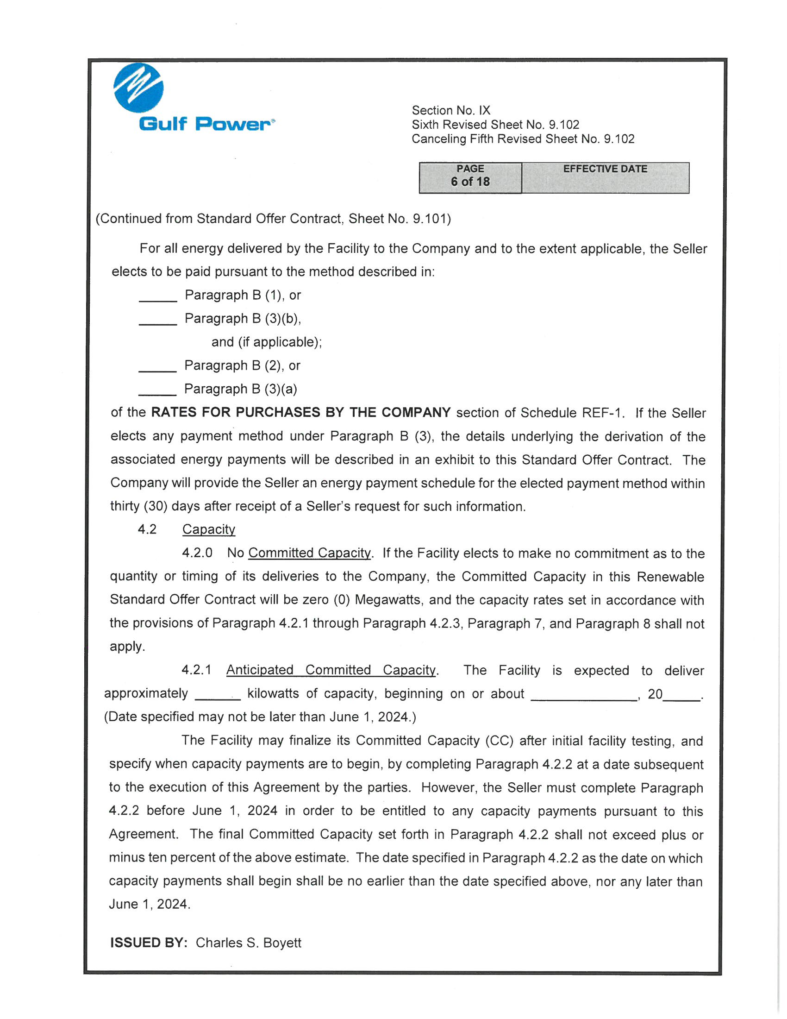

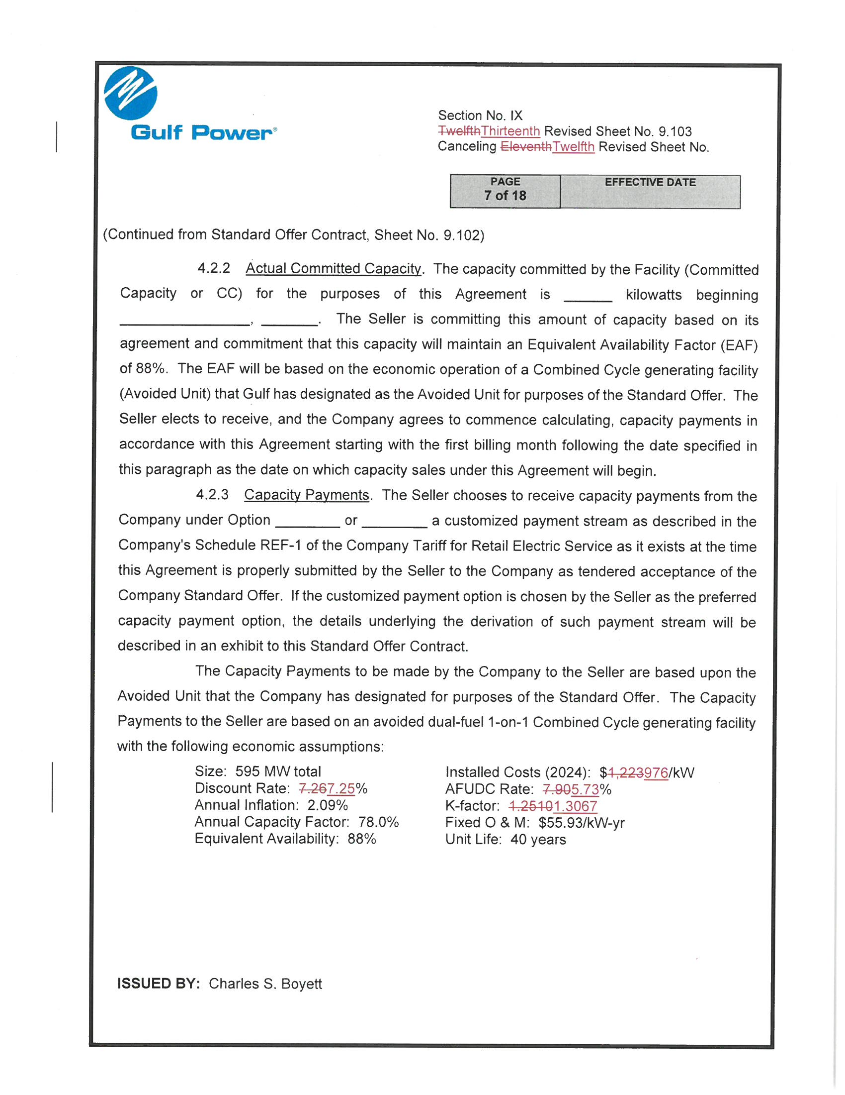

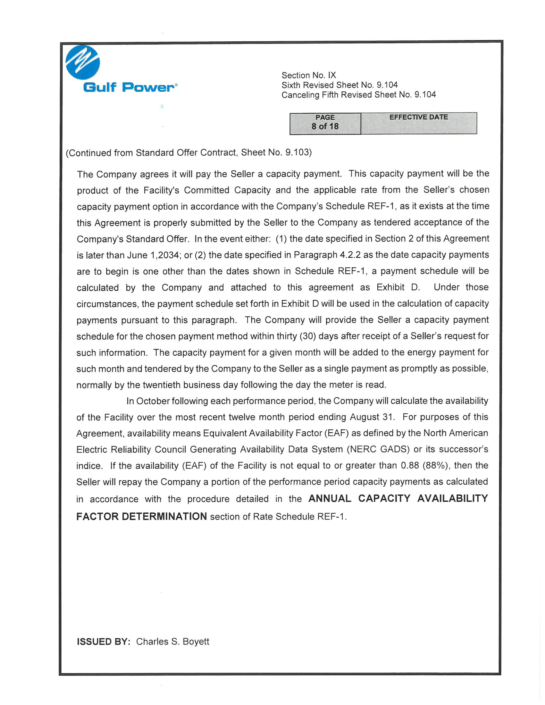

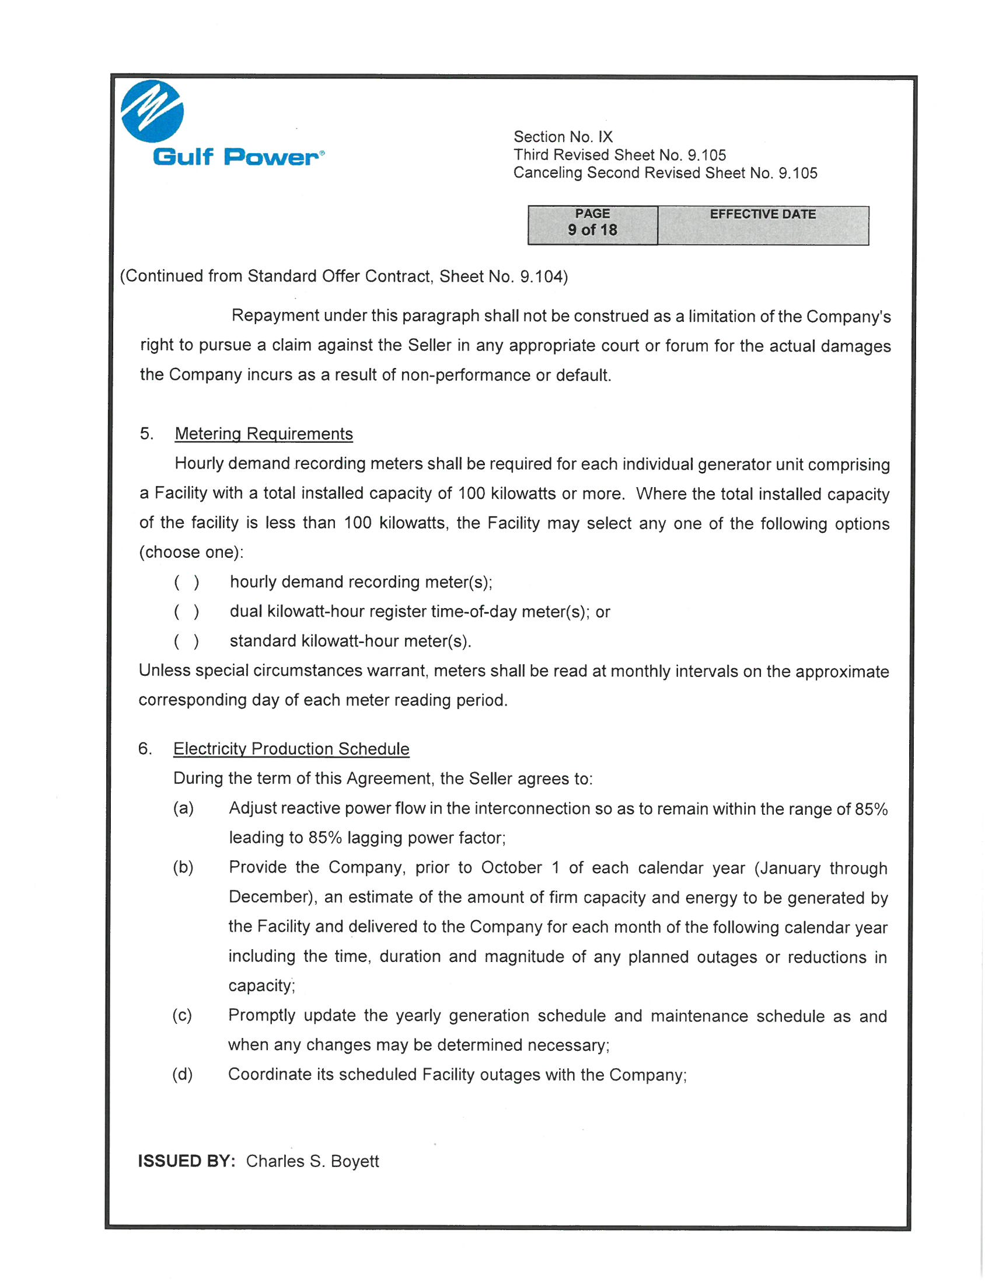

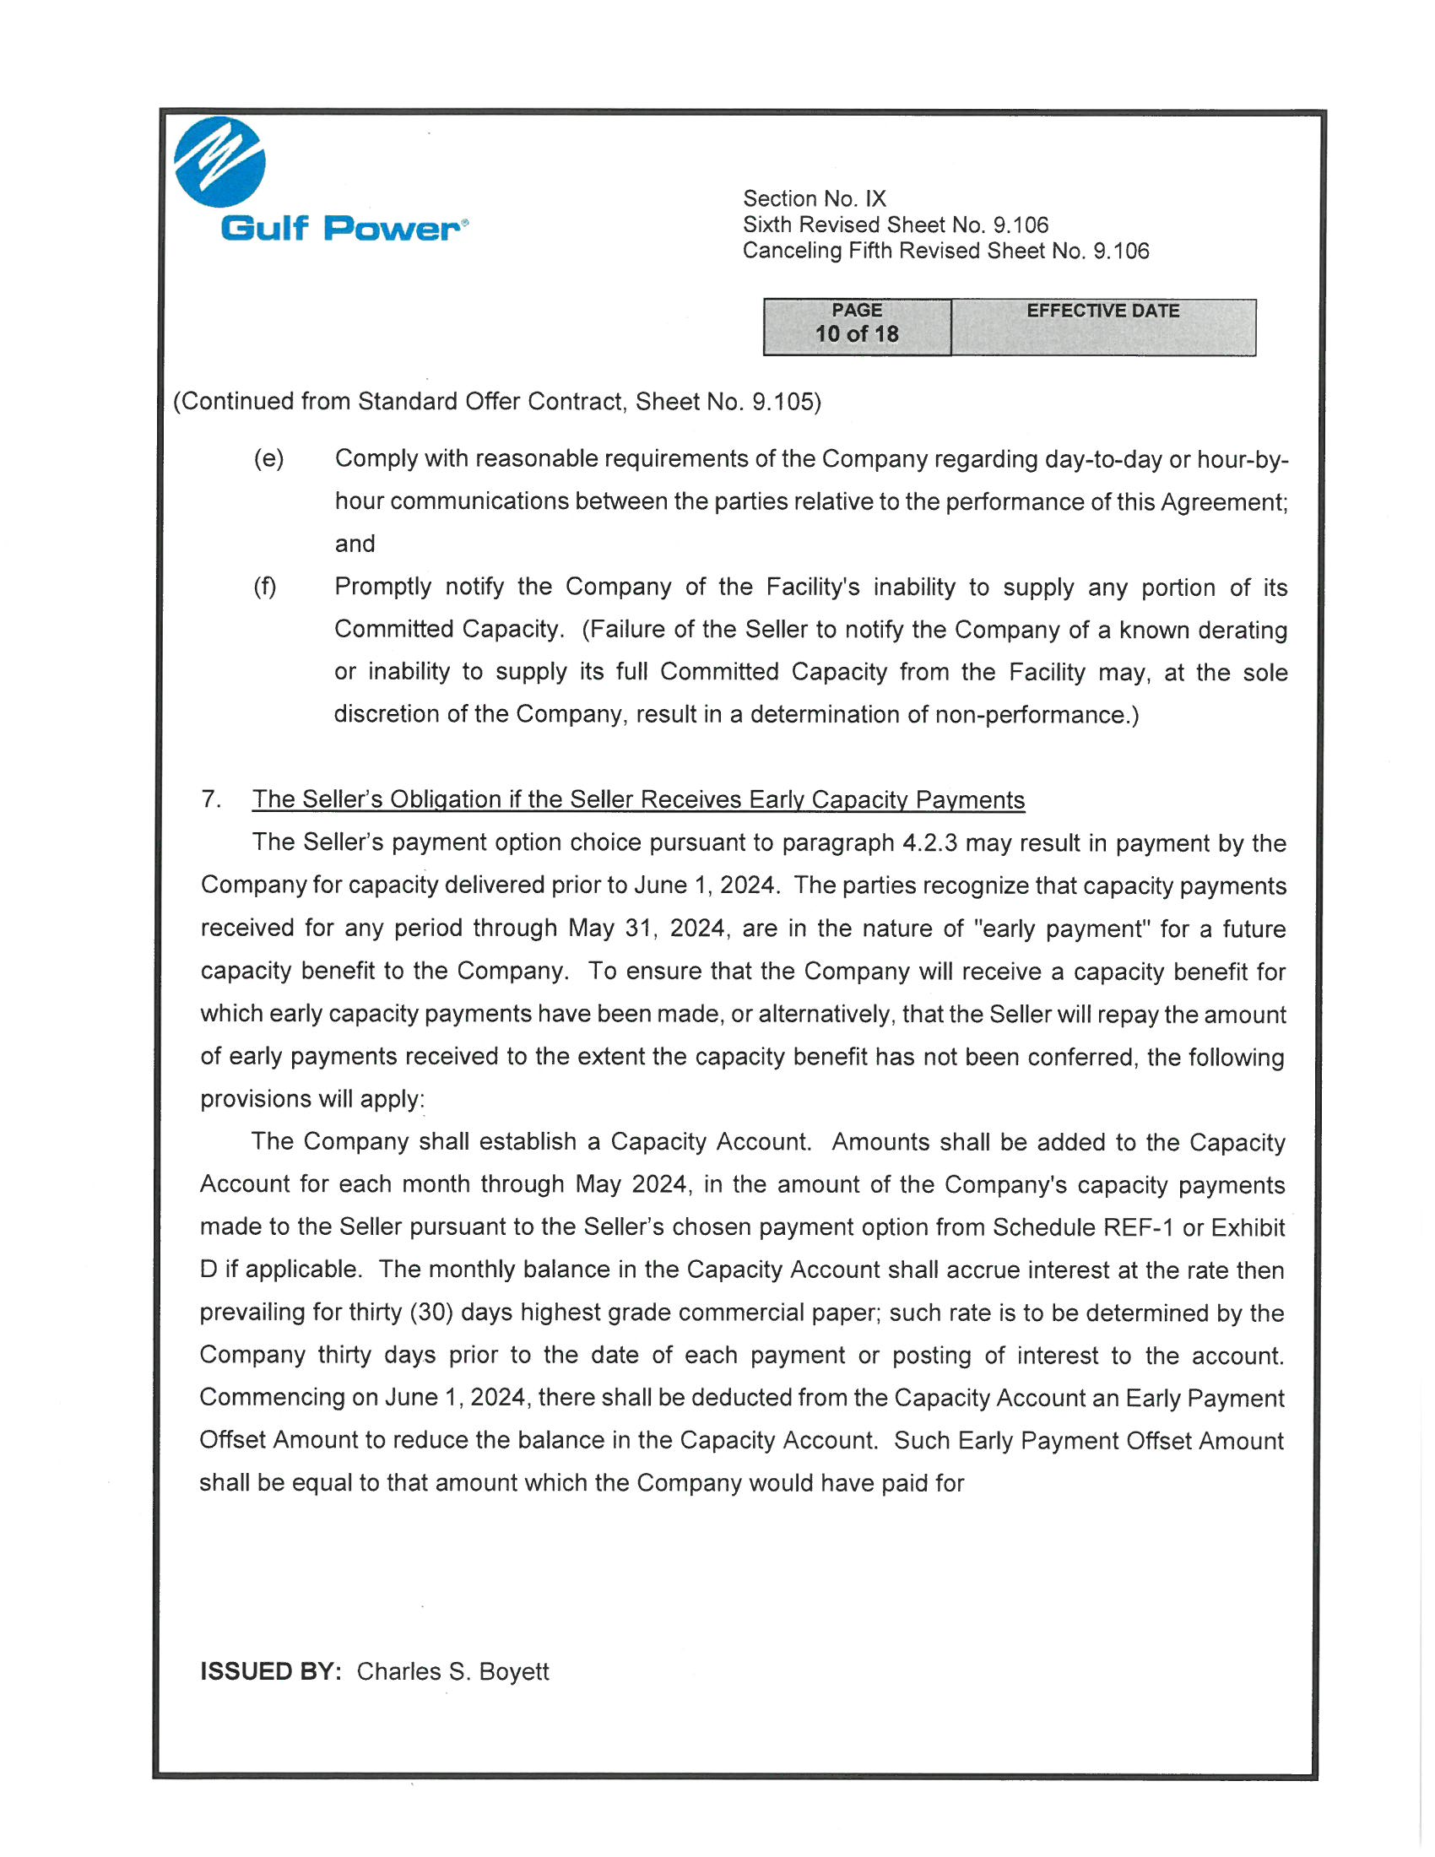

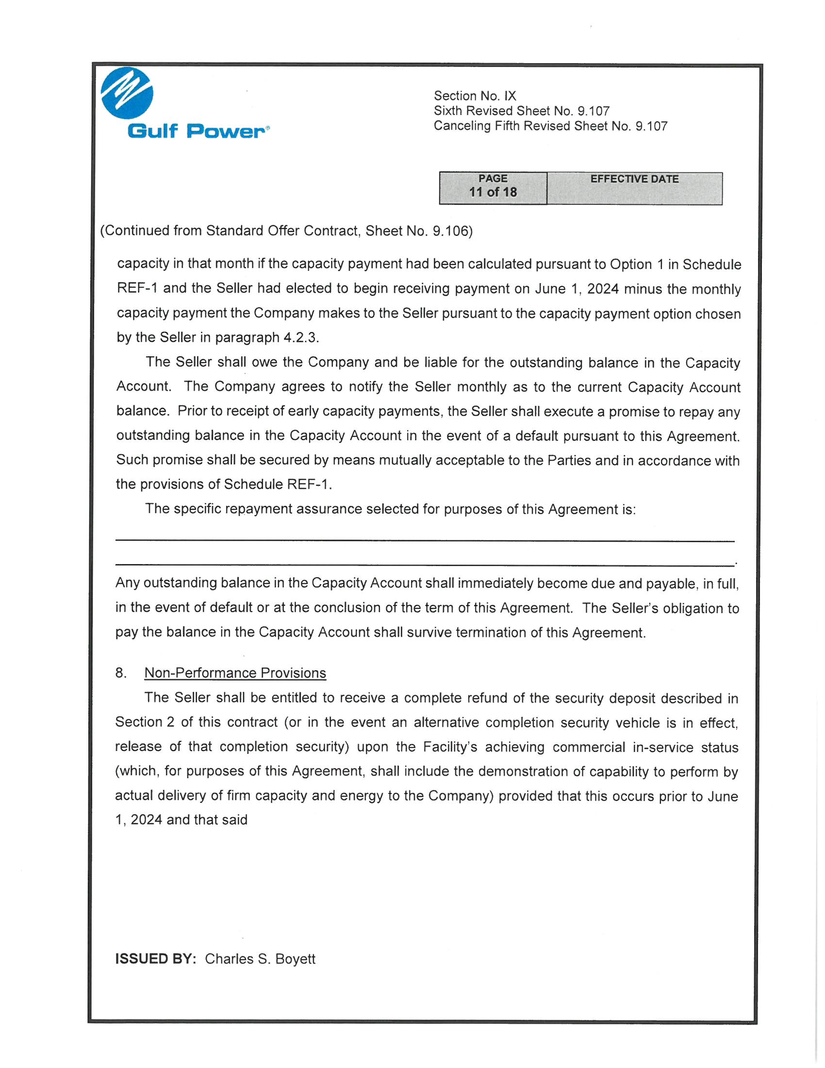

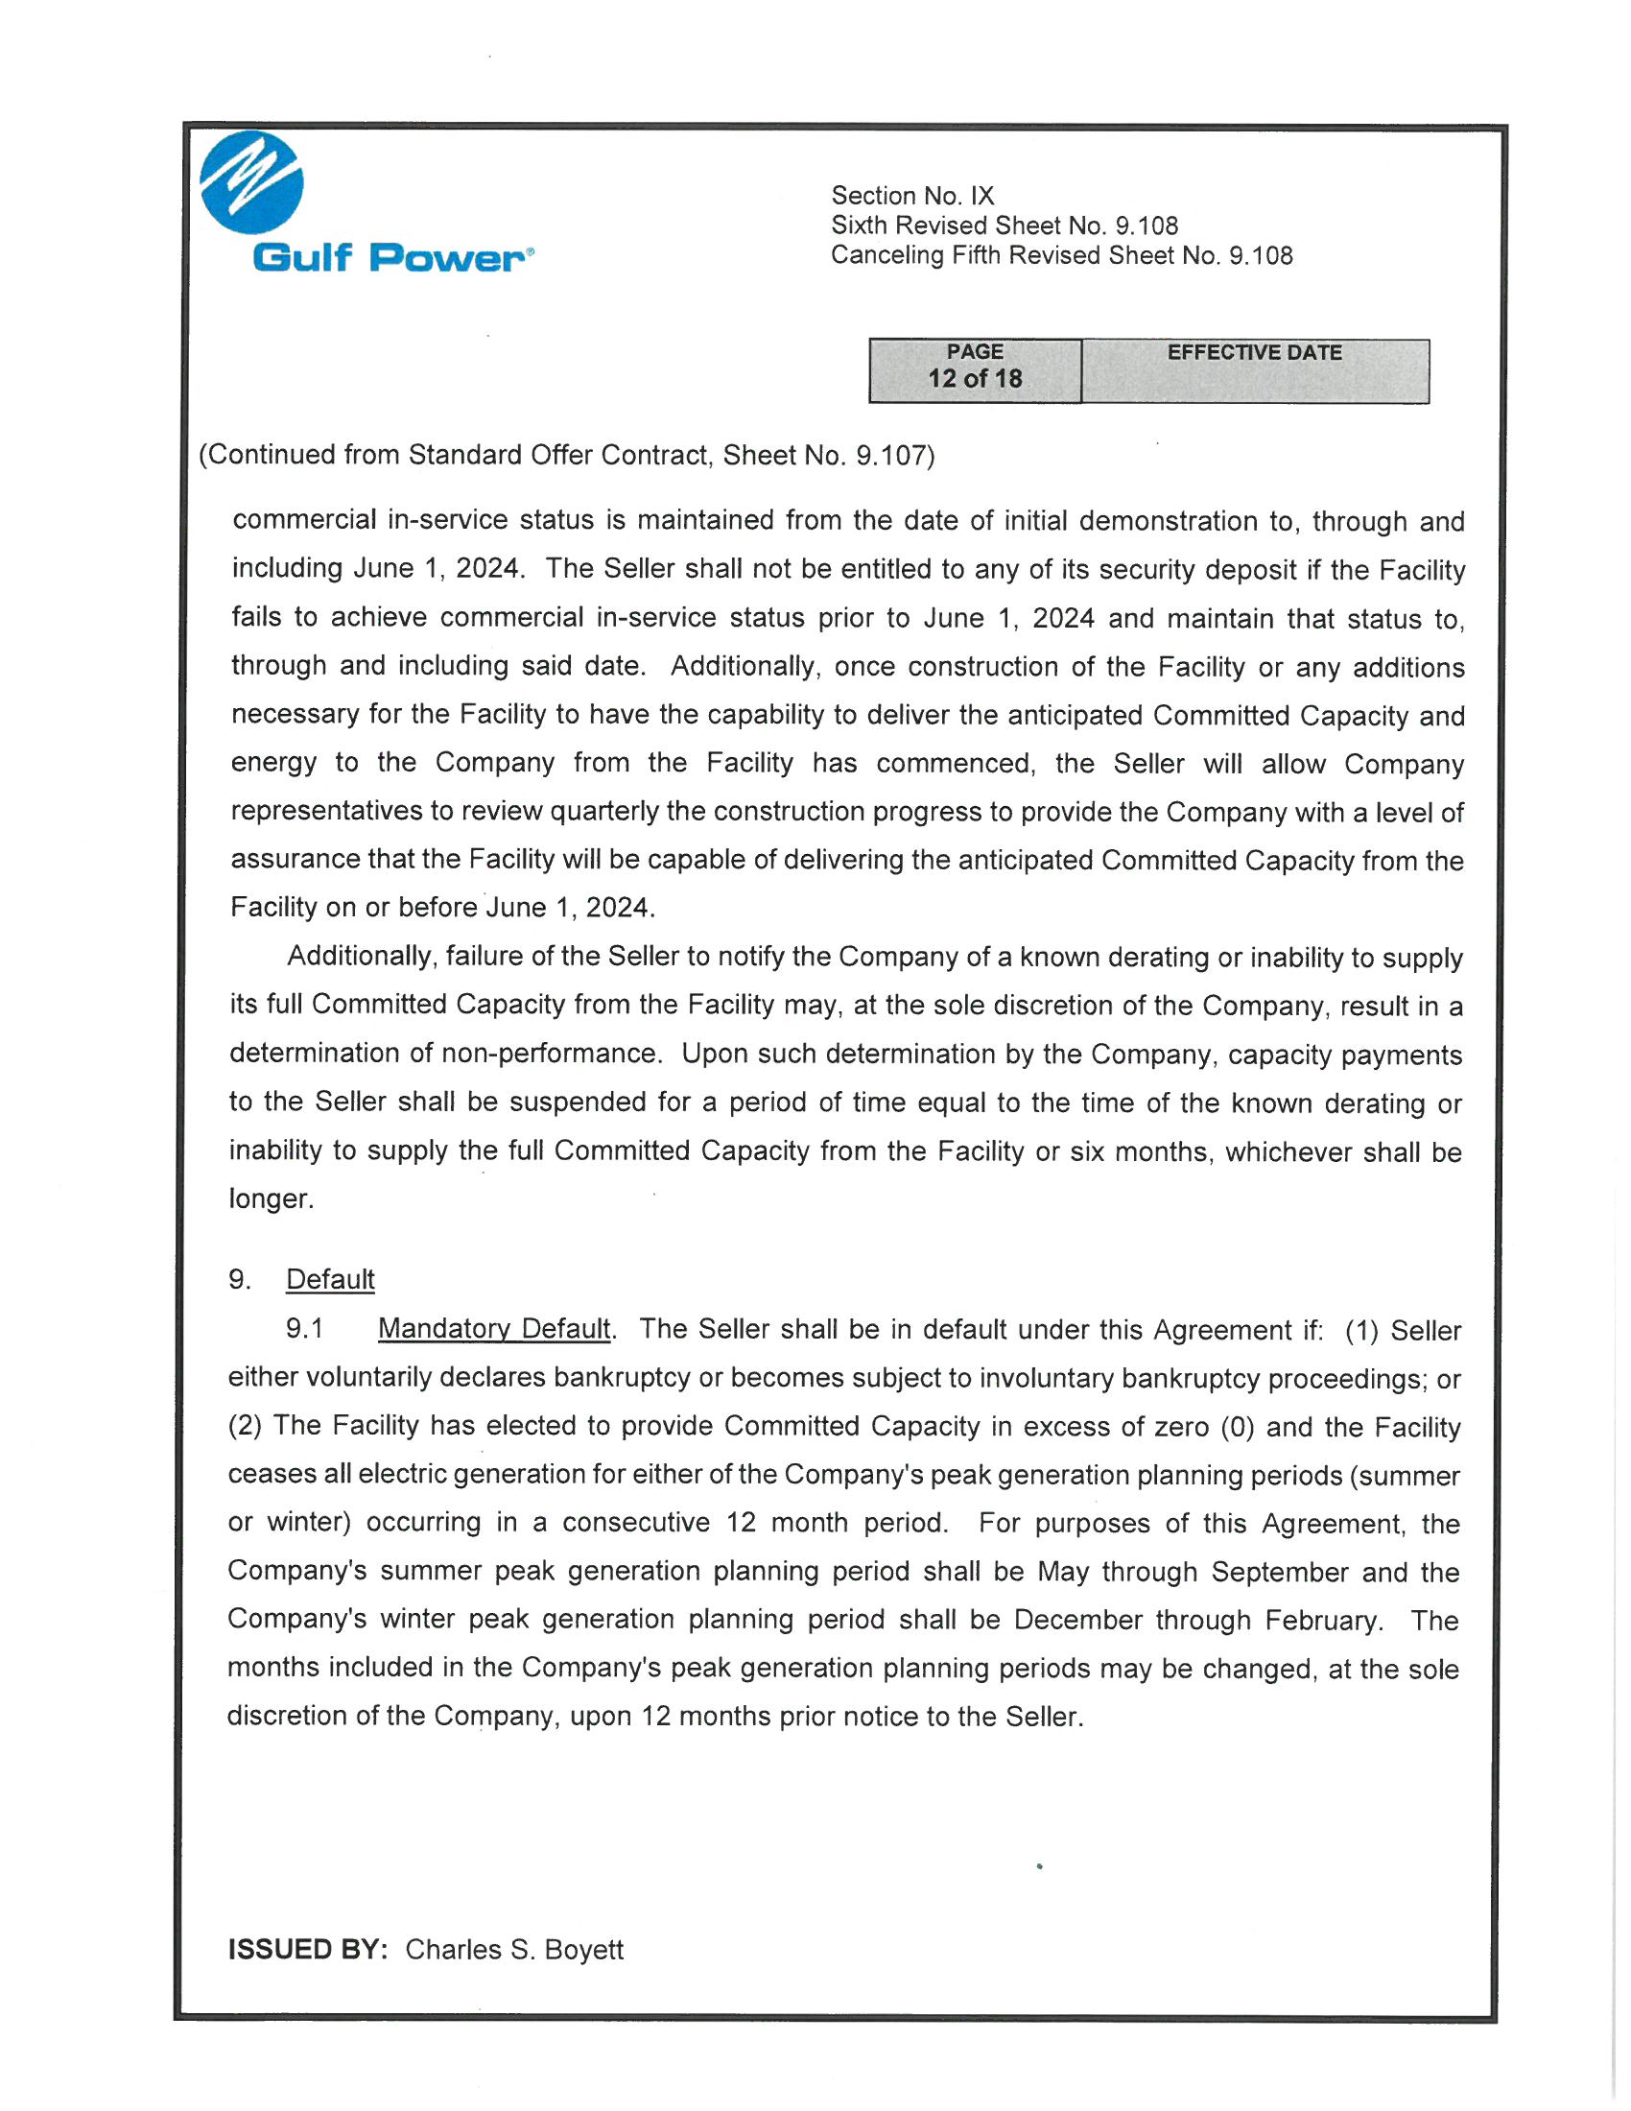

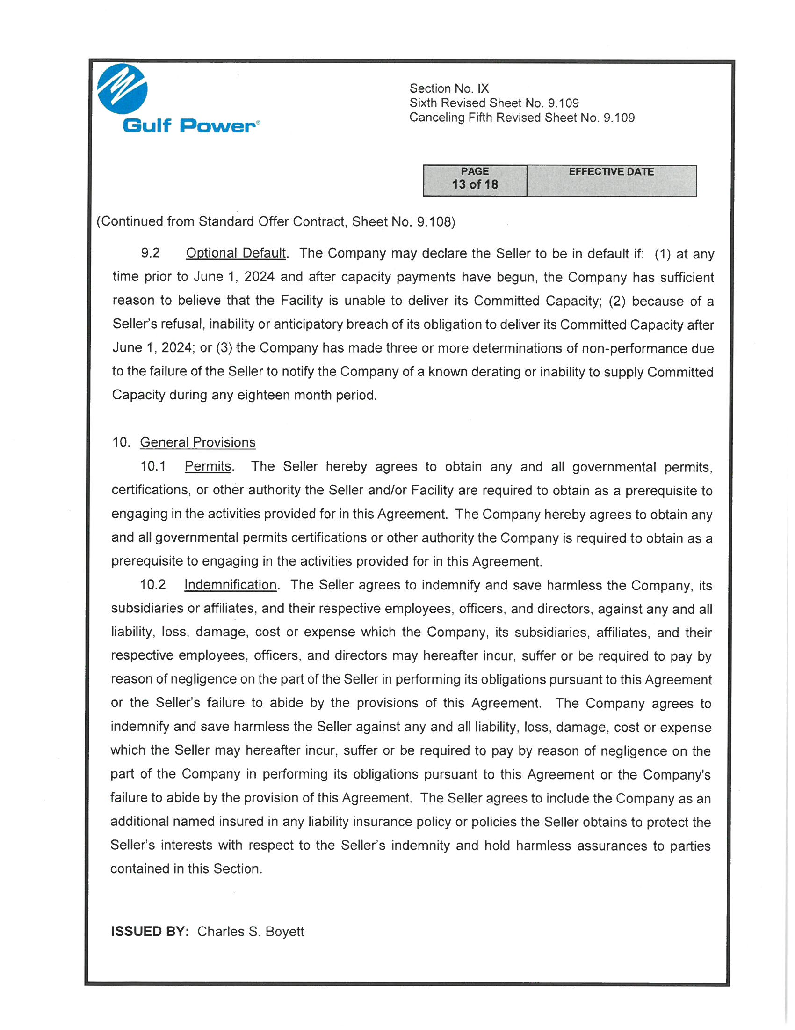

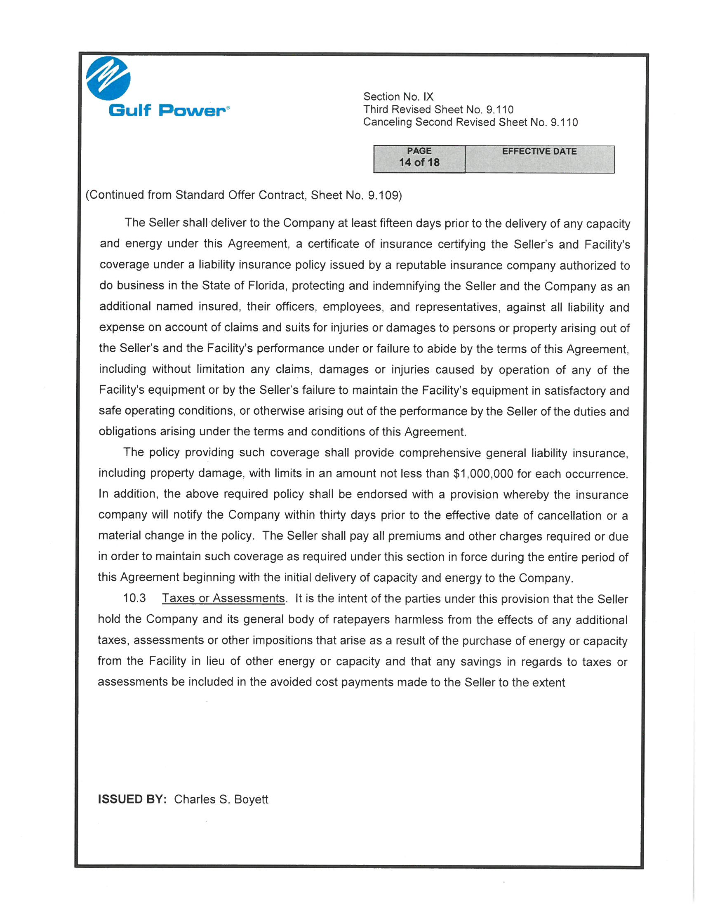

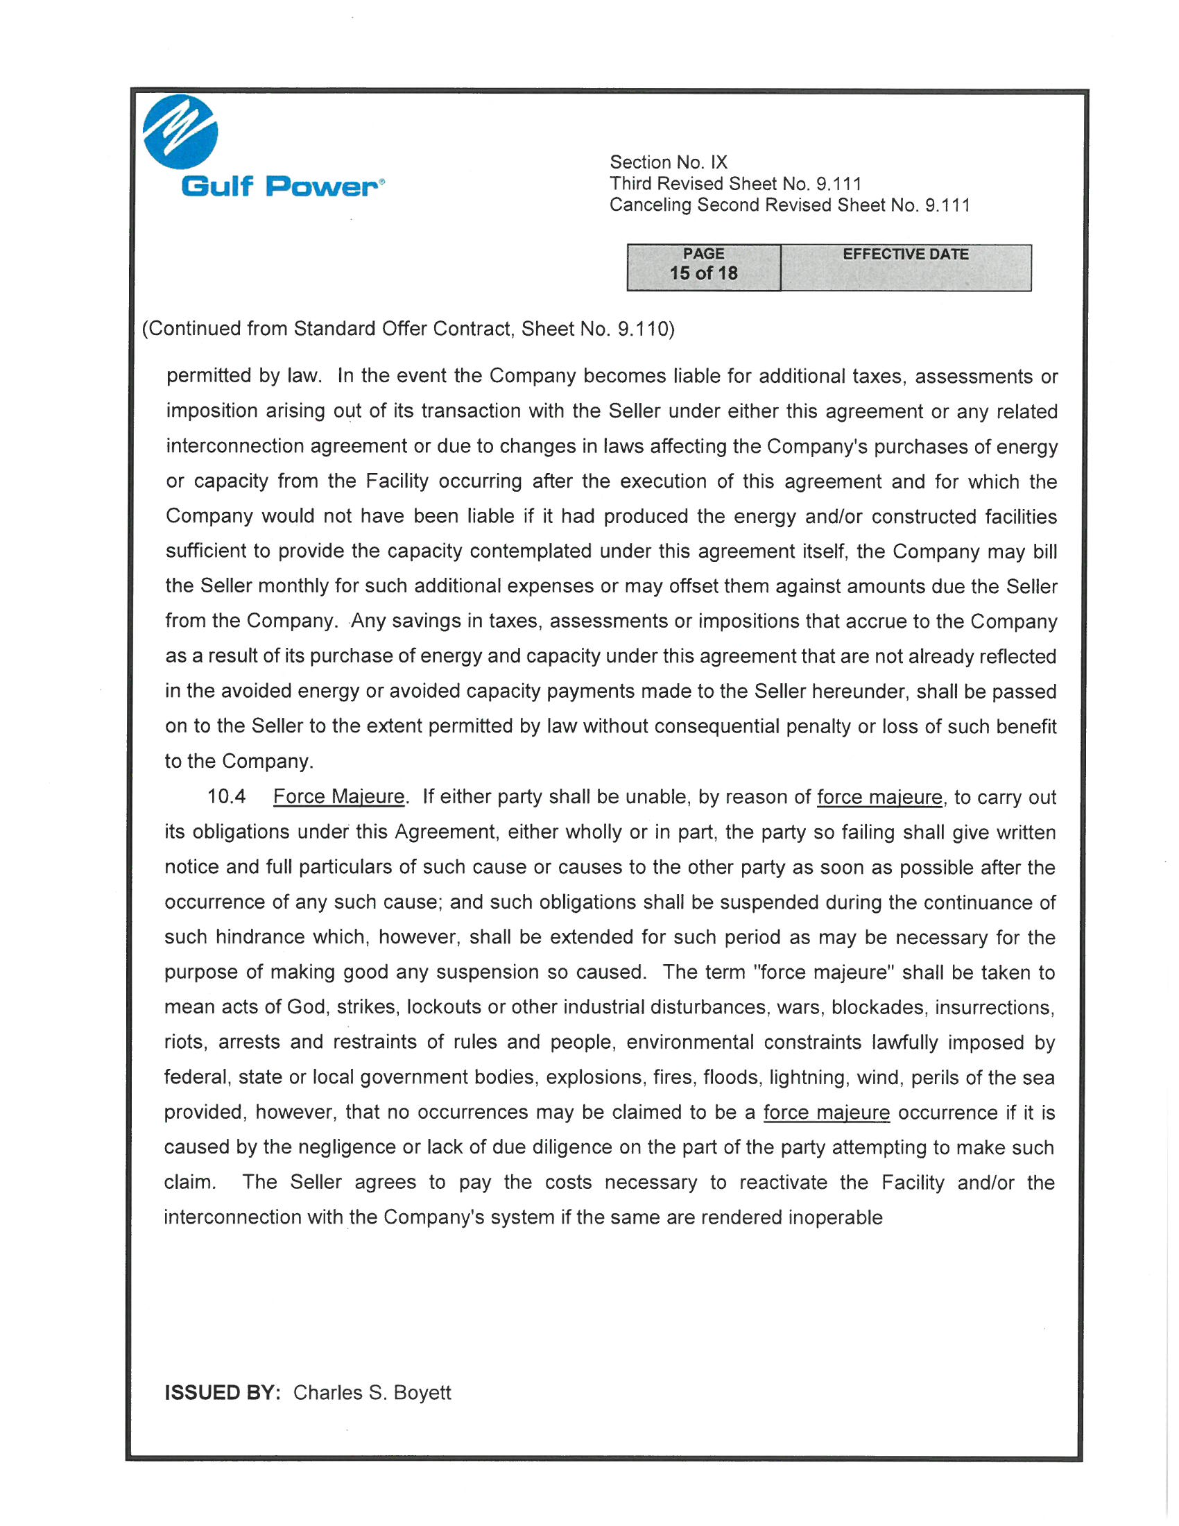

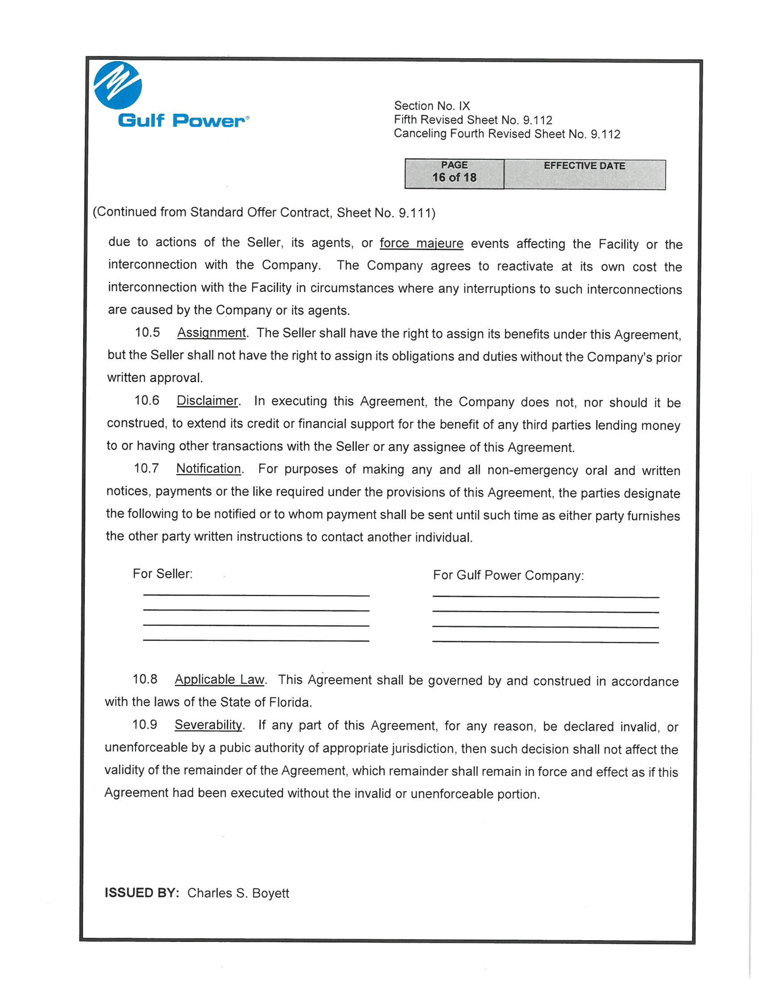

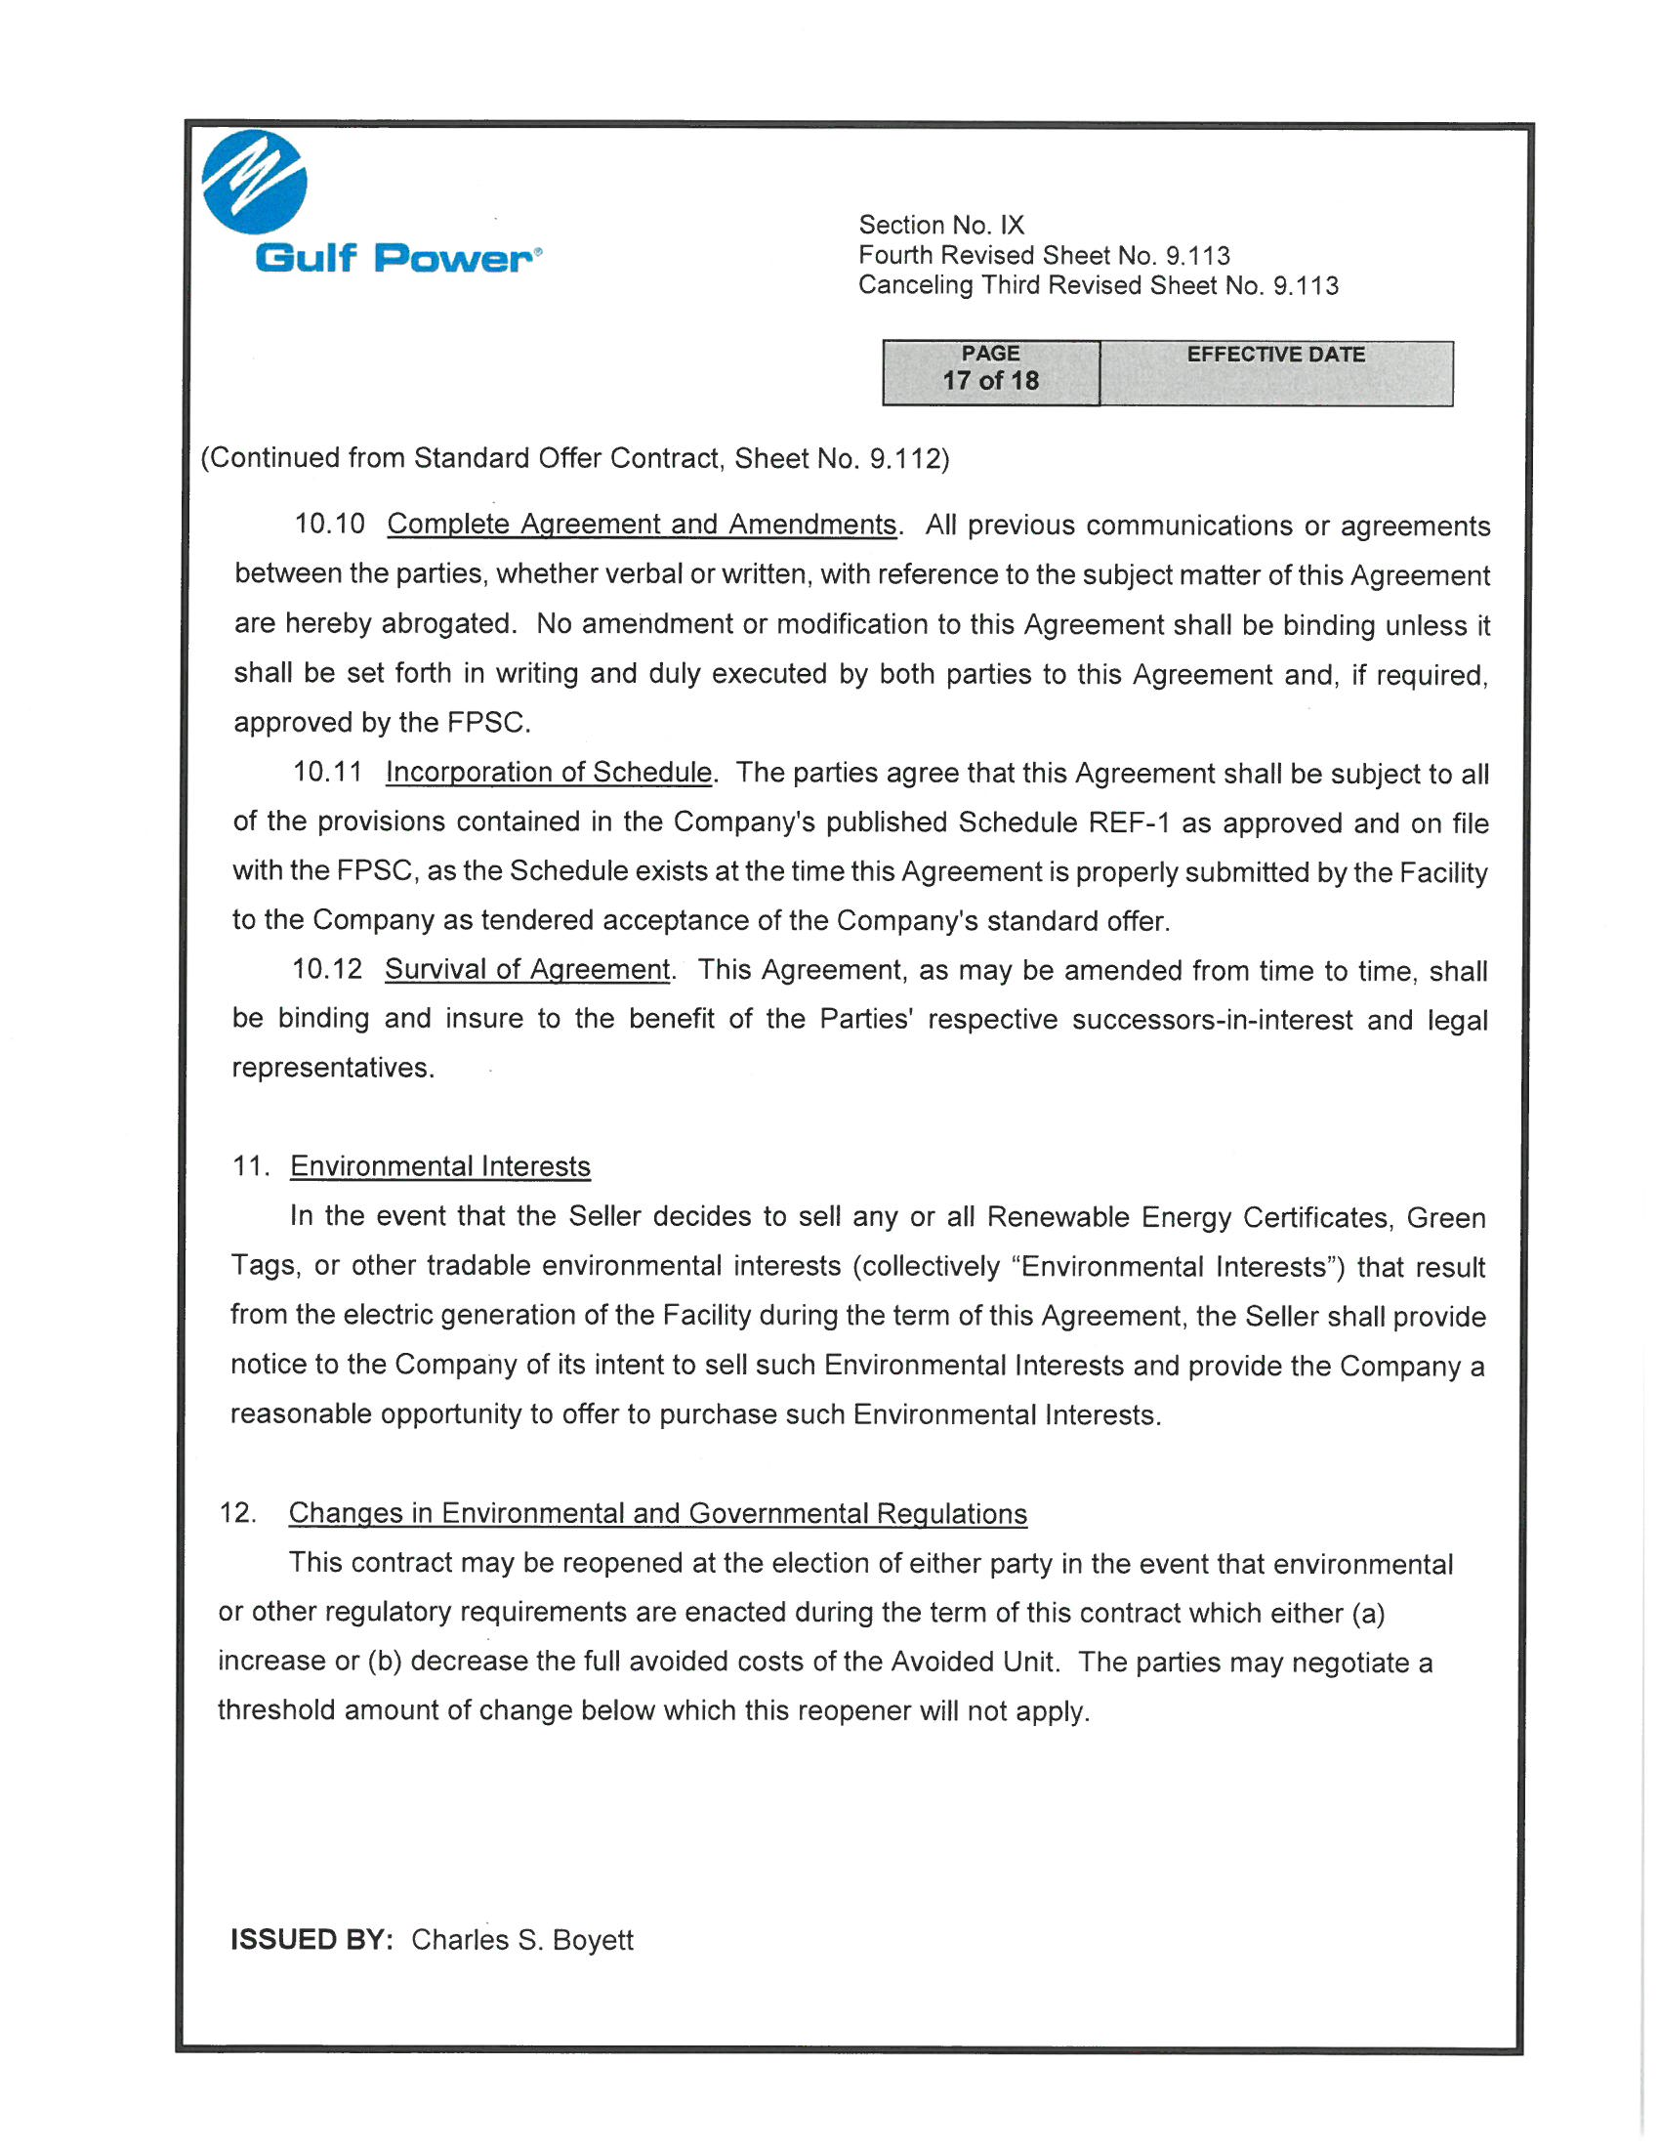

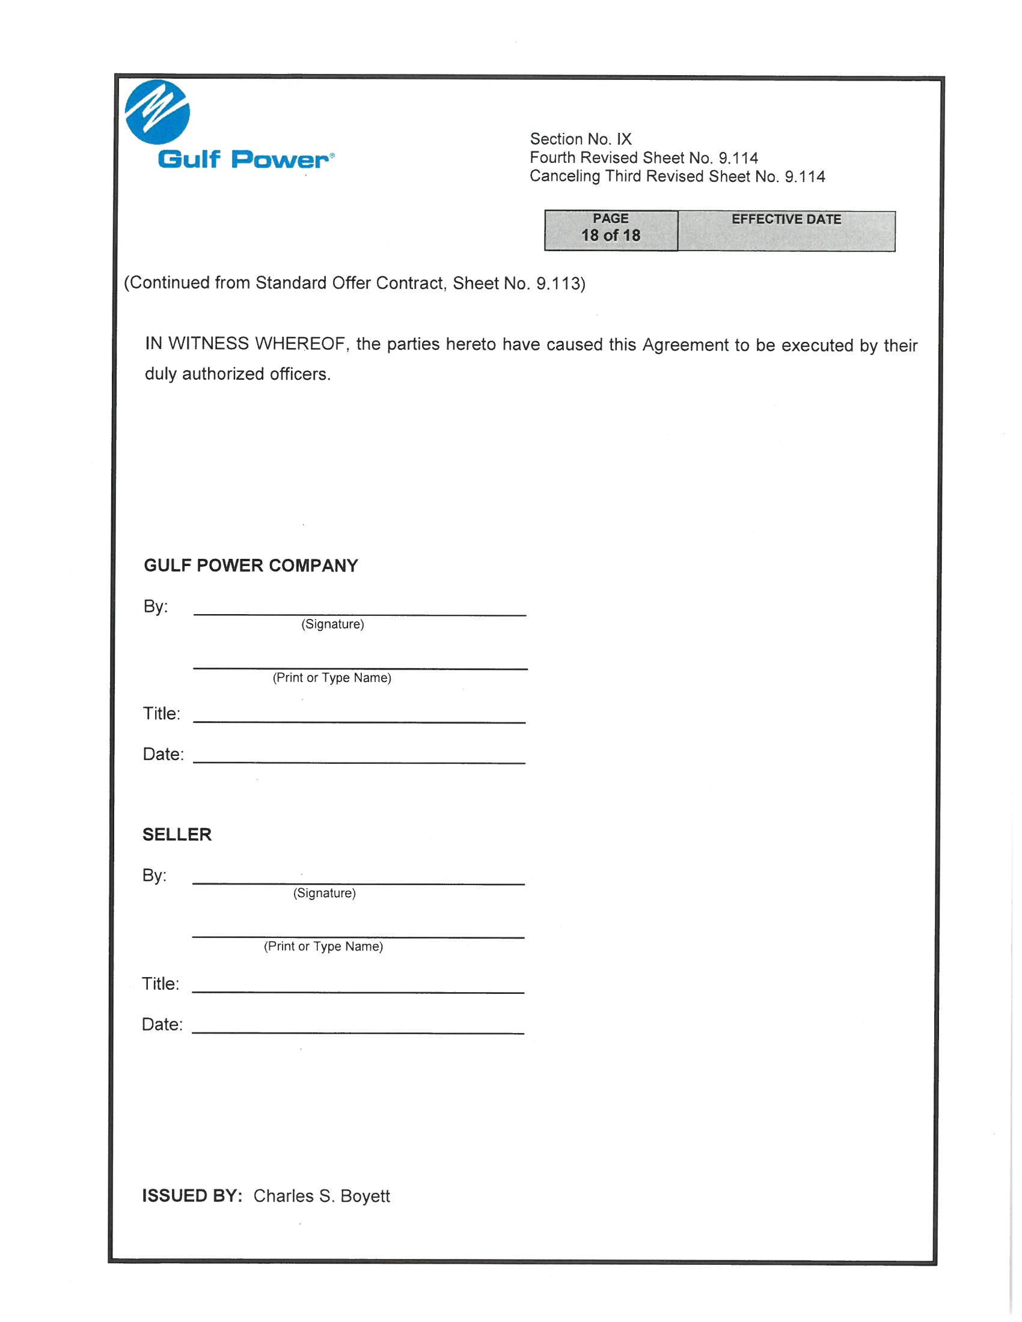

Document No. 03728-2019, filed April 15, 2019, in Docket No. 20190084-EQ.

