State of Florida |  | Public Service Commission  Capital Circle Office Center ● 2540 Shumard Oak Boulevard  Tallahassee, Florida 32399-0850  -M-E-M-O-R-A-N-D-U-M-
DATE: | May 2, 2019
TO: | Office of Commission Clerk (Teitzman)
FROM: | Office of Industry Development and Market Analysis (Deas, Fogleman, Wendel)  Office of the General Counsel (DuVal)
RE: | Docket No. 20190059-TX – Request for cancellation of Certificate of Authority No. 7830, effective May 14, 2019, and request for relinquishment of eligible telecommunications carrier (ETC) designation in Florida, by Global Connection Inc. of America (of Georgia).
AGENDA: | 05/14/19 – Regular Agenda –Proposed Agency Action- Interested Persons May Participate
COMMISSIONERS ASSIGNED: |  |  | All Commissioners
PREHEARING OFFICER: |  |  | Administrative
CRITICAL DATES: |  |  | None
SPECIAL INSTRUCTIONS: |  |  | None

Case Background
On March 11, 2019, Global Connection Inc. of America (of Georgia) (Global) filed a petition with the Florida Public Service Commission (Commission) for cancellation of its Certificate of Authority No. 7830 and relinquishment of its Eligible Telecommunications Carrier (ETC) designation in Florida effective May 14, 2019. Global has been a competitive local exchange carrier (CLEC) in Florida since June 28, 2001. On September 15, 2011, the Commission designated Global as an ETC in parts of AT&T Florida’s service territory. ETC designation is a requirement for telecommunications carriers to receive federal Universal Service Funds for the Lifeline program. The Lifeline program enables low-income households to obtain and maintain telephone service by providing households with discounts on their monthly telephone bills.
As of March 2019, Global only had three Lifeline customers in Florida. Global stated in its petition that Global is exiting the wireline telecommunications market in Florida. As a result, Global is requesting relinquishment of its ETC designation in Florida.
The Commission is vested with jurisdiction in this matter, pursuant to Section 364.10, Florida Statutes (F.S.), 47 U.S.C §214(e)(4), and 47 C.F.R. §54.205.

Discussion of Issues

Issue 1:
Should the Commission approve Global’s request to relinquish its ETC designation in Florida and acknowledge its notice of cancellation of CLEC Certificate No. 7830?

Recommendation:
Yes. The Commission should approve Global’s request to relinquish its ETC designation in Florida and acknowledge its notice of cancellation of CLEC Certificate No. 7830. (Deas, Fogleman, Wendel, Duval)

Staff Analysis:
An ETC may relinquish its ETC designation pursuant to 47 C.F.R. §54.205(a), which provides that:
A state commission shall permit an eligible telecommunications carrier to relinquish its designation as such a carrier in any area served by more than one eligible telecommunications carrier. An eligible telecommunications carrier that seeks to relinquish its eligible telecommunications carrier designation for an area served by more than one eligible telecommunications carrier shall give advance notice to the state commission of such relinquishment.
In approving a relinquishment, state commissions must require the remaining ETCs to ensure that existing customers will continue to be served. 47 C.F.R. §54.205(b), provides that:
Prior to permitting a telecommunications carrier designated as an eligible telecommunications carrier to cease providing universal service in an area served by more than one eligible telecommunications carrier, the state commission shall require the remaining eligible telecommunications carrier or carriers to ensure that all customers served by the relinquishing carrier will continue to be served, and shall require sufficient notice to permit the purchase or construction of adequate facilities by any remaining eligible telecommunications carrier. The state commission shall establish a time, not to exceed one year after the state commission approves such relinquishment under this section, within which such purchase or construction shall be completed.
In its petition, Global identified its service area by wire centers (Attachment A). Staff sent data requests to each ETC in Global’s service area asking each provider to verify that they were currently providing Lifeline service to customers or capable of providing service to customers in Global’s service area. Staff reviewed the responses to verify that customers in Global’s service area would continue to be served. Based on staff’s review and analysis, staff determined that customers in Global’s service area will continue to have Lifeline service available from one or more ETCs.

Global asserts a notice will be sent to all affected customers via first class mail 45 days prior to discontinuance of service. The notice will explain that Global will no longer provide wireline local exchange service in Florida. If customers do not choose another provider before the last service date their service will be terminated. Global also states it will provide customers a list of providers operating in Global’s service area.

After reviewing Global’s petition and the responses to the ETC data request, staff has verified there will be one or more ETCs remaining in Global’s service area. Therefore, Lifeline service will continue to be available to customers residing within the relinquishment area if Global’s petition is granted. Staff believes Global has met the 47 C.F.R. §54.205 requirements to relinquish its ETC designation in its service area. In addition, Global is requesting cancellation of its CLEC Certificate No. 7830, effective May 14, 2019. Global has met the requirements of Section 364.335(3), F.S., by providing notice in writing of its request for voluntary cancellation of its certificate and has submitted all Regulatory Assessment Fees. Therefore, staff recommends that the Commission should approve Global’s petition for relinquishment of its ETC designation and acknowledge cancellation of its CLEC Certificate No. 7830.

Issue 2:
Should this docket be closed?

Recommendation:
Yes, if no person whose substantial interests are affected by the proposed agency action files a protest within 21 days of the issuance of the order, this docket should be closed upon the issuance of a Consummating Order. (DuVal)

Staff Analysis:
At the conclusion of the protest period, if no protest is filed this docket should be closed upon the issuance of a Consummating Order.

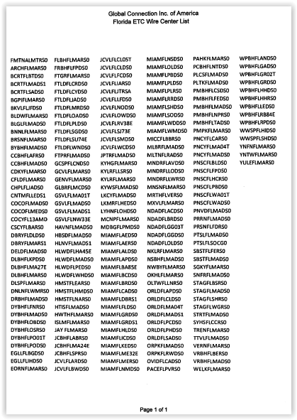

Order No. PSC-11-0389-PAA-TX
Based on the Universal Service Administrative Company’s disbursements to Global in Florida as of March 2019.
Specifically, staff understands that the following ETCs will continue to offer Lifeline in Global’s territory in whole or in part: AT&T Florida, WOW, Phone Club, Tele Circuit Network, SafeLink wireless, Assurance wireless, and T-Mobile wireless.

