State of Florida |  | Public Service Commission  Capital Circle Office Center ● 2540 Shumard Oak Boulevard  Tallahassee, Florida 32399-0850  -M-E-M-O-R-A-N-D-U-M-
DATE: | May 2, 2019
TO: | Office of Commission Clerk (Teitzman)
FROM: | Office of the General Counsel (Davis, Cibula)  Division of Economics (Draper, Merryday, Guffey)
RE: | Docket No. 20180143-EI – Petition to initiate rulemaking to revise and amend portions of Rule 25-6.0426, F.A.C., Recovery of Economic Development Expenses, by Florida Power & Light Company, Gulf Power Company, and Tampa Electric Company.
AGENDA: | 05/14/19 – Regular Agenda – Rule Proposal – Interested Persons May Participate
COMMISSIONERS ASSIGNED: |  |  | All Commissioners
PREHEARING OFFICER: |  |  | Fay
RULE STATUS: |  |  | Proposal May Be Deferred
SPECIAL INSTRUCTIONS: |  |  | None

Case Background
Rule 25-6.0426, Florida Administrative Code, (F.A.C.), addresses the recovery of economic development expenses for public electric utilities. The rule implements Section 288.035, Florida Statutes (F.S.), which requires the Commission to adopt rules for the recovery of economic development expenses by public utilities, including the sharing of expenses by shareholders.
On July 30, 2018, Florida Power & Light Company (FPL), Gulf Power Company (Gulf), and Tampa Electric Company (TECO) (collectively, petitioners) filed a joint petition to initiate rulemaking to amend Rule 25-6.0426, F.A.C. In their petition, the petitioners requested that the Commission amend the rule to increase the cap on recoverable economic development expenses on a phased-in basis through 2023.

On August 2, 2018, the Office of Public Counsel (OPC) filed a notice of intervention which was acknowledged by Order No. PSC-2018-0420-PCO-EI. Staff and OPC issued interrogatories and production of documents to the petitioners, Duke Energy Florida (DEF), and Florida Public Utilities Company (FPUC). The Commission granted the petition to initiate rulemaking and noticed the development of the rule in the September 7, 2018 edition of the Florida Administrative Register, Vol. 44, No. 175.

A rule development workshop was held on January 16, 2019, to obtain stakeholder comment on potential amendments to the rule. FPL, Gulf, TECO, and OPC participated in the workshop and filed post-workshop written comments. On March 14, 2019, the petitioners, Duke, and FPUC responded to staff’s data request regarding the Statement of Estimated Regulatory Cost (SERC).

This recommendation addresses whether the Commission should propose the amendment of Rule 25-6.0426, F.A.C., as set forth in Attachment A to the recommendation. The rule amendments as shown in Attachment A provide for an increase in the cap of recoverable economic development expenses; however, they differ from the petitioners’ proposed amendments. Attachment B to the recommendation illustrates recoverable economic development expenses for electric utilities for 2019 under the current rule, petitioners’ proposed rule, OPC’s proposal (based on OPC’s post-workshop comments), and staff’s recommended amendments. Attachment C further reflects the phased-in approach of percentage increases in the cap from 2019-2023 as proposed in the petitioners’ proposed rule amendments. Attachment D includes the Statement of Estimated Regulatory (SERC) costs.
Staff’s recommended rule amendments are based on the petition, the petitioners’ responses to staff’s and OPC’s interrogatories, the presentations and comments made during the workshop, and the post-workshop written comments. The Commission has jurisdiction pursuant to Sections 120.54, 350.127, and 288.035, F.S.

Discussion of Issues

Issue 1:
Should the Commission propose the amendment of Rule 25-6.0426, F.A.C., Recovery of Economic Development Expenses?

Recommendation:
Yes, the Commission should propose the amendment of Rule 25-6.0426, F.A.C., as set forth in Attachment A. The Commission should certify Rule 25-6.0426, F.A.C., as a minor violation rule. (Davis, Draper, Merryday)

Staff Analysis:
Staff recommends that the Commission propose the amendment of Rule 25-6.0426, F.A.C., as set forth in Attachment A. Subsection (3) of Rule 25-6.0426, F.A.C., is the only section of the rule for which amendments were offered. Subsection (3) of Rule 25-6.0426, F.A.C., places a cap on the amount of economic development expenses utilities may report for surveillance reports and earnings review calculations in between rate cases. Staff’s explanation as to its recommendation for the rule amendments is set forth in more detail below.

Current Rule 25-6.0426, F.A.C.
Subsection (3) of the rule currently states:
Prior to each utility’s next rate change enumerated in subsection (6), the amounts reported for surveillance reports and earnings review calculations shall be limited to the greater of:
(a) The amount approved in each utility’s last rate case escalated for customer growth since that time, or
(b) 95 percent of the expenses incurred for the reporting period so long as such does not exceed the lesser of 0.15 percent of gross annual revenues or $3 million.
When the rule was initially adopted in 1995, the Commission established the cap on economic development expenses in paragraph (3)(b) as the lesser of 0.15 percent of gross annual revenues or $3 million. The rule provided that ratepayers would be responsible for 90 percent of economic development expenses and shareholders for the remaining ten percent of economic development expenses. The Commission established the 95 percent sharing requirement when the rule was amended in 1998.

Petition to Initiate Rulemaking
The petitioners requested that subsection (3) of the rule be amended as follows:
Prior to each utility’s next rate change enumerated in subsection (6), the amounts reported for surveillance reports and earnings review calculations shall be limited to the greater of:
(a) The amount approved in each utility’s last rate case escalated for customer growth since that time, or
(b) 95 percent of the expenses incurred for the reporting period so long as such does not exceed the greater lesser of 0.15 percent of gross annual revenues or $3 million. Beginning on January 1, 2020, the amounts reported for surveillance reports and earnings review calculations shall not exceed the greater of $3 million or 95 percent of the following percentages of gross annual revenues: January 1, 2020 – 0.175 percent; January 1, 2021 – 0.2 percent; January 1, 2022 – 0.225 percent; and, January 1, 2023 and beyond – 0.25 percent.

Attachment C illustrates the phased-in approach of percentage increases in the cap from 2019-2023 as proposed in the petitioners’ proposed rule amendments. The petitioners stated that although Rule 25-60.426, F.A.C., is intended to promote economic development in Florida, the rule in its current form has become unduly restrictive. The $3 million expense cap set forth in the rule has not changed since 1995. For a large utility like FPL, according to the petitioners, the current rule has limited FPL’s recoverable economic development expenses to a flat $3 million per year in each and every year since the rule’s inception over 20 years ago.

The petitioners asserted that the impact of the utilities’ recoverable economic development expenses has steadily eroded since the rule was first established in 1995, with the expense cap decreasing by approximately 65 percent since 1995 due to inflation. The petitioners further explained that both the restrictive impact of the cap on large utilities and the steady erosion of the real value of the cap could be substantially avoided by the above-requested amendments. The petitioners stated in their post-workshop comments that these rule amendments are needed to encourage utilities to broaden economic development in Florida by allowing recovery of economic development expenses at levels commensurate with the economic size and reach of each utility.

According to the petitioners, the suggested rule amendments are not projected to have any adverse impacts to their general body of ratepayers. The petitioners contend that customers will see no rate increases as a result of the proposed rule amendments between rate cases and that the revenue increases from new and expanding business will allow for long-term fixed costs to be spread over a larger customer base, thereby benefiting existing customers.

During the staff workshop, FPL explained that the current $3 million cap creates tension between funding for economic development staffing and other economic development activities, such as rate discounts. FPL stated in its post-workshop comments that the proposed amendments to the rule “will gradually increase the level of funding for promotion of economic development for FPL from the current $3 million to approximately $27 million by 2023.” It asserted that this will “permit FPL to continue expanding its promotion of economic development in Florida” and “increase the funding available for economic development activities of all Florida investor-owned utilities.” This increase includes funding for staff in FPL’s Office of Economic Development which “will provide an enhanced staff focus in the following areas: (1) business development; (2) competitiveness; and (3) capacity building.”
Both Gulf and TECO stated in their post-workshop comments that they are not currently spending up to the existing cap limits. Both utilities also stated that they have no immediate plans to increase their involvement in economic development activities should the cap be increased. However, both utilities asserted that given the amount of time since the rule has been amended and due to the increasing importance of fostering economic development in Florida, it is appropriate to amend the rule to put the utilities in a posture to respond to and address changing conditions in the economic development marketplace.

OPC’s Comments
OPC stated in its post-workshop comments that it does not “categorically object to some level of increase in the amount allowed in the Rule as long as shareholders bear some of the increased costs that assumedly will contribute to their return.” OPC pointed out that all the utilities stated at the workshop that the utilities contribute no more than the five percent required under paragraph (3)(b) of the rule. OPC stated that it is concerned with “maintaining the appropriate balance between customer and shareholder responsibility regarding the amount spent on economic development and the amount paid by customers.”
In regard to the utilities’ request to change the word “lesser” to “greater” in paragraph (3)(b) of the rule, OPC asserted that the rule should remain the same. Instead, OPC suggested that the rule be amended to increase the $3 million cap to $10 million.
OPC stated it is concerned that use of the word “greater” instead of the limiting language “lesser” would “allow for increases in the amount that can be spent on economic development with no dollar amount ‘cap’ in the future.” It is concerned that there is a lack of evidence warranting the level of increase requested by the utilities. It further stated that the utilities did not “show that they were either foregoing economic development opportunities due to lack of funding or that they were spending more than five percent of shareholder monies on the costs for economic development opportunities that would otherwise be foregone.”
OPC asserted that the limitations in the rule are necessary because 95 percent of the costs are flowed through to the customers and the majority of the utilities have not been spending the allowable amounts under the current rule. It further asserted that “[a]llowing the cap to increase from $3 million to $10 million is a 333 percent increase which would allow all utilities to significantly increase spending for economic development above what they are currently spending.”

Staff’s Recommended Amendments to the Rule
Based on the petition, the petitioners’ responses to staff’s and OPC’s interrogatories, the presentations and comments made during the workshop, and the post-workshop written comments, staff believes that Rule 25-6.0426, F.A.C., should be revised to further encourage utilities to promote continued economic development. Therefore, as reflected in Attachment A, staff recommends that Section (3) of Rule 25-6.0426, F.A.C., be amended as follows:
Prior to each utility’s next rate change enumerated in subsection (6), the amounts reported for surveillance reports and earnings review calculations shall be limited to the greater of:
(a) The amount and level of sharing approved in each utility’s last rate case escalated for customer growth since that time, or
(b) 95 percent of the total economic development expenses incurred for the reporting period so long as the total economic development expenses do such does not exceed the greater lesser of 0.15 percent of jurisdictional gross annual revenues or $53 million.
Attachment B to the recommendation illustrates recoverable economic development expenses for electric utilities for 2019 under the current rule, the petitioners’ proposed rule, OPC’s proposal (based on OPC’s post-workshop comments), and staff’s recommended amendment as shown in Attachment A to the recommendation. Attachment C essentially illustrates the phased-in approach of the petitioners’ proposed annual cap increases from 2019-2023. Staff does not favor a phased-in approach of cap increases for the reasons discussed below. Instead, staff recommends a more moderate approach described as follows.
First, staff recommends that the Commission amend paragraph (3)(b) of the rule to change the word “lesser” to “greater” and to retain the current 0.15 percent ceiling. This amendment allows economic development expenses to increase commensurate with a utility’s size, addressing the petitioners’ concerns that the current rule is unduly restrictive for large utilities such as FPL (when measured in operating revenues). This will result in the ability of larger utilities to increase economic development expenses over time as operating revenues grow.
Additionally, staff’s proposed language would allow smaller utilities to increase their economic development expenses. Under the current “lesser” language, 0.15 percent of revenues is the economic development expense cap for Gulf and FPUC because 0.15 percent of jurisdictional operating revenues falls below the current $3 million cap, as shown in Column 2 of Attachment B. Under staff’s proposed amendment, changing “lesser” to “greater” will increase the allowed expenditures for Gulf and FPUC to the dollar cap in the rule, which would be $5 million as reflected in Column 6 of Attachment B.
Second, staff recommends that the Commission amend paragraph (3)(b) to increase the $3 million cap to $5 million to address the effects of inflation since 1995. Staff used the Consumer Price Index for all Urban Consumers (CPI-U) to bring $3 million in 1995 dollars to a present value of $4.95 million. This figure was rounded to $5 million for simplification. Adjusting the cap from $3 million to $5 million, in conjunction with changing “lesser” to “greater,” would allow all electric utilities to expand their economic development spending as shown in Column 6 of Attachment B. Staff notes that OPC’s proposal, as shown in Column 5 of Attachment B, does not provide for an increase in economic development expenses for TECO, Gulf, and FPUC.
Finally, staff is recommending three minor modifications to the rule to provide clarity to the rule. Staff recommends that the phrase “and the level of sharing” be added to paragraph (3)(a) of the rule. The current language may create uncertainty as to the percentage of economic development expenses approved in a utility’s last rate case subject to sharing between shareholders and ratepayers, if the Commission does not specifically address it. Section 288.035, F.S., states the “Commission shall adopt rules for the recovery of economic development expenses by public utilities, including the sharing of expenses by shareholders.” Therefore, this clarifies that the level of sharing by the Commission in a rate case shall be utilized for surveillance purposes.
Staff also recommends that paragraph (3)(b) be amended to add the phrase “total economic development expenses” to clarify that the cap prescribed by paragraph (3)(b) includes a 5 percent shareholder contribution. The amount reported for surveillance reports and earnings review calculations reflects only the 95 percent ratepayer contribution.
Staff further recommends that subsection (3)(b) be amended to add the word “jurisdictional” to clarify that the cap is derived from jurisdictional gross annual revenues, as opposed to system gross annual revenues. Jurisdictional revenues are derived from retail customers, which are under the Commission’s jurisdiction. System revenues include retail as well as wholesale customers, which are under federal jurisdiction. Staff believes this clarification is needed after communications with the utilities revealed different understandings of the term “gross annual revenues.”
The petitioners proposed phased-in increases to the percentage cap, from 0.175 percent in 2020 to 0.25 percent in 2023, as shown in Columns 2 and 5 of Attachment C of the recommendation. In the staff workshop, the petitioners communicated that, if the rule is amended as the petition proposes, the utilities are unlikely to immediately increase spending up to the caps. This reflects the petitioners’ stated belief that spending should gradually increase to a higher percentage over time. Staff believes having 0.15 percent revenue cap (as in the current rule), rather than 0.25 percent, better mitigates potential rate increases resulting from a larger increase in spending allowed under the phased-in approach. Further, the utilities did not adequately demonstrate the need to increase the existing percentage of revenues cap. Therefore, staff does not believe the petitioners’ phased-in increases to the percentage cap are warranted. If, with experience, the petitioners determine that the proposed amendments limit economic development activities, then this can be addressed in a rate case or further rule amendments may be proposed.

Minor Violation Rule Certification
Pursuant to Section 120.695, F.S., beginning July 1, 2017, for each rule filed for adoption the agency head shall certify whether any part of the rule is designated as a rule the violation of which would be a minor violation. Rule 25-6.0426, F.A.C., is currently listed on the Commission’s website as a rule for which a violation would be minor because violation of the rule would not result in economic or physical harm to a person or have an adverse effect on the public health, safety, or welfare or create a significant threat of such harm. The amendments to the rule would not change its status as a minor violation rule. Thus, staff recommends that the Commission certify Rule 25-6.0426, F.A.C., as a minor violation rule.

Statement of Estimated Regulatory Costs
Pursuant to Section 120.54, F.S., agencies are encouraged to prepare a statement of estimated regulatory costs (SERC) before the adoption, amendment, or repeal of any rule. The SERC is appended as Attachment D to this recommendation. The SERC analysis also includes whether the rule is likely to have an adverse impact on growth, private sector job creation or employment, or private sector investment in excess of $1 million in the aggregate within five years of implementation.
The SERC concludes that the rule will not likely directly or indirectly increase regulatory costs in excess of $200,000 in the aggregate in Florida within one year after implementation. Further, the SERC concludes that the rule will not likely have an adverse impact on economic growth, private sector job creation or employment, private sector investment, business competitiveness, productivity, or innovation in excess of $1 million in the aggregate within five years of implementation. Thus, the rule does not require legislative ratification pursuant to Section 120.541(3), F.S. In addition, the SERC states that the rule will not have an adverse impact on small business and will have no impact on small cities or counties. No regulatory alternatives were submitted pursuant to paragraph 120.541(1)(a), F.S. None of the impact/cost criteria established in paragraph 120.541(2)(a), F.S., will be exceeded as a result of the recommended revision.

Customer Bill Impacts
The SERC includes an analysis of customer bill impacts of the rule amendment as shown in Attachment D, page 24. As explained in the SERC, estimated customer bill impacts for residential and small commercial customers are projected by the petitioners, Duke, and FPUC to be minimal. In addition, the customers will see no rate increases as a result of an increase in economic development spending between rate cases. Finally, the petitioners assert in their responses to staff’s SERC data requests, that any new load resulting from economic development activities allows the petitioners to spread fixed costs over a greater customer base, putting downward pressure on rates for all customers.

Conclusion
Staff agrees with the petitioners that the current cap is unduly restrictive, especially for a large utility like FPL, and that inflation since 1995 has eroded the value of the $3 million cap. However, staff also believes that while the Commission should continue to encourage economic development, the Commission should consider moderation in the increase of recoverable economic development expenses. Based on the foregoing, staff recommends that the Commission propose the amendment of Rule 25-6.0426, F.A.C., as set forth in Attachment A. This more moderate approach when compared to the petitioners’ request will provide the petitioners with the opportunity for increased economic development spending to the benefit of the State of Florida. In addition, the Commission should certify Rule 25-6.0426, F.A.C., as a minor violation rule.

Issue 2:
Should this docket be closed?

Recommendation:
Yes. If no requests for hearing or comments are filed, the rule may be filed with the Department of State, and this docket should be closed.

Staff Analysis:
If no requests for hearing or comments are filed, the rule may be filed with the Department of State, and the docket should be closed.

25-6.0426 Recovery of Economic Development Expenses.
(1) Pursuant to Section 288.035, F.S., the Commission shall allow a public utility to recover reasonable economic development expenses subject to the limitations contained in subsections (3) and (4), provided that such expenses are prudently incurred and are consistent with the criteria established in subsection (7).
(2) Definitions.
(a) “Economic Development” means those activities designed to improve the quality of life for all Floridians by building an economy characterized by higher personal income, better employment opportunities, and improved business access to domestic and international markets.
(b) “Economic development organization” means a state, local, or regional public or private entity within Florida that engages in economic development activities, such as city and county economic development organizations, chambers of commerce, Enterprise Florida, the Florida Economic Development Council, and World Trade Councils.
(c) “Trade show” means an exhibition at which companies, organizations, communities, or states advertise or display their products or services, in which economic development organizations attend or participate to identify potential industrial prospects, to provide information about the locational advantages of Florida and its communities, or to promote the goods and services of Florida companies.
(d) “Prospecting mission” means a series of meetings with potential industrial prospects at their business locations with the objectives of convincing the prospect that Florida is a good place to do business and offers unique opportunities for that particular business, and encouraging the prospect to commit to a visit to Florida if a locational search is pending or in progress.
(e) “Strategic plan” means a long-range guide for the economic development of a community or state that focuses on broad priority issues, is growth-oriented, is concerned with fundamental change, and is designed to develop and capitalize on new opportunities.
(f) “Recruitment” means active efforts to encourage specific companies to expand or begin operations within Florida.
(3) Prior to each utility’s next rate change enumerated in subsection (6), the amounts reported for surveillance reports and earnings review calculations shall be limited to the greater of:
(a) The amount and level of sharing approved in each utility’s last rate case escalated for customer growth since that time, or
(b) 95 percent of the total economic development expenses incurred for the reporting period so long as the total economic development expenses do such does not exceed the greater lesser of 0.15 percent of jurisdictional gross annual revenues or $53 million.
(4) At the time of each utility’s next rate case and for subsequent rate proceedings enumerated in subsection (6) the Commission will determine the level of sharing of prudent economic development costs and the future treatment of these expenses for surveillance purposes.
(5) Each utility shall report its total economic development expenses as a separate line item on its income statement schedules filed with the earnings surveillance report required by Rule 25-6.1352, F.A.C. Each utility shall make a line item adjustment on its income statement schedule to remove the appropriate percentage of economic development expenses incurred for the reported period consistent with subsections (3) and (4).
(6) Requests for changes relating to recovery of economic development expenses shall be considered only in the context of a full revenue requirements rate case or in a limited scope proceeding for the individual utility.
(7) All financial support for economic development activities given by public utilities to state and local governments and organizations shall be pursuant to a prior written agreement. Recoverable economic development expenses shall be limited to the following:
(a) Expenditures for operational assistance, including:
1. Planning, attending, and participating in trade shows;
2. Planning, conducting, and participating in prospecting missions designed to encourage the location in Florida of domestic and foreign companies;
3. Providing financial support to economic development organizations to assist with their economic development operations;
4. Providing financial support to economic development programs or initiatives identified or developed by Enterprise Florida, Inc.;
5. Participating in joint economic development efforts, including public-private partnerships, consortia, and multi-county regional initiatives;
6. Participating in downtown revitalization and rural community developmental programs.
7. Supporting state and local efforts to promote small and minority-owned business development efforts; and
8. Supporting state and local efforts to promote business retention and expansion activities.
(b) Expenditures for assisting state and local governments in the design of strategic plans for economic development activities, including:
1. Making financial contributions to state and local governments to assist strategic planning efforts; and
2. Providing technical assistance, data, computer programming, and financial support to state and local governments in the design and maintenance of information systems used in strategic planning activities.
(c) Expenditures of marketing and research services, including;
1. Assisting state and local governments and economic development organizations in marketing specific sites for business and industry development or recruitment;
2. Assisting state and local governments and economic development organizations in responding to inquiries from business and industry concerning the development of specific sites within the utility’s service area;
3. Providing technical assistance, data, computer programming, and financial support to state and local governments in the design and maintenance of geographic information systems, computer networks, and other systems used in marketing and research activities;
4. Providing financial support to economic development organizations to assist with their research and marketing activities;
5. Sponsoring publications, conducting direct mail campaigns, and providing advertising support for state and local economic development efforts;
6. Participating in cooperative marketing efforts with economic development organizations;
7. Helping state and local businesses identify suppliers, markets, and sources of financial assistance;
8. Helping economic development organizations identify specific industries and companies for targeting and recruitment;
9. Working with economic development organizations to identify businesses in need of help for expansion, going out of business, or at risk of leaving the area;
10. Providing site and facility selection assistance, including lists of commercial or industrial sites, computer databases, toll-free telephone numbers, maps, photographs, videos, and other activities in cooperation with economic development organizations; and
11. Supporting state and local efforts to promote exports of goods and services, and other international business activities.
Rulemaking Authority 288.035(3), 350.127(2) FS. Law Implemented 288.035 FS. History–New 7-17-95, Amended 6-2-98, 9-25-00,______________
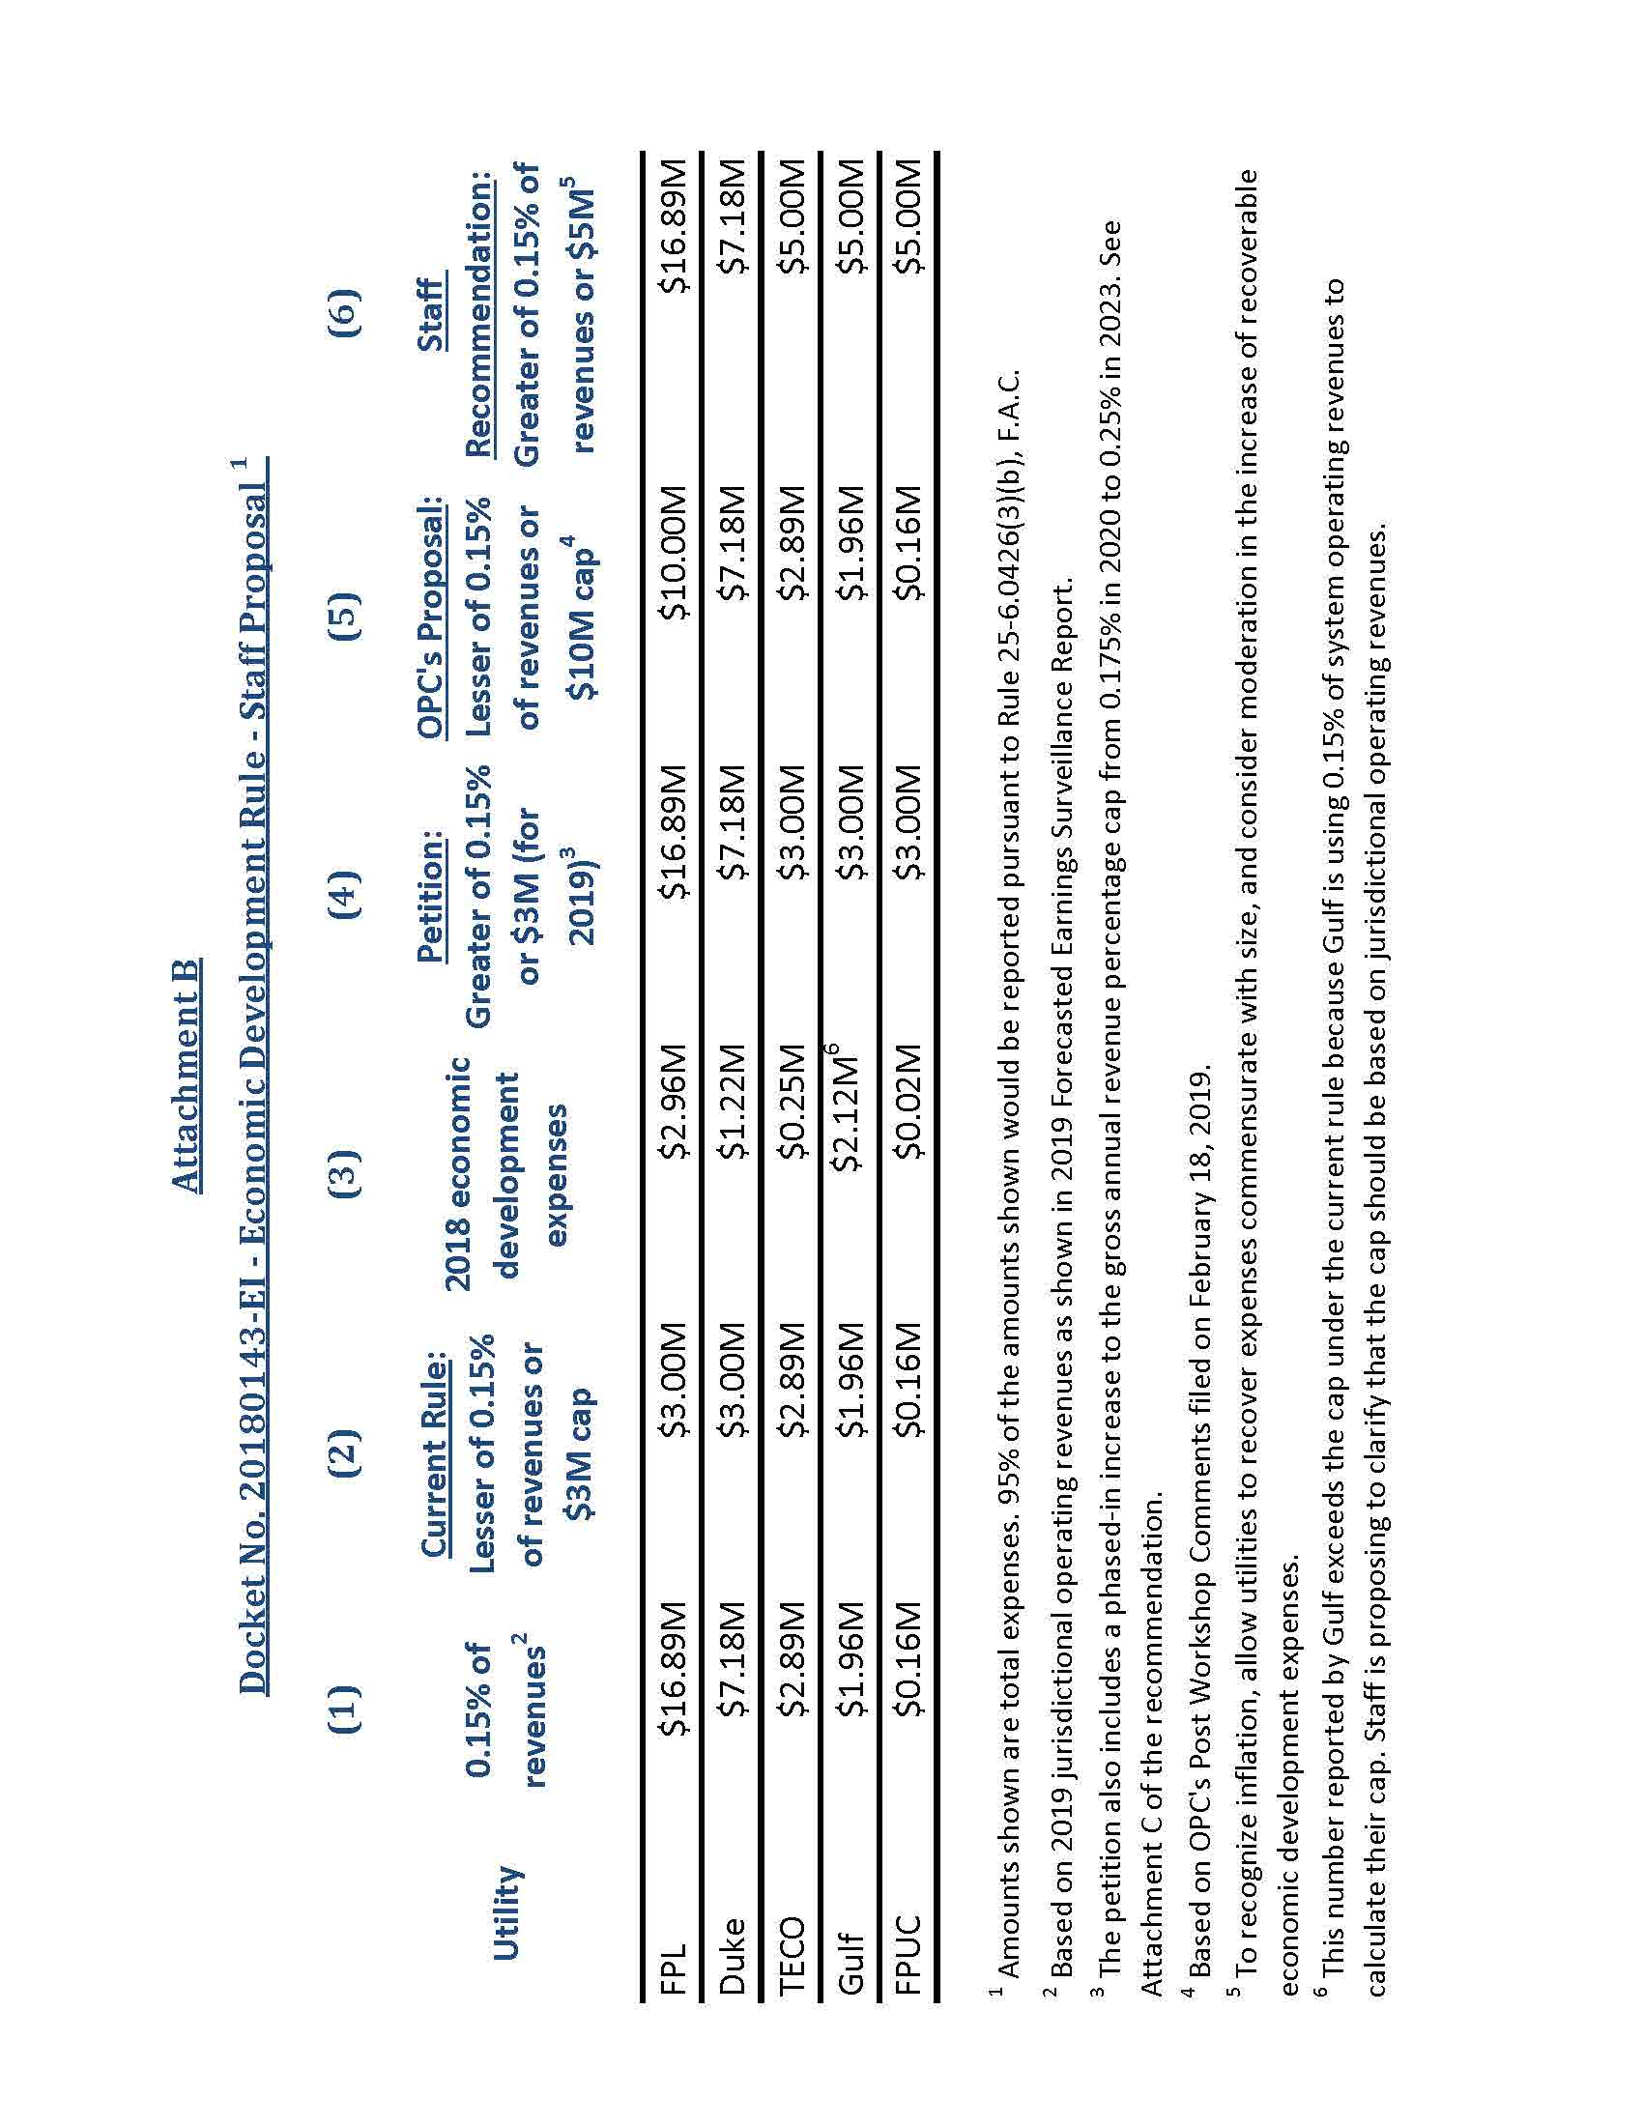
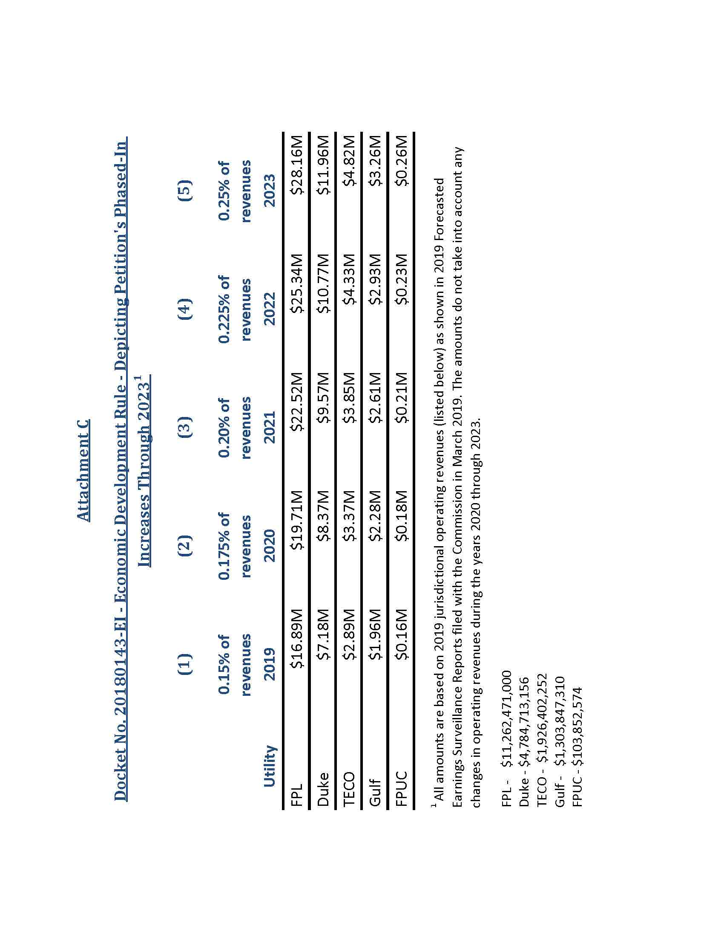
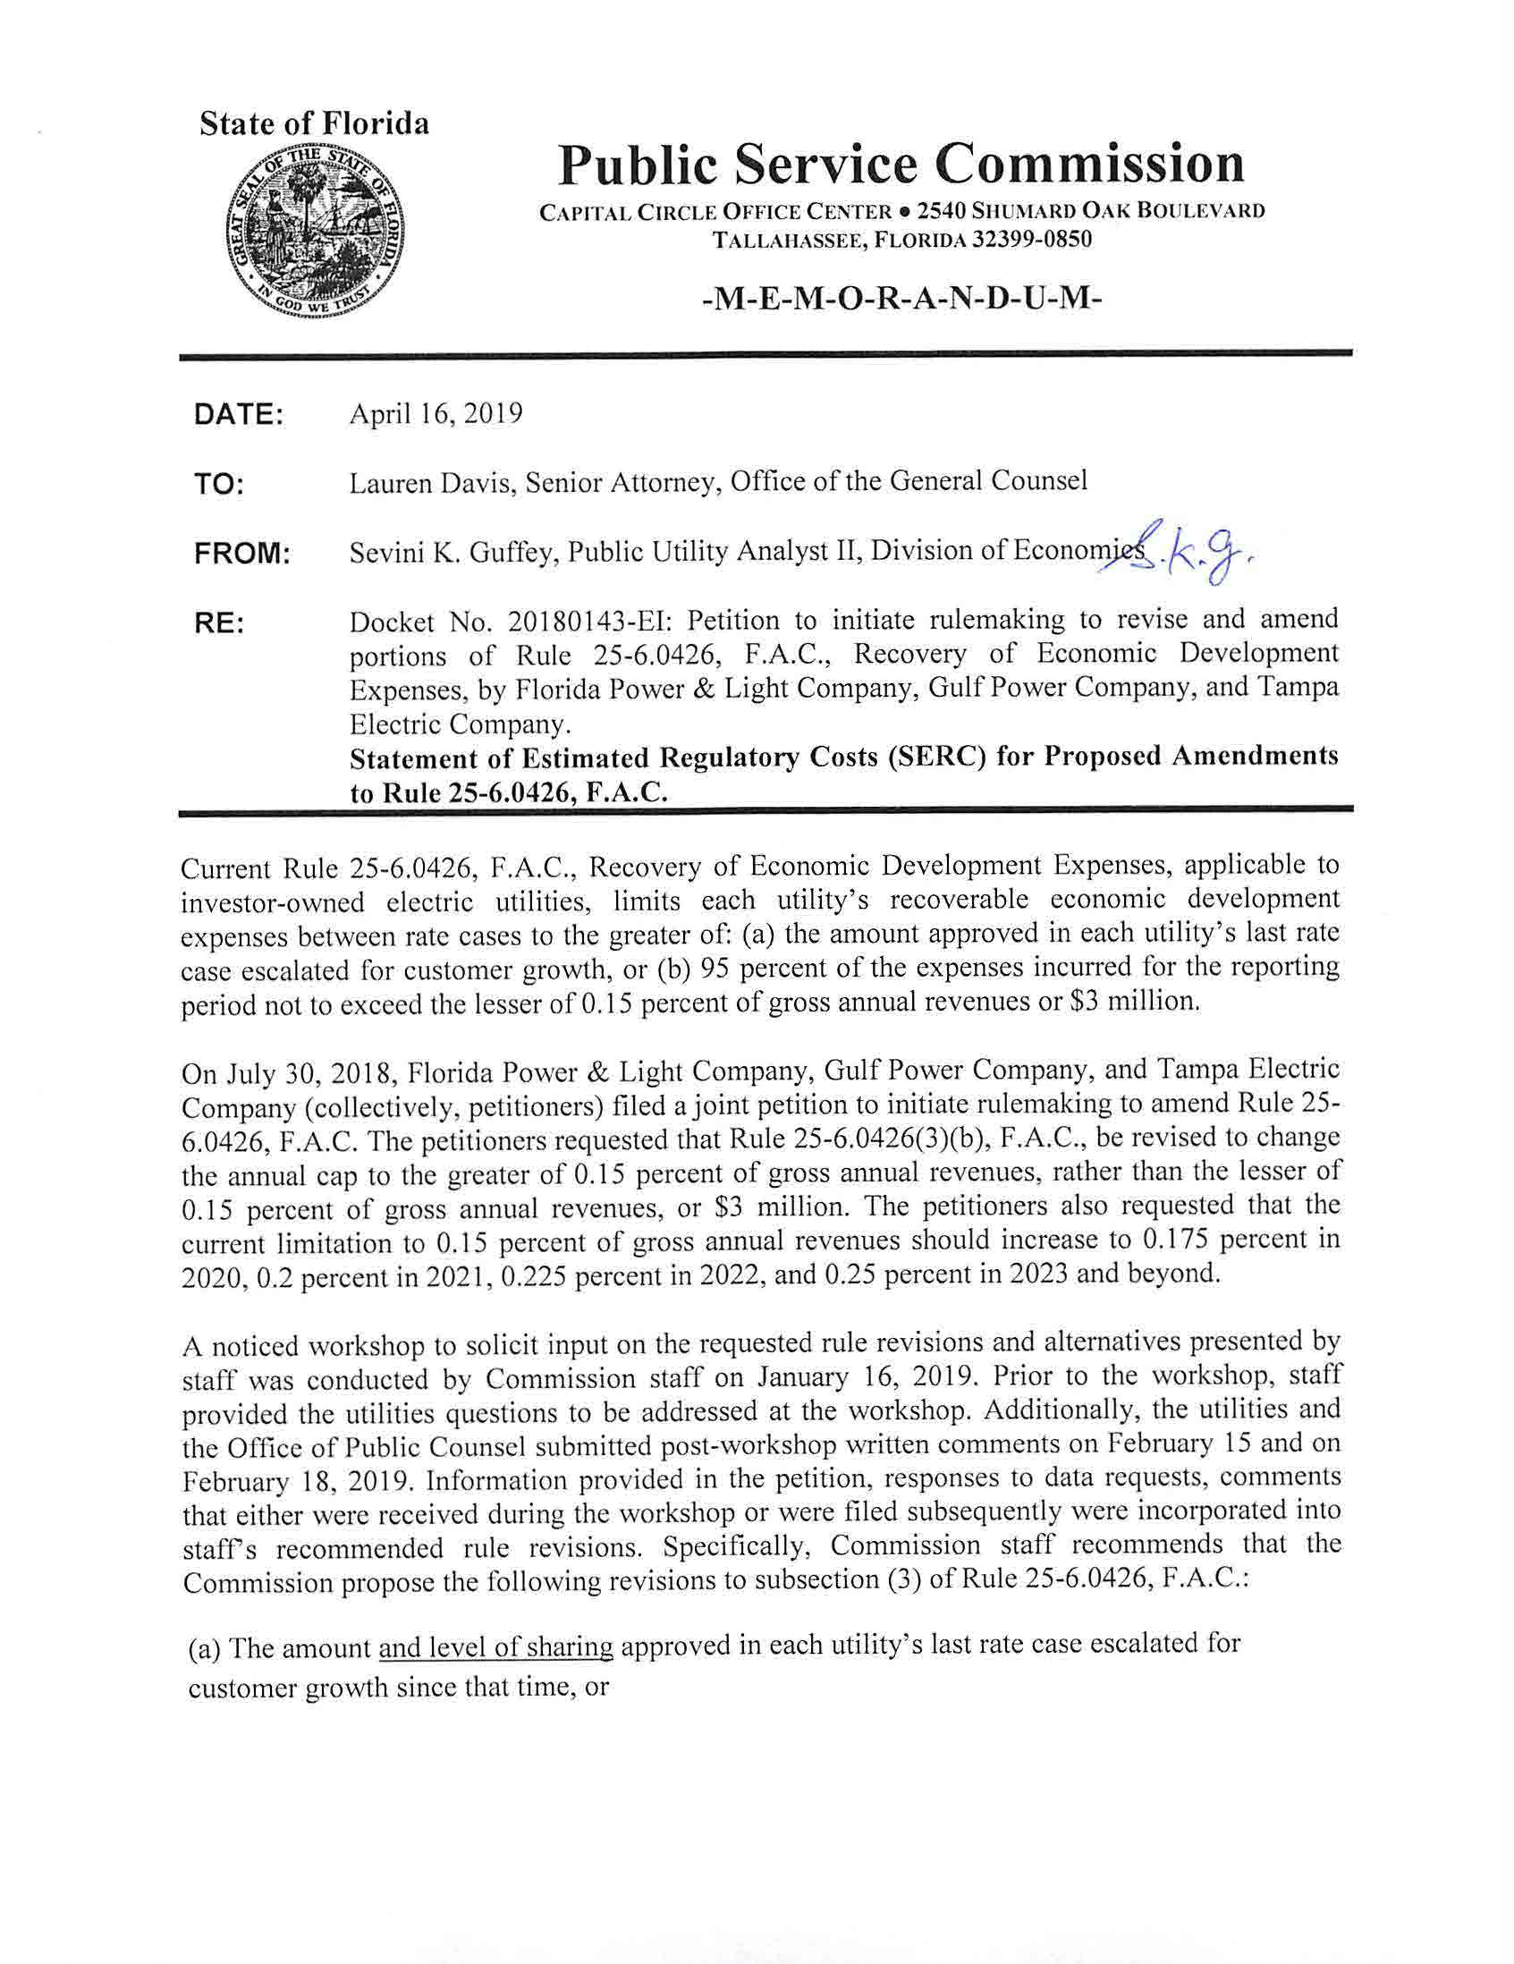
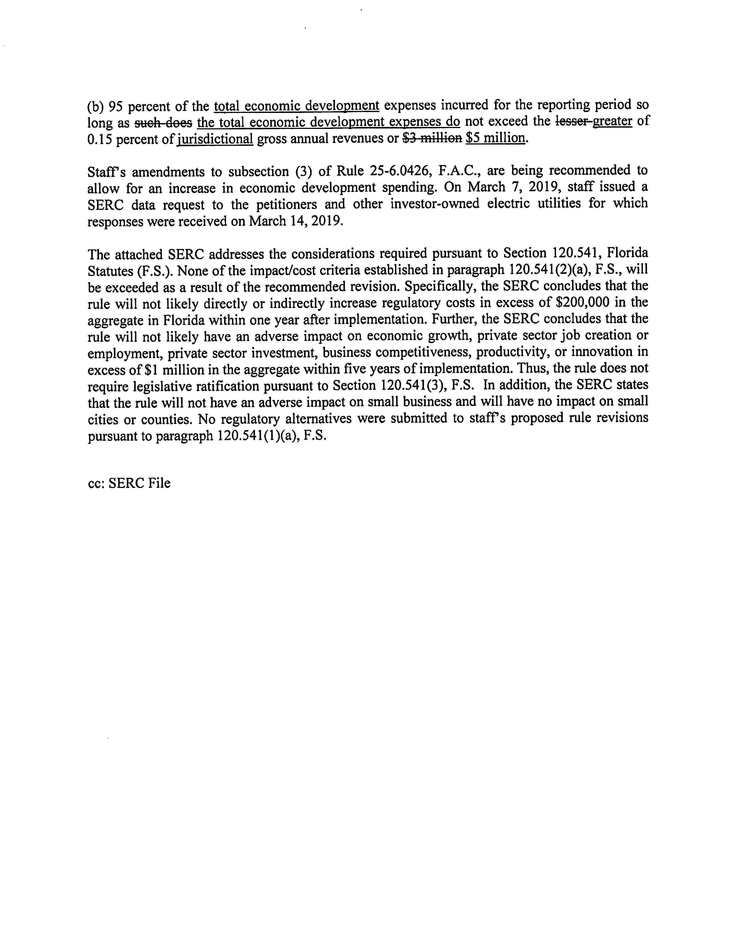
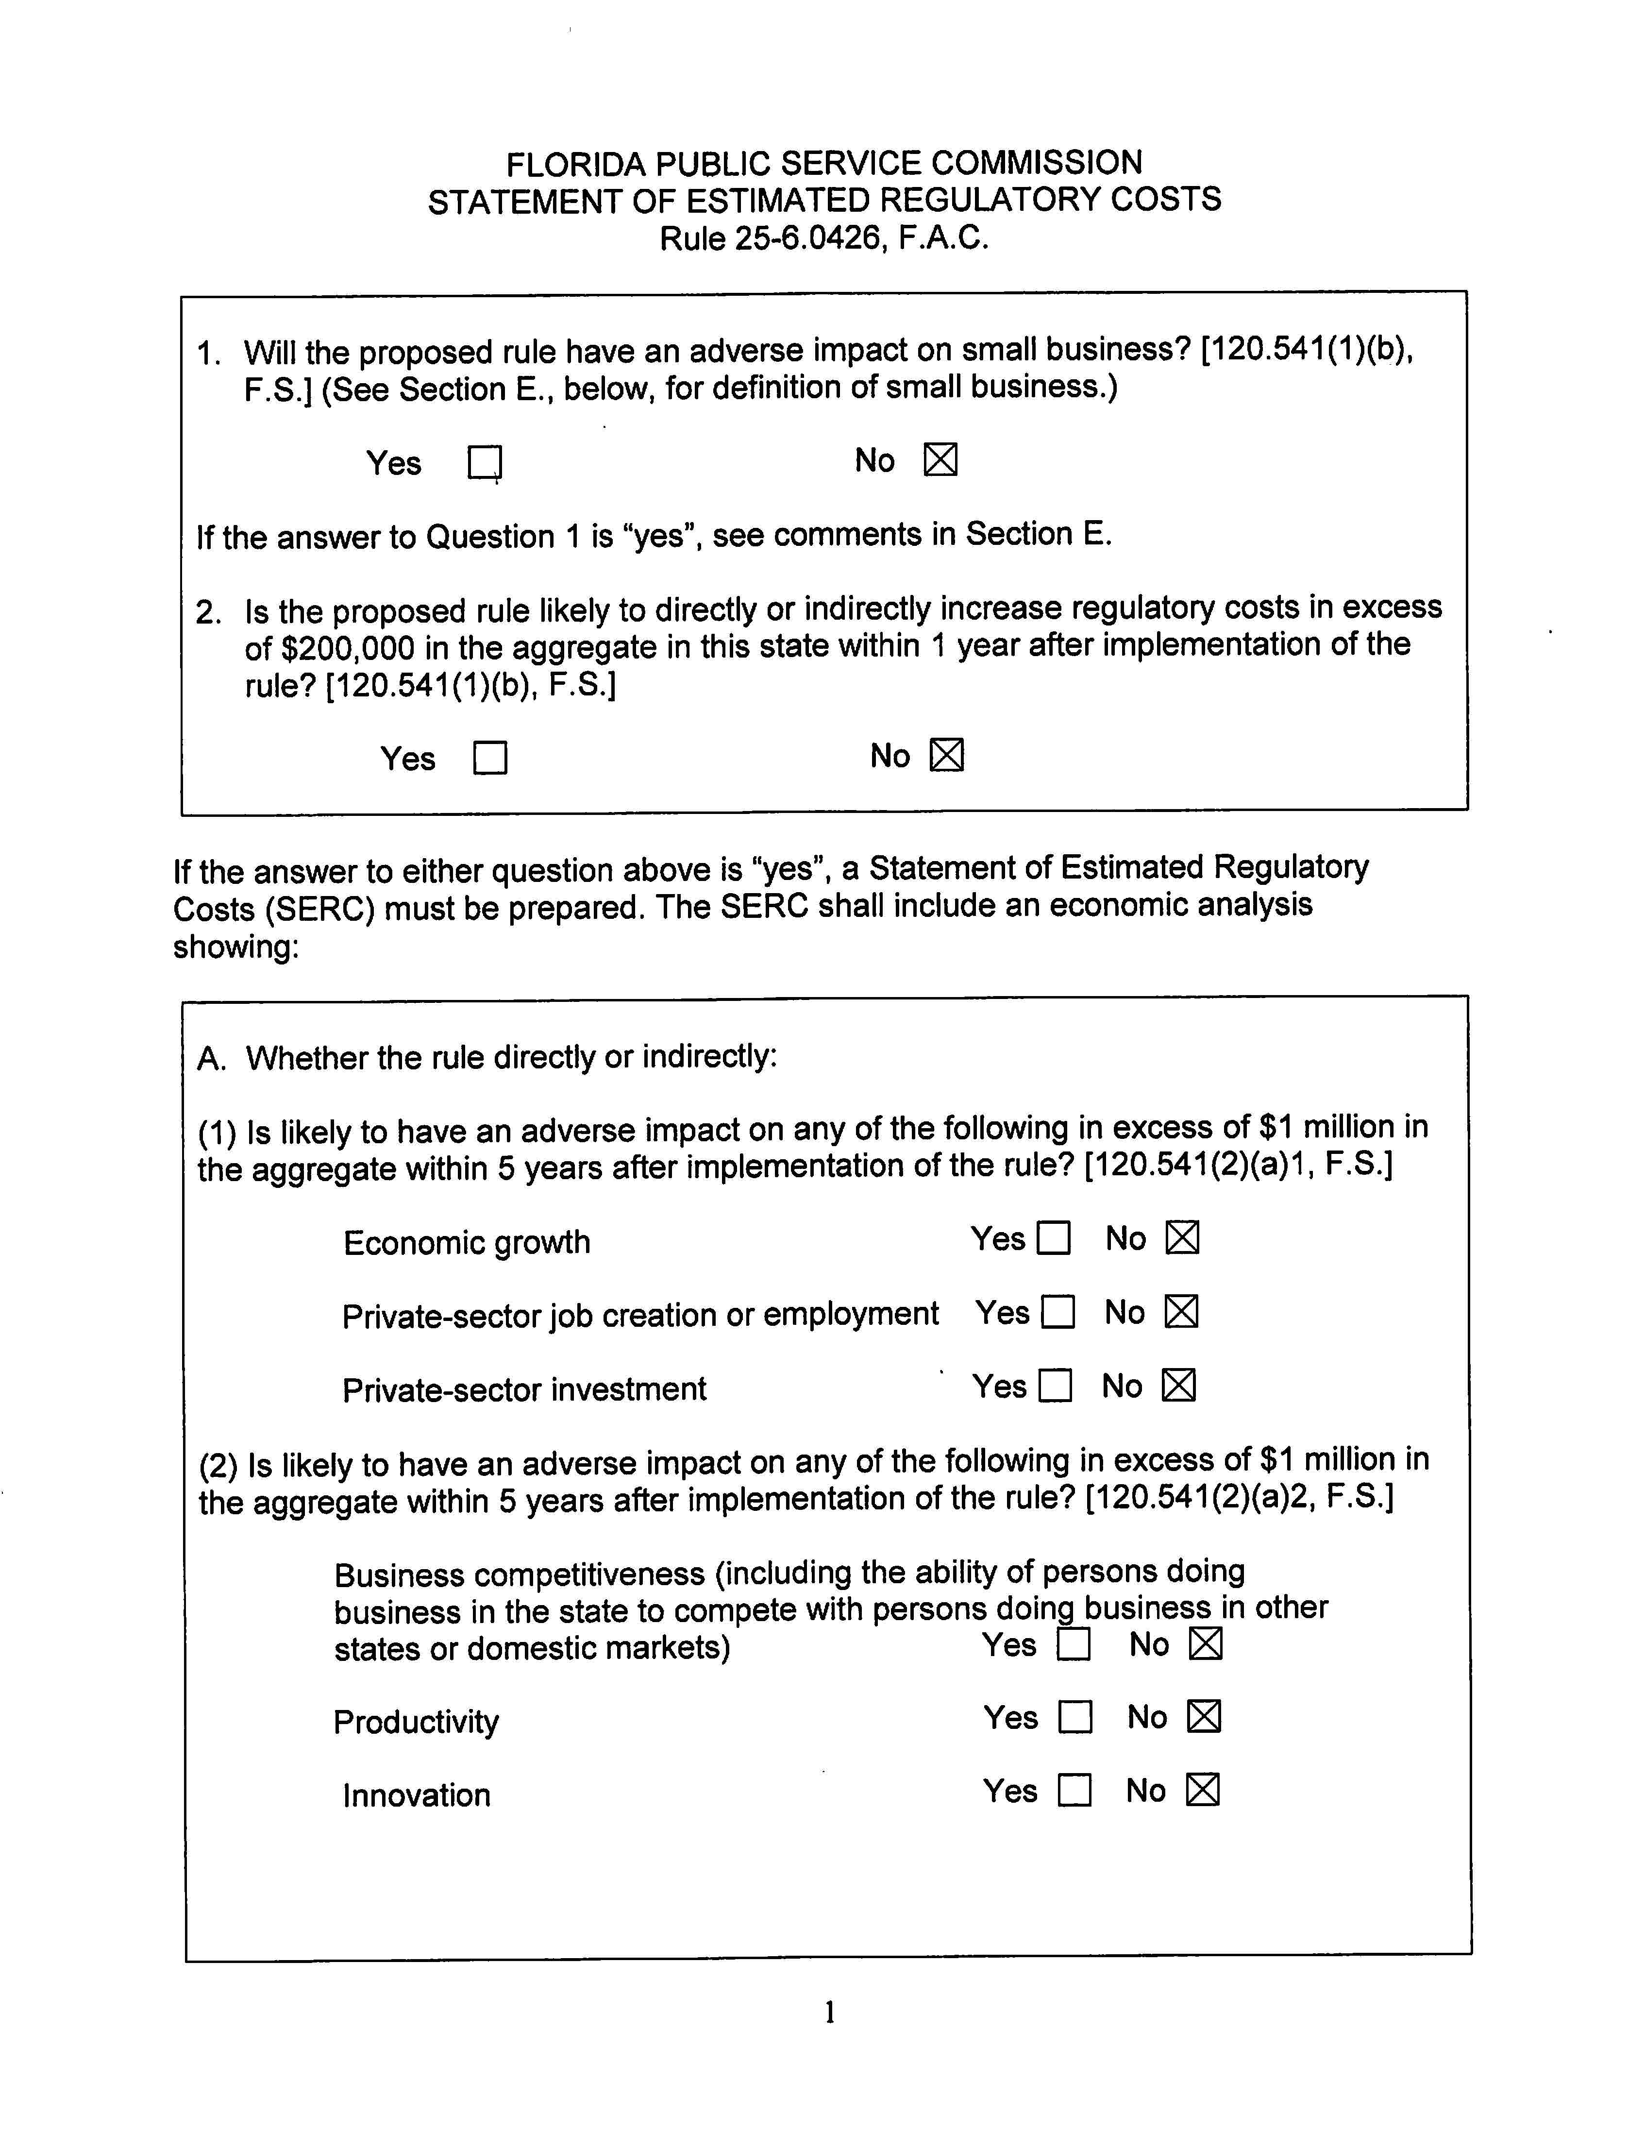
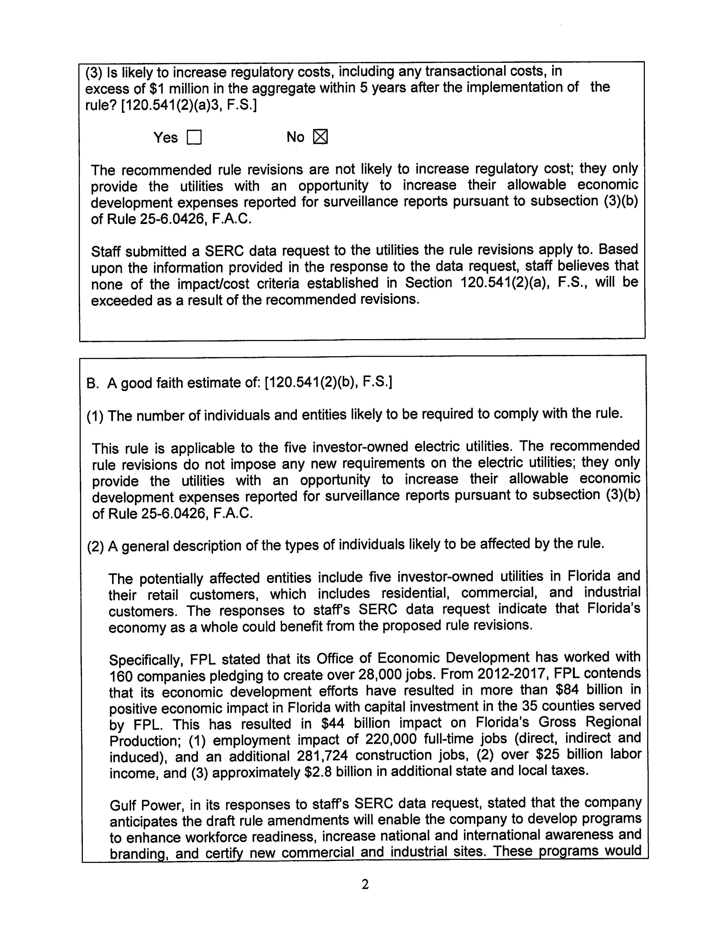
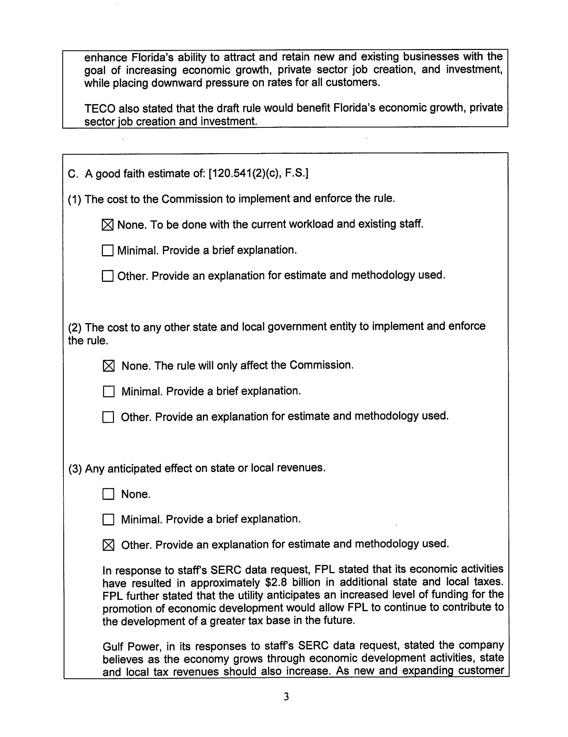
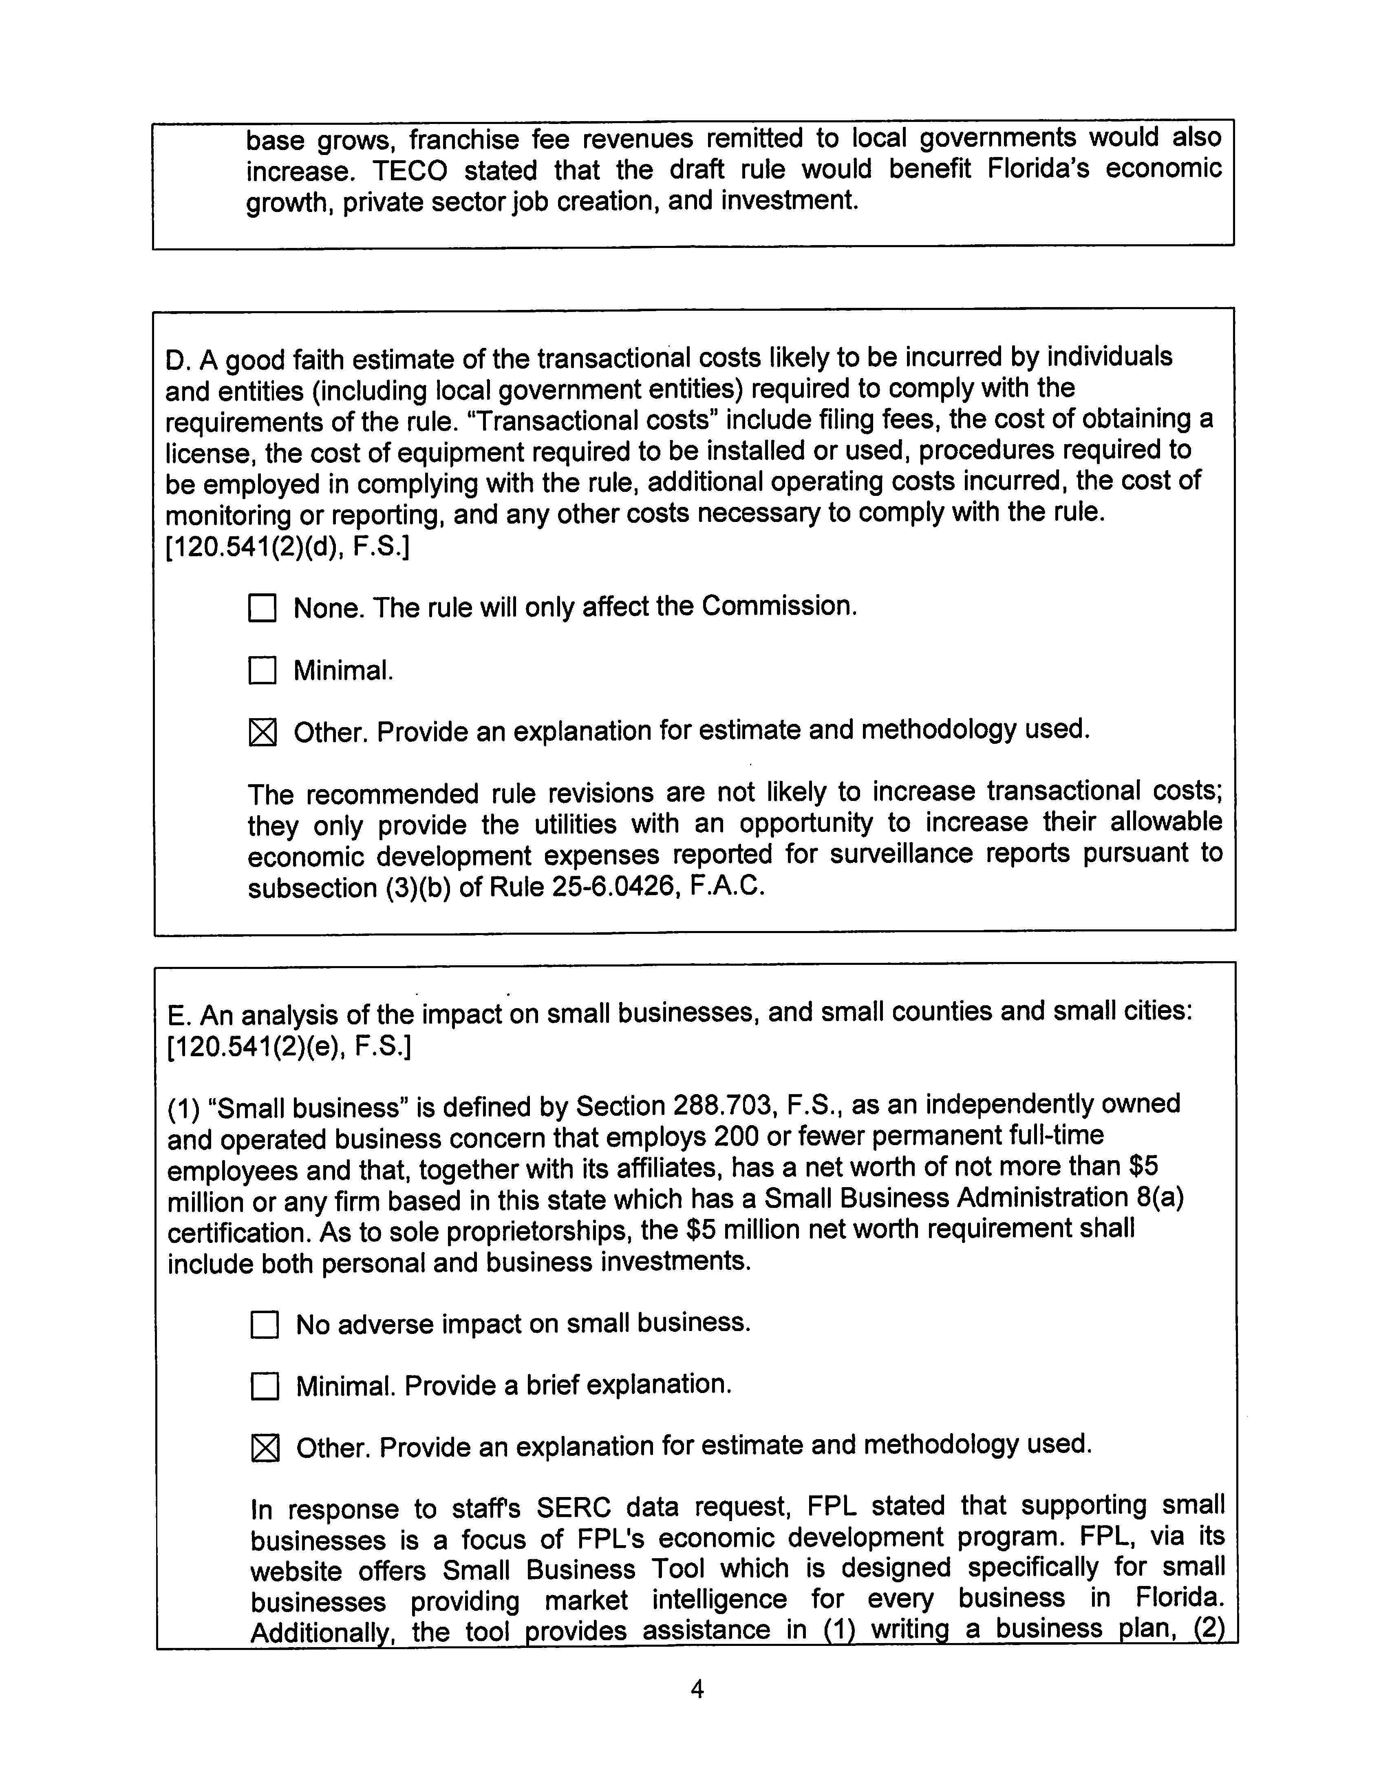
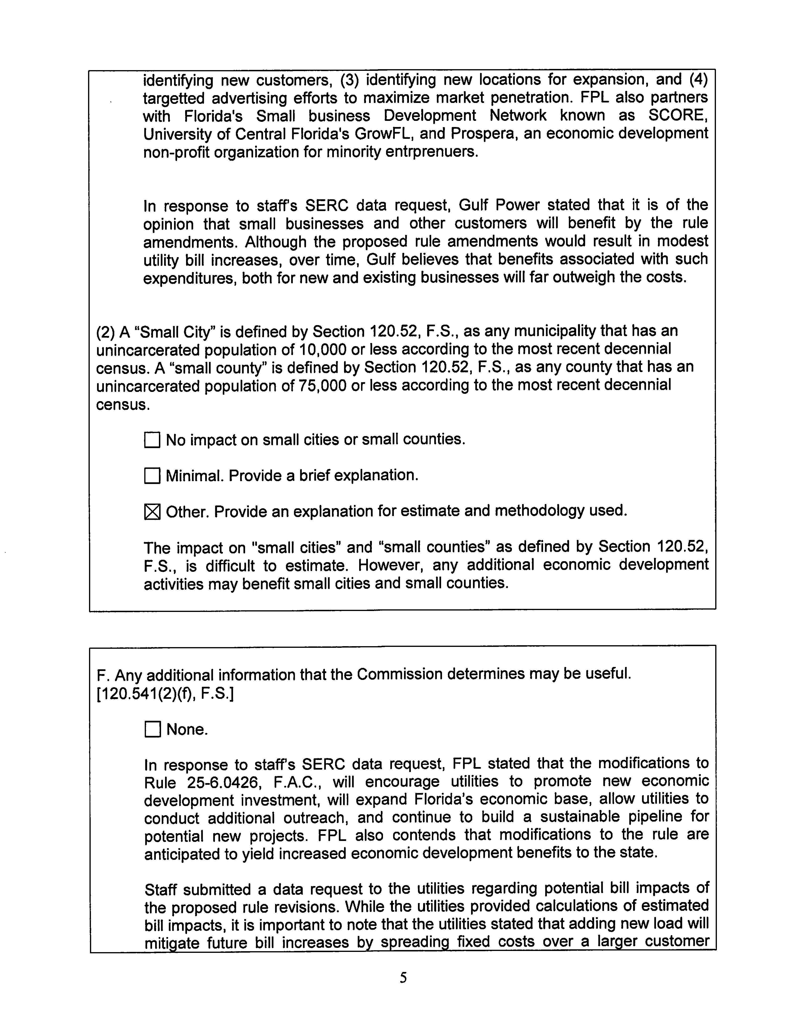
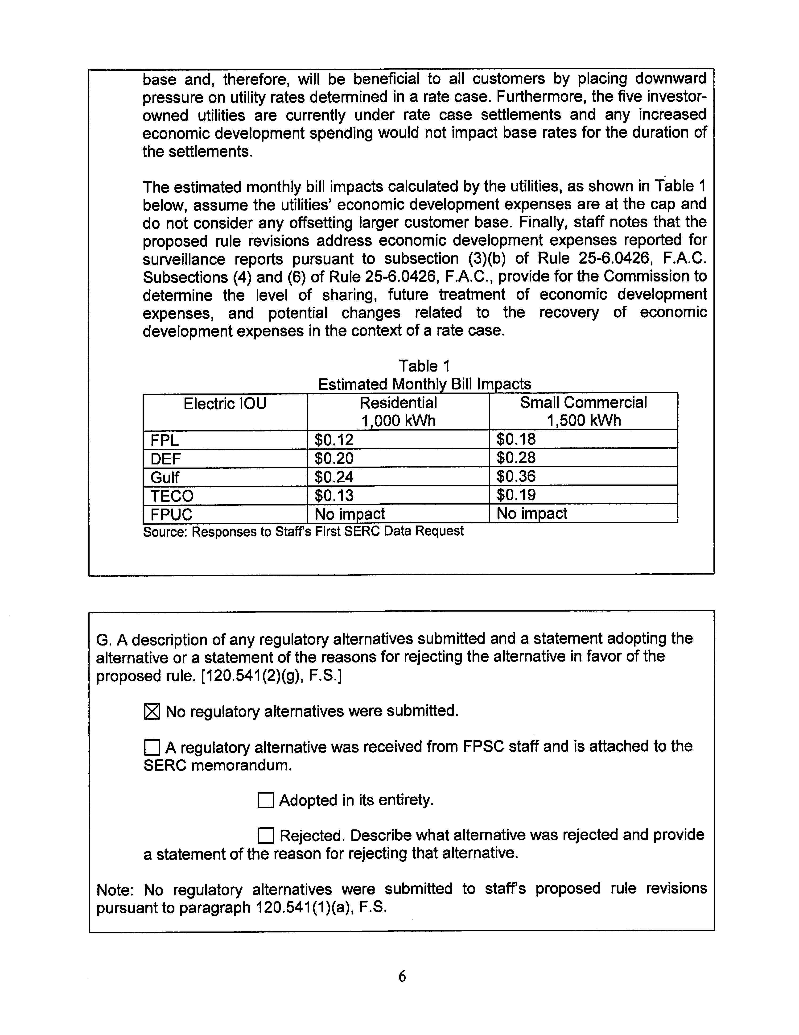

The Commission first adopted Rule 25-6.0426, F.A.C., on July 17, 1995, in Docket No. 930165-PU, In re: Proposed Rules 25-6.0426 and 25-7.042, F.A.C., Recovery of Economic Development Expenses. The rule has been amended twice since it was first adopted, on June 2, 1998, in Docket No. 971334-PU, In re: Proposed Amendments to Rules 25-6.0426, F.A.C., Recovery of Economic Development Expenses, and 25-7.042, F.A.C., Recovery of Economic Development Expenses; and on September 25, 2000, in Docket No. 000418-PU, In re: Proposed Amendments to Rules 25-6.0426 and 25-7.042, F.A.C., Recovery of Economic Development Expenses.
The 5 percent shareholder contribution was approved in Docket No. 971334-PU.

