State of Florida |  | Public Service Commission  Capital Circle Office Center ● 2540 Shumard Oak Boulevard  Tallahassee, Florida 32399-0850  -M-E-M-O-R-A-N-D-U-M-
DATE: | May 2, 2019
TO: | Office of Commission Clerk (Teitzman)
FROM: | Division of Accounting and Finance (Perez, Snyder, D. Smith, Mouring)  Division of Economics (Guffey, Draper)  Division of Engineering (P. Buys, Doehling, Thompson, Wooten, Ellis, Graves)  Office of the General Counsel (Simmons, J. Crawford, A. King)
RE: | Docket No. 20190038-EI – Petition for limited proceeding for recovery of incremental storm restoration costs related to Hurricane Michael, by Gulf Power Company.
AGENDA: | 05/14/19 – Regular Agenda – Participation is at the Commission’s Discretion
COMMISSIONERS ASSIGNED: |  |  | All Commissioners
PREHEARING OFFICER: |  |  | Fay
CRITICAL DATES: |  |  | 07/01/19 (Requested Implementation Date)
SPECIAL INSTRUCTIONS: |  |  | None

Case Background
On February 6, 2019, Gulf Power Company (Gulf or Company) filed a petition for a limited proceeding seeking authority to implement an interim storm restoration recovery charge to recover a total of $342 million for incremental restoration costs related to Hurricane Michael and to replenish its storm reserve. In its petition, Gulf asserts that as a result of Hurricane Michael, Gulf incurred total retail recoverable costs of approximately $350 million less the $48 million pre-storm balance of the storm reserve, resulting in net recoverable costs of $302 million. In addition, Gulf proposes to replenish its storm reserve to the $41 million balance as of December 31, 2016. The $342 million includes interest of $15.3 million on the unamortized storm reserve balance. Gulf filed its petition pursuant to the provisions of the Stipulation and Settlement Agreement (SSA) approved by the Commission in Order No. PSC-2017-0178-S-EI. Pursuant to Paragraph 7(a) of the SSA, Gulf can recover storm costs, not exceeding $4.00/1,000 kWh on monthly residential customer bills, on an interim basis, beginning 60 days following the filing of a petition for recovery. In addition, pursuant to Paragraph 7(b), Gulf may petition the Commission to allow for a charge greater than $4.00/1,000 kWh, or a period longer than 12 months, if costs exceed $100 million in a calendar year. In its petition, Gulf has requested an interim storm restoration recovery charge of $8.00/1,000 kWh on a residential bill, effective with the first billing cycle for April 2019. On March 13, 2019, Gulf requested that the Commission suspend the 60-day timeframe set forth in the SSA, and requested that the Commission approve the storm restoration recovery charge to become effective with the first billing cycle in July 2019. The Company estimates that the proposed recovery charge will need to be in effect for approximately 60 months.
The Office of Public Counsel’s intervention in this docket was acknowledged in Order No. PSC-2019-0087-PCO-EI, issued March 6, 2019.
The Commission has jurisdiction over this matter pursuant to Sections 366.04, 366.05, 366.06, and 366.076, Florida Statutes.

Discussion of Issues

Issue 1:
Should the Commission authorize Gulf to implement an interim storm restoration recovery charge?

Recommendation:
Yes. The Commission should authorize Gulf to implement an interim storm restoration recovery charge, subject to refund. Once the total actual storm costs are known, Gulf should be required to file documentation of the storm costs for Commission review and true up of any excess or shortfall. (Perez, Mouring)

Staff Analysis:
As stated in the Case Background, Gulf filed a petition for a limited proceeding seeking authority to implement an interim storm restoration recovery charge to recover a total of $342 million for the incremental restoration costs related to Hurricane Michael and to replenish its storm reserve. The requested recovery of $342 million represents net retail recoverable costs of approximately $302 million, plus an additional $41 million to replenish the storm reserve to the balance that existed on December 31, 2016. In addition, the $342 million includes interest on the unamortized storm reserve balance of $15.3 million. Gulf has requested an interim storm restoration recovery charge of $8.00 on a monthly 1,000 kWh residential bill, effective with the first billing cycle for July 2019. The Company estimates that the proposed recovery charge will need to be in effect for approximately 60 months.
In its petition, Gulf asserts that it incurred total retail recoverable costs of approximately $350 million as a result of Hurricane Michael. Gulf represented that this amount was calculated in accordance with the Incremental Cost and Capitalization Approach (ICCA) methodology prescribed in Rule 25-6.0143, Florida Administrative Code (F.A.C.). The net retail recoverable costs of $302 million were determined by reducing the $350 million total costs by the pre-storm storm reserve balance of $48 million. The SSA also allows Gulf to request the replenishment of its storm reserve to the $41 million balance that existed on December 31, 2016.
The approval of an interim storm restoration recovery charge is preliminary in nature and is subject to refund pending a further review once the total actual storm restoration costs are known. After the actual costs are reviewed for reasonableness and prudence, and are compared to the actual amount recovered through the interim storm restoration recovery charge, a determination will be made whether any over/under recovery has occurred. The disposition of any over/under recovery, and associated interest, would be considered by the Commission at a later date.
Based on a review of the information provided by Gulf in its petition, staff recommends that the Commission authorize Gulf to implement an interim storm restoration recovery charge, subject to refund. Once the total actual storm costs are known, Gulf should be required to file documentation of the storm costs for Commission review and true up of any excess or shortfall.

Issue 2:
Should the Commission approve Gulf's proposed interim storm restoration recovery tariffs as shown in Attachment A to the recommendation?

Recommendation:
Yes, the Commission should approve Gulf's proposed interim storm restoration recovery tariffs as shown in Attachment A to the recommendation. The proposed tariffs should become effective with the first billing cycle of July 2019. (Guffey, Draper)

Staff Analysis:
In its March 13, 2019 letter to the Commission, Gulf proposed to begin applying the interim storm restoration recovery charge to customer bills with the first billing cycle of July 2019, and to include the charge in the non-fuel energy charge on customer bills. The proposed approximate 60-month recovery period would be subject to modification based upon the Commission’s final decision regarding actual charges. In support of its rate calculations, Gulf provided Exhibit E to the petition.
Exhibit E illustrates the computation of the proposed interim storm restoration recovery charges for each rate class. Gulf represented that it followed the methodology for allocation of storm costs among rate classes consistent with the cost of service study filed in its 2016 rate case (Docket No. 20160186-EI). Staff reviewed Gulf’s calculations and believes the allocation methodology to be reasonable. The storm restoration costs are weighted to reflect storm restoration costs by function such as distribution and transmission (92 percent and 7 percent, respectively).
Application of the allocation methodology for the residential customer rate class results in a proposed interim storm recovery charge of 0.8 cents per kilowatt hour (kWh), which equates to $8.00 on a 1,000 kWh residential electric bill. The proposed interim charges for all rate classes are presented in Twenty-Second Revised Sheet No. 6.25, included in Exhibit F to Gulf’s petition. Revised Exhibit F also includes Table of Contents to add the interim storm restoration recovery charge. The proposed tariff sheets are included in Attachment A to this recommendation.
In its response to staff’s first data request, Gulf provided customer notifications for staff review and stated that the customers will be notified by media news releases, Company website, bill inserts, and by telephone to the Company’s largest commercial customers.
Based on its review of the information provided by Gulf, staff recommends the Commission approve Gulf's proposed interim storm restoration recovery tariffs, subject to refund, as shown in Attachment A to the recommendation. The proposed tariffs should become effective with the first billing cycle of July 2019.

Issue 3:
What is the appropriate security to guarantee the amount collected subject to refund through the interim storm restoration recovery charge?

Recommendation:
The appropriate security to guarantee the funds collected subject to refund is a corporate undertaking. (Hightower, D. Buys)

Staff Analysis:
Staff recommends that all funds collected subject to refund be secured by a corporate undertaking. The criteria for a corporate undertaking include sufficient liquidity, ownership equity, profitability, and interest coverage to guarantee any potential refund. Staff reviewed Gulf’s financial statements to determine if the Company can support a corporate undertaking to guarantee the funds collected for recovery of incremental storm restoration costs related to Hurricane Michael. Gulf’s 2015, 2016, and 2017 financial statements were used to determine the financial condition of the Company. Gulf’s financial performance demonstrates adequate levels of liquidity, ownership equity, profitability, and interest coverage to guarantee the potential refund.
Staff believes Gulf has adequate resources to support a corporate undertaking in the amount requested. Based on this analysis, staff recommends that a corporate undertaking of $68 million is acceptable. This brief financial analysis is only appropriate for deciding if the Company can support a corporate undertaking in the amount proposed and should not be considered a finding regarding staff's position on other issues in this proceeding.

Issue 4:
Should this docket be closed?

Recommendation:
No, this docket should remain open pending final reconciliation of actual recoverable Hurricane Michael storm costs with the amount collected pursuant to the interim storm restoration recovery charge, and the calculation of a refund or additional charge if warranted. (Simmons)

Staff Analysis:
No, this docket should remain open pending final reconciliation of actual recoverable Hurricane Michael storm costs with the amount collected pursuant to the interim storm restoration recovery charge, and the calculation of a refund or additional charge if warranted.

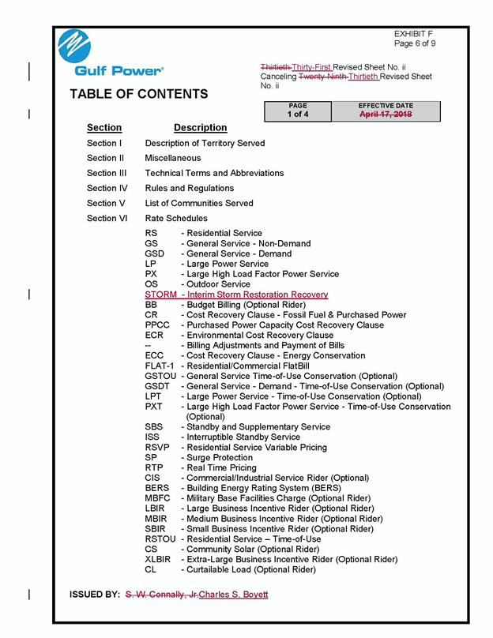

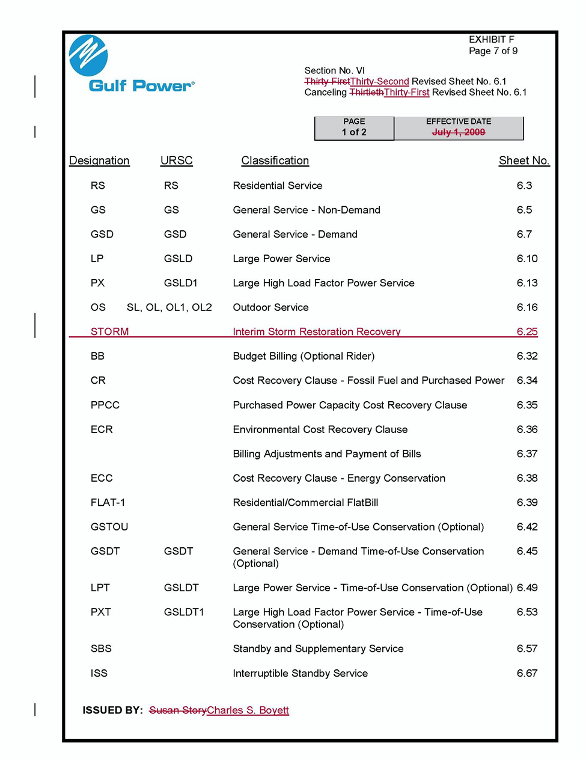

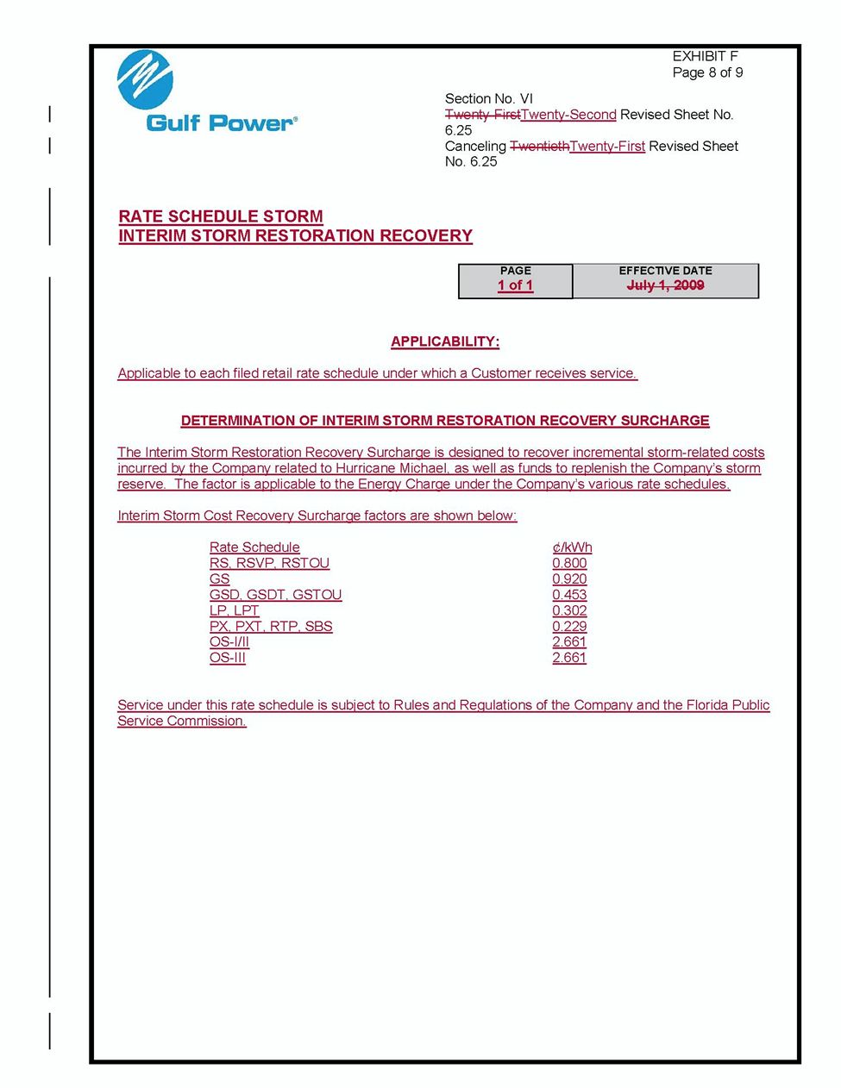

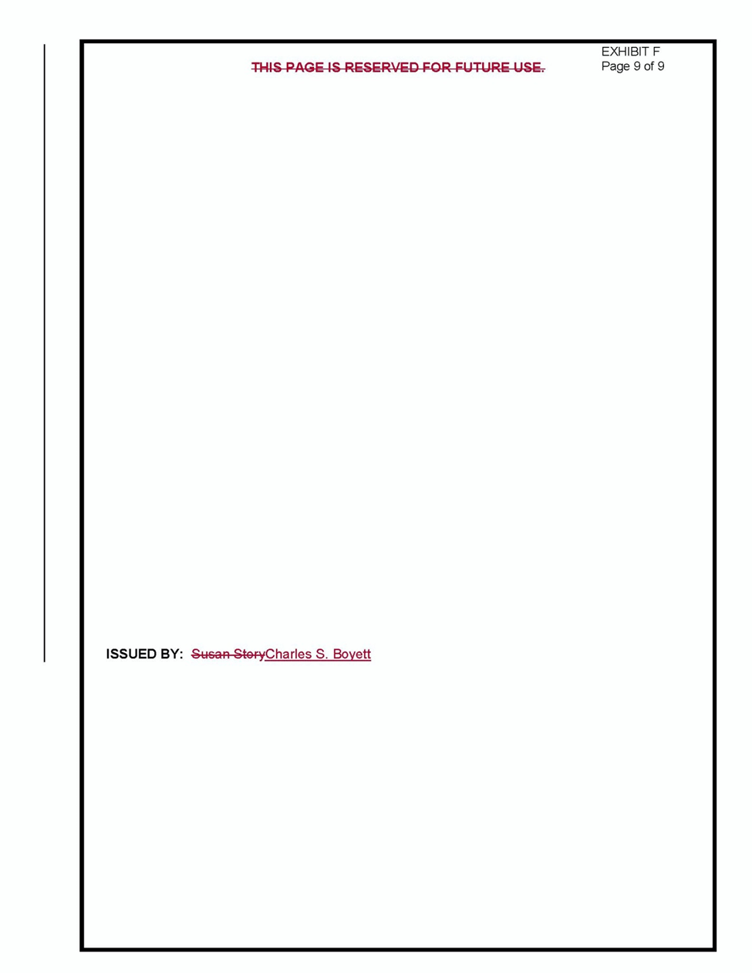

Order No. PSC-2017-0178-S-EI, issued May 16, 2017, in Docket No. 160186-EI, In re: Petition for rate increase by Gulf Power Company; and Docket No. 160170-EI, In re: Petition for approval of 2016 depreciation and dismantlement studies, approval of proposed depreciation rates and annual dismantlement accruals and Plant Smith Units 1 and 2 regulatory asset amortization, by Gulf Power Company.
See Document No. 00640-2019 Exhibit C, Page 1 (Gulf Petition).
Section E – Cost of Service and Rate Design Schedules Volume Two in Docket No. 20160186-EI, In re: Petition for an increase in rates by Gulf Power Company.

